**Name :- Mohini Pramod Badhe**

**Roll No :- 05**

**Practical :- 06**

**Practical Name :- Use git log or git log | less to see a list of changes to the repository.**

MOHINI@LAPTOP-J8VNJ4IR MINGW64 /c/mohini

$ git log

commit 6a7c704cd4d2ee35f720c228c4c997c1c2f660c4 (HEAD -> main)

Merge: a334409 2afa483

Author: MOHINI <mohinibadhe03@gmail.com>

Date: Wed Mar 27 23:45:43 2024 +0530

Merge https://github.com/mahibadhe18/MCA

commit 2afa483346dbd0b6476b198969c24eb2ced73b91

Author:MOHINI<165194707+mohinibadhe03.noreply.github.com> Date: Wed Mar 27 23:44:32 2024 +0530

Add files via upload

commit a3344094761d620ee8e4f562b8f233a974464eca

Author: MOHINI <mahibadhe03@gmail.com>

Date: Wed Mar 27 23:20:29 2024 +0530

first commit

commit 976afeaabd241b44750f52da78b2b5568f680df7 (origin/main, origin/HEAD)

Author: MOHINI <165194707+mahibadhe18@users.noreply.github.com> Date: Wed Mar 27 23:08:04 2024 +0530

Initial commit

MOHINI@LAPTOP-J8VNJ4IR MINGW64 ~/MCA (main)

$ git log --oneline

6a7c704 (HEAD -> main) Merge https://github.com/mahibadhe03/MCA

2afa483 Add files via upload a334409 first commit

976afea (origin/main, origin/HEAD) Initial commit

MOHINI@LAPTOP-J8VNJ4IR MINGW64 ~/MCA (main)

$ git log --stat

commit 6a7c704cd4d2ee35f720c228c4c997c1c2f660c4 (HEAD -> main)

Merge: a334409 2afa483

Author: MOHINI <mahibadhe03@gmail.com>

Date: Wed Mar 27 23:45:43 2024 +0530

Merge https://github.com/mahibadhe03/MCA

commit 2afa483346dbd0b6476b198969c24eb2ced73b91

Author: MOHINI<165194707+mahibadhe03@users.noreply.github.com> Date: Wed Mar 27 23:44:32 2024 +0530

Add files via upload

new pract.pdf | Bin 0 -> 25516 bytes 1 file changed, 0 insertions(+), 0 deletions(-)

commit a3344094761d620ee8e4f562b8f233a974464eca

Author: MOHINI <mahibadhe03@gmail.com>

Date: Wed Mar 27 23:20:29 2024 +0530

first commit

MCA2.txt | 0

1 file changed, 0 insertions(+), 0 deletions(-)

commit 976afeaabd241b44750f52da78b2b5568f680df7 (origin/main, origin/HEAD)

Author:MOHINI<165194707+mahibadhe03@users.noreply.github.com> Date: Wed Mar 27 23:08:04 2024 +0530

Initial commit

README.md | 1 +

1 file changed, 1 insertion(+)

MOHINI@LAPTOP-J8VNJ4IR MINGW64 ~/MCA (main)

$ git log --patch

commit 6a7c704cd4d2ee35f720c228c4c997c1c2f660c4 (HEAD -> main)

Merge: a334409 2afa483

Author:MOHINI <mahibadhe03@gmail.com>

Date: Wed Mar 27 23:45:43 2024 +0530

Merge https://github.com/mahibadhe18/MCA

commit 2afa483346dbd0b6476b198969c24eb2ced73b91

Author:MOHINI<165194707+mahibadhe03@users.noreply.github.com> Date: Wed Mar 27 23:44:32 2024 +0530

Add files via upload

**diff --git a/new pract.pdf b/new pract.pdf**

**new file mode 100644 index 0000000..9f74351**

**--- /dev/null**

**+++ b/new pract.pdf**

@@ -0,0 +1 @@

+^L

commit a3344094761d620ee8e4f562b8f233a974464eca

Author:MOHINI <mahibadhe03@gmail.com>

Date: Wed Mar 27 23:20:29 2024 +0530

first commit

**diff --git a/MCA2.txt b/MCA2.txt new file mode 100644**

**index 0000000..e69de29**

commit 976afeaabd241b44750f52da78b2b5568f680df7 (origin/main, origin/HEAD)

Author:MOHINI<165194707+mahibadhe03@users.noreply.github.com> Date: Wed Mar 27 23:08:04 2024 +0530

Initial commit

**diff --git a/README.md b/README.md**

**new file mode 100644**

**index 0000000..dd22ae2**

**--- /dev/null**

**+++ b/README.md** @@ -0,0 +1 @@

...skipping...

commit 6a7c704cd4d2ee35f720c228c4c997c1c2f660c4 (HEAD -> main)

Merge: a334409 2afa483

Author: MOHINI <mahibadhe03@gmail.com>

Date: Wed Mar 27 23:45:43 2024 +0530

Merge https://github.com/mahibadhe18/MCA

commit 2afa483346dbd0b6476b198969c24eb2ced73b91

Author:MOHINI<165194707+mahibadhe03@users.noreply.github.com> Date: Wed Mar 27 23:44:32 2024 +0530

Add files via upload

**diff --git a/new pract.pdf b/new pract.pdf**

**new file mode 100644 index 0000000..9f74351**

**--- /dev/null**

**+++ b/new pract.pdf**

@@ -0,0 +1 @@

+^L

commit a3344094761d620ee8e4f562b8f233a974464eca

Author: MOHINI <mahibadhe03@gmail.com>

Date: Wed Mar 27 23:20:29 2024 +0530

first commit

**diff --git a/MCA2.txt b/MCA2.txt new file mode 100644**

**index 0000000..e69de29**

commit 976afeaabd241b44750f52da78b2b5568f680df7 (origin/main, origin/HEAD)

Author: MOHINI<165194707+mahibadhe03@users.noreply.github.com> Date: Wed Mar 27 23:08:04 2024 +0530

Initial commit

**diff --git a/README.md b/README.md**

**new file mode 100644**

**index 0000000..dd22ae2**

**--- /dev/null**

**+++ b/README.md**

@@ -0,0 +1 @@ +# MCA

...skipping...

Merge: a334409 2afa483

Author: MOHINI <mahibadhe03@gmail.com>

Date: Wed Mar 27 23:45:43 2024 +0530

Merge https://github.com/mahibadhe18/MCA

commit 2afa483346dbd0b6476b198969c24eb2ced73b91

Author: MOHINI <165194707+mahibadhe03@users.noreply.github.com> Date: Wed Mar 27 23:44:32 2024 +0530

Add files via upload

**diff --git a/new pract.pdf b/new pract.pdf**

**new file mode 100644 index 0000000..9f74351**

**--- /dev/null**

**+++ b/new pract.pdf**

@@ -0,0 +1 @@

+^L

commit a3344094761d620ee8e4f562b8f233a974464eca

Author: MOHINI <mahibadhe03@gmail.com>

Date: Wed Mar 27 23:20:29 2024 +0530

first commit

**diff --git a/MCA2.txt b/MCA2.txt new file mode 100644**

**index 0000000..e69de29**

commit 976afeaabd241b44750f52da78b2b5568f680df7 (origin/main, origin/HEAD)

Author: MOHINI<mahibadhe03@gmail.com>

Date: Wed Mar 27 23:20:29 2024 +0530

Initial commit

**diff --git a/README.md b/README.md**

**new file mode 100644 index 0000000..dd22ae2**

**--- /dev/null**

**+++ b/README.md** @@ -0,0 +1 @@

MOHINI@LAPTOP-J8VNJ4IR MINGW64 ~/MCA (main)

$ git log --graph

* commit 6a7c704cd4d2ee35f720c228c4c997c1c2f660c4 (HEAD -> main)

|\ Merge: a334409 2afa483

| | Author: MOHINI<mahibadhe03@gmail.com>

| | Date: Wed Mar 27 23:45:43 2024 +0530

| |

| | Merge https://github.com/mahibadhe18/MCA

| |

| * commit 2afa483346dbd0b6476b198969c24eb2ced73b91

| | Author:MOHINI<165194707+mahibadhe03@users.noreply.github.com>

| | Date: Wed Mar 27 23:44:32 2024 +0530

| |

| | Add files via upload

| |

* | commit a3344094761d620ee8e4f562b8f233a974464eca

|/ Author: MOHINI <mahibadhe03@gmail.com>

| Date: Wed Mar 27 23:20:29 2024 +0530

|

| first commit

|

* commit 976afeaabd241b44750f52da78b2b5568f680df7 (origin/main, origin/HEAD)

Author: MOHINI<165194707+mahibadhe03@users.noreply.github.com>

Date: Wed Mar 27 23:08:04 2024 +0530

Initial commit

MOHINI@LAPTOP-J8VNJ4IR MINGW64 ~/MCA (main)

$ git log --graph --oneline

* 6a7c704 (HEAD -> main) Merge https://github.com/mahibadhe18/MCA

|\

| * 2afa483 Add files via upload

* | a334409 first commit

|/

* 976afea (origin/main, origin/HEAD) Initial commit

MOHINI@LAPTOP-J8VNJ4IR MINGW64 ~/MCA (main)

$ git log -3

commit 6a7c704cd4d2ee35f720c228c4c997c1c2f660c4 (HEAD -> main)

Merge: a334409 2afa483

Author: MOHINI<mahibadhe03gmail.com>

Date: Wed Mar 27 23:45:43 2024 +0530

Merge https://github.com/mahibadhe18/MCA

commit 2afa483346dbd0b6476b198969c24eb2ced73b91

Author:MOHINI<165194707+mahibadhe03@users.noreply.github.com> Date: Wed Mar 27 23:44:32 2024 +0530

Add files via upload

commit a3344094761d620ee8e4f562b8f233a974464eca

Author: MOHINI <mahibadhe03@gmail.com>

Date: Wed Mar 27 23:20:29 2024 +0530

first commit

MOHINI@LAPTOP-J8VNJ4IR MINGW64 ~/MCA (main)

$ git log --author="MCA1"

MOHINI@LAPTOP-J8VNJ4IR MINGW64 ~/MCA (main)

$ git log --author="mahibadhe03@gmail.com"

MOHINI@LAPTOP-J8VNJ4IR MINGW64 ~/MCA (main)

$ git log --grep="commit message"

MOHINI@LAPTOP-J8VNJ4IR MINGW64 ~/MCA (main)

$ git status

On branch main

Your branch is ahead of 'origin/main' by 3 commits. (use "git push" to publish your local commits)

Untracked files:

(use "git add <file>..." to include in what will be committed)

MCA/

nothing added to commit but untracked files present (use "git add" to track)

**Name :- Mohini Pramod Badhe**

**Roll No :- 05**

**Practical :- 07**

**Practical Name :- Use git branch to create a new branch and git checkout to switch to the branch.**

MOHINI@LAPTOP-J8VNJ4IR MINGW64 ~

$ cd MCA

MOHINI@LAPTOP-J8VNJ4IR MINGW64 ~/MCA (branch2)

$ git checkout main

Switched to branch 'main'

Your branch is ahead of 'origin/main' by 1 commit.

(use "git push" to publish your local commits)

MOHINI@LAPTOP-J8VNJ4IR MINGW64 ~/MCA (main)

$ git init MCA

Reinitialized existing Git repository in C:/Users/admin/MCA/MCA/.git/

MOHINI@LAPTOP-J8VNJ4IR MINGW64 ~/MCA (main)

$ git branch branch1

MOHINI@LAPTOP-J8VNJ4IR MINGW64 ~/MCA (main)

$ git checkout branch1

Switched to branch 'branch1'

MOHINI@LAPTOP-J8VNJ4IR MINGW64 ~/MCA (branch1)

$ touch MCA2.txt

MOHINI@LAPTOP-J8VNJ4IR MINGW64 ~/MCA (branch1)

$ git add MCA2.txt

MOHINI@LAPTOP-J8VNJ4IR MINGW64 ~/MCA (branch1)

$ git commit -m "First commit of branch first"

[branch1 e9eed8d] First commit of branch first 1 file changed, 0 insertions(+), 0 deletions(-)

create mode 100644 MCA2.txt

MOHINI@LAPTOP-J8VNJ4IR MINGW64 ~/MCA (branch1)

$ git push -u origin branch1

Enumerating objects: 3, done.

Counting objects: 100% (3/3), done.

Delta compression using up to 4 threads

Compressing objects: 100% (2/2), done.

Writing objects: 100% (2/2), 232 bytes | 116.00 KiB/s, done.

Total 2 (delta 1), reused 0 (delta 0), pack-reused 0

remote: Resolving deltas: 100% (1/1), completed with 1 local object.

remote: remote: Create a pull request for 'branch1' on GitHub by visiting:

remote: https://github.com/mahibadhe18/MCA/pull/new/branch1 remote:

To https://github.com/mahibadhe18/MCA.git * [new branch] branch1 -> branch1 branch 'branch1' set up to track 'origin/branch1'.

**Before Pull and merge on remote repository:-**

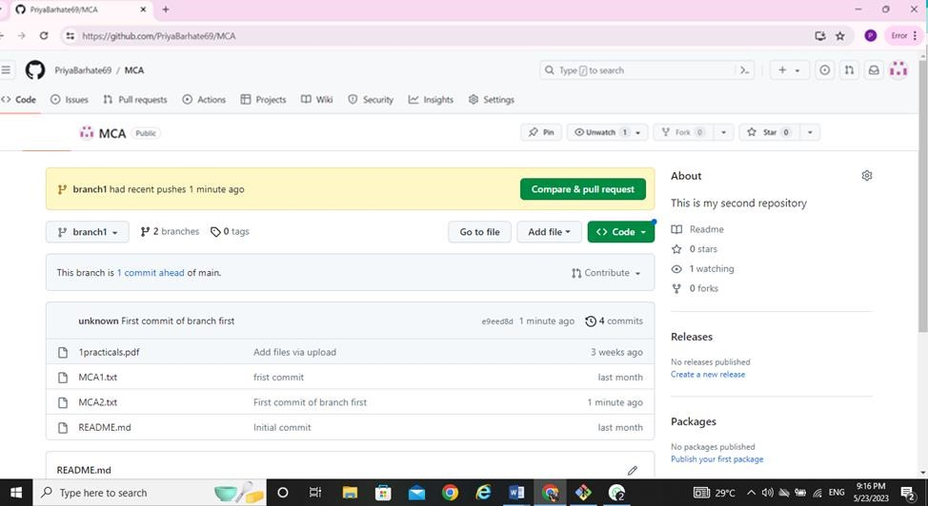

**Performing Pull request:-**

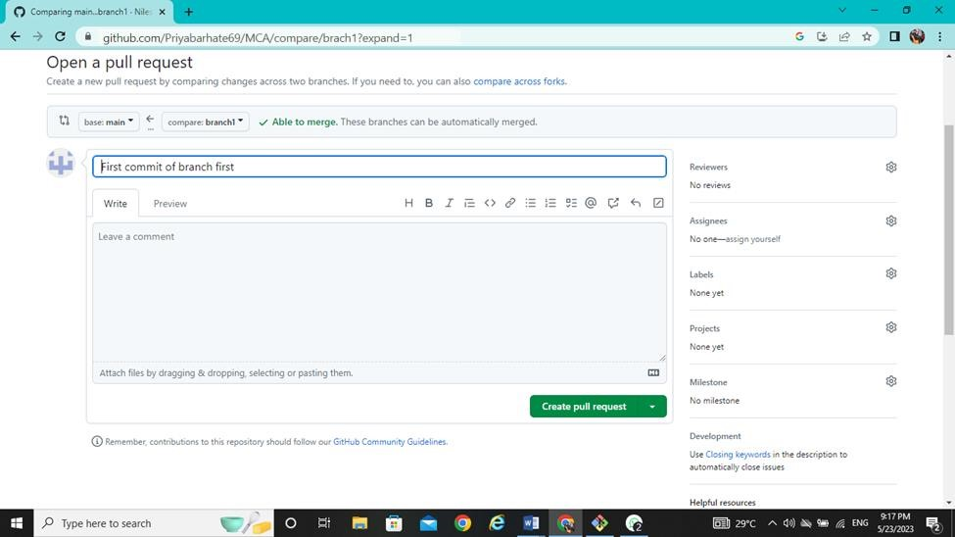

**After Pull performing Merge on remote repository at primary branch (main):-**

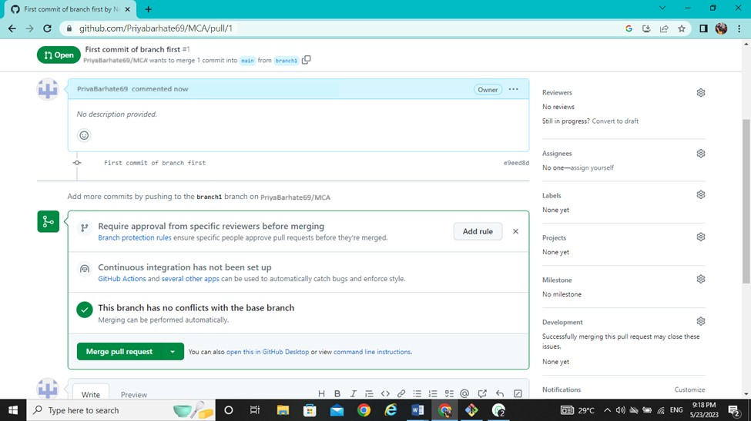

**After merge from first branch to primary branch (main) on remote repository:-**

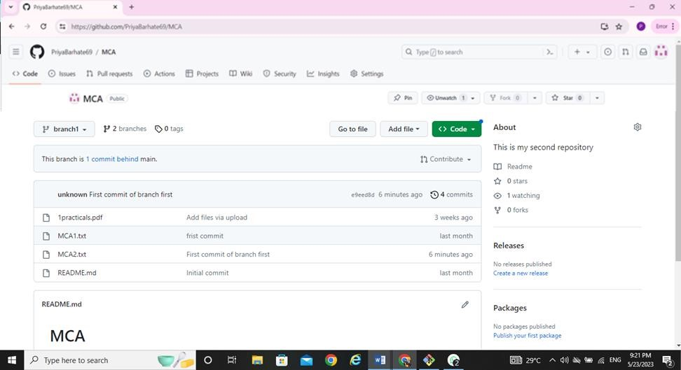

**Name :- Mohini Pramod Badhe**

**Roll No :- 05**

**Practical :- 08**

**Practical Name :- Use git merge to merge you changes to the primary branch.**

MOHINI@LAPTOP-J8VNJ4IR MINGW64 ~

$ git clone https://github.com/mahibadhe18/Dream.git Cloning into 'Dream'...

remote: Enumerating objects: 3, done. remote: Counting objects: 100% (3/3), done. remote: Compressing objects: 100% (2/2), done. remote: Total 3 (delta 0), reused 0 (delta 0), pack-reused 0 Receiving objects: 100% (3/3), done.

MOHINI@LAPTOP-J8VNJ4IR MINGW6 ~ $ cd Dream

MOHINI@LAPTOP-J8VNJ4IR MINGW64 ~/Dream (main)

$ touch Dream1.txt

MOHINI@LAPTOP-J8VNJ4IR MINGW64 ~/Dream (main)

$ git add Dream1.txt

MOHINI@LAPTOP-J8VNJ4IR MINGW64 ~/Dream (main)

$ git commit -m " I am Sorry "

[main 9b41a03] I am Sorry

1 file changed, 0 insertions(+), 0 deletions(-)

create mode 100644 Dream1.txt

MOHINI@LAPTOP-J8VNJ4IR MINGW64 ~/Dream (main)

$ git branch Mohini

MOHINI@LAPTOP-J8VNJ4IR MINGW64 ~/Dream (main)

$ git checkout main

Already on 'main'

Your branch is ahead of 'origin/main' by 1 commit.

(use "git push" to publish your local commits)

MOHINI@LAPTOP-J8VNJ4IR MINGW64 ~/Dream (main)

$ git checkout Mohini

Switched to branch 'Mohini'

MOHINI@LAPTOP-J8VNJ4IR MINGW64 ~/Dream (Mohini)

$ touch Dream2.txt

MOHINI@LAPTOP-J8VNJ4IR MINGW64 ~/Dream (Mohini)

$ git add Dream2.txt

MOHINI@LAPTOP-J8VNJ4IR MINGW64 ~/Dream (Mohini)

$ git commit -m " thank you "

[Priya b60f7b3] thank you

1 file changed, 0 insertions(+), 0 deletions(-) create mode 100644 Dream2.txt

MOHINI@LAPTOP-J8VNJ4IR MINGW64 ~/Dream (Mohini)

$ git merge main Already up to date.

MOHINI@LAPTOP-J8VNJ4IR MINGW64 ~/Dream (Priya)

$ git status

On branch Mohini

nothing to commit, working tree clean

MOHINI@LAPTOP-J8VNJ4IR MINGW64 ~/Dream (Mohini)

$ git branch --list * Mohini main

MOHINI@LAPTOP-J8VNJ4IR MINGW64 ~/Dream (Mohini)

$ git checkout Mohini

Already on 'Mohini'

MOHINI@LAPTOP-J8VNJ4IR MINGW64 ~/Dream (Mohini)

$ git checkout main

Switched to branch 'main'

Your branch is ahead of 'origin/main' by 1 commit.

(use "git push" to publish your local commits)

MOHINI@LAPTOP-J8VNJ4IR MINGW64 ~/Dream (main)

$ git checkout Mohini

Switched to branch 'Mohini'

MOHINI@LAPTOP-J8VNJ4IR MINGW64 ~/Dream (Mohini)

$ git merge main Already up to date.

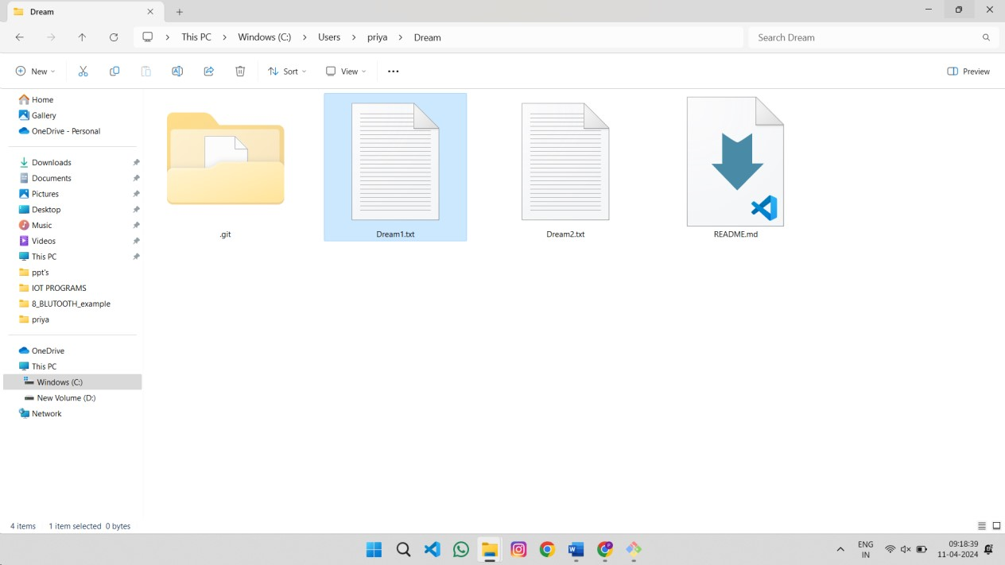

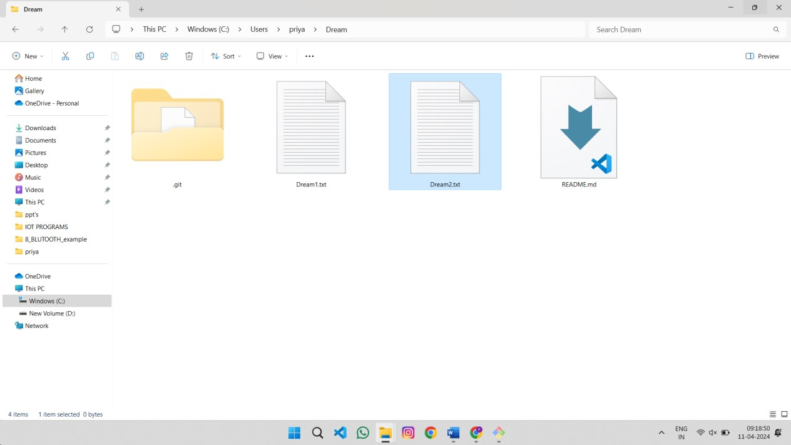

**Name :- Mohini Pramod Badhe.**

**Roll No :- 05**

**Practical :- 09**

**Practical Name :- Demonstrate the use of git diff command.**

MOHINI@LAPTOP-J8VNJ4IR MINGW64 ~

$ git clone https://github.com/mahibadhe18/KBCNMU2.git Cloning into 'KBCNMU2'...

remote: Enumerating objects: 9, done. remote: Counting objects: 100% (9/9), done. remote: Compressing objects: 100% (5/5), done. remote: Total 9 (delta 0), reused 0 (delta 0), pack-reused 0 Receiving objects: 100% (9/9), done.

MOHINI@LAPTOP-J8VNJ4IR MINGW64 ~

$ cd KBCNMU2

MOHINI@LAPTOP-J8VNJ4IR MINGW64 ~/KBCNMU2 (main)

$ git diff

diff --git a/MCA b/MCA index 8646659..17a37dc 100644

--- a/MCA

+++ b/MCA @@ -1 +1,2 @@

this is new file

+this is new file practical no 9 \ No newline at end of file **diff --git a/MCA2 b/MCA2 index 9722bcf..c981179 100644**

**--- a/MCA2**

**+++ b/MCA2**

@@ -1 +1 @@

-this is second file

+MY name Mohini

MOHINI@LAPTOP-J8VNJ4IR MINGW64~/KBCNMU2 (main)

$ git diff --color-words **diff --git a/MCA b/MCA index 8646659..17a37dc 100644**

**--- a/MCA**

**+++ b/MCA** @@ -1 +1,2 @@

this is new file this is new file practical no 9 **diff --git a/MCA2 b/MCA2 index 9722bcf..c981179 100644 --- a/MCA2**

**+++ b/MCA2** @@ -1 +1 @@

this is second filMY name Mohini

MOHINI@LAPTOP-J8VNJ4IR MINGW64 ~/KBCNMU2 (main)

$ git branch branch2

MOHINI@LAPTOP-J8VNJ4IR MINGW64 ~/KBCNMU2 (main)

$ git checkout branch2

Switched to branch 'branch2'

M MCA

M MCA2

MOHINI@LAPTOP-J8VNJ4IR MINGW64~/KBCNMU2 (branch2)

$ touch branch2.txt

MOHINI@LAPTOP-J8VNJ4IR MINGW64~/KBCNMU2 (branch2)

$ git add branch2.txt

MOHINI@LAPTOP-J8VNJ4IR MINGW64 ~/KBCNMU2 (branch2)

$ git commit -m "commit branch2 diff"

[branch2 51f998b] commit branch2 diff

1 file changed, 0 insertions(+), 0 deletions(-) create mode 100644 branch2.txt

MOHINI@LAPTOP-J8VNJ4IR MINGW64 ~/KBCNMU2 (branch2)

$ git diff main branch2 **diff --git a/branch2.txt b/branch2.txt**

**new file mode 100644**

**index 0000000..e69de29**

MOHINI@LAPTOP-J8VNJ4IR MINGW64 ~/KBCNMU2 (branch2)

$ git diff main branch2 --name-only branch2.txt

MOHINI@LAPTOP-J8VNJ4IR MINGW64 ~/KBCNMU2 (branch2)

$ git diff main **diff --git a/MCA b/MCA index 8646659..17a37dc 100644**

**--- a/MCA**

**+++ b/MCA** @@ -1 +1,2 @@

this is new file

+this is new file practical no 9

\ No newline at end of file

**diff --git a/MCA2 b/MCA2 index 9722bcf..c981179 100644**

**--- a/MCA2**

**+++ b/MCA2**

@@ -1 +1 @@

-this is second file

+MY name Mohini

**diff --git a/branch2.txt b/branch2.txt**

**new file mode 100644**

**index 0000000..e69de29**

MOHINI@LAPTOP-J8VNJ4IR MINGW64 ~/KBCNMU2 (branch2)

$ git diff main...branch2

**diff --git a/branch2.txt b/branch2.txt**

**new file mode 100644 index 0000000..e69de29**

