**Framework Details:**

* **Creator:** Mahendra Bhise
* **Framework:** BDD based cucumber framework
* **Language used:** Java
* **Design Technique:** Page Object Model using By locator
* **Dependencies:** Selenium, cucumber, junit
* **Code Repo:** Github**:** https://github.com/mahibhise/Modulr

**Folder Structure:**

* **Src/test/java**
  + Src/test/java has 4 packages as mentioned below:
  + **Pages Pkg**: to store webelement of each pages in class.
  + **stepDefinations pkg:** contains back ground code for feature file statements.
  + **testRunnerClass pkg:** contains test runner class.
  + **utilitiesAndConfig:** contains properties file.
* **src/test/resouces**
  + src/test/resouces contains two folders as metioned below.
  + **Driver:** contains exe for chrome driver
  + **featureFiles:** contains features file

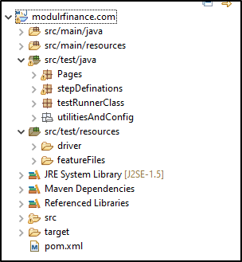

**Folder Structure:**

* Verify Login Functionality_Positive Flow
* Verify login functionality invalid credentials
* Verify password reset functionality