Introduction
This report will highlight the key features of the LEGO Mindstorms EV3 and concepts involved in programming robots. It will also contain a description of our robot followed by an in-depth analysis of how it operates. The report will be concluded with a group reflection detailing how well our team managed to work together.

R9D2 Sorter Bot
The R9D2 Sorter Bot was designed to help solve the problem of sorting different colours of Lego bricks into their own piles. The robot is a stationary machine that consists of a conveyor belt, NXT Colour Sensor, 2 NXT Large Motors, 2 EV3 Large Motors, NXT Sound sensor and EV3 Ultrasound Distance Sensor. R9D2 consists of 3 modules, the main conveyer belt, the sensor module suspended above the start of the conveyer belt and the sorted module suspended above the second half of the conveyer belt. We faced several challenges along the way, one of which was the colours we could sort. As of right now R9D2 can sort Red/Blue/White Blocks as these were the colours of appropriately sized bricks we had readily available and were easiest for the colour sensor to detect. Another issue we ran into was that the conveyer belt was too small so we couldn’t put larger blocks onto it, causing us to have to limit the variety of blocks we could sort. We also had to find a way to align the blocks right underneath the sensor which we overcame by having two rains on the sides of where the blocks were placed which pushed them to the centre of the belt as the conveyer moved them along.
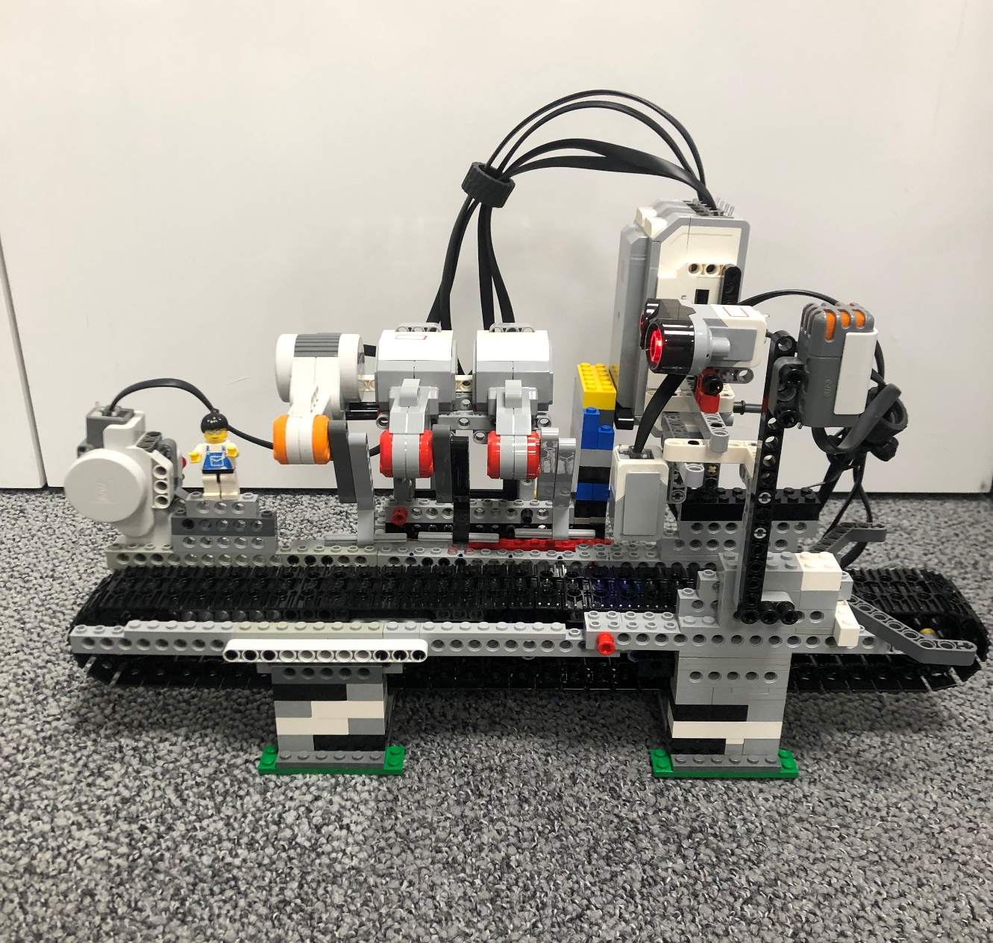
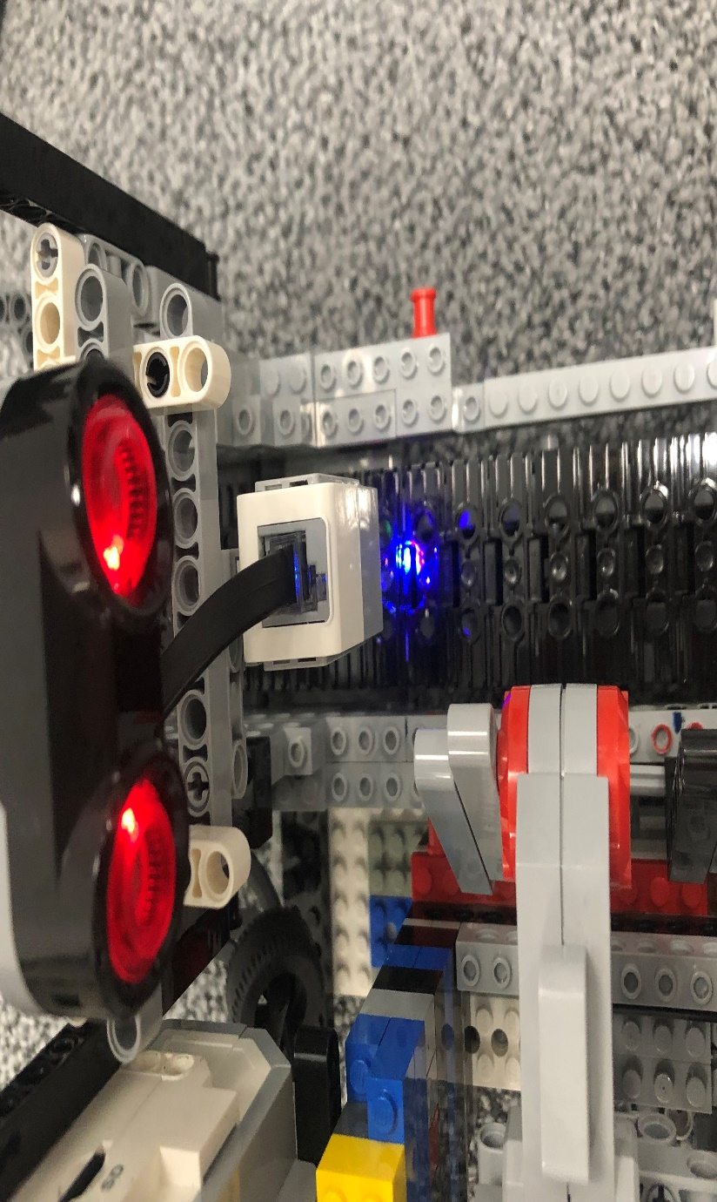
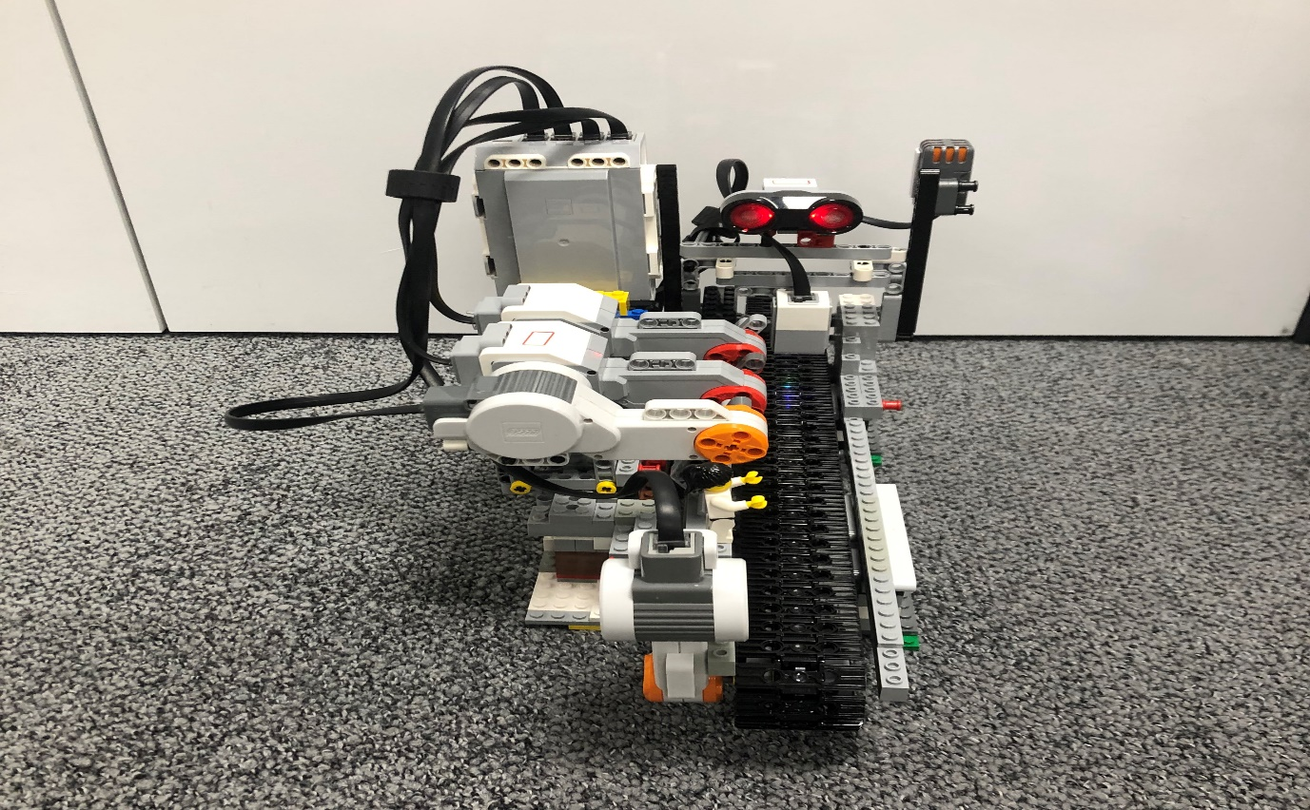
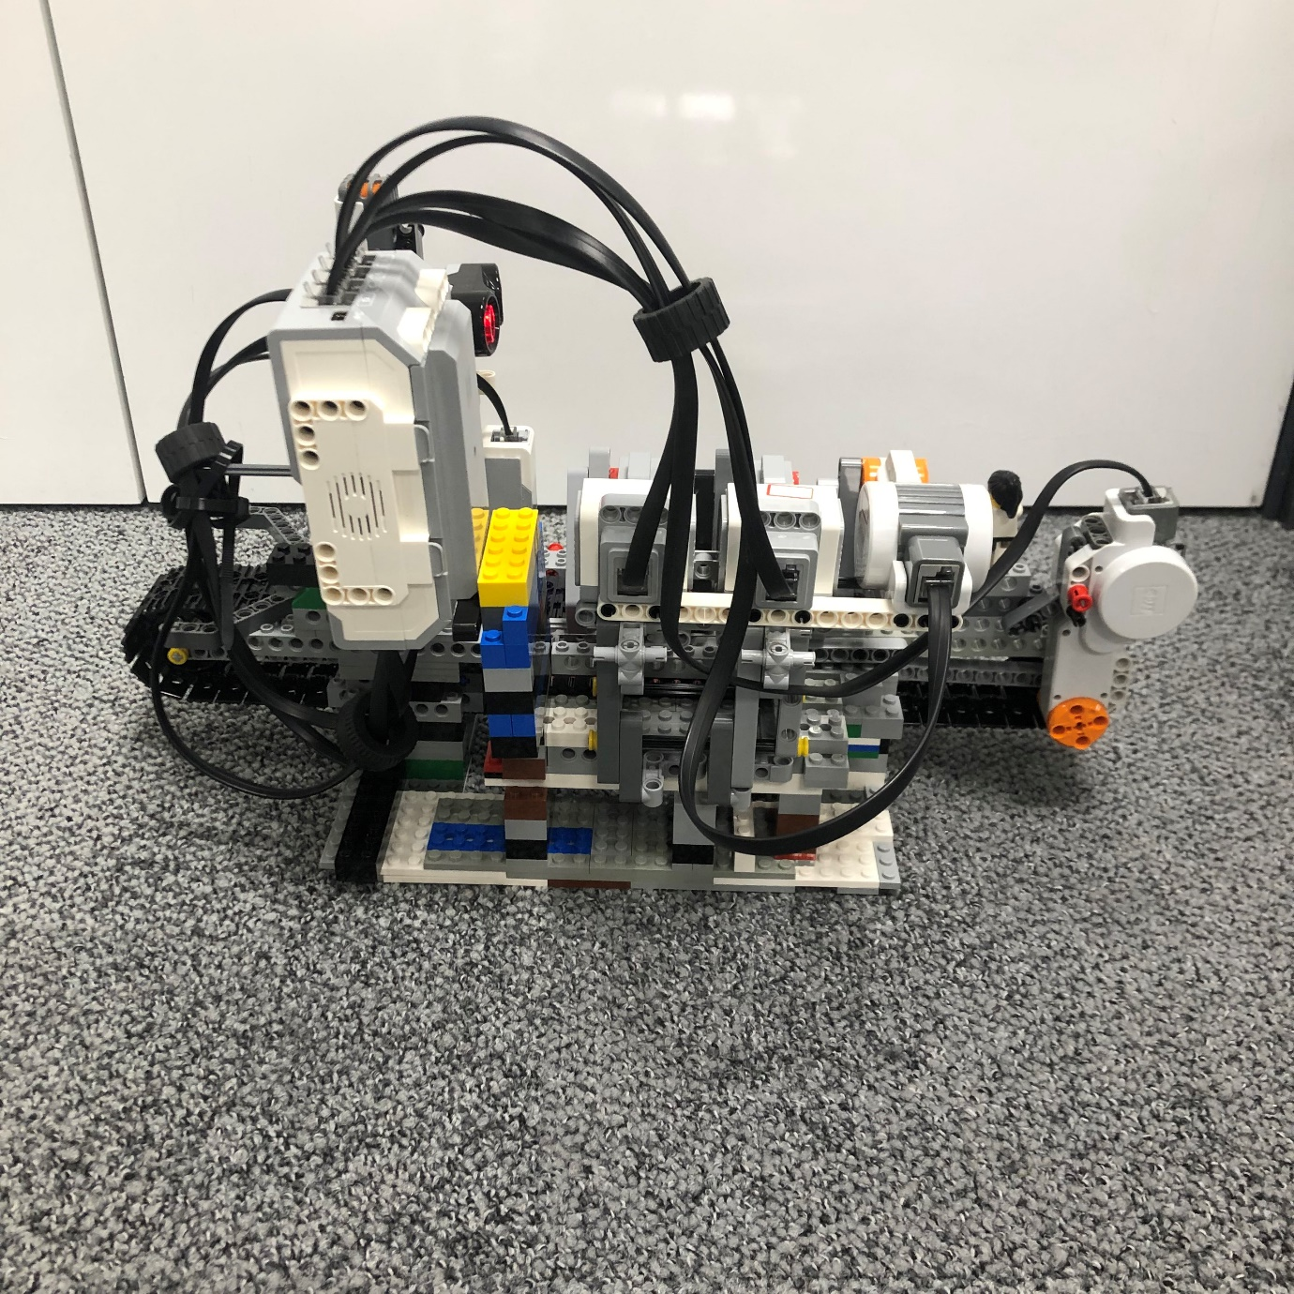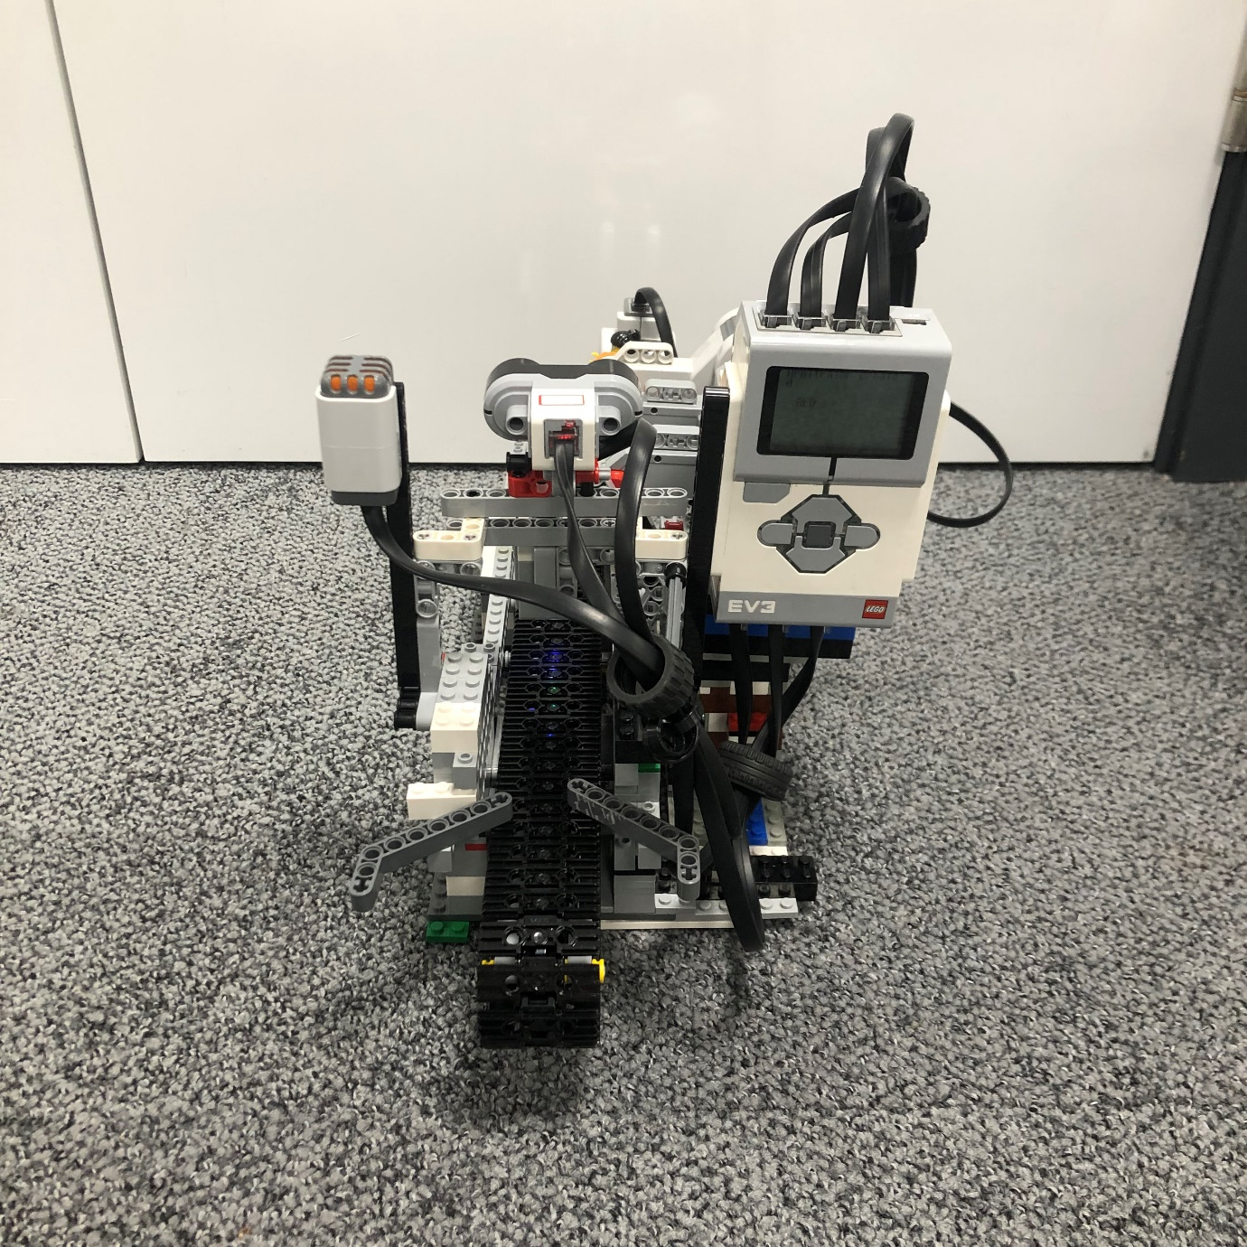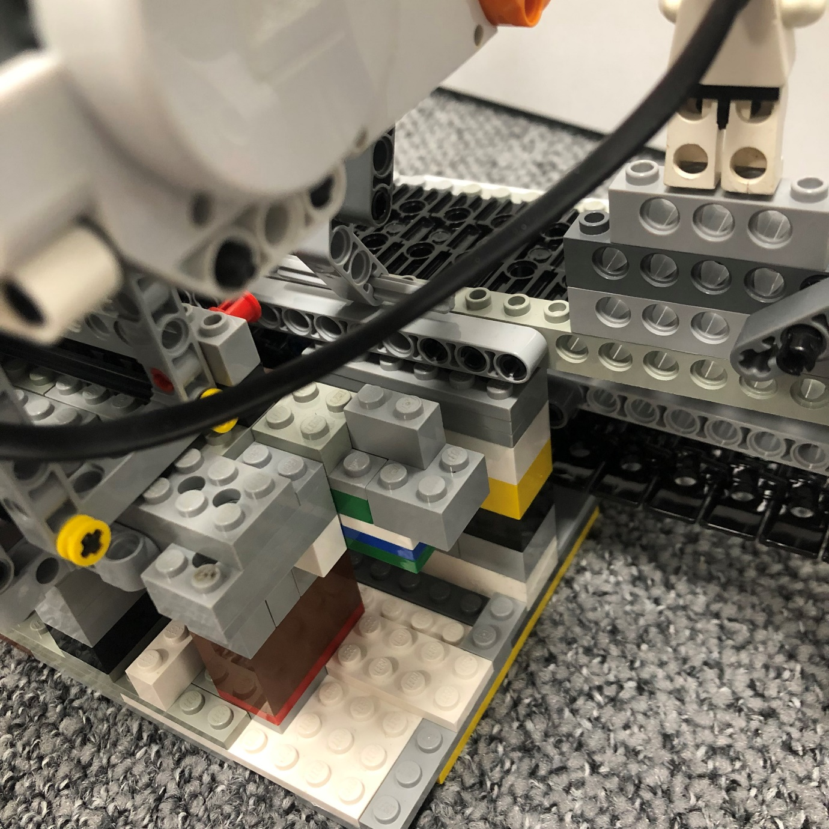

Key Concepts
LEGO Mindstorms:
Lego Mindstorms is a hardware and software kit for the development of programmable robots made with Lego building blocks. It had had 5 different generations, each of which contain, a computer Lego brick, various Lego technic parts and a set of modular sensors and motors. The generation of Mindstorms which we used for our project was the Lego Mindstorms EV3 which is part of the 3rd generation and was released on 1st September 2013. The EV3 Brick can also be controlled by smart devices such as a smartphone and can run alternative Operating Systems via the microSD Card port. The EV3 Brick has a display, speakers and buttons which can be used to navigate the menus and are also programmable. The ports on the EV3 Brick consists of the microSD Card slot, USB mini-B port (to connect to a computer), USB A port, 4 EV3 Sensor Ports, 4 Motor Ports and a EV3 charging port located on the lithium-ion battery pack.

LeJOS:
For our robot we didn’t utilise the included software to programme the Mindstorms kit. Instead, we were required to programme in java and that was only possible by using another Operating System called LeJOS. The JOS in LeJOS stands for Java Operating System, and it consists of a java virtual machine that can be run on the EV3 Brick. It also includes ‘!Command.jar’ which can be sued to communicate with the original firmware of the Mindstorm via Bluetooth. LeJOS allows us to code in java and run the compiled jar programmes on the EV3 Brick using the Java Virtual Machine (JVM). The developers of LeJOS have hidden the implementation details of sensors and actuators behind multiple interfaces by taking advantage of the Object-Oriented structure of Java, meaning that the developer can code the EV3 Robot without having to worry about details like the hexadecimal addresses of the hardware components and the precise voltages being sent to and received from each sensor or motor component.
LeJOS has many useful classes that help programme the Mindstorms EV3 kit. Three of the main ones we were taught how to implement were Pilots, Navigation and Behaviours.
Pilots:
The MovePilot class in LeJOS provides features for precise two-dimensional movement for wheeled robots. It takes in an argument for the chassis which contains an array of information about the wheels such as wheel diameter and axle length, and then can use that to precisely rotate, move forward and move backwards the robot. It automatically updates a OdometryPoseProvider of how much it has moved, and this allows for precise movement control. The MovePilot also allows for a degree of control over the max speed and max acceleration of the robot which increases movement accuracy and reduces chances of the robot drifting off course.
Navigation:
The OdometryPoseProvider class gets updated by the pilot after every movement and can be used to track the 2d position of the robot at any given time. It does this by using the information from the sensors and motors to know exactly where the robot has moved (This is also known as a Odometry). Once the robot knows its exact position/coordinates, it can be used to navigate complex environments, find its way to a waypoint or even avoid obstacles if given their coordinates.
Behaviours:
Behaviours are actions that will only run when certain conditions are met. Each behaviour interface must define 3 things, the circumstances which makes the behaviour take control of the robot, the action that the behaviour makes the robot perform and a way to exit from the action when behaviour loses control to higher priority behaviours. An Arbitrator object is created from an array of behaviours with varying priorities. In the case of our project the priority behaviours were MoveBelt.java and LowBattery.java.
Sensors:
The EV3 has 4 sensor ports to which we can attach various first party or third-party sensors. Sensors are devices which take measurements of different aspects of their surroundings and return that data to a compute module, which in this case in the EV3 Brick, which computes the data to become aware of its surroundings. At the start of the module, we were given and taught how use and implement 5 various sensors, 3 of which we ended up using in our final build for the R9D2 Sorter Bot. The sensors which we implemented into our project were;
•EV3 Colour Sensor: The colour sensor also doubles as a light intensity sensor. It had 3 modes which return a numerical value for either the light intensity or the RGB values. The 3 modes are;

getRedMode() - A red light is emitted, and the intensity of the reflected red light is detected, the intensity of the reflected light is output in a numerical value ranging from 0 (very dark) to 1 (very bright).

getAmbientMode() - The intensity of the light being input into the sensor is output as a numerical value ranging from 0 (very dark) to 1 (very bright).

getColorIDMode() – The colour sensor returns a value ranging from 0 (no colour) to 7 (Brown) which matches the colour id of the colour which is detected.

getRGBMode() – A white light is emitted and the reflected Red, Green and Blue intensity levels are output in a range from 0 (not very hight) to 1 (very high) (i.e. Red would output (1,0,0)).

•NXT Sound Sensor: This sensor essentially works like a microphone. It consists of a diaphragm that converts vibrations caused by air pressure into electrical signals and sends them to the Mindstorms Brick.

•EV3 Ultrasound (Distance) Sensor: The Ultrasound sensor has two modes. One mode is the distancer sensor mode where an ultrasound pulse is sent out and the bounced pulse is detected to measure the distance up to 255cm Infront of the sensor. The other mode is ‘listen only’ where the sensor listens to detect is another robot has fired off any ultrasound pulses. It can also send single sound pulses to act as a sonar. It returns the distance as a numerical value in meters.
In addition to this the EV3 Brick also has support for Bluetooth and Internet connections which can be opened and used as input and outputs. We had issues connecting the Bluetooth to our laptops at the start but nearing the end of the project we managed to get it working on one of the team members devices, and we used it to connect to the EV3 Brick to upload and test code.

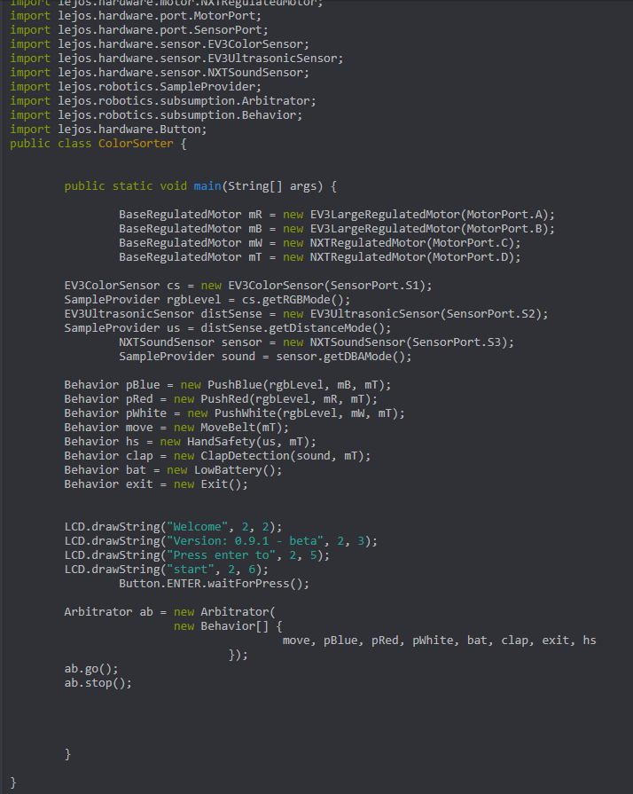
Technical Explanation

The ColourSorter class is the main class of the robot. It initialises the Motors and Sensors as well as the different behaviour classes. It then displays a version message until the enter button is pressed to start the programme. Once the button is pressed a new arbitrator is created and initialised with the behaviours going in order of the lowest priority to the highest priority. Then the arbitrator is told to start running using the .go() method.

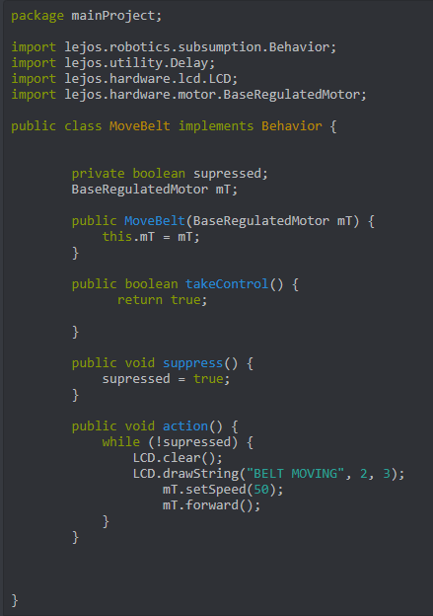

The MoveBelt class is the lowest priority class because it controls the conveyor belt movement. For safety reasons we can’t leave this always on so whenever an error is thrown such as “Hand Detected” the corresponding class (in this case the HandSafety class) will take control and cause the belt to stop to prevent chances of injury to the hand.

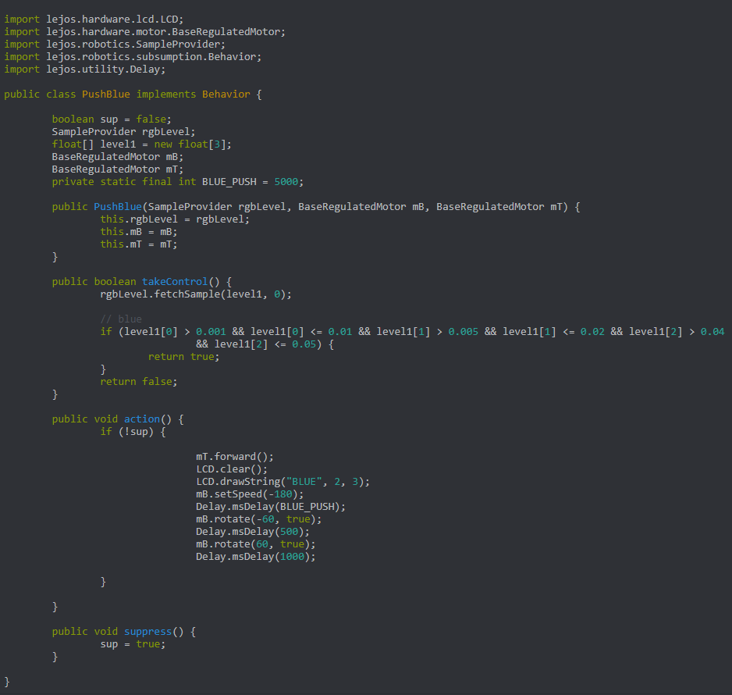
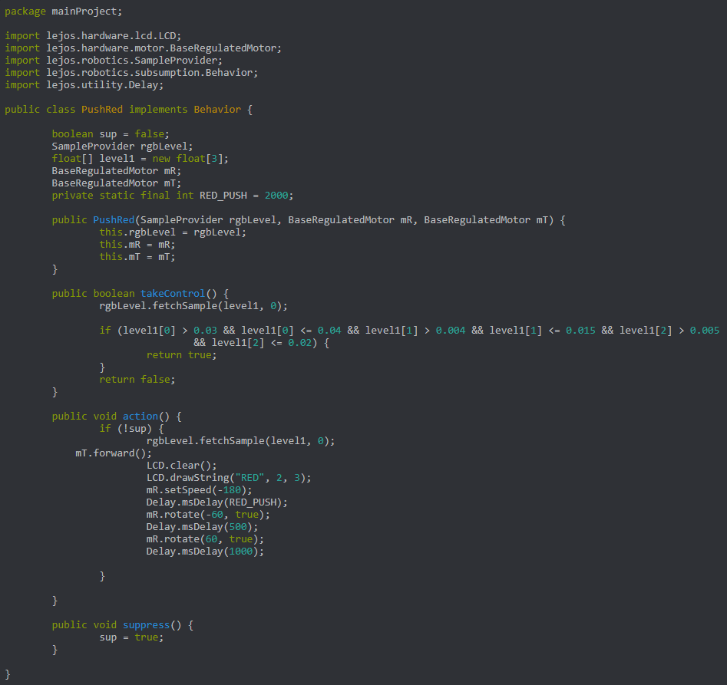

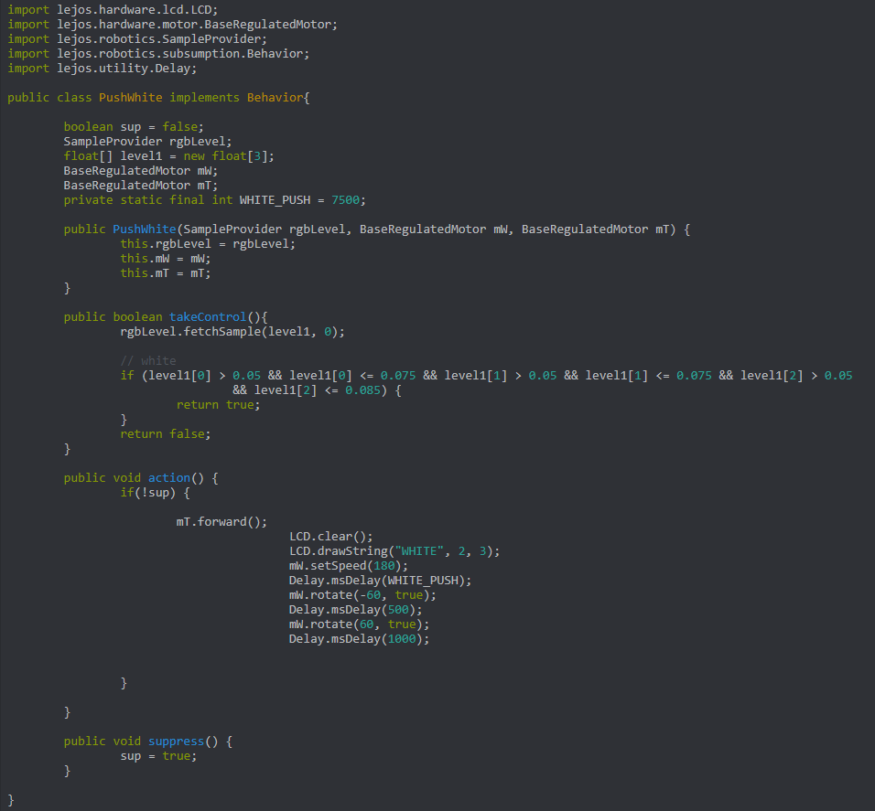

The sorter module of the R9D2 is controlled by several behaviours which are unofficially grouped together as “Sorting Behaviours” as they essentially perform the same tasks using the same implementations but with different variable values. The constructor takes in the RGB level detected by the colour sensor SampleProvider, and two BaseRegulatedMotors (One for a sorter arm and the other for the Conveyer Belt). Using the RGB level the takeControl method checks weather one of the “Sorting Behaviours” should take control. The colour sensor thread is always working so there is a constant input being sent from it if the main programme is running. If the sensor detects Red then the PushRed behaviour takes control which prints “RED” on the screen to show its detected and after n secs (where n is the number of seconds taken for block to go from colour sensor to Infront of the red sorter arm) it rotates mR 60 degrees which moves the arm and pushes the red block into the red box. If the sensor detects Blue, the pushBlue behaviour takes control and it shows “BLUE” on the lcd screen. For Blue blocks the delay before the sorting arm is activated is n + x (where x is the time taken for the brick to move from armR to armB). I f the sensor detects white, the pushWhite behaviour takes control and it shows “WHITE” on the lcd screen. For White blocks the delay before the sorting arm is activated is n + y (where y is the time taken for the brick to go from mR to mW). All the values for the time taken for bricks to reach the arm of their colours are initialised as ‘private static final int’ integer constants within their respective classes.

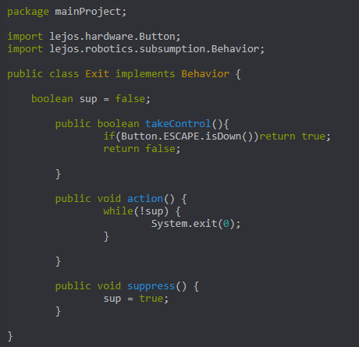

The Exit class is the second highest priority behaviour (Only topped by the HandSafety behaviour) because we always need a way to exit the robot programme or turn the robot off. This behaviour is activated is the escape button is pressed and uses the System.exit(0) method to close/end the robot programme.

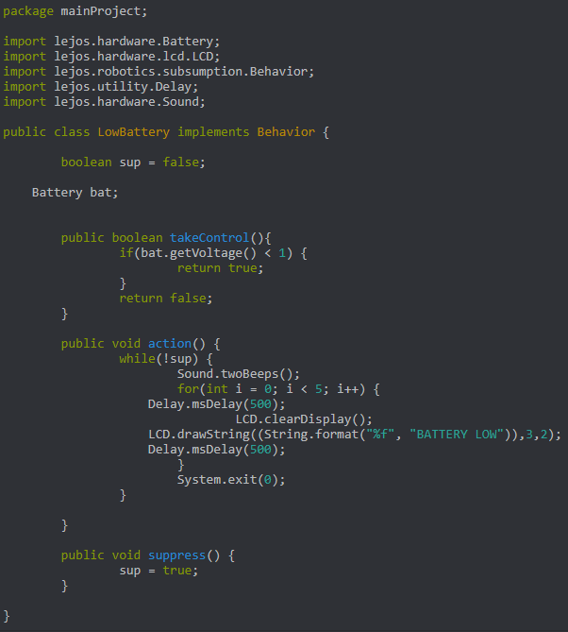

The LowBattery behaviour is activated when the EV3 battery voltage falls below 1v. There are then 2 beeps followed by a “Battery Low” indicator and then the programme is ended. This behaviour has a higher priority than the “Move” and “Push” behaviours as they use motors and it doesn’t make sense to use motors when the battery of the EV3 is low as it wont be able to power them.

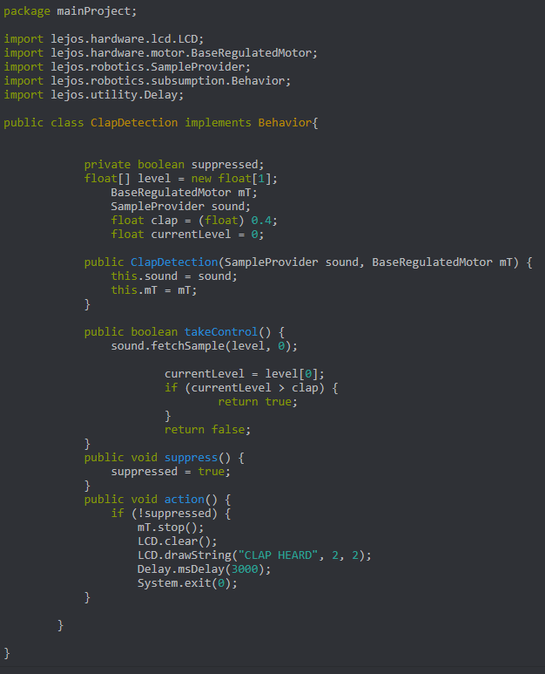

The Clap detection behaviour is used to start the Conveyer belt and then to end the programme.

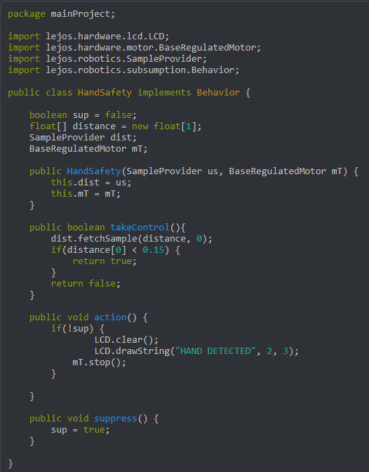

The hand safety behaviour is the most important as safety is always a very important concern on industrial robots. Therefore it has been given the highest priority. It is activated when the ultrasound sensor detects a hand and then it prints “HAND DETECTED” on the lcd screen and stops the conveyer belt in its tracks to prevent injury.

Control Flow

Reflection
Our group worked extremely well together. All the team members attended nearly all the meetings with the group and the TAs, and everyone contributed to the project equally. During the first 5 weeks we all attempted the individual worksheets ourselves and the group worksheets together. We managed to get some insight into who the strongest programmers in the group were. Using this insight, we split the group into 2 subgroups for the final project. The first group was the design group whose job it was to focus on designing and building the robot. The second group consisted of the pair of more competent programmers and their job would be to create a programme that makes the robot work and have the desired functions. After we got the robots, main functions working such as sorting, colour sensor and conveyer belt, we tasked each person in the group to turn one or two of the functions into behaviours. Everyone contributed quite a lot to the final code and design of the R9D2 robot, whether it was by creating functions, creating behaviours or by cleaning up the design with zip ties. At first because we fell behind and couldn’t figure out behaviours, we ran into issues with changing the functions into behaviours, however after some practice and group debugging, we managed to get the behaviours working. The Robot currently only sorts Red/ Blue /White, however if we started again, I would have liked for it to be able to sort Red/ Green/ Blue. The robot was successful in the sense that it managed to sort 3 different coloured bricks into separate piles.

Conclusion
I shall conclude this report by mentioning that our group worked well and efficiently together to create R9D2 so much so that we were done with building our final robot within a day or two, way earlier than some other groups and this allowed us to spend more time of the code perfecting it.

