Chapter 6

RESULTS
The screenshots of the Naive Bayes Classifier and the accuracy results of the designed system are outlined below.
6.1 Screenshots
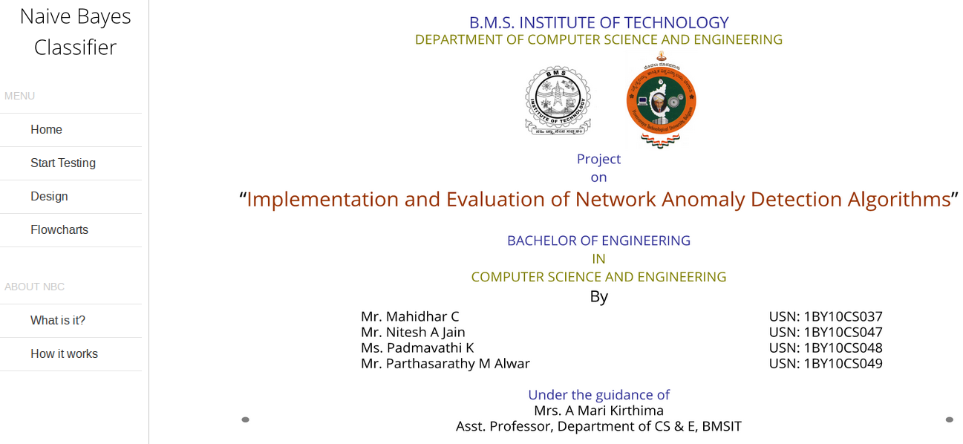
Figure 6.1 Home Page
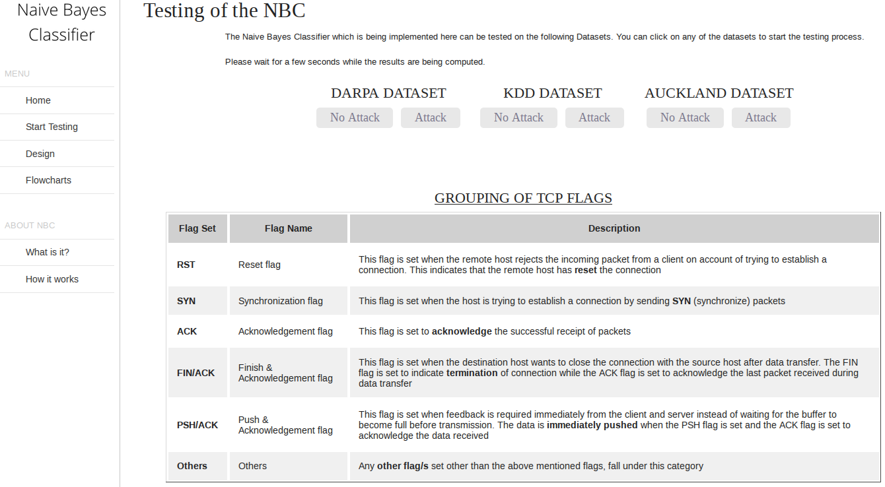
Figure 6.2 Testing Page
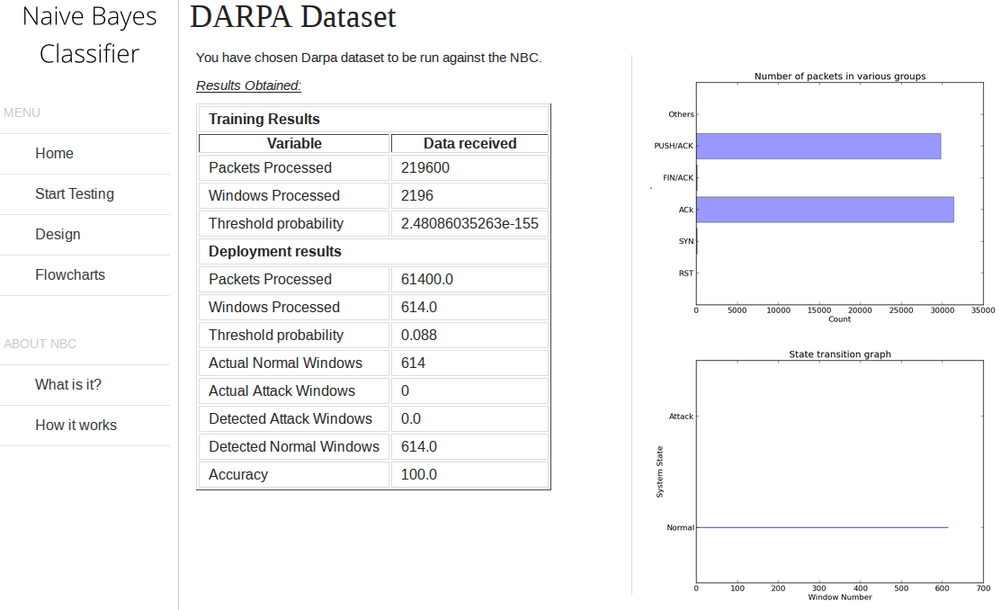
Figure 6.3 DARPA No Attack Results

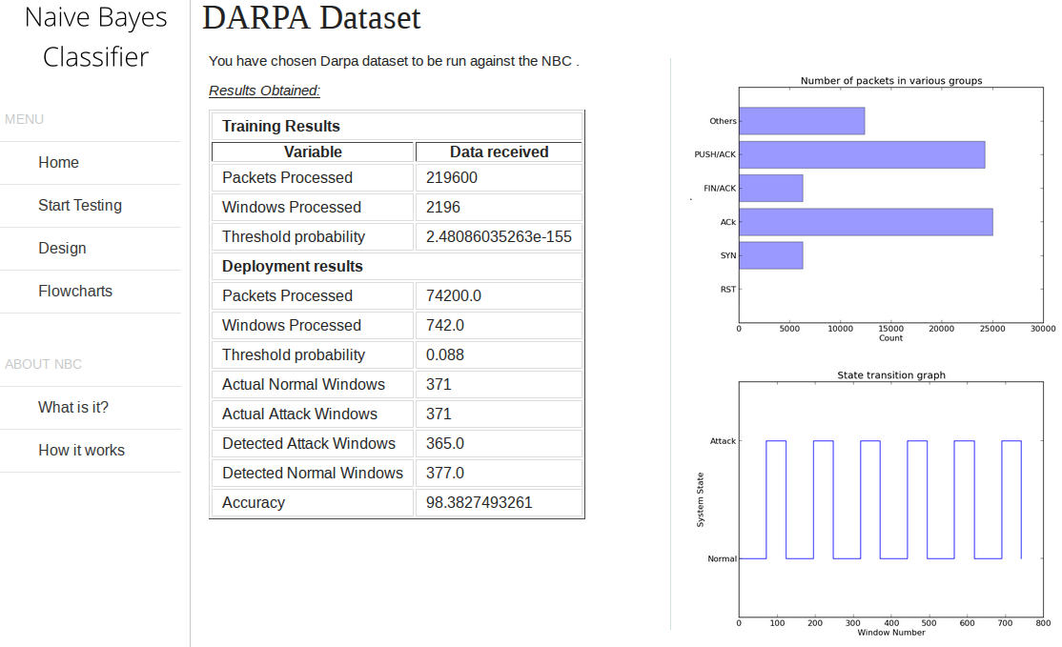
Figure 6.4 DARPA Attack Results

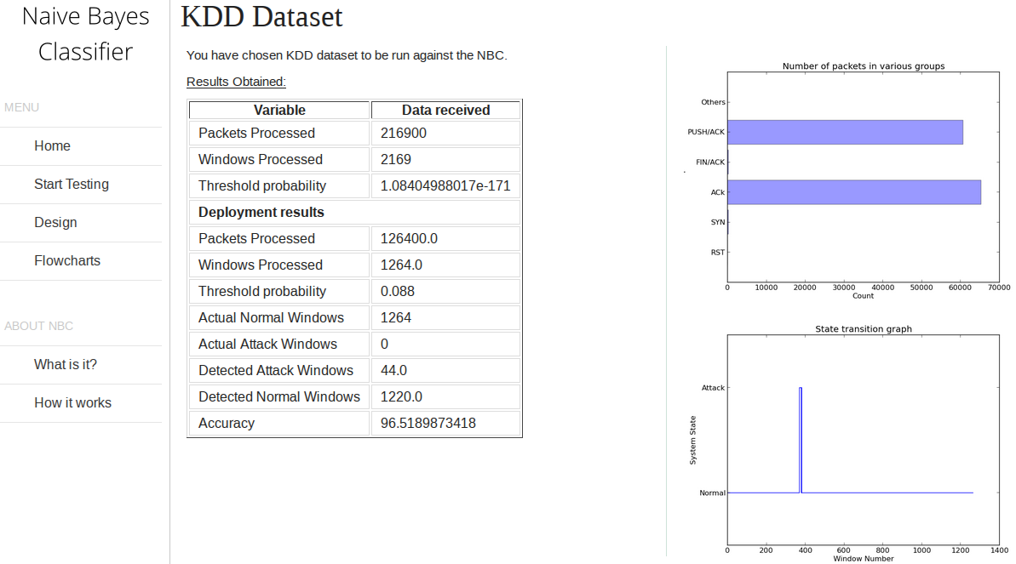
Figure 6.5 KDD No Attack Results

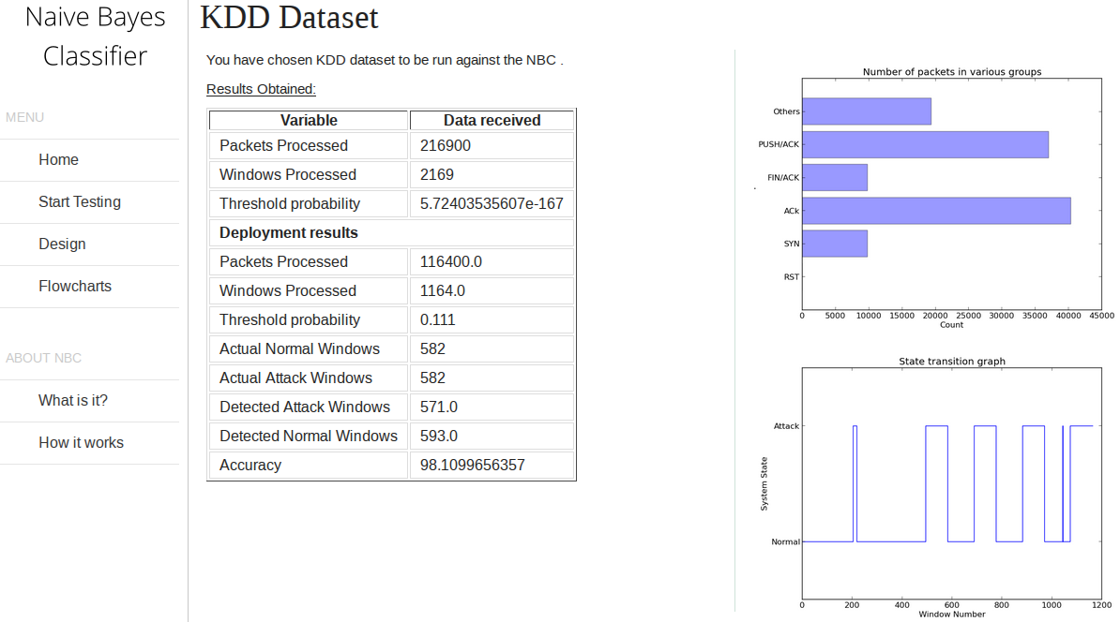
Figure 6.6 KDD Attack Results

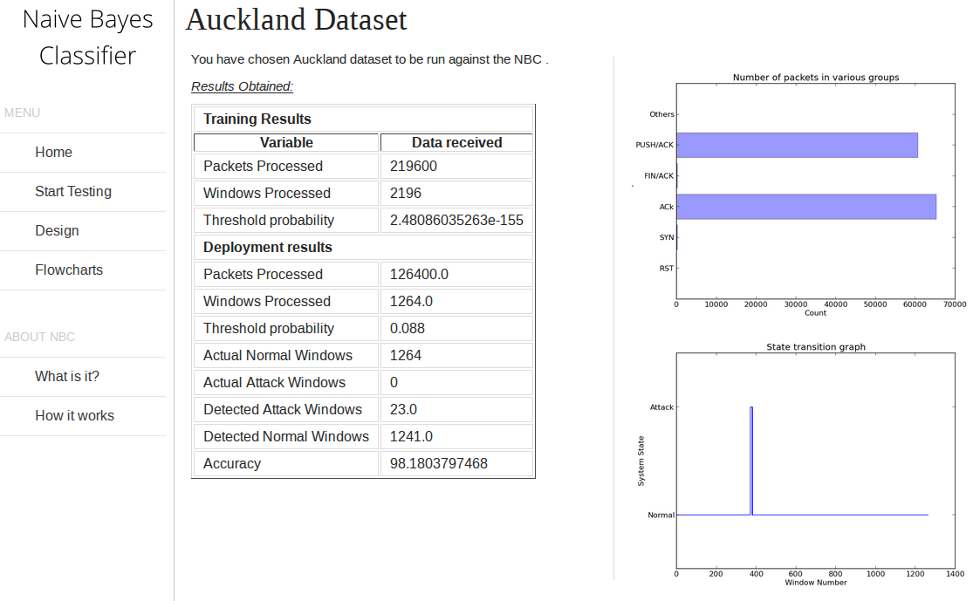
Figure 6.7 Auckland No Attack Results

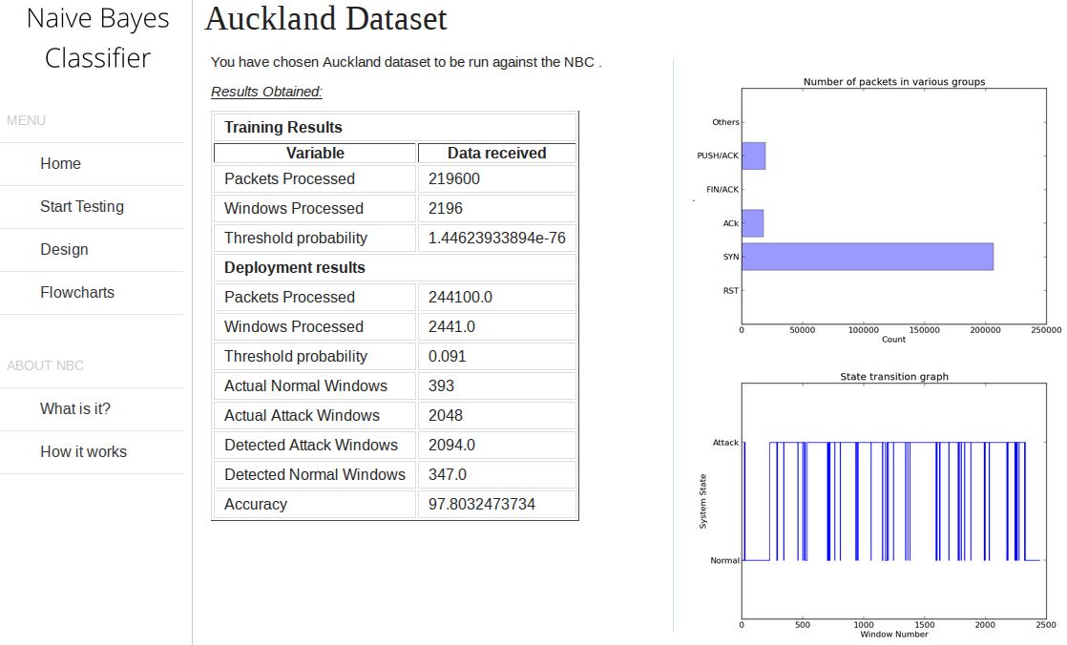
Figure 6.8 Auckland Attack Results

6.2 Results Obtained
The Naive Bayes classifier was tested against the DARPA, KDD and Auckland -II datasets. The formula to calculate the accuracy is as follows
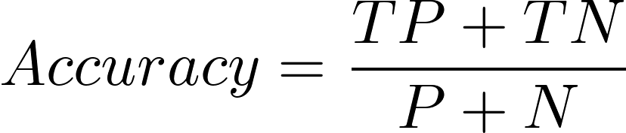
where,
TP - True Positives
TN - True Negatives
P - Number of Attack Windows
N - Number of Normal Windows
Each dataset had two types of traffic – Clean traffic and Mixed traffic. The clean traffic has no attacks whereas the mixed traffic has both clean and attack packets. Using the above formula the accuracies for each dataset are as follows:
Dataset | Accuracy
DARPA
No Attack | 100%
Attack | 98.38%
KDD
No Attack | 96.52%
Attack | 98.11%
Auckland
No Attack | 98.18%
Attack | 97.80%
Table 6.1 Results for various datasets

