**BASIC**

**1.How can you retrieve all the information from the cd.facilities table?**

* [**Retrieve everything from a table**](https://pgexercises.com/questions/basic/selectall.html)

**→ select * from cd.facilities;**

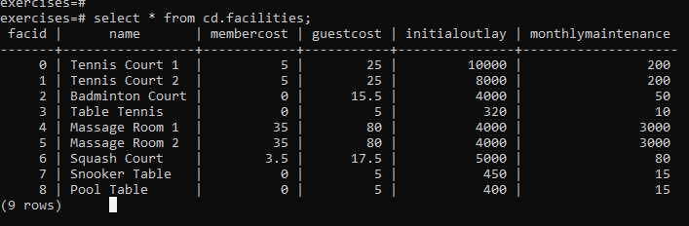

**2.You want to print out a list of all of the facilities and their cost to members. How would you retrieve a list of only facility names and costs?**

* [**Retrieve specific columns from a table**](https://pgexercises.com/questions/basic/selectspecific.html)

**→ select name, membercost from cd.facilities;**

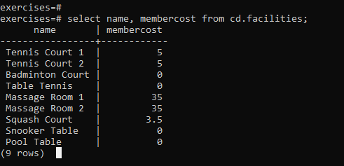

**3.How can you produce a list of facilities that charge a fee to members?**

* [**Control which rows are retrieved**](https://pgexercises.com/questions/basic/where.html)

**→ select * from cd.facilities where membercost > 0;**

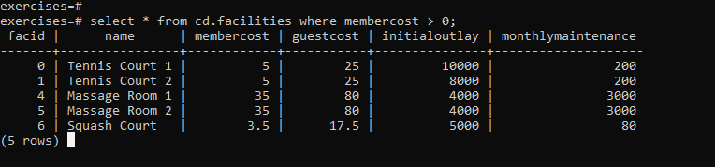

**4.How can you produce a list of facilities that charge a fee to members, and that fee is less than 1/50th of the monthly maintenance cost? Return the facid, facility name, member cost, and monthly maintenance of the facilities in question.**

* [**Control which rows are retrieved - part 2**](https://pgexercises.com/questions/basic/where2.html)

**→ select facid, name, membercost, monthlymaintenance**

**from cd.facilities**

**where**

**membercost > 0 and**

**(membercost < monthlymaintenance/50.0);**

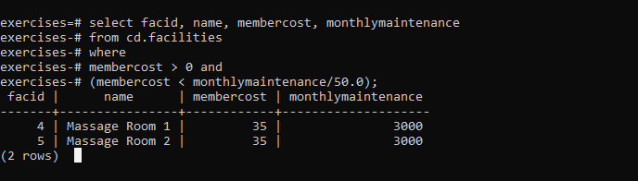

**5.How can you produce a list of all facilities with the word 'Tennis' in their name?**

* [**Basic string searches**](https://pgexercises.com/questions/basic/where3.html)

**→select \***

**from cd.facilities**

**where**

**name like '%Tennis%';**

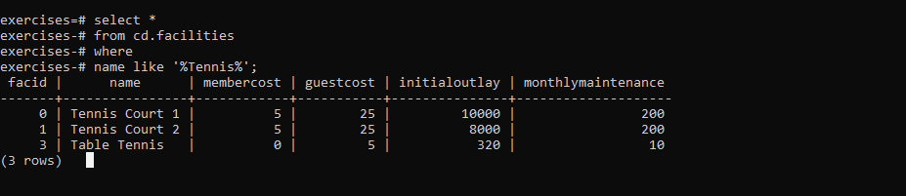

**6.How can you retrieve the details of facilities with ID 1 and 5? Try to do it without using the OR operator.**

* [**Matching against multiple possible values**](https://pgexercises.com/questions/basic/where4.html)

**→select \***

**from cd.facilities**

**where**

**facid in (1,5);**

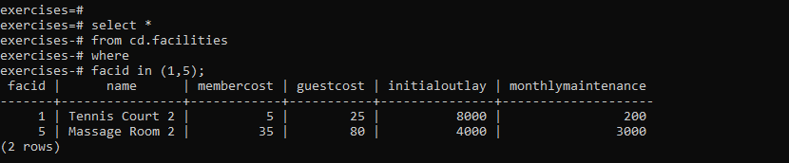

**7.How can you produce a list of facilities, with each labelled as 'cheap' or 'expensive' depending on if their monthly maintenance cost is more than $100? Return the name and monthly maintenance of the facilities in question.**

* [**Classify results into buckets**](https://pgexercises.com/questions/basic/classify.html)

**→ select name,**

**case when (monthlymaintenance > 100) then**

**'expensive'**

**else**

**'cheap'**

**end as cost**

**from cd.facilities;**

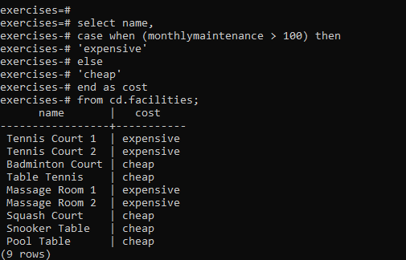

**8.How can you produce a list of members who joined after the start of September 2012? Return the memid, surname, firstname, and joindate of the members in question.**

* [**Working with dates**](https://pgexercises.com/questions/basic/date.html)

**→ select memid, surname, firstname, joindate**

**from cd.members**

**where joindate >= '2012-09-01';**

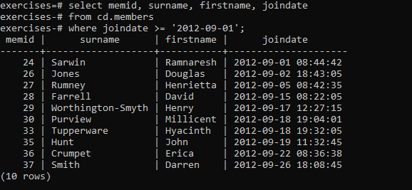

**9. How can you produce an ordered list of the first 10 surnames in the members table? The list must not contain duplicates.**

* [**Removing duplicates, and ordering results**](https://pgexercises.com/questions/basic/unique.html)

**→ select distinct surname**

**from cd.members**

**order by surname**

**limit 10;**

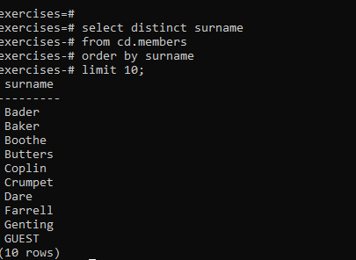

**10.You, for some reason, want a combined list of all surnames and all facility names. Yes, this is a contrived example :-). Produce that list!**

* [**Combining results from multiple queries**](https://pgexercises.com/questions/basic/union.html)

**→ select surname**

**from cd.members**

**union**

**select name**

**from cd.facilities;**

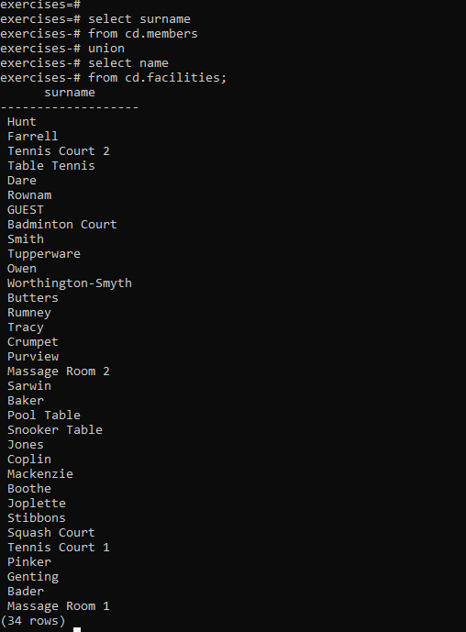

**11.How can you produce an ordered list of the first 10 surnames in the members table? The list must not contain duplicates.**

* [**Simple aggregation**](https://pgexercises.com/questions/basic/agg.html)

**→ select max(joindate) as latest**

**from cd.members;**

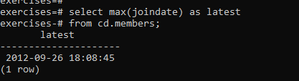

**12.You, for some reason, want a combined list of all surnames and all facility names. Yes, this is a contrived example :-). Produce that list!**

* [More aggregation](https://pgexercises.com/questions/basic/agg2.html)

→ select firstname, surname, joindate

from cd.members

order by joindate desc

limit 1;

