**String Operations**

**1.**[**Format the names of members**](https://pgexercises.com/questions/string/concat.html)

**Query:** select surname || ', ' || firstname as name from cd.members

**OUTPUT:** 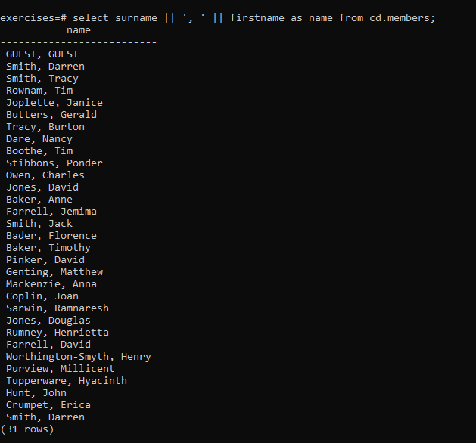

**2.**[**Find facilities by a name prefix**](https://pgexercises.com/questions/string/like.html)

**Query:** select * from cd.facilities where name like 'Tennis%';

**OUTPUT:** 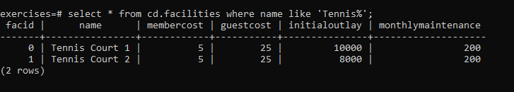

**3.**[**Perform a case-insensitive search**](https://pgexercises.com/questions/string/case.html)

**Query:** select * from cd.facilities where upper(name) like 'TENNIS%';

**OUTPUT:**

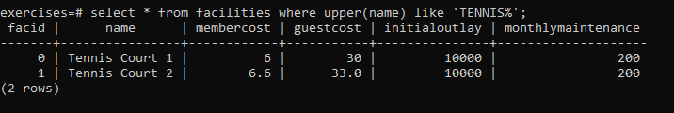

**4.**[**Find telephone numbers with parentheses**](https://pgexercises.com/questions/string/reg.html)

**Query:** select memid, telephone from cd.members where telephone similar to '%[()]%';

**OUTPUT:** 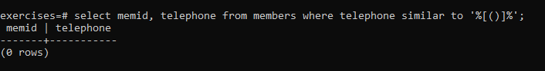

**5.**[**Pad zip codes with leading zeroes**](https://pgexercises.com/questions/string/pad.html)

**Query:** select lpad(cast(zipcode as char(5)),5,'0') zip from cd.members order by zip

**OUTPUT:** 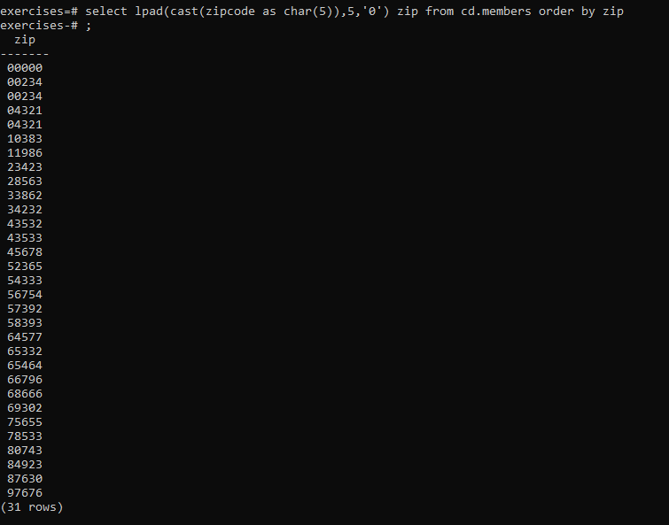

**6.**[**Count the number of members whose surname starts with each letter of the alphabet**](https://pgexercises.com/questions/string/substr.html)

**Query:** select substr (mems.surname,1,1) as letter, count(*) as count from cd.members mems group by letter order by letter

**OUTPUT:** 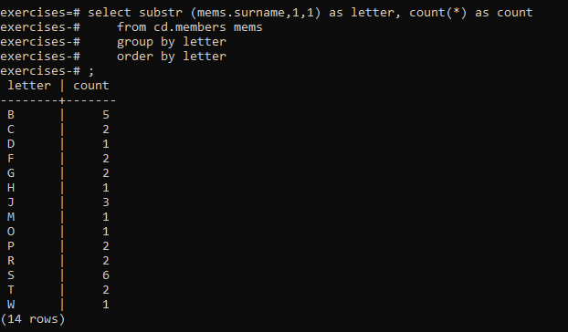

**7.**[**Clean up telephone numbers**](https://pgexercises.com/questions/string/translate.html)

**Query:** select memid, regexp_replace(telephone, '[^0-9]', '', 'g') as telephone

from cd.members

order by memid;

**OUTPUT:**

