NAME : MAHI
Flask and MongoDB
Github link: https://github.com/mahii-patel/Flask_and_MongoDB_mahi

TASK 1:
Create a backend folder inside that create a file data.json. This file stores the data that will be read by the Flask application.
[
{
"id" : 1,
"name" : "mahi",
"department" : "Cloud and application development"
},
{

"id" : 2,
"name" : "Nishra",
"department" : "Cyber security"
},
{
"id" : 3,
"name" : "Tirth",
"department" : "Data Science"
},
{
"id" : 4,
"name" : "Nishant",
"department" : "Data Science"
}
]
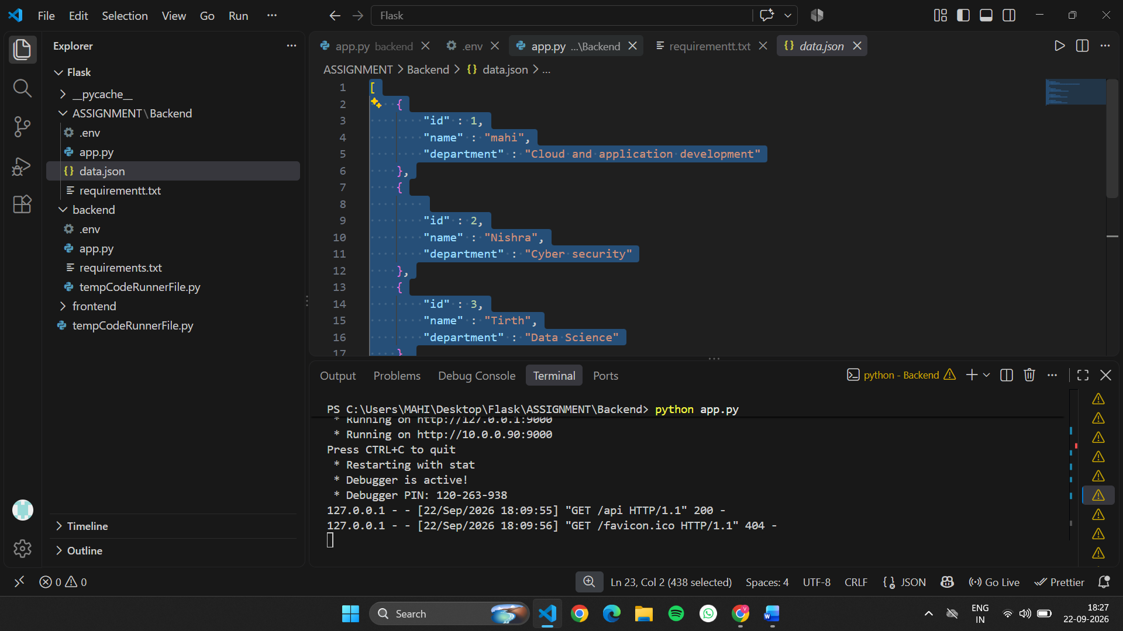

Next create a file which name is app.py. this file return the data of data.json
@app.route("/api")
def api():

data_file = os.path.join(os.path.dirname(os.path.abspath(__file__)), "data.json")

with open(data_file, "r") as file:
data = json.load(file)

return data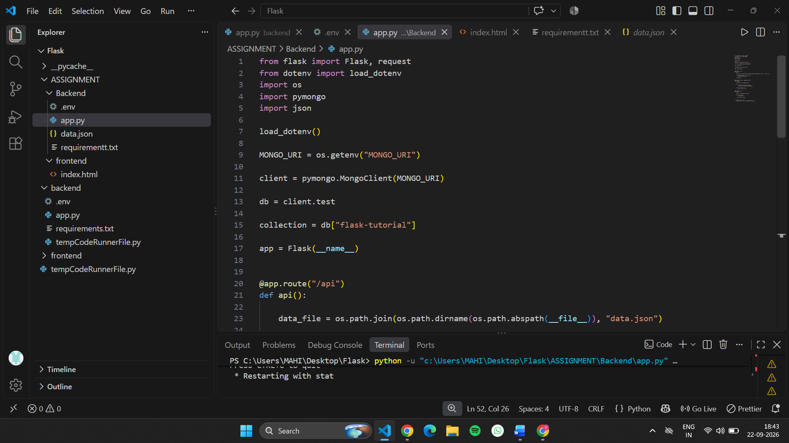

INSTALL FLASK:
Pip install flask
Run the Flask Application
Run the following command in the project folder:
python app.py
After starting the application, http://127.0.0.1:9000
Than I open URL like : http://127.0.0.1:9000/api

And that’s the final output of task 1:
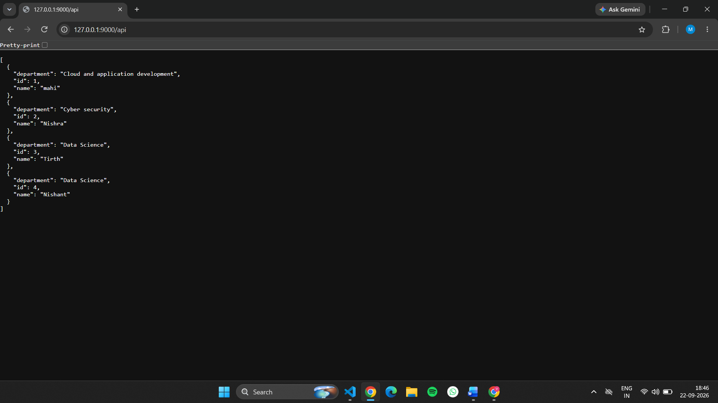

TASK 2: Frontend Form with MongoDB Atlas

We create form for insert data and message success and error.
We create app.py
from flask import Flask, render_template, request
from pymongo import MongoClient
from dotenv import load_dotenv
import os

load_dotenv()

app = Flask(__name__, template_folder="../frontend")

client = MongoClient("mongodb://localhost:27017/")
db = client["student_db"]
collection = db["students"]

@app.route("/")
def home():
return render_template("index.html")

@app.route("/submit", methods=["POST"])
def submit():

try:
name = request.form["name"]
email = request.form["email"]
age = request.form["age"]

raise Exception("This is a test error")

student = {
"name": name,
"email": email,
"age": int(age)
}

collection.insert_one(student)

return render_template("success.html")

except Exception as e:

return render_template(
"index.html",
error=str(e)
)

if __name__ == "__main__":
app.run(port=9000, debug=True)
than we create frontend form index.html inside frontend folder.
<!DOCTYPE html>
<html>
<head>
<title>Student Form</title>
</head>

<body>

<h1>Student Registration Form</h1>

<!-- {% if error %}
<p style="color: red;">
Error: {{ error }}
</p>
{% endif %} -->

<form action="/submit" method="POST">

<label>Name:</label>
<input type="text" name="name" required>
<br><br>

<label>Email:</label>
<input type="email" name="email" required>
<br><br>

<label>Age:</label>
<input type="number" name="age" required>
<br><br>

<button type="submit">Submit</button>

</form>

</body>
</html>
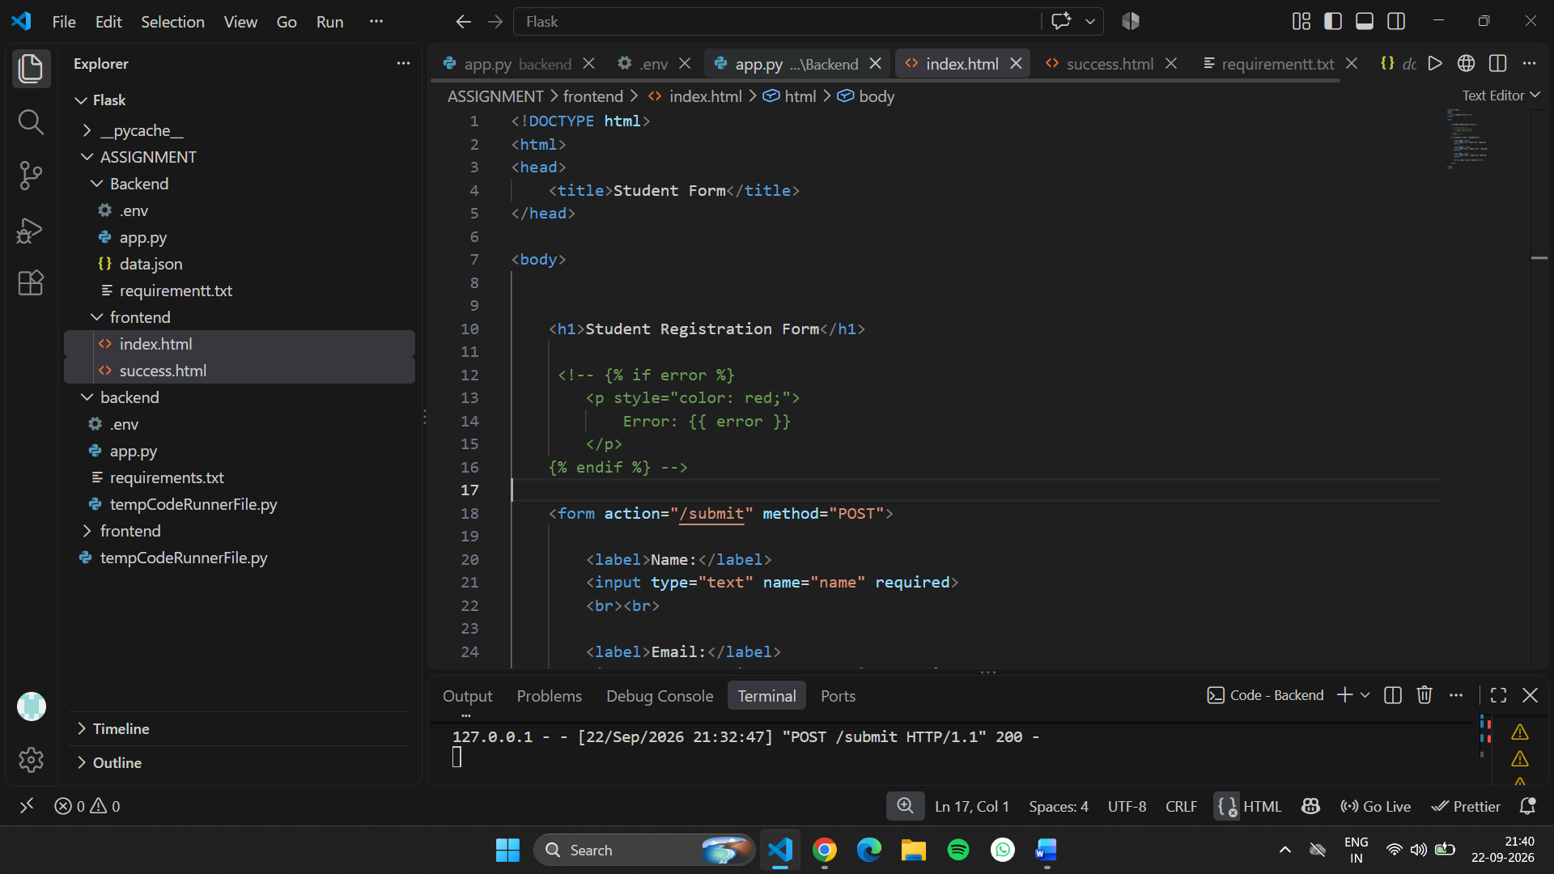

Than we create success.html also in frontend folder to show form submitted successful.

<!DOCTYPE html>
<html>
<head>
<title>Success</title>
</head>
<body>

<h1>Data submitted successfully</h1>

</body>
</html>
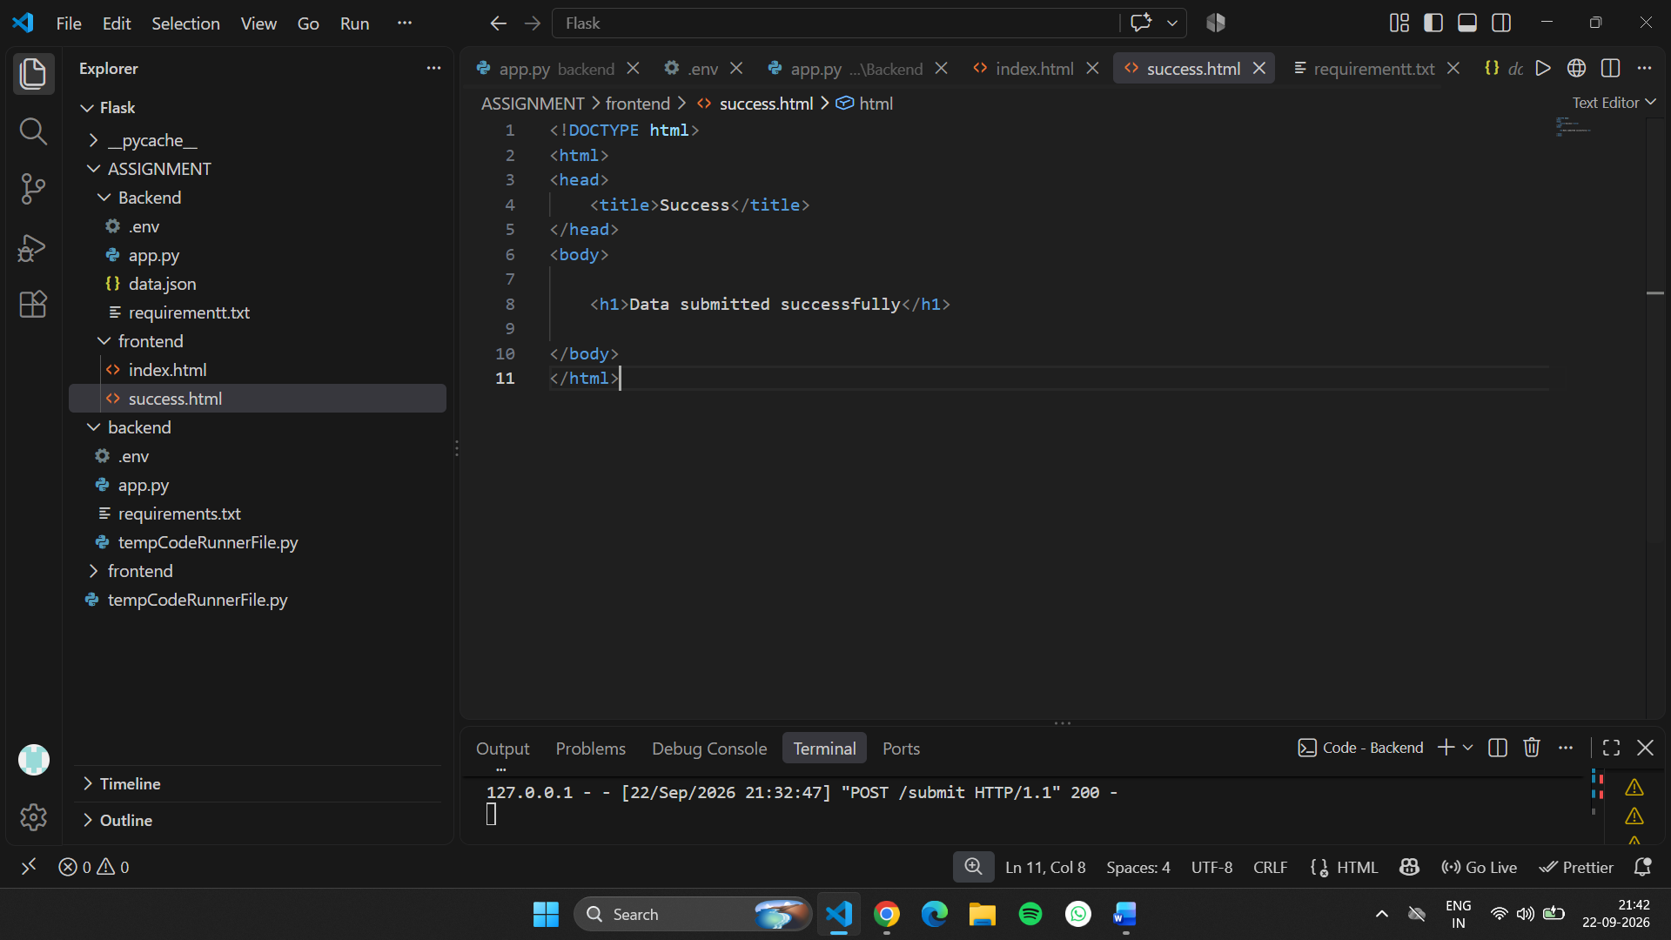
This is student registration form 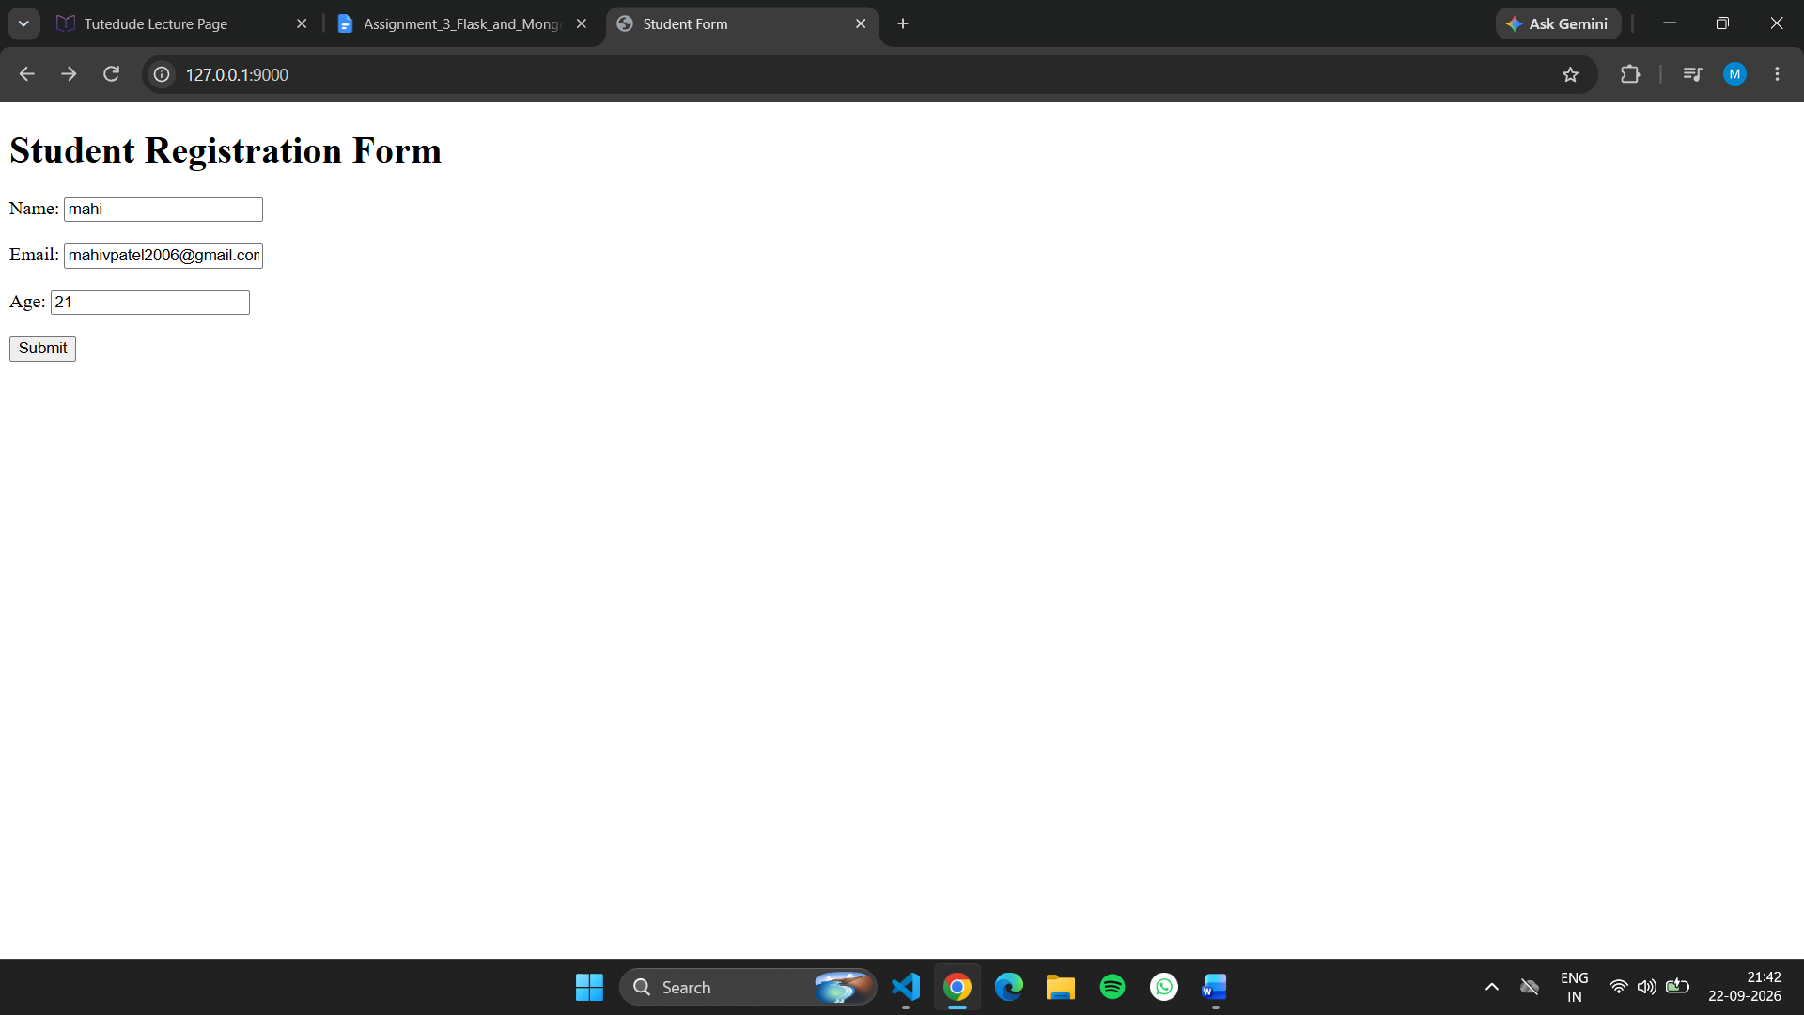
Than I click on submit that show to data submit successfully
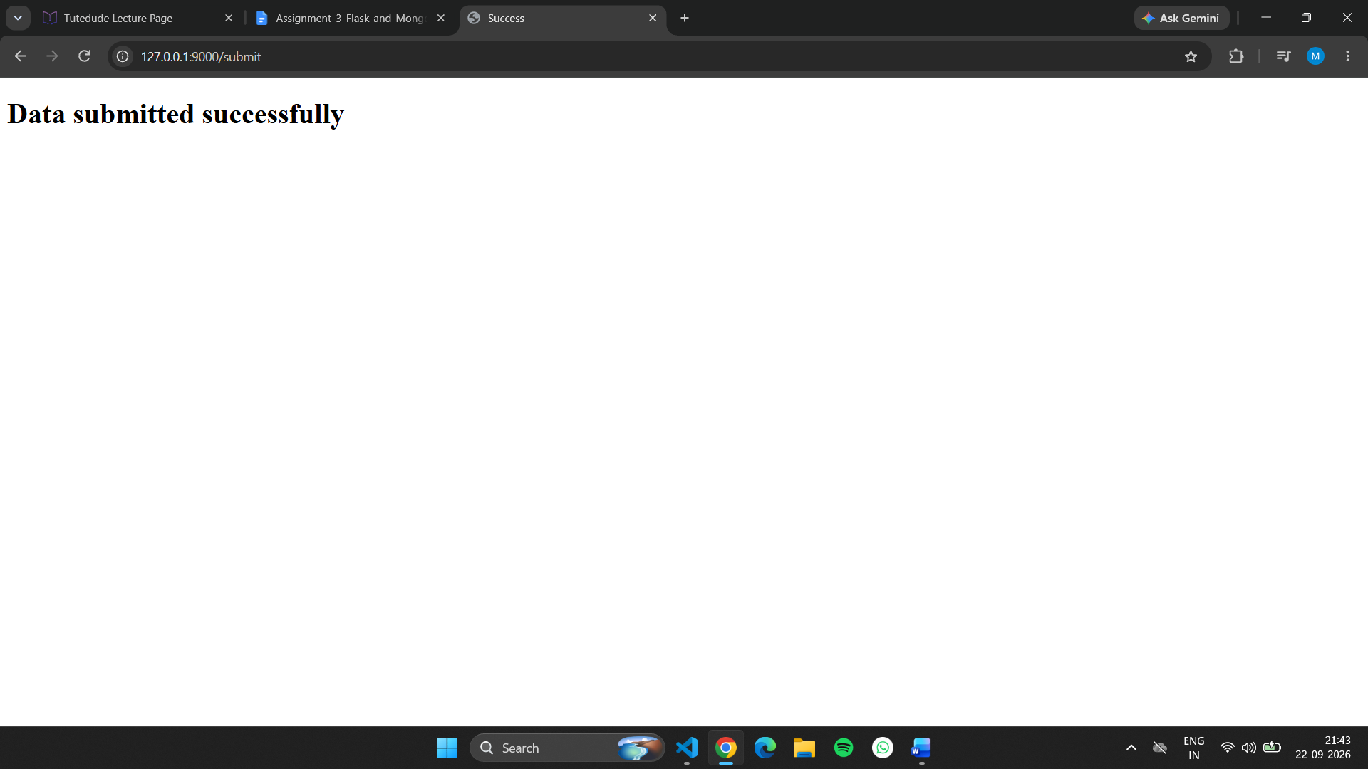
Than for error message
In app.py add this line:
raise Exception("This is a test error")

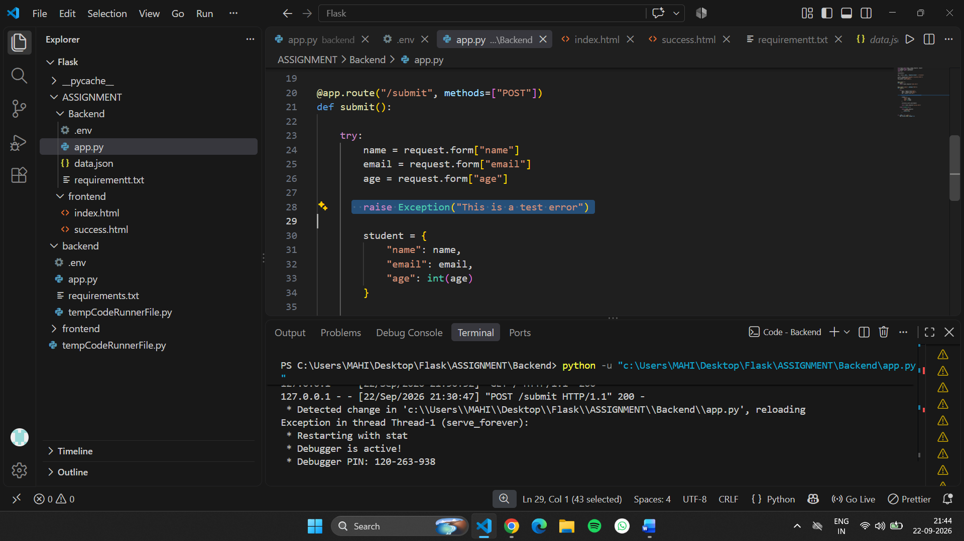
And index.html we add this line:
{% if error %}
<p style="color: red;">
Error: {{ error }}
</p>
{% endif %}
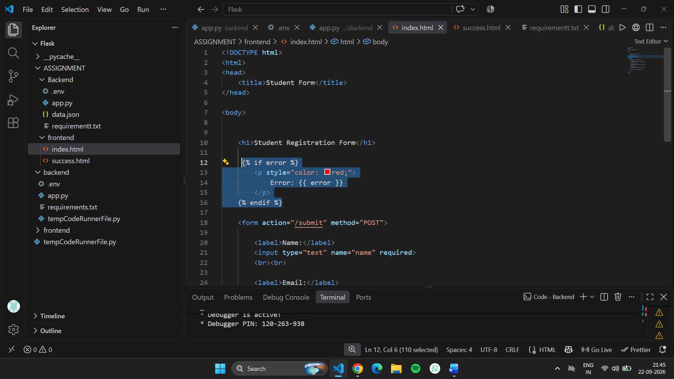this lines use for error message and also we use p style for adding color ….

And that’s the output of error checking: