GIT & GITHUB ASSIGNMENT
Link : https://github.com/mahii-patel/version-control-git

Task 1: Repository Setup & First Branch
- Create a new GitHub repository.
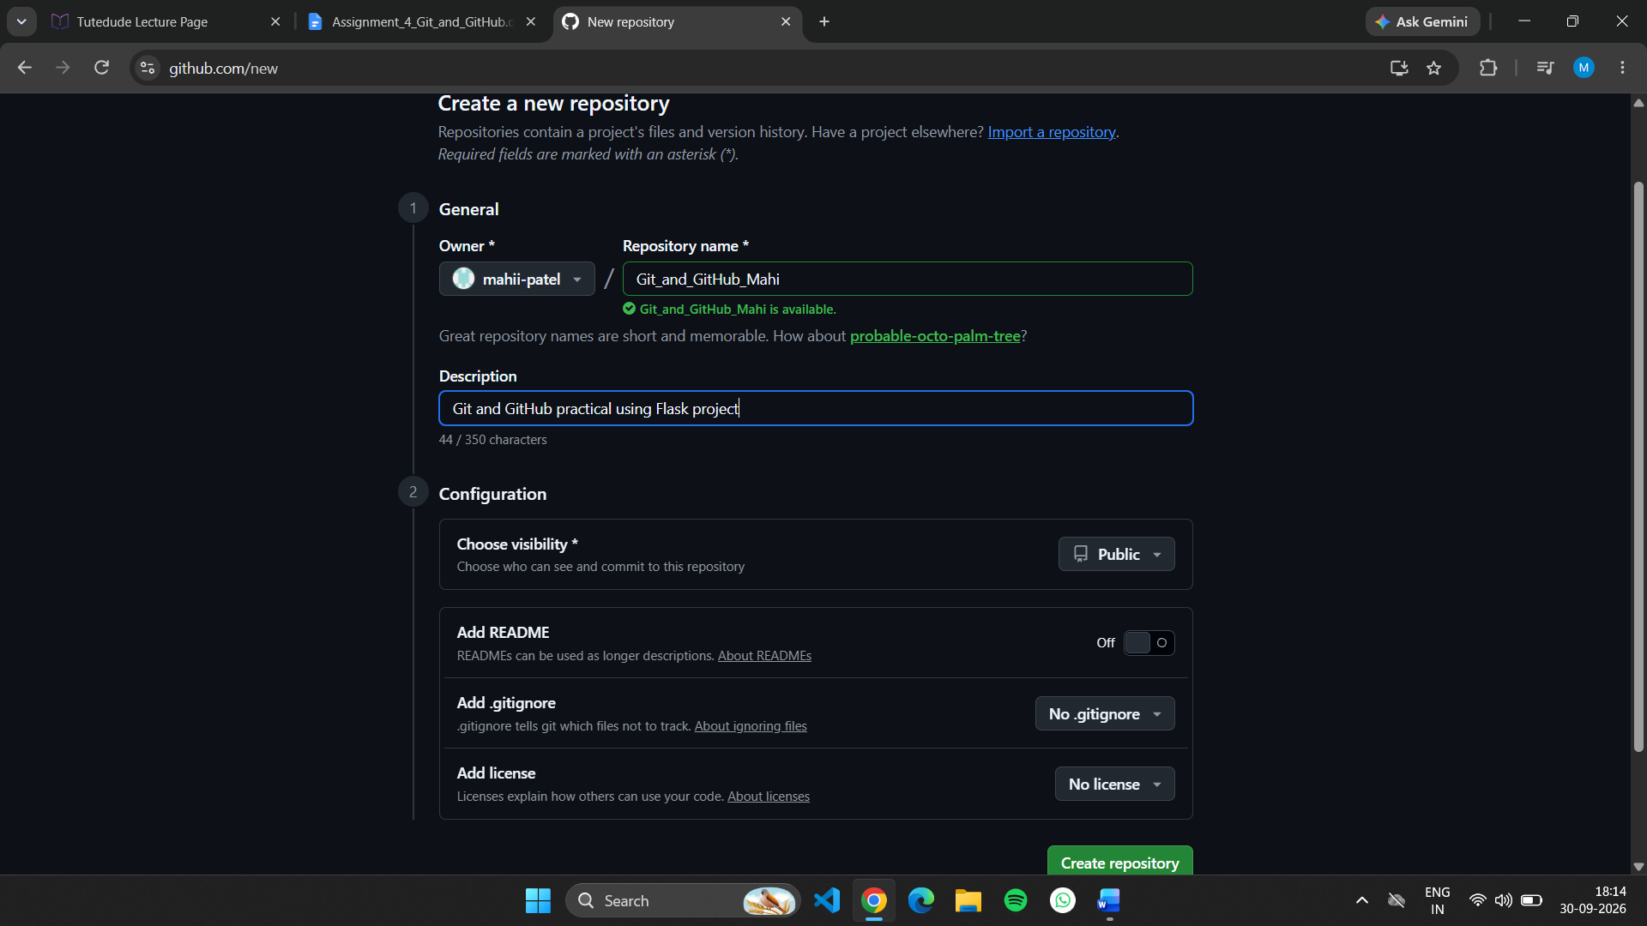

- Clone the repository to your local machine using SSH (generate an SSH key if needed, and add the public key to your GitHub account).
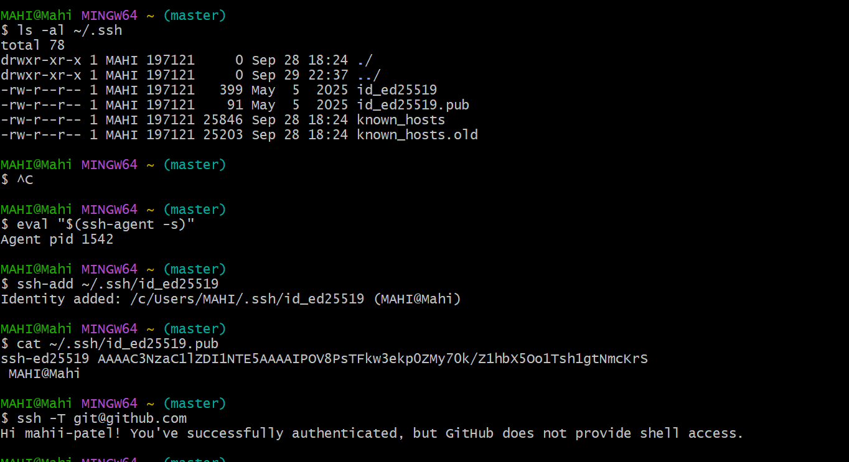
Git clone:
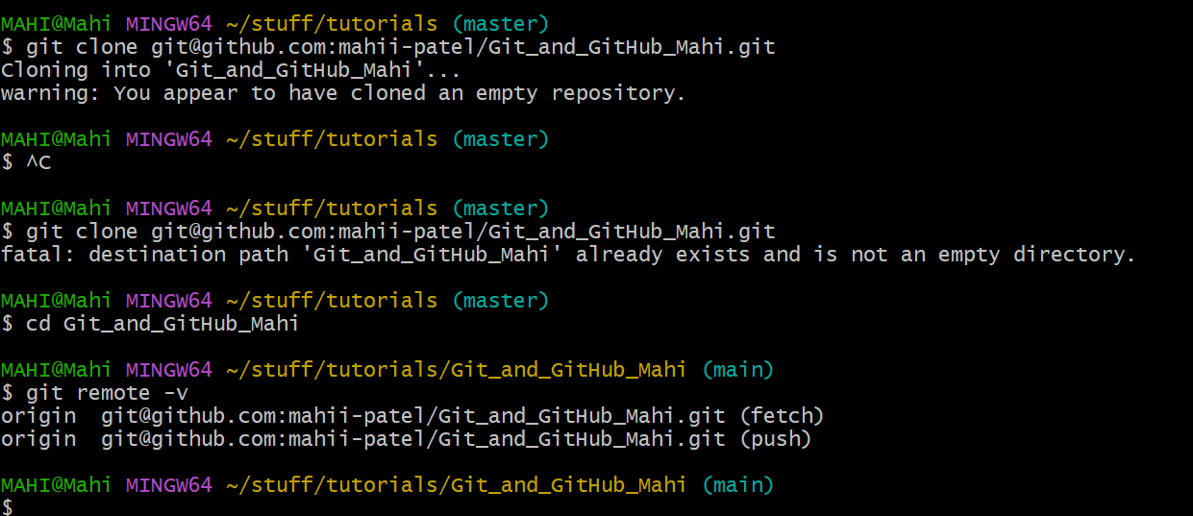

- Create a new branch named after your username (e.g., Tutedude).
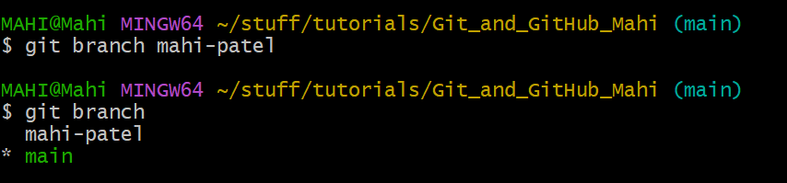

- Add your Flask project files to this branch.
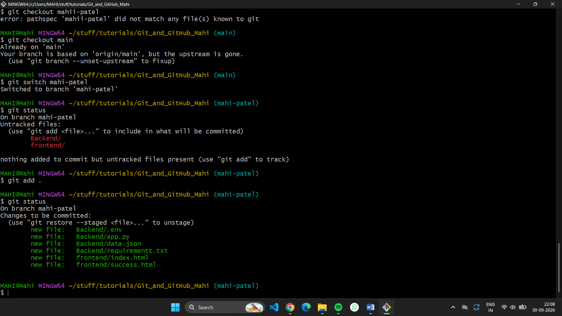

- Commit the changes and merge the branch into the main branch.

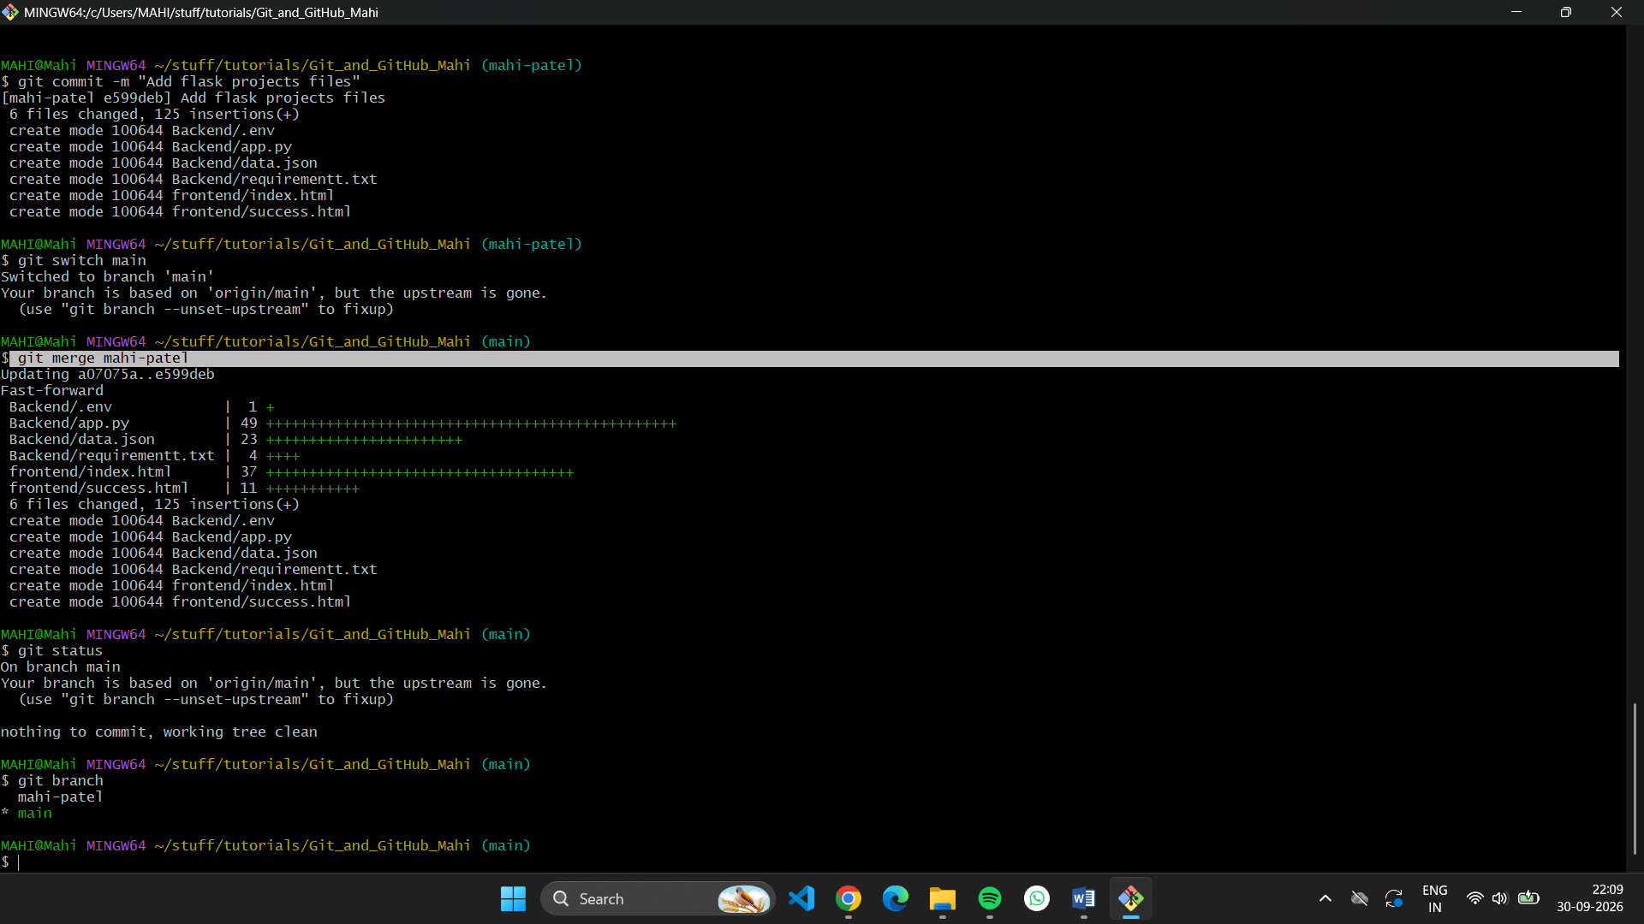

Task 2: Update JSON & Resolve Conflicts
- Create a new branch named _new (e.g., Tutedude_new).
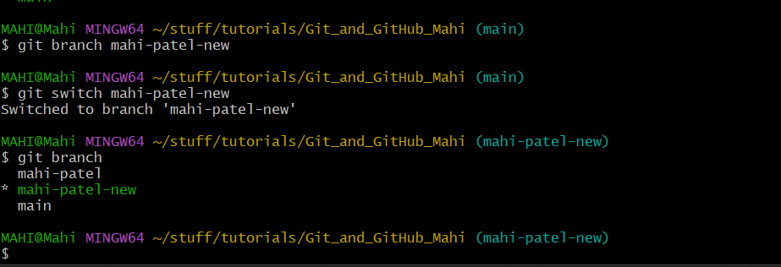

- Update the content of the JSON file used for the /api route in this branch.
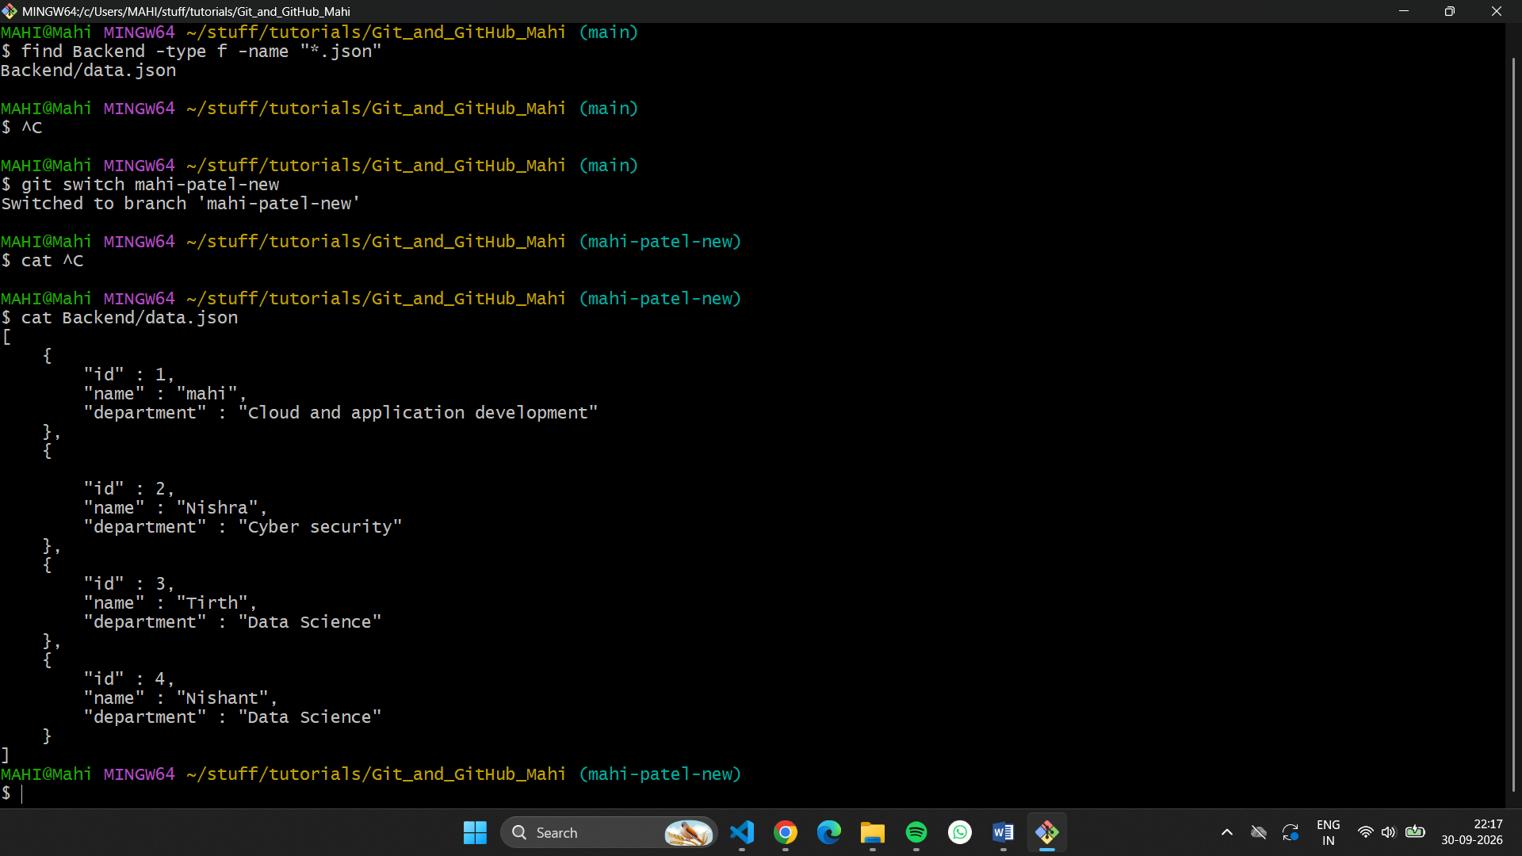
I update this in vscode
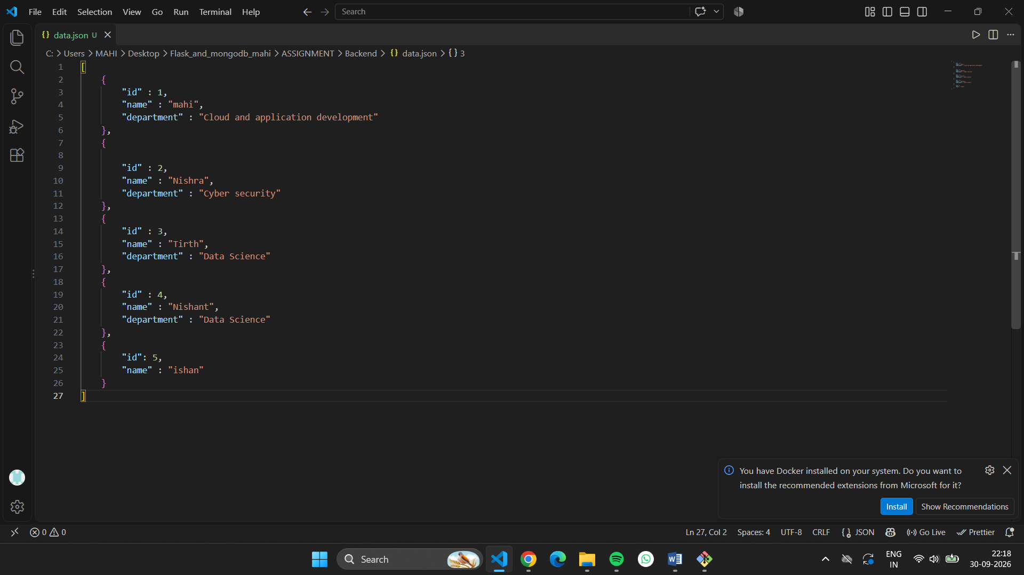
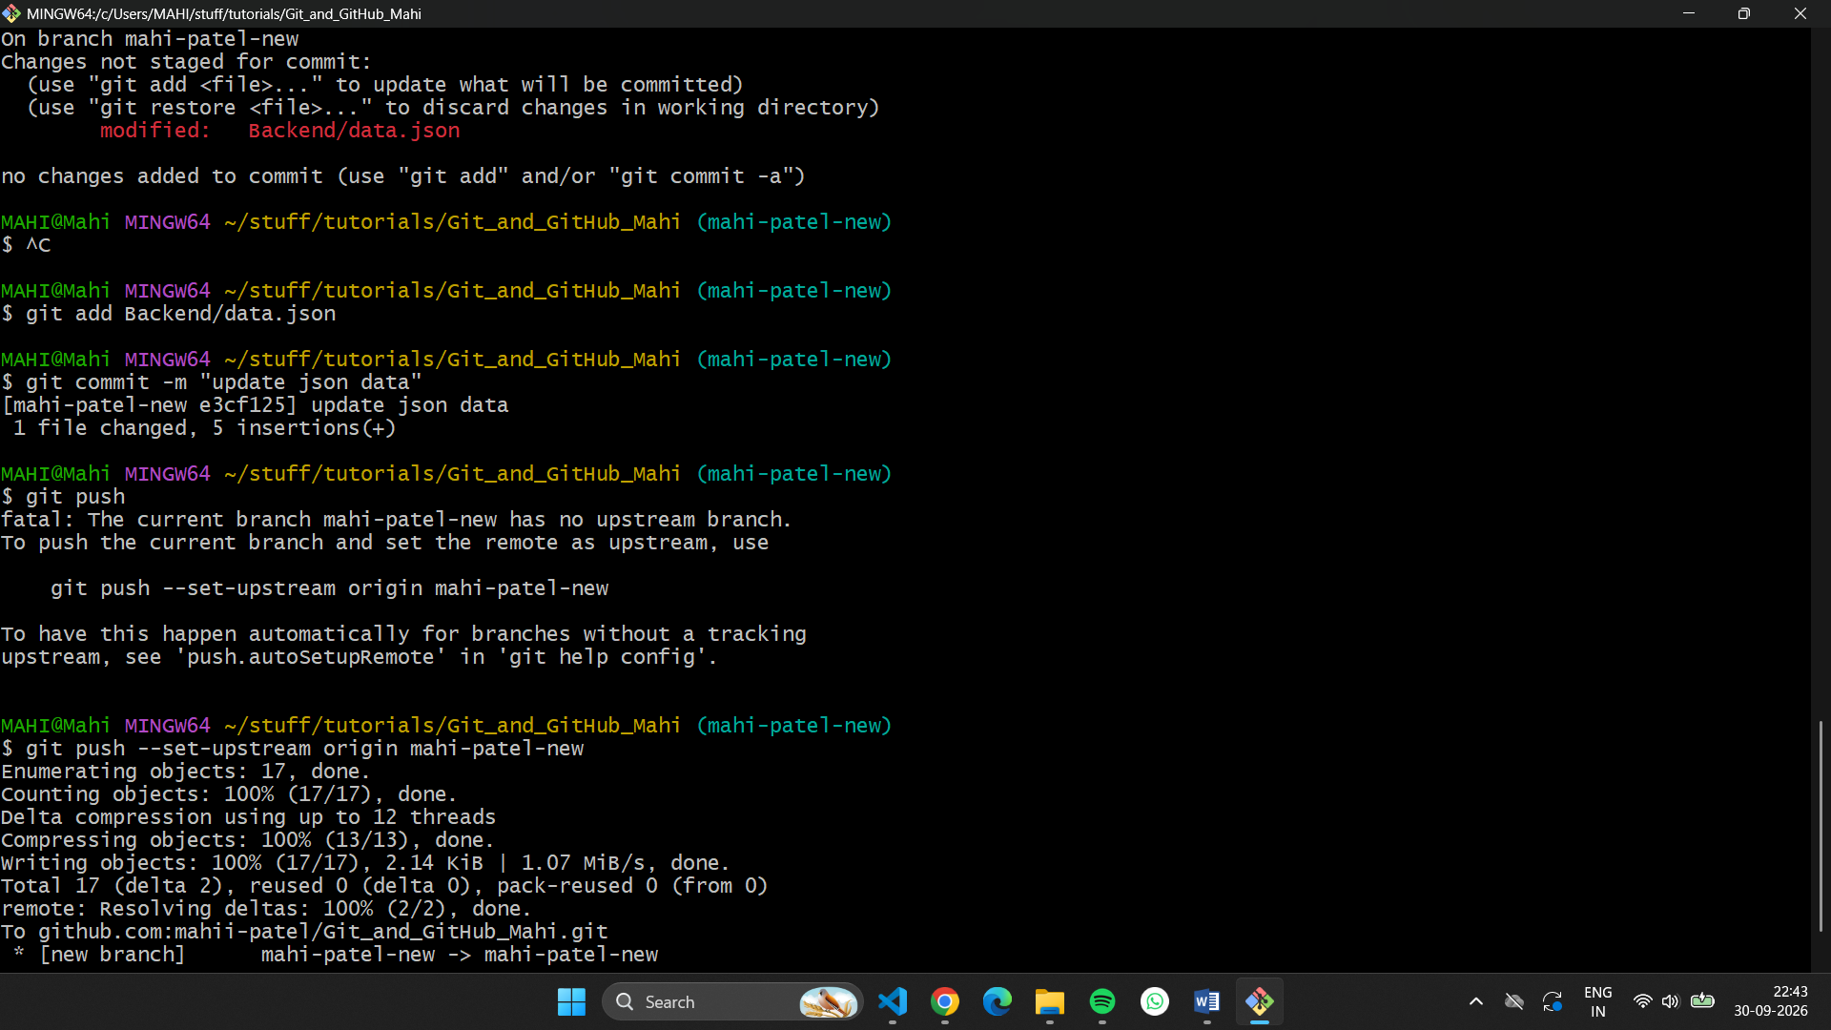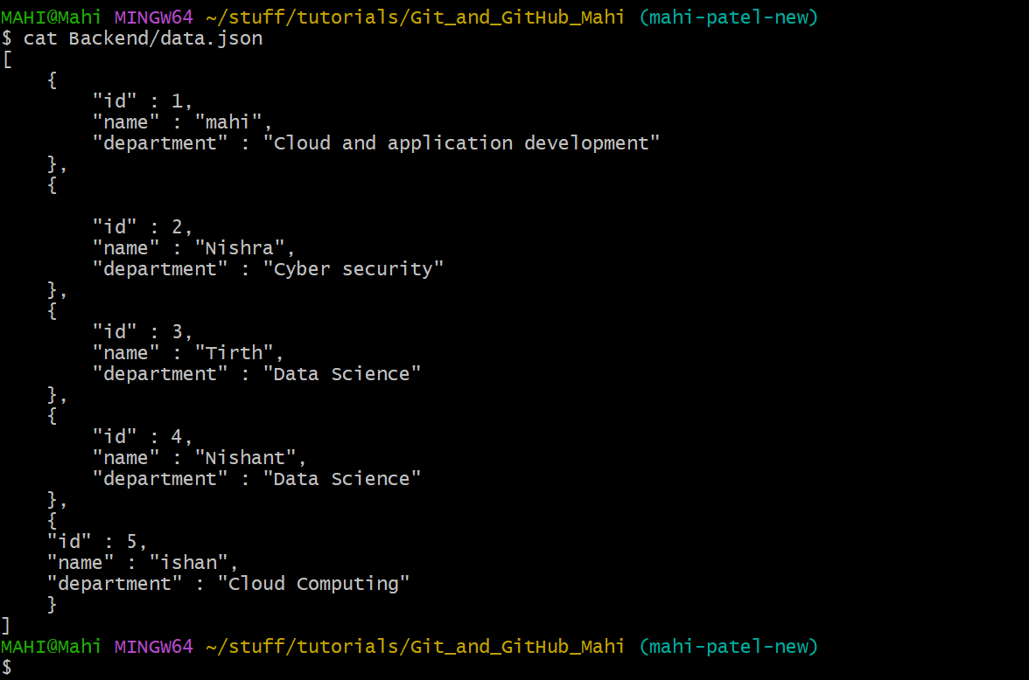

- Merge the _new branch into the main branch.
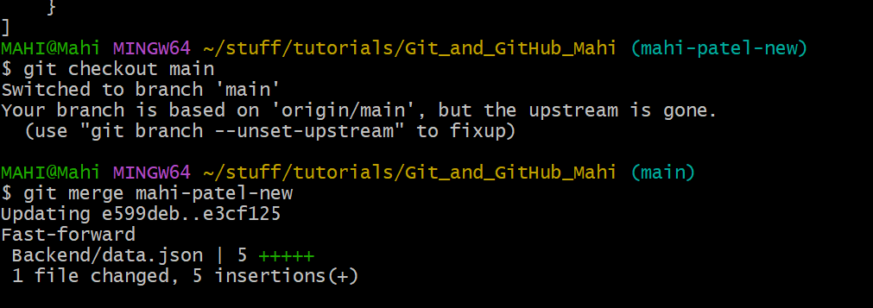

- If there are conflicts during the merge, resolve them by accepting the changes from the _new branch.

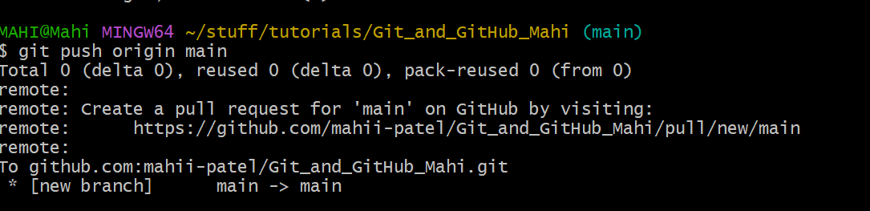

- Add the resolved changes to the staging area, commit them, and push the updates to the remote repository.

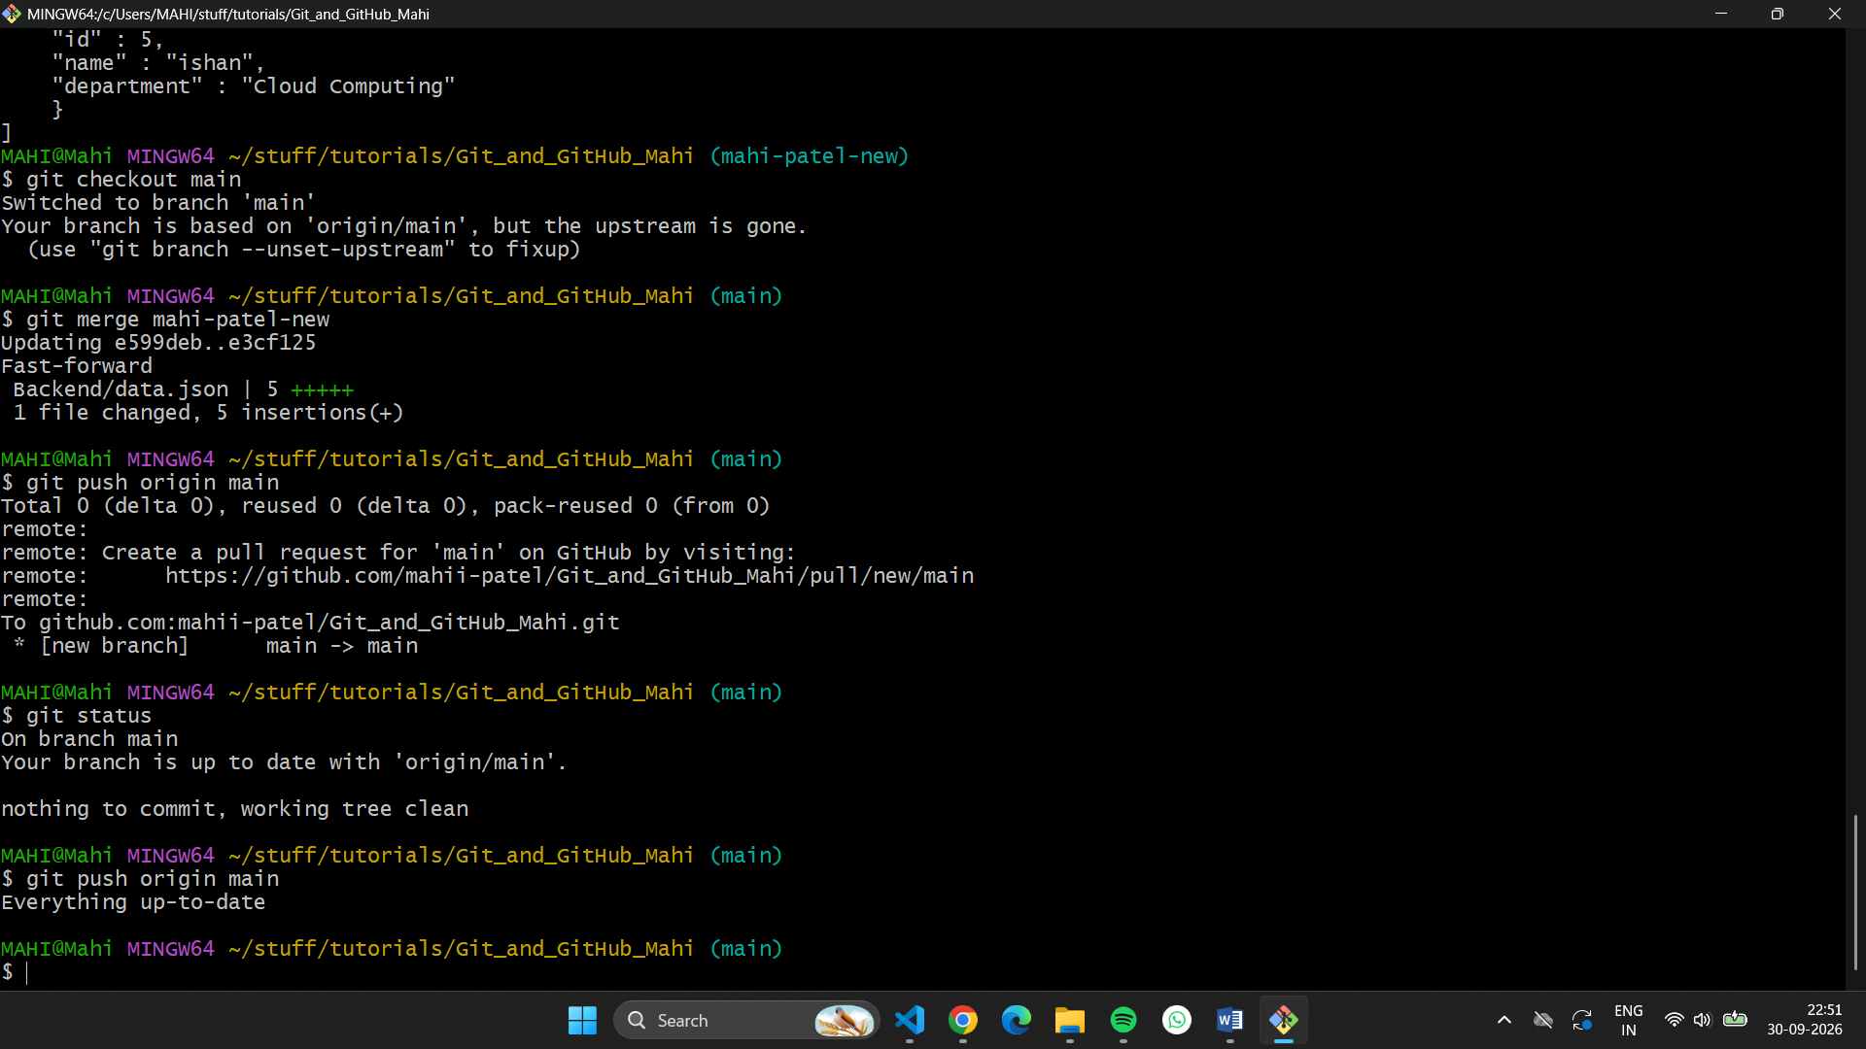

Task 3: Parallel Feature Development
- Branch Creation: Create two branches, master_1 and master_2, from the main branch.
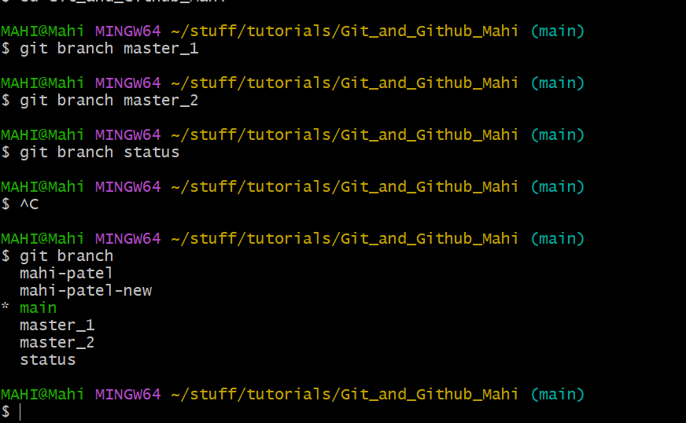
- Feature Development in master_1: Create a To-Do Page in the frontend with a form containing the fields Item Name and Item Description.

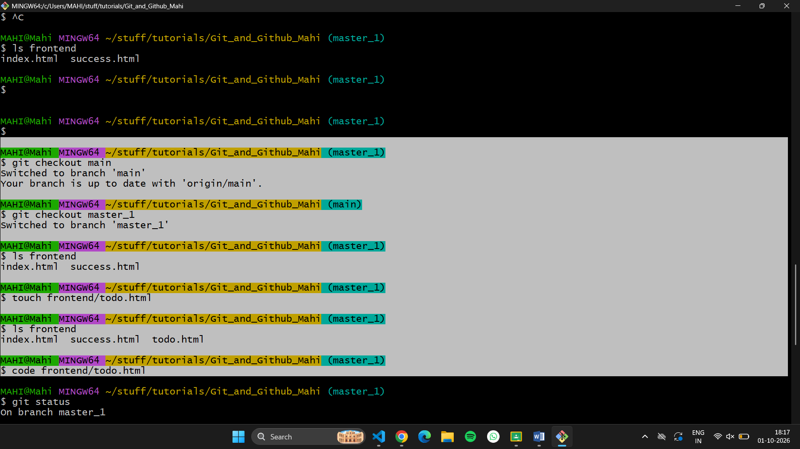
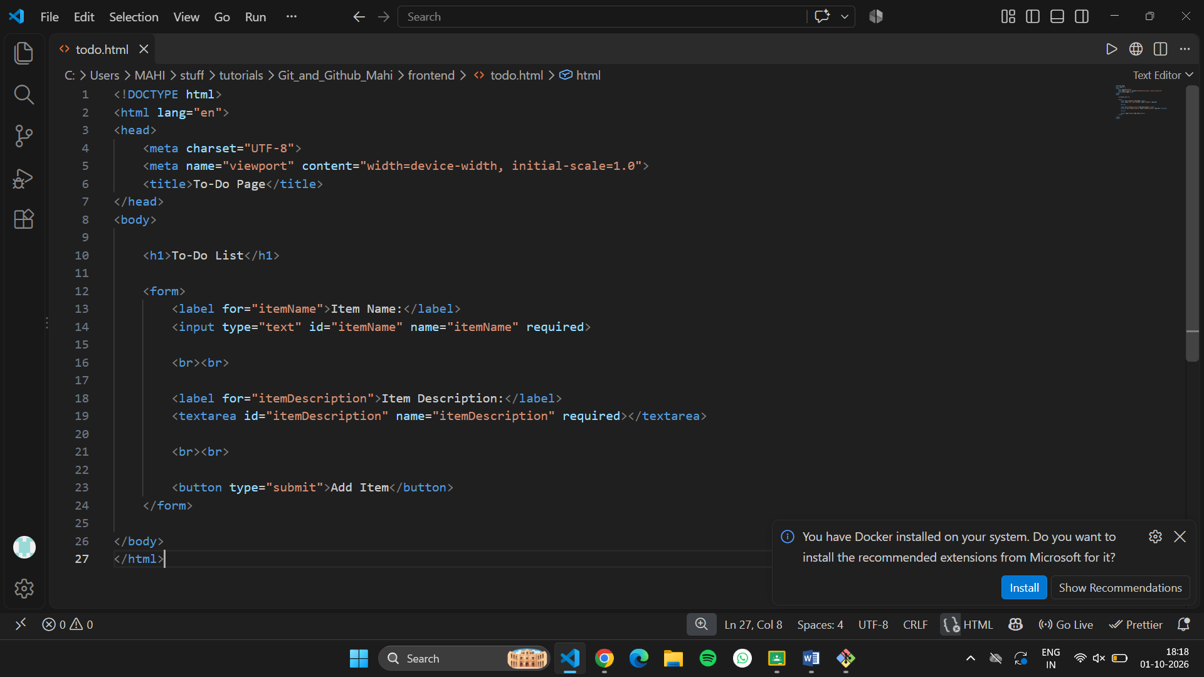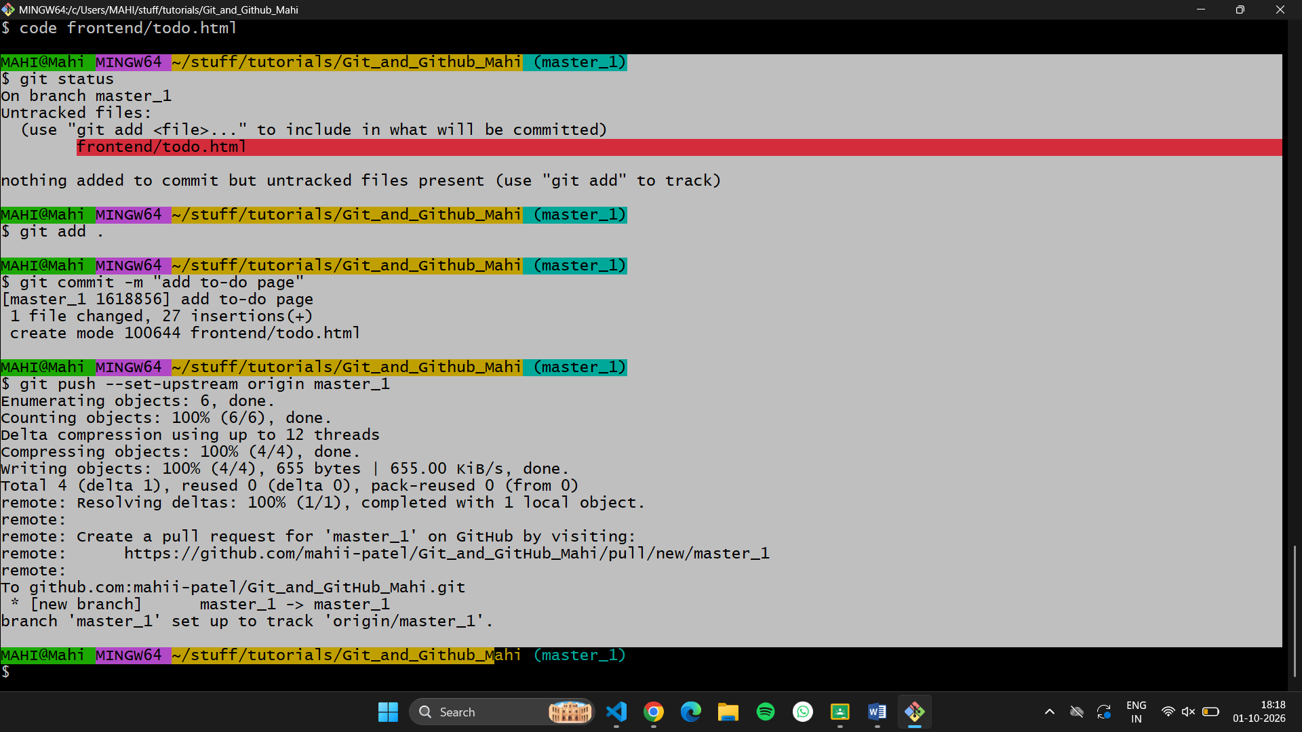

Backend API in master_2: Create a backend route named /submittodoitem that accepts itemName and itemDescription via a POST

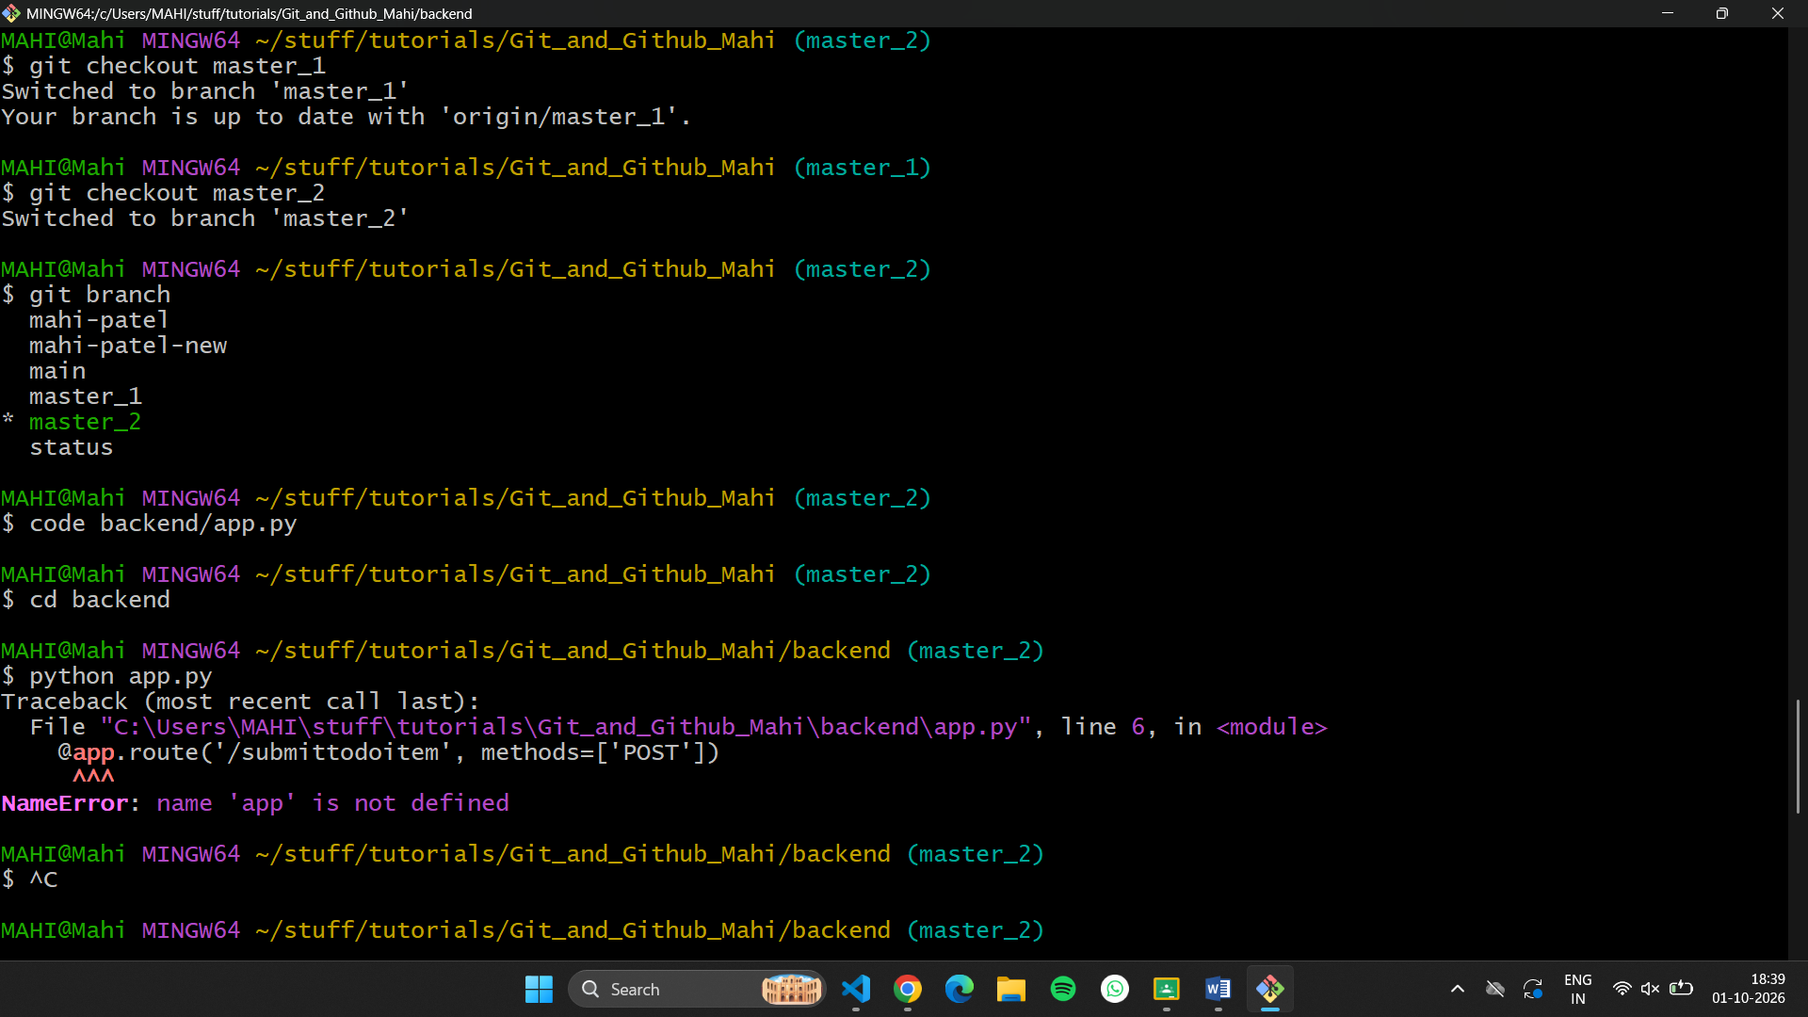
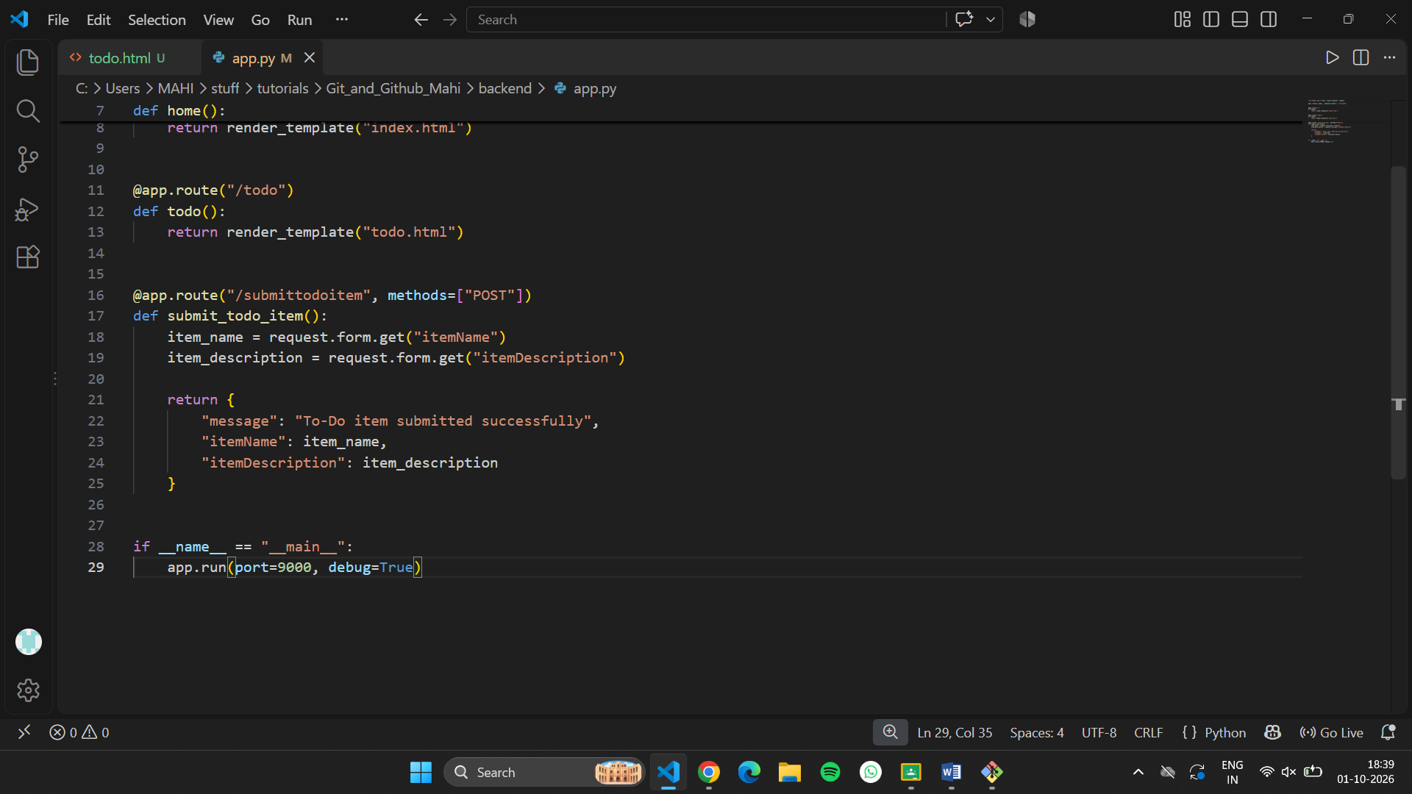
Change the form action
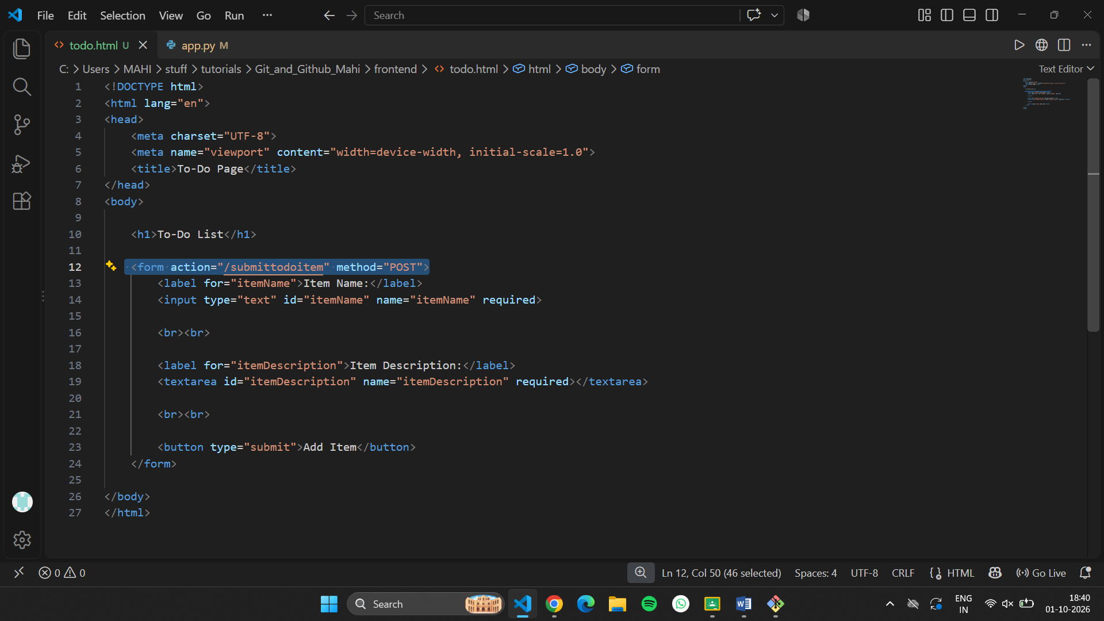

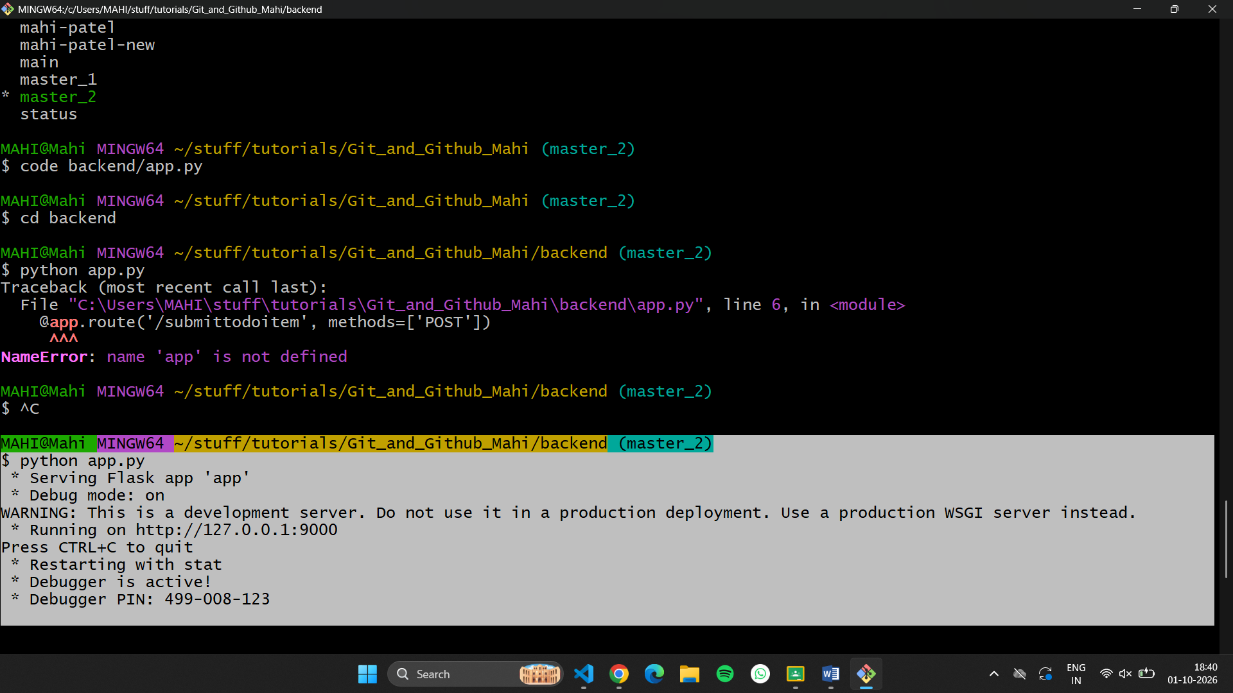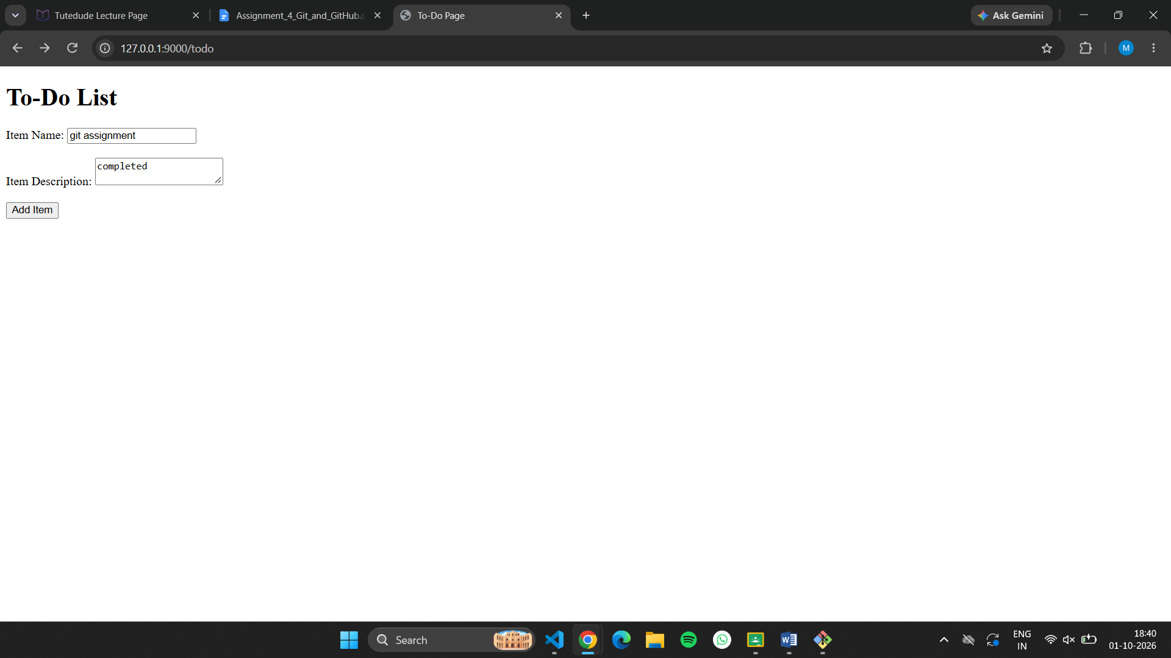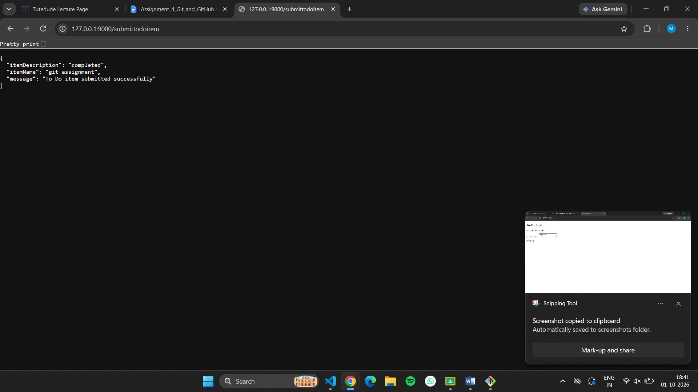
4.Merging Changes: Merge the changes from both master_1 and master_2 into the main branch.
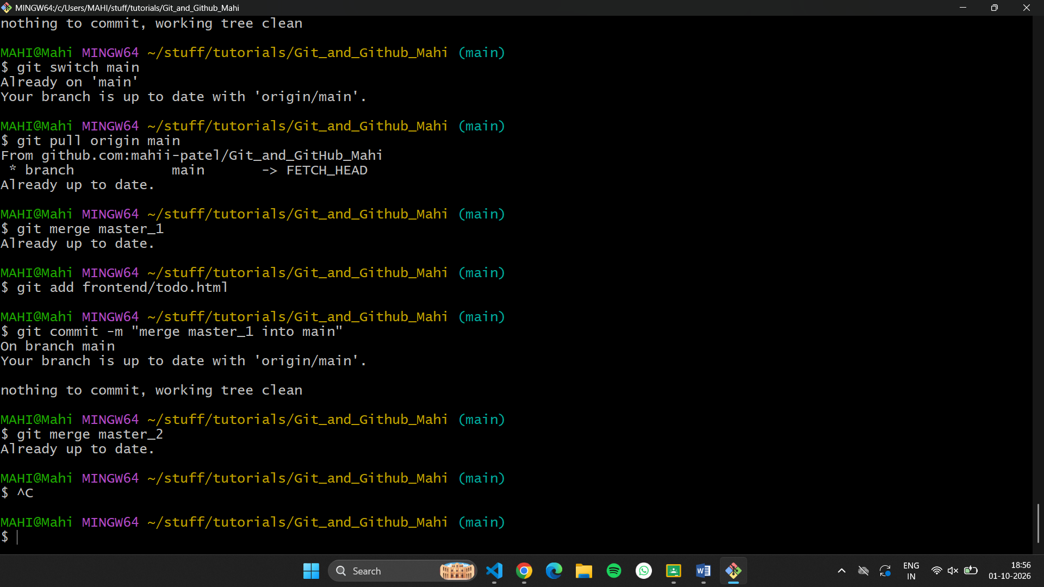

Task 4: Sequential Commits, Reset & Rebase
- Enhancing the To-Do Form in master_1: Add the following fields to the To-Do form: Item ID, Item UUID, Item Hash.
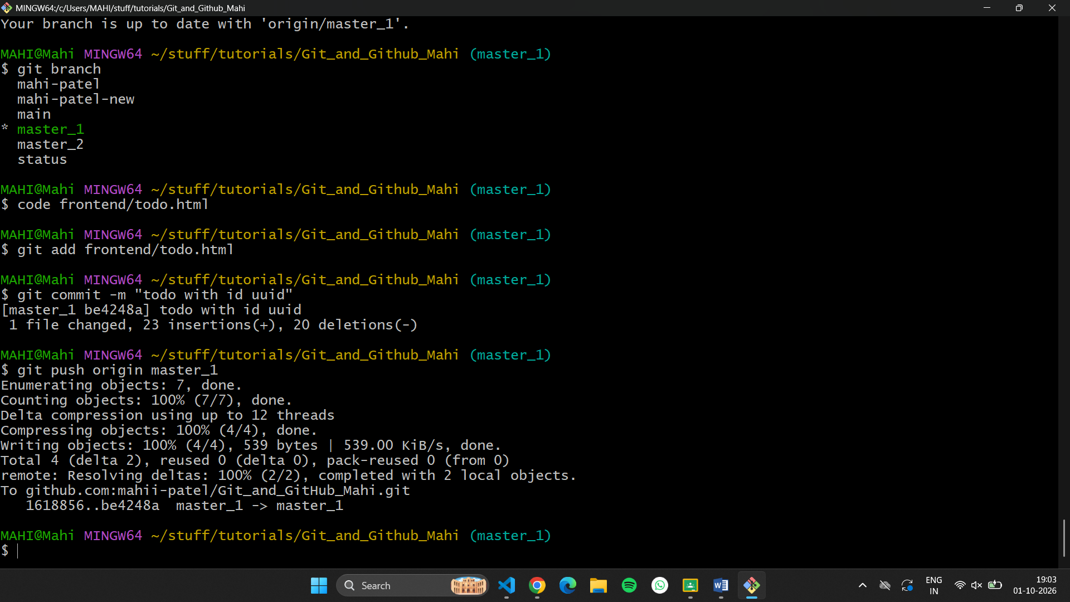
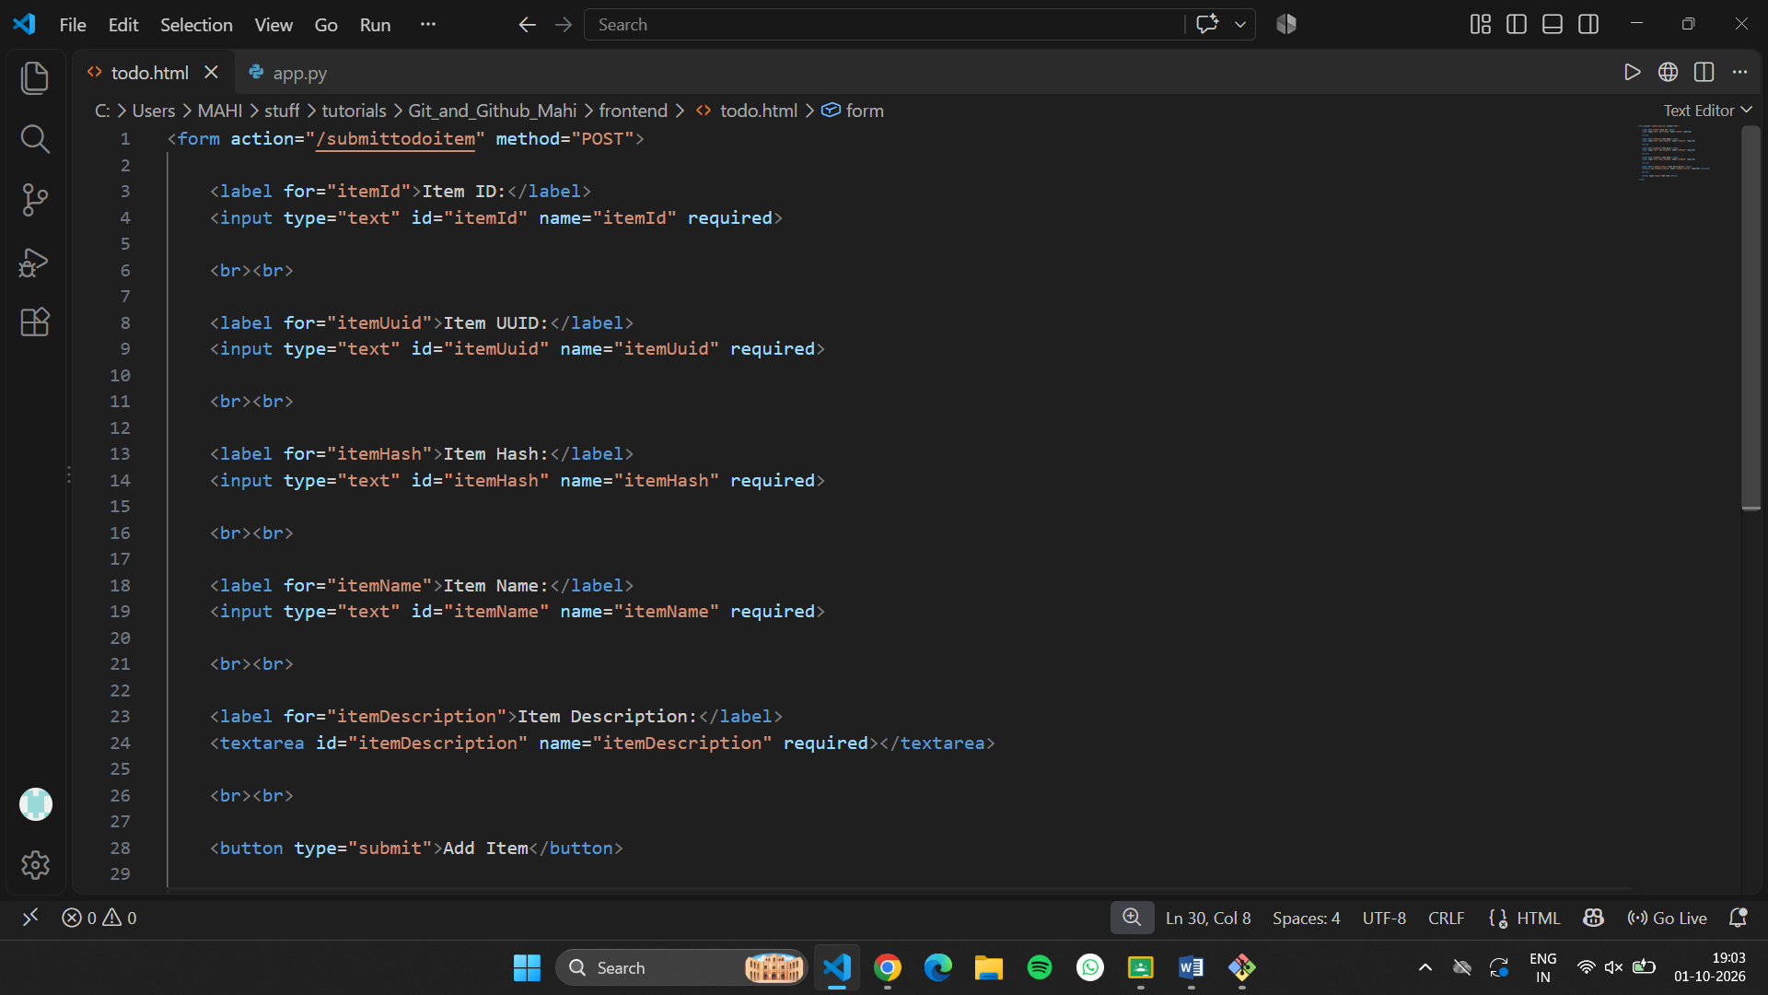

- Committing in Sequence: Add and commit each field separately — first commit: Item ID; second commit: Item UUID; third commit: Item Hash.
Item id:
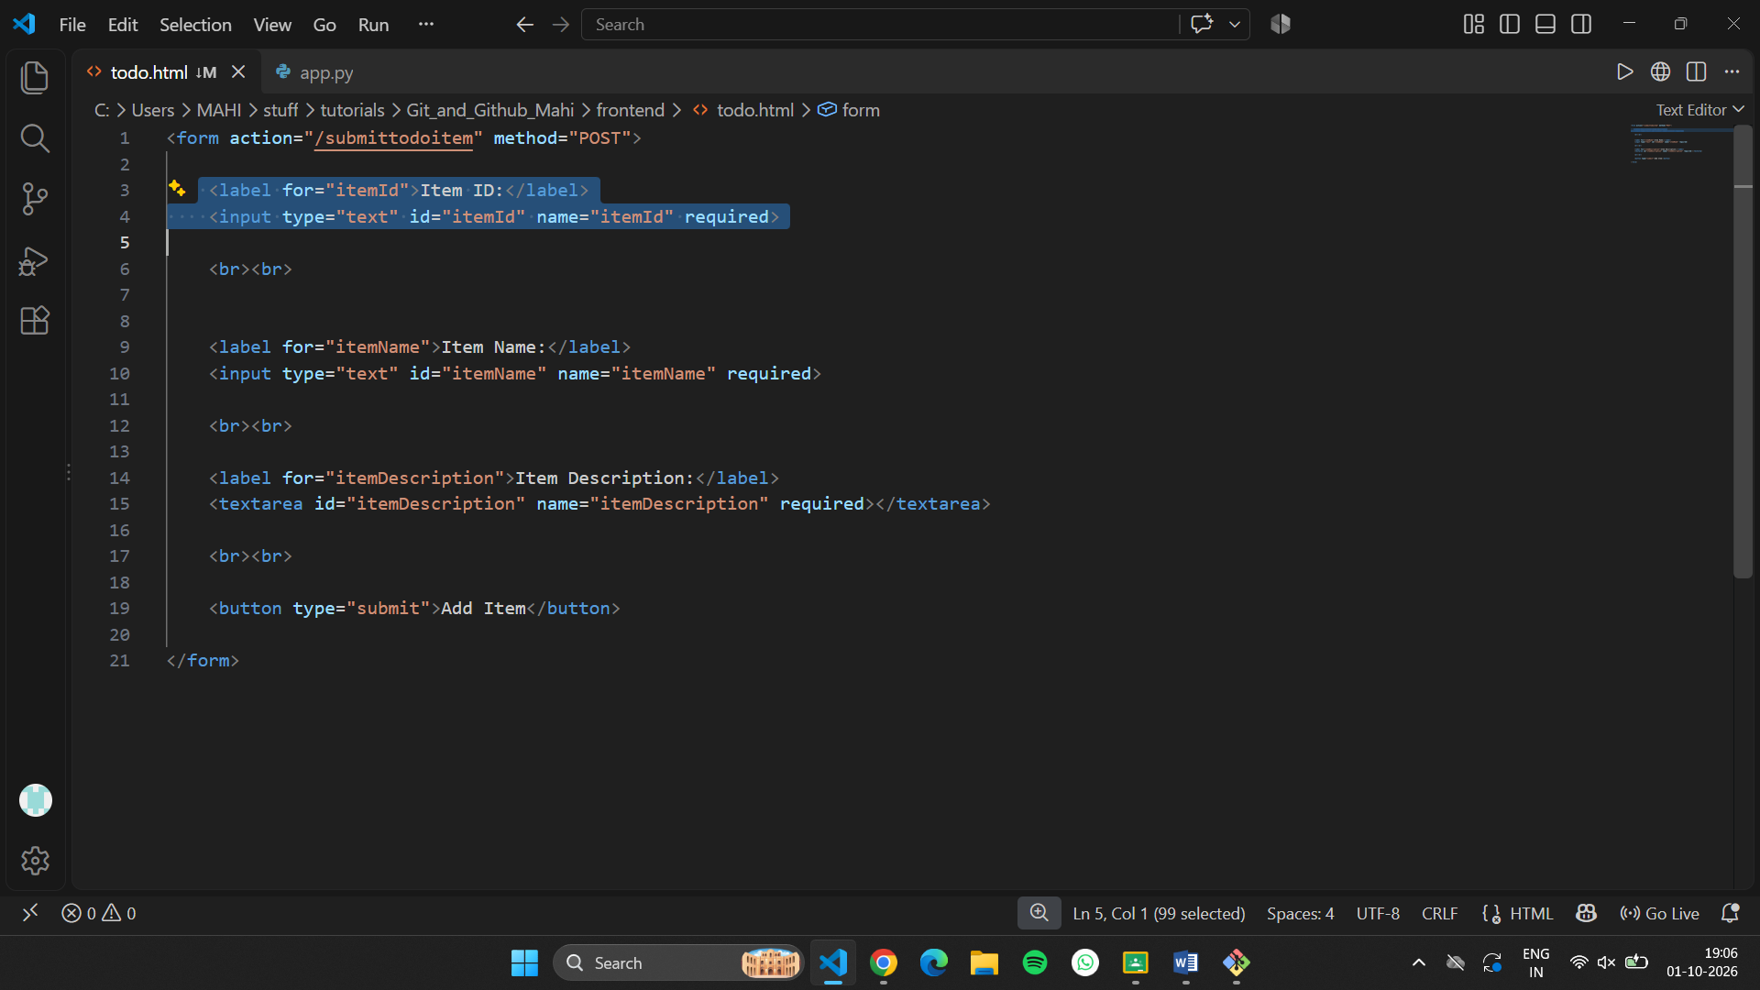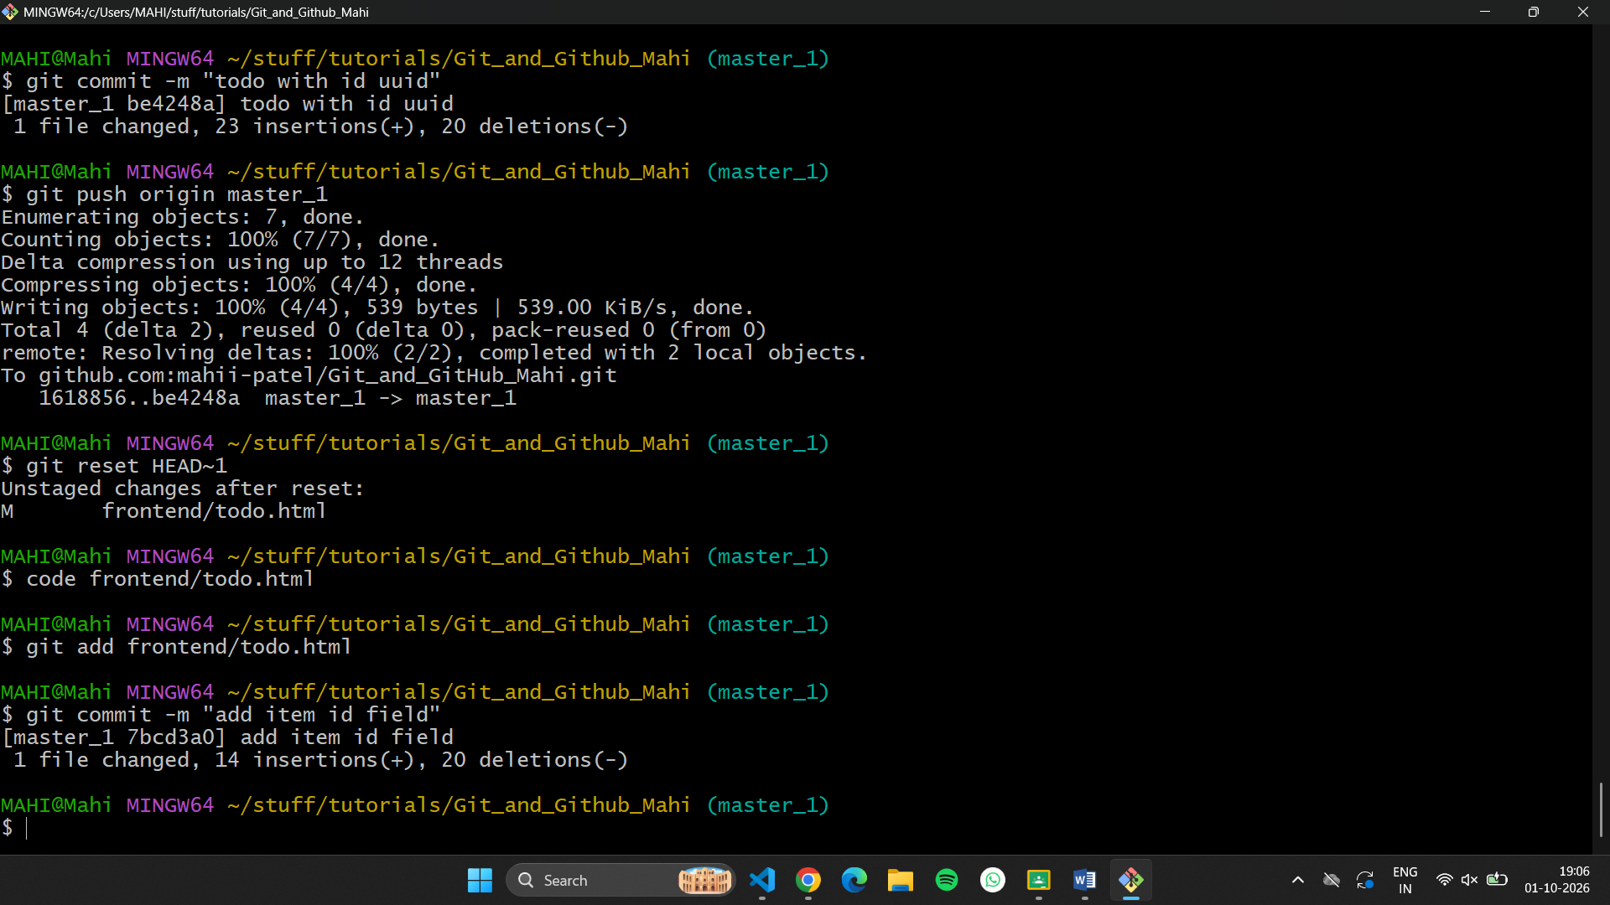
Item uuid:
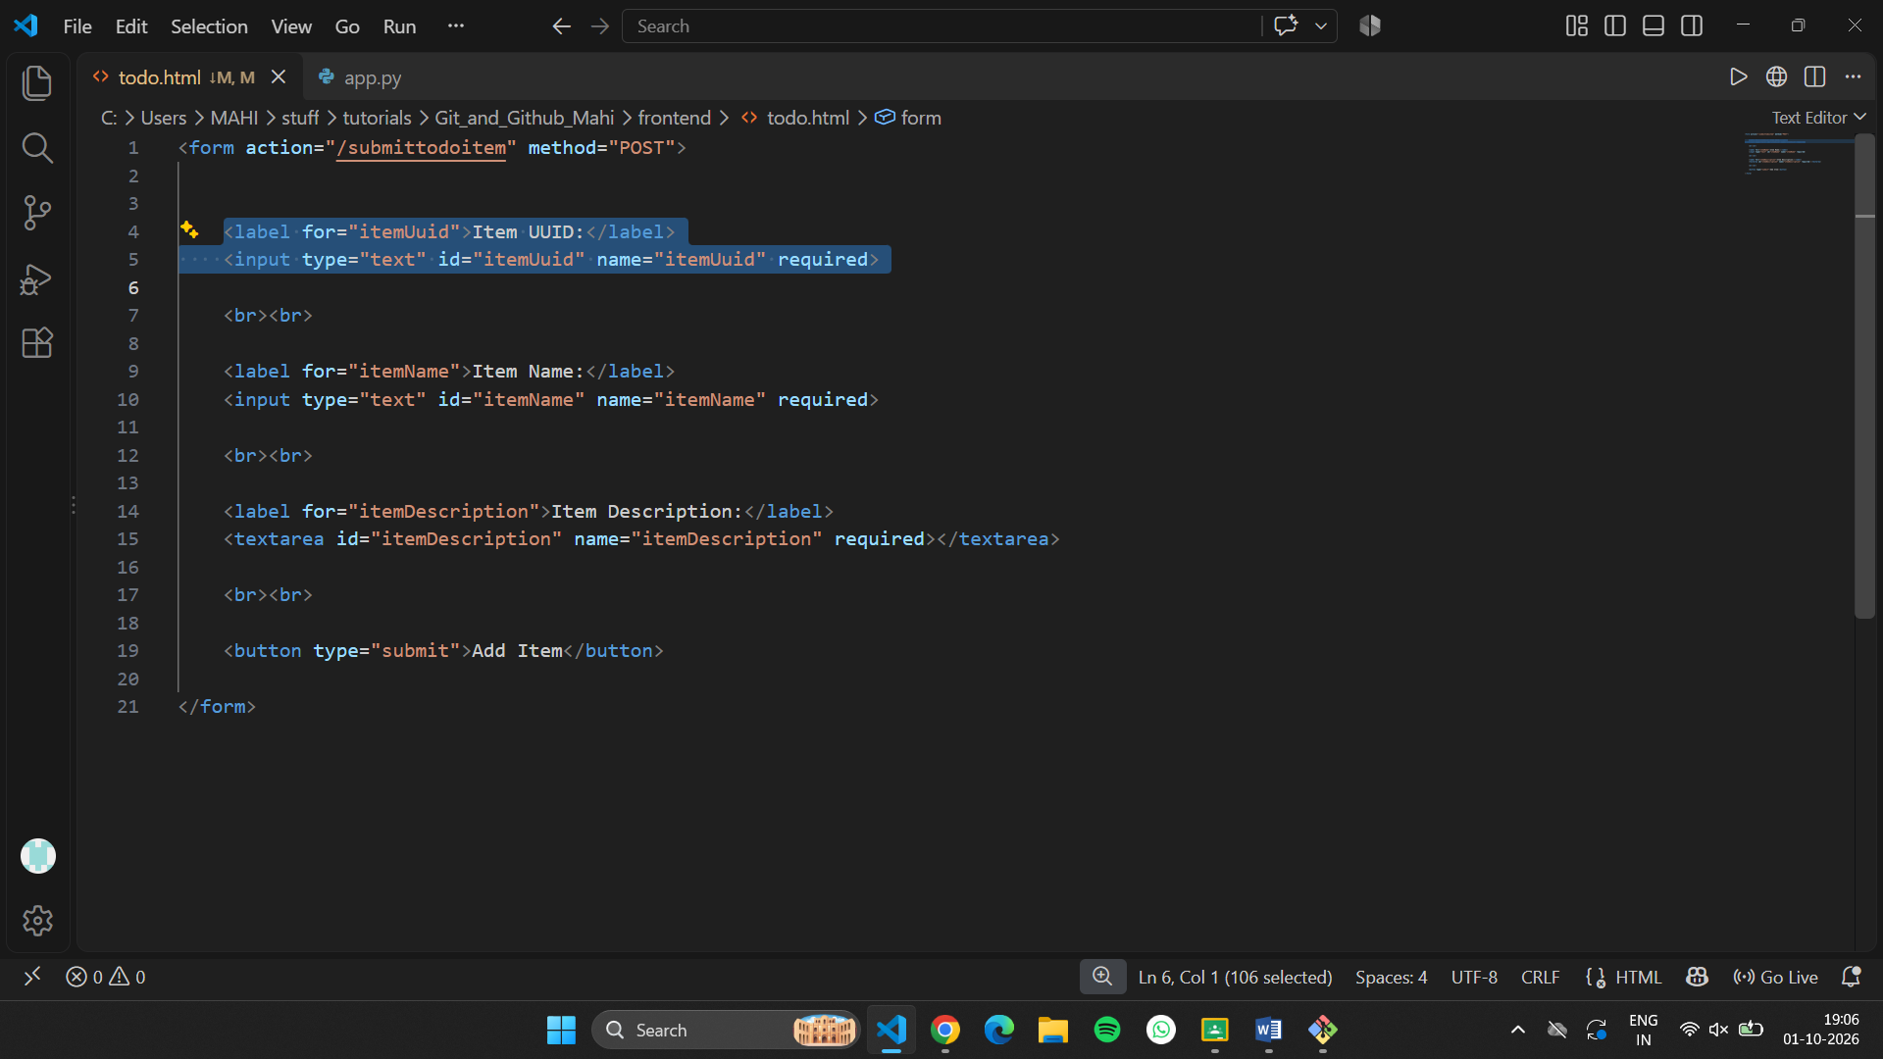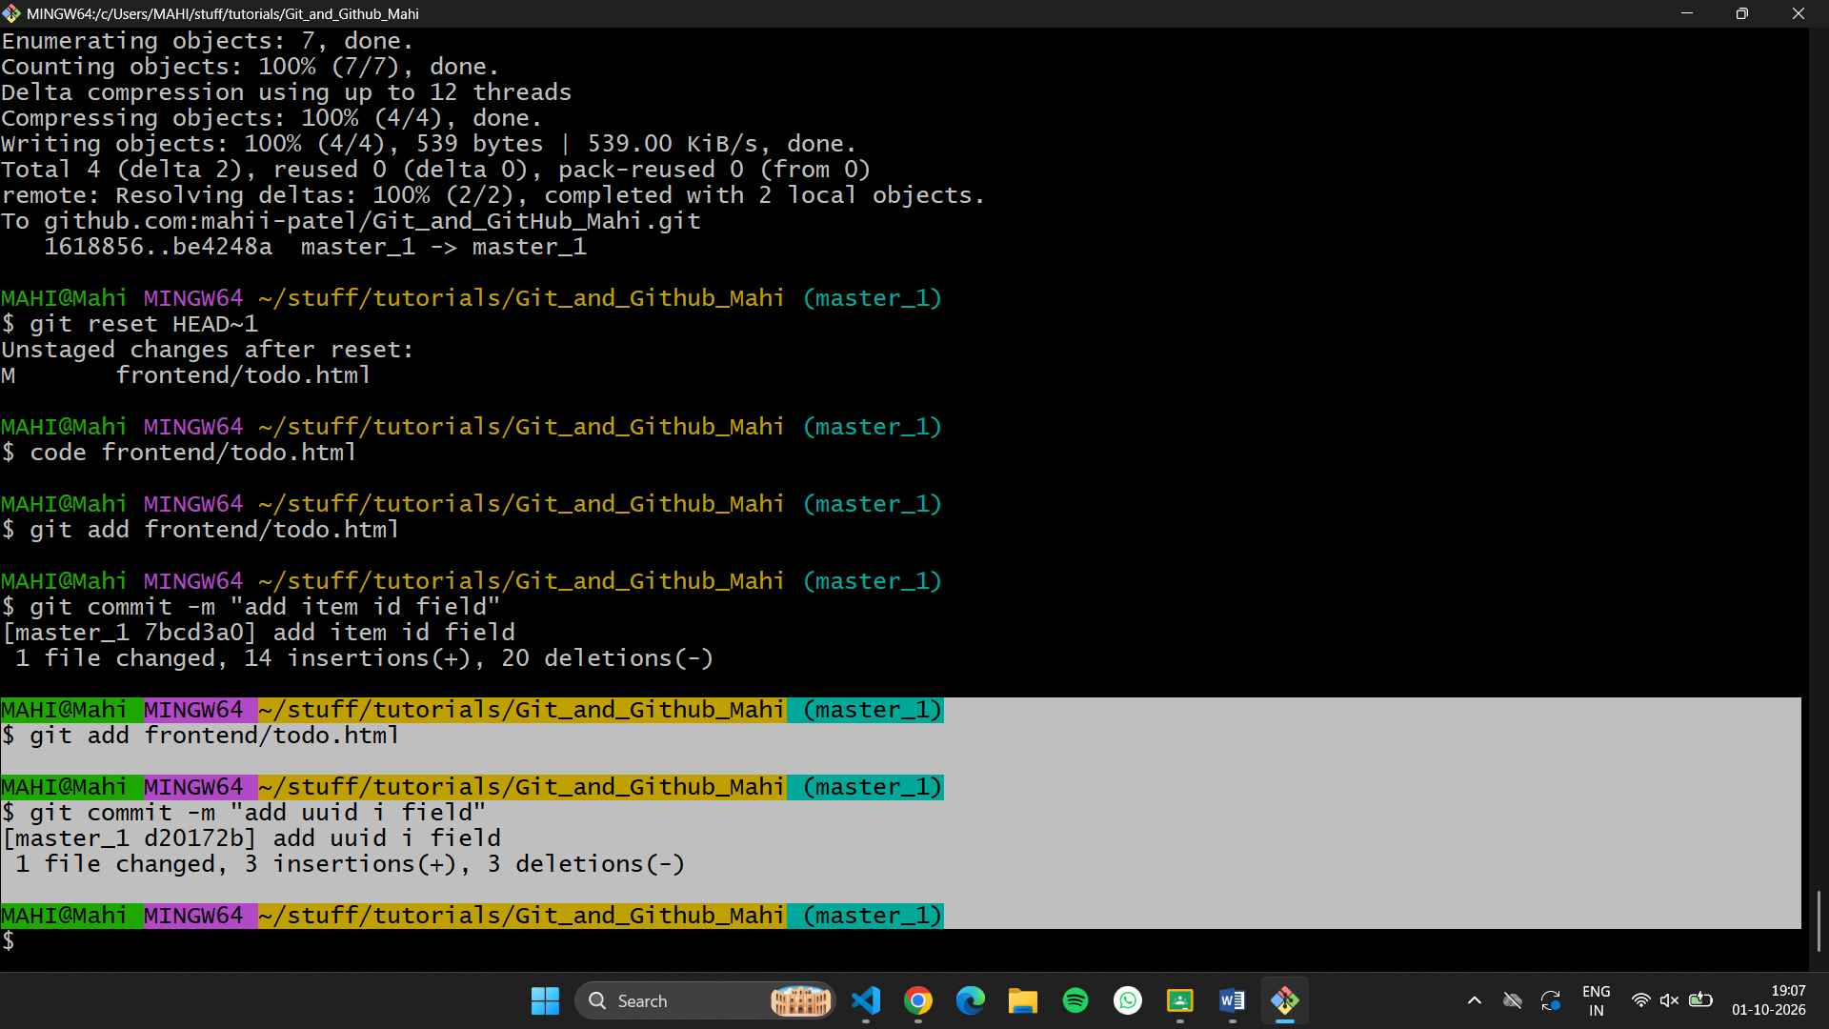
Item hash:
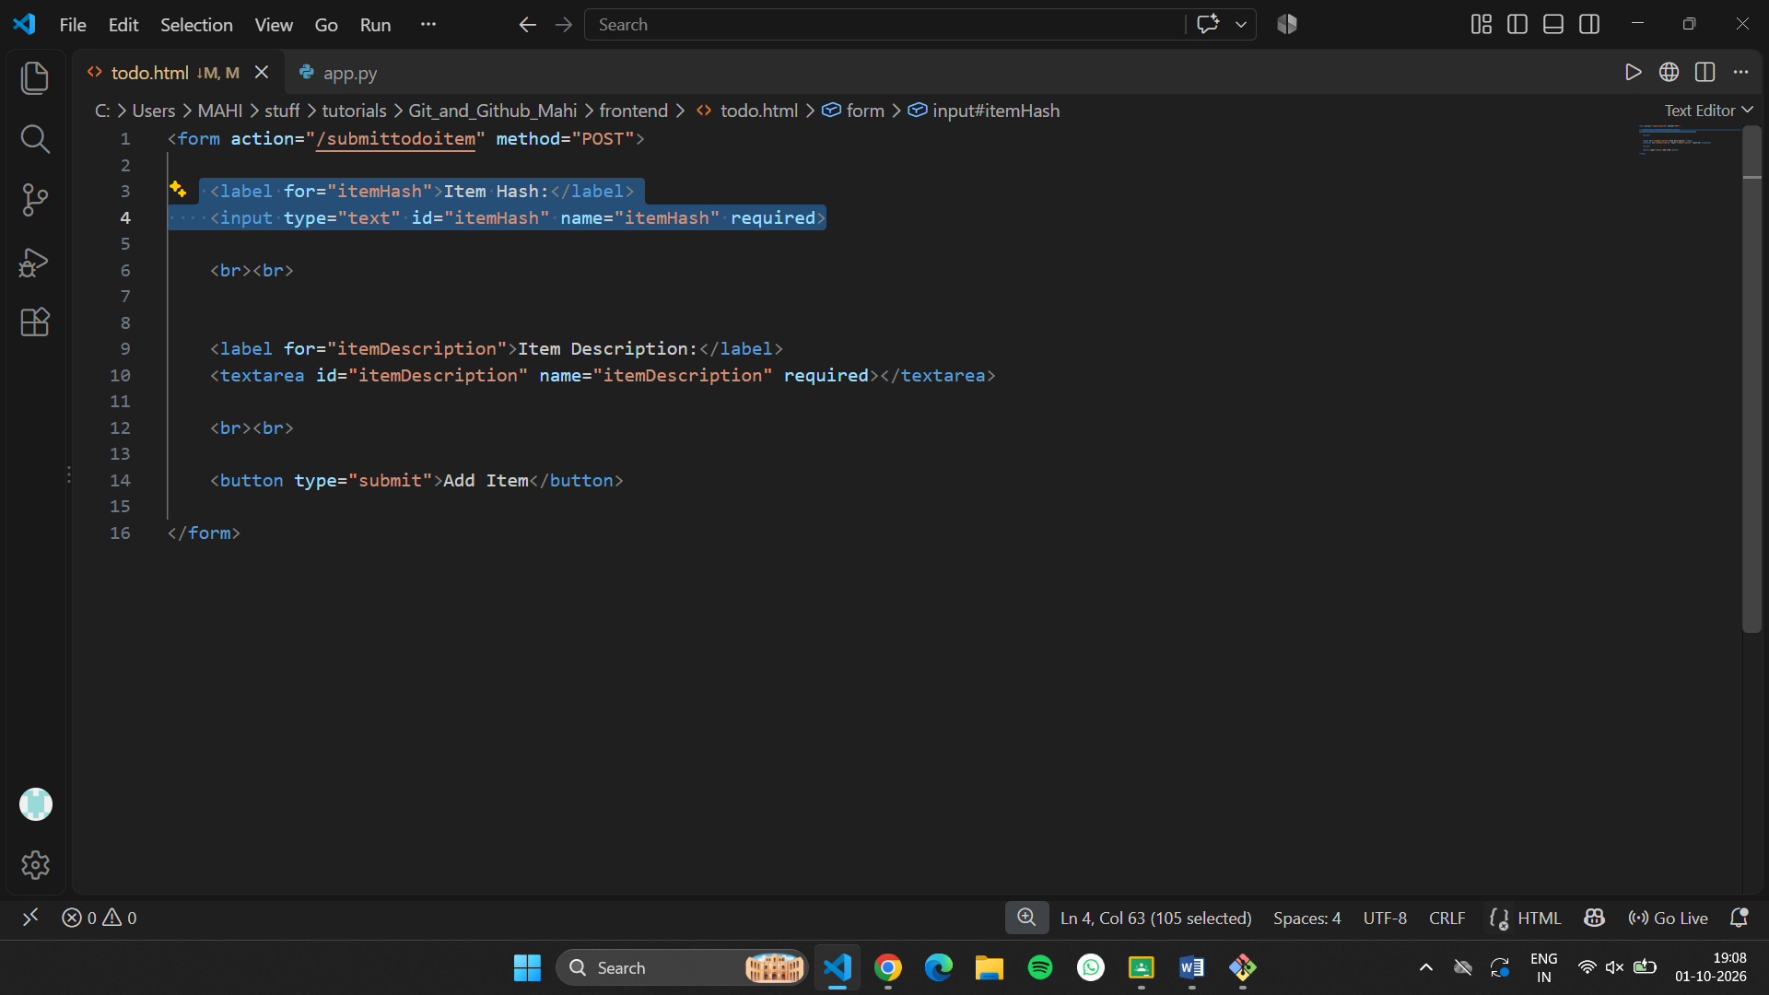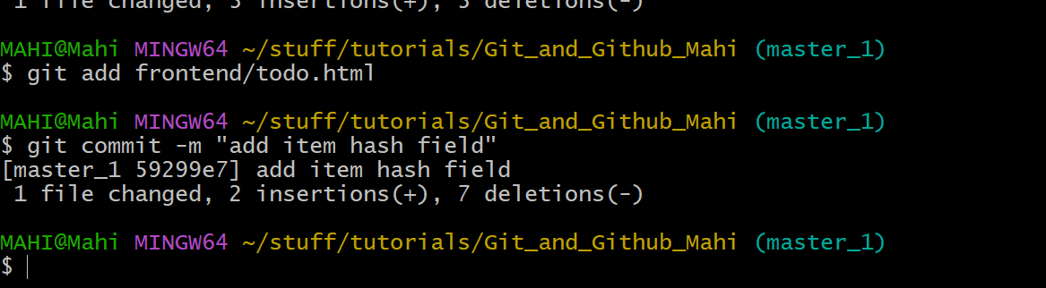

- Merging to main: Merge the master_1 branch into the main branch.

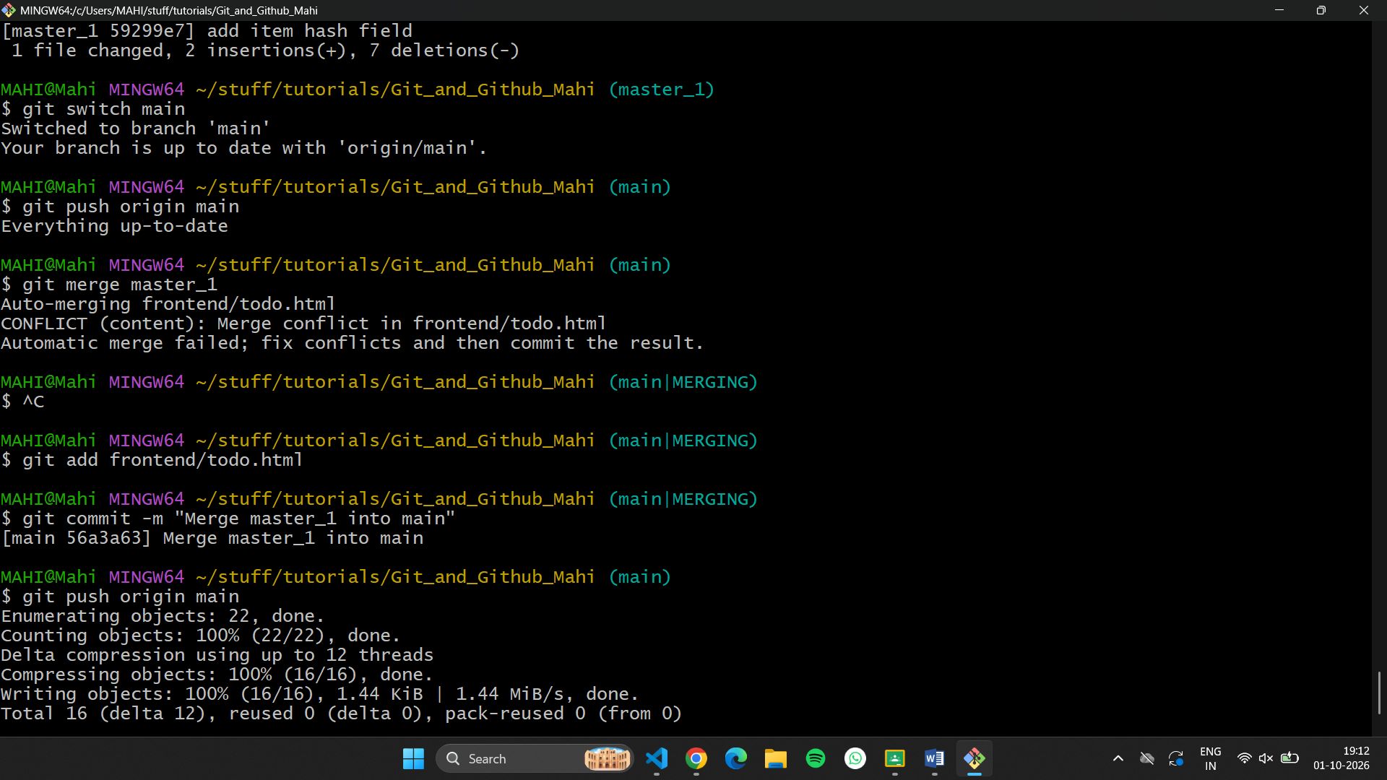
- Git Reset: In the main branch, roll back to the commit where only the Item ID field was added. Use git reset --soft to ensure changes remain staged, then re-commit this state and merge it to main.
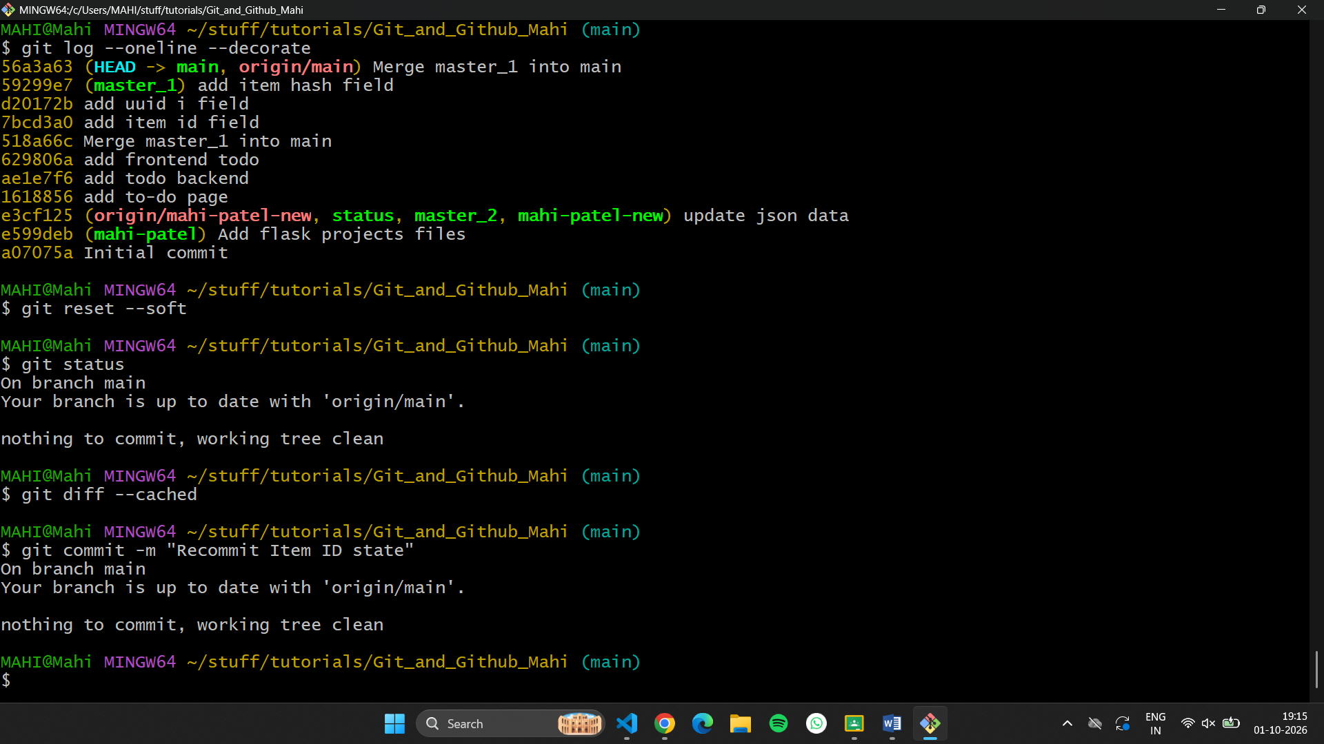
- Rebasing: Rebase the updated main branch changes onto master_1 using git rebase main master_1. Preserve individual commits (do NOT squash) to maintain commit history.
