EX. NO: 11  DATE: | MINI PROJECT - Agricultural Crop Condition Analysis
Aim:
To develop a machine learning-based Agricultural Crop Condition Analysis system that groups crops according to environmental conditions and recommends suitable crops based on parameters such as temperature, rainfall, humidity, soil moisture, soil pH, nitrogen, phosphorus, and potassium.
Define:
In the Define phase, the main problem identified during the empathy phase is clearly stated.
Problem Statement
"How might we develop a simple machine learning application that analyzes environmental conditions and groups crops according to their suitability, helping users identify crops that are better suited to specific agricultural conditions?"
Existing Problems
• Farmers may find it difficult to select suitable crops based on multiple environmental parameters.
• Environmental conditions vary between agricultural regions and fields.
• Considering temperature, rainfall, humidity, soil moisture, pH, and nutrients simultaneously can be difficult manually.
• Traditional crop selection may not effectively identify similarities between different crop requirements.
• There is a need for a simple data-driven crop suitability analysis tool.
Objective
The main objectives are:
1. To collect and analyze crop environmental condition data.
2. To preprocess and standardize environmental parameters.
3. To apply K-Means clustering to group crops with similar environmental requirements.
4. To evaluate the generated clusters using Elbow Method and Silhouette Score.
5. To analyze user-provided agricultural conditions and identify the closest crop group.
6. To recommend suitable crops through an interactive Streamlit application.
Empathy:
The empathy phase focuses on understanding the difficulties faced by farmers and agricultural users in identifying environmentally compatible crops.
Problem Understanding
Farmers and agricultural users need an easier way to understand which crops are environmentally compatible with their field conditions. Crop growth is governed by multiple interconnected factors: Temperature, Rainfall, Humidity, Soil Moisture, Soil pH, Nitrogen, Phosphorus, and Potassium.
User Needs
• Users need a simple way to analyze agricultural conditions.
• The system should require understandable environmental inputs.
• The analysis should be generated quickly.
• Crop groups should be presented clearly.
• Recommended crops should be easy to understand.
• The system should provide an explanation of why crops are recommended.
• The interface should be easy to use.
Ideate:
During the Ideate phase, different possible solutions are considered.
Proposed Ideas
1. Develop a machine learning system for crop condition analysis.
2. Use environmental and soil parameters as input features.
3. Apply preprocessing and feature scaling before clustering.
4. Use K-Means clustering to group crops based on environmental similarity.
5. Use Elbow Method and Silhouette Score to evaluate cluster quality.

6. Use PCA for visualizing high-dimensional crop clusters.
7. Develop a Streamlit-based interactive dashboard.
8. Provide crop suitability recommendations based on environmental conditions.
Prototype:
The proposed prototype is an Agricultural Crop Condition Analysis and Crop Suitability Recommendation Dashboard developed using Python, Machine Learning, and Streamlit. The system provides an interactive interface where users can enter eight basic environmental and soil parameters: Temperature, Rainfall, Humidity, Soil Moisture, Soil pH, Nitrogen, Phosphorus, and Potassium.
The dataset contains 220 samples covering 22 crop varieties across five major agricultural categories: Wetland/High Moisture (Rice, Sugarcane, Banana, Jute, Coconut), Semi-Arid/Drought-Tolerant (Millet, Sorghum, Chickpea, Pigeon Pea, Groundnut), Cereals (Wheat, Barley, Maize), Commercial/Cash Crops (Cotton, Soybean, Mustard, Sunflower, Coffee), and Horticultural Crops (Potato, Tomato, Onion, Garlic).
Major Sections
1. Home / Overview: Introduces the application, key capabilities, and user workflow.
2. Crop Analysis: Input sliders, preset scenarios, and instant suitability recommendations.
3. Cluster Analysis: Cluster profiles, radar charts, and interactive 2D/3D PCA cluster visualization.
4. Data Exploration: Dataset exploration, statistical summaries, and correlation heatmaps.
5. ML Model & Technical Evaluation: Elbow method, Silhouette score evaluation (k=4), and metrics.
This prototype provides an interactive and explainable system to demonstrate how unsupervised machine learning can be applied to precision agriculture.
Code:
import streamlit as st
import pandas as pd
import numpy as np
from sklearn.preprocessing import StandardScaler
from sklearn.cluster import KMeans
from sklearn.metrics import silhouette_score
from sklearn.decomposition import PCA

# Page configuration
st.set_page_config(
page_title="AgriSense AI - Crop Condition Analysis",
page_icon="🌾",
layout="wide"
)

# Title
st.title("🌾 AgriSense AI - Crop Condition Analysis")
st.write("Enter environmental conditions to get crop recommendations.")

# Load agricultural dataset
data = pd.read_csv("data/crop_dataset.csv")

# Feature selection
features = [
"temperature", "rainfall", "humidity", "soil_moisture",
"soil_ph", "nitrogen", "phosphorus", "potassium"
]
X = data[features]

# Preprocess and standardize data
scaler = StandardScaler()
X_scaled = scaler.fit_transform(X)

# Train K-Means Clustering model (optimal k = 4)
optimal_k = 4
kmeans = KMeans(n_clusters=optimal_k, random_state=42, n_init=10)
clusters = kmeans.fit_predict(X_scaled)
data["Cluster"] = clusters

# Cluster evaluation using Silhouette Score
sil_score = silhouette_score(X_scaled, clusters)

# Dimensionality reduction with PCA for 2D visualization
pca = PCA(n_components=2)
pca_coords = pca.fit_transform(X_scaled)
data["PCA1"] = pca_coords[:, 0]
data["PCA2"] = pca_coords[:, 1]

# User environmental inputs interface
st.subheader("Enter Agricultural Environmental Conditions")

temperature = st.number_input(
"Temperature (°C)",
min_value=5.0,
max_value=50.0,
value=26.5
)

rainfall = st.number_input(
"Rainfall (mm)",
min_value=100.0,
max_value=3500.0,
value=1800.0
)

humidity = st.number_input(
"Relative Humidity (%)",
min_value=15.0,
max_value=100.0,
value=80.0
)

soil_moisture = st.number_input(
"Soil Moisture (%)",
min_value=10.0,
max_value=90.0,
value=65.0
)

soil_ph = st.number_input(
"Soil pH",
min_value=4.0,
max_value=9.5,
value=6.5
)

nitrogen = st.number_input(
"Nitrogen (N) kg/ha",
min_value=10.0,
max_value=250.0,
value=120.0
)

phosphorus = st.number_input(
"Phosphorus (P) kg/ha",
min_value=5.0,
max_value=150.0,
value=50.0
)

potassium = st.number_input(
"Potassium (K) kg/ha",
min_value=10.0,
max_value=250.0,
value=55.0
)

# Analyze crop suitability
if st.button("Analyze Crop Suitability"):
input_data = pd.DataFrame([[
temperature,
rainfall,
humidity,
soil_moisture,
soil_ph,
nitrogen,
phosphorus,
potassium
]], columns=features)

# Standardize input data
input_scaled = scaler.transform(input_data)

# Predict closest cluster
prediction = kmeans.predict(input_scaled)[0]

# Compute suitability scores using Gaussian RBF formula:
# S = 100 * exp(-d^2 / (2 * sigma^2))
sigma = 1.0
crop_scores = []
for crop in data["crop_name"].unique():
crop_data = data[data["crop_name"] == crop][features]
crop_mean = scaler.transform(crop_data).mean(axis=0)
dist = np.linalg.norm(input_scaled[0] - crop_mean)
suitability = 100.0 * np.exp(-(dist ** 2) / (2 * (sigma ** 2)))
crop_scores.append((crop, suitability))

# Rank and display top recommendations
crop_scores.sort(key=lambda x: x[1], reverse=True)
top_crops = crop_scores[:3]

# Display result
st.success(f"Assigned Cluster Group: Cluster {prediction}")
for crop_name, score in top_crops:
st.metric(label=f"Recommended: {crop_name}", value=f"{score:.1f}%")

st.info("Suitability scores computed via Euclidean distance and Gaussian radial basis scoring.")
App:
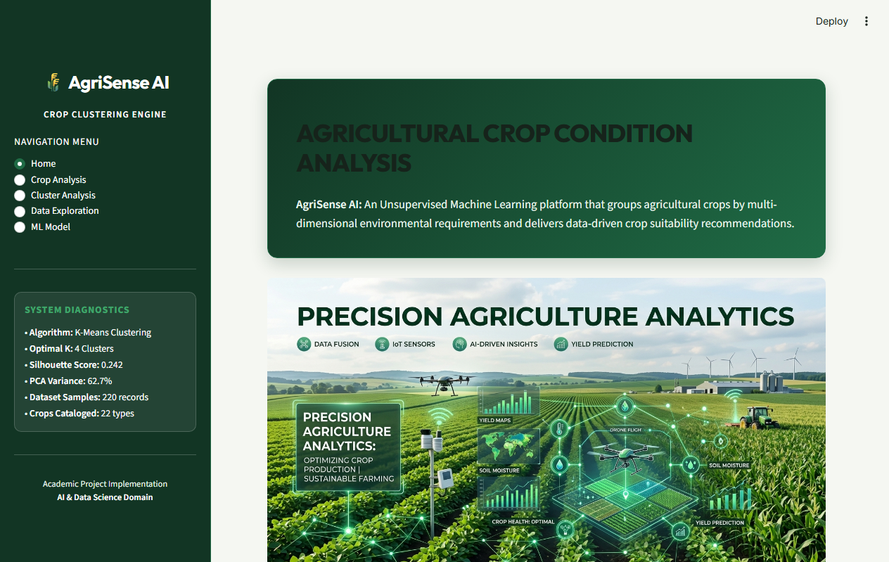
Fig. 1: AgriSense AI Crop Condition Analysis Application

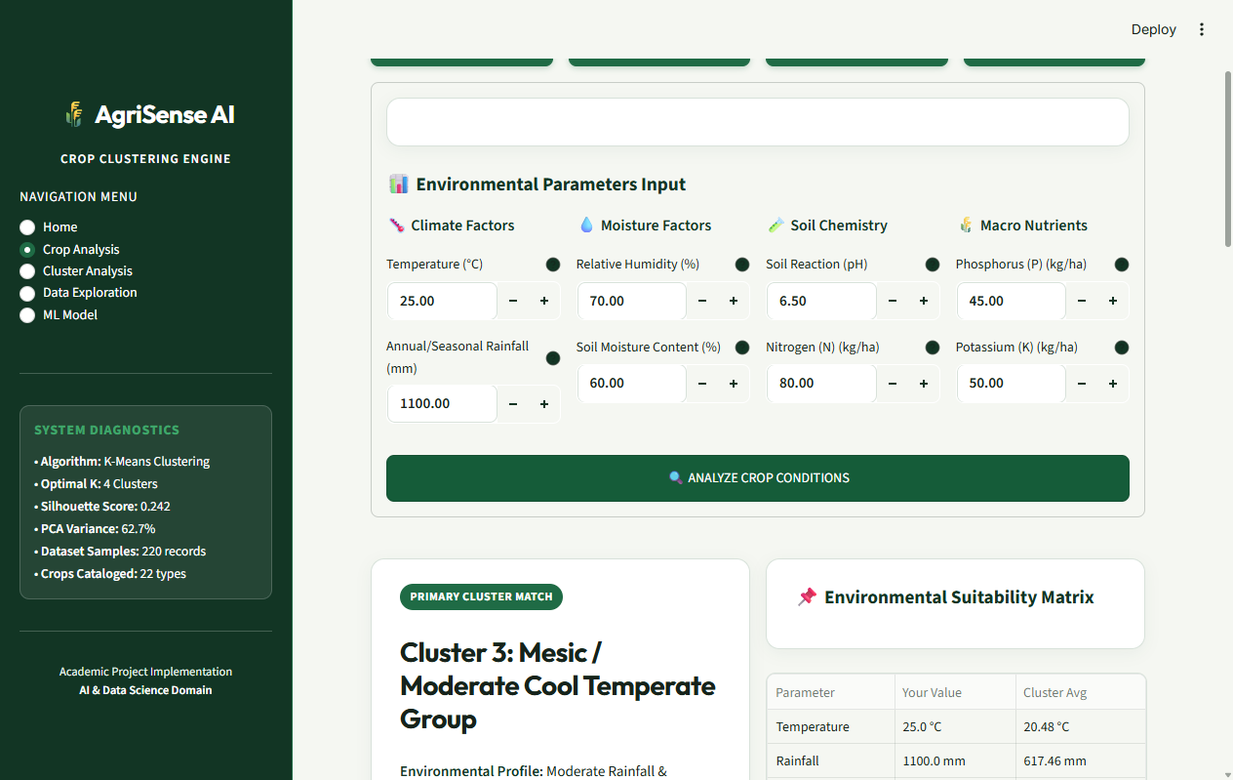
Fig. 2: Crop Suitability Recommendation Result
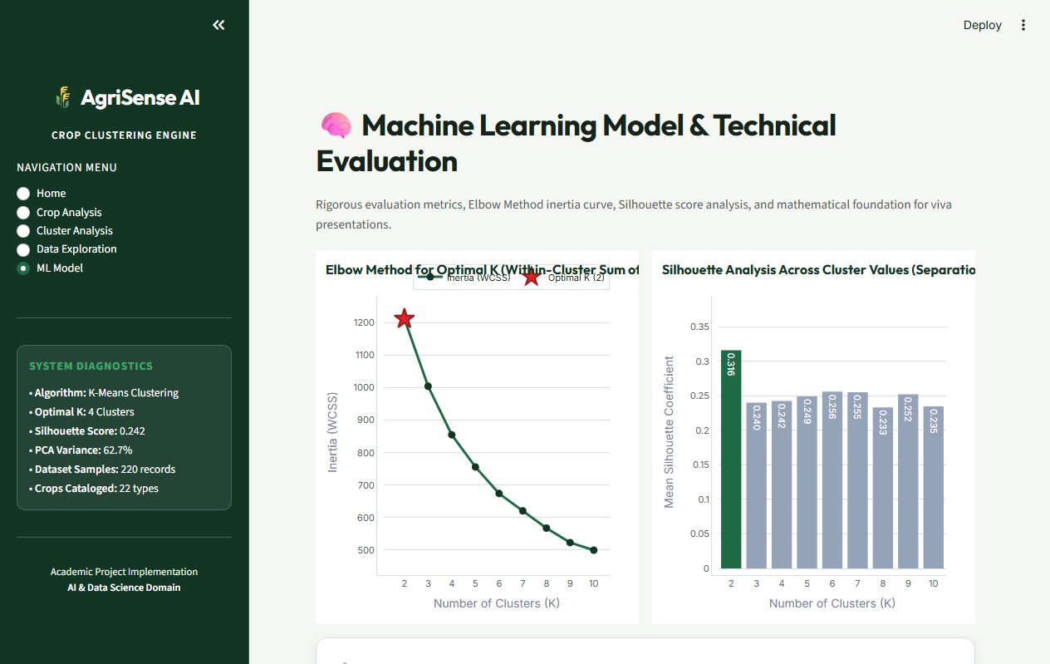
Fig. 3: Machine Learning Model Evaluation & Cluster Analysis Dashboard
Result:
The Agricultural Crop Condition Analysis system was successfully developed using Machine Learning and Streamlit. The system analyzes environmental and soil parameters, groups crops using K-Means clustering, evaluates the clusters using Elbow Method and Silhouette Score, and recommends suitable crops based on the entered agricultural conditions. The system was tested with different environmental inputs and successfully generated crop group and suitability recommendations.

