**MONGO DB Day 1 task**

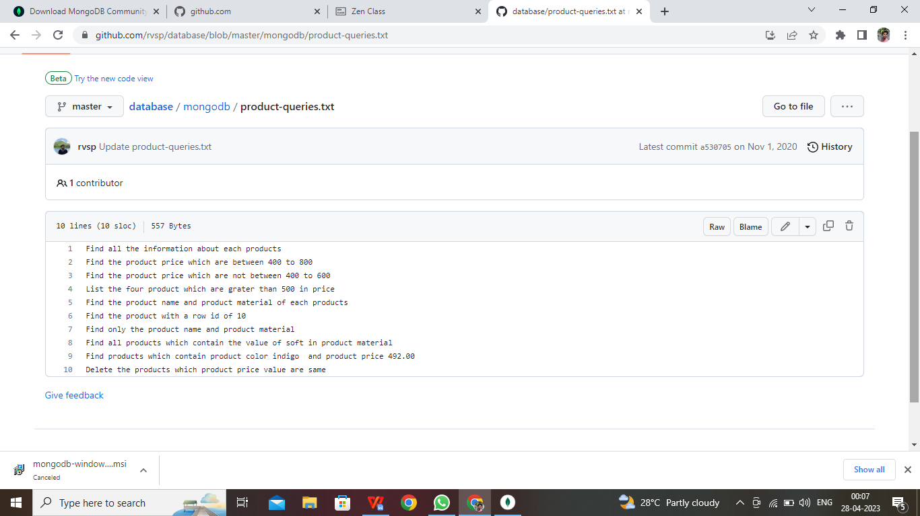

1. **db.product.find();**

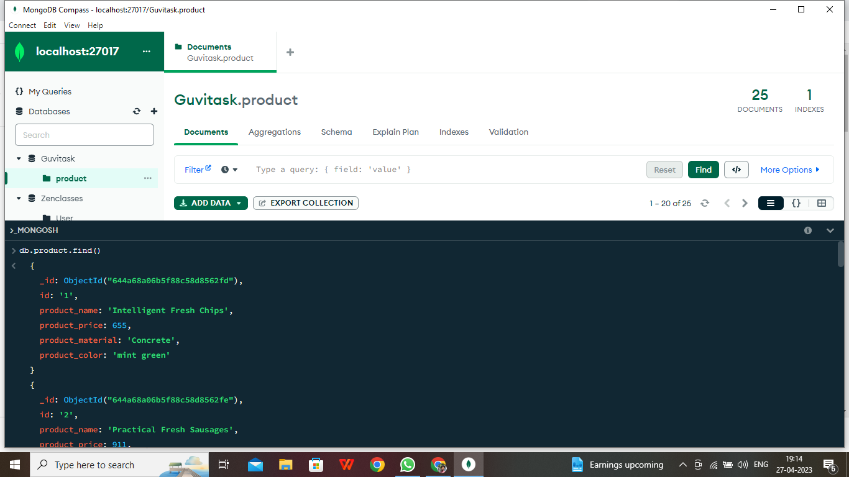

1. **db.product.find({product_price:{$gte:400,$lte:800}})**

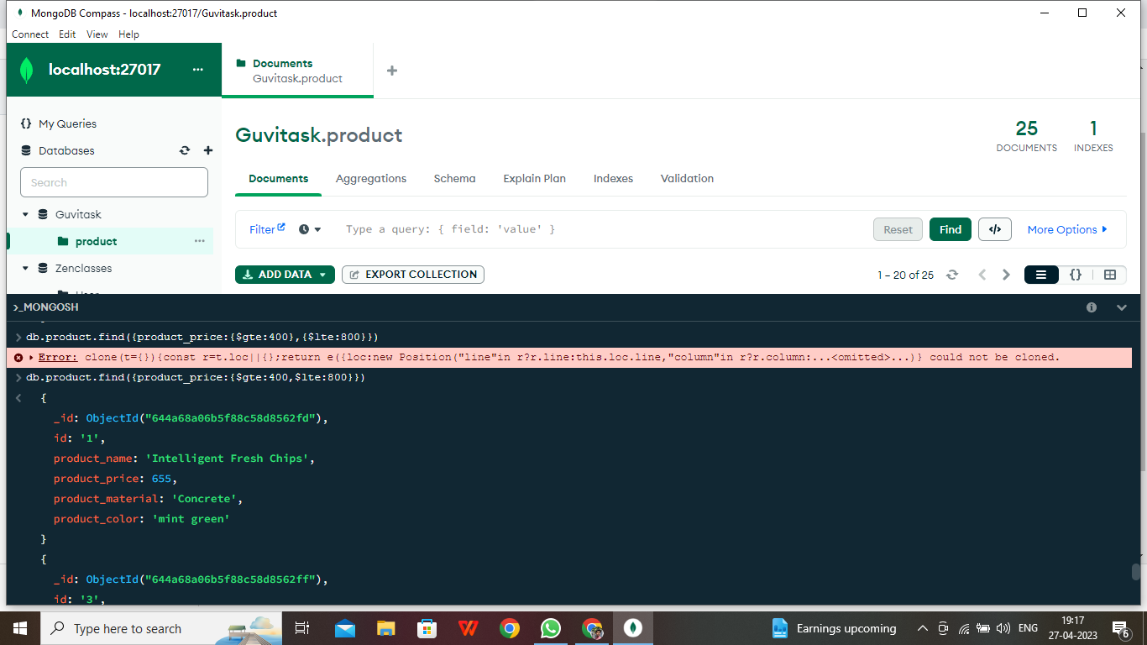

**3.**db.product.find({product_price:{$not:{$gte:400, $lte:600}}})

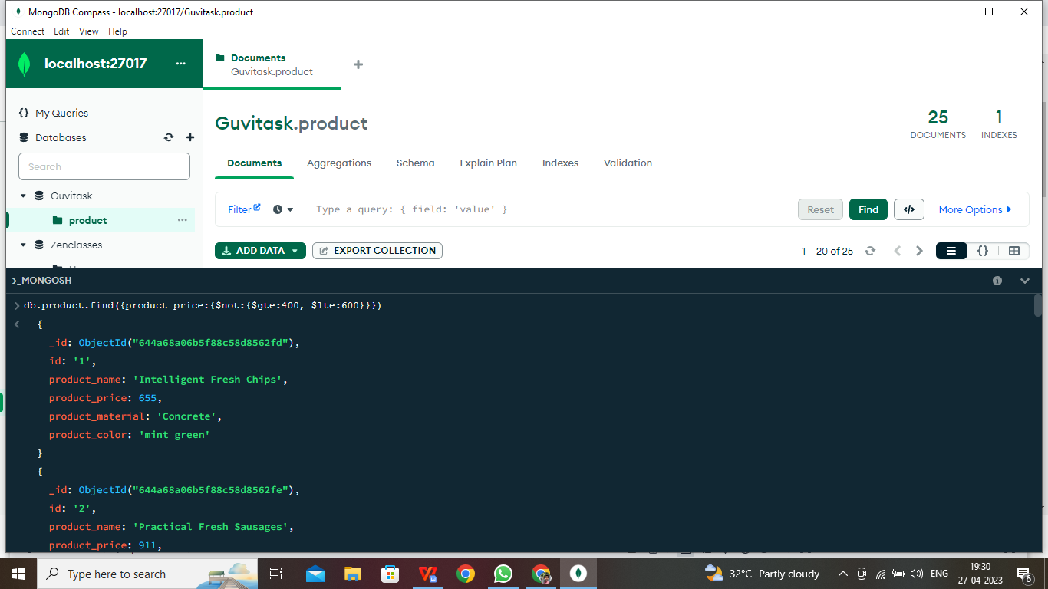

**4.db.product.find({product_price:{$gte:500}}).limit(4)**

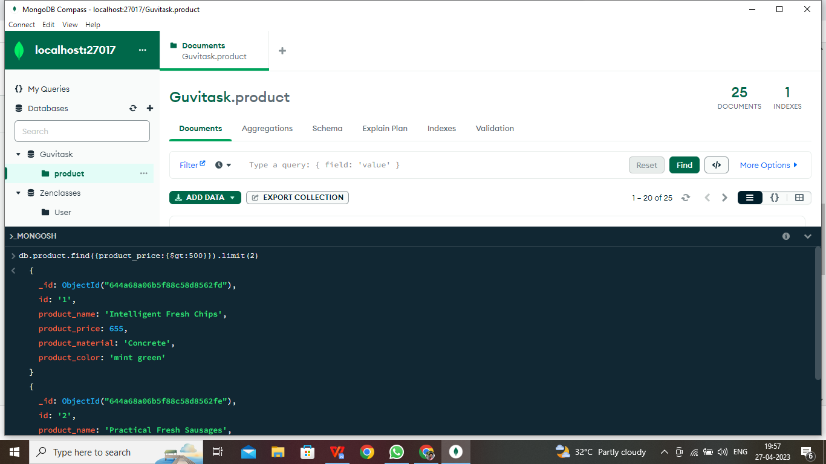

1. **db.product.find({product_price:{$gte:0}},{product_price:1,product_name:1,_id:0})**

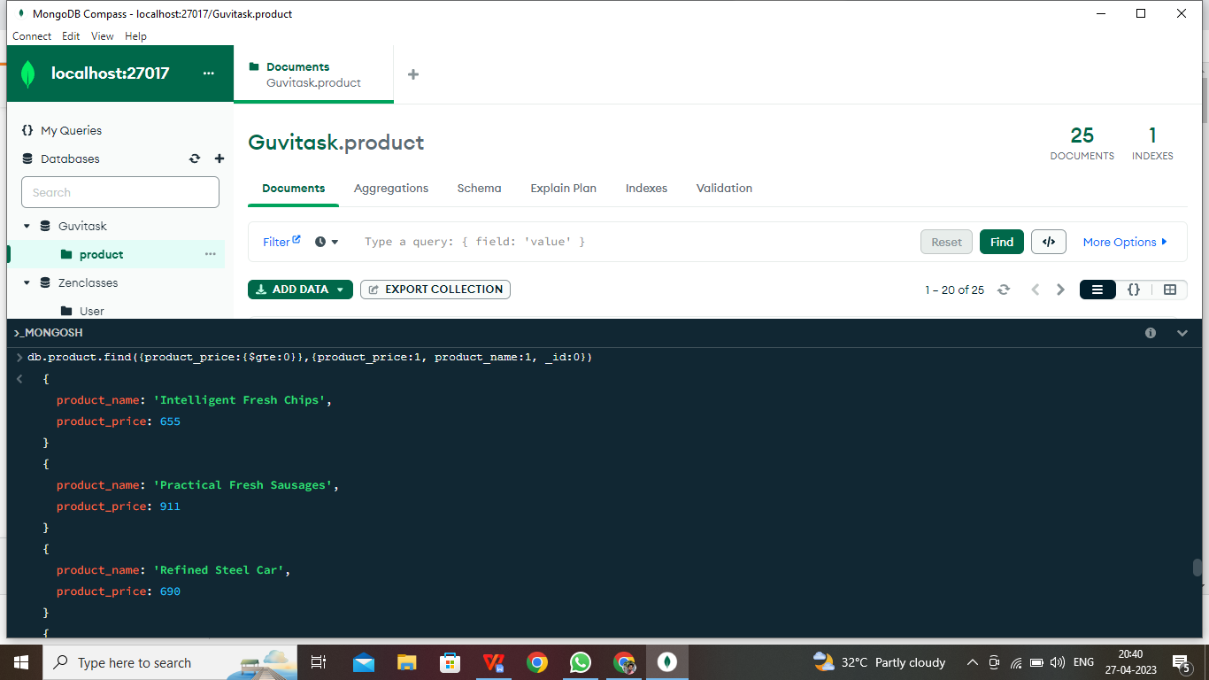

1. **db.product.find({id:’10’})**

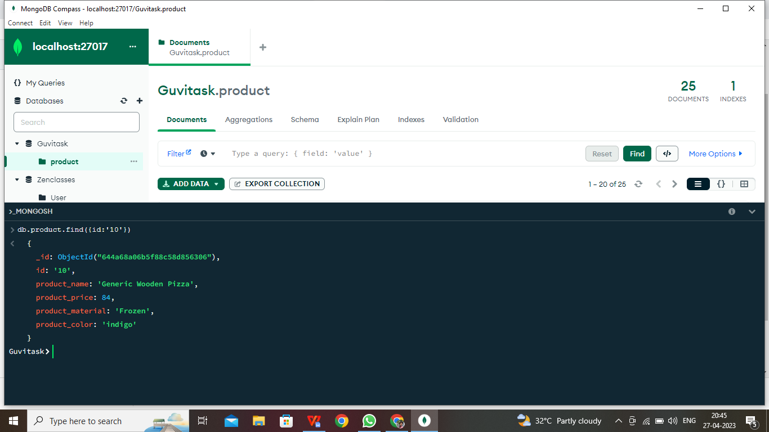

**7.db.product.find({product_price:{$gte:0}},{product_material:1,product_name:1,_id:0})**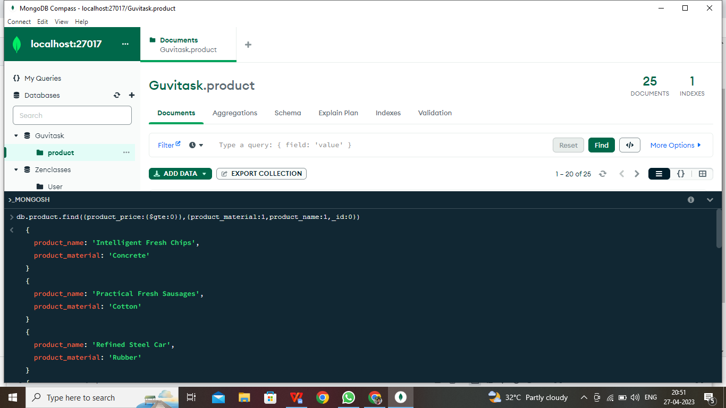

**8.db.product.find({product_material:{$regex:’Soft’}})**

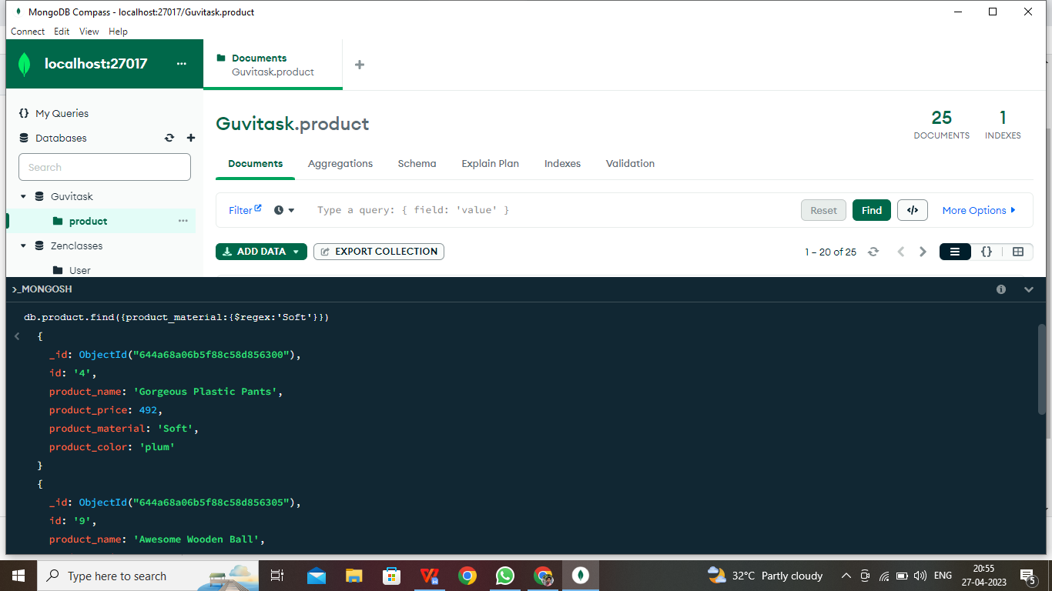

1. **db.getCollection('product').aggregate([{$match:{product_color:'indigo'}}]);**

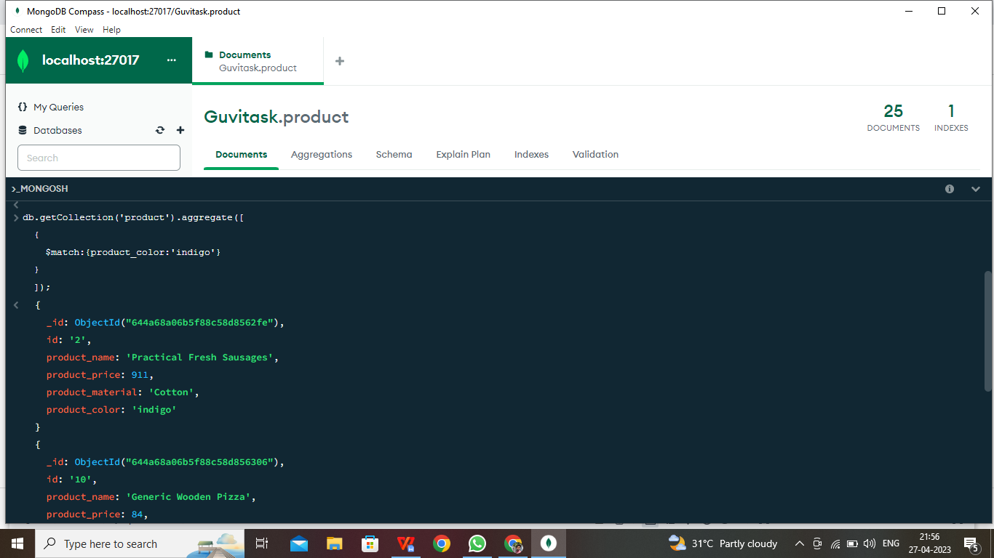

**9.db.getCollection('product').aggregate([{$match:{product_price:492}}]);**