CHALLENGE ON LAMDA, API GATEWAY AND KMS KEYS

AWS LAMDA:
AWS Lambda is a compute service that runs code without the need to manage servers. Your code runs, scaling up and down automatically, with pay-per-use pricing.

You can use Lambda for:
- File processing: Process files automatically when uploaded to Amazon Simple Storage Service. See file processing examples for details.
- Long-running workflows: Use durable Lambda functions to build stateful, multi-step workflows that can run for up to one year. Perfect for order processing, approval workflows, human-in-the-loop processes, and complex data pipelines that need to remember their progress.
- Database operations and integration examples: Respond to database changes and automate data workflows. See database examples for details.
- Scheduled and periodic tasks: Run automated operations on a regular schedule using EventBridge. See scheduled task examples for details.
- Stream processing: Process real-time data streams for analytics and monitoring. See Kinesis Data Streams for details.
- Web applications: Build scalable web apps that automatically adjust to demand.
- Mobile backends: Create secure API backends for mobile and web applications.
- IoT backends: Handle web, mobile, IoT, and third-party API requests. See IoT for details.

Functions and durable functions
Lamba functions run for up to 15 minutes and are ideal for event-driven tasks like processing API requests, handling file uploads, or responding to database changes. Durable functions extend this model for workloads that need to run longer and survive interruptions. They can execute for up to one year, automatically checkpointing their progress so they resume reliably after failures. Use durable functions when you need multi-step workflows, human-in-the-loop approvals, or coordination across services over extended periods.

How Lambda works
  - When using Lambda, you are responsible only for your code. Lambda runs your code on a high-availability compute infrastructure and manages all the computing resources, including server and operating system maintenance, capacity provisioning, automatic scaling, and logging.
- Because Lambda is a serverless, event-driven compute service, it uses a different programming paradigm than traditional web applications. The following model illustrates how Lambda works:
- You write and organize your code in Lambda functions, which are the basic building blocks you use to create a Lambda application.
- You control security and access through Lambda permissions, using execution roles to manage what AWS services your functions can interact with and what resource policies can interact with your code.
- Event sources and AWS services trigger your Lambda functions, passing event data in JSON format, which your functions process (this includes event source mappings).
- Lambda runs your code with language-specific runtimes (like Node.js and Python) in execution environments that package your runtime, layers, and extensions.

Key features
Configure, control, and deploy secure applications:
- Environment variables modify application behaviour without new code deployments.
- Versions safely test new features while maintaining stable production environments.
- Layers optimize code reuse and maintenance by sharing common components across multiple functions.
- Code signing enforce security compliance by ensuring only approved code reaches production systems.

Scale and perform reliably:
- Concurrency and scaling controls precisely manage application responsiveness and resource utilization during traffic spikes.
- Snapstart significantly reduce cold start times. Lambda SnapStart can provide as low as sub-second startup performance, typically with no changes to your function code.
- Response Streaming optimize function performance by delivering large payloads incrementally for real-time processing.
- Container image package functions with complex dependencies using container workflows

Connect and integrate seamlessly:
- VPC networks secure sensitive resources and internal services.
- File Systems integration that shares persistent data and manage stateful operations across function invocations.
- Function URLs create public-facing APIs and endpoints without additional services.
- Extensions augment functions with monitoring, security, and operational tools.

The python code example show how to get started using Lambda:

import boto3

def main():
"""
List the Lambda functions in your AWS account.
"""
# Create the Lambda client
lambda_client = boto3.client("lambda")

# Use the paginator to list the functions
paginator = lambda_client.get_paginator("list_functions")
response_iterator = paginator.paginate()

print("Here are the Lambda functions in your account:")
for page in response_iterator:
for function in page["Functions"]:
print(f" {function['FunctionName']}")

if __name__ == "__main__":
main()

STEP BY STEP IMPLEMENTATION:
- Lambda_handler :- this is the first function that aws lambda looks for
- before executing the script
- Event:- This is a Python dictionary that contains information about why
- the function was triggered
- Context:- this contains system information about the running
- environment (like how much time is left before AWS shuts the function
- down)
- Return:- it return the answer to whoever sends the request
- Creating a simple function that takes two numbers, adds them together,
- and returns the result

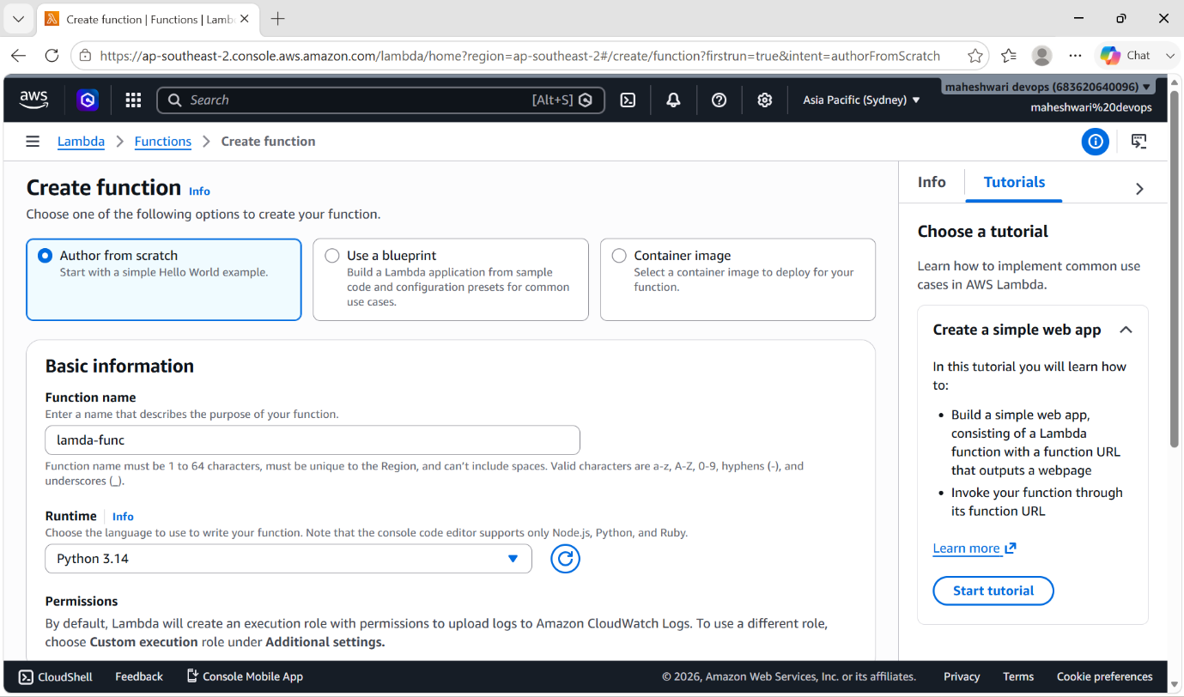

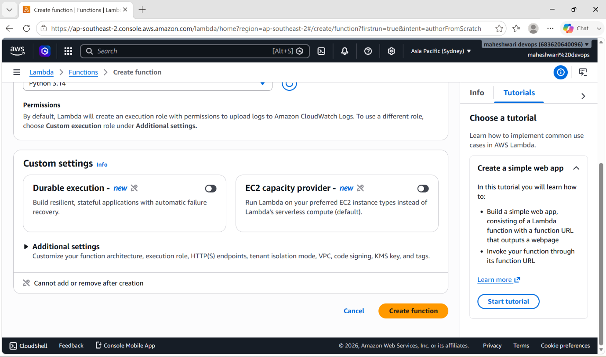

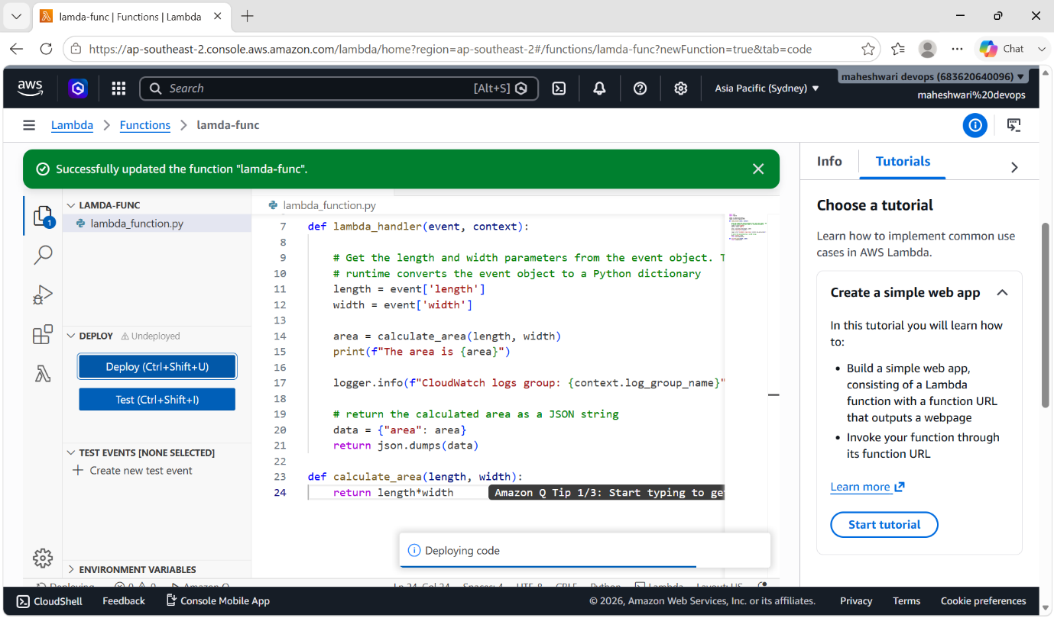

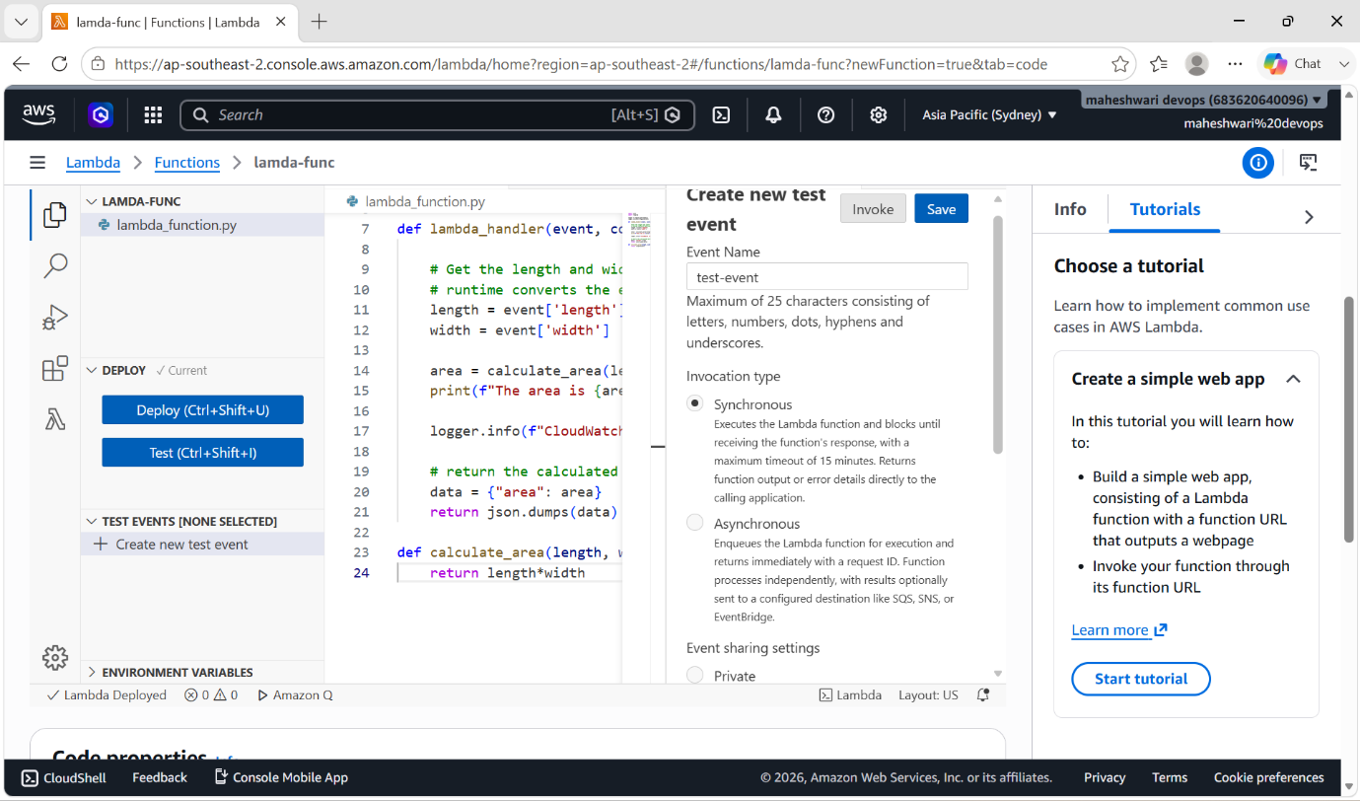

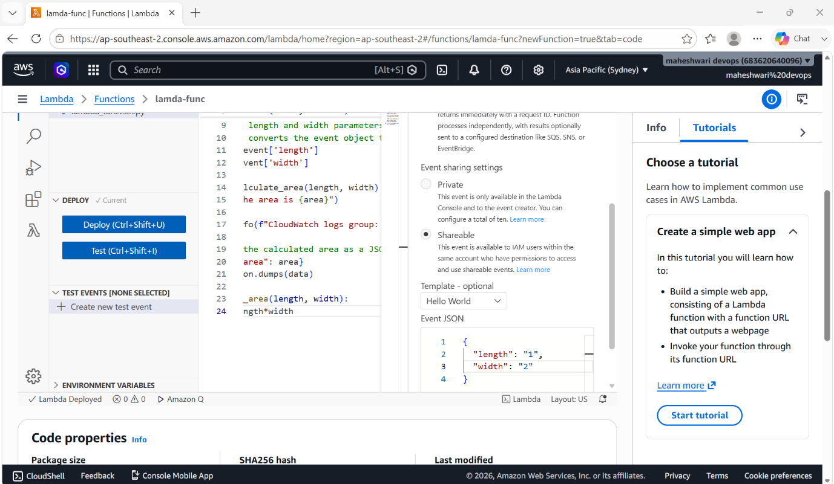

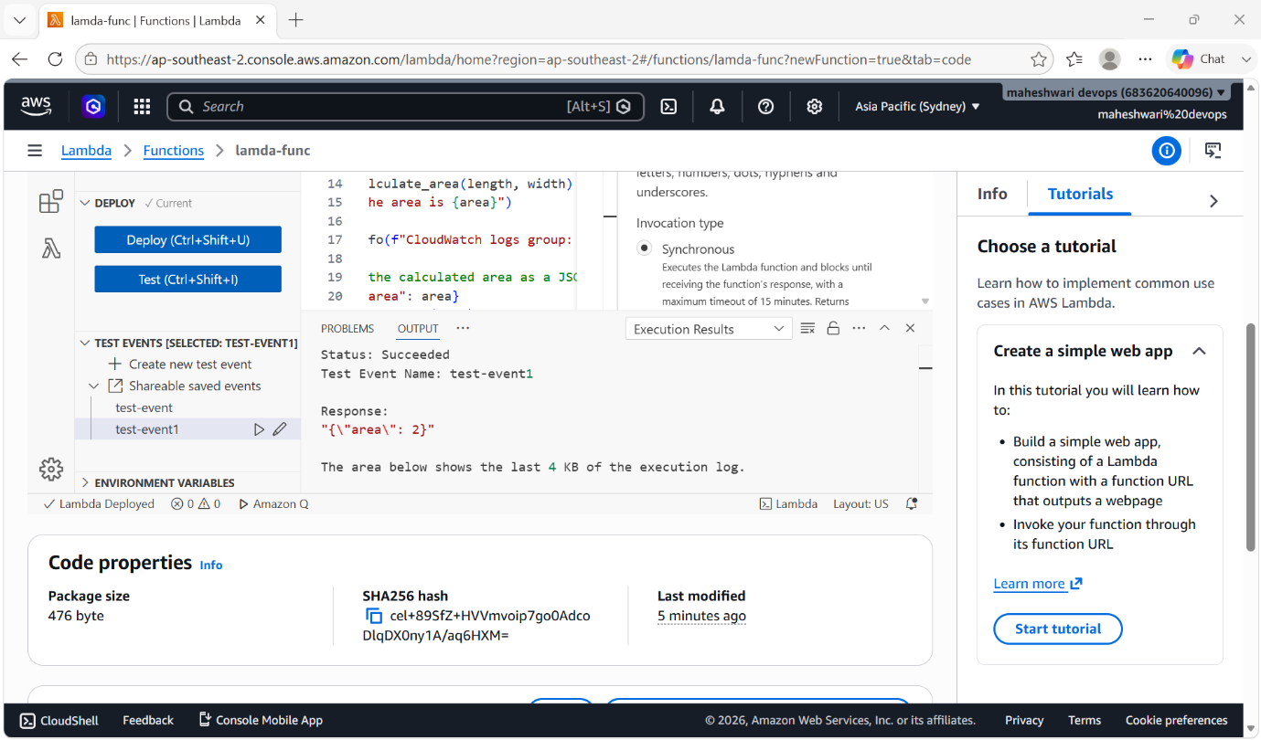

API GATEWAY

- An API Gateway is a centralized server or software component that acts as a single entry point ("front door") for all incoming client requests to your backend services
- If a user makes a request the api checks the security and access for the user
- If I have to use api gateway and load balancer and instance for user the request flow as shown in below

[ Public Internet ]
│
▼
┌─────────────────────────────────┐
Amazon API Gateway <-- Manages Auth,│ │
Throttling, & Public HTTPS
└───────────────┬─────────────────┘
│
(Secure VPC Link)▼
┌─────────────────────────────────┐
Application Load Balancer (ALB) <-- Private / Internal│ │
Load Balancer
└───────────────┬─────────────────┘
│
┌───────┴───────┐
▼ ▼
┌───────────────┐┌───────────────┐
EC2 App 1 EC2 App 2 <-- Isolated Backend│ ││ │
Instances (Private Subnets)
└───────────────┘└───────────────┘
- First the traffic is distributed to the available servers equally
then the allowed traffic is checked by the api gateway
then it allows to the instance

- Created 2 instances in EC2.
- created a load balancer and api gateway to my instances
- and this load balancer url is connected with the api gateway for the deployment.

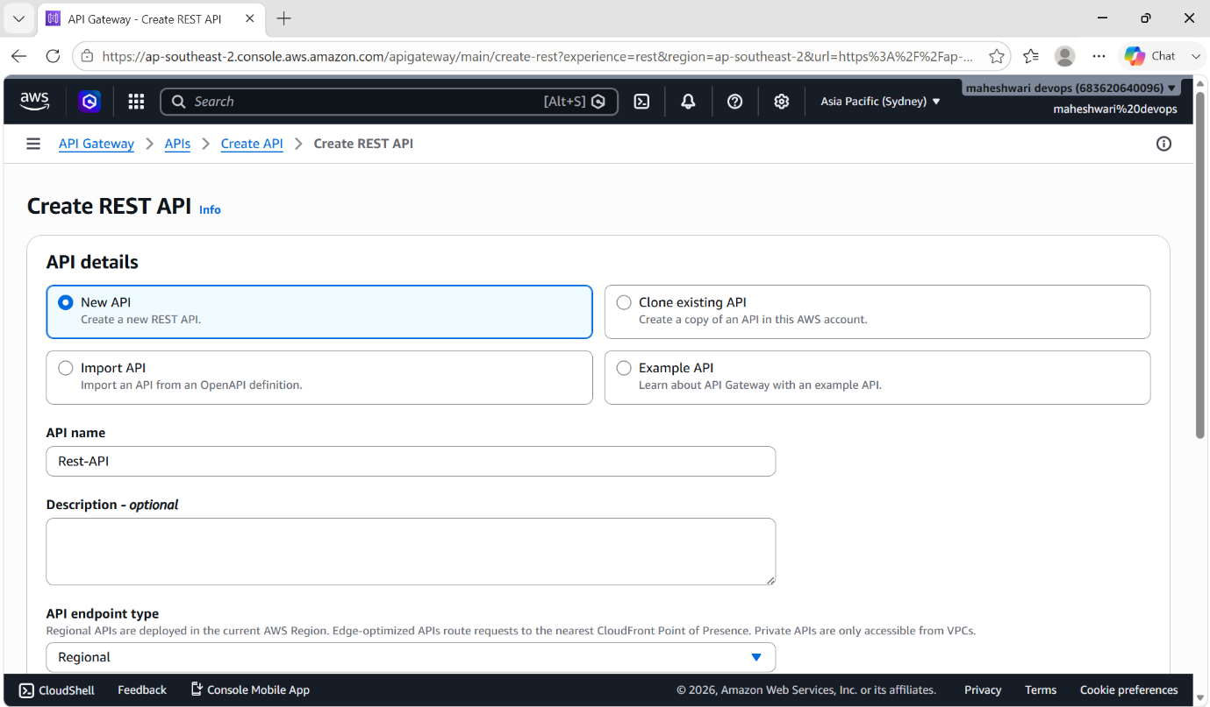

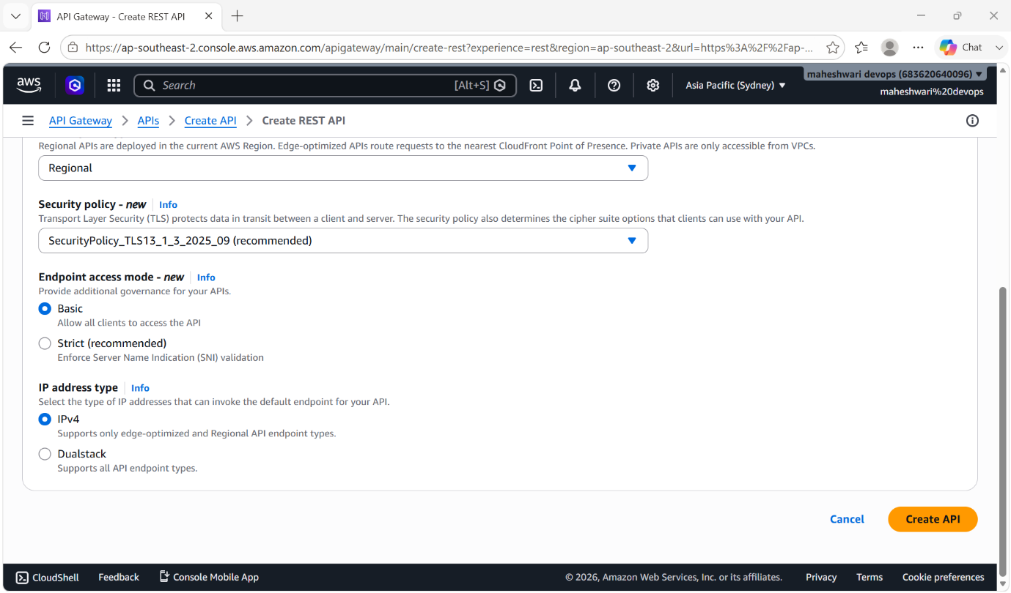

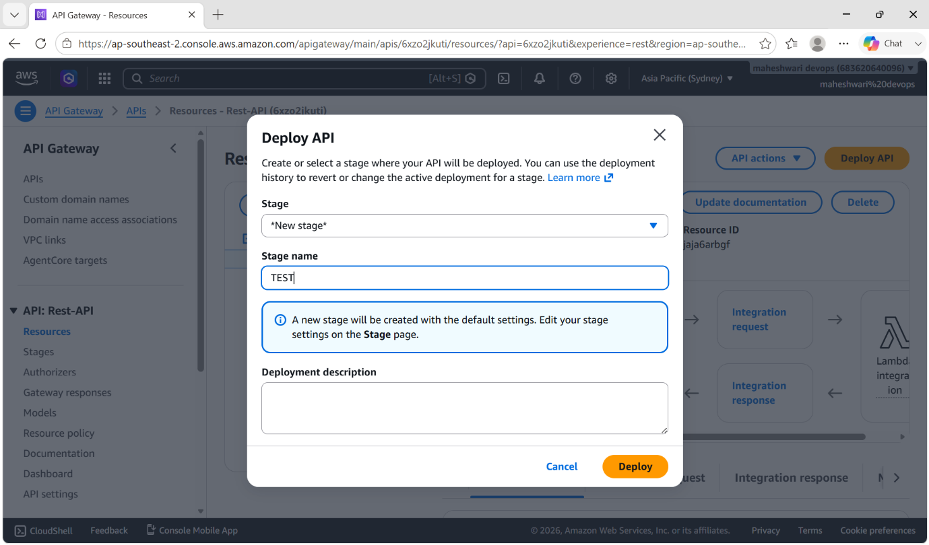

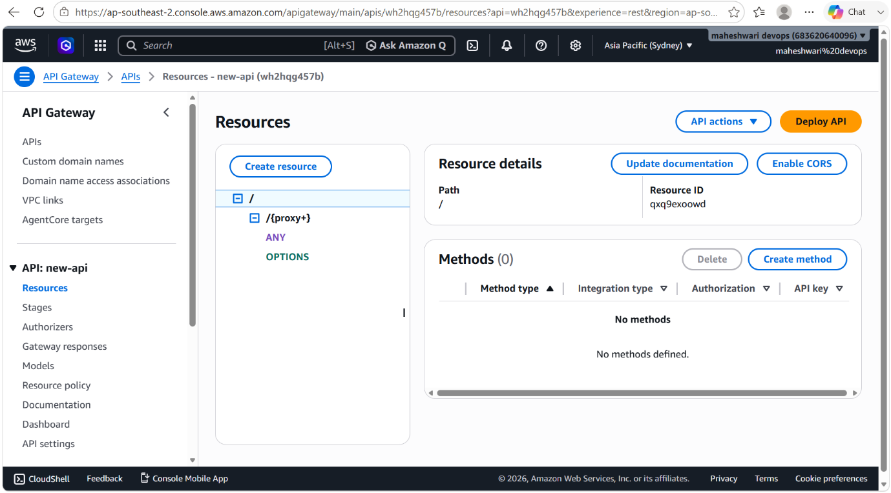

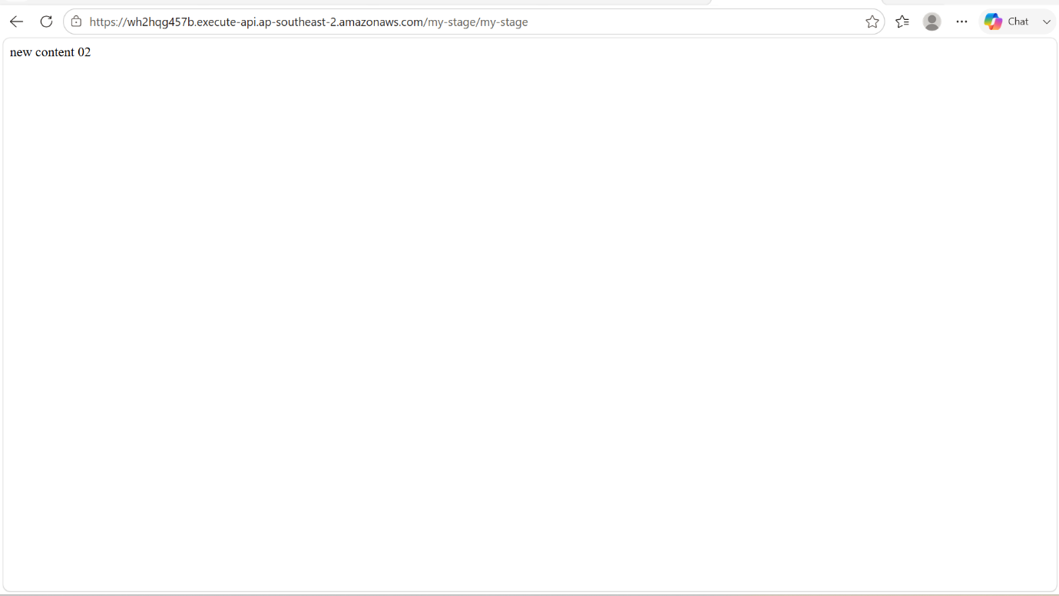

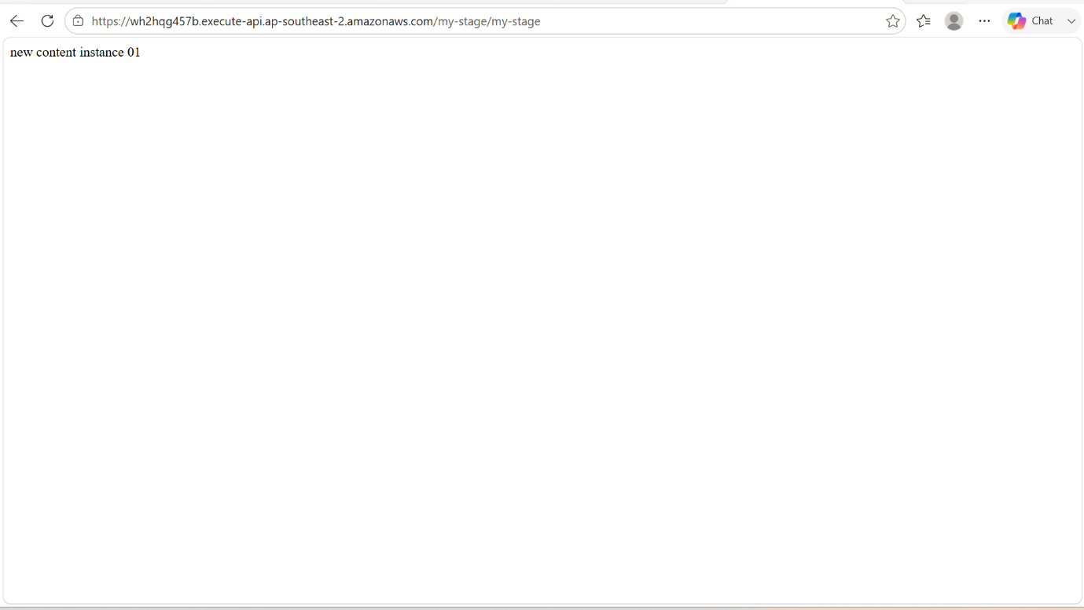

AWS KEY MANAGEMENT SERVICE

AWS managed service that makes it easy for you to create and control the keys used to encrypt and sign your data.

why use AWS KMS?
- When you encrypt data, you need to protect your encryption key. If you encrypt your key, you need to protect its encryption key. Eventually, you must protect the highest level encryption key (known as a root key) in the hierarchy that protects your data. That's where AWS KMS comes in.

- AWS KMS protects your root keys. KMS keys are created, managed, used, and deleted entirely within AWS KMS. They never leave the service unencrypted. To use or manage your KMS keys, you call AWS KMS.
- Additionally, you can create and manage key policies in AWS KMS, ensuring that only trusted users have access to KMS keys.

Key Architecture
- Symmetric Keys: 256-bit keys (AES-GCM) used for standard data
encryption and decryption.
- Asymmetric Keys: RSA or ECC key pairs used for encryption, decryption, or digital signatures.
- HMAC Keys: Symmetric keys used to generate and verify message
authentication codes.

Key Types & Governance
- Customer Managed: Keys you create and control ($1/month base cost).
- You manage policies and rotation.
- AWS Managed: Created automatically by AWS services (e.g., S3, EBS).
- Free to store; you only pay for API usage.
- AWS Owned: Internal AWS keys used to protect infrastructure. Invisible
- in your account and completely free

Use case example
- If I upload a object to a bucket
- I will be creating a bucket with sse-kms that is managed by aws
- Now my files are protected by kms
- I will be uploading a new file to a bucket that has key enabled

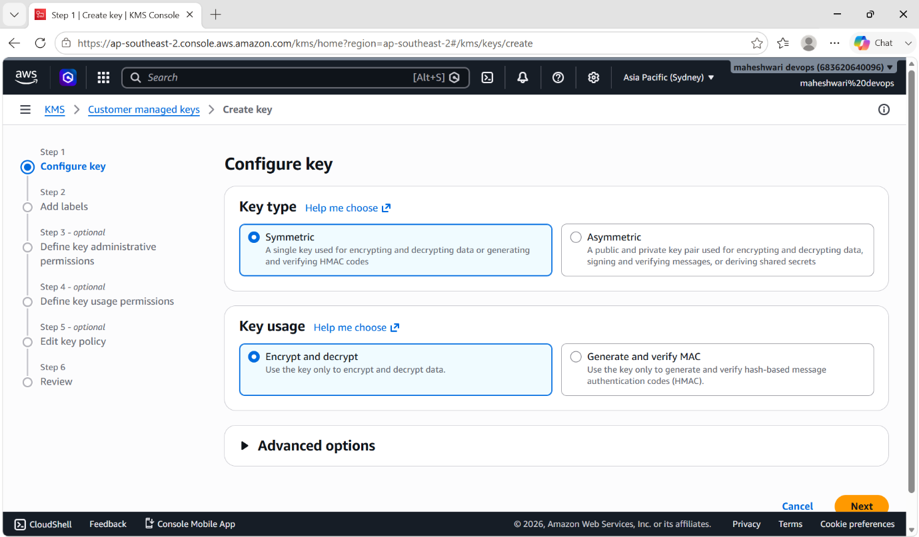

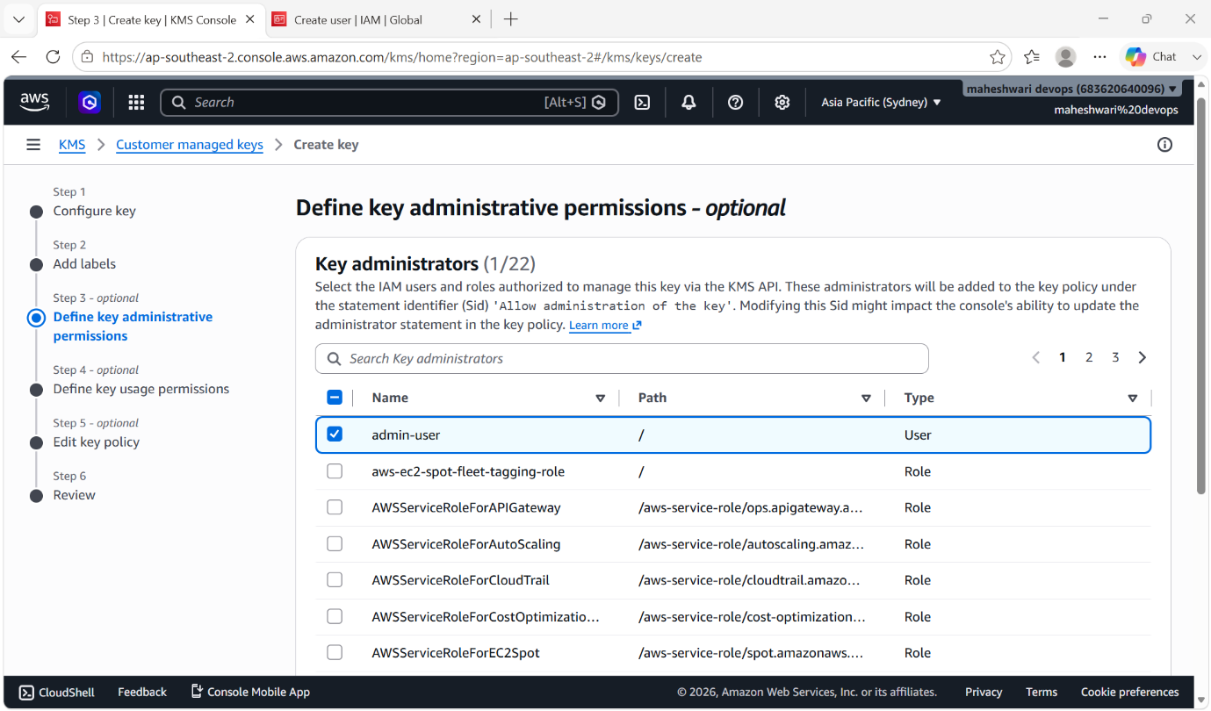

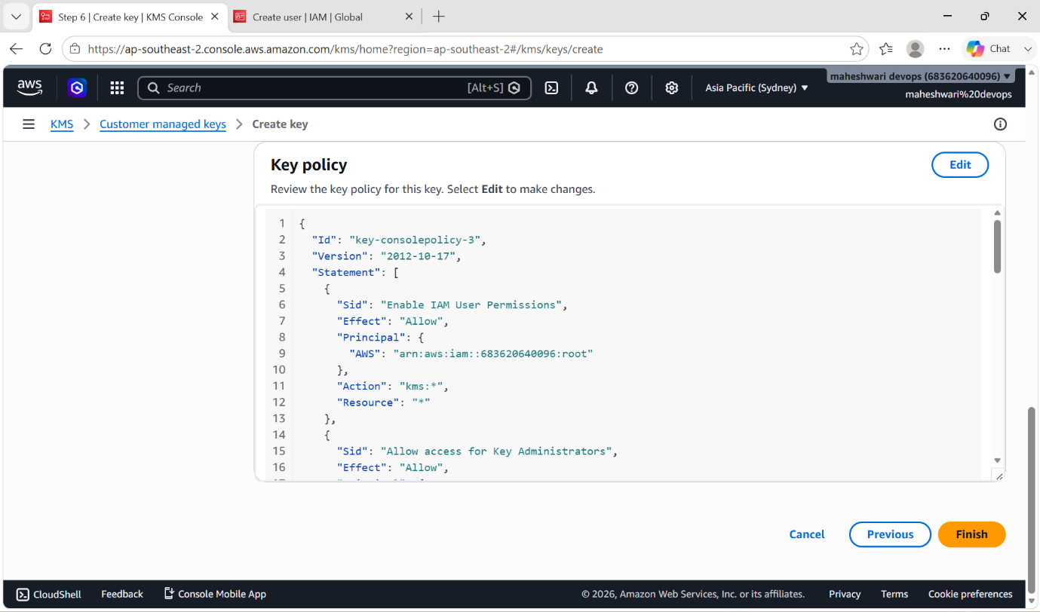

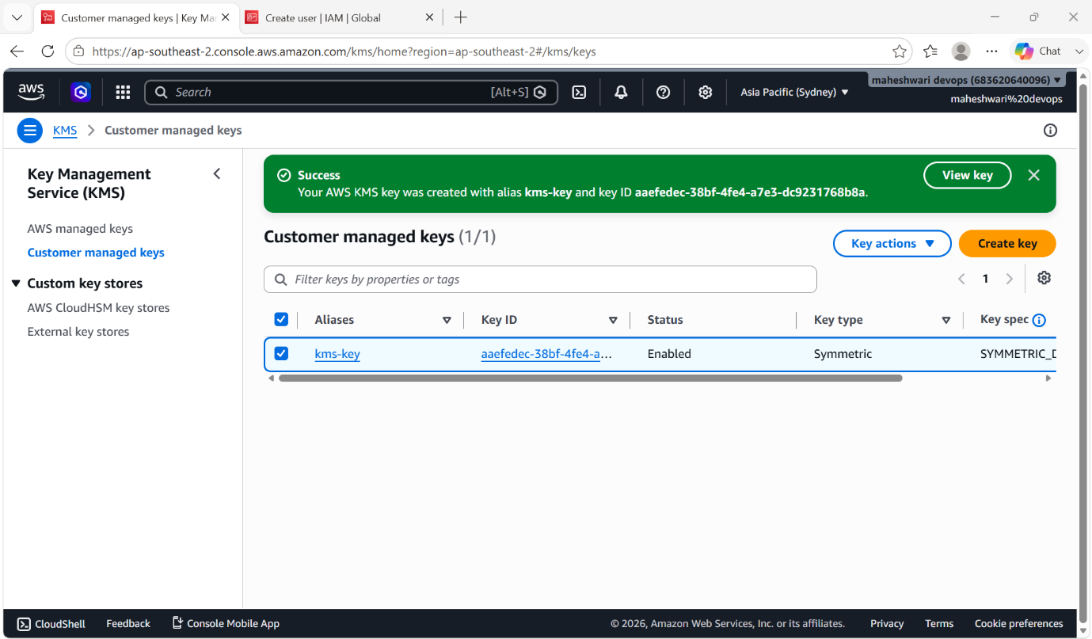

- We can this KMS Key and we can delete that bucket also.

