CHALLENGE ON SQS, MQ AND SECRETS MANAGER

SIMPLE QUEUE SERVICE

- Amazon SQS is a fully managed message queuing service used to decouple applications. It acts as a middle layer between components so they can communicate reliably.
- Architecture Flow of SQS:

Producer (Application)
│
│ Sends Messages
▼
Amazon SQS Queue
│
│ Stores Messages Temporarily
▼
Consumer (Application/EC2/Lambda)
│
│ Processes Messages
▼
Deletes Message from Queue

- COMPONENTS:

- Producer:
- The application that sends message to the SQS queue.
- Examples:
- Web application
- EC2 instance
- Lamda function
- Microservice

- SQS Queue:
- Temporarily stores messages until consumers process them.
- Highly available and scalable.
- Messages are rebundantly stored across multiple AWS servers.

- Consumer:
- Retrieves messages from the queue.
- Processes the task.
- Deletes the message after successful processing.

MESSAGE LIFECYCLE:

- Producer sends a message to SQS.
- SQS stores the message.
- Consumer polls the queue and receives the message.
- The message becomes temporarily invisible to other consumers (Visibility Timeout).
- Consumer processes the message.
- Consumer deletes the message from the queue.

IMPORTANT CONCEPTS:

- Visibility timeout:
- Prevents multiple consumers from processing the same message simultaneously.
- If the consumer fails to delete the message before the timeout expires, the message becomes visible again.

- Dead-letter Queue:
- Stores messages that fail processing multiple times.
- Helps troubleshoot problematic messages.

- Long polling:
- Waits for messages to arrive before responding.
- Reduces empty responses and lowers cost.

Benefits of using Amazon SQS:
- Failure or slowness in one service does not directly affect the other.
- Prevent backend systems from becoming overloaded.
- Reduces the risk of losing tasks.
- Automatic recovery from failures.
- Supports growth from a few messages to millions of messages.
- Faster response times for users.
- Easier troubleshooting without blocking older messages.
- Optimizes cost and performance.
- Makes it easy to build event-driven architectures.
- Lower operational header.

Difference between Standard Queue VS FIFO Queue:

Standard Queue | FIFO Queue
Messages may be delivered out of order. | Messages are delivered in the exact order they are sent.
Duplicate messages can occur. | Duplicate messages are prevented using deduplication.
Supports very high throughput. | Lower throughput than Standard Queue (unless using high-throughput FIFO).
Provides at-least-once delivery. | Supports exactly-once processing with deduplication.
Best for high-volume workloads where order is not important. | Best for workloads where message order and uniqueness are critical.

QUOTAS:
Quotas in SQS are the limits set by AWS on SQS resources and operations.

1.Message size quota: Maximum size of a message that can be sent.
2.Retention period quota: How long messages can stay in a queue.
3.throughput quota: Maximumn number of messages that can be sent or received per second.
4.policy quota: maximum size and complexity of a queue access policy.
5.batch quots: maximum number of messages in a batch request(10).

DEAD-LETTER QUEUE (DLQ):
- A Dead-Letter Queue is a special queue where messages that cannot be processed successfully are sent.
- Example:
- A message is sent to the main queue
- A consumer tries to process it but fails.
- SQS retries processing the message several times.
- If the message still fails after the configured number of attempts (maxRecieveCount), SQS moves it to the DLQ.
- WHY USE A DLQ:
- Prevents problematic messages from blocking the main queue.
- Helps identify and troubleshoot failed messages.
- Allows you to inspect and reprocess messages later.

EXAMPLE FOR HANDS ON EXPERIENCE:

SQS + EC2 WORKER:

Producer (AWS CLI)
↓
SQS Queue
↓
EC2 Instance (Worker)
↓
Processes Message
↓
Deletes Message from Queue

PURPOSE: EC2 + SQS is used to build scalable, decoupled, and fault-tolerant background processing systems where SQS acts as a buffer between producers and workers.
STEP BY STEP IMPLEMENTATION:
- Create an SQS Queue, in the process we have to select standard queue and give a name and create a queue.

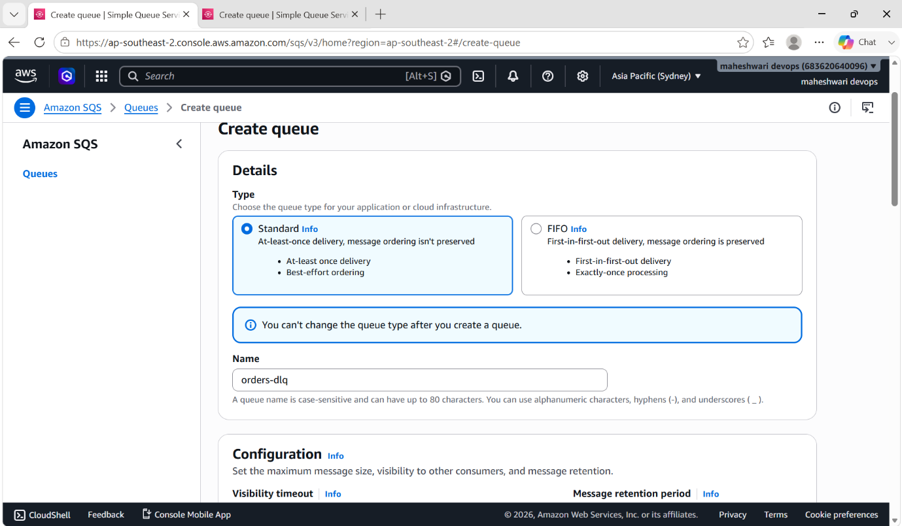

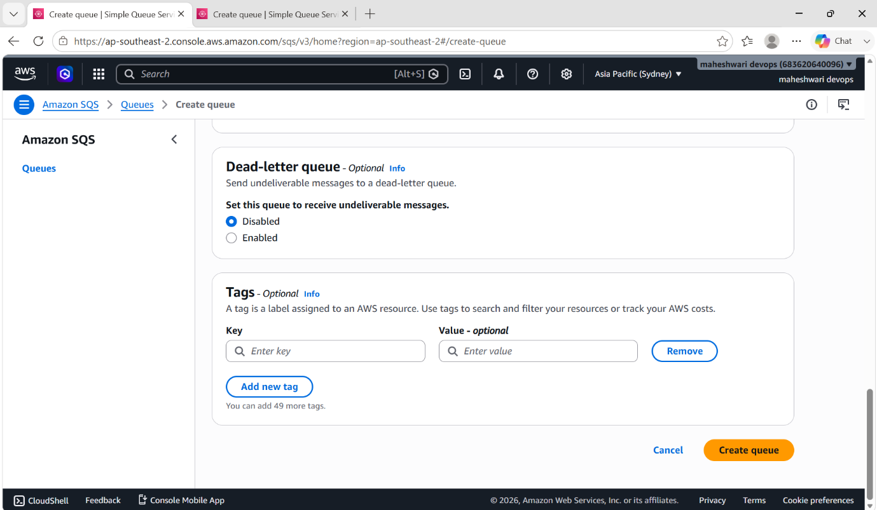

- And now create an instance with amazon linux 2 image.
- Create an IAM Role for SQS full access for the EC2 instance and attach that role to the EC2 instance
- After launching an instance, login into that instance using ssh that is in git bash.
- After ssh, we have to download python3 and install boto3
- After installation, we have to write a worker script in our instance.
- The worker script will acts as a consumer for the SQS queue.
- And after writing the script, give the executive permissions to the worker script.
- In the worker script, we have to edit the queue url with our queue url that we have created.
- And now run the worker and you will get the messages as
No messages
No messages.
- Because we haven’t raise the orders yet.

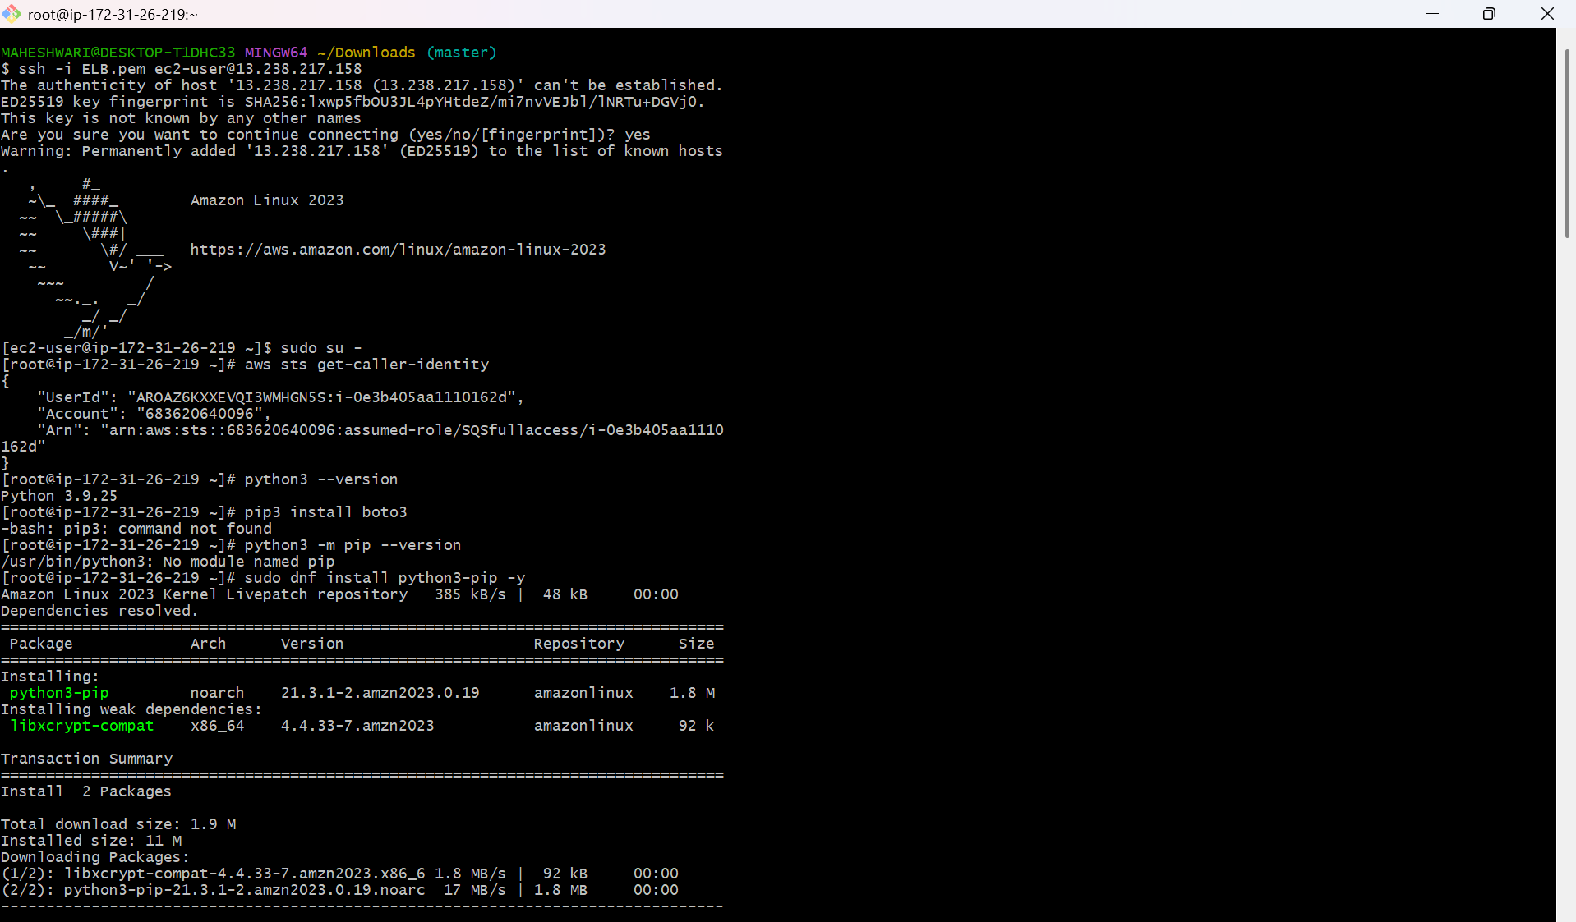

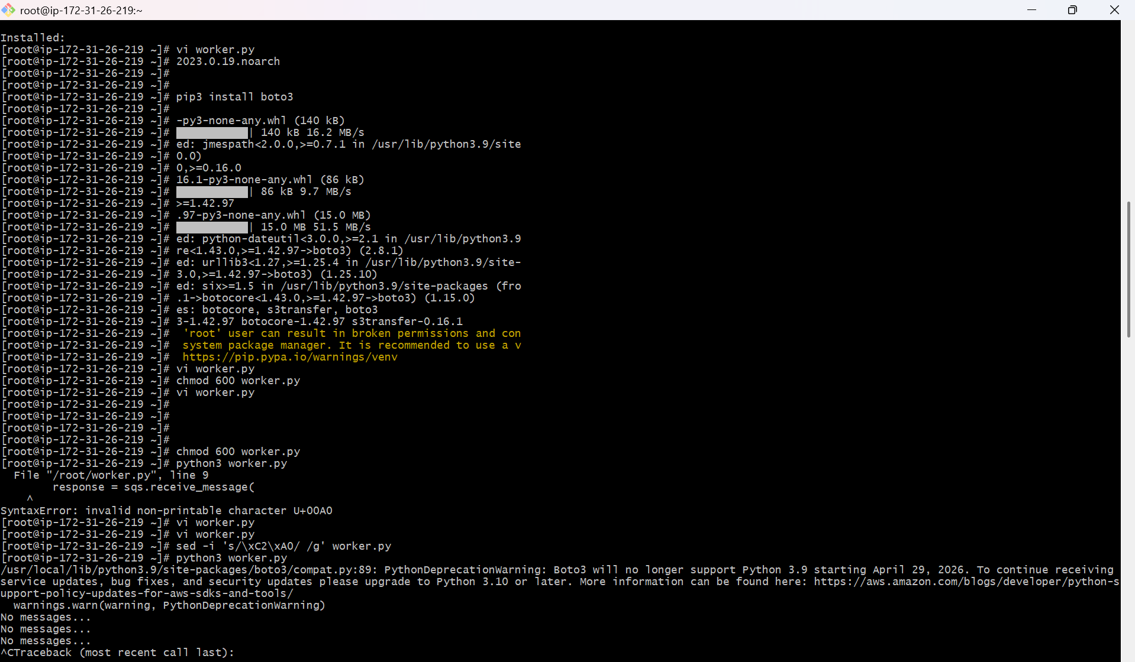

- Now open another terminal and request the order and u will get to see that some queue is creating.
- And the command to send the message is
aws sqs send-message \
--queue-url "<paste-the-correct-queue-url>" \
--message-body "Order-1001"

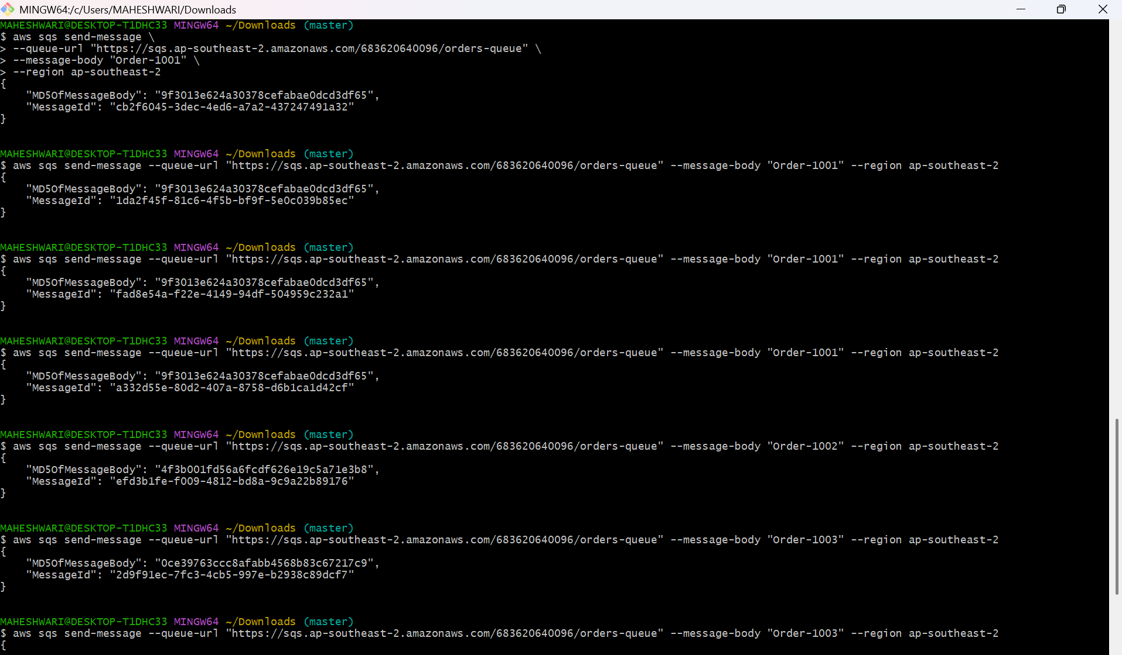
- And now go to the EC2 instance terminal and there you will see the messages by running the script

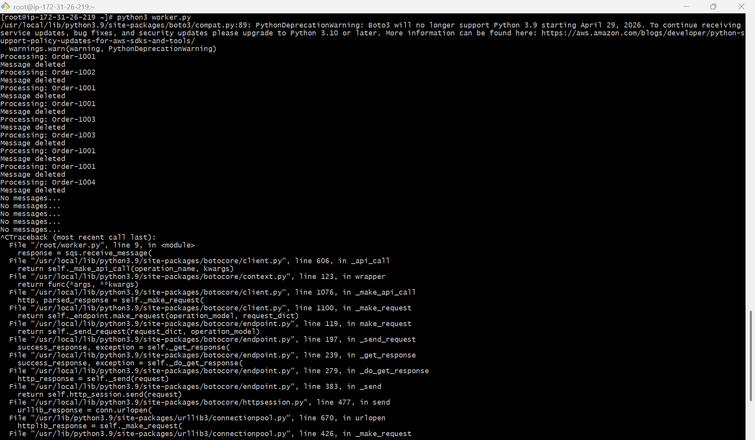

- In the AWS console also we can check for the messages requested.

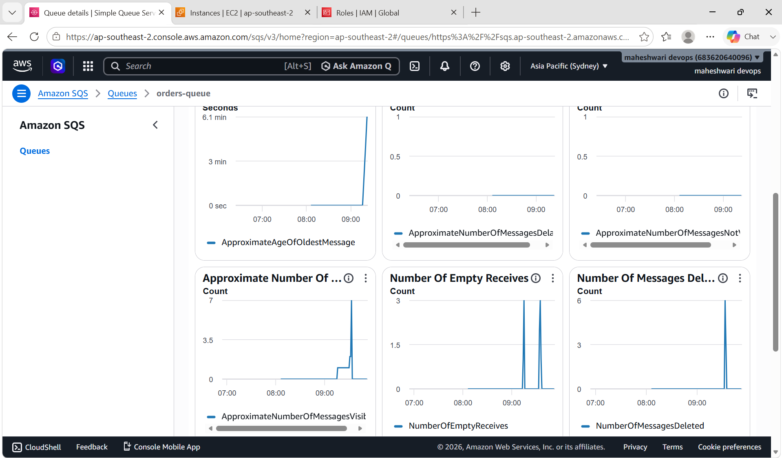

AMAZON MESSAGE QUEUE (MQ)

Amazon MQ is a managed message broker service in AWS that lets you run traditional messaging systems like ActiveMQ and RabbitMQ without managing the infrastructure yourself.

ActiveMQ: Apache ActiveMQ is an open-source message broker that helps different applications communicate by sending messages between them asynchronously.

RabbitMQ: RabbitMQ is an open source message used to send and receive messages between applications asynchrounously.

ADVANTAGES OF AMAZON MQ:

1. No server management
You don’t need to install, patch, or maintain message broker servers like ActiveMQ or RabbitMQ. AWS handles it for you

2. Easy migration for legacy systems
If you already use ActiveMQ or RabbitMQ, you can move to Amazon MQ without changing your application code much.

3. Supports advanced messaging protocols
It supports standard protocols like:
- JMS
- AMQP
- MQTT
This makes it suitable for enterprise and IoT systems.

4. Reliable message delivery
Messages are stored safely until they are processed, reducing the risk of data loss.

5. High availability
Amazon MQ can be deployed in Multi-AZ mode, so if one server fails, another takes over automatically.

6. Secure communication
Supports encryption in transit and at rest, plus AWS IAM and VPC-based security.

7. Works well with complex messaging patterns
Supports:
- Point-to-point (queues)
- Publish/subscribe (topics)
- Request-response patterns

Key components of MQ systems

1. Producer
- Sends messages
- Example: EC2 app, microservice, API

2. Queue / Broker
- Stores messages temporarily
- Ensures delivery
- Handles ordering/retries
Examples:
- Amazon Simple Queue Service (SQS)
- RabbitMQ
- Apache ActiveMQ
- Amazon MQ

3. Consumer
- Reads messages
- Processes them
- Deletes after success

Types of messaging patterns

1. Point-to-Point (Queue model)
- One message → one consumer
- Used in order processing
Producer → Queue → One Consumer

2. Publish / Subscribe (Pub-Sub)
- One message → many consumers
Producer → Topic → Multiple Consumers
Used in:
- Notifications
- Event broadcasting

Key MQ features

1. Asynchronous communication
- Producer doesn’t wait for consumer

2. Decoupling
- Services are independent

3. Reliability
- Messages stored until processed

4. Retry mechanism
- Failed messages retried automatically

5. Dead Letter Queue (DLQ)
- Stores failed messages

Types of MQ systems

1. Simple queue (SQS style)
- Easy
- Scalable
- No server management

2. Full message broker (RabbitMQ / ActiveMQ)
- Advanced routing
- Complex workflows
- Requires setup

3. Managed broker (Amazon MQ)
- Runs ActiveMQ/RabbitMQ for you
- Enterprise features

STEP BY STEP IMPLEMENTATION:

- Create a RabbitMQ broker in Amazon MQ service in AWS.

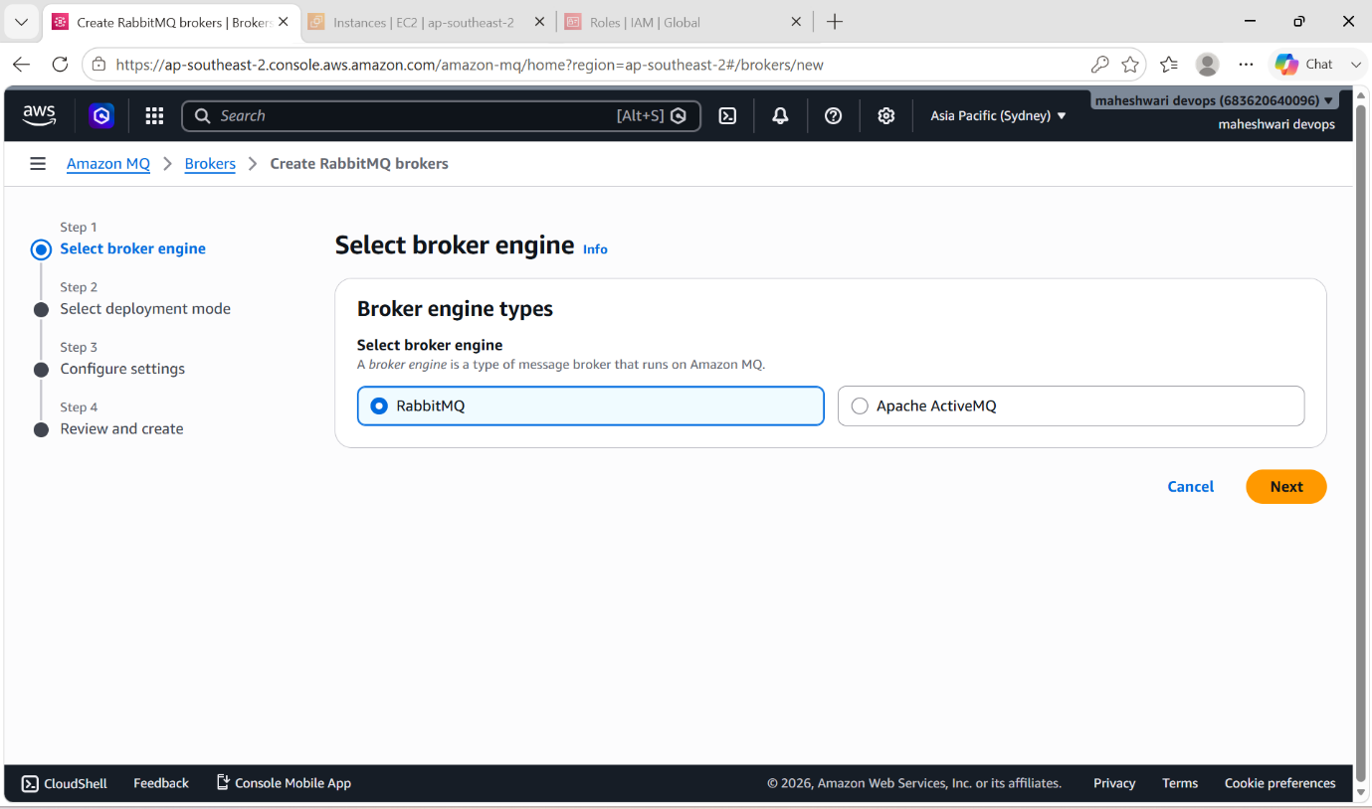

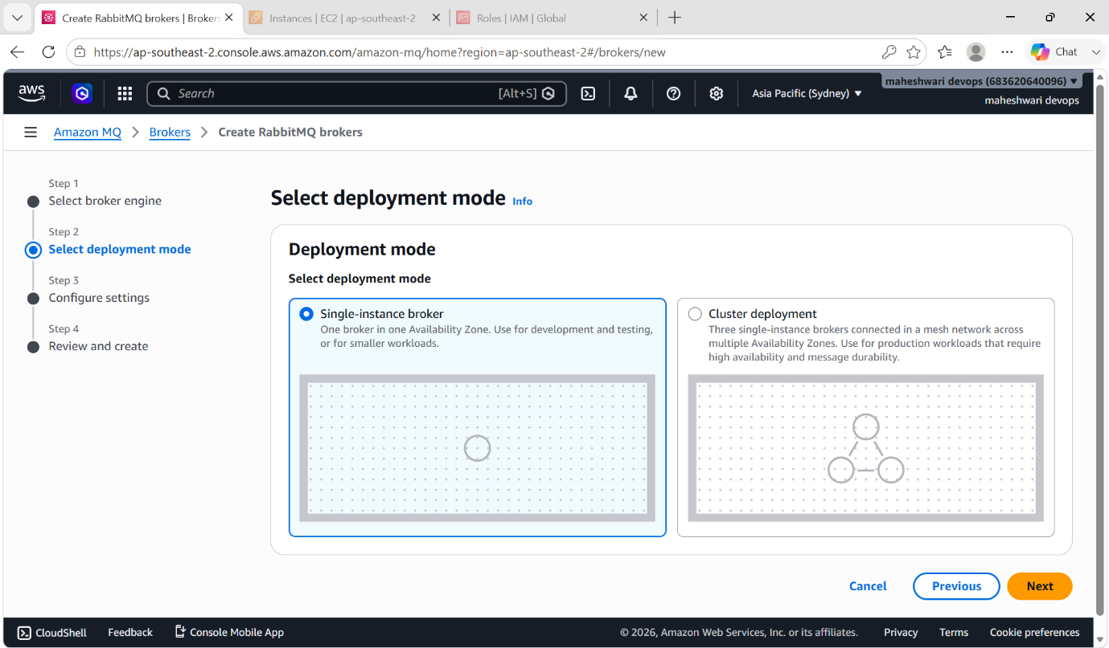

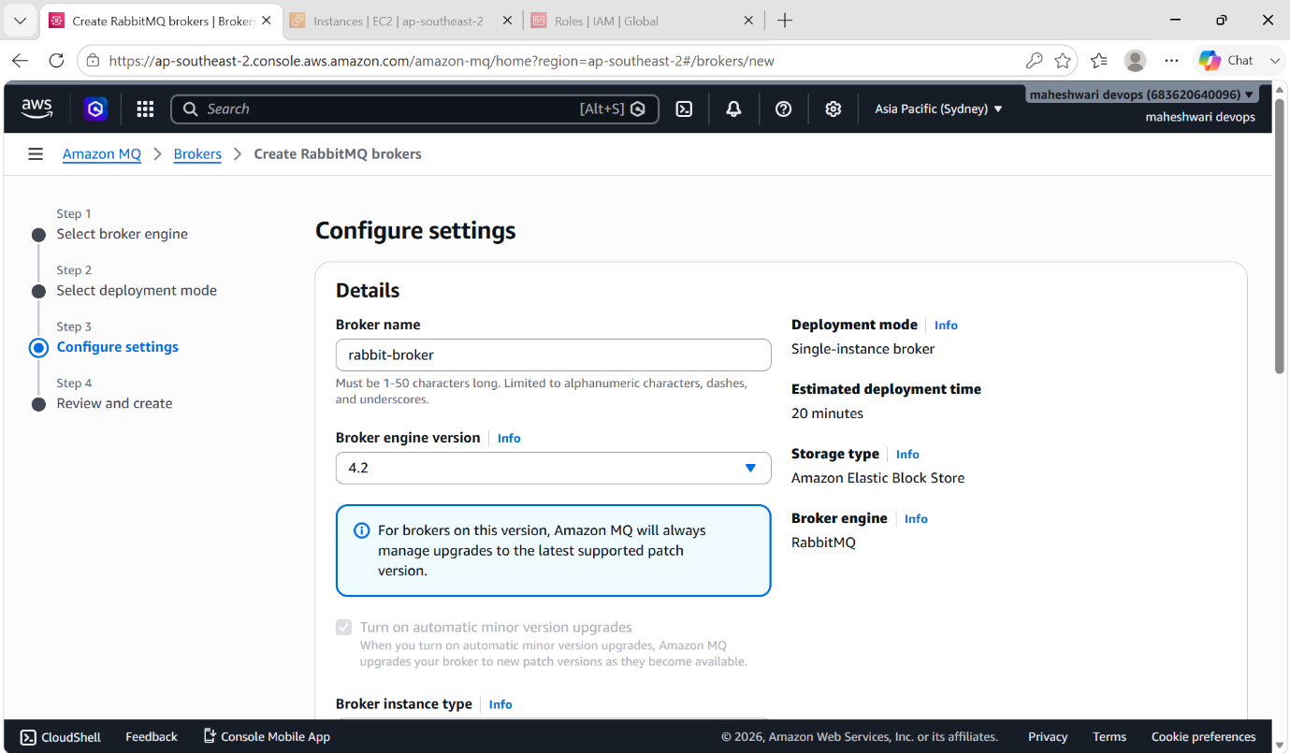

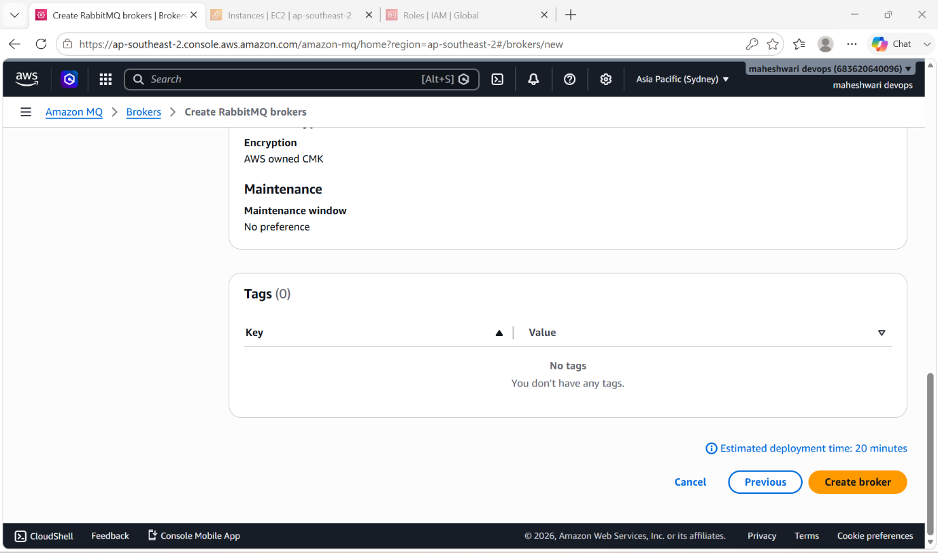

- Create RabbitMQ instance and ssh into that instance.
- After access to that instance, we have to download the RabbitMQ server.
- Before that we have to install docker by using the command yum install docker -y
- After this we have to download RabbitMQ server.

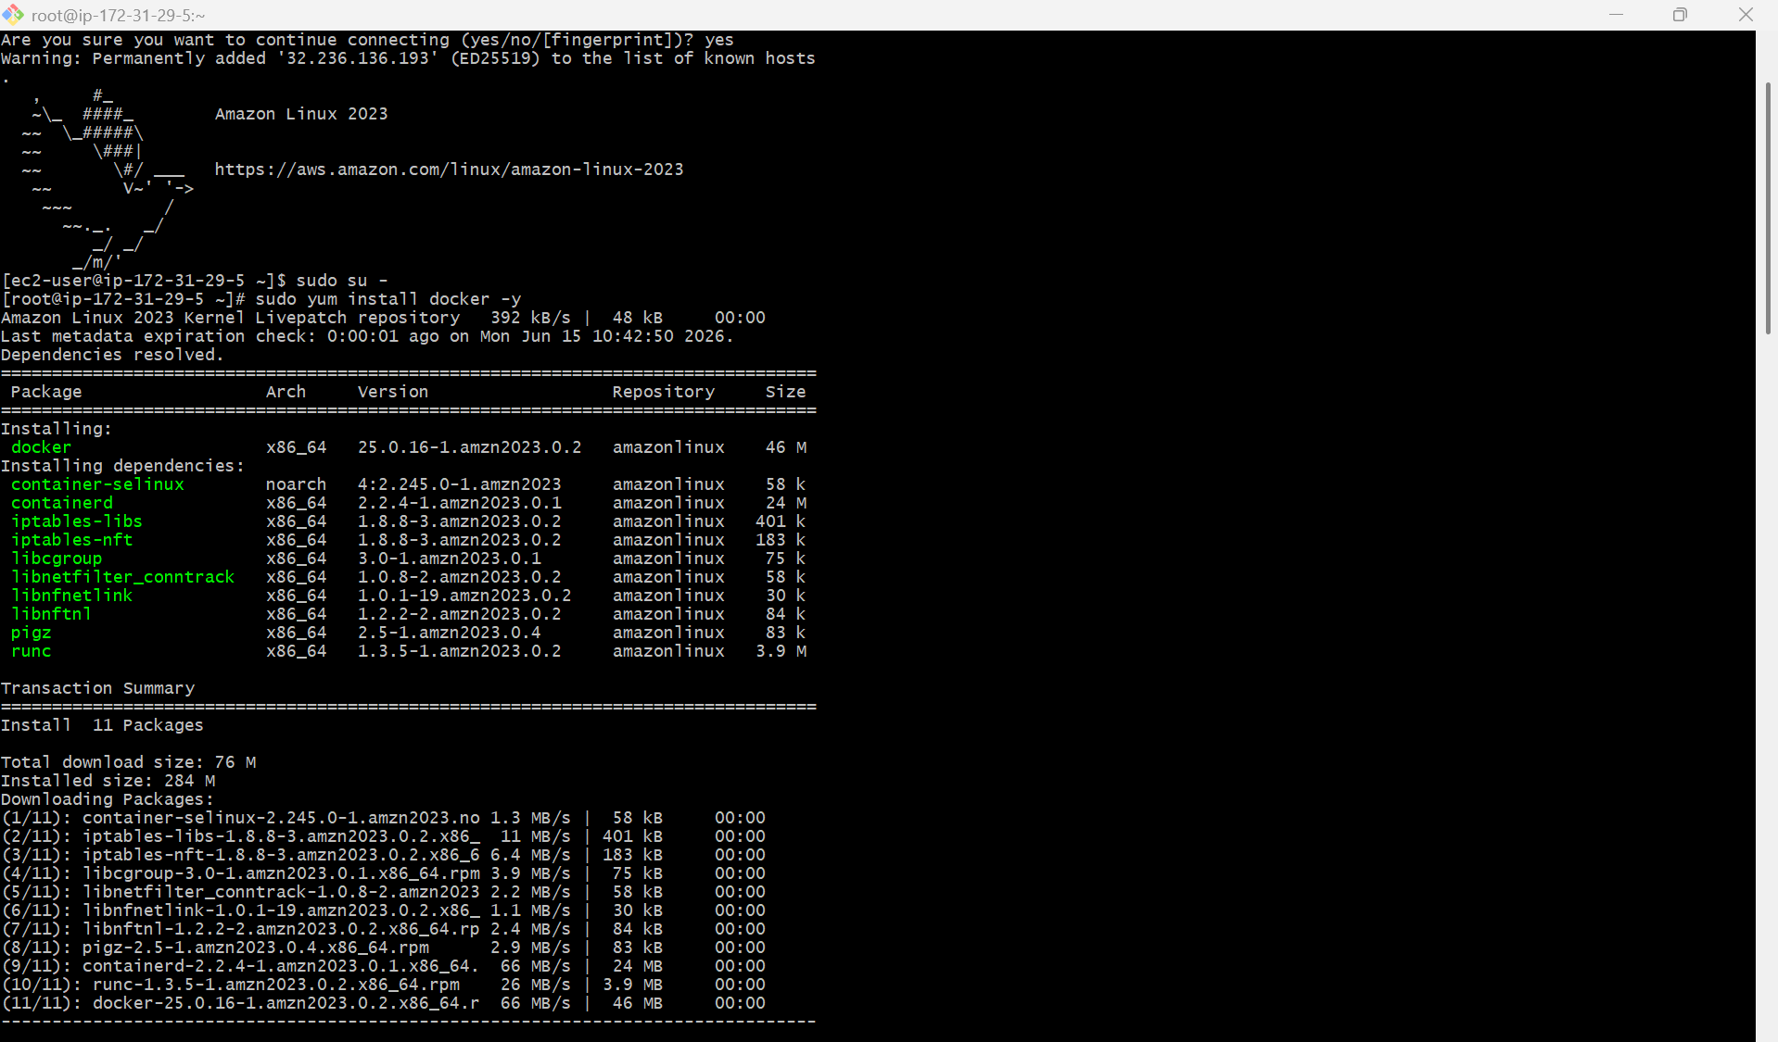

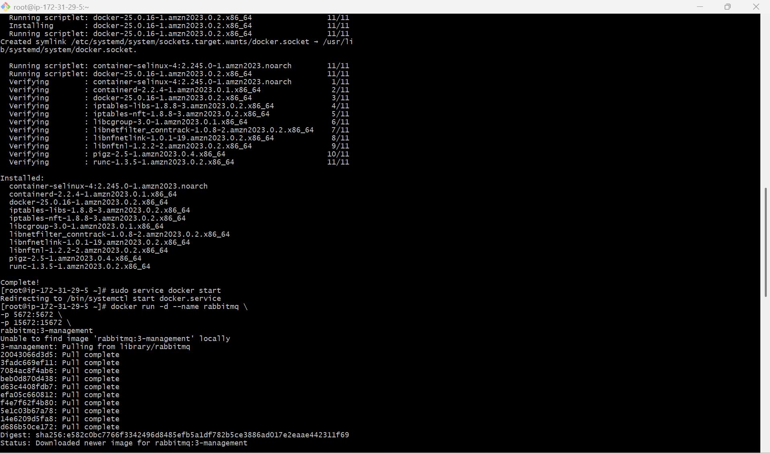

- After this, we have login into the RabbitMQ server by using the public IP of instance.

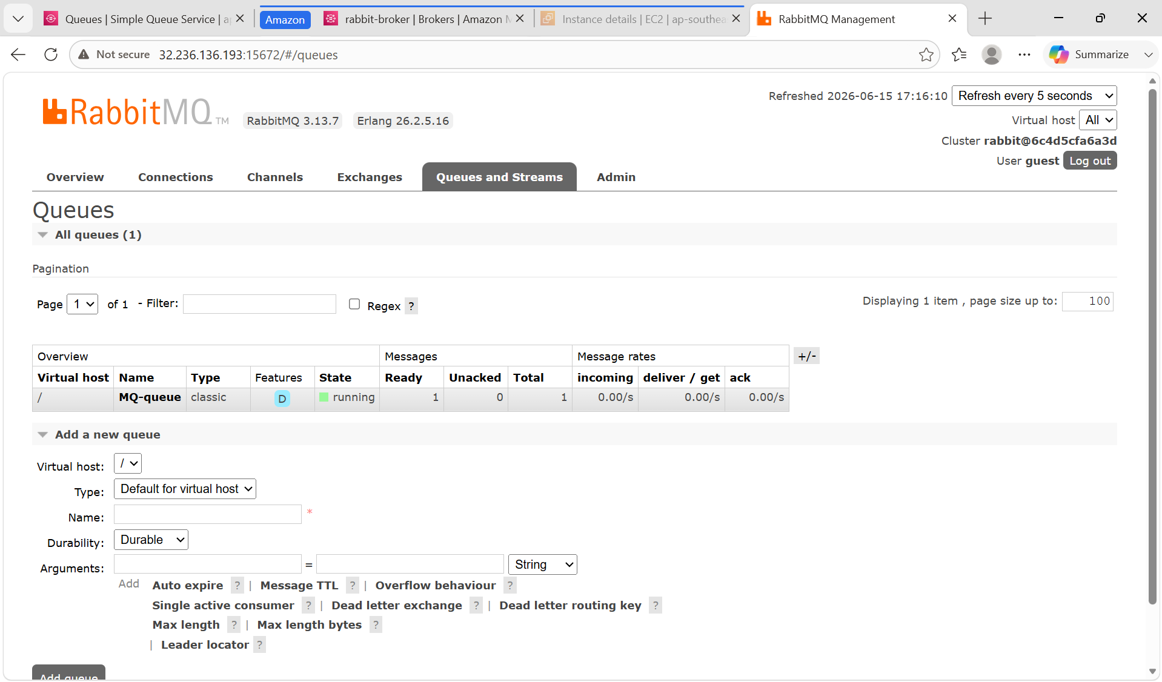

- There we can publish the messages and get the messages also.

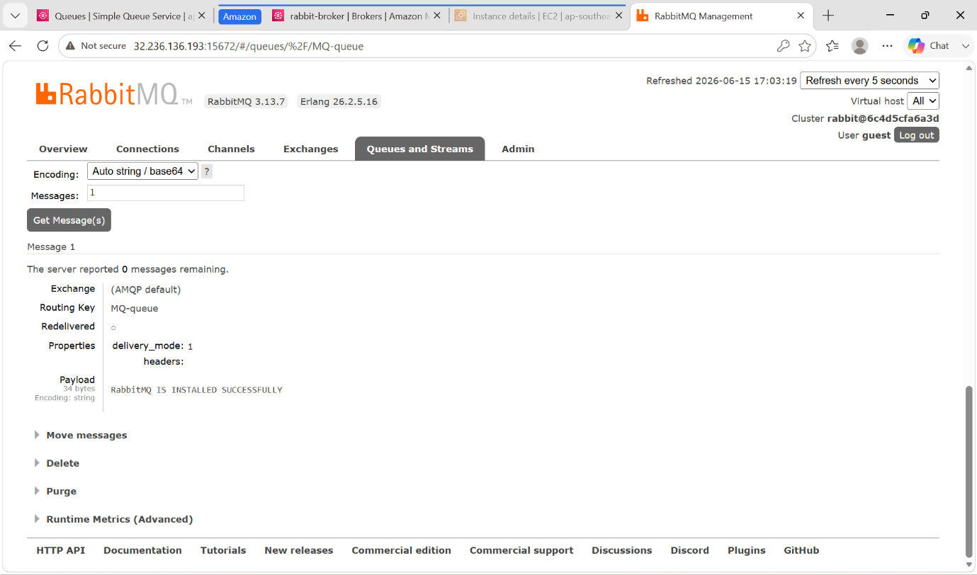

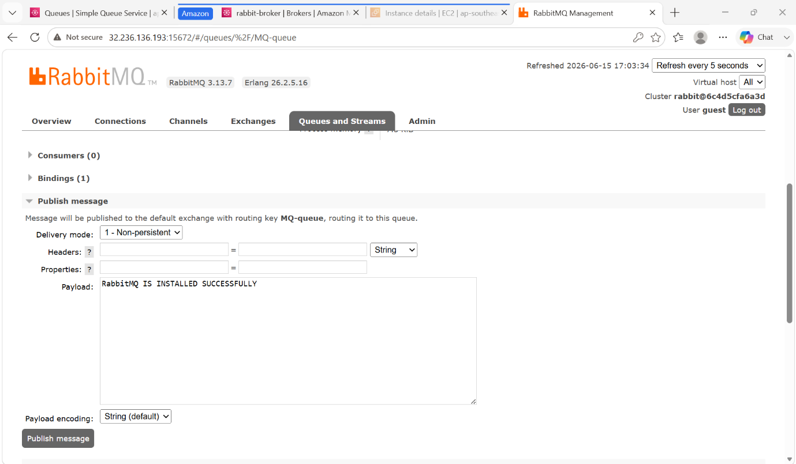

AWS SECRETS MANAGER

AWS Secret Manager helps you manage, retrieve, rotate database credentials, application credentials, OAuth tokens, API keys and other secrets throughout their lifecycles. Many AWS services store and use secrets in Secrets manager.

Secrets Manager helps you improve your security posture, because you no longer need hard-coded credentials in application source code. Storing the credentials in Secrets Manager helps avoid possible compromise by anyone who can inspect your application or the components.

You replace hard-coded credentials with a runtime call to the Secrets Manager service to retrieve credentials dynamically when you need them.

STEP BY STEP IMPLEMENTATION:

- Create a secret manager by using other that is EC2 instance.
- After selecting that, we have to create a KEY-PAIR i.e.., user name and password we have to give.
- After that we have to launch an instance, and after launching that we have to do ssh to that instance.
- We have to create a policy to give permissions from EC2 to Secret MANAGER and this created policy we have to add to the role.
- After creating role, we have attach this role to the instance.
- After logging into that instance, we have download the aws cli in our instance.
- Command -> yum install awscli -y
- After downloading that we have to get the secret manager credentials.
- Command -> aws secretsmanager get-secret-value \
--secret-id ec2-app-secret \
--region ap-southeast-2
- By executing this command, will get secret manager credentials.

