KUBERNETES-01

1. Setup Minikube in your local machine.

PURPOSE: The purpose of this exercise is to install and configure Minikube on a local machine to create a single node Kubernetes cluster for learning, development and testing Kubernetes applications without requiring a cloud environment.

OBJECTIVE:

- Install Minikube and its prerequisites on the local machine.
- Configure a virtualization driver (Docker, Hyper-V, VirtualBox, or WSL2).
- Create and verify a local Kubernetes cluster.
- Learn basic Kubernetes cluster management using Minikube.
- Deploy and access a sample application running inside the Kubernetes cluster.

STEP BY STEP IMPLEMENTATION:

- Firstly we have to download the docker desktop on our local machine.
- Then we have to set up that in the path of environment variables.

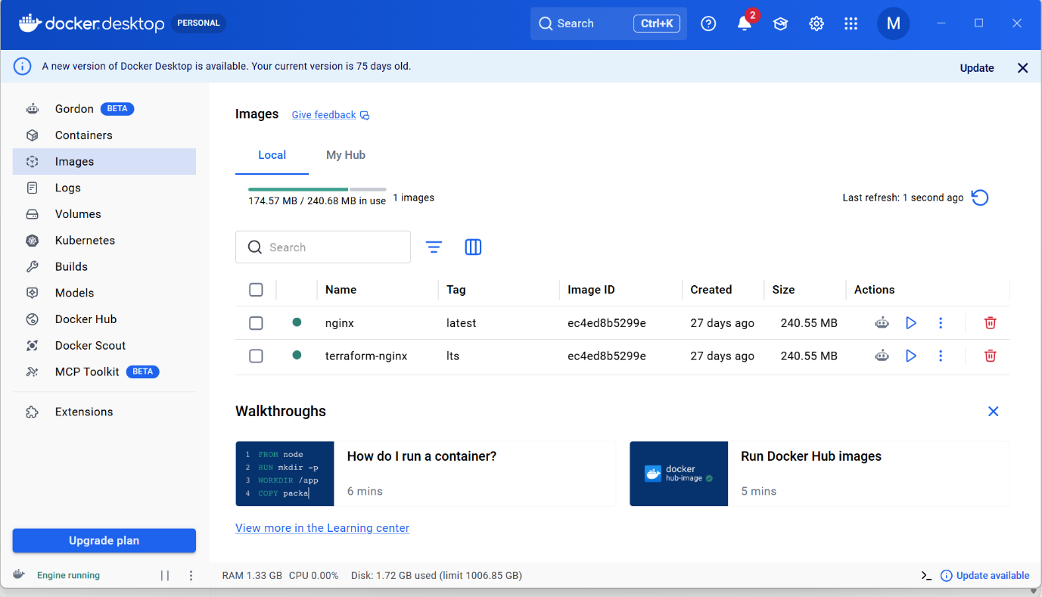

- Then we have to download the oracle virtual box on our local machine.

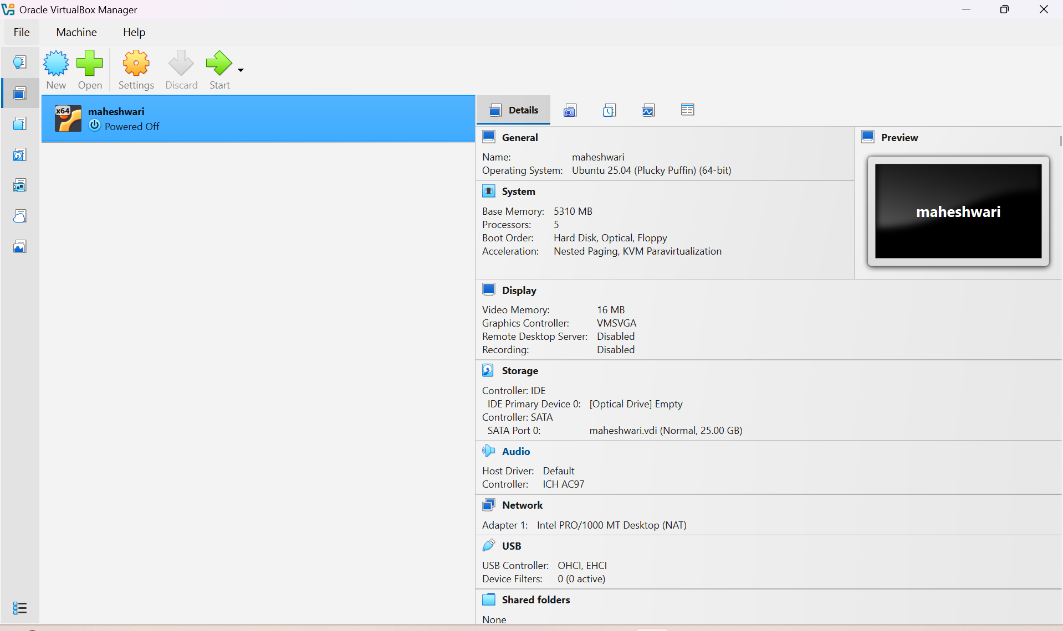

- Then we have to check for the systeminfo on the CMD of our local machine

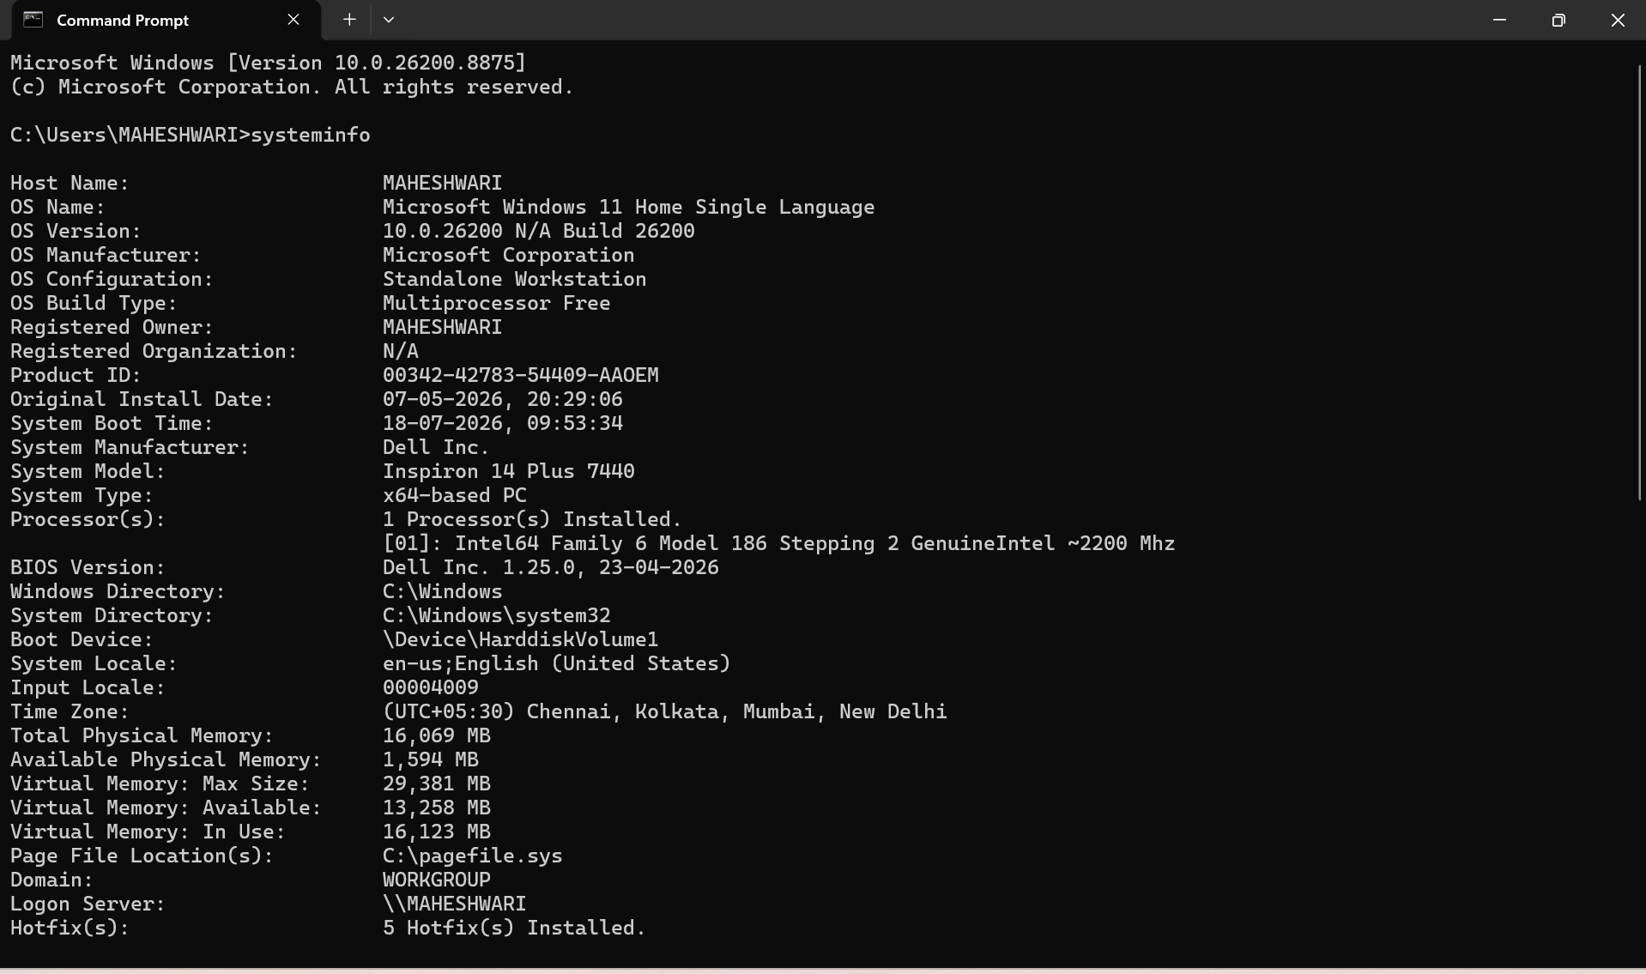

- Then we have to download the minikube using powershell and powershell should be open as administrator.
- We have to pass these commands to download the minikube on our local machine.

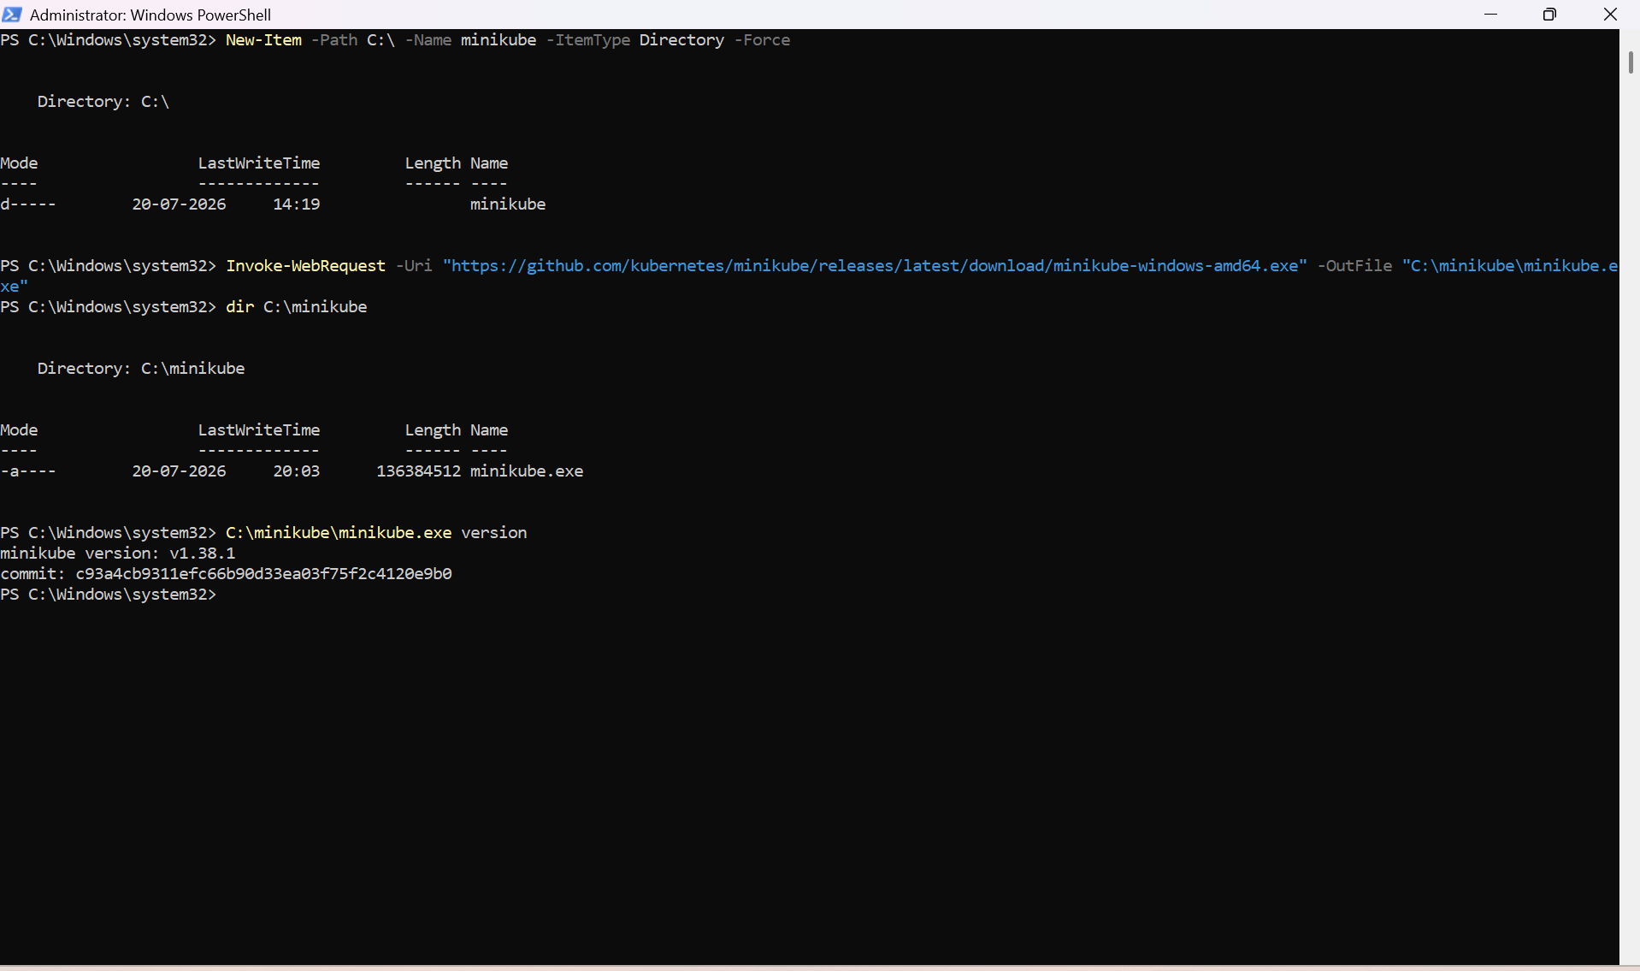

- Then we have to set the path in the system environment variables of our local machine.

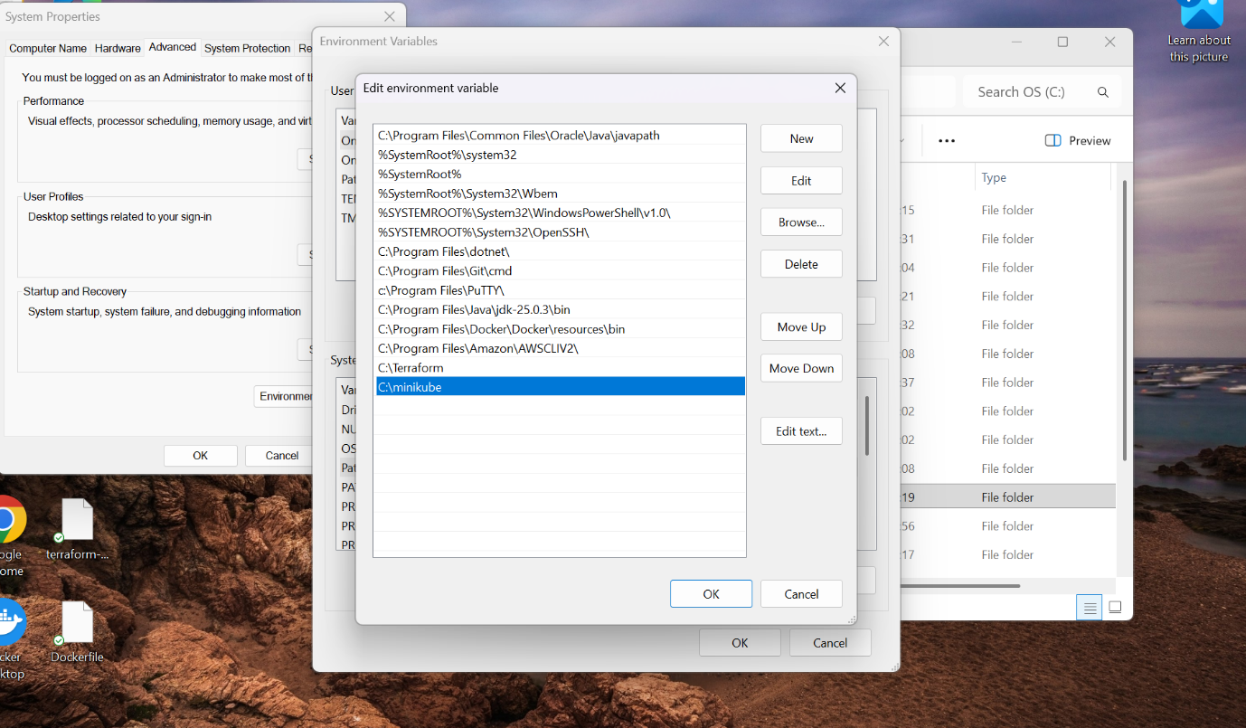

- Then we have to close the old powershell and open the new powershell.
- Then execute this command -> minikube version

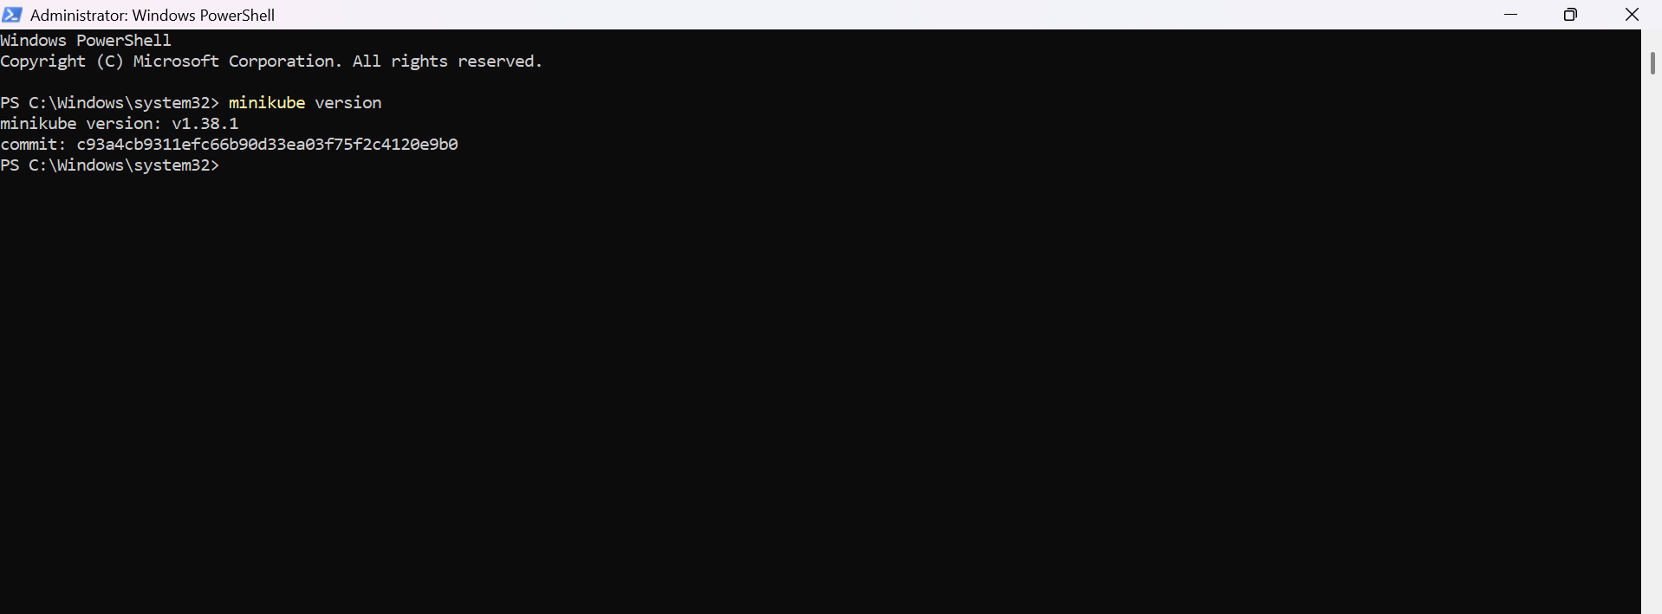

2. Setup k8s master and two worker nodes on ubuntu.

PURPOSE: The purpose of this exercise is to deploy a multi-node Kubernetes cluster consisting of one Master (Control Plane) node and two Worker nodes on Ubuntu. This setup provides a production-like environment for learning Kubernetes architecture, cluster administration, application deployment and workload management.

OBJECTIVE:
- Install Kubernetes components (kubeadm, kubelet and kubectl) on all Ubuntu nodes.
- Configure one node as the Kubernetes control plane (Master).
- Join two Ubuntu machines as worker nodes.
- Install a container Network Interface (CNI) plugin to enable pod networking.
- Verify communication between all cluster nodes.
- Deploy and manage applications across the Kubernetes cluster.

EXPECTED OUTCOME:

After completing this exercise, you will be able to:
- Build a Kubernetes cluster with one Master node and two Worker nodes.
- Understand the responsibilities of the control plane and worker nodes.
- Configure networking between cluster nodes.
- Deploy applications using Kubernetes resources.
- Scale and manage workloads across multiple nodes.
- Monitor cluster health using Kubernetes commands.
- Gain hands-on experience with a production-style Kubernetes environment.

STEP BY STEP IMPLEMENTATION:

- First created three ec2 instances with existing key-pair, instance type as t2.medium , default security groups & EBS volume as 20 GiB
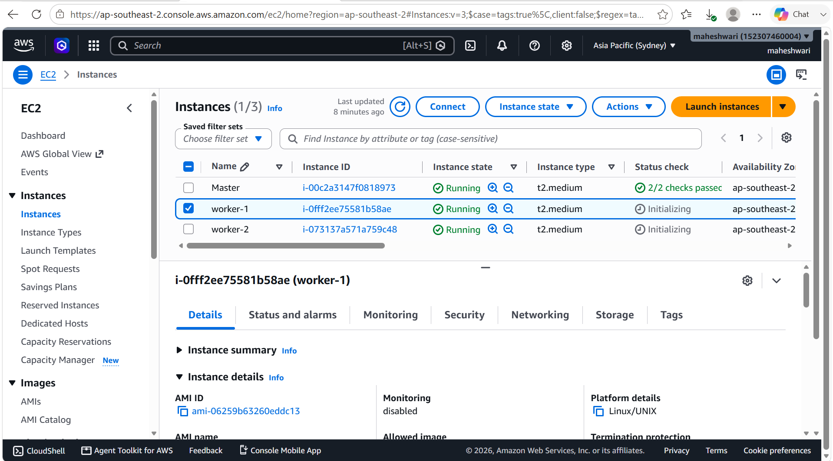

- change the root IP with specific names like master, worker-1 and worker-2 for our identification in the /etc/hostname file.

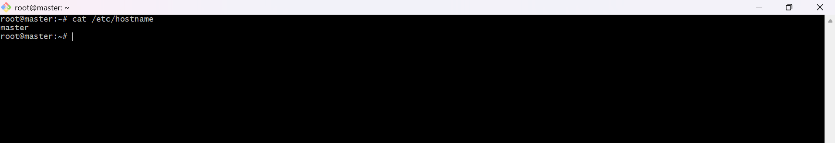

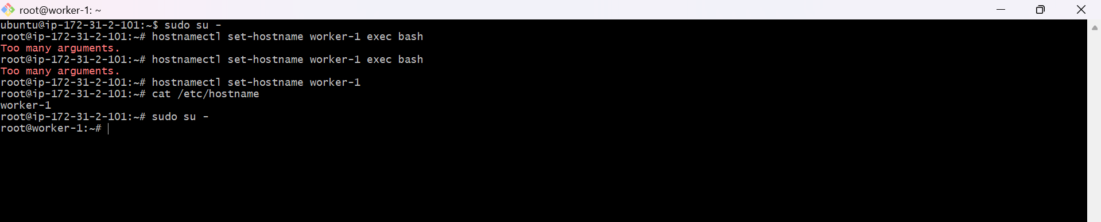

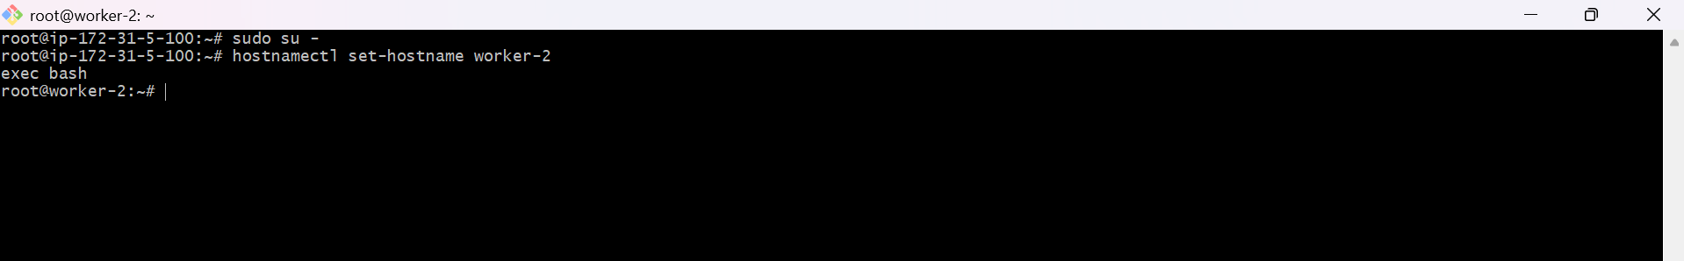

- install docker in all the servers i.e.., in the master and worker nodes.
- Now install the docker in k8s – Master ec2
- instance using the commands
Sudo apt-get update -y
Sudo apt-get upgrade -y
Sudo apt-get install docker.io -y
Systemctl enable docker
Systemctl start docker
Systemctl status docker

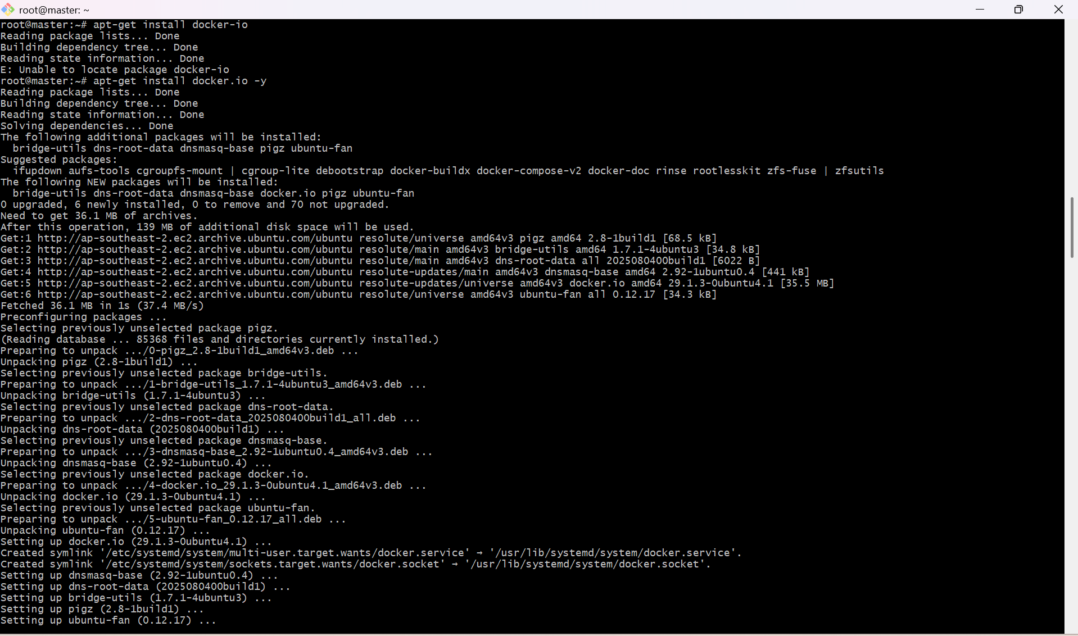

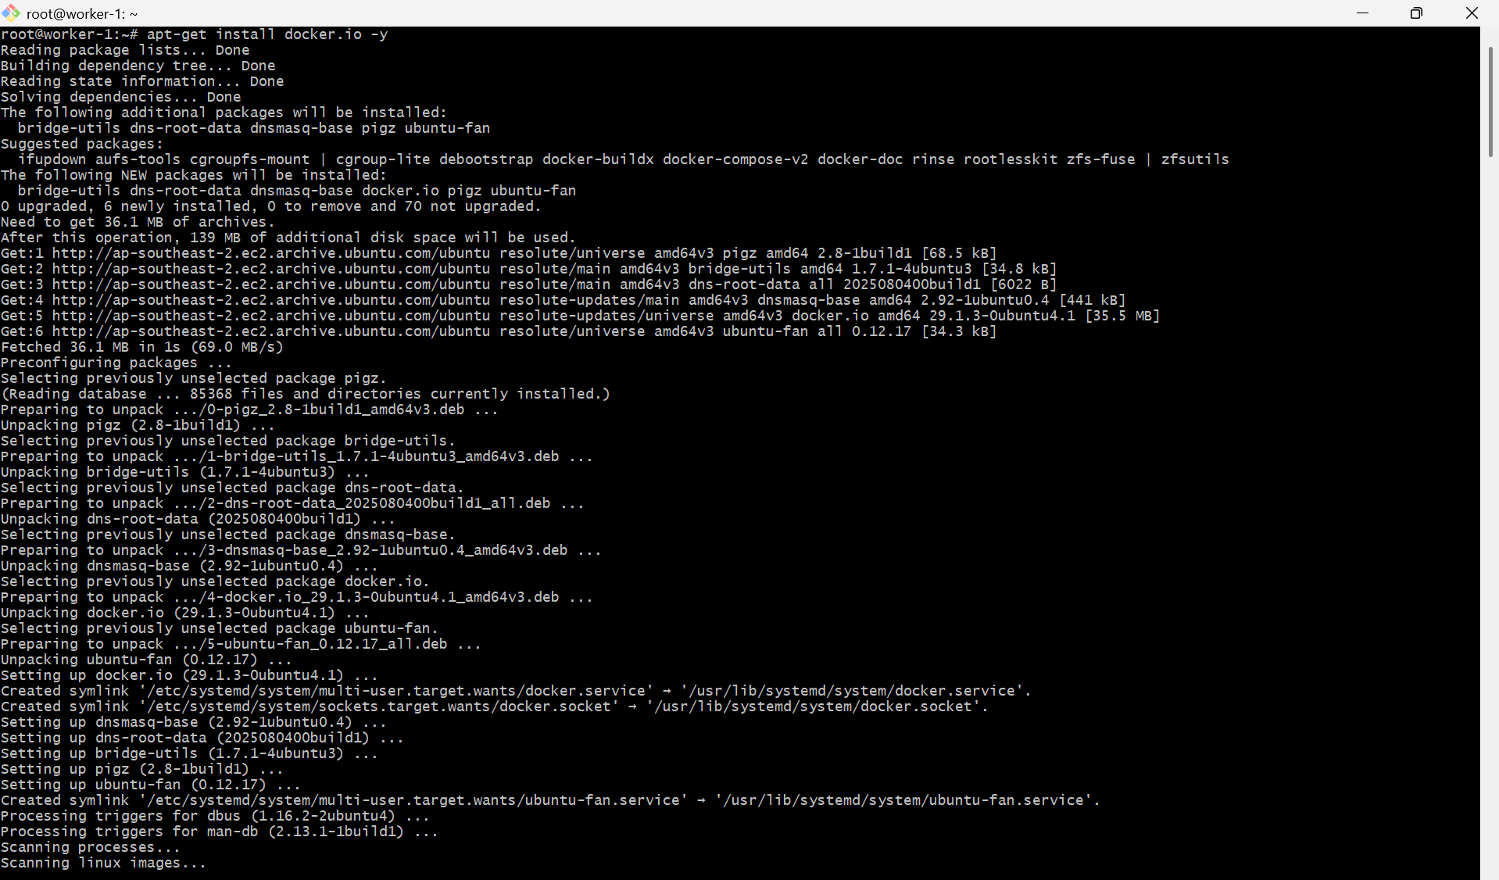

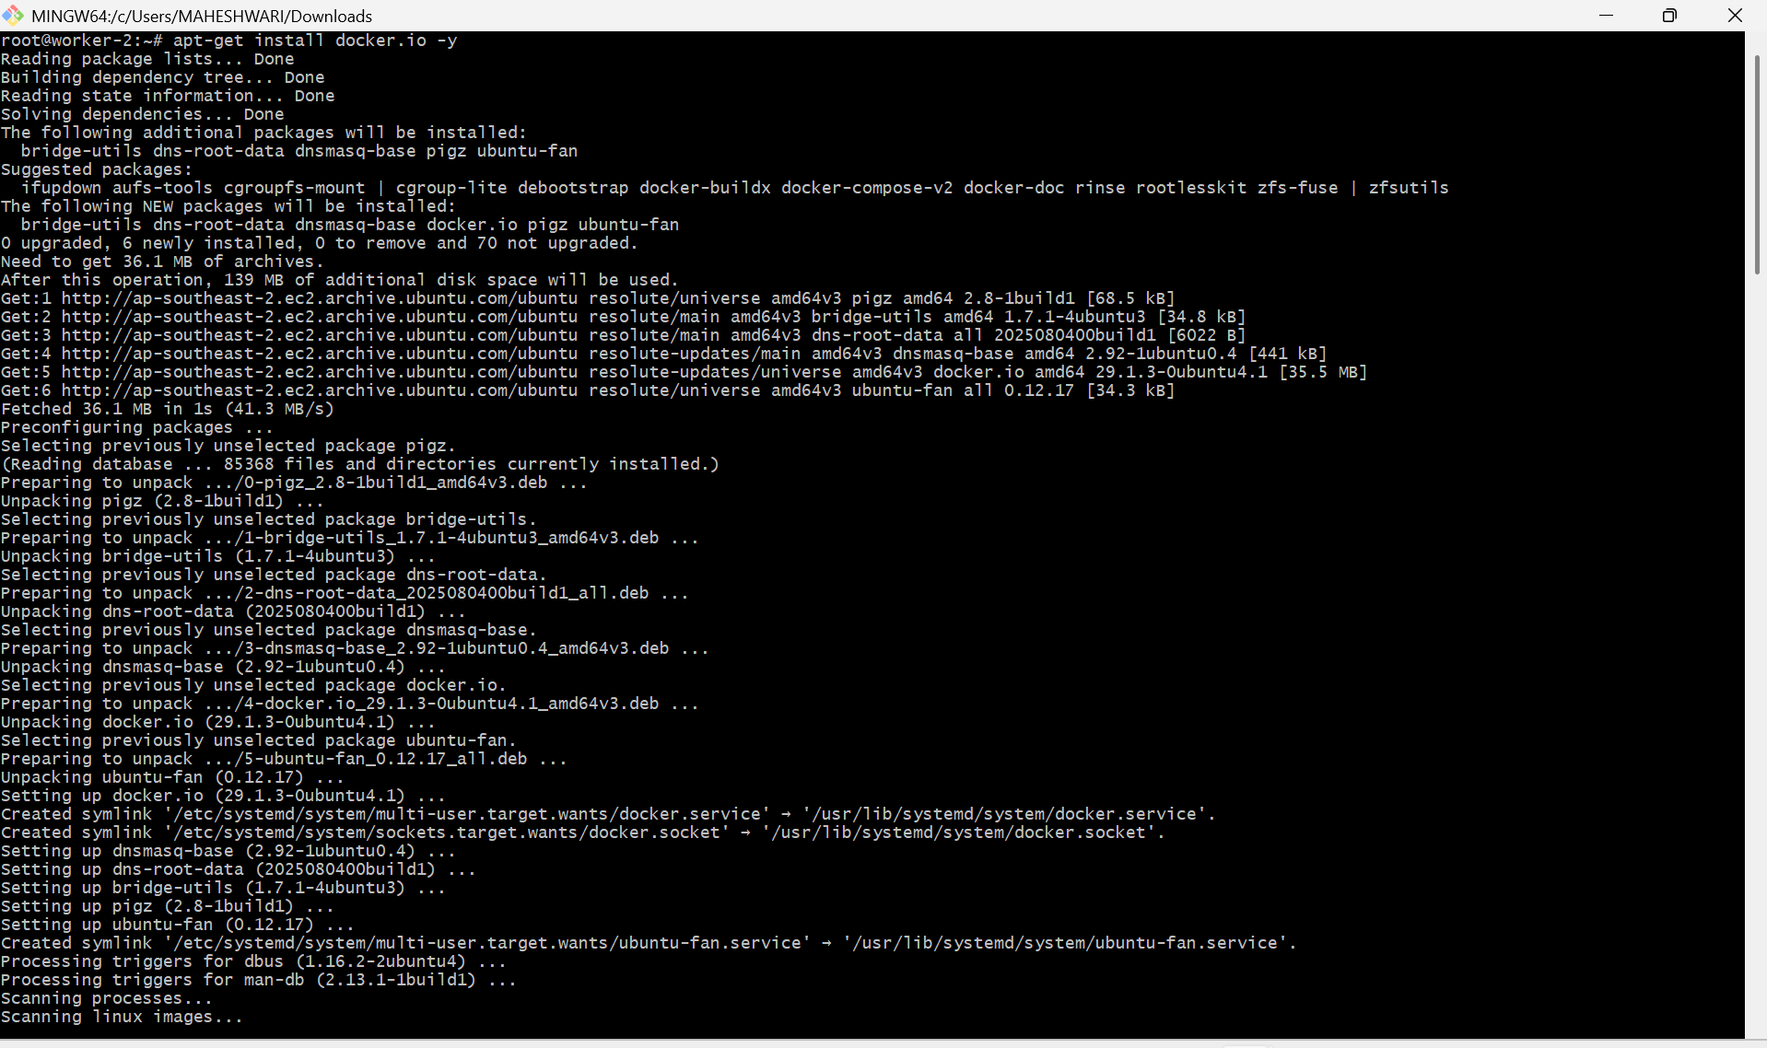

- To set up k8s cluster we use tool, kubeadm from
- the below link & ran the commands in k8s – Master, Worker – 01 & Worker -02 instances
https://kubernetes.io/docs/setup/production-environment/
tools/kubeadm/install-kubeadm/
- sudo apt-get install -y apt-transport-https ca-certificates curl gpg
- curl -fsSL https://pkgs.k8s.io/core:/stable:/v1.36/deb/Relea
se.key | sudo gpg --dearmor -o /etc/apt/keyrings/kubernetes-apt-keyring.gpg
- echo 'deb [signed-by=/etc/apt/keyrings/kubernetes-apt-
keyring.gpg] https://pkgs.k8s.io/core:/stable:/v1.36/deb/ /' |
- sudo tee /etc/apt/sources.list.d/kubernetes.list
- sudo apt-get update
- sudo apt-get install -y kubelet kubeadm kubectl
- sudo apt-mark hold kubelet kubeadm kubectl
- sudo systemctl enable --now kubelet
- kubectl version

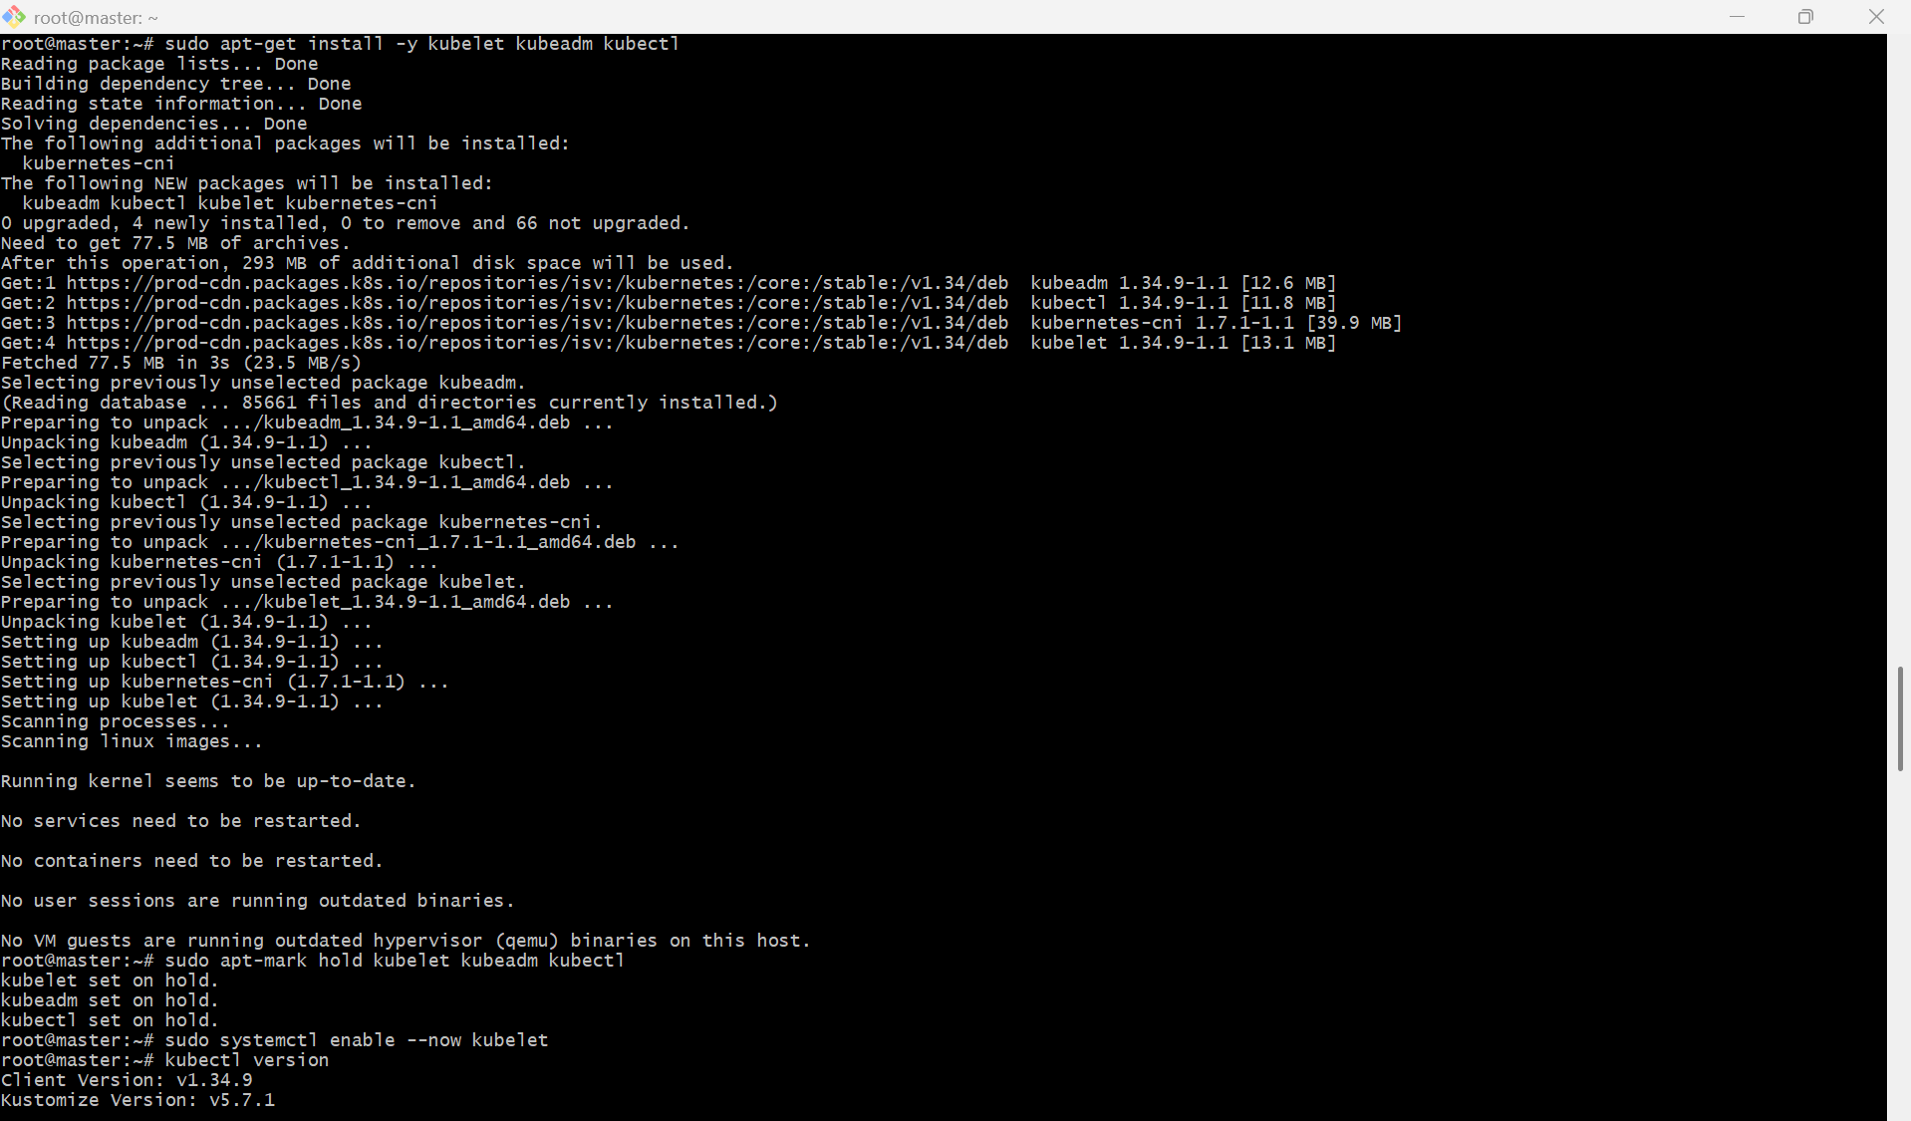

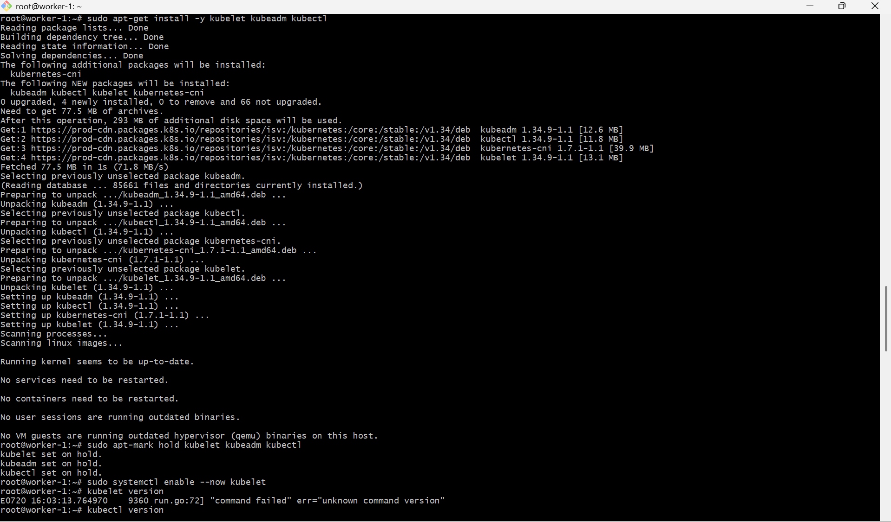

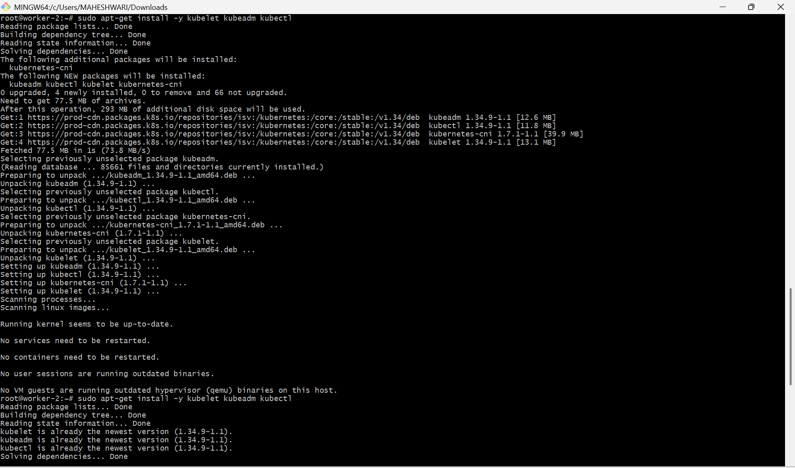

- To configure Master we need to execute the below command in k8s – Master instance
- kubeadm init --pod-network-cidr=10.244.0.0/16

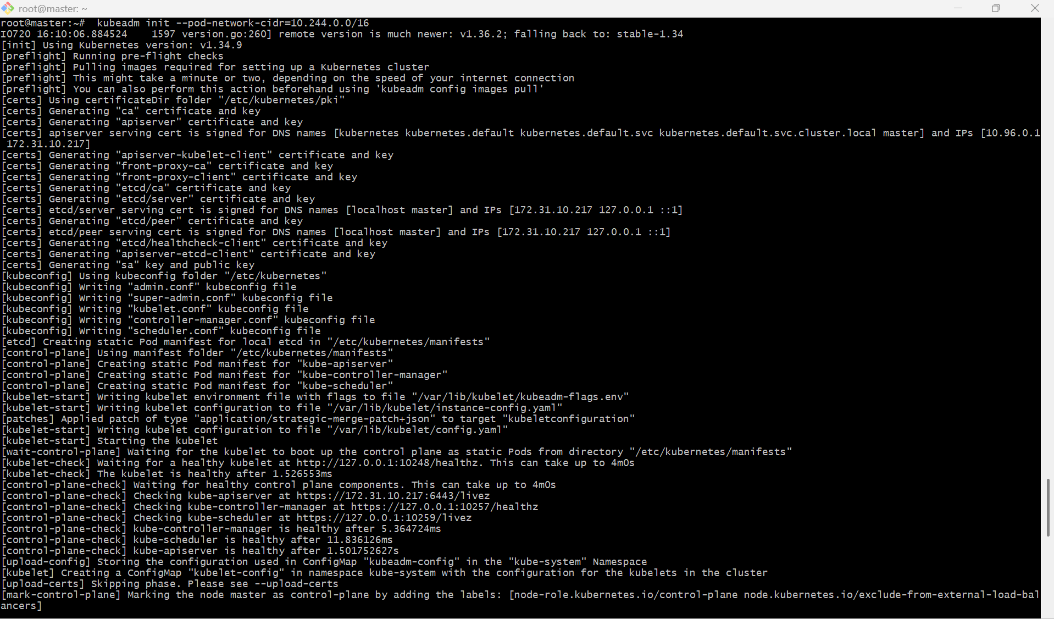

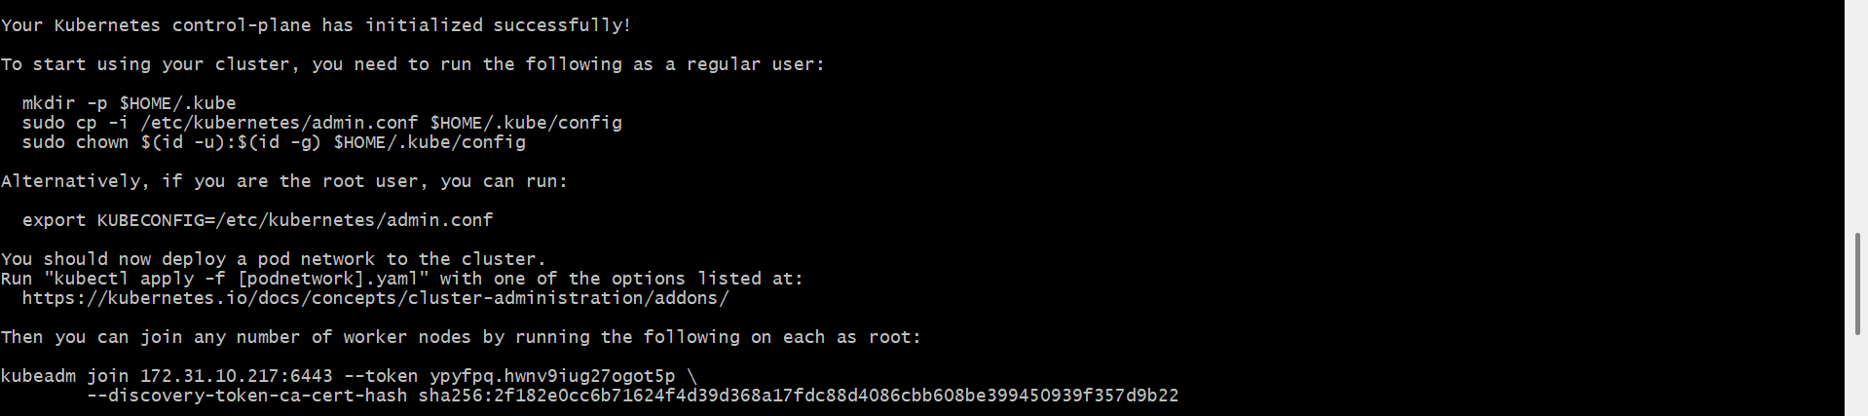

- Now run the below commands in master instance
- mkdir -p $HOME/.kube
- sudo cp -i /etc/kubernetes/admin.conf $HOME/.kube/config
- sudo chown $(id -u):$(id -g) $HOME/.kube/config

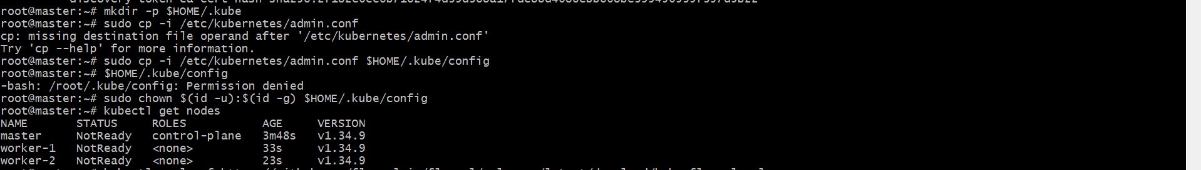

- Now run the below command in Worker – 01 &
Worker – 02 instances

kubeadm join 172.31.10.217:6443 --token ypyfpq.hwnv9iug27ogot5p \ --discovery-token-ca-cert-hash sha256:2f182e0cc6b71624f4d39d368a17fdc88d4086cbb608be399450939f357d9b22
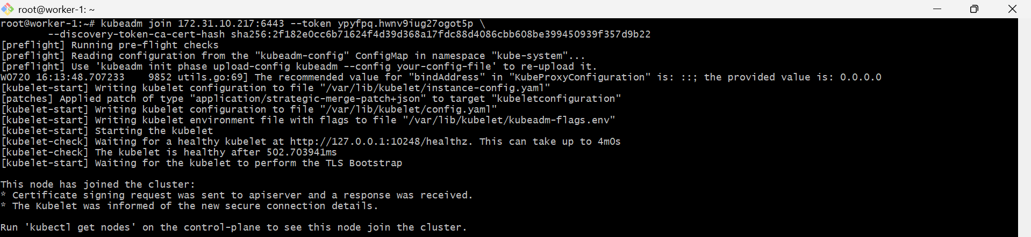

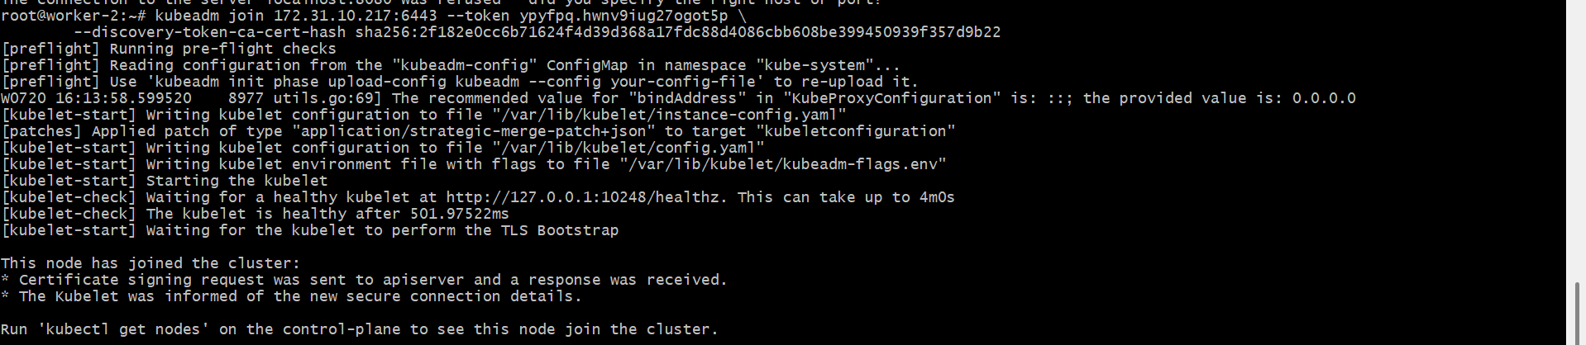

- Now in the k8s – Master instance run kubectl get nodes

- Now run the command in k8s – Master instance to make the worker nodes ready
kubectl apply -f https://github.com/flannel-io/flannel/releases/lat est/download/kube-flannel.yml
- Verified the cluster by the command, kubectl get nodes

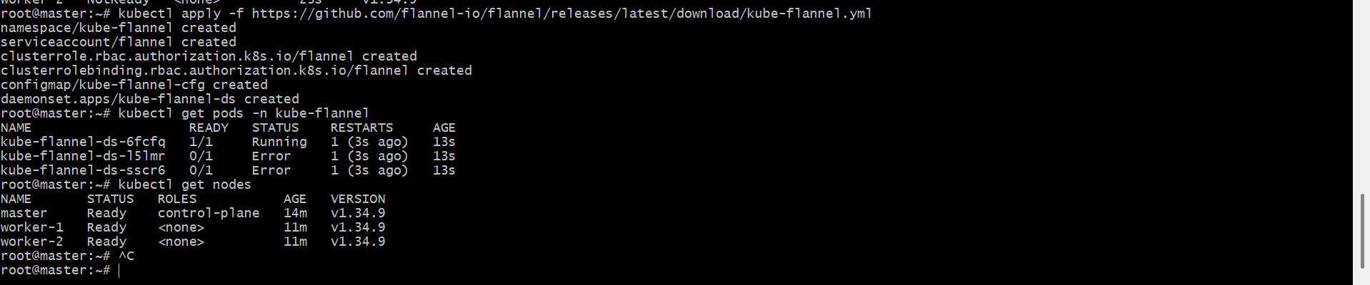

3. Run one nginx pod.

PURPOSE: To learn how to deploy and manage a simple application in Kubernetes by creating a single Nginx Pod. This exercise helps you understand the basic Kubernetes object (Pod) and how to verify its status.

OBJECTIVE:
- Create a single Nginx Pod using kubectl.
- Verify that the Pod is running successfully.
- Access the Pod details.
- Understand the Pod lifecycle and basic management commands.

POD:
- pods: pod is the smallest unit in k8s.
- pod will have atleast one container.
- Multi container pods:
- we can have multiple container in one pod.
- one container with application and another container will be helper container.
- Helper container: this will be deployed along with our application,helper container will help
- our application with any processing/functionality.

STEP BY STEP IMPLEMENTATION:

- we have to execute a command and that command will create a pod with the image nginx.

- Kubectl run firstpod --generator=run-pod/v1 --image=nginx

- Firstpod = name of pod
- generator = to specify to create pod,if not specified then it will create deployment
- image = docker image
- Note: Generators might be deprecated

- we can also use this command
- kubectl run firstpod –image=nginx

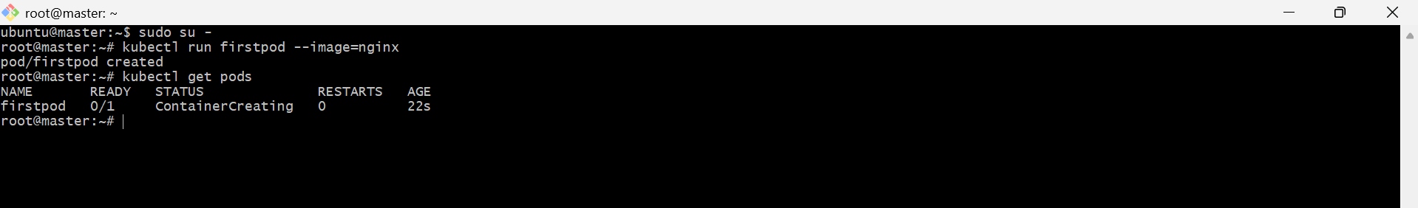

commands for pods:
==================
- kubectl run nginx --image=nginx --> to run a pod with name nginx and image nginx
- kubectl get pods --> to display the list of pods



- kubectl describe pod nginx --> Detail information of the pod created.

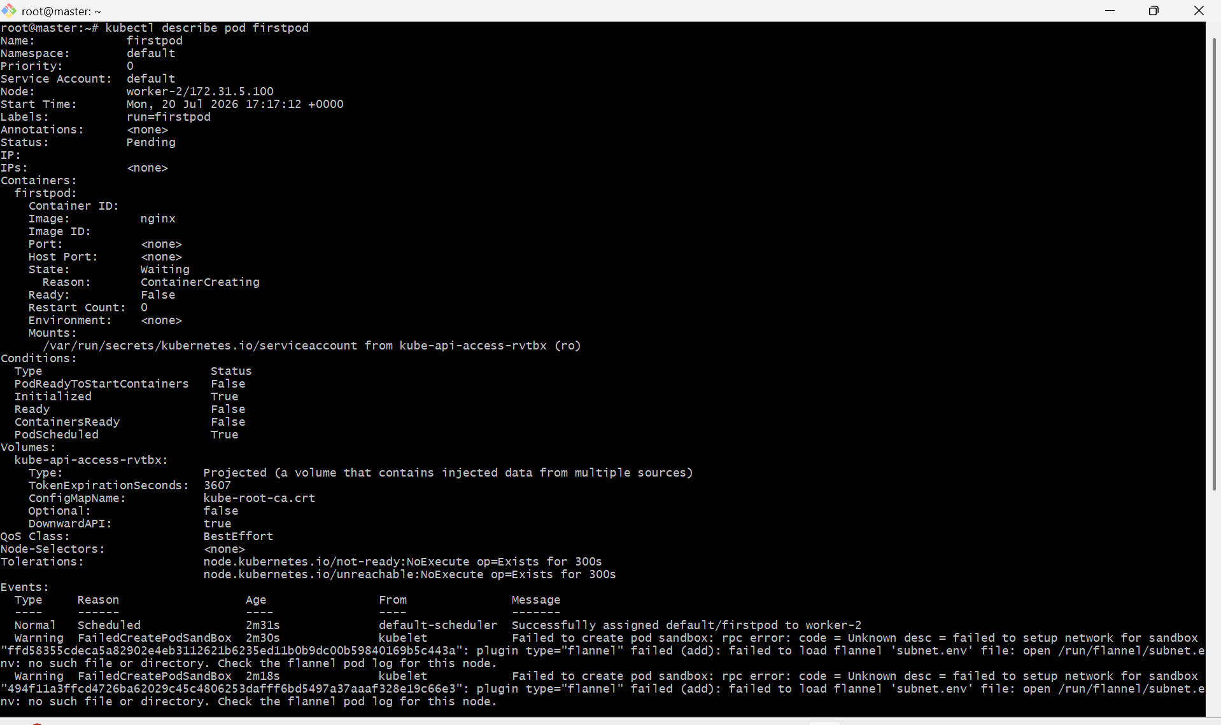

- kubectl get pods -o wide --> additional information of pod like node,ip etc

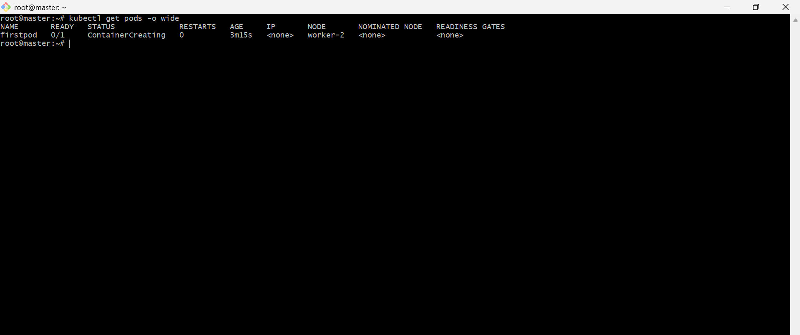

- kubectl explain pods -->Detailed description of pods

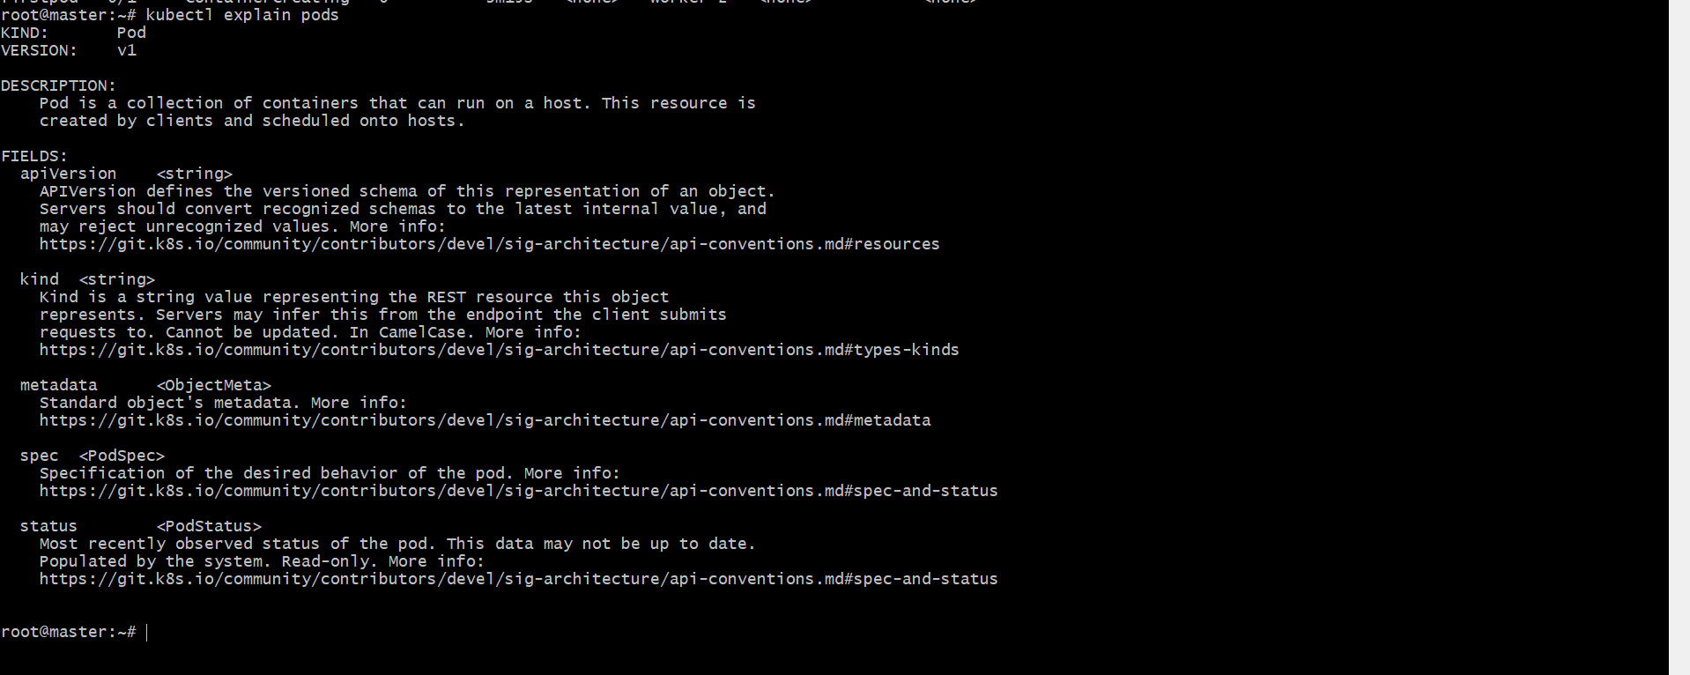

- kubectl get pods -w --> Continously watch the status of POD

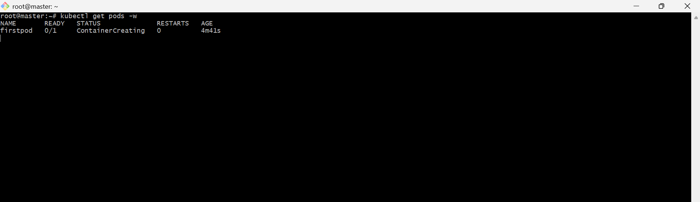

- kubectl delete pod pod_name --> To delete the pod
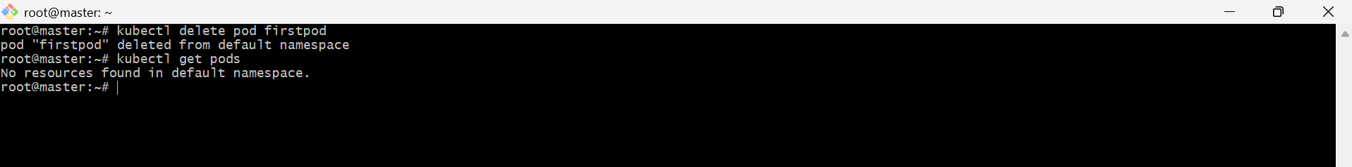
- kubectl delete resourcetype resourcename
- kubectl run nginx --dry-run=client --image=nginx --> To check how the command will execute.

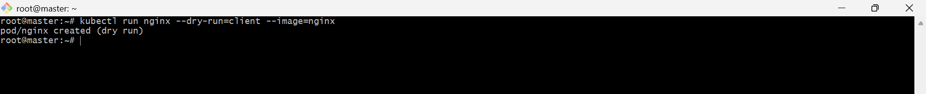

- kubectl delete pods --all --> Delete all pods

