KUBERNETES-02

1. Create a Simple Pod Using YAML Task: Write a YAML file to create a Pod named firstpod with an nginx container. Verify the Pod creation using kubectl get pods and check the logs of the container using kubectl logs firstpod.

PURPOSE: The purpose of this task is to learn how to define and deploy a Kubernetes pod using a YAML manifest. It introduces the declarative approach of Kubernetes, where infrastructure and application resources are described in configuration file rather than created through imperative commands.

OBJECTIVE:
- Create a Pod named firstpod using a YAML manifest.
- Deploy an Nginx container inside the pod.
- Apply the YAML file using kubectl.
- Verify that the pod is running successfully
- View the container logs using kubectl logs.

EXPECTED OUTCOME:

After completing this task:
- A Pod named firstpod is successfully created.
- The Nginx container is running inside the Pod.
- The Pod status is Running.
- The Nginx startup logs are displayed using kubectl logs.
- You gain hands-on experience with creating and managing Pods using Kubernetes YAML manifests.

STEP BY STEP IMPLEMENTATION:

- First of all, we have to connect with the master server instance.
- In that instance, we have to create a file with the yaml extension.
- After that creating the file, we have to execute the command to run that yaml file.
- kubectl create -f firstpod.yaml
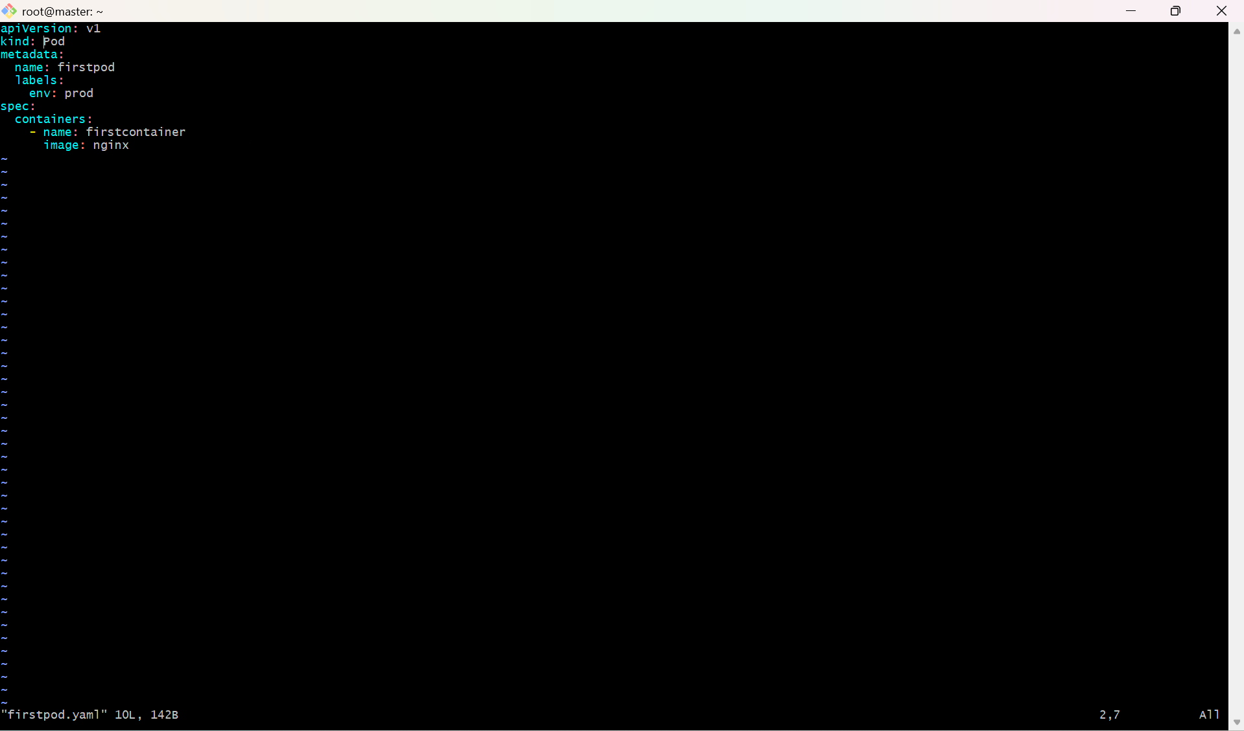

- we can verify the created pods by using this command, kubectl get pods.

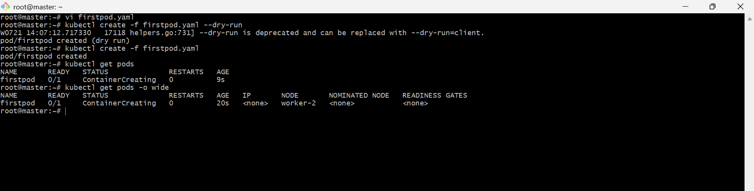

2. Set Environment Variables in a Pod Task: Modify the YAML file to include environment variables myname: sabair and City: Hyderabad. Deploy the Pod and use kubectl exec <pod_name> -- env to check if the environment variables are set properly.

PURPOSE: The purpose of this task is to understand how to configure environment variables for containers running inside a Kubernetes Pod. Environment variables allow applications to receive configuration values without modifying the application code, making deployments more flexible and portable.

OBJECTIVE:
- Create or modify a Kubernetes Pod YAML manifest.
- Add environment variables myname=sabair and City=Hyderabad to the container.
- Deploy the Pod using kubectl apply.
- Verify that the Pod is running successfully.
- Confirm that the environment variables are available inside the container using kubectl exec.

OUTCOME:

After completing this task:
- A Kubernetes Pod named envpod is successfully created.
- The Nginx container is running inside the Pod.
- The environment variables myname=sabair and City=Hyderabad are configured for the container.
- The variables can be viewed using kubectl exec and printenv, confirming that the application inside the container can access them.

STEP BY STEP IMPLEMENTATION:

- Firstly we have to delete the pod that we have created in the first task, because Kubernetes will not allow us to modify the yaml file when it has been created already.
- To delete the pod that exists -> kubectl delete pod firstpod
- Then modify the existing yaml file with environment variables.
- Then after modifying, we have to create the pod with the command -> kubectl create -f firstpod.yaml
- Then to verify the environment variables, we have to execute the command -> kubectl exec firstpod -- env
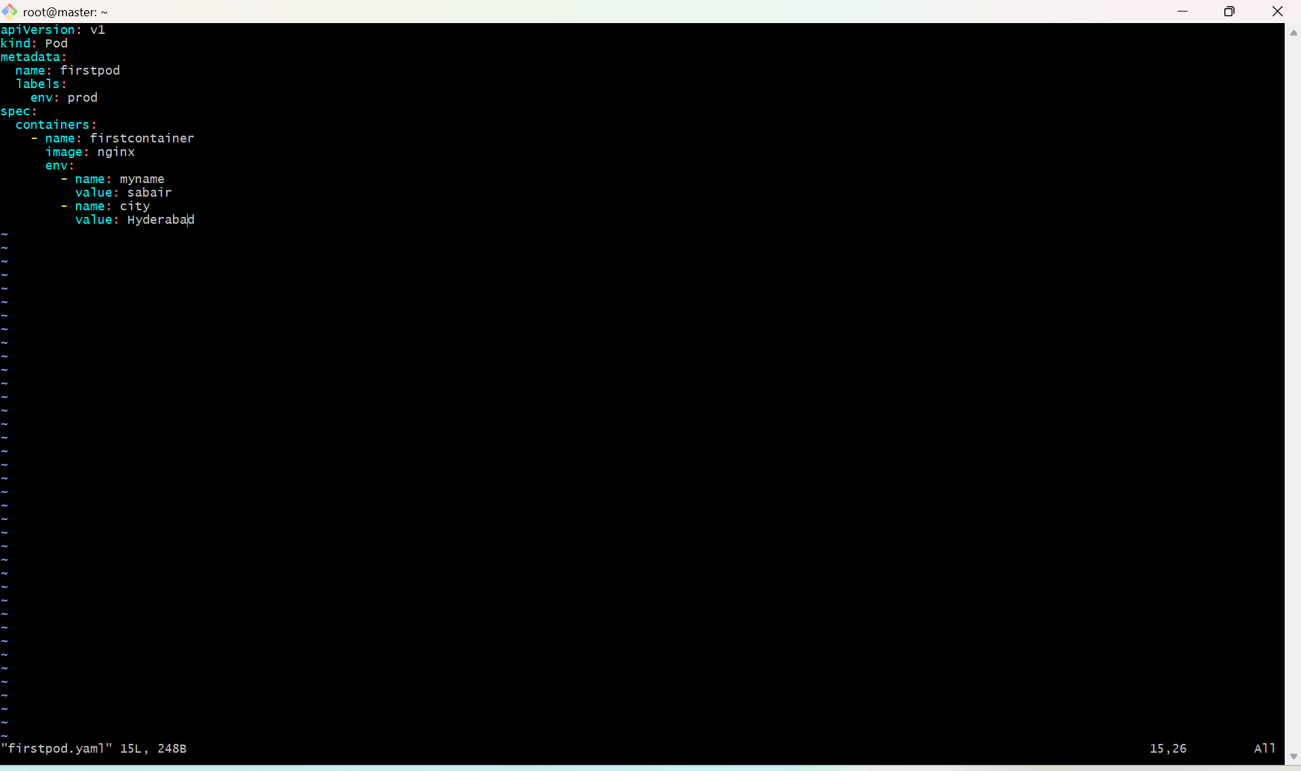

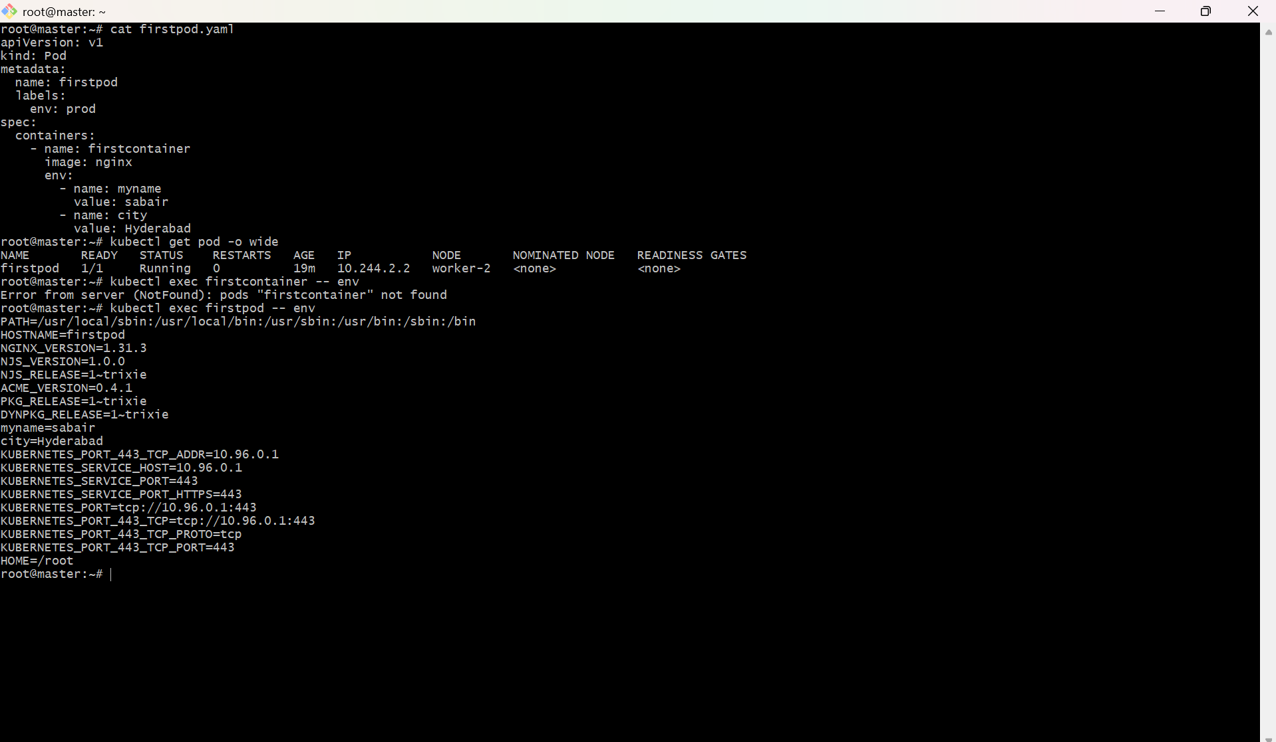

3. Deploy a Pod with Commands (Args) in YAML Task: Modify the YAML file to add args that instruct the container to sleep for 50 seconds. Deploy the Pod and use kubectl describe pod to verify the args are correctly passed to the container.

PURPOSE: The purpose of this task is to learn how to pass command-line arguments (args) to a container in a Kubernetes Pod. This helps in customizing the behaviour of a container at runtime without modifying the container image.

OBJECTIVE:
- Create a Kubernetes Pod using a YAML manifest.
- Configure the container to execute a sleep command for 50 seconds using command and args.
- Deploy the Pod using kubectl.
- Verify that the Pod is created successfully.
- Use kubectl describe pod to confirm that the command and arguments are correctly passed to the container.

STEP BY STEP IMPLEMENTATION:

- Firstly we have to delete the pod that we have created in the first task, because Kubernetes will not allow us to modify the yaml file when it has been created already.
- To delete the pod that exists -> kubectl delete pod firstpod
- Then we have to modify the existing yaml file with args statement that will sleep the container for 50seconds.
- Then we have to execute the command -> kubectl create -f firstpod.yaml
- To verify we have to watch the pods status continuously by this command -> kubectl get pods -w
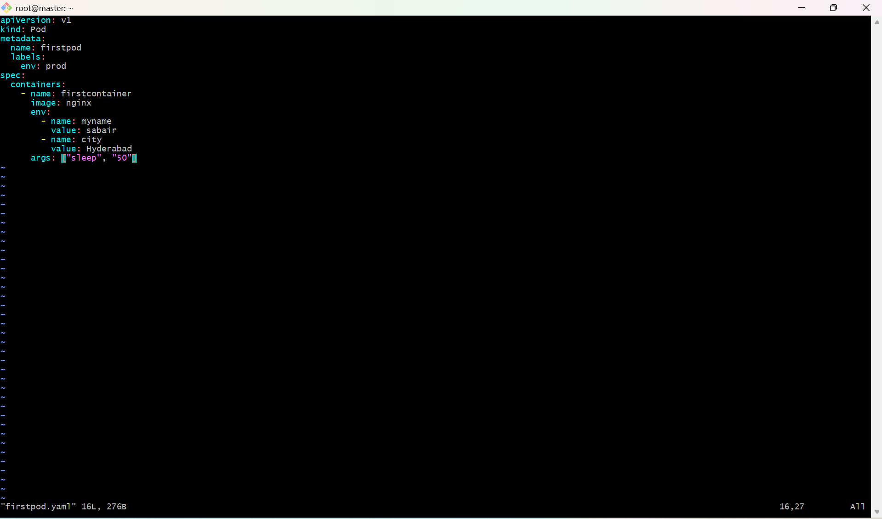

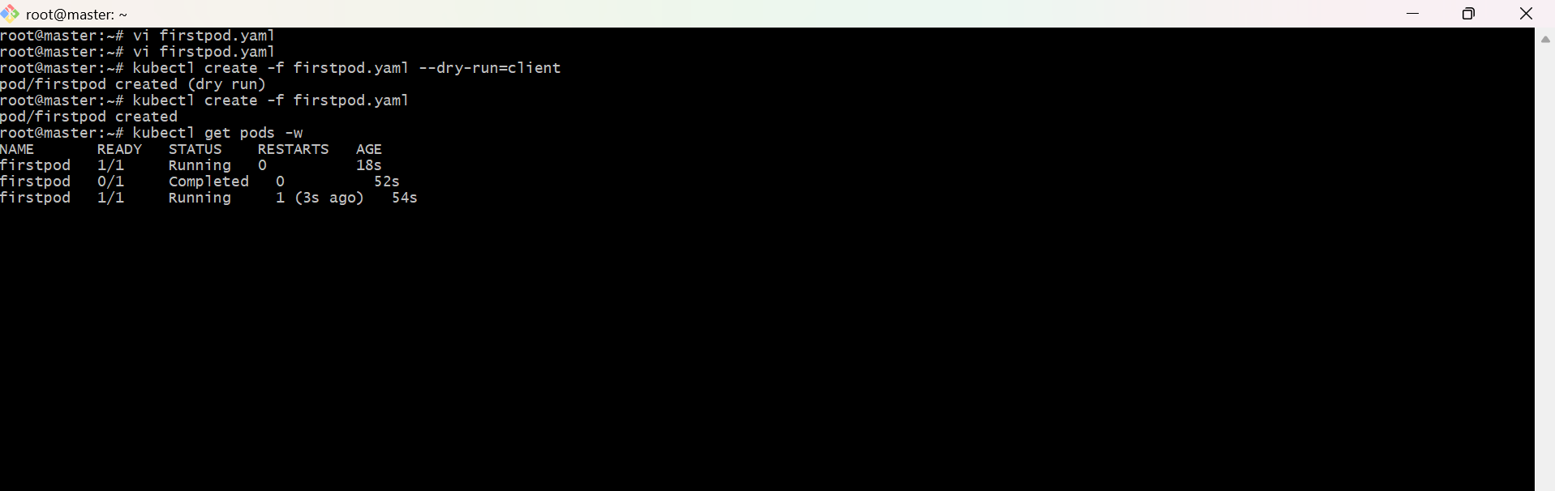

4. Create a Pod with Two Containers Task: Create a YAML file to define a Pod with two nginx containers inside. Use kubectl exec to access both containers and verify that both containers can communicate through the same network (e.g., using telnet between them).

PURPOSE: The purpose of this task is to understand the multi-container Pod concept in Kubernetes. Multiple containers within the same Pod share the same network namespace, allowing them to communicate with each other using localhost and share the same IP address.

OBJECTIVE:
- Create a Kubernetes Pod with two Nginx containers.
- Deploy the Pod using a YAML manifest.
- Verify that both containers are running.
- Access each container using kubectl exec.
- Confirm that both containers share the same network namespace by connecting to the Nginx service through localhost.

EXPECTED OUTCOME:

After completing this task:
- A Pod named twocontainerpod is successfully created.
- Both Nginx containers are running within the same Pod.
- The first container listens on port 80, and the second listens on port 8080.
- Both containers share the same Pod IP address and network namespace.
- Communication between the containers using localhost is successful, demonstrating how containers within a Pod can communicate over the shared network.

STEP BY STEP IMPLEMENTATION:

- Firstly we have to delete the pod that we have created in the first task, because Kubernetes will not allow us to modify the yaml file when it has been created already.
- To delete the pod that exists -> kubectl delete pod firstpod
- Then we have to edit the yaml file with the multi containers and images.
- Then we have to create the pod -> kubectl create -f firstpod.yaml
- Then we have to get into that containers and execute the curl command to connect between containers.

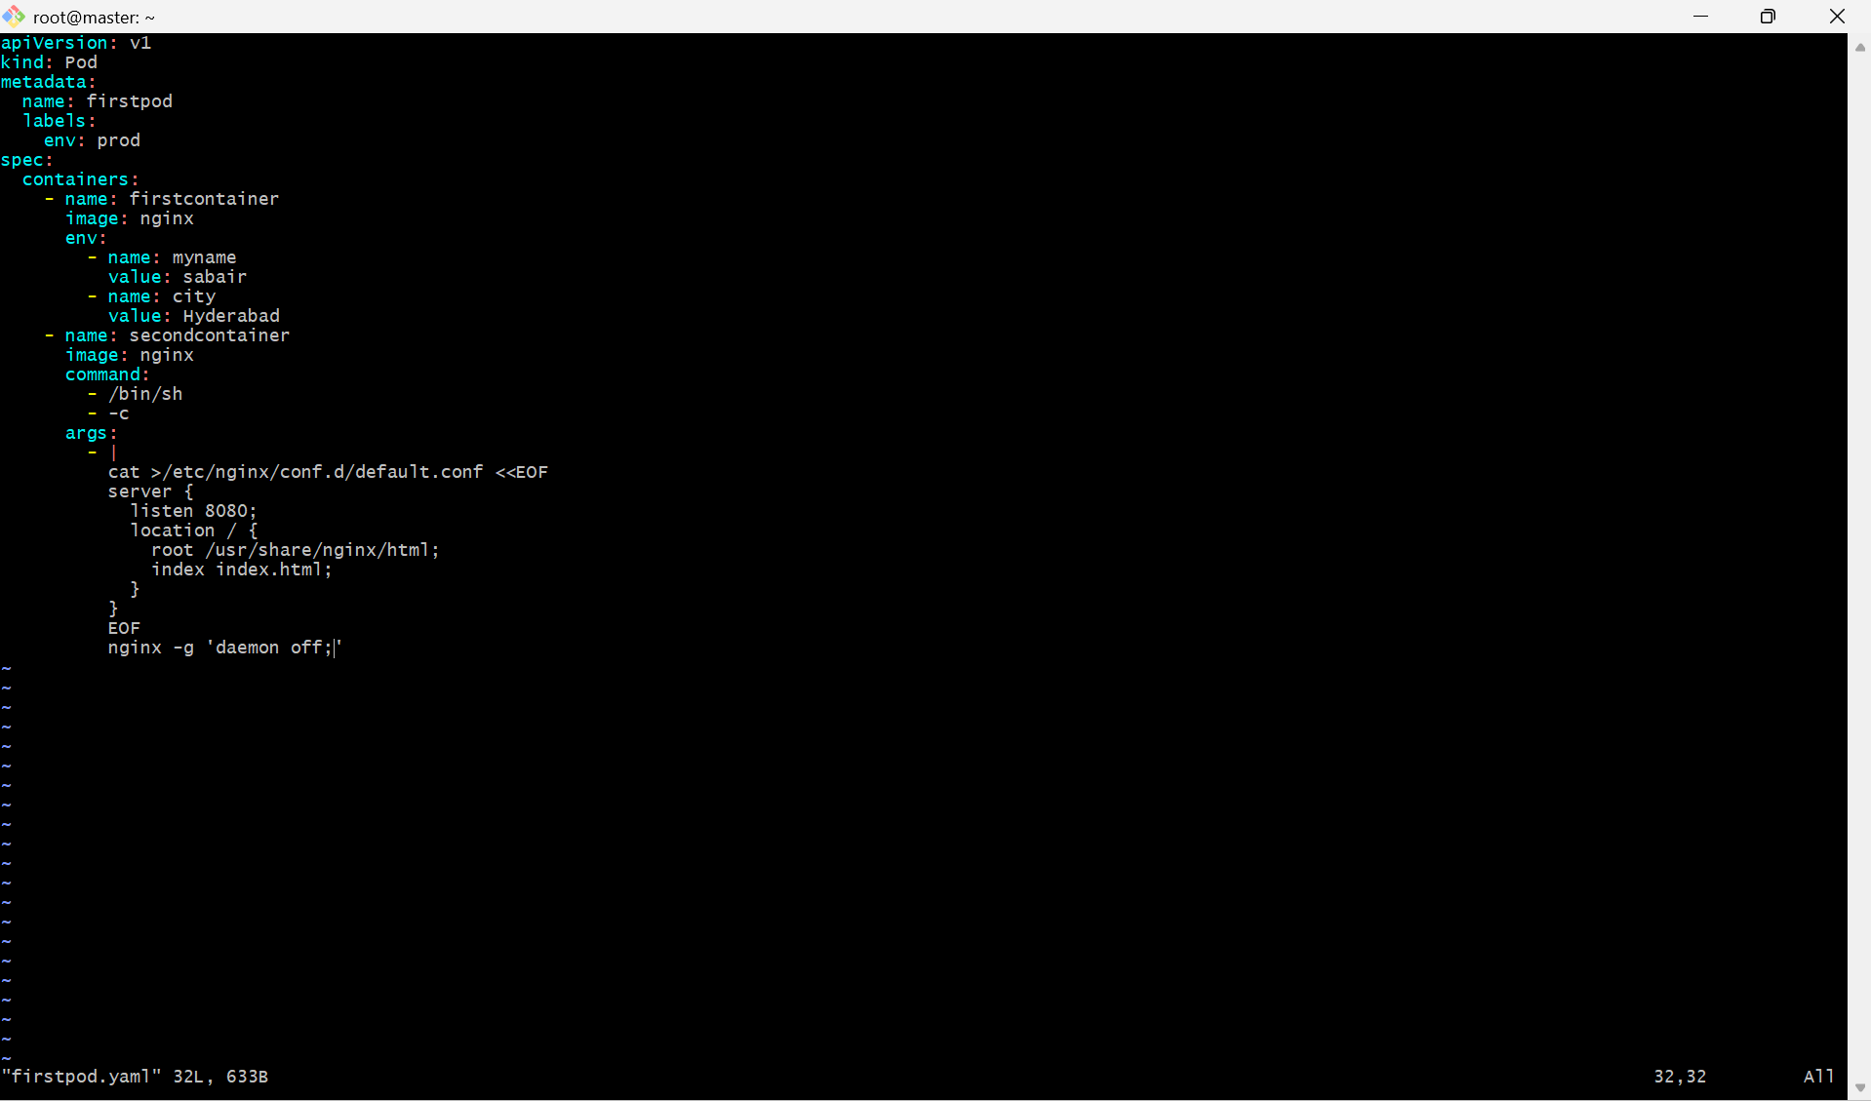

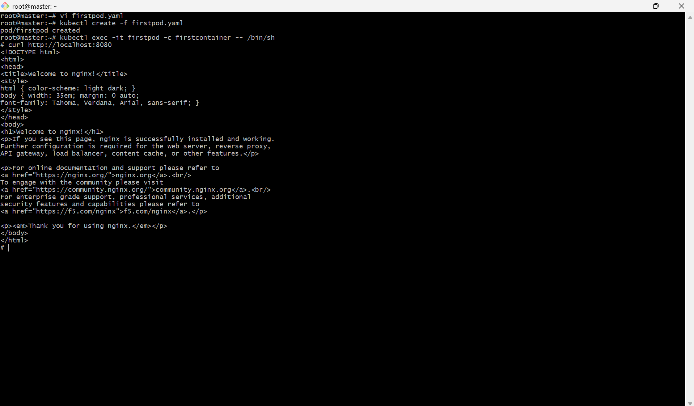

5. Set Up an Init Container in a Pod Task: Modify the YAML to include an init container that sleeps for 30 seconds before the main containers start. Verify the init container's execution using kubectl describe pod and check the logs to confirm its completion.

PURPOSE: The purpose of this task is to understand how Init Containers work in Kubernetes. An Init Container runs before the main application containers and must complete successfully before the main containers are started. It is commonly used for initialization tasks such as waiting for services, downloading configuration files, or preparing the application environment.

OBJECTIVE:
- Create a Kubernetes Pod with an Init Container.
- Configure the Init Container to sleep for 30 seconds before exiting.
- Deploy the Pod using a YAML manifest.
- Verify that the Init Container runs and completes successfully.
- Confirm the Init Container execution using kubectl describe pod and kubectl logs.

EXPECTED OUTCOME:
After completing this task:
- An Init Container named init-sleep runs before the main application container.
- The Init Container sleeps for 30 seconds, performs its initialization task, and exits successfully.
- The Nginx container starts only after the Init Container completes.
- kubectl describe pod shows the Init Container in the Completed state.
- kubectl logs initpod -c init-sleep confirms that the Init Container executed successfully before the main container started.

STEP BY STEP IMPLEMENTATION:
- Firstly we have to delete the pod that we have created in the first task, because Kubernetes will not allow us to modify the yaml file when it has been created already.
- To delete the pod that exists -> kubectl delete pod firstpod
- We have to edit the yaml file with the init containers.
- After created the yaml file and we have to create the pod with the command -> kubectl create -f firstpod.yaml
- Then we have to verify with the pods that have created -> kubectl get pods.

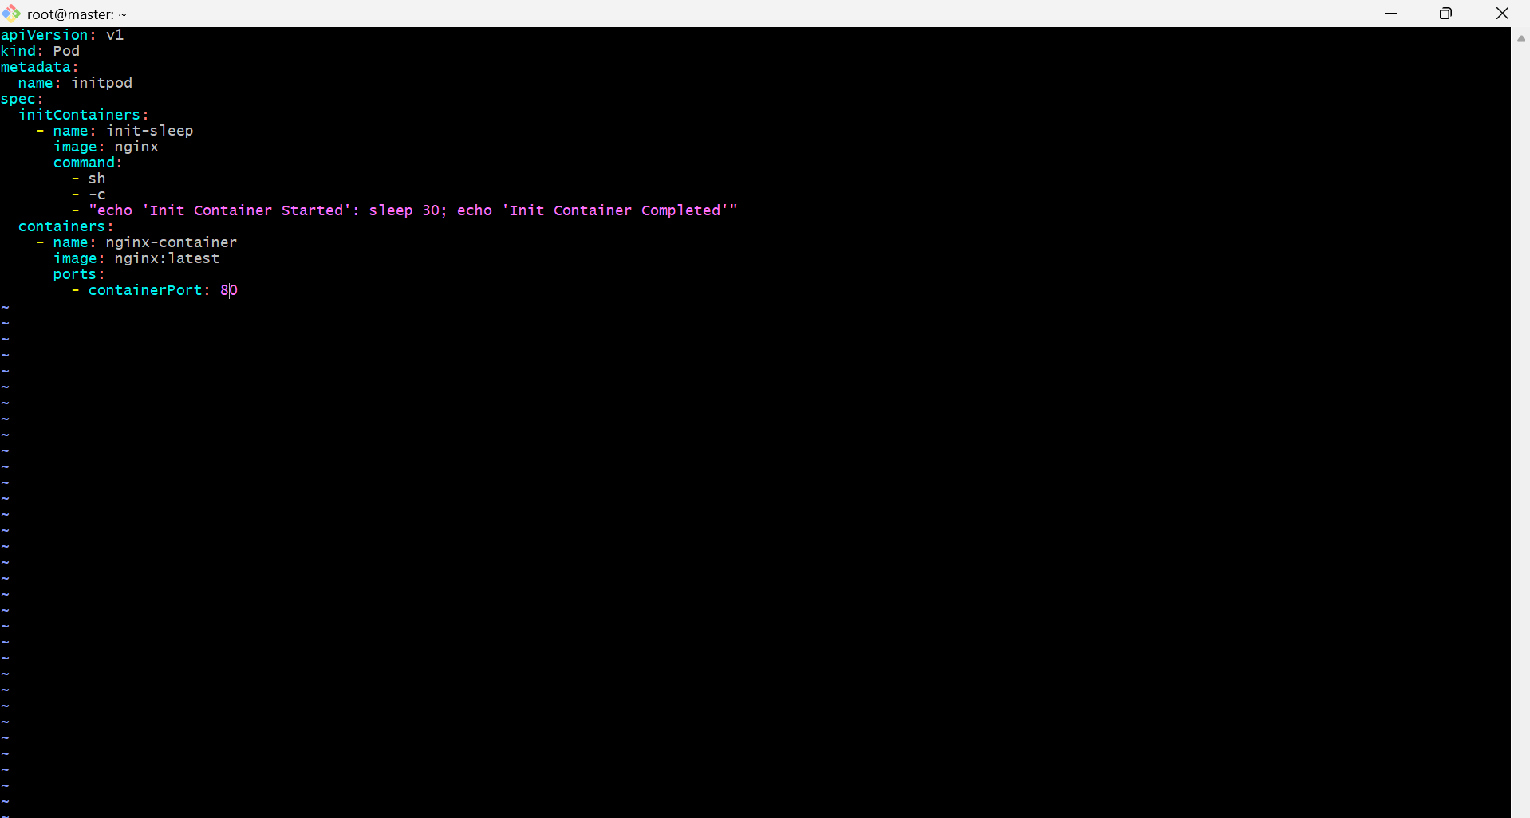

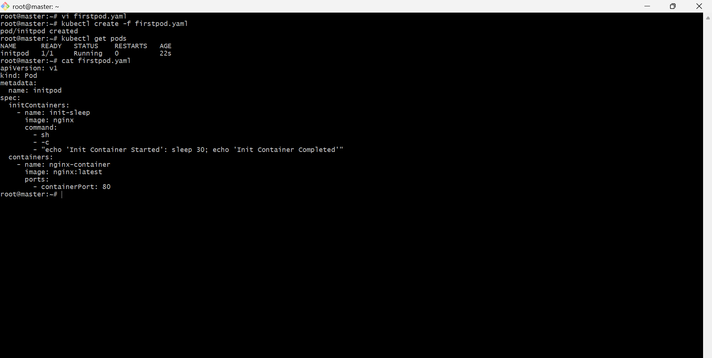

6. Run a Dry Run Command to Generate YAML Task: Use the kubectl run nginx --image=nginx --dry-run=client -o yaml command to generate a Pod YAML definition. Modify the generated YAML to suit specific requirements (e.g., labels or environment variables) and deploy it.

PURPOSE: The purpose of this task is to learn how to use the kubectl run command with the --dry-run=client option to generate a Kubernetes Pod YAML manifest without creating the resource. This approach helps you quickly generate a template, customize it as needed, and deploy it using the declarative method.

OBJECTIVE:
- Generate a Pod YAML manifest using the kubectl run command.
- Save the generated YAML to a file.
- Modify the YAML by adding custom labels and environment variables.
- Deploy the modified Pod.
- Verify that the Pod is running with the updated configuration.

EXPECTED OUTCOME:

After completing this task:
- A Pod YAML manifest is successfully generated using the kubectl run command with the --dry-run=client option.
- The generated YAML is customized by adding labels and environment variables.
- The modified Pod is deployed successfully using kubectl apply.
- The Pod runs with the specified labels and environment variables.
- You gain practical experience generating Kubernetes manifests from the command line and customizing them before deployment.

STEP BY STEP IMPLEMENTATION:
- We have to create file with yaml extension.
- Then we have to edit the file with yaml language to create nginx service by pulling the nginx image.
- Then after creating the file, we have to dry run the file with this command -> kubectl create -f firstpod.yaml –dry-run=client
- This command will helps us to know that what are the actual changes that are being done by executing this yaml file.
- After that we have to execute the command -> kubectl create -f firstpod.yaml
- This command will helps us to create the actual pod.
- To verify the pods created by executing the command -> kubectl get pods.

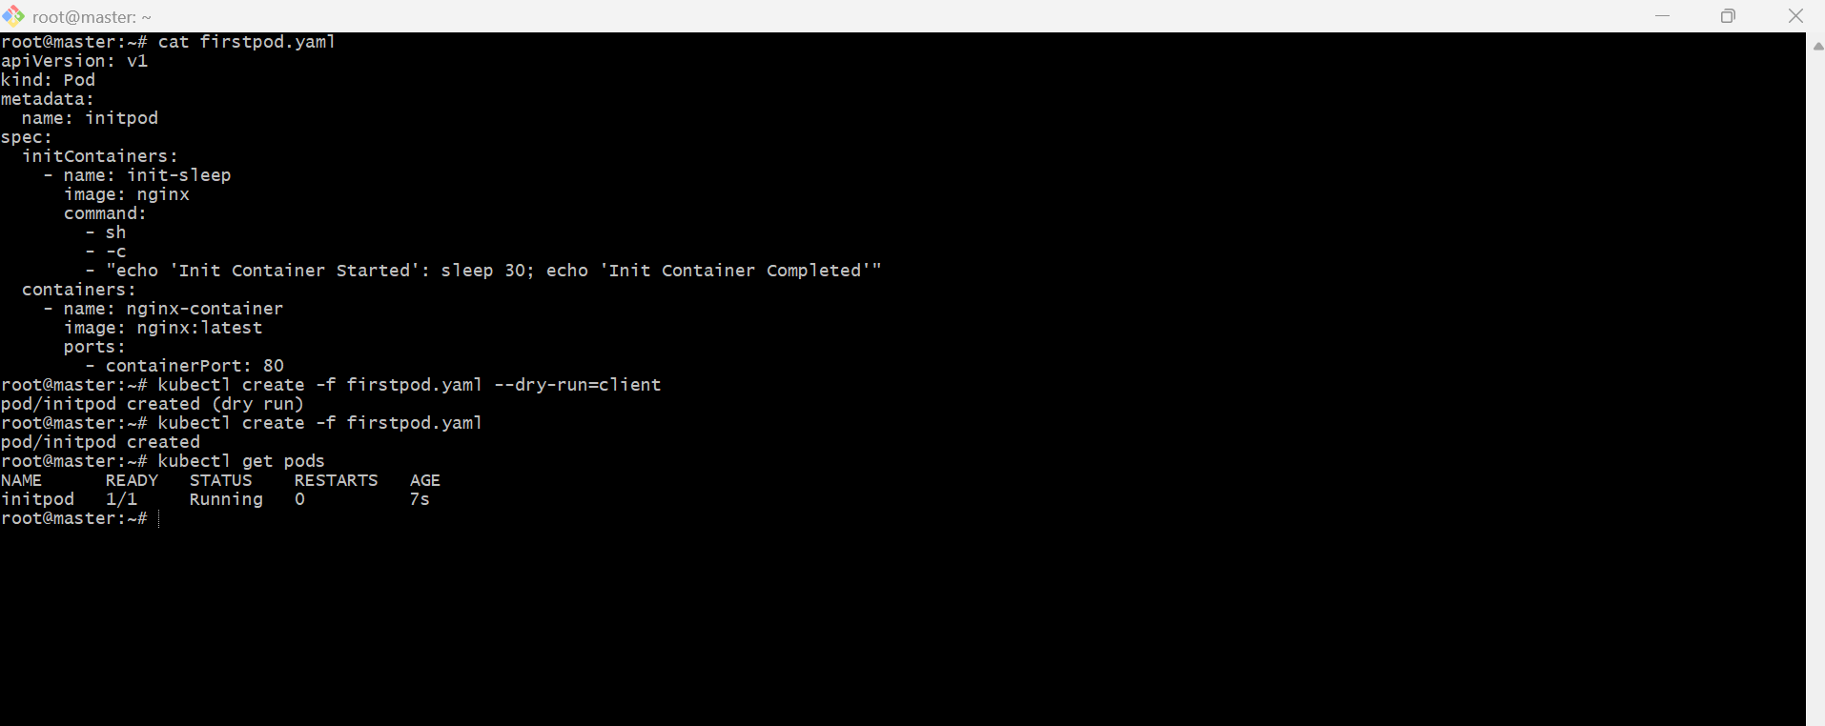

7. Use kubectl apply vs kubectl create Task: Create a YAML file to define a Pod. First, deploy it using kubectl create -f <file_name>.yml and then modify the YAML (e.g., change the image version). Use kubectl apply to redeploy and verify the difference between both commands.

PURPOSE: The purpose of this task is to understand the difference between the kubectl create and kubectl apply commands. kubectl create is used to create a resource for the first time, whereas kubectl apply is used to create or update resources declaratively by comparing the current state with the desired state defined in a YAML manifest.

OBJECTIVE:
- Create a Pod using a YAML manifest.
- Deploy the Pod using kubectl create.
- Modify the YAML file by changing the container image version.
- Attempt to update the Pod using kubectl apply.
- Observe the behavior of both commands and understand why Pods are immutable for most specification changes.

EXPECTED OUTCOME:
After completing this task:
- A Pod is successfully created using kubectl create.
- Re-running kubectl create results in an AlreadyExists error.
- Updating the YAML and using kubectl apply demonstrates how Kubernetes handles declarative updates.
- You understand that kubectl create is for initial creation, while kubectl apply is intended for managing changes to resources over time.

STEP BY STEP IMPLEMENTATION:
- Create a new file with the yaml extension because Kubernetes will accept the yaml language.
- After editing the yaml file, we have to create the pod -> kubectl create -f firstpod.yaml
- We can verify with the command -> kubectl get pods.

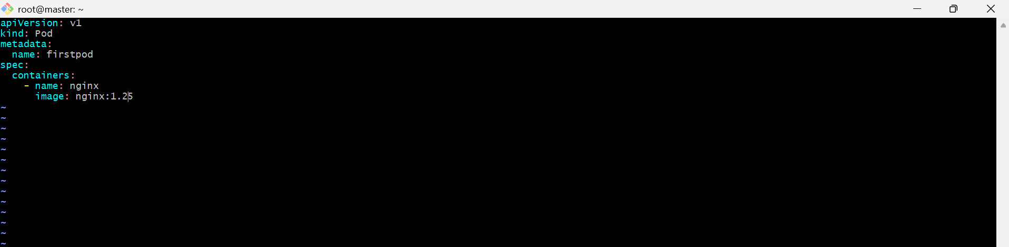

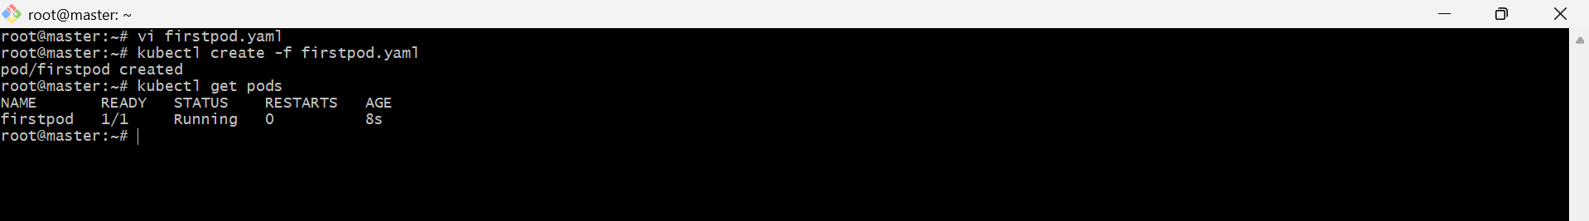

- Then I have changed the nginx image version in the yaml file and then use the command -> kubectl apply -f firstpod.yaml

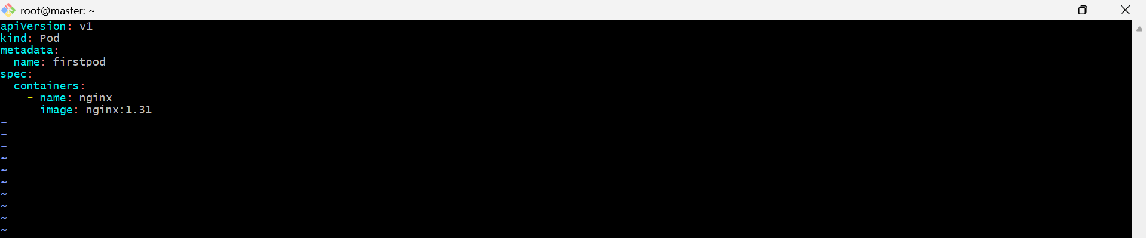

- kubectl create -f file.yaml → Creates a new resource only once and fails if it already exists.
- kubectl apply -f file.yaml → Creates the resource if it doesn't exist, or updates the existing resource to match the YAML configuration.

8. Edit an Existing Pod Configuration Task: Use kubectl edit pod <pod_name> to modify the running Pod's environment variables or image. After making the changes, verify if they took effect by checking the container logs or environment variables using kubectl exec.

PURPOSE: The purpose of this task is to learn how to edit a running Kubernetes Pod using the kubectl edit command and understand which Pod fields are mutable (editable) and which are immutable (cannot be changed after Pod creation).

OBJECTIVE:
- Edit a running Pod using kubectl edit.
- Attempt to modify the container image or environment variables.
- Observe whether the changes are accepted.
- Verify the changes using kubectl describe, kubectl exec, or kubectl logs.
- Understand the limitations of editing standalone Pods.

EXPECTED OUTCOME:

After completing this task:
- You understand how to use kubectl edit to modify a running Pod.
- You observe that some fields (such as the container image) may be editable, while others (such as environment variables) are immutable.
- You verify the changes using kubectl describe, kubectl exec, and kubectl logs.
- You understand why Deployments are preferred over standalone Pods for managing application updates.

STEP BY STEP IMPLEMENTATION:
- Change the existing yaml file nginx version from 1.31 to 1.25 and exit from that file.
- For this we have to execute this command -> kubectl edit pod firstpod.

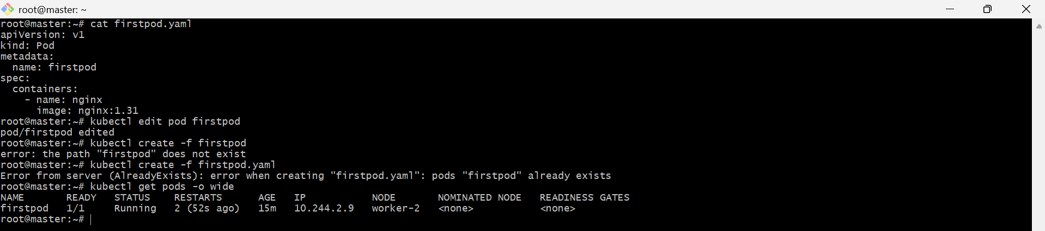

- try to change the environment variables in the pod.

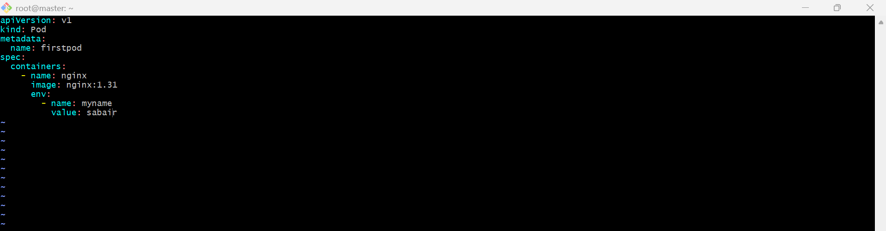

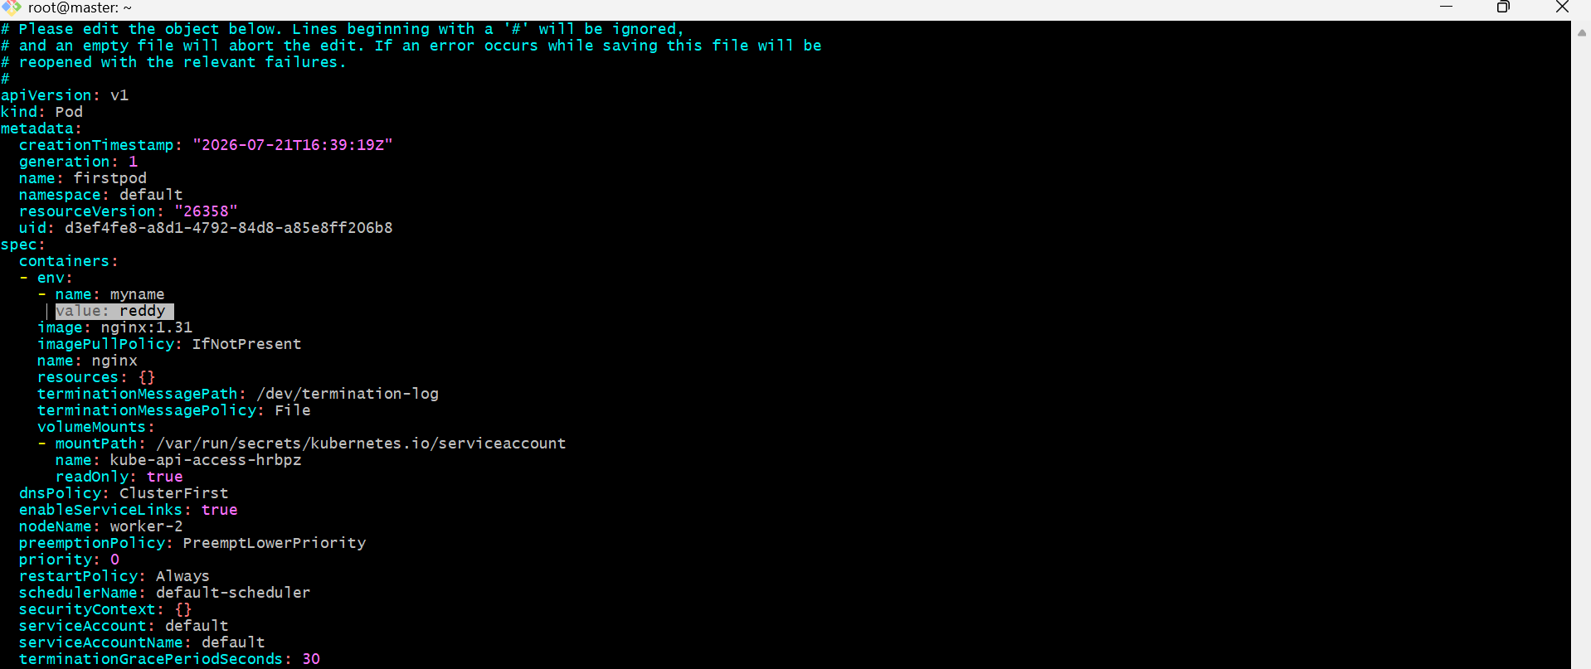

- it will throw an error when you modify the environmental variables.

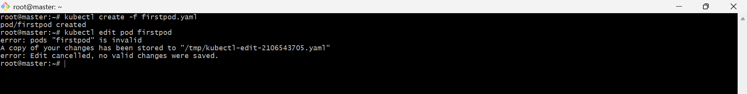

Important Notes
- Image: Can be updated for a running Pod in many Kubernetes versions.
- Environment variables: Cannot be changed after Pod creation.
- Commands, ports, volumes, and restart policy: Cannot be modified in a running Pod.
- For production workloads, use a Deployment instead of a standalone Pod because Deployments support rolling updates and configuration changes.

9. Expose a Pod Using a Service Task: Create a YAML file to expose your firstpod using a Service (ClusterIP). Ensure that your service is exposing the Pod on port 80 and verify it using kubectl get svc.

PURPOSE: The purpose of this task is to learn how to expose a Kubernetes Pod internally within the cluster using a ClusterIP Service. A ClusterIP Service provides a stable IP address and DNS name, allowing other Pods in the cluster to communicate with the application without directly accessing the Pod's IP address.
OBJECTIVE:
- Create a Pod named firstpod.
- Create a ClusterIP Service to expose the Pod on port 80.
- Verify that the Service is created successfully.
- Test connectivity to the Service from another Pod.

EXPECTED OUTCOME:

After completing this task:
- A Pod named firstpod is running.
- A ClusterIP Service named firstpod-service is created.
- The Service exposes the Pod on port 80.
- kubectl get svc shows the Service with a ClusterIP.
- kubectl get endpoints confirms the Service is associated with the Pod.
- Another Pod in the cluster can successfully access the application using the Service name (firstpod-service).

STEP BY STEP IMPLEMENTATION:
- Create the pod with the yaml language and file with the yaml extension.

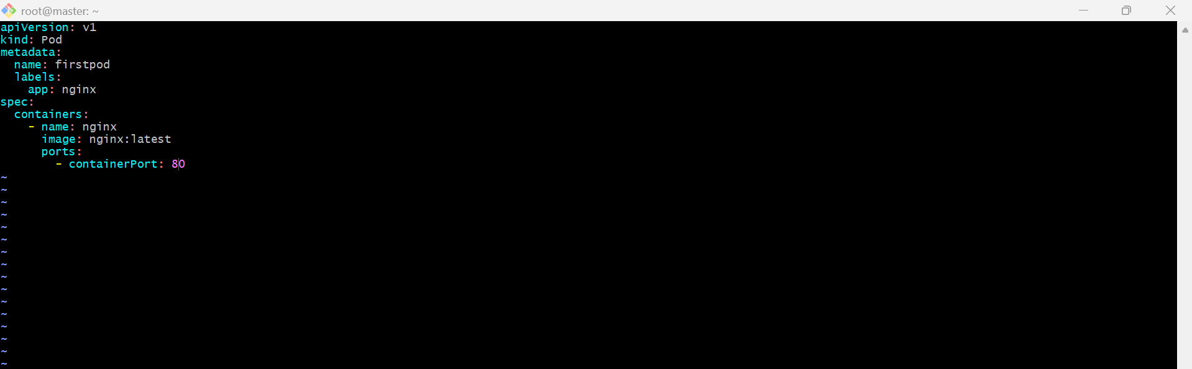

- Then we have to create service.yaml file.

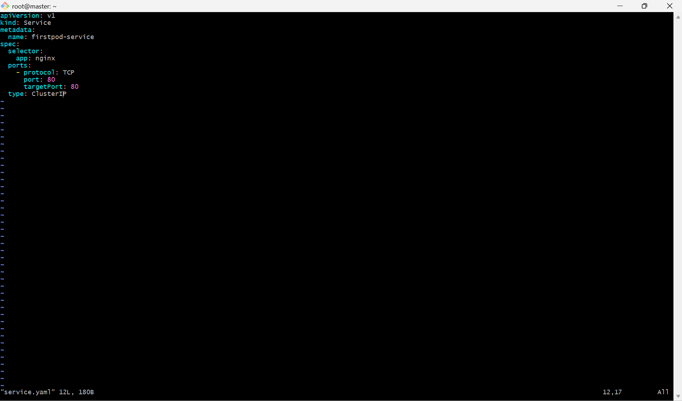

- Then we have to create the pod and service for the pod.
- kubectl apply -f firstpod.yaml
- kubectl apply -f service.yaml
- these command will create pod and service.
- We can verify it with the commands
  - kubectl get pods -> for pod verification
  - kubectl get svc -> for service verification.
- Then we can also verify with the command -> kubectl get endpoints.
- Then we can get into the busybox -> kubectl run testpod --image=busybox --rm -it – sh
- In the busybox, we have to execute this command -> wget -qO- http://firstpod-service
- This confirms that the Service can reach the Nginx Pod.

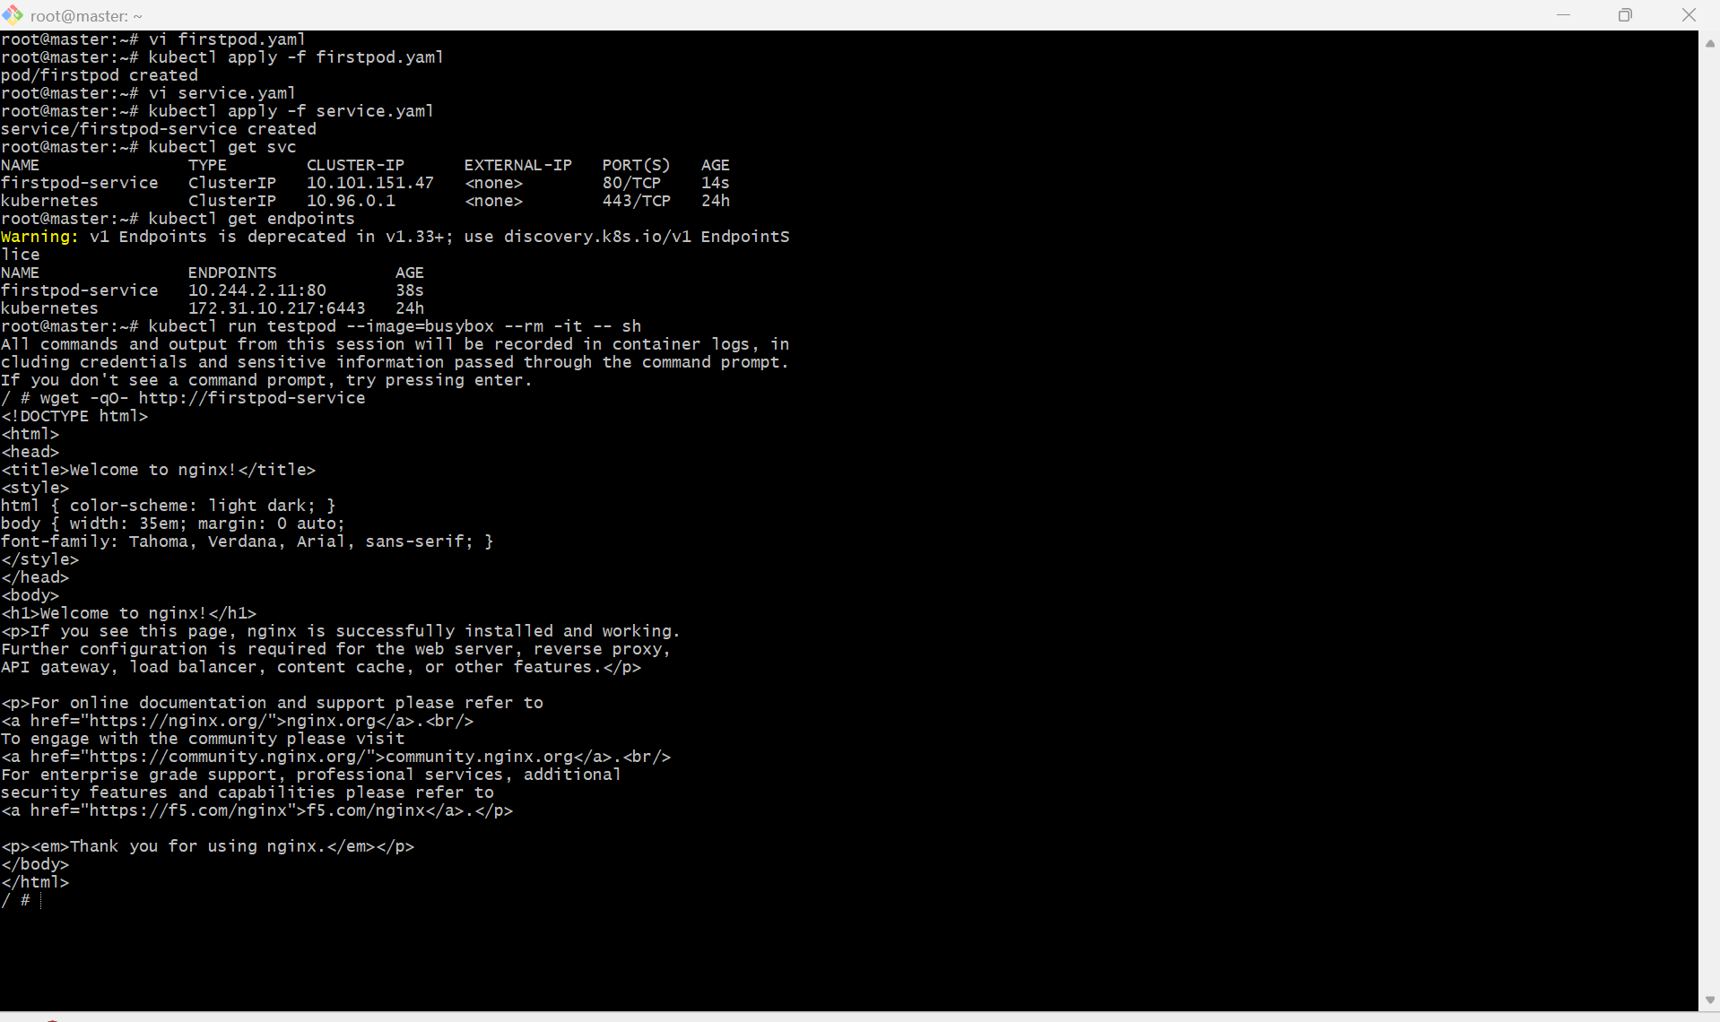

10. Pod with Resource Limits and Requests Task: Add resource requests and limits to the containers in your YAML file. Specify CPU and memory requests/limits for both containers and deploy the Pod. Use kubectl describe pod to verify if the resource configurations are correctly applied.

PURPOSE: The purpose of this task is to learn how to define resource requests and resource limits for containers in a Kubernetes Pod. Resource requests reserve the minimum CPU and memory required by a container, while resource limits define the maximum CPU and memory the container is allowed to consume.

OBJECTIVE:
- Create a Pod with two containers.
- Configure CPU and memory requests for each container.
- Configure CPU and memory limits for each container.
- Deploy the Pod using a YAML manifest.
- Verify the resource configuration using kubectl describe pod.

EXPECTED OUTCOME:
After completing this task:
- A Pod named resource-pod is successfully deployed with two containers.
- Each container has defined CPU and memory requests as well as CPU and memory limits.
- kubectl describe pod resource-pod confirms that the resource configurations are correctly applied.
- You understand how Kubernetes uses requests for scheduling and limits to restrict the maximum CPU and memory usage of containers.

STEP BY STEP IMPLEMENTATION:

- Create a Pod YAML file with two containers.
- Define CPU and memory requests for each container.
- Define CPU and memory limits for each container.
- Save the YAML file.
- Deploy the Pod to the Kubernetes cluster.
- Verify that the Pod is created successfully.
- Check the Pod status and ensure both containers are running.
- Inspect the Pod details to verify that the CPU and memory requests/limits are correctly applied.
- If the Pod is not running, examine the Pod events and container logs to identify the issue.
- Fix any configuration errors, redeploy the Pod, and verify that the resource settings are applied successfully.

