KUBERNETES-03

1. Create a ClusterIP service for an Apache web server pod.

PURPOSE: To expose an Apache web server Pod internally within the Kubernetes cluster using a ClusterIP Service.

OBJECTIVE:
- Deploy an Apache web server Pod.
- Create a ClusterIP service to expose the Pod.
- Verify that the service routes traffic to the Apache Pod.

EXPECTED OUTCOME:
- The Apache Pod runs successfully.
- A ClusterIP service is created.
- Other Pods within the cluster can access the Apache web server using the service name.

STEP BY STEP IMPLEMENTATION:

- We have to create a new file with the yaml extension to create a Pod.
- And also create one more file for the service to assign for the Pod.
- Service will be assigned based upon the labels that have created for the Pod.
- That labels should called in the service file in the selector block of the file.
- Then we have to create both files by using commands
- kubectl create -f firstpod.yaml
- kubectl create -f service.yaml
- Then for the verification we have to run these commands
- kubectl get pods
- kubectl get svc
- then we have to execute these command in both worker nodes for the verification of clusterIP by using this command
- curl localhost:80

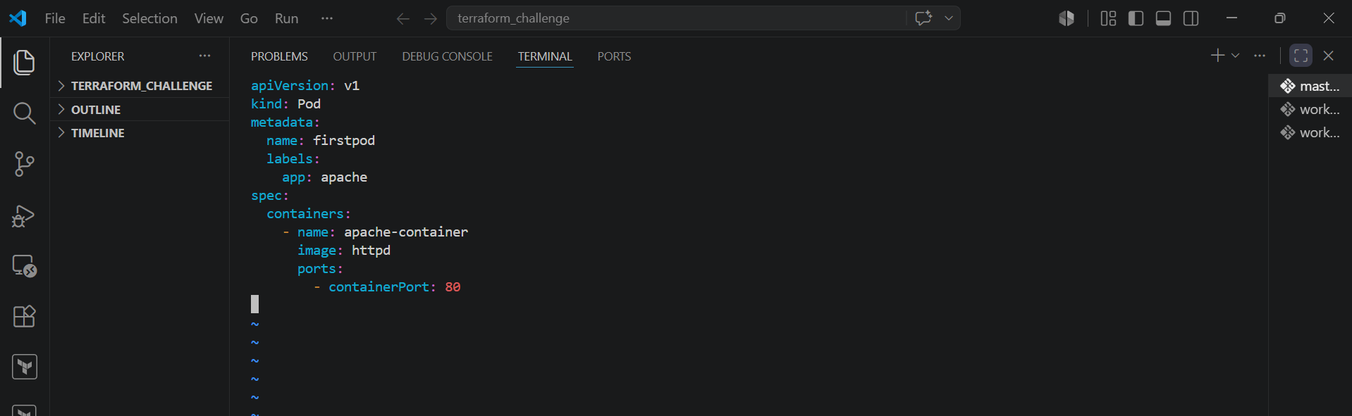

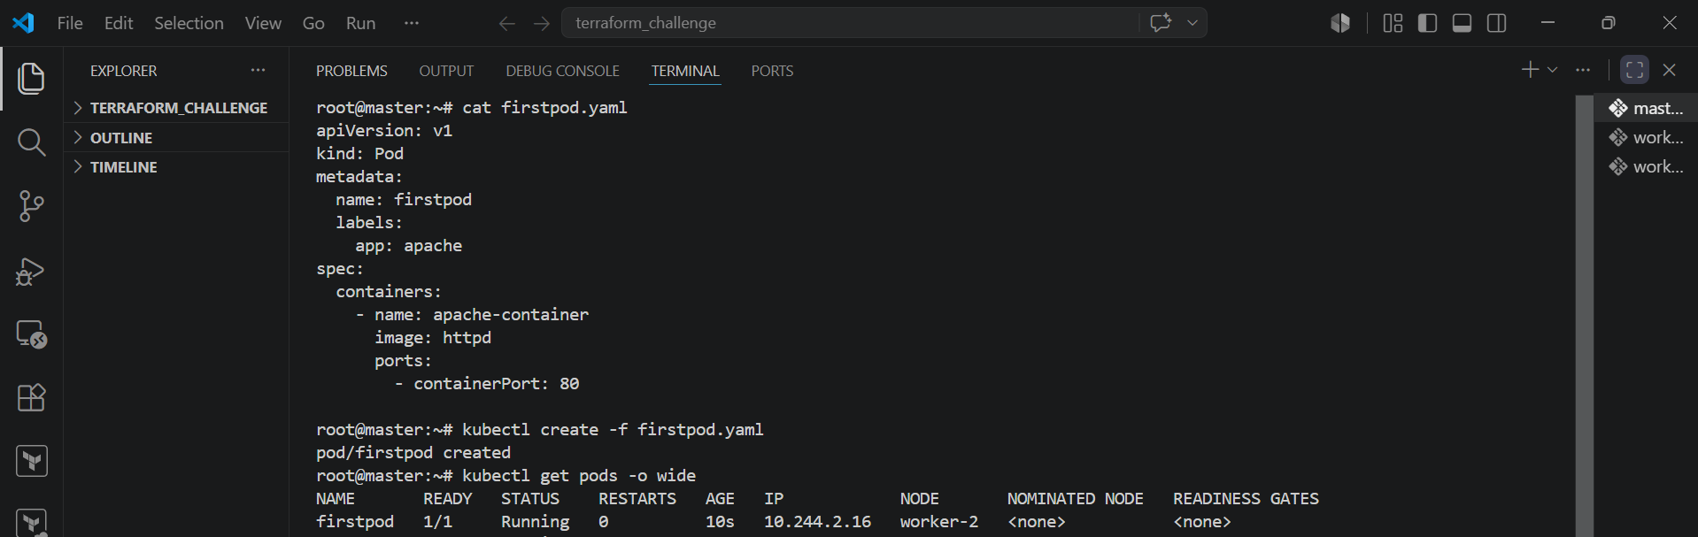

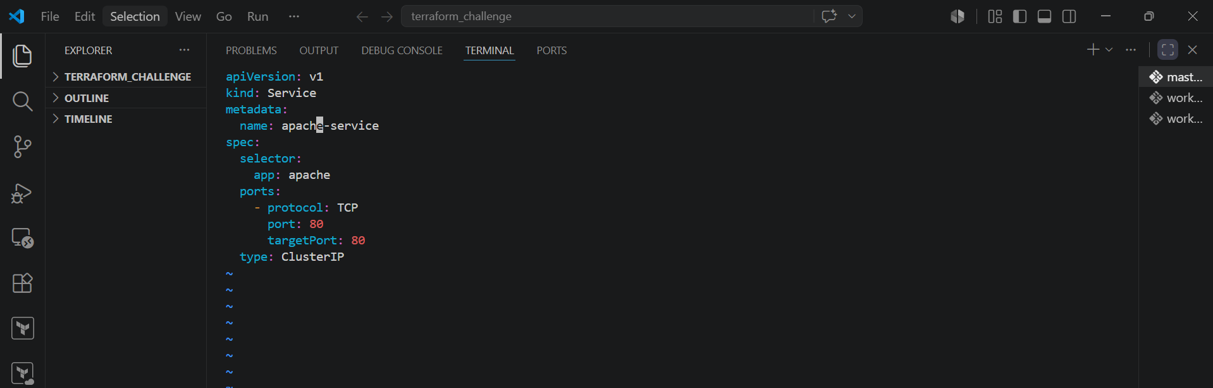

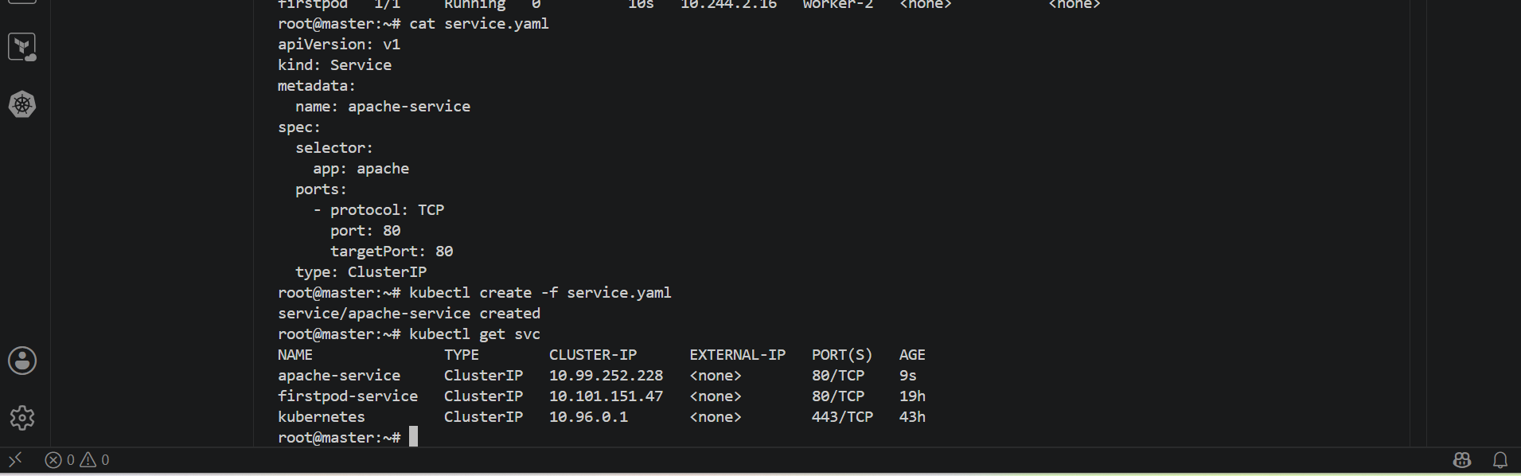

- execute this command in the worker node 1 -> curl 10.244.2.16:80

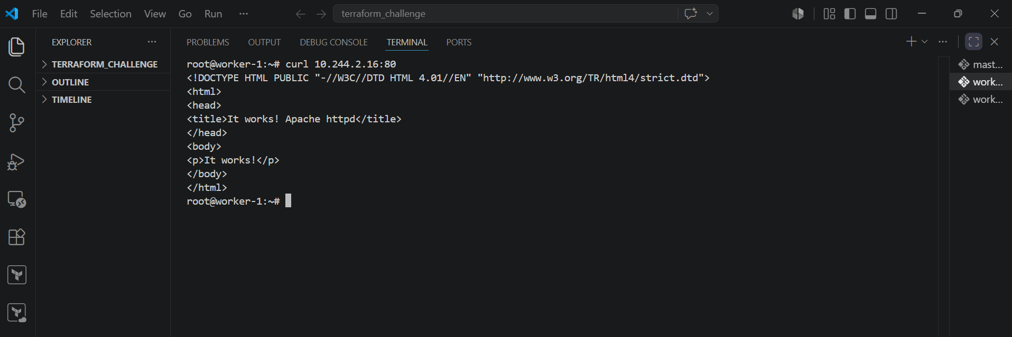

- execute this command in the worker node 2 -> curl 10.244.2.16:80

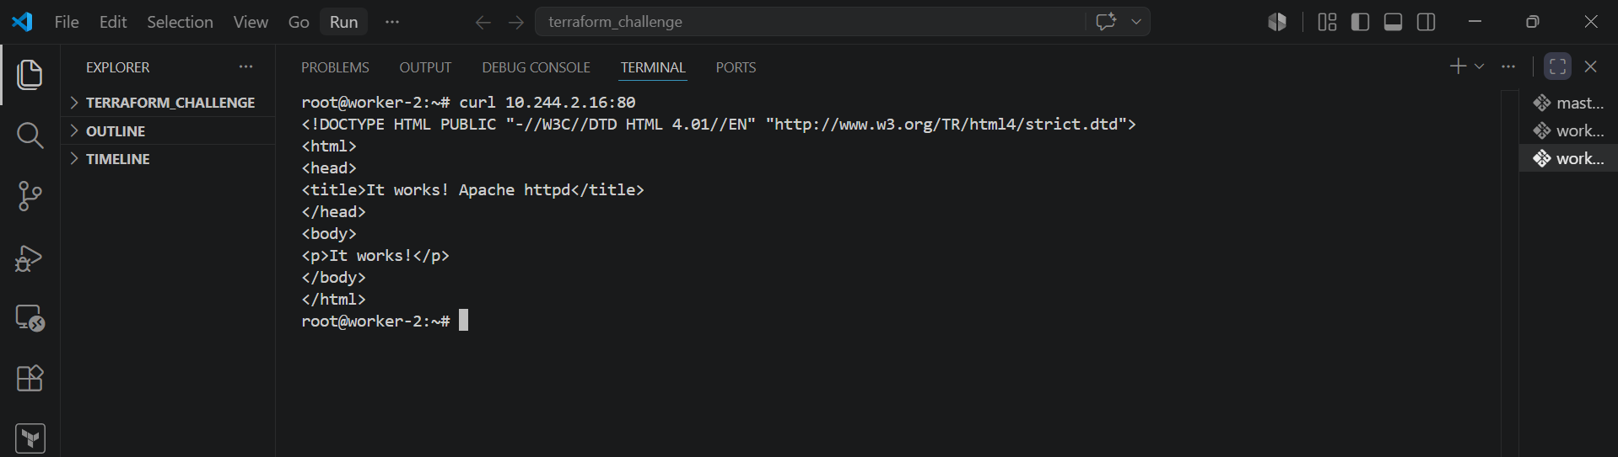

2. Expose an Nginx pod externally using a NodePort service.

PURPOSE: To make an Nginx web server Pod accessible from outside the Kubernetes cluster using a NodePort service.

OBJECTIVE:
- create an nginx pod.
- Expose the pod using a NodePort Service.
- Verify that the application is accessible through the worker node’s IP address and the assigned NodePort.

EXPECTED OUTCOME:
- An Nginx Pod is running successfully.
- A NodePort Service is created.
- The Nginx web page cab be accessed externally using the node IP and NodePort.

STEP BY STEP IMPLEMENTATION:
- We have to create a pod and a service of NodePort type by creating two yaml files.
- Firstpod.yaml and service.yaml
- Then we have to create both the files by executing this command -> kubectl create -f <filename>.yaml
- Then we can verify it in the browser with the public ip and the NodePort port number.

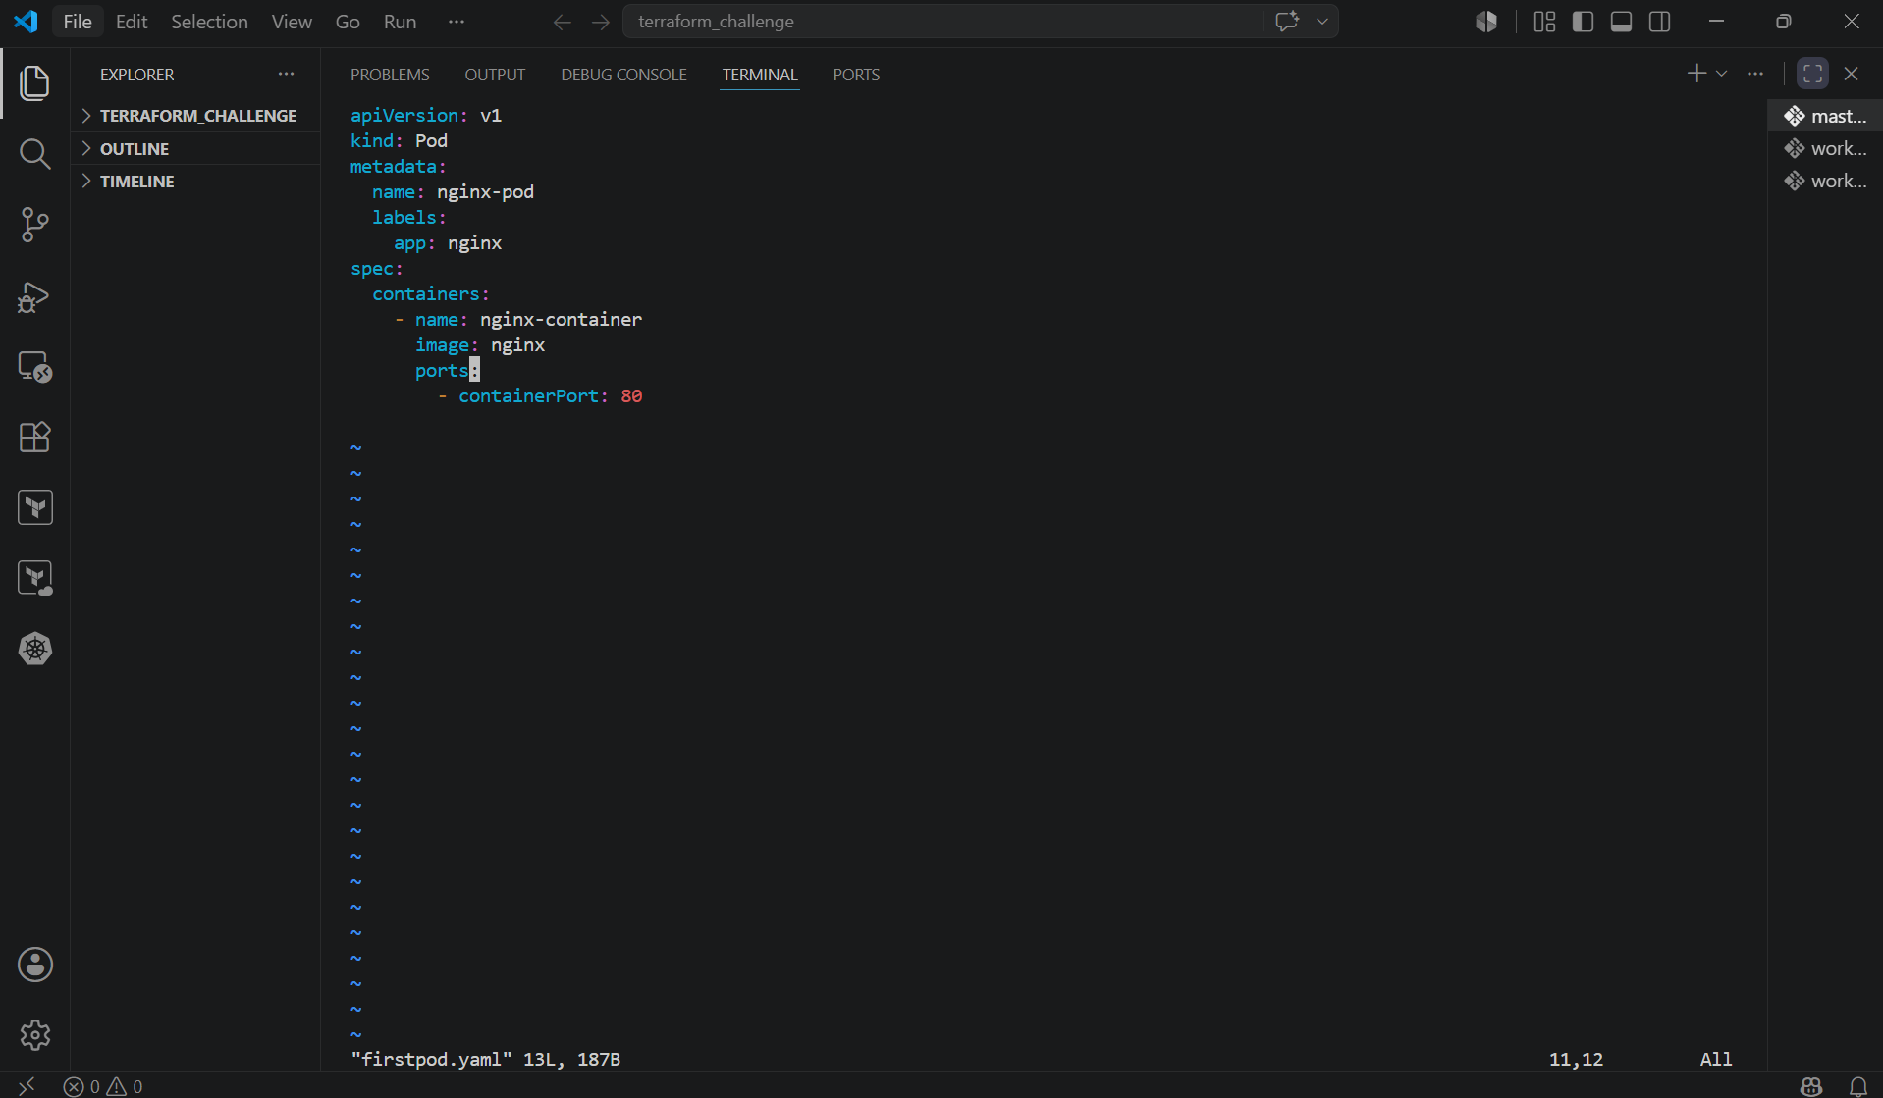

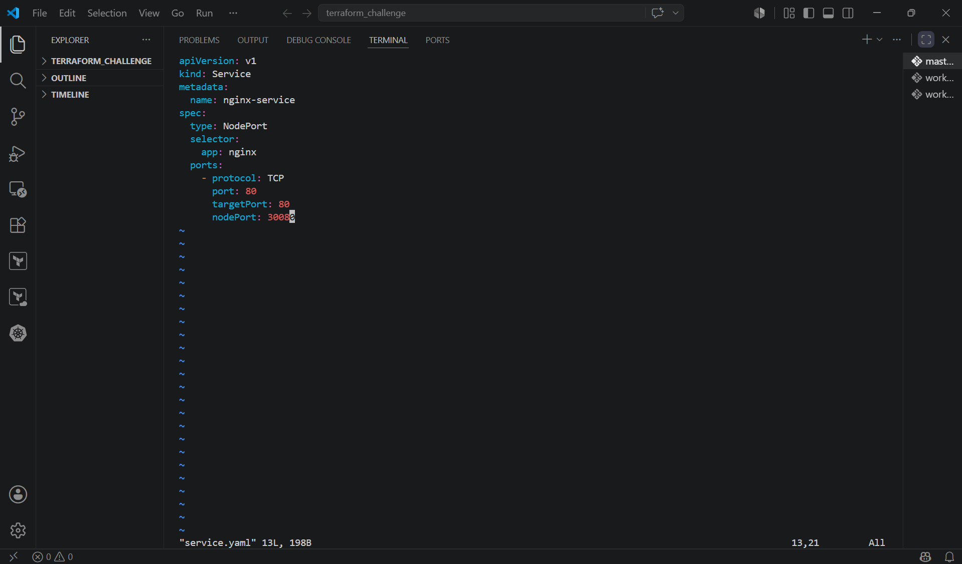

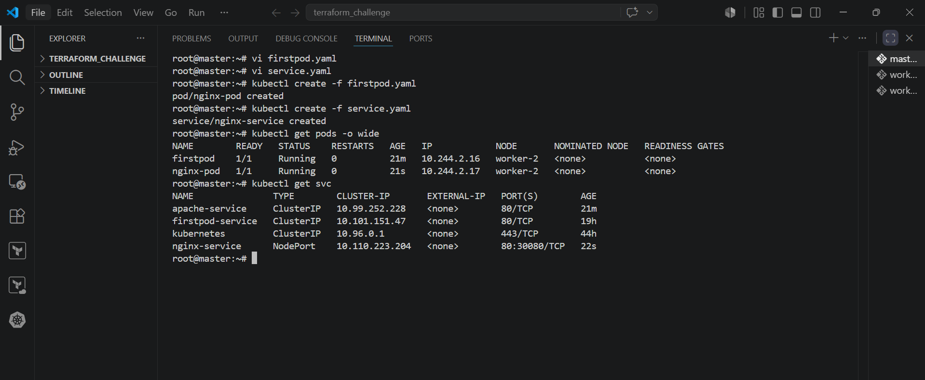

- Verify it with the master node public IP

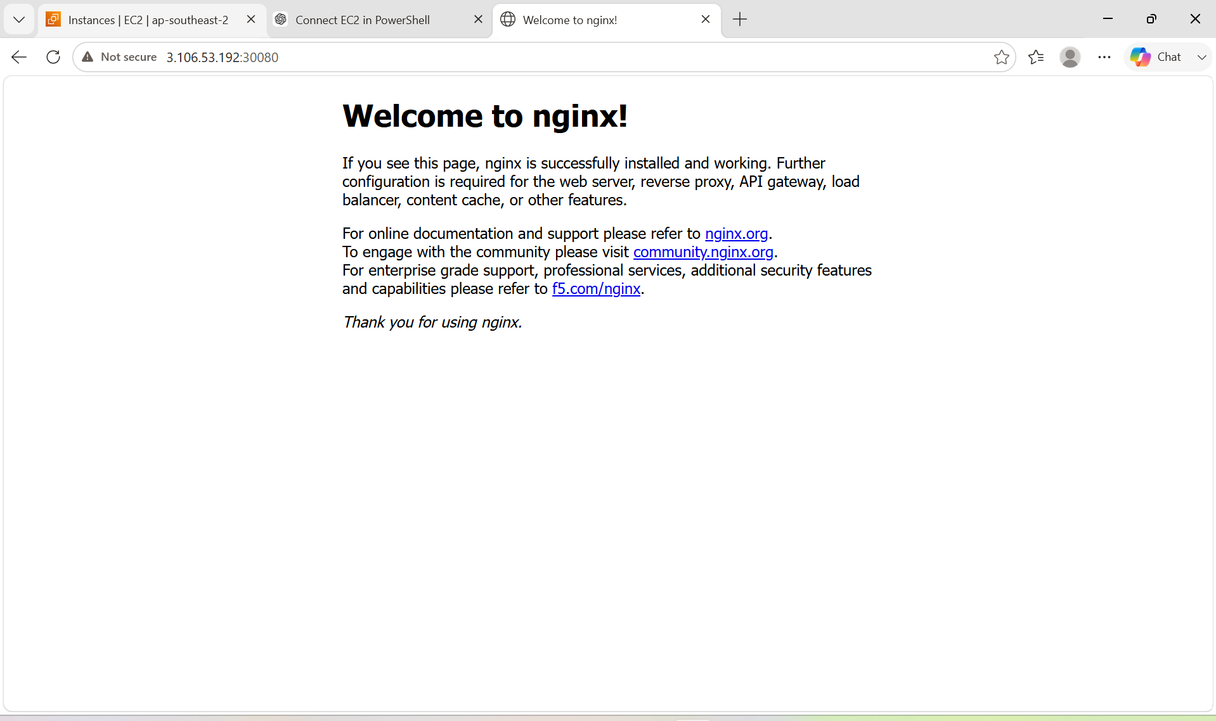

- Verify it with worker node 1 public Ip

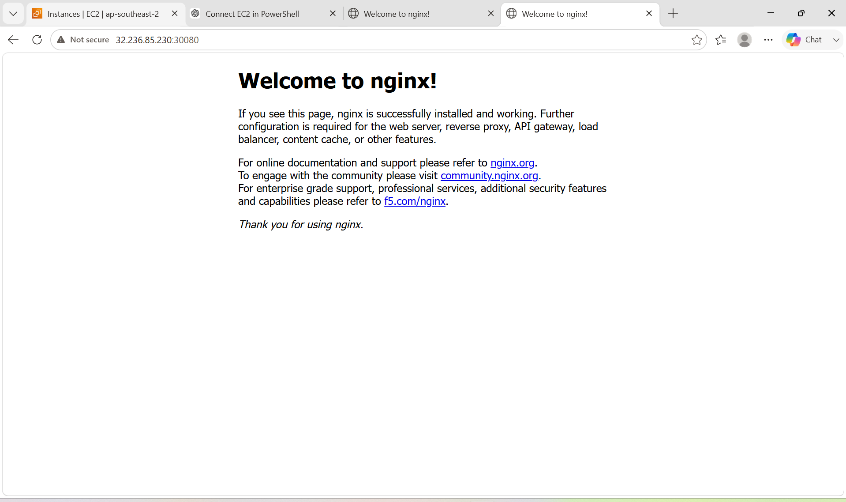

- Verify it with the worker node 2 public IP

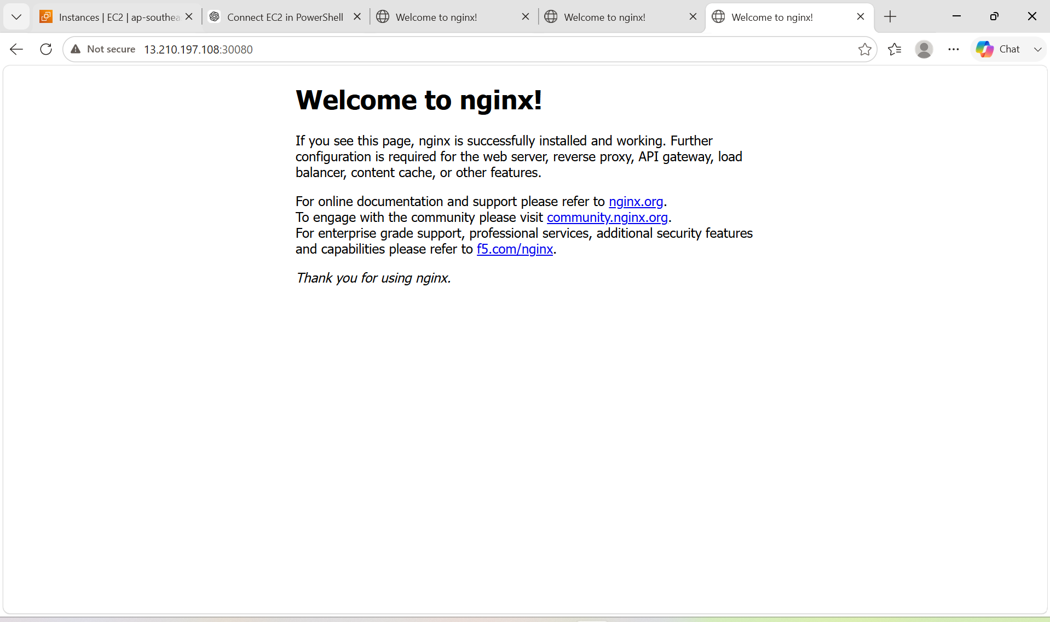

3. Deploy a ReplicationController to maintain 3 replicas of an Nginx pod.

PURPOSE: To ensure that three Nginx Pods are always running by using a ReplicationController.

OBJECTIVE:
- Create a ReplicationController.
- Deploy 3 replicas of an Nginx Pod.
- Verify that Kubernetes maintains the desired number of replicas.
- Test self-healing by deleting a Pod and confirming that a new one is created automatically.

EXPECTED OUTCOME:
- Three Nginx Pods are running.
- The ReplicationController maintains the desired state.
- If a Pod is deleted, Kubernetes automatically creates a replacement Pod.

STEP BY STEP IMPLEMENTATION:
- Create a ReplicationController file with the yaml extension.
- Then we have to create that file.
- Then we can verify with the command -> kubectl get pods -o wide

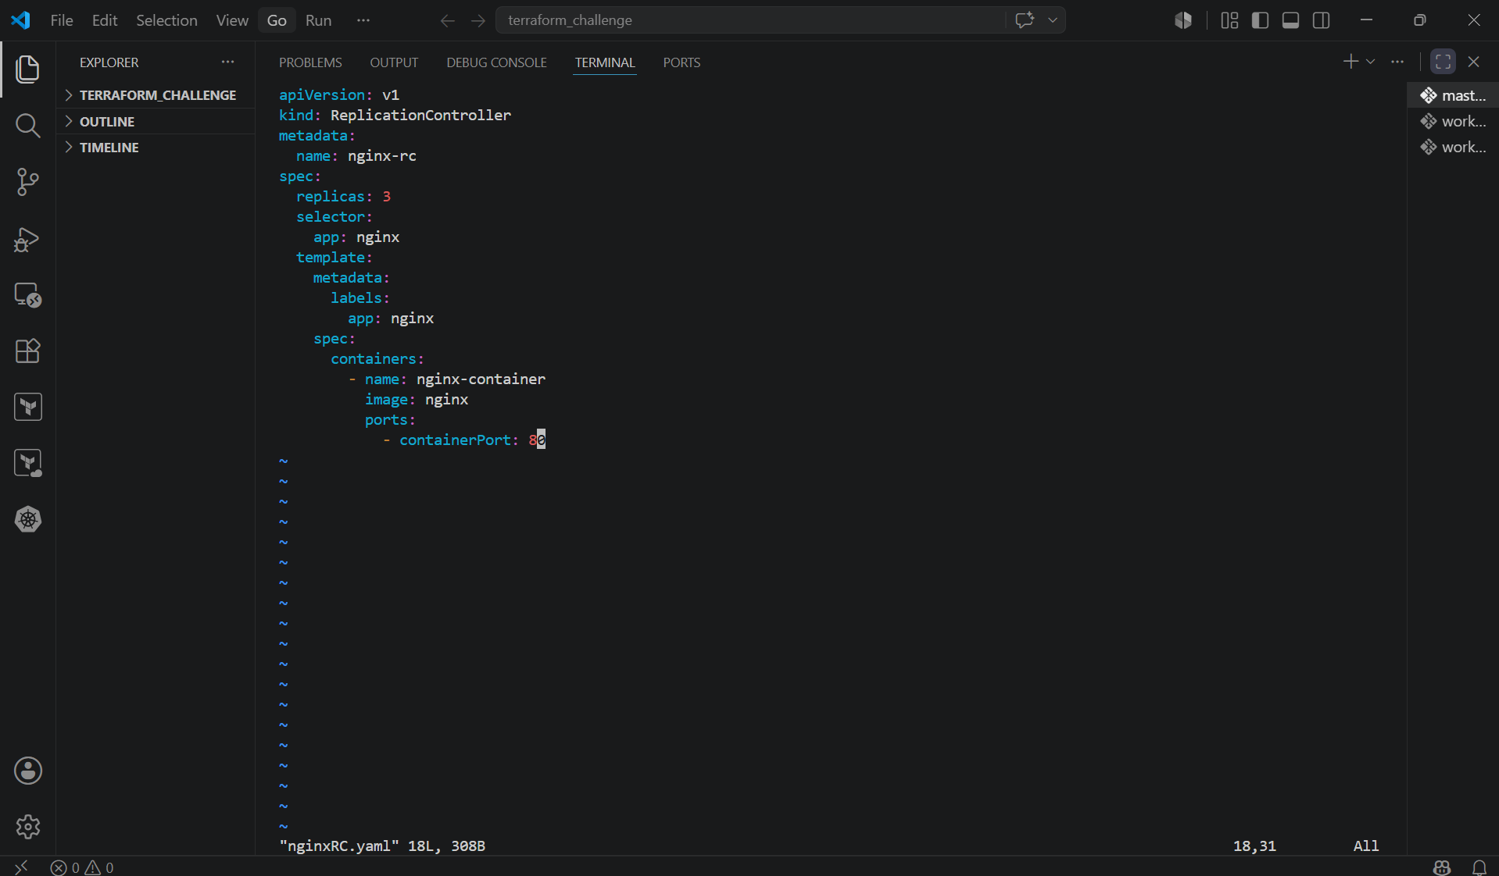

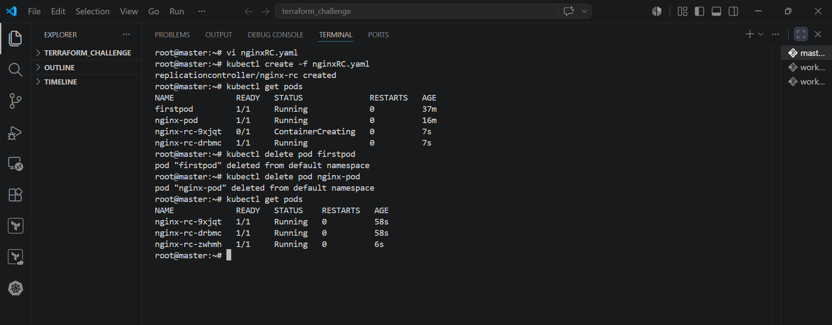

- Then we can verify by deleting the pod and then we can see the again RC will spin up the pods to replicas number.

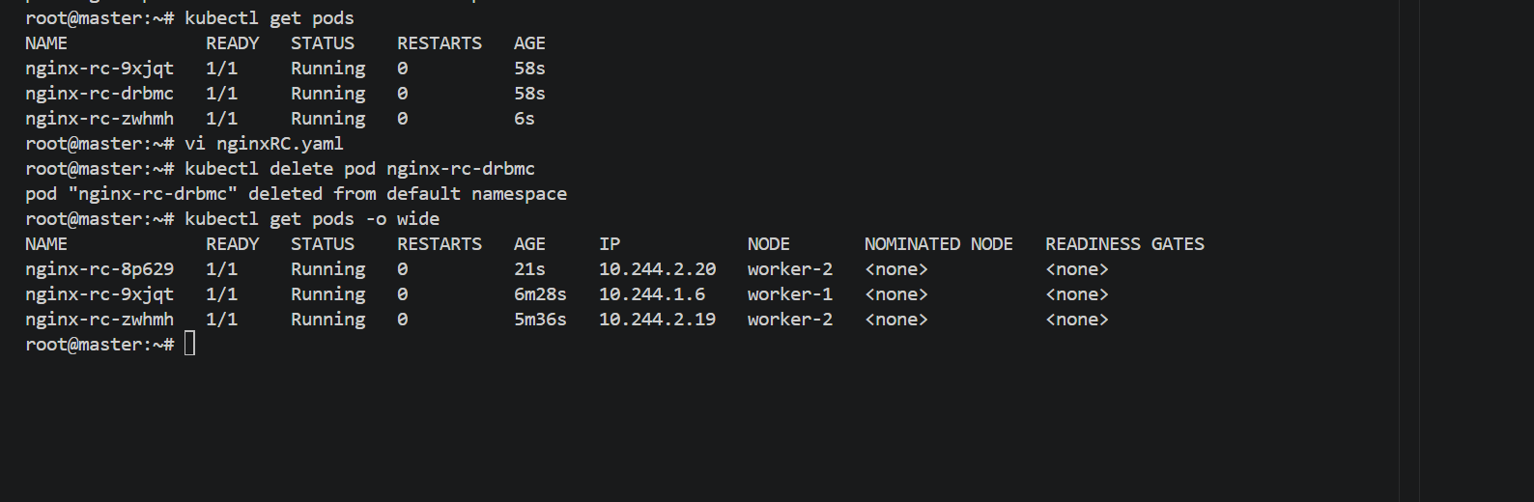

4. Scale the ReplicationController from 3 replicas to 5 replicas

PURPOSE: To increase the number of Nginx Pod replicas managed by a ReplicationController from 3 to 5, ensuring higher availability and capacity.

OBJECTIVE:
- Scale the existing ReplicationController.
- Increase the replica count from 3 to 5.
- Verify that Kubernetes creates two additional Pods.

EXPECTED OUTCOME:
- The ReplicationController manages 5 Nginx Pods.
- Kubernetes automatically creates two new Pods.
- All five Pods are in the Running state.

STEP BY STEP IMPLEMENTATION:

- We can edit the yaml file of ReplicationController.
- One more option, we can edit that in the command line itself with a single command
- kubectl scale rc nginx-rc –replicas=5
- then we can verify it with the command -> kubectl get pods.
- And also kubectl get rc

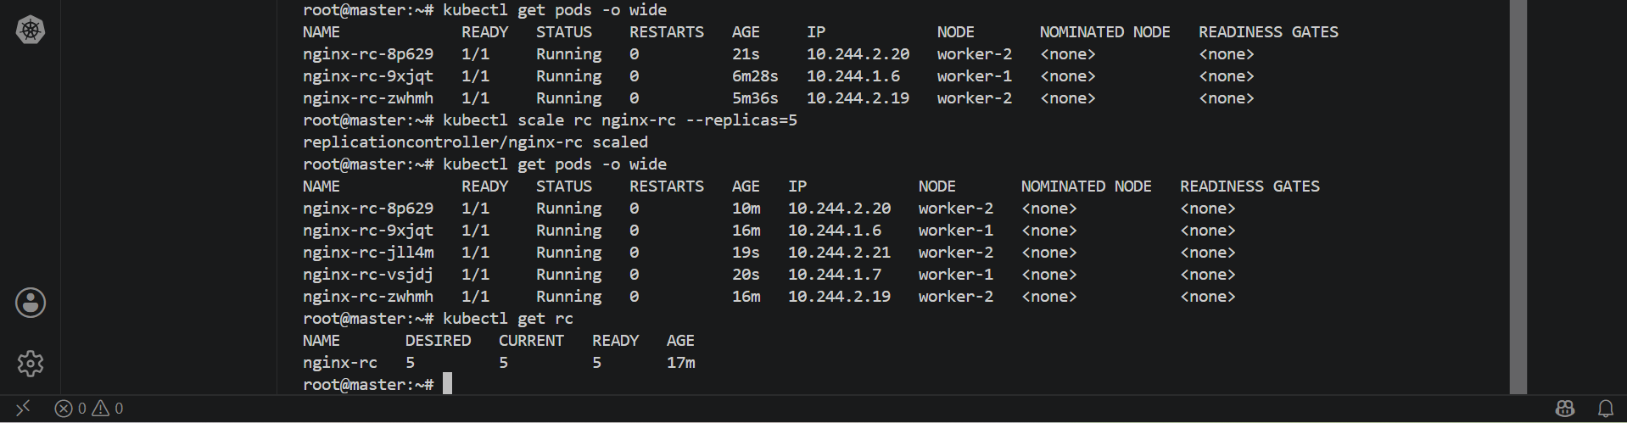

5. Create a ReplicaSet to manage pods based on multiple labels (prod and test).

PURPOSE: To deploy and manage Pods using a ReplicaSet with multiple labels (environment and app) so that only Pods matching both labels are managed.

OBJECTIVE:
- Create a ReplicaSet with 3 replicas.
- Use multiple labels (app: nginx and environment: prod).
- Use a selector with matchLabels.
- Verify that only Pods matching both labels are managed by the ReplicaSet.

EXPECTED OUTCOME:
- A ReplicaSet creates and maintains 3 Nginx Pods.
- The ReplicaSet manages only Pods that match both app: nginx and environment: prod.
- Pods with environment: test are not managed by this ReplicaSet.

STEP BY STEP IMPLEMENTATION:
- Create the ReplicaSet yaml file with the labels app:nginx and env:prod
- Then create a Pod with the labels app:nginx and env:test.
- Now we have to create the two files and then verify it
- Verify that the test Pod is not managed by the ReplicaSet.
- Delete one of the ReplicaSet-managed Pods and confirm that a new Pod is created automatically.

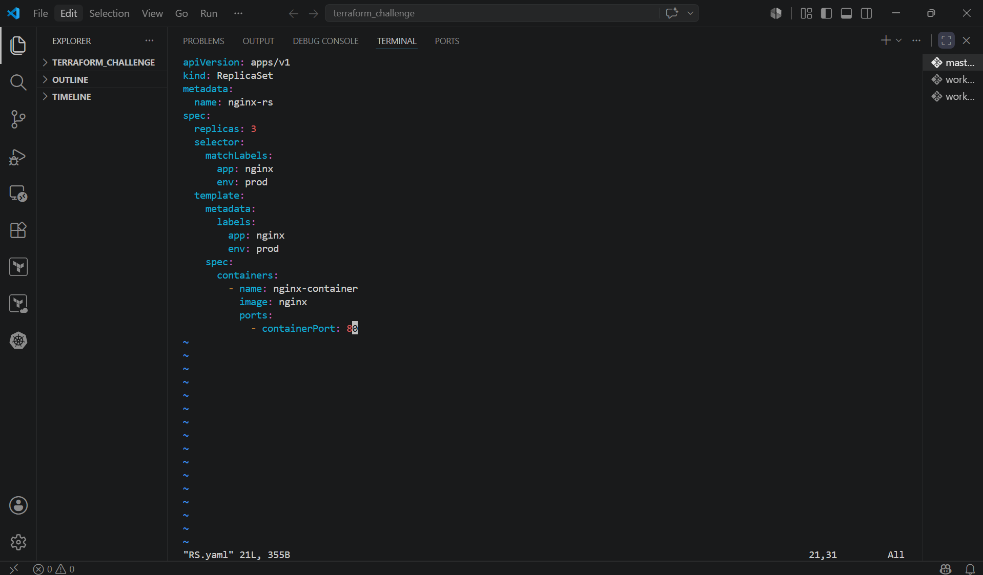

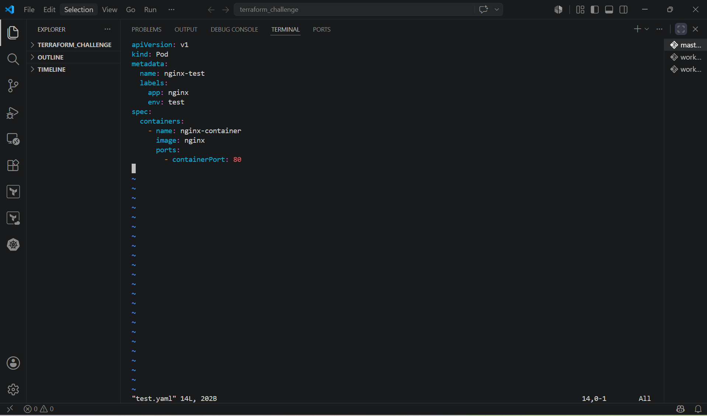

- When we get the complete information about the pods, then we can see that the labels matched with the ReplicaSet labels then they are controlled by the ReplicaSets.

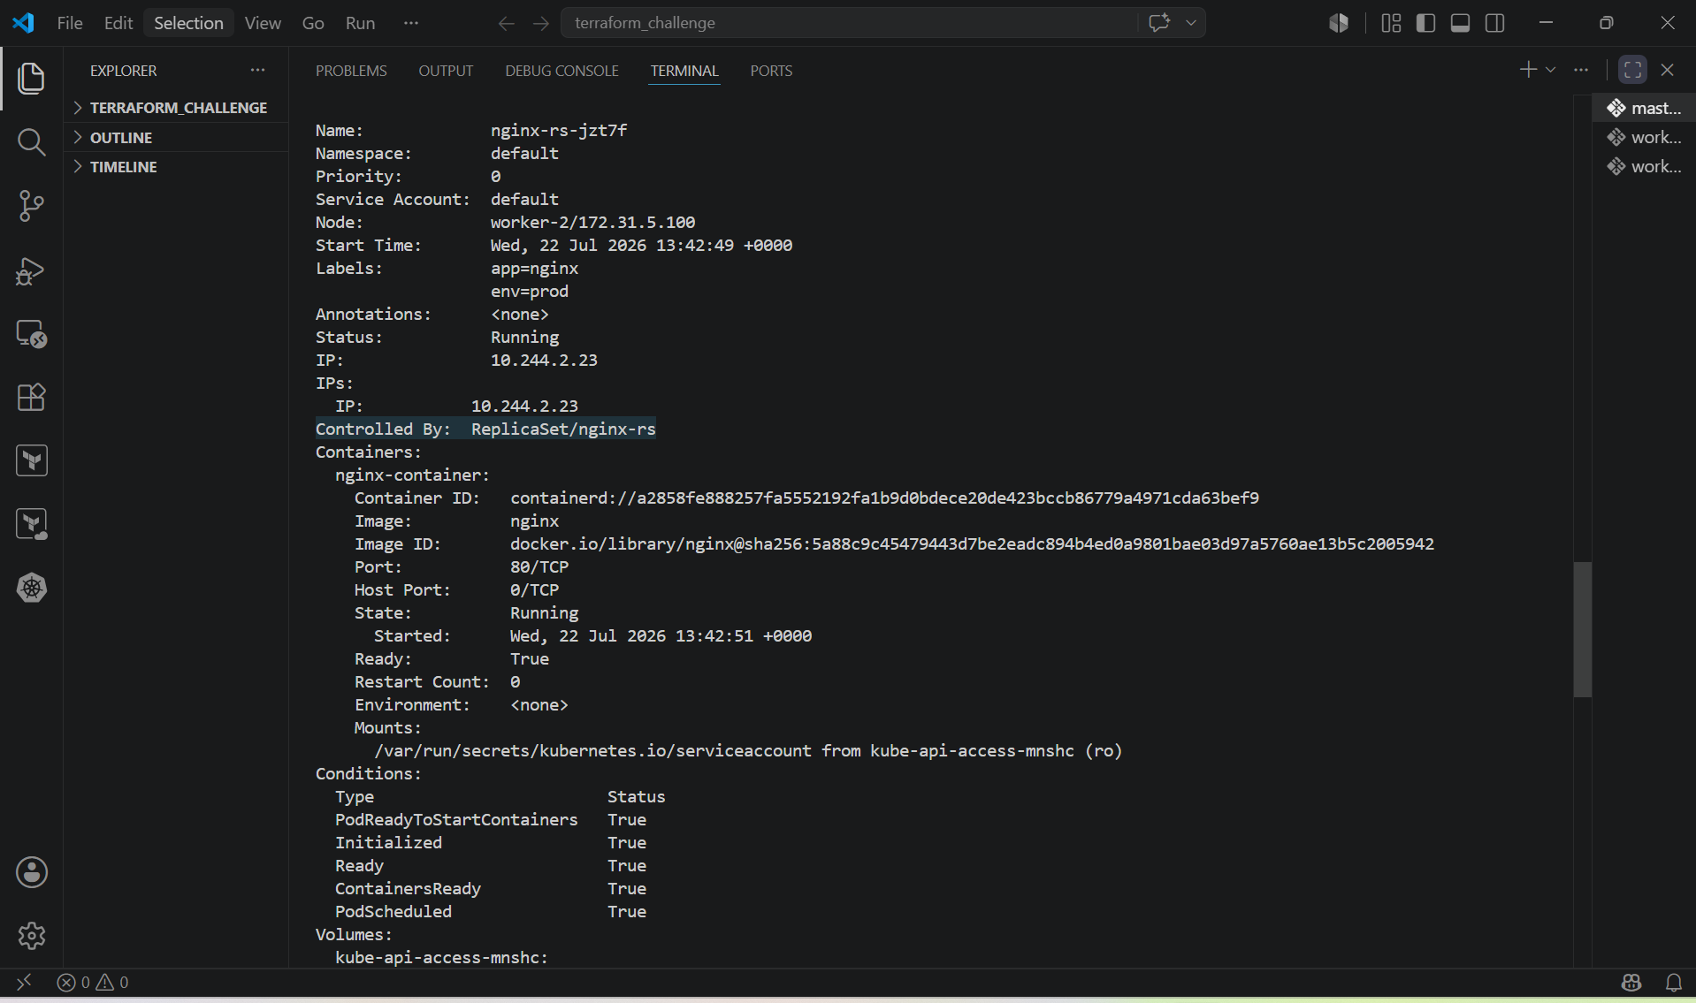

- Whereas, the pod that doesn’t match with the labels, then they are independent from the Replicaset.

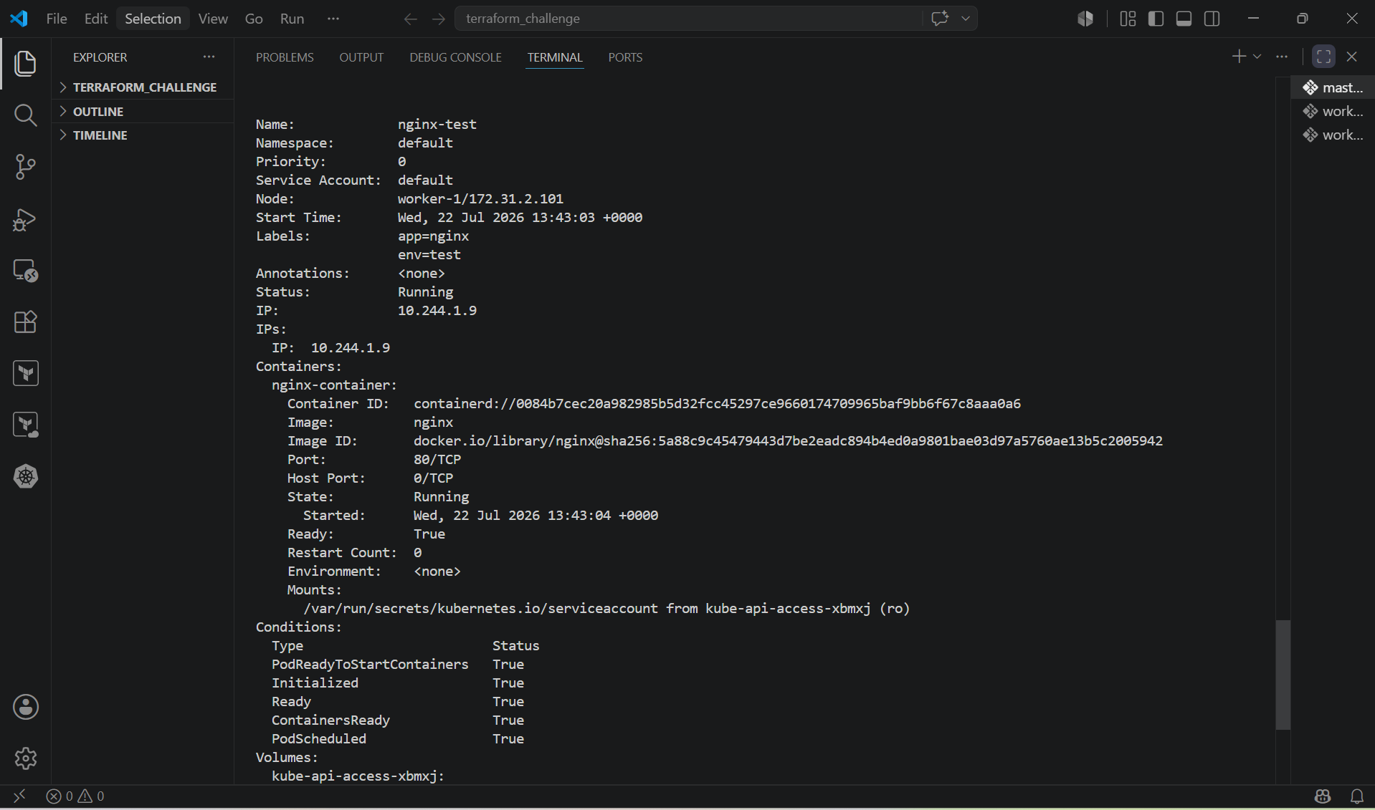

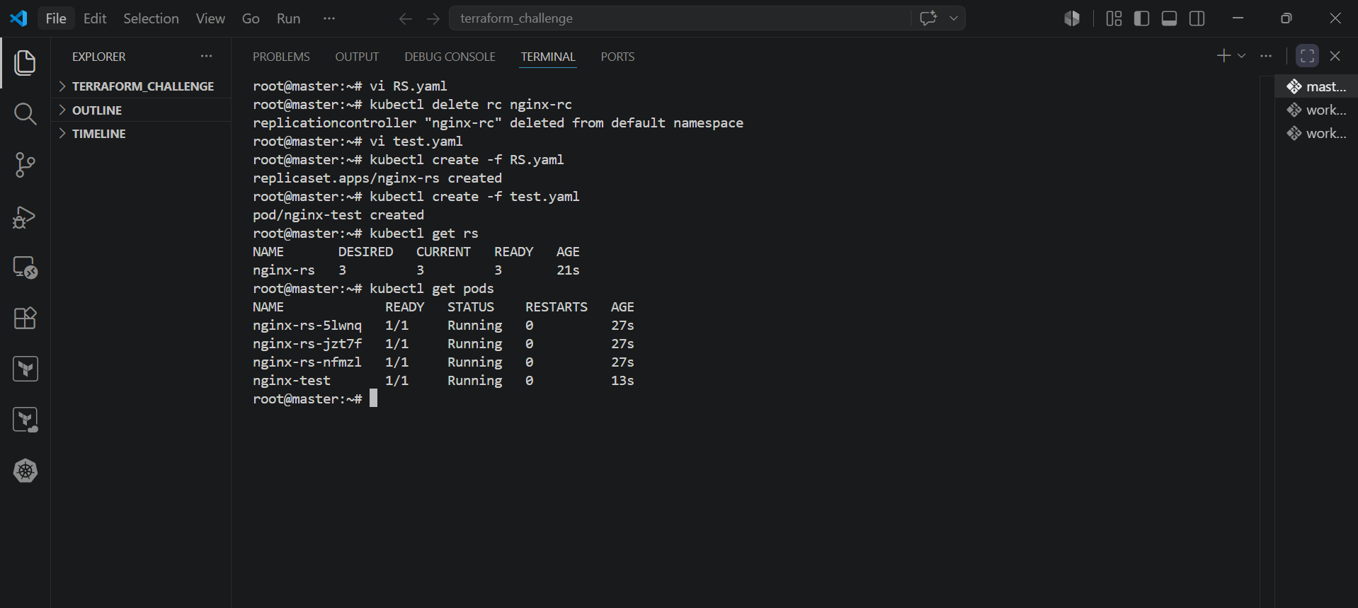

6. Deploy a ReplicaSet that excludes pods with the label backend.

PURPOSE: To deploy a ReplicaSet that manages only Pods not labelled as backend by using a set-based selector with NotIn.

OBJECTIVE:
- Create a ReplicaSet with 3 replicas.
- Use a selector that excludes Pods with the label tier: backend.
- Verify that only Pods matching the selector are managed.

EXPECTED OUTCOME:
- The ReplicaSet creates and manages 3 frontend Nginx Pods.
- Pods labeled tier: backend are not managed by the ReplicaSet.

STEP BY STEP IMPLEMENTATION:
- Create a ReplicaSet Yaml file with the set based selector using NotIn operator and also we have to mention the tier in the selectors.
- In this file only we have to create a container
- Then we have to create a pod file and mention the tier as backend.
- We have to create these files
- Then we can verify by using these commands
- Kubectl get pods
- Kubectl describe pods

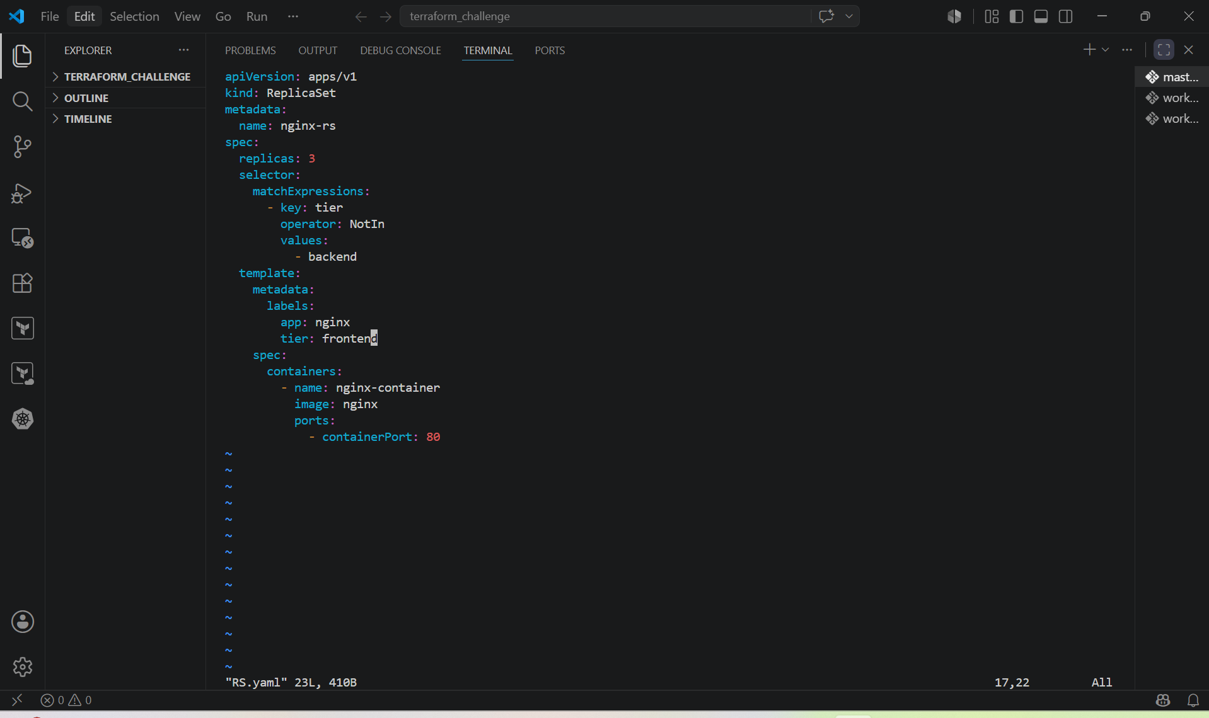

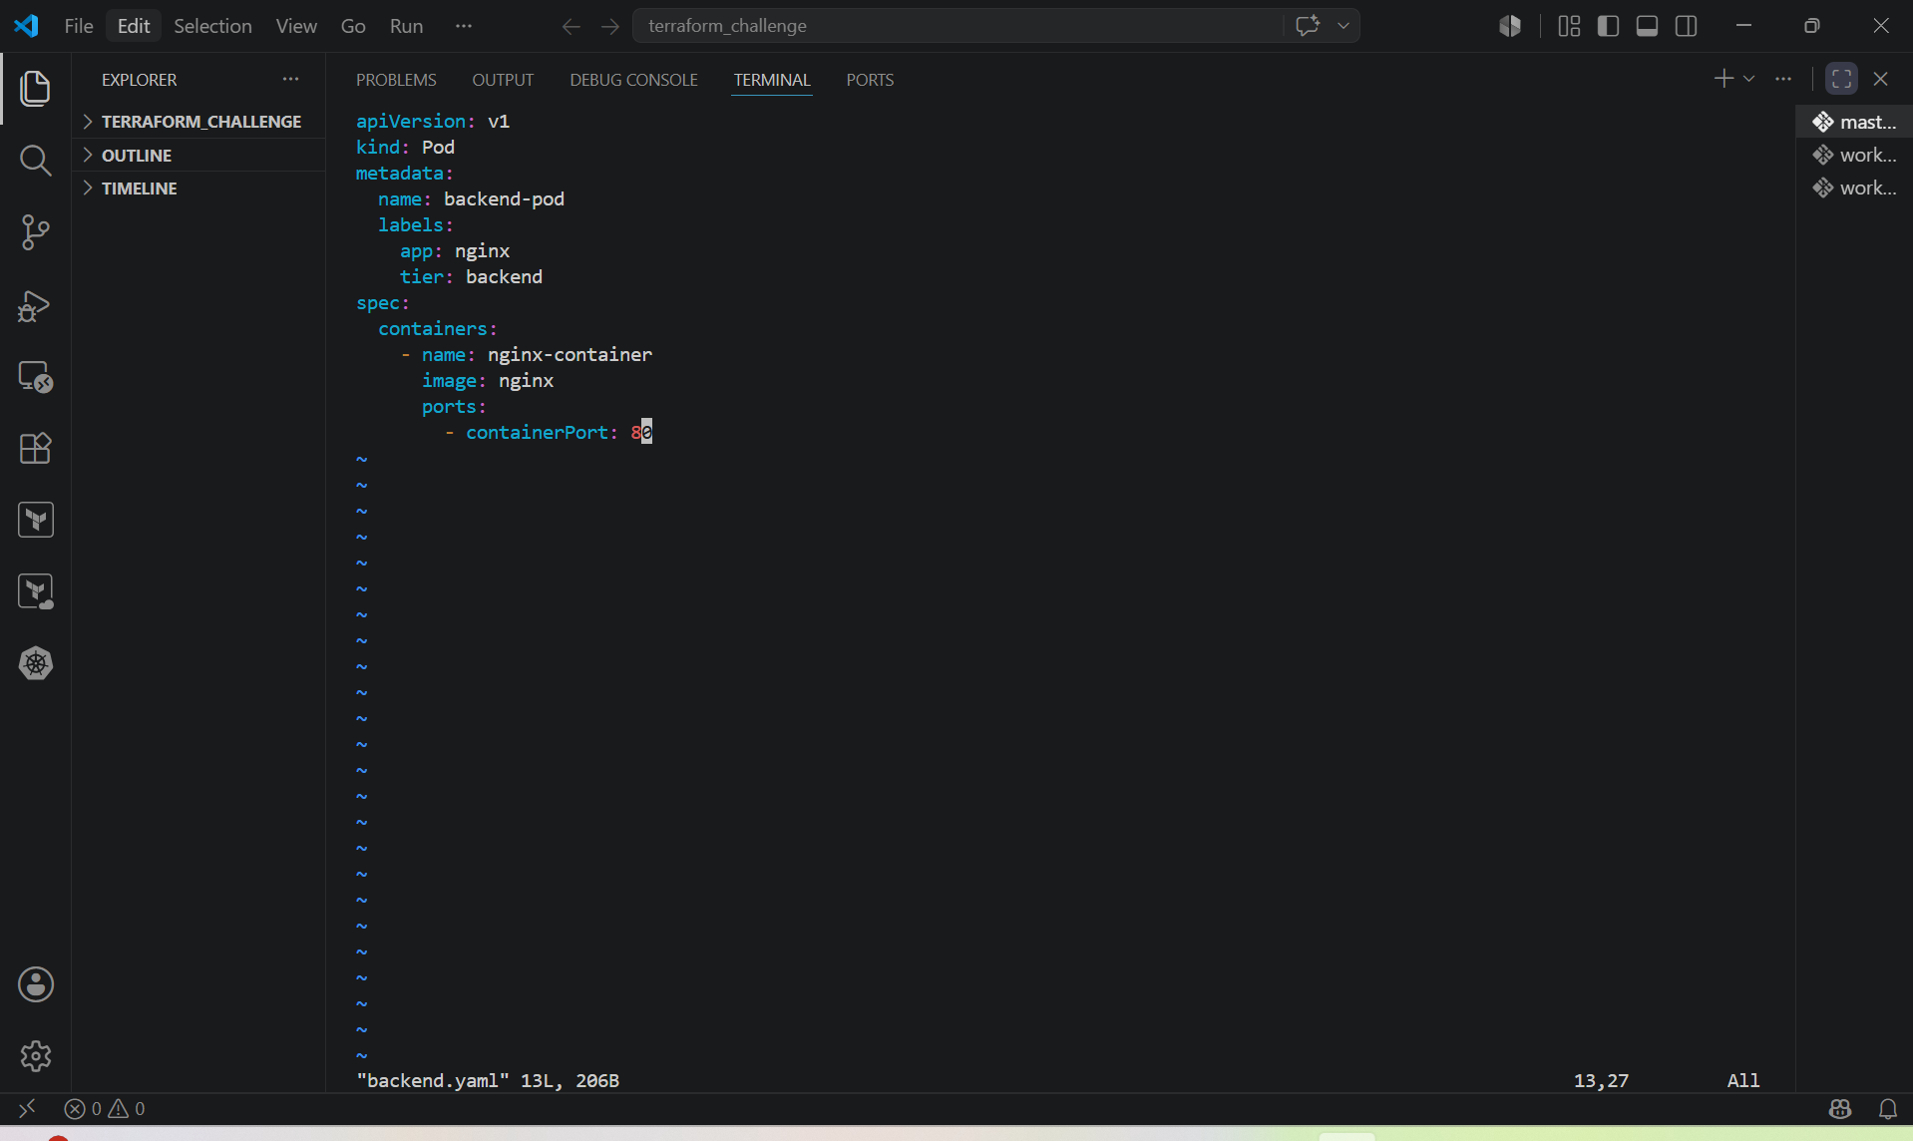

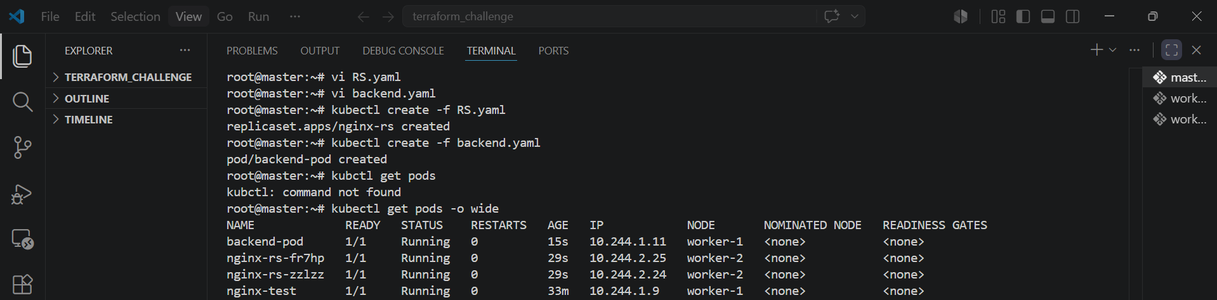

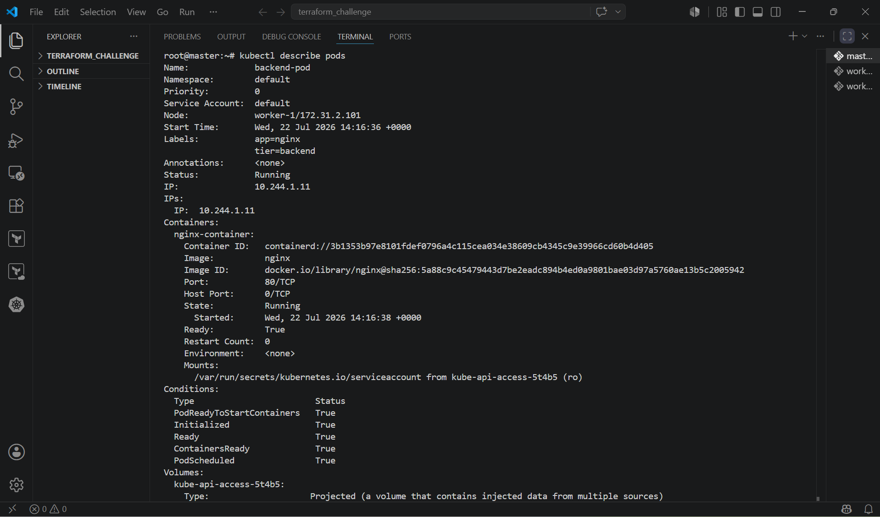

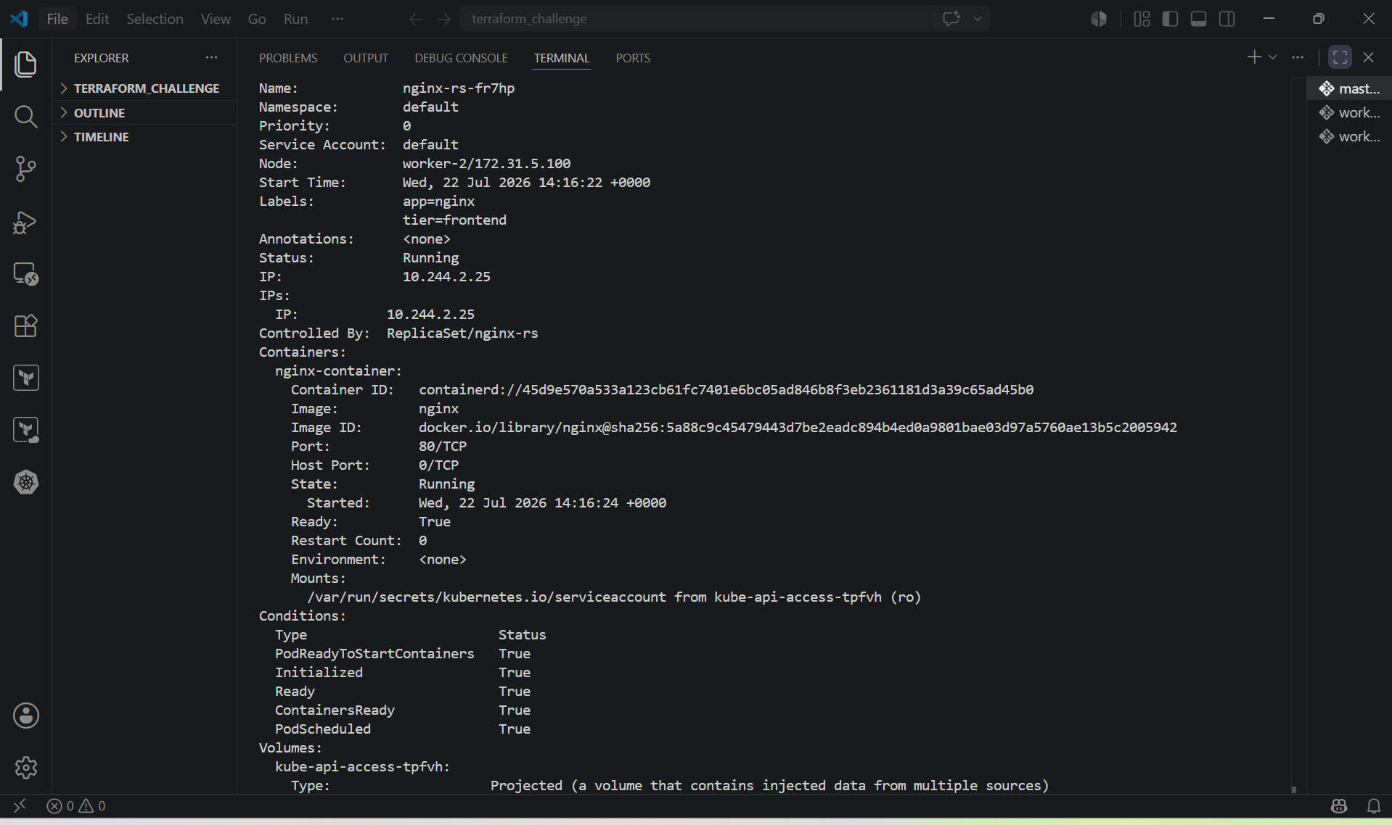

- If we accidentally deleted the pod also, the ReplicaSet will automatically spin the containers.

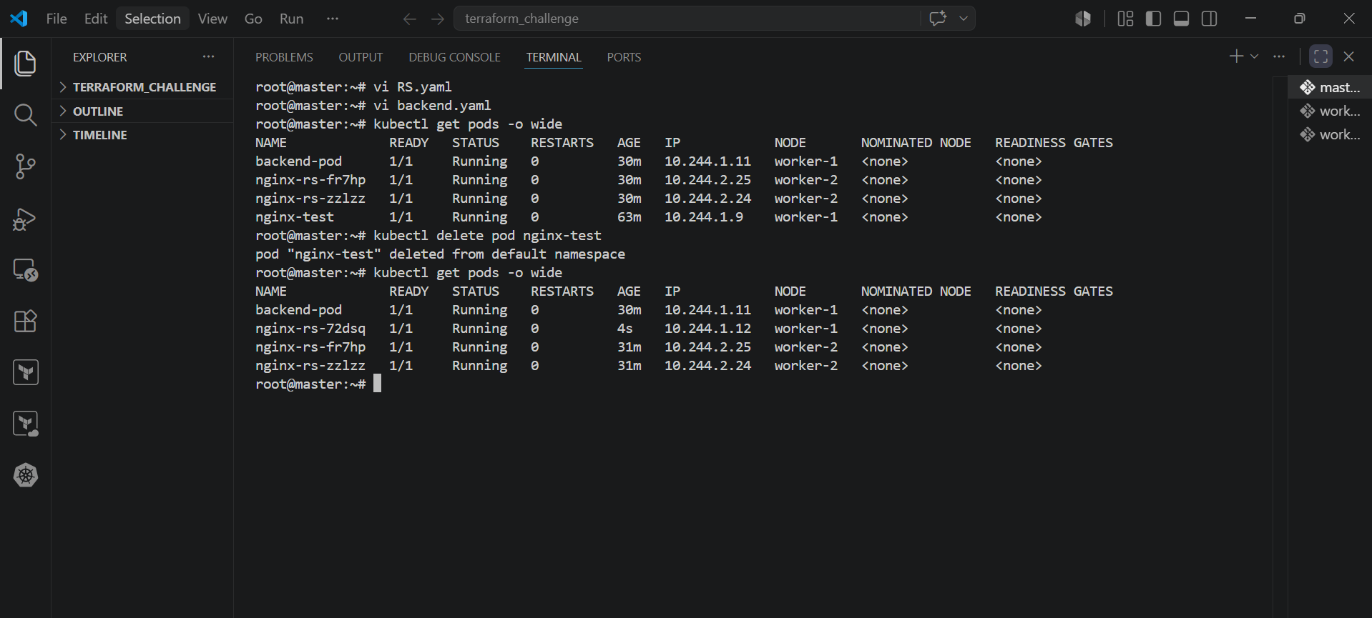

7. Test load balancing across multiple pods using a NodePort service.

PURPOSE: To demonstrate how a NodePort Service distributes incoming requests across multiple Nginx Pods.

OBJECTIVE:
- Deploy multiple Nginx Pods using a Deployment.
- Expose the Pods using a NodePort Service.
- Verify that requests are load balanced among the Pods.

OUTCOME:
- Three Nginx Pods are running.
- A NodePort Service exposes the Pods externally.
- Incoming requests are distributed across the available Pods.

STEP BY STEP IMPLEMENTATION:
- Create the Deployment (nginx-deployment.yaml)
- Create the service.yaml file
- Deploy the Resources
- Create the Deployment.
- Create the NodePort Service.
- Verify that all three Pods are running.
- Verify that the NodePort Service has been created.
- Verify that the Service endpoints include all three Pods.
- Verify the Deployment

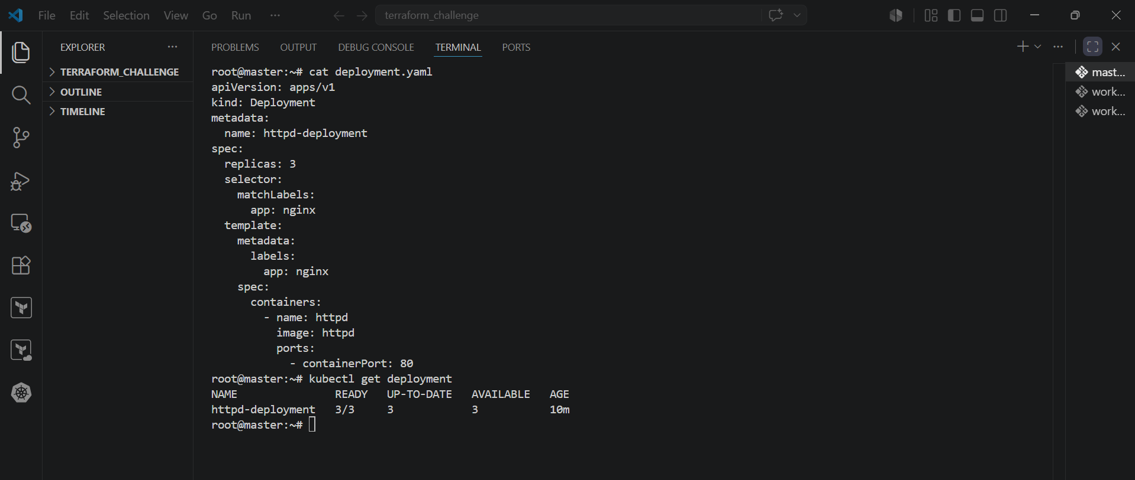

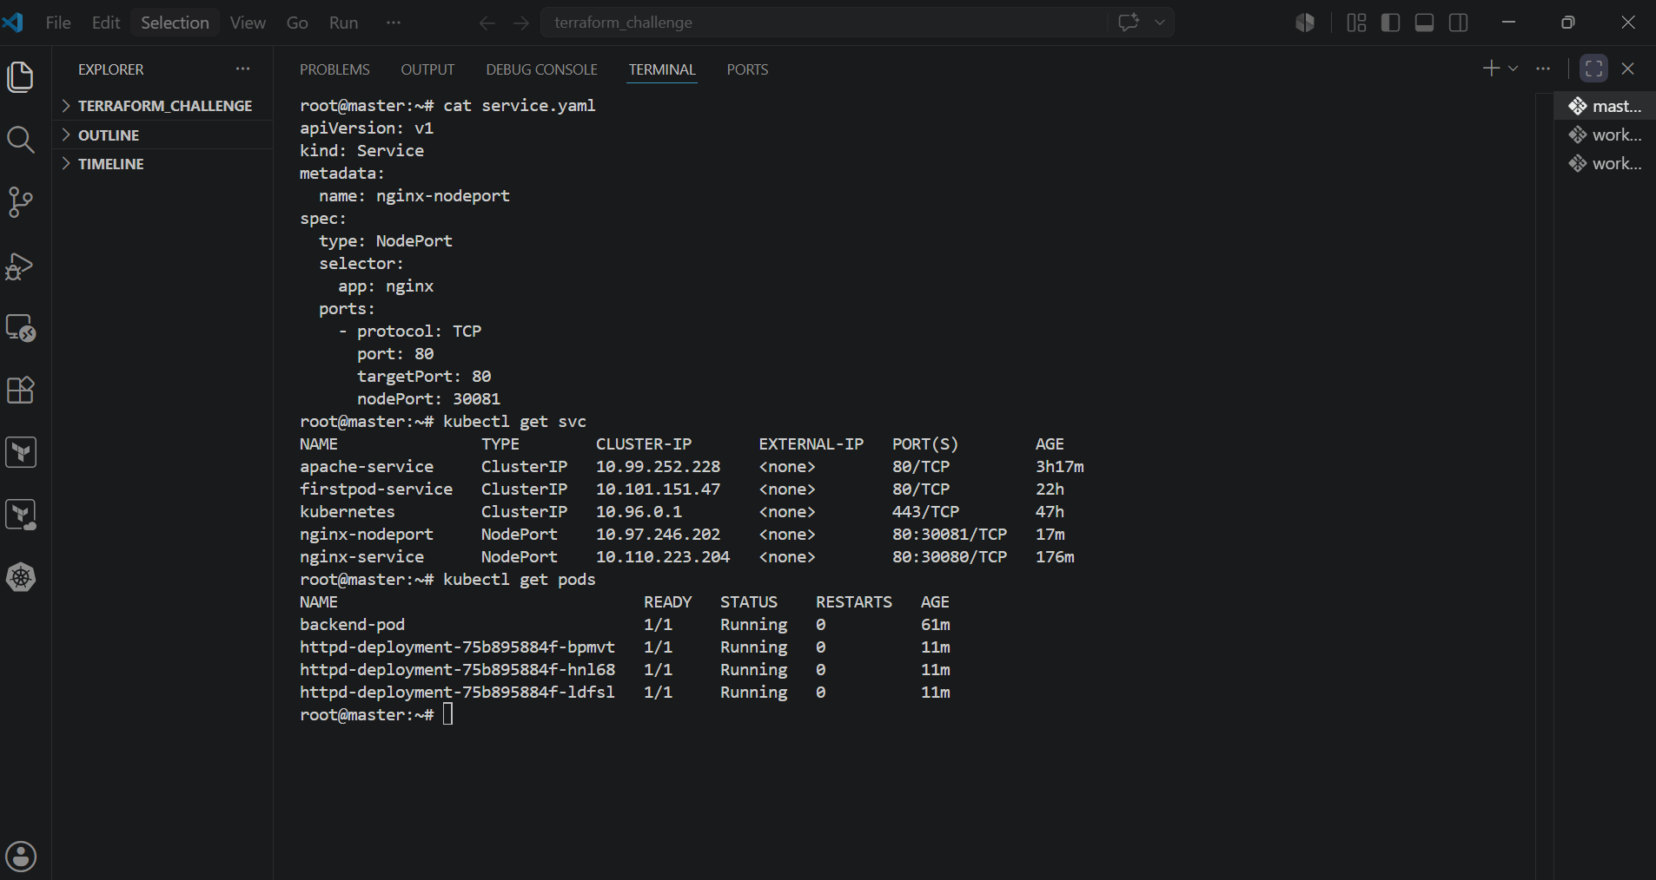

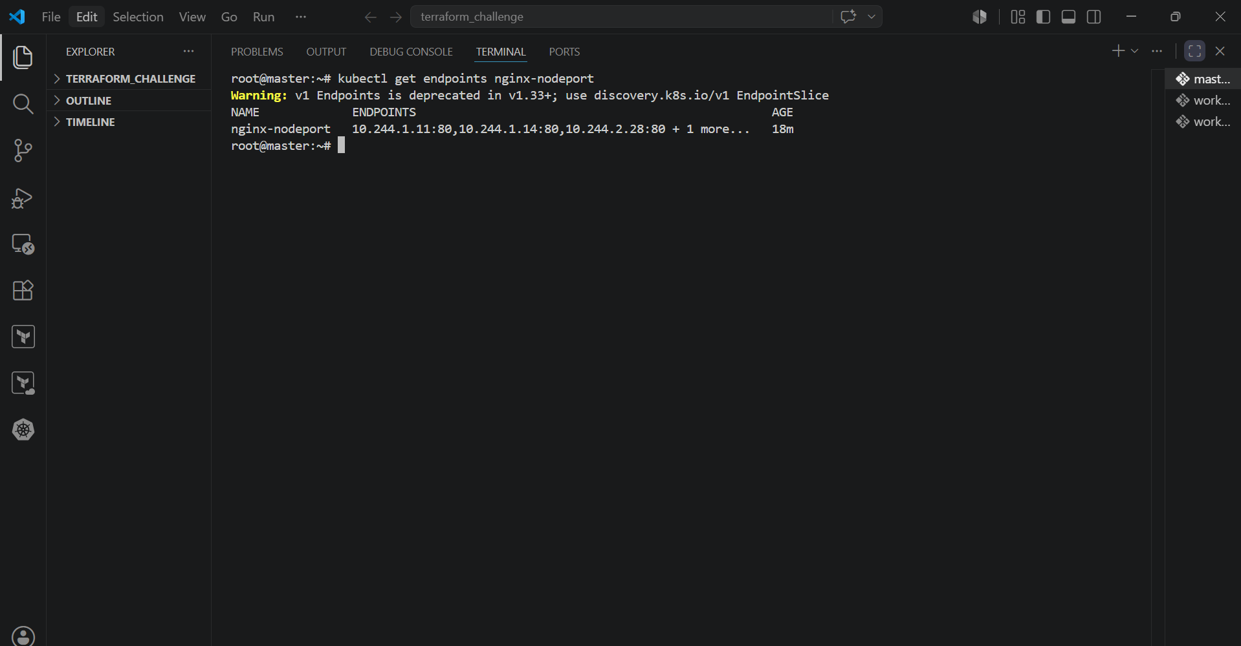

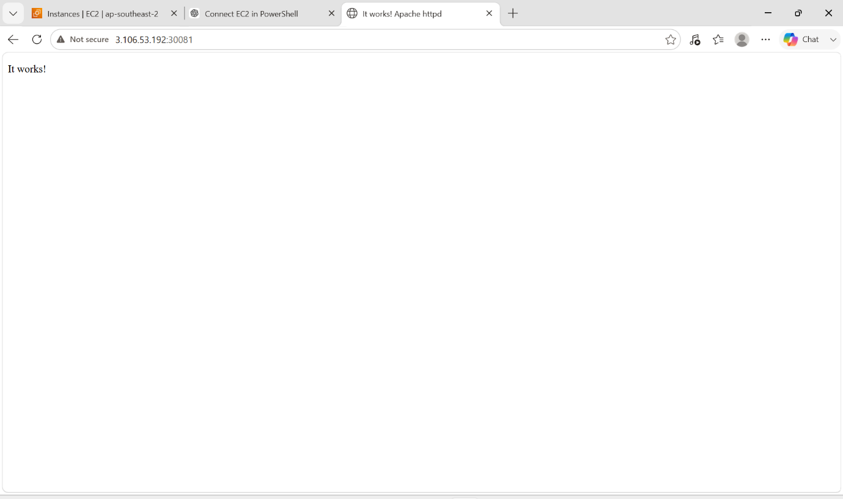

8. Delete a ReplicationController without affecting the running pods.

PURPOSE: To remove the ReplicationController while keeping the Pods it created running.

OBJECTIVE:
- Delete only the ReplicationController.
- Leave the existing Pods running.
- Verify that the Pods are no longer managed by a ReplicationController.

EXPECTED OUTCOME:

- The ReplicationController is deleted.
- Existing Pods continue running.
- No new Pods are created if one of the remaining Pods is deleted.

STEP BY STEP IMPLEMENTATION:

- View the ReplicationController
- Delete the ReplicationController and Orphan the Pods
  - kubectl delete rc nginx-rc --cascade=orphan
- Verify the ReplicationController is Deleted
  - kubectl get rc
- Verify the Pods Are Still Running
  - kubectl get pods
- Verify the Pods Are No Longer Managed
  - kubectl delete pod <pod-name>
  - kubectl get pods
- Since the ReplicationController has been deleted, Kubernetes will not create a replacement Pod.

