KUBERNETES-04

1. Deploy an application using a Deployment with 3 replicas and a rolling update strategy.

PURPOSE: To deploy an application using a Kubernetes Deployment with 3 replicas and configure it to perform rolling updates, ensuring zero or minimal downtime during application updates.

OBJECTIVE:
- Create a Deployment with 3 replicas.
- Configure the Deployment to use the RollingUpdate strategy.
- Verify that all pods are running.
- Update the application image and observe the rolling update process.

EXPECTED OUTCOME:
- Successfully deployed an application using a Kubernetes Deployment.
- Three replicas of the application were running.
- A rolling update was performed with minimal or no downtime.
- The Deployment maintained application availability while updating Pods.
- Rollout history was available, and the application could be rolled back if required.

STEP BY STEP IMPLEMENTATION:
- Create a Deployment YAML file

apiVersion: apps/v1
kind: Deployment
metadata:
name: nginx-deployment
spec:
replicas: 3
strategy:
type: RollingUpdate
rollingUpdate:
maxUnavailable: 1
maxSurge: 1
selector:
matchLabels:
app: nginx
template:
metadata:
labels:
app: nginx
spec:
containers:
- name: nginx
image: nginx:1.25
ports:
- containerPort: 80
- Deploy the application -> kubectl apply -f deployment.yaml
- Verify the Deployment -> kubectl get deployment
- Verify the Pods -> kubectl get pods
- Perform a Rolling Update
- Update the image: kubectl set image deployment/nginx-deployment nginx=nginx:1.26
- Watch the Rolling Update -> kubectl rollout status deployment/nginx-deployment
- Verify the Updated Image -> kubectl describe deployment nginx-deployment
- Then while doing all this process, we have to watch the pods activities by connecting to the instance using other platform.

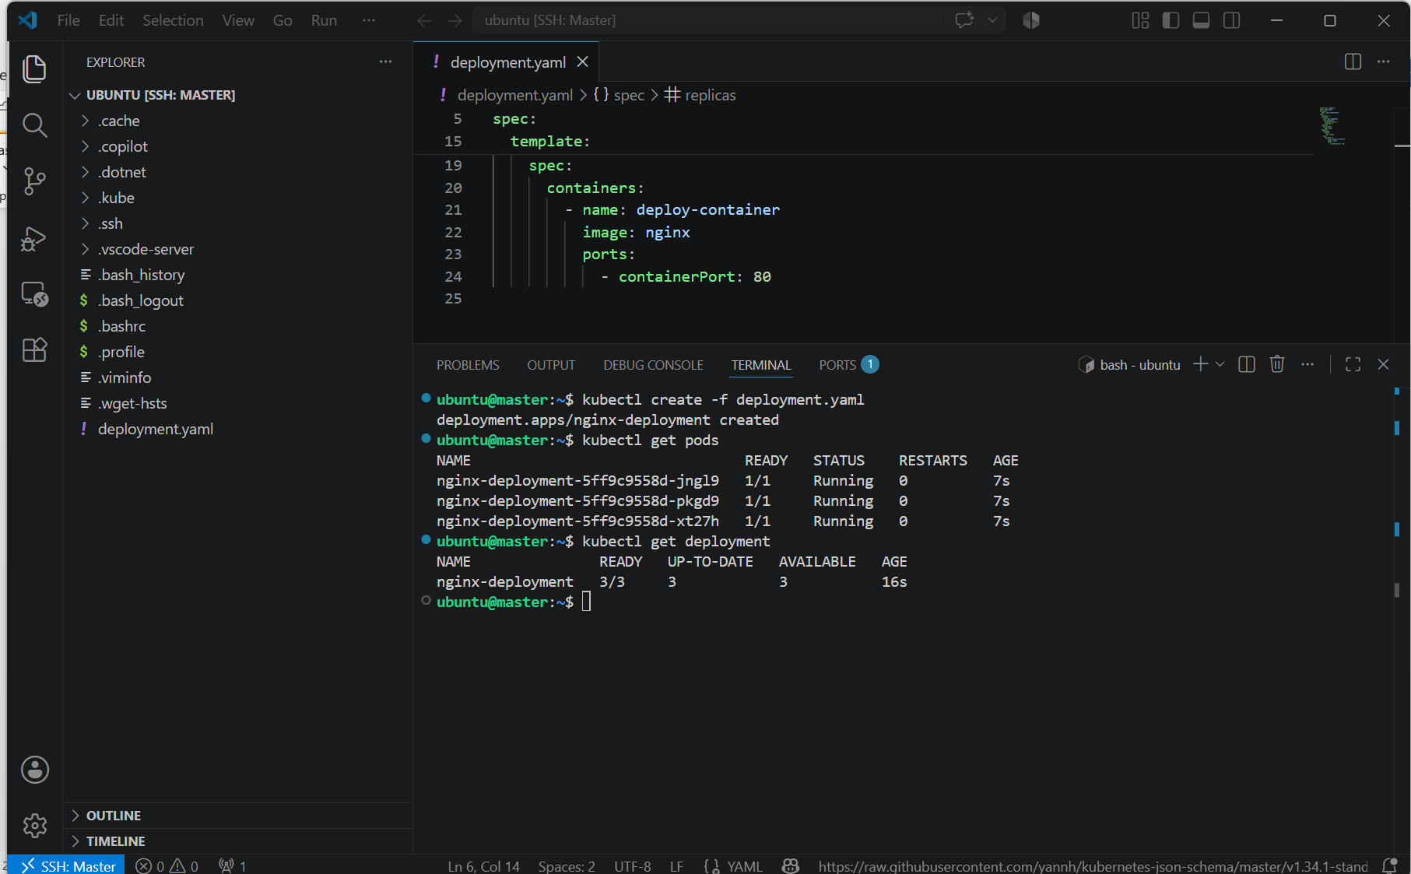

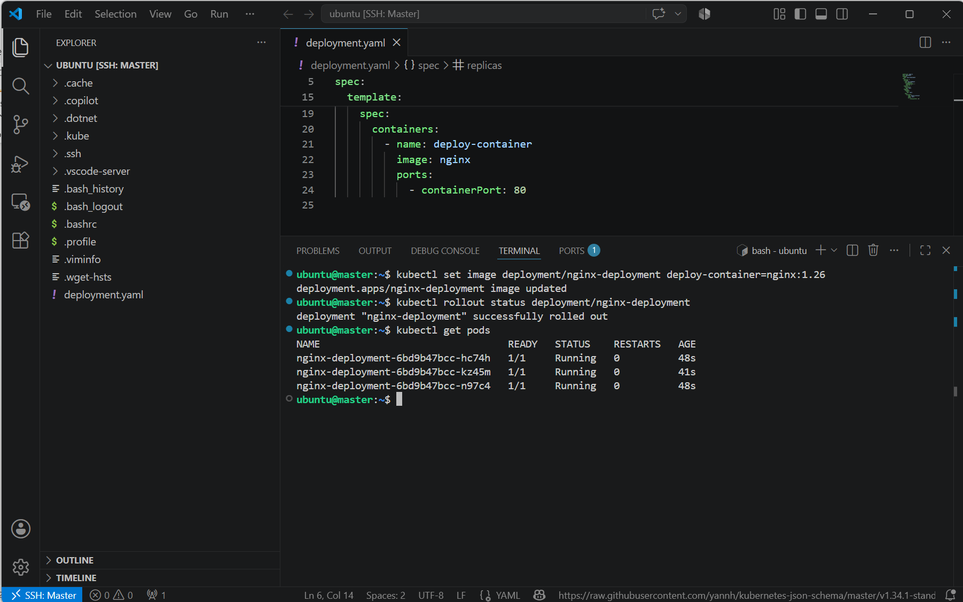

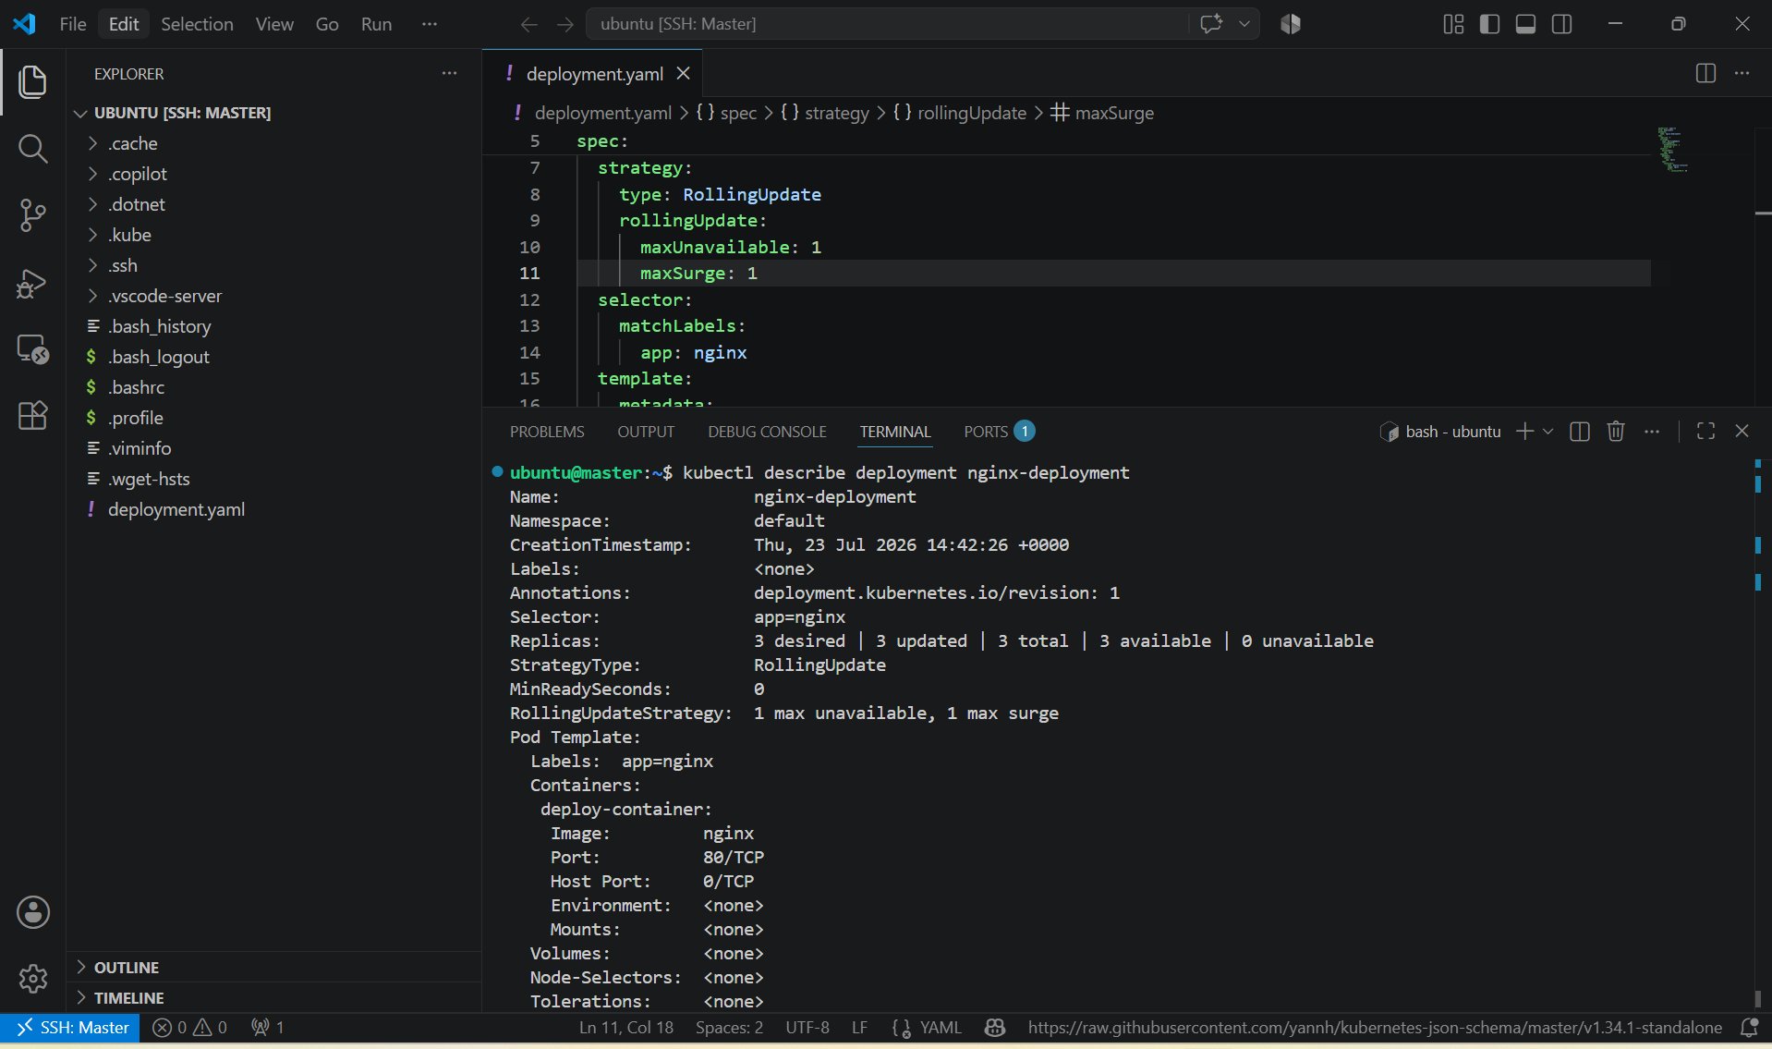

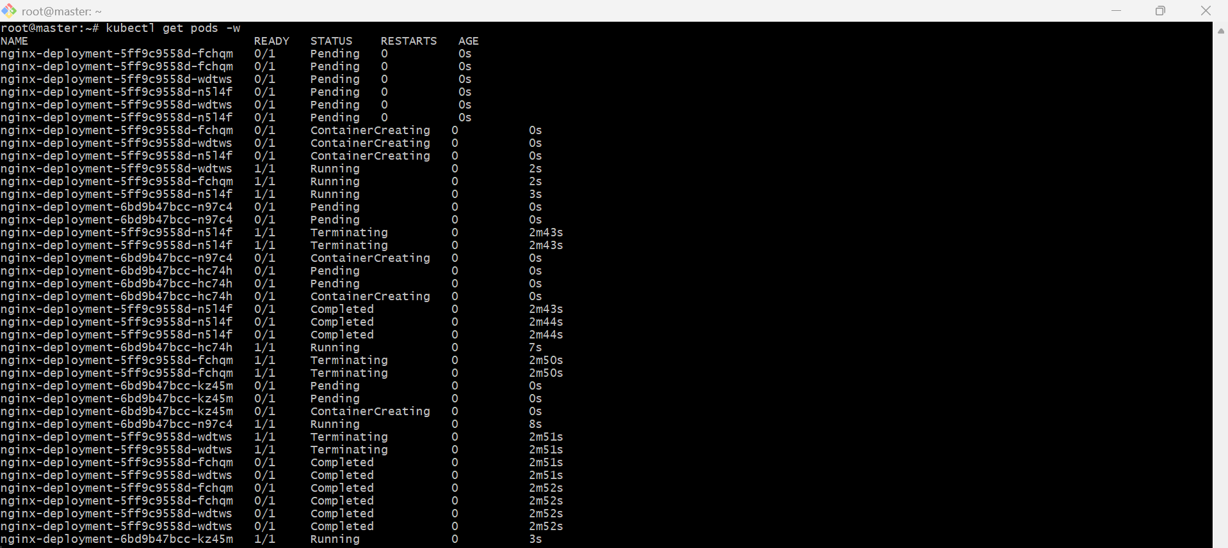

2. Configure a Deployment with a Recreate strategy and observe the downtime.

PURPOSE: To understand how the Recreate deployment strategy works by terminating all existing pods before creating new ones, resulting in temporary application downtime during updates.

OBJECTIVE:
- Create a Deployment with the Recreate strategy.
- Deploy an application with 3 replicas.
- Update the applicate image.
- Observe the downtime during the update.

EXPECTED OUTCOME:
- Successfully created a Deployment using the Recreate strategy.
- Deployed 3 replicas of the application.
- Updated the application image.
- Observed that all old Pods were deleted before new Pods were created, causing temporary downtime.
- Understood the difference between Recreate and RollingUpdate deployment strategies.

What happens with the Recreate strategy?
- All existing Pods are terminated.
- There is a brief period where no Pods are running (application downtime).
- New Pods are created with the updated image.
- The application becomes available again after the new Pods start.

Typical sequence:

3 Pods Running
↓
All 3 Pods Terminated
↓
No Pods Running (Downtime)
↓
3 New Pods Created
↓
Application Available Again

STEP BY STEP IMPLEMENTATION:
- Create a file named deployment.yaml.

apiVersion: apps/v1
kind: Deployment
metadata:
name: nginx-recreate
spec:
replicas: 3
strategy:
type: Recreate
selector:
matchLabels:
app: nginx
template:
metadata:
labels:
app: nginx
spec:
containers:
- name: nginx-container
image: nginx:1.25
ports:
- containerPort: 80

- Apply the Deployment -> kubectl apply -f deployment.yaml
- Verify the Deployment -> kubectl get deployment
- Verify the Pods -> kubectl get pods
- Update the Deployment Image -> kubectl set image deployment/nginx-deployment deploy-container=nginx:1.26
- Observe the Update in another platform -> kubectl get pods -w
- Verify the Updated Deployment -> kubectl describe deployment nginx-deployment
- View Rollout History -> kubectl rollout history deployment/nginx-deployment

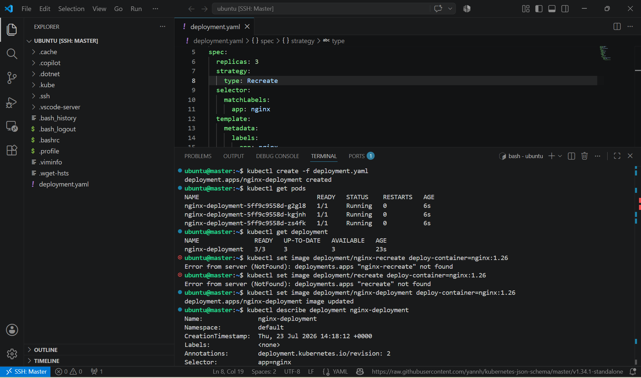

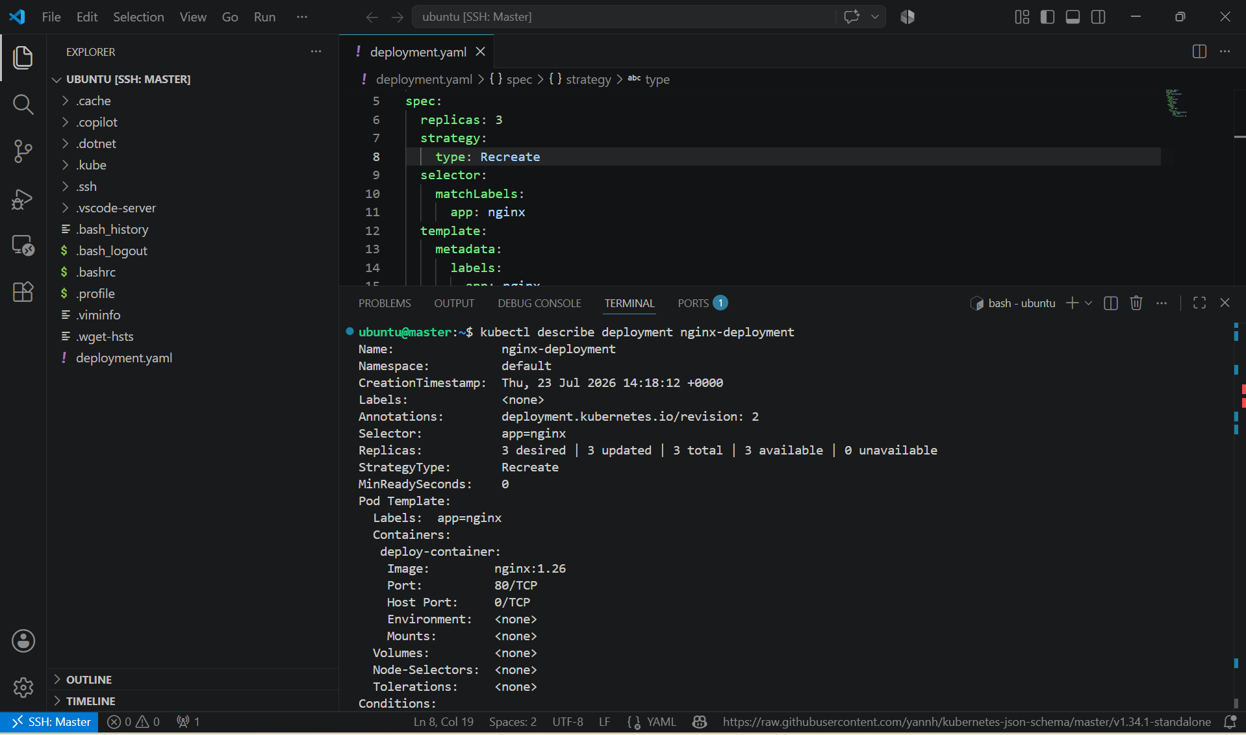

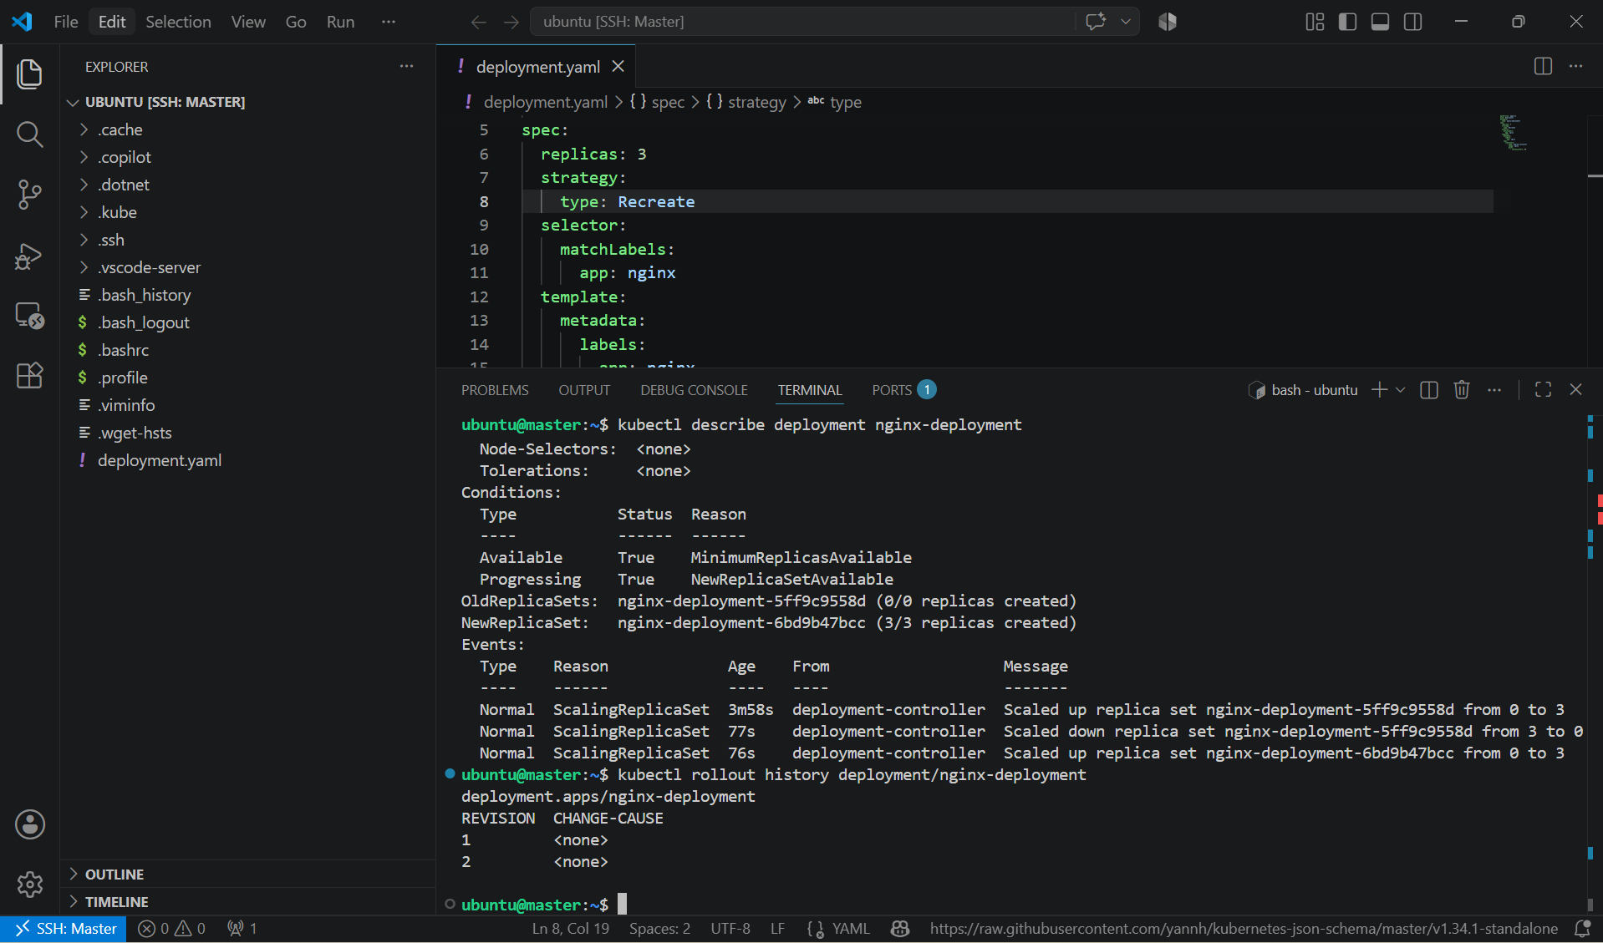

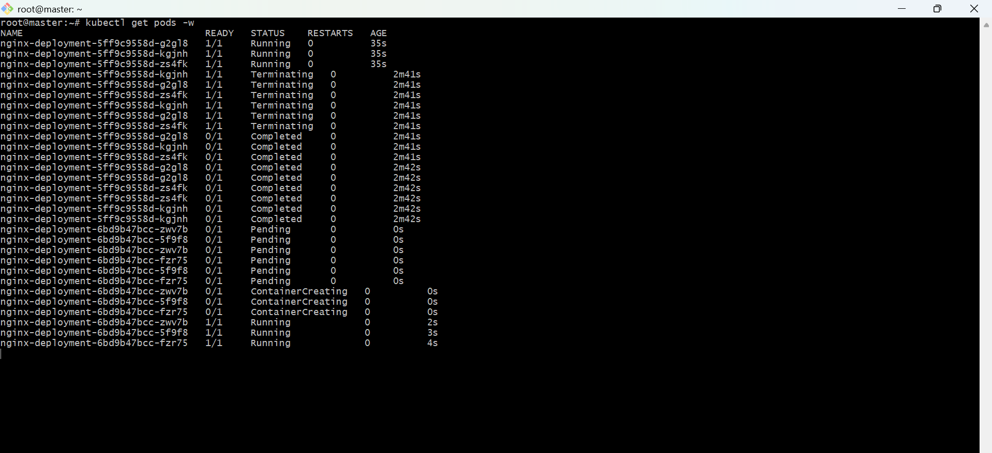

3. Update an existing Deployment and perform a rollback to the previous version.

PURPOSE: To update an existing Kubernetes Deployment to anew application version and roll it back to the previous version if required.

OBJECTIVE:
- Update the image of an existing Deployment.
- Verify the rollout
- View rollout history
- Roll back to the previous version.

EXPECTED OUTCOME:
- Successfully updated the existing Deployment to a new image version.
- Verified the rollout completed successfully.
- Viewed the rollout history.
- Performed a rollback to the previous version.
- Confirmed that the Deployment was restored to the earlier version with minimal downtime.

STEP BY STEP IMPLEMENTATION:
- Verify the Existing Deployment -> kubectl get deployments
- Check the Current Image -> kubectl describe deployment nginx-deployment
- Update the Deployment Image -> kubectl set image deployment/nginx-deployment deploy-container=nginx:1.26
- Monitor the Rollout -> kubectl rollout status deployment/nginx-deployment
- Verify the Updated Image -> kubectl describe deployment nginx-deployment
- View Rollout History -> kubectl rollout history deployment/nginx-deployment
- Roll Back to the Previous Version -> kubectl rollout undo deployment/nginx-deployment
- Verify the Rollback -> kubectl rollout status deployment/nginx-deployment
- Check Rollout History Again -> kubectl rollout history deployment/nginx-deployment

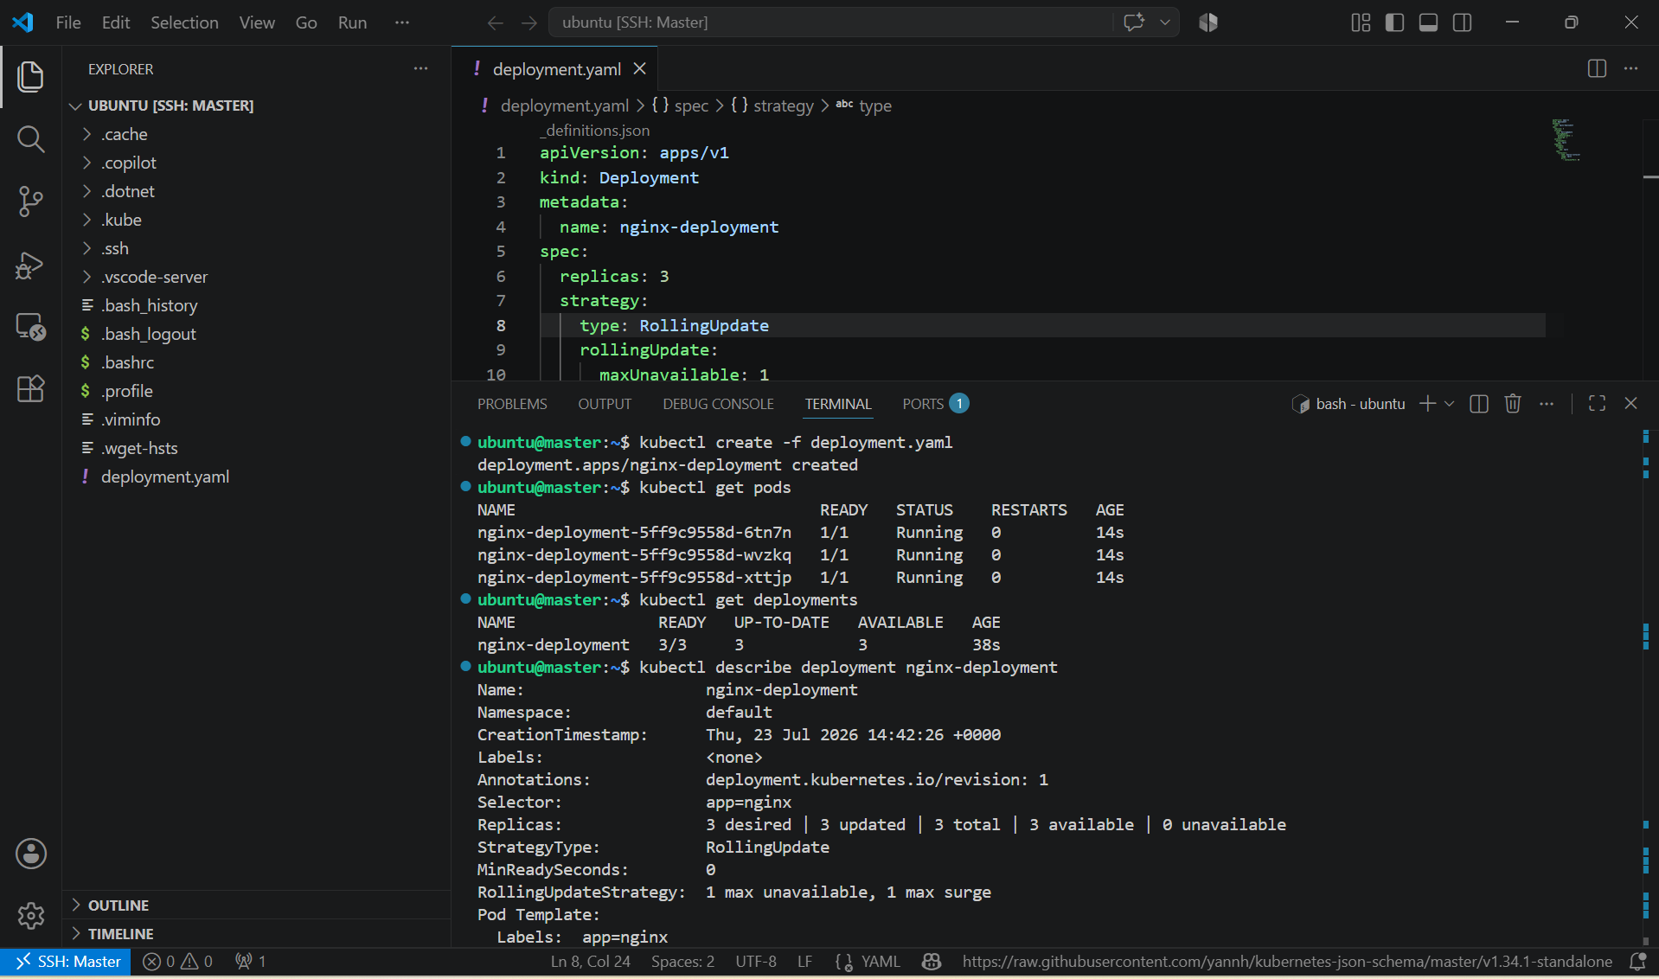

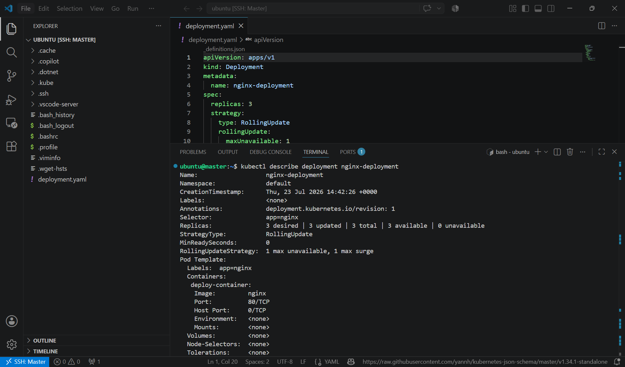

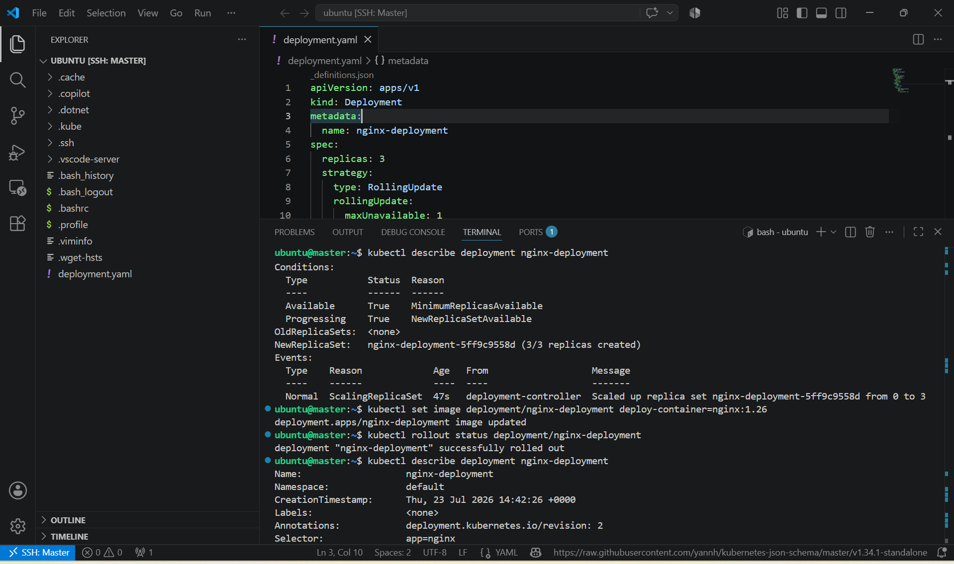

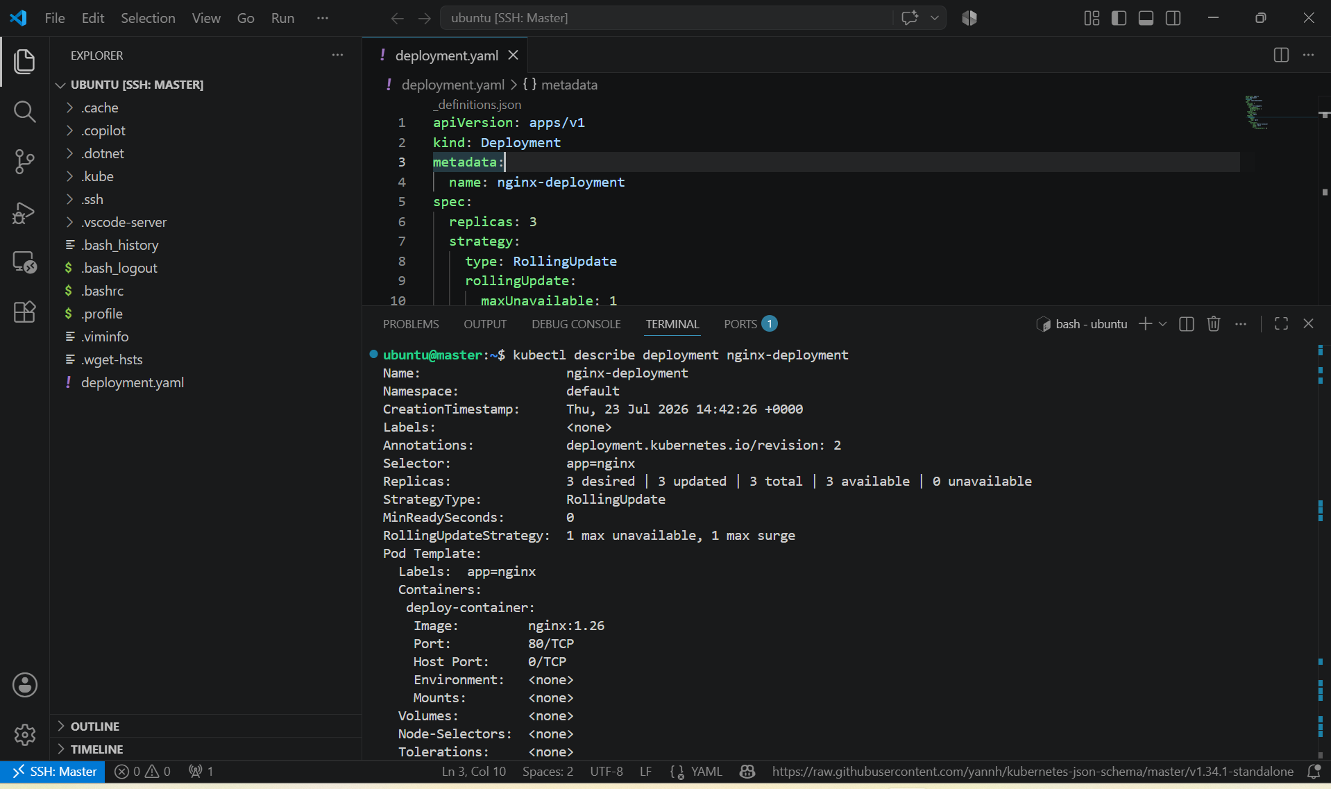

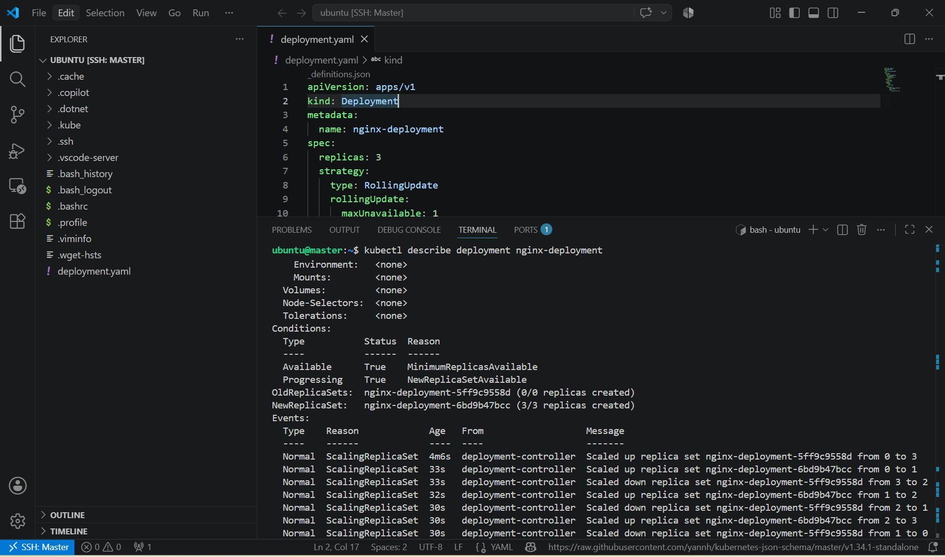

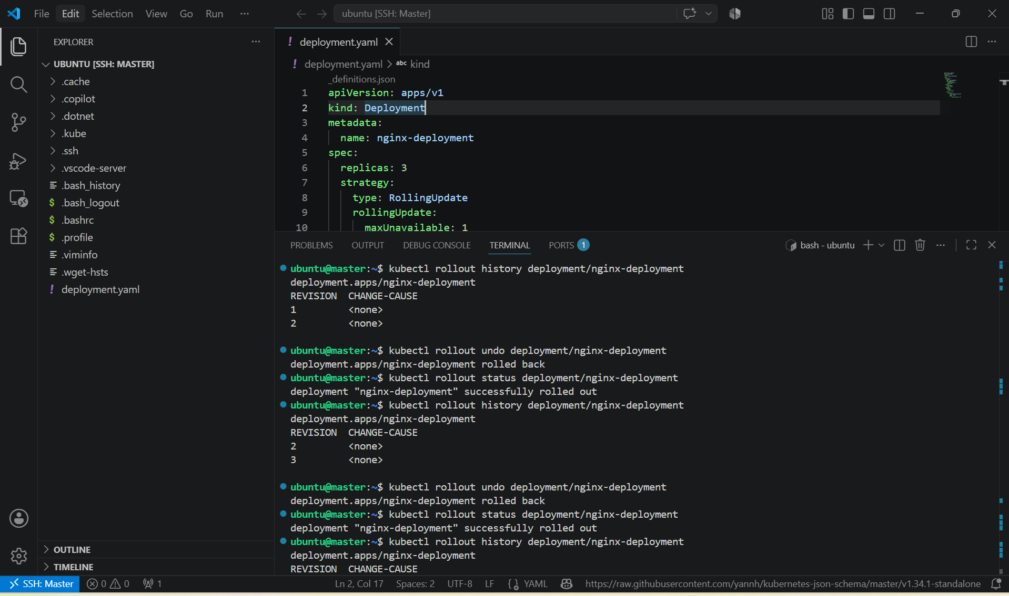

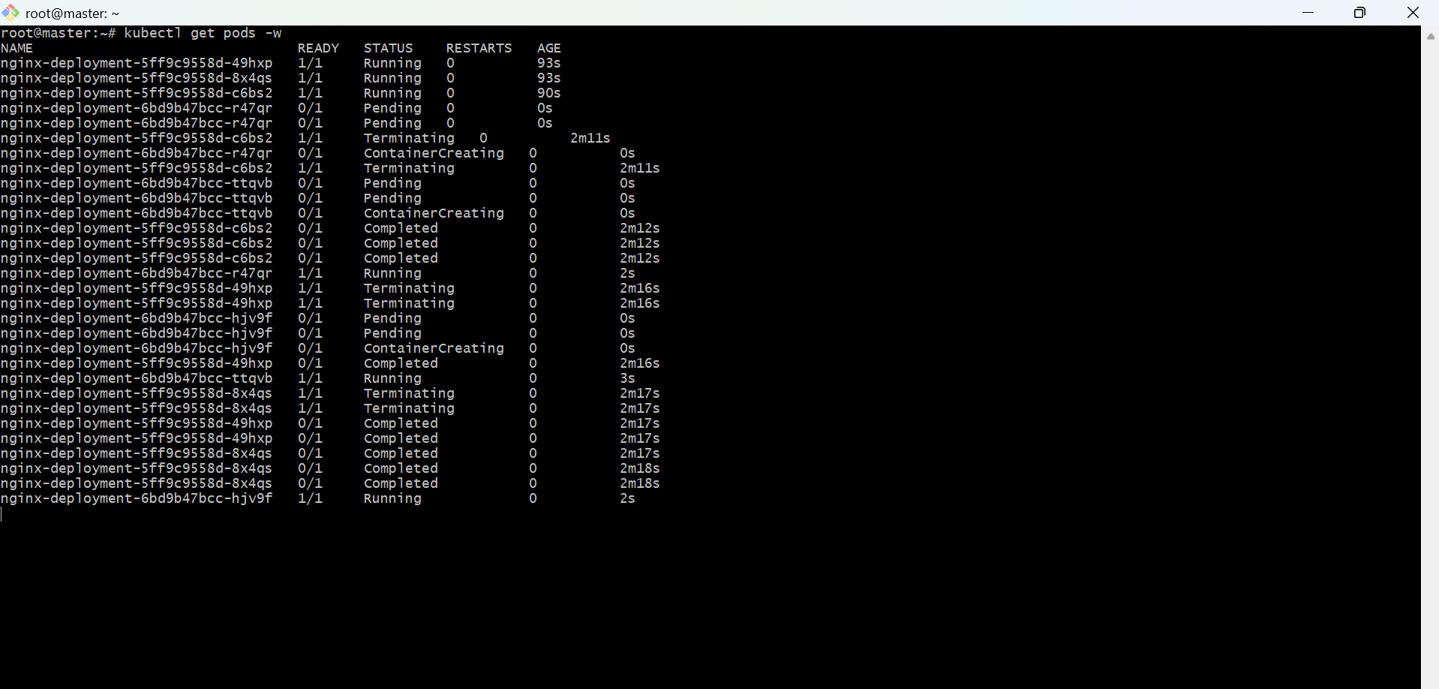

4. Modify a Deployment to add resource requests and limits for CPU and memory.

PURPOSE: To configure CPU and memory requests andlimits for a Deployment, ensuring efficient resource allocation and preventing containers from consuming excessive resources.

OBJECTIVE:
- Modify an existing Deployment.
- Add CPU and memory requests.
- Add CPU and memory limits.
- Apply the updated Deployment.
- Verify the resource configuration.

EXPECTED OUTCOME:
- Modified the Deployment to include CPU and memory resource requests and limits.
- Applied the updated Deployment successfully.
- Verified that the Pods were recreated with the new resource configuration.
- Confirmed the resource settings using kubectl describe or kubectl get pod -o yaml.

STEP BY STEP IMPLEMENTATION:
- Edit your deployment.yaml file and add the resources section under the container specification.

apiVersion: apps/v1
kind: Deployment
metadata:
name: nginx-deployment
spec:
replicas: 3
selector:
matchLabels:
app: nginx
template:
metadata:
labels:
app: nginx
spec:
containers:
- name: deploy-container
image: nginx:1.25
ports:
- containerPort: 80
resources:
requests:
cpu: "250m"
memory: "128Mi"
limits:
cpu: "500m"
memory: "256Mi"

- Apply the Updated Deployment -> kubectl apply -f deployment.yaml
- Verify the Deployment -> kubectl get deployment
- Verify the Resource Configuration -> kubectl describe deployment nginx-deployment
- Verify the Running Pods -> kubectl get pods
- View Resource Requests and Limits -> kubectl get pod <pod-name> -o yaml

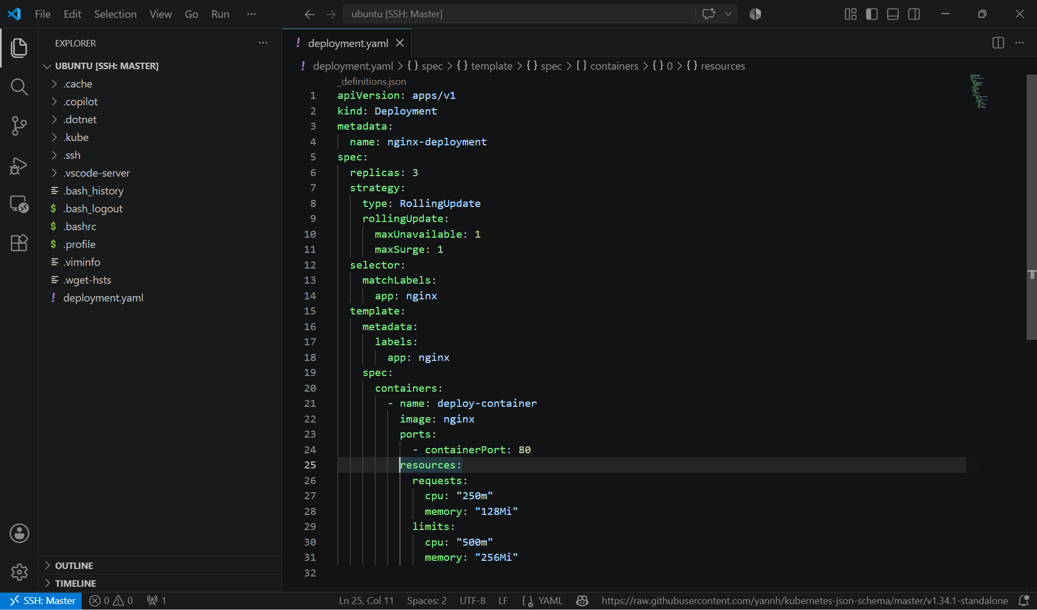

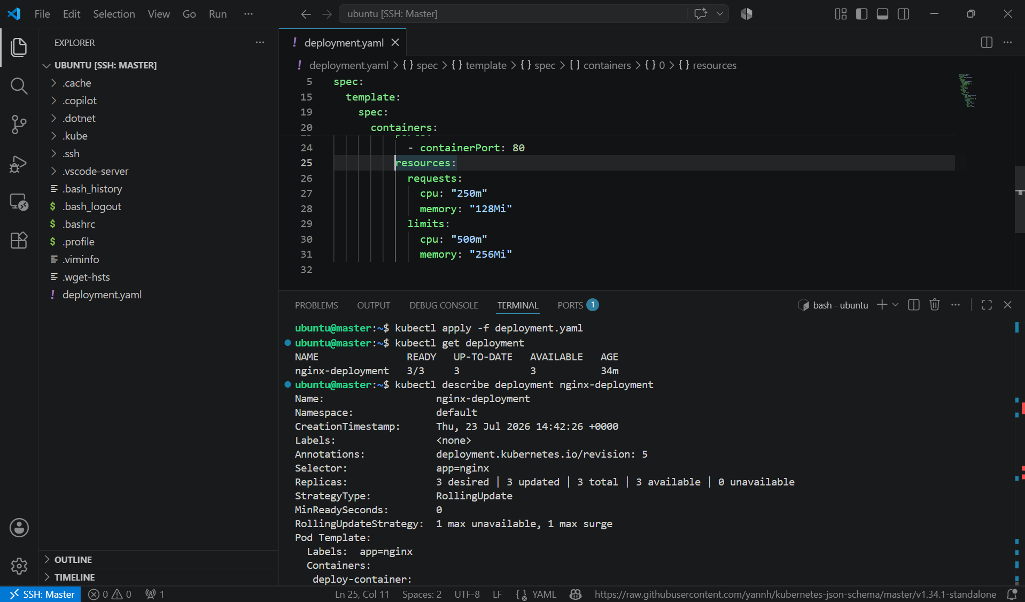

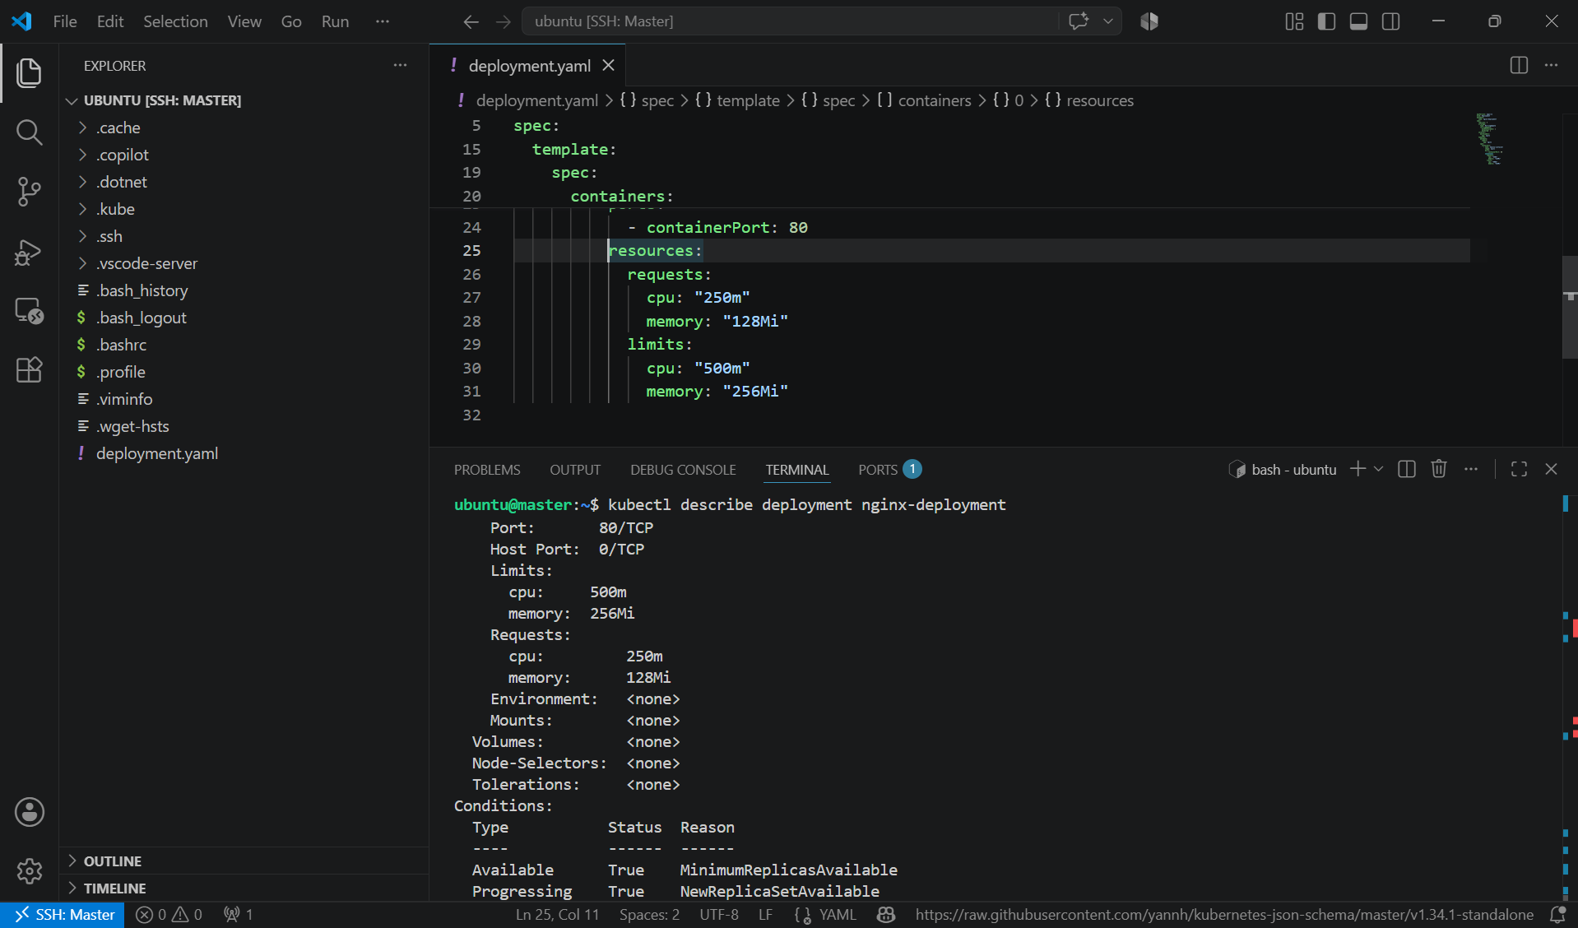

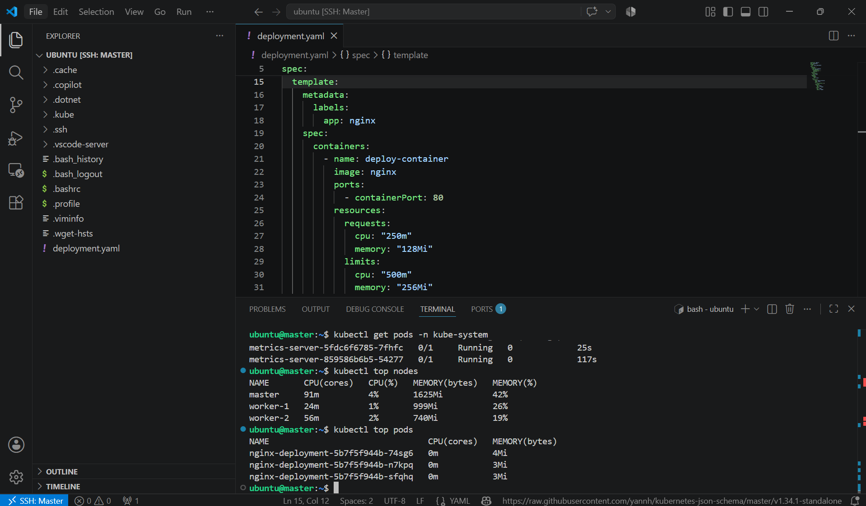

5. Create a Deployment with MaxSurge and MaxUnavailable configurations.

PURPOSE: To configure a Kubernetes Deployment with a RollingUpdate strategy using MaxSurge and MaxUnavailable settings to control how Pods are updated during a rolling deployment.

OBJECTIVE:
- Create a Deployment with 3 replicas.
- Configure maxSurge and maxUnavailable.
- Deploy the application.
- Update the image and observe the rolling update behavior.

EXPECTED OUTCOME:
- Created a Deployment with 3 replicas.
- Configured the RollingUpdate strategy with maxSurge: 1 and maxUnavailable: 1.
- Successfully updated the Deployment without downtime.
- Observed how Kubernetes gradually replaced old Pods while maintaining application availability.

STEP BY STEP IMPLEMENTATION:
- Create a Deployment YAML file

apiVersion: apps/v1
kind: Deployment
metadata:
name: nginx-deployment
spec:
replicas: 3
strategy:
type: RollingUpdate
rollingUpdate:
maxUnavailable: 1
maxSurge: 1
selector:
matchLabels:
app: nginx
template:
metadata:
labels:
app: nginx
spec:
containers:
- name: nginx
image: nginx:1.25
ports:
- containerPort: 80
- Deploy the application -> kubectl apply -f deployment.yaml
- Verify the Deployment -> kubectl get deployment
- Verify the Pods -> kubectl get pods
- Perform a Rolling Update
- Update the image: kubectl set image deployment/nginx-deployment nginx=nginx:1.26
- Watch the Rolling Update -> kubectl rollout status deployment/nginx-deployment
- Verify the Updated Image -> kubectl describe deployment nginx-deployment
- Then while doing all this process, we have to watch the pods activities by connecting to the instance using other platform.









6. Set up a Deployment with a custom revision history limit.

PURPOSE: To configure a Kubernetes Deployment with a custom revision history limit, which controls how many previous ReplicaSets Kubernetes retains for rollback purposes.

OBJECTIVE:
- Create a Deployment.
- Set a custom revisionHistoryLimit.
- Deploy the application.
- Update the Deployment multiple times.
- Verify that only the specified number of revisions is retained.

EXPECTED OUTCOME:
- Created a Deployment with a custom revisionHistoryLimit.
- Configured Kubernetes to retain only the specified number of previous revisions.
- Updated the Deployment multiple times to generate new revisions.
- Verified that older ReplicaSets were automatically cleaned up once the history limit was exceeded.
- Confirmed that recent revisions remained available for rollback.

STEP BY STEP IMPLEMENTATION:
- Create a file named deployment.yaml
apiVersion: apps/v1
kind: Deployment
metadata:
name: nginx-deployment
spec:
replicas: 3
revisionHistoryLimit: 3
strategy:
type: RollingUpdate
selector:
matchLabels:
app: nginx
template:
metadata:
labels:
app: nginx
spec:
containers:
- name: deploy-container
image: nginx:1.25
ports:
- containerPort: 80
- Apply the Deployment -> kubectl apply -f deployment.yaml
- Verify the Deployment -> kubectl get deployments
- Verify the Revision History Limit -> kubectl describe deployment nginx-deployment
- Update the Deployment Multiple Times -> kubectl set image deployment/nginx-deployment deploy-container=nginx:1.26
- View the Rollout History -> kubectl rollout history deployment/nginx-deployment
- Verify the ReplicaSets -> kubectl get replicasets
- Only the latest ReplicaSets should be present. Older ReplicaSets beyond the configured limit are automatically removed after they are no longer needed.

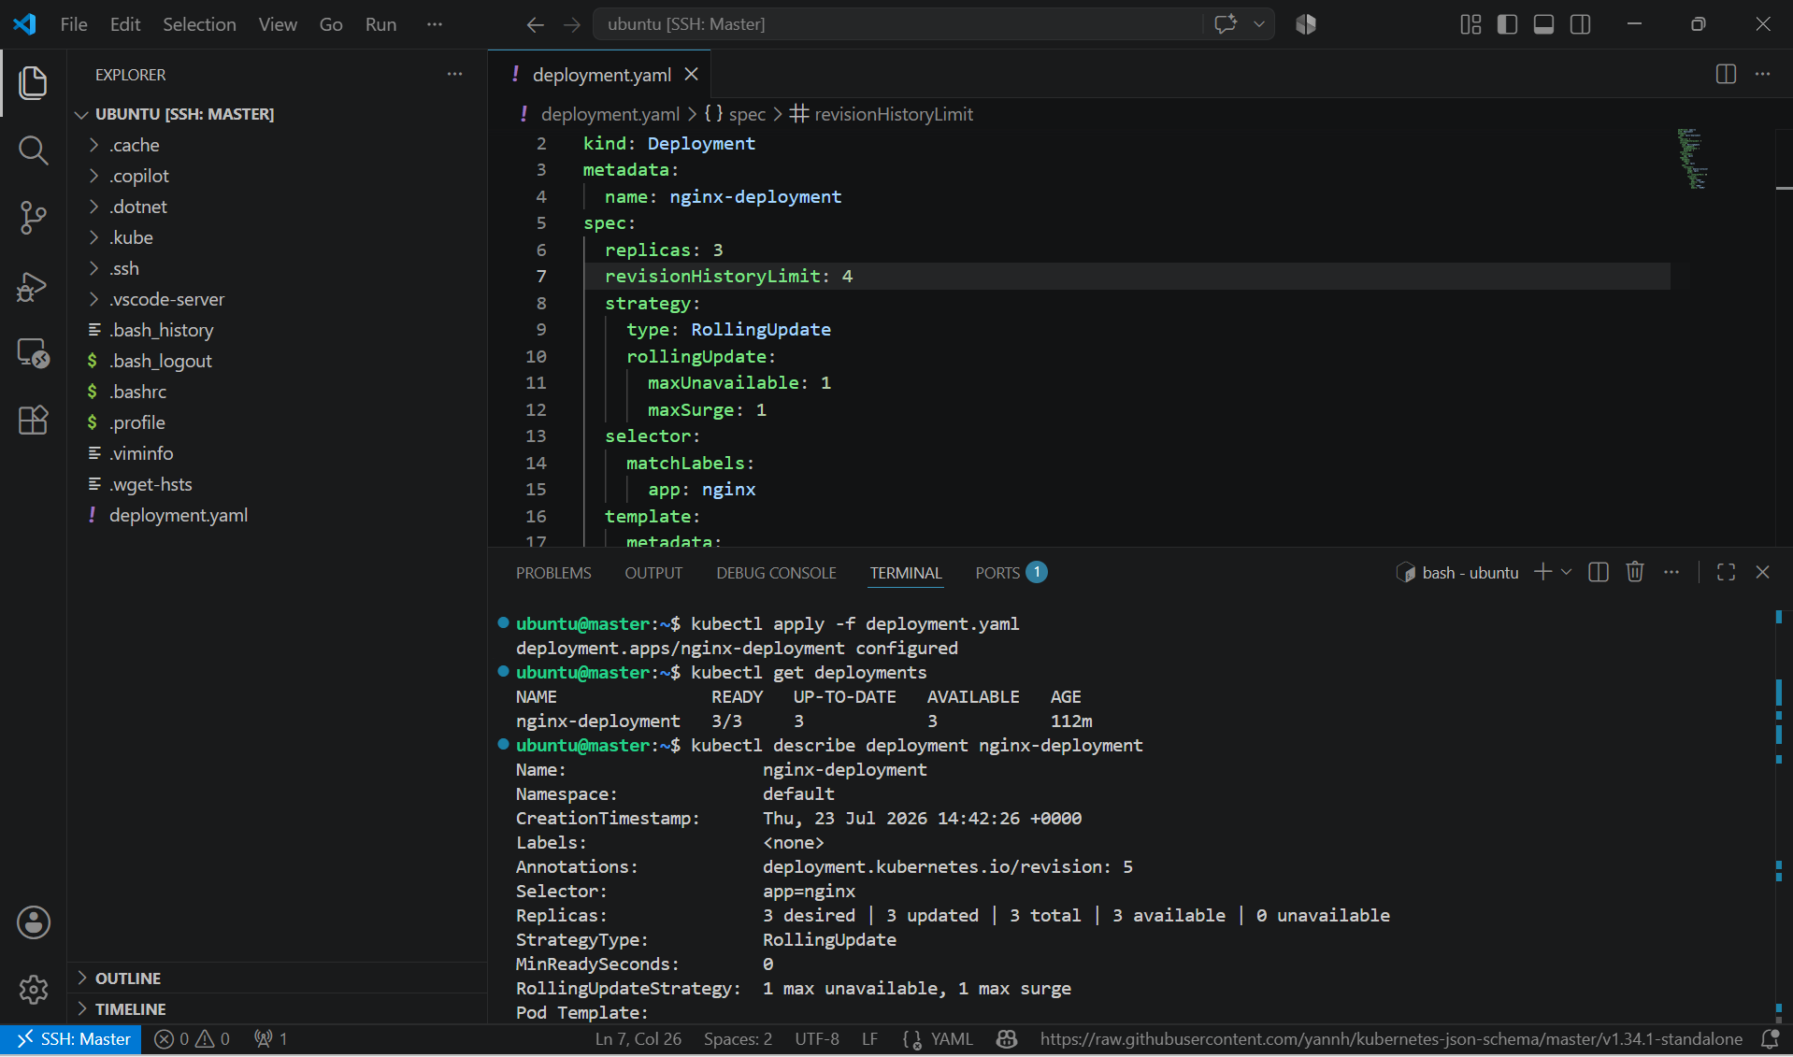

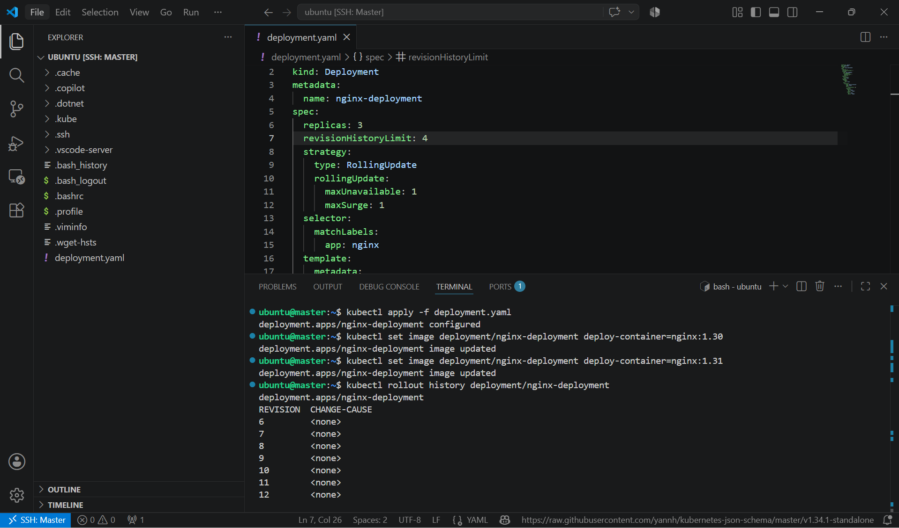

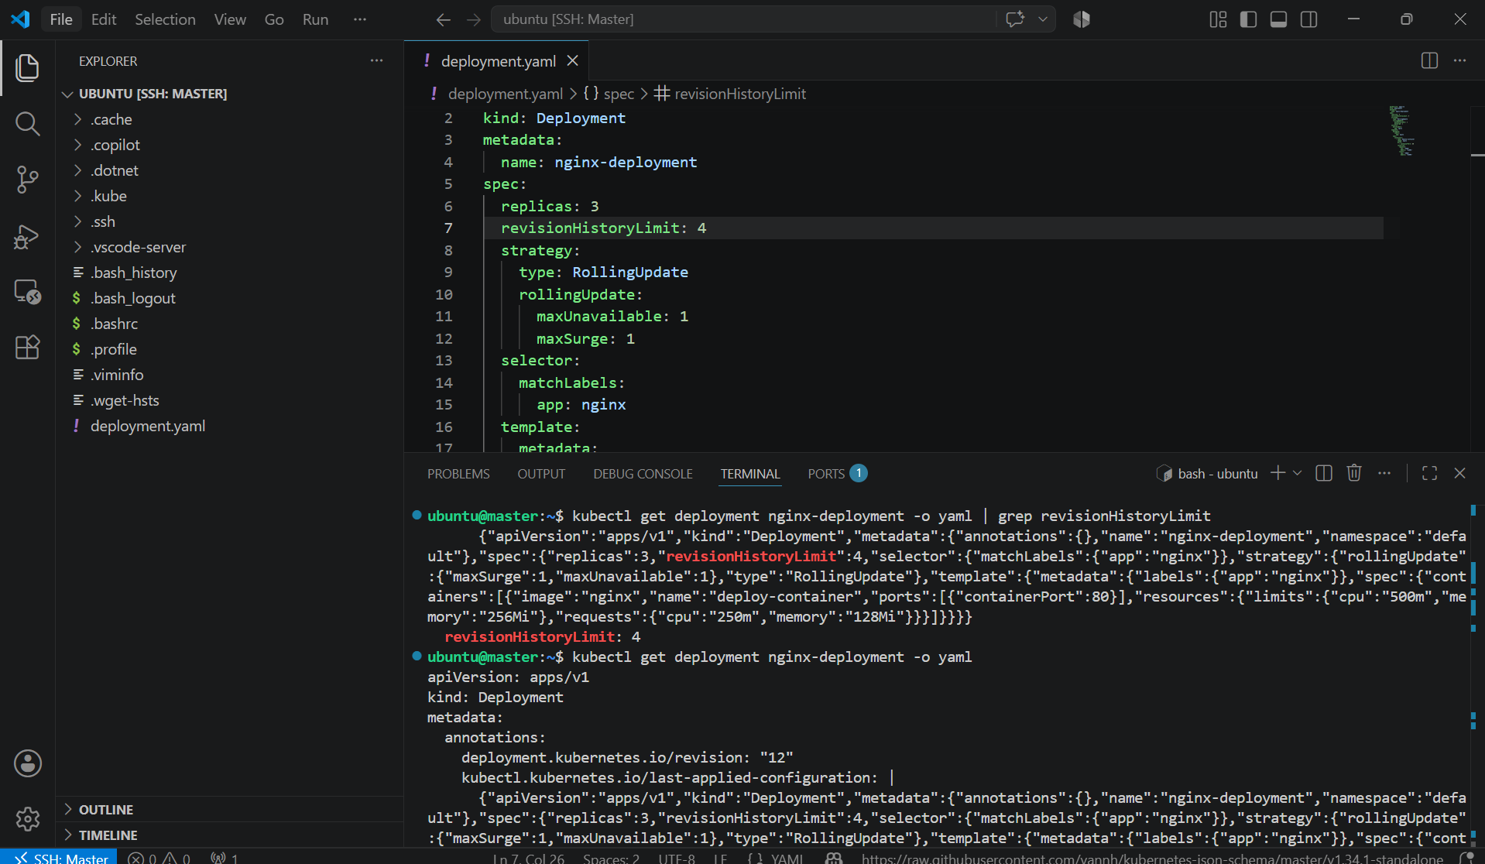

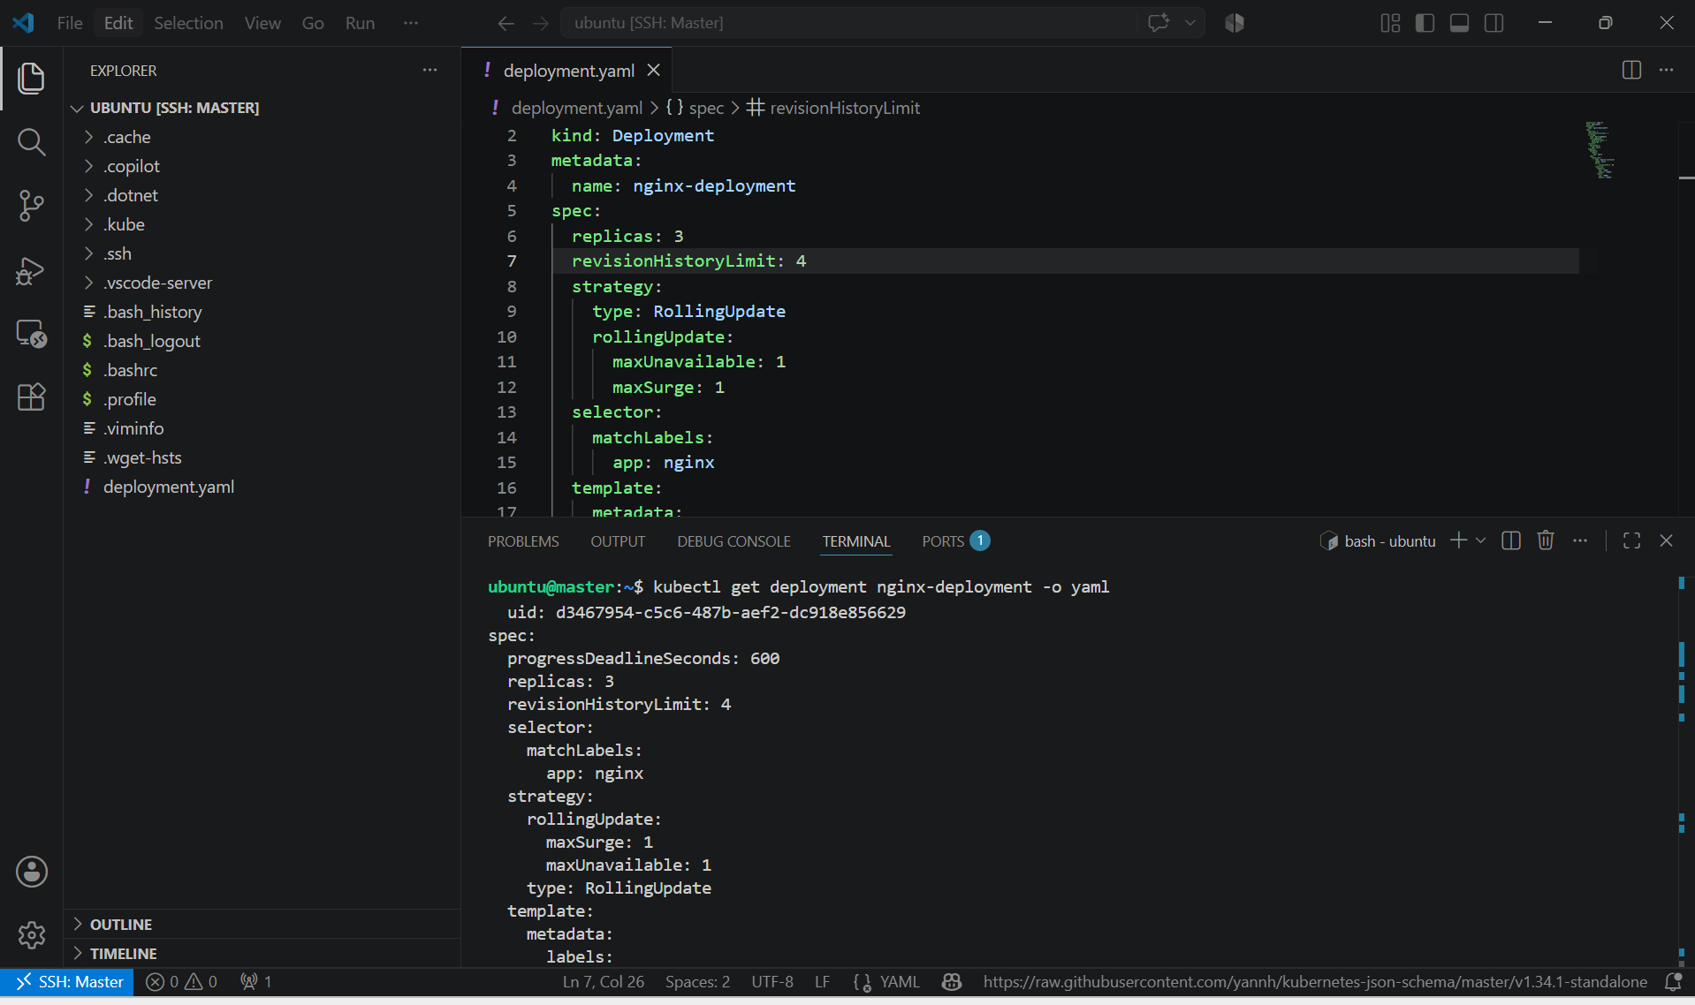

7. Pause a Deployment during an update, and then resume it.

PURPOSE: To learn how to temporarily pause a Deployment, make changes without triggering an immediate rollout, and then resume the Deployment to apply all pending changes.

OBJECTIVE:
- Pause a Deployment.
- Update the container image while paused.
- Verify that no rollout occurs.
- Resume the Deployment.
- Verify that the rollout starts and completes successfully.

EXPECTED OUTCOME:
- ✅ Paused the Deployment using kubectl rollout pause.
- ✅ Updated the Deployment configuration while it was paused.
- ✅ Confirmed that no rollout occurred during the pause.
- ✅ Resumed the Deployment using kubectl rollout resume.
- ✅ Verified that the Deployment rolled out successfully with the updated image.

STEP BY STEP IMPLEMENTATION:

- Verify the Deployment -> kubectl get deployments
- Pause the Deployment -> kubectl rollout pause deployment/nginx-deployment
- Update the Container Image -> kubectl set image deployment/nginx-deployment deploy-container=nginx:1.32
- Note: The Deployment is paused, so the Pods will not be updated yet.
- Verify That No Rollout Occurred -> kubectl rollout status deployment/nginx-deployment
- Expected output: -> Waiting for deployment spec update to be observed...
- Resume the Deployment -> kubectl rollout resume deployment/nginx-deployment
- Watch the Rollout -> kubectl rollout status deployment/nginx-deployment
- Verify the Updated Image -> kubectl get deployment nginx-deployment -o yaml | grep image:
- Verify the Pods -> kubectl get pods
- All Pods should now be recreated and running the updated image.

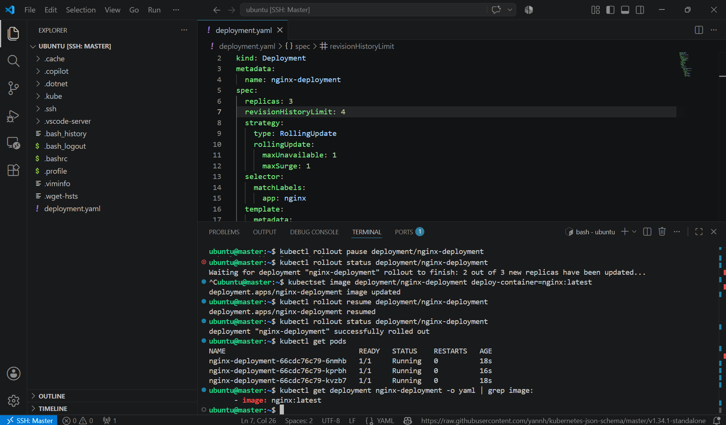

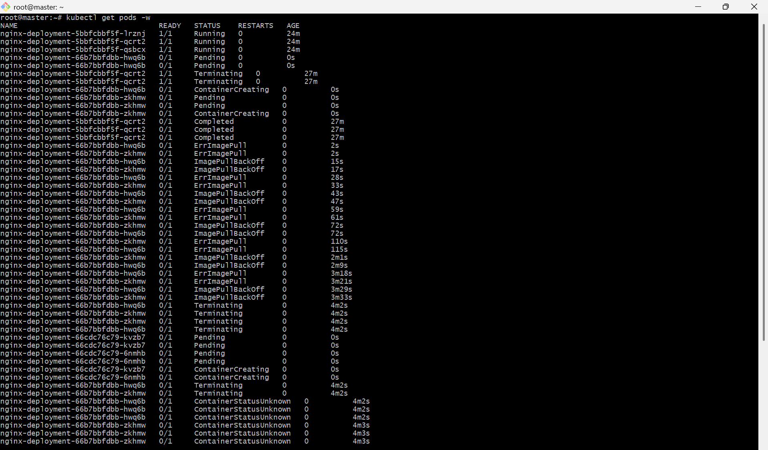

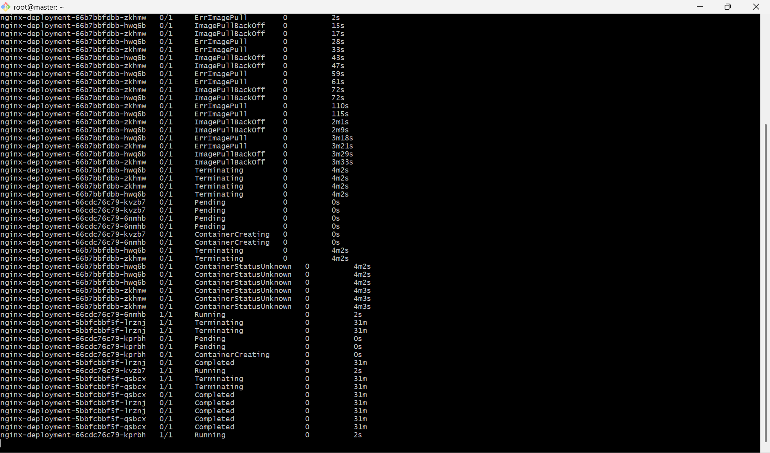

8. Create a pod using resource requests for memory and CPU, and observe how the scheduler assigns it to a node.

PURPOSE: To create a Pod with CPU and memory resource requests and observe how the Kubernetes scheduler selects a node based on available resources.

OBJECTIVE:
- Create a Pod with CPU and memory requests.
- Deploy the Pod.
- Verify that the scheduler assigns it to a worker node.
- Inspect the Pod's resource configuration.

EXPECTED OUTCOME:
- ✅ Created a Pod with CPU and memory requests.
- ✅ Configured CPU and memory limits.
- ✅ Kubernetes scheduler assigned the Pod to a suitable worker node.
- ✅ Verified the assigned node using kubectl get pod -o wide.
- ✅ Verified the resource requests and limits using kubectl describe pod.

STEP BY STEP IMPLEMENTATION:
- Create a file named resource-pod.yaml.
apiVersion: v1
kind: Pod
metadata:
name: resource-pod
spec:
containers:
- name: nginx-container
image: nginx:latest
resources:
requests:
cpu: "250m"
memory: "128Mi"
limits:
cpu: "500m"
memory: "256Mi"
- Create the Pod -> kubectl create -f resource-pod.yaml
- Verify the pod -> kubectl get pods
- Observe Which Node the Scheduler Chose -> kubectl get pods -o wide
- Inspect Scheduling Details -> kubectl describe pod resource-pod
- View Node Resource Allocation -> kubectl describe node worker-1
- In the Allocated resources section, you can see how the Pod's CPU and memory requests contribute to the node's allocated resources.

