KUBERNETES-05

1. Create a namespace dev-environment and apply a resource-based quota that restricts the number of pods to 3 and services to 2.

PURPOSE: To create a separate Kubernetes namespace named dev and enforce resource limits using a ResourceQuota, restricting the namespace to a maximum of 3 Pods and 2 Services. This helps control resource usage and prevents excessive resource consumption within the namespace.

OBJECTIVE:
- Create a namespace named dev-environment.
- Apply a ResourceQuota to limit:
  - Pods: 3
  - Services: 2
- Verify that the quota has been successfully applied.

EXPECTED OUTCOME:
- The dev-environment namespace is successfully created.
- A ResourceQuota named dev-resource-quota is applied.
- The namespace is limited to:
  - 3 Pods
  - 2 Services
- Any attempt to create more than 3 Pods or 2 Services in the dev-environment namespace will be denied by Kubernetes.

RESULT: The namespace was successfully configured with a ResourceQuota, demonstrating how Kubernetes can enforce resource usage limits at the namespace level to ensure efficient resource management and isolation between different environments.

STEP BY STEP IMPLEMENTATION:

- Create the Namespace -> kubectl create namespace dev
- Create a file named quota.yaml.
apiVersion: v1
kind: ResourceQuota
metadata:
name: dev-resource-quota
namespace: dev
spec:
hard:
pods: "3"
services: "2"

- Apply the ResourceQuota -> kubectl apply -f quota.yaml
- Verify the ResourceQuota -> kubectl get resourcequota -n dev
- View ResourceQuota Details -> kubectl describe resourcequota dev-resource-quota -n dev

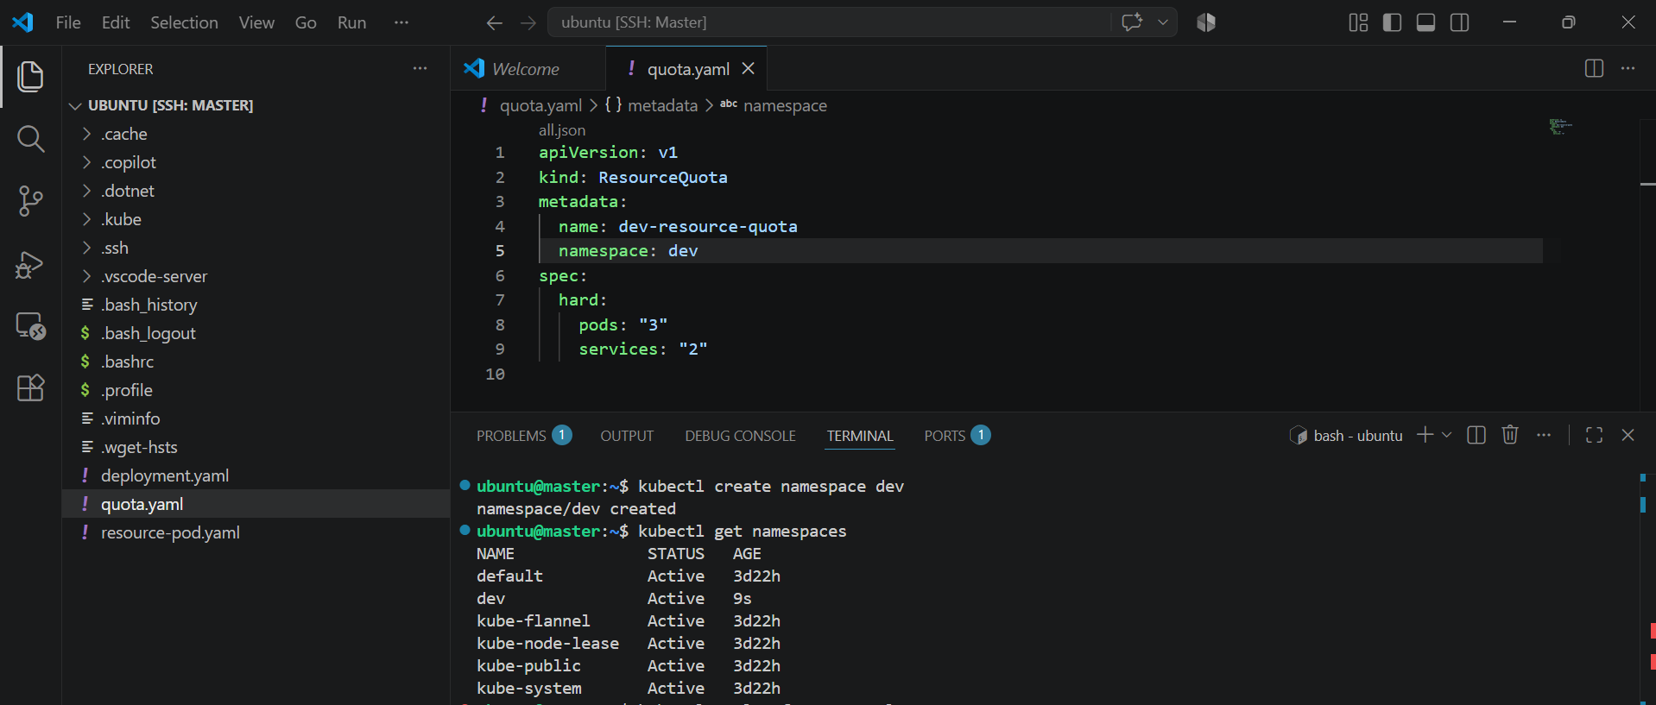

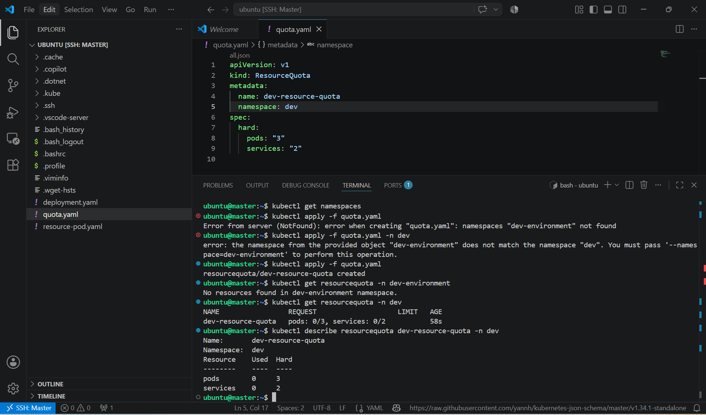

- Now we can verify by creating more than three pods and we can see the error that limit has reached.

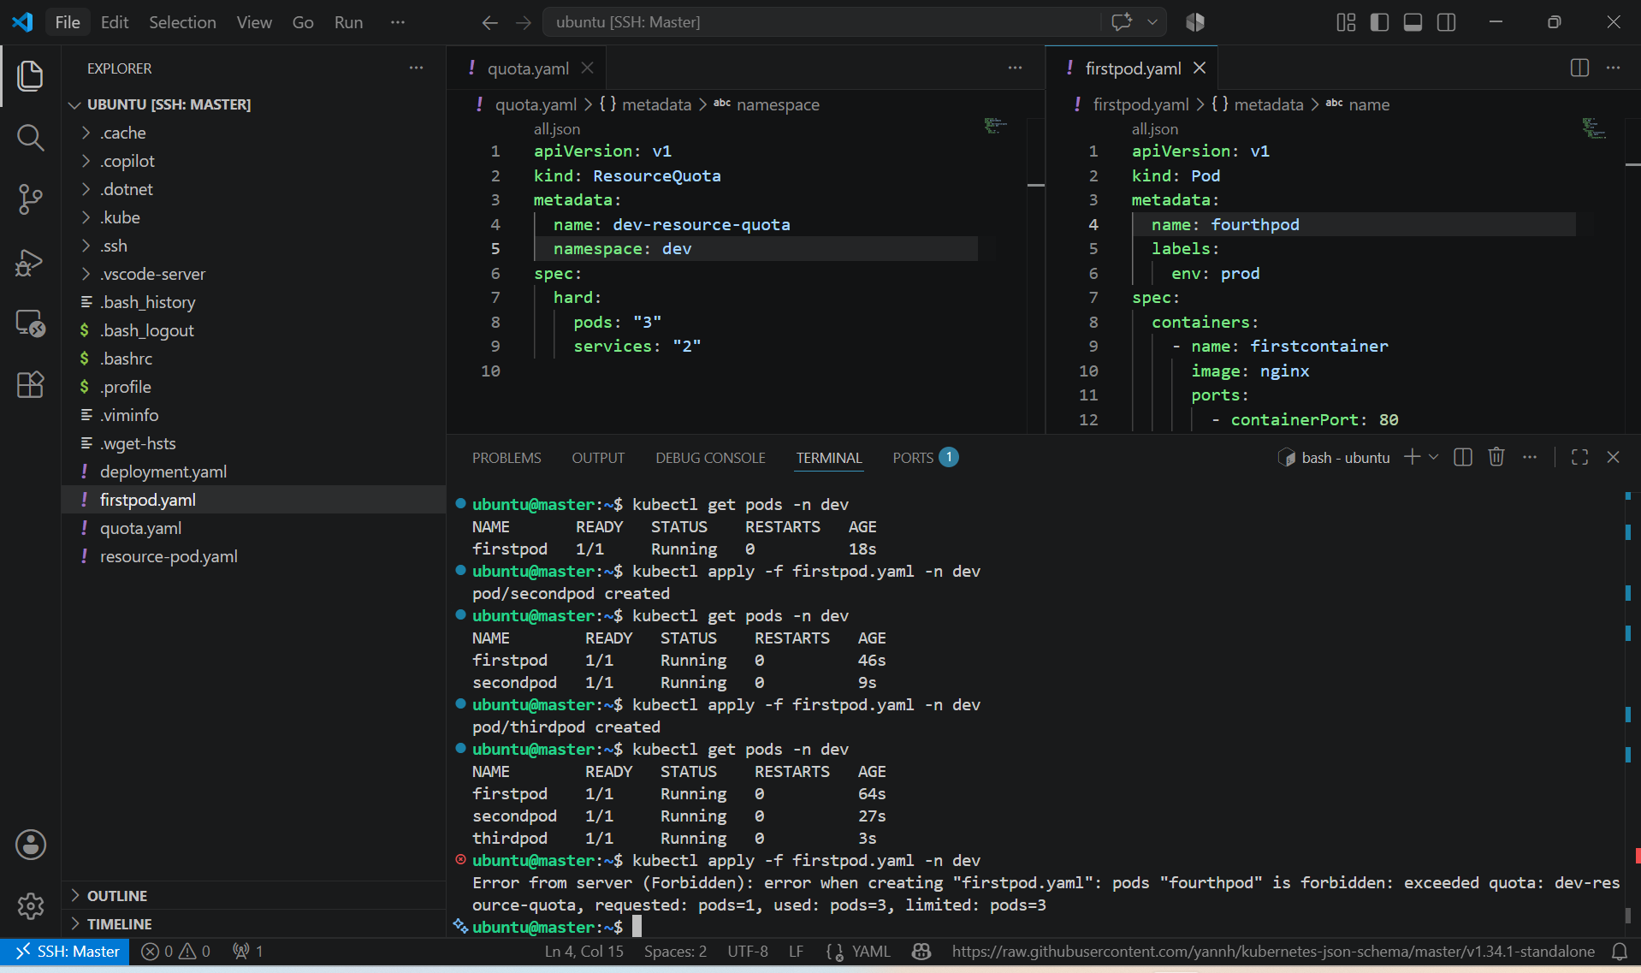

2. Create a pod in the prod-environment namespace with 0.2 CPU and 200Mi memory requests, and 0.5 CPU and 500Mi memory limits.

PURPOSE: To create a Pod in the prod-environment namespace with specific CPU and memory requests and limits, ensuring the scheduler reserves the required resources and prevents the Pod from exceeding the defined resource limits.

OBJECTIVE:
- Create a Pod in the prod-environment namespace.
- Configure:
  - CPU Request: 0.2 CPU (200m)
  - Memory Request: 200Mi
  - CPU Limit: 0.5 CPU (500m)
  - Memory Limit: 500Mi

EXPECTED OUTCOME:
- A Pod named resource-pod is successfully created in the prod-environment namespace with:
  - CPU Request: 200m (0.2 CPU)
  - Memory Request: 200Mi
  - CPU Limit: 500m (0.5 CPU)
  - Memory Limit: 500Mi
- Kubernetes schedules the Pod based on the requested resources and enforces the specified resource limits during execution.

STEP BY STEP IMPLEMENTATION:
- Create the Namespace (if it does not exist)
- Create a YAML file
apiVersion: v1
kind: Pod
metadata:
name: resource-pod
namespace: dev
spec:
containers:
- name: nginx-container
image: nginx
ports:
- containerPort: 80
resources:
requests:
cpu: "200m"
memory: "200Mi"
limits:
cpu: "500m"
memory: "500Mi"

- Create the Pod -> kubectl apply -f resource-pod.yaml -n dev
- Verify the Pod -> kubectl get pods -n dev
- Verify Resource Requests and Limits -> kubectl describe pod resource-pod -n dev



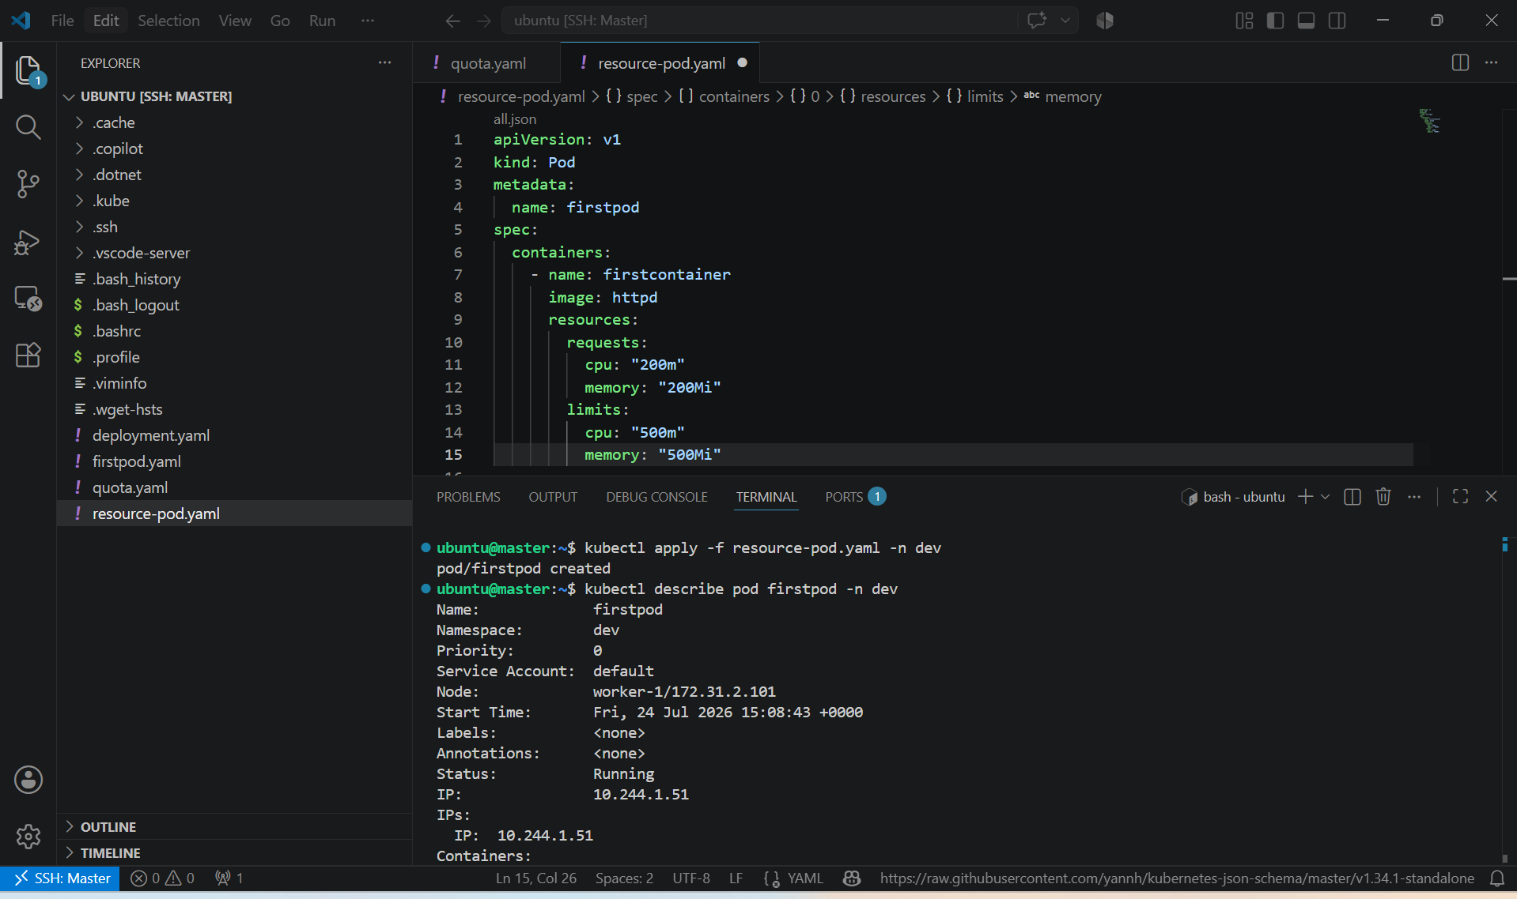

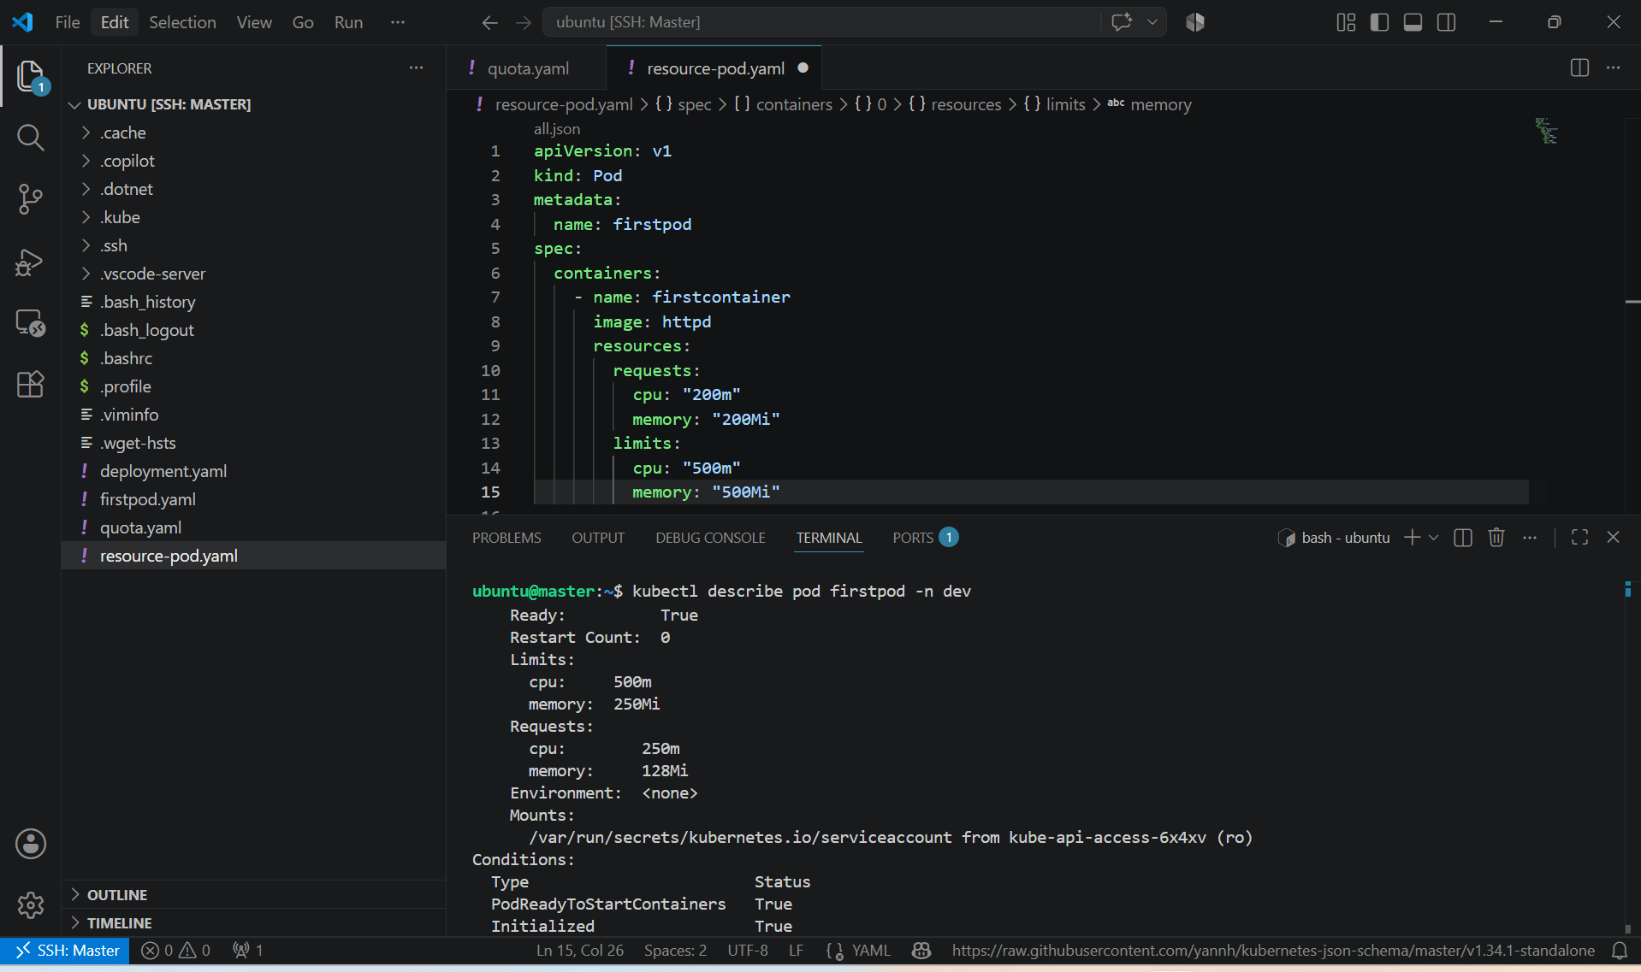

3. In the staging-environment namespace, set a LimitRange that assigns default CPU and memory limits (300m CPU, 600Mi memory) and applies a minimum and maximum CPU.

PURPOSE: To configure a LimitRange in the staging-environment namespace that automatically assigns default CPU and memory limits to containers and enforces minimum and maximum CPU usage for containers created in the namespace.

OBJECTIVE:
- Create a namespace named staging-environment.
- Apply a LimitRange that:
  - Sets default CPU limit to 300m.
  - Sets default memory limit to 600Mi.
  - Enforces a minimum CPU of 100m.
  - Enforces a maximum CPU of 500m.

EXPECTED OUTCOME:
- A LimitRange is successfully configured in the staging-environment namespace. Any container created without explicitly specifying resource limits will automatically receive:
  - Default CPU Limit: 300m
  - Default Memory Limit: 600Mi
  - Additionally, Kubernetes enforces:
  - Minimum CPU: 100m
  - Maximum CPU: 500m
- This ensures consistent resource allocation and prevents containers from requesting too little or consuming excessive CPU resources.

STEP BY STEP IMPLEMENTATION:
- Create the Namespace -> kubectl create namespace staging-environment
- Create a YAML file
apiVersion: v1
kind: LimitRange
metadata:
name: staging-limitrange
namespace: staging-environment
spec:
limits:
- type: Container
default:
cpu: "300m"
memory: "600Mi"
min:
cpu: "100m"
max:
cpu: "500m"
- Apply the LimitRange -> kubectl apply -f limitrange.yaml -n staging-environment
- Verify the LimitRange -> kubectl get limitrange -n staging-environment
- View LimitRange Details -> kubectl describe limitrange staging-limitrange -n staging-environment

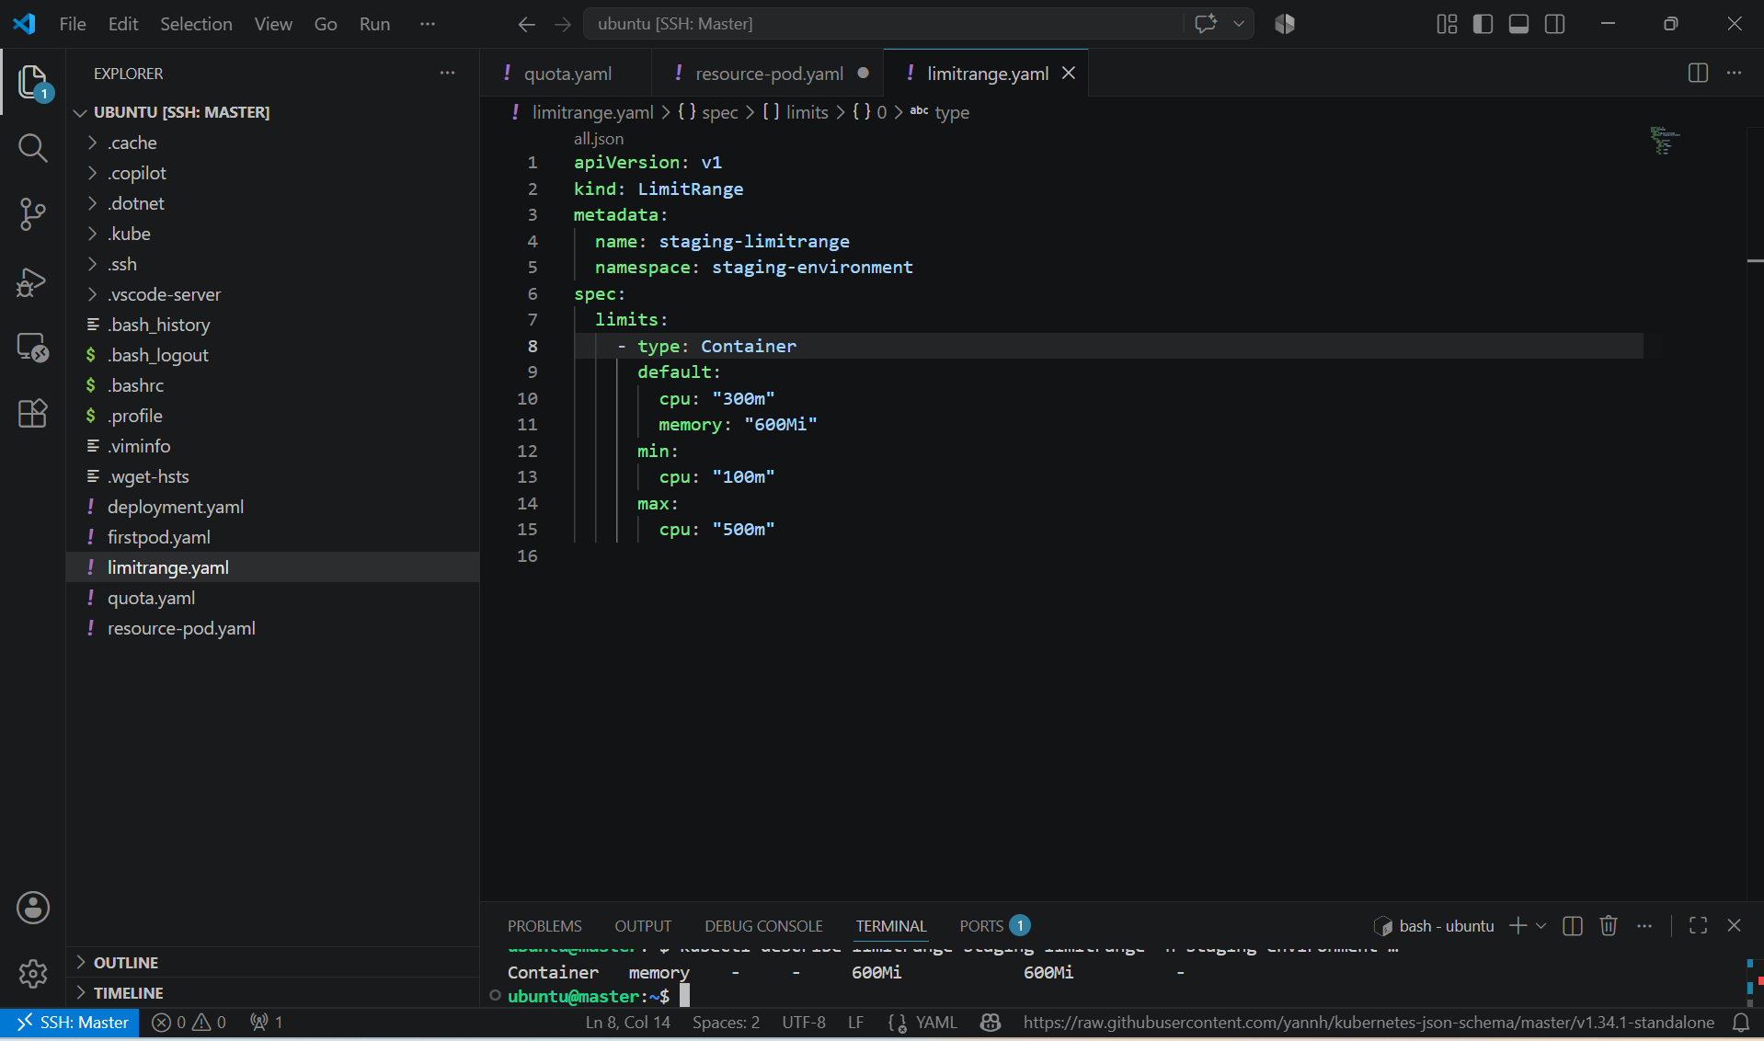

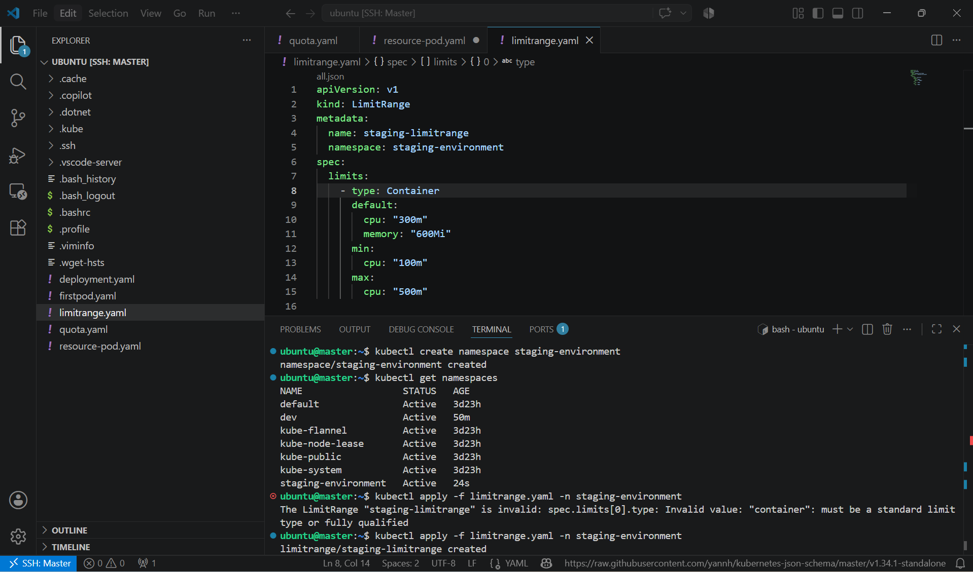

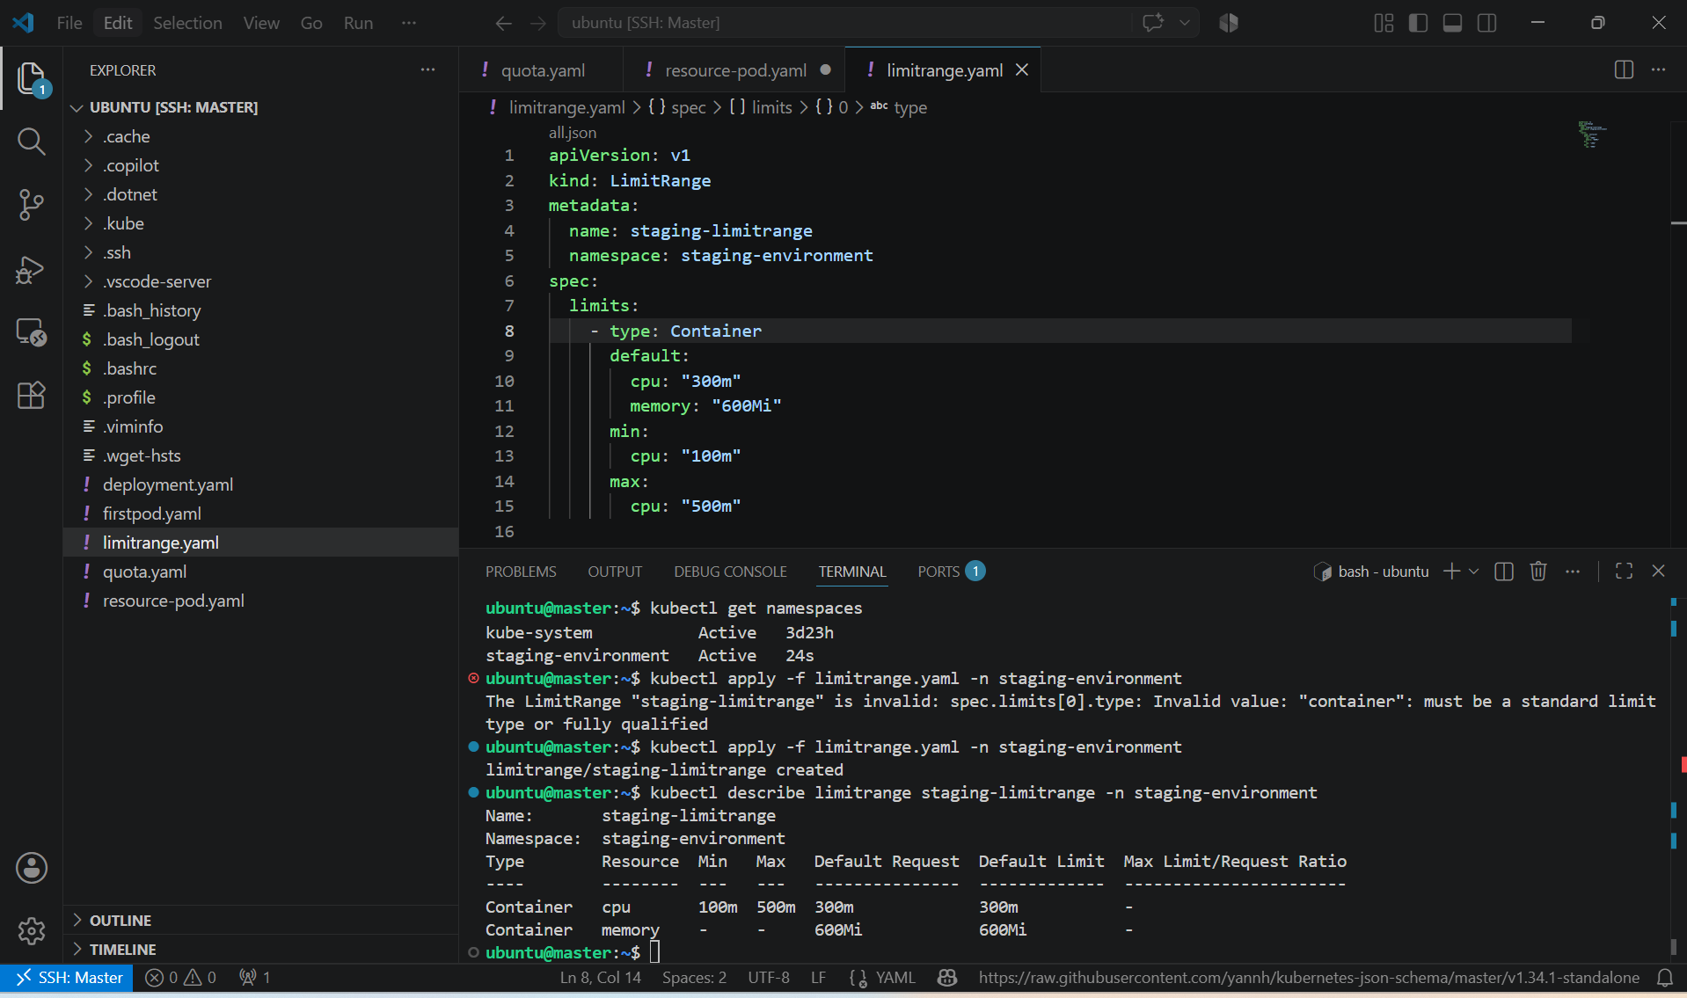

4. Create a pod and a NodePort service in the default namespace, then create another pod in the test namespace and communicate between them using Service DNS.

PURPOSE: To create a Pod and a NodePort Service in the default namespace, create another Pod in the test namespace, and verify communication between them using the Kubernetes Service DNS.

OBJECTIVE:
- Create an Nginx Pod in the default namespace.
- Expose it using a NodePort Service.
- Create another Pod in the test namespace.
- Verify communication using the Service DNS name.

EXPECTED OUTCOME: A Pod and a NodePort Service were successfully created in the default namespace. Another Pod was created in the test namespace, and communication between the two namespaces was verified using the Kubernetes Service DNS (nginx-service.default.svc.cluster.local). This demonstrates Kubernetes' built-in DNS-based service discovery across namespaces.

STEP BY STEP IMPLEMENTATION:

- Create the test Namespace -> kubectl create namespace test
- Create the Pod in the Default Namespace
- Create a file named default-pod.yaml.
apiVersion: v1
kind: Pod
metadata:
name: nginx-pod
spec:
containers:
- name: nginx
image: nginx
ports:
- containerPort: 80
- Apply it -> kubectl apply -f default-pod.yaml
- Create the NodePort Service
- Create a file named nodeport-service.yaml.
apiVersion: v1
kind: Service
metadata:
name: nginx-service
spec:
type: NodePort
selector:
app: nginx
ports:
- port: 80
targetPort: 80
- Note: The Service selector (app: nginx) must match the Pod label. Update the Pod YAML as shown below:

metadata:
name: nginx-pod
labels:
app: nginx
- Apply the Service -> kubectl apply -f nodeport-service.yaml
- Create a Pod in the test Namespace
- Create a file named test-pod.yaml.
apiVersion: v1
kind: Pod
metadata:
name: test-pod
namespace: test
spec:
containers:
- name: busybox
image: busybox
command: ["sleep", "3600"]
- Apply it -> kubectl apply -f test-pod.yaml
- Verify the Resources
    - kubectl get pods
    - kubectl get svc
    - kubectl get pods -n test
- Test Communication Using Service DNS
- Access the BusyBox Pod -> kubectl exec -it test-pod -n test – sh
- Inside the container, test the Service DNS -> wget -qO- http://nginx-service.default.svc.cluster.local
- If successful, the default Nginx welcome page HTML is displayed, confirming DNS resolution and connectivity.

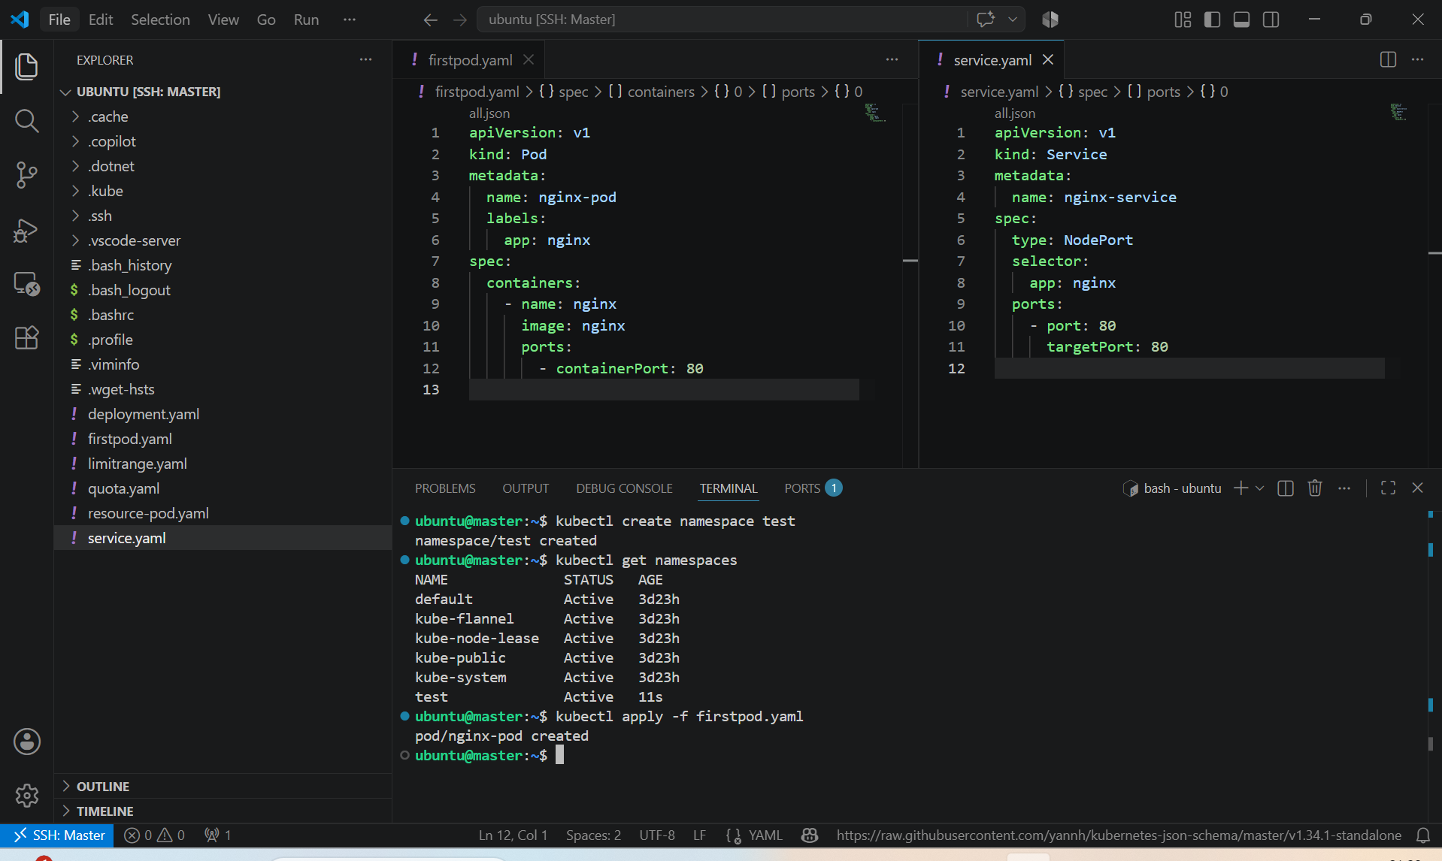

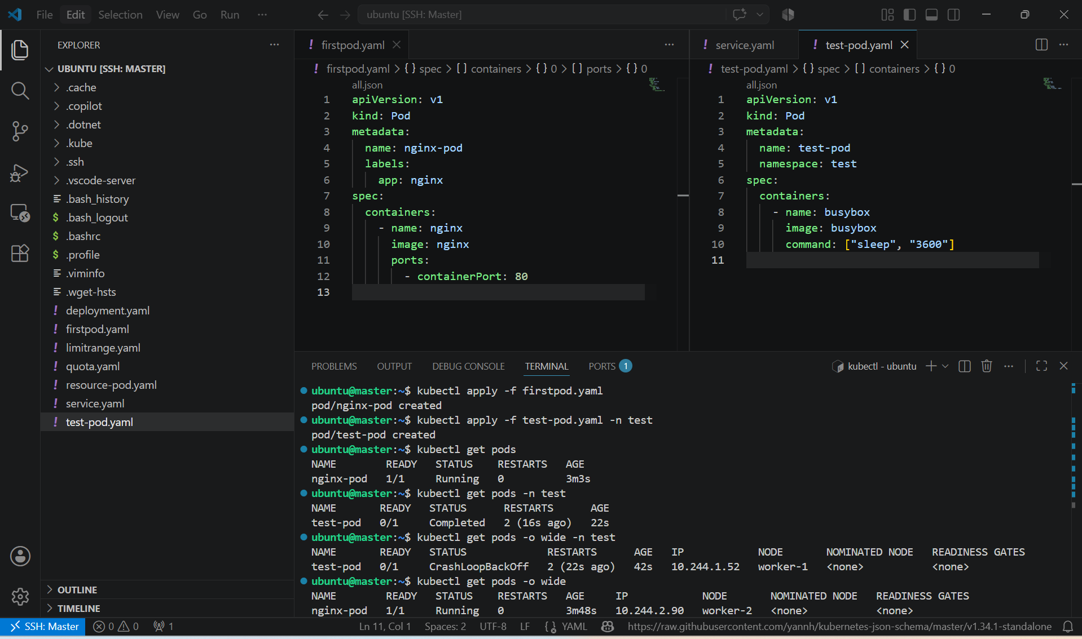

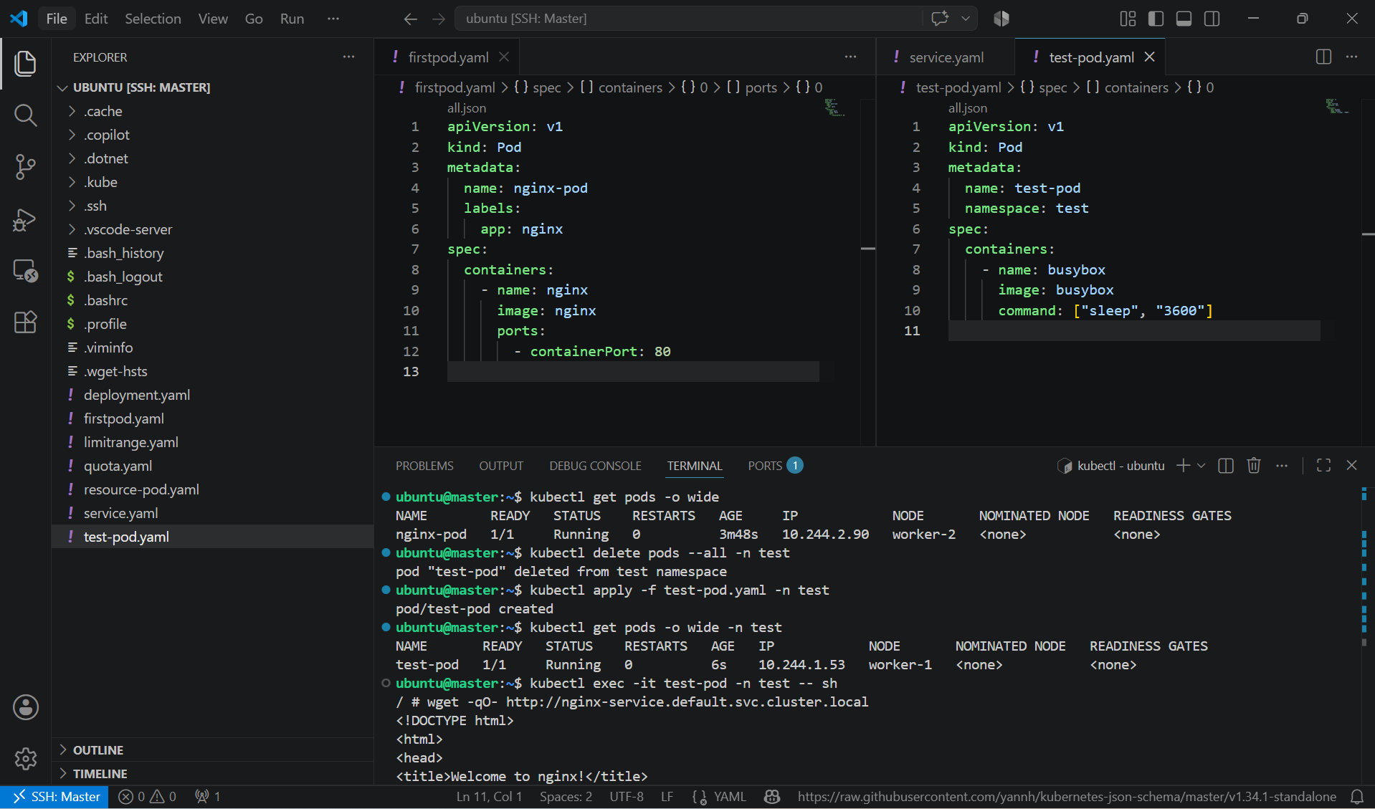

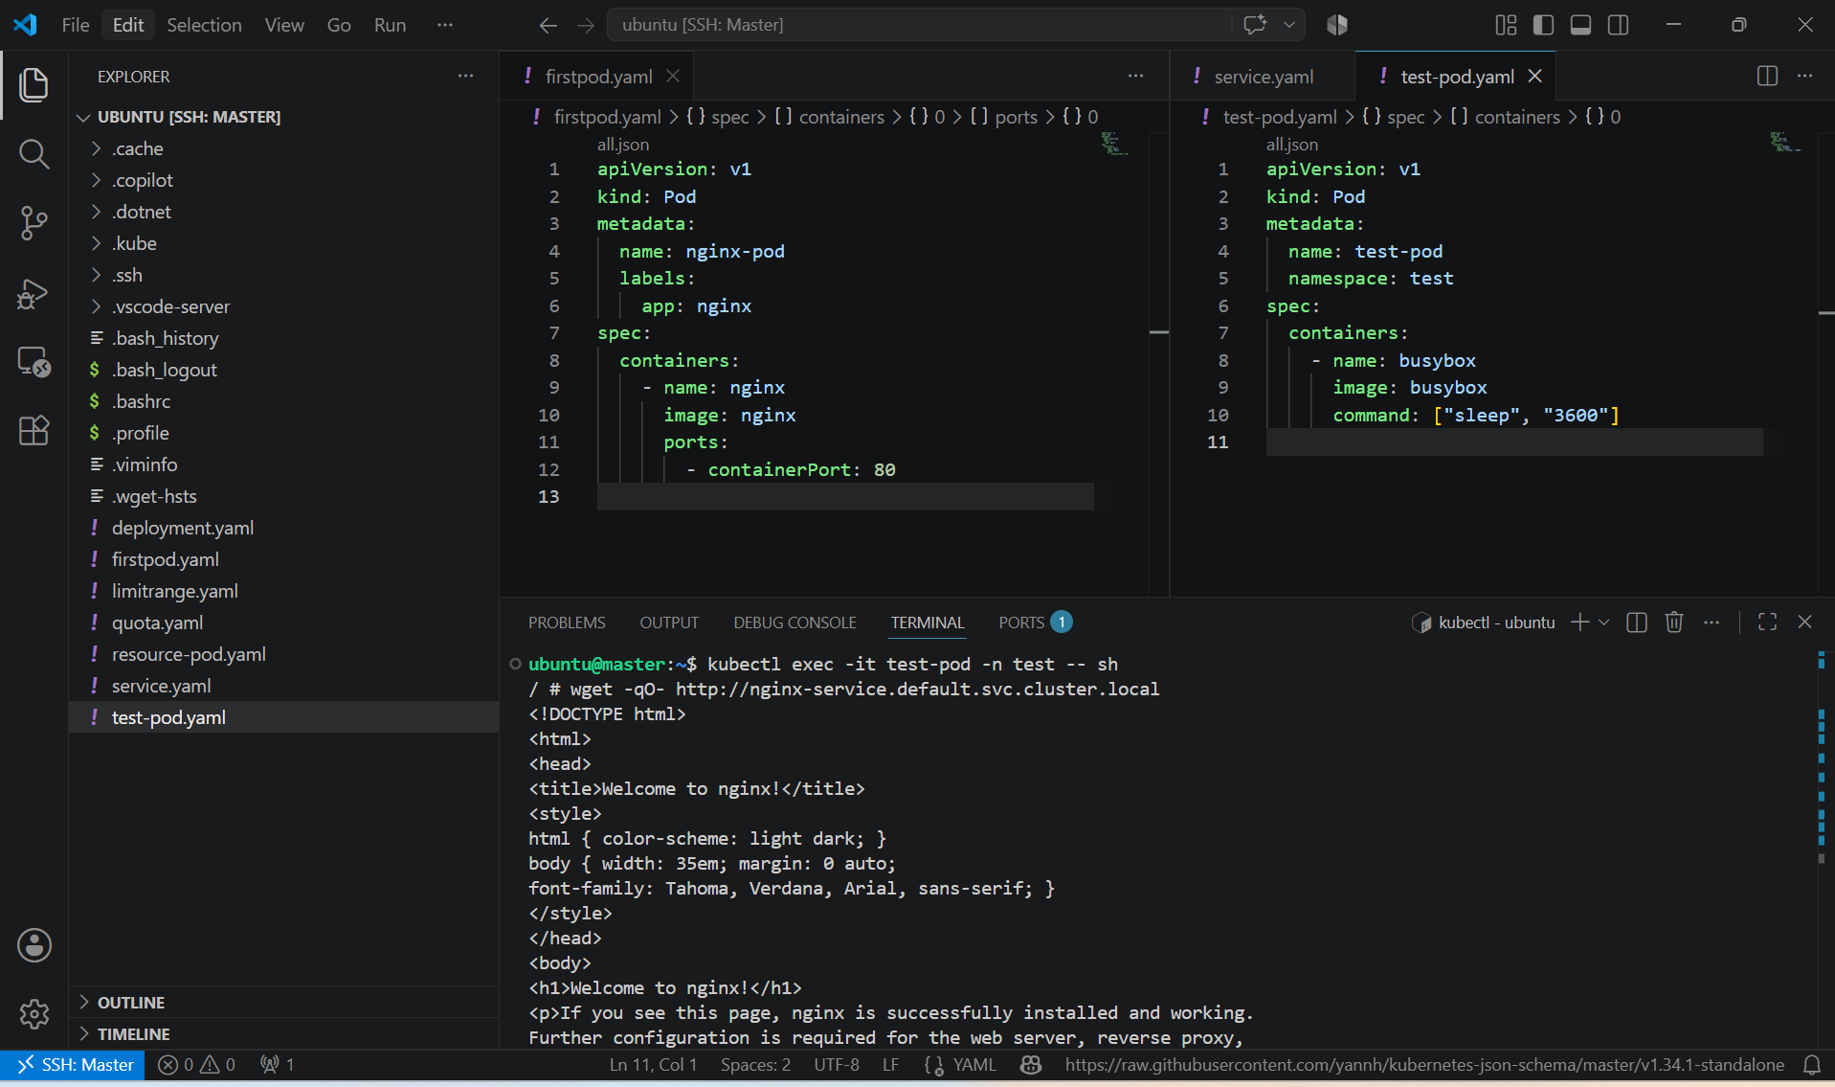

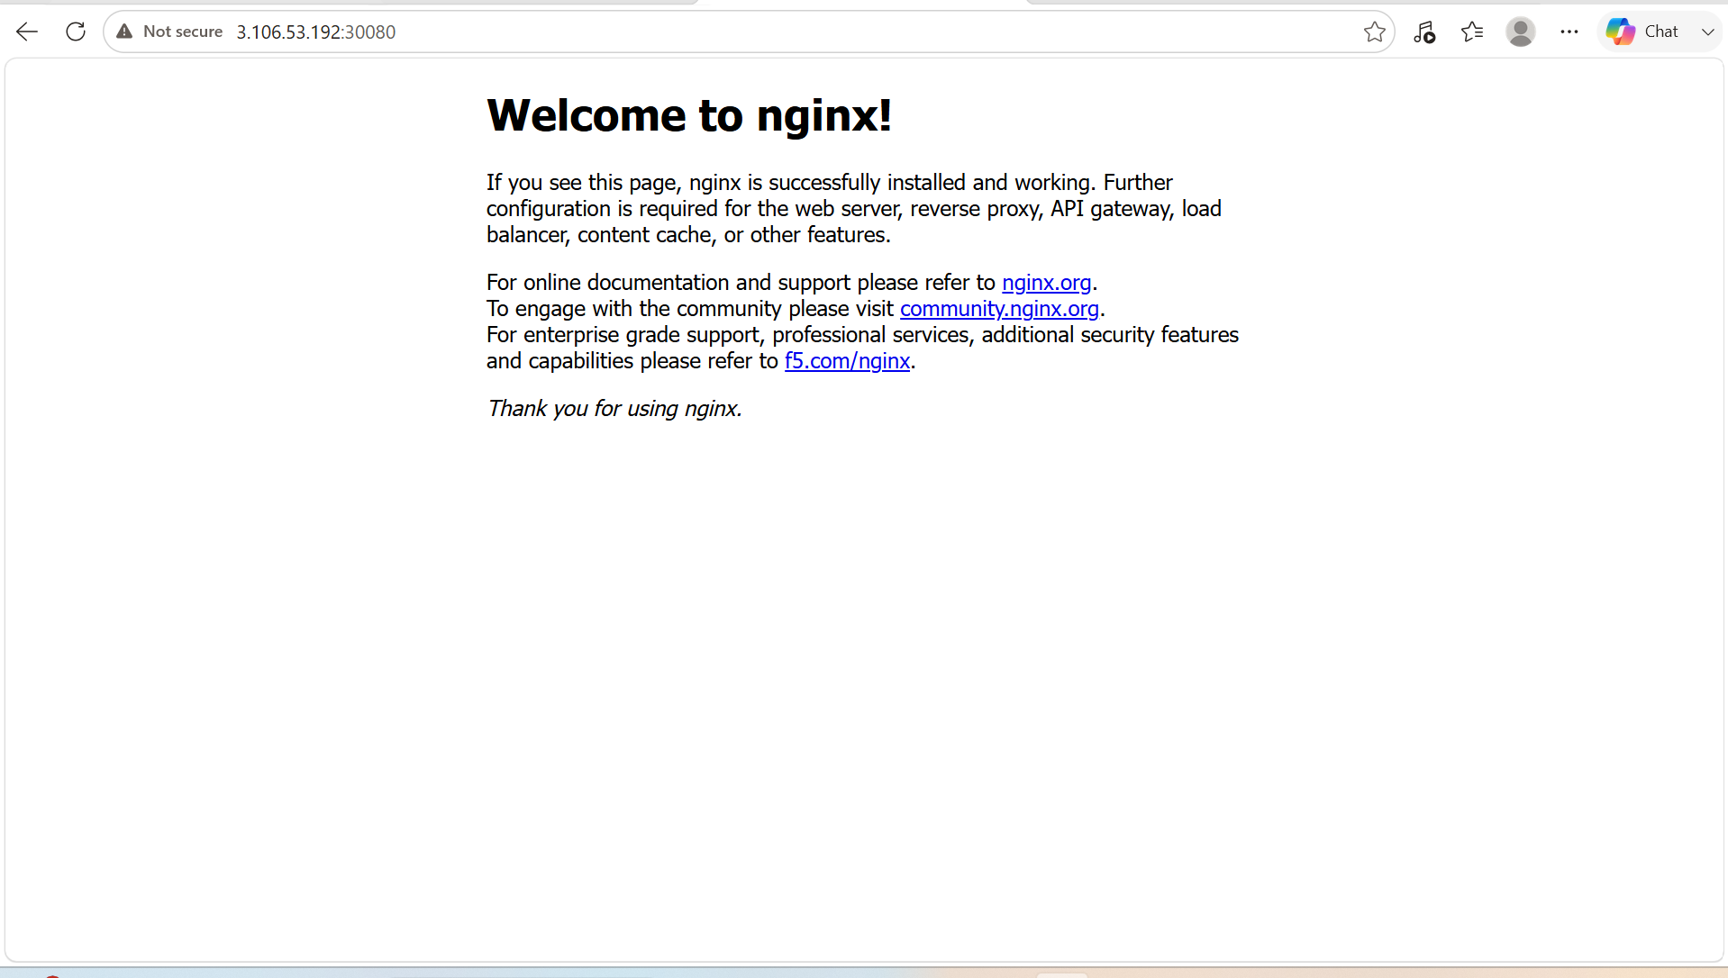

5. Apply a LimitRange with a max limit/request ratio of 2 for memory in the performance-environment namespace, and test by creating a pod with mismatched resource requests and limits.

PURPOSE: To configure a LimitRange in the performance-environment namespace that enforces a maximum memory limit/request ratio of 2, and verify the policy by attempting to create a Pod that violates the ratio.

OBJECTIVE:
- Create the performance-environment namespace.
- Apply a LimitRange with a maximum memory limit/request ratio of 2.
- Create a Pod whose memory limit exceeds the allowed ratio.
- Verify that Kubernetes rejects the Pod.

EXPECTED OUTCOME: A LimitRange was successfully configured in the performance-environment namespace with a maximum memory limit/request ratio of 2. Kubernetes rejected the Pod whose memory limit exceeded twice its memory request, while accepting the Pod that complied with the configured ratio, demonstrating enforcement of resource allocation policies.

STEP BY STEP IMPLEMENTATION:
- Create the Namespace -> kubectl create namespace performance-environment
- Create the LimitRange and Create a file named limitrange.yaml.
apiVersion: v1
kind: LimitRange
metadata:
name: performance-limitrange
namespace: performance-environment
spec:
limits:
- type: Container
maxLimitRequestRatio:
memory: "2"
- Apply the LimitRange -> kubectl apply -f limitrange.yaml
- Verify the LimitRange -> kubectl describe limitrange performance-limitrange -n performance-environment
- Create a Pod that Violates the Ratio and Create a file named invalid-pod.yaml.
apiVersion: v1
kind: Pod
metadata:
name: invalid-pod
namespace: performance-environment
spec:
containers:
- name: nginx
image: nginx
resources:
requests:
memory: "200Mi"
limits:
memory: "600Mi"
- Here:
  - Memory Request = 200Mi
  - Memory Limit = 600Mi
  - Ratio = 600 / 200 = 3
  - Since 3 > 2, Kubernetes should reject the Pod.
- Apply the Pod -> kubectl apply -f invalid-pod.yaml
- Create a Valid Pod and Create valid-pod.yaml.
apiVersion: v1
kind: Pod
metadata:
name: valid-pod
namespace: performance-environment
spec:
containers:
- name: nginx
image: nginx
resources:
requests:
memory: "200Mi"
limits:
memory: "400Mi"
- Here:
  - Memory Request = 200Mi
  - Memory Limit = 400Mi
  - Ratio = 2 ✔ (Allowed)
- Apply it:
    - kubectl apply -f valid-pod.yaml
    - kubectl get pods -n performance-environment

