KUBERNETES-06

1. Create a ConfigMap from a directory containing multiple files and inject the variables into a pod as environment variables.

PURPOSE: The purpose of this task isto store application configuration separately from the container image by using a Kubernetes configMap. This allows you to update configuration without rebuilding the application image and promotes better configuration management across different environments.

OBJECTIVE:
- Create a ConfigMap from a directory containing multiple configuration files.
- Inject the ConfigMap data into a Pod as environment variables.
- Verify that the application can access the configuration through environment variables.

EXPECTED OUTCOME:
- A ConfigMap named app-config is created successfully.
- The Pod starts successfully.
- The container receives the following environment variables:
  - APP_NAME=myapp
  - APP_ENV=production
- The application can access these variables without modifying the container image.

STEP BY STEP IMPLEMENTATION:
- Create a directory first and then create 2 files in that directory.
- Then after creating the directory and the files, we have to create yaml file to create a pod with the configMap.
- That configMap values will passed as the environment variables in the yaml file for the pod.
- Create the ConfigMap from the Directory -> kubectl create configmap <configMap-name> --from-file=<directoryName>
- Then after creating config map, we have to create a pod from the yaml file -> kubectl create -f <yamlfileName>
- To verify that, we have to run these commands ->
  - kubectl describe configmap <configMapName>
  - kubectl exec configmap-env-pod -- env | grep APP -> verify the environment variables.
  - We can also verify it by entering into the pod and execute the command -> env

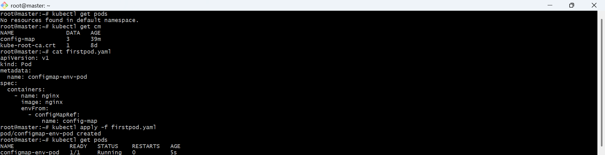

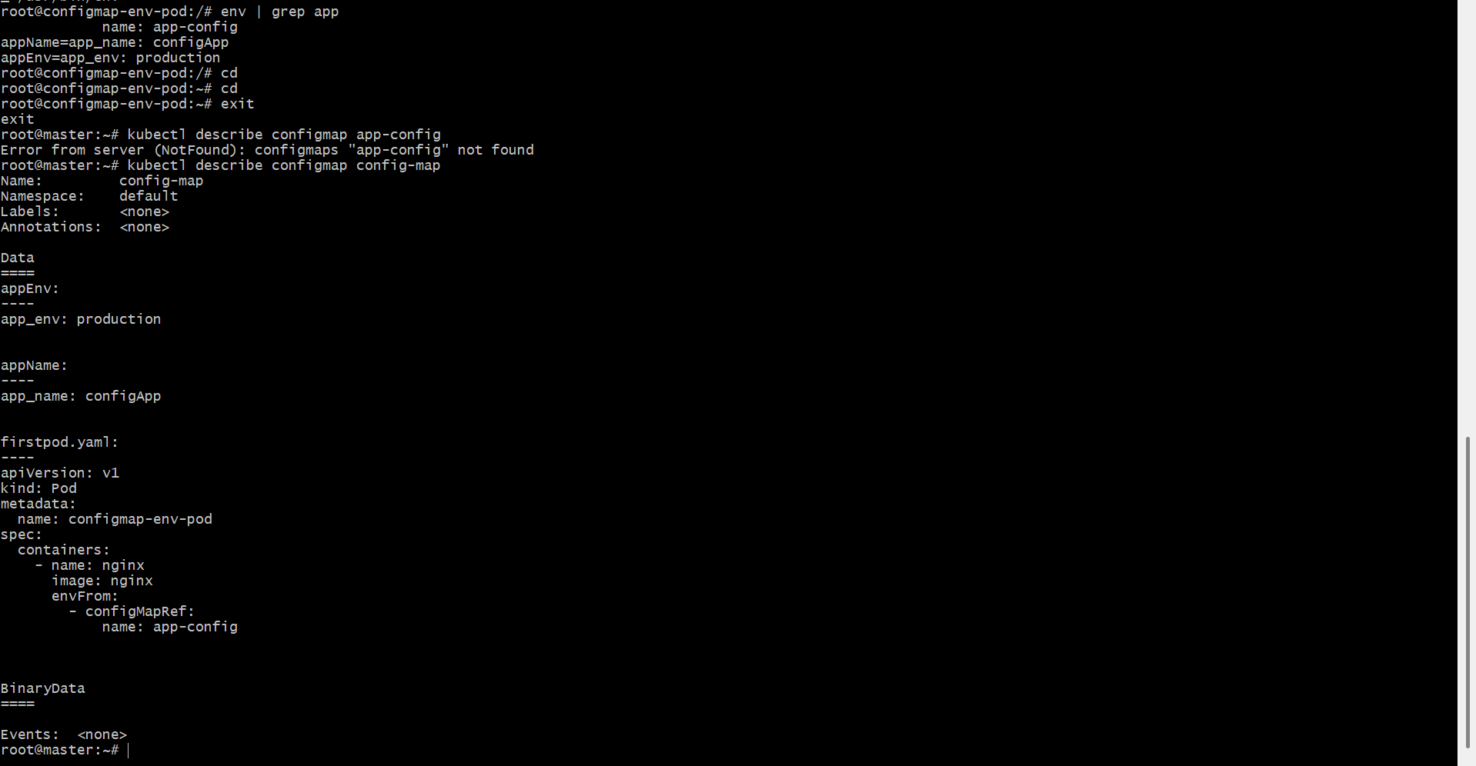

2. Create a ConfigMap from a file and mount it as a volume inside a pod, ensuring the configuration data is available as files.

PURPOSE: The purpose of this task is to store configuration in a ConfigMap and mount it inside a Pod as files. This allows applications to read configuration from files without rebuilding the container image.

OBJECTIVE:
- Create a ConfigMap from a configuration file.
- Mount the ConfigMap into a Pod as a volume.
- Verify that the configuration file is available inside the container.

EXPLANATION:
- --from-file=app.properties creates a ConfigMap using the file.
- The filename (app.properties) becomes the ConfigMap key.
- The file content becomes the ConfigMap value.
- Kubernetes mounts the ConfigMap as a volume.
- Inside the container, each ConfigMap key appears as a separate file.

EXPECTED OUTCOME:
- A ConfigMap named app-config is created.
- The Pod starts successfully.
- The configuration file is mounted at /etc/config/app.properties.
- The application can read the configuration directly from the mounted file.

STEP BY STEP IMPLEMENTATION:
- Create a file named application.properties
- In that we have to add the configuration details that we want to add.
- Then we have to create configMap using this created file by executing this command -> kubectl create configmap <configmapName> --from-file=application.properties.
- Then we have to create a yaml file for creating a pod and execute apply command by passing the yaml file for that command -> kubectl apply -f <yamlFileName>
- Then verify with these commands ->
  - kubectl get configmap
  - kubectl get pods
  - kubectl describe cm <configmapName>
  - kubectl exec configmap-volume-pod -- ls /etc/config -> verify the mounted volume

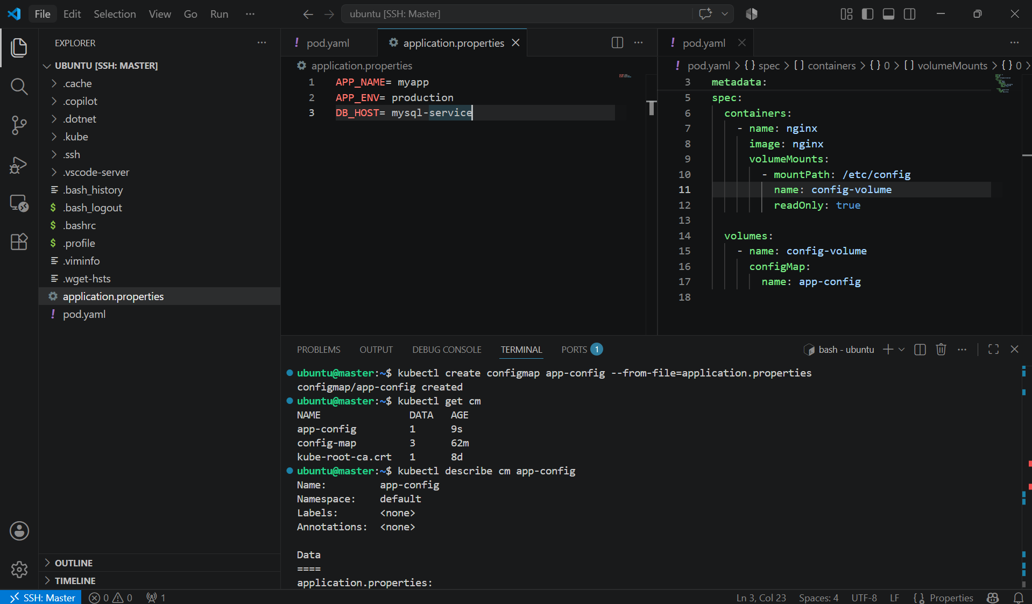

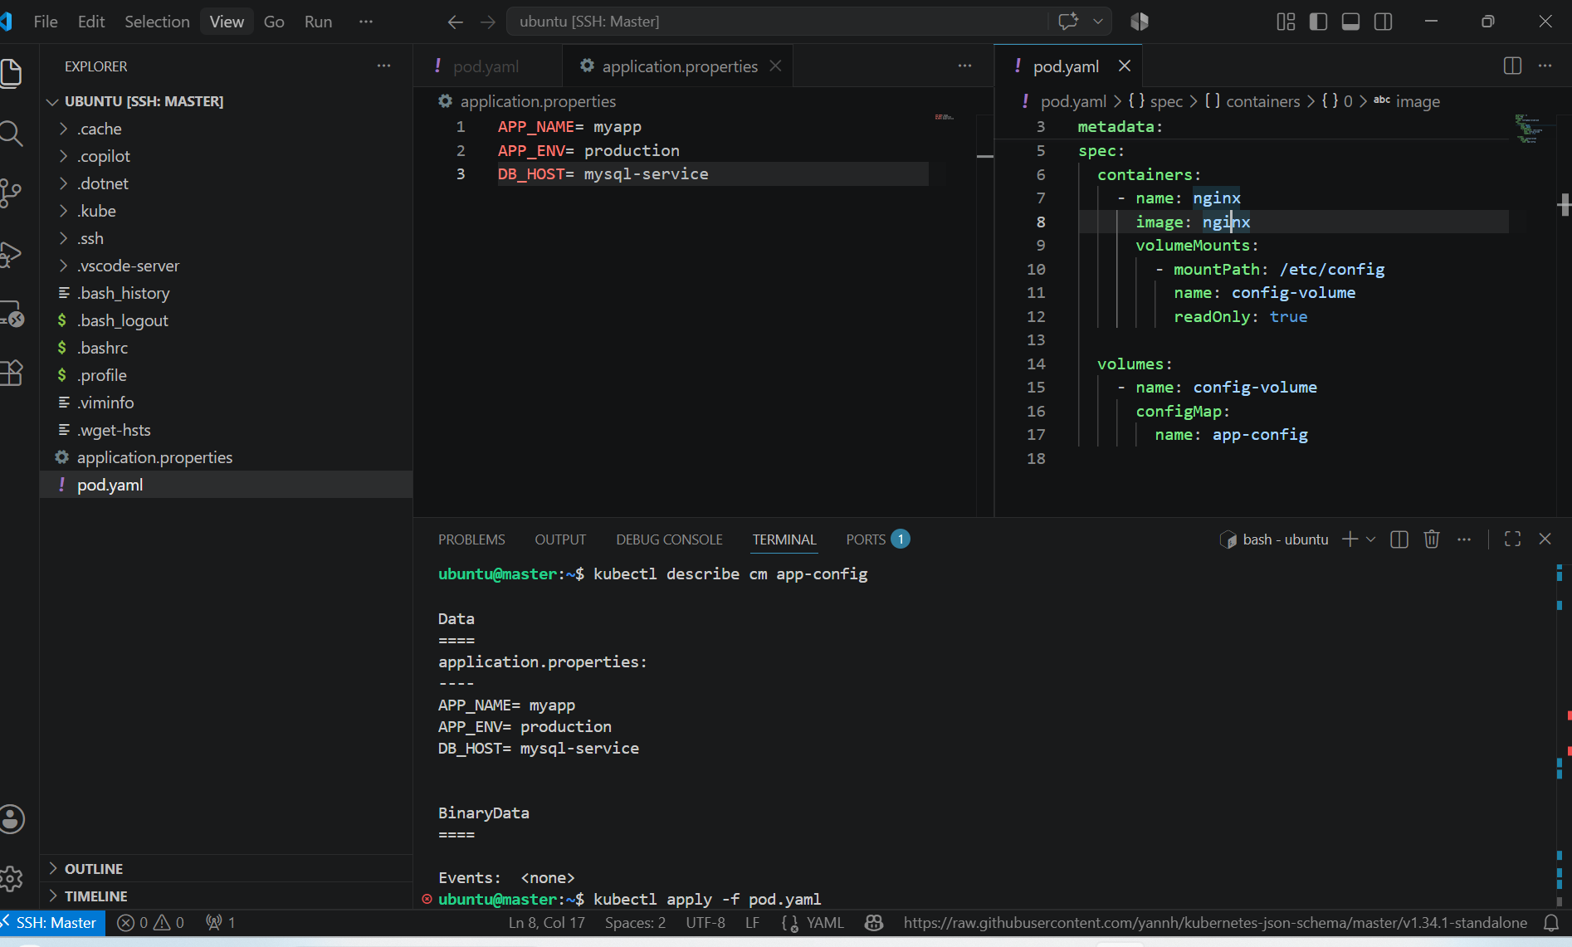

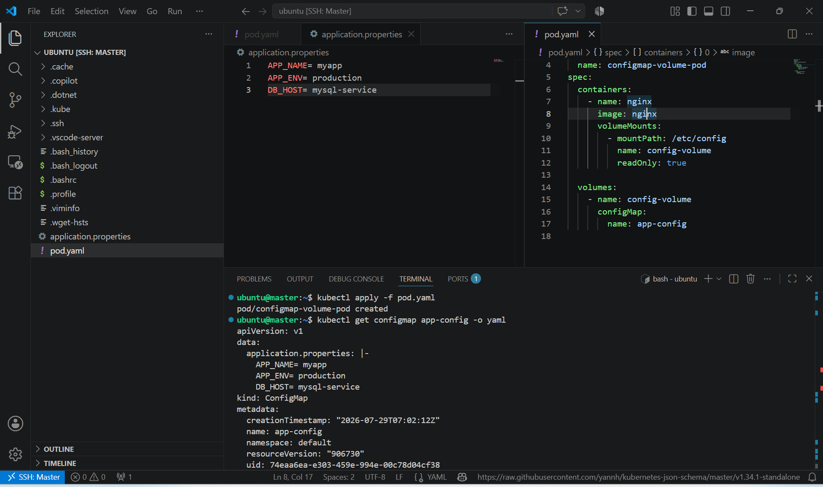

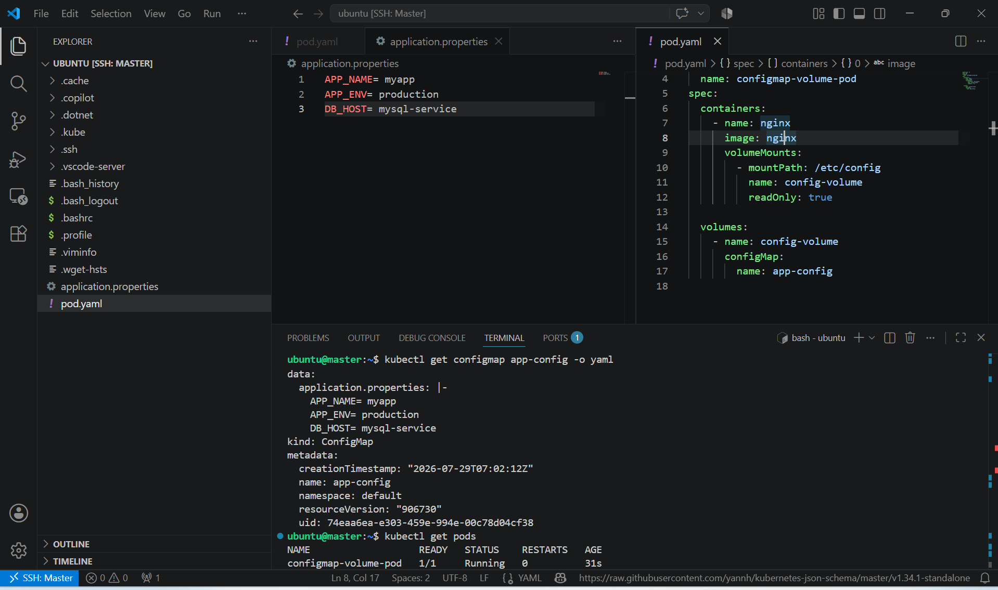

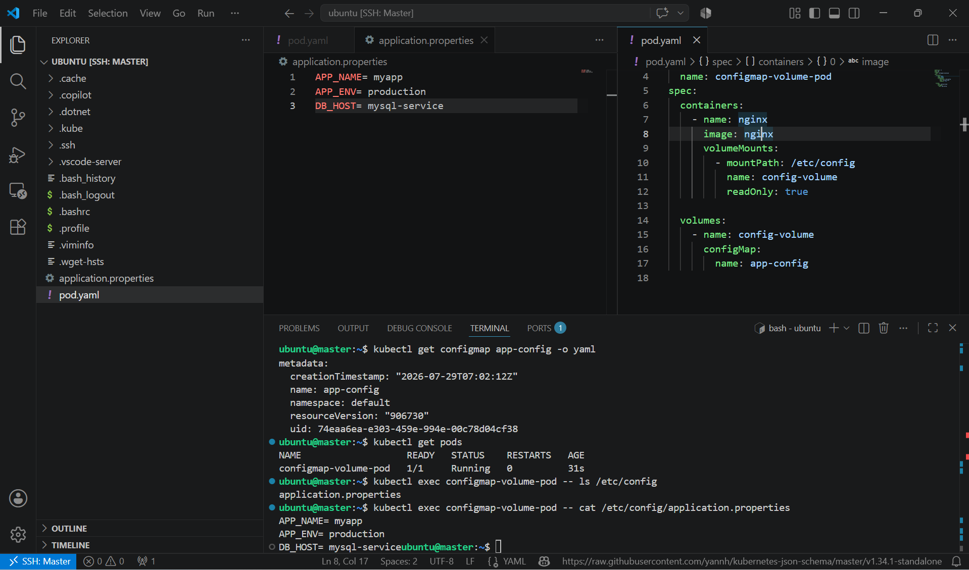

3. Create a Secret with sensitive information (username and password) and inject it into a pod as environment variables.

PURPOSE: The purpose of this task is to securely store sensitive information, such as usernames and passwords, using a Kubernetes Secret instead of hardcoding them in the Pod specification or container image.

OBJECTIVE:
- create a Secret containing a username and password.
- Inject the Secret into a Pod as environment variables.
- Verify that the Pod can access the Secret values.

EXPECTED OUTCOME:
- A Secret named db-secret is created.
- The Pod starts successfully.
- The container receives:
  - DB_USERNAME=admin
  - DB_PASSWORD=Admin@123
- The application can securely read the credentials from environment variables.

STEP BY STEP IMPLEMENTATION:
- Create a secret first using --from-literal

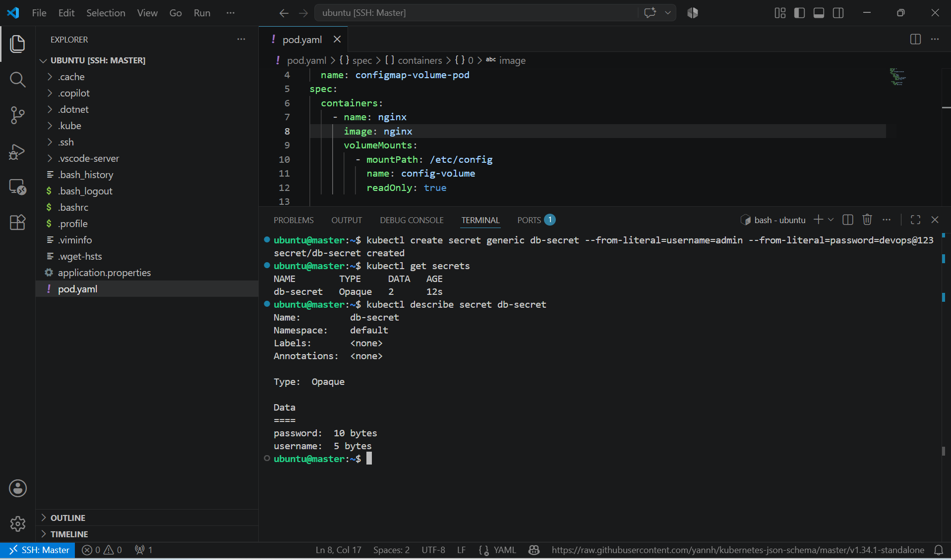

- Then create a pod and apply it by using the command -> kubectl apply -f <yamlfile>
- In the yaml file we have to pass the secrets as environment variables.

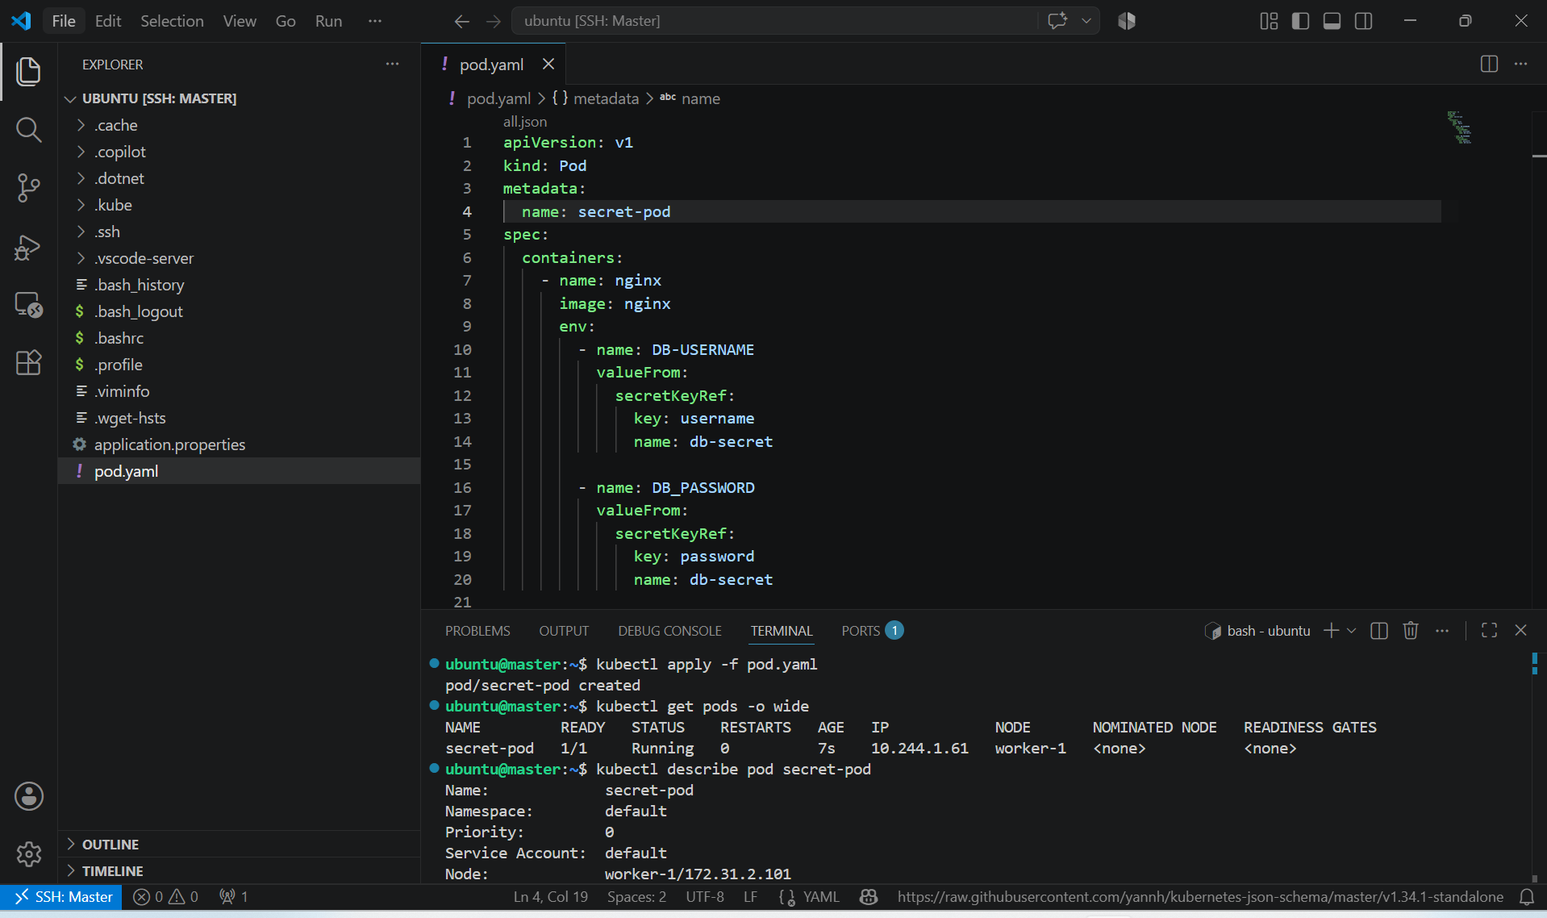

- Verify the Environment Variables -> kubectl exec secret-env-pod -- env | grep DB_

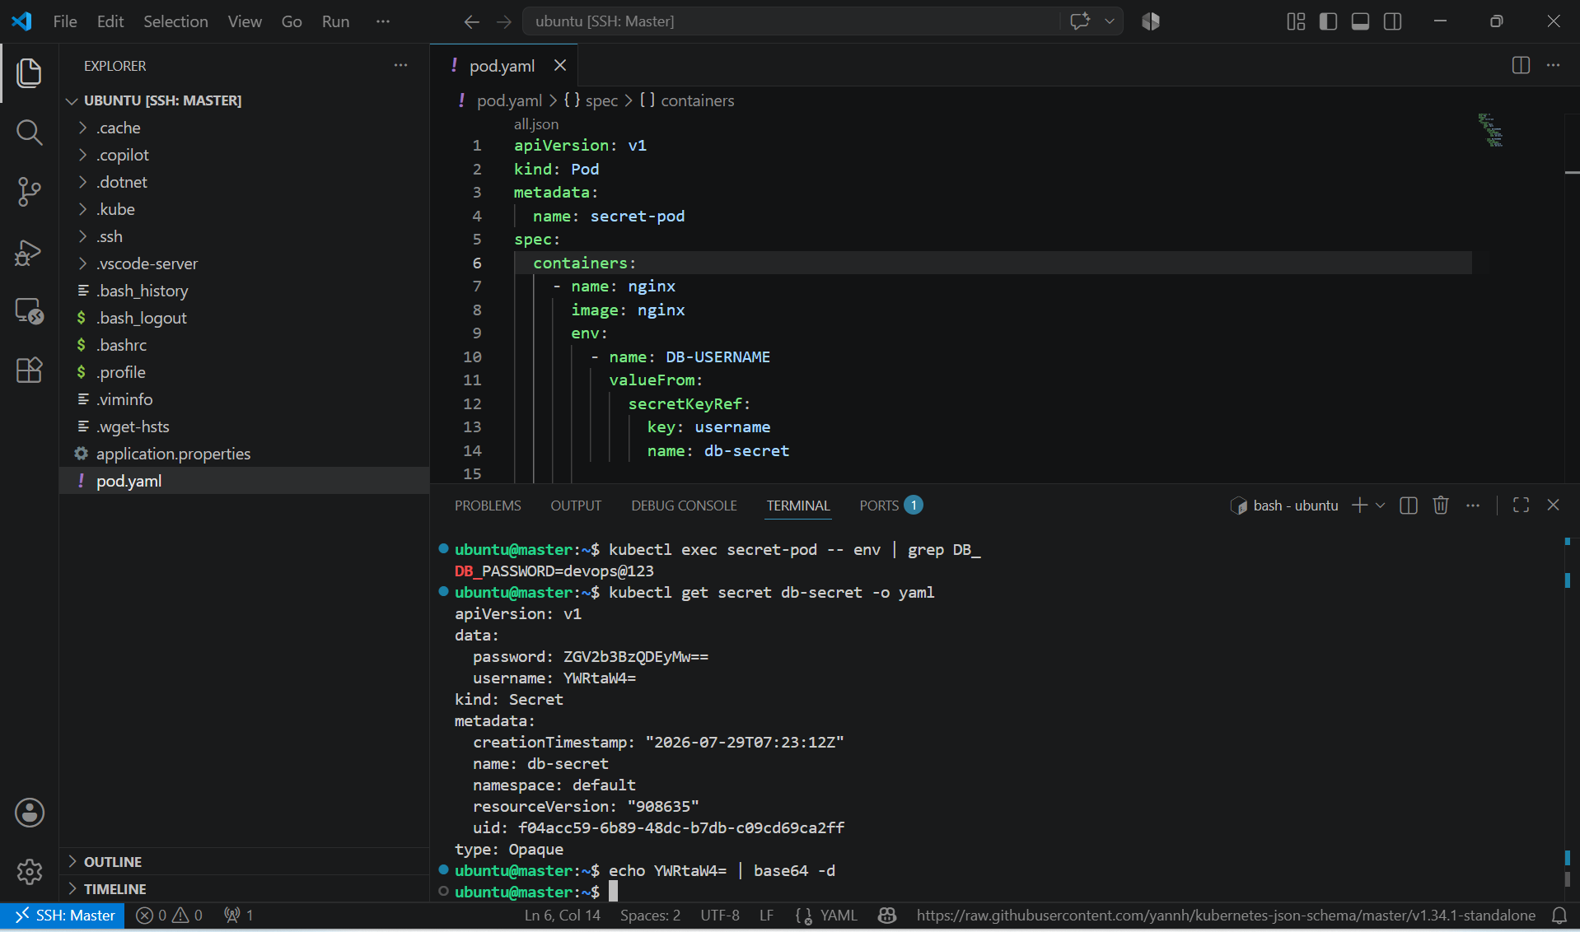

4. Create a Secret using a YAML file, mount it as a volume in a pod, and verify the specific Secret values are available as files.

PURPOSE: The purpose of this task is to store sensitive information securely in a Kubernetes Secret and mount it as files inside a pod. This is commonly used for credentials, certificates, API keys and TLS files that applications read from the file system.

OBJECTIVE:
- Create a Secret using a YAML manifest.
- Mount the secret as a volume inside a pod.
- Verify that each Secret key is available as a file.

EXPECTED OUTCOME:
- A Secret named db-secret is created.
- The Pod starts successfully.
- The directory /etc/secret contains:
  - username
  - password
- Reading these files returns:
  - admin
  - Admin@123

EXPLANATION:
- The Secret is created using a YAML manifest.
- Secret values are stored in the data section as Base64-encoded strings.
- Each key (username, password) becomes a separate file when the Secret is mounted.
- Kubernetes automatically decodes the Base64 values before writing them into the files inside the container.

STEP BY STEP IMPLEMENTATION:
- Create a secrets.yaml file and edit it with the required secrets that we want to add to that file.
- We should not pass the details directly, first we have to encrypt the data into base64 values and that encrypted values should be added to the file.
- After that execute a command to create a secret.
- Then verify it with the command -> kubectl get secrets.

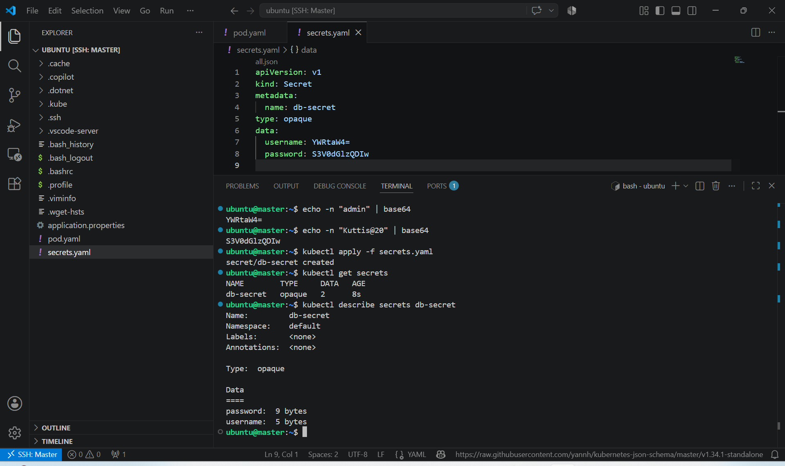

- Then we have to create pod by using the secrets.yaml file that we have created earlier.

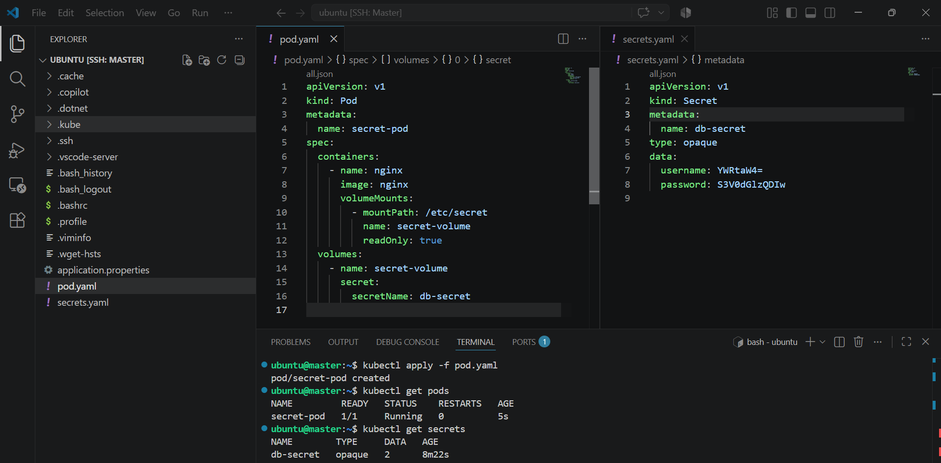

- Verify the Mounted Secret Files -> kubectl exec secret-volume-pod -- ls /etc/secret
- Display the username -> kubectl exec secret-volume-pod -- cat /etc/secret/username
- Display the password -> kubectl exec secret-volume-pod -- cat /etc/secret/password

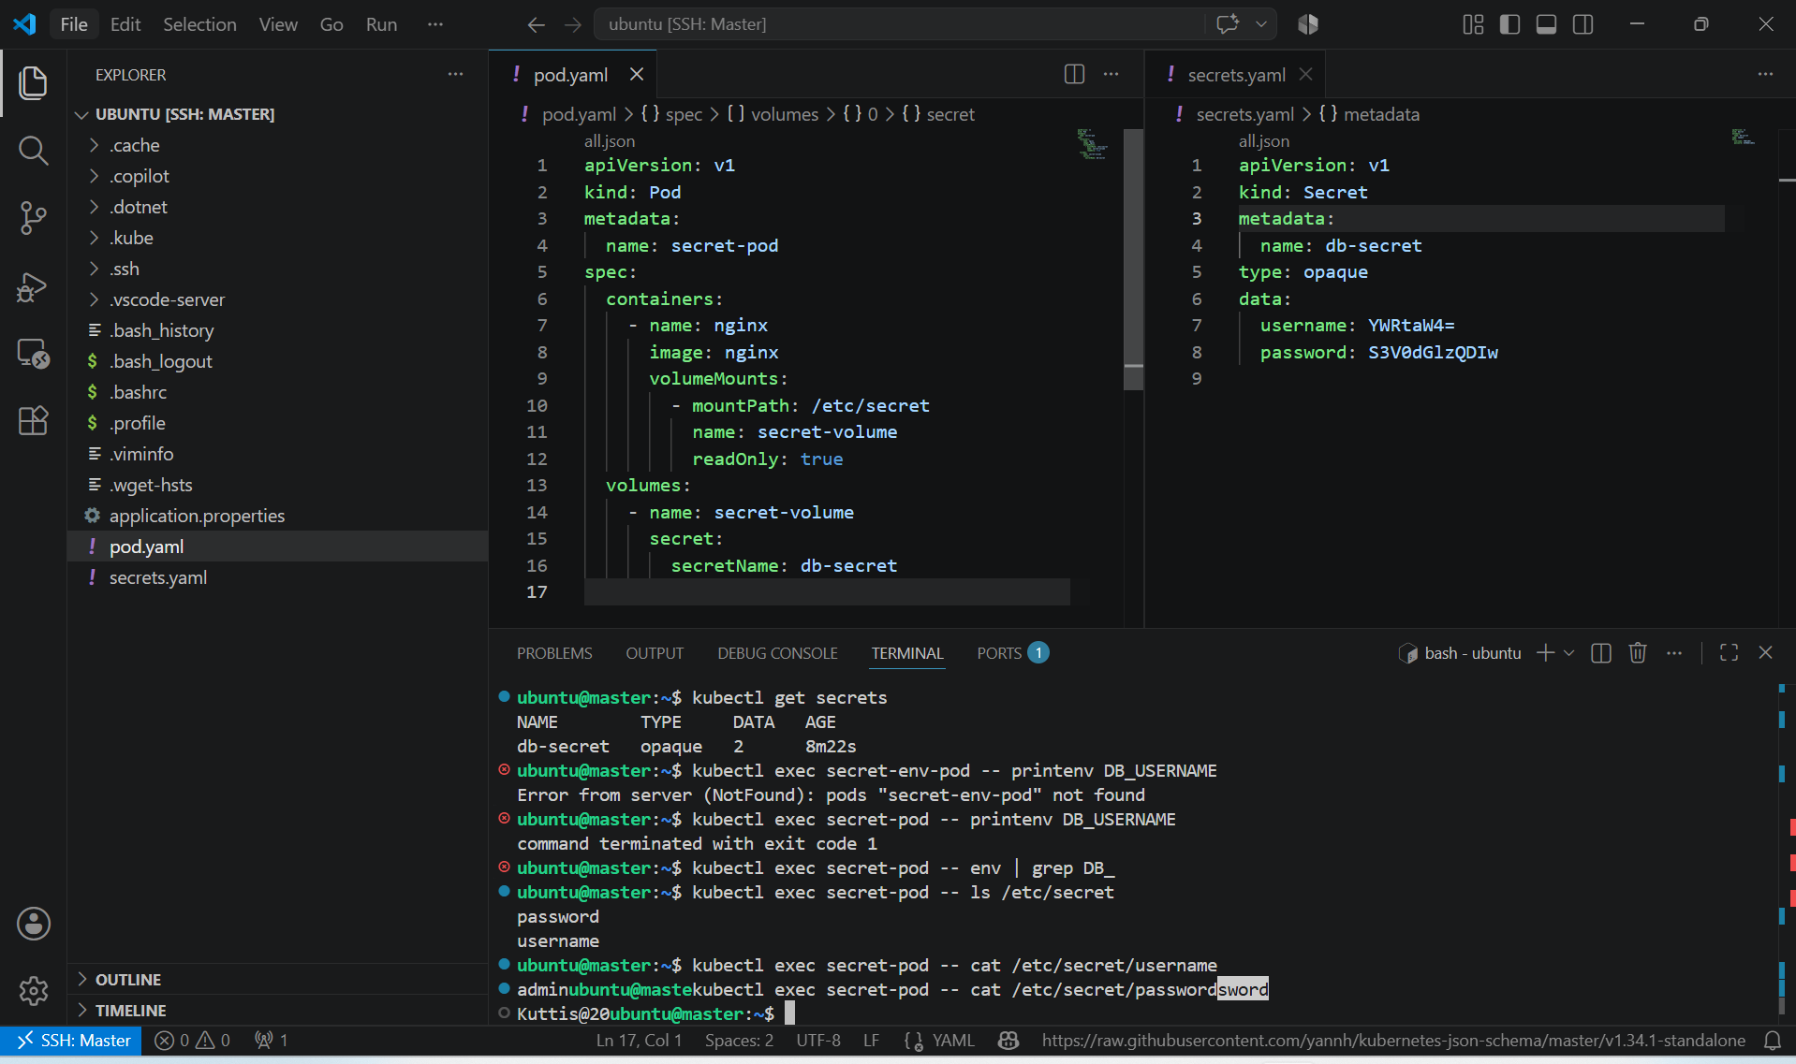

Secret Usage | Verification Command
Mounted as Volume | kubectl exec secret-pod -- cat /etc/secret/username
Injected as Environment Variables | kubectl exec secret-pod -- printenv DB_USERNAME

5. Inject a ConfigMap as environment variables and a Secret as files into the same pod, ensuring both are accessible within the pod.

PURPOSE: The purpose of this task is to demonstrate how a Pod can use both ConfigMaps and Secrets at the same time:
- Use a ConfigMap for non-sensitive configuration as environment variables.
- Use a Secret for sensitive information as mounted files.

OBJECTIVE:
• Create a ConfigMap for application configuration.
• Create a Secret for sensitive credentials.
• Deploy a Pod that:
- Loads the ConfigMap as environment variables.
- Mounts the Secret as files.
• Verify both are accessible inside the Pod.

EXPECTED OUTCOME:
- ConfigMap values are available as:
  - APP_NAME=myapp
  - APP_ENV=production
- Secret files are available at:
  - /etc/secret/username
  - /etc/secret/password

STEP BY STEP IMPLEMENTATION:
- Create config map and secrets in the same way that we have created in the earlier tasks.
- Then in the pod.yaml file, configure secrets as volumes and configmaps will be configured as environment variables.
- After that we have to create a pod by using that yaml file.
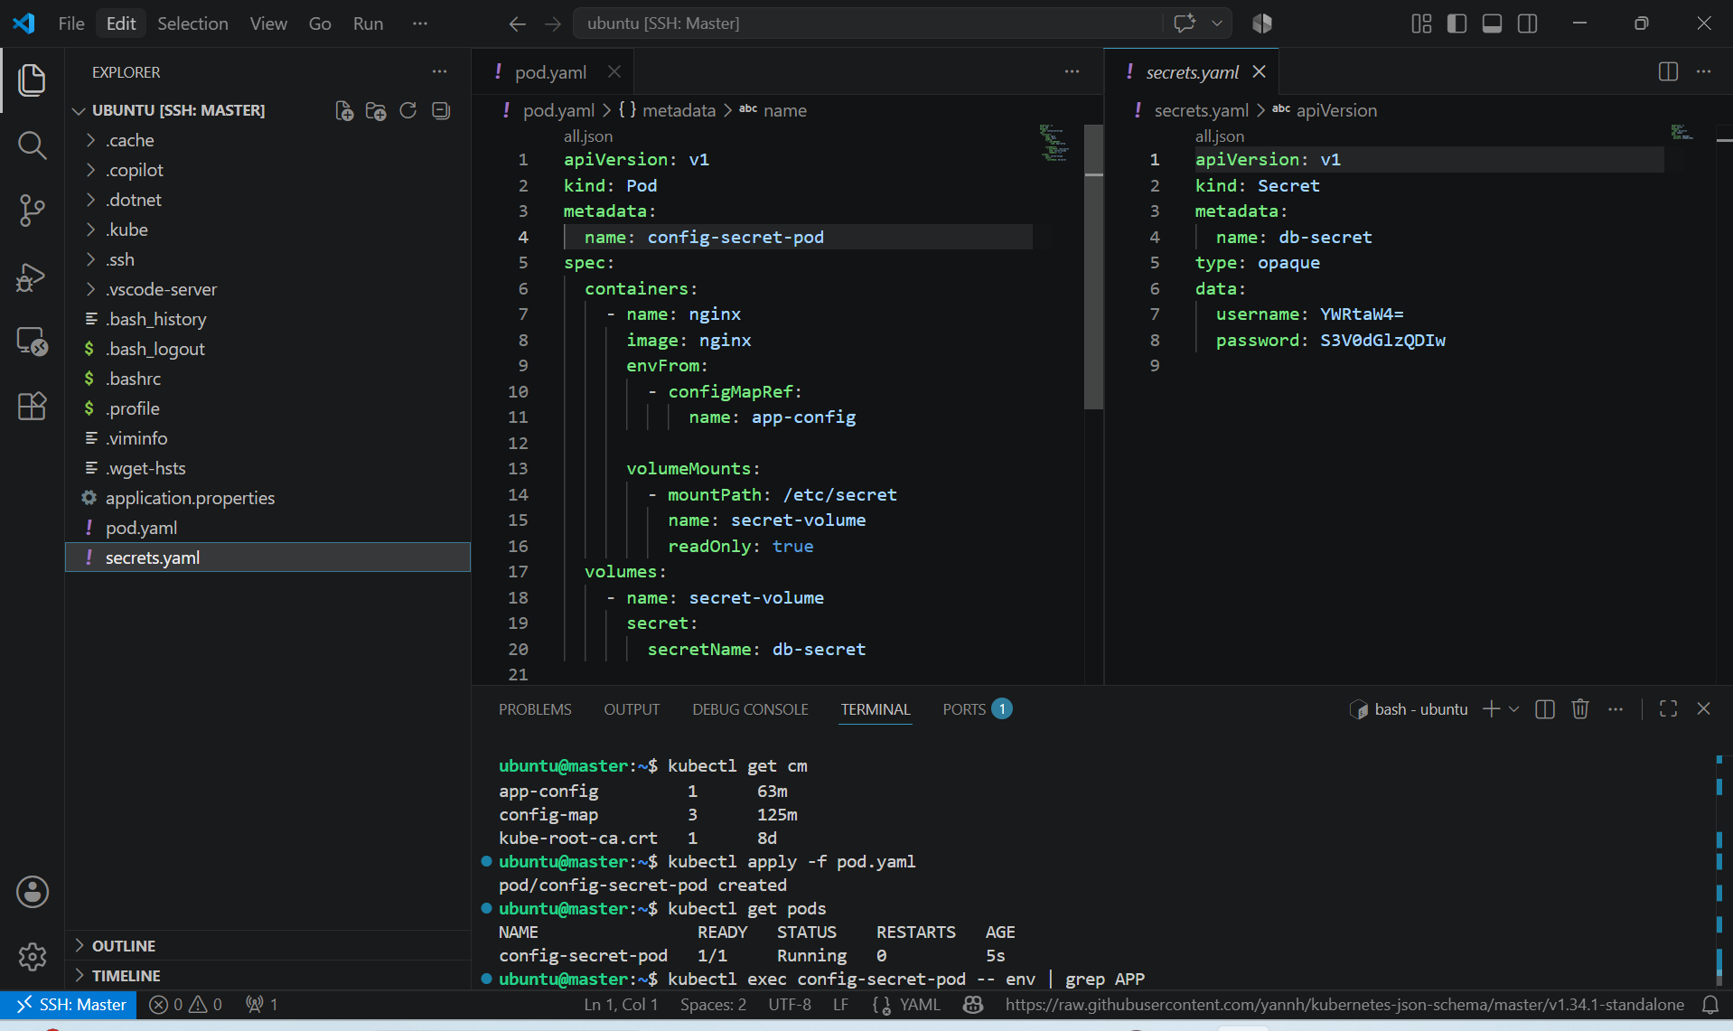

- To verify, execute these commands->
  - Verify the Pod -> kubectl get pods
  - Verify ConfigMap Environment Variables -> kubectl exec config-secret-pod -- env | grep APP
  - List the mounted Secret files -> kubectl exec config-secret-pod -- ls /etc/secret
  - Read the username -> kubectl exec config-secret-pod -- cat /etc/secret/username
  - Read the password -> kubectl exec config-secret-pod -- cat /etc/secret/password

