KUBERNETES-07

1. Execute all yaml files shown in video.

Taint and Tolerations:
- Taint and Tolerations are advance k8s pod scheduling technique.
- Taint are attached to Node.
- Toleration are attached to Pods.
- Taint in general terms means a filter.
- Tolerations with matching taint will be scheduled on tainted node.
- Tolerations allow the scheduler to schedule pods with matching taints.

- kubectl taint nodes <node_name> special=true:NoSchedule

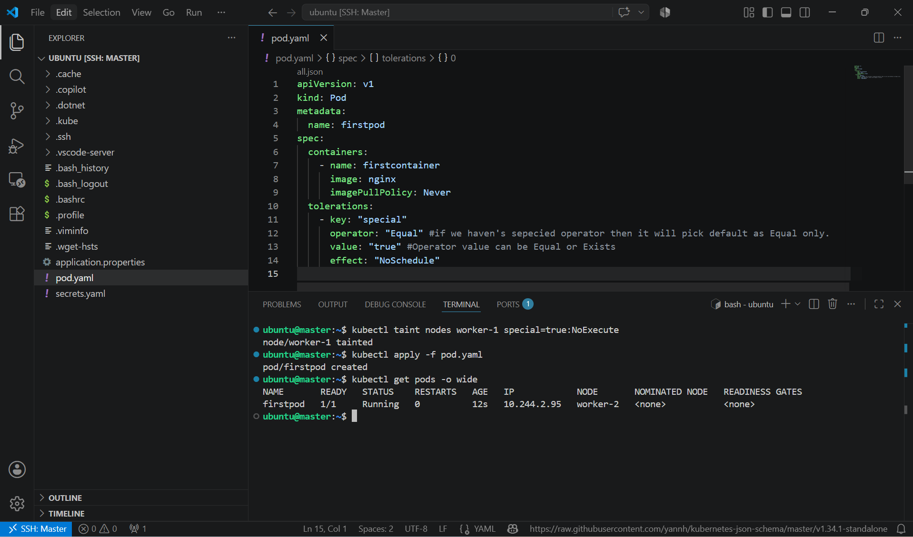

- How to add toleration to pod using operator Exists?

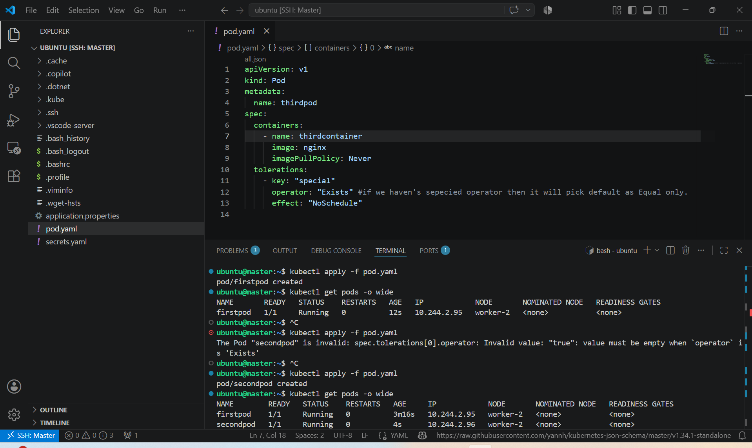

- We can use toleration seconds in tolerations of yaml if the effect is "NoExecute"

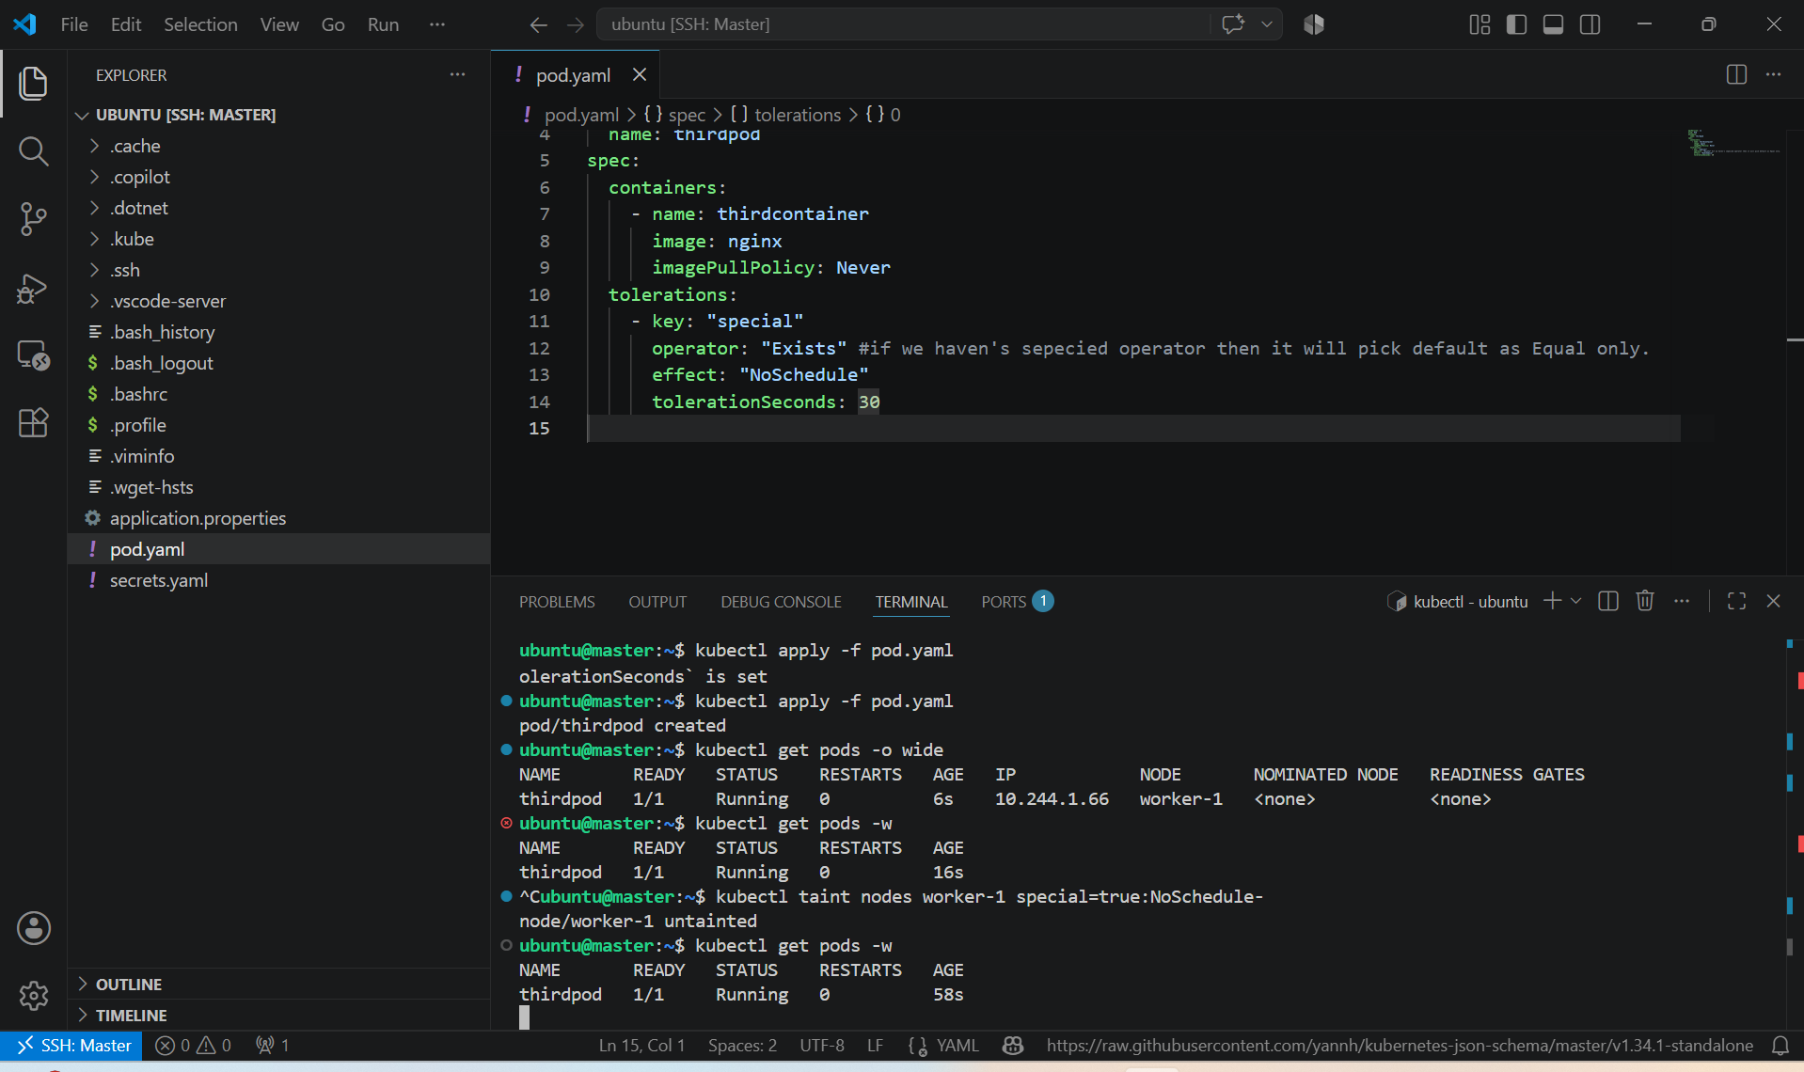

- kubectl taint nodes <node_name> special=true:NoSchedule-
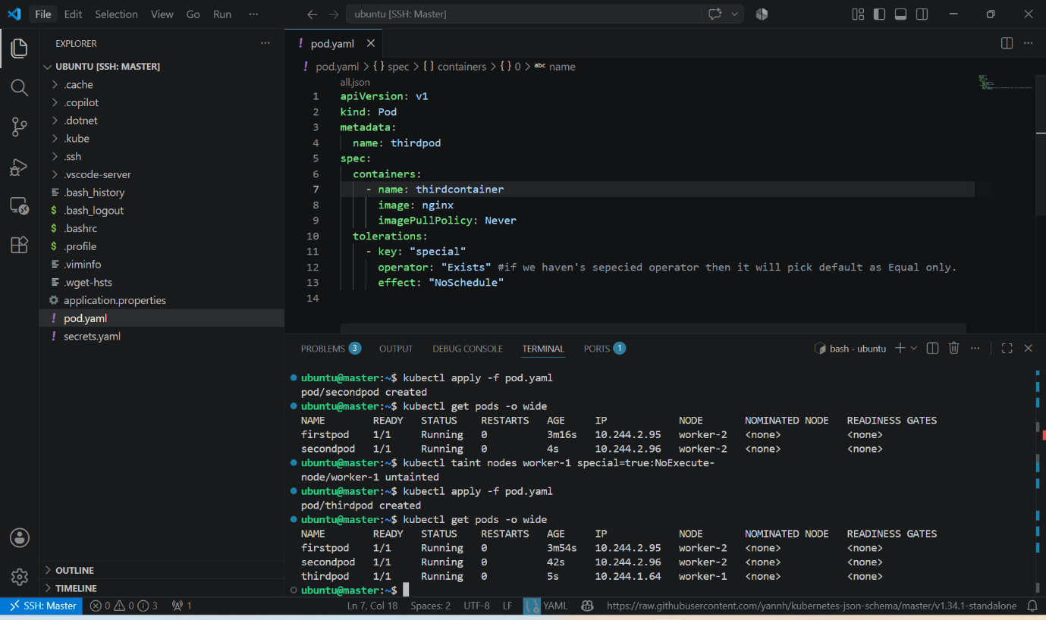

Node Selector:

- Node selector helps us to select node where the pod can be scheduled.
- It will work based on the label attached to node.
- How to attach label to node ?
  - kubectl label nodes <node_name> env=prod

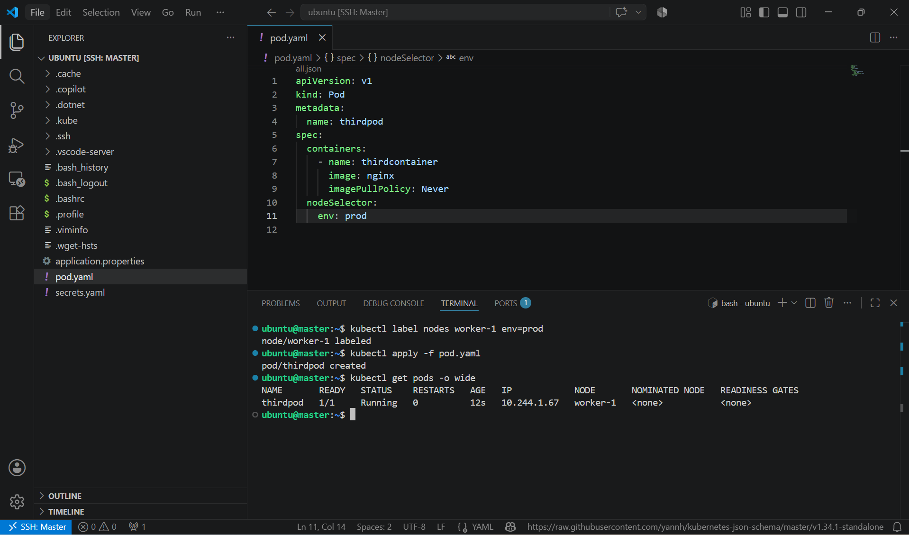

Node Affinity:

Node affinity is a set of rules used by the scheduler to determine where a pod can be placed.

Two types of Node Affinity is available:
1) PreferredDuringSchedulingIgnoredDuringExecution (Soft Scheduling):
Means we are asking scheduler to check if the values/label is matching then schedule pod on the node and
if node with same label is not available then it will schedule on any available node.
Ignored During Execution means if the pod is already scheduled on node and later on we have removed the label then
the pod will be ingored and continue running on the same node.

How to create pod using YAML?
apiVersion: v1
kind: Pod
metadata:
name: firstpod
spec:
containers:
- name: firstcontainer
image: nginx
imagePullPolicy: Never
affinity:
nodeAffinity:
preferredDuringSchedulingIgnoredDuringExecution:
- preference:
matchExpressions:
- key: env
operator: In
values:
- test
weight: 1

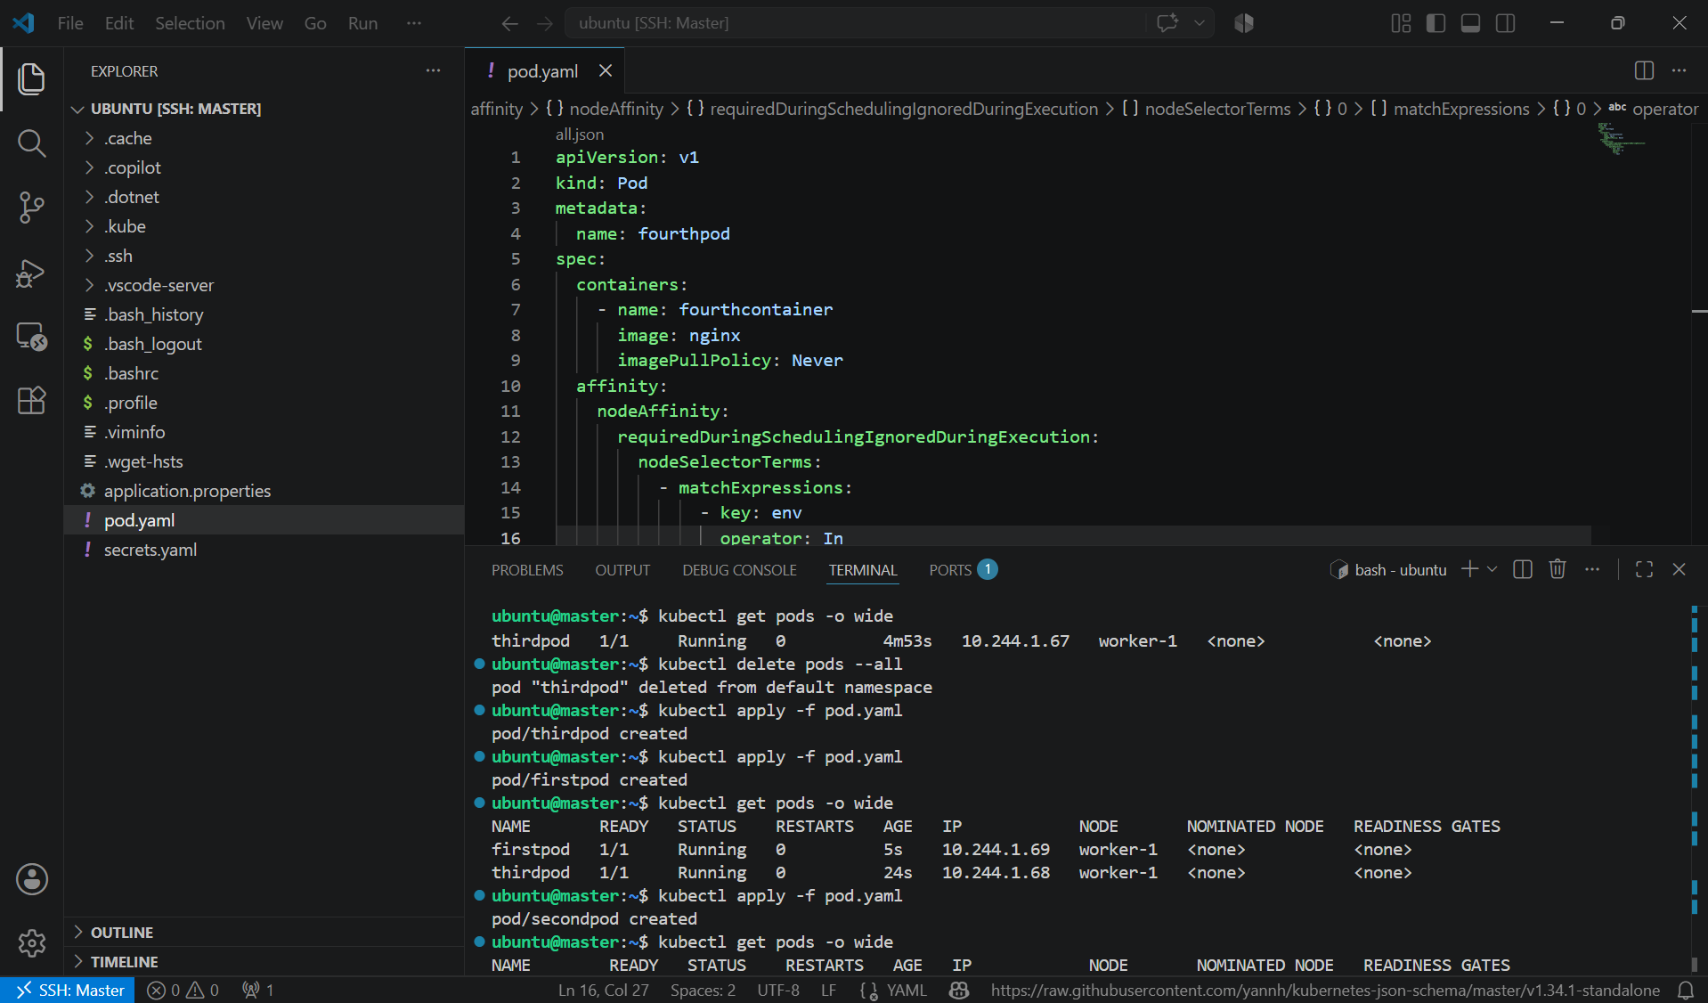

2) RequiredDuringSchedulingIgnoredDuringExecution (Hard Scheduling):
Means we are asking scheduler to check if the values/label is matching then schedule pod on the node.
If not matched then pod will not be scheduled in other nodes.
Ignored During Execution means if the pod is already scheduled on node and later on we have removed the label then
the pod will be ingored and continue running on the same node.

apiVersion: v1
kind: Pod
metadata:
name: secondpod
spec:
containers:
- name: firstcontainer
image: nginx
imagePullPolicy: Never
affinity:
nodeAffinity:
requiredDuringSchedulingIgnoredDuringExecution:
nodeSelectorTerms:
- matchExpressions:
- key: env #label name
operator: In #Values for operator can be IN,NotIn
values:
- test # label value

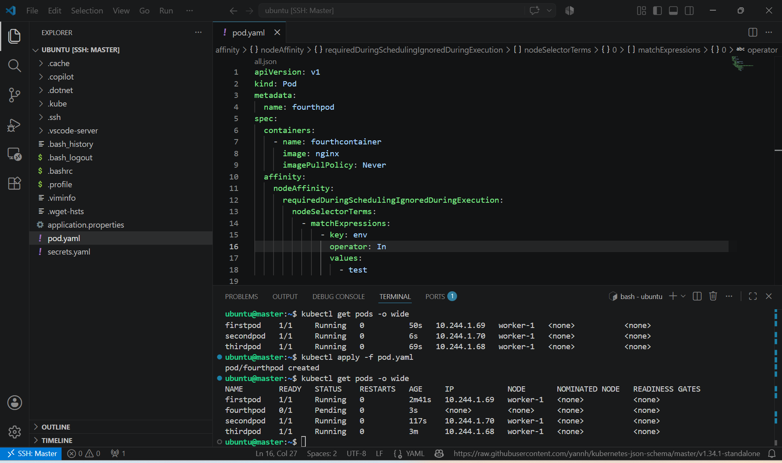

Try to Remove label and check IgnoredDuringExecution:
kubectl label node <node_name> <label_name>-

If you will check kubectl get pods
Pods will be still up and running.

2. Taint a Node and Schedule a Tolerant Pod Taint a node with special=true:NoSchedule. Create a pod with a toleration that matches the taint, allowing it to be scheduled on the tainted node.

PURPOSE: The purpose of this task is to prevent normal pods from being scheduled on a specific node using a taint, while allowing only pods with the appropriate toleration to run on that node.

OBJECTIVE:
- Taint a node with special=true:NoSchedule.
- Create a Pod with a matching toleration.
- Verify that the Pod is scheduled on the tainted node.

EXPECTED OUTCOME:
- Taint: Prevents Pods from being scheduled onto a node.
- Toleration: Allows a Pod to be scheduled onto a node with a matching taint.
- NoSchedule: New Pods without a matching toleration are not scheduled onto the node.

STEP BY STEP IMPLEMENTATION:
- Taint the Node -> kubectl taint nodes worker-1 special=true:NoSchedule
- Verify the taint -> kubectl describe node worker-1 | grep Taints

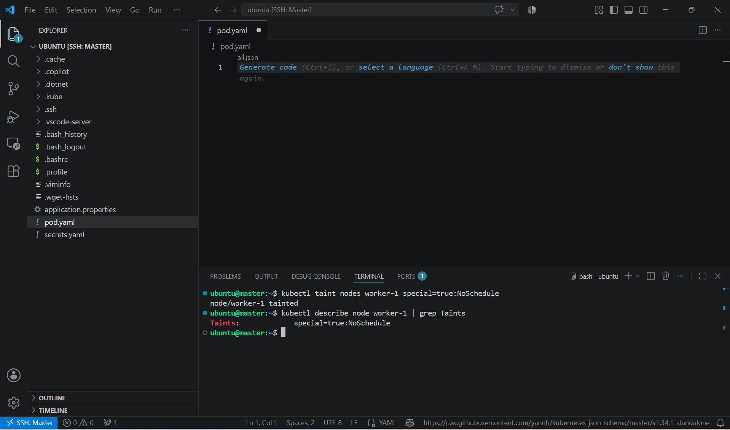

- Create a file named pod.yaml.

apiVersion: v1
kind: Pod
metadata:
name: tolerant-pod
spec:
nodeName: worker-1
containers:
- name: nginx
image: nginx

tolerations:
- key: "special"
operator: "Equal"
value: "true"
effect: "NoSchedule"

- Note: nodeName: worker-1 ensures the Pod is placed on the tainted node for this exercise. Without it, the scheduler may choose another eligible node.
- Create the pod -> kubectl apply -f pod.yaml

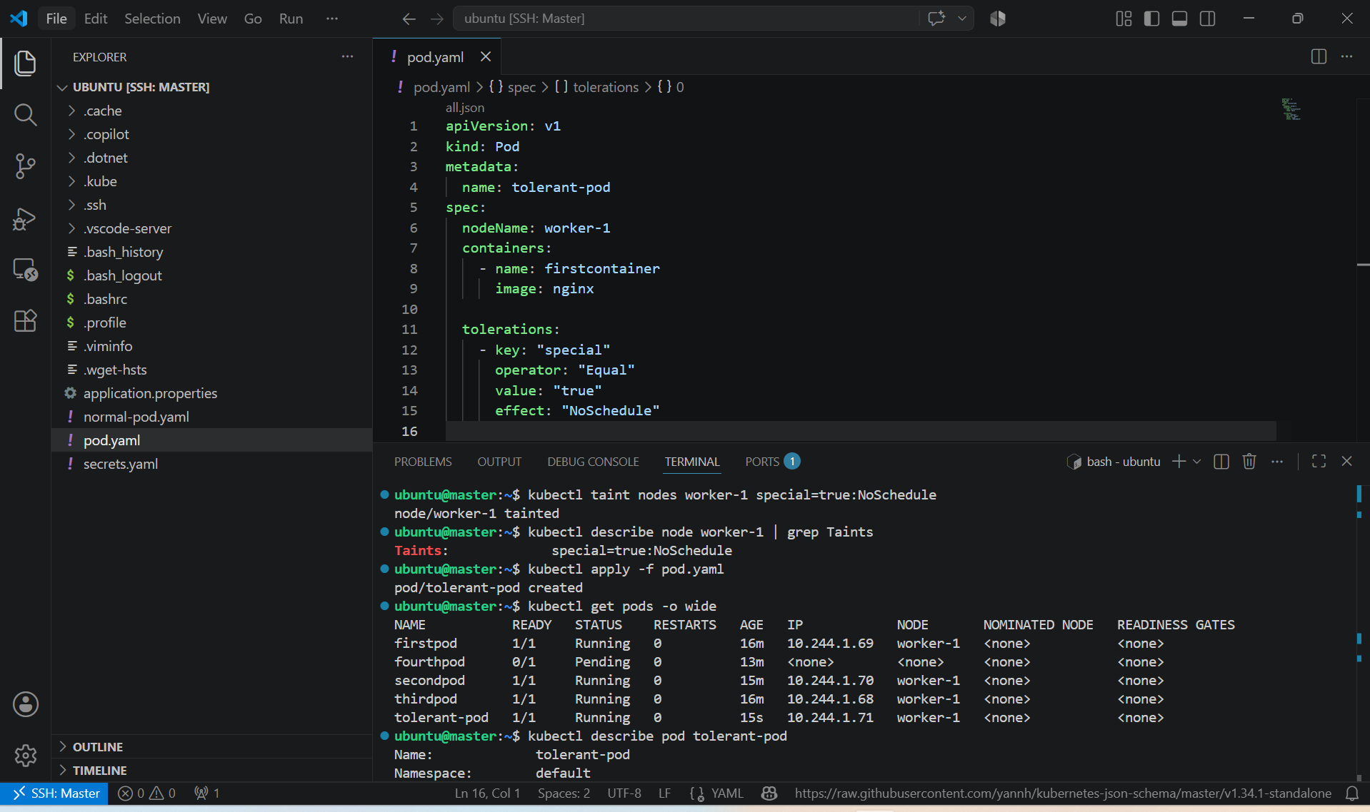

- To verify use this command -> kubectl describe pod tolerant-pod

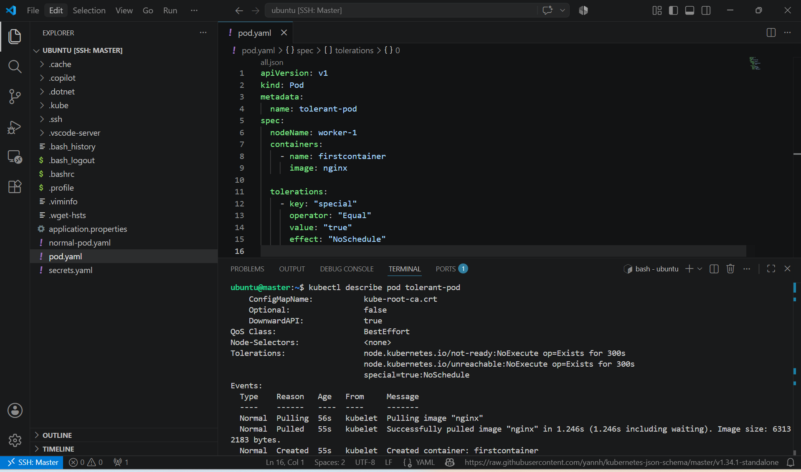

- Create a Pod without the tolerations section

apiVersion: v1
kind: Pod
metadata:
name: normal-pod
spec:
nodeName: worker-1
containers:
- name: nginx
image: nginx

- If you let the scheduler choose the node (remove nodeName), the Pod will not be scheduled onto worker-1 because of the taint.

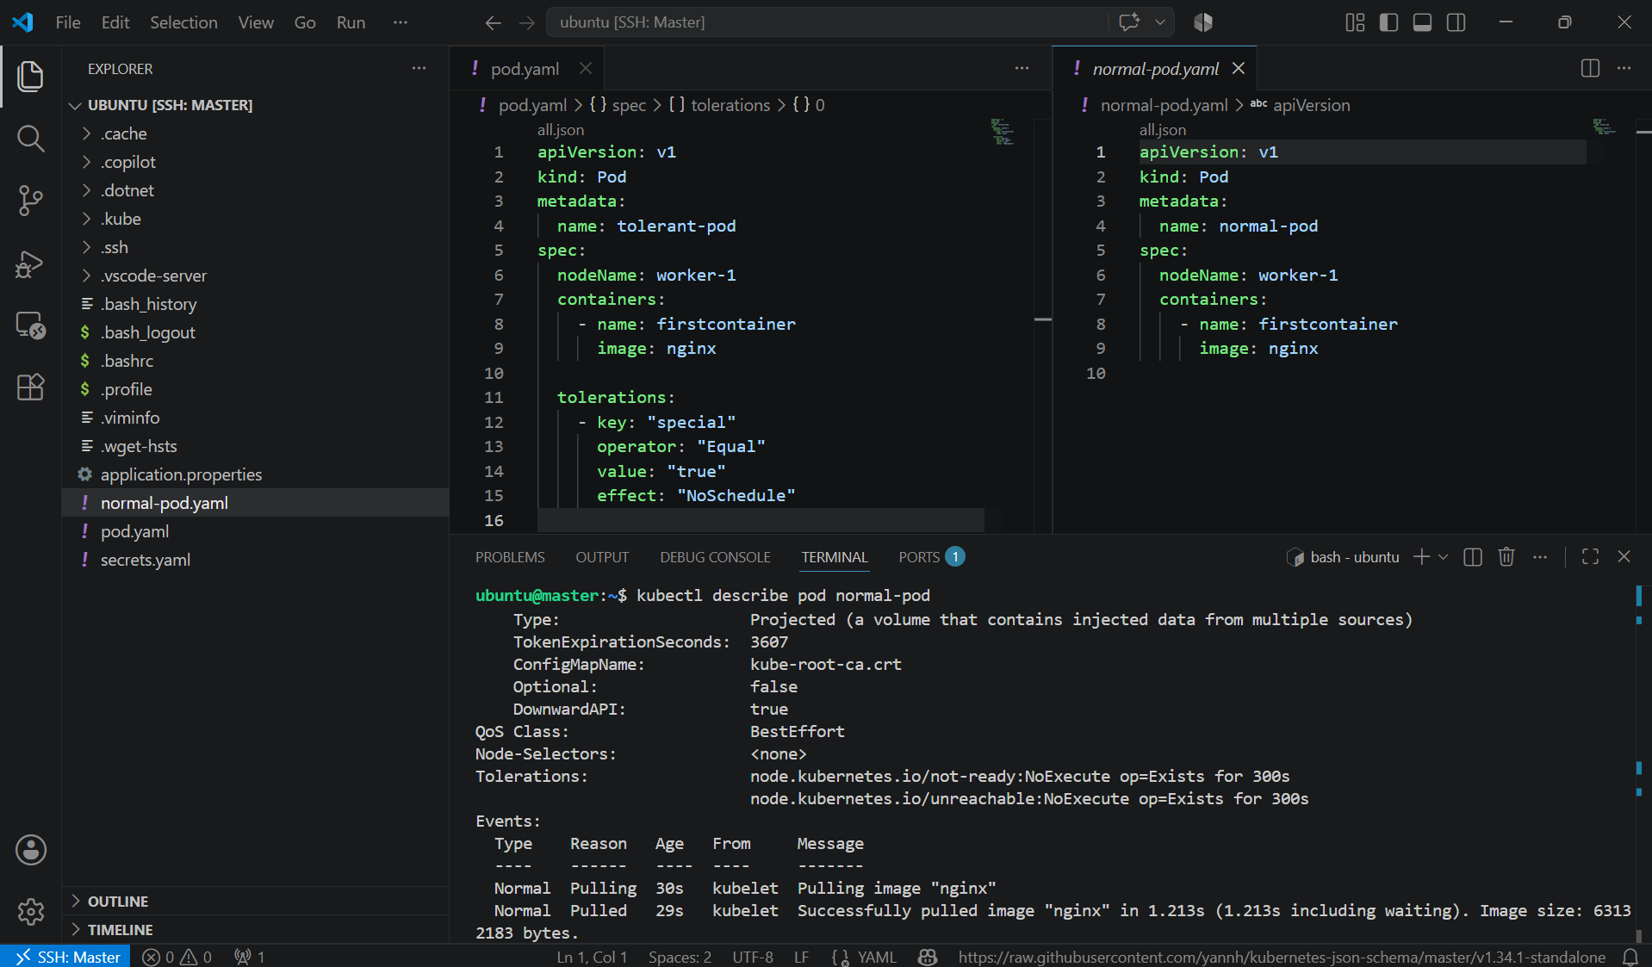

- Remove the Taint (Cleanup) -> kubectl taint nodes worker-1 special=true:NoSchedule-
- Verify -> kubectl describe node worker-1 | grep Taints

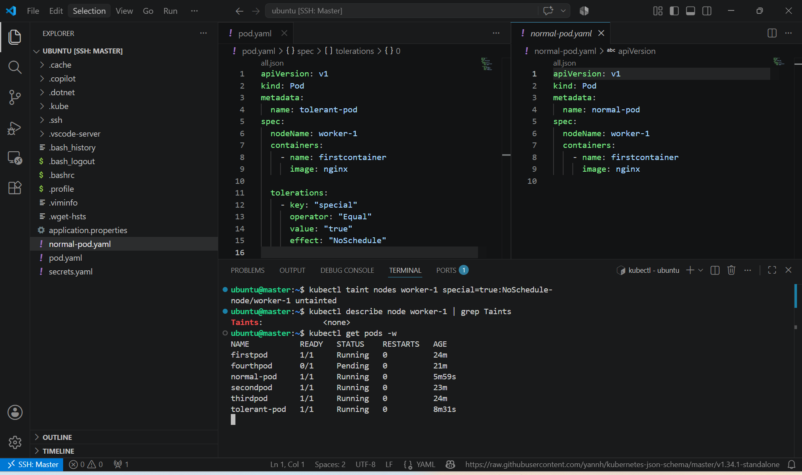

3. Use NodeSelector to Schedule a Pod on a Specific Node Label a node with env=dev. Create a pod with a nodeSelector that schedules it only on the node labeled env=dev.

PURPOSE: The purpose of this task is to schedule a Pod on a specific node based on a node label. nodeSelector is the simplest scheduling mechanism in Kubernetes for matching Pods to labeled nodes.

OBJECTIVE:
- Label a node with env=dev.
- Create a Pod with a nodeSelector that matches the label.
- Verify that the Pod is scheduled on the labeled node.

EXPECTED OUTCOME:
- worker-1 is labeled with env=dev.
- The Pod contains:
  - nodeSelector:
  - env: dev
- The Pod is scheduled only on worker-1.
STEP BY STEP IMPLEMENTATION:
- Label worker-1 with env=dev -> kubectl label node worker-1 env=dev
- Verify the label -> kubectl get nodes --show-labels
- Create a file named pod.yaml
apiVersion: v1
kind: Pod
metadata:
name: dev-pod
spec:
nodeSelector:
env: dev

containers:
- name: nginx
image: nginx
- Create a pod -> kubectl apply -f pod.yaml
- Check where the Pod is running -> kubectl get pods -o wide
- Verify the Node Label -> kubectl describe node worker-1

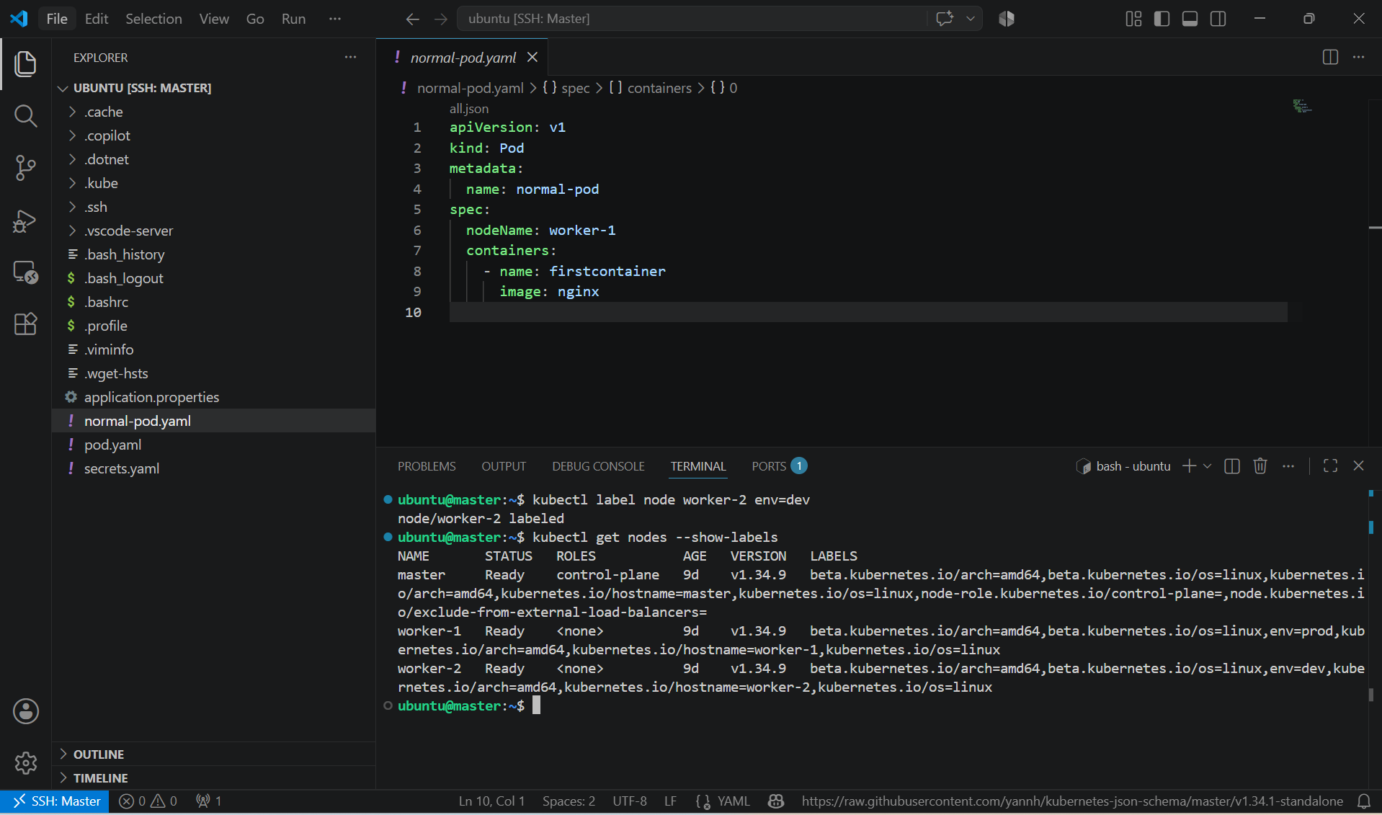

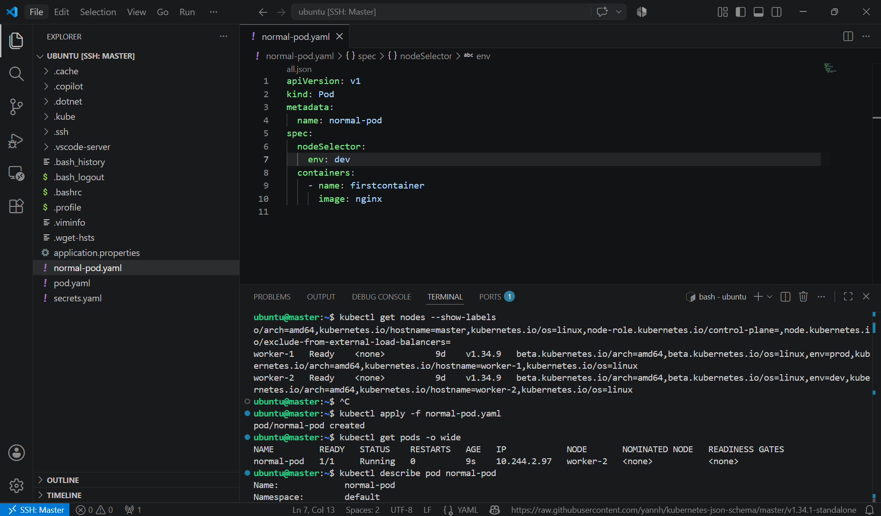

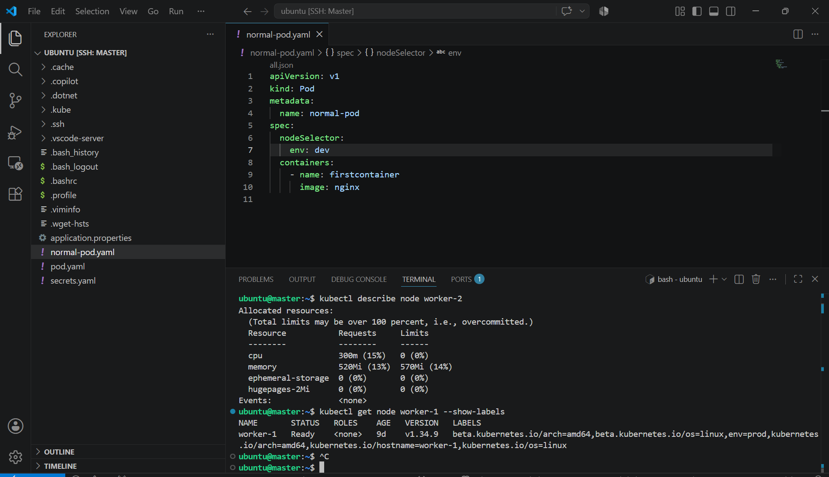

4. Use Node Affinity with Soft Scheduling Label a node with env=test. Create a pod with PreferredDuringSchedulingIgnoredDuringExecution node affinity, preferring to schedule it on a node labeled env=test. Remove the label and verify the pod continues to run.

PURPOSE: The purpose of this task is to demonstrate soft scheduling using PreferredDuringSchedulingIgnoredDuringExecution. The scheduler will prefer nodes with a specific label but can schedule the Pod on another node if no matching node is available.

OBJECTIVE:
- Label a node with env=test.
- Create a Pod using PreferredDuringSchedulingIgnoredDuringExecution node affinity.
- Verify the Pod is scheduled on the preferred node.
- Remove the label and verify the running Pod is not evicted.

EXPECTED OUTCOME:
- worker-1 is labeled with env=test.
- The Pod prefers to run on worker-1.
- After removing the label:
- The Pod continues running.
- It is not rescheduled or evicted.

STEP BY STEP IMPLEMENTATION:
- Label the worker-1 with env=test -> kubectl label node worker-1 env=test.
- Then verify -> kubectl get nodes –show-labels

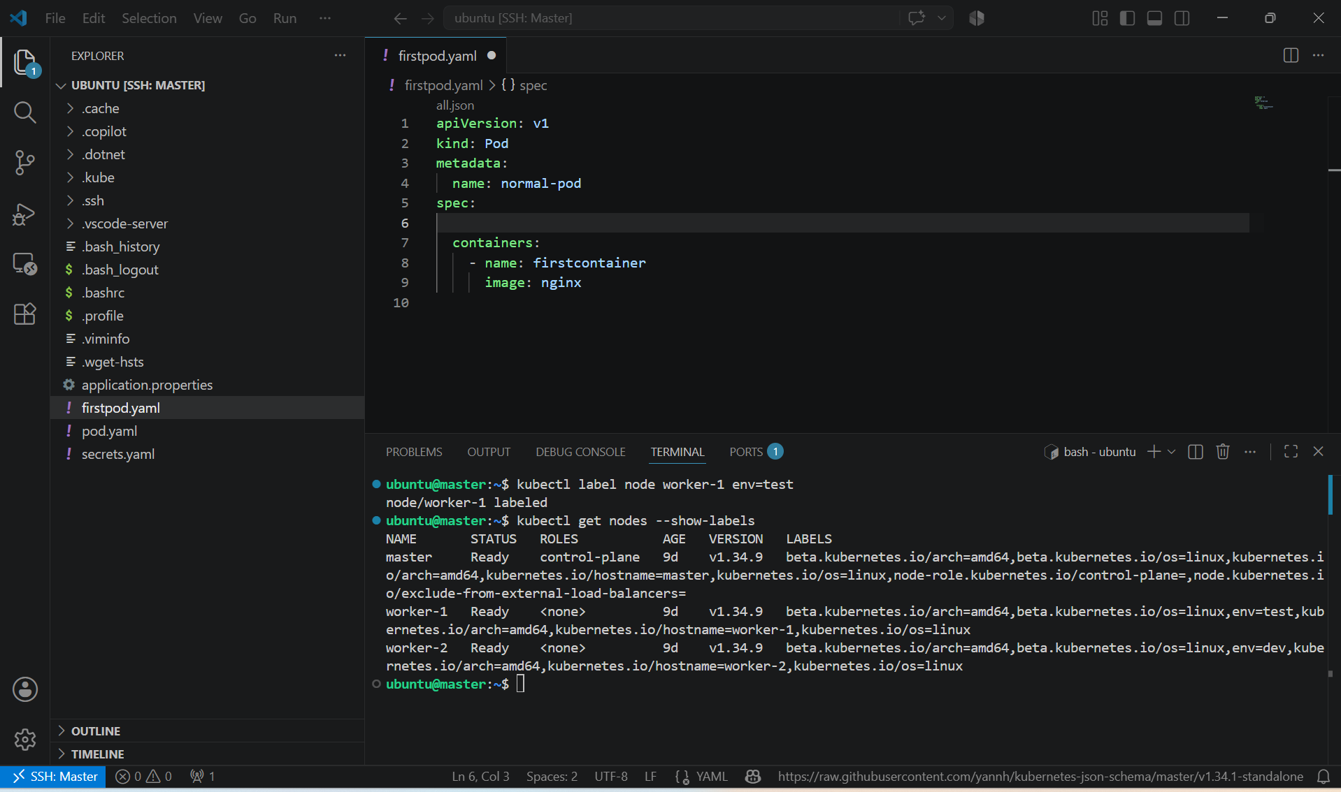

- Create a file named pod.yaml ad apply the file to create pod -> kubectl apply -f pod.yaml
- To verify -> kubectl get pods -o wide

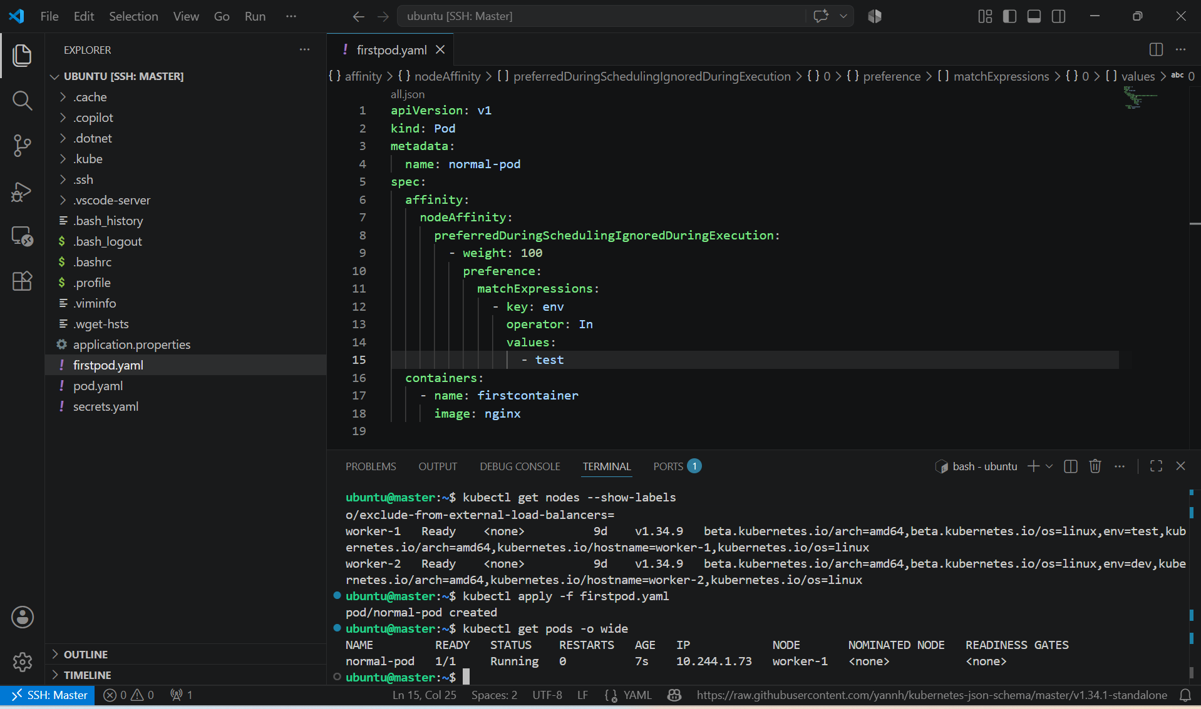

- Remove the label -> kubectl label node worker-1 env-
- To verify -> kubectl get nodes –show-labels
- Then verify that the pod still runs even after the label is removed -> kubectl get pods -o wide

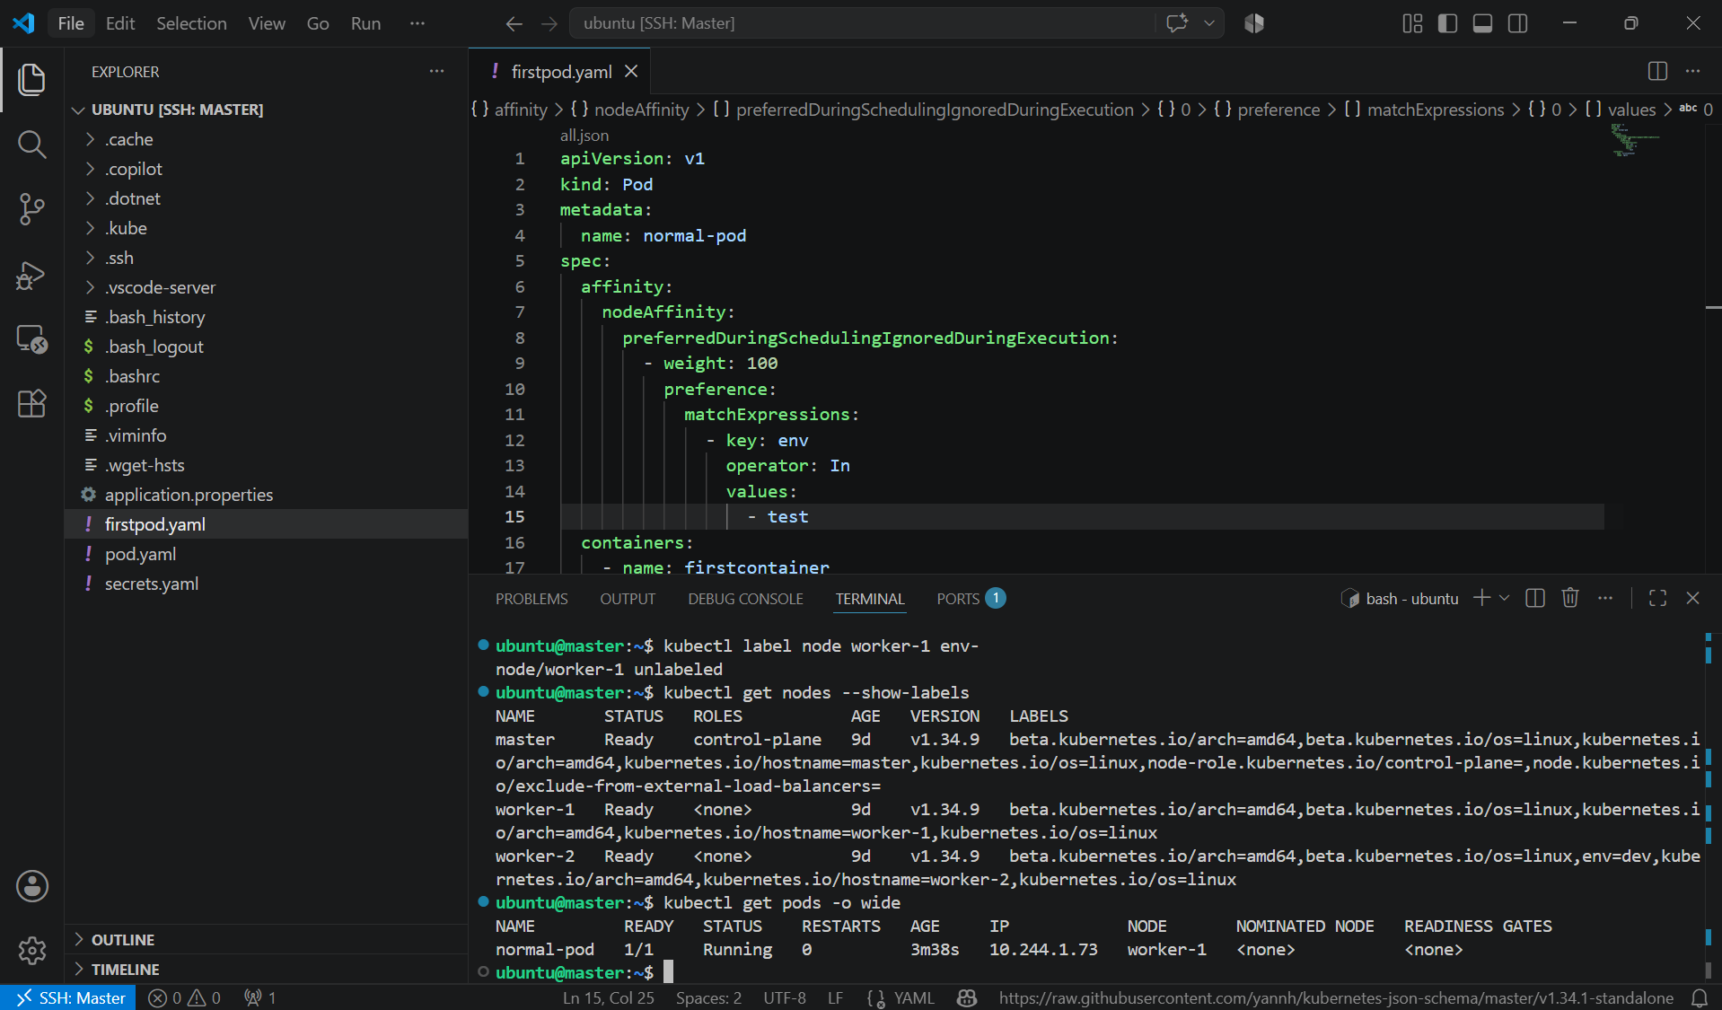

5. Implement Node Affinity with Hard Scheduling Create a pod with RequiredDuringSchedulingIgnoredDuringExecution node affinity, ensuring it will only be scheduled on a node labeled env=prod. Verify the pod cannot be scheduled if no node has the env=prod label.

PURPOSE: The purpose of this task is to demonstrate hard scheduling using requiredDuringSchedulingIgnoredDuringExecution, ensuring a Pod is scheduled only on nodes that match a specific label.

OBJECTIVE:
- Create a Pod with RequiredDuringSchedulingIgnoredDuringExecution node affinity.
- Require the node to have the label env=prod.
- Verify the Pod remains Pending if no node has the env=prod label.
- Label a node with env=prod and verify the Pod is scheduled successfully.

EXPECTED OUTCOME:
- Without the env=prod label:
  - Pod status is Pending.
  - kubectl describe pod reports that no nodes match the affinity.
- After labeling worker-1 with env=prod:
  - The Pod is scheduled successfully.
  - Pod status changes to Running on worker-1.

STEP BY STEP IMPLEMENTATION:
- Create a file named pod.yaml.
apiVersion: v1
kind: Pod
metadata:
name: prod-pod
spec:
affinity:
nodeAffinity:
requiredDuringSchedulingIgnoredDuringExecution:
nodeSelectorTerms:
- matchExpressions:
- key: env
operator: In
values:
- prod

containers:
- name: nginx
image: nginx
- Create the Pod -> kubectl apply -f firstpod.yaml

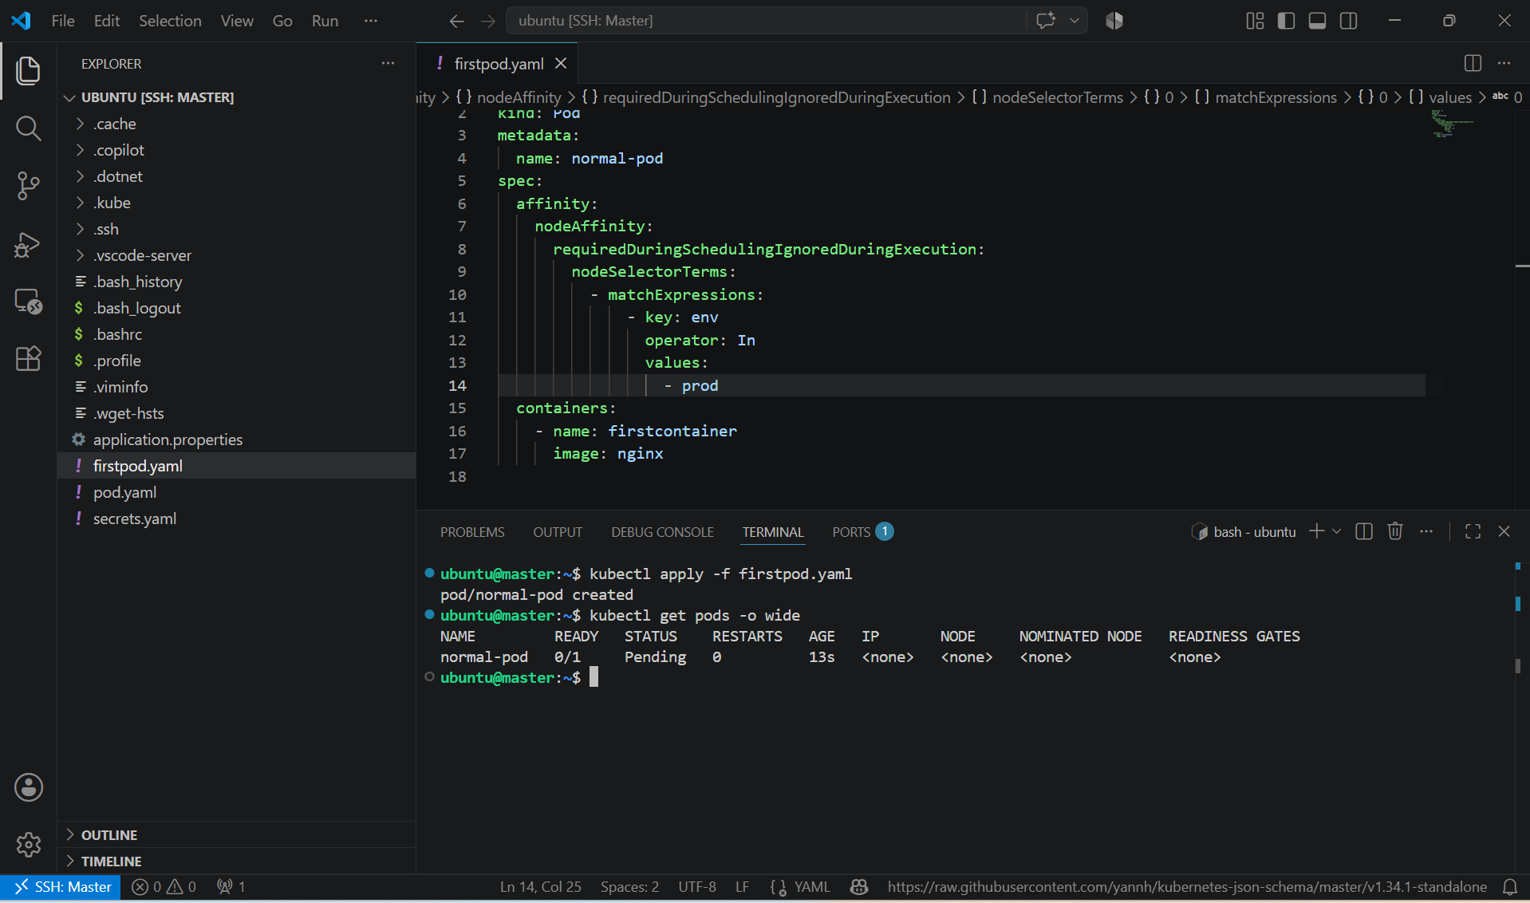

- Verify the Pod Cannot Be Scheduled -> kubectl get pods -o wide
- Describe the pod -> kubecl describe pod normal-pod

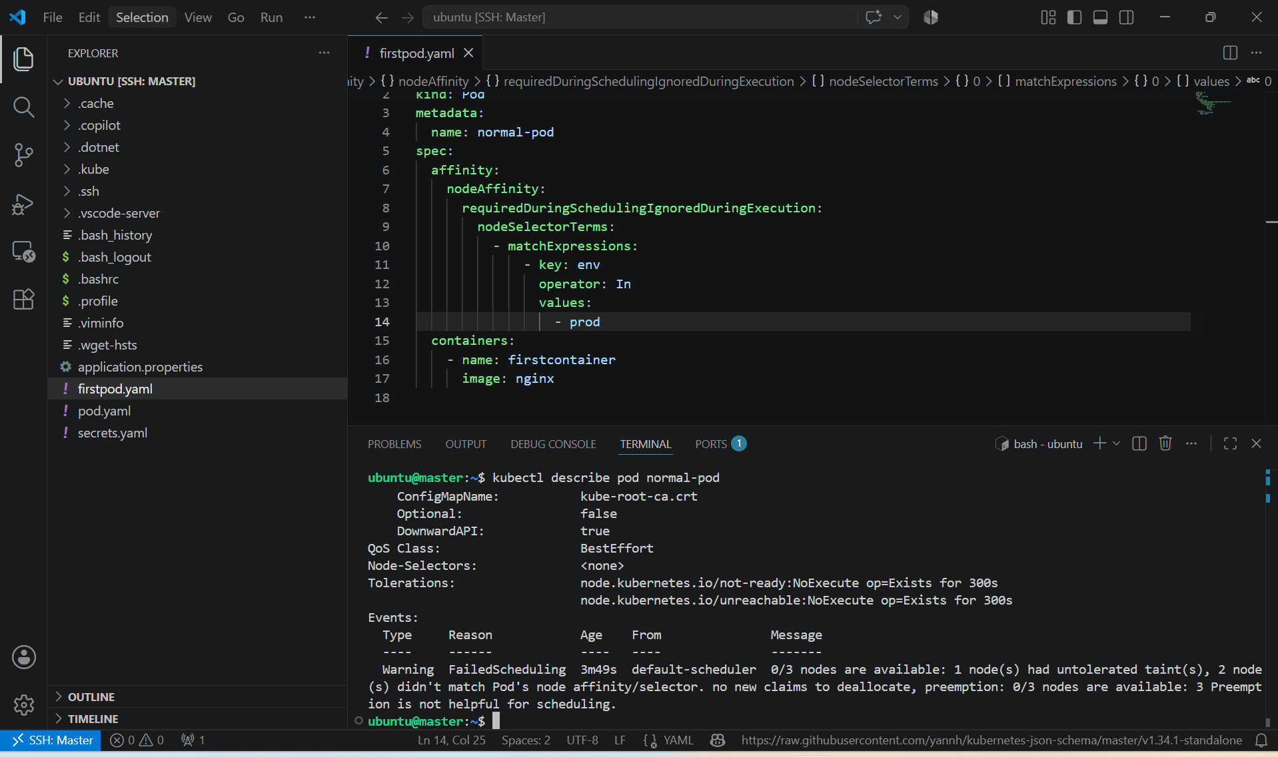

- Label worker-1 with env=prod. -> kubectl label node worker-1 env=prod
- Verify -> kubectl get nodes –show-labels

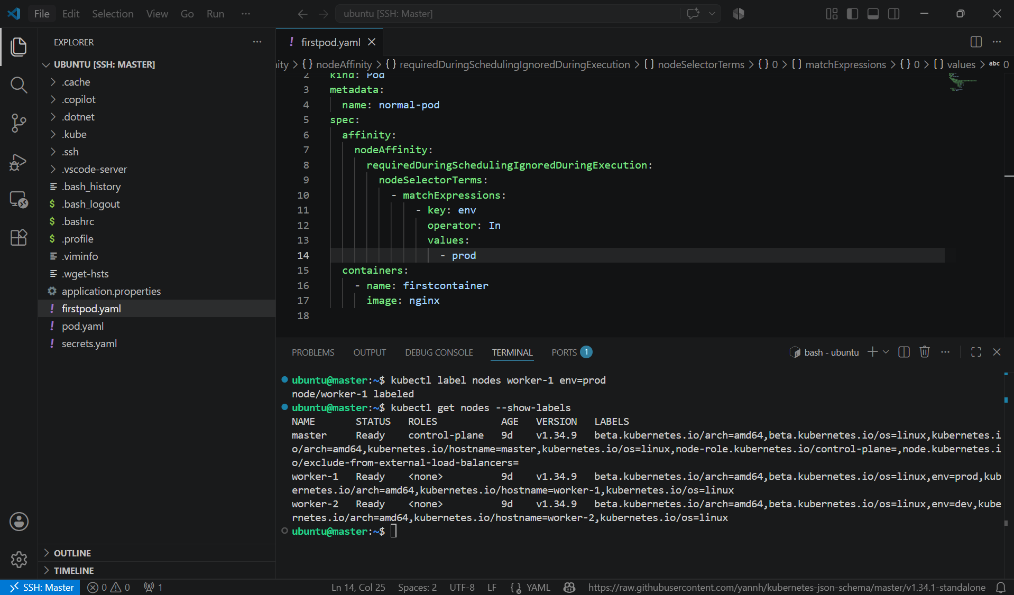

- Verify the pod is scheduled within a few seconds of label attached to the node -> kubectl get pods -o wide

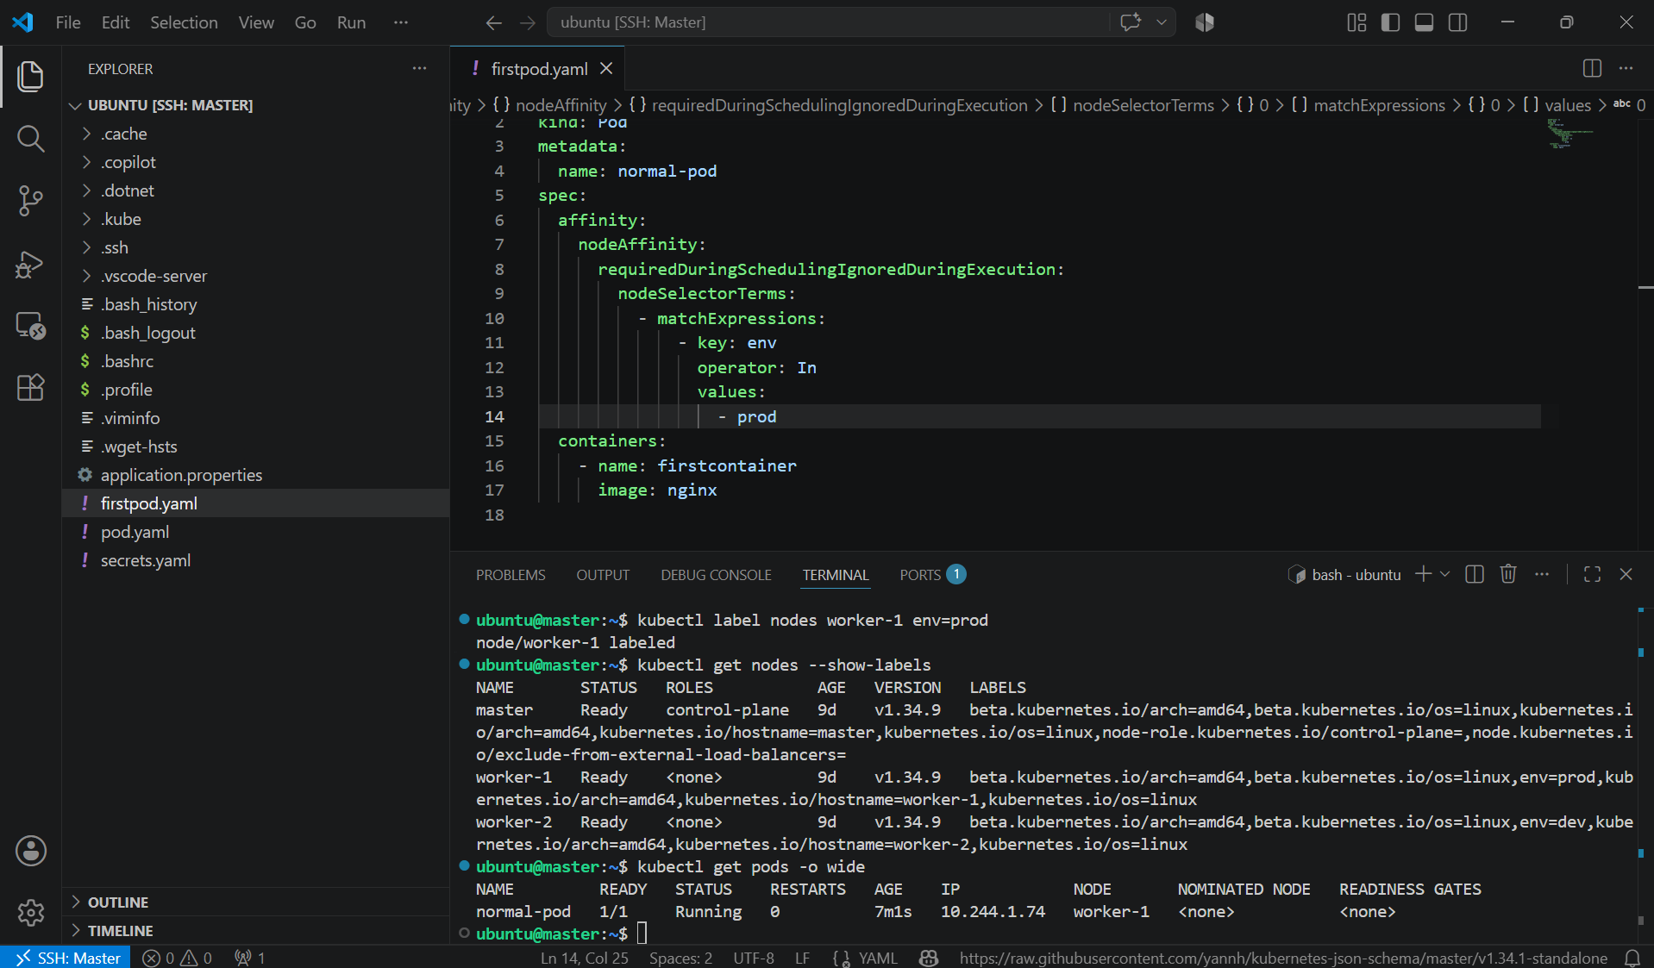

6. Taint a Node and Use NoExecute with Toleration Seconds Taint a node with special=true:NoExecute. Create a pod with a tolerationSeconds field (e.g., 60 seconds) and observe it gets evicted after 60 seconds on the tainted node.

PURPOSE: The purpose of this task is to demonstrate how the NoExecute taint works. A Pod with a matching toleration and tolerationSeconds can run on the tainted node temporarily and will be evicted after the specified time expires.

OBJECTIVE:
- Taint a node with special=true:NoExecute.
- Create a Pod with a matching toleration and tolerationSeconds: 60.
- Verify the Pod is scheduled on the tainted node.
- Observe that the Pod is evicted after 60 seconds.

EXPECTED OUTCOME:

Time | Pod Status
Immediately after creation | Running
Within 60 seconds | Running
After ~60 seconds | Terminating
After eviction | Deleted
STEP BY STEP IMPLEMENTATION:

- Taint the node worker-1 -> kubectl taint nodes worker-1 special=true:NoExecute
- Then verify -> kubectl get nodes | grep Taints

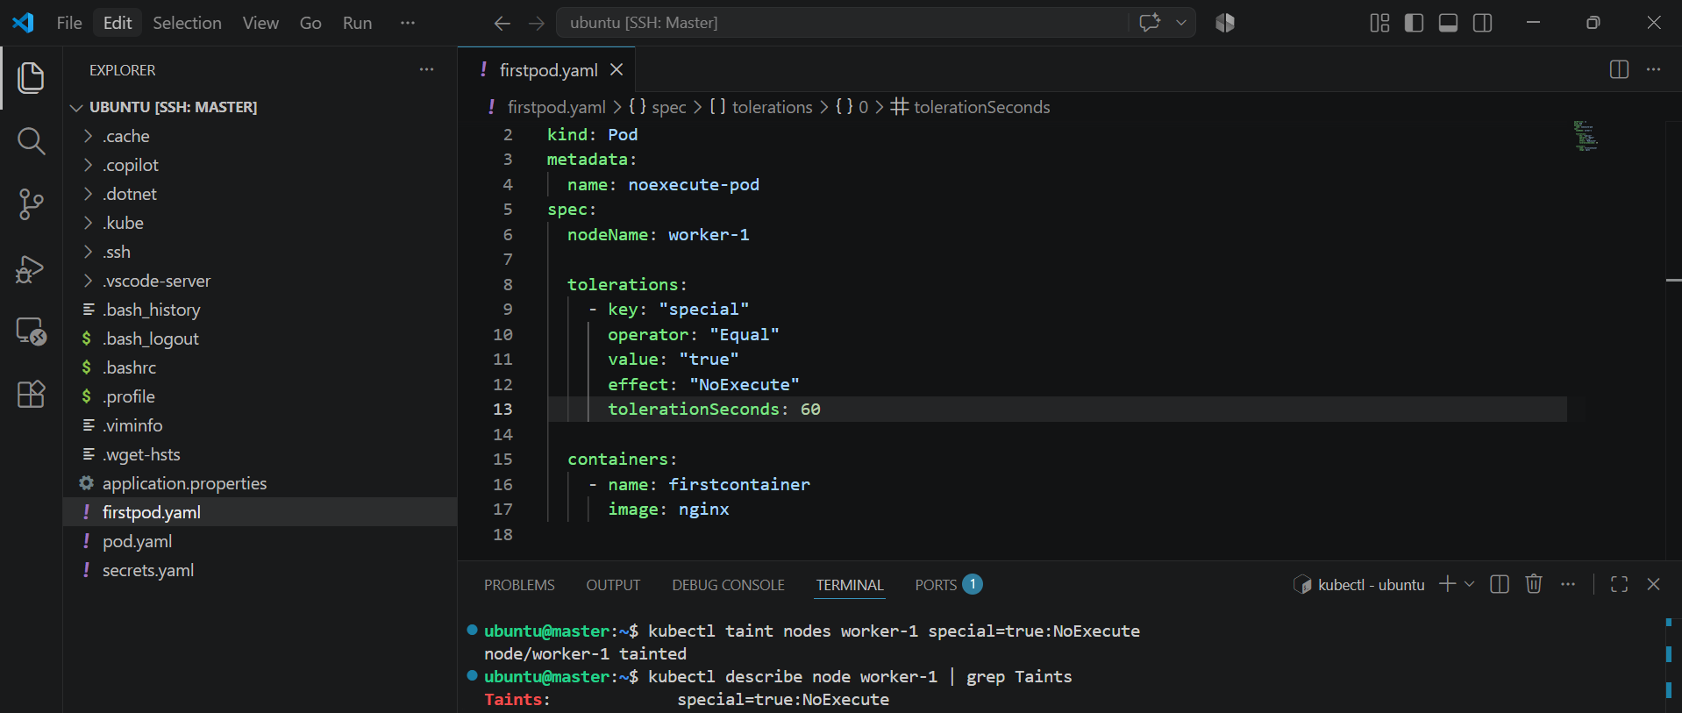

- Then create a file named firstpod.yaml and apply the file to create pod -> kubectl apply -f firstpod.yaml
- Verify to watch continuously so that we can see after the tolerationseconds 60 and it will be terminated

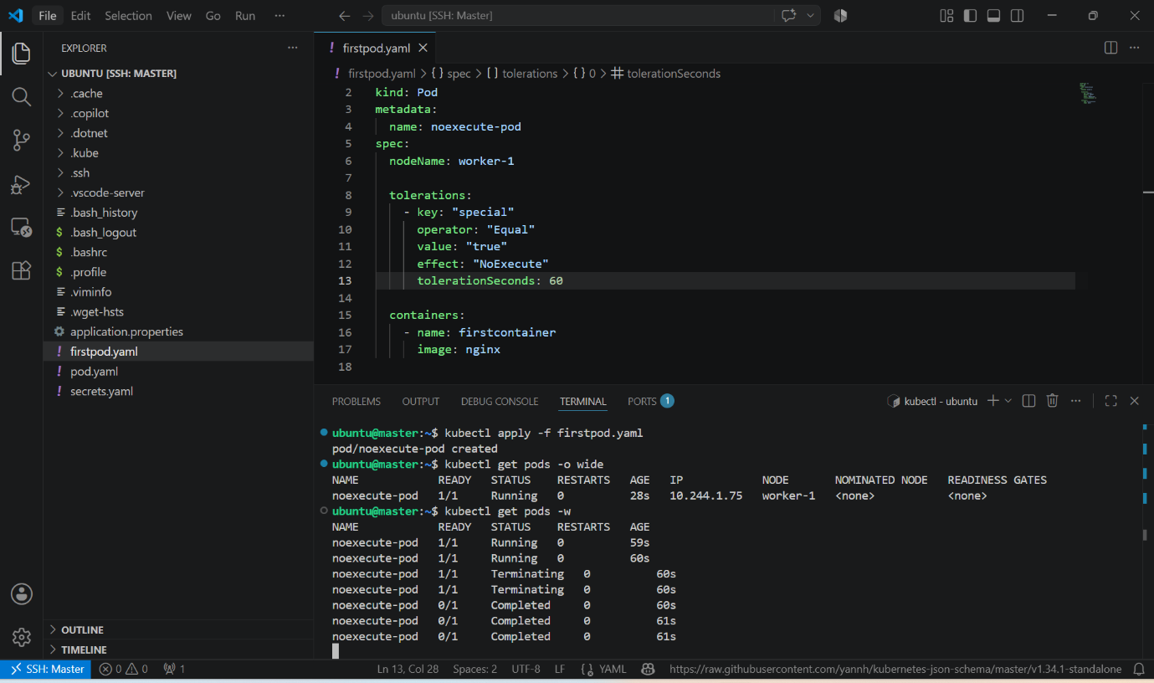

- The Pod is evicted because its toleration expired.
- Verify the Eviction Reason -> kubectl describe pod noexecute-pod

