KUBERNETES-08

1. Create and Test a Kubernetes Pod with an EmptyDir Volume

PURPOSE: The purpose of this lab is to understand how an EmptyDir volume works in Kubernetes by creating a Pod with two containers that share the same temporary storage. This demonstrates how containers within the same Pod can exchange data using a shared volume.

OBJECTIVE:
After completing this lab, you will be able to:
- Create a Pod that uses an EmptyDir volume.
- Mount the same EmptyDir volume into multiple containers.
- Verify that data written by one container can be accessed by another container.
- Understand that EmptyDir storage is temporary and is deleted when the Pod is removed.

EXPECTED OUTCOME: Successfully created a Kubernetes Pod using an EmptyDir volume. The shared volume allowed two containers within the same Pod to exchange data. The test also confirmed that EmptyDir is ephemeral storage, meaning all stored data is automatically removed when the Pod is deleted.

STEP BY STEP IMPLEMENTATION:
- Create a file named pod.yaml and edit the content whatever we want in that file to create empty directory.

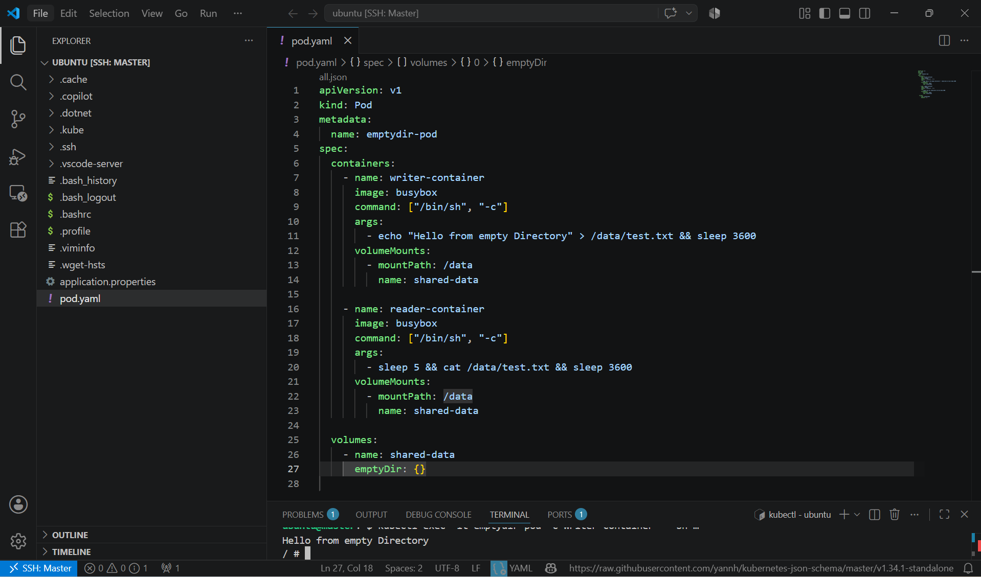

- Then we have to apply the yaml file to create a pod -> kubectl apply -f pod.yaml

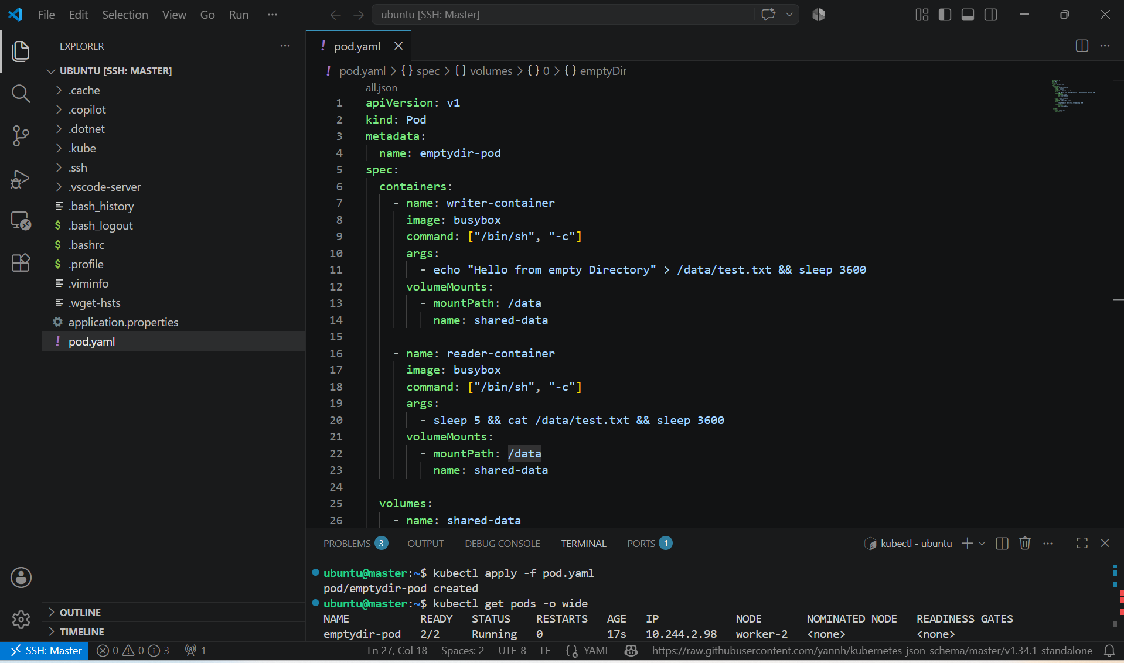

- Verify Data Sharing, Check the logs of the reader container -> kubectl logs emptydir-pod -c reader-container
- This confirms that the second container successfully read the file created by the first container through the EmptyDir volume.
- Verify Inside the Container, Access the writer container -> kubectl exec -it emptydir-pod -c writer-container – sh
- View the file -> cat /data/test.txt

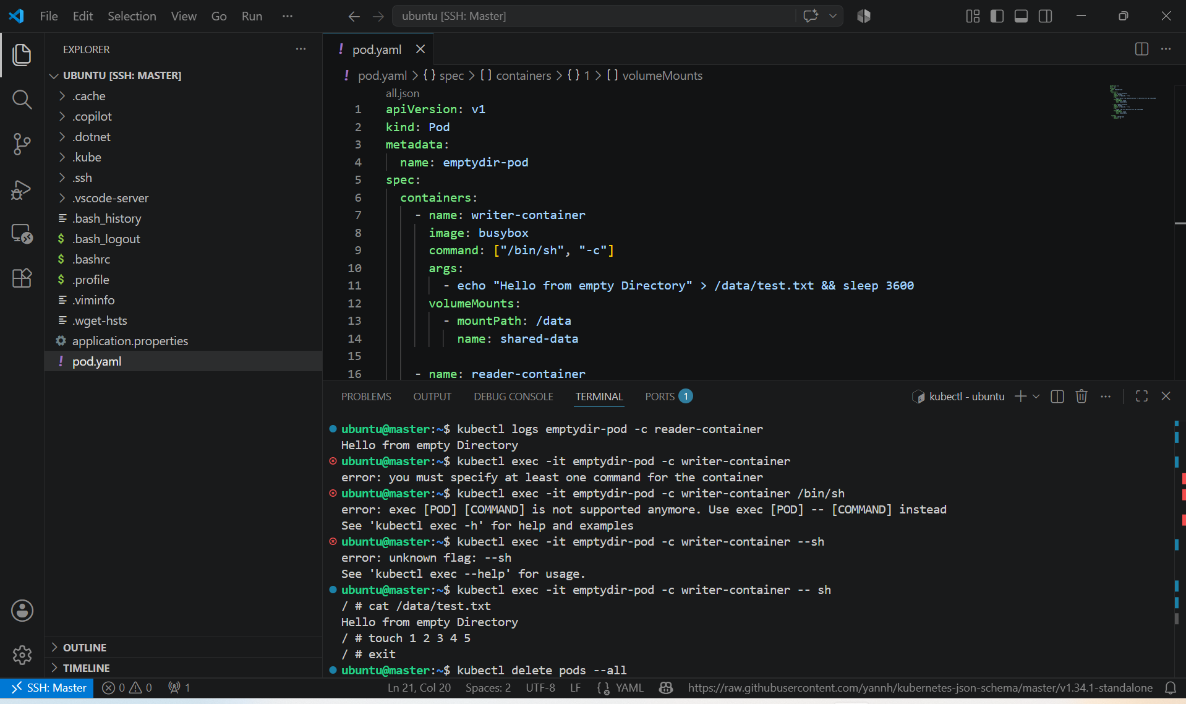

- Delete the Pod and Verify EmptyDir Behavior by creating the pod again

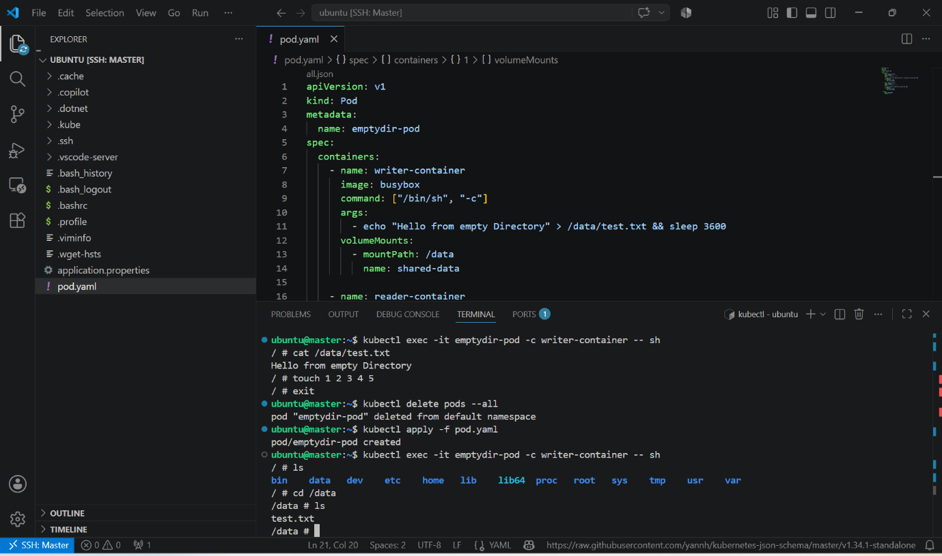

- Notice that the previous data does not exist because the EmptyDir volume is recreated each time the Pod starts.

Key Learning
- EmptyDir is created when a Pod starts.
- It is shared among all containers in the same Pod.
- It is commonly used for temporary files, caching, and inter-container communication.
- The data persists only as long as the Pod exists.
- Once the Pod is deleted, all data stored in the EmptyDir volume is permanently removed.

2. Configure a HostPath Volume in Kubernetes and Validate Data Persistence

PURPOSE: The purpose of this task is to understand how a HostPath volume works in Kubernetes by mounting a directory from the worker node’s filesystem into a Pod. This task demonstrates how data stored on the host machine persists even after the Pod is deleted and recreated.

OBJECTIVE:
After completing this task, you will be able to:
  - Create a Pod using a HostPath volume.
  - Mount a host directory inside a container.
  - Write data to the mounted directory.
  - Verify that the data persists after deleting and recreating the Pod.
  - Understand the difference between HostPath and EmptyDir volumes.

EXPECTED OUTCOME: Successfully configured a HostPath volume in Kubernetes. Data written by the Pod was stored on the host node and remained available even after the Pod was deleted and recreated, demonstrating data persistence.

STEP BY STEP IMPLEMENTATION:
- Create a yaml file named pod.yaml and edit the file with this content.
apiVersion: v1
kind: Pod
metadata:
name: hostpath-pod
spec:
containers:
- name: app-container
image: busybox
command: ["/bin/sh", "-c"]
args:
- echo "HostPath Volume Test" > /data/test.txt && sleep 3600
volumeMounts:
- name: host-storage
mountPath: /data

volumes:
- name: host-storage
hostPath:
path: /tmp/hostpath-data
type: DirectoryOrCreate
Explanation
- hostPath.path: Directory on the Kubernetes node.
- DirectoryOrCreate: Creates the directory automatically if it doesn't exist.
- /data: Directory inside the container mapped to the host.

- Then we have to create pod by using this yaml file -> kubectl apply -f pod.yaml
- The verify the pods -> kubectl get pods -o wide

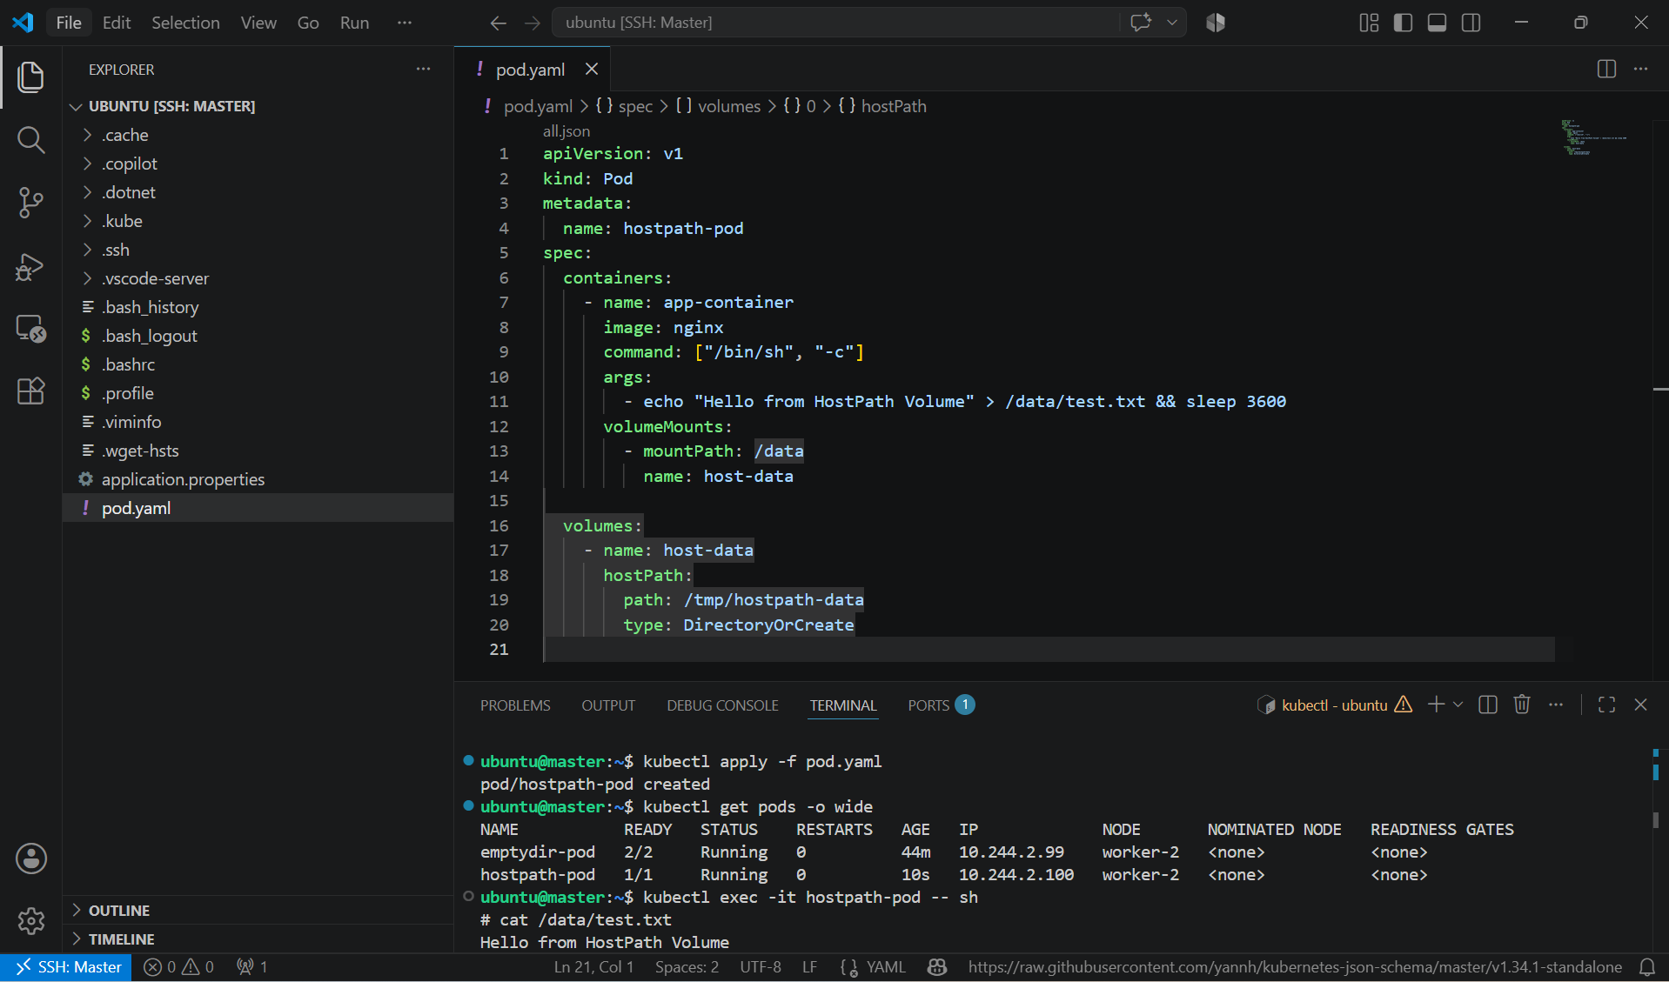

- Then we have to verify whether the content in that specific path is created or not.
- For that we have to connect to that container -> kubectl exec -it hostpath-pod -- sh
- Then we have cat the content in the /data path -> cat /data/test.txt

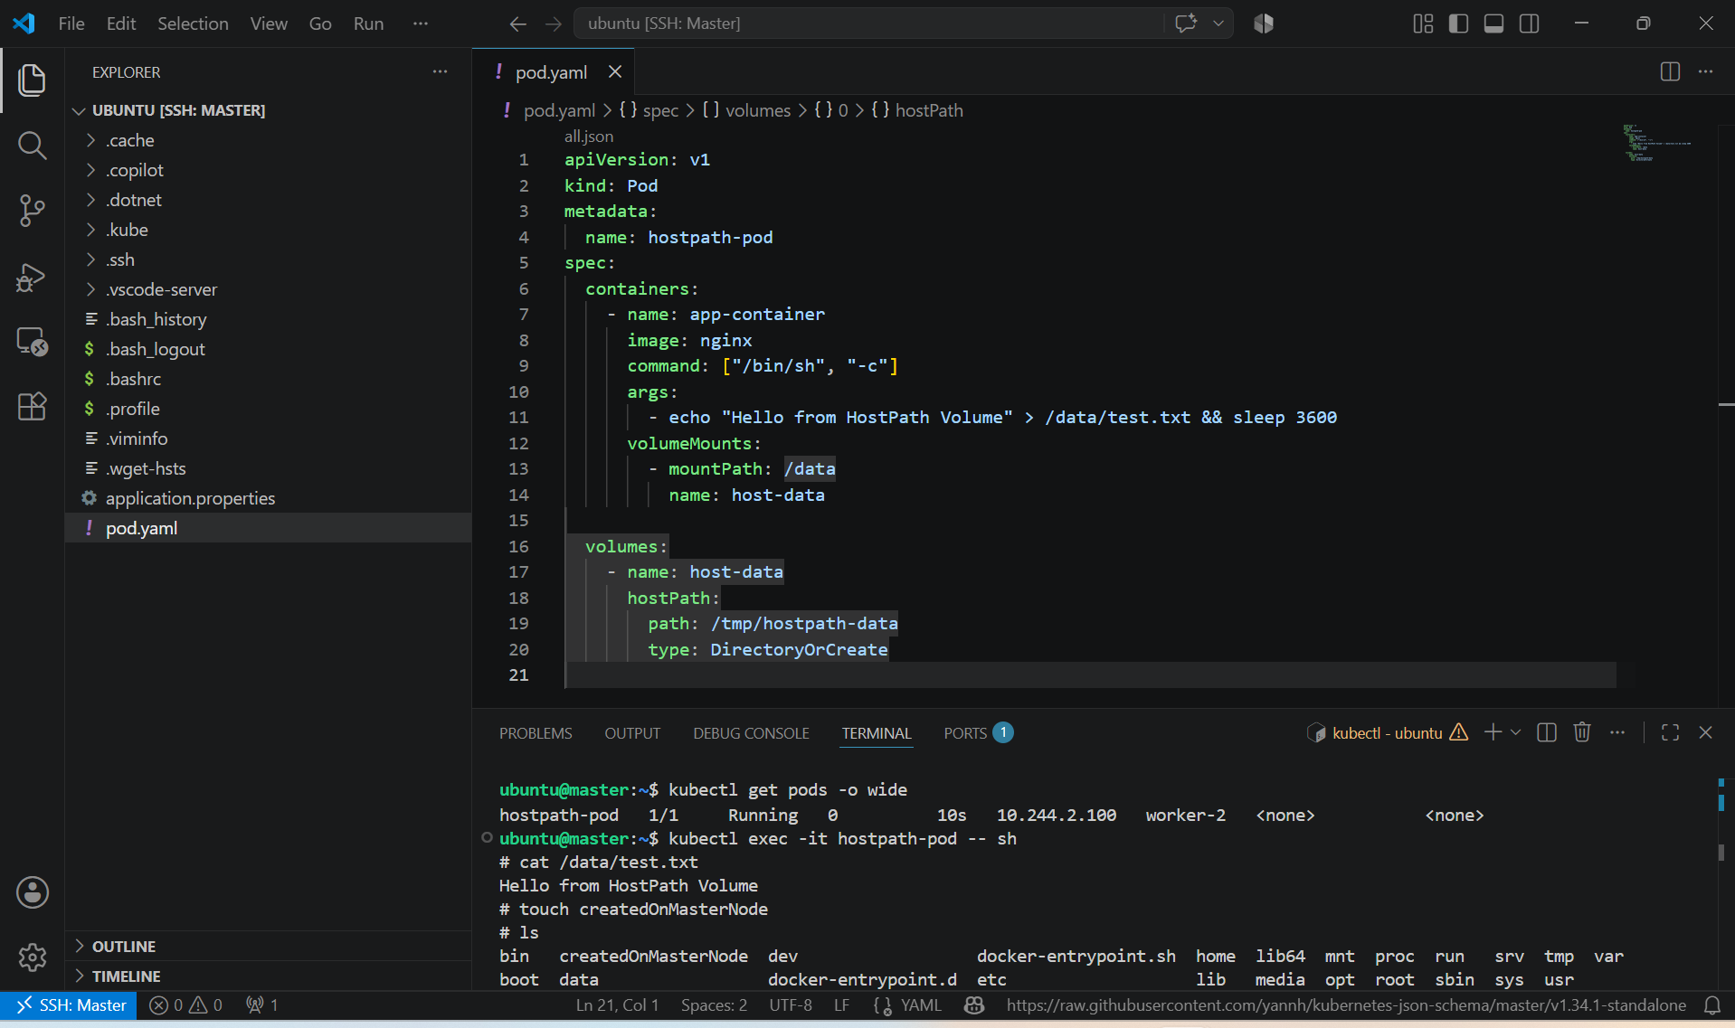

- Verify the File on the Kubernetes Node, SSH into the node where the Pod is running.
- Find the node first and then decide on which node the pod is running.
- In my case, pod is running on worker-2, so I have connected to the worker-2 node and there I have searched for hostpath-data in the tmp directory

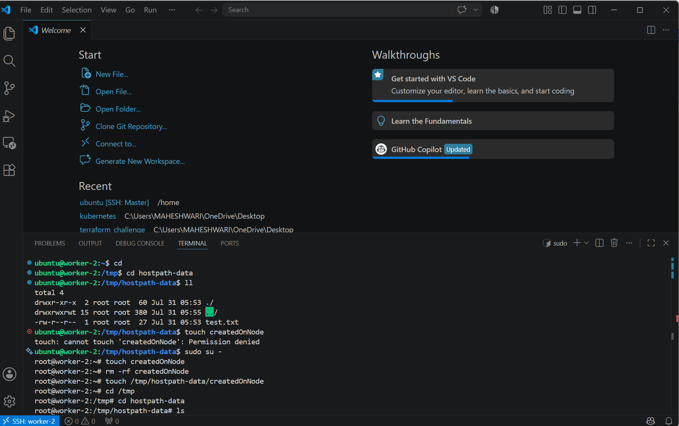

- We can also verify that the whatever the files we are created in the worker node that will be reflected in the volume that we have created.

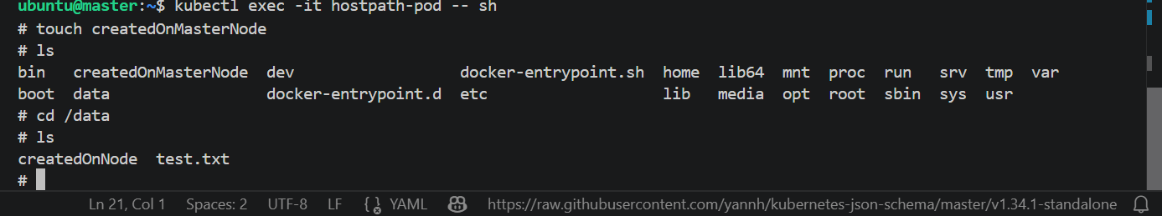

- Delete the Pod, Recreate the Pod and Validate Data Persistence, Check the file again by connecting to the container.
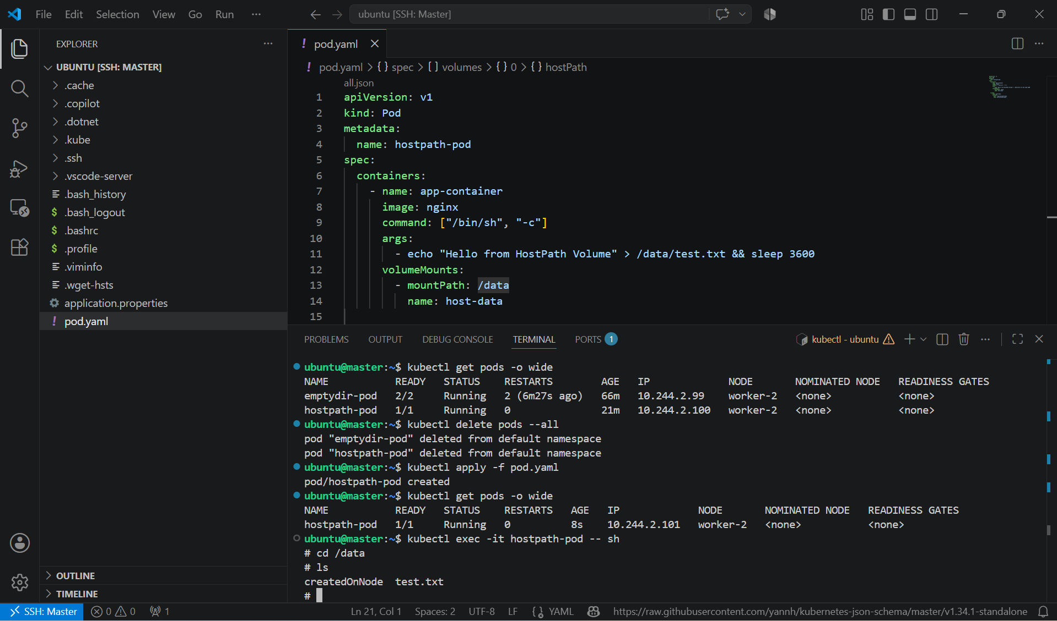

- The file is still available because it was stored on the node's filesystem, not inside the Pod.

Key Learning
- HostPath mounts a directory from the Kubernetes node into a Pod.
- Data is stored on the host machine, not inside the container.
- Data persists even if the Pod is deleted and recreated (as long as it is scheduled on the same node).
- HostPath is commonly used for development, testing, log collection, and node-specific applications.
- HostPath is generally not recommended for production workloads because it tightly couples Pods to a specific node and can introduce security risks.

3. Deploy an Amazon EBS Volume Using Persistent Volume and Persistent Volume Claim (PVC)

PURPOSE: The purpose of this task is to learn how to use an Amazon Elastic Block Storage (EBS) volume as persistent storage in Kubernetes by creating a Persistent Volume (PV), Persistent Volume Claim (PVC) and mounting into a Pod lifecycle.

OBJECTIVE:
After completing this lab, you will be able to:
- Create an Amazon EBS volume.
- Create a Persistent Volume (PV) using the EBS volume.
- Create a Persistent Volume Claim (PVC).
- Deploy a Pod that uses the PVC.
- Verify that data persists after the Pod is deleted and recreated.

EXPECTED OUTCOME: Successfully deployed an Amazon EBS volume using a Persistent Volume (PV) and Persistent Volume Claim (PVC). The Pod stored data on the EBS volume, and the data remained intact after the Pod was deleted and recreated, demonstrating persistent storage in Kubernetes.

STEP BY STEP IMPLEMENTATION:
- Create an Amazon EBS Volume
  - Using the AWS Console:
  - Open EC2 Dashboard
  - Select Elastic Block Store → Volumes
  - Click Create Volume
  - Configure:
  - Size: 5 GiB
  - Type: gp3
  - Availability Zone: Same as Kubernetes worker node

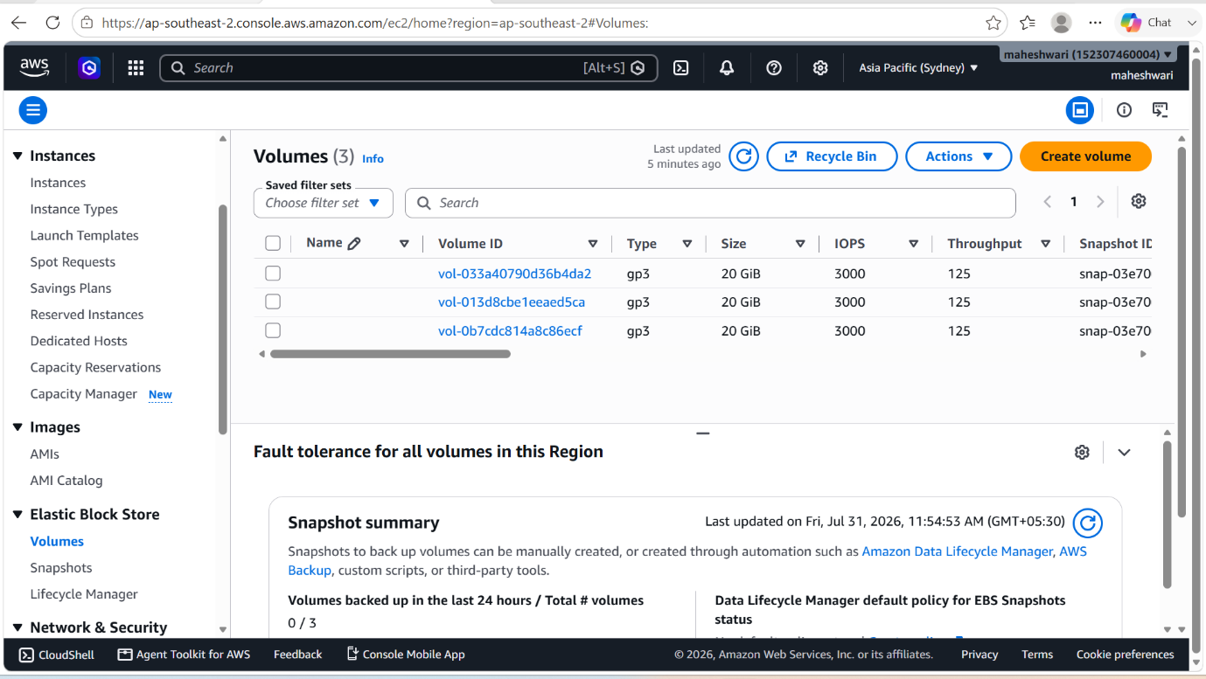

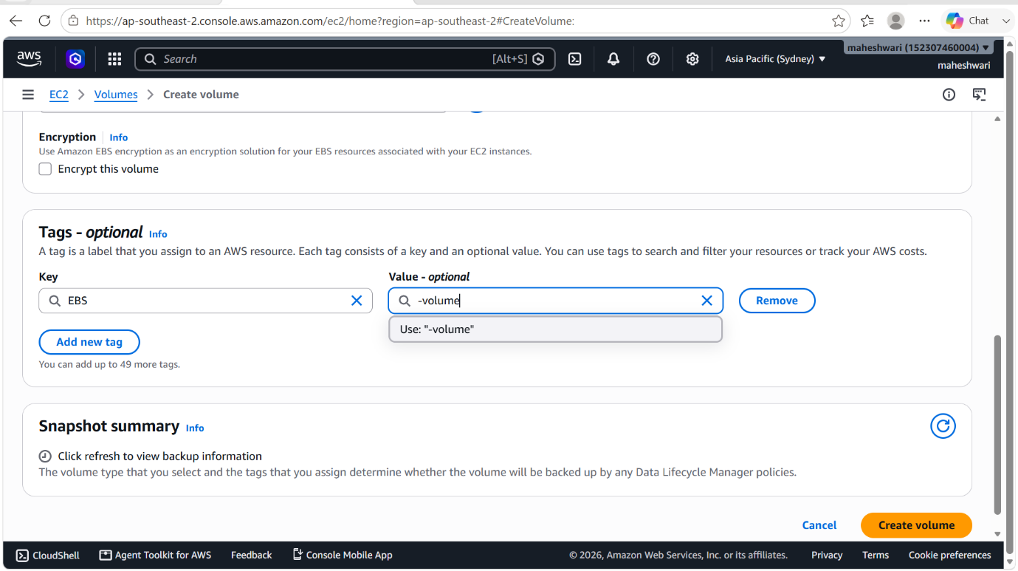

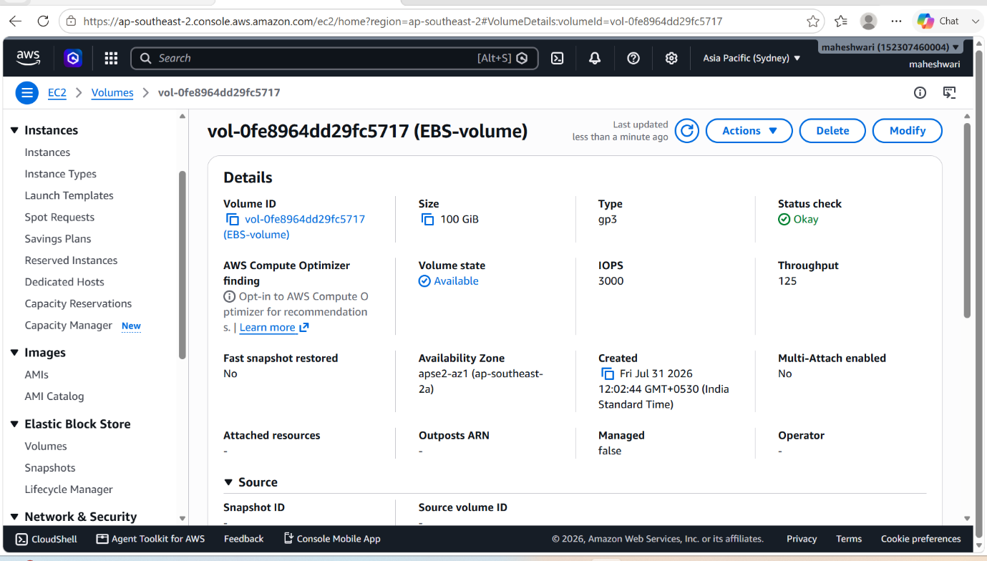

- Before creating all these we have to download the ebscsi driver in the master node and also helm.
- For that we have to execute these commands in the node
- kubectl version
- helm repo add aws-ebs-csi-driver https://kubernetes-sigs.github.io/aws-ebs-csi-driver
helm repo update

helm install aws-ebs-csi-driver aws-ebs-csi-driver/aws-ebs-csi-driver \
-n kube-system
- kubectl get csidrivers

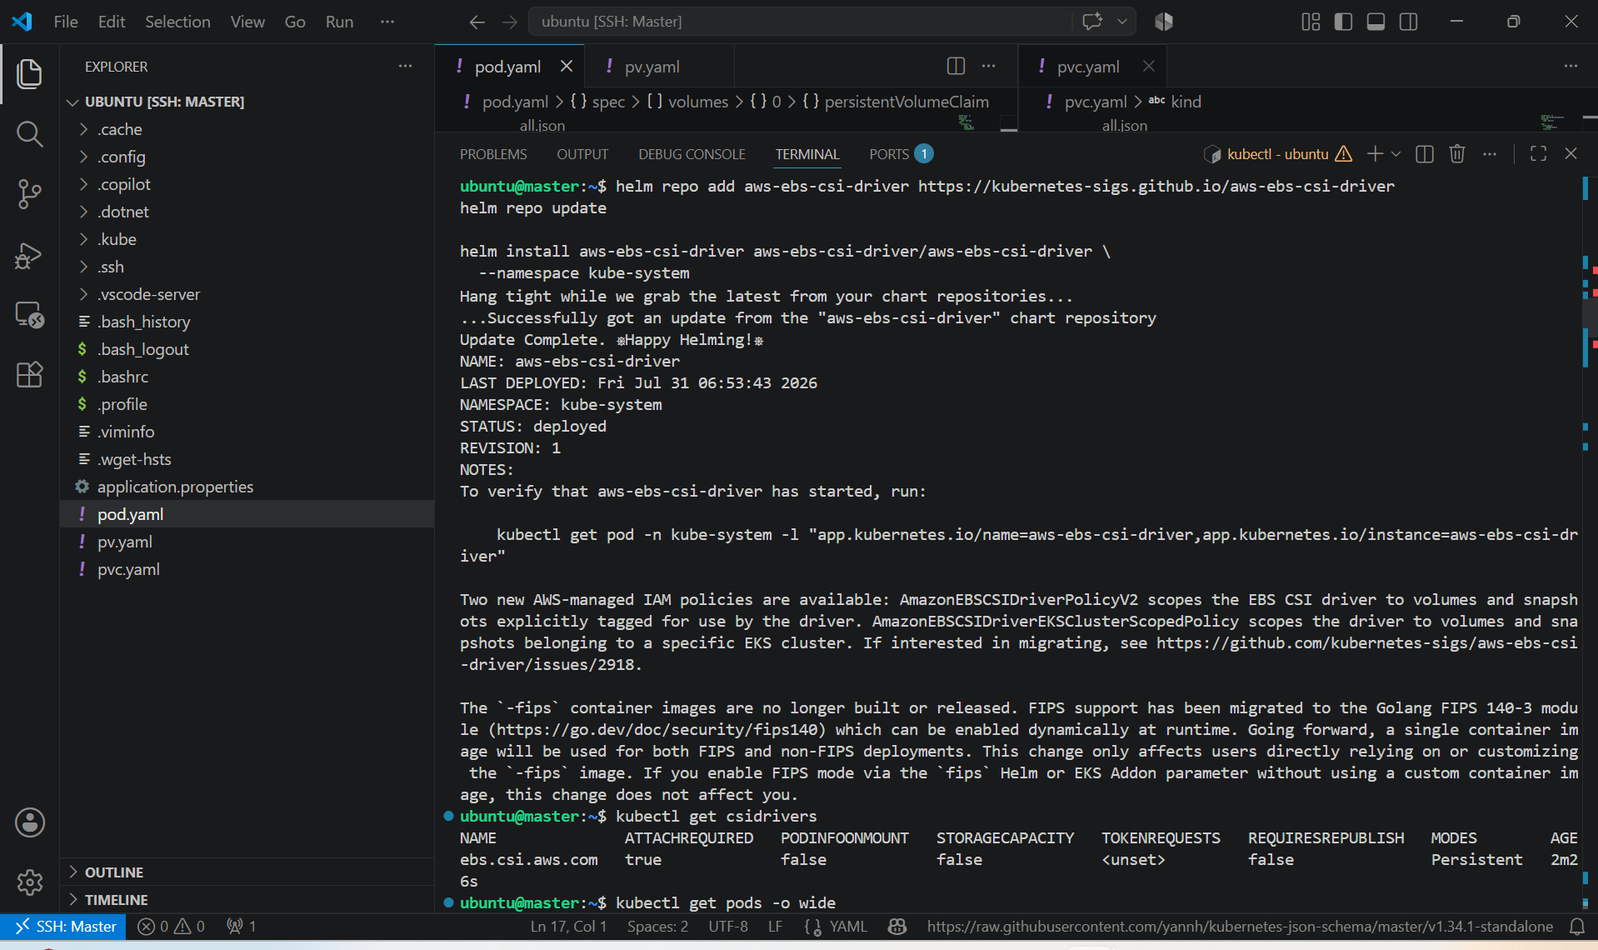

- next we have to a Role to the EC2 instance and for that we have to create a new role with AmazonEBSCSIDriverPolicy attached to the Role.

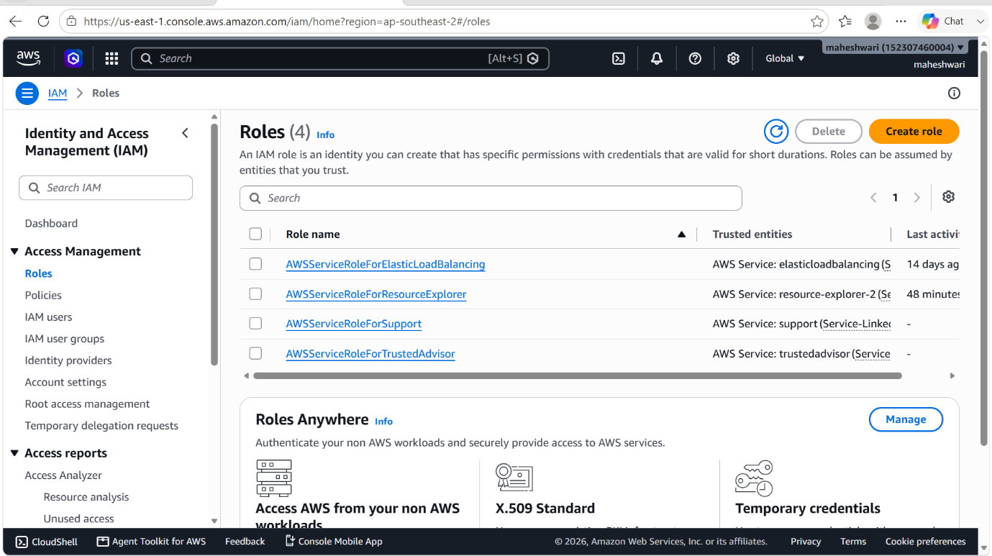

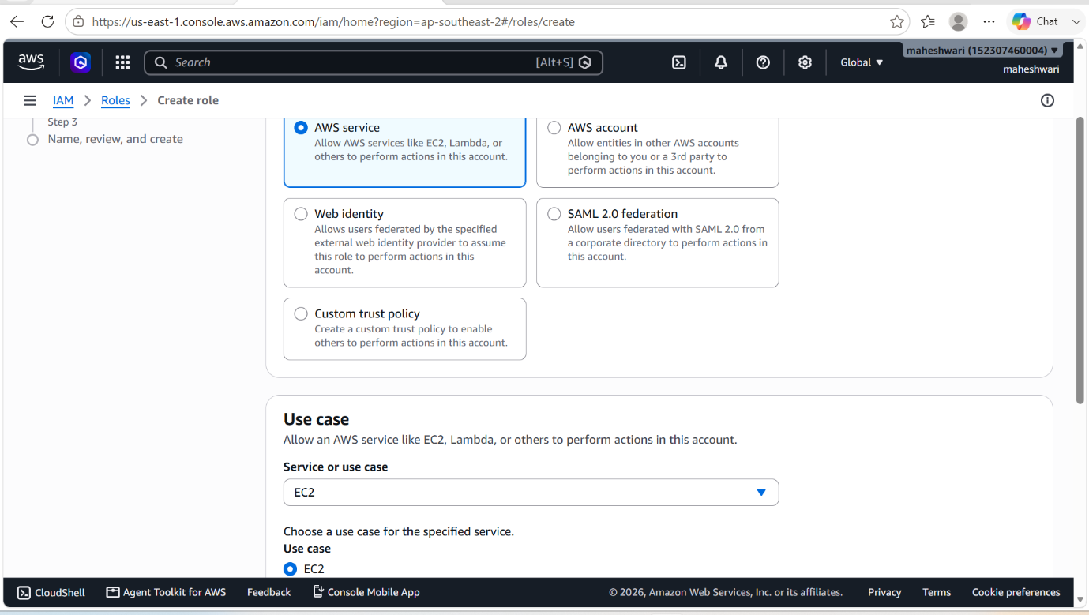

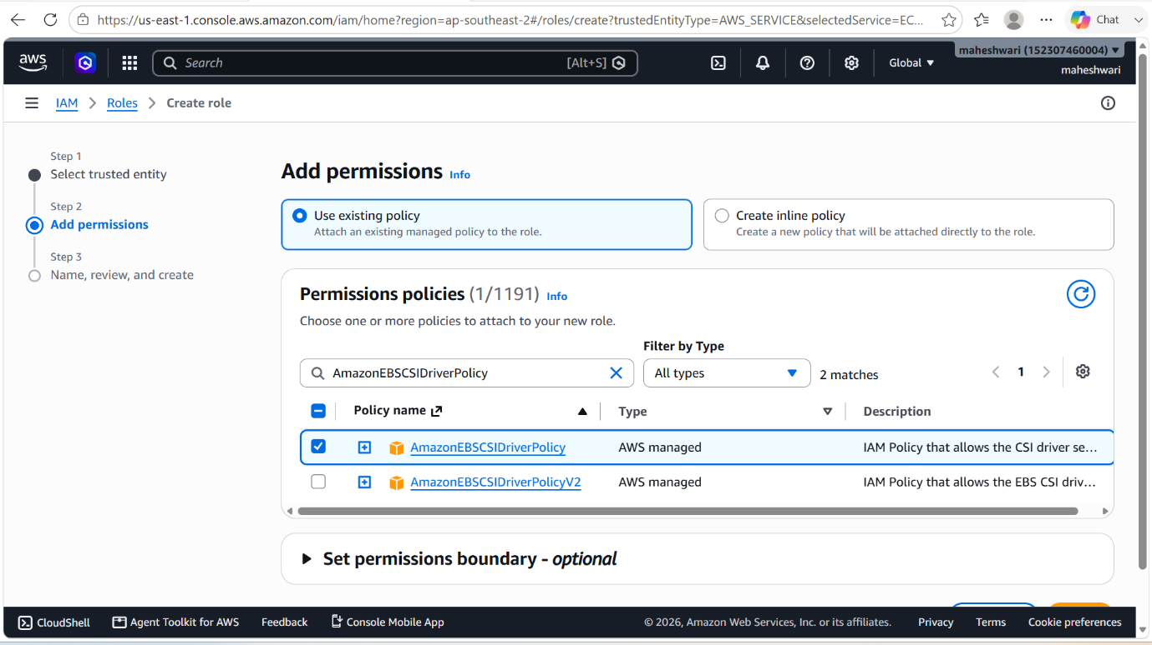

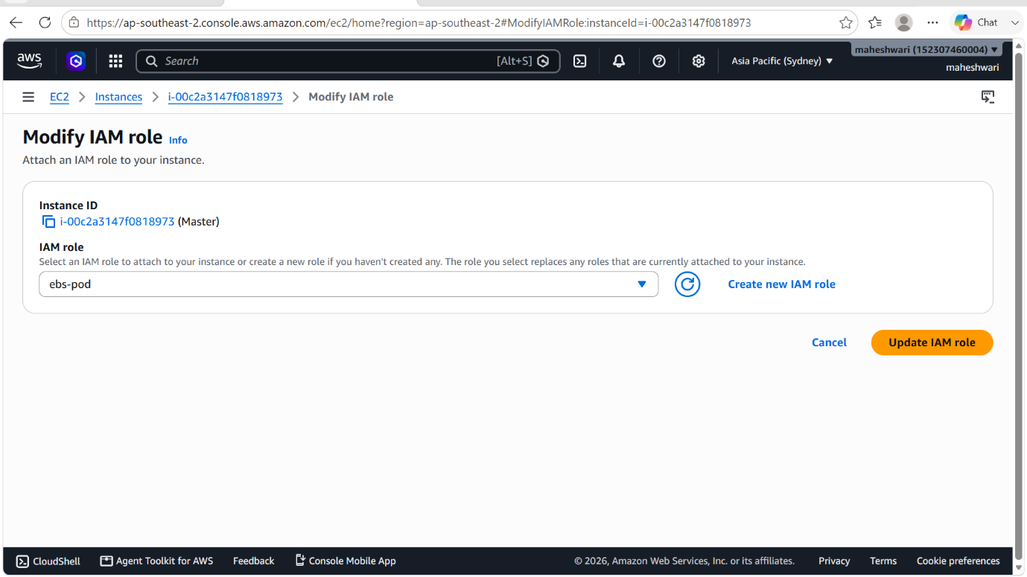

- attach that created new Role to all the three instance i.e.., master, worker-1 and worker-2 instances.

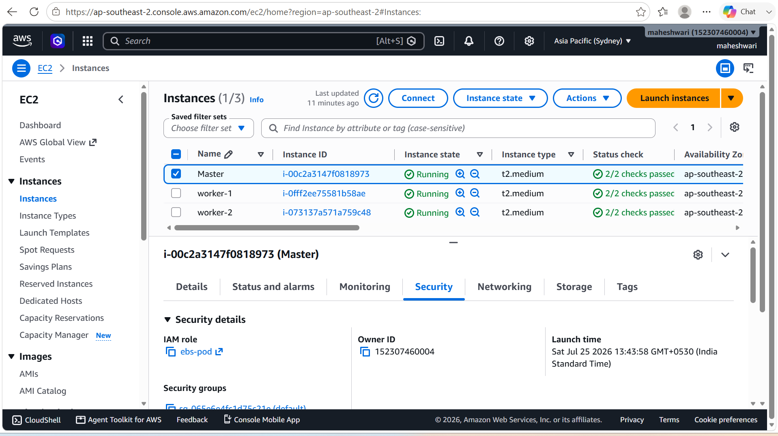

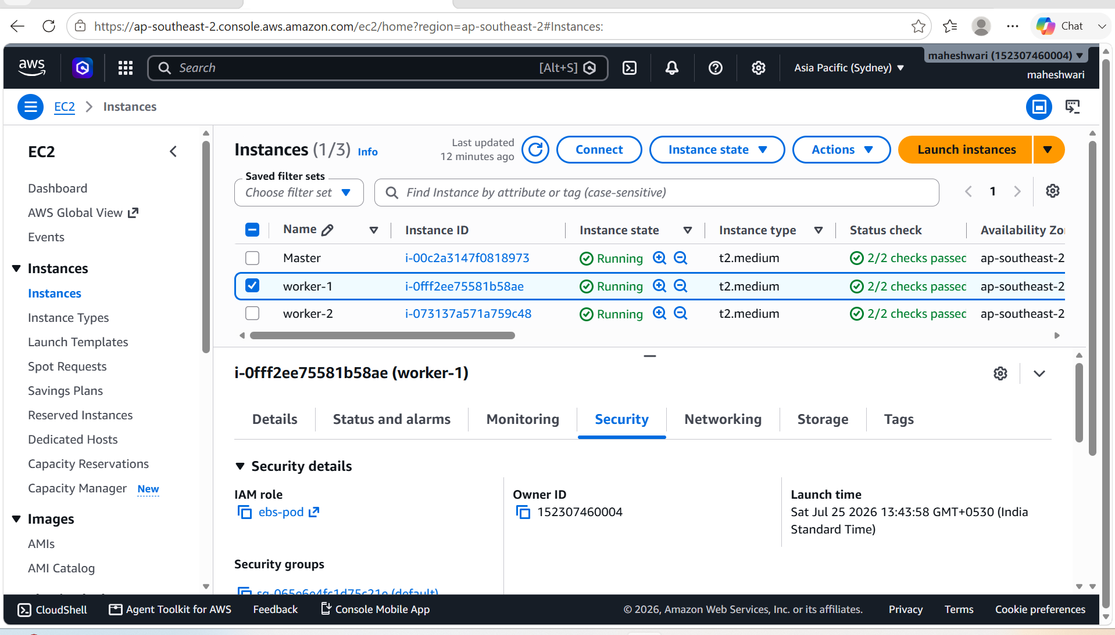

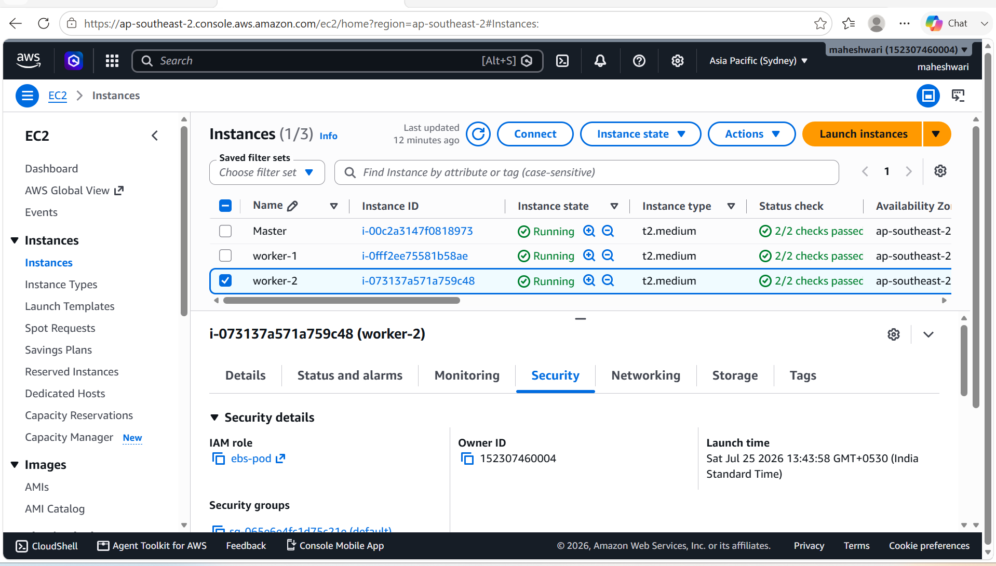

- Create a yaml file named pv.yaml and apply that file to create a persistant volume -> kubectl apply -f pv.yaml
- To verify the pv -> kubectl get pv

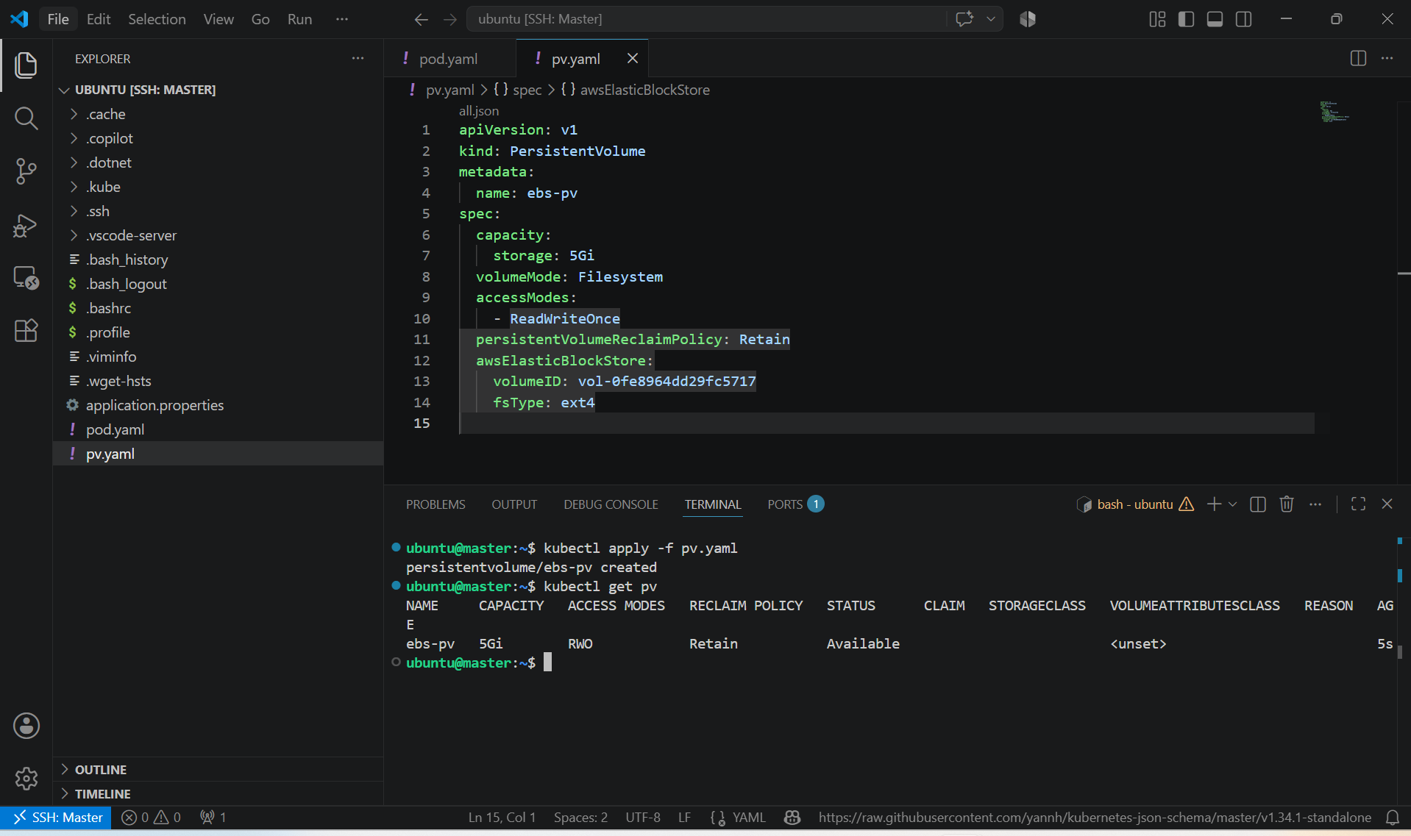

- Create a file named pvc.yaml and apply that file to create a persistent volume claim from that file -> kubectl apply -f pvc.yaml
- Then to verify -> kubectl get pvc
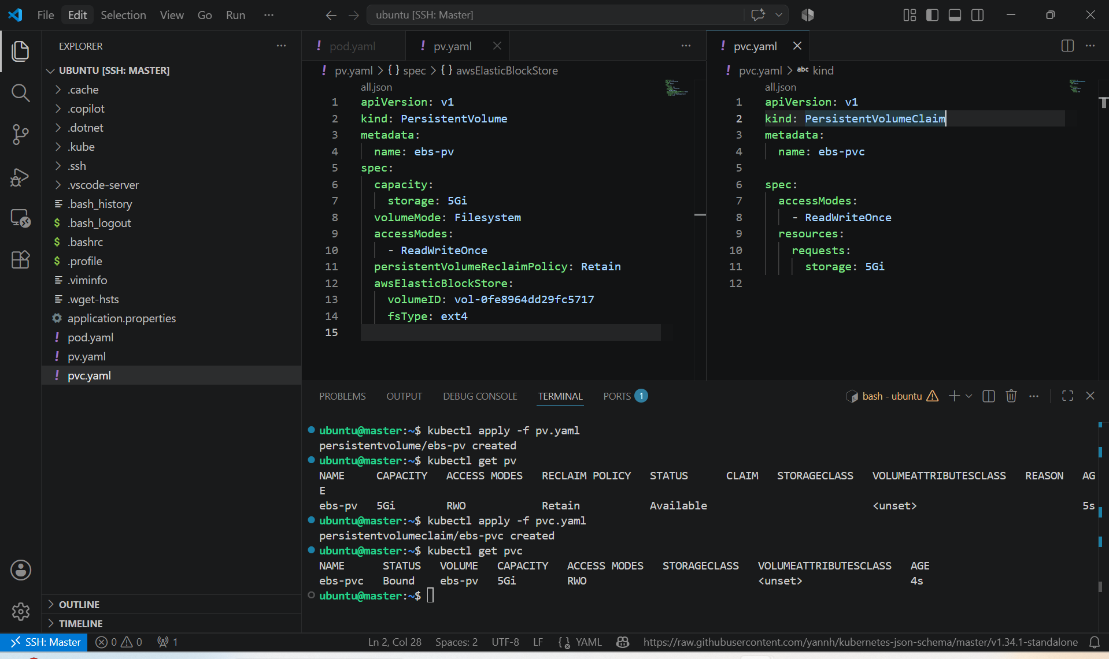

- Create a pod using pvc -> kubectl apply -f pod.yaml
- That pod.yaml file will contains

apiVersion: v1
kind: Pod
metadata:
name: ebs-pod
spec:
containers:
- name: app
image: nginx
volumeMounts:
- mountPath: "/usr/share/nginx/html"
name: ebs-storage

volumes:
- name: ebs-storage
persistentVolumeClaim:
claimName: ebs-pvc

- Then verify it by connecting to the container and there we can add the content to the ebs volume.

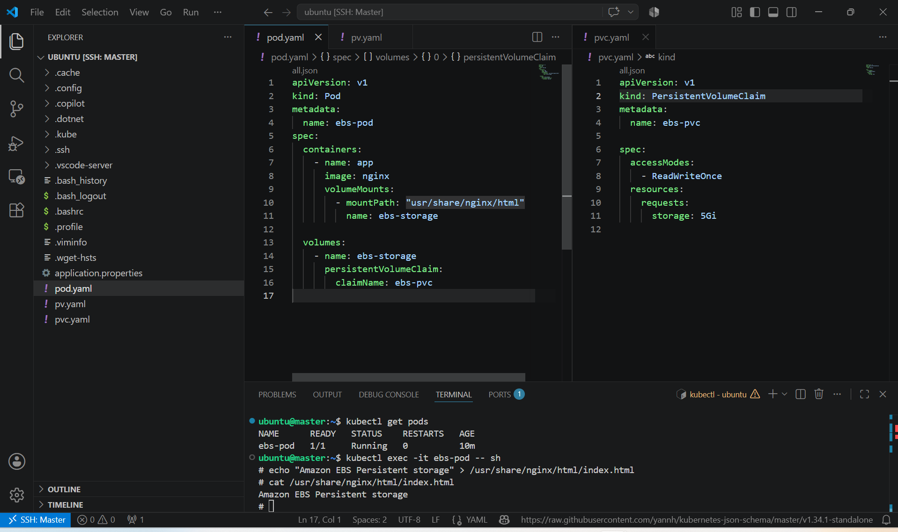

- Then we can delete the pod and again recreate the pod then verify that still the ebs-volume is added.

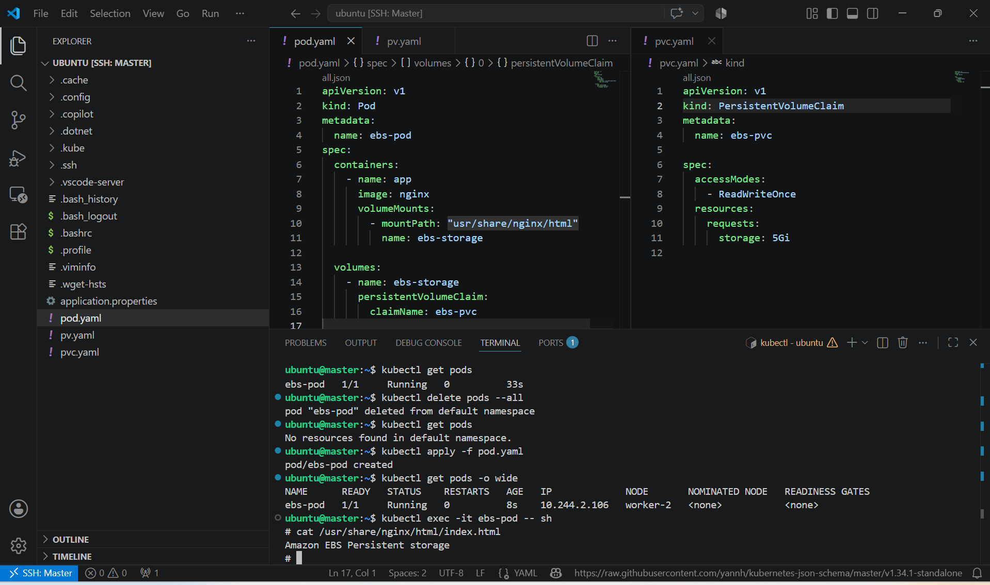

- Whenever the pod is running using ebs storage then our ebs volume will be in use state, that volume will not used by any other pod.

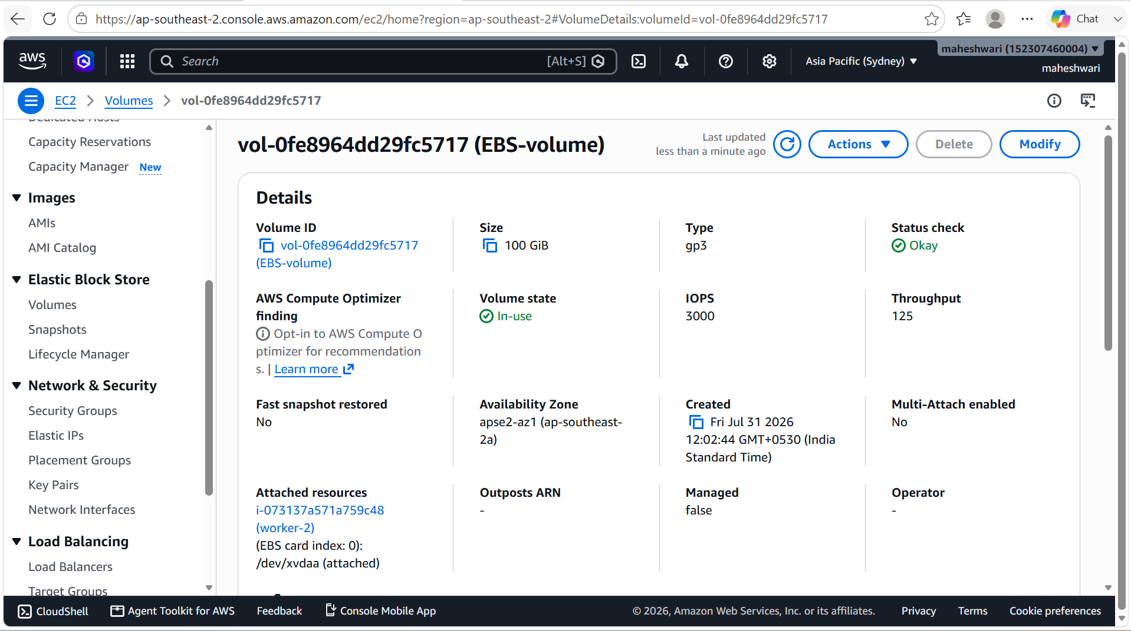

- Once we delete our pod, our ebs volume will be again in the available state.

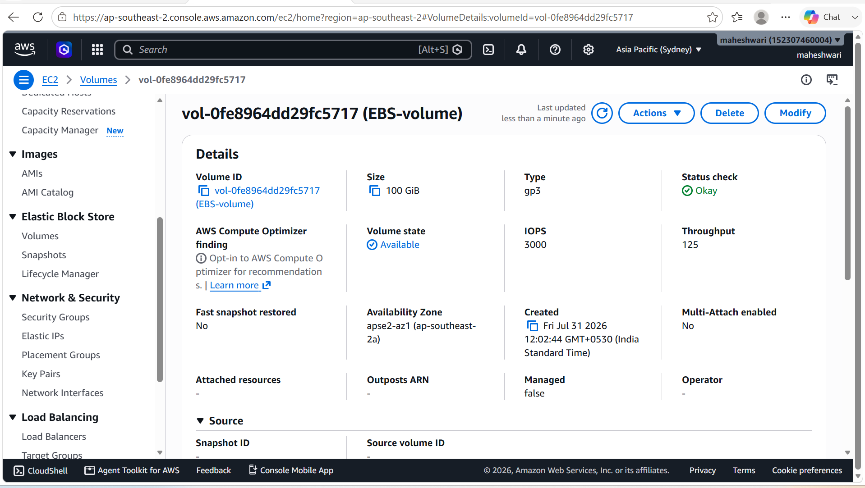

Root Cause Analysis:

- AWS EBS CSI Driver was not installed.
- Helm was missing.
- Helm was initially run on a worker node instead of the master node.
- The AWS EBS CSI Controller entered CrashLoopBackOff.
- The CSI controller lacked the AWS credentials or IAM permissions needed to manage EBS volumes.
- As a result, Kubernetes could not attach the EBS volume, leaving the application Pod in ContainerCreating.

To resolve the issue:
- Install Helm.
- Install the AWS EBS CSI Driver.
- Create an IAM Role for the EC2 instances.
- Attach the AmazonEBSCSIDriverPolicy (or an equivalent custom policy) to the IAM role.
- Attach the IAM role (instance profile) to the Kubernetes EC2 instances.
- Restart the EBS CSI Controller Pods.
- Recreate the application Pod.
- Verify that the Pod reaches the Running state and the EBS volume is successfully mounted.

Key Learning
- Persistent Volume (PV) represents storage available to the Kubernetes cluster.
- Persistent Volume Claim (PVC) is a request for storage by a Pod.
- Amazon EBS provides durable block storage for Kubernetes workloads on AWS.
- ReadWriteOnce (RWO) allows the volume to be mounted as read-write by a single node.
- Setting the reclaim policy to Retain preserves the EBS volume even after the PVC is deleted.
- Unlike EmptyDir, EBS-backed PVs persist data beyond the lifecycle of Pods, making them suitable for stateful applications such as databases and content management systems.

4. Set Up an Amazon EFS Volume and Attach it to Multiple Pods

PURPOSE: The purpose of this task is to learn how to use Amazon Elastic File System (EFS) as shared persistent storage in Kubernetes. Unlke Amazon EBS, Amazon EFS supports multiple pods across multiple nodes accessing the same storage simultaneously.

OBJECTIVE:
After completing this lab, you will be able to:
- Create an Amazon EFS file system.
- Install the Amazon EFS CSI Driver.
- Create a Persistent Volume (PV).
- Create a Persistent Volume Claim (PVC).
- Deploy multiple Pods using the same EFS volume.
- Verify that data written by one Pod is accessible from another Pod.

EXPECTED RESULT: Successfully configured an Amazon EFS volume using a Persistent Volume (PV) and Persistent Volume Claim (PVC). Multiple Pods simultaneously accessed the same shared storage, and data remained available even after deleting and recreating a Pod.

Architecture

Amazon EFS
│
EFS CSI Driver
│
Persistent Volume
│
Persistent Volume Claim
│ │
Pod-1 Pod-2

STEP BY STEP IMPLEMENTATION:
- Create an file system in AWS EFS
  - Open AWS Console
  - Go to Amazon EFS
  - Click Create File System
  - Select the VPC used by your Kubernetes cluster.
  - Create mount targets in every Availability Zone where your worker nodes run.
  - Note the File System ID.
- Install the Amazon EFS CSI Driver
- helm repo add aws-efs-csi-driver https://kubernetes-sigs.github.io/aws-efs-csi-driver/

helm repo update

helm install aws-efs-csi-driver aws-efs-csi-driver/aws-efs-csi-driver \
-n kube-system

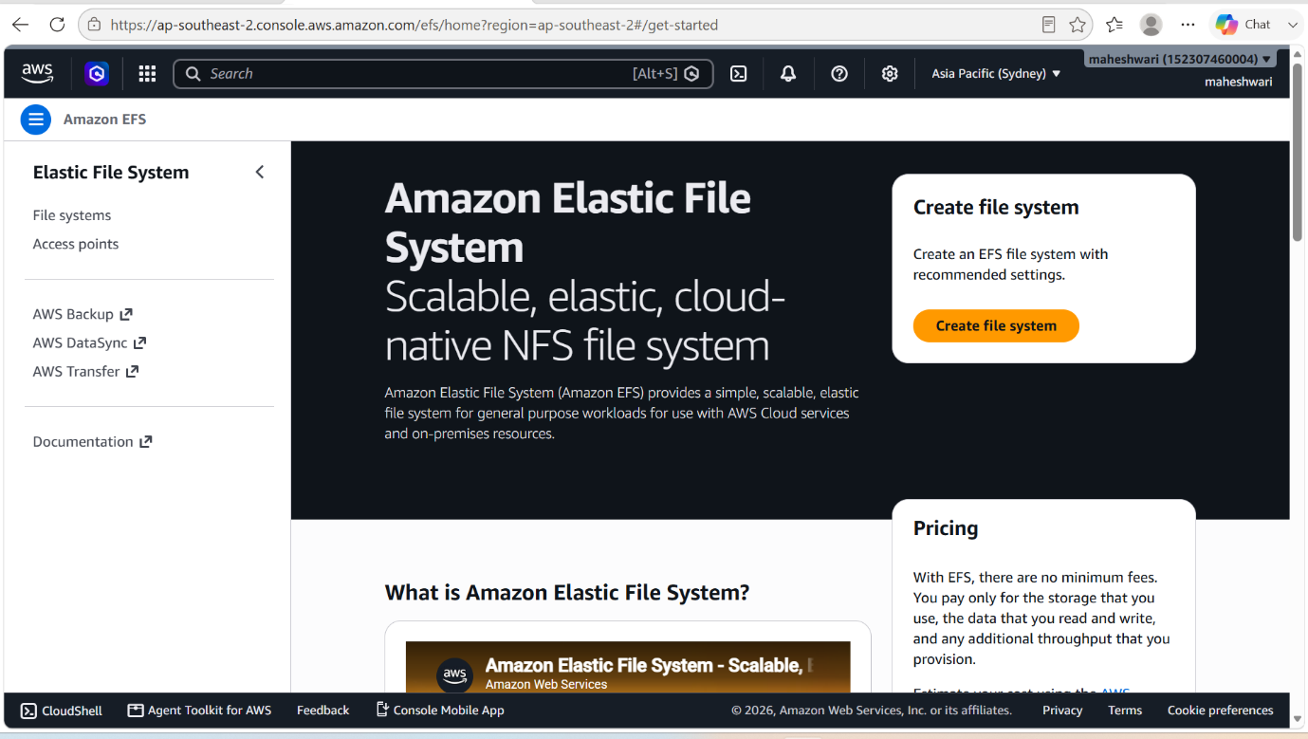

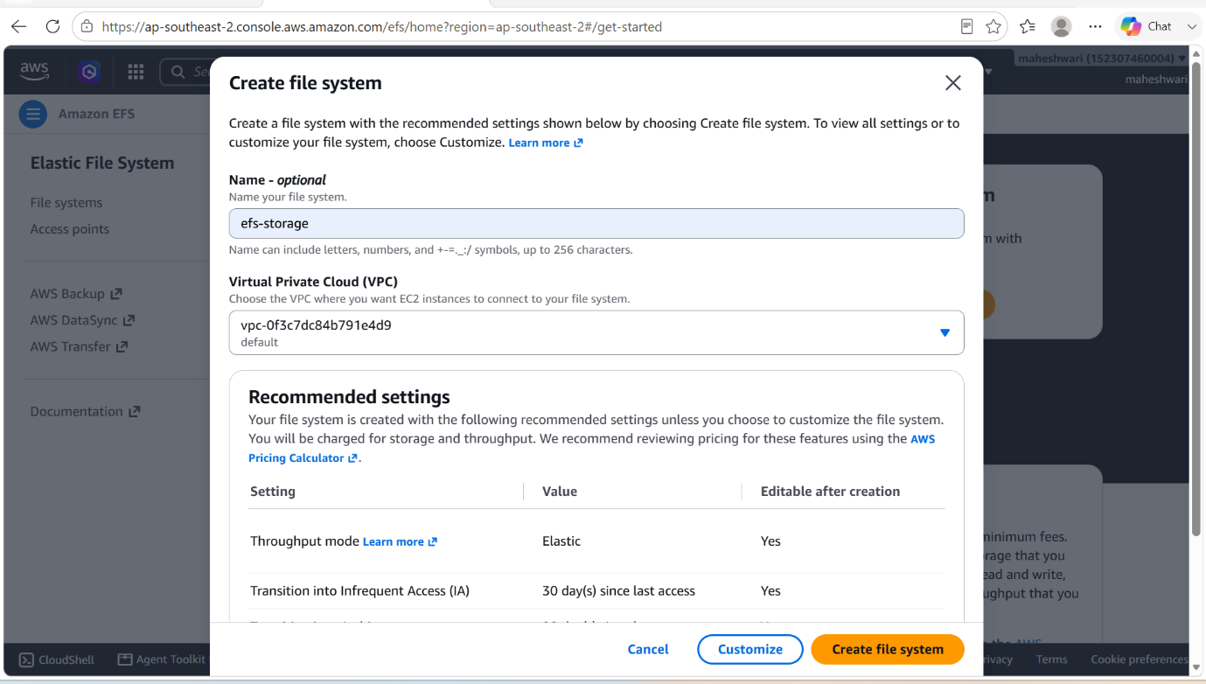

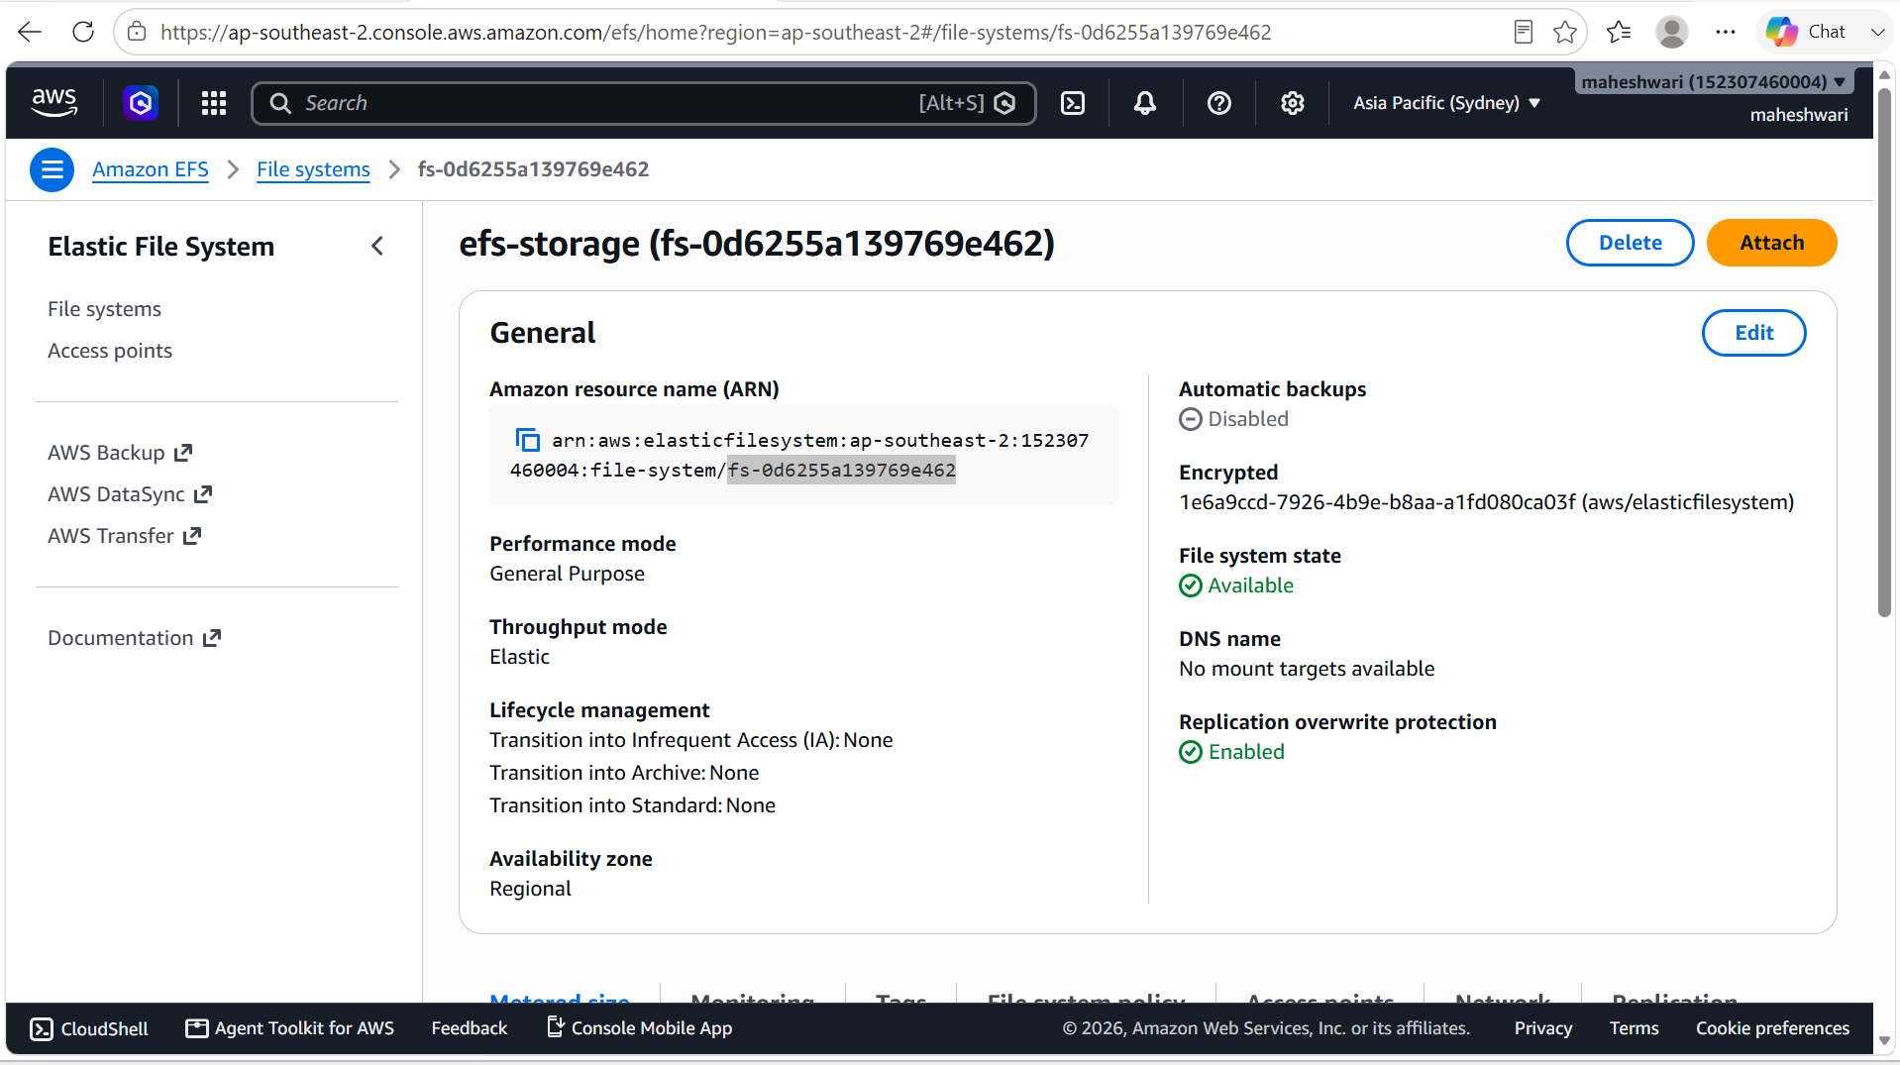

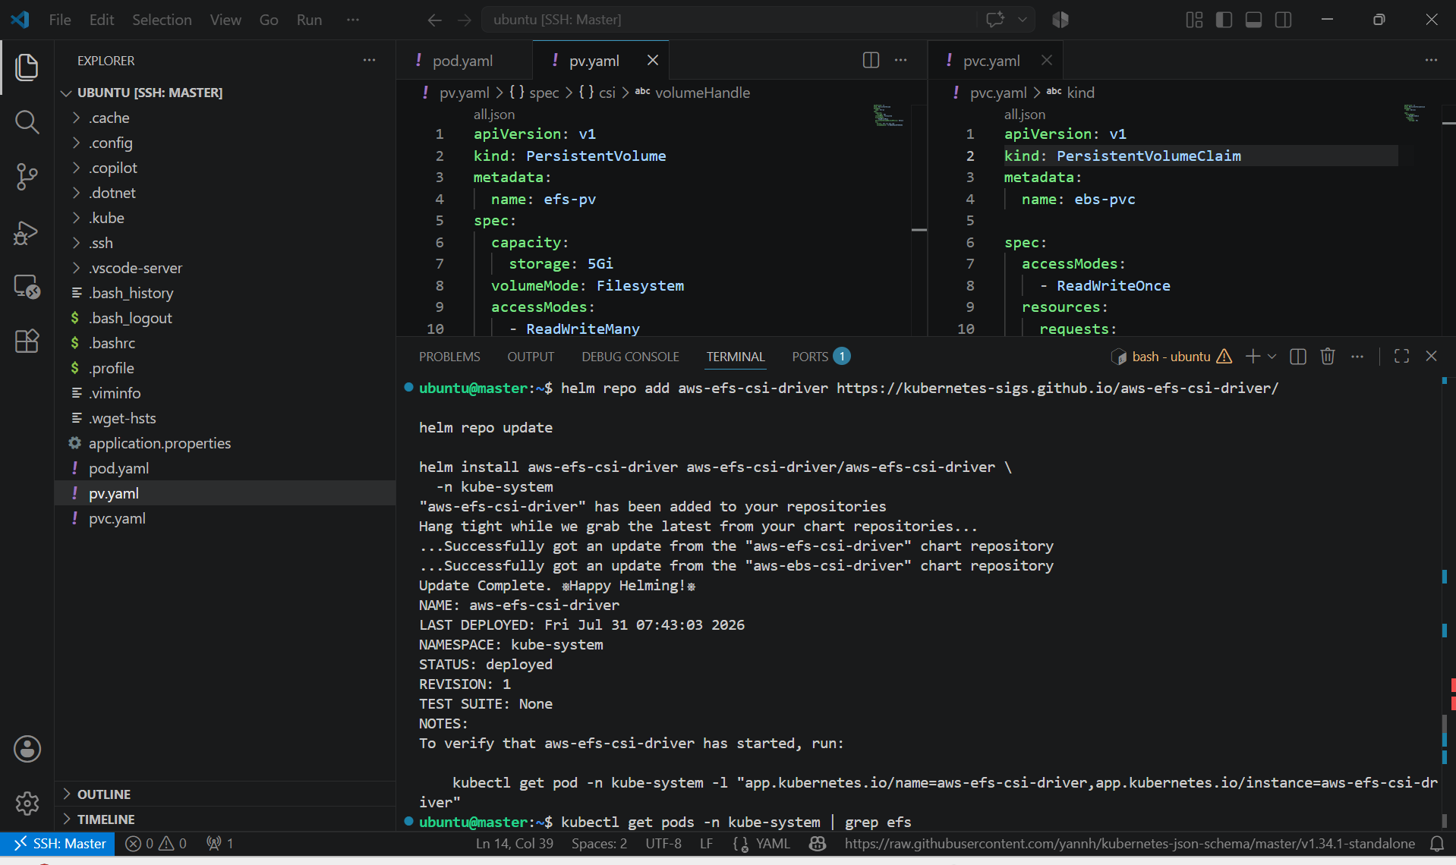

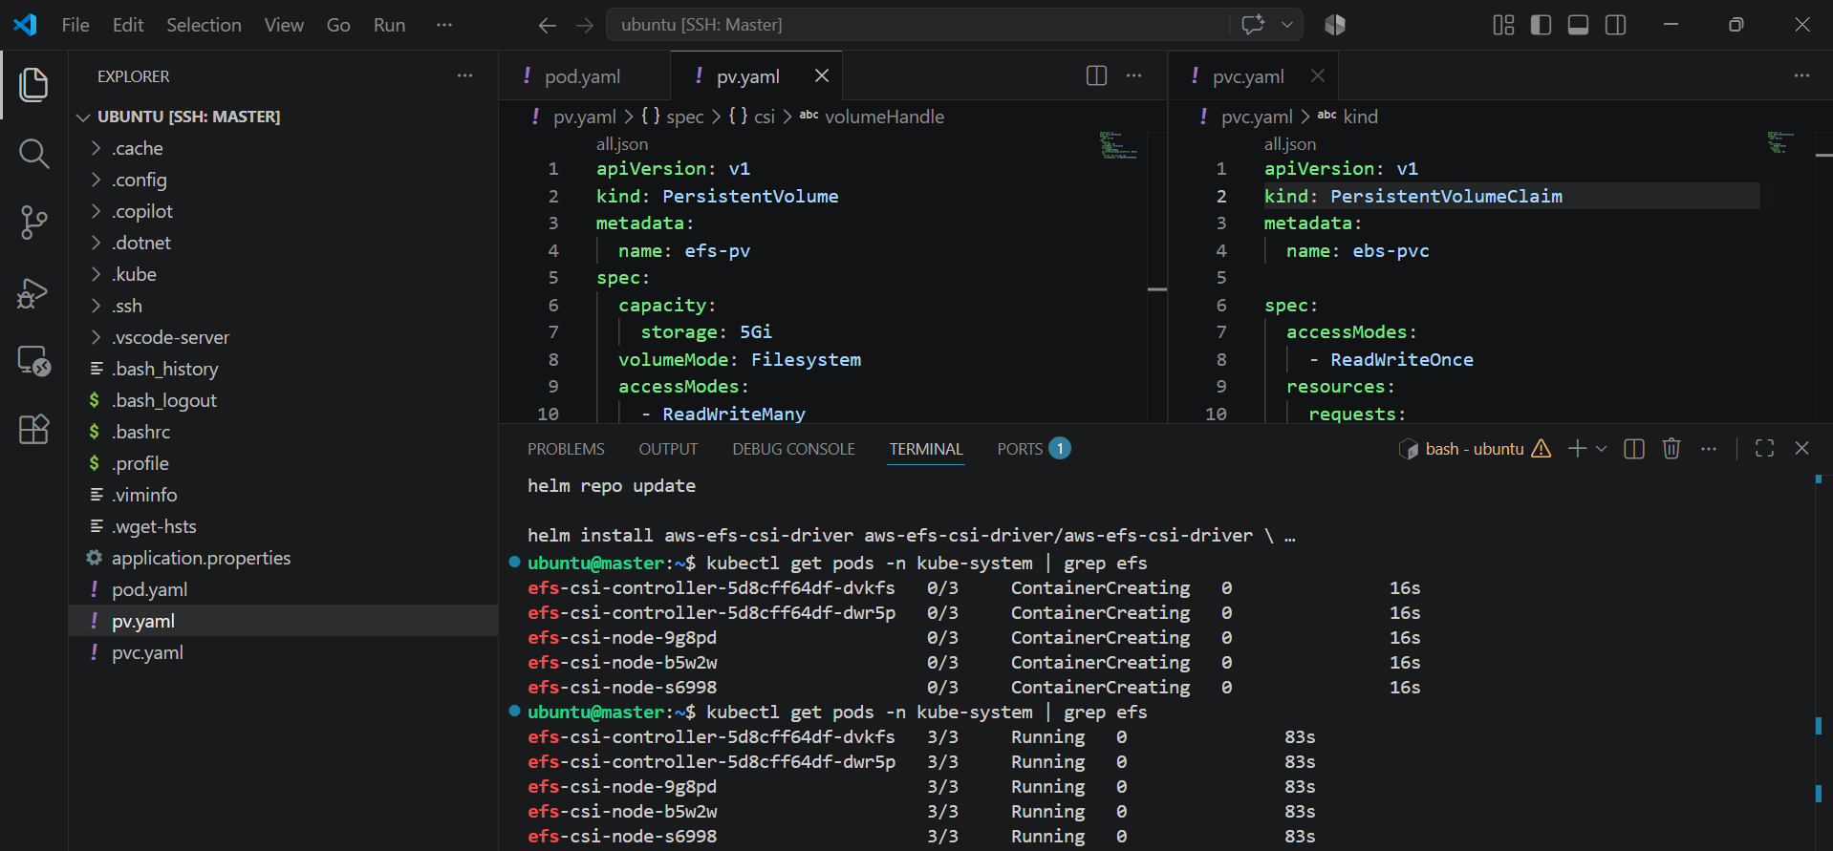

- create a file named pv.yaml and apply that file to create persistent volume -> kubectl apply -f pv.yaml
- to verify -> kubectl get pv

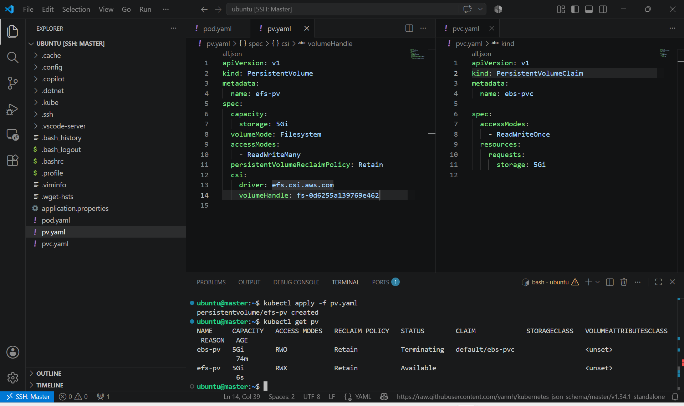

- create a file named pvc.yaml and apply that file to create a persistent volume claim
- to verify -> kubectl get pvc

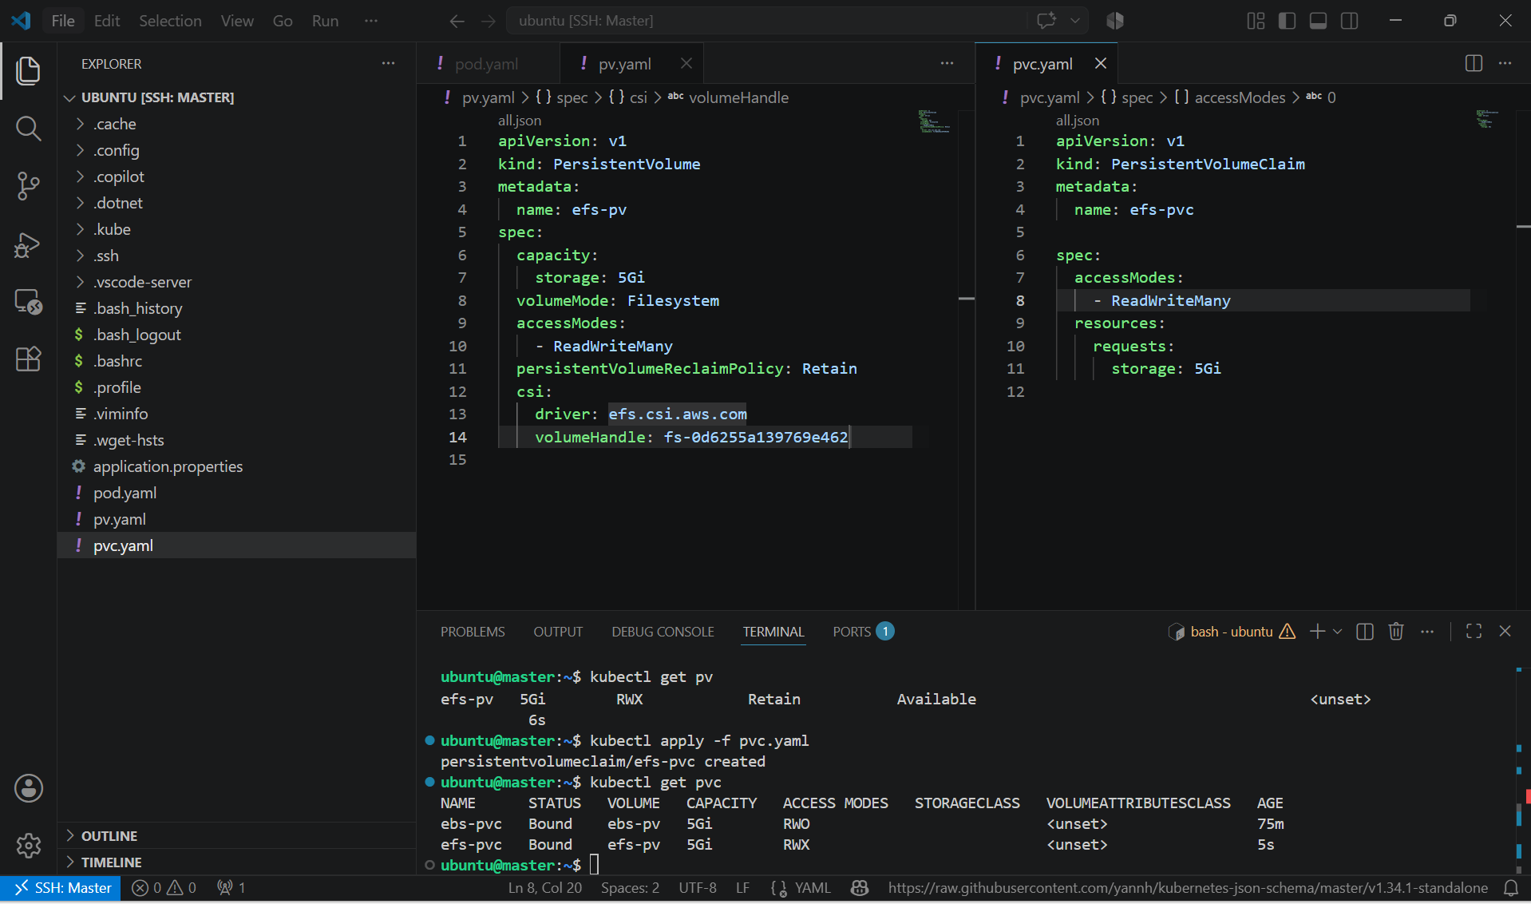

- create two pods using yaml file and pvc claim.
- First-pod:

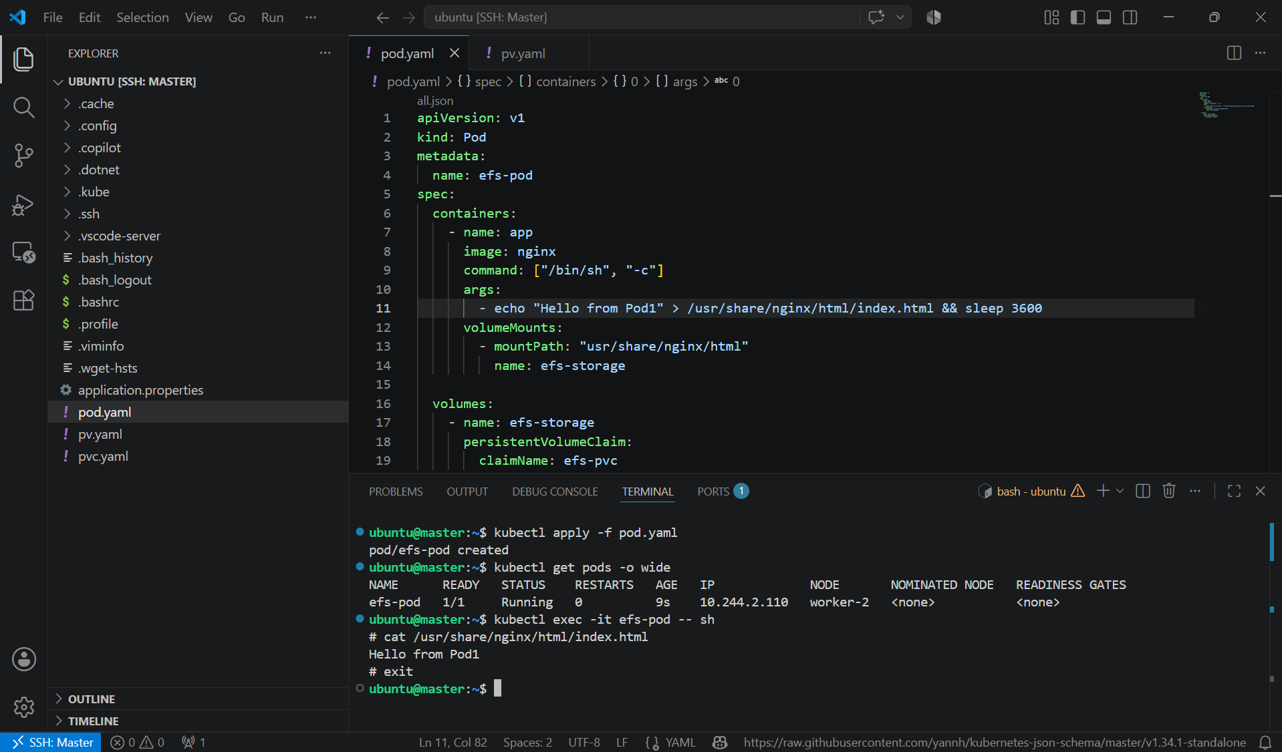

- Second-pod:

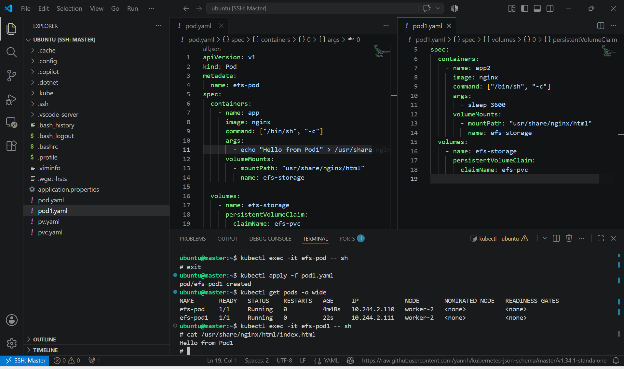

- This confirms that Pod-2 is reading the file written by Pod-1 through Amazon EFS.
- Modify the File from Pod-2 by connecting to the container.

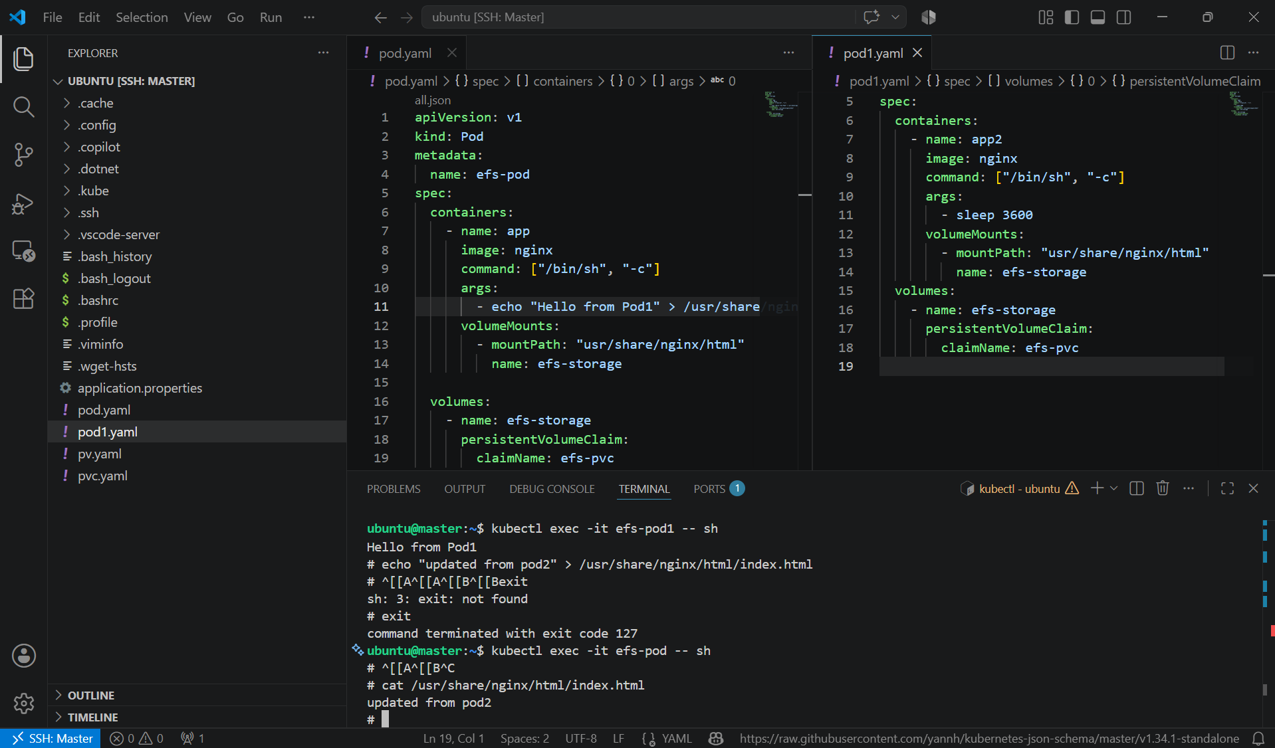

Key Learning
- Amazon EFS provides shared file storage for Kubernetes.
- Multiple Pods across different nodes can access the same volume simultaneously using ReadWriteMany (RWX).
- The Amazon EFS CSI Driver enables Kubernetes to mount EFS file systems.
- Data persists independently of Pod lifecycle.
- EFS is well suited for shared content repositories, web applications, CMS platforms, and workloads requiring concurrent access from multiple Pods.

5. Implement and Test Liveness and Readiness Probes in a Kubernetes Pod

Created an Nginx Pod with an HTTP liveness probe.
· Configured the liveness probe to check / on port 80.
· Verified that the container remained healthy with the correct port.
· Changed the liveness probe port to 8080.
· Verified that the liveness probe failed.
· Observed Kubernetes restarting the unhealthy container.
· Verified that the container restart count increased.
· Restored the liveness probe to port 80.
· Created another Nginx Pod with a readiness probe.
· Configured the readiness probe to check /index.html.
· Created a ClusterIP Service for the readiness Pod.
· Verified that the Ready Pod appeared in Service endpoints.
· Deleted the Nginx index.html file.
· Verified that the Pod changed from 1/1 to 0/1.
· Verified that the Pod remained in Running status.
· Verified that the container was not restarted.
· Confirmed that the NotReady Pod was removed from Service endpoints

Probe fails
↓
Kubernetes considers the container unhealthy
↓
Container is restarted
↓
RESTARTS count increases
Readiness failure
Probe fails
↓
Pod becomes 0/1 NotReady
↓
Container continues running
↓
RESTARTS remains unchanged
↓
Pod is removed from Service endpoints

apiVersion: v1
kind: Pod
metadata:
name: liveness-pod
labels:
app: liveness-demo
spec:
containers:
- name: nginx-container
image: nginx:latest

ports:
- containerPort: 80

livenessProbe:
httpGet:
path: /
port: 80
initialDelaySeconds: 5
periodSeconds: 5
timeoutSeconds: 2
failureThreshold: 3

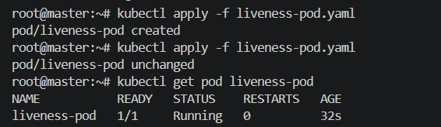

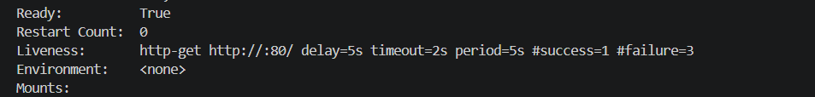

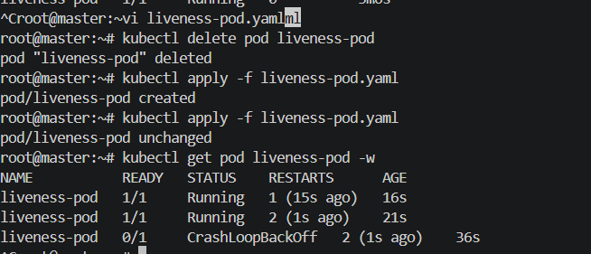

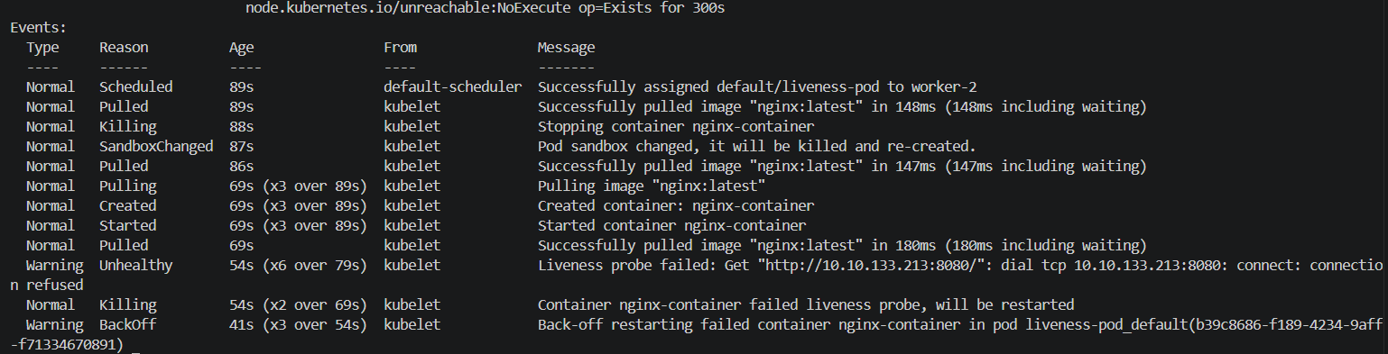

Implement and Test a Readiness Probe

