KUBERNETES-09

1. Execute all the steps shown in video.

Ingress:
========
Ingress will helps us to expose the applciations and manage
external access by providing http/https routing rules to the services
within a k8s cluster.

Ingress controller:
==================
Nothing but a load balancer which is responsible for implementing and managing Ingress resources.

We have multiple load balancer in market like
NGINX
A10
F5
Traefik
HA PROXY

Ingress is developed by k8s.
Ingress controller is developed by the load balancer companies.

Why should we use Ingress?
prior to ingress we were using load balancer service to expose our application
to outside world,but it only provides round robin algorith.

There were couple of issues for applicaitons,
for example if we have 100 services then we need to create 100 services.
It will not support different features which our load balancer's were doing.
Like path based routing,rules,whitelisting,blacklisting,tls,sticky session,hostbasedrouting.

To over come the problem Ingress has been introduced to k8s.

What needs to be done by user?
1) He needs to create one ingress.
2) He needs to create ingress controller based upon the features/capabalities we need.

Deployment.yaml:

apiVersion: apps/v1
kind: Deployment
metadata:
name: nginx-deployment
spec:
replicas: 1
selector:
matchLabels:
app: nginx
template:
metadata:
labels:
app: nginx
spec:
containers:
- name: nginx
image: nginx:latest
ports:
- containerPort: 80

Service.yaml:

apiVersion: v1
kind: Service
metadata:
name: nginx-service
spec:
selector:
app: nginx
ports:
- protocol: TCP
port: 80
targetPort: 80
nodePort: 30001
type: NodePort

ingress.yaml:

apiVersion: networking.k8s.io/v1
kind: Ingress
metadata:
name: nginx-ingress
spec:
rules:
- host: nginx.example.com
http:
paths:
- path: /
pathType: Prefix
backend:
service:
name: nginx-service
port:
number: 80

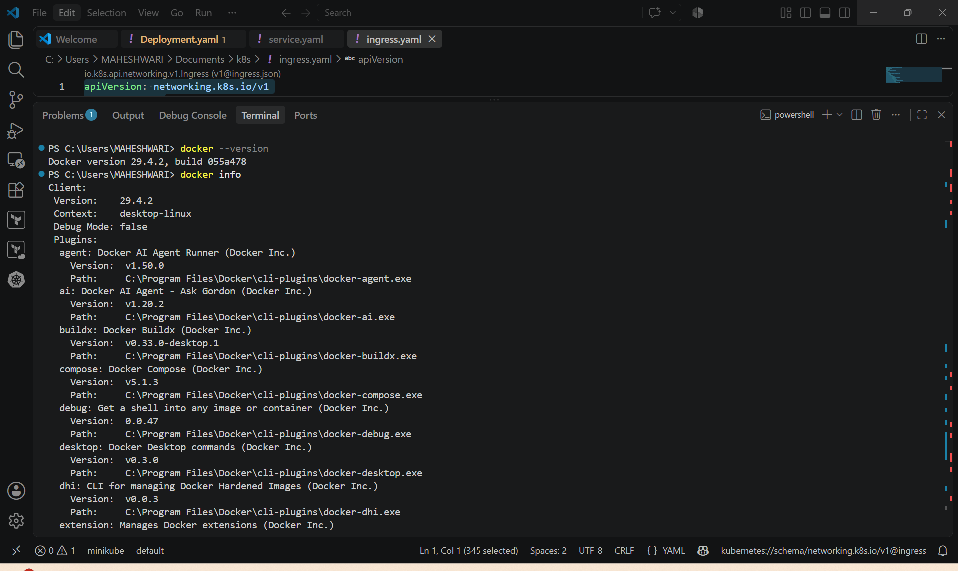

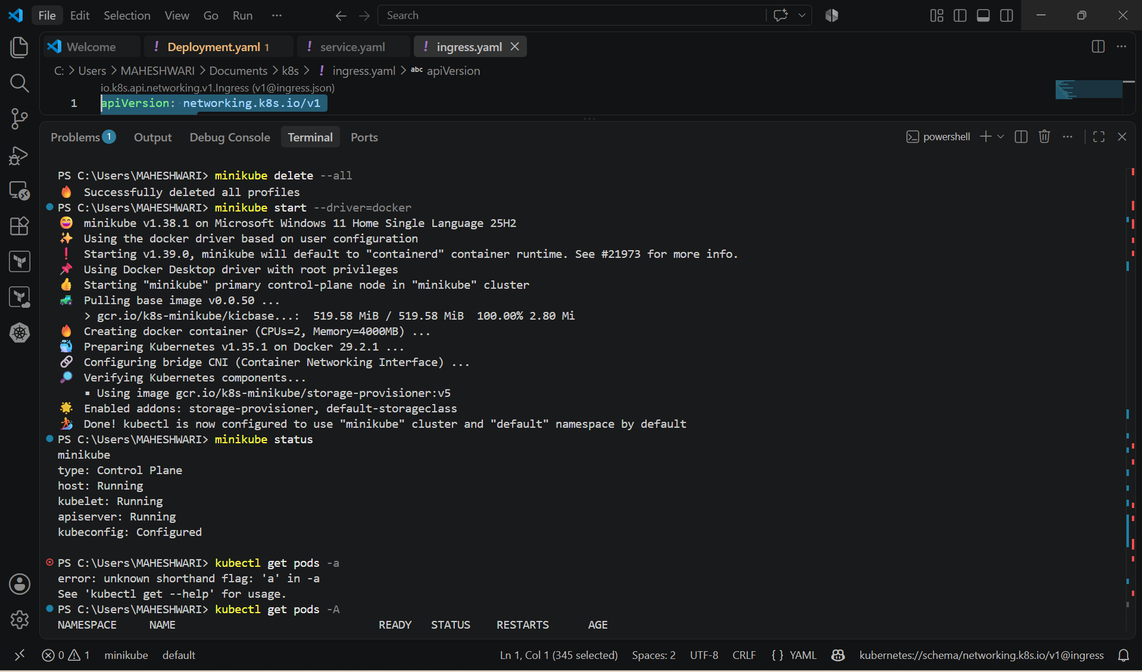

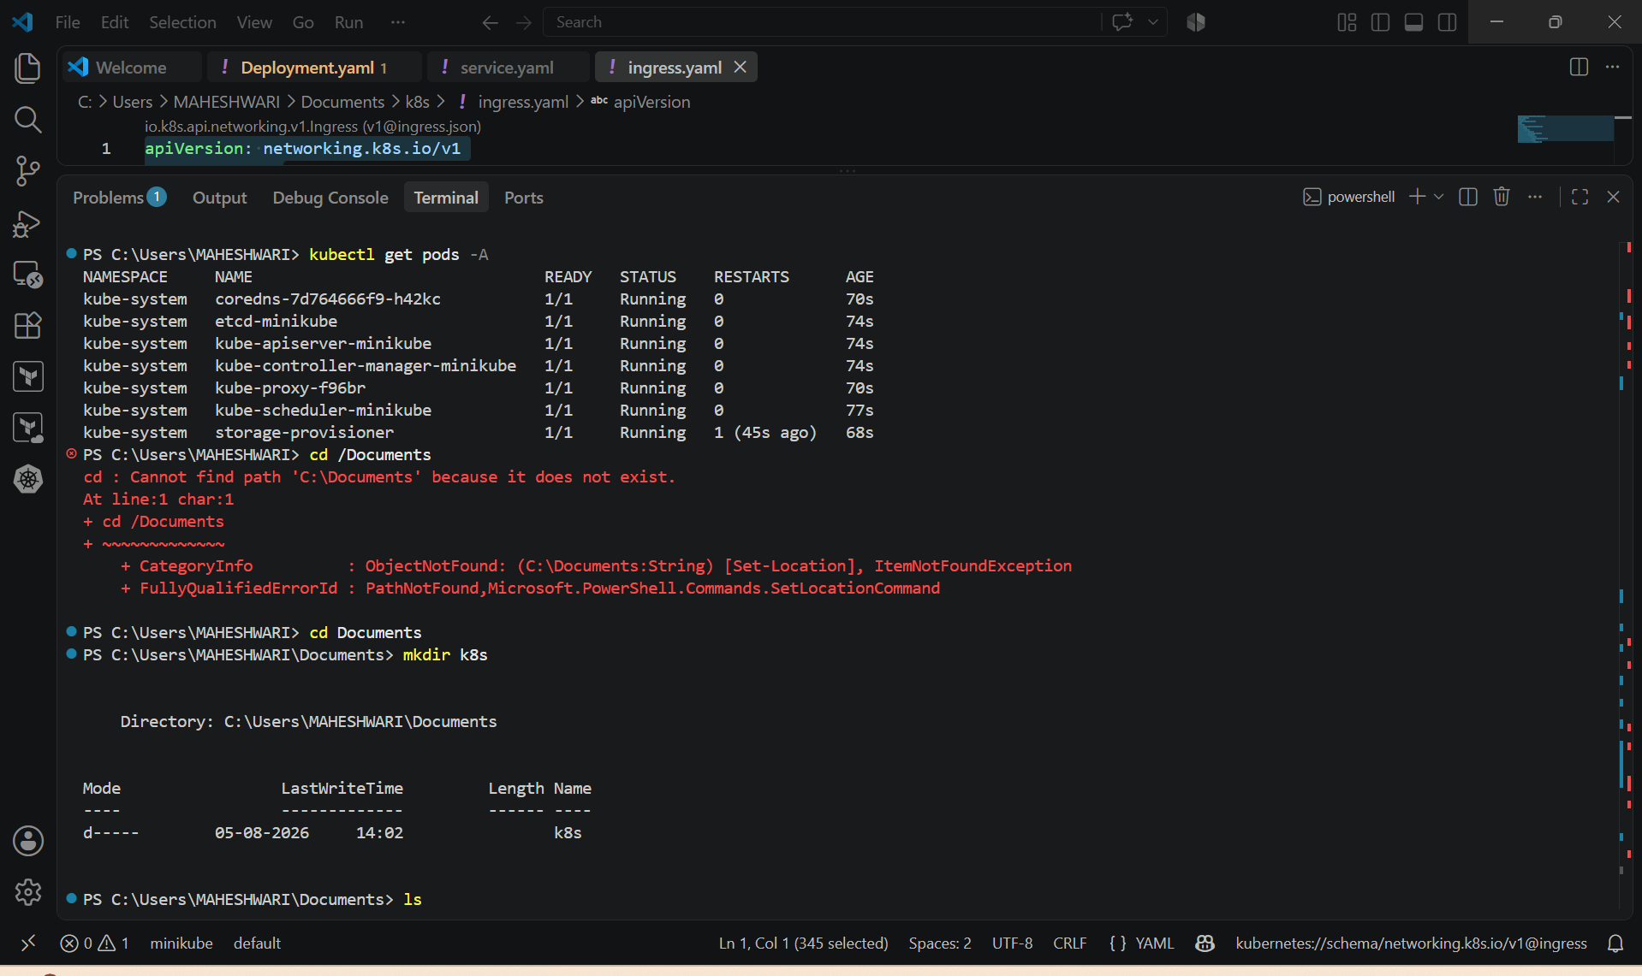

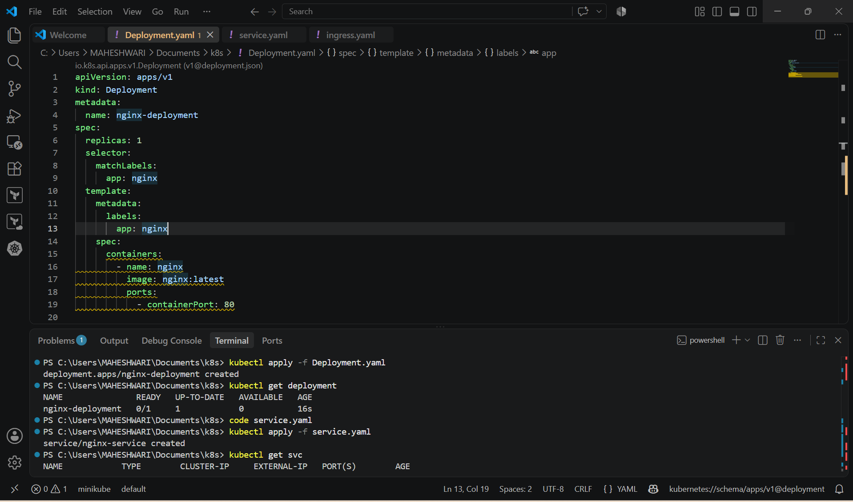

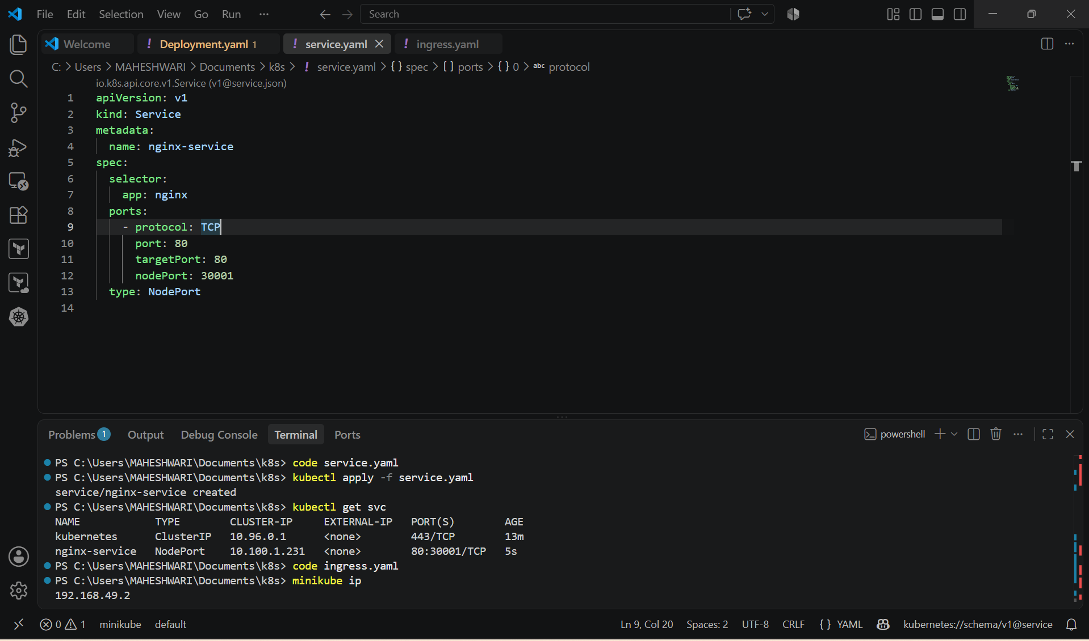

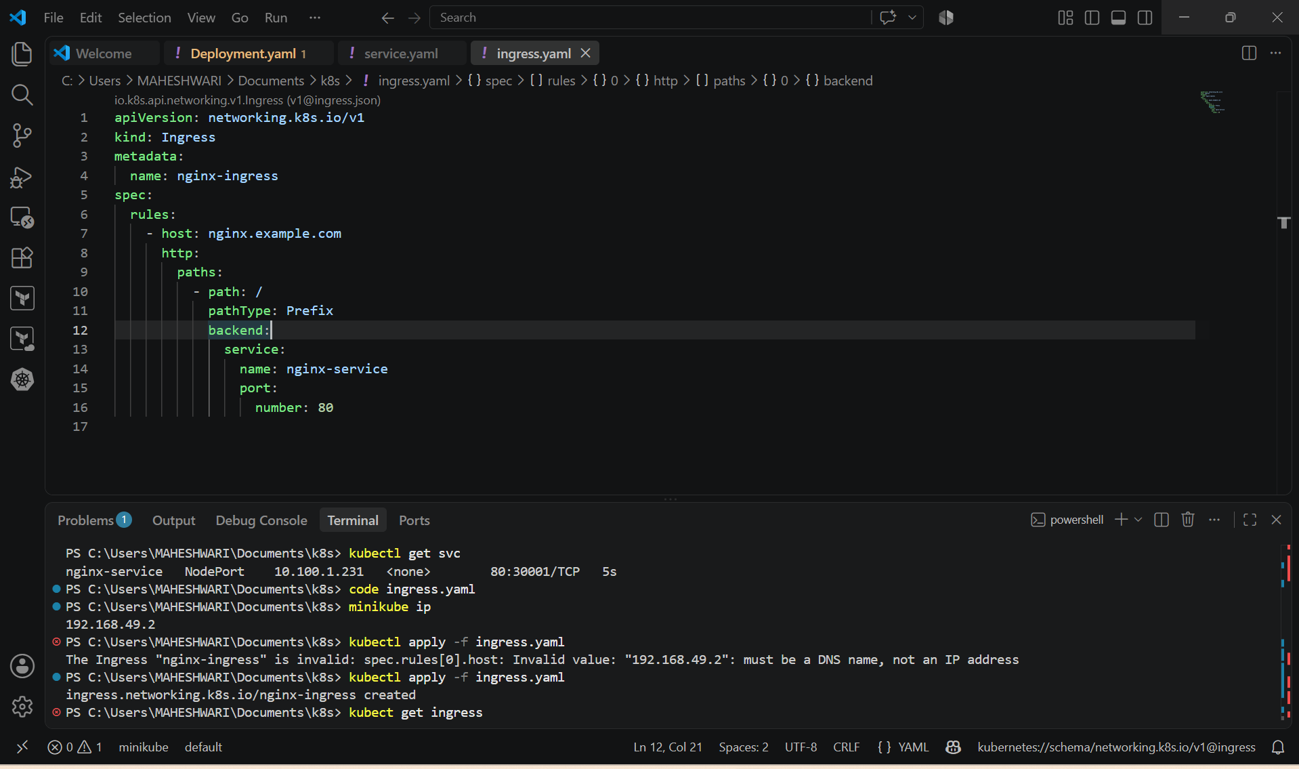

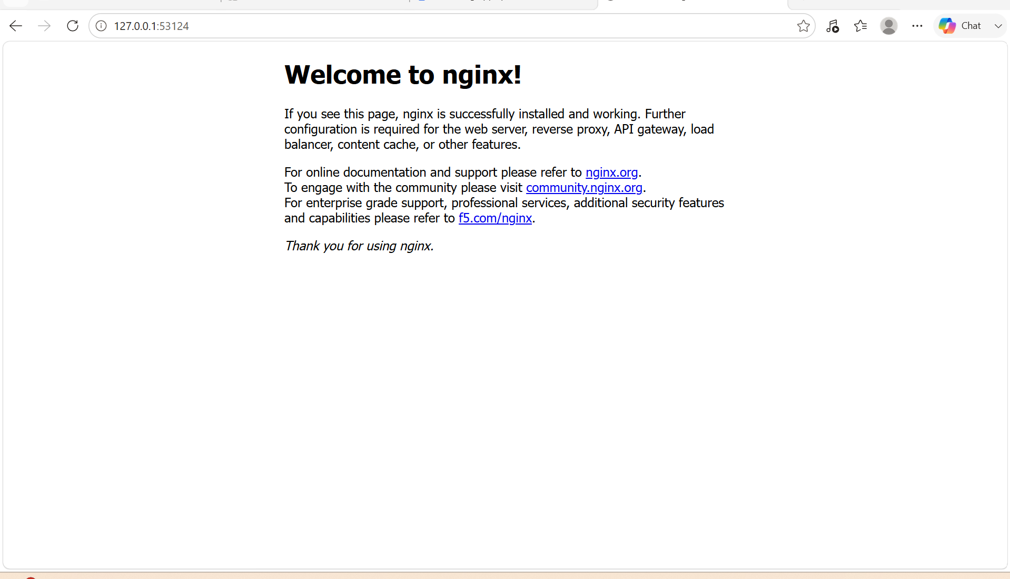

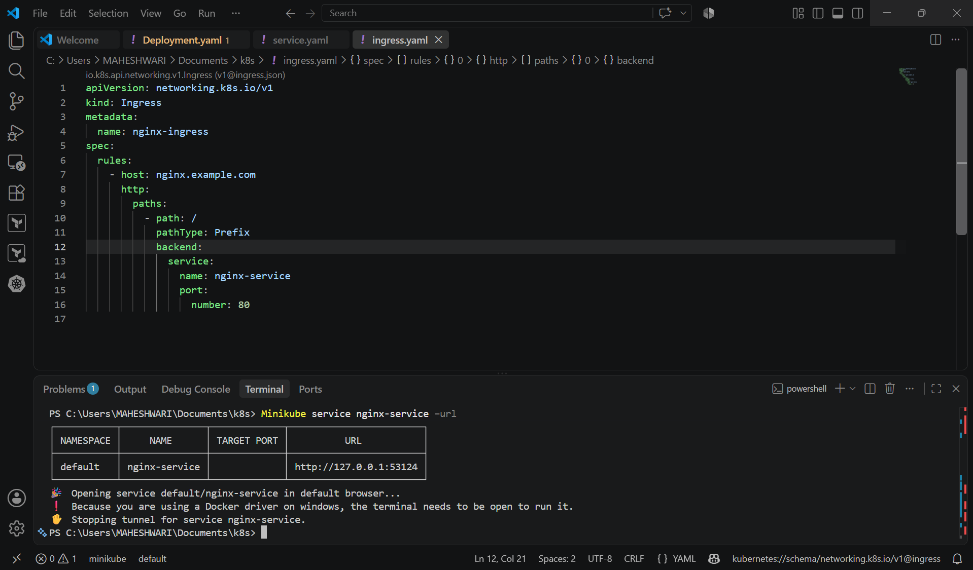

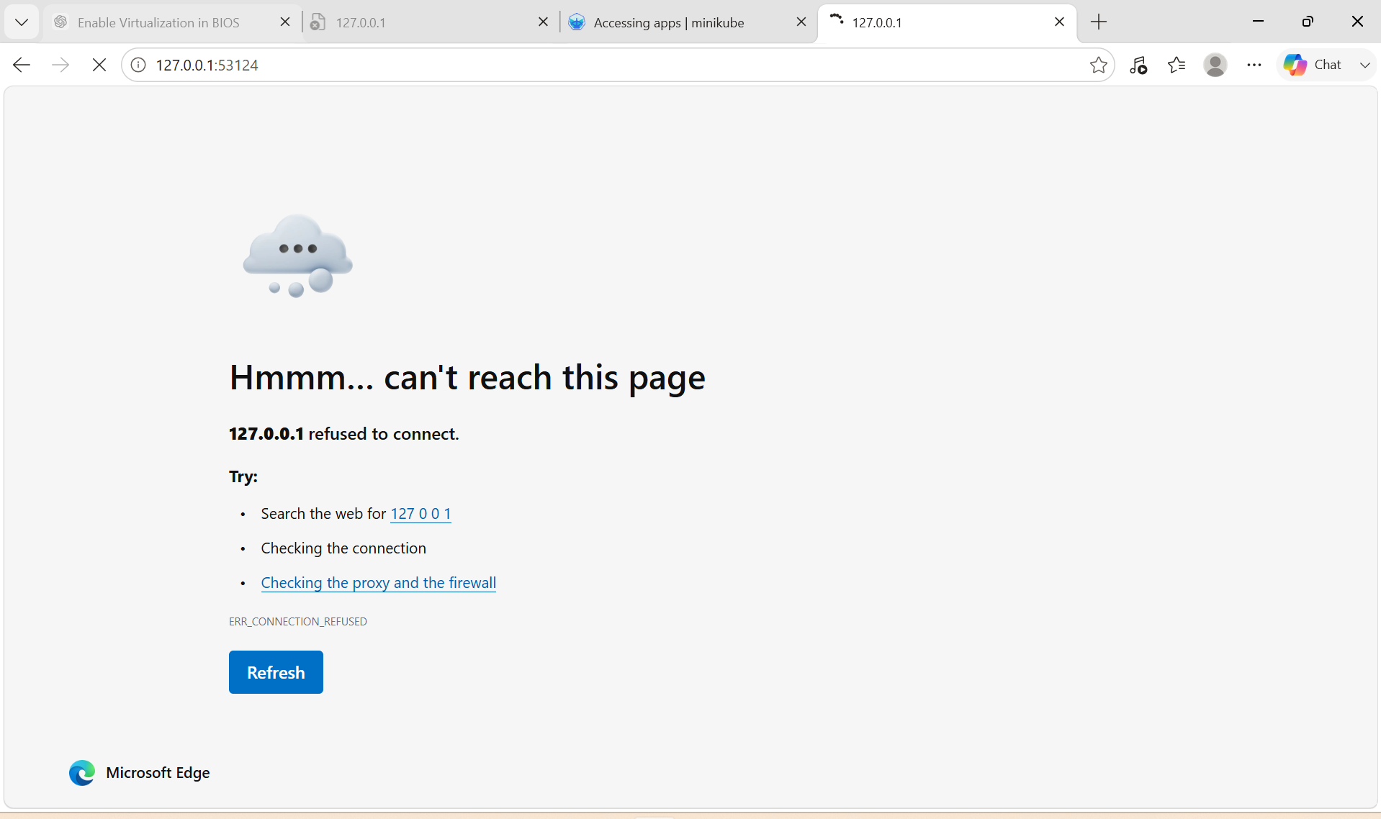

2. Upgrade k8s cluster from 1.26 to 1.28 Version. Note: Document to upgrade cluster.https://devopscube.com/upgrade-kubernetes-cluster-kubeadm/

These instructions are for Kubernetes v1.30.
Update the apt package index and install packages needed to use the Kubernetes apt
repository:
sudo apt-get update
# apt-transport-https may be a dummy package; if so, you can skip that package
sudo apt-get install -y apt-transport-https ca-certificates curl gpg
Download the public signing key for the Kubernetes package repositories. The same signing key
is used for all repositories so you can disregard the version in the URL:
# If the directory `/etc/apt/keyrings` does not exist, it should be created before the curl
command, read the note below.
# sudo mkdir -p -m 755 /etc/apt/keyrings
curl -fsSL https://pkgs.k8s.io/core:/stable:/v1.30/deb/Release.key | sudo gpg --dearmor -o
/etc/apt/keyrings/kubernetes-apt-keyring.gpg
Add the appropriate Kubernetes apt repository. Please note that this repository have packages
only for Kubernetes 1.35; for other Kubernetes minor versions, you need to change the
Kubernetes minor version in the URL to match your desired minor version (you should also
check that you are reading the documentation for the version of Kubernetes that you plan to
install).
# This overwrites any existing configuration in /etc/apt/sources.list.d/kubernetes.list
echo 'deb [signed-by=/etc/apt/keyrings/kubernetes-apt-keyring.gpg]
https://pkgs.k8s.io/core:/stable:/v1.30/deb/ /' | sudo tee /etc/apt/sources.list.d/kubernetes.list

Prerequisites
- Verify the current Kubernetes version.
- Take an etcd backup (recommended).
- Ensure all cluster nodes are in the Ready state.
- Verify internet connectivity.
- Check available Kubernetes package versions.
- Ensure you have root or sudo privileges on all nodes.

Step 1: Verify Existing Cluster Version
Run the following commands on the control plane node.
kubectl get nodes
kubectl version
kubeadm version
kubelet --version

Step 2: Upgrade the Control Plane Node
2.1 Remove Package Hold for kubeadm
sudo apt-mark unhold kubeadm

2.2 Verify Current Kubernetes Repository
cat /etc/apt/sources.list.d/kubernetes.list
If the repository is pointing to v1.34, update it to v1.35.
Remove the old repository file.
sudo rm -f /etc/apt/sources.list.d/kubernetes.list
Create the new repository.
echo "deb [signed-by=/etc/apt/keyrings/kubernetes-apt-keyring.gpg] https://pkgs.k8s.io/core:/stable:/v1.35/deb/ /" | sudo tee /etc/apt/sources.list.d/kubernetes.list
Update package information.
sudo apt update

2.3 Verify Available kubeadm Versions
apt-cache madison kubeadm

2.4 Install the Required kubeadm Version
sudo apt-get install -y kubeadm=1.35.7-1.1
Hold the package after installation.
sudo apt-mark hold kubeadm

2.5 Verify kubeadm Version
kubeadm version

2.6 Plan the Upgrade
sudo kubeadm upgrade plan
Review the available upgrade versions.

2.7 Upgrade the Control Plane
sudo kubeadm upgrade apply v1.35.7
Confirm the upgrade when prompted.

2.8 Upgrade kubelet and kubectl
Remove package hold.
sudo apt-mark unhold kubelet kubectl
Install the required versions.
sudo apt-get install -y kubelet=1.35.7-1.1 kubectl=1.35.7-1.1
Hold the packages again.
sudo apt-mark hold kubelet kubectl

2.9 Restart kubelet
sudo systemctl daemon-reload

sudo systemctl restart kubelet

2.10 Verify Control Plane
kubectl get nodes

kubectl version

Step 3: Upgrade Worker-1

3.1 Drain Worker Node
kubectl drain worker-1 --ignore-daemonsets --delete-emptydir-data

3.2 Login to Worker-1
ssh worker-1

sudo su -

3.3 Update Kubernetes Repository
Check repository.
cat /etc/apt/sources.list.d/kubernetes.list
Remove old repository.
rm -f /etc/apt/sources.list.d/kubernetes.list
Create new repository.
echo "deb [signed-by=/etc/apt/keyrings/kubernetes-apt-keyring.gpg] https://pkgs.k8s.io/core:/stable:/v1.35/deb/ /" | tee /etc/apt/sources.list.d/kubernetes.list
Update packages.
apt update
Verify available versions.
apt-cache madison kubeadm

apt-cache madison kubelet

apt-cache madison kubectl

3.4 Upgrade kubeadm
apt-mark unhold kubeadm

apt-get install -y kubeadm=1.35.7-1.1

apt-mark hold kubeadm

3.5 Upgrade Worker Node
kubeadm upgrade node

3.6 Upgrade kubelet and kubectl
apt-mark unhold kubelet kubectl

apt-get install -y kubelet=1.35.7-1.1 kubectl=1.35.7-1.1

apt-mark hold kubelet kubectl

3.7 Check kubeadm Flags
Open the kubelet flags file.
nano /var/lib/kubelet/kubeadm-flags.env
If the file contains
KUBELET_KUBEADM_ARGS="--pod-infra-container-image=registry.k8s.io/pause:3.10.1"
replace it with
KUBELET_KUBEADM_ARGS=""
Save the file.

3.8 Restart kubelet
systemctl daemon-reload

systemctl restart kubelet

3.9 Verify kubelet Service
systemctl status kubelet

3.10 Verify Installed Versions
kubeadm version

kubelet --version

kubectl version --client

3.11 Return to Master Node
exit

3.12 Enable Scheduling on Worker-1
kubectl uncordon worker-1

Step 4: Upgrade Worker-2
Repeat the same process used for Worker-1.

4.1 Drain Worker Node
kubectl drain worker-2 --ignore-daemonsets --delete-emptydir-data

4.2 Login to Worker-2
ssh worker-2

sudo su -

4.3 Update Repository
cat /etc/apt/sources.list.d/kubernetes.list

rm -f /etc/apt/sources.list.d/kubernetes.list

echo "deb [signed-by=/etc/apt/keyrings/kubernetes-apt-keyring.gpg] https://pkgs.k8s.io/core:/stable:/v1.35/deb/ /" | tee /etc/apt/sources.list.d/kubernetes.list

apt update

4.4 Verify Available Versions
apt-cache madison kubeadm

apt-cache madison kubelet

apt-cache madison kubectl

4.5 Upgrade kubeadm
apt-mark unhold kubeadm

apt-get install -y kubeadm=1.35.7-1.1

apt-mark hold kubeadm

4.6 Upgrade Worker Node
kubeadm upgrade node

4.7 Upgrade kubelet and kubectl
apt-mark unhold kubelet kubectl

apt-get install -y kubelet=1.35.7-1.1 kubectl=1.35.7-1.1

apt-mark hold kubelet kubectl

4.8 Edit kubeadm Flags
nano /var/lib/kubelet/kubeadm-flags.env
Replace
KUBELET_KUBEADM_ARGS="--pod-infra-container-image=registry.k8s.io/pause:3.10.1"
with
KUBELET_KUBEADM_ARGS=""
Save the file.

4.9 Restart kubelet
systemctl daemon-reload

systemctl restart kubelet

4.10 Verify kubelet
systemctl status kubelet

4.11 Verify Versions
kubeadm version

kubelet --version

kubectl version --client

4.12 Return to Master
exit

4.13 Enable Scheduling
kubectl uncordon worker-2

Step 5: Final Cluster Verification
Verify all nodes.
kubectl get nodes
Verify Kubernetes version.
kubectl version
Verify cluster health.
kubectl get pods -A
Verify kubelet version on each node.
kubelet --version
Verify kubeadm version.
kubeadm version

Common Issues Encountered During the Upgrade
1. kubeadm version not found
- Cause: Repository was still configured for v1.34.
- Resolution: Updated the Kubernetes repository to v1.35 and refreshed the package list with apt update.
2. kubelet and kubectl versions not found
- Cause: Worker nodes were still using the v1.34 package repository.
- Resolution: Updated the repository on each worker node to v1.35, ran apt update, and then installed the required versions.
3. Worker drain failed due to local storage
- Error indicated that pods using emptyDir could not be evicted.
- Resolution: Used:
kubectl drain <worker-node> --ignore-daemonsets --delete-emptydir-data
4. kubelet failed to start after upgrade
- Cause: The obsolete --pod-infra-container-image flag remained in /var/lib/kubelet/kubeadm-flags.env.
- Resolution: Removed the obsolete flag by changing:
KUBELET_KUBEADM_ARGS="--pod-infra-container-image=registry.k8s.io/pause:3.10.1"
to:
KUBELET_KUBEADM_ARGS=""
Then restarted the kubelet service.
5. Worker node became NotReady
- Cause: kubelet repeatedly failed to start because of the obsolete flag.
- Resolution: Corrected the kubelet flags, restarted the kubelet service, verified it was running, and then uncordoned the node.
6. apt-cache madison returned no package versions
- Cause: The repository configuration had not been refreshed or was still pointing to the previous Kubernetes release.
- Resolution: Verified the repository configuration, ran apt update, and then confirmed available package versions using apt-cache madison.

