KUBERNETES-10

1. Setup eks cluster using eksctl

PURPOSE: The purpose of this task is to create a fully managed Kubernetes cluster on Amazon Elastic Kubernetes Service (EKS) using the eksctl command-line tool. eksctl automates the creation of all the AWS resources required for an EKS cluster, such as the control plane, worker nodes, VPC components (if needed), IAM roles, and CloudFormation stacks.

OBJECTIVE:
The objective of this exercise is to:
- Create an Amazon EKS cluster using eksctl.
- Deploy managed worker nodes for running containerized applications.
- Configure kubectl to communicate with the EKS cluster.
- Verify that the Kubernetes control plane and worker nodes are functioning correctly.
- Prepare the cluster for deploying Kubernetes workloads and applications.

PREREQUISITES:
Before creating the cluster, ensure the following are available:
- AWS Account
- IAM User with AdministratorAccess (or required EKS permissions)
- AWS CLI installed and configured
- kubectl installed
- eksctl installed
- EC2 instance (Amazon Linux/Ubuntu) or local machine with internet connectivity

ARCHITECTURE:

AWS Cloud
|
Amazon EKS Control Plane
|
-------------------------------
| |
Managed Node Group Managed Node Group
| |
EC2 Worker Nodes EC2 Worker Nodes
|
Kubernetes Pods

STEP BY STEP IMPLEMENTATION:

Step 1: Verify AWS CLI
aws --version

Step 2: Verify AWS Credentials
aws configure
Provide:
- AWS Access Key
- AWS Secret Key
- Region (Example: us-east-1)
- Output format (json)
Verify:
aws sts get-caller-identity

Step 3: Verify kubectl
kubectl version --client

Step 4: Verify eksctl
eksctl version

Step 5: Create the EKS Cluster
Example:
eksctl create cluster \
--name demo-cluster \
--region us-east-1 \
--version 1.34 \
--nodegroup-name workers \
--node-type t3.medium \
--nodes 2 \
--nodes-min 2 \
--nodes-max 3 \
--managed
This command creates:
- EKS Control Plane
- Managed Node Group
- Two EC2 worker nodes
- Required IAM Roles
- Security Groups
- Networking Components (if needed)
- CloudFormation stacks

Step 6: Verify Cluster Creation
eksctl get cluster
Example output:
NAME REGION
demo-cluster us-east-1

Step 7: Verify Node Group
eksctl get nodegroup --cluster demo-cluster

Step 8: Update kubeconfig
aws eks update-kubeconfig \
--region us-east-1 \
--name demo-cluster

Step 9: Verify Cluster Connectivity
kubectl cluster-info

Step 10: Verify Worker Nodes
kubectl get nodes
Expected output:
NAME STATUS ROLES AGE
ip-192-168-xx-xx.ec2.internal Ready <none> 5m
ip-192-168-yy-yy.ec2.internal Ready <none> 5m

Step 11: Verify System Pods
kubectl get pods -A
Important system pods include:
- CoreDNS
- kube-proxy
- AWS VPC CNI
- EKS add-ons
All should be in the Running state.

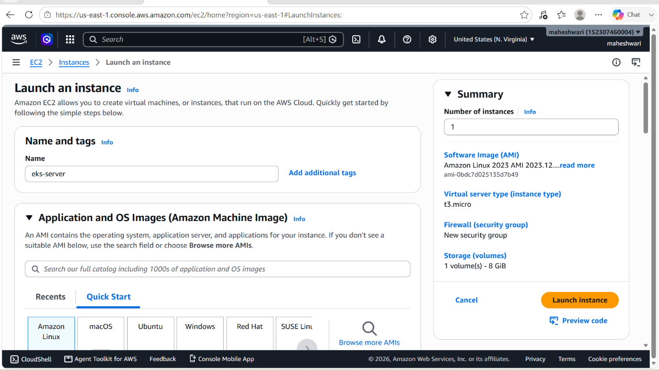

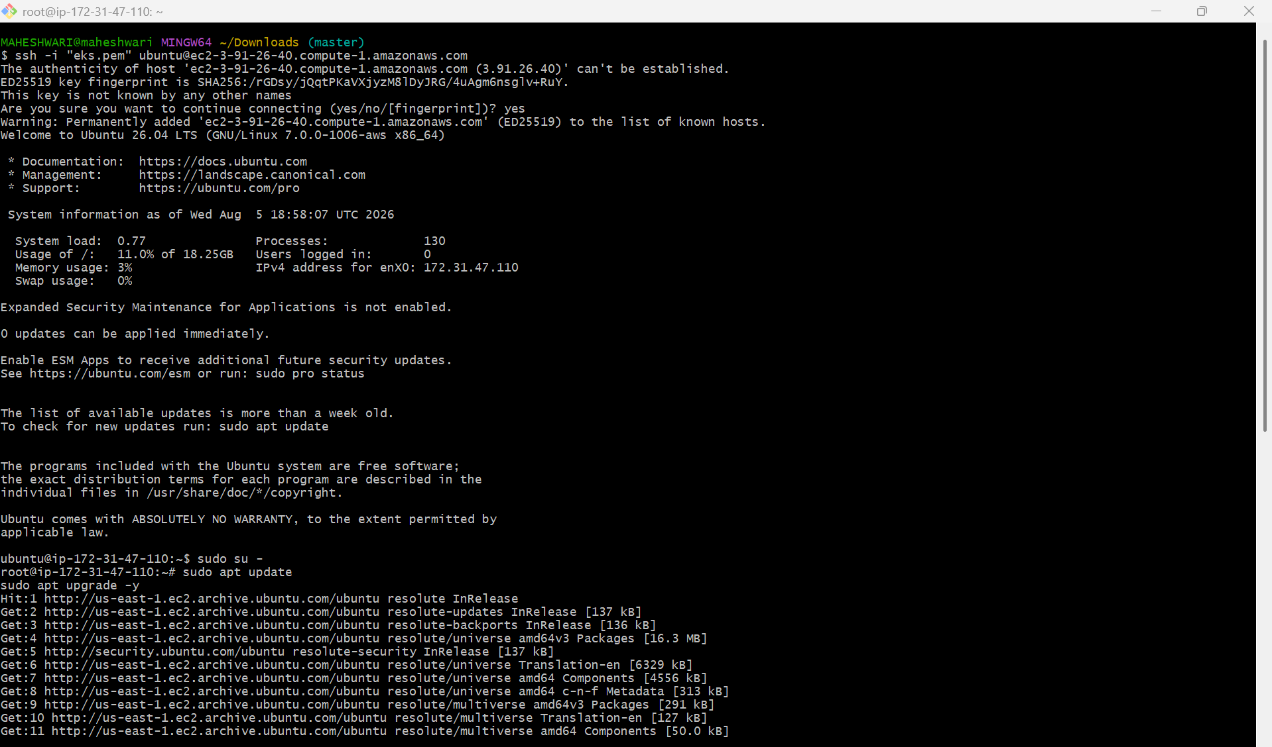

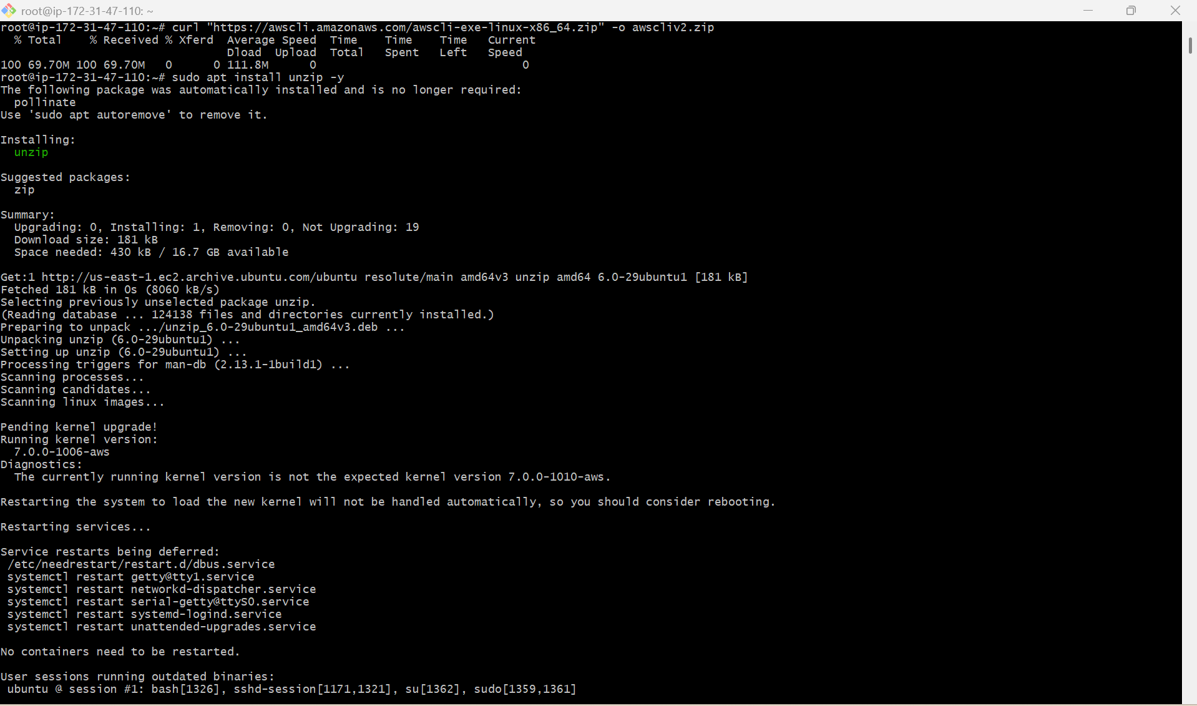

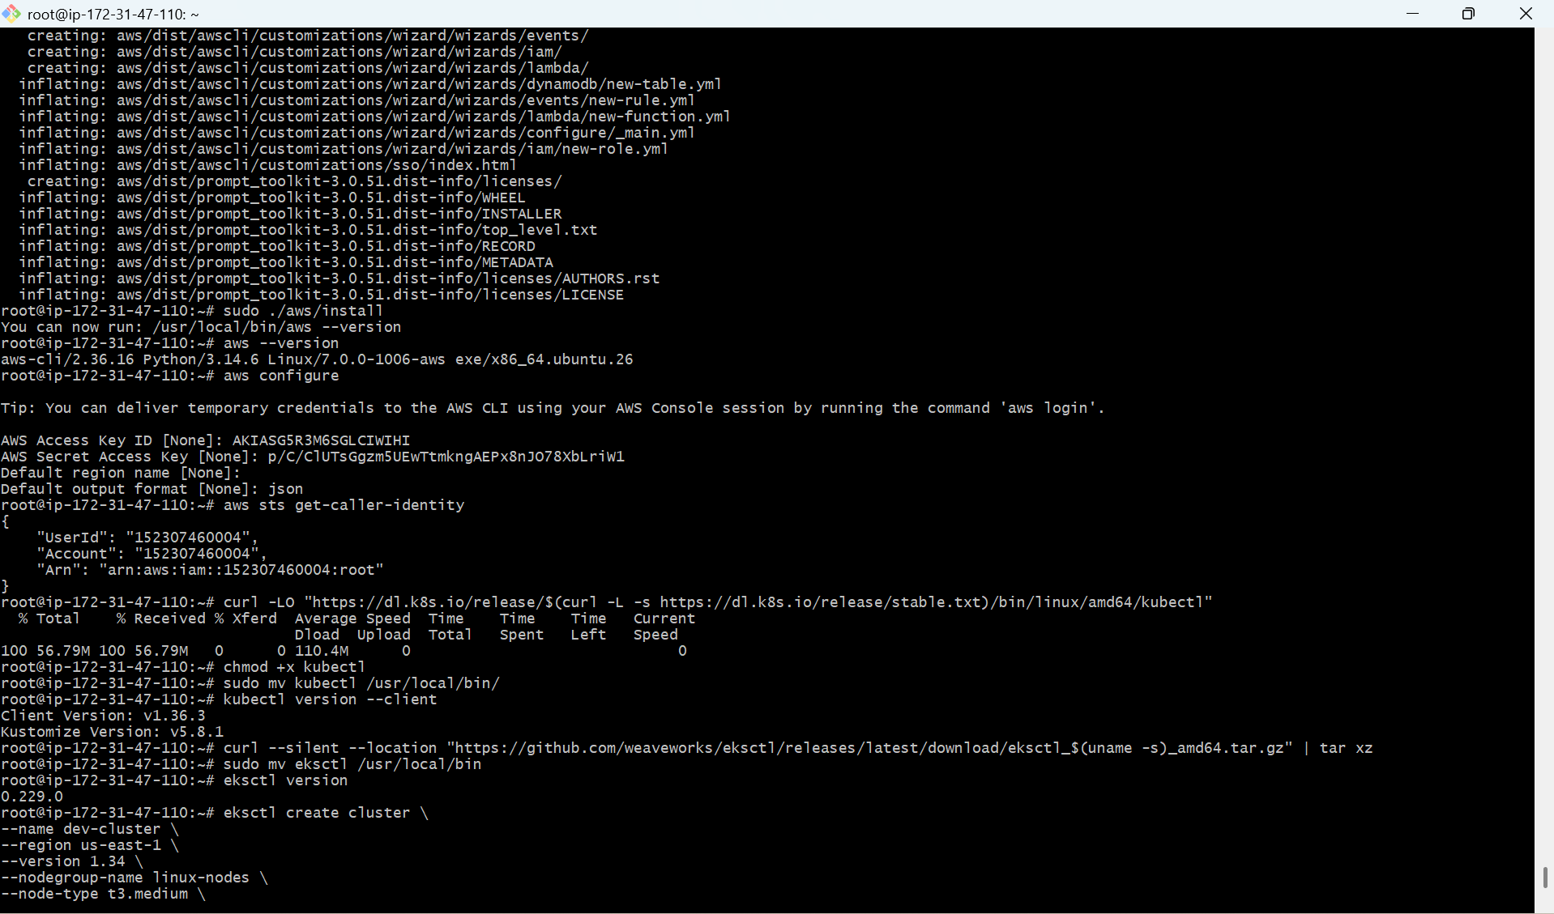

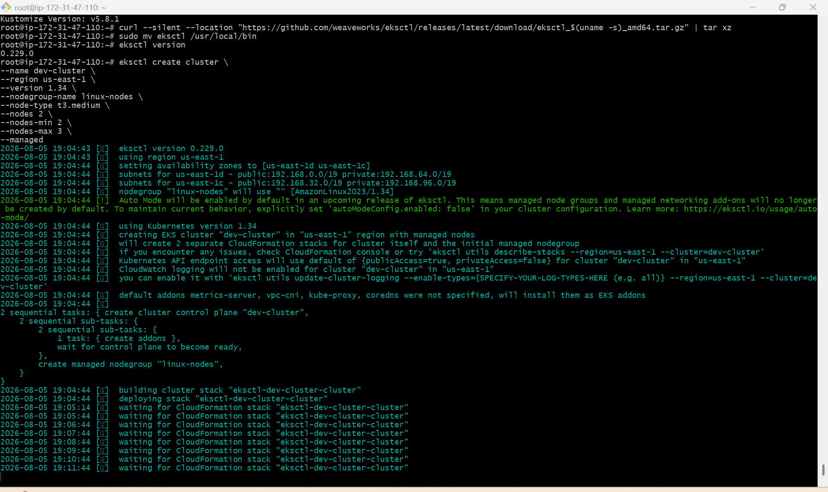

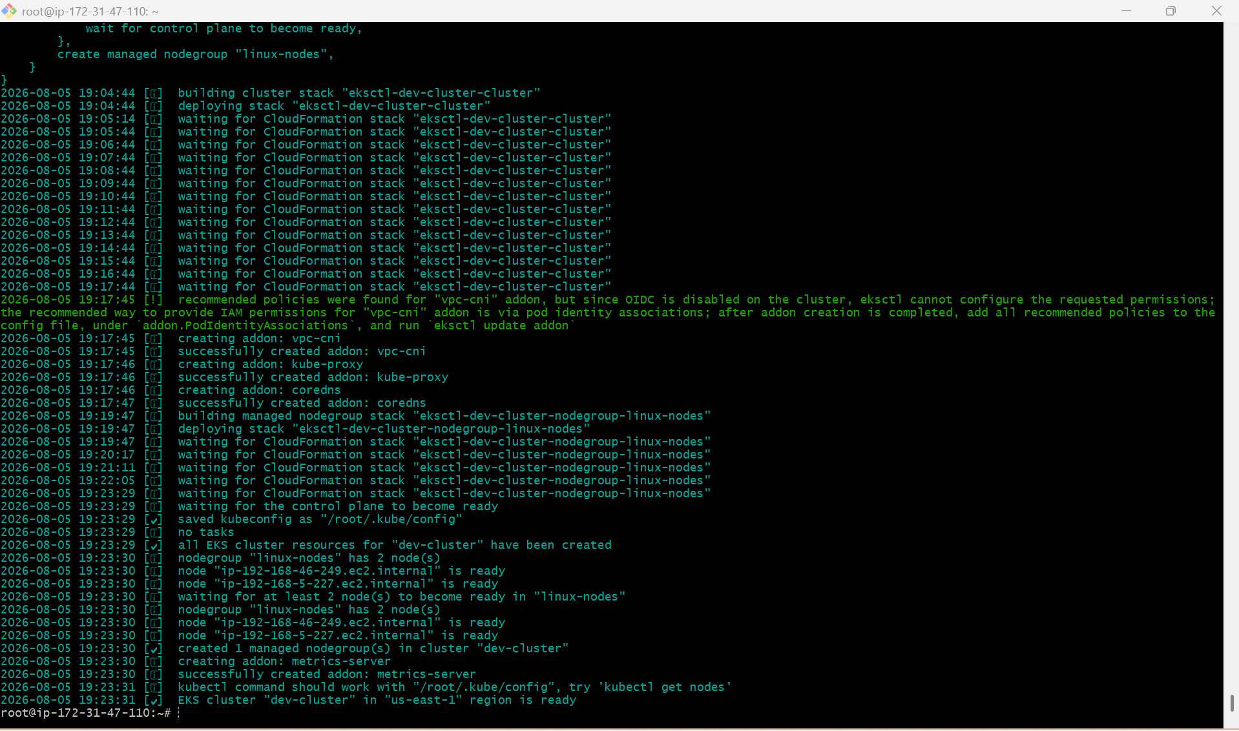

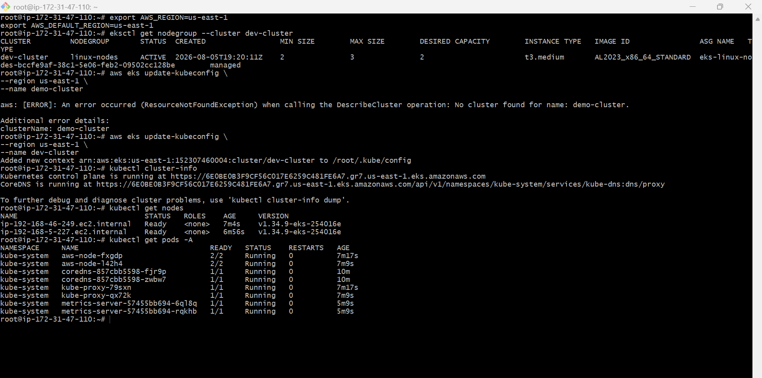

2. setup eks cluster using console

Prerequisites
Before creating the cluster, ensure you have:
- AWS Account
- IAM user with AdministratorAccess (or required EKS permissions)
- AWS Region selected (example: US East (N. Virginia) - us-east-1)
- Default VPC available (or create a custom VPC)

Step 1: Login to AWS Console
- Open AWS Console.
- Search for EKS.
- Click Elastic Kubernetes Service (EKS).

Step 2: Create an IAM Role for the EKS Cluster
- Open IAM.
- Click Roles.
- Click Create role.
Choose
- Trusted entity
  - AWS service
- Use case
  - EKS - Cluster
Click Next.
Attach policy
- AmazonEKSClusterPolicy
Click
- Next
- Role name
Example
eks-cluster-role
Click Create Role.

Step 3: Create IAM Role for Worker Nodes
Again create another role.
Trusted entity
- AWS Service
Use case
- EC2
Attach these policies:
AmazonEKSWorkerNodePolicy

AmazonEC2ContainerRegistryPullOnly

AmazonEKS_CNI_Policy
Role name
eks-node-role
Create the role.

Step 4: Create EKS Cluster
Go to
AWS Console
→ EKS
→ Clusters
→ Create Cluster
Select
Create

Cluster Configuration
Cluster name
dev-cluster
Kubernetes Version
1.34
Cluster IAM Role
eks-cluster-role
Secrets Encryption
Leave default.
Click
Next

Step 5: Networking
Select your VPC.
Example
Default VPC
Select at least 2 public or private subnets in different Availability Zones.
Example
Subnet-1 (us-east-1a)

Subnet-2 (us-east-1b)
Security Group
Use default or create one.
Endpoint Access
Choose
Public
(Optional)
Enable both
Public and Private
Click
Next

Step 6: Logging
Optional
Enable all logs:
- API
- Audit
- Authenticator
- Controller Manager
- Scheduler
Click
Next

Step 7: Review
Review everything.
Click
Create
Cluster creation takes approximately 10–15 minutes.

Step 8: Create Managed Node Group
Once cluster status becomes Active:
Open
Cluster
→ Compute
→ Add Node Group

Node Group Details
Name
linux-nodes
Node IAM Role
eks-node-role
Click
Next

Step 9: Configure Nodes
AMI Type
Amazon Linux 2023
Capacity Type
On-Demand
Instance Type
t3.medium
Disk Size
20 GB
Scaling
Desired
2
Minimum
2
Maximum
3
Click
Next

Step 10: Select Subnets
Choose the same subnets used by the cluster.
Click
Next

Step 11: Review
Click
Create
Wait around 5–10 minutes for the node group to become Active.

Step 12: Verify the Cluster
Go to:
EKS
→ Clusters
→ dev-cluster
You should see:
Status:
Active
Under Compute, verify:
Node Group:
linux-nodes

Status:
Active

Desired:
2

Ready:
2

Step 13: Connect to the Cluster (Optional)
If you want to manage the cluster using kubectl, install the AWS CLI and kubectl, then update your kubeconfig:
aws configure

aws eks update-kubeconfig \
--region us-east-1 \
--name dev-cluster
Verify connectivity:
kubectl get nodes
Expected output:
NAME STATUS ROLES AGE VERSION
ip-192-168-xx-xx.ec2.internal Ready <none> 2m v1.34.x
ip-192-168-yy-yy.ec2.internal Ready <none> 2m v1.34.x

Architecture

Internet
|
AWS Load Balancer
|
Amazon EKS Control Plane
|
-------------------------------
| |
Worker Node 1 Worker Node 2
(t3.medium) (t3.medium)
| |
+----------- Kubernetes -------+
Pods & Services

Summary
- Created an IAM role for the EKS control plane.
- Created an IAM role for worker nodes.
- Created an EKS cluster (dev-cluster) using the AWS Console.
- Configured networking with a VPC and subnets across multiple Availability Zones.
- Added a managed node group (linux-nodes) with two t3.medium instances.
- Verified the cluster and node group are active.
- (Optional) Connected to the cluster using the AWS CLI and kubectl to manage workloads.

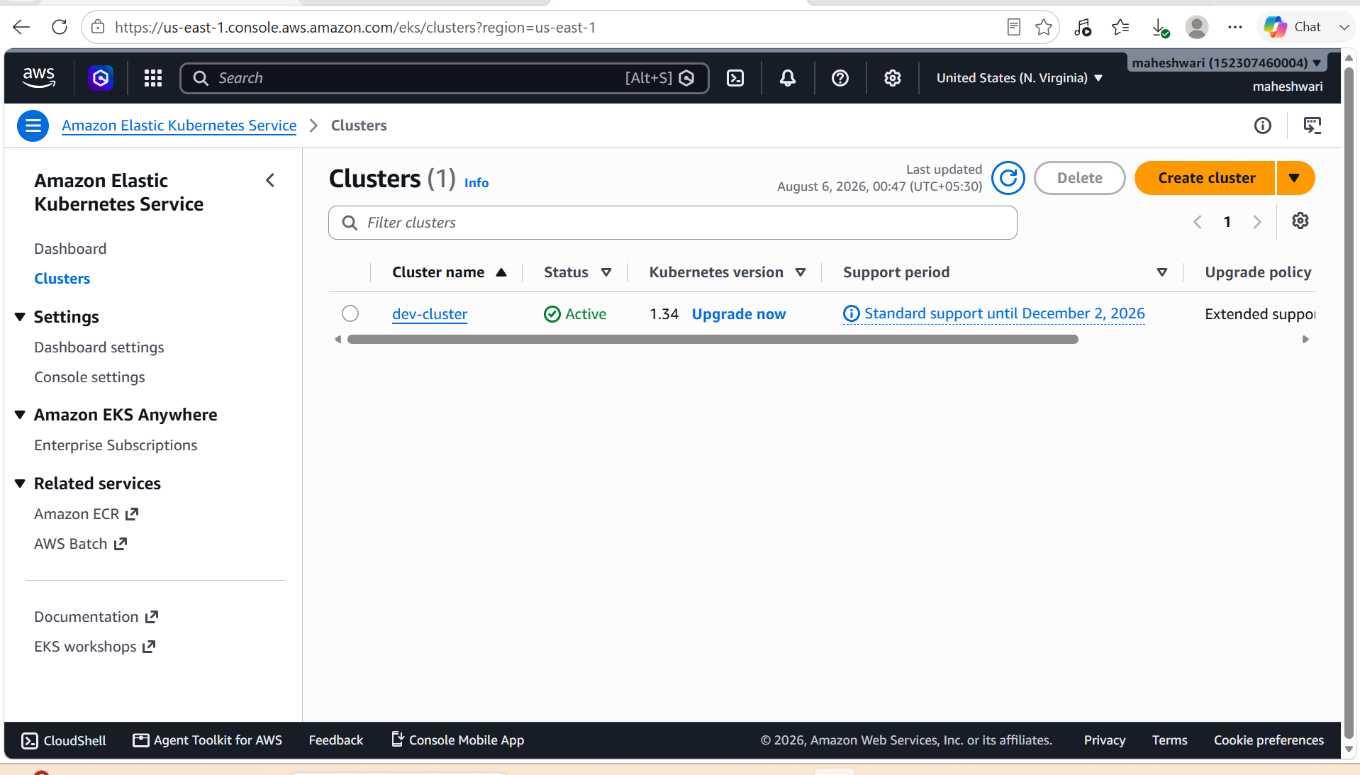

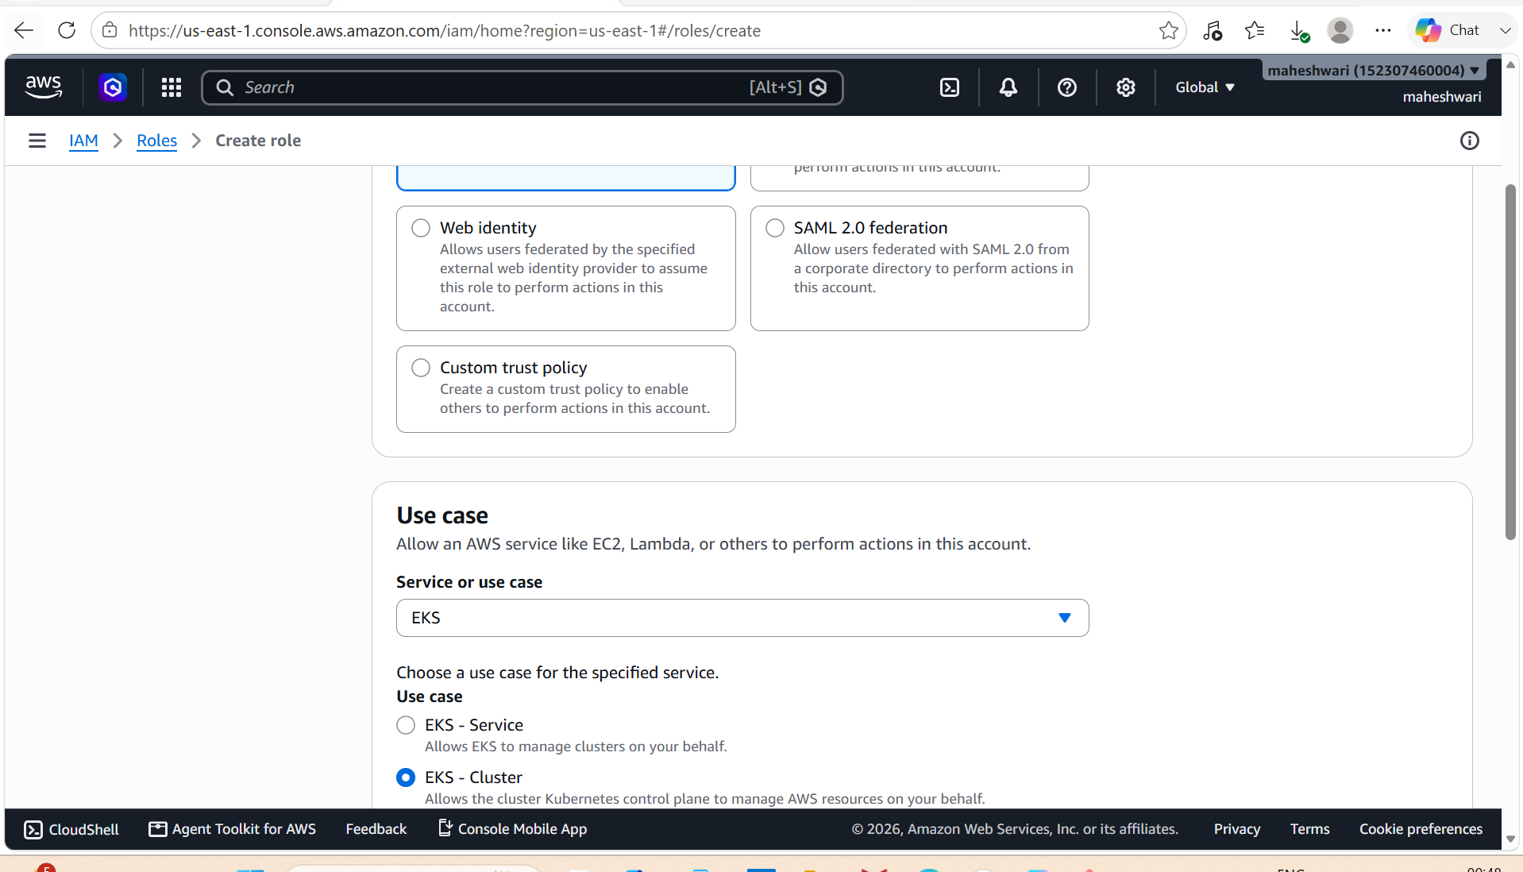

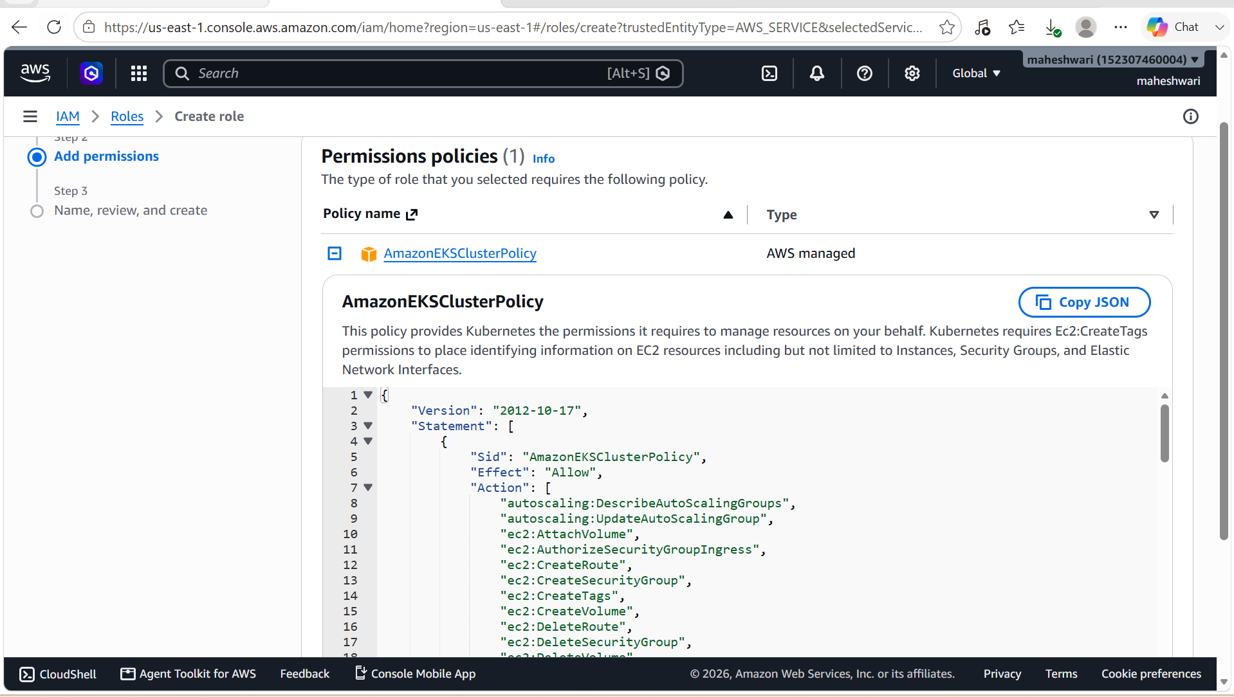

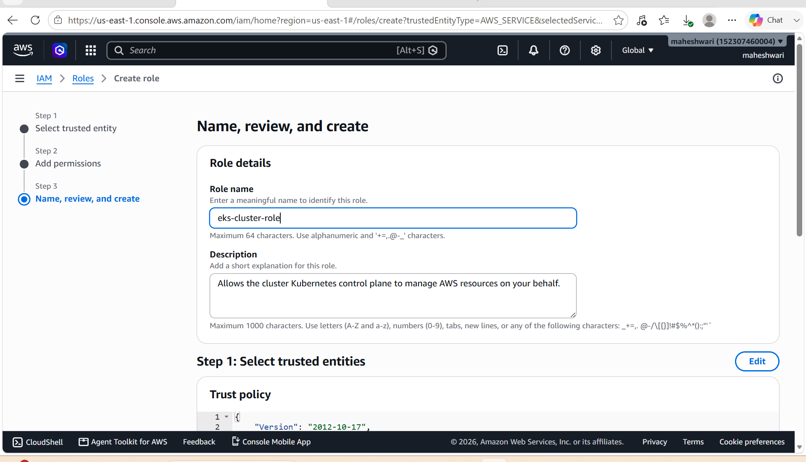

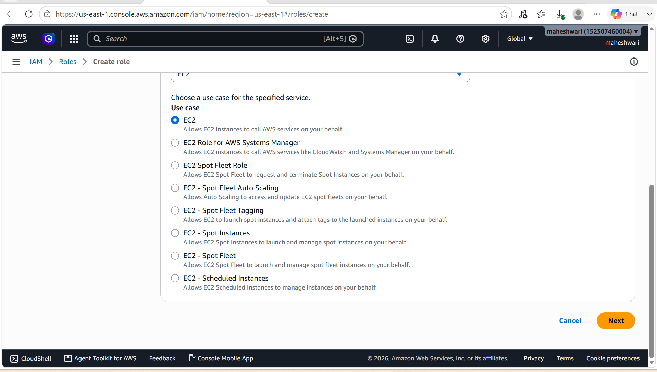

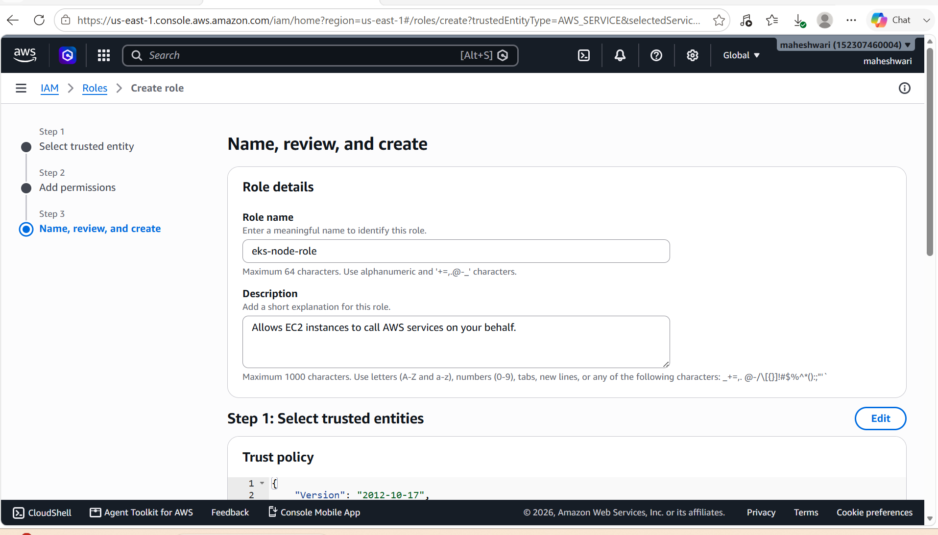

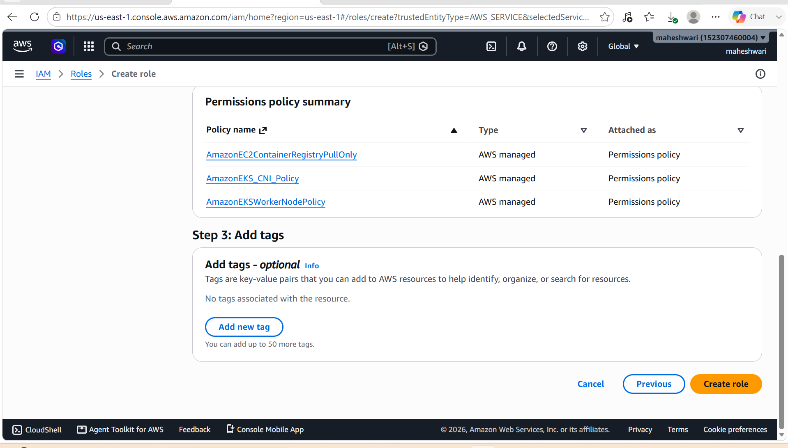

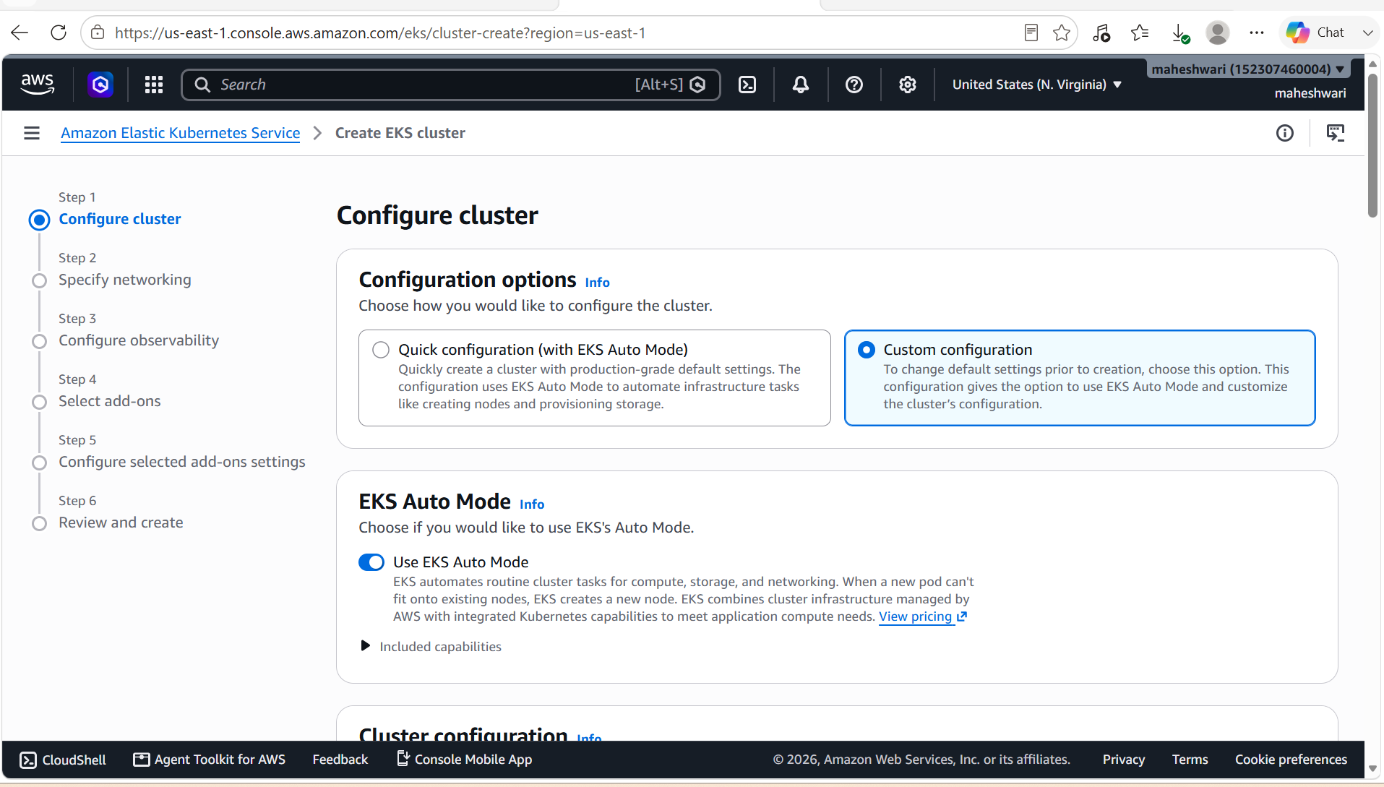

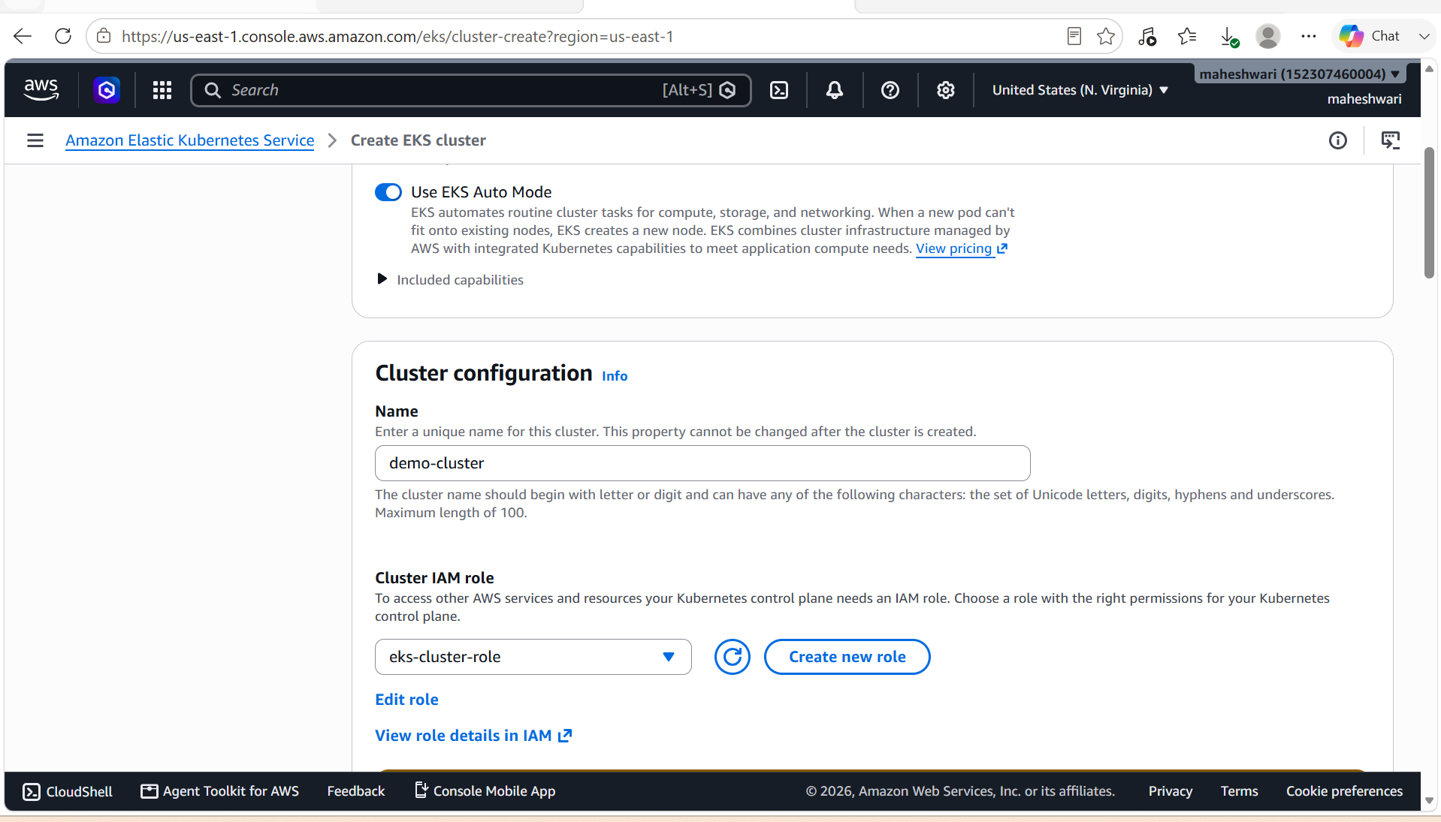

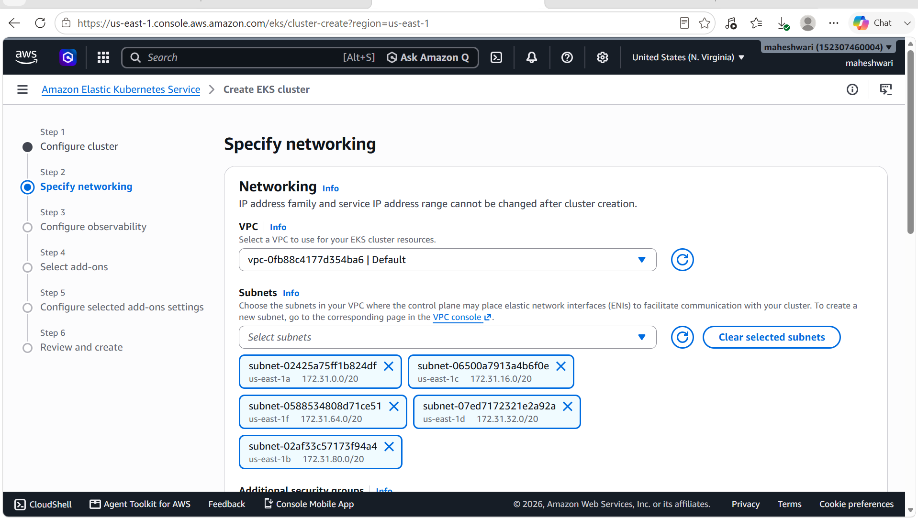

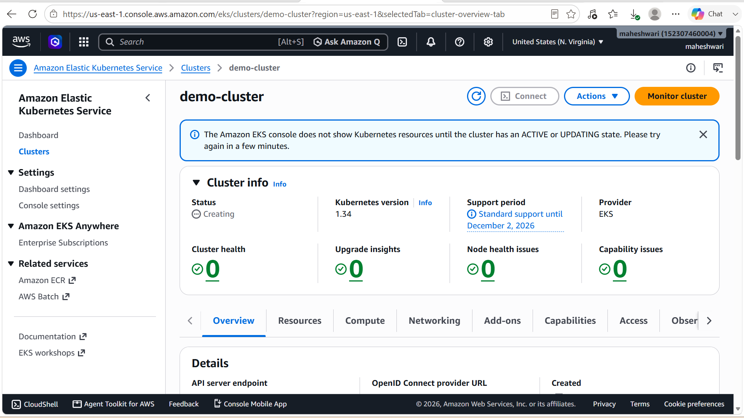

3. Setup HPA

Prerequisites
Ensure that:
- Amazon EKS cluster is running.
- Worker nodes are in the Ready state.
- kubectl is configured.
- Metrics Server is installed (required for HPA).
Verify your cluster:
kubectl get nodes

Step 1: Install Metrics Server
Install the Metrics Server:
kubectl apply -f https://github.com/kubernetes-sigs/metrics-server/releases/latest/download/components.yaml
Verify that the Metrics Server pod is running:
kubectl get pods -n kube-system
Example output:
metrics-server-6d8c7b8b9f-abcde 1/1 Running

Step 2: Verify Metrics Server
Check node metrics:
kubectl top nodes
Example:
NAME CPU(cores) CPU%
ip-192-168-10-101.ec2.internal 90m 4%
ip-192-168-20-102.ec2.internal 120m 6%
Check pod metrics:
kubectl top pods

Step 3: Create a Sample Deployment
Create a file named nginx-deployment.yaml:
apiVersion: apps/v1
kind: Deployment
metadata:
name: nginx-deployment
spec:
replicas: 2
selector:
matchLabels:
app: nginx
template:
metadata:
labels:
app: nginx
spec:
containers:
- name: nginx
image: nginx
ports:
- containerPort: 80
resources:
requests:
cpu: 100m
limits:
cpu: 500m
Apply it:
kubectl apply -f nginx-deployment.yaml
Verify:
kubectl get deployments

Step 4: Expose the Deployment
kubectl expose deployment nginx-deployment \
--port=80 \
--target-port=80 \
--type=ClusterIP
Verify:
kubectl get svc

Step 5: Create the Horizontal Pod Autoscaler
Run:
kubectl autoscale deployment nginx-deployment \
--cpu-percent=50 \
--min=2 \
--max=10
This configures:
- Target CPU utilization: 50%
- Minimum replicas: 2
- Maximum replicas: 10
Verify:
kubectl get hpa
Example output:
NAME REFERENCE TARGETS MINPODS MAXPODS REPLICAS AGE
nginx-deployment Deployment/nginx-deployment 1%/50% 2 10 2 1m

Step 6: View HPA Details
kubectl describe hpa nginx-deployment
This displays:
- Current CPU utilization
- Target utilization
- Current replicas
- Desired replicas
- Scaling events

Step 7: Generate Load
Run a temporary BusyBox pod:
kubectl run load-generator \
--image=busybox \
--restart=Never \
-- /bin/sh -c "while true; do wget -q -O- http://nginx-deployment; done"

Step 8: Monitor Autoscaling
Watch the HPA:
kubectl get hpa -w
Monitor the deployment:
kubectl get deployment -w
Monitor the pods:
kubectl get pods -w
As CPU usage increases, you should see the replica count increase, for example:
REPLICAS
2
3
5
7

Step 9: Stop the Load
Delete the load generator:
kubectl delete pod load-generator
After a few minutes, HPA will scale the deployment back down to the minimum number of replicas (2).

Step 10: Verify the Final State
kubectl get hpa
kubectl get deployment
kubectl get pods

Optional: Create HPA Using YAML
apiVersion: autoscaling/v2
kind: HorizontalPodAutoscaler
metadata:
name: nginx-hpa
spec:
scaleTargetRef:
apiVersion: apps/v1
kind: Deployment
name: nginx-deployment
minReplicas: 2
maxReplicas: 10
metrics:
- type: Resource
resource:
name: cpu
target:
type: Utilization
averageUtilization: 50
Apply it:
kubectl apply -f hpa.yaml

Useful Commands
kubectl get hpa
kubectl describe hpa nginx-hpa
kubectl top nodes
kubectl top pods
kubectl get deployment
kubectl get pods
kubectl get events

Architecture
Client Requests
|
Kubernetes Service
|
nginx Deployment
|
+--------+--------+
| |
Pod 1 Pod 2
|
Horizontal Pod Autoscaler
|
CPU > 50% ? Scale Up
CPU < 50% ? Scale Down
|
Min Replicas = 2
Max Replicas = 10
Outcome
With HPA configured:
- The deployment starts with 2 replicas.
- If average CPU utilization exceeds 50%, Kubernetes automatically adds more pods (up to 10).
- When the load decreases, Kubernetes scales the deployment back down, but never below 2 replicas.

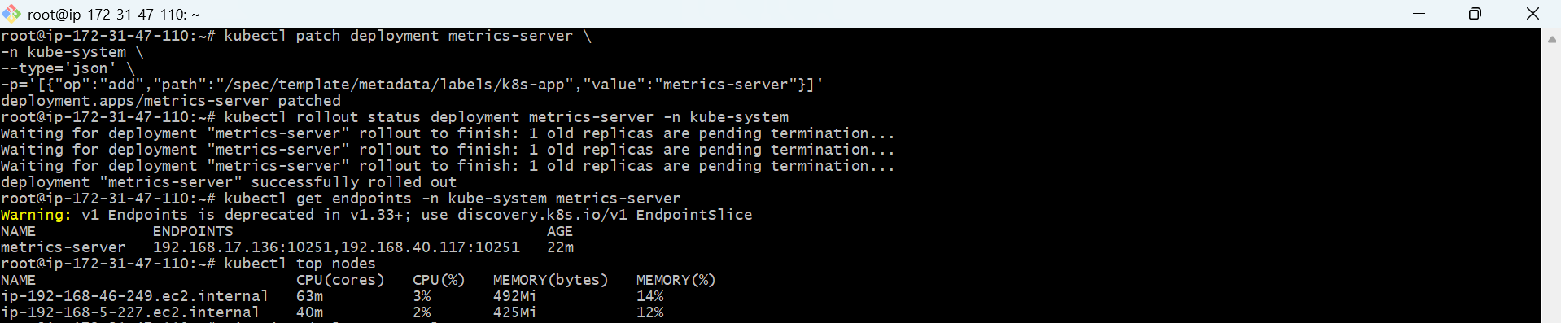

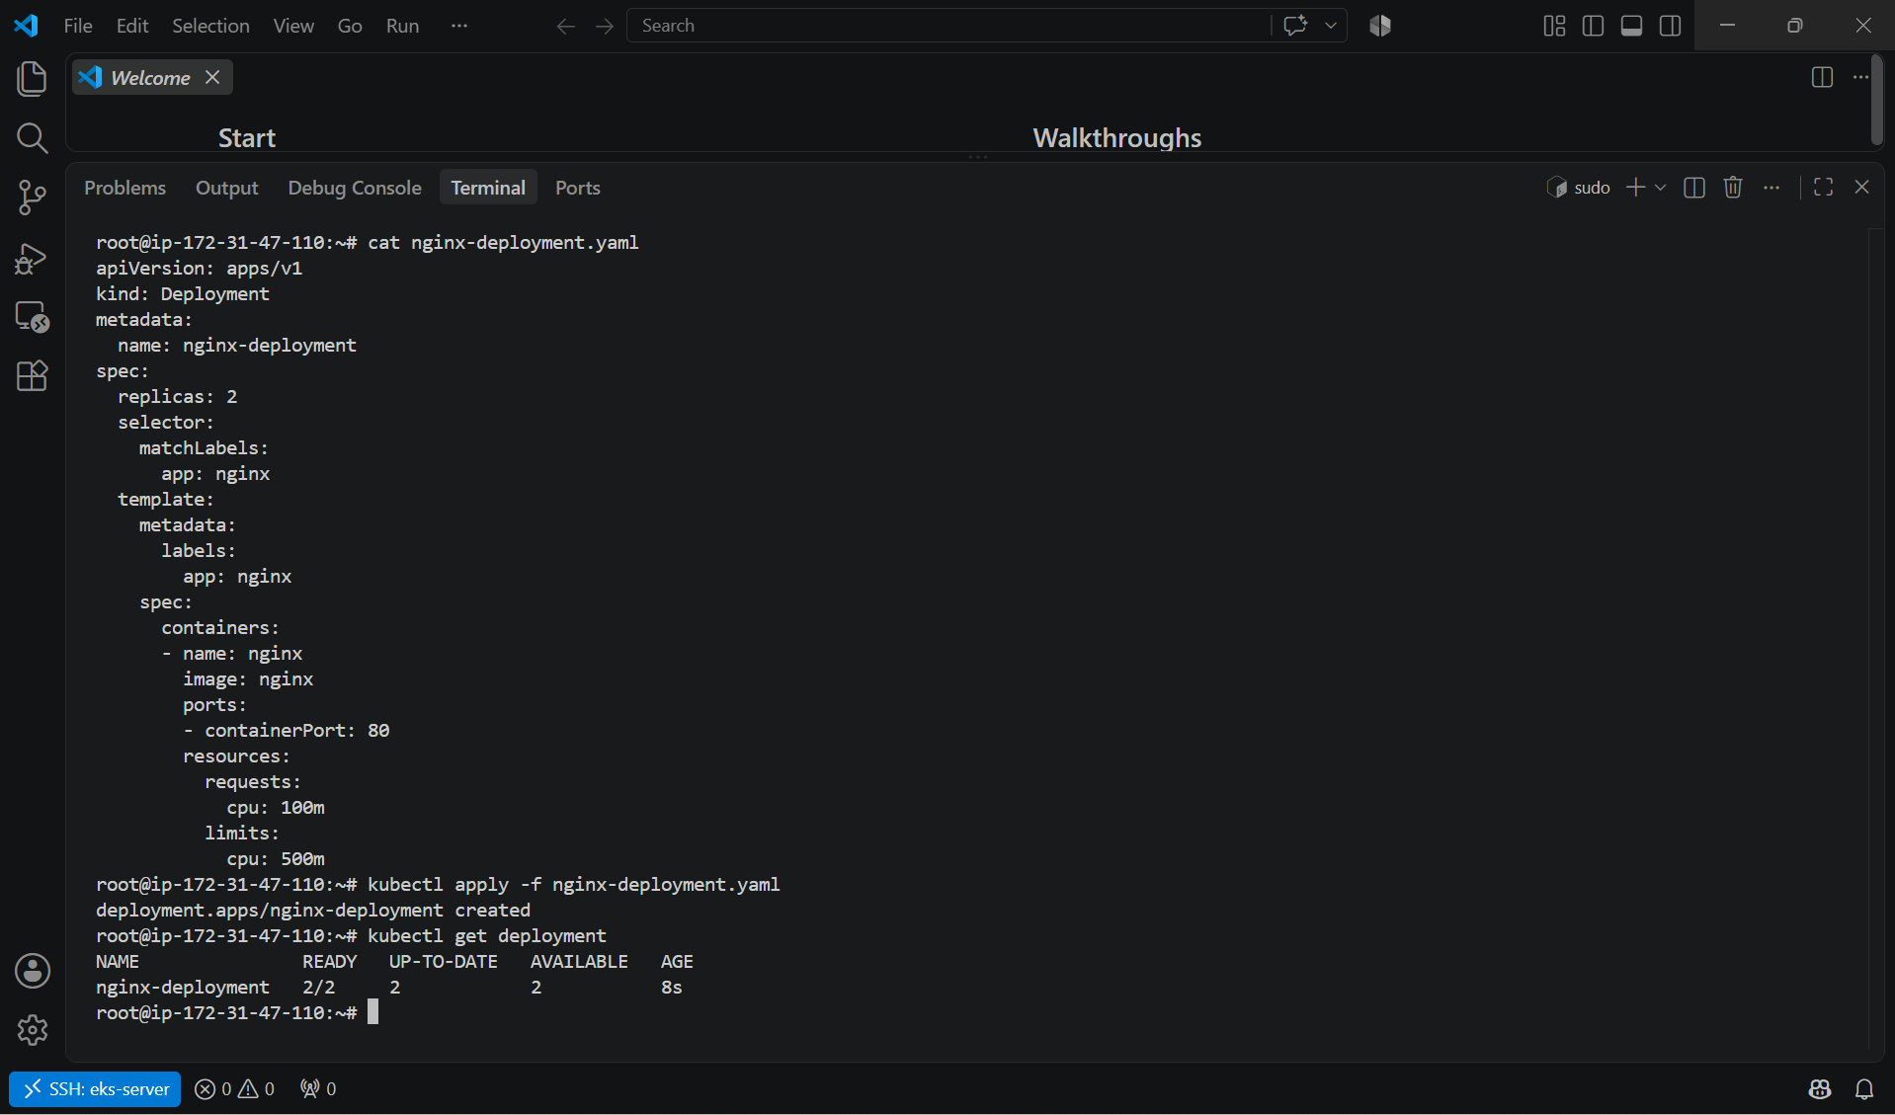

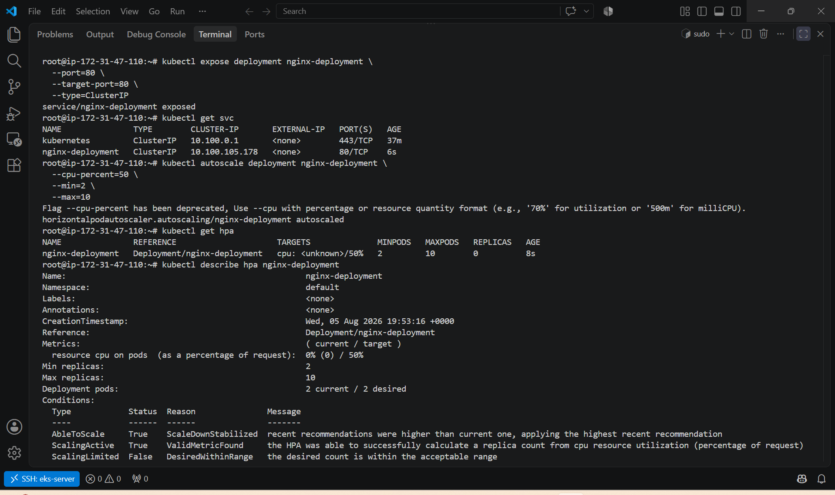

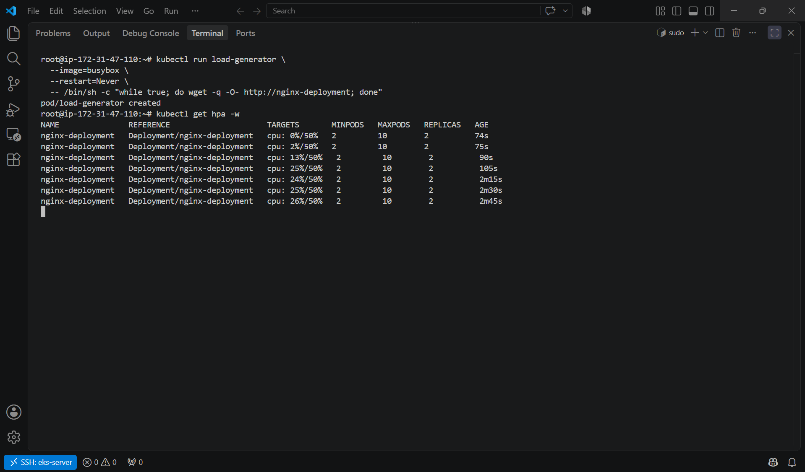

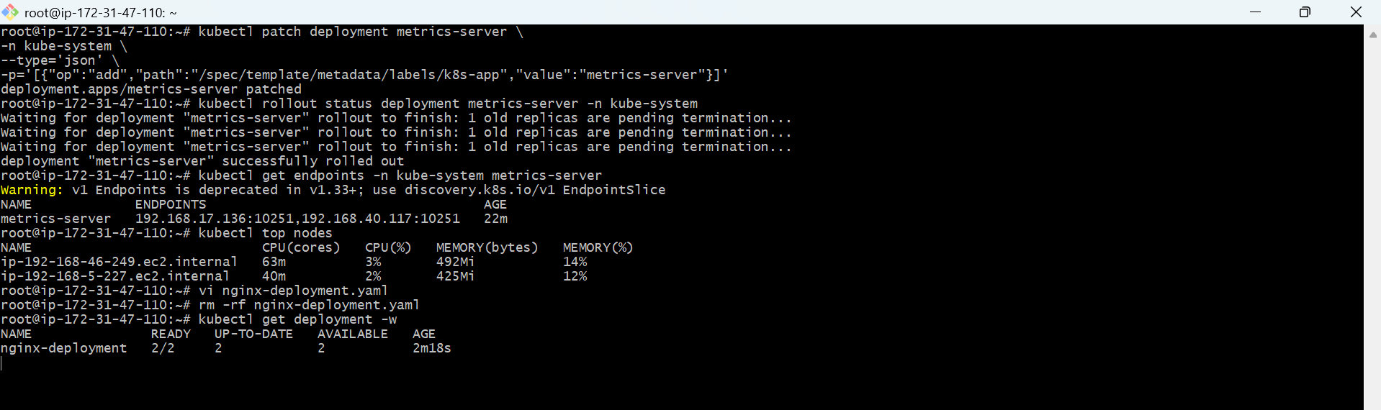

4. Setup cluster autoscale

Cluster Autoscaler automatically adjusts the number of EC2 worker nodes in your EKS cluster based on pending pods. It works alongside the Horizontal Pod Autoscaler (HPA): HPA scales pods, while Cluster Autoscaler scales nodes.
Prerequisites
- Amazon EKS cluster is running.
- Managed Node Group is configured.
- kubectl is connected to the cluster.
- AWS CLI is configured.
- Metrics Server is installed (required for HPA, not Cluster Autoscaler itself).
Verify:
kubectl get nodes

Step 1: Enable Auto Scaling on the Node Group
In the AWS Console:
- Open Amazon EKS.
- Select your cluster.
- Go to Compute.
- Select your managed node group.
- Click Edit.
- Configure the scaling settings, for example:
  - Minimum: 2
  - Desired: 2
  - Maximum: 5
- Save the changes.
Alternatively, using the AWS CLI:
aws eks update-nodegroup-config \
--cluster-name dev-cluster \
--nodegroup-name linux-nodes \
--scaling-config minSize=2,maxSize=5,desiredSize=2 \
--region us-east-1

Step 2: Associate an IAM OIDC Provider
Check whether one already exists:
aws eks describe-cluster \
--name dev-cluster \
--region us-east-1 \
--query "cluster.identity.oidc.issuer" \
--output text
If no OIDC provider is associated, create one:
eksctl utils associate-iam-oidc-provider \
--cluster dev-cluster \
--region us-east-1 \
--approve

Step 3: Create an IAM Policy
Create a file named cluster-autoscaler-policy.json:
{
"Version": "2012-10-17",
"Statement": [
{
"Effect": "Allow",
"Action": [
"autoscaling:SetDesiredCapacity",
"autoscaling:TerminateInstanceInAutoScalingGroup"
],
"Resource": "*"
},
{
"Effect": "Allow",
"Action": [
"autoscaling:DescribeAutoScalingGroups",
"autoscaling:DescribeAutoScalingInstances",
"autoscaling:DescribeLaunchConfigurations",
"autoscaling:DescribeScalingActivities",
"autoscaling:DescribeTags",
"ec2:DescribeImages",
"ec2:DescribeInstanceTypes",
"ec2:DescribeLaunchTemplateVersions",
"ec2:DescribeInstances",
"ec2:DescribeSubnets",
"ec2:DescribeAvailabilityZones",
"eks:DescribeNodegroup"
],
"Resource": "*"
}
]
}
Create the policy:
aws iam create-policy \
--policy-name AmazonEKSClusterAutoscalerPolicy \
--policy-document file://cluster-autoscaler-policy.json

Step 4: Create an IAM Service Account
Replace <AWS_ACCOUNT_ID> with your AWS account ID.
eksctl create iamserviceaccount \
--cluster dev-cluster \
--namespace kube-system \
--name cluster-autoscaler \
--attach-policy-arn arn:aws:iam::<AWS_ACCOUNT_ID>:policy/AmazonEKSClusterAutoscalerPolicy \
--override-existing-serviceaccounts \
--approve \
--region us-east-1

Step 5: Deploy Cluster Autoscaler
Download the manifest:
curl -O https://raw.githubusercontent.com/kubernetes/autoscaler/master/cluster-autoscaler/cloudprovider/aws/examples/cluster-autoscaler-autodiscover.yaml
Edit the deployment:
vi cluster-autoscaler-autodiscover.yaml
Change the cluster name:
--node-group-auto-discovery=asg:tag=k8s.io/cluster-autoscaler/dev-cluster
Also add:
--balance-similar-node-groups
--skip-nodes-with-system-pods=false
Apply the manifest:
kubectl apply -f cluster-autoscaler-autodiscover.yaml

Step 6: Annotate the Deployment
kubectl -n kube-system annotate deployment cluster-autoscaler \
cluster-autoscaler.kubernetes.io/safe-to-evict="false"

Step 7: Verify
Check the pod:
kubectl get pods -n kube-system | grep cluster-autoscaler
View logs:
kubectl logs -n kube-system deployment/cluster-autoscaler
You should see messages similar to:
Registered ASG
Starting main loop
Cluster Autoscaler initialized

Step 8: Test Cluster Autoscaler
Create a deployment that requests more CPU than your current nodes can provide:
apiVersion: apps/v1
kind: Deployment
metadata:
name: cpu-demo
spec:
replicas: 20
selector:
matchLabels:
app: cpu-demo
template:
metadata:
labels:
app: cpu-demo
spec:
containers:
- name: nginx
image: nginx
resources:
requests:
cpu: "500m"
memory: "256Mi"
Apply it:
kubectl apply -f cpu-demo.yaml
Watch the pods:
kubectl get pods -w
Some pods will remain in the Pending state because there isn't enough capacity.
Watch the nodes:
kubectl get nodes -w
After a few minutes, Cluster Autoscaler should launch additional EC2 instances and the pending pods will be scheduled.

Step 9: Scale Down
Delete the test deployment:
kubectl delete -f cpu-demo.yaml
After the autoscaler delay (typically around 10 minutes), unused nodes should be terminated automatically, respecting the node group's minimum size.

Verification Commands
kubectl get deployment -n kube-system cluster-autoscaler
kubectl get pods -n kube-system
kubectl logs -n kube-system deployment/cluster-autoscaler
kubectl get nodes
kubectl get events

Architecture
Kubernetes Cluster
|
+----------------+----------------+
| |
HPA (Scales Pods) Cluster Autoscaler
|
v
AWS Auto Scaling Group
|
+-------------------+-------------------+
| |
Worker Node 1 Worker Node 2
| |
Kubernetes Pods Kubernetes Pods

Expected Outcome
- HPA increases or decreases the number of pods based on CPU or memory usage.
- When pods cannot be scheduled because the cluster lacks resources, Cluster Autoscaler increases the number of EC2 worker nodes (up to the configured maximum).
- When nodes become underutilized and empty, Cluster Autoscaler removes them while maintaining the configured minimum node count.

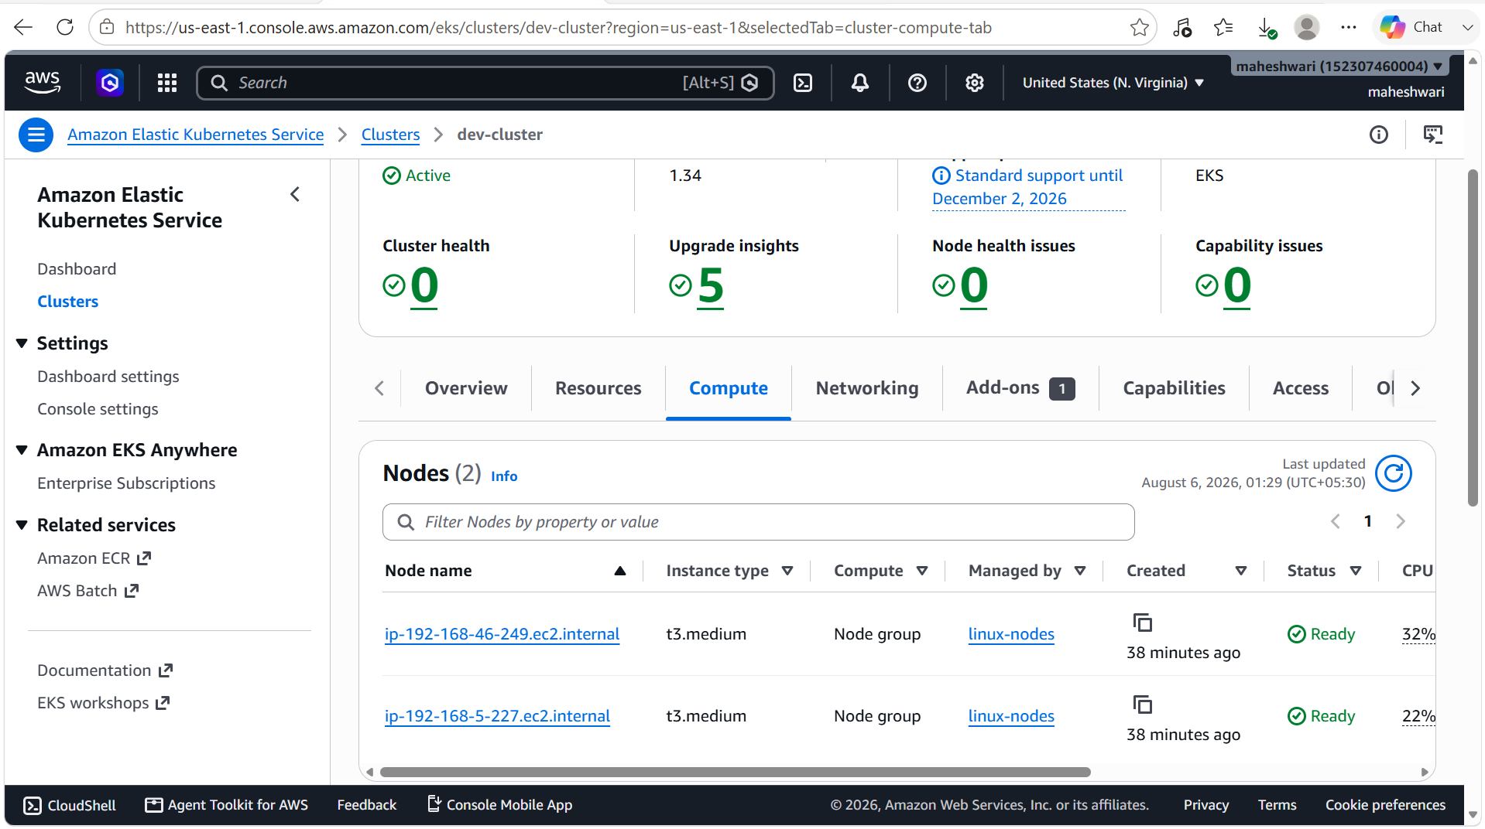

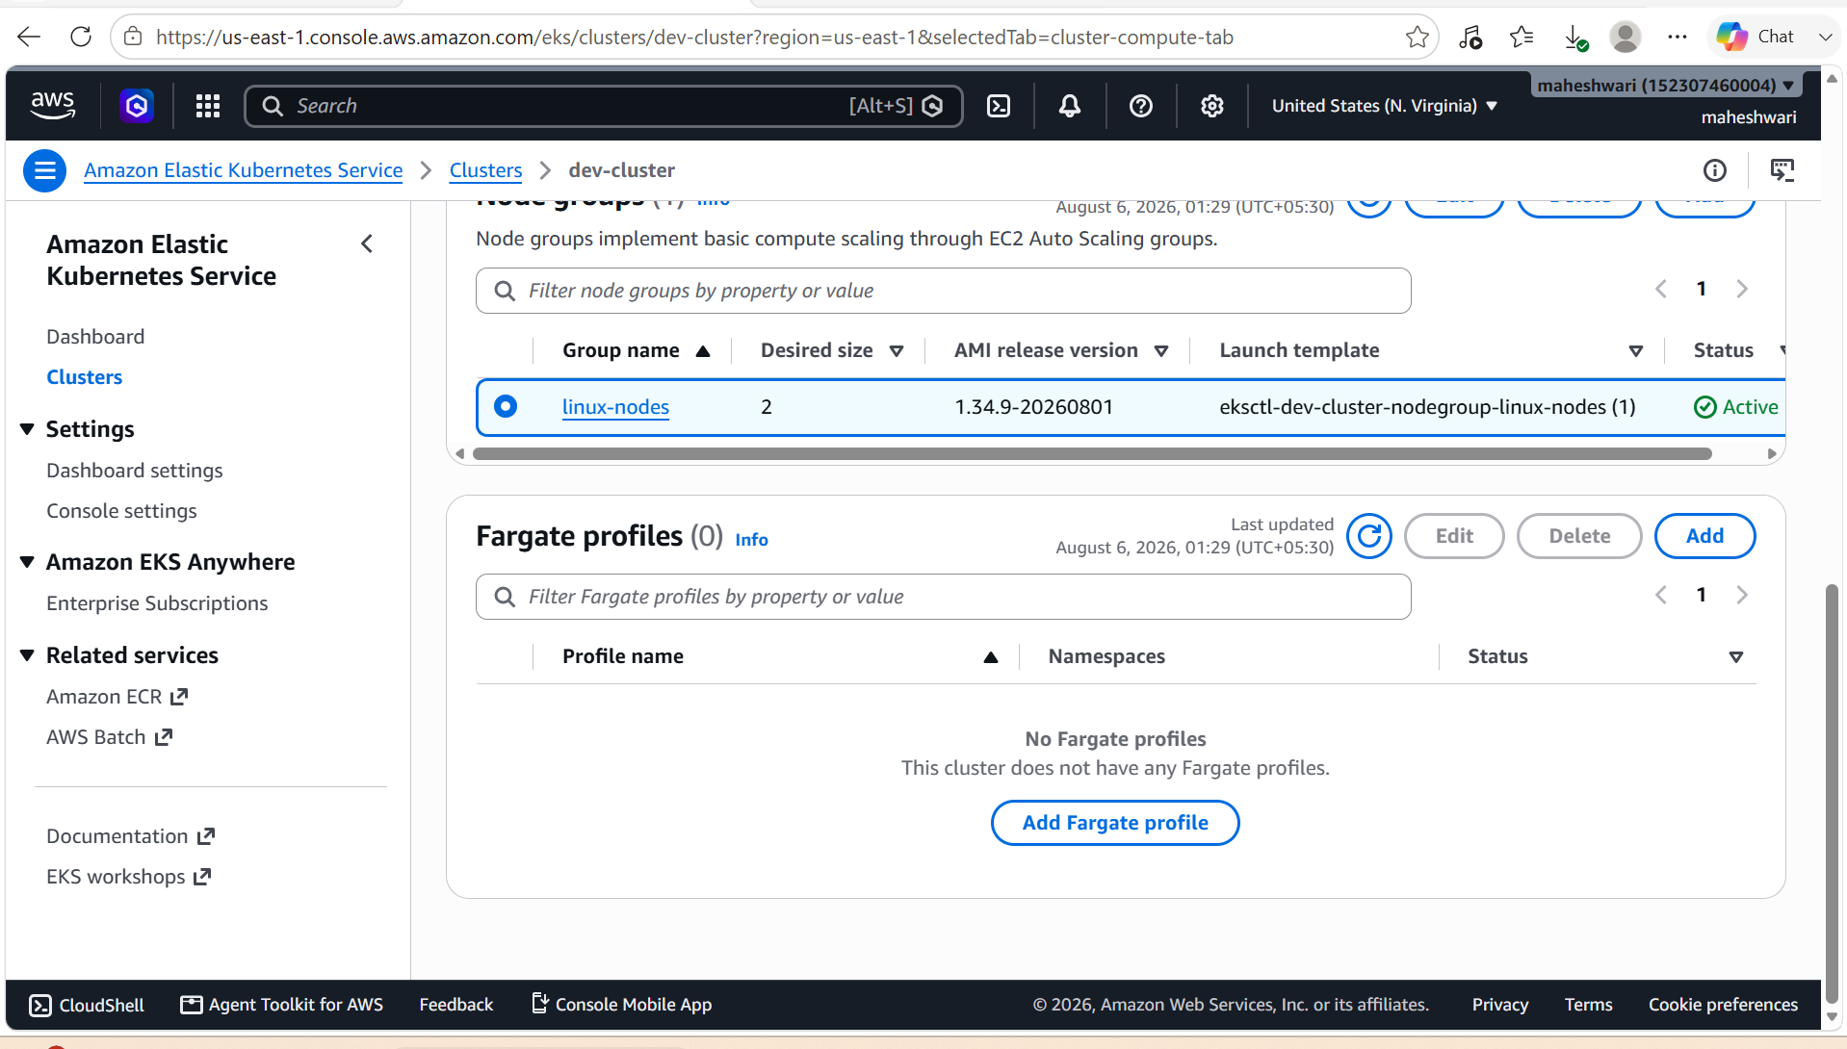

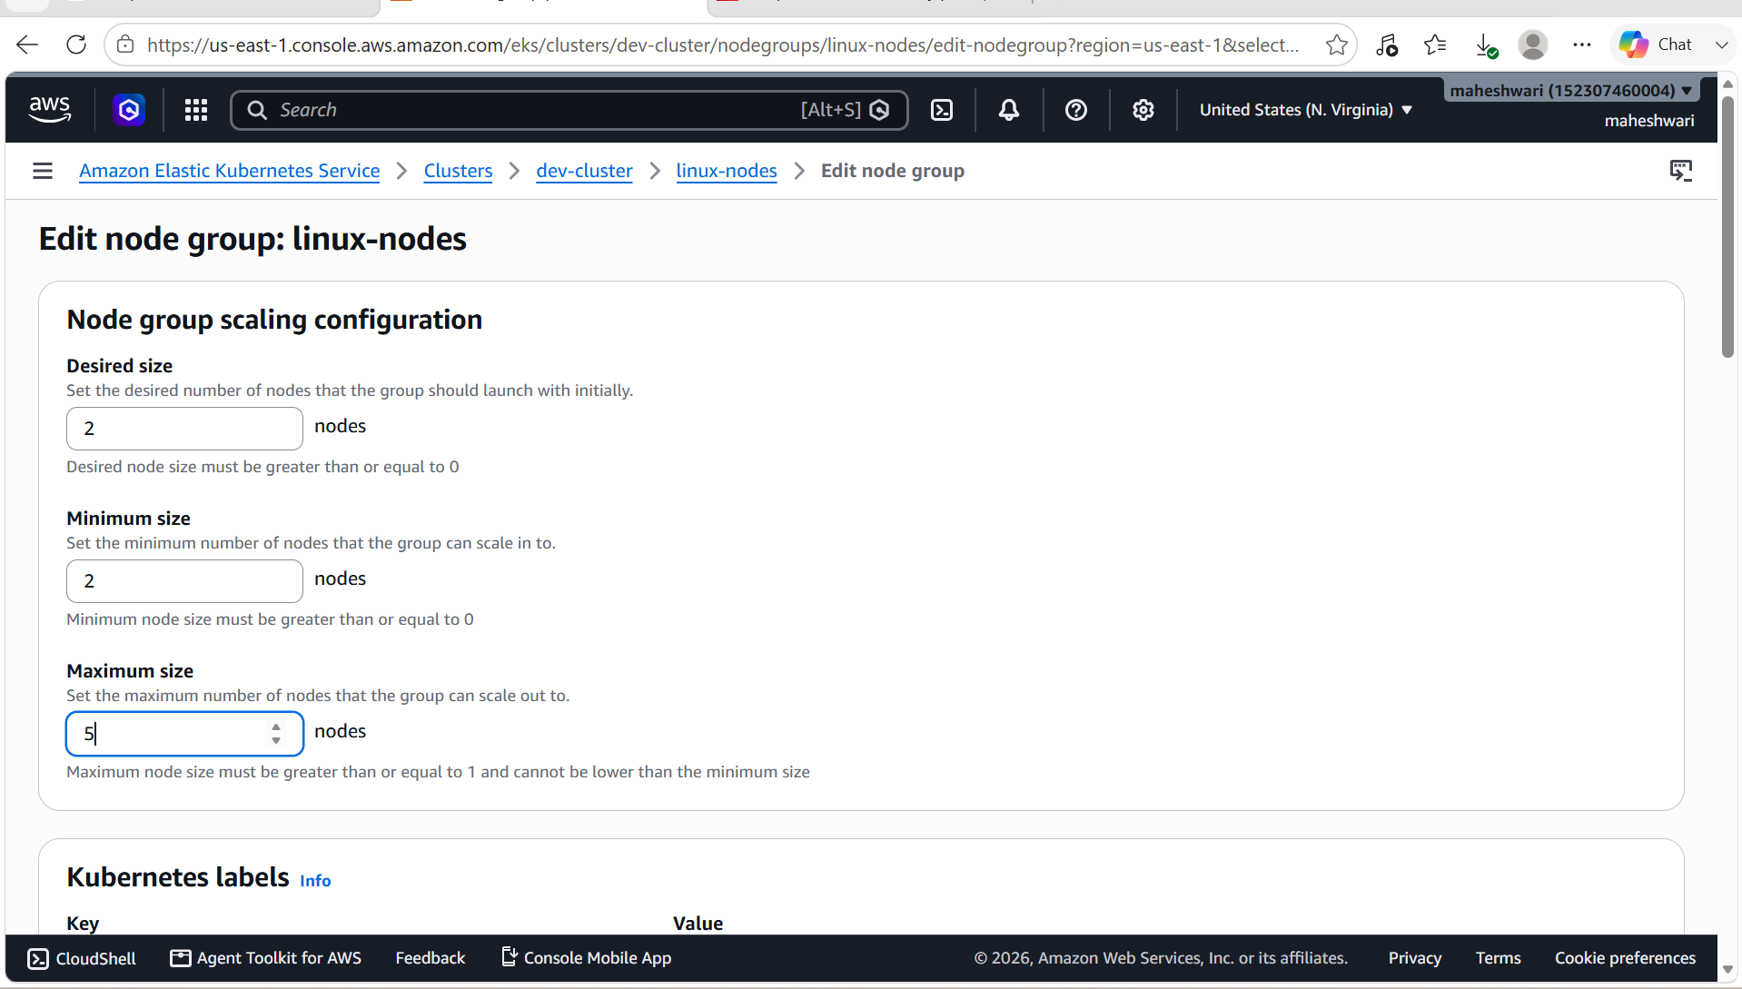

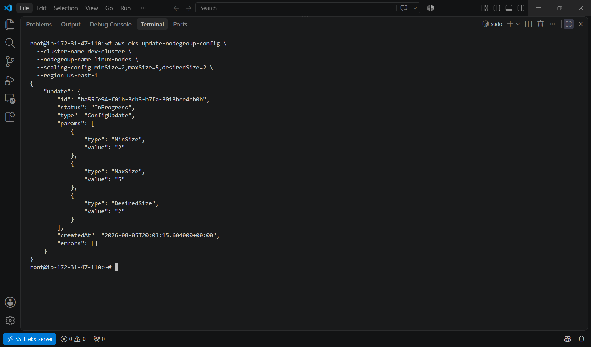

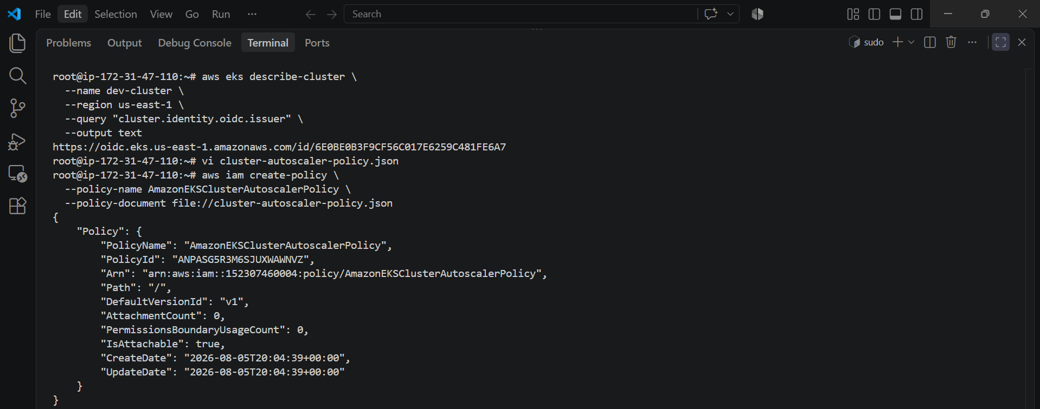

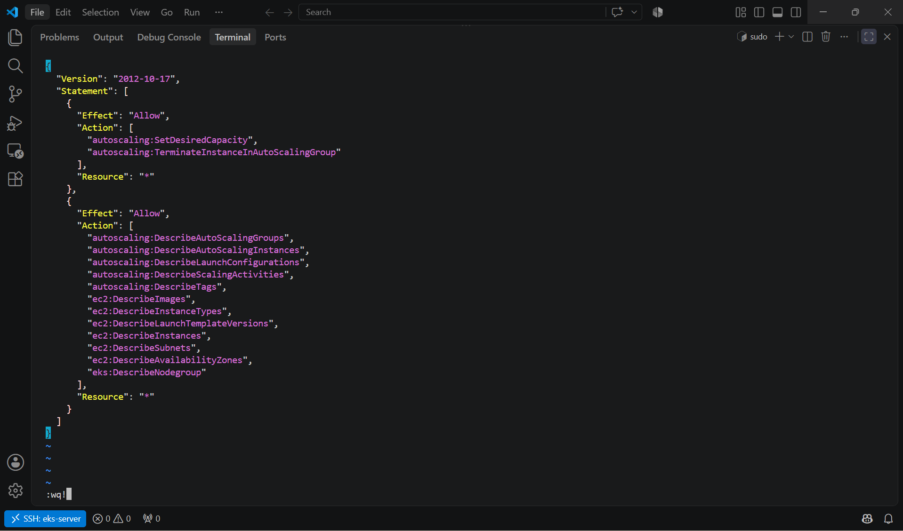

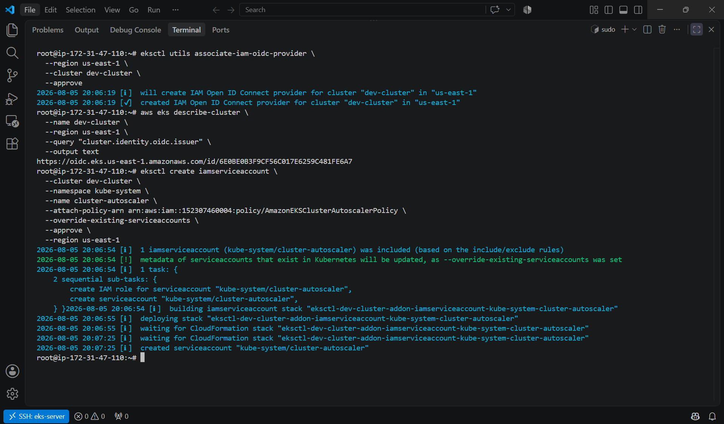

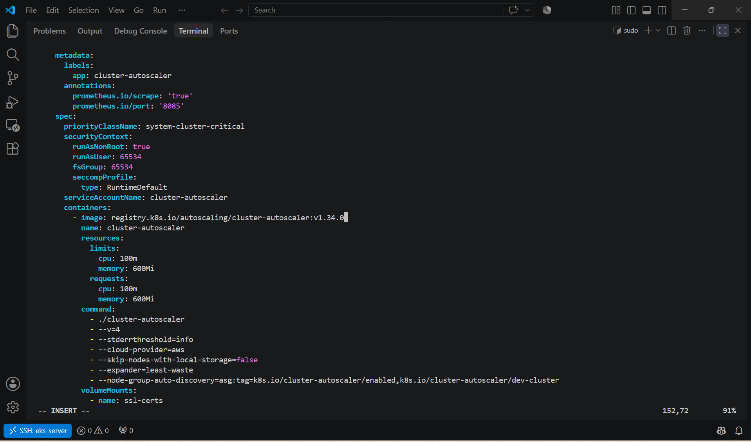

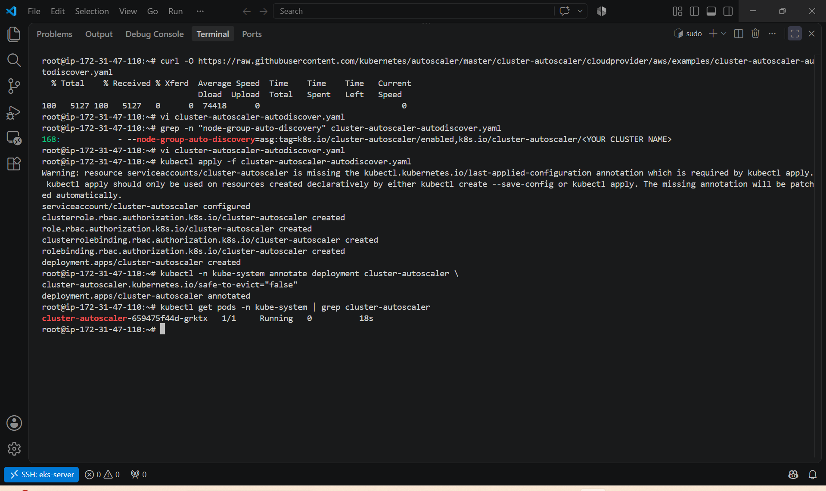

5. Setup cronjob and job

Kubernetes Job and CronJob Setup
What is a Job?
A Job runs one or more Pods until a task completes successfully. It is used for one-time tasks like:
- Database backup
- Data migration
- Batch processing
- Sending reports

Create a Job
Create a file named job.yaml
apiVersion: batch/v1
kind: Job
metadata:
name: demo-job
spec:
template:
spec:
containers:
- name: demo-job
image: busybox
command: ["sh", "-c", "echo Hello from Kubernetes Job; sleep 10"]
restartPolicy: Never
backoffLimit: 4
Apply the Job:
kubectl apply -f job.yaml

Verify the Job
List Jobs:
kubectl get jobs
Example:
NAME COMPLETIONS DURATION AGE
demo-job 1/1 12s 15s
Check Pods created by the Job:
kubectl get pods
Describe the Job:
kubectl describe job demo-job
View the Job logs:
kubectl logs job/demo-job
Expected output:
Hello from Kubernetes Job

Delete the Job
kubectl delete job demo-job

What is a CronJob?
A CronJob creates Jobs on a schedule, similar to Linux cron.
Examples:
- Daily backup
- Hourly cleanup
- Weekly report generation

Create a CronJob
Create a file named cronjob.yaml
apiVersion: batch/v1
kind: CronJob
metadata:
name: demo-cronjob
spec:
schedule: "*/1 * * * *"
jobTemplate:
spec:
template:
spec:
containers:
- name: hello
image: busybox
command:
- /bin/sh
- -c
- date; echo "CronJob executed"
restartPolicy: Never
This schedule runs every minute.
Apply it:
kubectl apply -f cronjob.yaml

Verify the CronJob
List CronJobs:
kubectl get cronjobs
Example:
NAME SCHEDULE SUSPEND ACTIVE LAST SCHEDULE AGE
demo-cronjob */1 * * * * False 0 20s 1m
Watch Jobs being created:
kubectl get jobs -w
Watch Pods:
kubectl get pods -w

View CronJob Logs
Find the Job created by the CronJob:
kubectl get jobs
Example:
demo-cronjob-29214200
View its logs:
kubectl logs job/demo-cronjob-29214200
Expected output:
Wed Aug 6 07:30:01 UTC 2026
CronJob executed

Describe the CronJob
kubectl describe cronjob demo-cronjob

Suspend the CronJob
kubectl patch cronjob demo-cronjob -p '{"spec":{"suspend":true}}'
Verify:
kubectl get cronjobs

Resume the CronJob
kubectl patch cronjob demo-cronjob -p '{"spec":{"suspend":false}}'

Delete the CronJob
Delete only the CronJob:
kubectl delete cronjob demo-cronjob
Delete the Jobs created by it:
kubectl delete jobs --all

Useful Commands
kubectl get jobs
kubectl describe job demo-job
kubectl logs job/demo-job

kubectl get cronjobs
kubectl describe cronjob demo-cronjob
kubectl get pods
kubectl get jobs
kubectl logs job/<job-name>

Architecture
Kubernetes Cluster
|
+--------------+--------------+
| |
Job (One-time) CronJob (Scheduled)
| |
Creates Pod Creates Job
| |
Task Executes Creates Pod
| |
Completed Runs Every Minute (or schedule)

Expected Outcome
- Job runs once and completes after successfully executing its task.
- CronJob automatically creates a new Job based on the configured schedule (for example, every minute), and each Job runs independently until it completes.

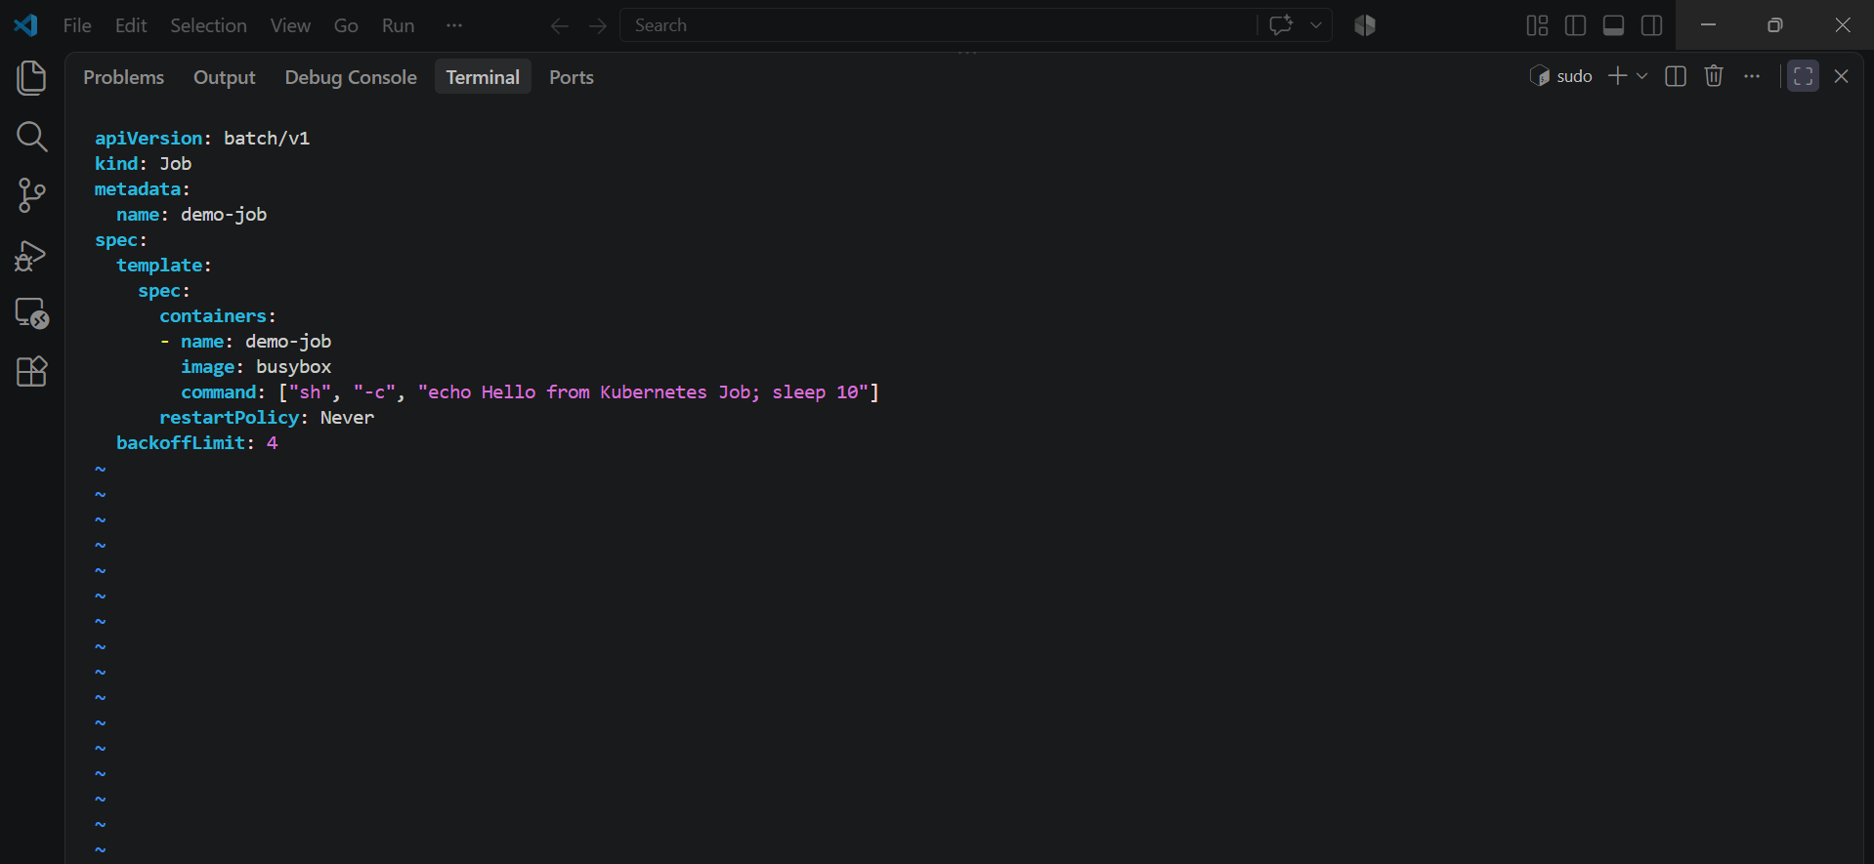

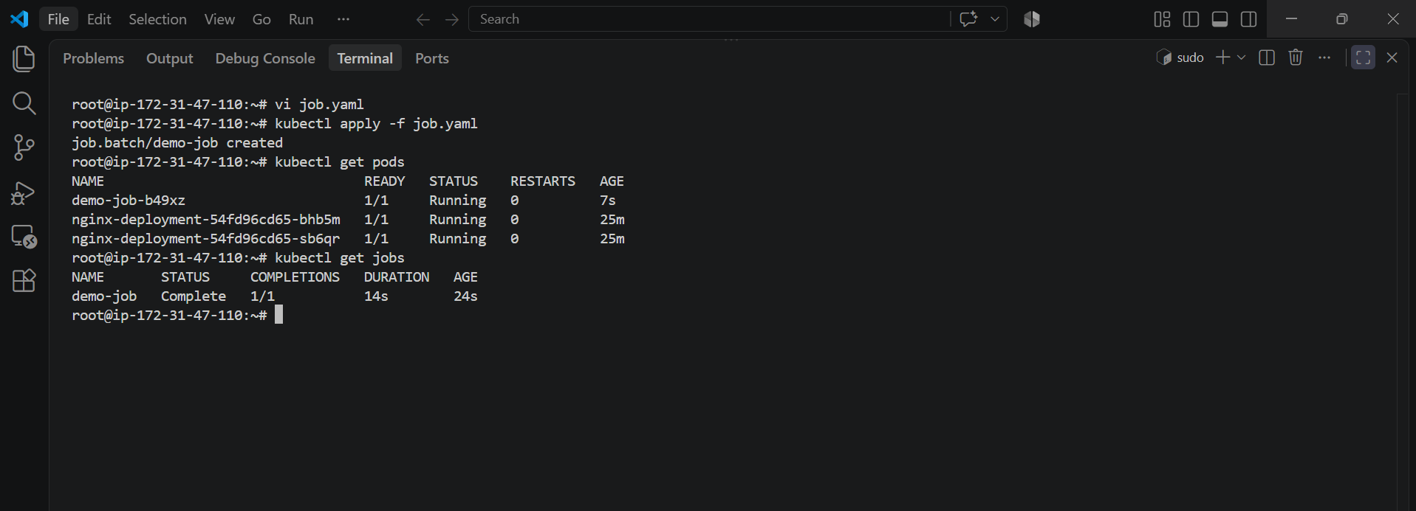

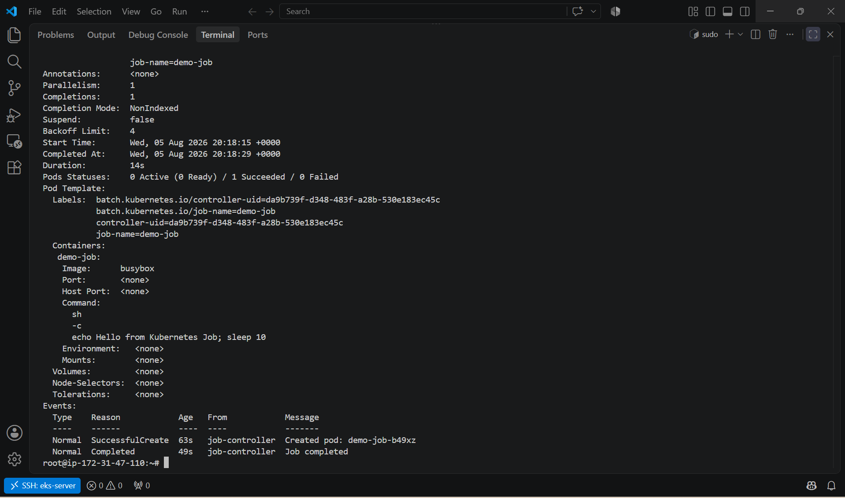

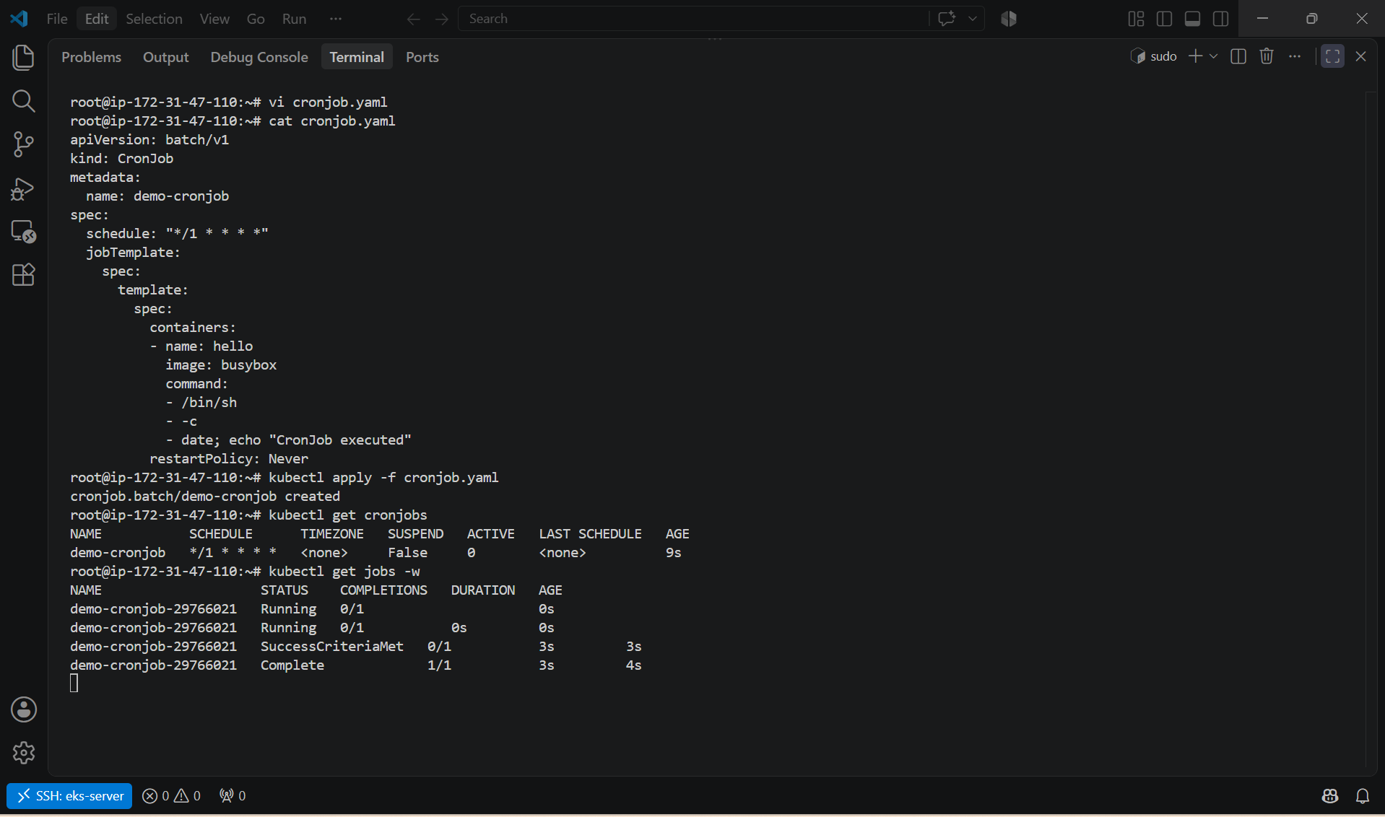

6. Create secret and inject inside pod

Create a Secret Using kubectl
Create a Secret named my-secret:
kubectl create secret generic my-secret \
--from-literal=username=admin \
--from-literal=password=Admin@123
Verify the Secret:
kubectl get secrets
Describe the Secret:
kubectl describe secret my-secret
View the encoded Secret data:
kubectl get secret my-secret -o yaml

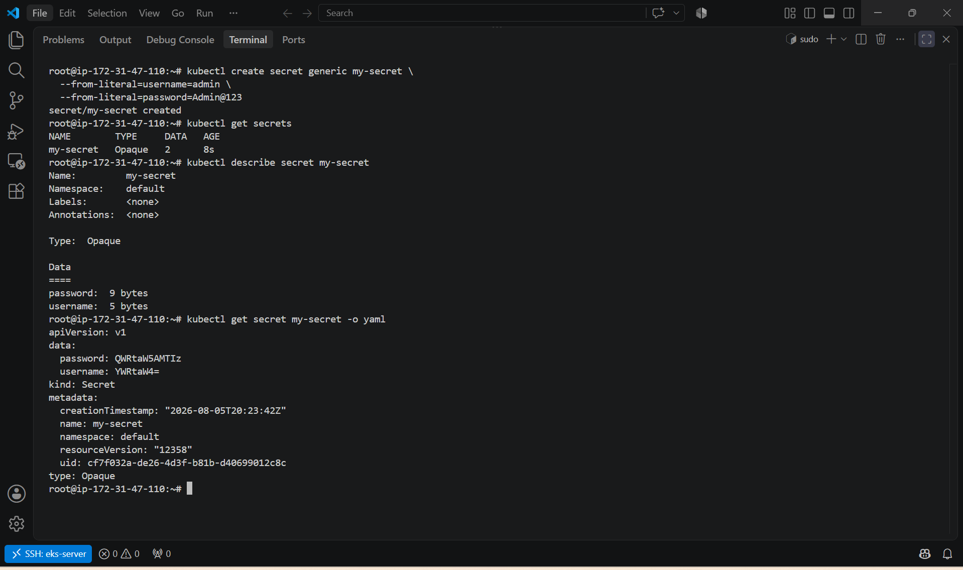

7. Check differen add-ons available on eks.

You can check the available Amazon EKS add-ons using either the AWS CLI or the AWS Management Console.

Method 1: List Available EKS Add-ons (AWS CLI)
Run:
aws eks describe-addon-versions --region us-east-1
This returns all supported add-ons and their available versions.
To list only the add-on names:
aws eks describe-addon-versions \
--region us-east-1 \
--query "addons[].addonName" \
--output text
Example output:
amazon-cloudwatch-observability
aws-ebs-csi-driver
aws-efs-csi-driver
aws-load-balancer-controller
coredns
eks-pod-identity-agent
kube-proxy
metrics-server
snapshot-controller
vpc-cni

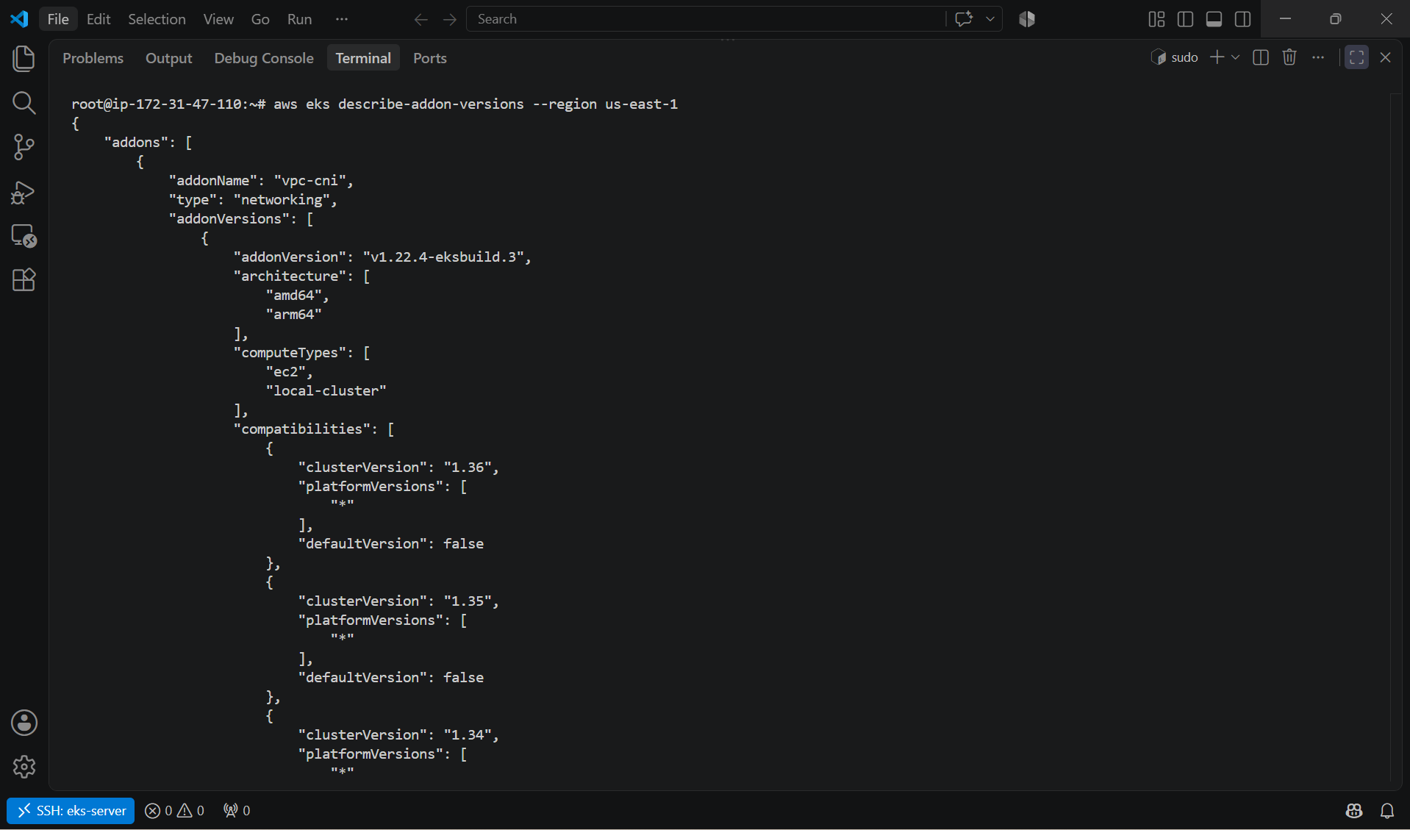

Method 2: List Installed Add-ons in Your Cluster
Run:
aws eks list-addons \
--cluster-name dev-cluster \
--region us-east-1
Example:
{
"addons": [
"vpc-cni",
"coredns",
"kube-proxy",
"metrics-server"
]
}

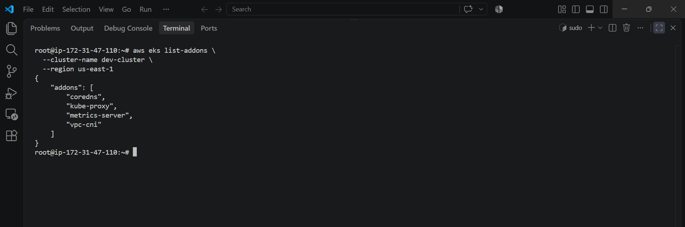

Method 3: Get Details of an Installed Add-on
Example for CoreDNS:
aws eks describe-addon \
--cluster-name dev-cluster \
--addon-name coredns \
--region us-east-1
Example output:
Addon Name: coredns
Status: ACTIVE
Version: v1.12.x-eksbuild.x

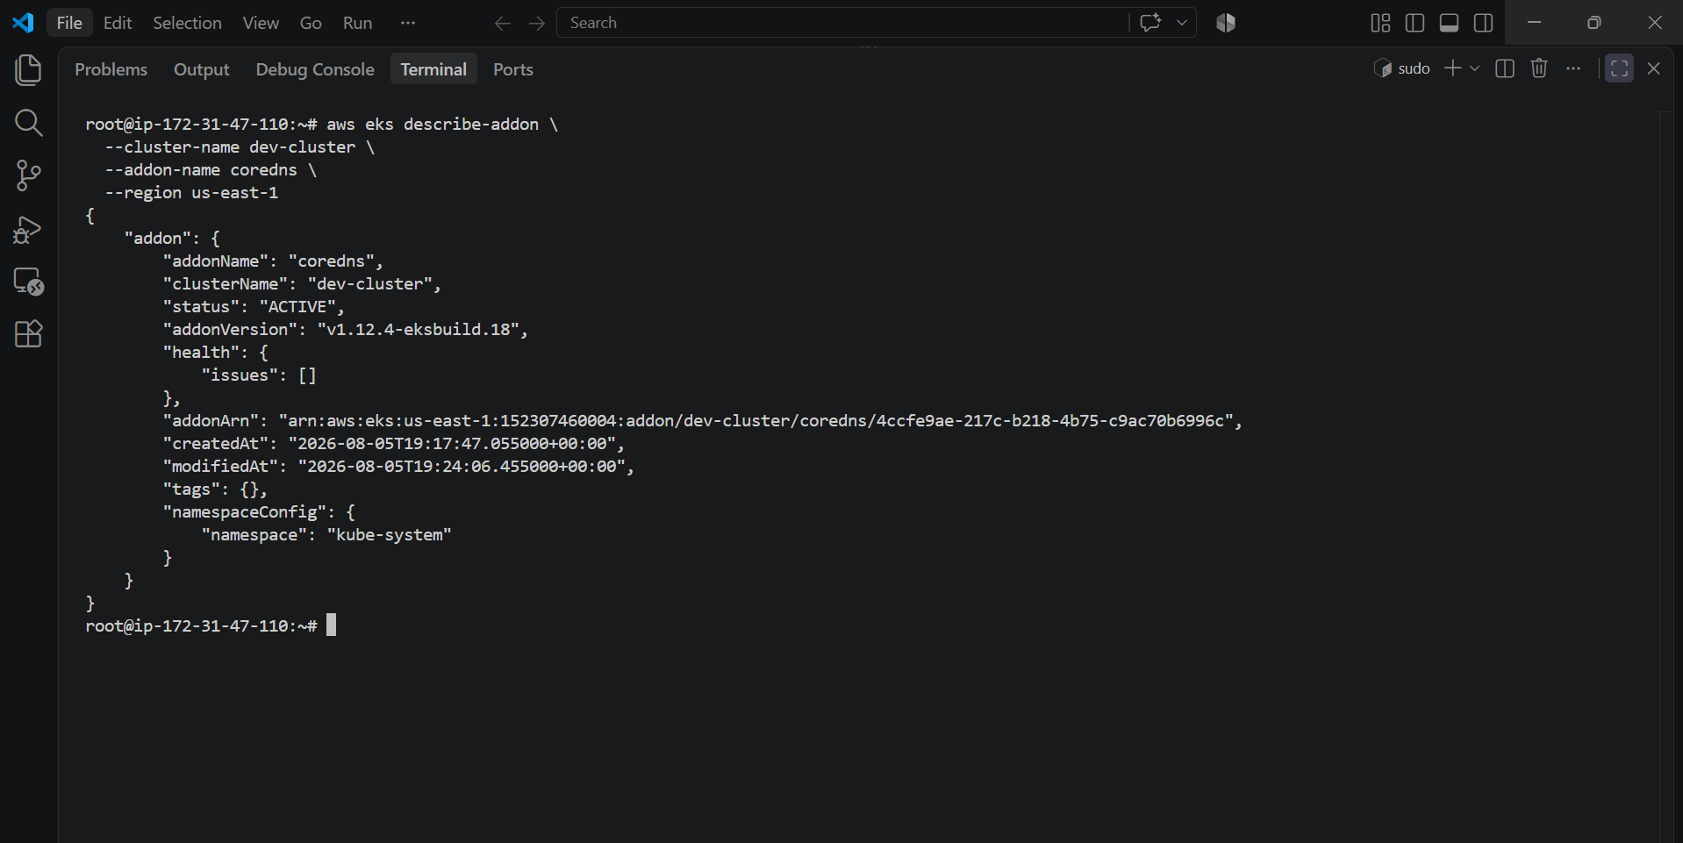

Method 4: Check from the AWS Console
- Log in to the AWS Management Console.
- Open Amazon EKS.
- Select your cluster (dev-cluster).
- Click the Add-ons tab.
You'll see:
- Installed add-ons
- Version
- Status (ACTIVE, DEGRADED, etc.)
- Option to Get more add-ons

Common Amazon EKS Add-ons
Add-on | Purpose
Amazon VPC CNI | Provides networking for Pods
CoreDNS | DNS service discovery within the cluster
kube-proxy | Handles Kubernetes Service networking
Metrics Server | Collects CPU and memory metrics for HPA
AWS Load Balancer Controller | Manages Application and Network Load Balancers
Amazon EBS CSI Driver | Enables provisioning and mounting of Amazon EBS volumes
Amazon EFS CSI Driver | Enables mounting Amazon EFS file systems in Pods
CloudWatch Observability | Sends logs and metrics to Amazon CloudWatch
Snapshot Controller | Supports Kubernetes VolumeSnapshots
EKS Pod Identity Agent | Enables EKS Pod Identity for AWS IAM access from Pods

Check Installed Kubernetes Components
You can also verify the corresponding Kubernetes resources:
kubectl get pods -n kube-system
or
kubectl get daemonsets -n kube-system
or
kubectl get deployments -n kube-system
These commands show the pods and controllers backing installed add-ons.

Useful Commands
# List installed add-ons
aws eks list-addons --cluster-name dev-cluster --region us-east-1

# List all supported add-ons
aws eks describe-addon-versions --region us-east-1

# Describe a specific installed add-on
aws eks describe-addon \
--cluster-name dev-cluster \
--addon-name coredns \
--region us-east-1
These commands will help you discover what add-ons are available in EKS and which ones are currently installed in your cluster.

8. Upgrade eks cluster

Upgrade an Amazon EKS Cluster
Upgrading an EKS cluster involves updating the control plane first, then managed add-ons, and finally the worker nodes.
Example: Upgrade from Kubernetes 1.34 to 1.35 (replace versions as appropriate for your cluster).

Step 1: Check the Current Cluster Version
aws eks describe-cluster \
--name dev-cluster \
--region us-east-1 \
--query "cluster.version"
Or:
kubectl version

Step 2: Check Available Kubernetes Versions
aws eks describe-addon-versions \
--region us-east-1 \
--query "addons[].addonVersions[].compatibilities[].clusterVersion" \
--output text

Step 3: Upgrade the EKS Control Plane
aws eks update-cluster-version \
--name dev-cluster \
--kubernetes-version 1.35 \
--region us-east-1
Check the update status:
aws eks list-updates \
--name dev-cluster \
--region us-east-1
Get update details:
aws eks describe-update \
--name dev-cluster \
--update-id <UPDATE_ID> \
--region us-east-1
Wait until the update status becomes Successful.

Step 4: Verify the Control Plane Version
aws eks describe-cluster \
--name dev-cluster \
--region us-east-1 \
--query "cluster.version"

Step 5: Upgrade EKS Managed Add-ons
List installed add-ons:
aws eks list-addons \
--cluster-name dev-cluster \
--region us-east-1
Update each add-on.
Update CoreDNS
aws eks update-addon \
--cluster-name dev-cluster \
--addon-name coredns \
--region us-east-1
Update kube-proxy
aws eks update-addon \
--cluster-name dev-cluster \
--addon-name kube-proxy \
--region us-east-1
Update VPC CNI
aws eks update-addon \
--cluster-name dev-cluster \
--addon-name vpc-cni \
--region us-east-1
Update Metrics Server (if installed as an EKS add-on)
aws eks update-addon \
--cluster-name dev-cluster \
--addon-name metrics-server \
--region us-east-1

Step 6: Upgrade the Managed Node Group
List node groups:
aws eks list-nodegroups \
--cluster-name dev-cluster \
--region us-east-1
Update the node group:
aws eks update-nodegroup-version \
--cluster-name dev-cluster \
--nodegroup-name linux-nodes \
--region us-east-1
Monitor the update:
aws eks list-updates \
--name dev-cluster \
--nodegroup-name linux-nodes \
--region us-east-1

Step 7: Verify the Worker Nodes
kubectl get nodes
Example:
NAME STATUS ROLES AGE VERSION
ip-192-168-10-100.ec2.internal Ready <none> 5m v1.35.x
ip-192-168-20-101.ec2.internal Ready <none> 5m v1.35.x

Step 8: Verify the Cluster
kubectl get pods -A
kubectl get deployments -A
kubectl get daemonsets -A
Ensure all Pods are in the Running state.

Step 9: Verify Add-on Versions
aws eks describe-addon \
--cluster-name dev-cluster \
--addon-name coredns \
--region us-east-1
Repeat for:
- kube-proxy
- vpc-cni
- metrics-server

Step 10: Verify Cluster Health
kubectl get componentstatuses
kubectl get nodes
kubectl get pods -A

Rollback
Amazon EKS does not support downgrading the Kubernetes version. If an upgrade fails or you need to return to an older version, the recommended approach is to create a new cluster at the desired version and migrate your workloads.

Useful Commands
# Current cluster version
aws eks describe-cluster --name dev-cluster --region us-east-1

# Installed add-ons
aws eks list-addons --cluster-name dev-cluster --region us-east-1

# Node groups
aws eks list-nodegroups --cluster-name dev-cluster --region us-east-1

# Nodes
kubectl get nodes

# All pods
kubectl get pods -A

Upgrade Order (Best Practice)
Current Version
│
▼
1. Upgrade EKS Control Plane
│
▼
2. Upgrade EKS Add-ons
│
▼
3. Upgrade Managed Node Groups
│
▼
4. Verify Nodes
│
▼
5. Verify Applications
Best Practices
- Upgrade one minor version at a time (for example, 1.34 → 1.35).
- Ensure all workloads are healthy before starting.
- Back up important application data before the upgrade.
- Upgrade managed add-ons after the control plane.
- Upgrade worker nodes after the add-ons.
- Validate your applications after each stage of the upgrade.
