TASKS ON JENKINS

1. Install Jenkins and run Jenkins on port number 8081.

PURPOSE: To install Jenkins and configure it to run on port 8081 instead of the default port 8080.

OBJECTIVE:
- Install Java and Jenkins.
- Start Jenkins service.
- Change Jenkins port from 8080 to 8081.
- Access Jenkins through the browser.

OUTCOME: Jenkins is operational and accessible on port 8081, ready for continuous integration and continuous deployment activities.

PREREQUISITES:
- A Linux Server or EC2 instance.
- Sudo/Root Access.
- Java Installed.
- Internet Access.
- Open Port 8081.
- Package Manager Availability.
- Sufficient System Resources.
- Jenkins Repository Access.
- Systemd Service Manager.

STEP BY STEP IMPLEMENTATION:

- Create a new instance to install the packages related to Jenkins server.
- After creating an instance, connect to that instance using ssh connect.
- After connecting to the instance, we have install Java 21 because java is the prerequisite for the Jenkins Package.
- After installing java, we have download the tar file related to Jenkins using wget command.
- And then we have extract the Jenkins file from the tar file.
- After this we have install the Jenkins package in the instance by using command -> yum install Jenkins.

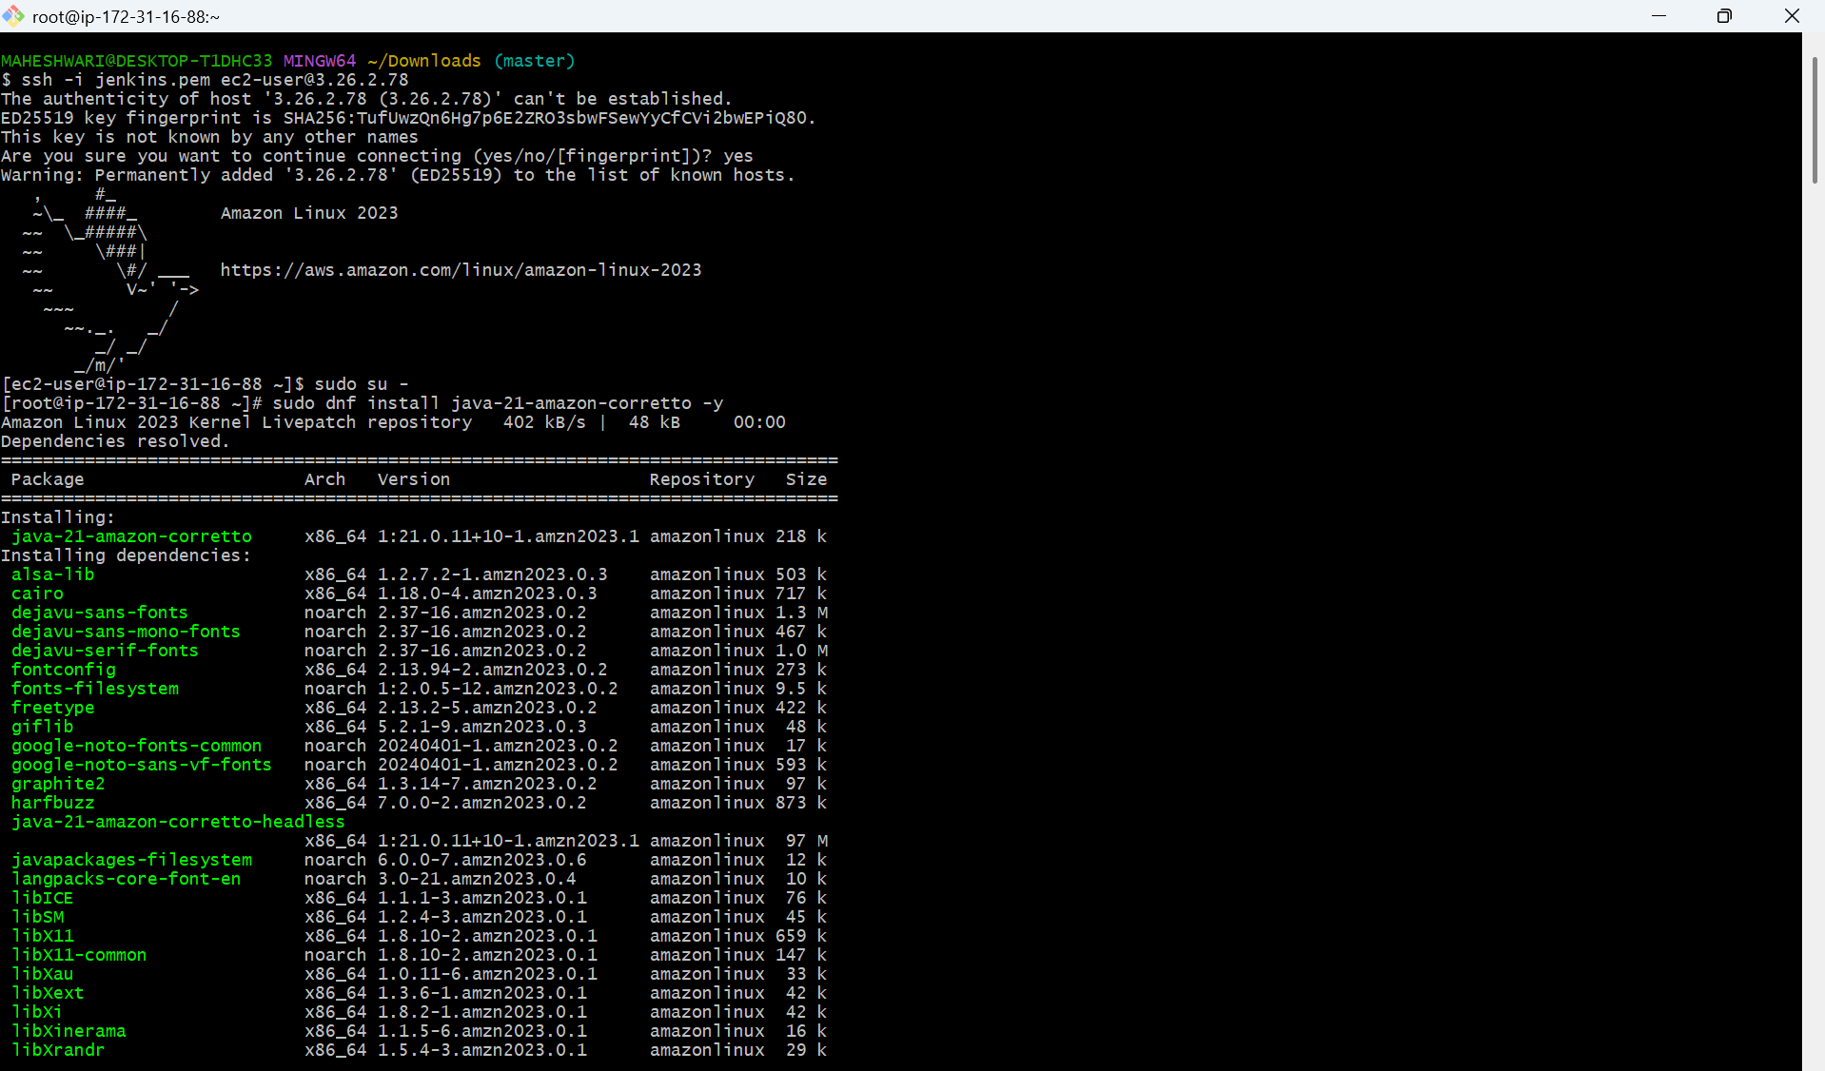

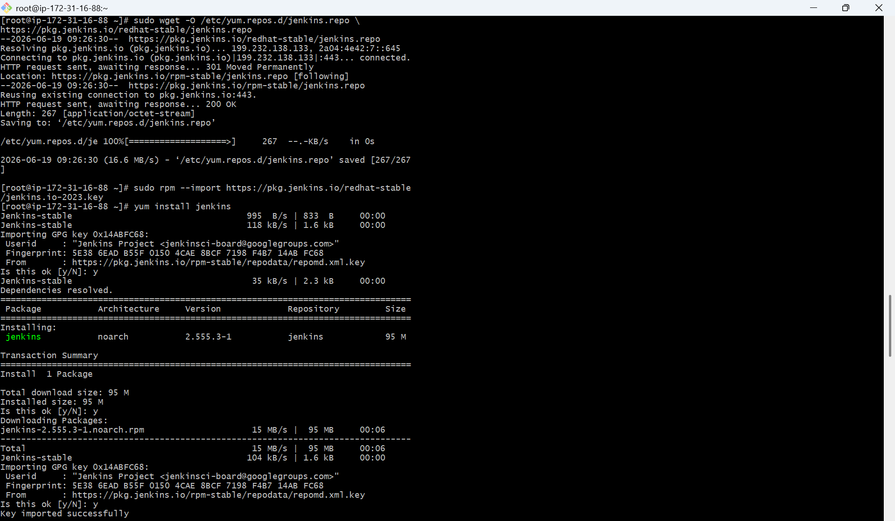

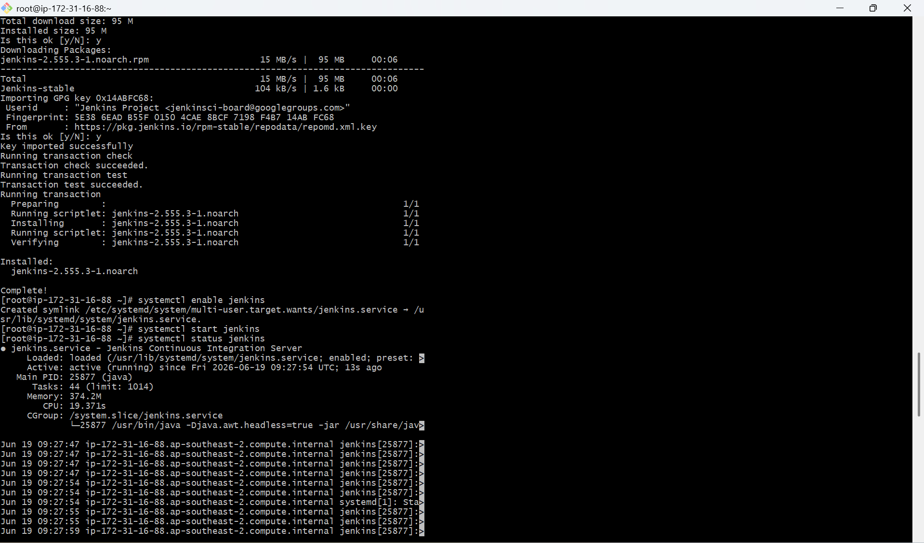

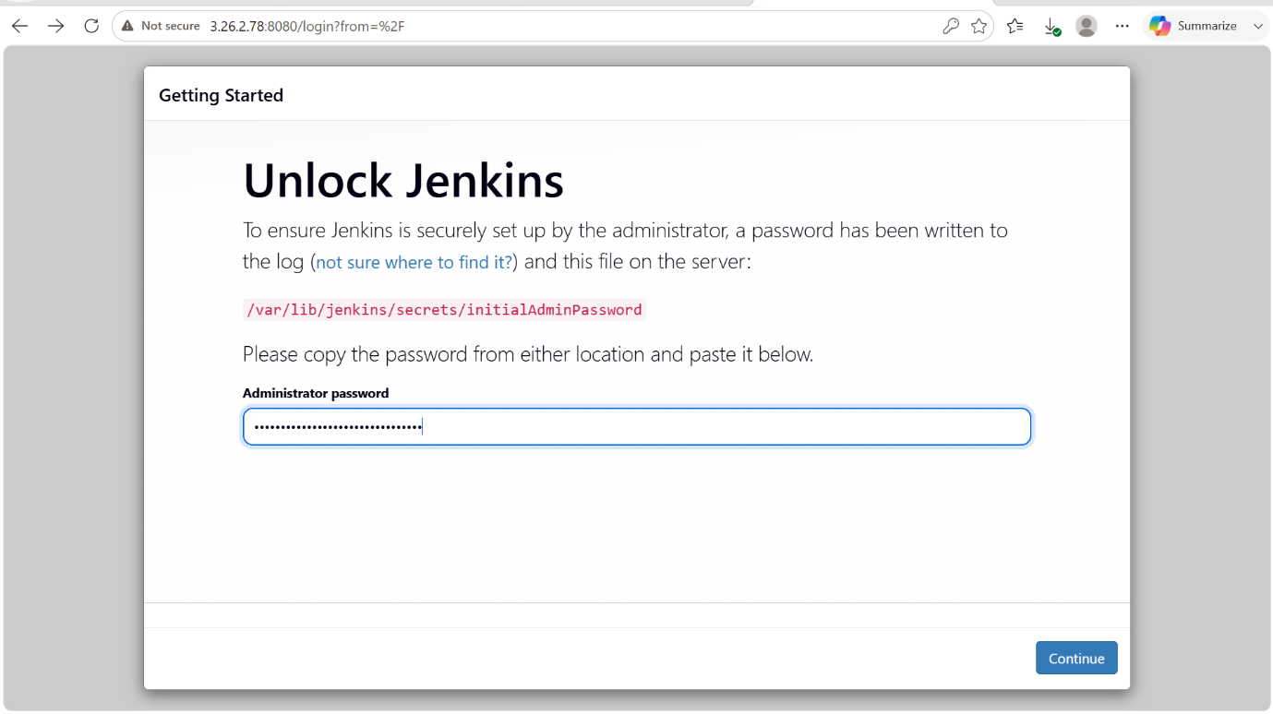

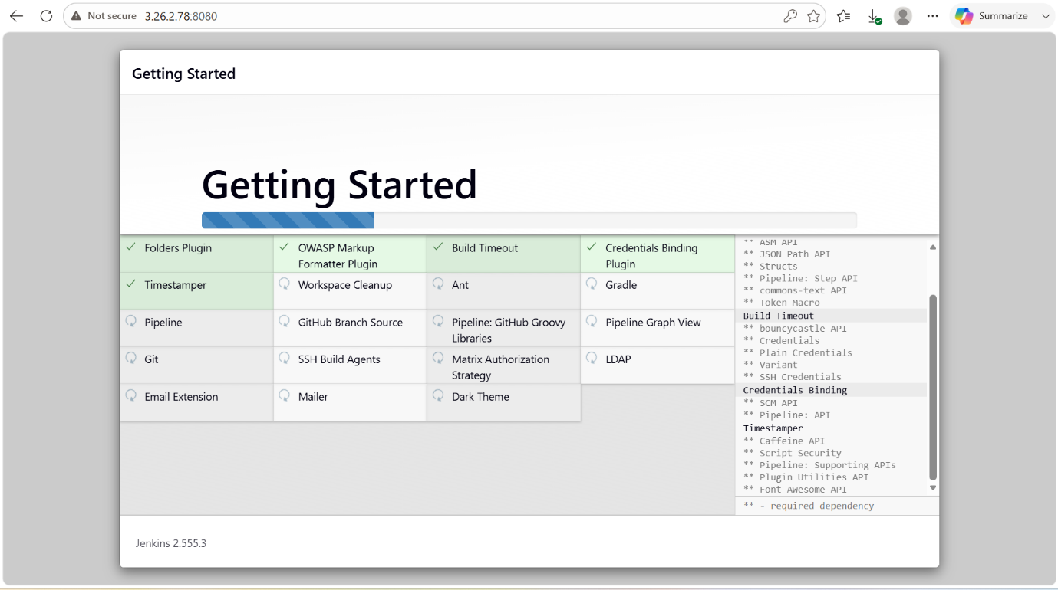

- Default port number of Jenkins is 8080.
- Now we have to change the port number from 8080 to 8081.
- In the jenkins.service file, we have to edit the port number from 8080 to 8081.
- Now we can successfully access our jenkins service on port number 8081 -> httpd://<public-ip>:8081/

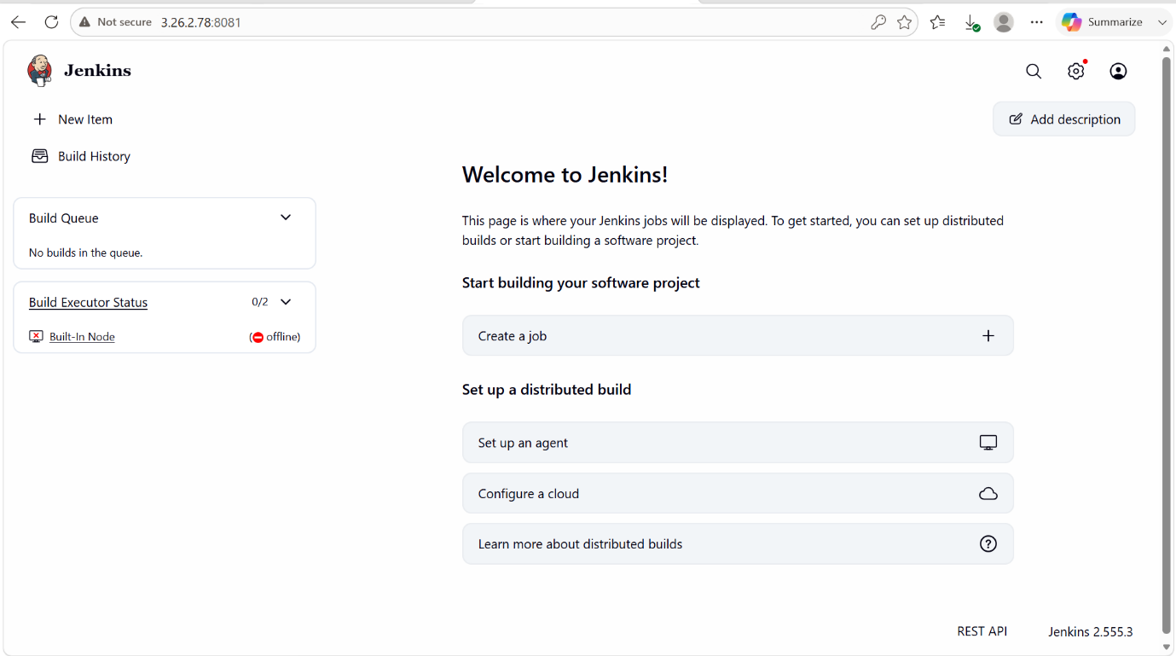

2. Secure Jenkins server

PURPOSE: The purpose of securing a jenkins server is to protect the continuous integration/Continuous Deployment (CI/CD) environment from unauthorized access, data breaches and malicious activities. Since Jenkins manages source code, build pipelines, credentials and departments, securing it is critical to maintaining the confidentiality, integrity and availability of software delivery processes.

OBJECTIVE: The objective of securing a Jenkins server is to implement security controls that protect the CI/CD infrastructure, build processes, credentials, and deployment pipelines from unauthorized access and cyber threats.

OUTCOME: A secure Jenkins environment where users, credentials, build jobs, and deployment processes are protected, ensuring reliable and secure software delivery.

STEP BY STEP IMPLEMENTATION:

- At the first login, the Jenkins server will create a password for the first time login purpose.
- We can also use that password for everytime but it is not recommended because of the security purpose.
- So we have to create our own user name and password to secure our jenkins server.
- And also we have to delete the password that have been given for us by the jenkins server.

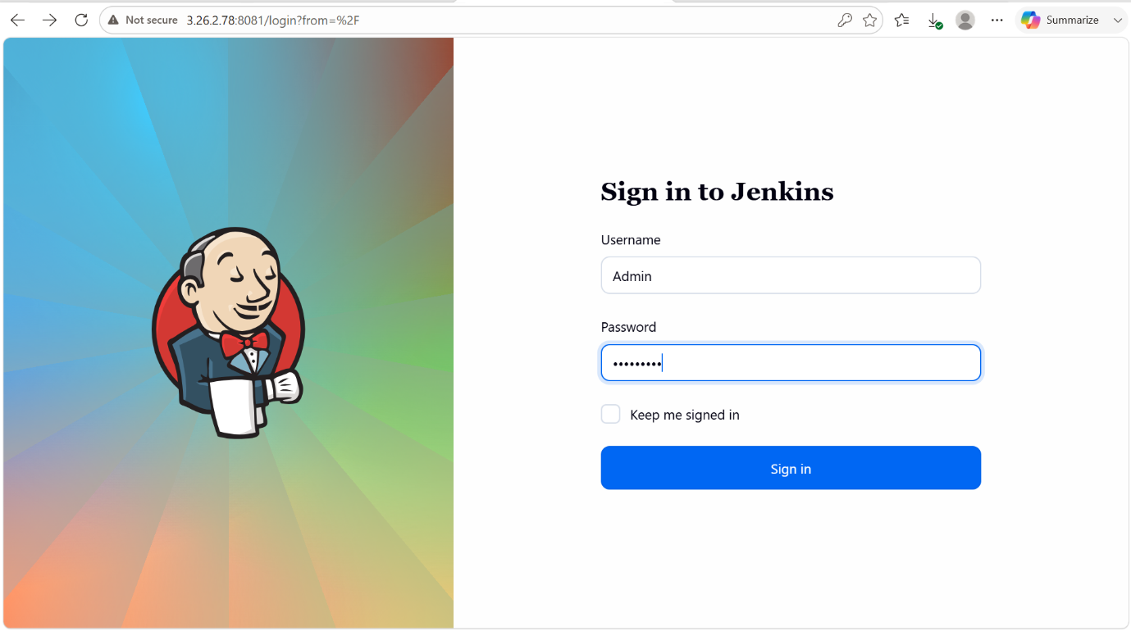



3. Create users called DevOps, Testing in Jenkins with Limited access.

PURPOSE: The purpose of creating separate Jenkins users such as DevOps and Testing with limited access is to implement Role-Based Access Control (RBAC) and ensure that users can only perform actions relevant to their responsibilities.
OBJECTIVE: The objective of creating DevOps and Testing users with limited access in Jenkins is to implement role-based access control (RBAC) and secure that each user has only the permissions necessary to perform their assigned tasks.

OUTCOME: DevOps and Testing users can securely access Jenkins and perform only their authorized tasks, while administrative functions, critical configurations, and sensitive information remain protected from unauthorized access.

STEP BY STEP IMPLEMENTATION:

- Firstly we have to install the plugin called role-based authorization strategy plugin in the available plugins and we can find them in the installed plugins.
- Next we have to go the security page, we have to give the authorization as Role based strategy.
- Then we have to create roles for both devops and testing in manage and assign roles page.
- In that page, we have create roles first and after that assign role to the user.
- And we can check the users by using the username and password.

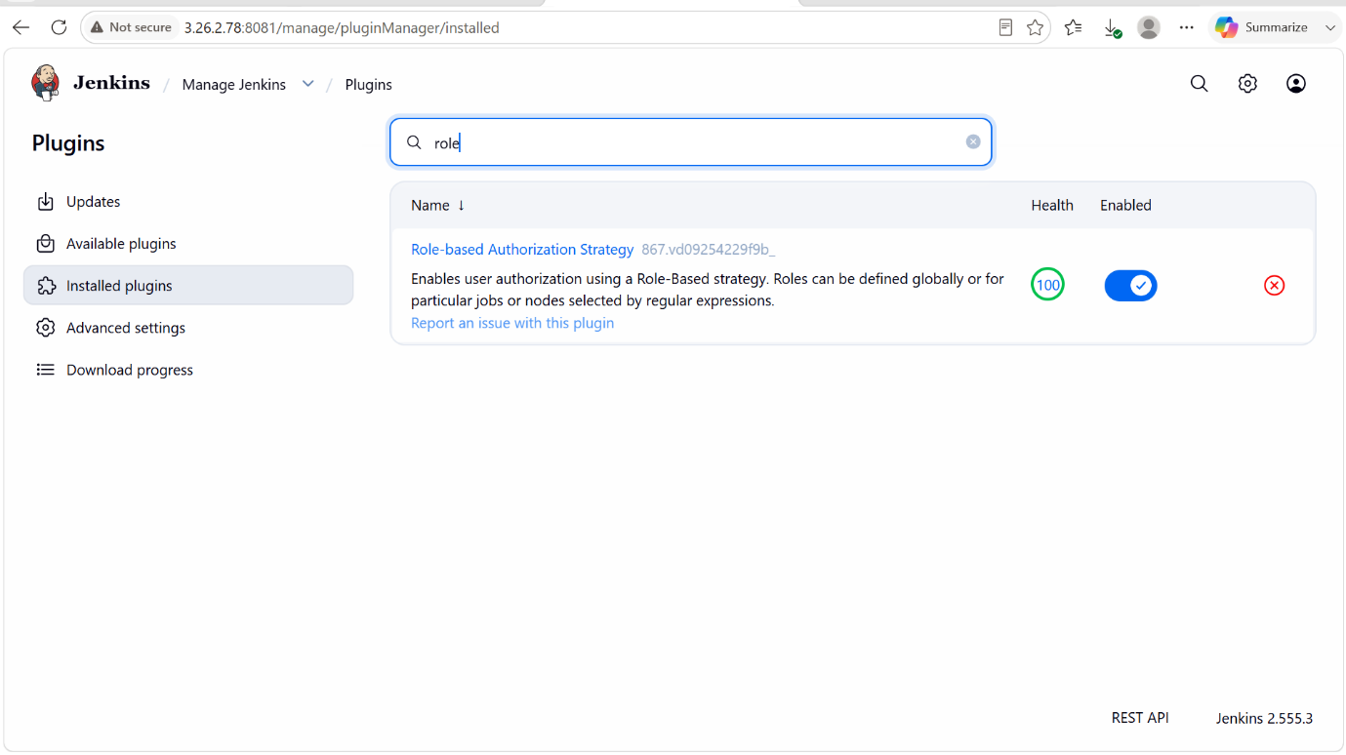

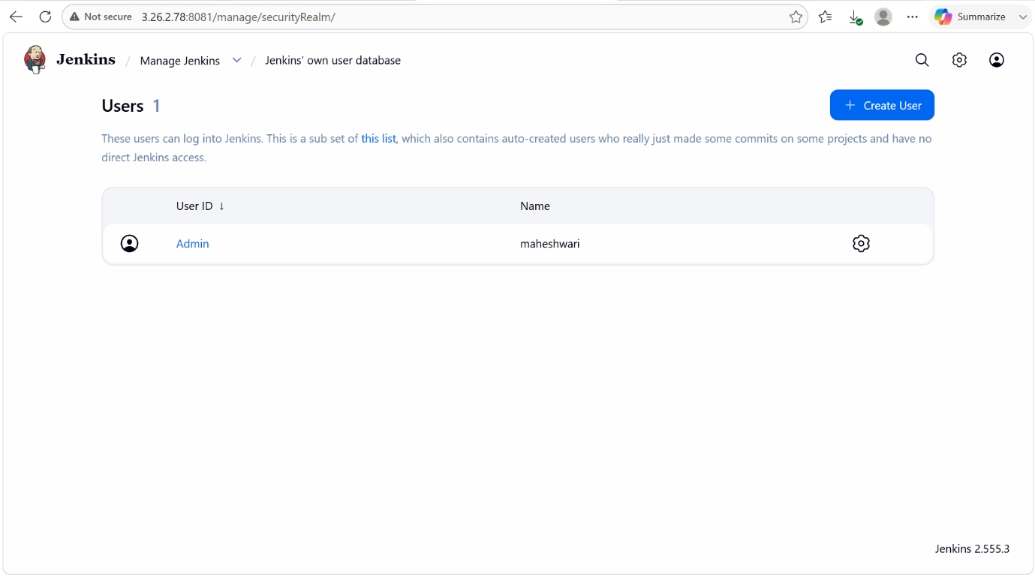

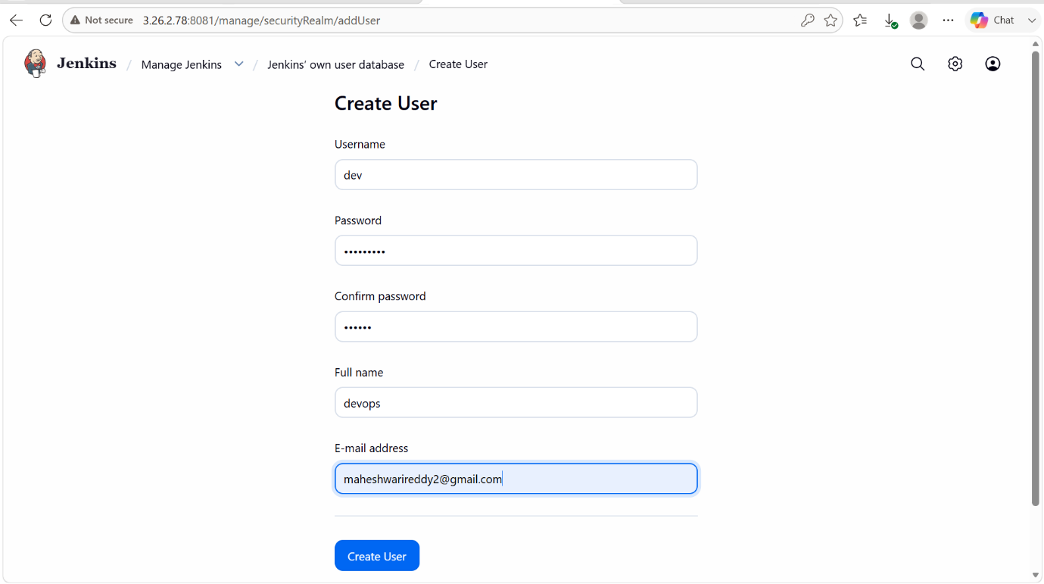



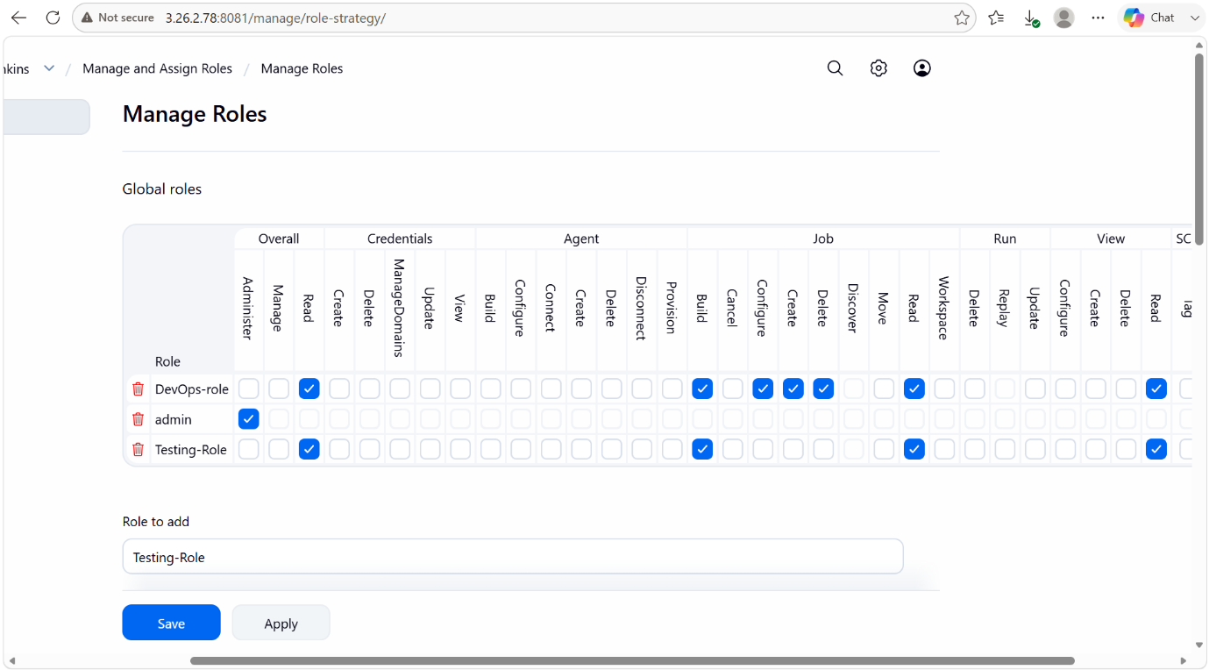

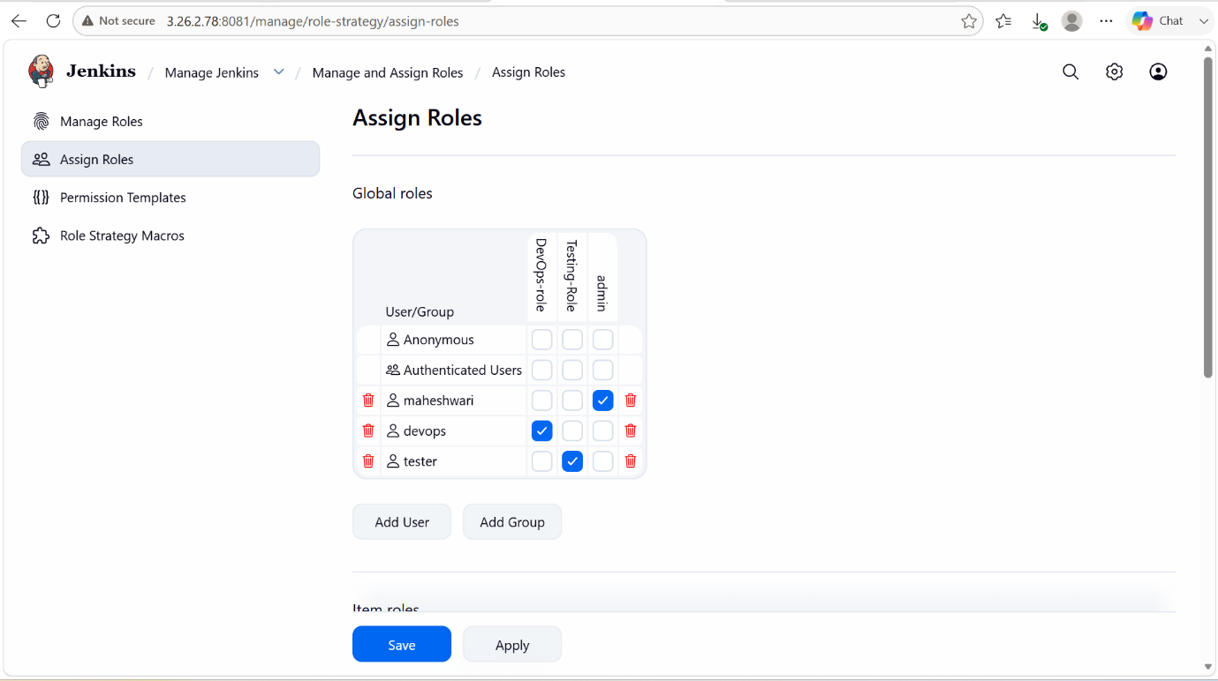

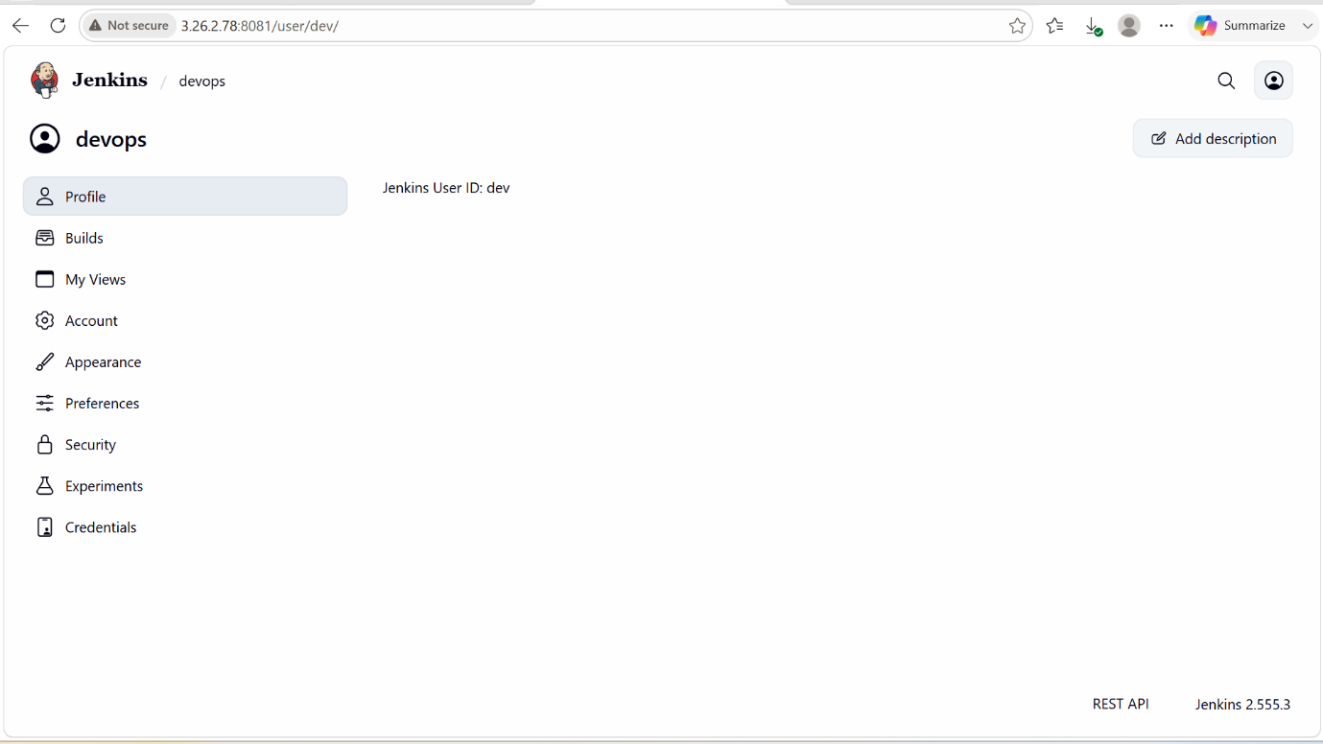

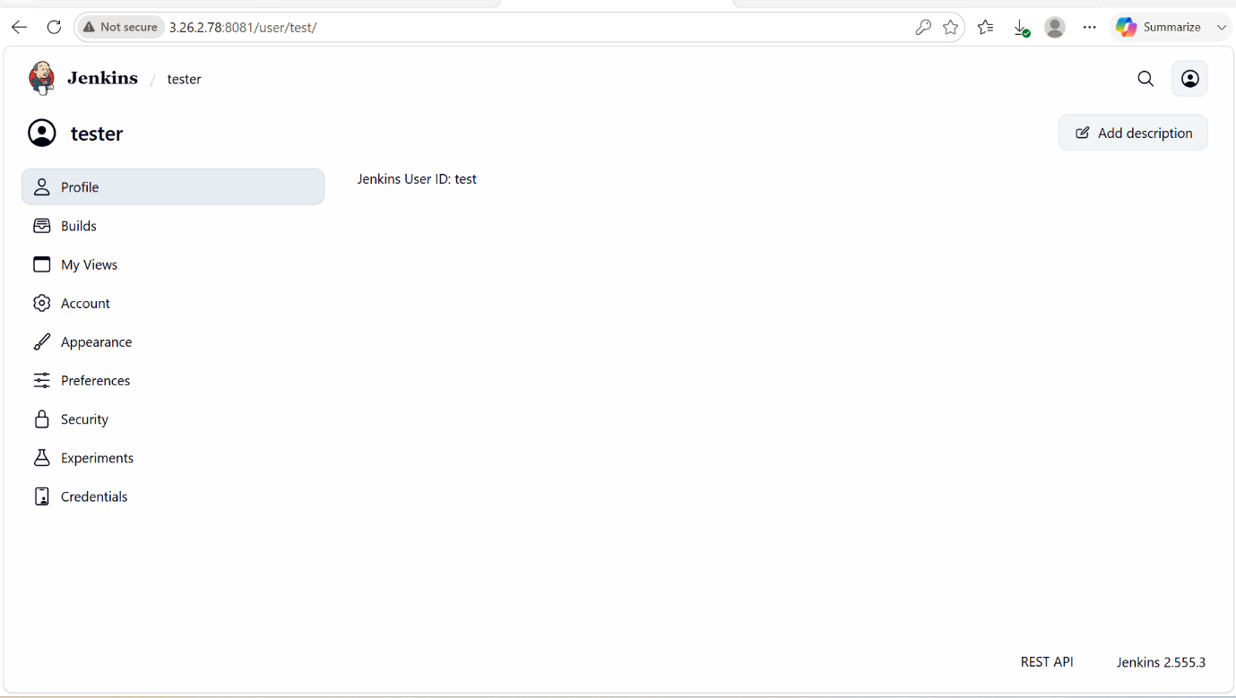

4. Configure labels and restrict the jobs to execute based on label only

PURPOSE: To control where Jenkins jobs rub by assigning labels to jenkins agents (nodes) and configuring jobs to execute only an agents that match specific labels. This ensures proper resource utilizations, workload segregation and environment specific job execution.

OBJECTIVE:
- Assign labels to Jenkins agents.
- Restrict jobs to run only on designated agents.
- Separate build, test and deployment workloads.
- Improve security and resource management.

OUTCOME: Jobs configured with a label expression are successfully executed only on the matching Jenkins agents, ensuring controlled, secure and efficient workload distribution across the Jenkins infrastructure.

STEP BY STEP IMPLEMENTATION:

- Firstly we have to install the node and label parameter and get that into success.
- Use the existing built-in node and add the labels in that node.
- Increase the volume of the node and so it will not create any issue to make it online.
- After creating label, we have to create a job with the free style option while creating the job.
- While creating the job, we can add the github project also to that job.
- After creating this click on build now.
- Then it will proceed with the job and result will be seen in the build executor status tab.

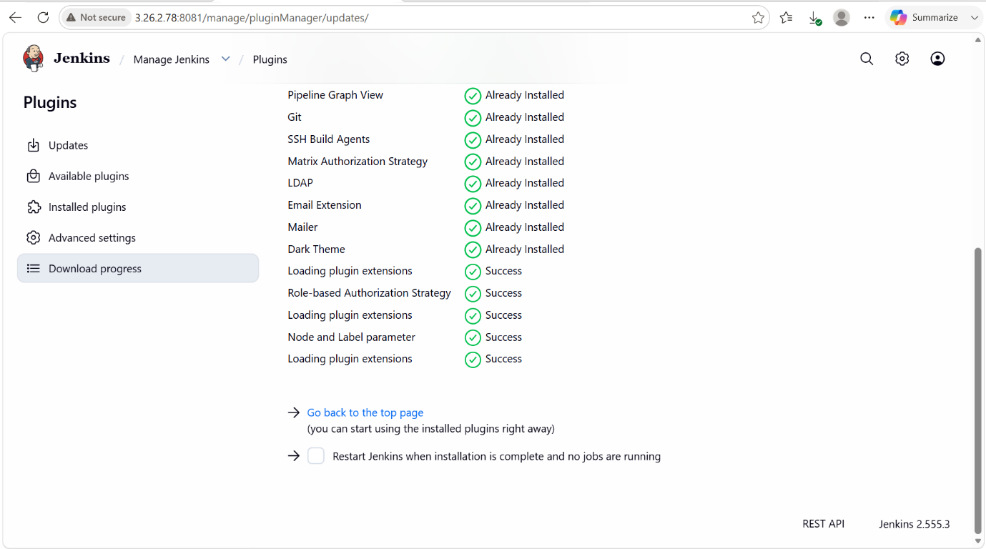

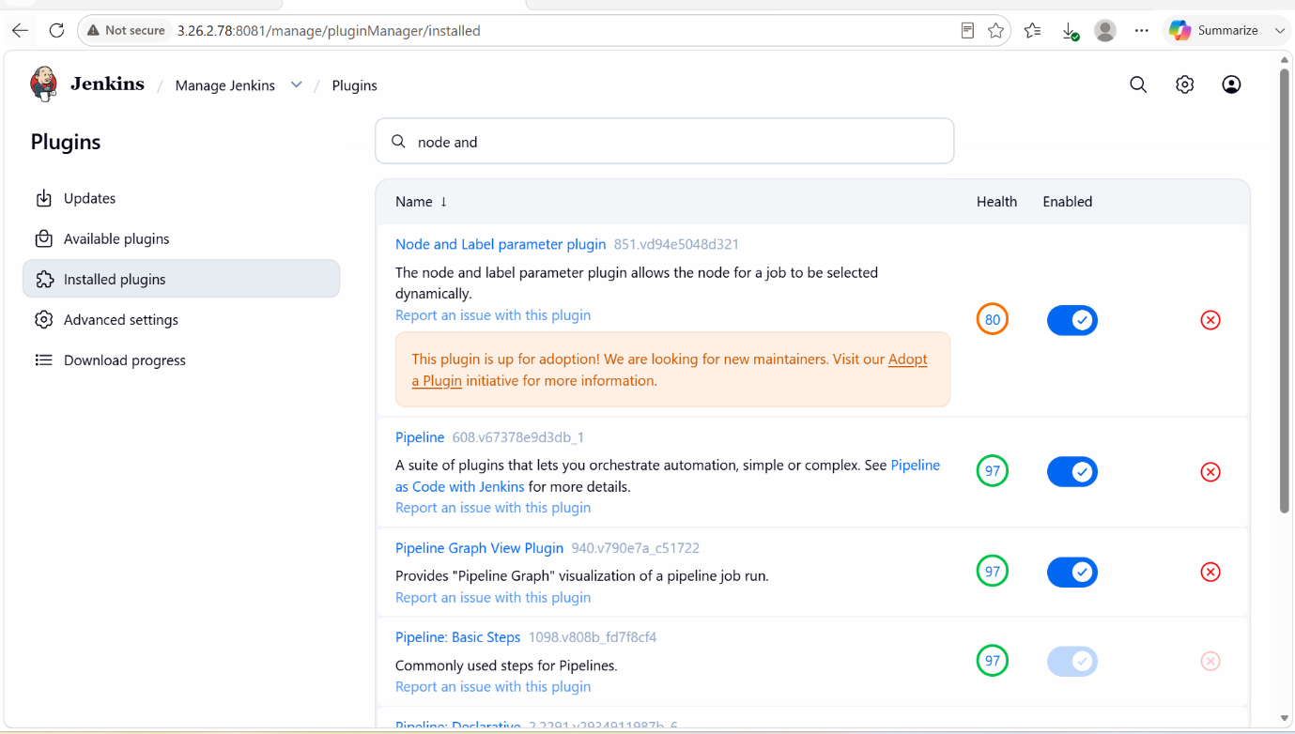

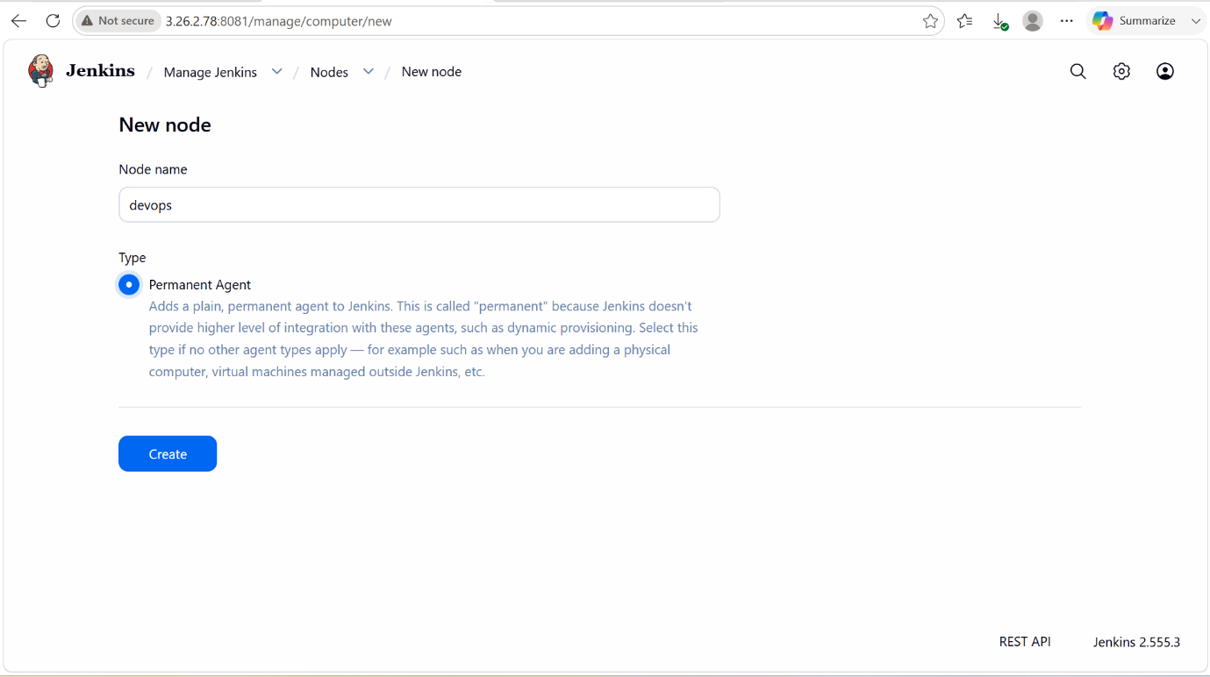

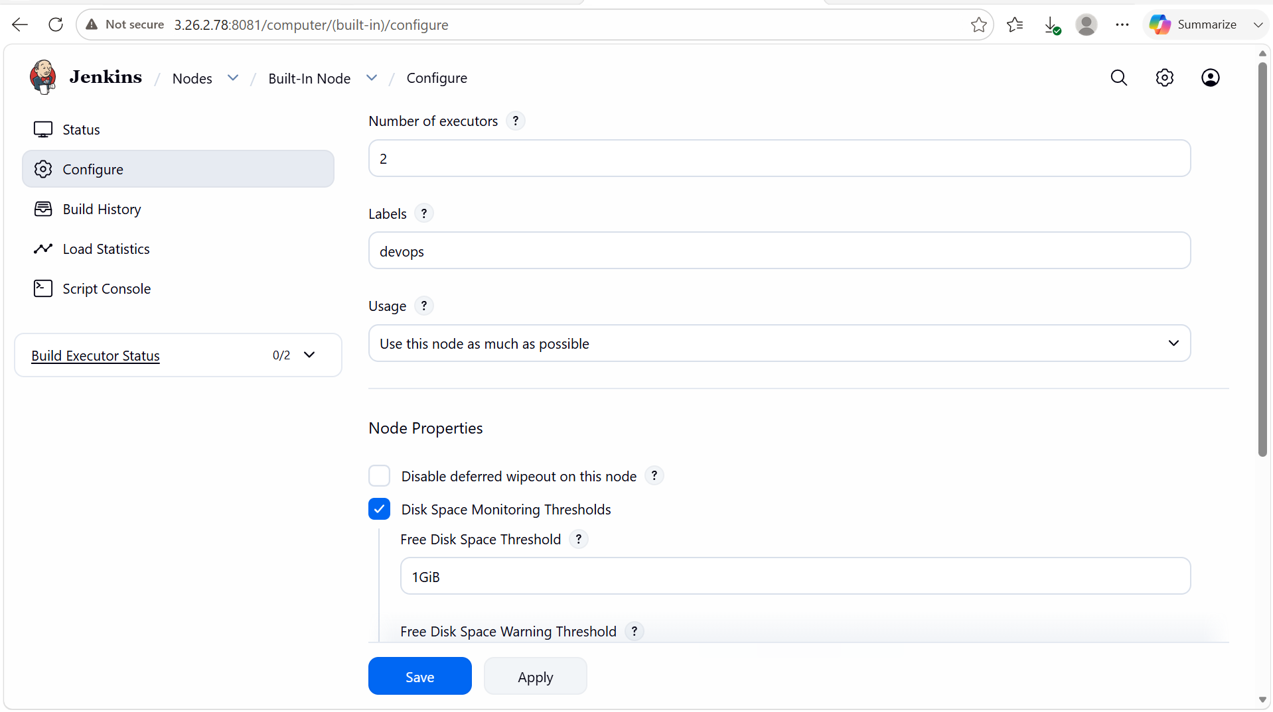

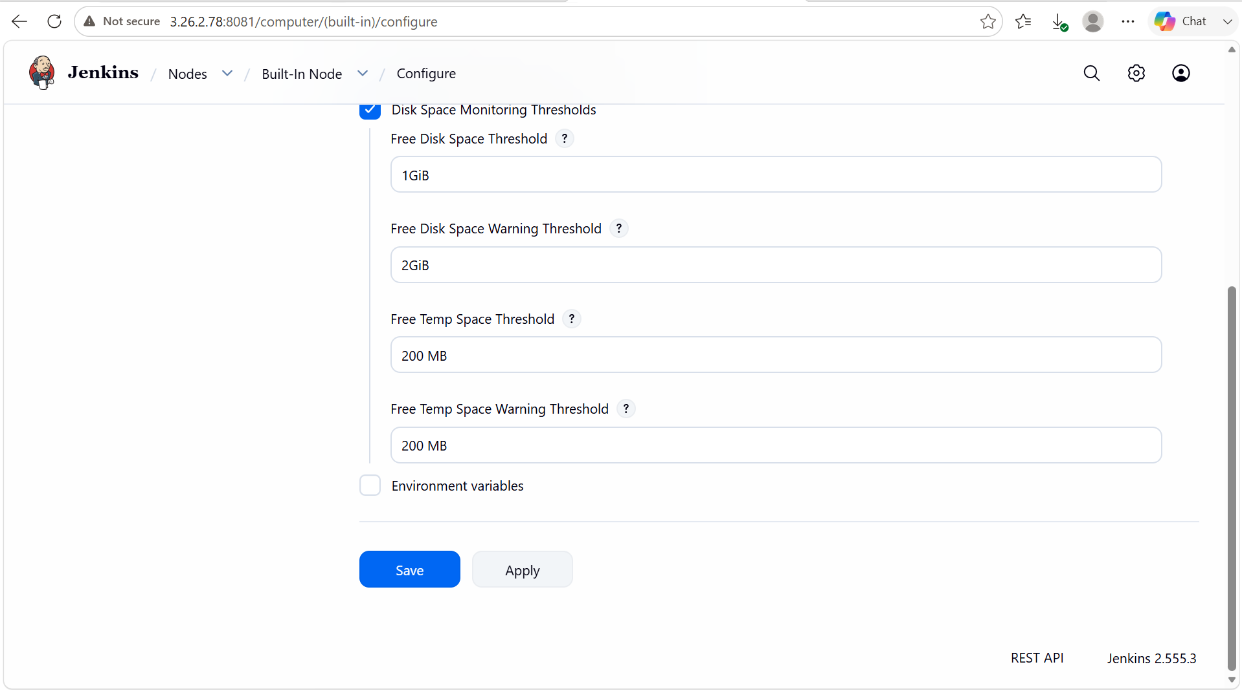

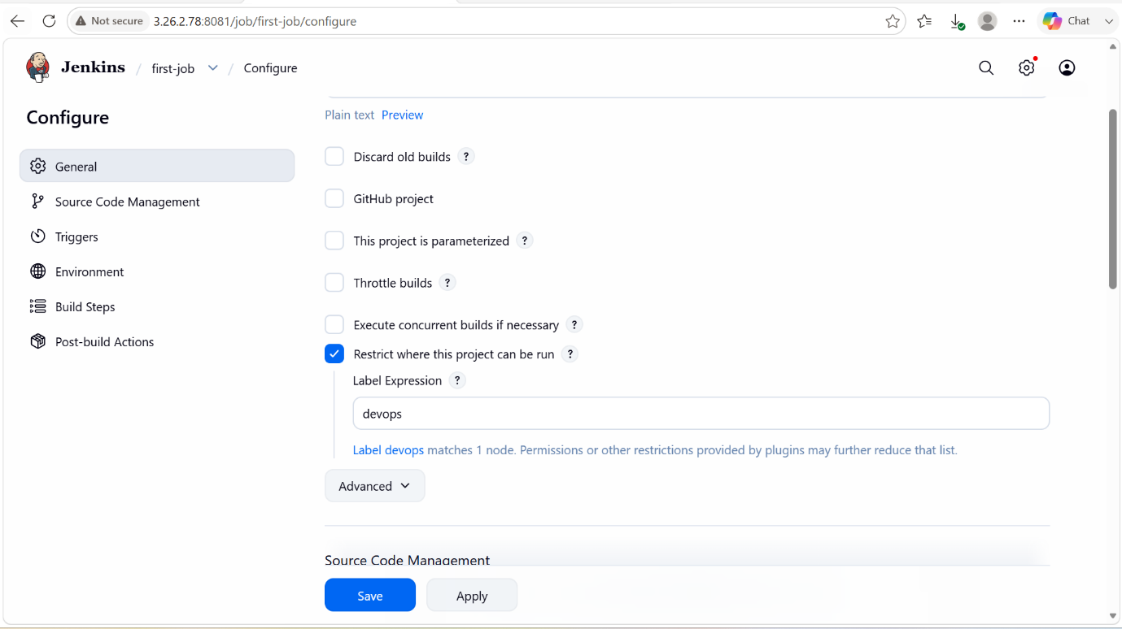

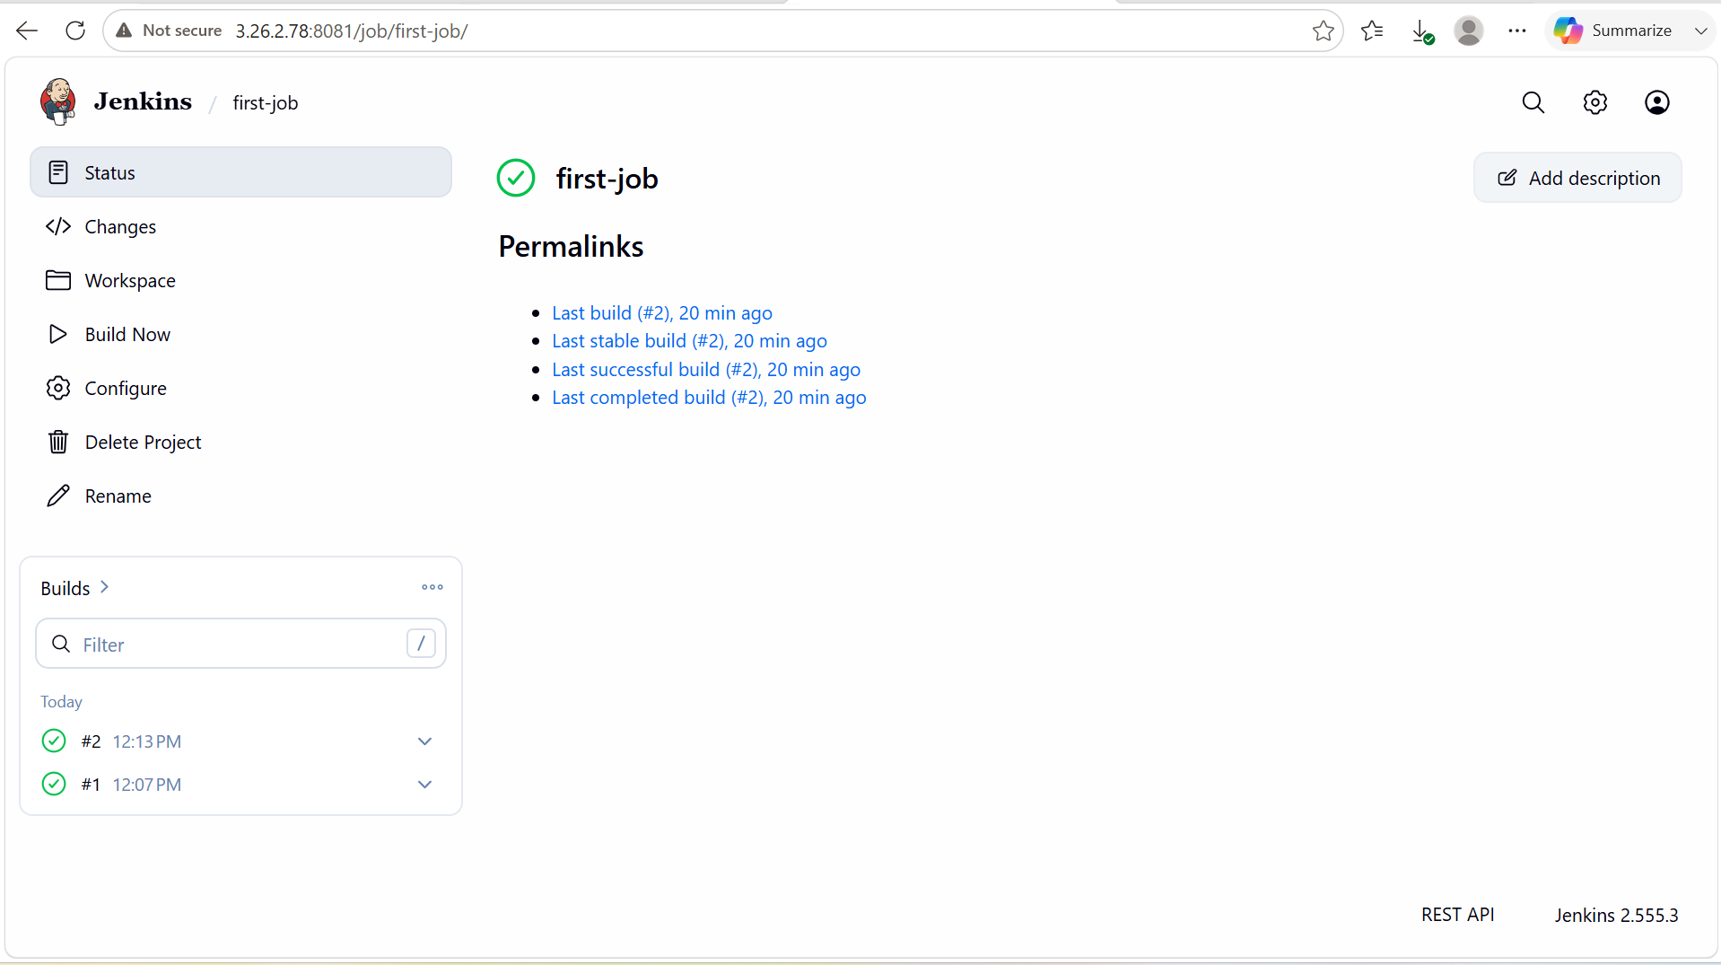

5. Create Three sample jobs using the below URL.

Source Code:https://github.com/betawins/Techie_horizon_Login_app.git

PURPOSE: To set the pre sample job as the main source for the next sample job. That pre sample job is healthy then only the nest job will execute.

STEP BY STEP IMPLEMENTATION:
- First of all create 3 sample jobs.
- For the sample only we have to give the github repo url as the source code.
- After build this job, we can now access the github repo in the job workflow tab.

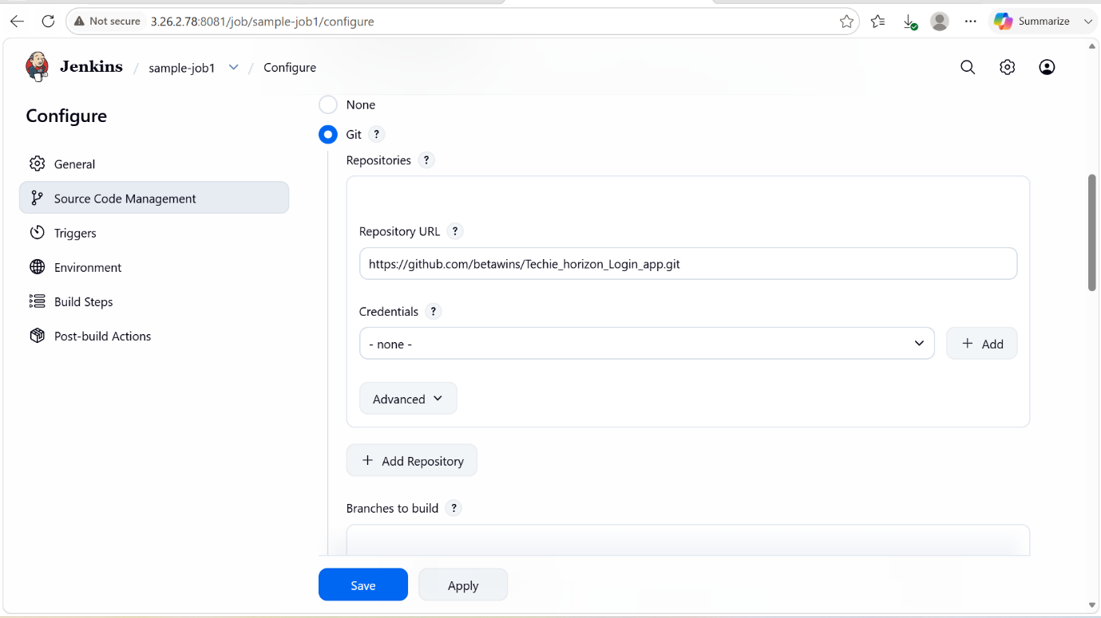

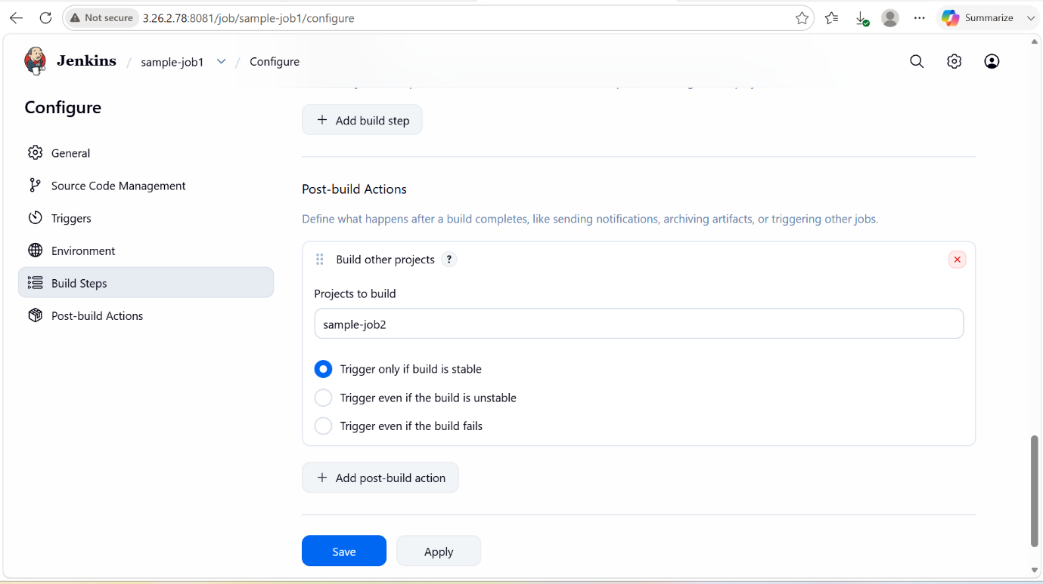

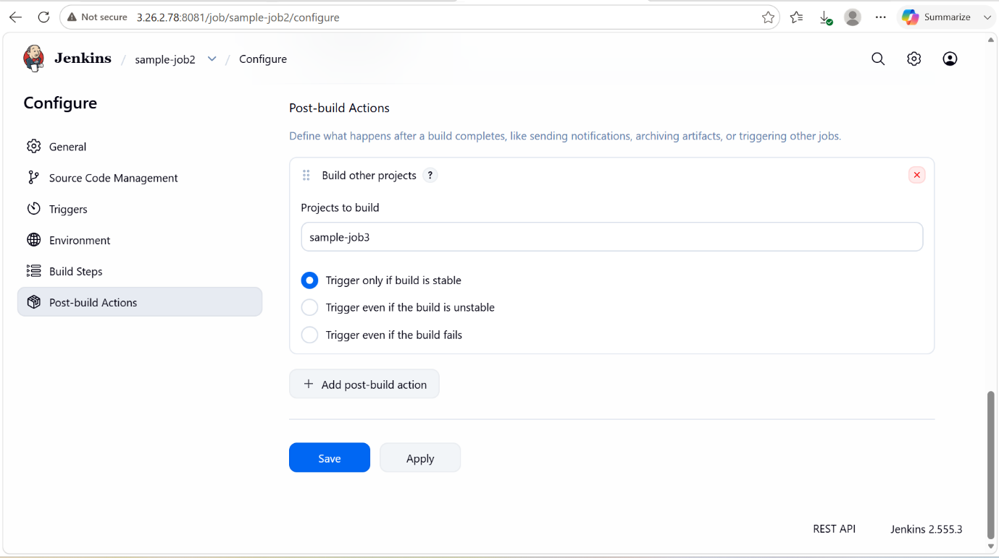

6. Create one Jenkins job using GitHub Private repository.

Using SSH Key Authentication

PURPOSE: To securely integrate Jenkins with a private GitHub repository so that source code can be automatically fetched, built, tested, and deployed as part of a Continuous Integration and Continuous Delivery (CI/CD) process while maintaining code confidentiality and access control.

OBJECTIVE: To configure a Jenkins job that securely authenticates with a GitHub private repository, retrieves the source code, and automates build, test, and deployment tasks, ensuring a reliable and efficient CI/CD workflow while protecting repository access through secure credentials.

STEP BY STEP IMPLEMENTATION:

- In the instance we have to do the ssh-keygen and it will create rsa keys both public and private.
- We have to place the public key in the GitHub in the SSH and GPG keys.
- And that same key should be placed in the jenkins in the credentials that is in the manage jenkins tab.

