MASTER AND SLAVE ARCHITECTURE

1. Configure 2 slave machines in the Jenkins master.

PURPOSE: The purpose of configuring two slave machines (Jenkins agents) with a Jenkins master is to distribute and execute build, test, and deployment jobs on multiple servers instead of running everything on the Jenkins master.

OBJECTIVE: The objective is to connect two slave machines to the jenkins master so that Jenkins can distribute, manage and execute jobs across multiple nodes efficiently.

PREREQUISITES:
- Jenkins Master Server
- Two Agent Machines
- Java Installation
- Network connectivity
- SSH Configuration
- Jenkins Users Permissions
- Agents Workspace Directory
- Jenkins Plugins
- Git Installation
- Labels planning

OUTCOME: Two Jenkins agent machines are successfully connected to the Jenkins master, enabling distributed, parallel, label-based execution of CI/CD jobs with improved performance, scalability, and resource utilization.

STEP BY STEP IMPLEMENTATION:
- Launch 2 instances and connect to that instance.
- After connecting, we have to do key gen by using command -> ssh-keygen
- After keygen we have to copy that public key to authorized_keys -> cat /root/.ssh/id_rsa.pub > authorized_keys
- After that we have change the permissions for that file -> chmod 600 authorized_keys
- Same for 2 instances that we have created repeat this process for second instance also.

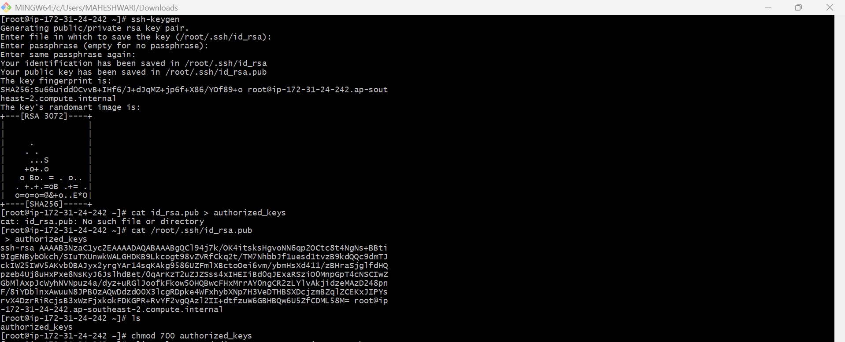

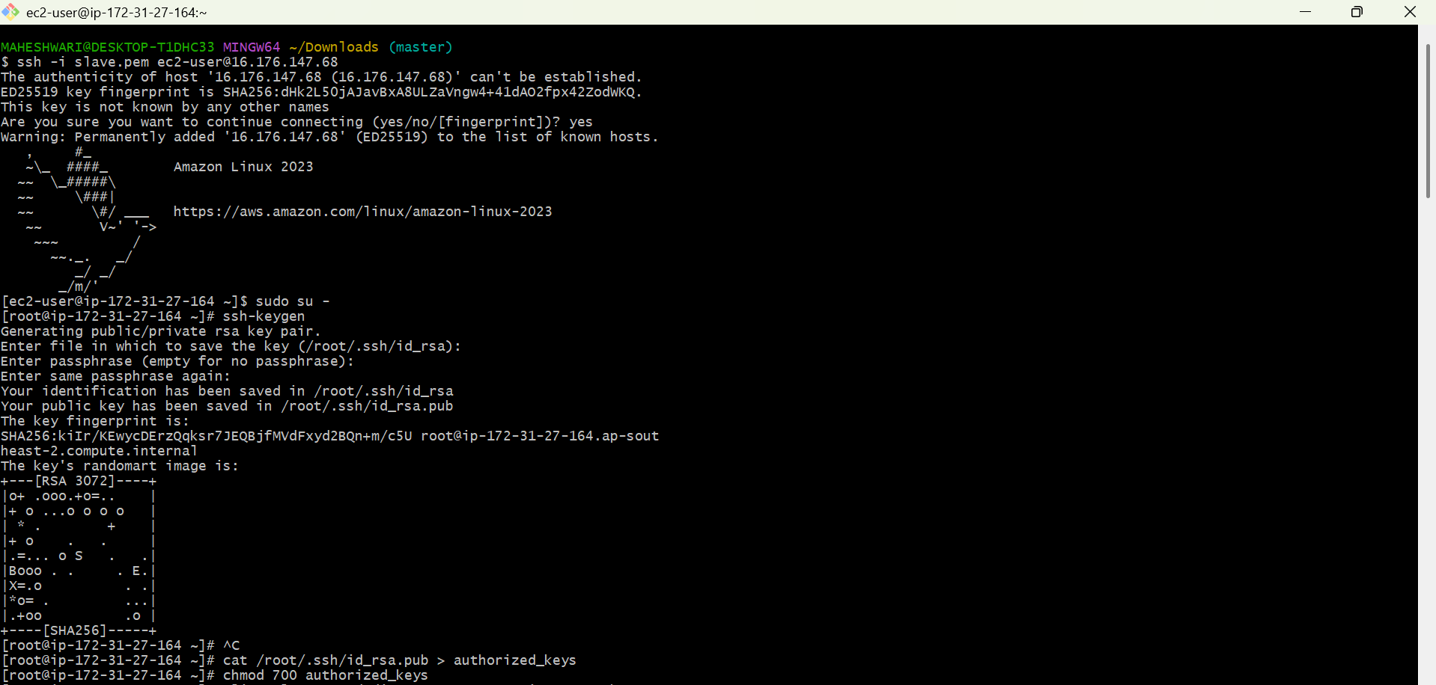

- After this, we have to login into master machine.
- After logging we have to switch to the root user.
- Create a new directory -> mkdir -p /var/lib/jenkins/.ssh
- Get into that directory -> cd /var/lib/jenkins/.ssh
- After we have to scan the known_host -> ssh-keyscan -H <slave-node-IP> >> /var/lib/jenkins/.ssh/known_hosts
- We have to change the ownership to the known_hosts file -> chown jenkins:jenkins known_hosts
- Change the permissions -> chmod 600 known_hosts

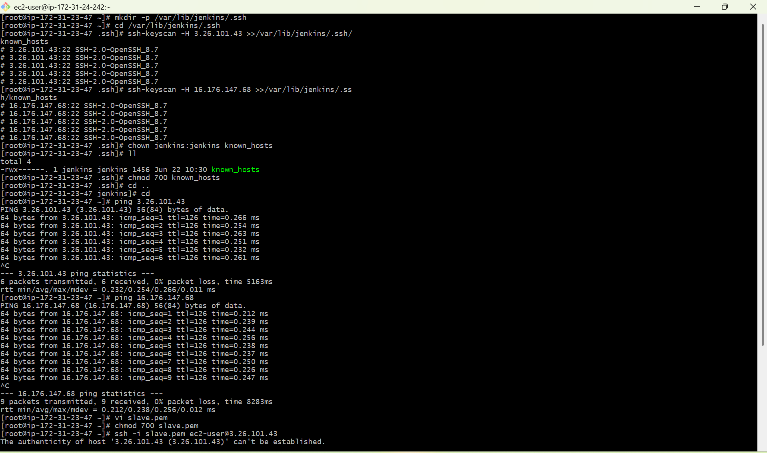
- After we have to go to the Jenkins GUI page, there we have to create 2 nodes.
- In that we have to give remote directory path as /home/ec2-user/jenkins for both the nodes.
- After that we have to give the labels.
- After that we have to select launch agents via ssh, In that it will ask for host IP and credentials.
- The credentials will be the instance pem key file that we have to create a credential with that pem file.
- Repeat this same for the second node also.

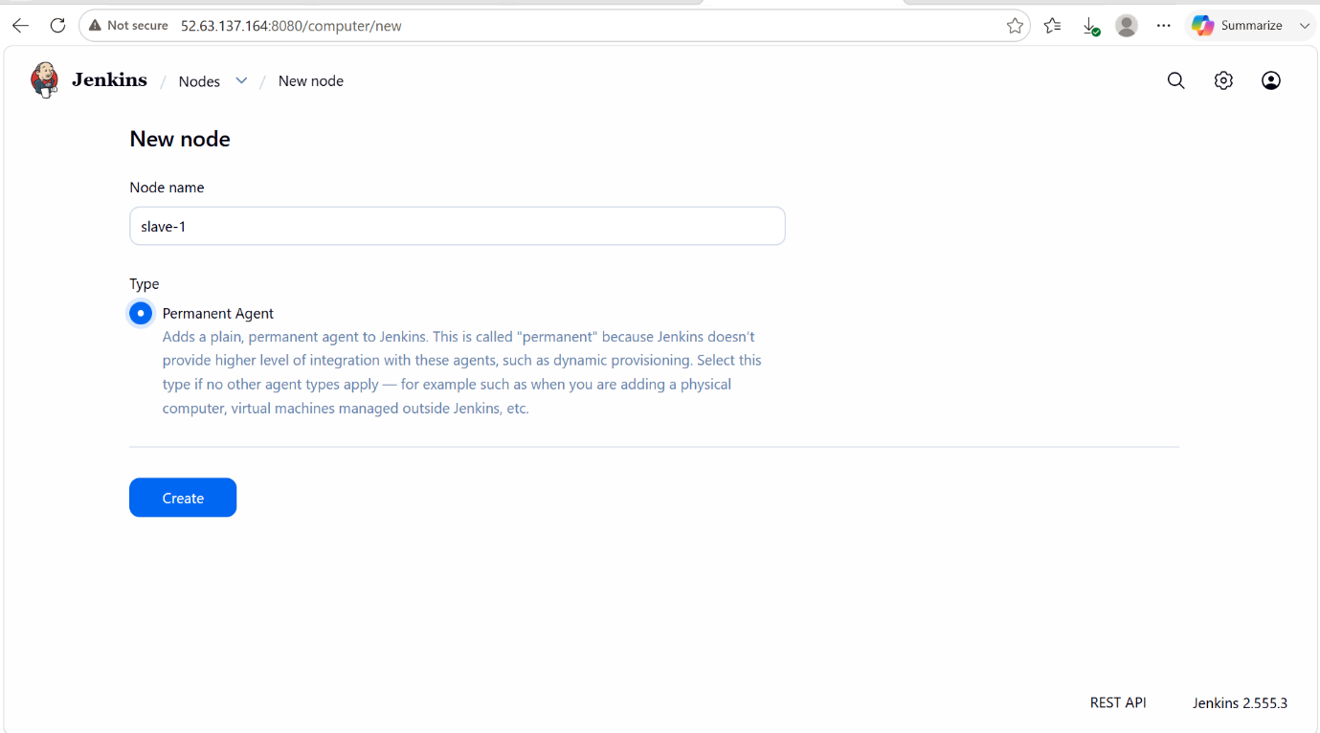

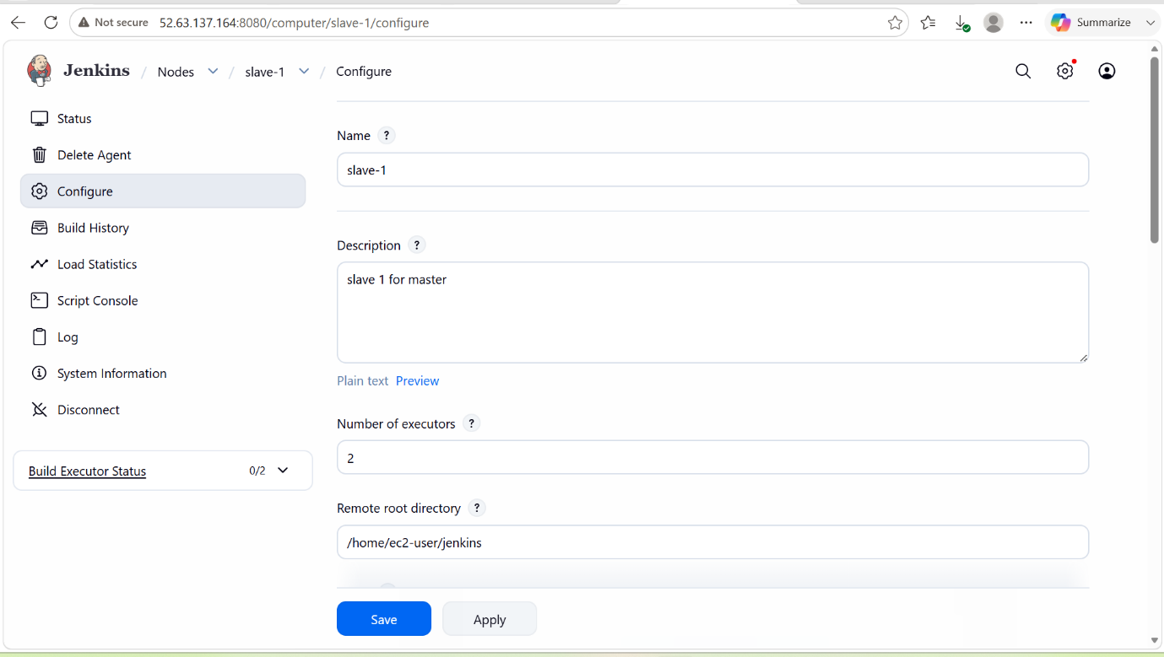

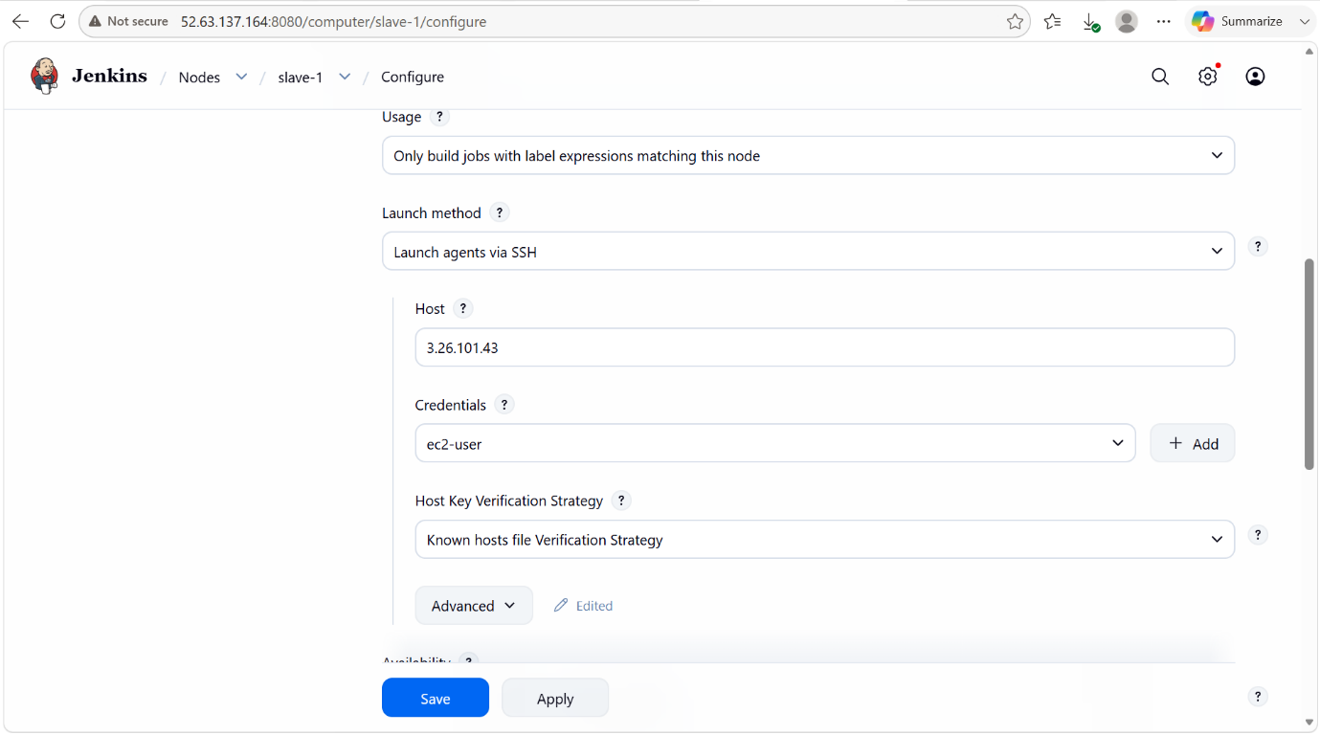

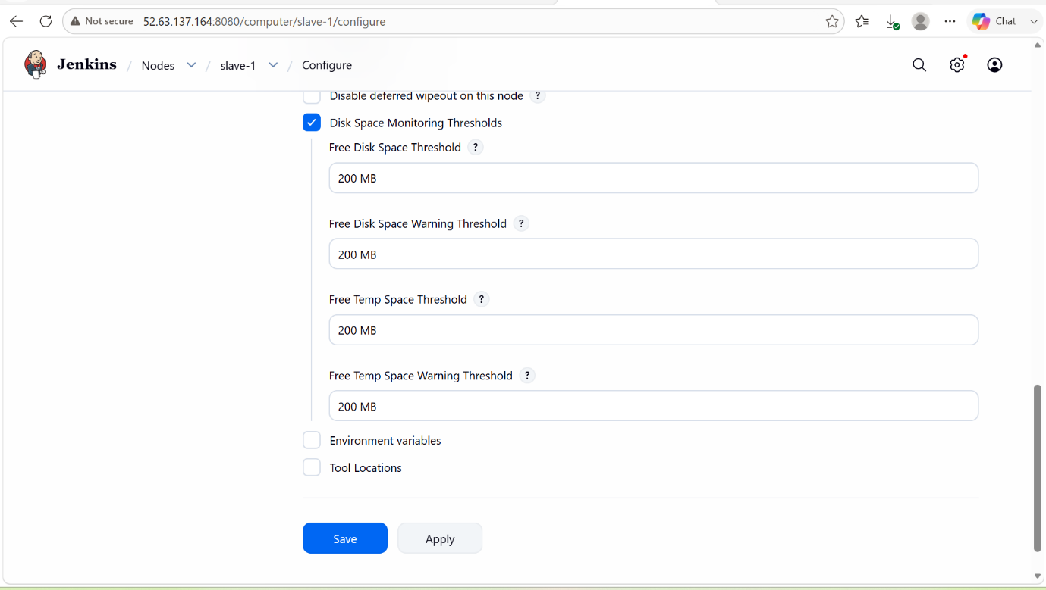

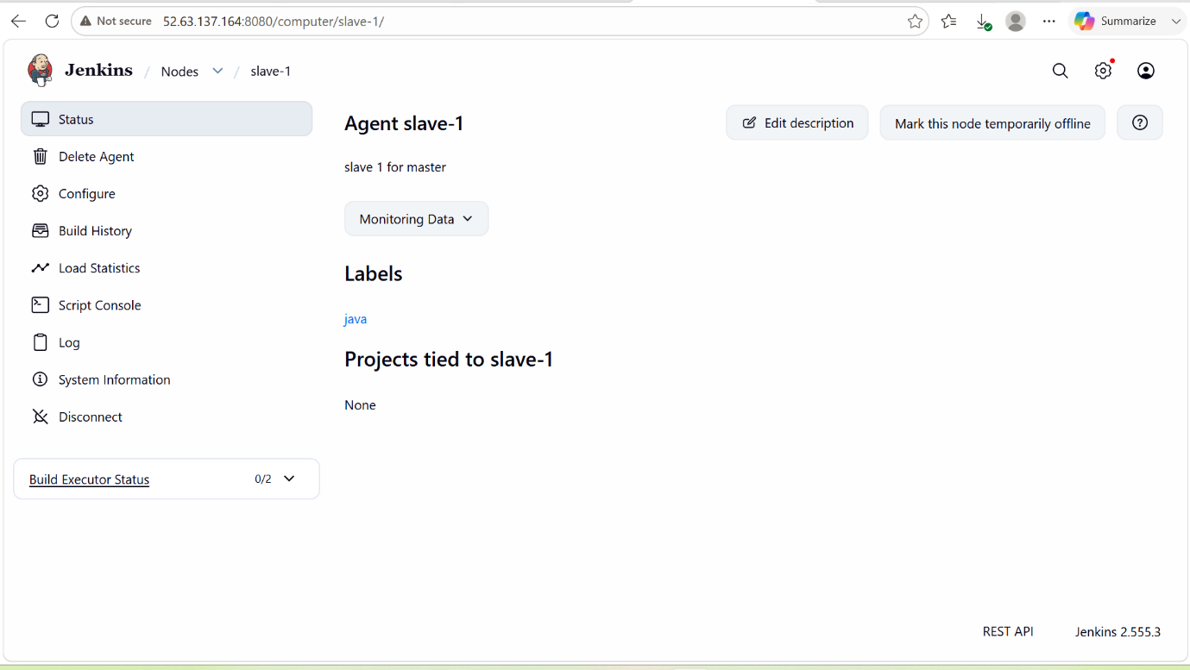

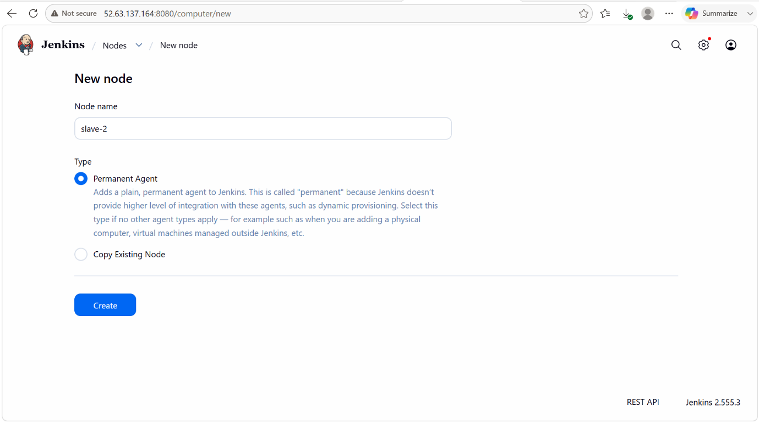

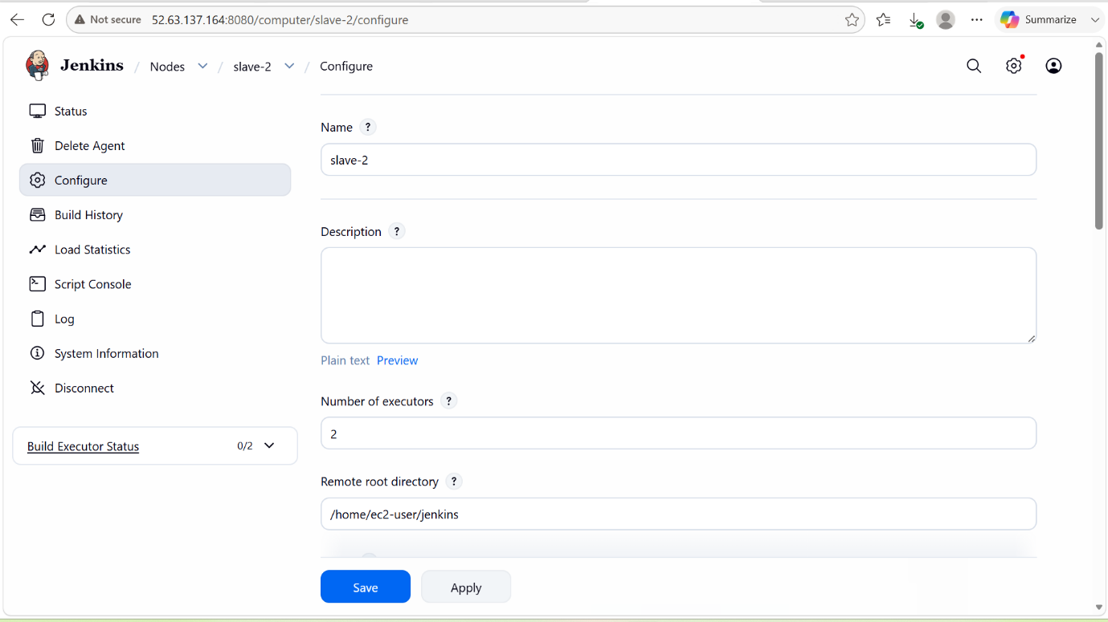

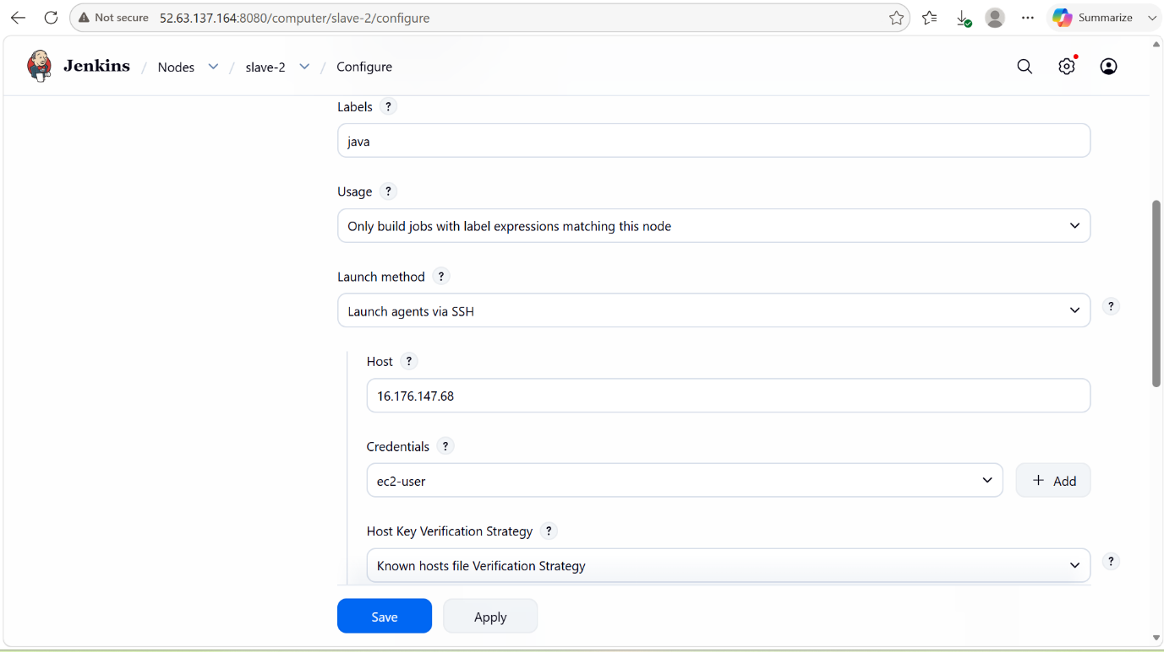

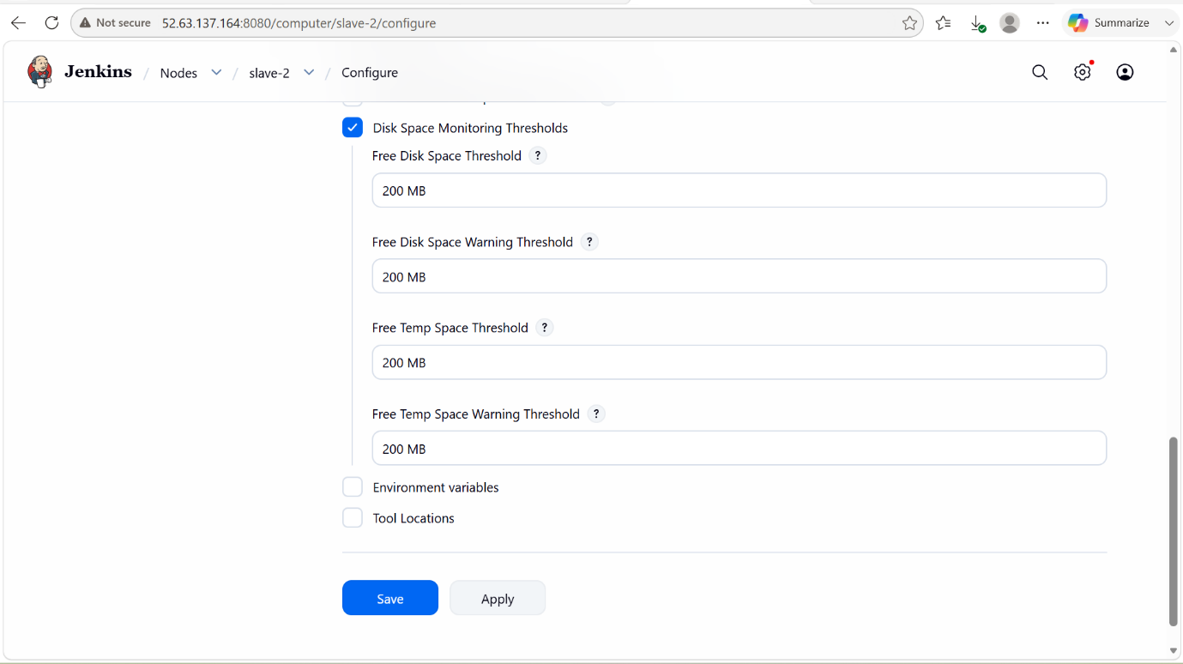

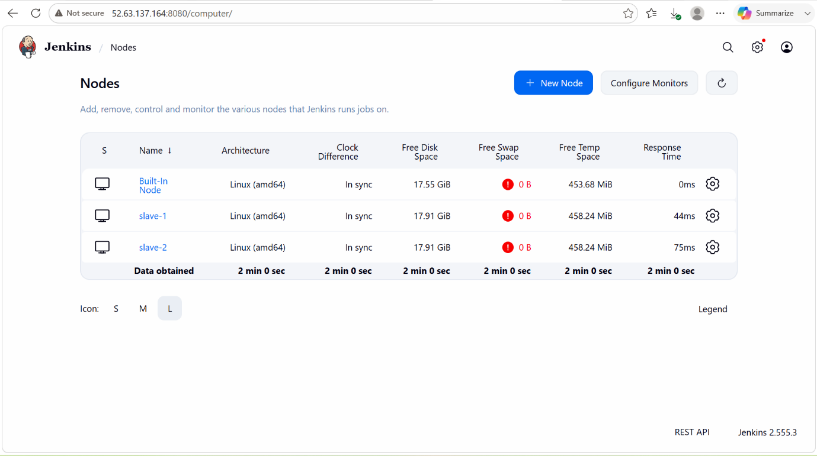

2. Configure webhooks to the Jenkins job

PURPOSE: The purpose of configuring webhooks in Jenkins is to automatically trigger Jenkins jobs whenever changes occur in the source code repository, eliminating the need for manual job execution or frequent polling.

OBJECTIVE: To establish an automated integration between sorce code repository and Jenkins so that Jenkins jobs are triggered automatically whenever code changes occur, enabling continuous integration and faster delivery of software.

OUTCOME: Jenkins automatically receives repository event notifications and triggers the configured job, resulting in faster builds, continuous integration, reduced manual effort, and improved CI/CD automation.

STEP BY STEP IMPLEMENTATION:
- Go to github and which repo you want to select u have to click on that repo and go to settings and there you will get to see webhooks there.
- Create the webhook with jenkins payloadURL with the prefix
- After that go to jenkins create a job and in that job we have to configure the build trigger as GitHub hook trigger for GITScm polling.
- After this we have to click on save and click on build now.

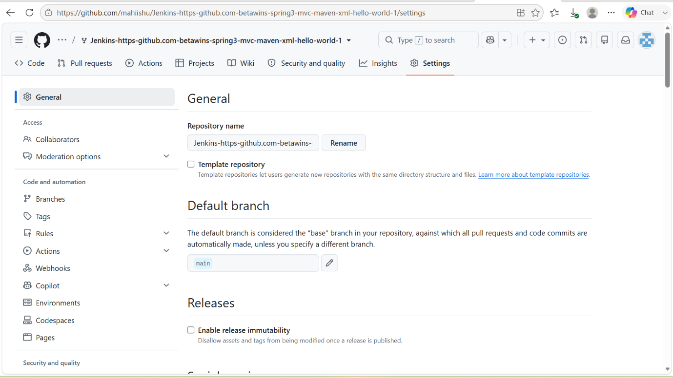

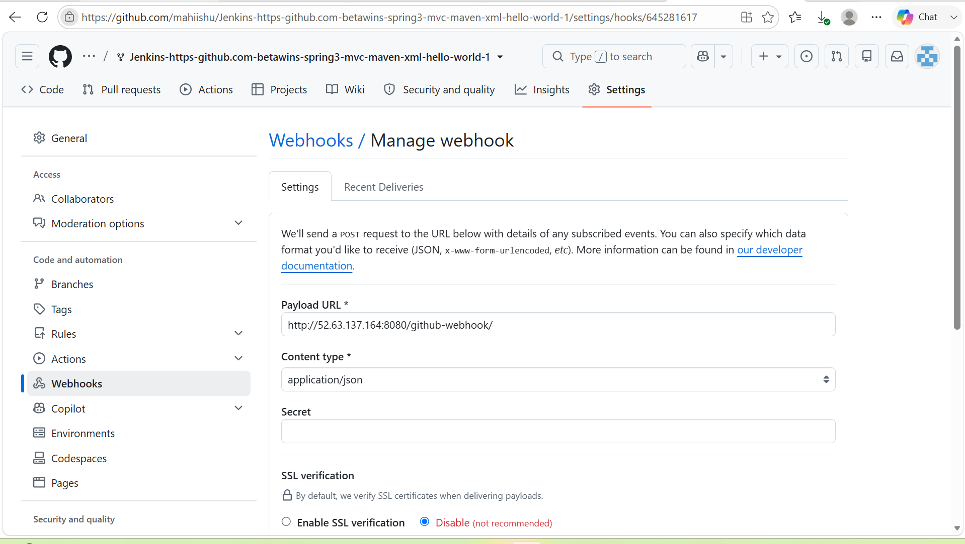

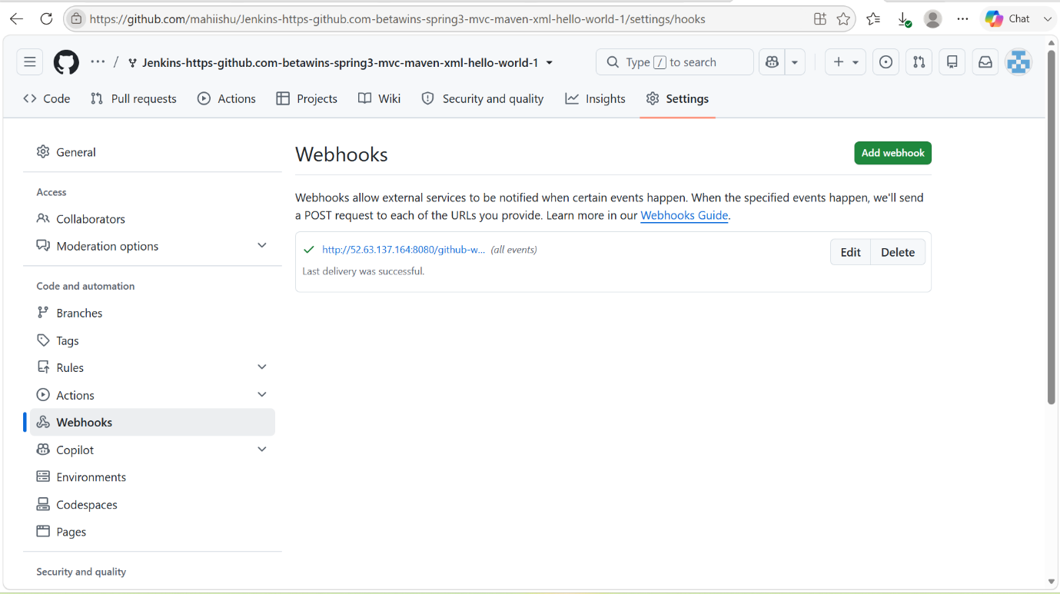

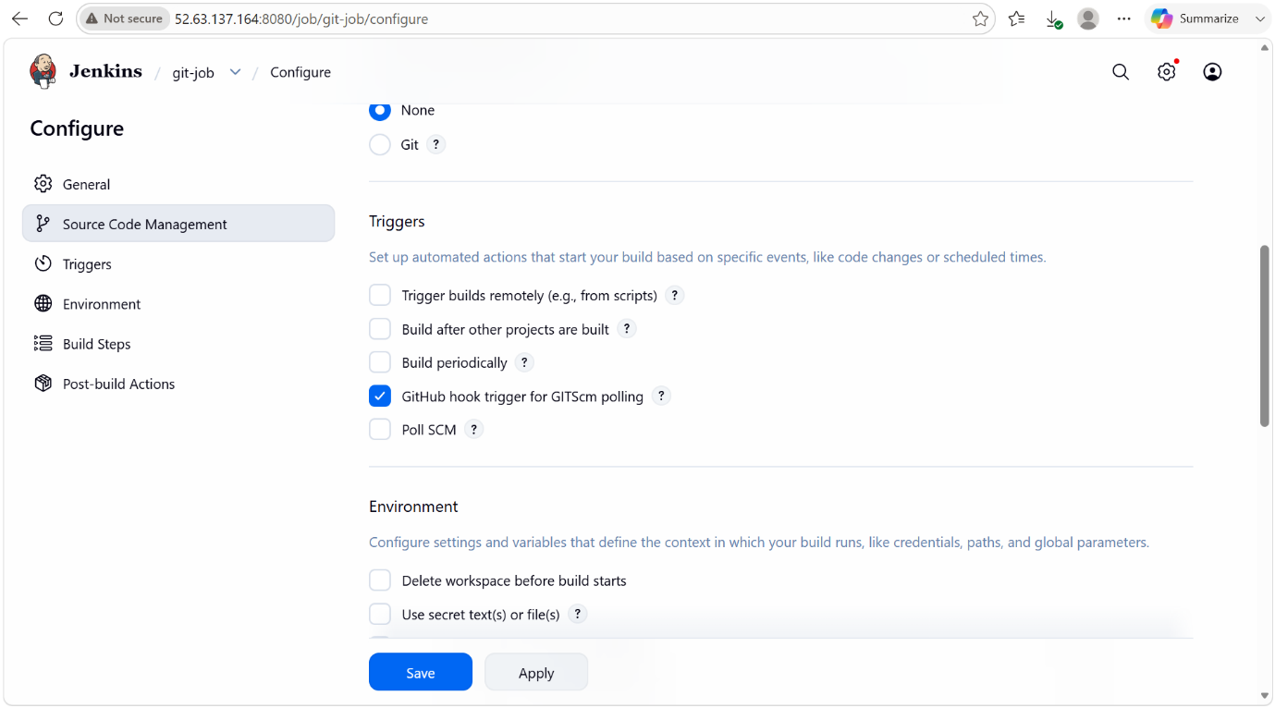

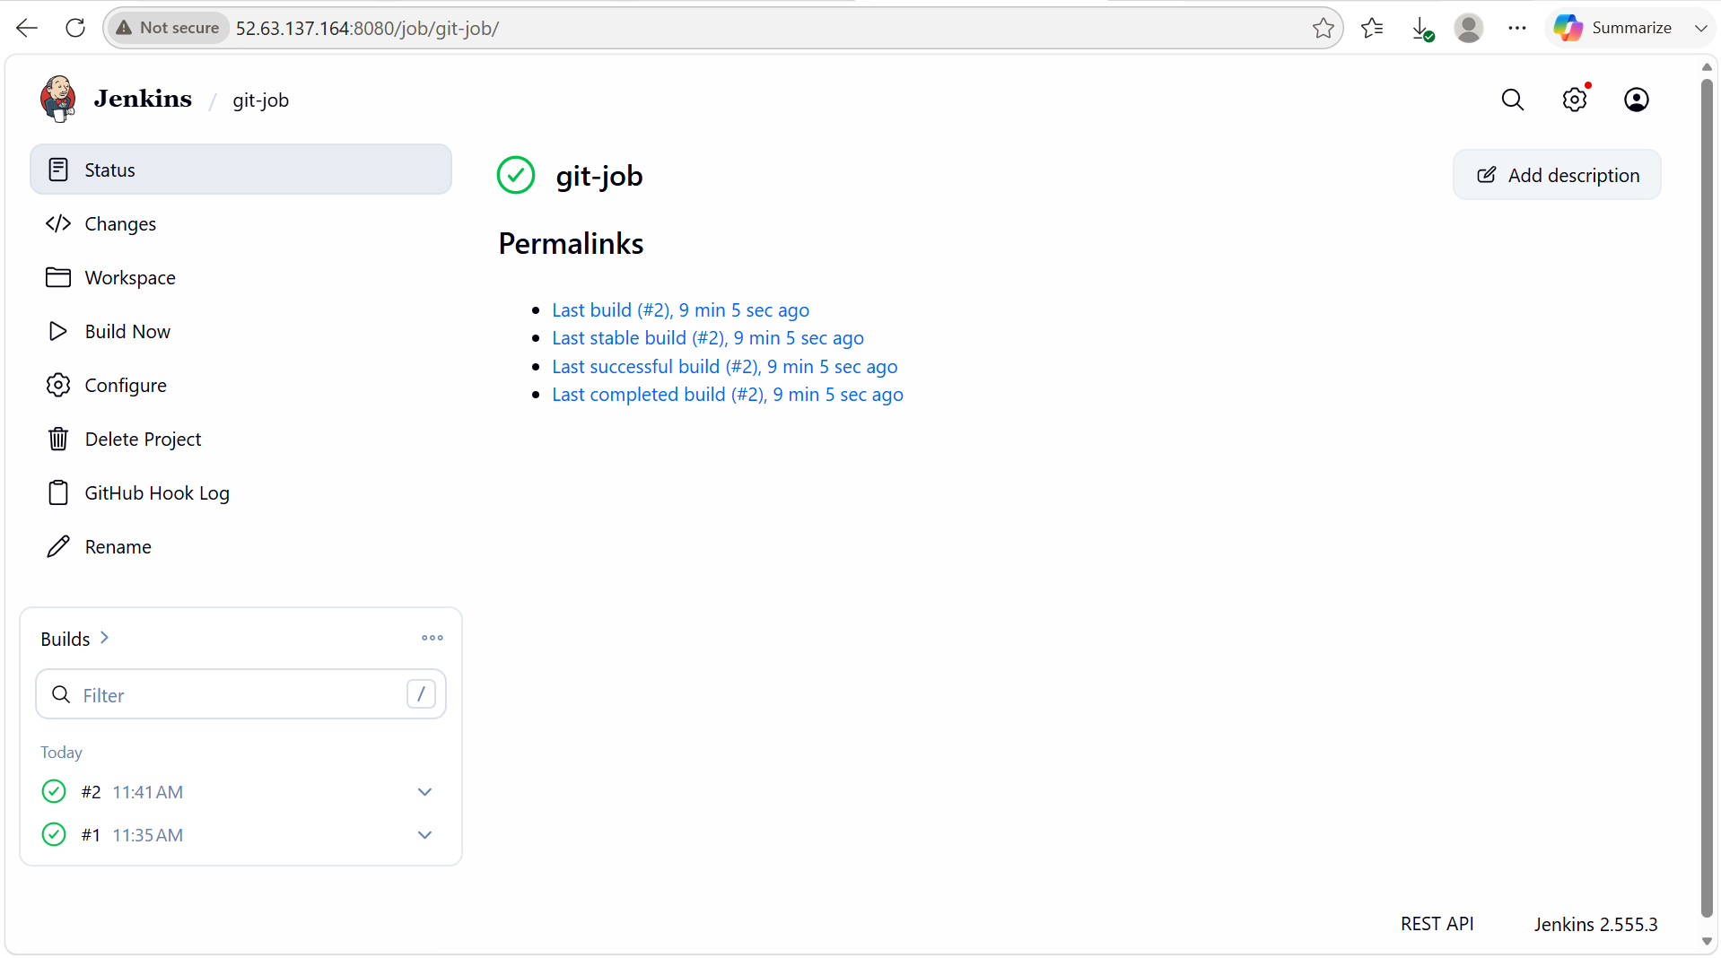

3. Configure Poll SCM and Build Periodically options in the Jenkins job.

PURPOSE:

Poll SCM: The purpose of Poll SCM (Source Code Management) is to allow Jenkins to periodically check the source code repository for changes and automatically trigger a build when new changes are detected.

Build Periodically: The purpose of Build Periodically is to schedule Jenkins jobs to run at specific time intervals regardless of whether any code changes have occurred.

OBJECTIVE: To automate Jenkins job execution by either monitoring the source code repository for changes (Poll SCM) or scheduling jobs to run at predefined time intervals (Build Periodically), ensuring timely builds, testing and task execution without manual intervention.

OUTCOME: Jenkins automatically triggers jobs based on source code changes (Poll SCM) and scheduled time intervals (Build Periodically), resulting in efficient automation, improved continuous integration, reduced manual effort, and reliable execution of CI/CD and operational tasks.

STEP BY STEP IMPLEMENTATION:
- We have to create 2 jobs one for Poll SCM and one for Build Periodically.
- For both jobs we have to give the github project URL.
- After that we have to set the triggers in the job configurations.

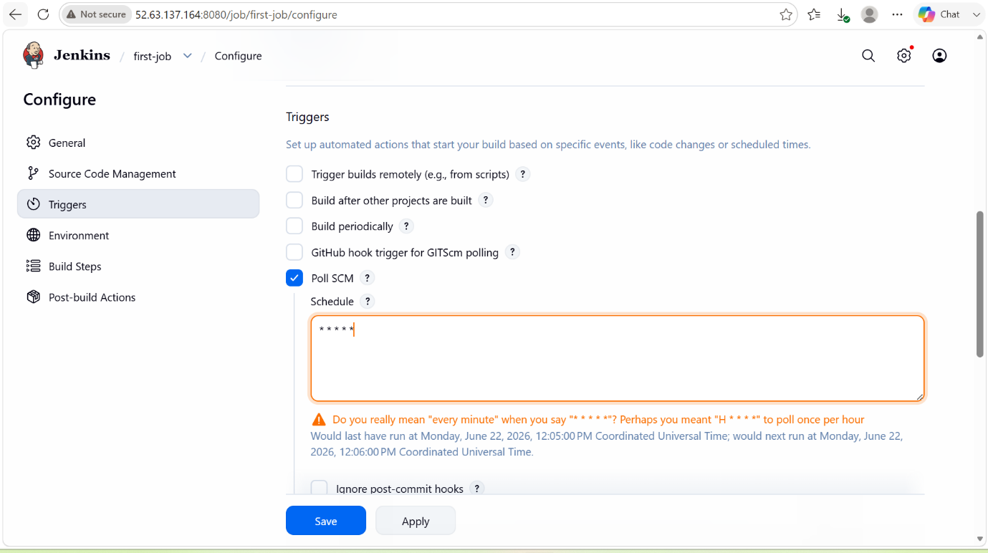

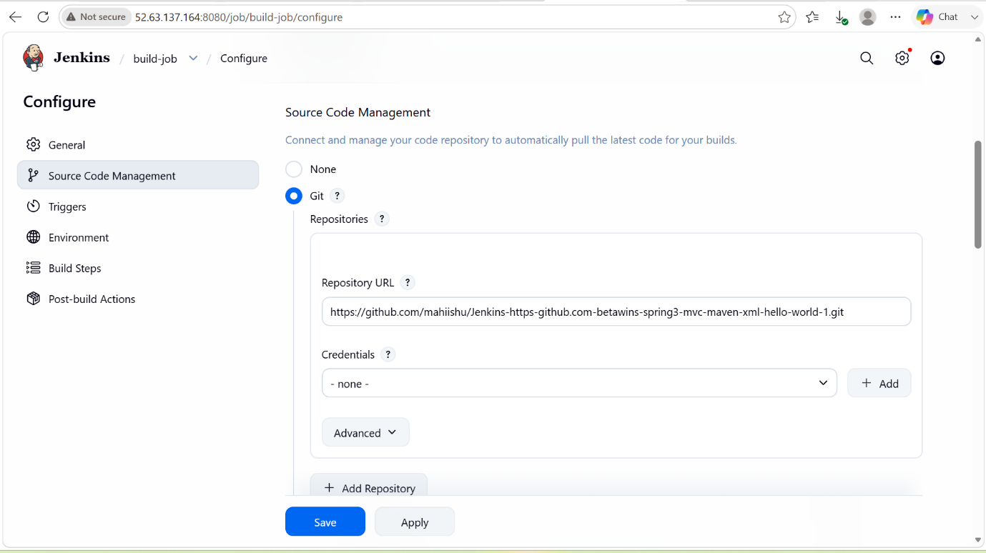

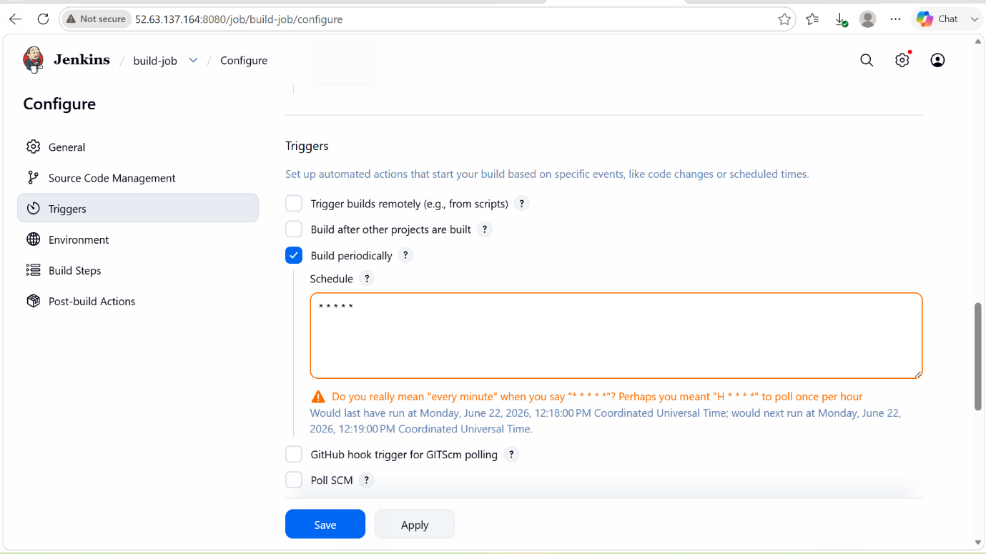

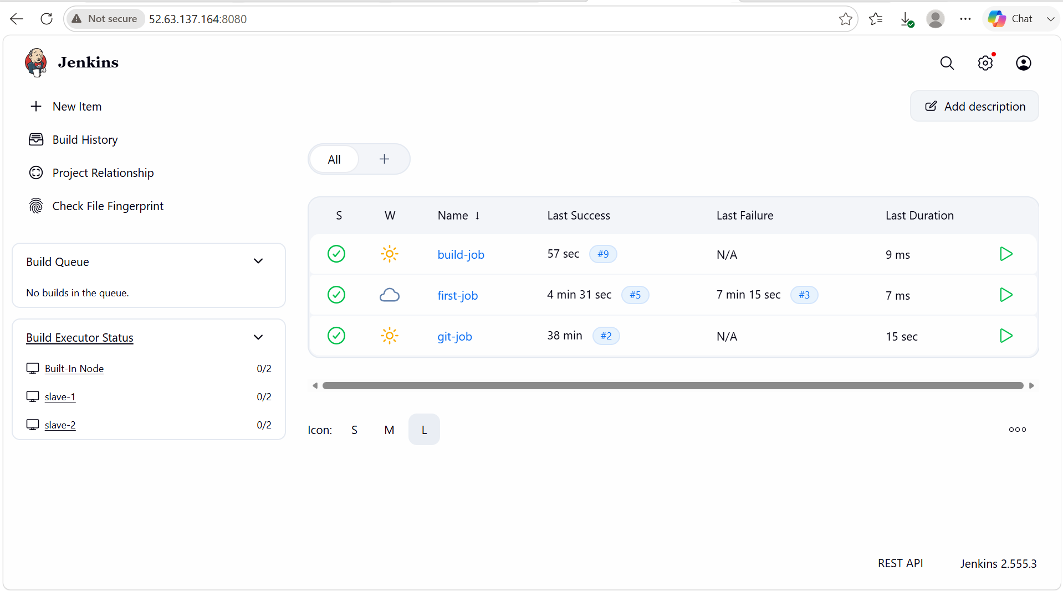

4. Take a backup of the Jenkins server using a bash-script.

PURPOSE: The purpose of taking a backup of the Jenkins server using a Bash Script is to automate the backup process of jenkins configuration, jobs, plugins and build data, ensuring quick recovery in case of server failure, data corruption or accidental deletion.
OBJECTIVE: To automate the backup process of the Jenkins server by creating a Bash script that regularly backs up Jenkins configuration files, jobs, plugins, user data, and build history. This ensures data protection, enables quick recovery in case of server failure, accidental deletion, or corruption, and minimizes downtime by maintaining up-to-date backups of the Jenkins environment.

OUTCOME: Successfully automated Jenkins server backups using a Bash script, ensuring regular data protection, quick recovery, and reduced manual effort.

STEP BY STEP IMPLEMENTATION:
- Connect to the master server by using SSH bash
- After connecting, we have to write a script to take the backup of a Jenkins files.

BASH SCRIPT:

#!/bin/bash

# Variables
JENKINS_HOME="/var/lib/jenkins"
BACKUP_DIR="/backup/jenkins"
DATE=$(date +%Y-%m-%d_%H-%M-%S)

# Create backup directory if it doesn't exist
mkdir -p $BACKUP_DIR

# Create compressed backup
tar -czvf $BACKUP_DIR/jenkins_backup_$DATE.tar.gz $JENKINS_HOME

echo "Backup completed successfully: jenkins_backup_$DATE.tar.gz"

- We have to define variables with the paths of Jenkins home path and backup storage path that’s where our backup of our file will be stored.
- We have to name the script file name with the extension .sh
- Vi backup.jenkins.sh and change the permissions of the file chmod 600 backup.jenkins.sh
- By running that file we will have the backup of our Jenkins file -> bash backup.jenkins.sh
- Backup file will be stored in the /backup/Jenkins path.

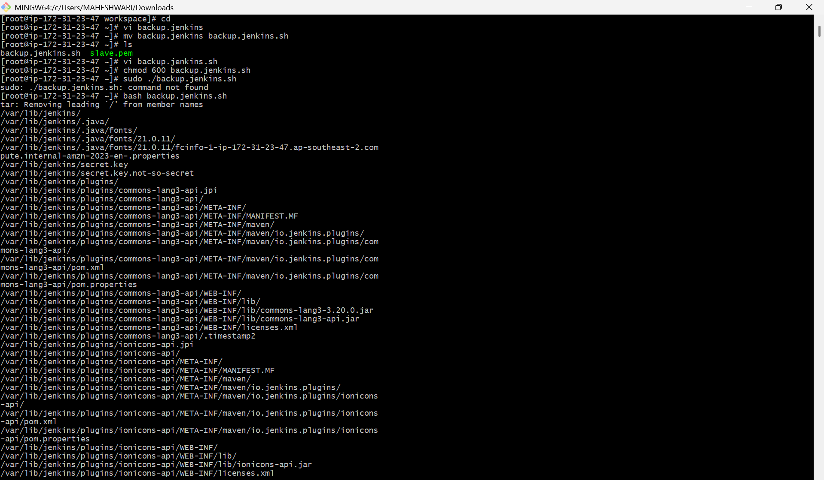

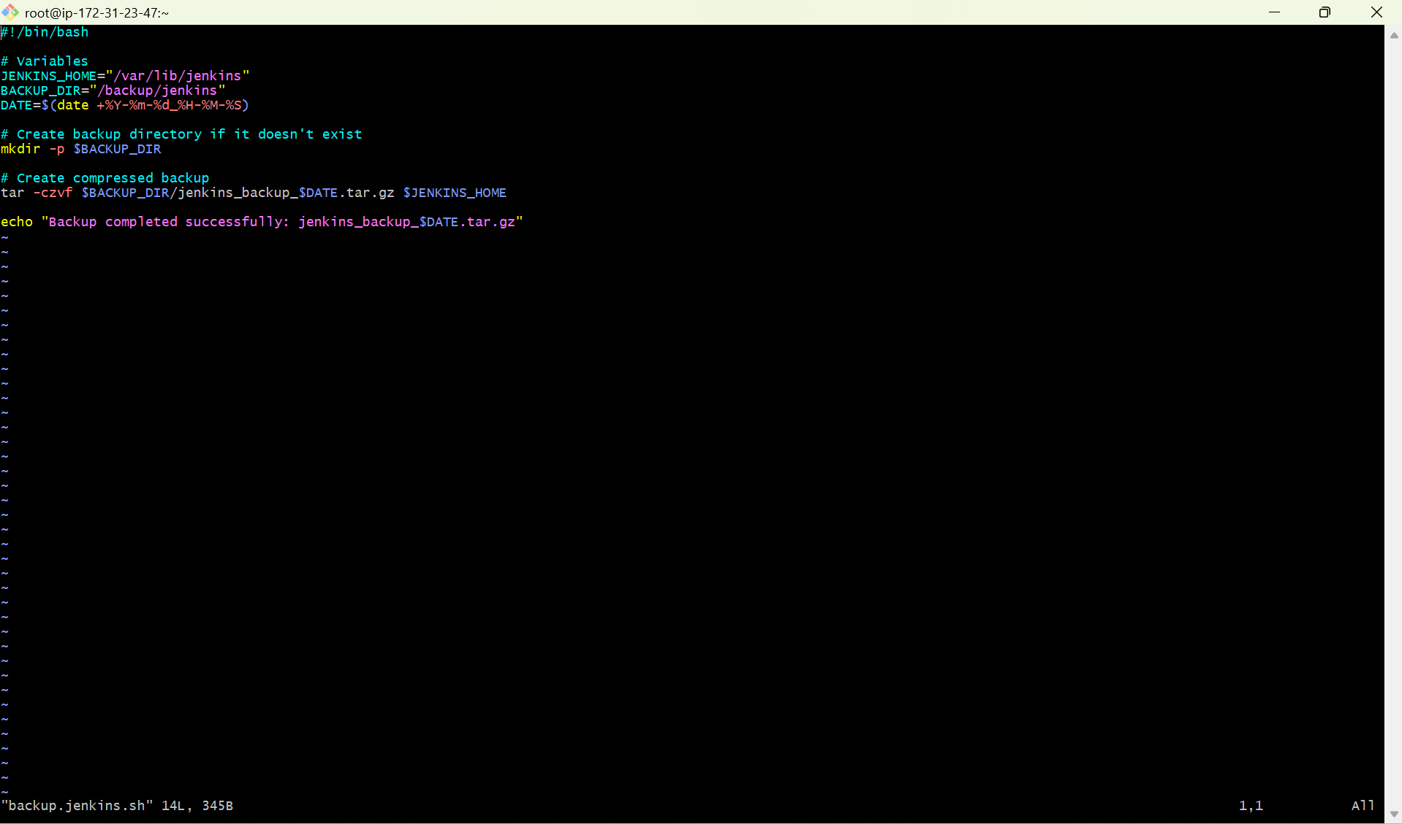

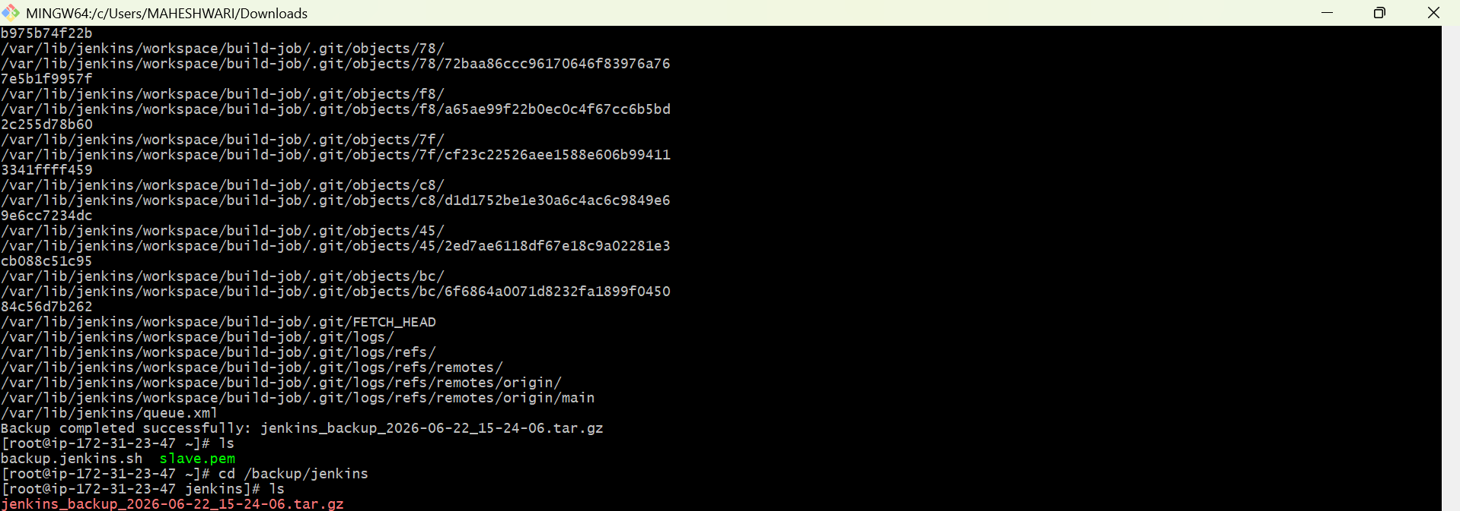

5. Take a backup of Jenkins using the Thin Backup plugin.

PURPOSE: To create and manage backups of Jenkins configurations, jobs, plugins and user settings using the ThinBackup plugin.

OBJECTIVE: To configure the ThinBackup plugin and automate Jenkins backups for easy recovery and disaster management.

OUTCOME: Successfully backed up Jenkins configurations, jobs, plugins, and settings using the ThinBackup plugin, ensuring reliable data protection and quick recovery in case of system failures or data loss.

PREREQUISITES: Jenkins server running, admin access available, ThinBackup plugin installed, and sufficient storage configured for backups.

STEP BY STEP IMPLEMENTATION:
- We have to first install the ThinBackup plugin in the available plugins.
- After the installation of the plugin, we have to next do the backup.
- After that, we have to go to manage Jenkins when u scroll down there you can see ThinBackup option.
- That’s where we have to get the backup of the Jenkins file.

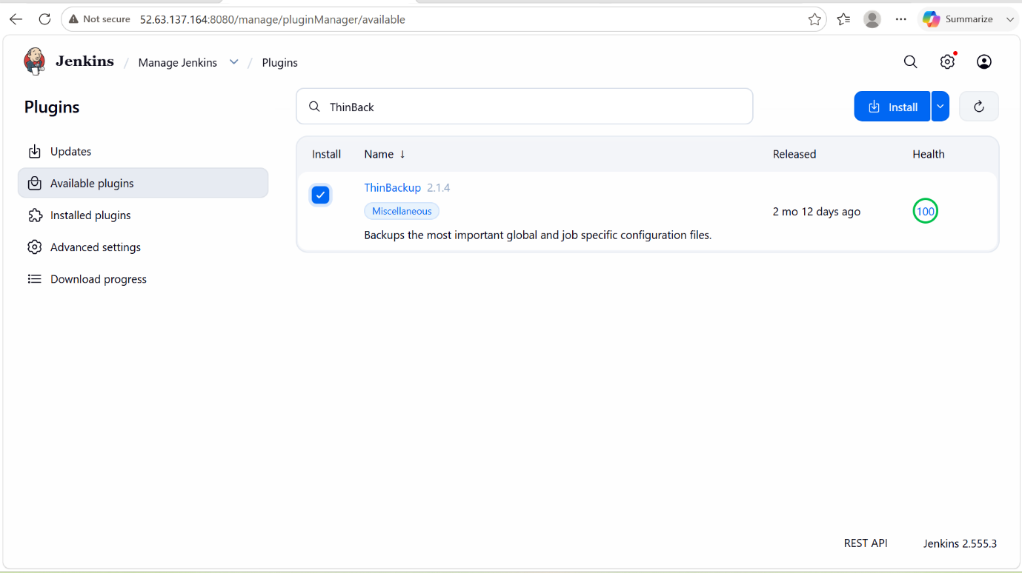

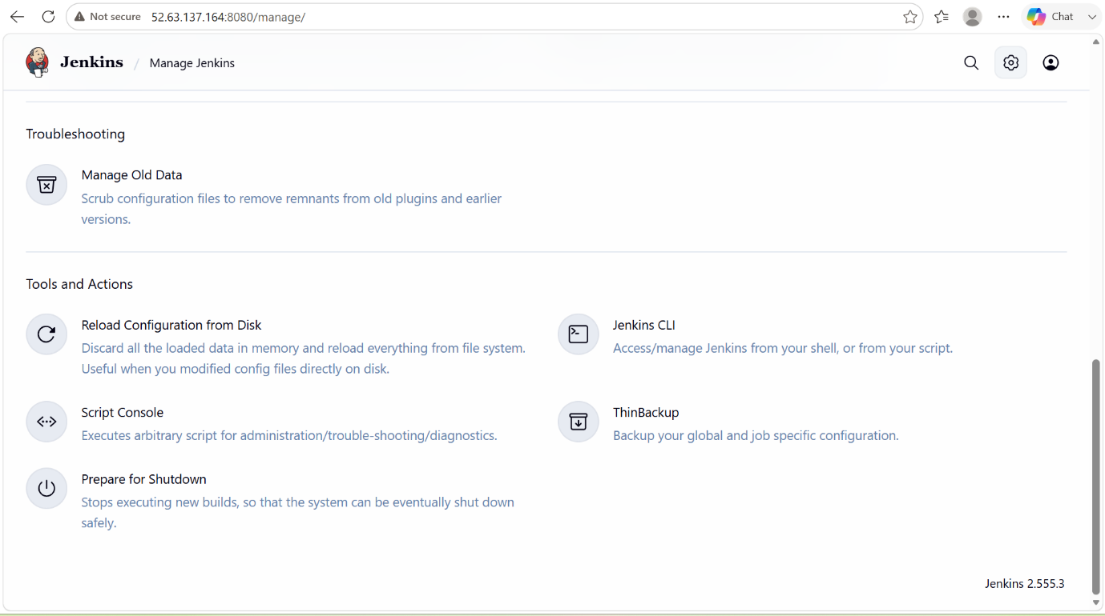

- Then we have to change the configurations that where this backup file should be stored.
- For that, we have to go to manage Jenkins and then system.
- And then search for the Thin backup by pressing ctrl+f then it will show the search bar for us.
- That’s where we have to search for thin backup and give the path where you want to store this backup.
- If we didn’t created that path or directory then go and create manually.
- After all this process, we have to click on backup now in the thinbackup .

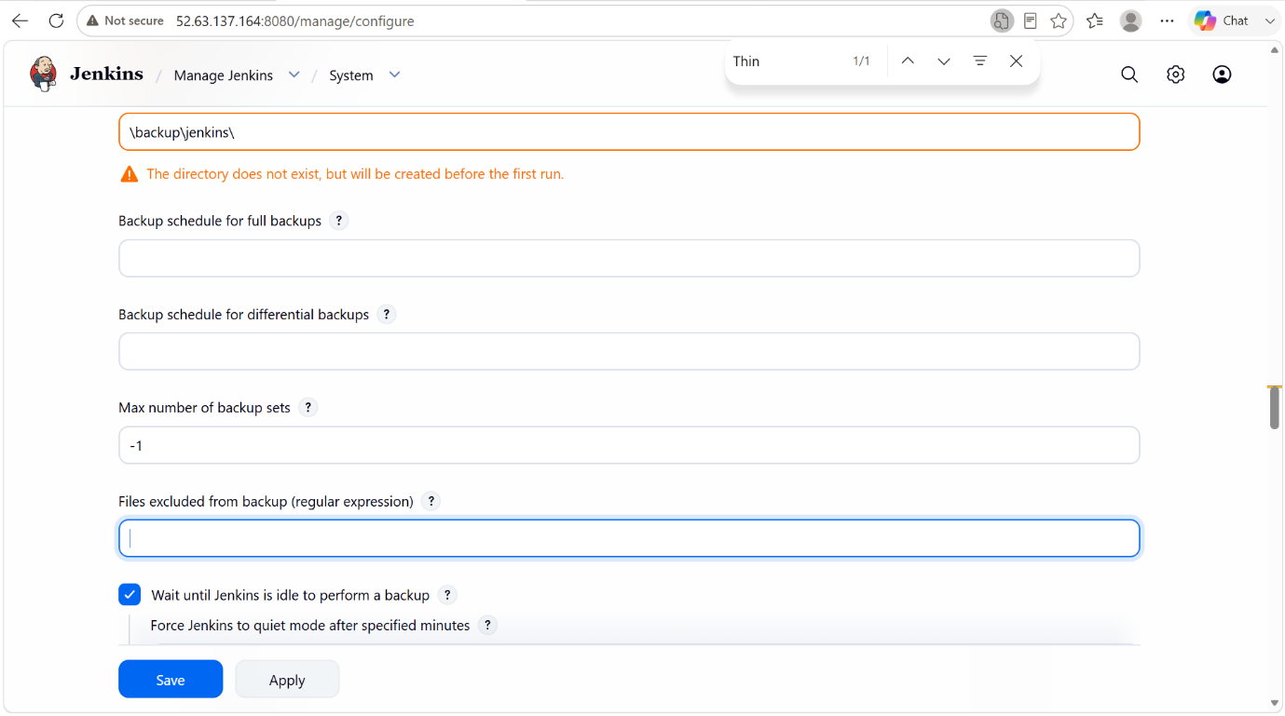

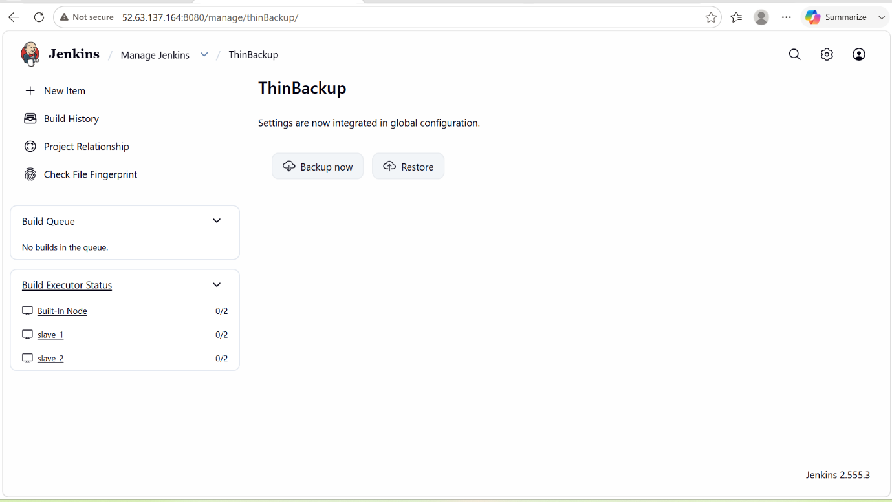

- We can also check whether our backup is success or not in the system logs.

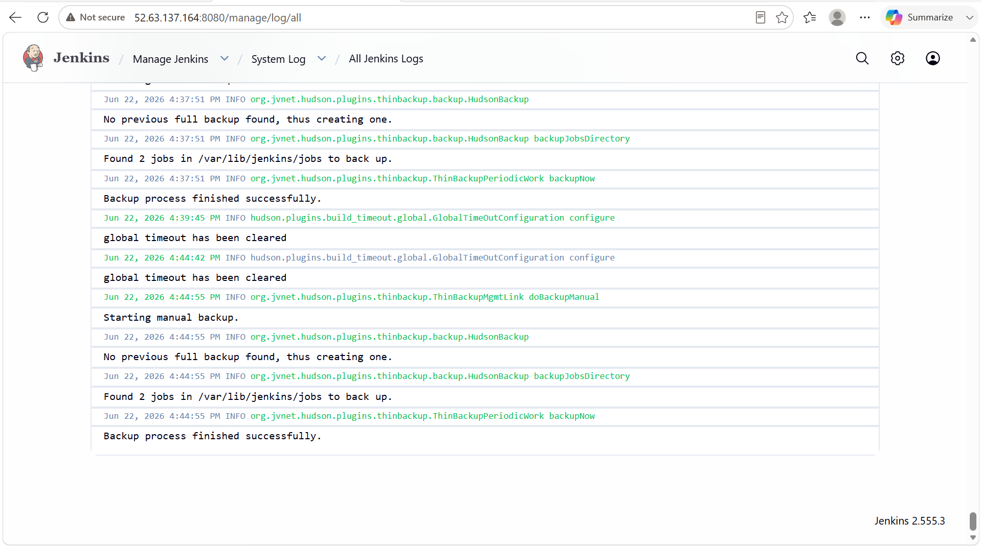

6. Set up a new Jenkins server and restore the backup taken in task 4.

PURPOSE: To recover and recreate the Jenkins environment on a new server by restoring previously backed-up Jenkins data, ensuring business continuity, minimizing downtime, and validating the effectiveness of the backup and disaster recovery process.

OBJECTIVE: To install and configure a new Jenkins server and restore the backup created in Task 4, ensuring that all Jenkins jobs, configurations, plugins, credentials, and system settings are successfully recovered and the Jenkins environment is fully operational.

OUTCOME: Successfully set up a new Jenkins server and restored the backup, recovering all jobs, configurations, plugins, credentials, and settings. The Jenkins environment was restored to its previous state, ensuring minimal downtime and validating the backup and disaster recovery process.

PREREQUISITES: New server ready, Java and Jenkins installed, backup files available, admin access provided, and sufficient storage and permissions for restoration.

STEP BY STEP IMPLEMENTATION:
- The backup of Jenkins that we have created in the task 4, we have to copy that backup file to the new instance that we have created as our backup server.
- Command to use -> scp -i /root/slave.pem /backup/jenkins/jenkins_backup_2026-06-22_15-24-06.tar.gz ec2-user@32.236.18.233:/tmp/
- After this go to the new instance there you can see the backup file in the /tmp directory
- After that copy that file from tmp to /var/lib path
- Copied file should be extracted
- Now you can see the file with Jenkins name.

