1. Create one Jenkins job using the below code and create three stages.

stage1: Git clone to download the source code.

stage2: Sonarqube Integration to check the quality of code.

stage3: Slack Integration to send the alerts to slack.

Source Code: https://github.com/betawins/VProfile-1.git

PREREQUISITES:

- Amazon Linux 2023 EC2 instance
- Root or sudo access
- Java 17 installed (required for recent SonarQube versions)
- Security Group allowing required ports:
      - SSH (22)
- SonarQube (9000)

stage1: Git clone to download the source code.

- Create an EC2 instance with the jenkins 21 download.
- After that we have to install jenkins and start jenkins.
- Browse the jenkins server using public IP on port number : 8080
- After create a new job with git source code repo url.
- After clicking on build now it will execute job and when you check in the workspace you will get to see the repo files.

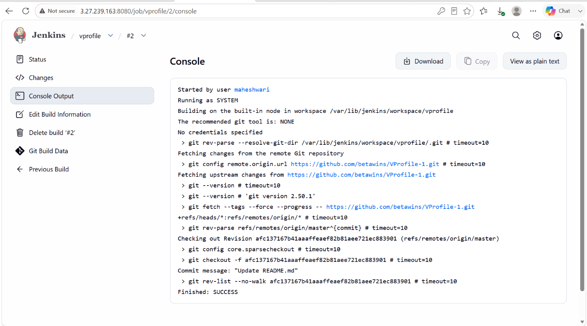

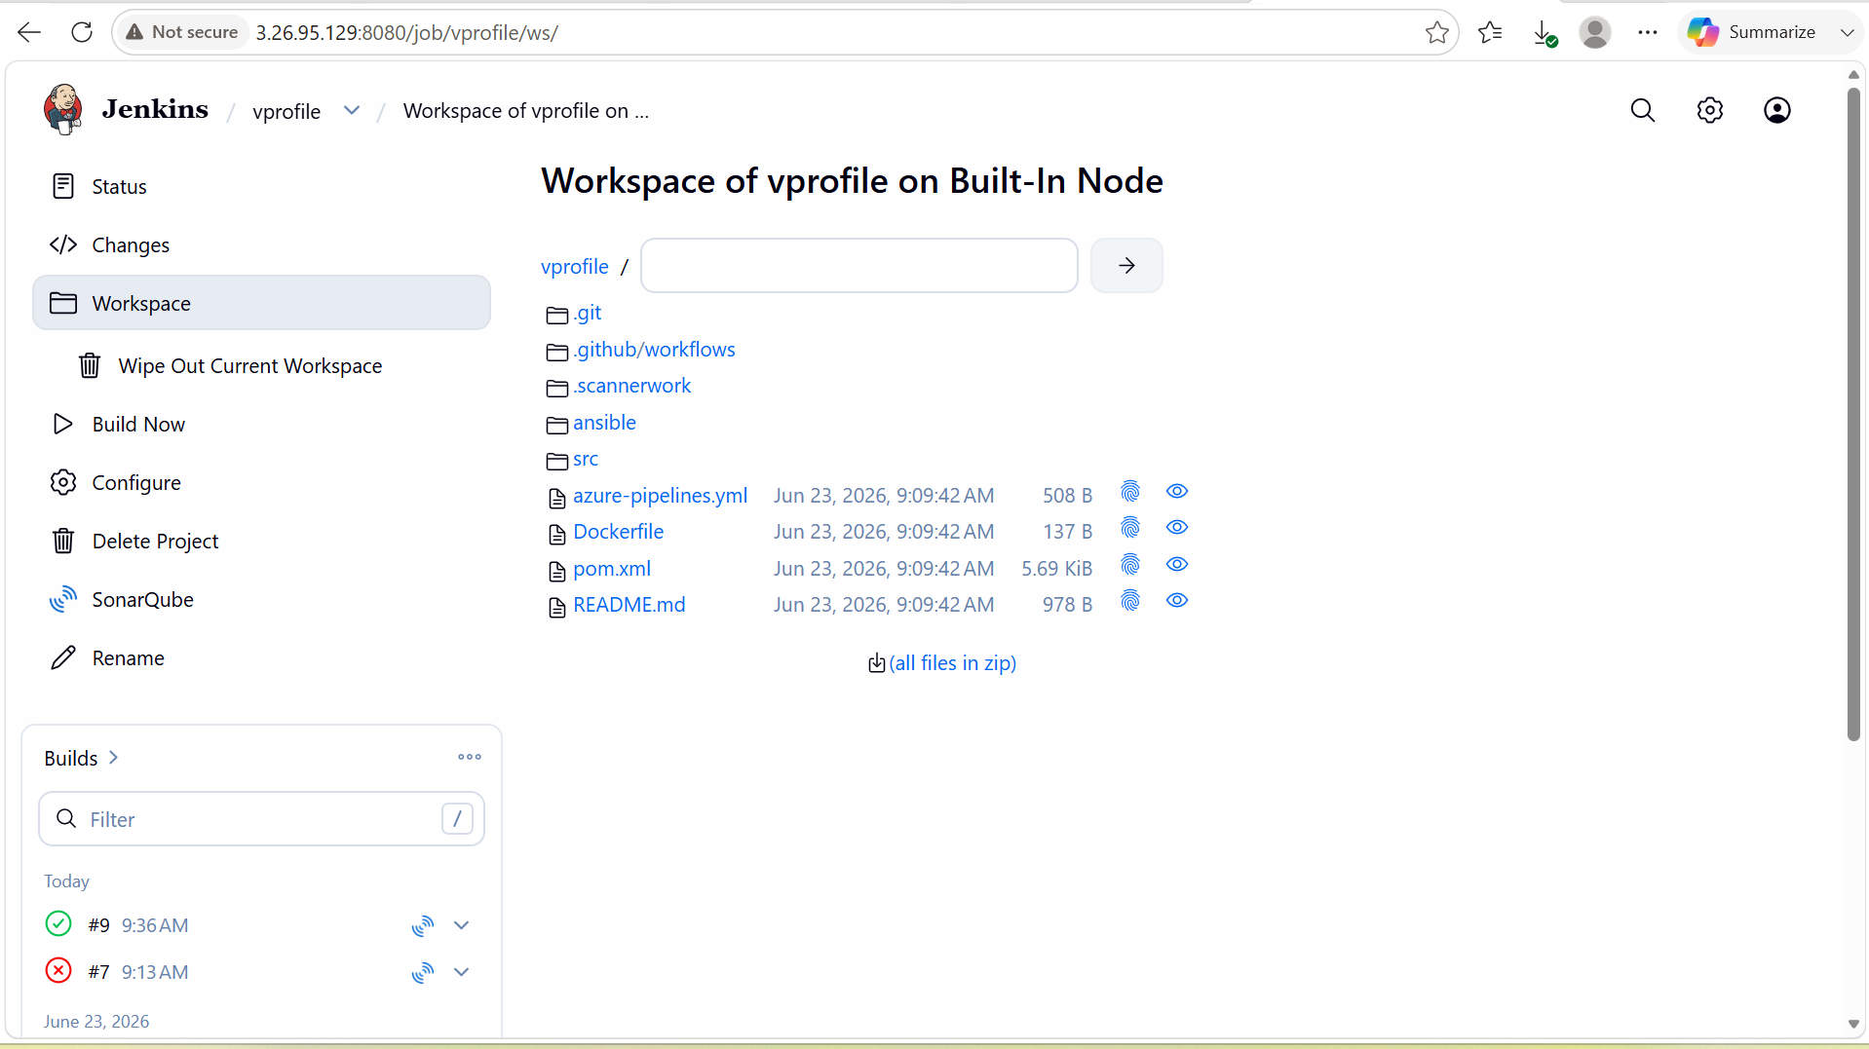

stage2: Sonarqube Integration to check the quality of code.

- Launch an EC2 instance and connect to that instance.
- After connecting, we have to install java 21 because java is the prerequisite for the SonarQube.
- After installing Java, install postgress SQL and if your are using amazon linux image 2023 then you don’t need to use wget you can directly install postgress SQL in the CLI by using command
- ->sudo dnf install postgresql15-server postgresql15 -y
- Then initialize the DB -> sudo /usr/pgsql-16/bin/postgresql-16-setup initdb
- After that start the postgress SQL and check the status by using systemctl commands.
- Systemctl start postgress
- Set password for the postgress SQL user -> su – postgres
- It will open a shell psql
- There you have to change the password -> ALTER USER postgres PASSWORD 'StrongPassword@123';
- To exit from the postgres SQL -> \q
- After that we have to create sonarqube database and user.
- In the postgres user only we have to run this commands to create DB and user
CREATE USER sonar WITH PASSWORD 'Sonar@123';
CREATE DATABASE sonarqube OWNER sonar;
GRANT ALL PRIVILEGES ON DATABASE sonarqube TO sonar;
- After that exit from the postgress user.
- To Configure PostgreSQL Authentication -> vi /var/lib/pgsql/16/data/pg_hba.conf
- In that file we have to change this configuration ->
host all all 127.0.0.1/32 scram-sha-256
- After that we have to restart the postgress SQL again by using systemctl restart postgres
- Verify Database connection -> psql -h localhost -U sonar -d sonarqube
- We have to configure SonarQube in the sonar.properties file
sonar.jdbc.username=sonar
sonar.jdbc.password=Sonar@123
sonar.jdbc.url=jdbc:postgresql://localhost:5432/sonarqube
- After this we have to restart the SonarQube.

Integrate SonarQube with Jenkins
- Install SonarQube Scanner plugin in Jenkins CLI using wget command.
- After that go to manage jenkins in the GUI and there in the system configure SonarQube, we have to give name and SonarQube URL and authentication token created in the SonarQUbe for secure connection between jenkins and SonarQube.
- Then go to manage jenkins -> tools and there we have to configure the sonar scanner.
- Sonar scanner has to be installed in the Jenkins CLI and get that sonar scanner path
- In the tools we have to give the name and path of the sonar scanner.
- Now we have to build the job and get the report in the SonarQube.

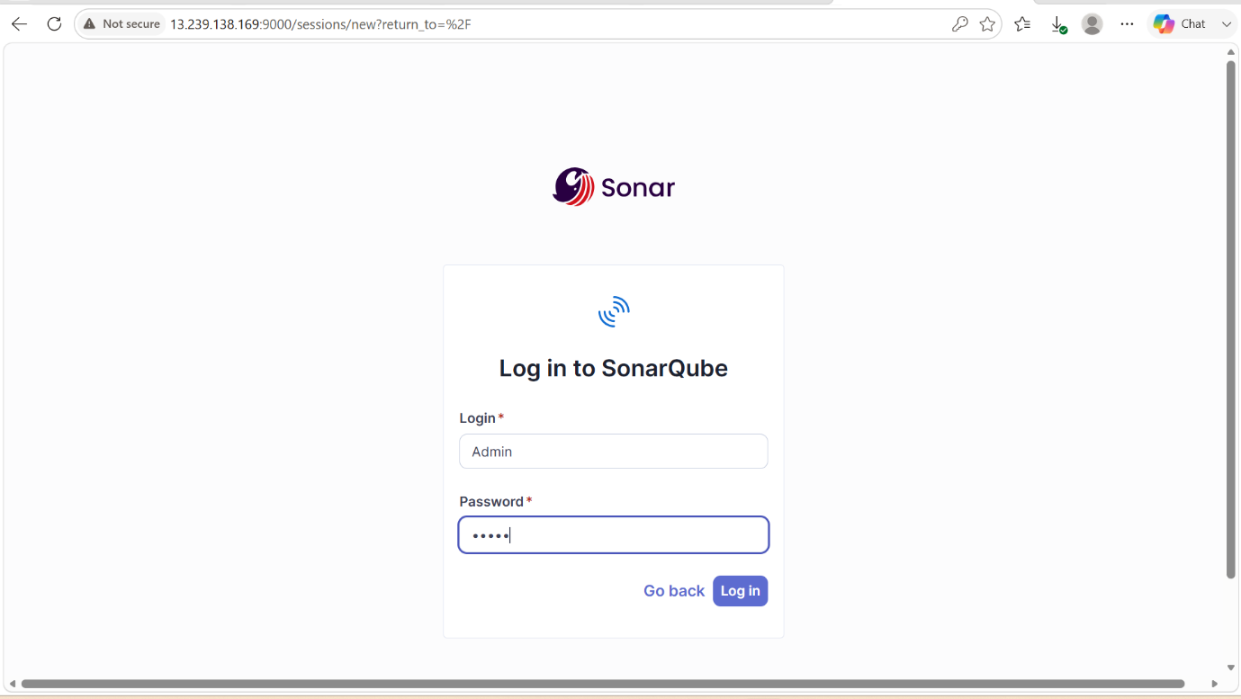

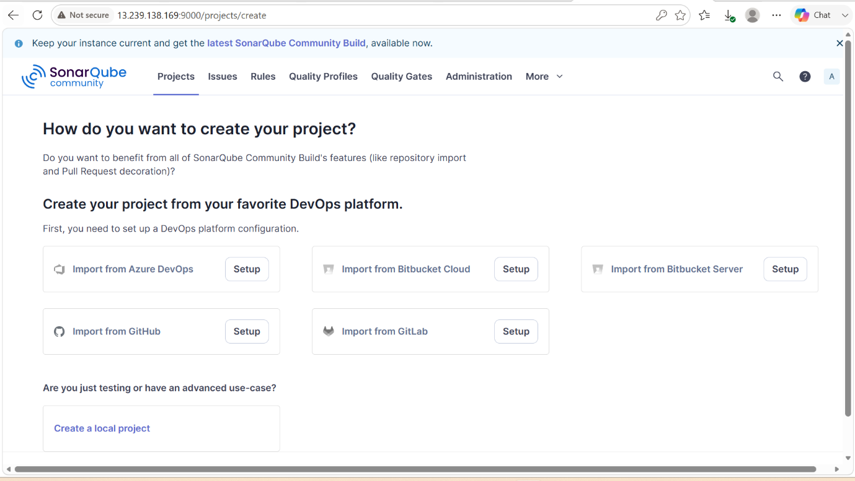

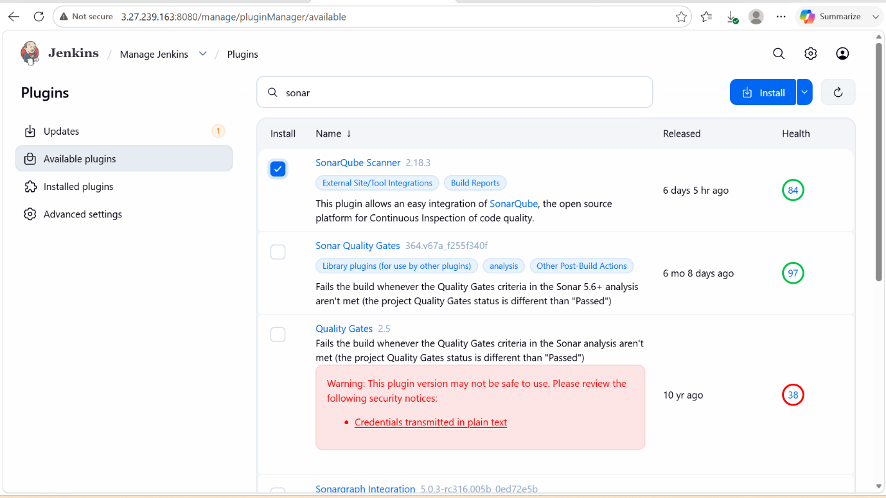

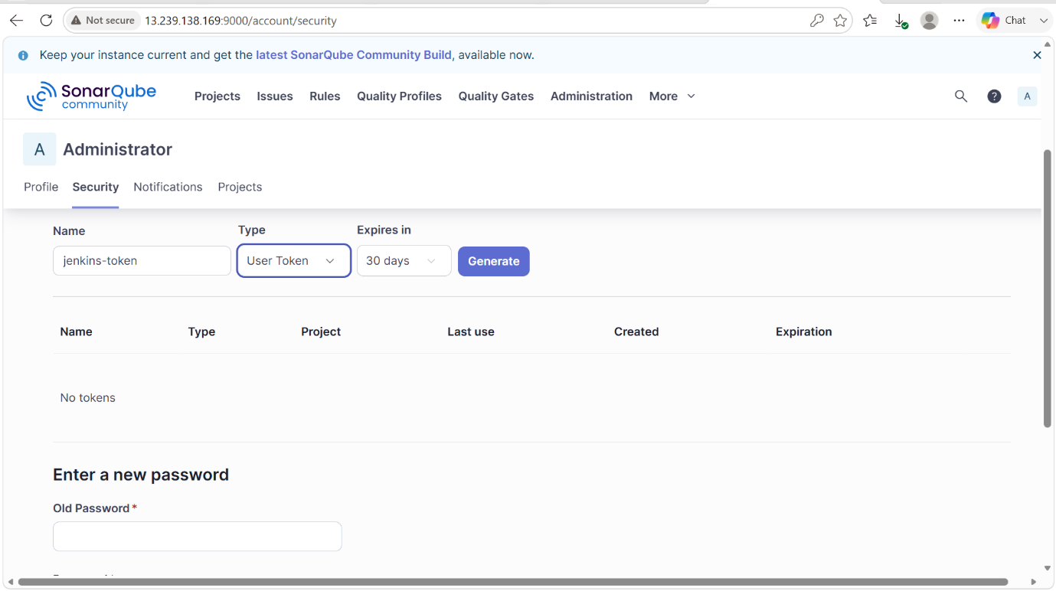

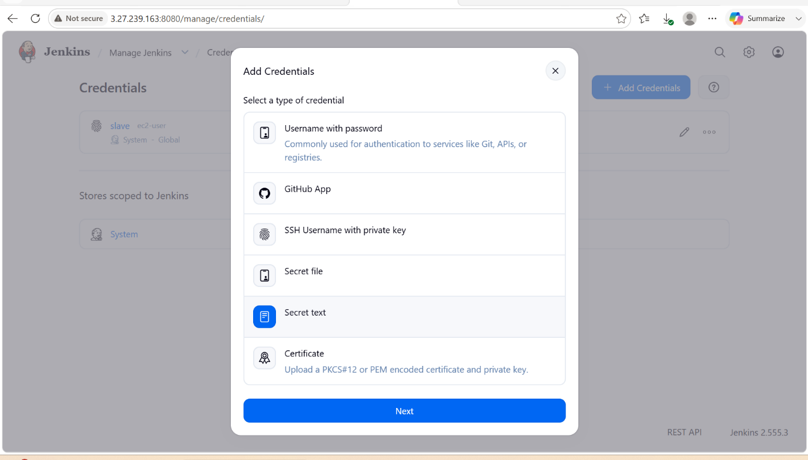

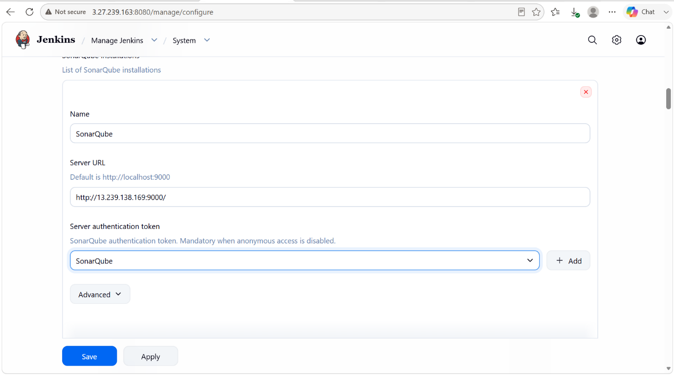



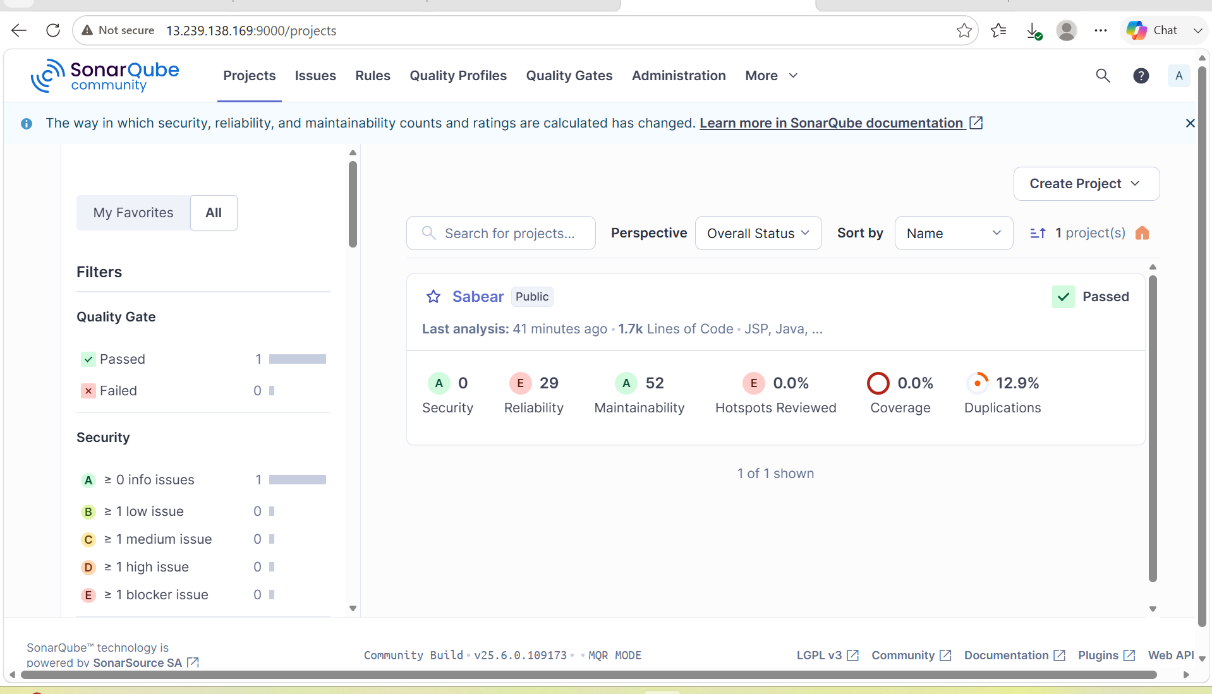

stage3: Slack Integration to send the alerts to slack.

- We have to create a new workspace first and create a channel also for jenkins alerts.
- After that we have to install Slack plugin in Jenkins and in the slack we have to configure the jenkins CI in the slack
- We have to configure slack in the jenkins in the manage jenkins -> system -> slack -> name and credentials
- After that we have to configure post build actions with the slack that sends the notifications when you run a job.

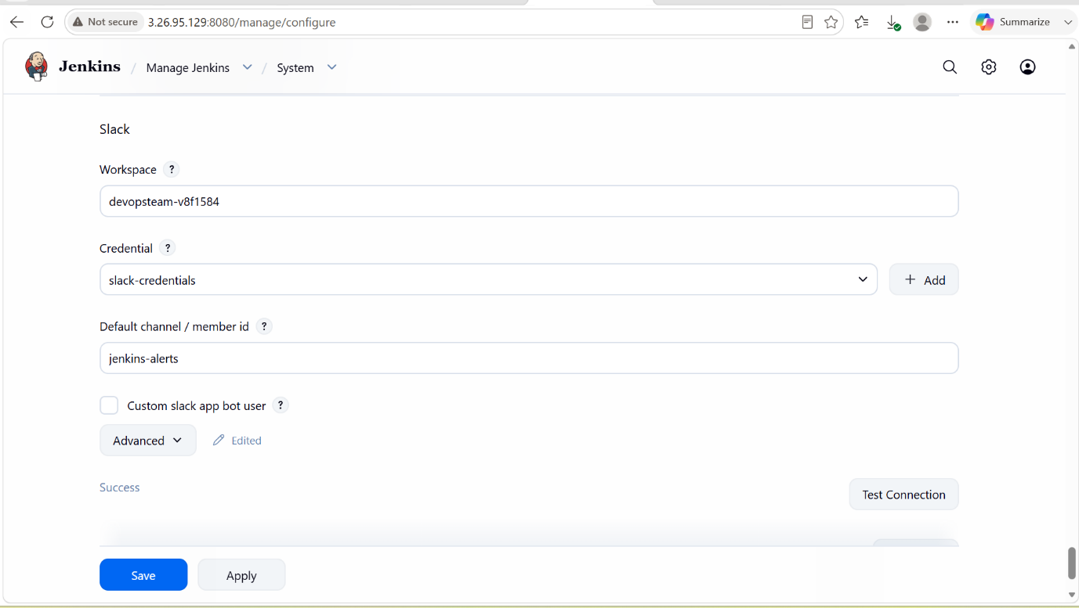

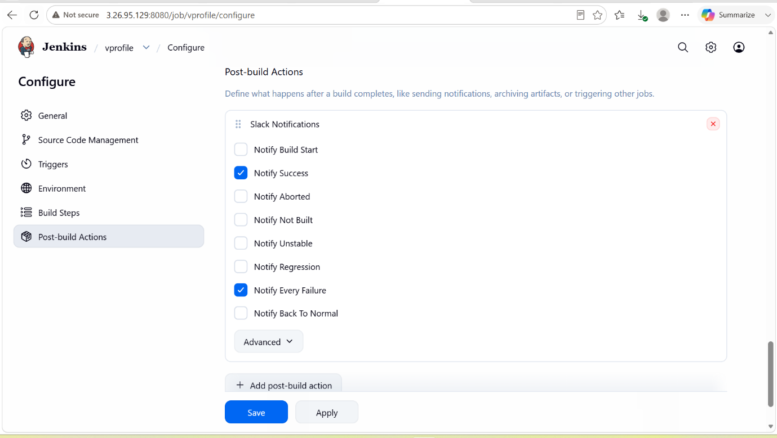

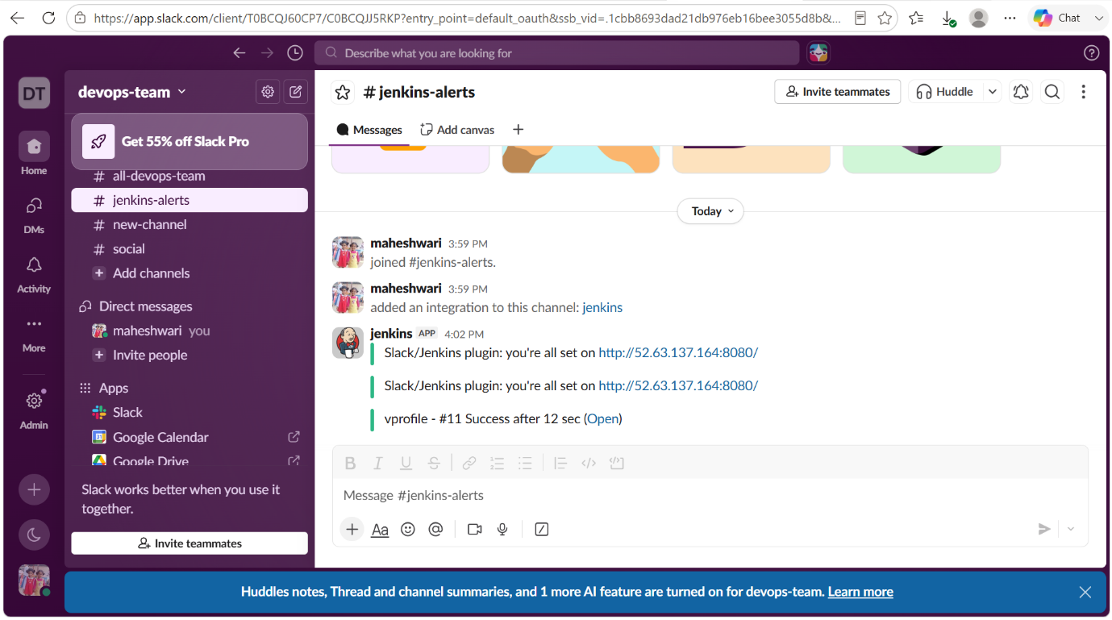

2. Create one Jenkins job using the below code and create three stages.

stage1: Git clone to download the source code.

stage2: Sonarqube Integration to check the quality of code.

stage3: Slack Integration to send the alerts to slack.

Source Code: https://github.com/betawins/hiring-app.git

stage1: Git clone to download the source code.

NOTE: we have check for whether the central repo is using master or main as branch name.
Then only our job will be successful and also we will be able to clone it.

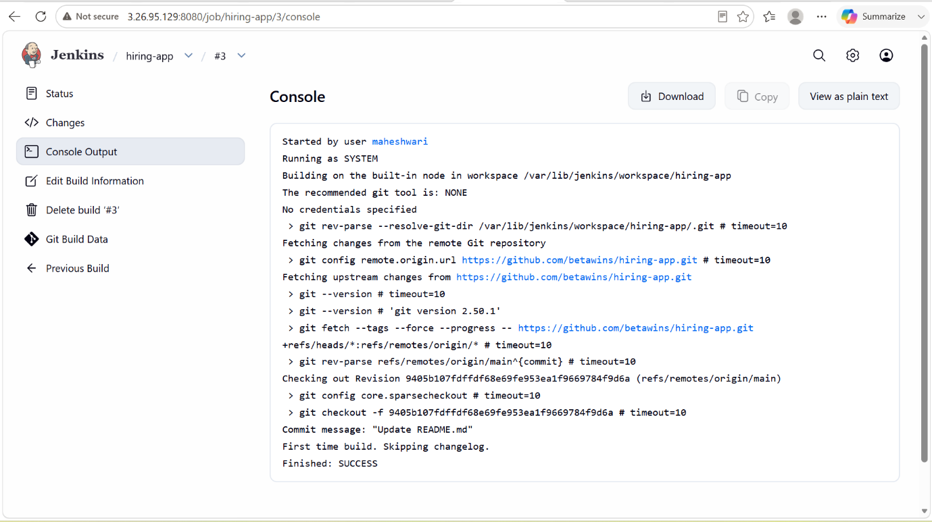

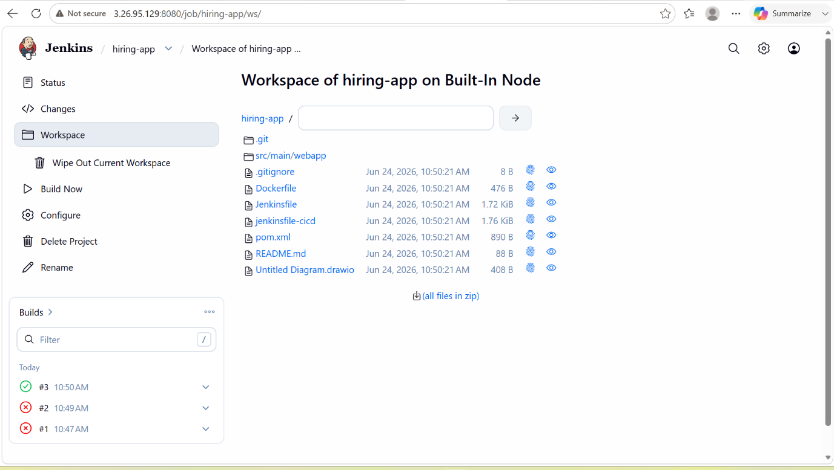

stage2: Sonarqube Integration to check the quality of code.
- we have to first configure the SonarQube in the job and in the build step, we have to select for the execute sonarscanner there we have to pass the analysis report

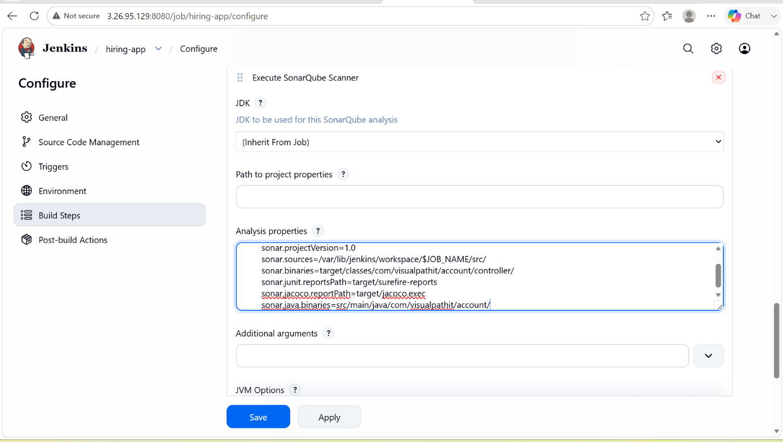

- after that we have to run the job and it will create a report in the SonarQube.

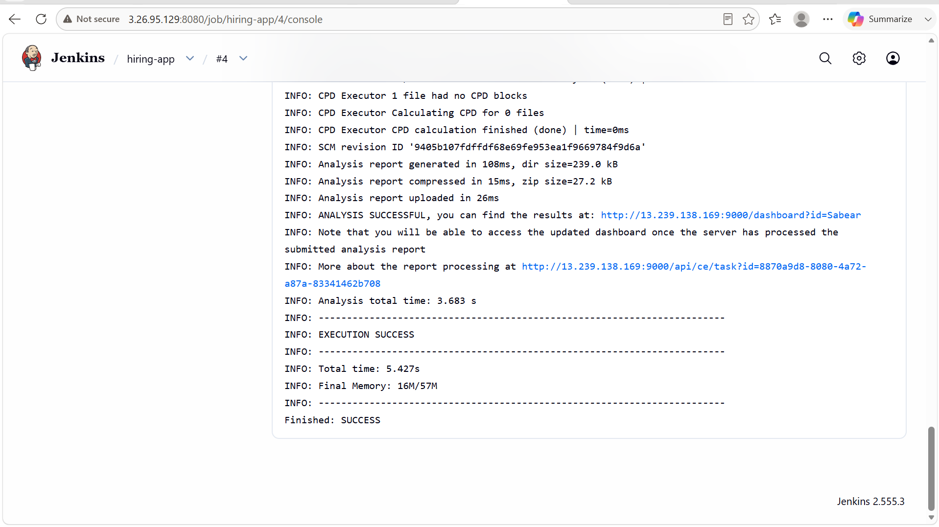

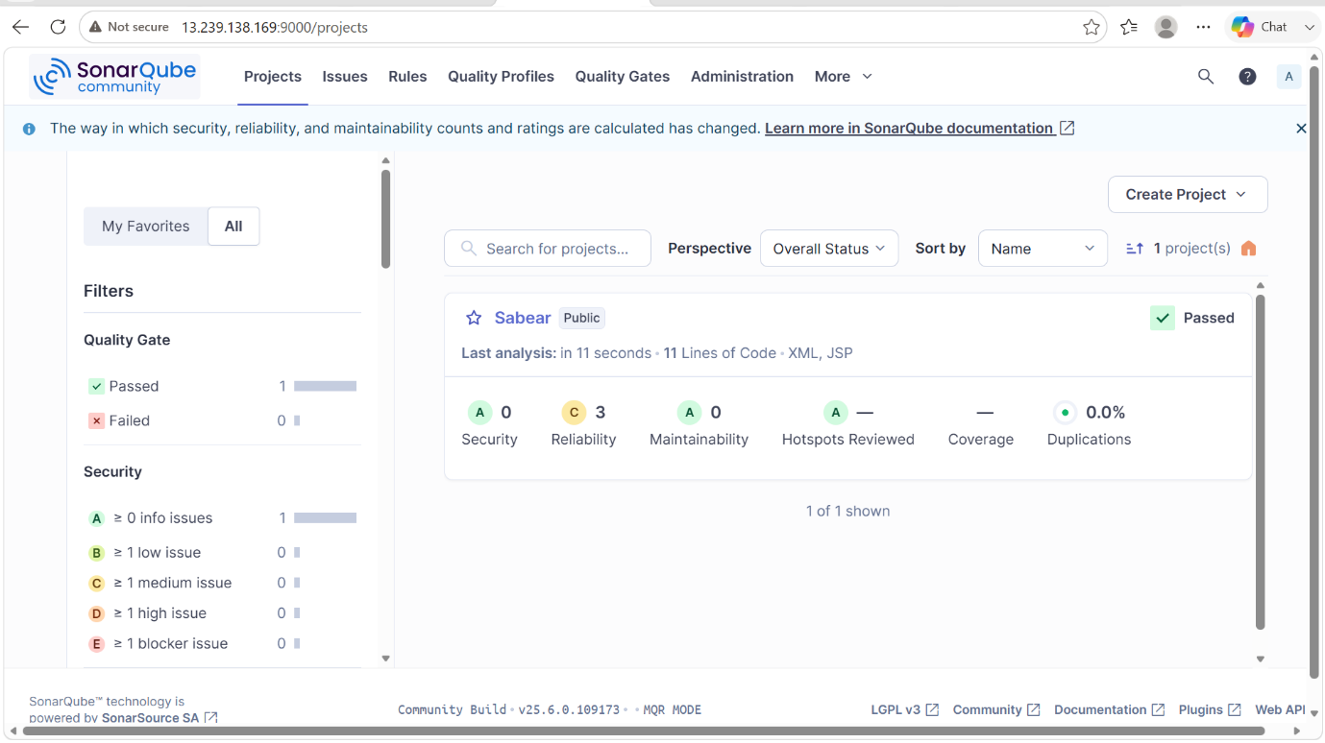

stage3: Slack Integration to send the alerts to slack.

- in the post build actions, we have select the slack notifications and tick for which notifications it should sent.

