COMPLETE CI/CD PIPELINE OF PROJECTS

1) Setup Jenkins CICD pipeline using freestyle job using Docker containers using below code.
Source Code: https://github.com/betawins/hiring-app.git
Stages:

Git Clone

SonarQube Integration

Maven Compilation

Nexus Artifactory

Slack Notification

Deploy On tomcat

Stage-1: GIT CLONE:

- Create a new job using free style job and in that we have to configure a source code management as git and there we have to give the URL of the central repository.
- After that we have check whether the repo is using main or master branch. If it is using branch name as main, we have to give as main.
- After this click on save and click on build now.
- If it is success then it will clone the central repo from github and it will be stored in the workspace of the job.

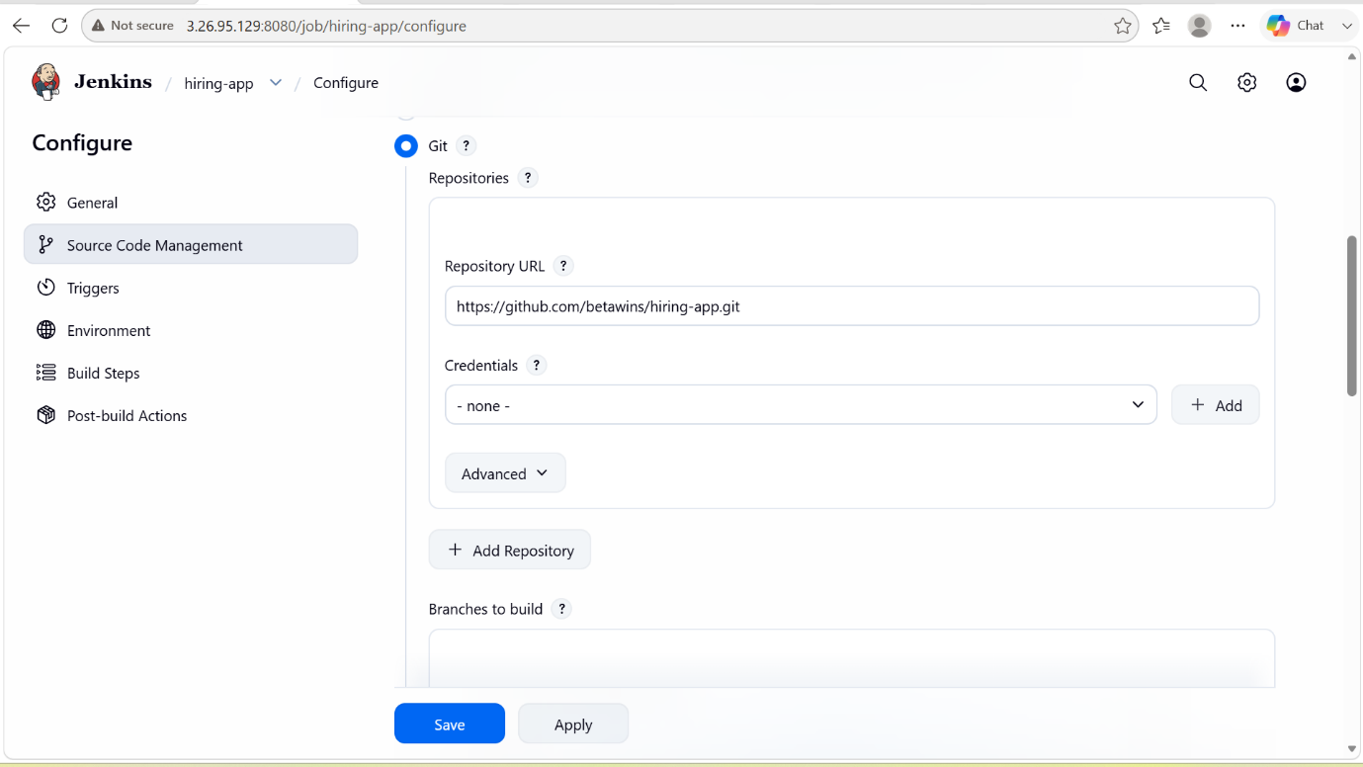

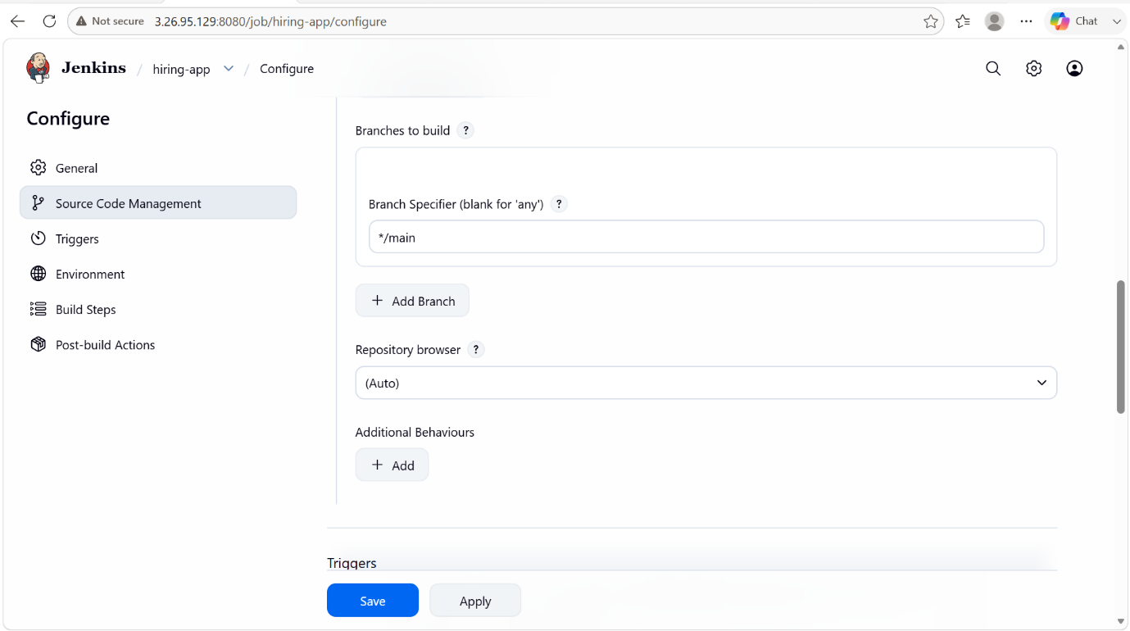

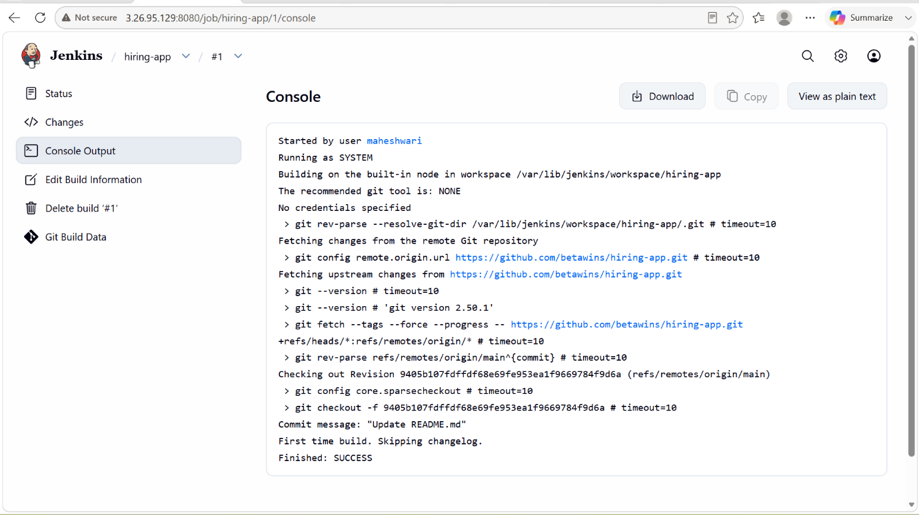

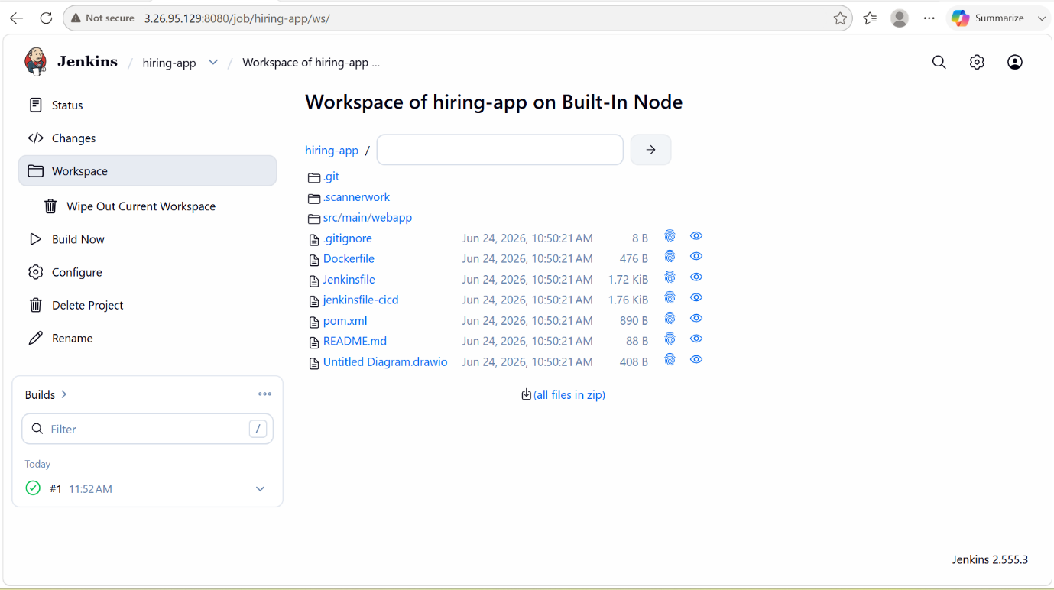

Stage-2 : SONARQUBE INTEGRATION:

- Launch an new instance with the t2.large and 20GB volume.
- After launching we have to connect to that instance.
- In that instance, we have to install docker before that we have to update the instance and enable the docker and then start the docker
  - sudo dnf update -y
  - sudo dnf install docker -y
  - sudo systemctl enable docker
  - sudo systemctl start docker

- To check whether it is running or not we can use this command -> docker –version or docker ps
- Then we have to pull the SonarQube docker image by executing this command -> docker pull sonarqube:community
- To verify whether sonarqube is present or not by executing this command -> docker images
- Then after we have to run the sonarqube ->
docker run -d \
--name sonarqube \
-p 9000:9000 \
sonarqube:community
- To verify whether sonarqube is running in the docker image or not -> docker ps
- Then in the browser we have to look for the sonarqube webpage
http://<public_IP>:9000
- Default port number : 9000
- Default credentials for the first time login
Username: admin
Password: admin
- After this step it will ask for us to create a new password.

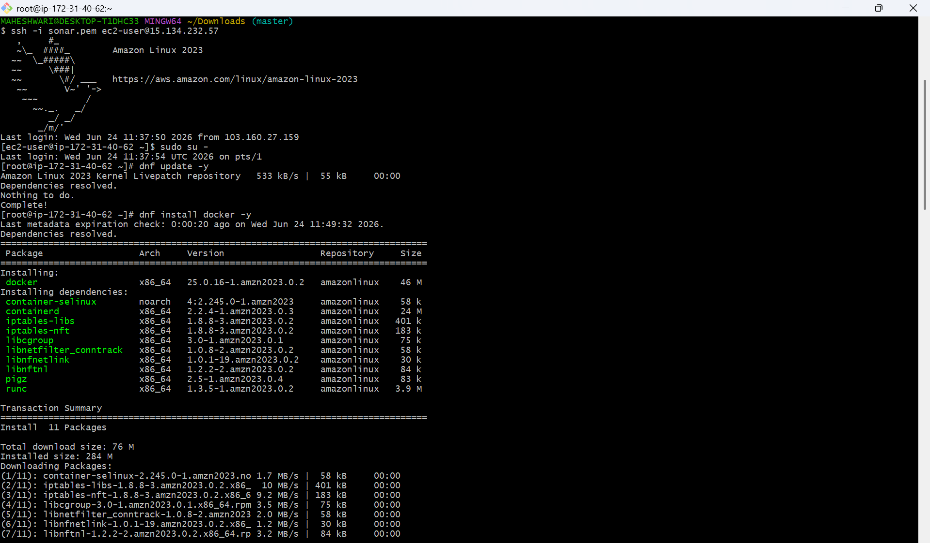

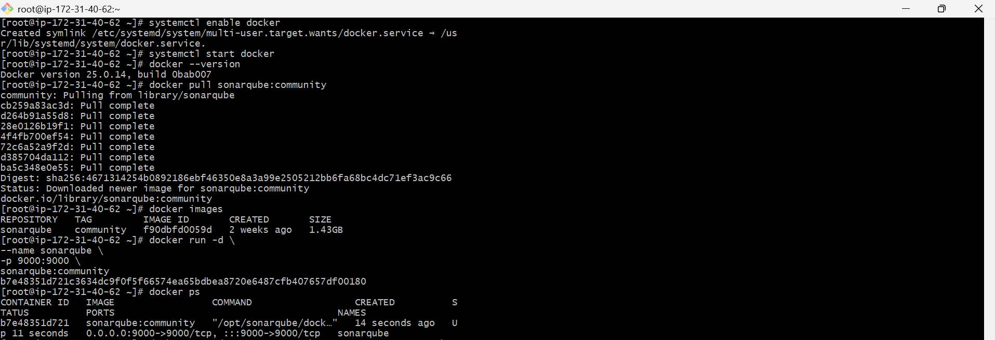

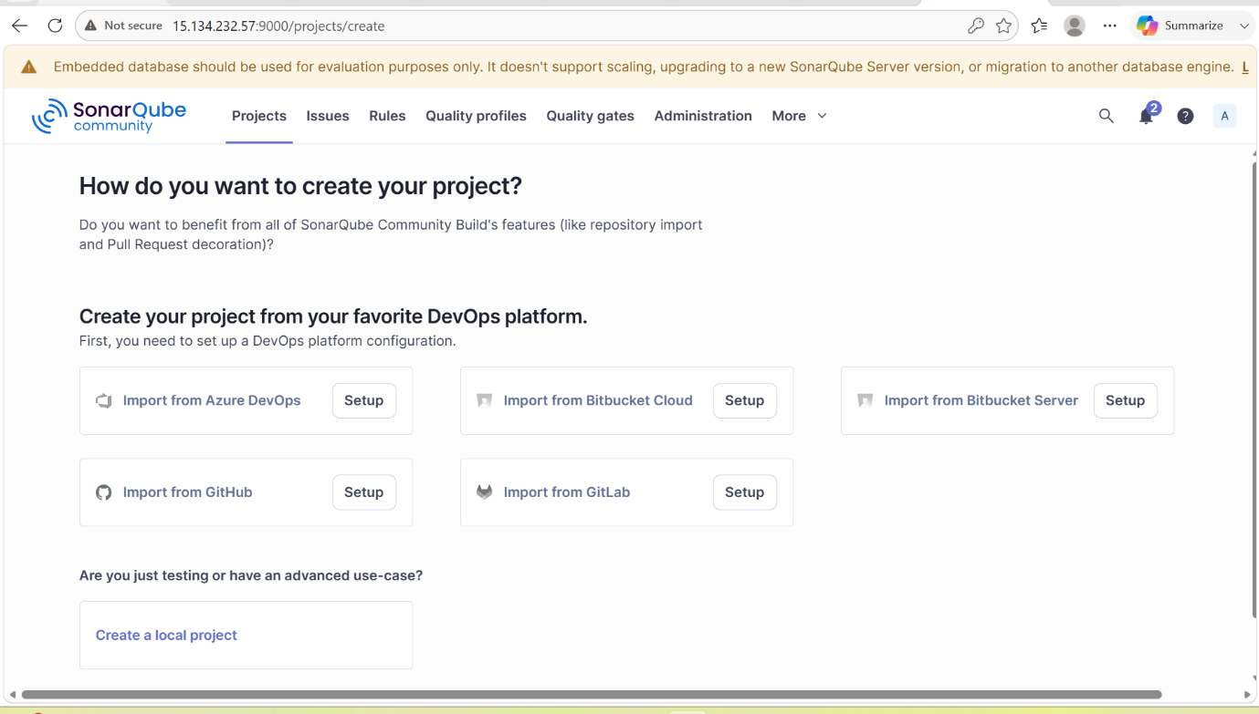

- In Jenkins, we have to configure the SonarQube path in manage jenkins -> system -> add SonarQube installations
- And there we have to give the name and SonarQube URL path -> http://<public-IP>:9000
- And also it will ask for the credentials, we have to create a new credentials in the manage jenkins -> credentials -> secret text
- That secret text will be created in the SonarQube as token
My account -> security -> generate token
- It will create token and that should be copied to the jenkins paste in the credentials secret text.
- This created credentials will be used to the SonarQube installations.

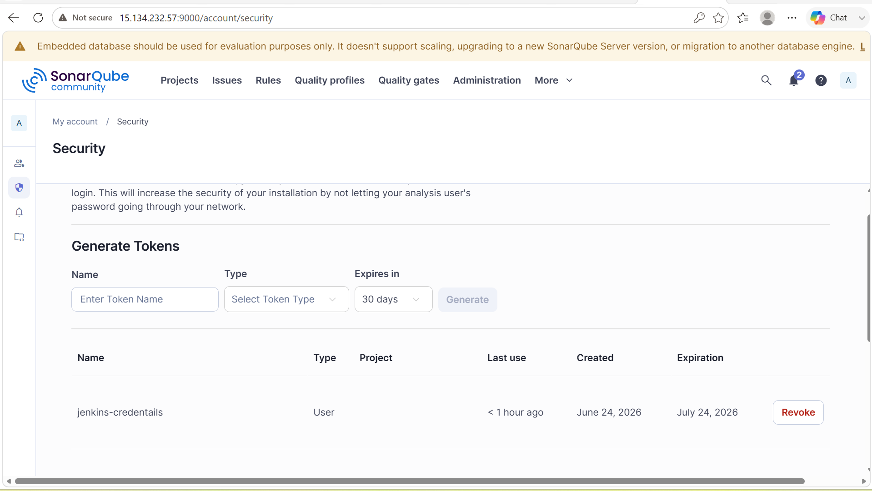

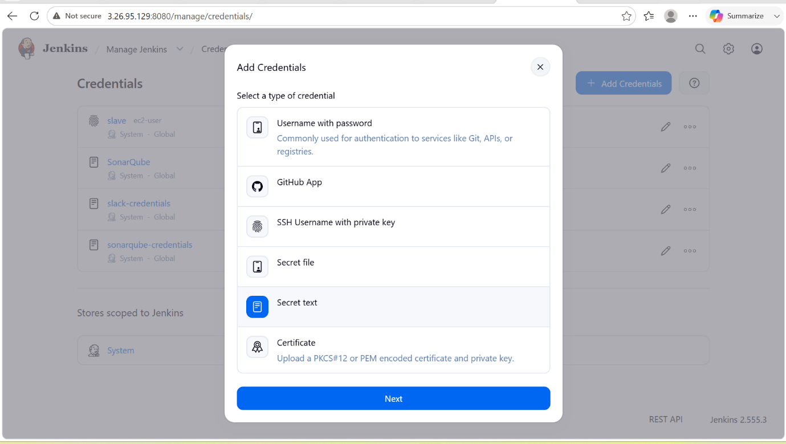

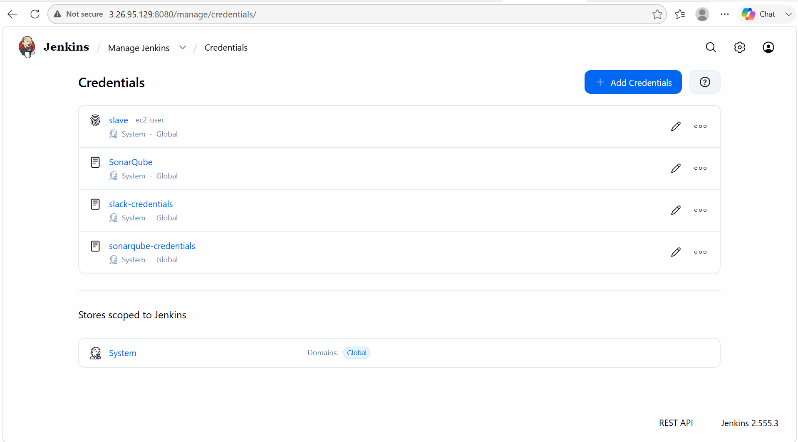
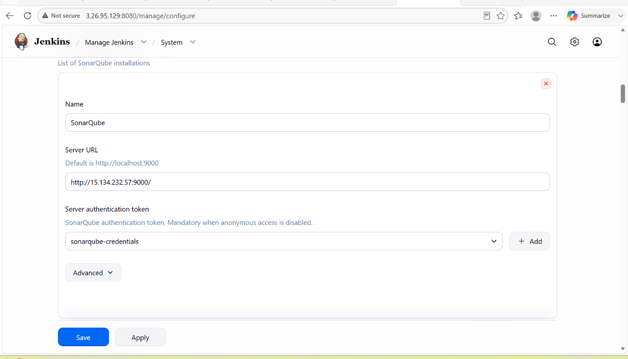

- We have to install the sonarscanner in the Jenkins CLI using wget

- Go to manage jenkins -> tools -> SonarQube Scanner installations -> give the name and pass the path that we have installed In the jenkins server

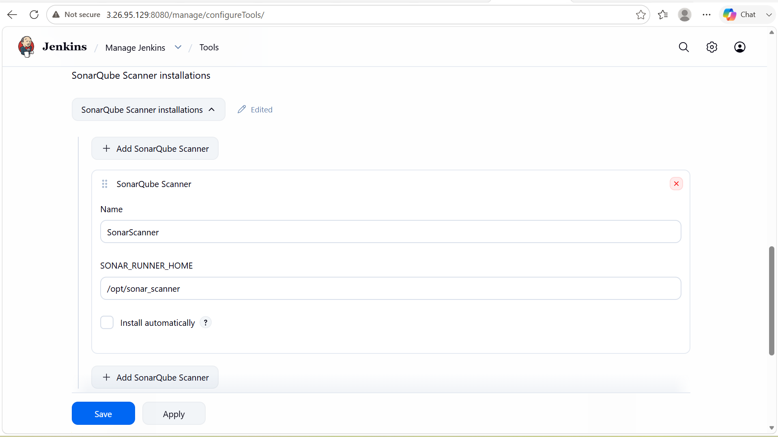

- Now configure the sonar scanner in the job -> configure -> build steps -> execute sonar scanner -> pass the analysis properties.

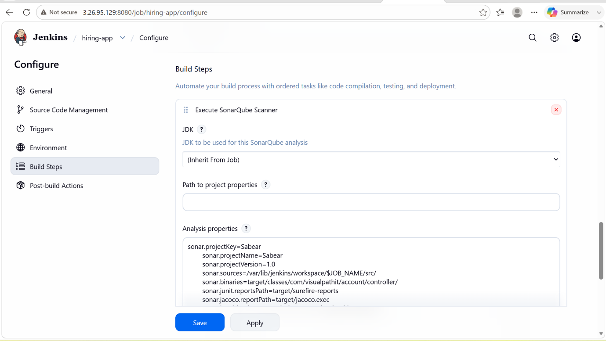

- Now run the job if it is success then integration will be successful

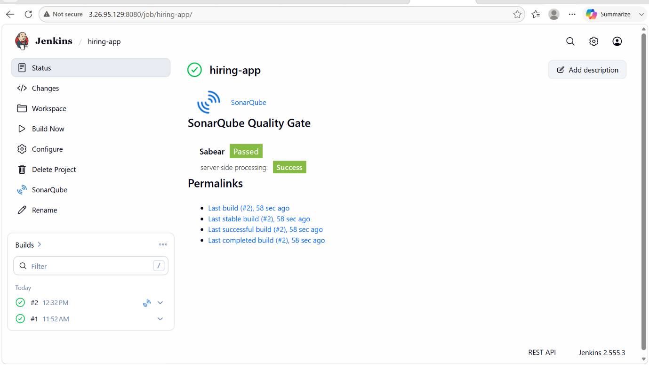

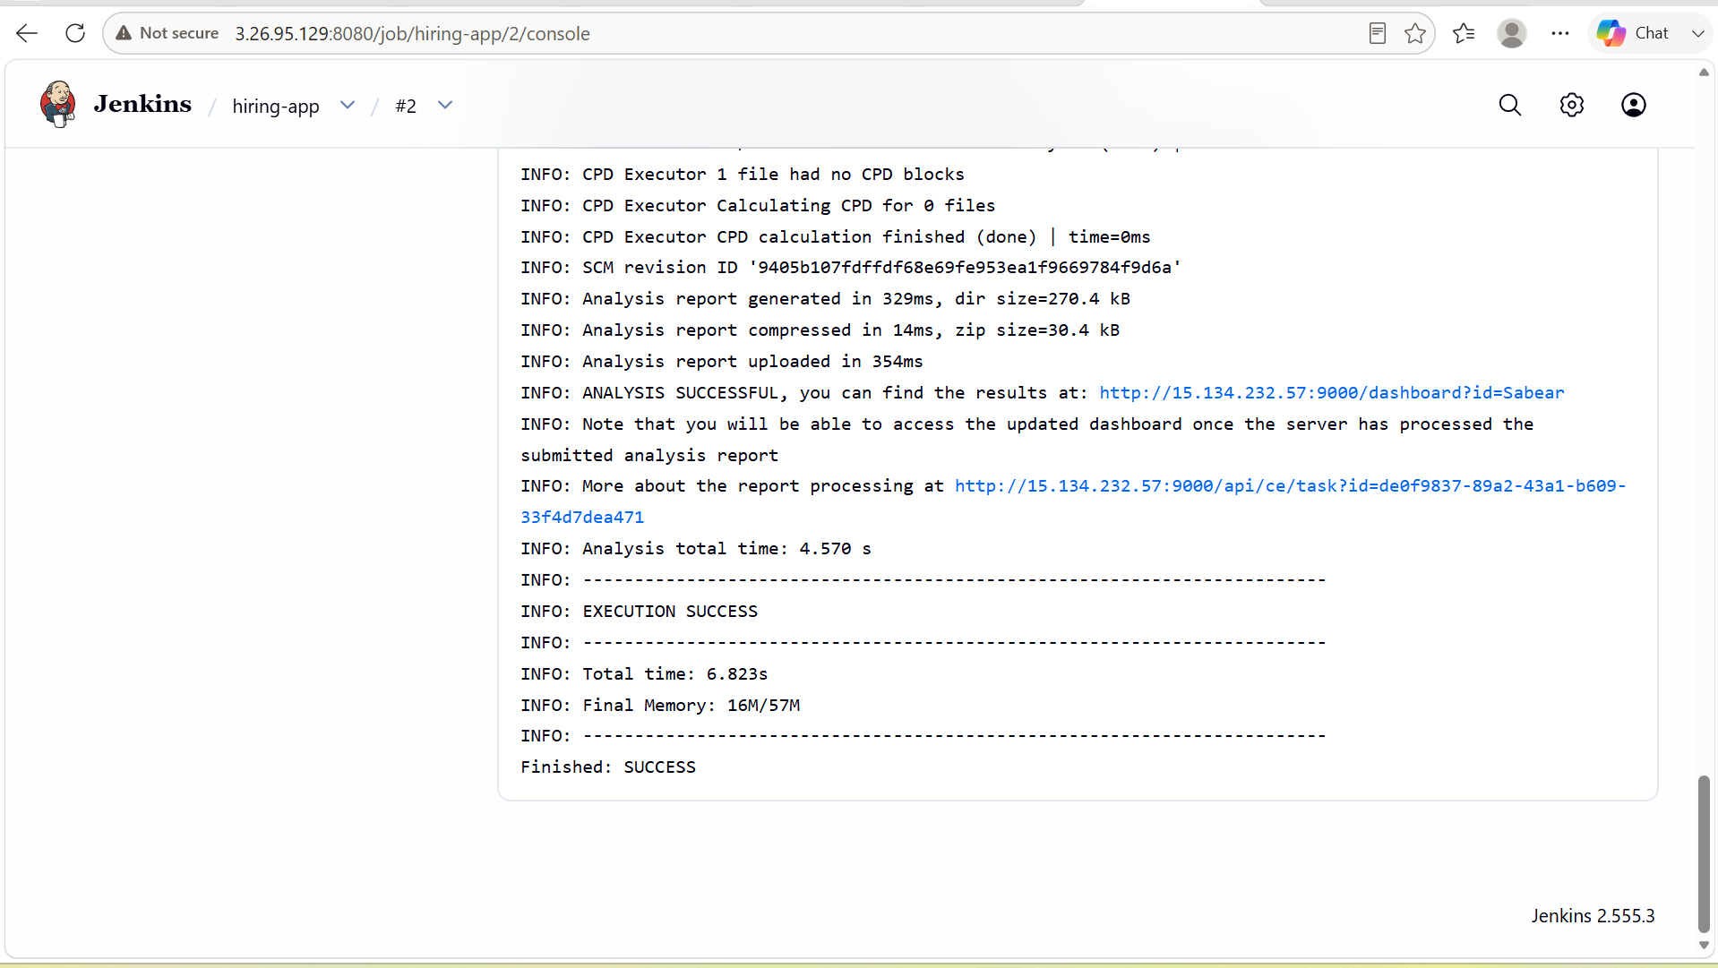

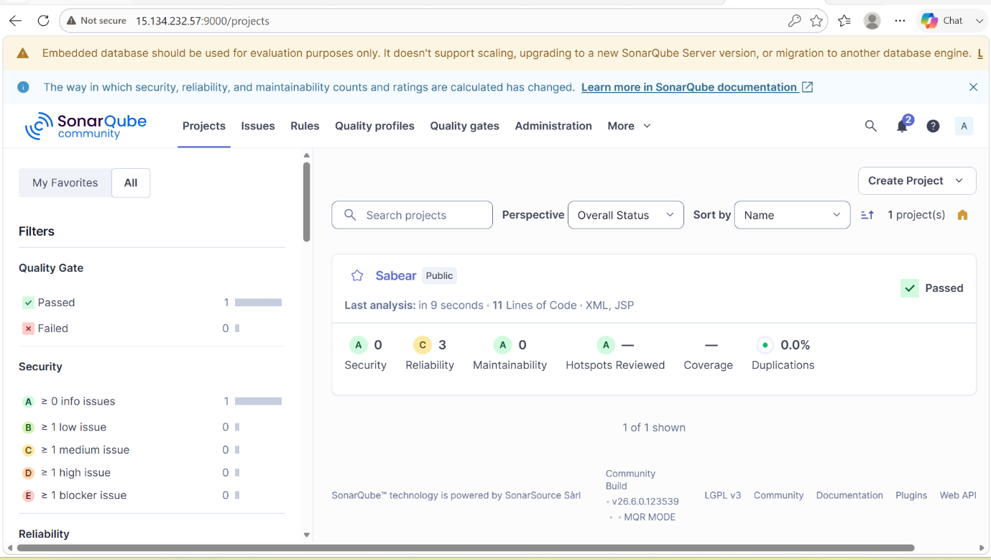

Stage-3: Maven compilation:

PURPOSE: The purpose of Maven compilation is to convert the application’s source code (.java files) into executable java bytecode (.class files) and prepare the application for packaging and deployment.

OBJECTIVE:
- Compile Java source code automatically.
- Detect and report coding errors during the build process.
- Manage project dependencies required for compilation.
- Generate .class files from .java files.
- Ensure consistent builds across different environments.

What Happens During Maven Compilation?

when you run the job in the jenkins, maven performs the following:
  - Reads the pom.xml file.
  - Downloads required dependencies from repositories if not already available.
  - Compiles source files located in /src/main/java.
  - Generates compiled class files in target/classes.

OUTCOME:
- Java source code is successfully compiled.
- Compilation errors are identified early.
- Dependencies are resolved automatically.
- Compiled files are stored in the target/classes directory.
- The project becomes ready for testing, packaging, and deployment.

STEP BY STEP IMPLEMENTATION:
- Download maven from apache archieve by using wget command in the jenkins server.
- After downloading, we have to extract the file.
- After that store mvn path in bashrc file.
- In that we have to set path of the maven present in our instance like /opt/maven. For this we have to execute the command for defining the variable -> export M2_HOME=/opt/maven
- after this command, to set the path this command should be executed -> export PATH=$M2_HOME/bin:$PATH.
- After that we have to set the path in environment -> source ~/.bashrc.
- Then check for the maven version -> mvn -v
- Now go to jenkins server GUI, we have to go to manage jenkins -> tools -> maven installations, we have to give the version maven we have installed and path of maven in the instance /opt/maven.
- In the job, we have to configure the build step as invoke maven targets.
- After when you run the job it will creates directory called targets in that we will get to see the .war files.

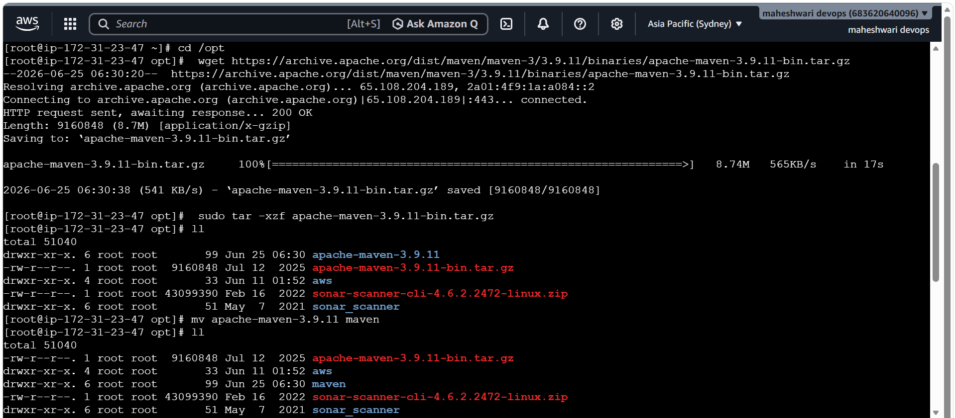

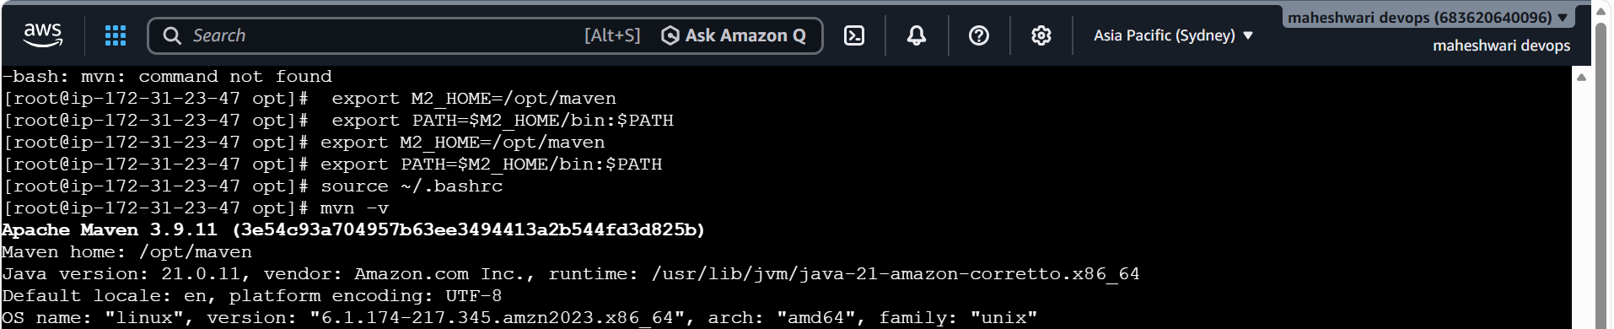

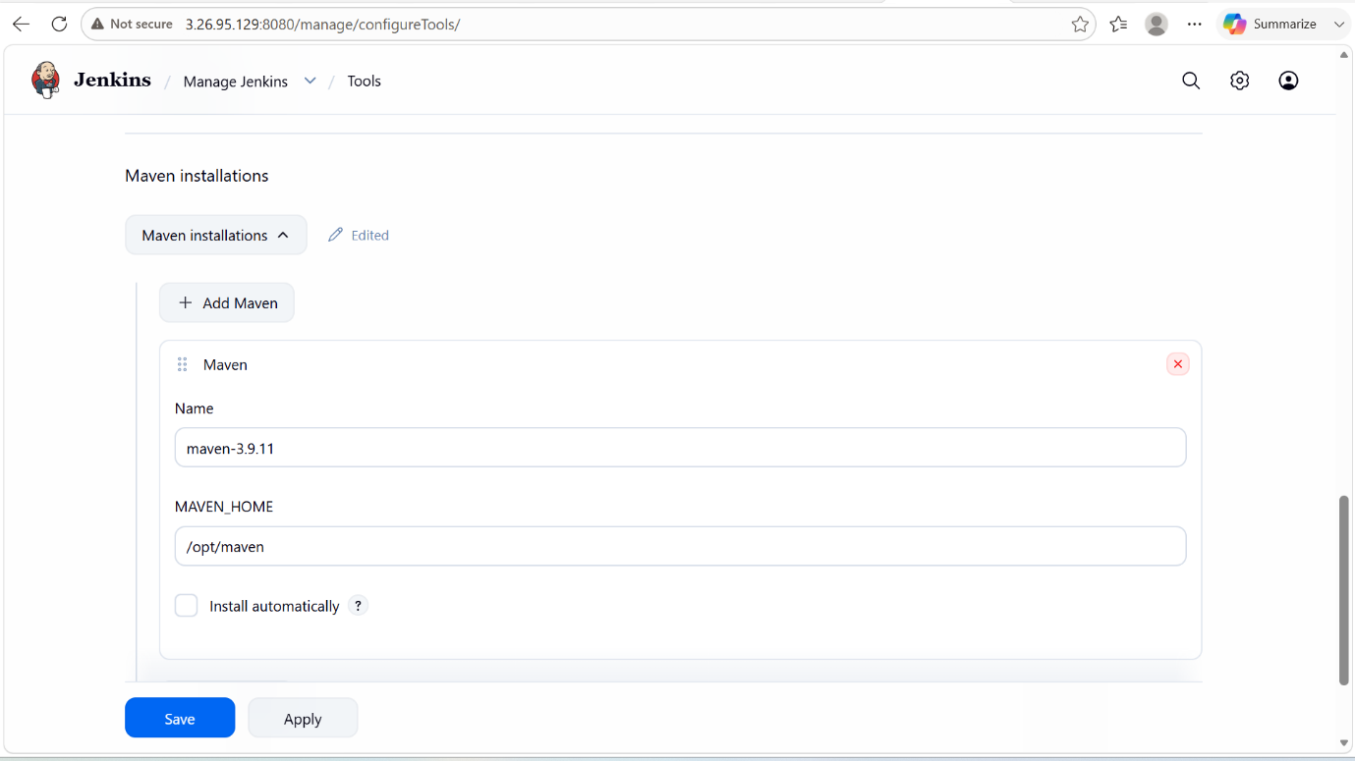

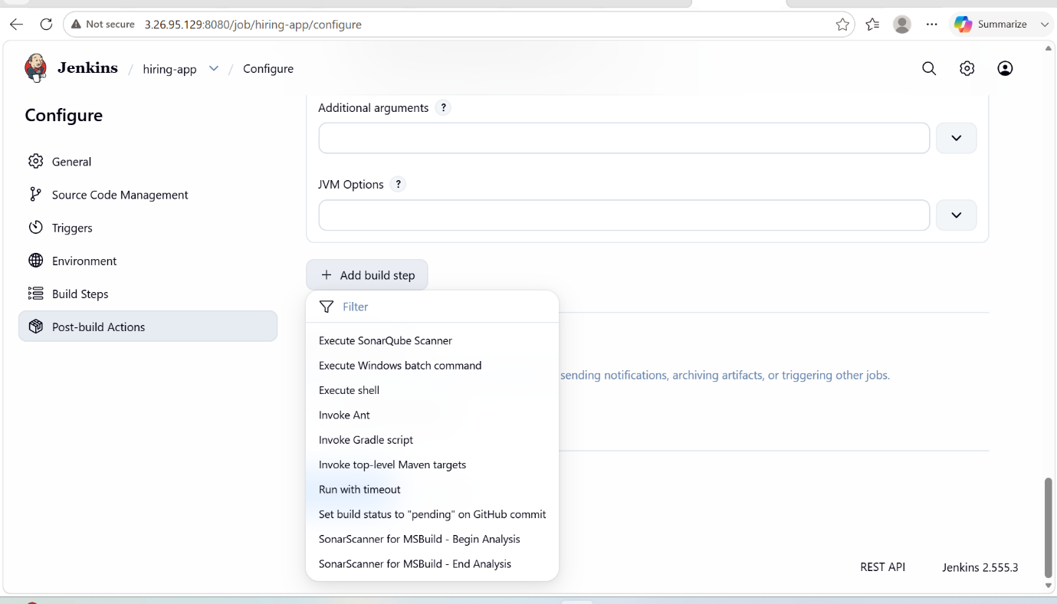

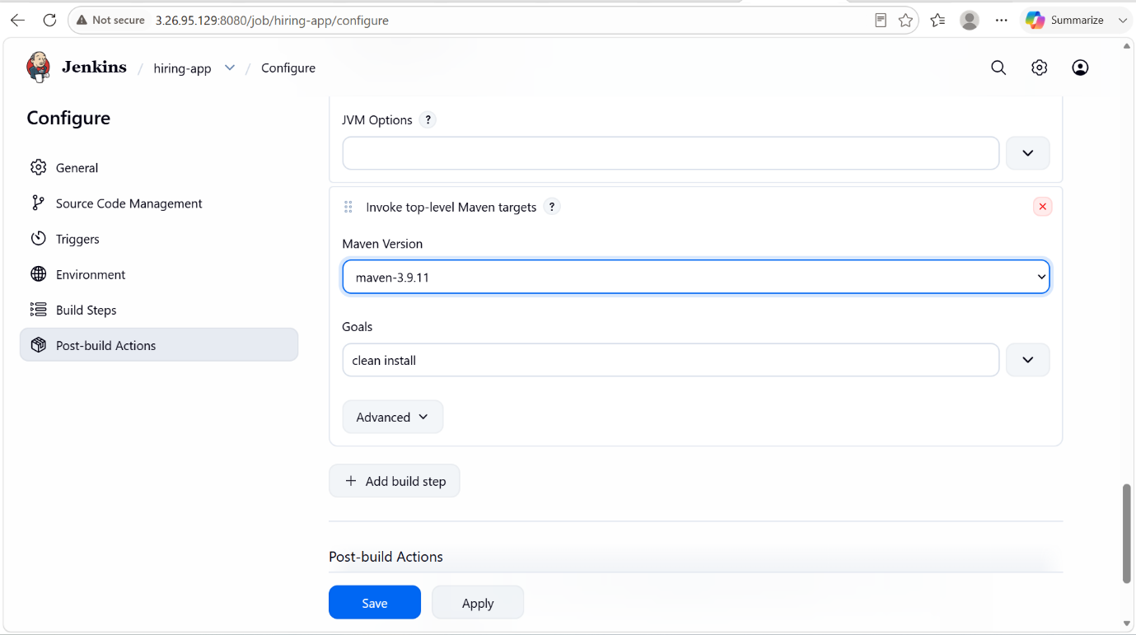

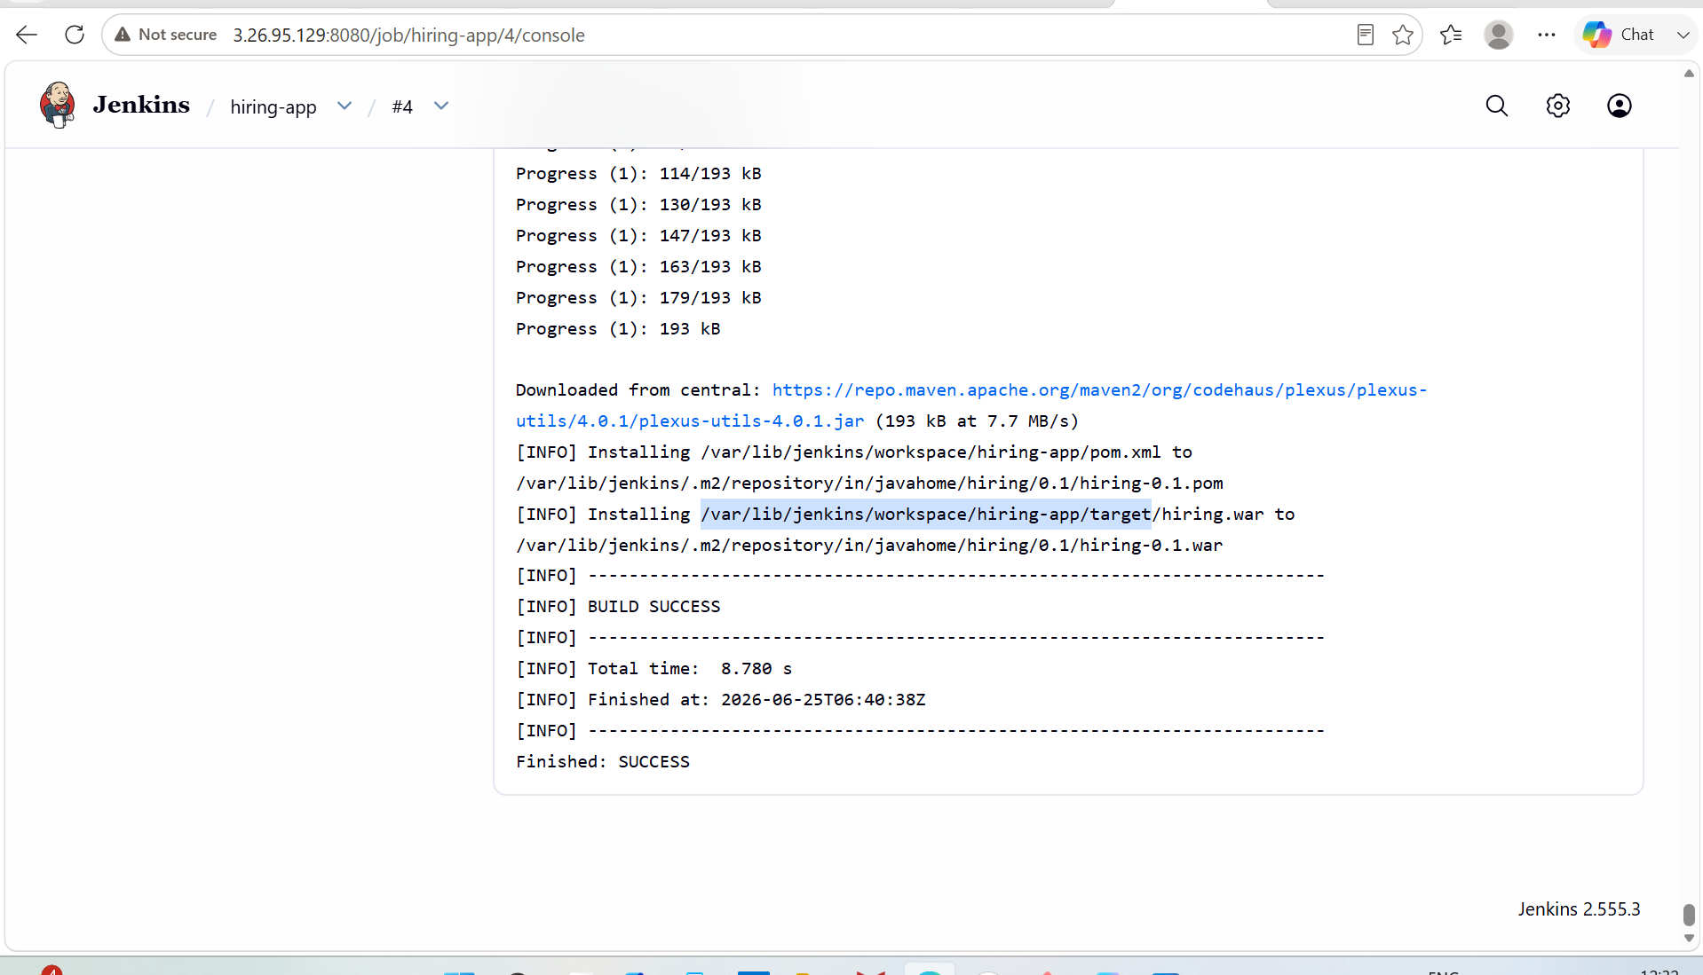

STAGE-4: Nexus Artifactory

PURPOSE: Install Nexus Repository Manager using Docker to store and manage artifacts such as Maven JARs, WARs, Docker images and other build packages.

PREREQUISITES:
- Java 21 should be installed.
- Docker installed and running.
- Atleast 4GB RAM.
- Port 8081 open in the server firewall/security group.

STEP BY STEP IMPLEMENTATION:
- Make sure in an instance docker is installed and it is running successfully.
- After that, pull nexus image by using command -> docker pull sonatype/nexus3
- After that start the nexus server with the command ->
docker run -d \
--name nexus \
-p 8081:8081 \
-v nexus-data:/nexus-data \
sonatype/nexus3
- Open nexus server in the browser -> http://<public-IP>:8081
- This will open nexus server for us.
- Use the admin password created by the nexus server and after that it will prompt us to create your custom password.
- After logging in, create a new repo, go to settings -> repositories -> create new repo -> there create new repo with required details.
- Go to jenkins, install plugin nexus artifact uploader.
- go to your job and click on configure, in that add build step with required details.
- That details will be available in the pom.xml file of the repo that we have cloned to our workspace.

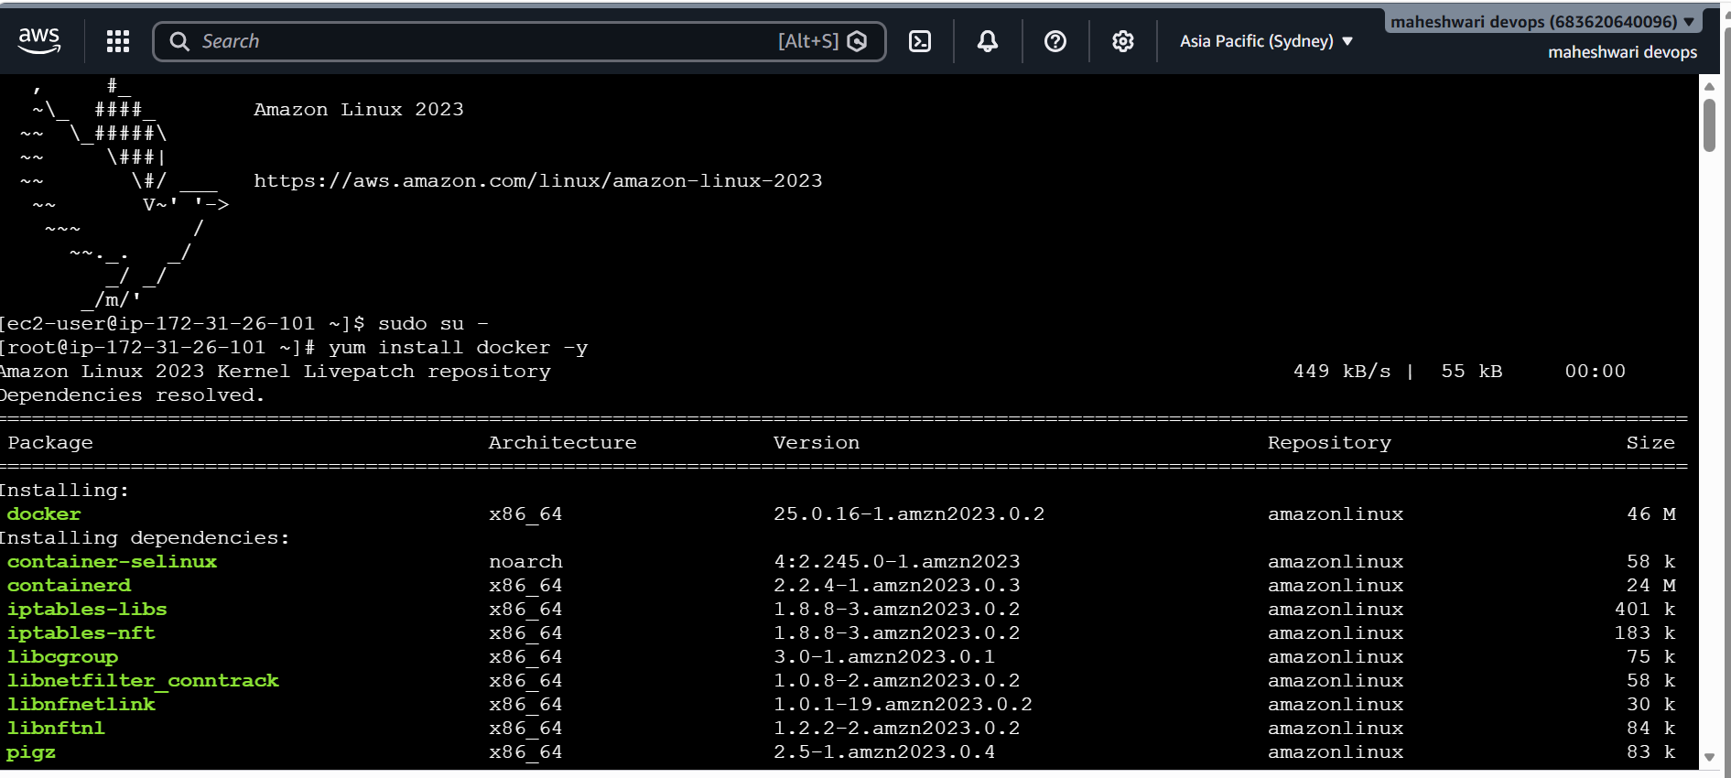

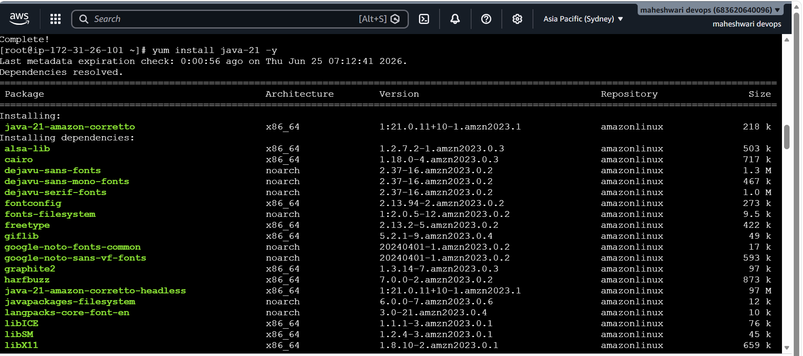

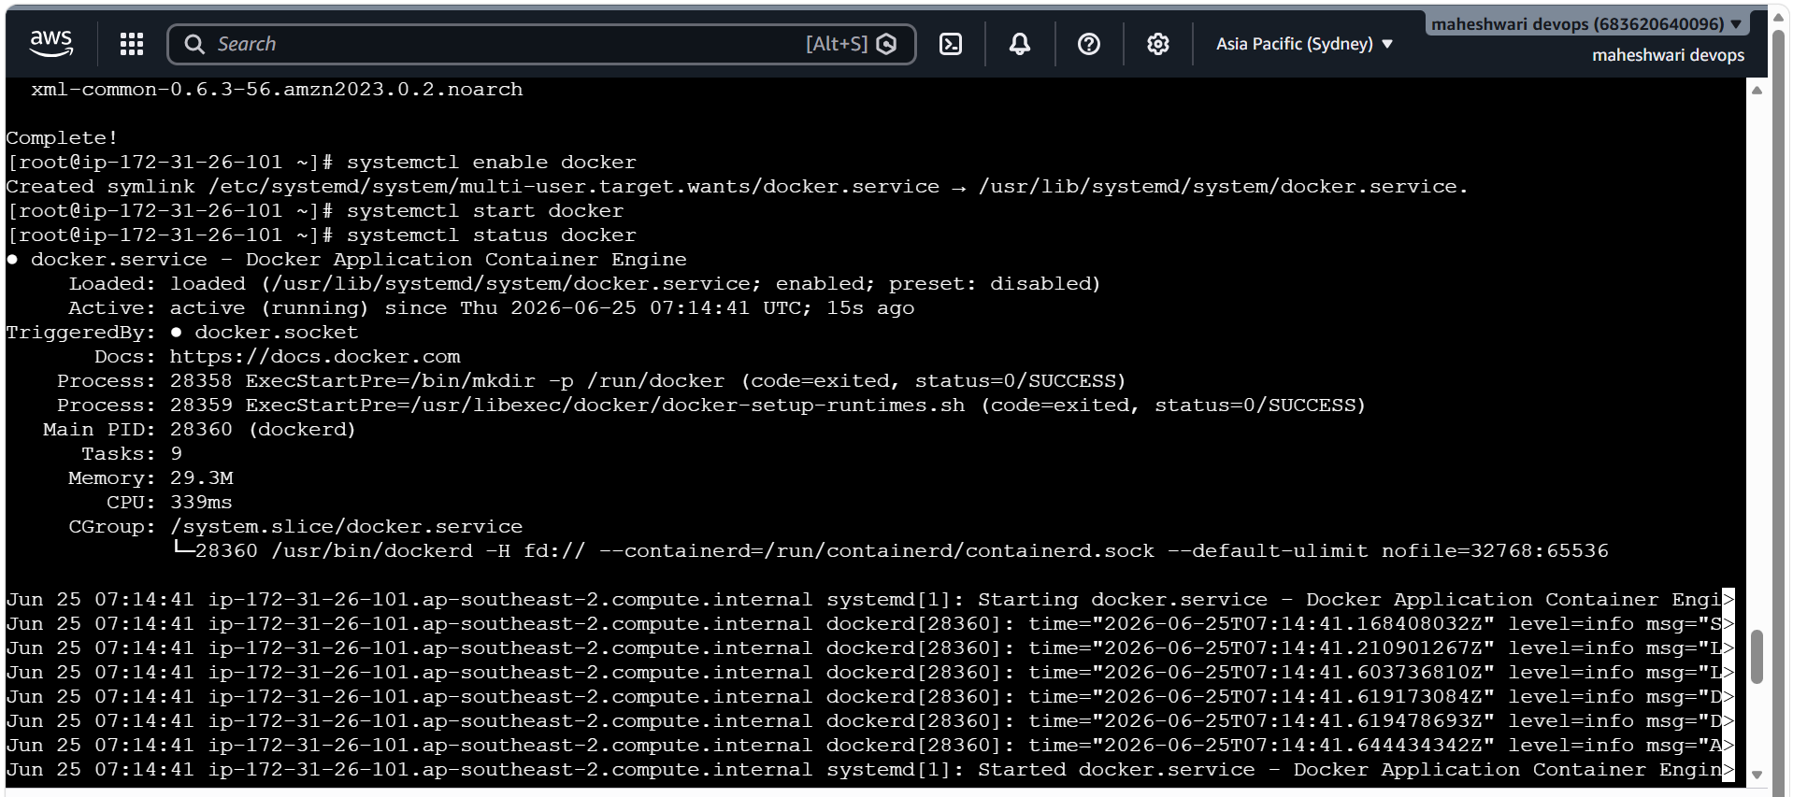

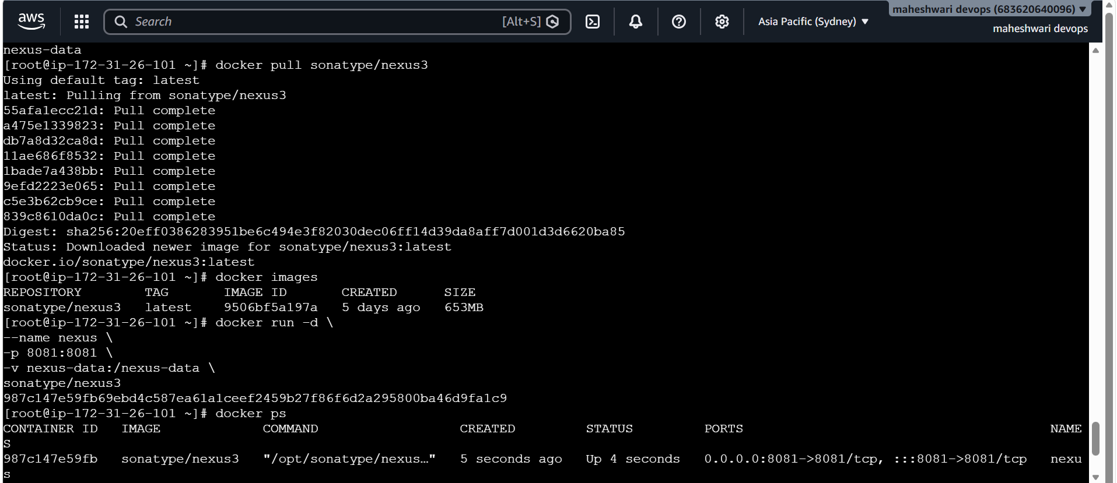

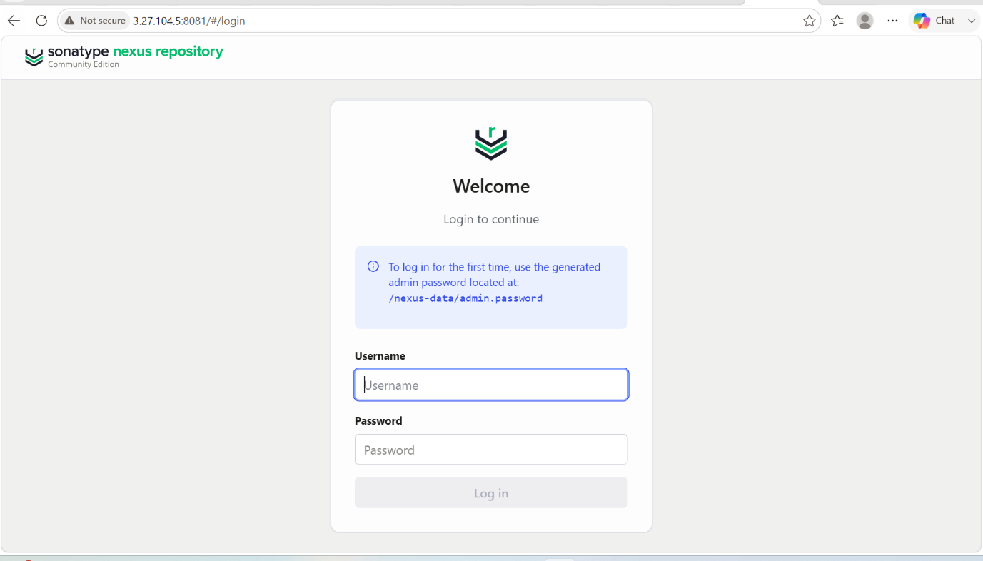

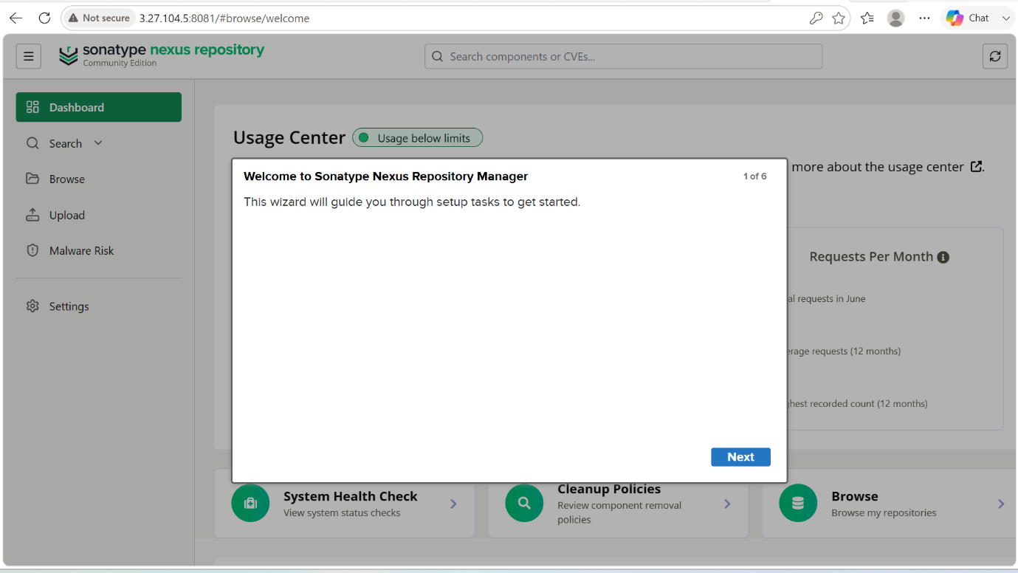

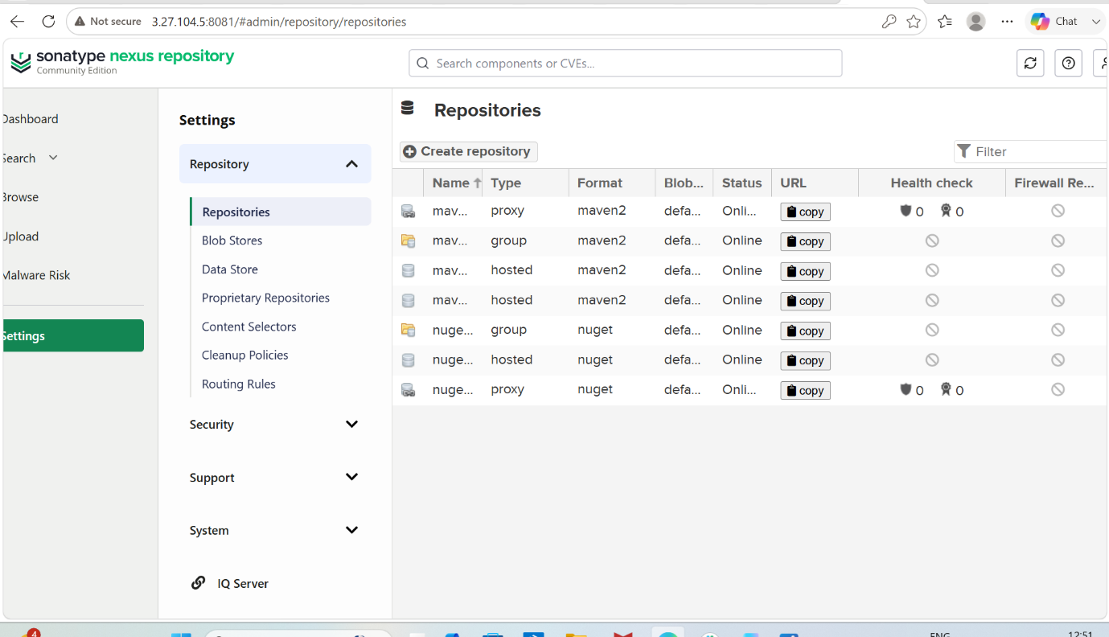

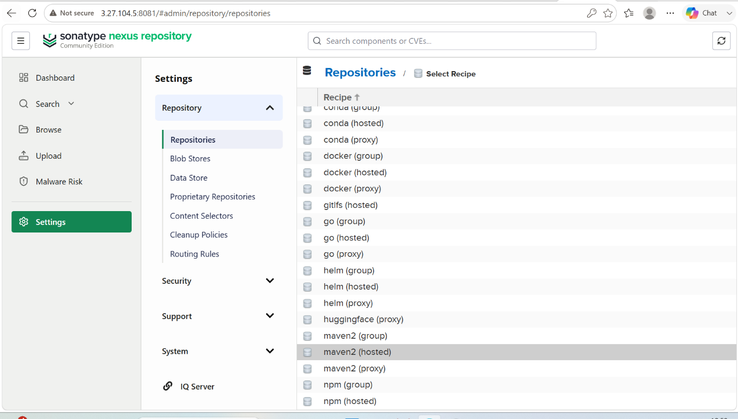

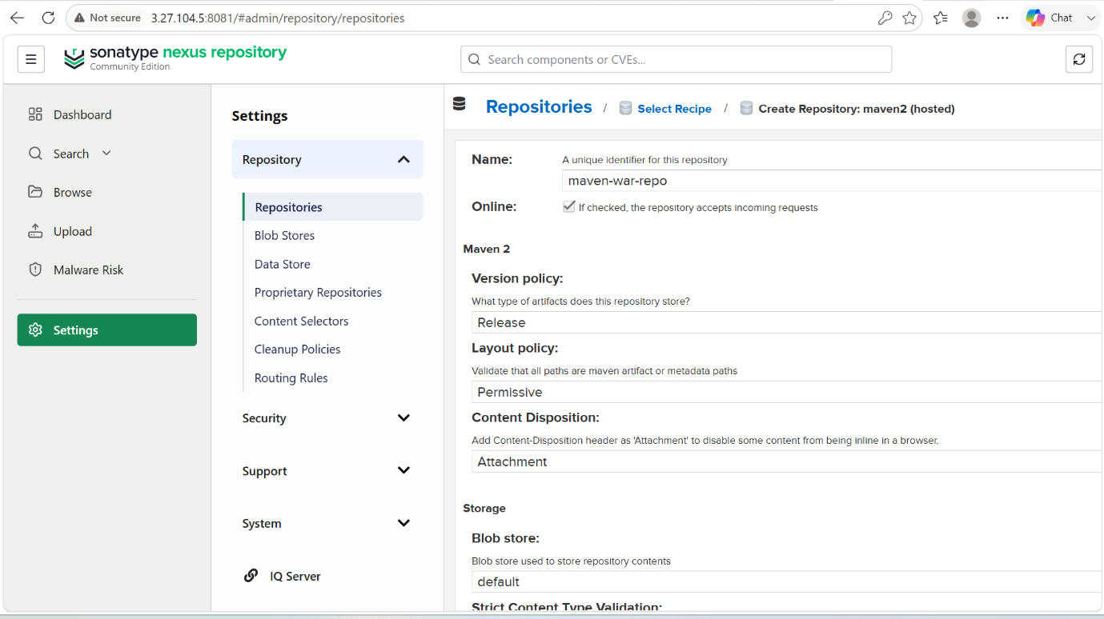

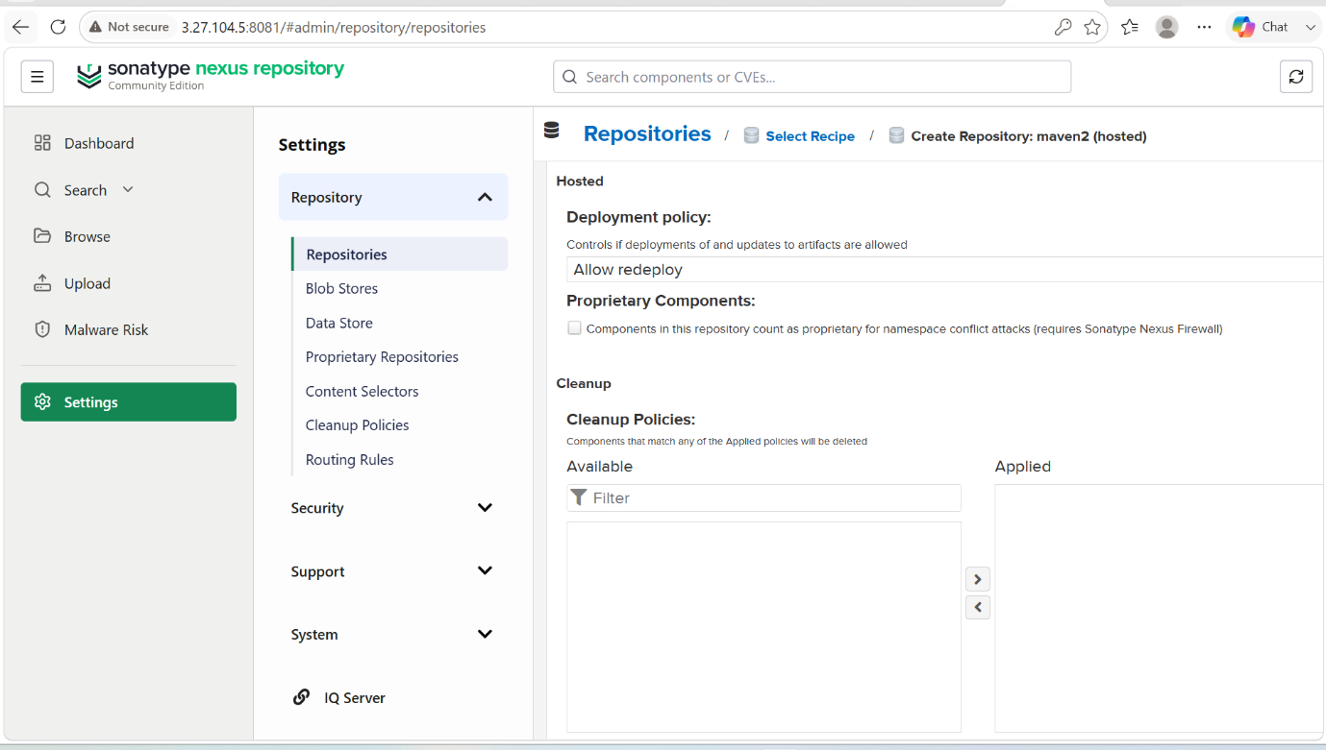

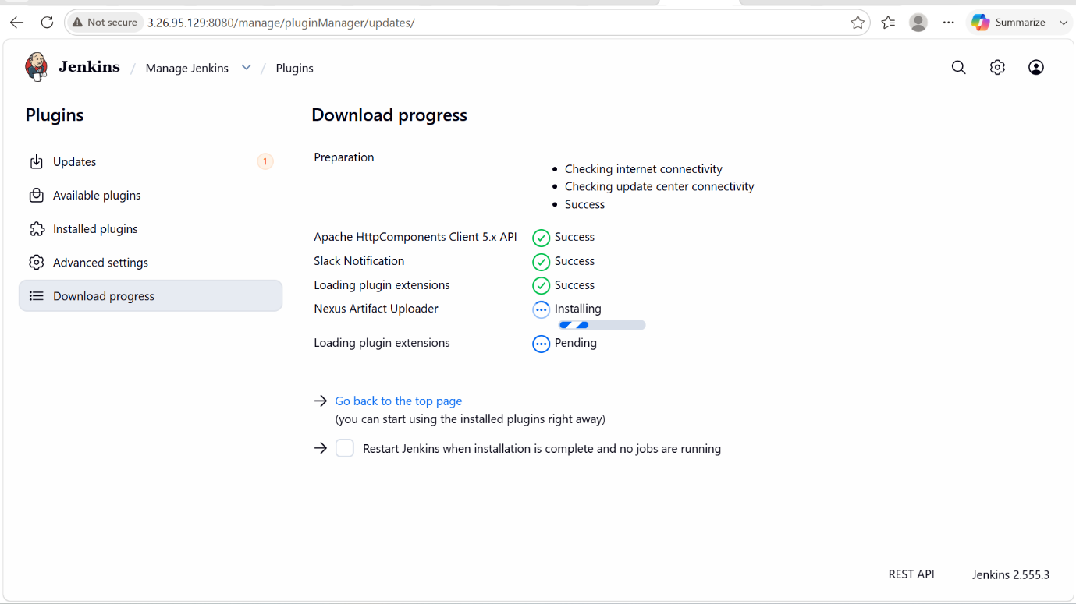

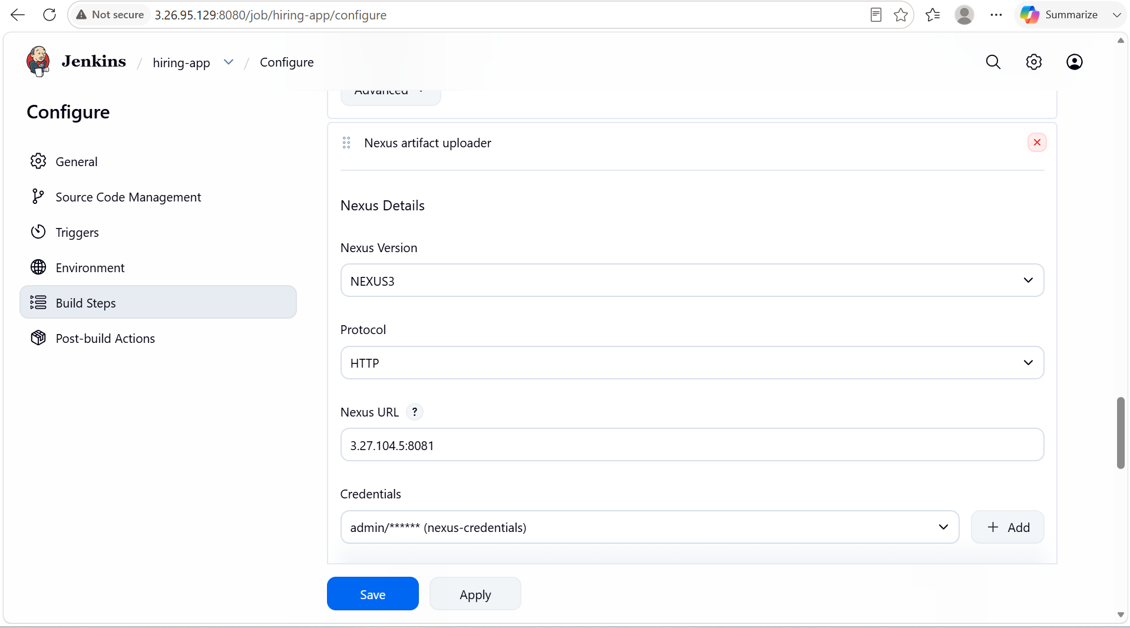

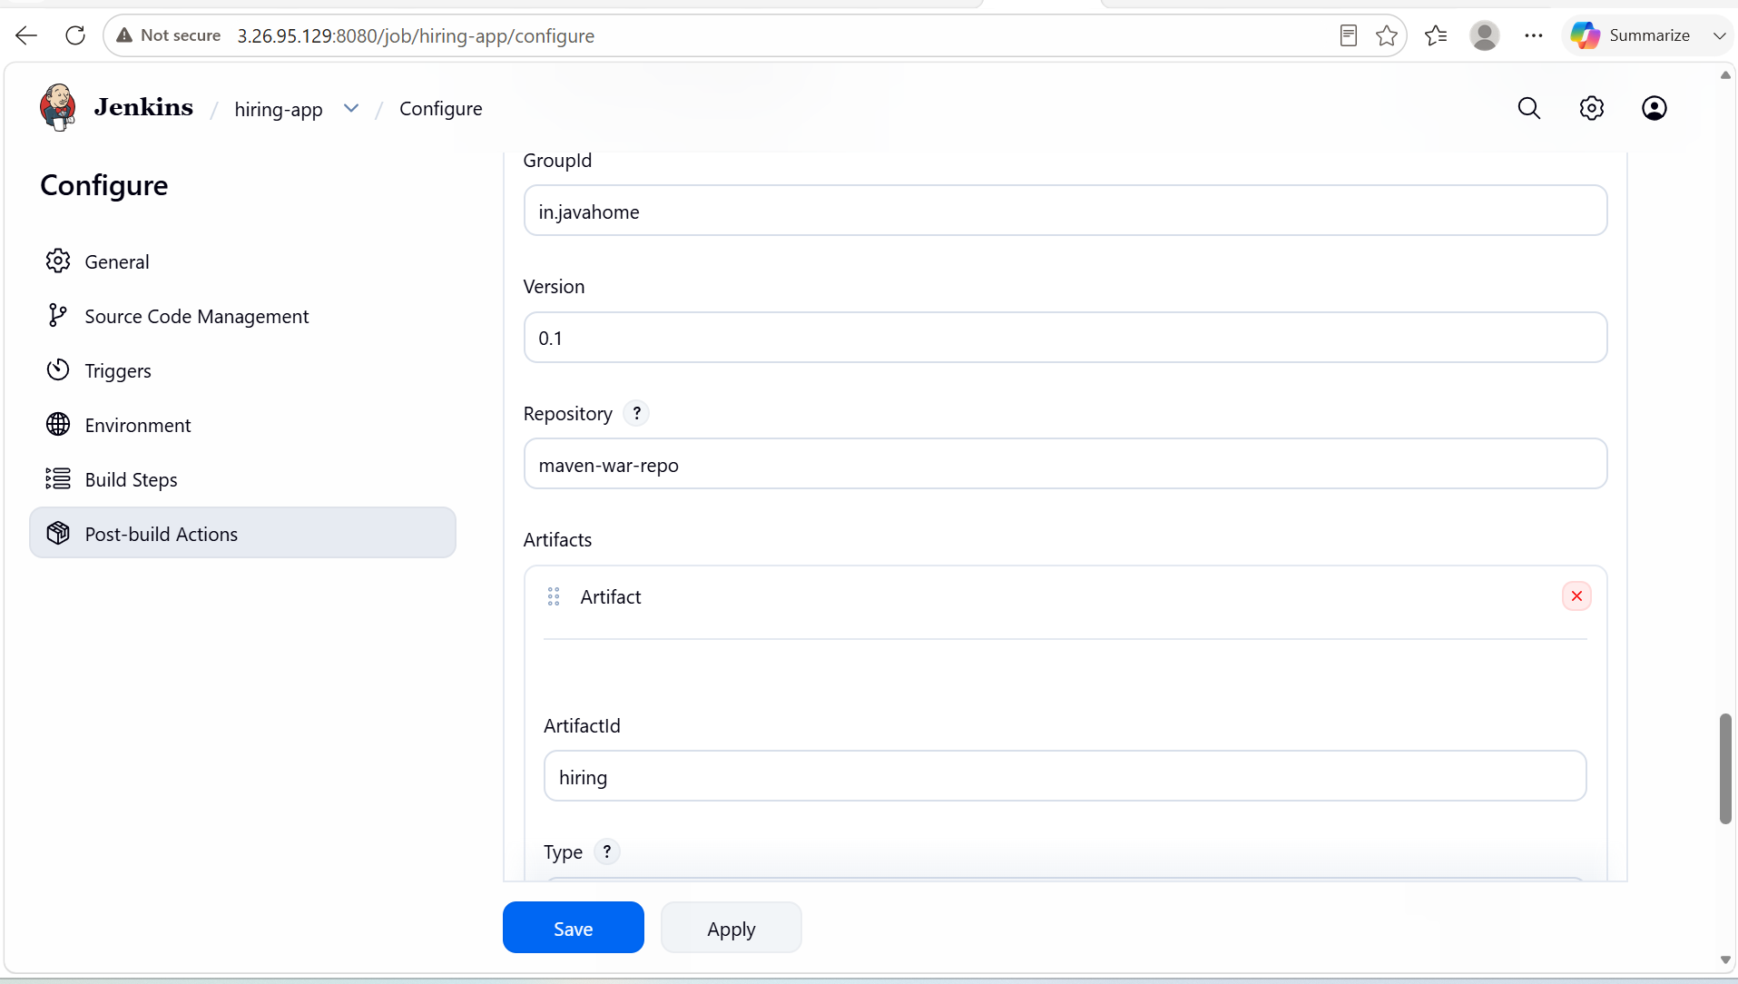

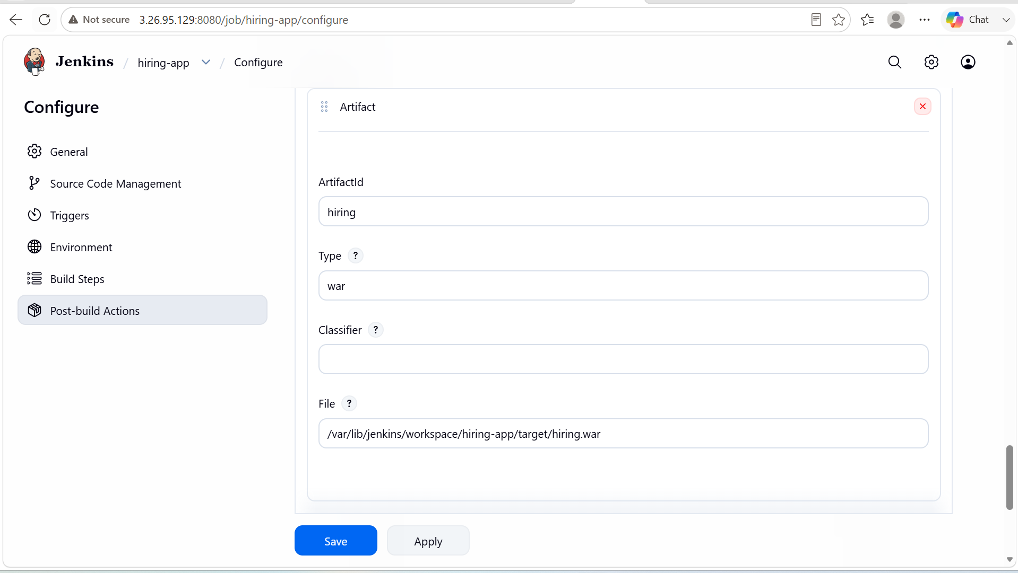

- When you click on build now, it will run our job and upload the war file to our nexus server.

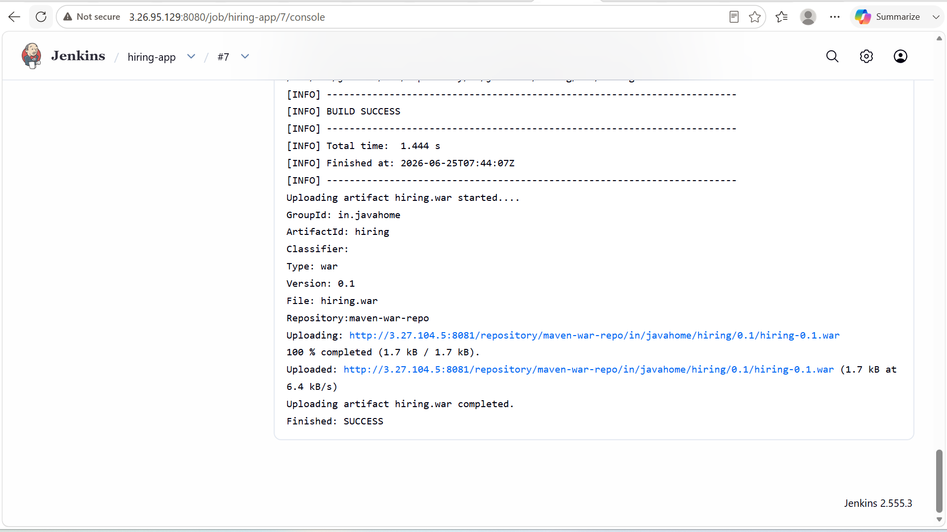

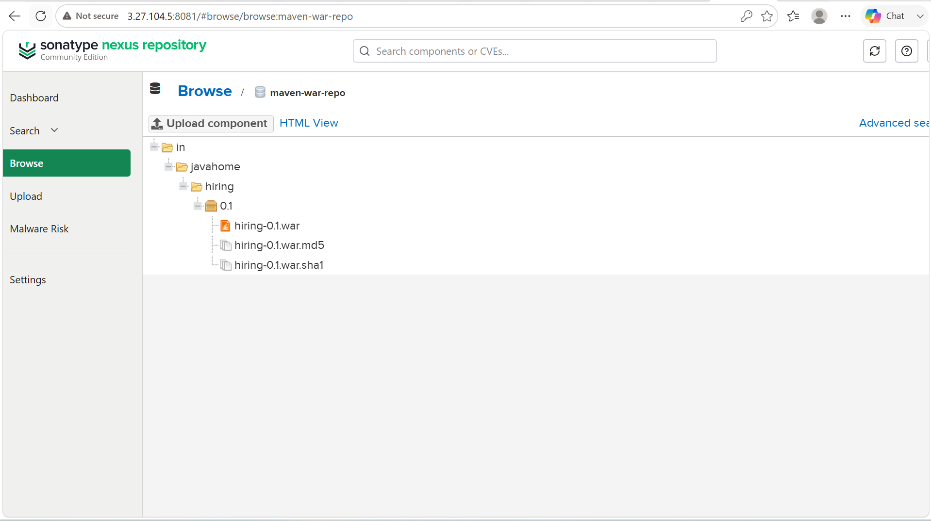

STAGE-5: Slack integration:

- We have to create a new workspace first and create a channel also for jenkins alerts.
- After that we have to install Slack plugin in Jenkins and in the slack we have to configure the jenkins CI in the slack
- We have to configure slack in the jenkins in the manage jenkins -> system -> slack -> name and credentials
- After that we have to configure post build actions with the slack that sends the notifications when you run a job.

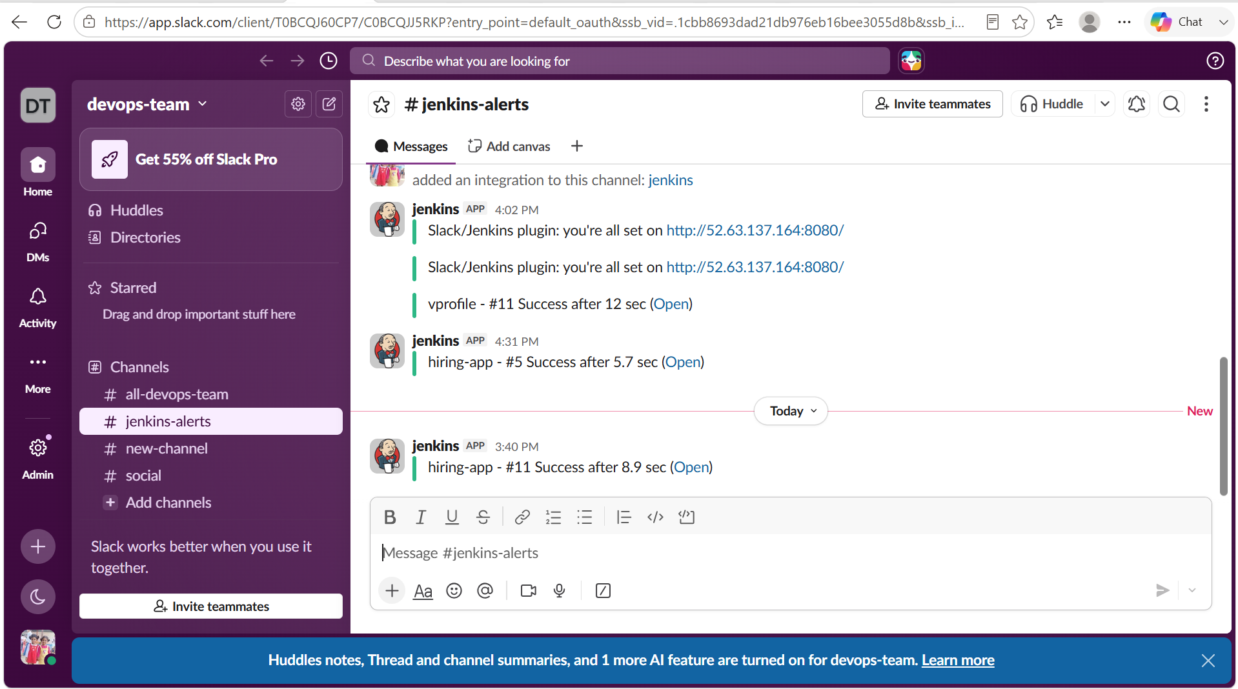

STAGE-6: Deploy to Tomcat:

PURPOSE: The purpose of deploying an application to Apache Tomcat is to make a Java web application available for users to access through a web browser.

OBJECTIVE:

- Host and run Java web applications (WAR files).
- Provide a web server and servlet container environment.
- Make the application accessible through HTTP/HTTPS.
- Enable testing and validation of application functionality.
- Support automated deployments through CI/CD tools like Jenkins.

STEP BY STEP IMPLEMENTATION:
- Install the plugin in jenkins, plugin name will be deploy to container.
- After that we have to configure it in the job and there we have to give the type of file like **.war and context as / and we have to add the container also that the tomcat version we are using in the CLI.
- After that go to tomcat server CLI, we have to comment the value classname = in all the files of webapps with the context.xml files.
- After that we have to add the users in the conf/tomcat.users.xml file insert this ->
<role rolename="manager-gui"/>
<role rolename="manager-script"/>
<role rolename="manager-jmx"/>
<role rolename="manager-status"/>
<user username="admin" password="admin" roles="manager-gui, manager-script, manager-jmx, manager-status"/>
<user username="deployer" password="deployer" roles="manager-script"/>
<user username="tomcat" password="s3cret" roles="manager-gui"/>
- We have to login into the tomcat server on the browser with the username as deployer and password as deployer
- These are passed in the tomcat.users.xml file by us in the previous step.
- Click on build now and you will get see that your application has been deployed on the tomcat server.

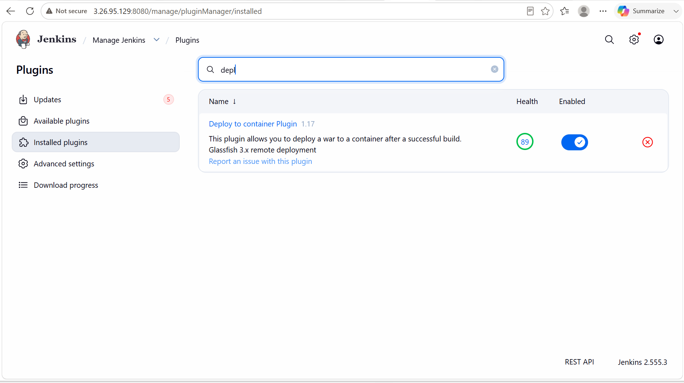

- We have to add the credentials in the jenkins as same credentials that we have used while logging into the tomcat server on browser.

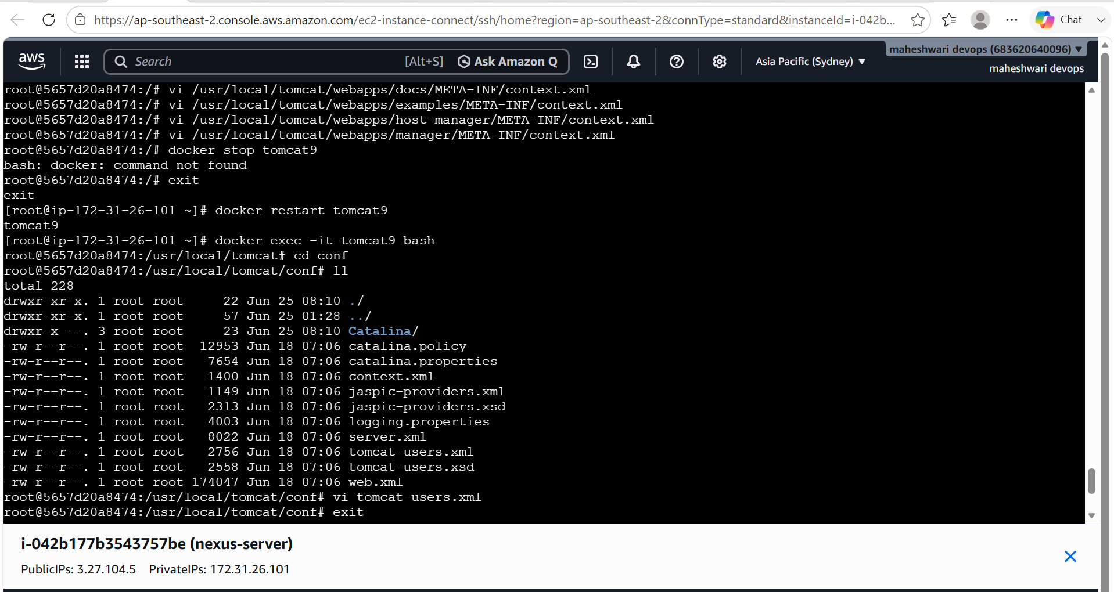

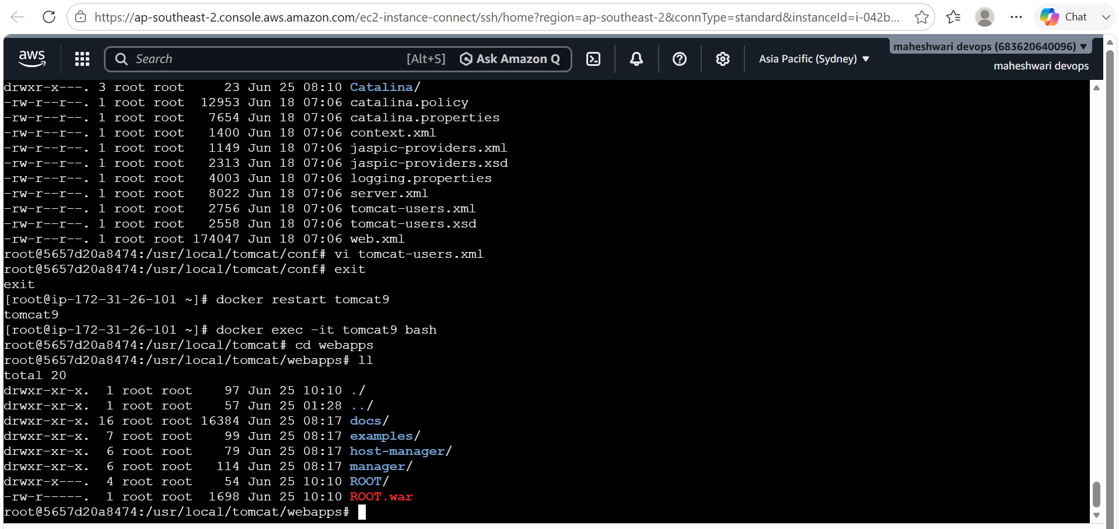
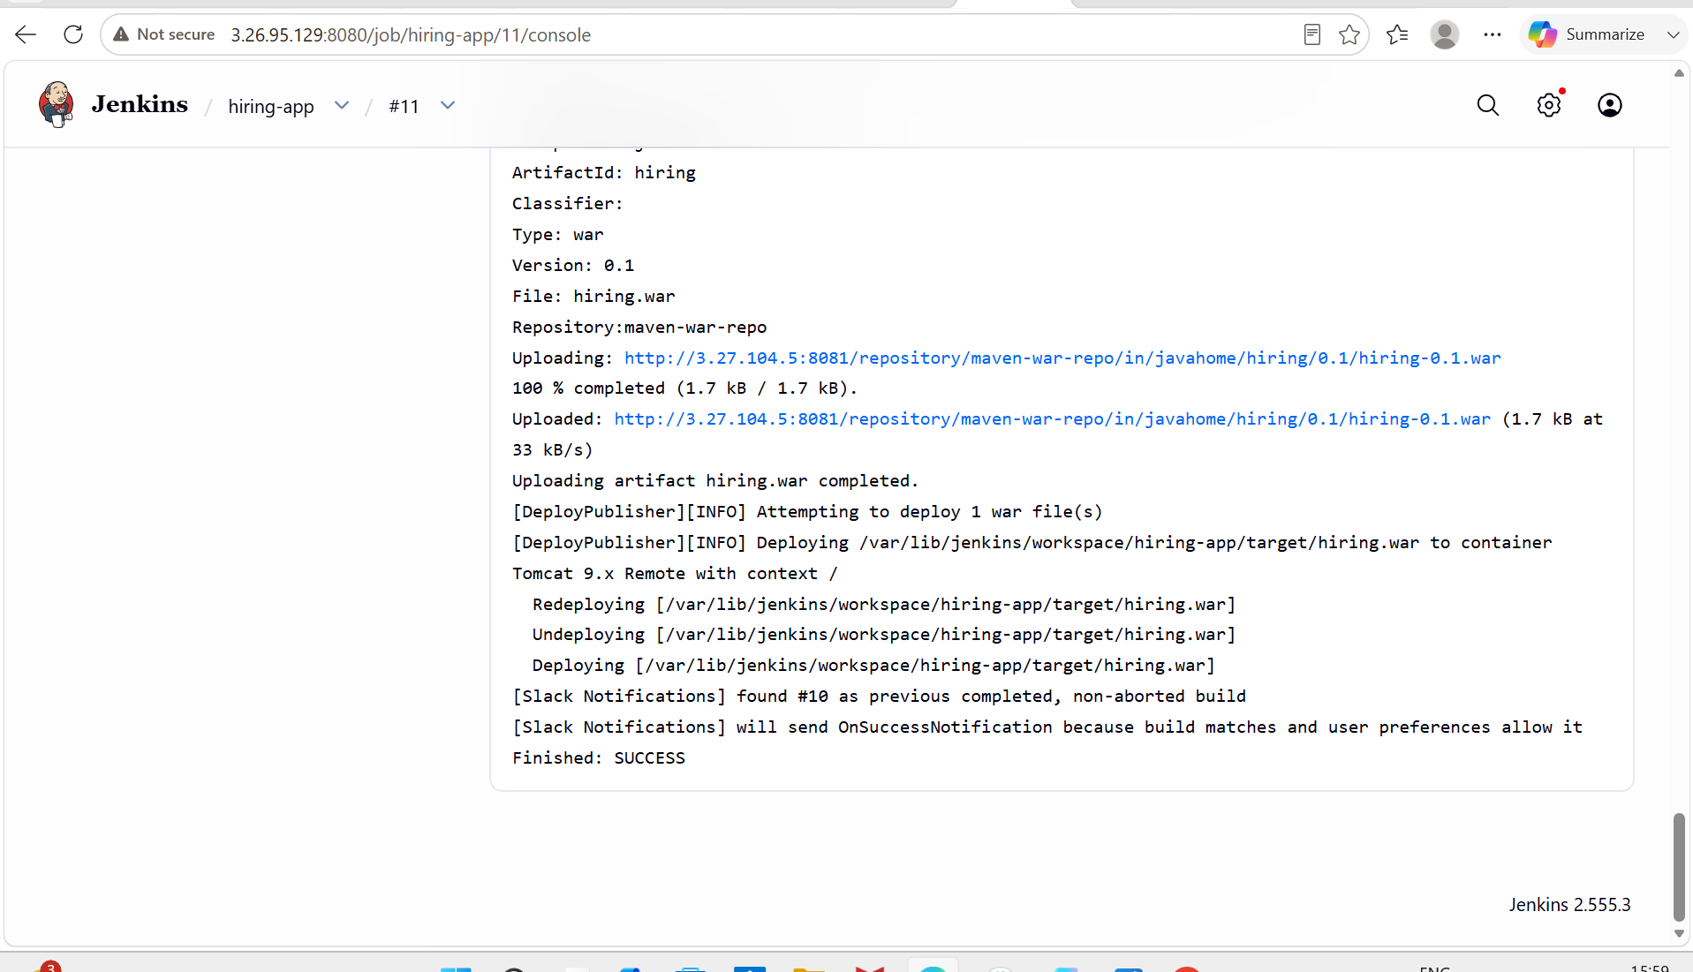

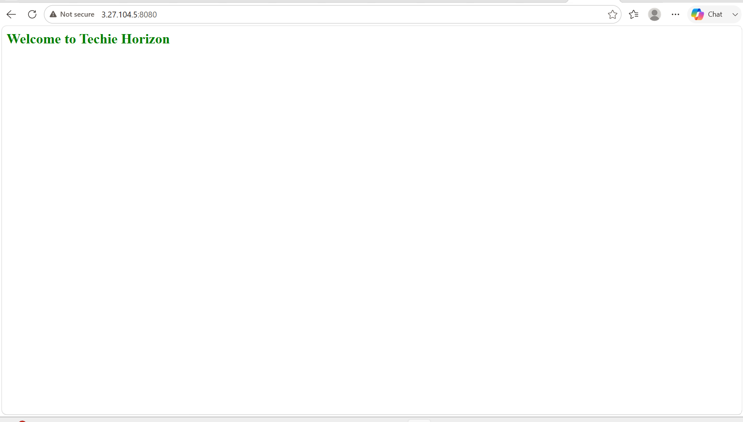

2. Setup a Jenkins CICD pipeline using Declarative pipeline using feature-1.1 branch.
Source Code: https://github.com/betawins/sabear_simplecutomerapp/tree/feature-1.1
stages:

Git Clone

SonarQube Integration

Maven Compilation

Nexus Artifactory

Slack Notification

Deploy On tomcat

DECLARATIVE PIPELINE:

- A Declarative pipeline provides a structured, human readable way to define CI/CD workflows.
- It uses a predefined syntax with pipeline, stages and steps blocks, making it easier to maintain and enforce best practices compared to Scripted Pipelines.

PIPELINE FOR THE ABOVE REPO:

pipeline{
agent any
tools {
jdk 'JDK-21'
maven 'maven-3.9.11'
}

environment {
SONAR_SERVER = 'SonarQube'
NEXUS_URL = '3.27.104.5:8081'
NEXUS_REPO = 'maven-releases-1'
SLACK_CHANNEL = '#jenkins-alerts'
JOB_NAME = 'SimpleCustomerApp'
}

stages {

stage ('Git Clone') {
steps {
git branch: 'feature-1.1',
url: 'https://github.com/betawins/sabear_simplecutomerapp'
}
}

stage ('SonarQube Integration') {
steps {
withSonarQubeEnv('SonarQube') {
sh '''
mvn sonar:sonar\
-Dsonar.projectKey=sabear-app\
-Dsonar.projectName=sabear-app
'''
}
}
}

stage ('Maven Compilation') {
steps {
sh 'mvn clean install'
}
}

stage('Find WAR') {
steps {
script {
env.WAR_FILE = sh(
script: "find target -name '*.war' | head -1",
returnStdout: true
).trim()

echo "WAR File = ${env.WAR_FILE}"
}
}
}

stage ('Nexus Artifactory') {
steps {
nexusArtifactUploader(
nexusVersion: 'nexus3',
protocol: 'http',
nexusUrl: '3.27.104.5:8081',
groupId: 'com.javatpoint',
version: "${BUILD_NUMBER}",
repository: 'maven-releases-1',
credentialsId: 'nexus-creds',
artifacts: [
[
artifactId: 'SimpleCustomerApp',
classifier: '',
file: env.WAR_FILE,
type: 'war'
]
]
)

}
}
stage('Deploy On Tomcat') {
steps {
deploy adapters:
[
tomcat9(
credentialsId: 'tomcat',
path: '',
url: 'http://3.27.104.3:8080' )
],
contextPath: '/',
war: 'target/*.war'
} }
}
post {
success {
slackSend(channel: "${SLACK_CHANNEL}", color: '#36A64F',
message: ":white_check_mark: Build SUCCESS: ${env.JOB_NAME} #${env.BUILD_NUMBER}")
}
failure {
slackSend(channel: "${SLACK_CHANNEL}", color: '#FF0000',
message: ":x: Build FAILED: ${env.JOB_NAME} #${env.BUILD_NUMBER}")
}
}
}

STAGES:

- Git Clone: this stage will clone the central repository from the GitHub.
- SonarQube Integration: It will test the quality of code and records the report in the SonarQube and it will pass or fail the source code based on the quality gates and quality profiles.
- Maven Compilation: it will compile the source code and it will create a package for us as war file.
- Nexus Integration: It will act as repository for the packages that are created by the maven. Generally nexus stores our artifacts.
- Deploy to tomcat: artifacts will be deployed to our application server like tomcat.
- Slack notification: it is a post build action. It will used for the notifications for our job.

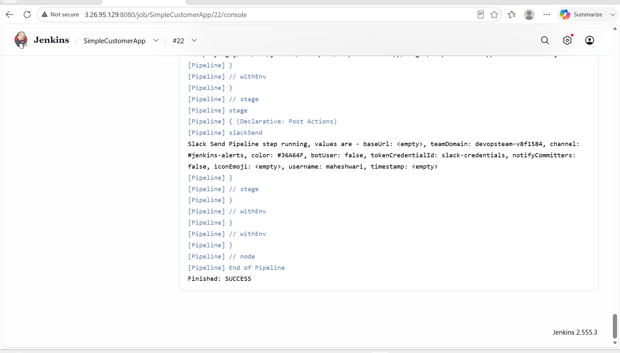

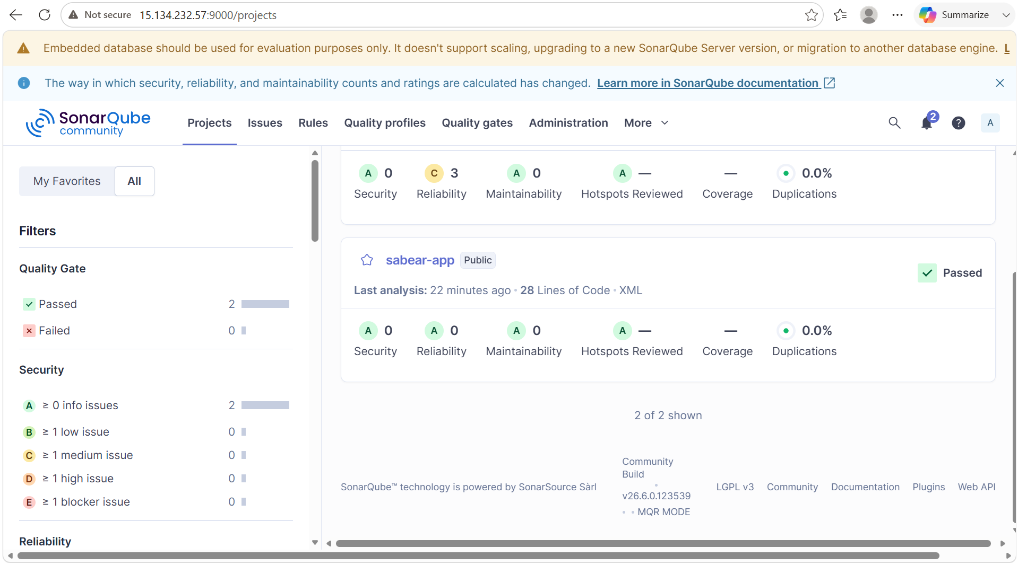

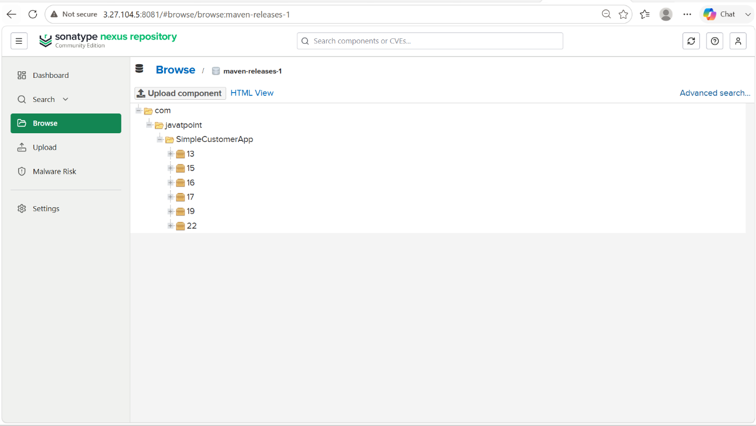

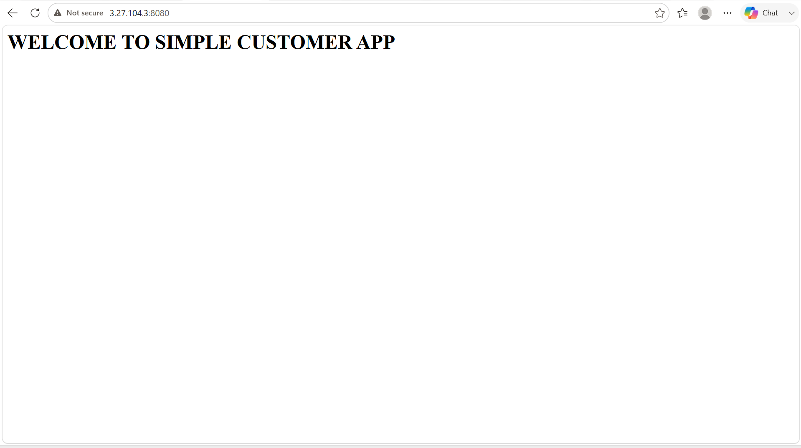

Setup a Jenkins CICD pipeline using Scripted pipeline using feature-1.1 branch.
Source Code: https://github.com/betawins/sabear_simplecutomerapp/tree/feature-1.1
stages:

Git Clone

SonarQube Integration

Maven Compilation

Nexus Artifactory

Slack Notification

Deploy On tomcat

SCRIPTED PIPELINE:
A Scripted Pipeline in Jenkins is a pipeline written in Groovy using Jenkins Pipeline syntax. It provides maximum flexibility and is ideal for complex CI/CD workflows.

SCRIPTED PIPELINE FOR THE ABOVE REPO:

node {
def mvnHome = tool 'maven-3.9.11'
def jdkHome = tool 'JDK-21'

env.JAVA_HOME = jdkHome
env.PATH = "${jdkHome}/bin:${mvnHome}/bin:${env.PATH}"

stage ('Git Clone') {
git branch: 'feature-1.1',
url: 'https://github.com/betawins/sabear_simplecutomerapp'

sh 'pwd'
sh 'ls -ltr'
}

stage ('SonarQube Integration') {

withSonarQubeEnv('SonarQube') {
sh """
${mvnHome}/bin/mvn sonar:sonar \
-Dsonar.projectKey=sabear-app\
-Dsonar.projectName=sabear-app
"""
}
}

stage ('Maven Compilation') {
sh """
${mvnHome}/bin/mvn clean package
"""
}

stage('Find WAR') {
WAR_FILE = sh(
script: "ls target/*.war | head -1",
returnStdout: true
).trim()

echo "WAR File = ${WAR_FILE}"
}

stage('Nexus Artifactory') {
nexusArtifactUploader(
nexusVersion: 'nexus3',
protocol: 'http',
nexusUrl: '3.27.104.5:8081',
groupId: 'com.javatpoint',
version: "${env.BUILD_NUMBER}",
repository: 'maven-releases-2',
credentialsId: 'nexus-creds',

artifacts: [
[
artifactId: 'SimpleCustomerApp',
classifier: '',
file: WAR_FILE,
type: 'war'
]
]
)
}

stage('Deploy On Tomcat') {
deploy adapters:
[
tomcat9(
credentialsId: 'tomcat',
path: '',
url: 'http://13.239.15.61:8080/'
)
],
contextPath: '/',
war: 'target/*.war'

}
stage('Slack Notification') {
slackSend(
channel: '#jenkins-alerts',
color: 'good',
message: "SUCCESS: ${env.JOB_NAME} Build #${env.BUILD_NUMBER}"
)
}
}

STAGES:

- Git Clone: this stage will clone the central repository from the GitHub.
- SonarQube Integration: It will test the quality of code and records the report in the SonarQube and it will pass or fail the source code based on the quality gates and quality profiles.
- Maven Compilation: it will compile the source code and it will create a package for us as war file.
- Nexus Integration: It will act as repository for the packages that are created by the maven. Generally nexus stores our artifacts.
- Deploy to tomcat: artifacts will be deployed to our application server like tomcat.
- Slack notification: it is a post build action. It will used for the notifications for our job.

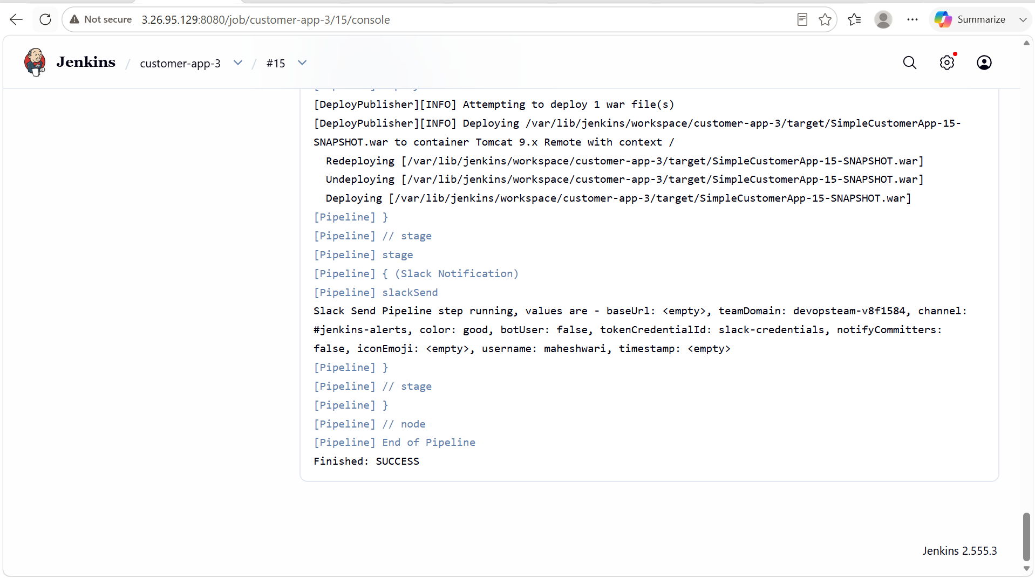

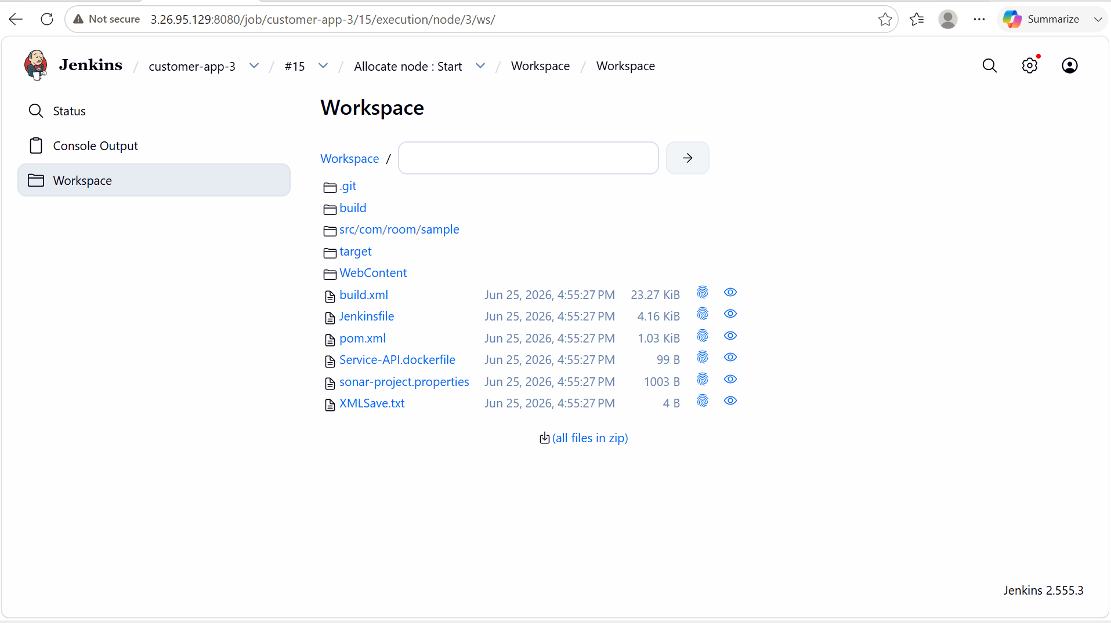

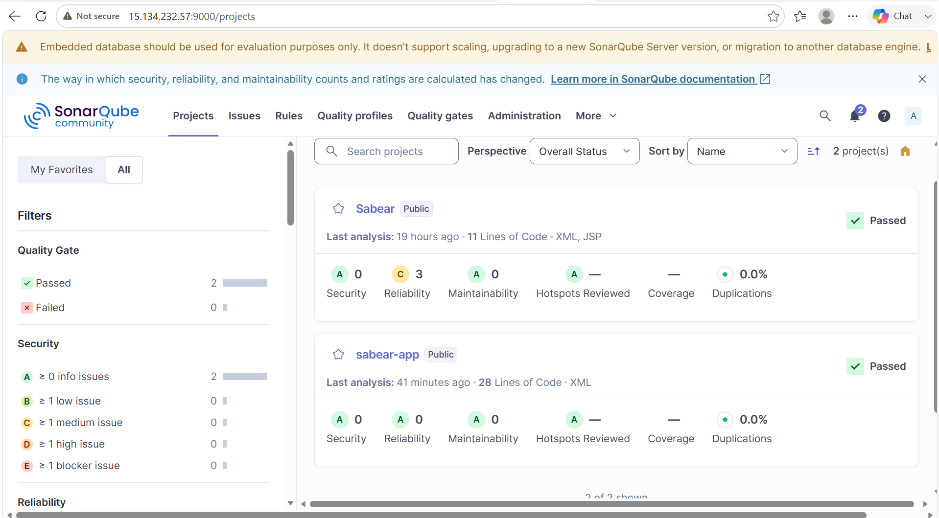

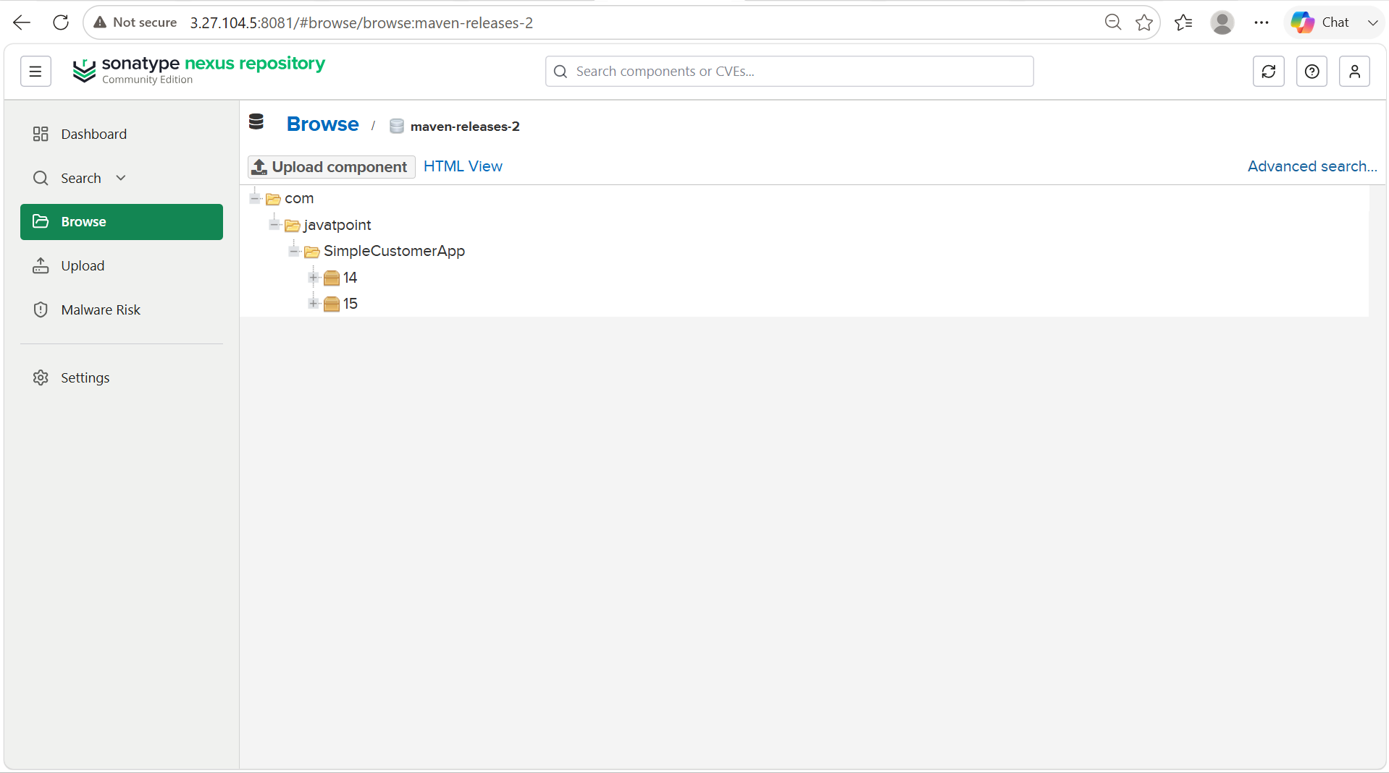

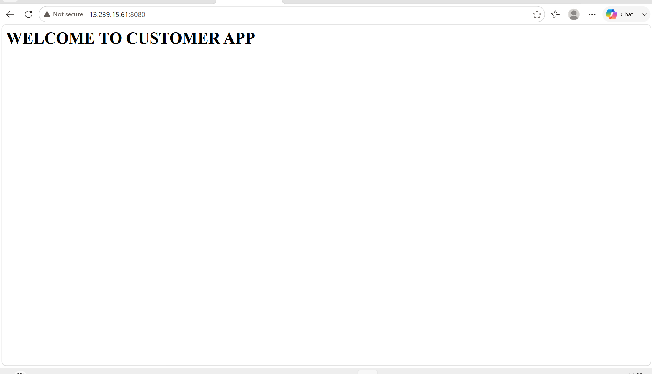

4. Write sample skeleton of pipelines.

- A Pipeline skeleton is the basic structure of a Jenkins Pipeline that you can customize by adding build, test, deployment and notification steps.
- Jenkins supports two main types of pipelines for implementing CI/CD workflows.
1.Scripted Pipeline:

A Scripted Pipeline is written entirely in Groovy and provides maximum flexibility for implementing complex build and deployment logic.

FEATURES:
- Written using Groovy scripting.
- Supports loops, conditions and exception handling.
- Suitable for complex workflows.
- More flexible but requires more coding
Advantages:
- Highly flexible.
- Supports advanced programming constructs.
- Ideal for complex CI/CD pipelines.
Disadvantages:
- More difficult to write and maintain.
- Requires knowledge of Groovy.

Scripted Code:

node {
#define tools that we are added in the manage jenkins here like maven and java
#define environments here

stage (‘Git Clone’) {
#clones the repo and stores it in the workspace
}

stage (‘SonarQube Integration’) {
#here sonar scanner will send the analysis report to the SonarQube and there it will pass or fail the code based on quality gates and quality profile.
}

stage (‘Maven compilation’) {
# It will create a package for us from the source code
}

stage (‘Nexus repository’) {
# Created packages are stored in the nexus repository as artifacts
}

stage (‘deploy to tomcat’) {
#application will be deployed to tomcat
}

stage (‘Slack Notification’) {
SlackSend (
#sends the notification about the job to our slack workspace
)
}
}

2. Declarative Pipeline:

A Declarative Pipeline uses a structured, predefined syntax that is easier to read, write, and maintain.

Features:
- Uses the pipeline {} syntax.
- Simple and readable.
- Built-in support for post actions, environment variables and parameters.
- Recommended for most Jenkins projects.

Advantages:

- Easy to learn and maintain.
- Standardized structure.
- Built-in error handling and post-build actions.
- Recommended by Jenkins for most use cases.

Disadvantages:

- Less flexible than Scripted Pipelines.
- Some advanced logic may require using a script {} block.

Declarative Pipeline:

pipeline {

agent any

stages {

stage('Checkout') {
steps {
echo 'Checkout Source Code'
}
}

stage('Build') {
steps {
echo 'Build Application'
}
}

stage('Deploy') {
steps {
echo 'Deploy Application'
}
}
}

post {
success {
echo 'Pipeline Completed Successfully'
}

failure {
echo 'Pipeline Failed'
}
}
}

5. Create a parameterized job in Jenkins.

PURPOSE: To create a Jenkins job that accepts user-defined input values at build time, making the job reusable for different environments, branches or configurations without modifying the job itself.

OBJECTIVE:
- Create a Jenkins parameterized job.
- Configure different parameter types.
- Use parameter values during job execution.
- Execute the same job with different inputs.

PREREQUISITES:
- Jenkins installed and running.
- User logged in with job creation permissions.
- Git repository.
- Basic knowledge of Jenkins freestyle or pipeline jobs.

OUTCOME:
- A Jenkins job accepts user input at build time.
- Users can run the same job with different branch names, environments, or options.
- The pipeline or build steps use the provided parameter values, making the job more flexible and reusable.

STEP BY STEP IMPLEMENTATION:

- Go to Jenkins, there create a new job with freestyle job type.
- After that we have to select this job is project parameterized.
- Now it will prompt for different type of parameters and we have to select parameter.
- After this, it will prompt us to give some details.
- In the source management, we have to select the git and give the central repo url.
- Now when you build the job, it will clone the specific branch from the central repo.

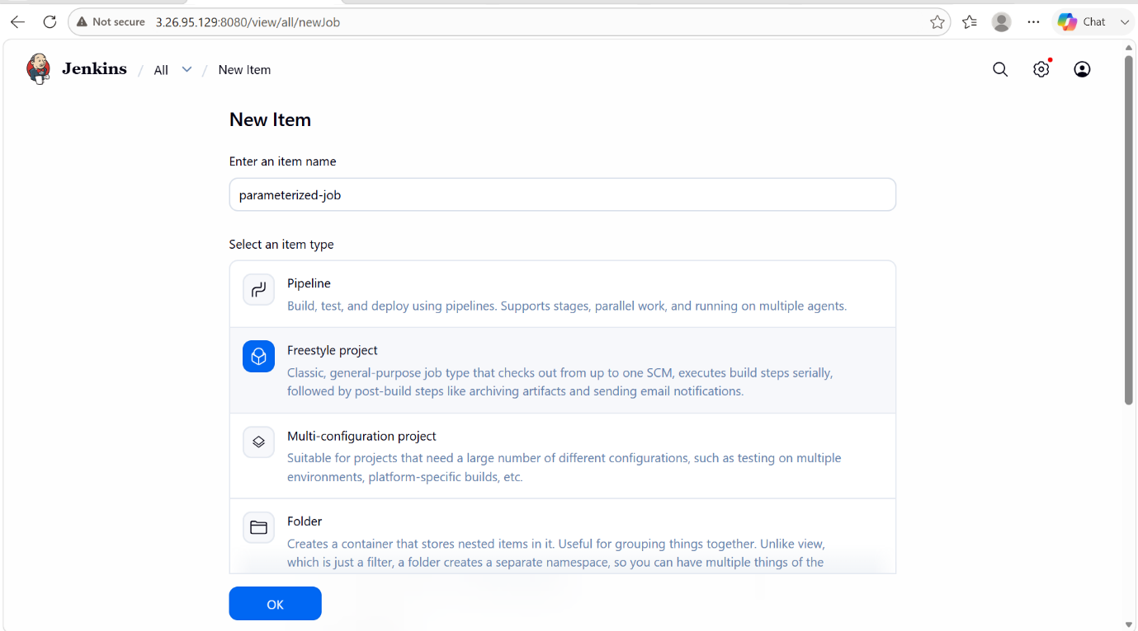

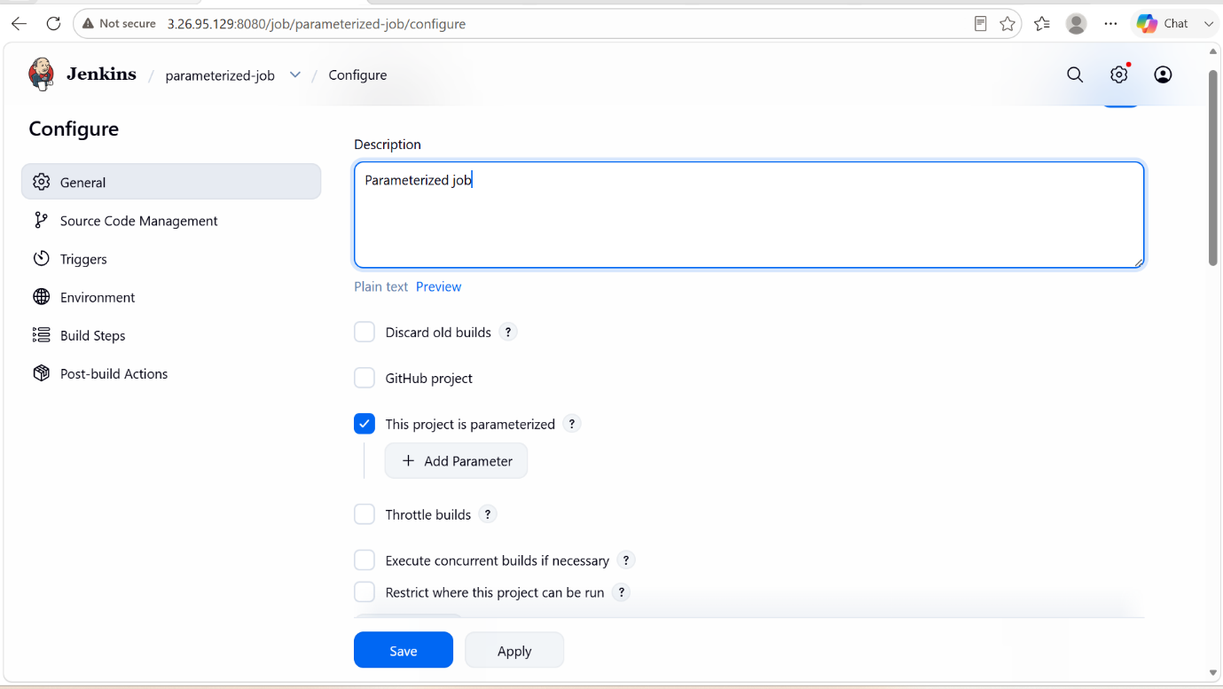

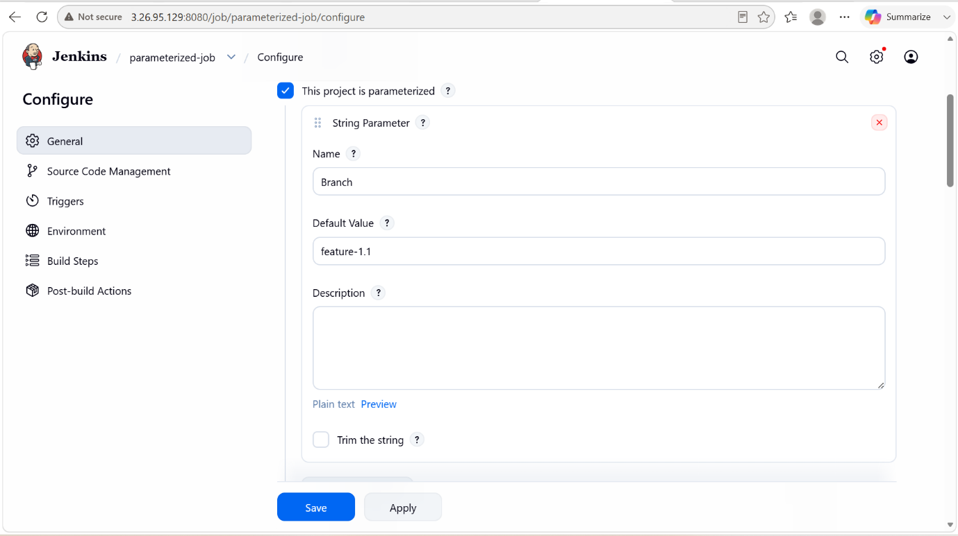

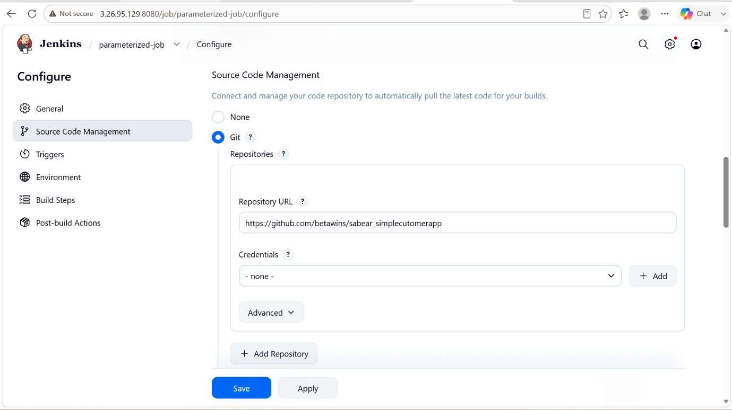

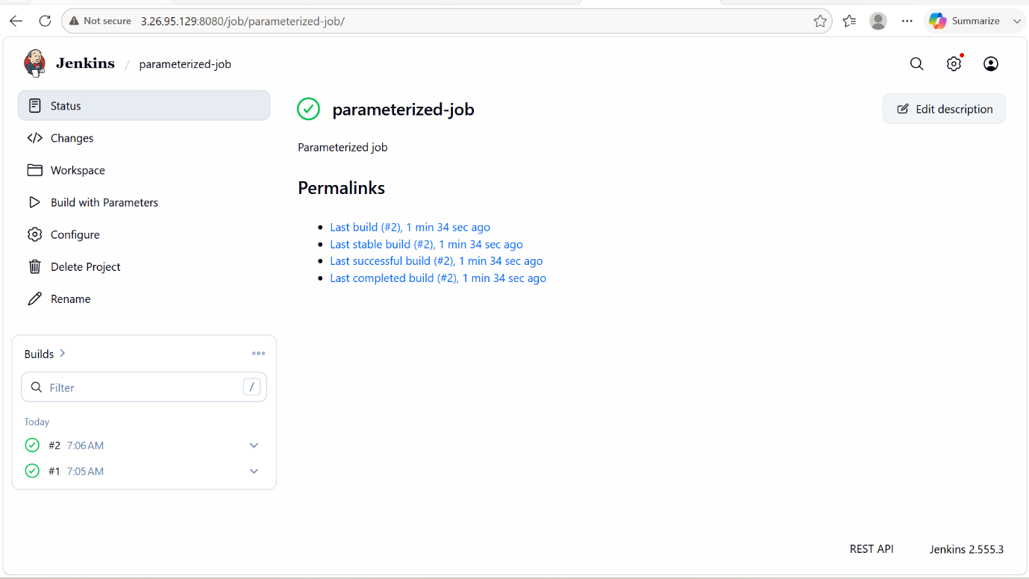

6. Setup one slave machine for Jenkins.

PURPOSE: The purpose of configuring two slave machines (Jenkins agents) with a Jenkins master is to distribute and execute build, test, and deployment jobs on multiple servers instead of running everything on the Jenkins master.

OBJECTIVE: The objective is to connect two slave machines to the jenkins master so that Jenkins can distribute, manage and execute jobs across multiple nodes efficiently.

PREREQUISITES:
- Jenkins Master Server
- Two Agent Machines
- Java Installation
- Network connectivity
- SSH Configuration
- Jenkins Users Permissions
- Agents Workspace Directory
- Jenkins Plugins
- Git Installation
- Labels planning

OUTCOME: Two Jenkins agent machines are successfully connected to the Jenkins master, enabling distributed, parallel, label-based execution of CI/CD jobs with improved performance, scalability, and resource utilization.

STEP BY STEP IMPLEMENTATION:
- Launch 2 instances and connect to that instance.
- After connecting, we have to do key gen by using command -> ssh-keygen
- After keygen we have to copy that public key to authorized_keys -> cat /root/.ssh/id_rsa.pub > authorized_keys
- After that we have change the permissions for that file -> chmod 600 authorized_keys
- Same for 2 instances that we have created repeat this process for second instance also.

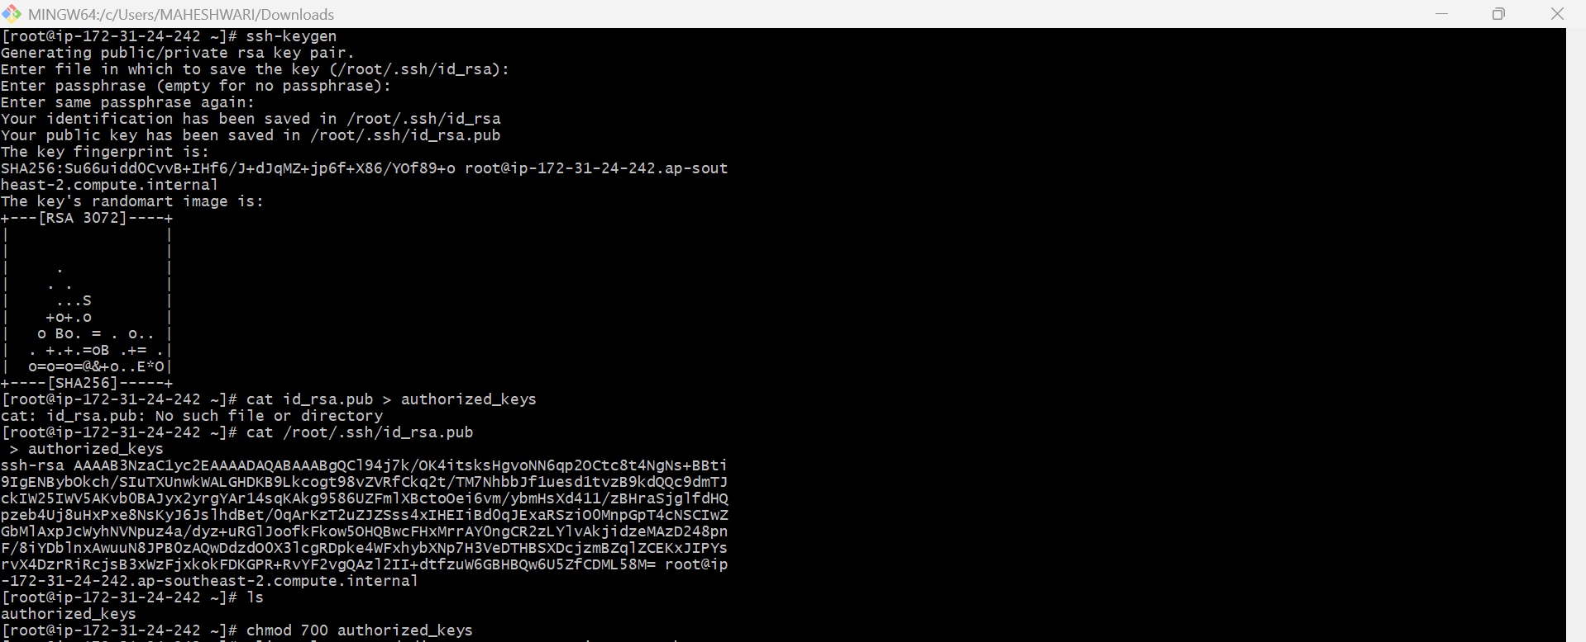

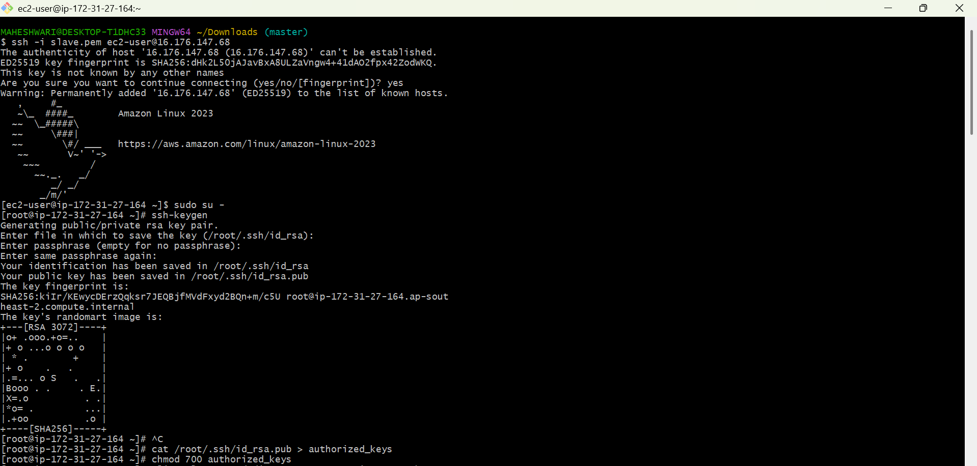

- After this, we have to login into master machine.
- After logging we have to switch to the root user.
- Create a new directory -> mkdir -p /var/lib/jenkins/.ssh
- Get into that directory -> cd /var/lib/jenkins/.ssh
- After we have to scan the known_host -> ssh-keyscan -H <slave-node-IP> >> /var/lib/jenkins/.ssh/known_hosts
- We have to change the ownership to the known_hosts file -> chown jenkins:jenkins known_hosts
- Change the permissions -> chmod 600 known_hosts

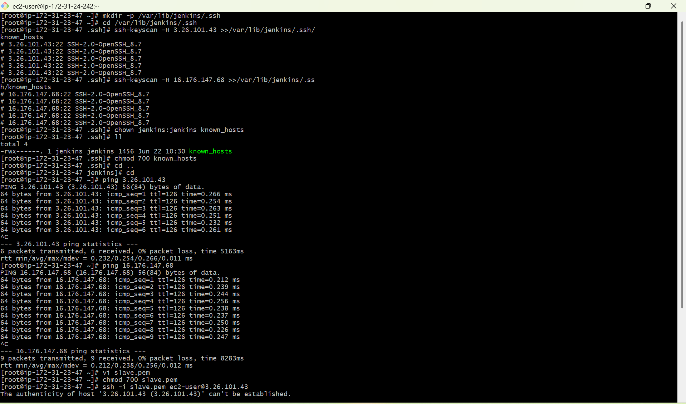
- After we have to go to the Jenkins GUI page, there we have to create 2 nodes.
- In that we have to give remote directory path as /home/ec2-user/jenkins for both the nodes.
- After that we have to give the labels.
- After that we have to select launch agents via ssh, In that it will ask for host IP and credentials.
- The credentials will be the instance pem key file that we have to create a credential with that pem file.

