TASKS ON DOCKER

1. Setup a virtual machine using Ubuntu image.

PURPOSE: To create a virtual machine (VM) using an Ubuntu image in Oracle VirtualBox for learning, software development, testing or system administration without affecting the host operating system.

OBJECTIVE:

- Install Oracle VirtualBox.
- Download the Ubuntu ISO image.
- Create a new Ubuntu virtual machine.
- Install Ubuntu on the virtual machine.
- Verify that the VM is working correctly.

PREREQUISITES:

- Oracle VirtualBox installed on your computer.
- Ubuntu Desktop ISO image.
- At least:
- 8GB RAM
- 25GB free disk space
- Hardware virtualization

STEP BY STEP IMPLEMENTATION:

- Download Oracle VirtualBox from the official website.
- Install it using the default settings.
- Launch VirtualBox after installation.
- Download the ubuntu desktop ISO from the official Ubuntu website and save the ISO file to your computer.
- Create anew virtual machine and allocate memory & CPU
- Create Virtual Hard Disk and start the virtual machine.
- Install Ubuntu in the virtual machine.
- Give username and password. These credentials will be used to login into our ubuntu server.

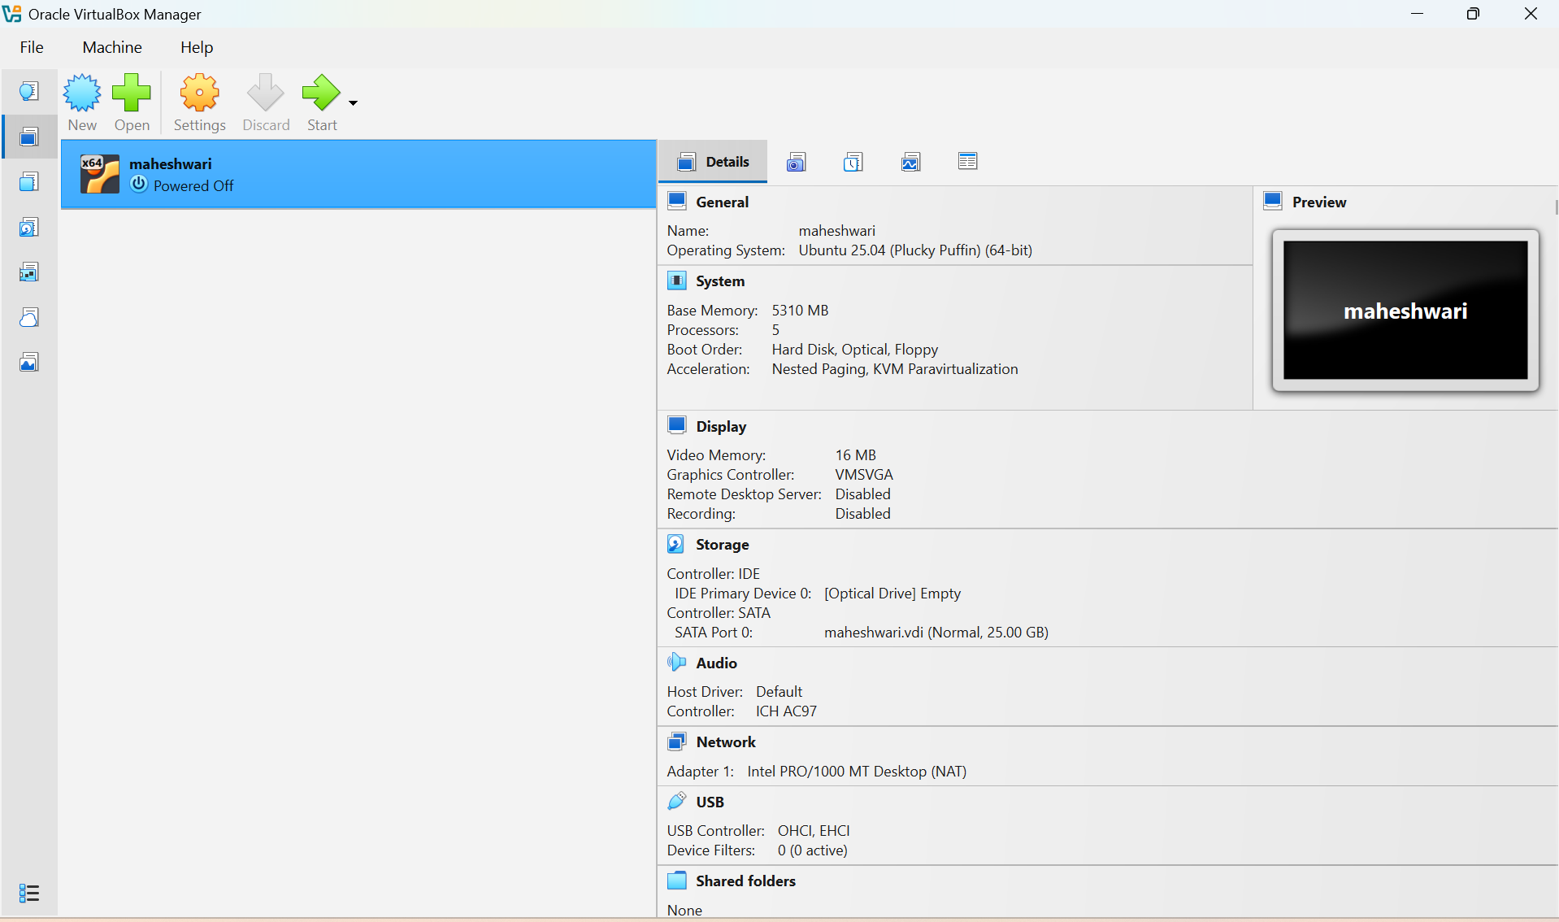

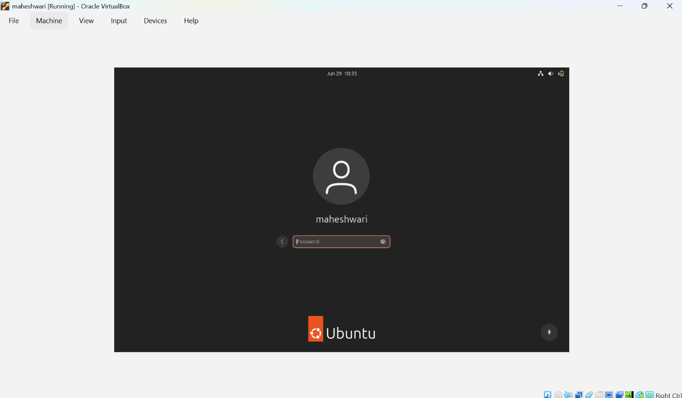

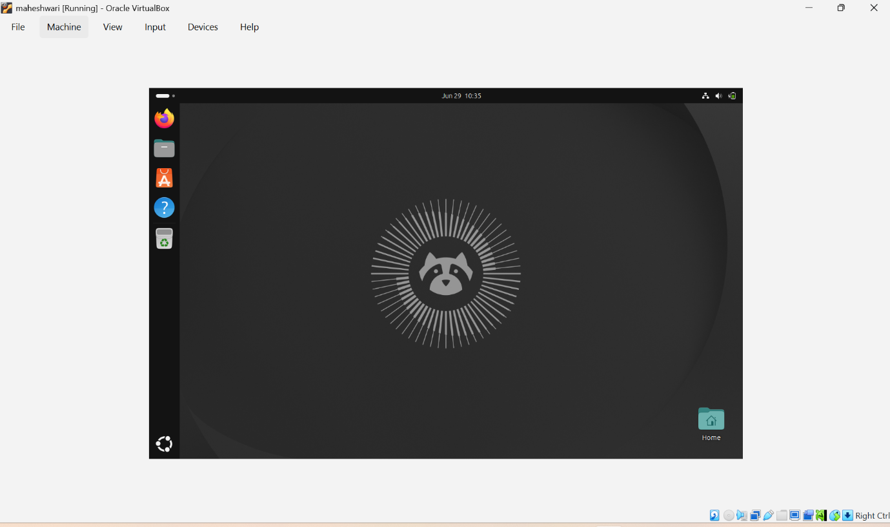

2. Install docker on ec2.

PURPOSE: To install and configure Docker on an EC2 instance so that applications can be packaged and run as containers.

OBJECTIVE:
- Install Docker Engine on an EC2 instance.
- Start and enable the Docker service.
- Allow the current user to run Docker commands without using sudo.
- Verify the Docker installation.

PREREQUISITES:
- Allow EC2 instance.
- SSH access to the instance.
- A user with sudo privileges.
- Internet connectivity.

STEP BY STEP IMPLEMENTATION:

- Launch an EC2 instance in AWS.
- After launching that instance, we have to SSH to that instance.
- After connection, we have to update the server.
- Install docker with the command -> yum install docker -y
- After that we have to start the docker -> systemctl start docker
- Check status -> systemctl status docker
- Check version of the docker -> docker –version

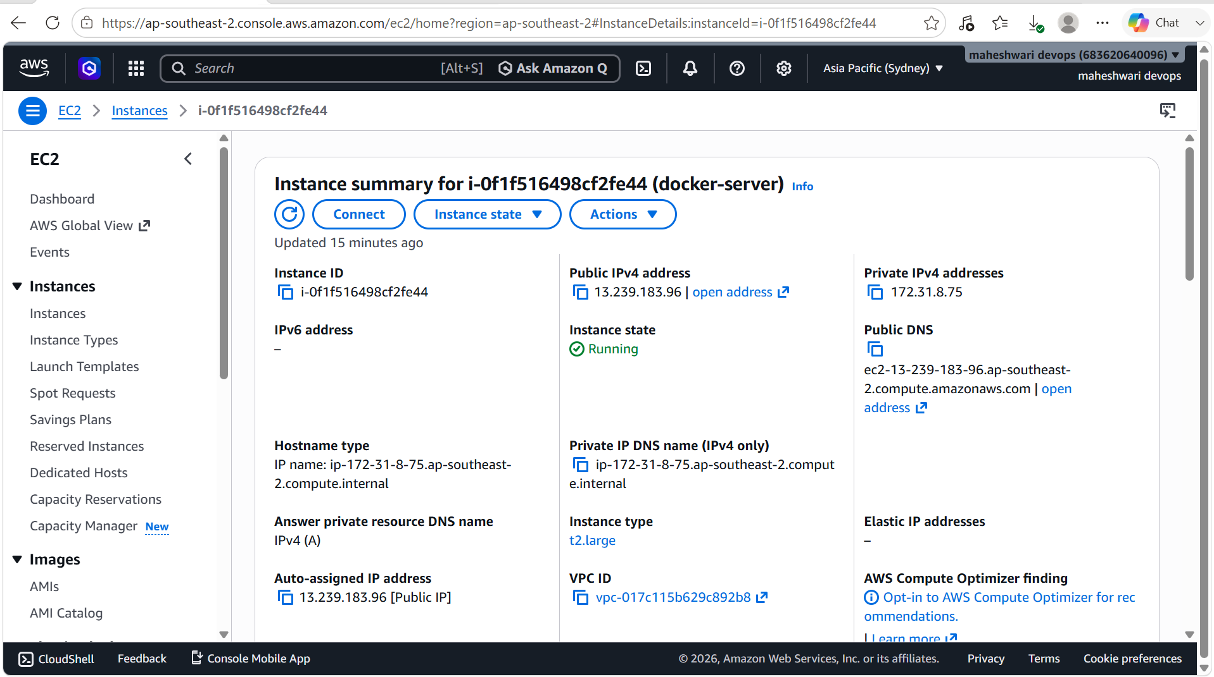

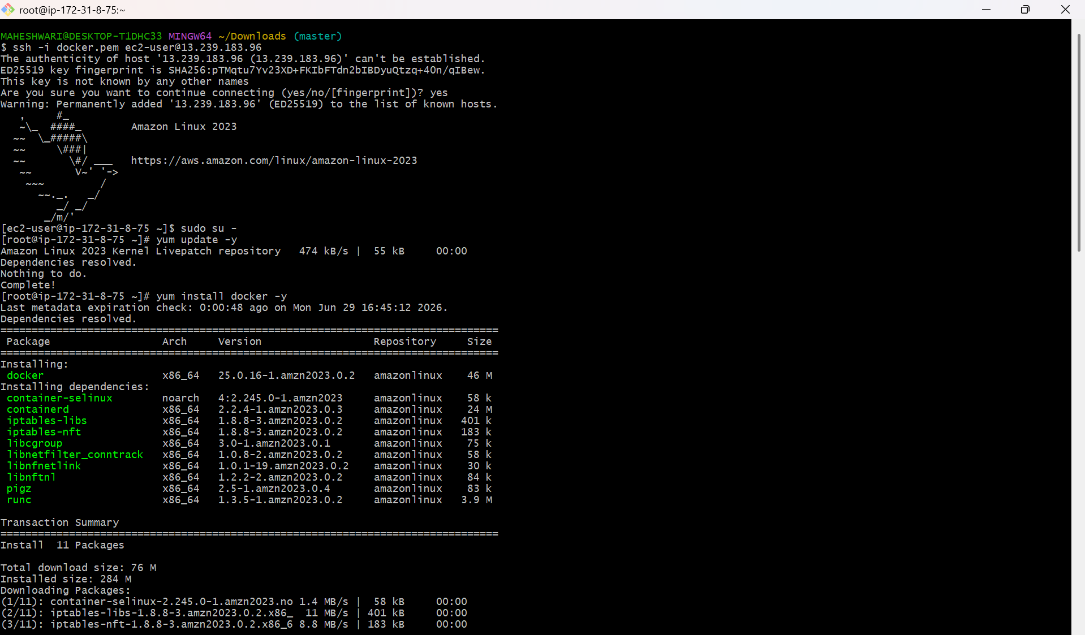

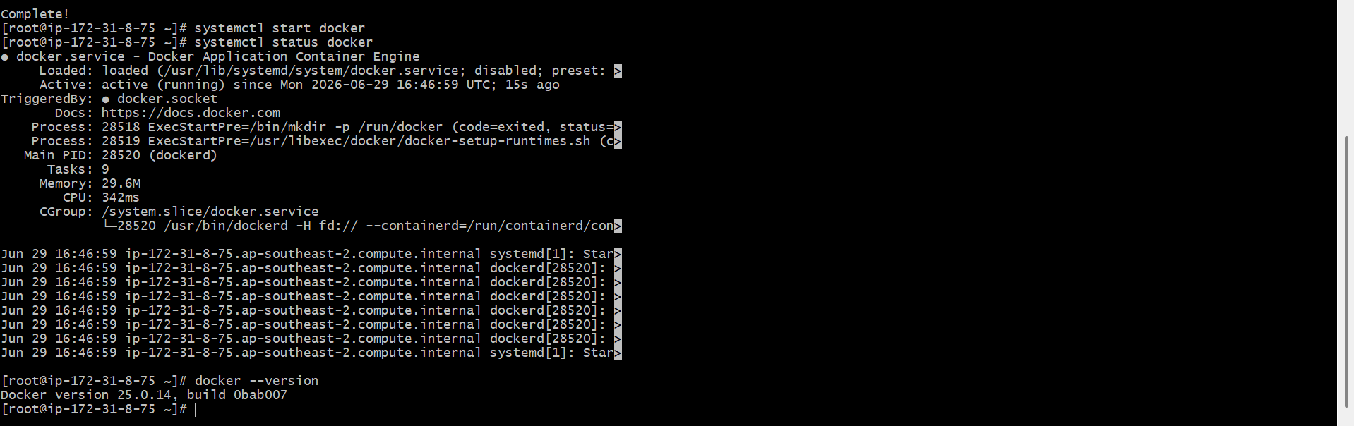

3. Pull 5 docker images. (nginx, Apache tomcat, ubuntu, Jenkins, SonarQube)

PURPOSE: To download commonly used Docker Hub and store them locally for creating and running containers.

OBJECTIVE:
- Pull the latest version of five popular Docker images.
- Verify that the images are downloaded successfully.
- Understand the basic Docker image management commands.

PREREQUISITES:
- Docker installed and running on the system.
- Internet connectivity.
- A user with permission to run Docker commands.

STEP BY STEP IMPLEMENTATION:
- Verify whether the docker is installed -> docker –version

- Pull the nginx image -> docker pull nginx
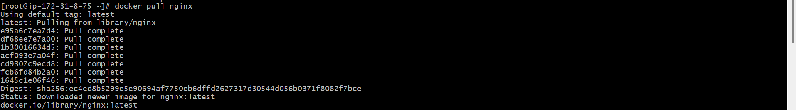

- Pull the apache tomcat image -> docker pull tomcat

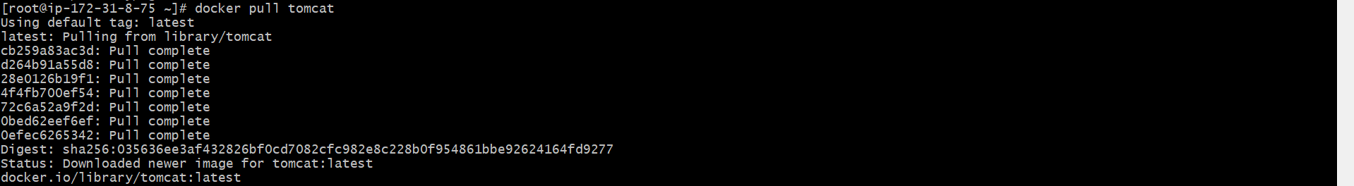

- Pull the ubuntu image -> docker pull ubuntu

- Pull the Jenkins image -> docker pull Jenkins/Jenkins:lts

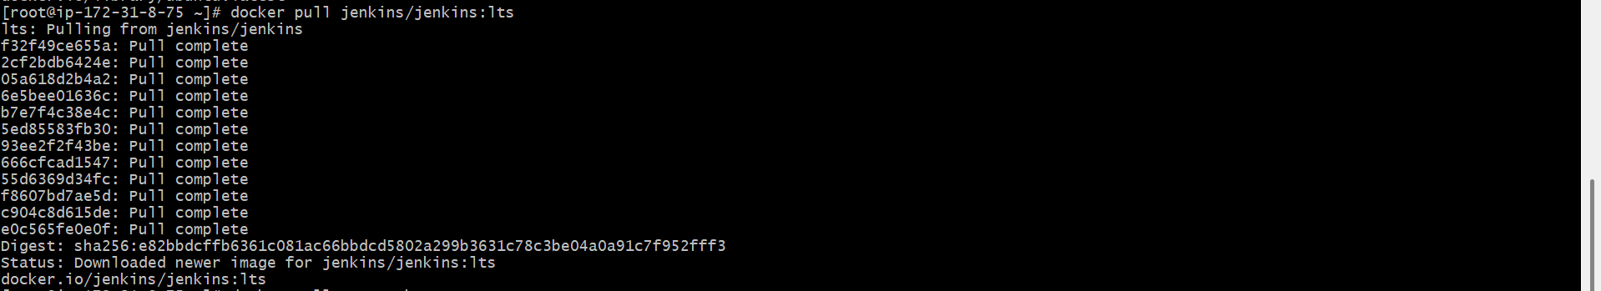

- Pull the SonarQube image -> docker pull sonarqube

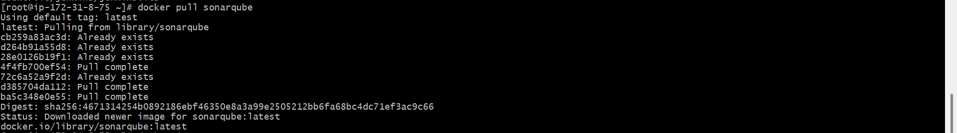

- When we execute docker image, it will returns all the images that are pulled into our docker container.

4. Run nginx container and expose on port 81.

PURPOSE: To run a Nginx web server inside a Docker container and map the container’s port 80 to port 81 on the host machine.

OBJECTIVE:
- Start an Nginx container in detached mode.
- Expose the Nginx web server on host port 81.
- Verify that the container is running and accessible.

PREREQUISITES:

- Docker is installed and running.
- The Nginx image has been pulled (or Docker can pull it automatically).
- Port 81 is open in the EC2 security Group if you are using AWS.

STEP BY STEP IMPLEMENTATION:

- After Nginx has pulled from the docker hub.\
- We have to run the docker Nginx image in background.
- docker run nginx command will run nginx server but it will occupy the CLI.
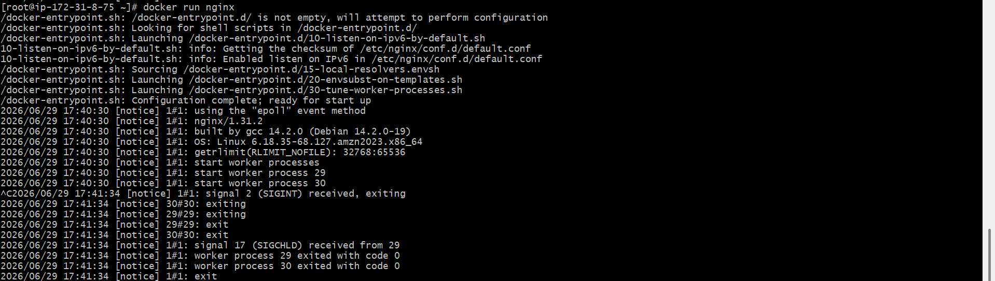
- So we have to run the nginx in the background with the command -> docker run -d –name nginx-container -p 81:80 nginx.
- This will run the nginx and we can also access in the browser with public of the instance.
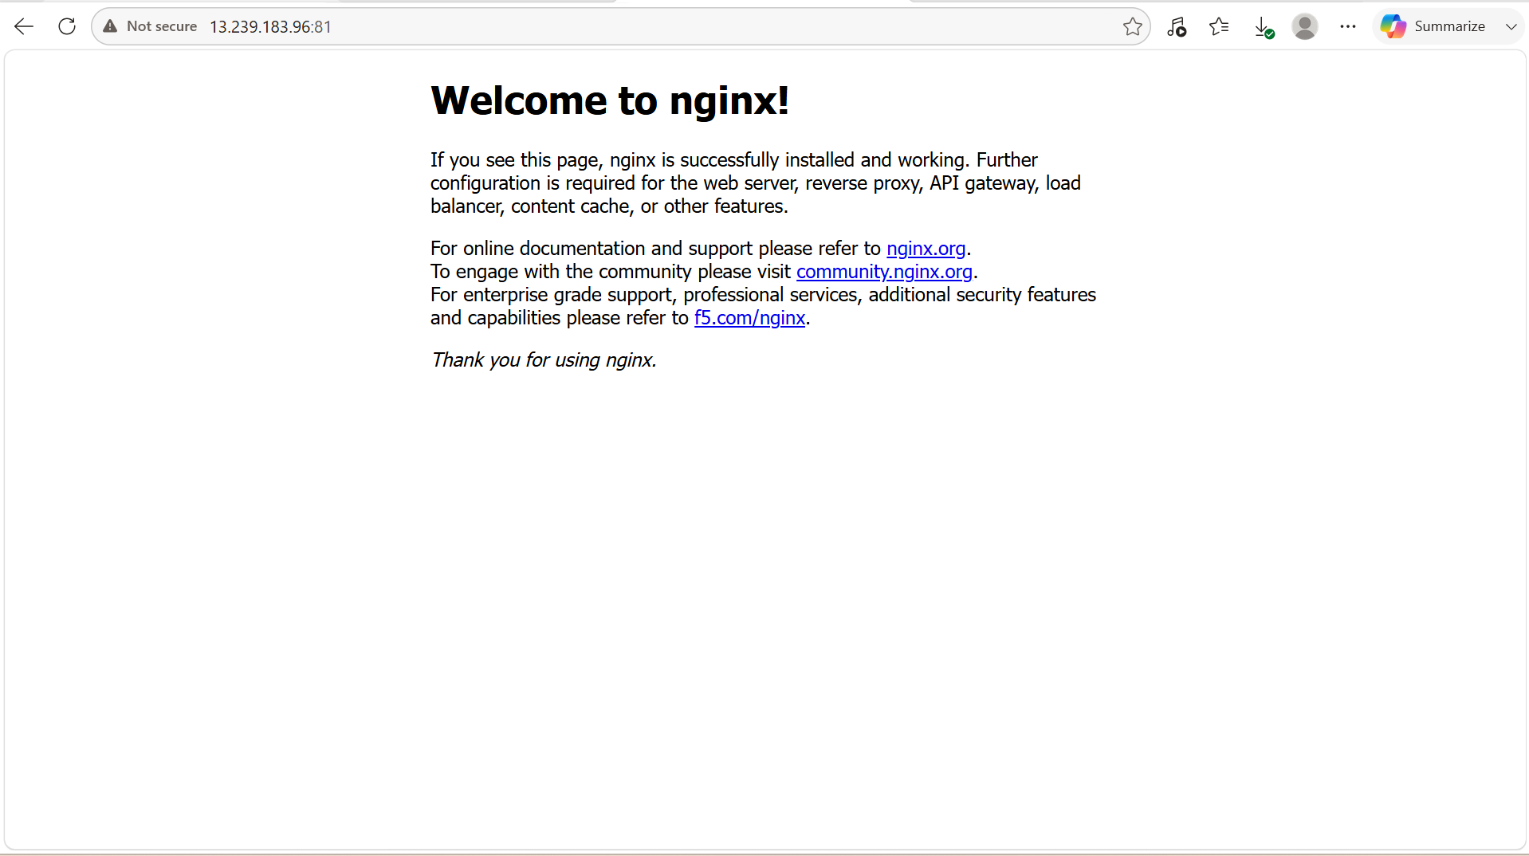

5. Delete the Apache tomcat image from local.

- Docker rmi <imageId> -> this command will delete the particular image.
- If we want to delete tomcat, then we have to pass the command like -> docker rmi <imageId of tomcat>

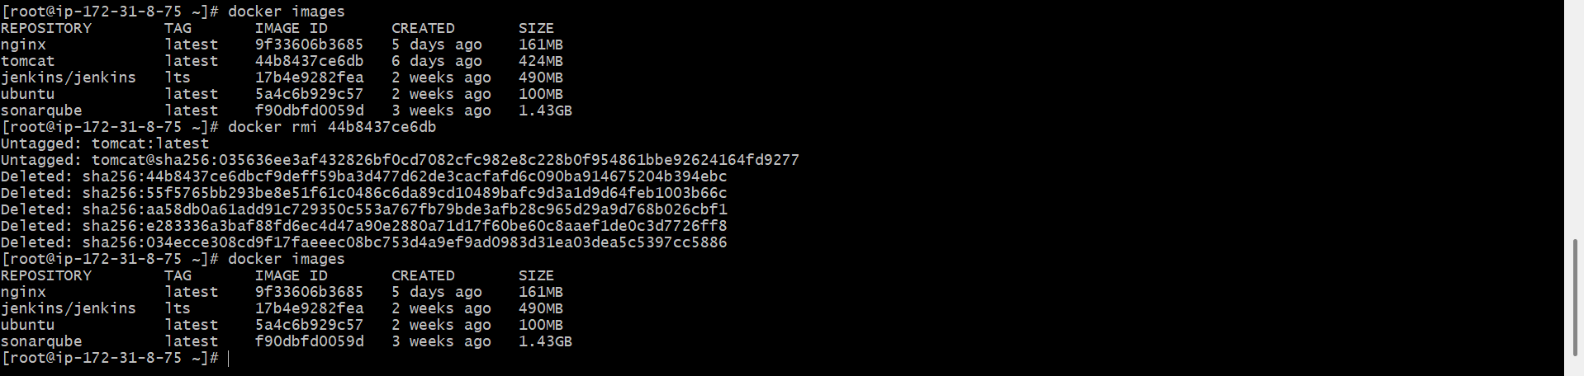

6. Inspect the Jenkins image, SonarQube image.

PURPOSE: To inspect the metadata and configuration details of the Jenkins and SonarQube Docker images.

OBJECTIVE:

- View detailed information about Jenkins image.
- View detailed information about the SonarQube image.
- Understand image properties such as layers, environment variables, ports, entrypoint and labels.

- To inspect the docker image Jenkins : docker inspect Jenkins/Jenkins:lts

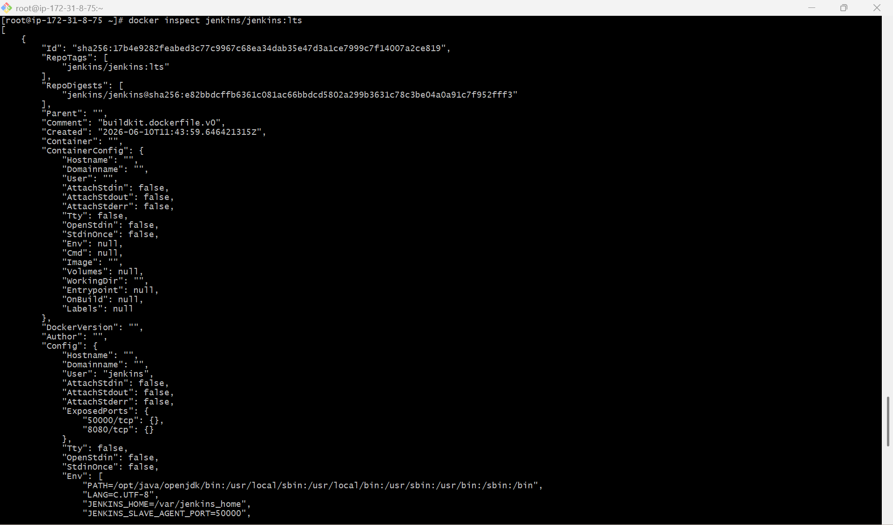

- To inspect SonarQube -> docker inspect sonarqube

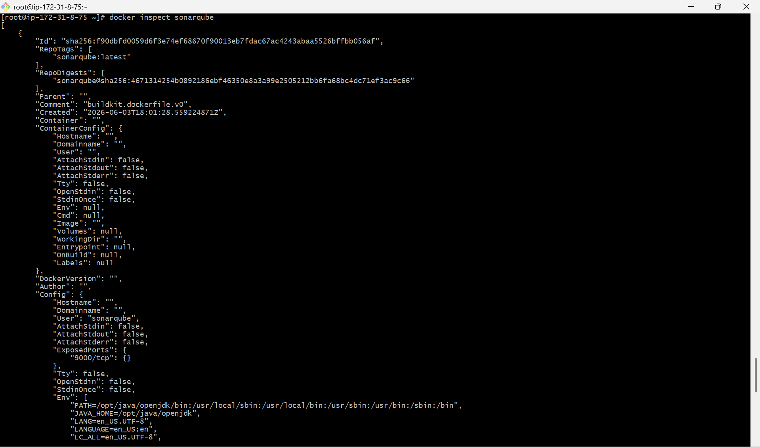

7. Run Jenkins container and run one sample job.

PURPOSE: To deploy Jenkins using Docker, access the Jenkins web interface, and create a simple Freestyle job.

OBJECTIVE:

- Run a Jenkins container.
- Access the Jenkins dashboard.
- Unlock Jenkins and install plugins.
- Create and execute a sample Freestyle job.

STEP BY STEP IMPLEMENTATION:
- Pull the Jenkins image first and afterwards we have to start the image.

docker run -d \
--name jenkins-container \
-p 8080:8080 \
-p 50000:50000 \
-v jenkins_home:/var/jenkins_home \
jenkins/jenkins:lts

- When you connect to the Jenkins server, it will ask for the secret password -> docker exec jenkins-container cat /var/jenkins_home/secrets/initialAdminPassword
- After that it will prompt us to create a new user and password.
- After create a new job with freestyle job style.

