DOCKER-3

1. Create a image from running container.

OBJECTIVE: To create a new Docker image from an existing running container, preserving all changes made inside the container (such as installed software, configuration files or application updates) so the container state can be reused or shared.

PURPOSE:
- Save changes made inside a running container.
- Create a reusable Docker image without rebuilding from a Dockerfile.
- Share customized containers with other environments.
- Push the new image to Docker Hub or Amazon ECR for deployment.
- Use the image as a base for future containers.

PREREQUISITES:
- Docker installed and running.
- A running container.

STEP BY STEP IMPLEMENTATION:
- Using docker commit command we can create a new image out of an running container.
- docker commit <containerId> <newImageName>:<tag>
- this command will create a new image.
- When you execute the docker images command, it will return the images with the new image.

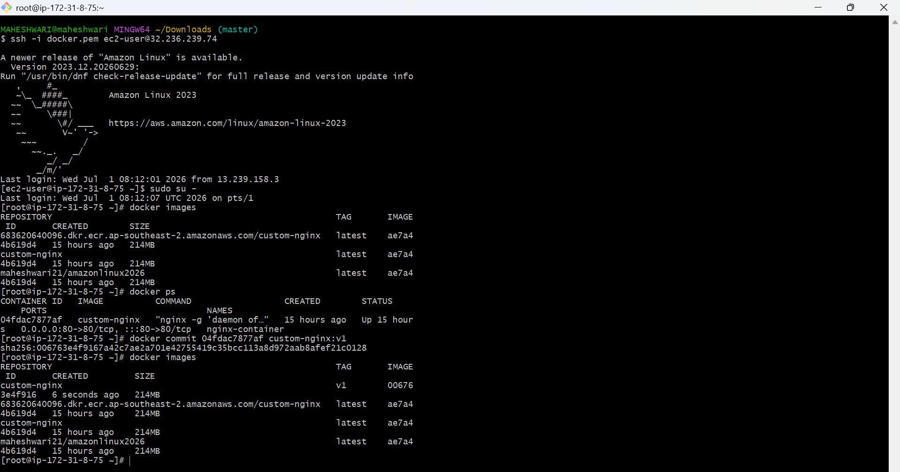

2. Copy image from local machine to docker server and load the image.

OBJECTIVE: To transfer a Docker image from one machine to another without using a container registry, and load it on the destination Docker server for deployment or execution.

PURPOSE:
- Move Docker images between systems in offline or registered environments.
- Deploy images without Docker Hub or Amazon ECR.
- Back up and restore Docker images.
- Share images across development, testing and production servers.

PREREQUISITES:
- Docker installed on both the source and destination.
- SSH access to the destination server.
- An existing Docker image on the source machine.

STEP BY STEP IMPLEMENTATION:
- In our local machine, check whether the docker is installed or not with the command -> docker –version.
- After that we have pull the image.
- That pulled image should be saved as a tar file -> docker save -o <image.tar> <imagename>:<tag>
- Then we have to copy that tar file to the destination -> scp -i <pathOfPemfile> <tarfile> ec2-user@<publicIP>:/tmp
- Then now we can see the tar file in the destination in the tmp path.
- Now load that image from the tar file -> docker load -i <imageName>

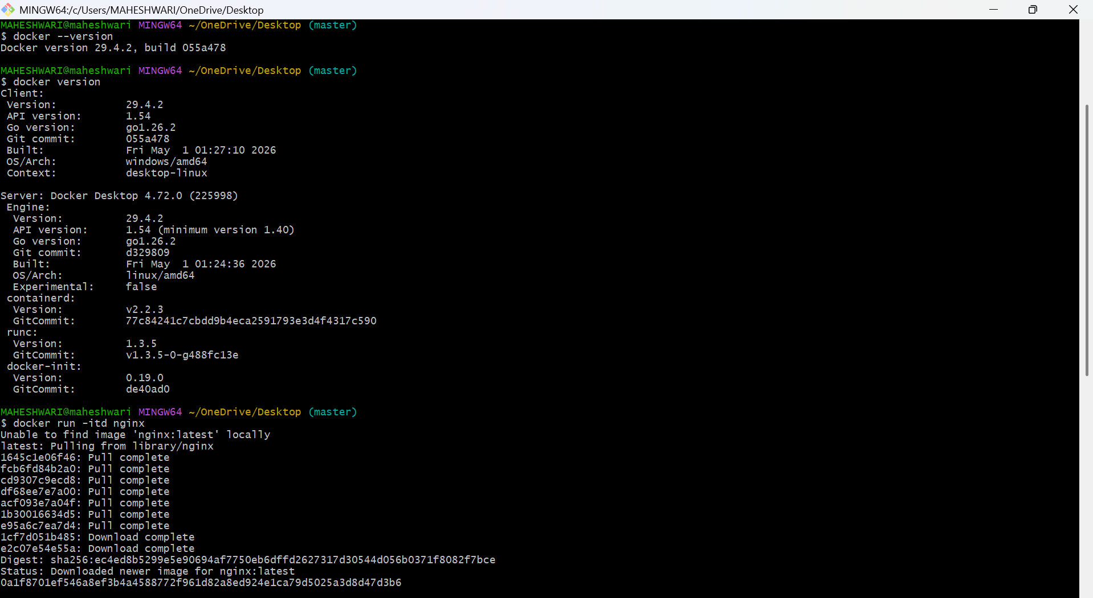

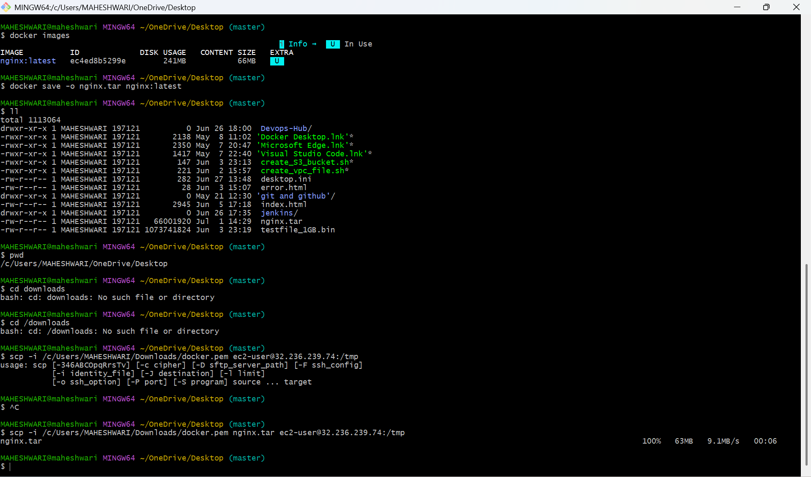

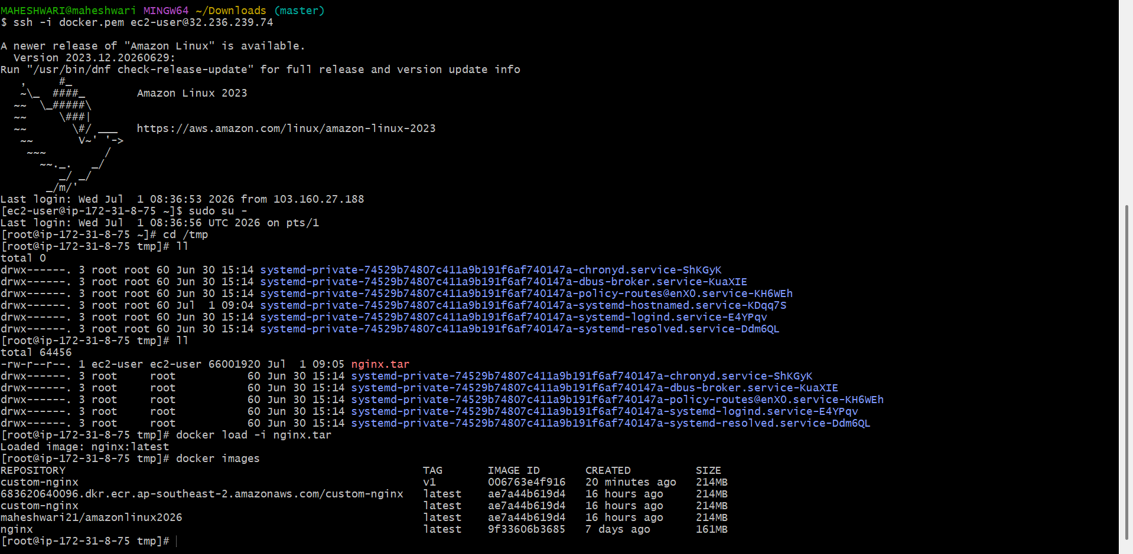

3. Create Docker image using alpine and customize with tomcat.

PURPOSE:

- Build a lightweight Tomcat image using Alpine Linux.
- Reduce image size for faster deployment.
- Customize the Tomcat installation.
- Deploy Java web applications (WAR files) inside the container.
- Use the image in Docker Hub, Amazon ECR, or Kubernetes.

OBJECTIVE: To build a lightweight Docker image based on Alpine Linux, install Apache Tomcat, and deploy it as a containerized web application server.

STEP BY STEP IMPLEMENTATION:

- Create a docker file and build that docker file -> docker build -t <dockerimagename>
- By this command, it will create a new image.
- Run that image and access that in the browser with public IP.

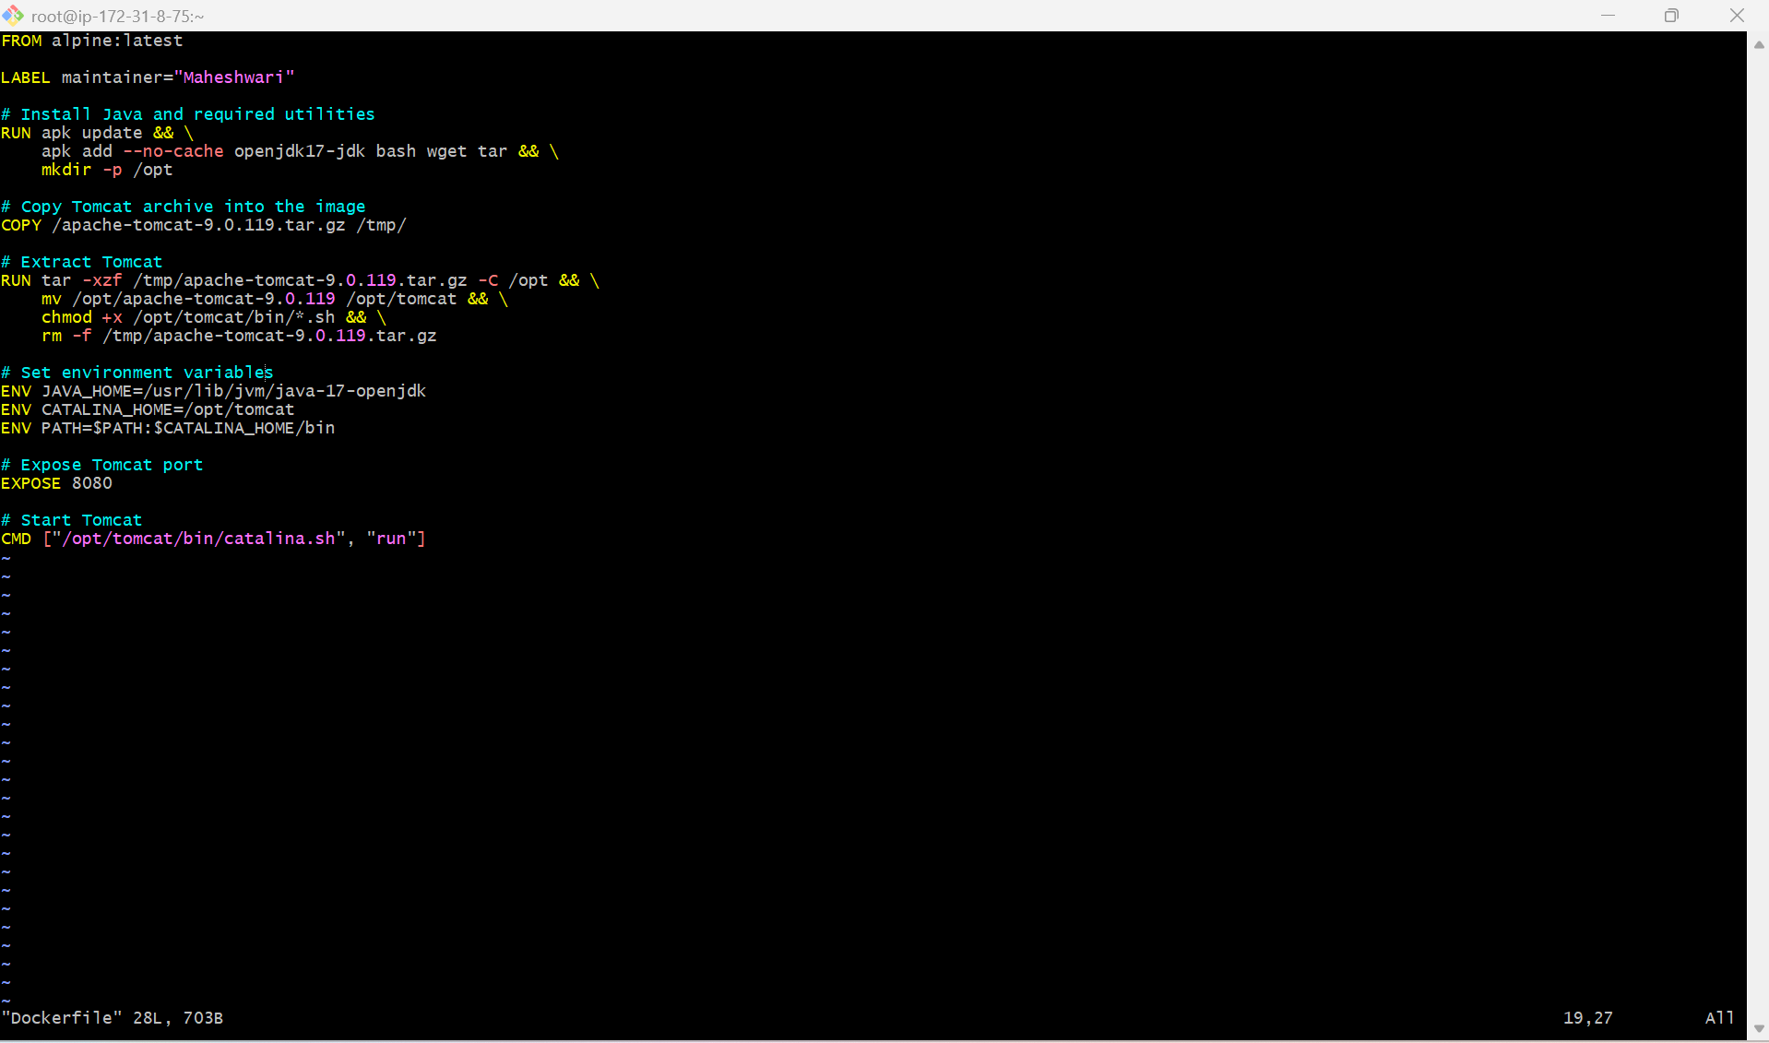

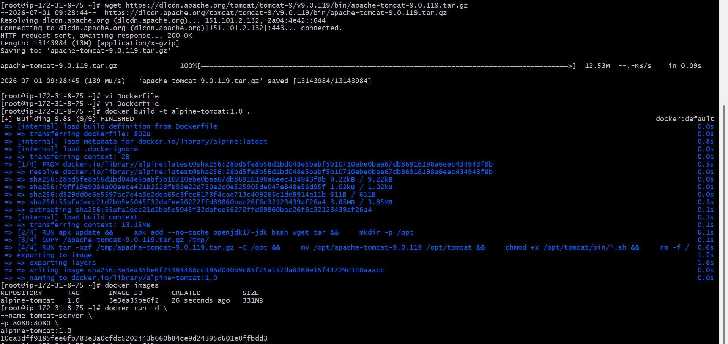

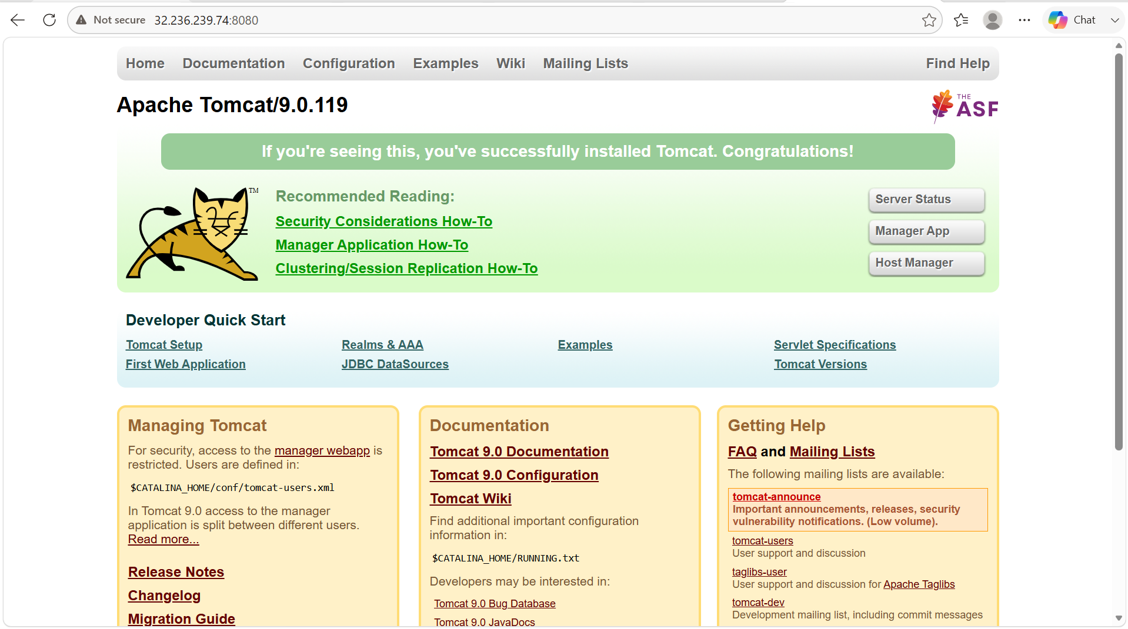

4. Create single stage and multi stage docker file using this source

code:https://github.com/betawins/multi-stage-example.git

OBJECTIVE: To build Docker images for a Spring Boot application using both Single-Stage and Multi-stage Docker builds, understand the differences between the two approaches, and learn hot multi-stage builds help create smaller, more secure and production ready Docker images.

PURPOSE:
- Containerize a Spring Boot application using Docker.
- Learn the difference between Single-Stage and Multi-Stage Docker builds.
- Reduce Docker image size using Multi-Stage builds.
- Eliminate unnecessary build tools from the final image.
- Improve deployment speed and security.
- Prepare production-ready Docker images for Kubernetes, Docker
Swarm, Amazon ECS, or Amazon EKS.

What is a Single-Stage Docker Build?
A Single-Stage Docker Build performs all tasks such as compiling the source code, packaging the application, and running it within the same Docker image.
The final image contains:
- Source code
- Maven
- JDK
- Build cache
- Application JAR
Advantages
- Easy to create.
- Suitable for development and testing.
Disadvantages
- Large image size.
- Includes unnecessary build tools.
- Less secure for production.

What is a Multi-Stage Docker Build?
A Multi-Stage Docker Build divides the build process into multiple stages. The first stage compiles the application, while the second stage contains only the runtime environment and the generated application artifact.
The final image contains:
- JRE
- Application JAR
It does not contain:
- Maven
- Source code
- Build dependencies
Advantages
- Smaller image size.
- Faster deployment.
- Improved security.
- Best practice for production deployments.

PREREQUISITES:
- Docker installed
- Git installed
- Internet connectivity.
- Java 17
- Maven.

STEP BY STEP IMPLEMENTATION:
- Create a docker file for the single stage docker file named as Dockerfile.single
- After that we have to create a new image by using dockerfile -> docker build -t <dockerFile> <imageName> .
- We have to pass . in the end of the command because it will take the docker file from the same path where our docker file and the cloned repository.
- Then run the image -> docker run -itd -p 8082:8080 –name <imageName> <containerName>:<tag>
- Then we can access in the browser by using the publicIP of the server.

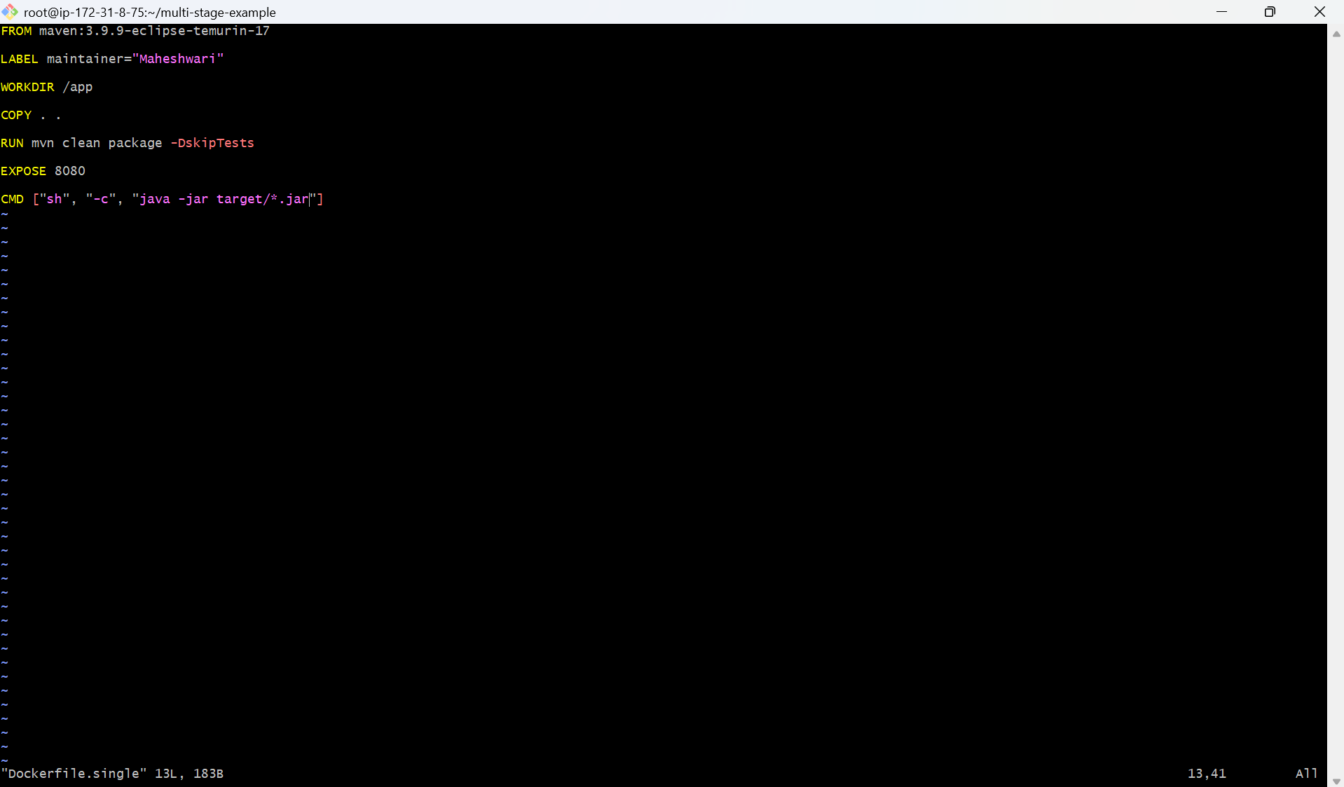

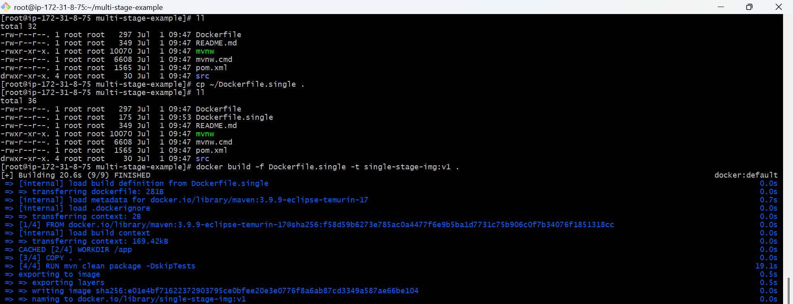

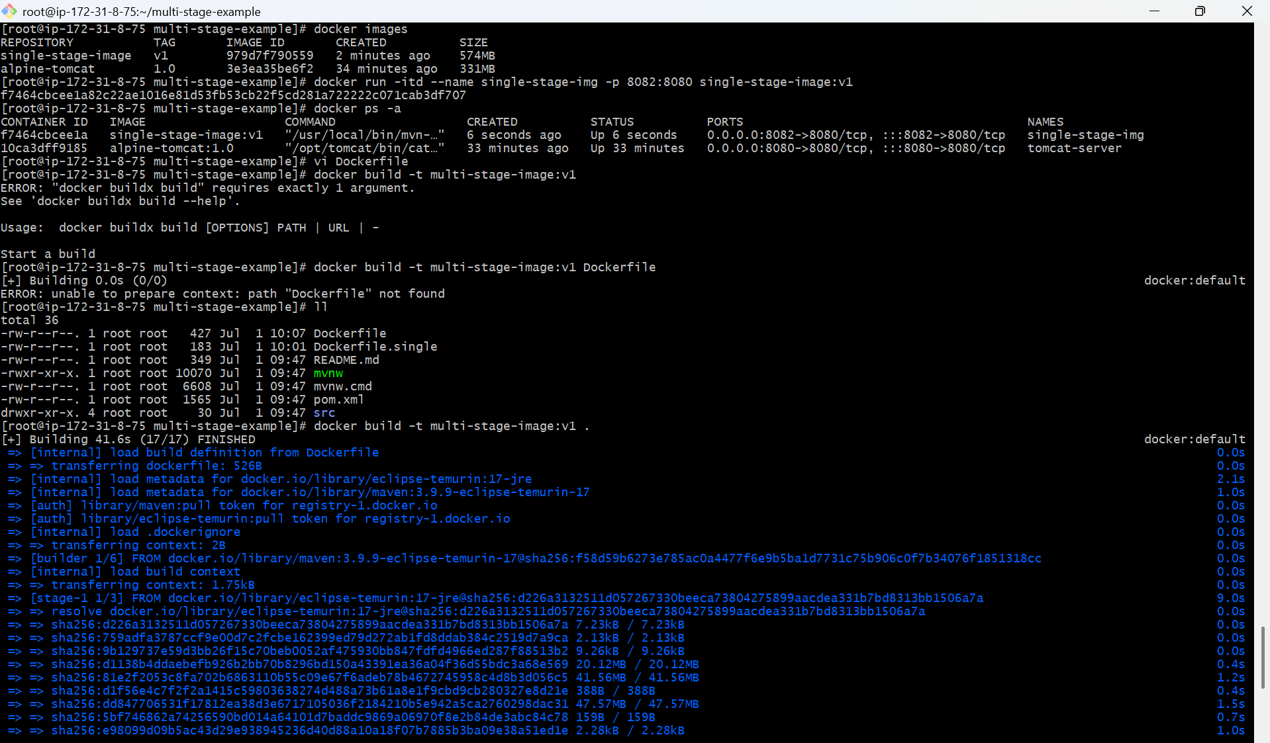

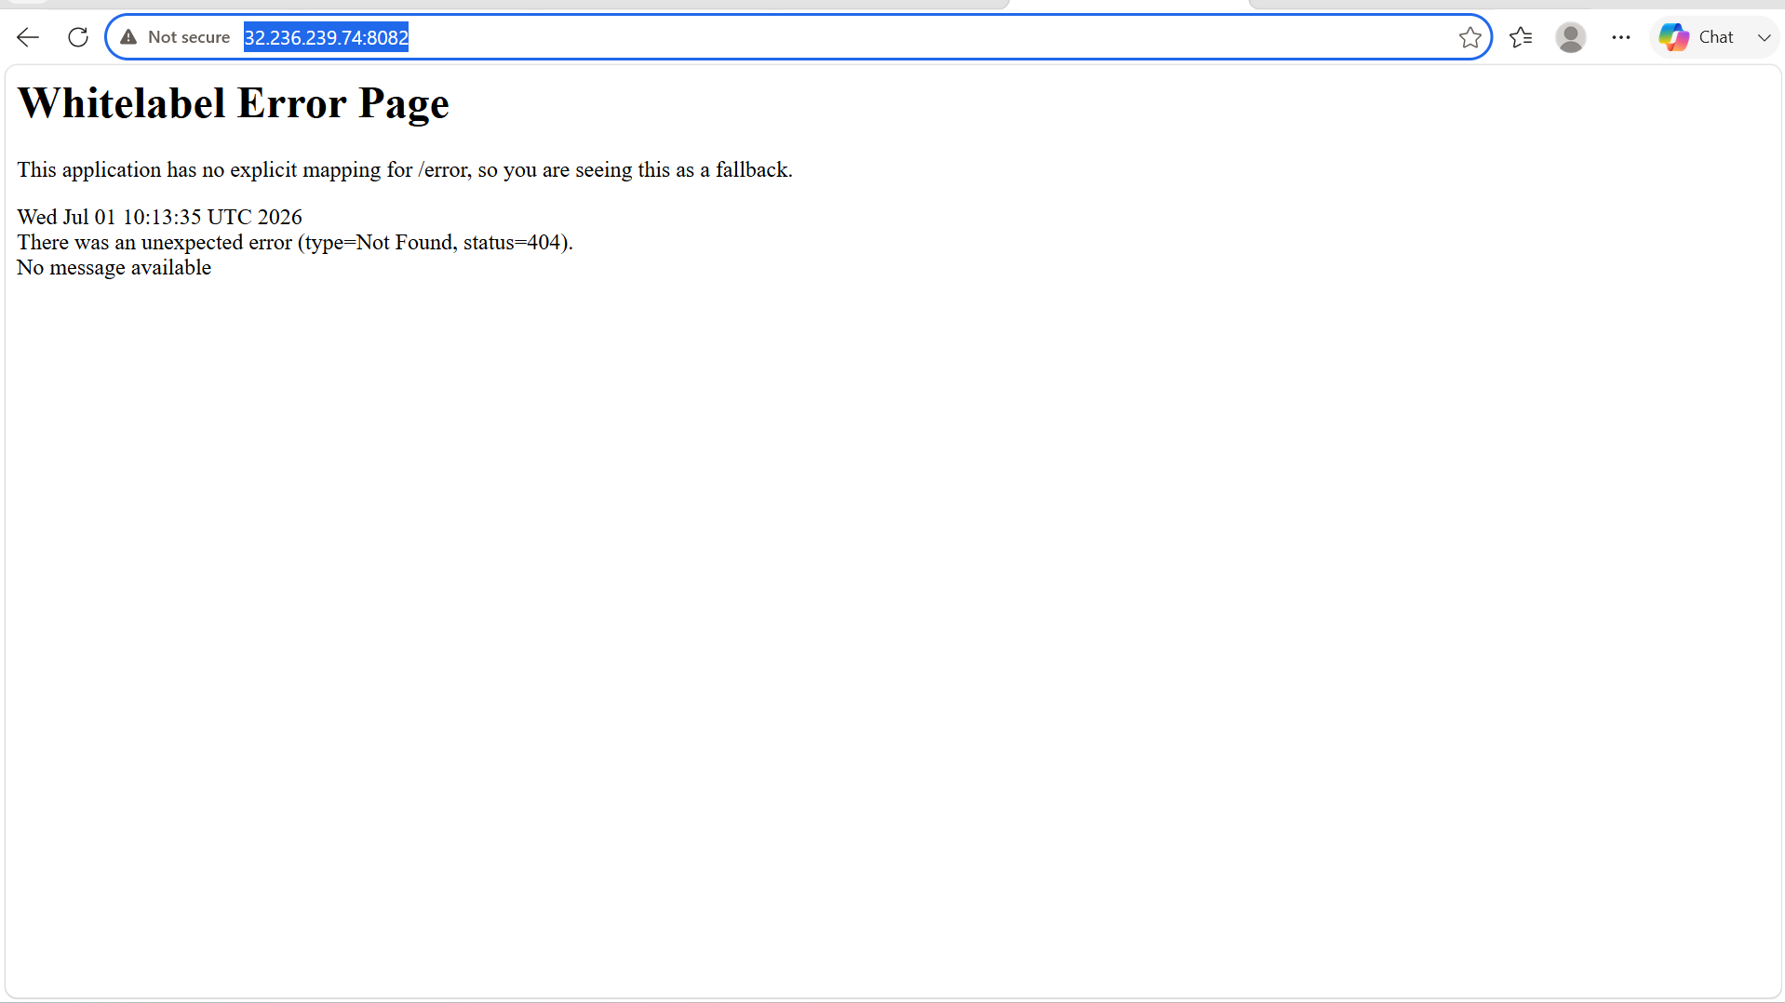

- Create a docker file for the single stage docker file named as Dockerfile
- After that we have to create a new image by using dockerfile -> docker build -t <dockerFile> <imageName>:<tag> .
- We have to pass . in the end of the command because it will take the docker file from the same path where our docker file and the cloned repository.
- Then run the image -> docker run -itd -p 8082:8080 –name <imageName> <containerName>:<tag>
- Then we can access in the browser by using the publicIP of the server.

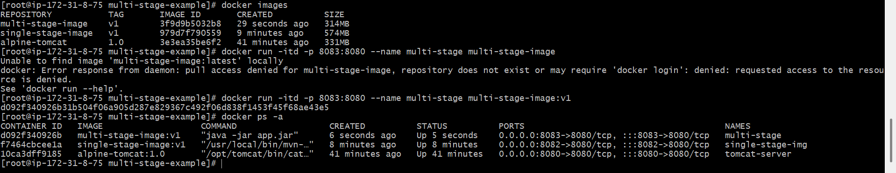

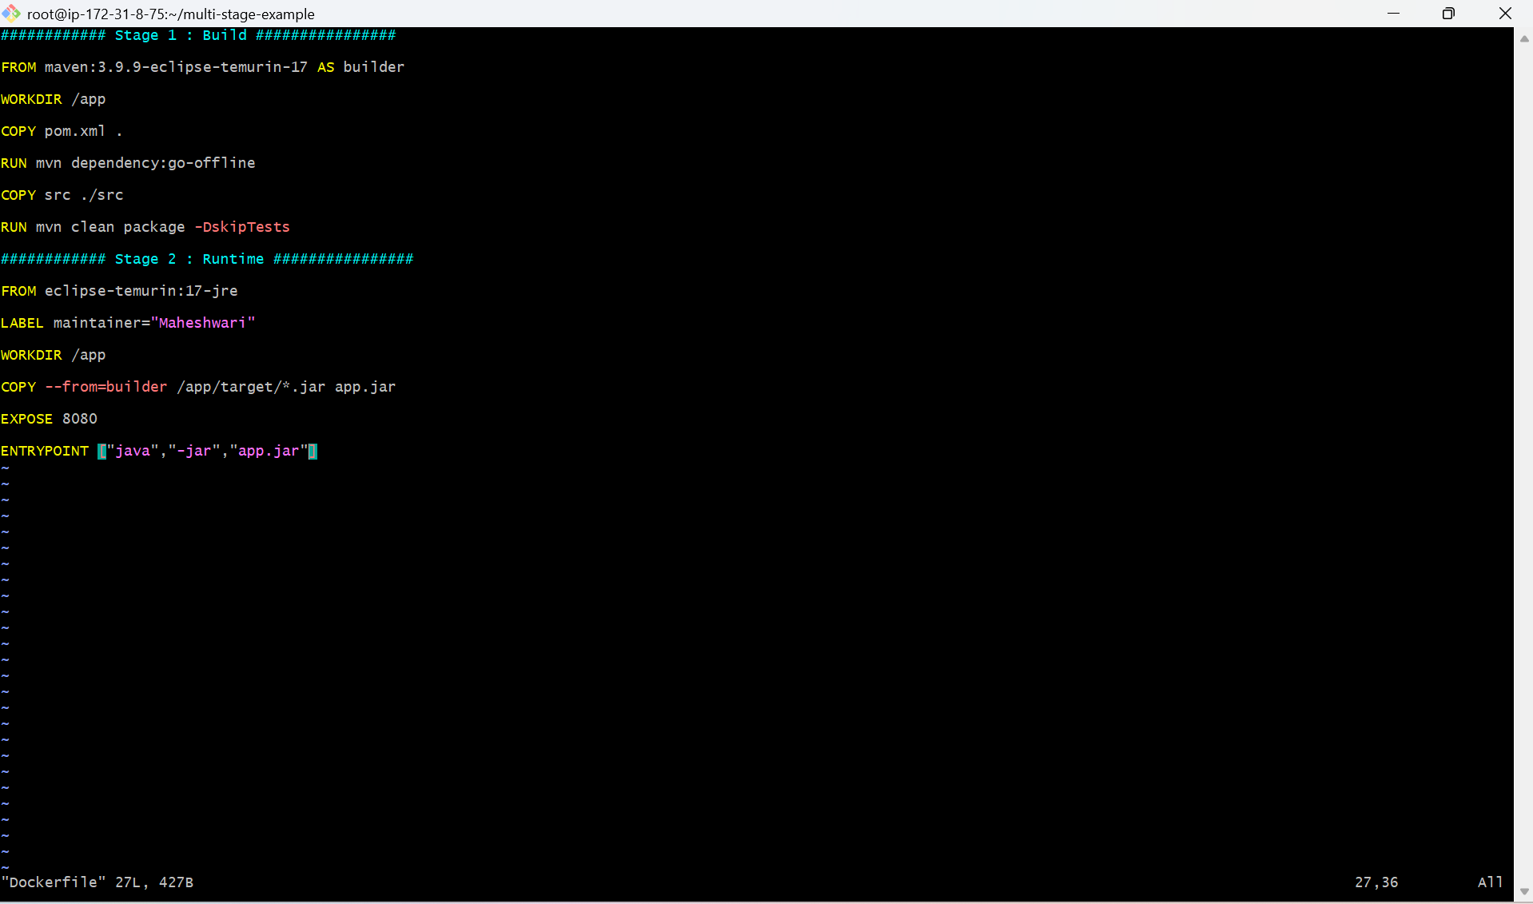

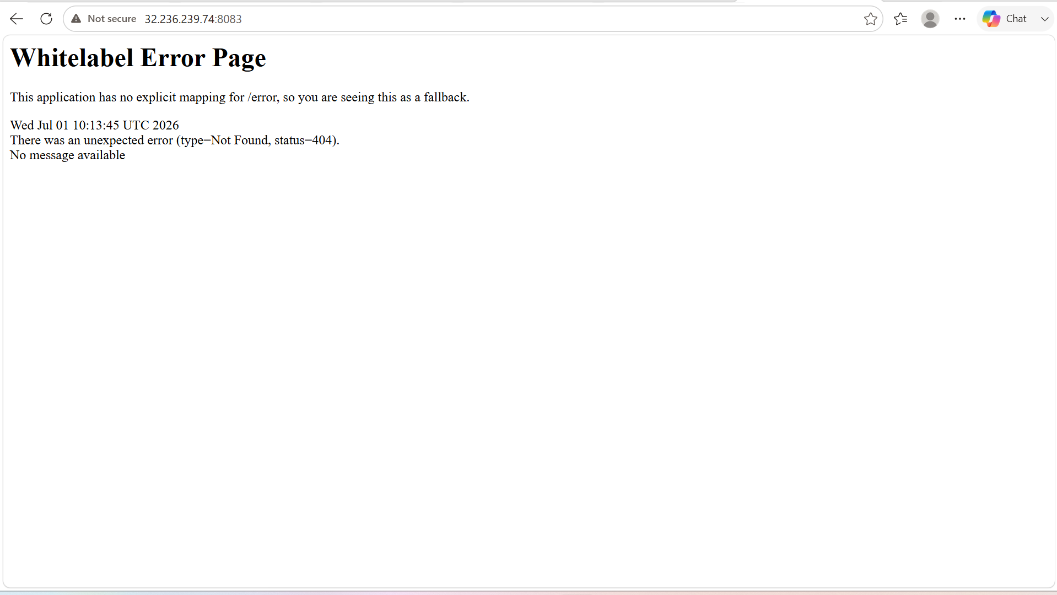

5. Install docker compose and execute sample application.

OBJECTIVE: To install Docker Compose, create a docker-compose.yml file and deploy a sample multi-container application using a single command.

PURPOSE:
- Learn how to install Docker Compose.
- Understand Infrastructure as Code (IaC) for containers.
- Deploy multiple containers together.
- Manage container lifecycle using a single configuration file.
- Simplify application deployment and networking.

What is Docker Compose?
- Docker Compose is a tool used to define and run multi-container Docker applications using a YAML configuration file (docker-compose.yml).
- Instead of running multiple docker run commands, Docker Compose allows you to start all required containers with a single command.

Advantages of Docker Compose
- Easy deployment of multiple containers.
- Automatically creates a network.
- Supports persistent volumes.
- Easy scaling of services.
- Simple container management.
- Version-controlled infrastructure.

Prerequisites
- Docker installed
- Internet connectivity
- Root or sudo privileges

STEP BY STEP IMPLEMENTATION:

- Download the docker-compose package using curl with link ->
sudo curl -L https://github.com/docker/compose/releases/download/1.21.0/docker-compose-`uname -s`-`uname -m` | sudo tee /usr/local/bin/docker-compose > /dev/null
- After that change the permissions to that file -> sudo chmod +x /usr/local/bin/docker-compose
- Create a symbolic link -> ln -s /usr/local/bin/docker-compose /usr/bin/docker-compose
- Verify the docker-compose installed or not -> docker-compose –version
- Then create a sample docker-compose.yml file for application.

version: '3'
services:
db:
image: mysql:5.7
volumes:
- db_data:/var/lib/mysql
restart: always
environment:
- MYSQL_ROOT_PASSWORD=somewordpress
- MYSQL_DATABASE=wordpress
- MYSQL_USER=wordpress
- MYSQL_PASSWORD=wordpress
wordpress:
depends_on:
- db
image: wordpress:latest
ports:
- "8000:80"
restart: always
environment:
- WORDPRESS_DB_HOST=db:3306
- WORDPRESS_DB_USER=wordpress
- WORDPRESS_DB_PASSWORD=wordpress
- WORDPRESS_DB_NAME=wordpress
volumes:
db_data: { }

- Then run the docker-compose.yml file with the command -> docker-compose up -d
- Then check for the containers -> docker-compose ps

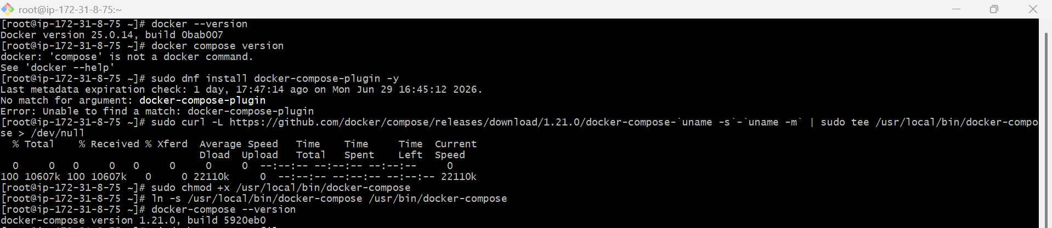

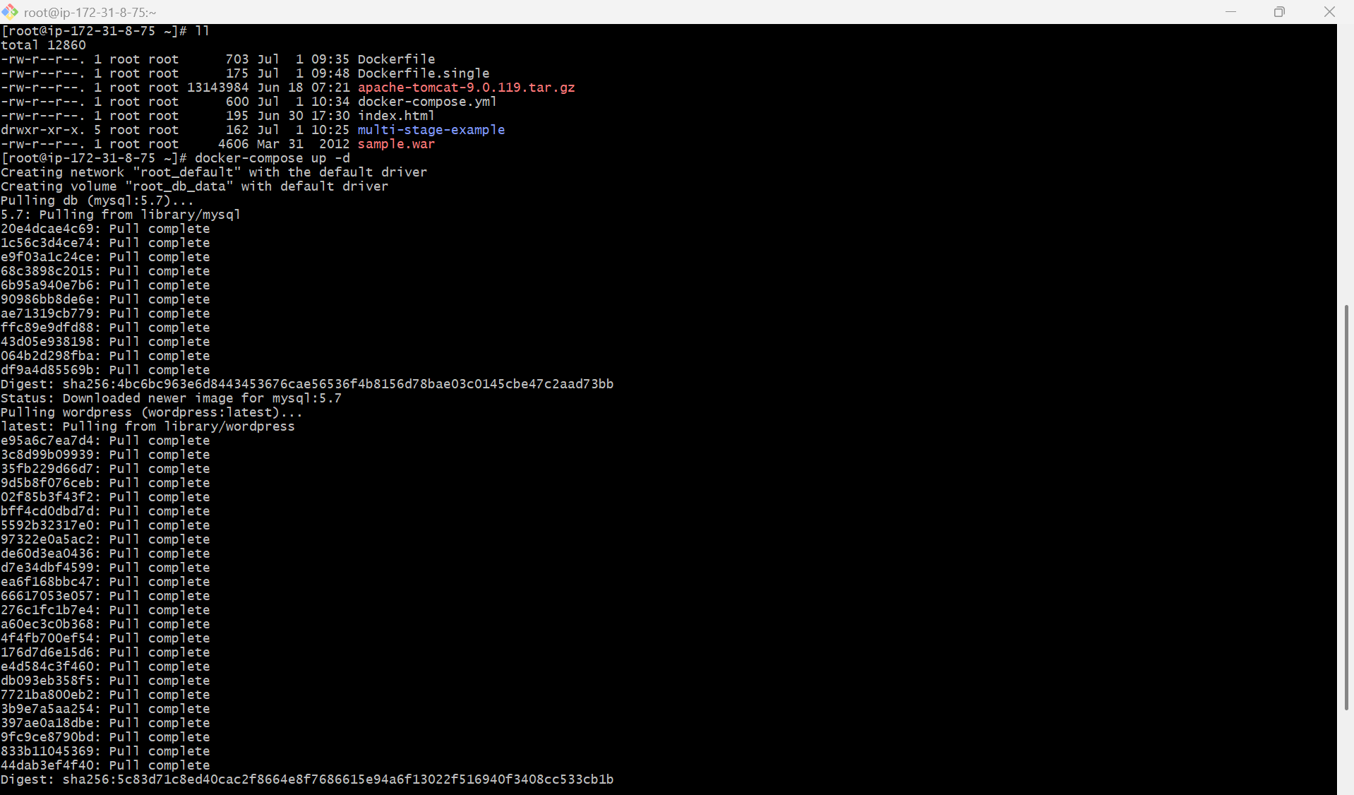

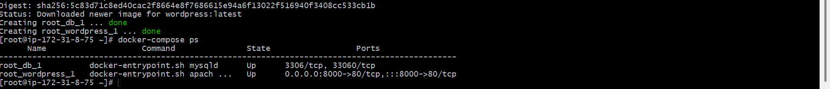

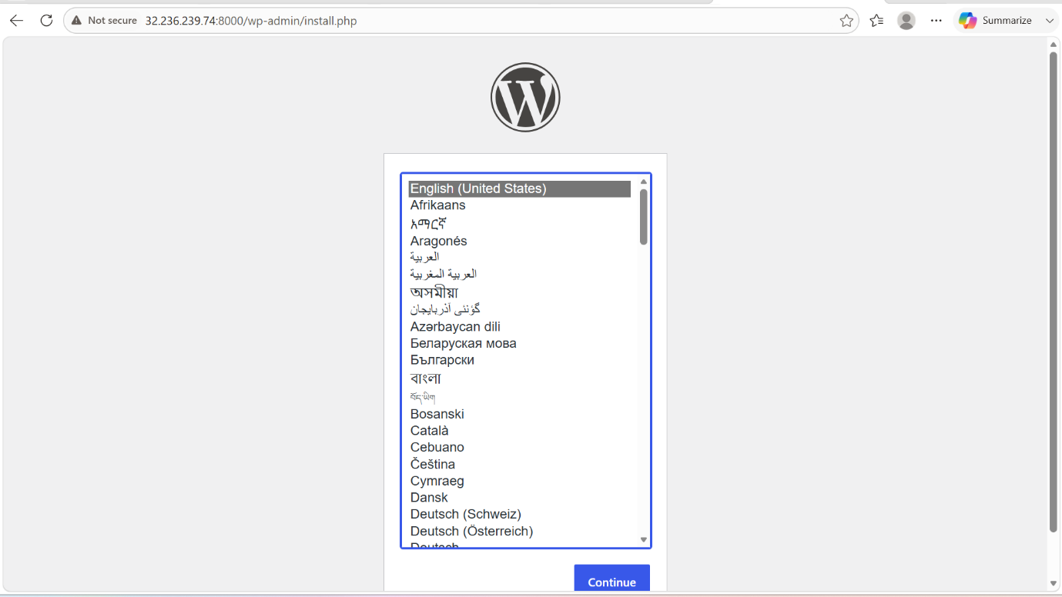

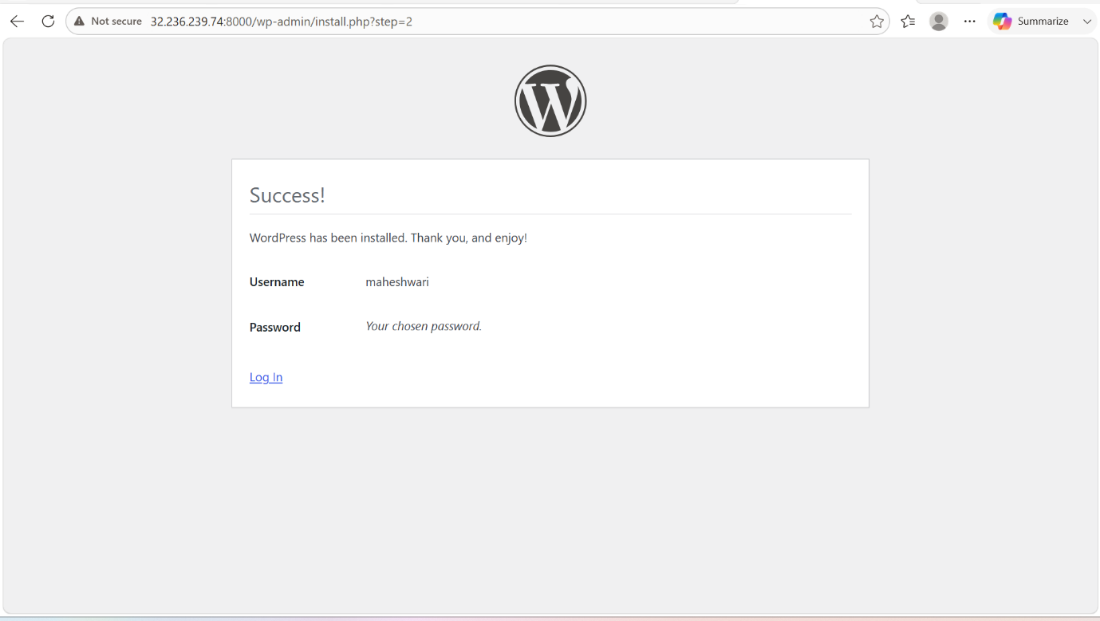

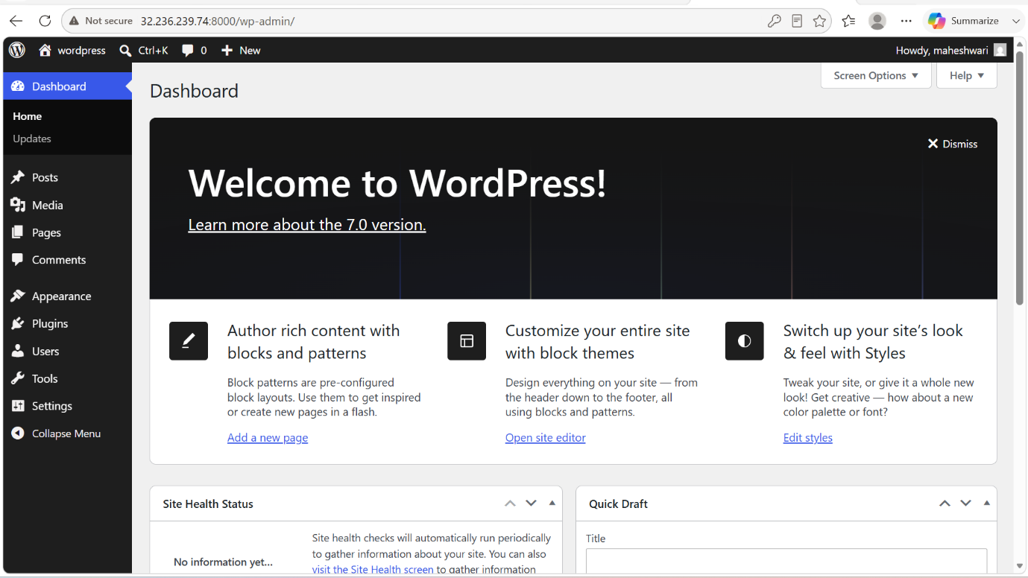

6. Implement solution to scan images when pushed to docker registry.

OBJECTIVE: To implement an automated image vulnerability scanning solution that scans Docker images whenever they are pushed to a container registry, helping identifying security vulnerabilities before deployment.

PURPOSE:
- Detect security vulnerabilities in Docker images.
- Prevent deployment of vulnerable container Images.
- Improve container security.
- Integrate security into the CI/CD pipeline.
- Ensure compliance with organizational security policies.

What is Container Image Scanning?
Container image scanning is the process of analyzing Docker images for:
- Operating system vulnerabilities
- Outdated packages
- Common Vulnerabilities and Exposures (CVEs)
- Security misconfigurations
- Malware (supported by some tools)
Scanning helps ensure only secure images are deployed.

STEP BY STEP IMPLEMENTATION:

- Create a docker hub account and create a new repo
- And in the CLI we have change the image name which we want to push to the docker hub with the docker hub repo name.
- Then in the docker hub, we have to enable the Docker scout image analysis in the settings of the repo.
- Then in the CLI we have push the image into the docker hub.

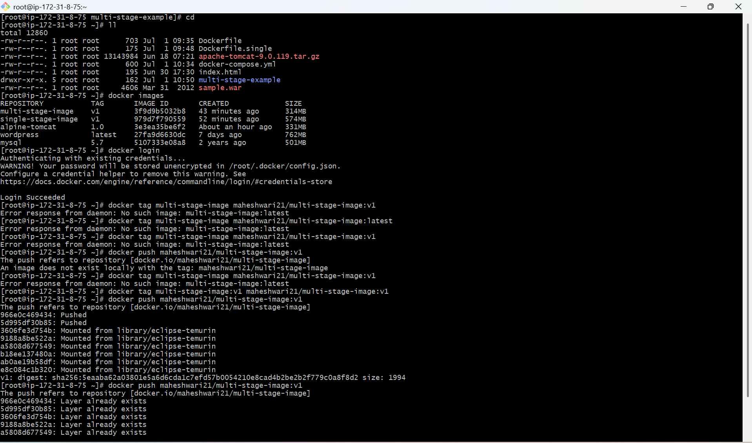

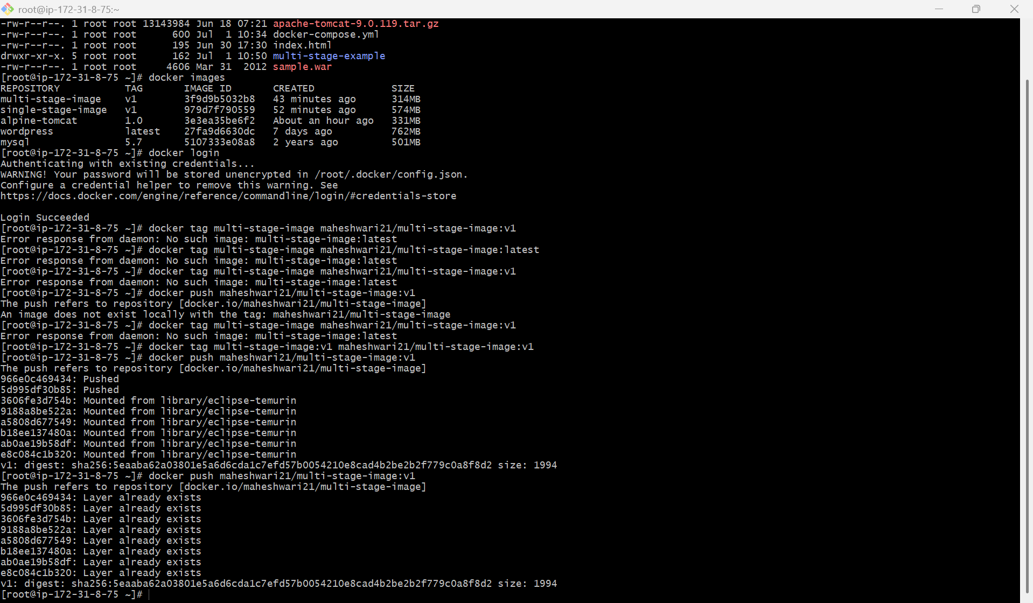

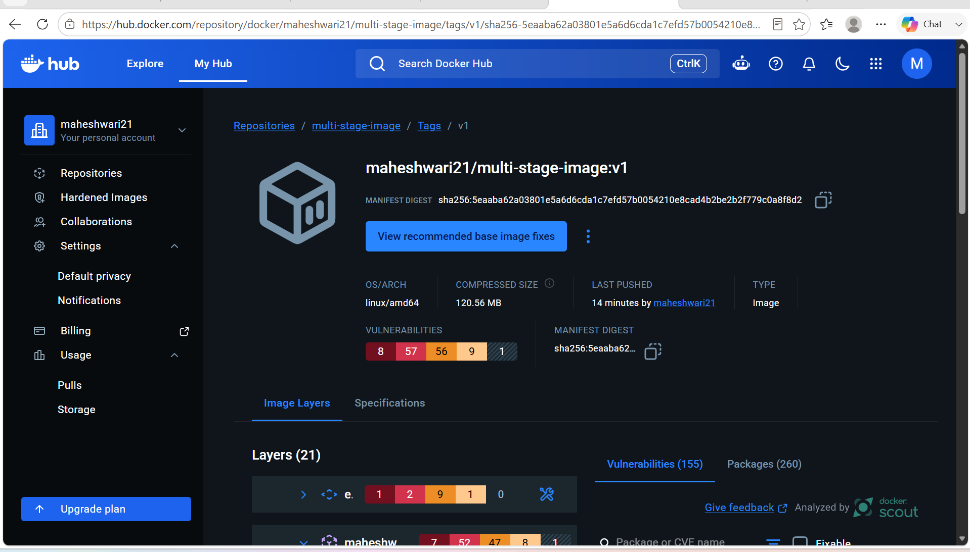

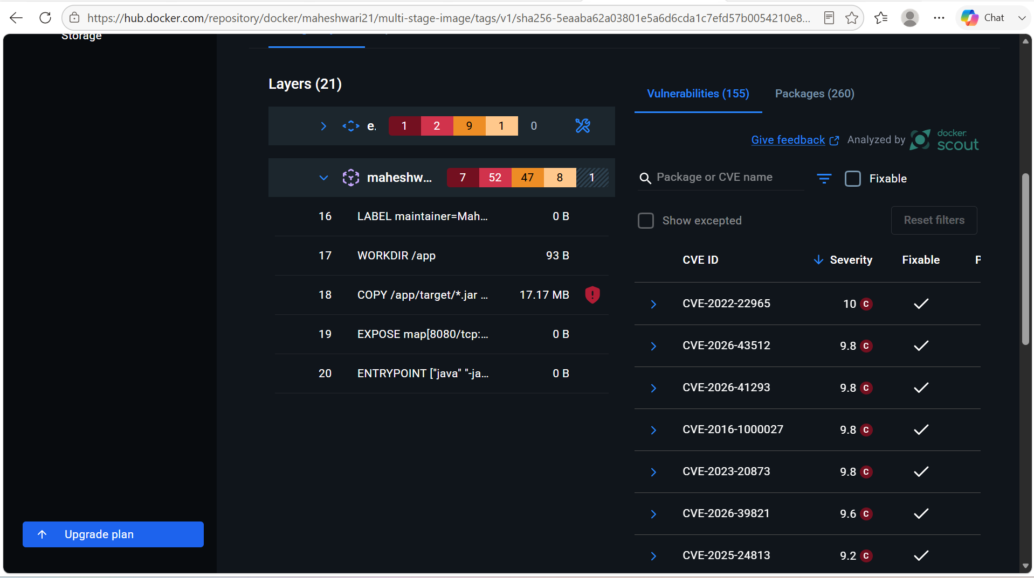

7. Implement solution to scan images when pushed to AWS ECR.

OBJECTIVE: To configure Amazon Elastic Container Registry (ECR) to automatically scan Docker images whenever they are pushed to a repository, allowing vulnerabilities to be identified before images are deployed.

PURPOSE:
- Automatically scan container images for vulnerabilities.
- Identify Common Vulnerabilities and Exposures (CVEs).
- Improve container security.
- Integrate security into the CI/CD pipeline (DevSecOps).
- Prevent deployment of vulnerable images.

What is Amazon ECR Image Scanning?
Amazon ECR provides built-in image scanning that automatically scans images after they are pushed to a repository. It detects known vulnerabilities in the operating system packages and application dependencies.
Amazon ECR supports:
- Basic Scanning – Uses AWS native scanning.
- Enhanced Scanning – Uses Amazon Inspector for continuous vulnerability monitoring and more detailed findings.

Prerequisites
- AWS Account
- AWS CLI installed and configured
- Docker installed
- Amazon ECR repository
- Docker image to push

STEP BY STEP IMPLEMENTATION:

- Create a new repository in the AWS ECR service from the CLI.
aws ecr create-repository \
--repository-name multi-stage-image \
--image-scanning-configuration scanOnPush=true \
--region ap-southeast-2
- Then verify the configurations ->
aws ecr describe-repositories \
--repository-names multi-stage-image \
--region ap-southeast-2
- Login to AWS ECR ->
aws ecr get-login-password --region ap-southeast-2 | \
docker login \
--username AWS \
--password-stdin \
683620640096.dkr.ecr.ap-southeast-2.amazonaws.com
- Tag the docker image ->
docker tag multi-stage-image:v1 \
683620640096.dkr.ecr.ap-southeast-2.amazonaws.com/multi-stage-image:v1
- Then push the image to the AWS ECR ->
docker push \
683620640096.dkr.ecr.ap-southeast-2.amazonaws.com/multi-stage-image:v1
- Verify the results in the AWS ECR.

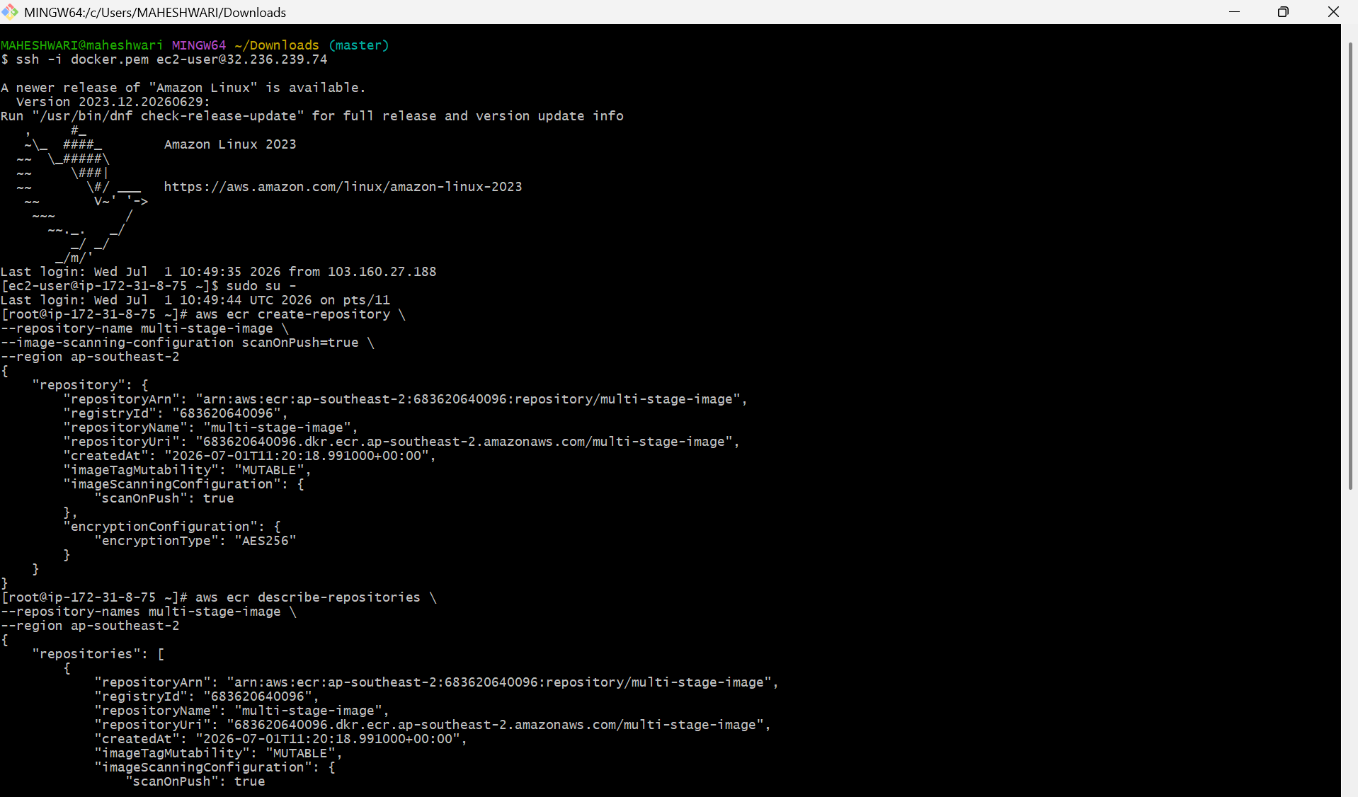

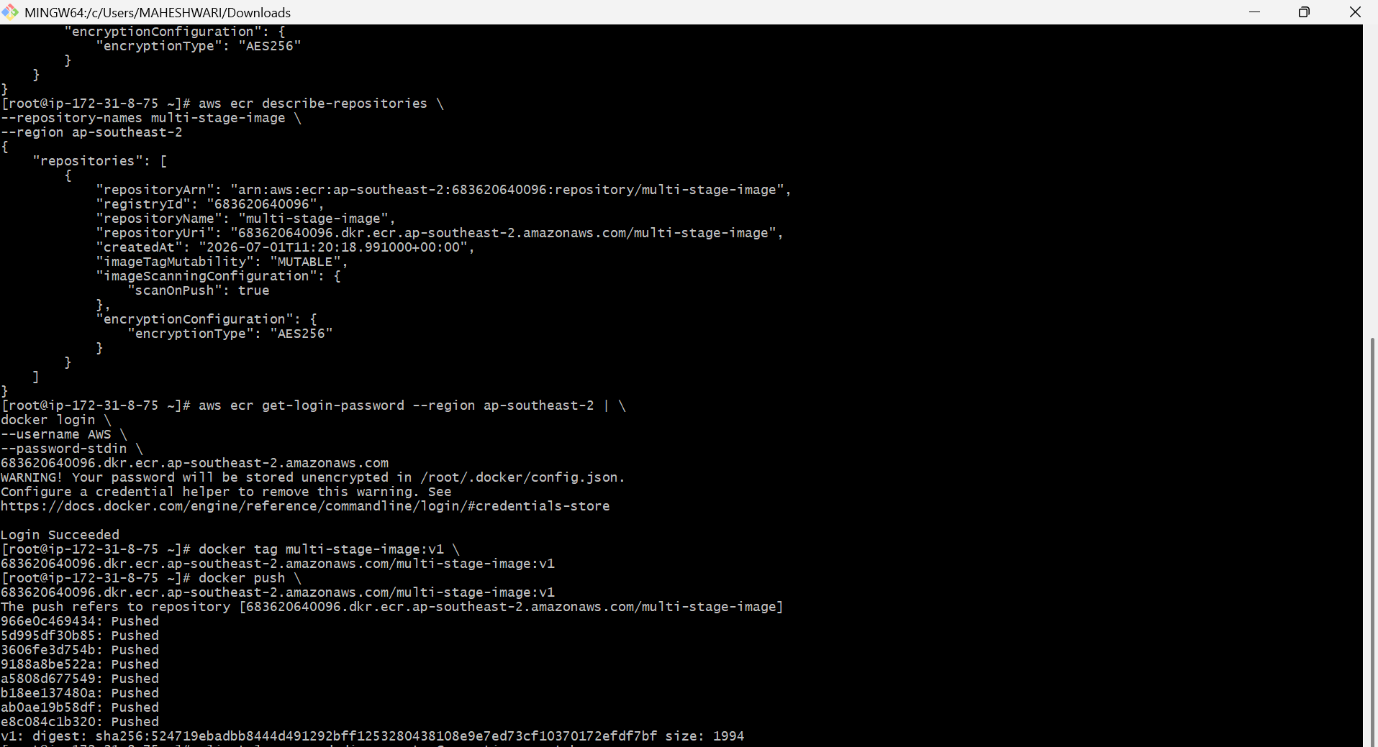

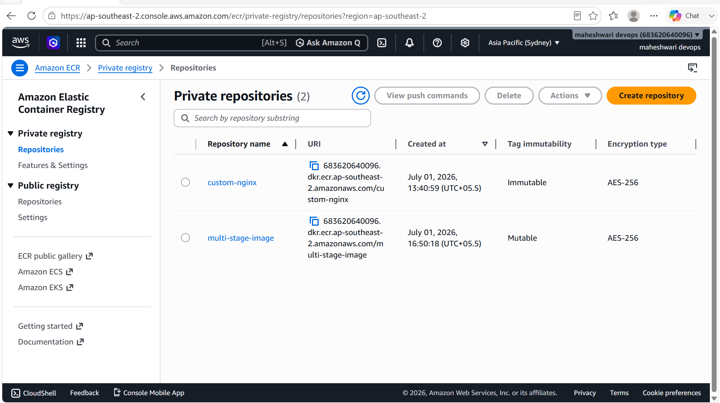

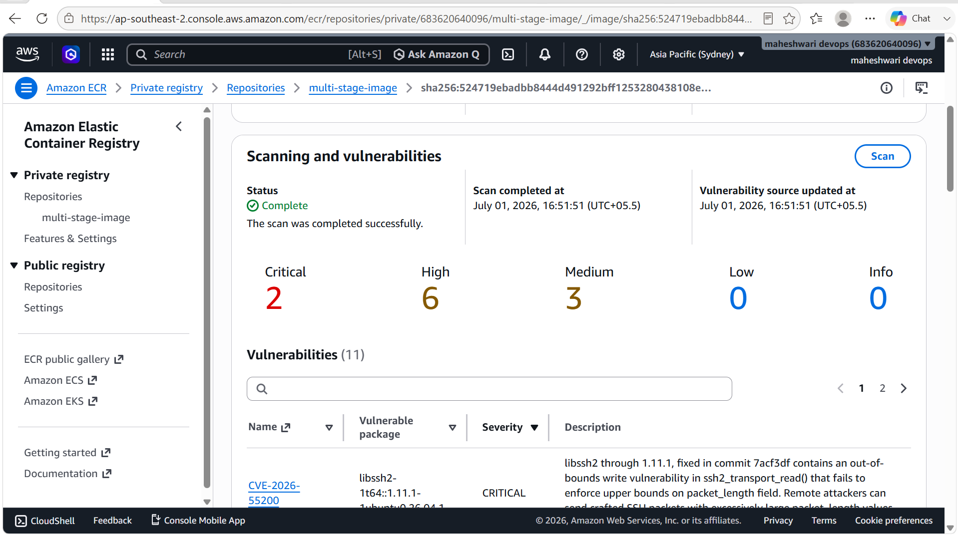

5. Create one Jenkins job to build and push the Docker image to Docker Hub.

PURPOSE: The purpose of this experiment is to automate the process of building a Docker image from a GitHub source repository and pushing it to Docker Hub using a Jenkins Pipeline. This demonstrates the use of Jenkins for Continuous Integration (CI) by integrating source code management, Docker image creation, and image publishing into a single automated workflow.

OBJECTIVE:

- Learn how to create a Jenkins Pipeline job.
- Integrate Jenkins with a GitHub repository.
- Clone the application source code from the GitHub repository (https://github.com/betawins/Python-app.git).
- Build a Docker image using the application's Dockerfile.
- Configure Docker Hub credentials securely in Jenkins.
- Authenticate Jenkins with Docker Hub.
- Push the Docker image to a Docker Hub repository automatically.
- Understand the role of Jenkins in automating Docker image build and deployment processes.
- Gain hands-on experience with Continuous Integration (CI) using Jenkins and Docker.
- Reduce manual effort and ensure consistent, repeatable Docker image builds and publishing.

STEP BY STEP IMPLEMENTATION:

- Create a image with the Dockerfile in the jenkins-docker directory.
- After that in the Docker file, we have to place the content in the docker file ->

FROM jenkins/jenkins:lts

USER root

RUN apt-get update && \
apt-get install -y docker.io && \
apt-get clean

USER jenkins
- Then build the image from the Docker file -> docker build -t jenkins-docker-image:v2
- After that make sure that the jenkins user can access the Docker socket in the jenkins-container -> docker exec -u root -it jenkins-container
- Then in the jenkins container -> docker ps -a
- After that the run the jenkins-image ->
docker run -d \
--name jenkins-container \
--user root \
-p 8080:8080 \
-p 50000:50000 \
-v jenkins_home:/var/jenkins_home \
-v /var/run/docker.sock:/var/run/docker.sock \
jenkins-docker-image:v2
- Then in the jenkins browser access with the publicIP:8080.
- Create a new job with the pipeline job style and write a pipeline
pipeline {
agent any

environment {
IMAGE_NAME = "YOUR_DOCKERHUB_USERNAME/python-app"
IMAGE_TAG = "v1"
}

stages {
stage('Clone Repository') {
steps {
git branch: 'main',
url: 'https://github.com/betawins/Python-app.git'
}
}

stage('Build Docker Image') {
steps {
sh 'docker build -t ${IMAGE_NAME}:${IMAGE_TAG} .'
}
}

stage('Docker Login') {
steps {
withCredentials([usernamePassword(
credentialsId: 'dockerhub-creds',
usernameVariable: 'DOCKER_USER',
passwordVariable: 'DOCKER_PASS'
)]) {
sh '''
echo $DOCKER_PASS | docker login -u $DOCKER_USER --password-stdin
'''
}
}
}

stage('Push Image') {
steps {
sh 'docker push ${IMAGE_NAME}:${IMAGE_TAG}'
}
}
}
}
- Then click on build now and the job will get success.

