DOCKER – 02

1. Create a tomcat container on 8080 and deploy sample application in tomcat.

PURPOSE: The purpose of this task is to learn how to deploy a java web application in a Dockerized Apache Tomcat server. By running Tomcat inside a Docker container, you can achieve a consistent, portable and isolated application environment without installing tomcat directly on the host machine.

OBJECTIVE:

- Pull the official Tomcat Docker image.
- Create and run Tomcat container.
- Expose Tomcat on port 8080.
- Deploy a sample WAR application into the Tomcat server.
- Verify that the application is successfully deployed and accessible through a web browser.
- Understand how Docker simplifies application deployment and management.

STEP BY STEP IMPLEMENTATION:

- Pull the tomcat image from the docker hub -> docker pull tomcat
- After that we have to run the tomcat ->
docker run -d \
--name tomcat-container \
-p 8080:8080 \
tomcat
- After we have to get the sample war by using wget.
- Then we have to copy the sample file to the docker tomcat container.
- Then we can automatically see the sample page in the browser.

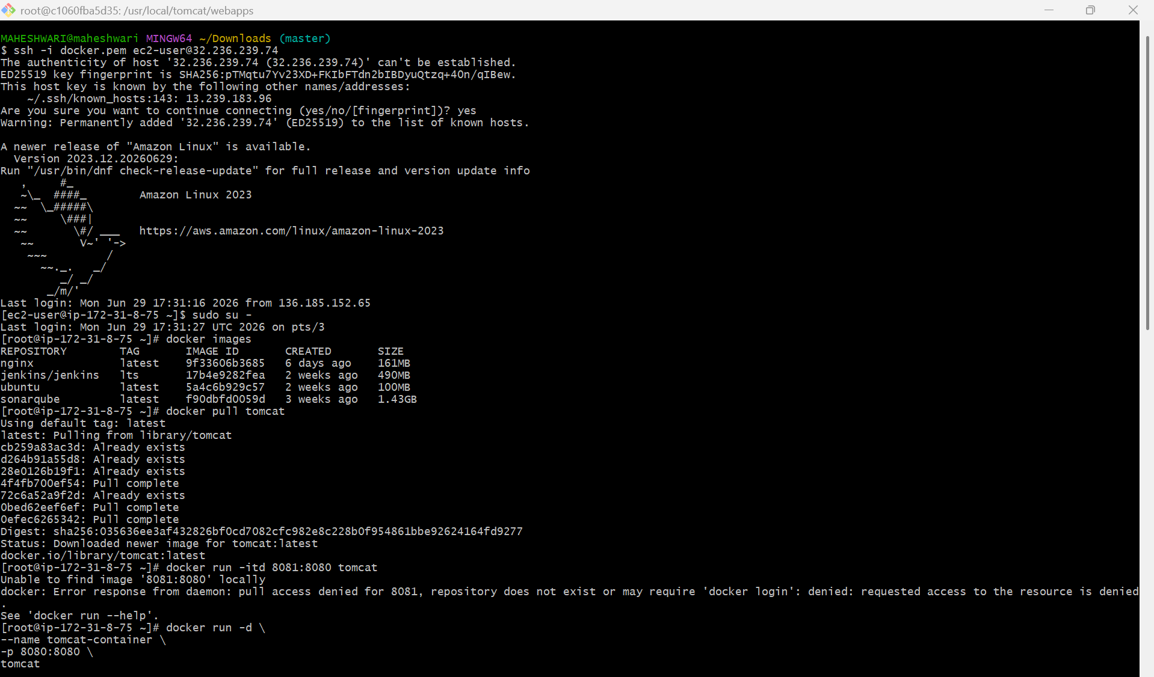

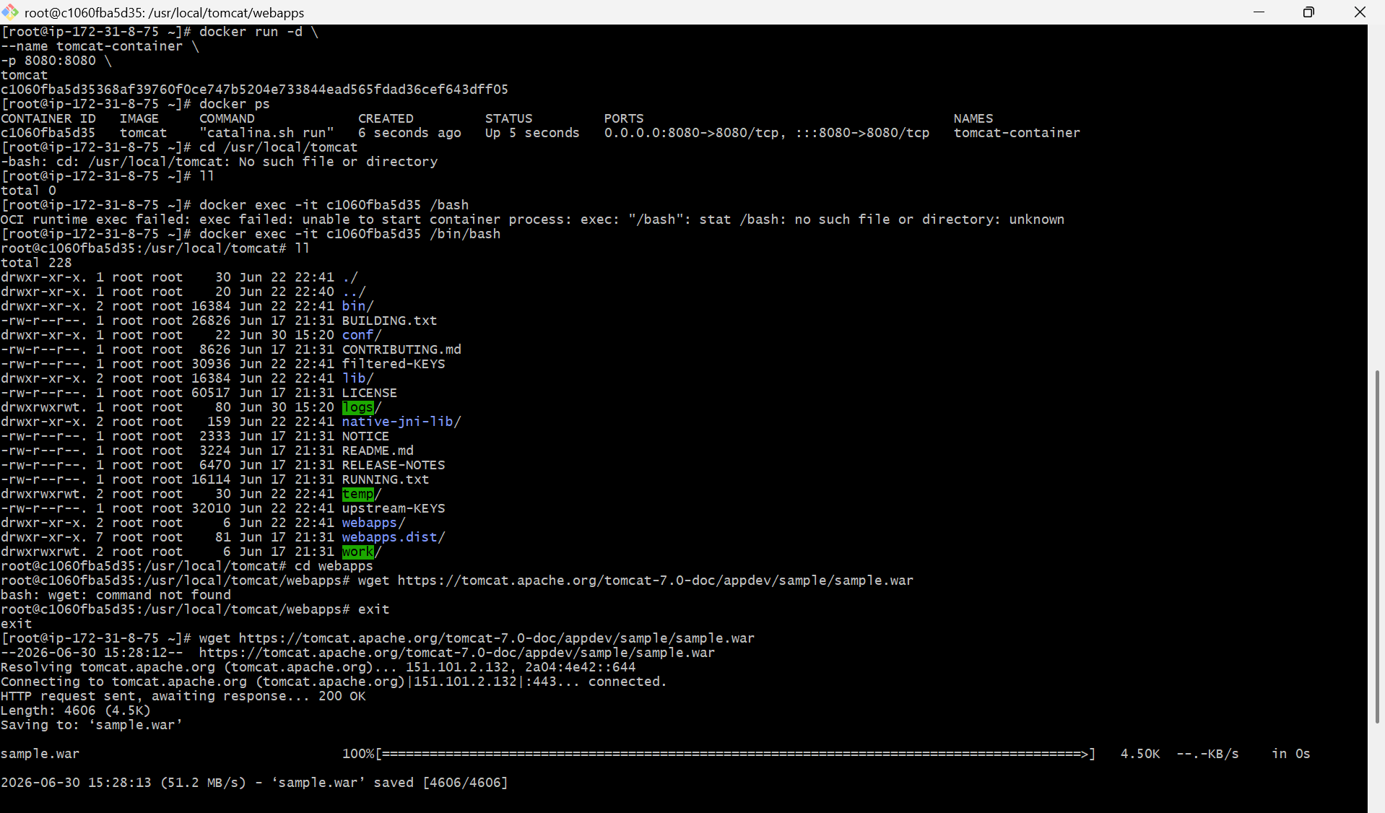

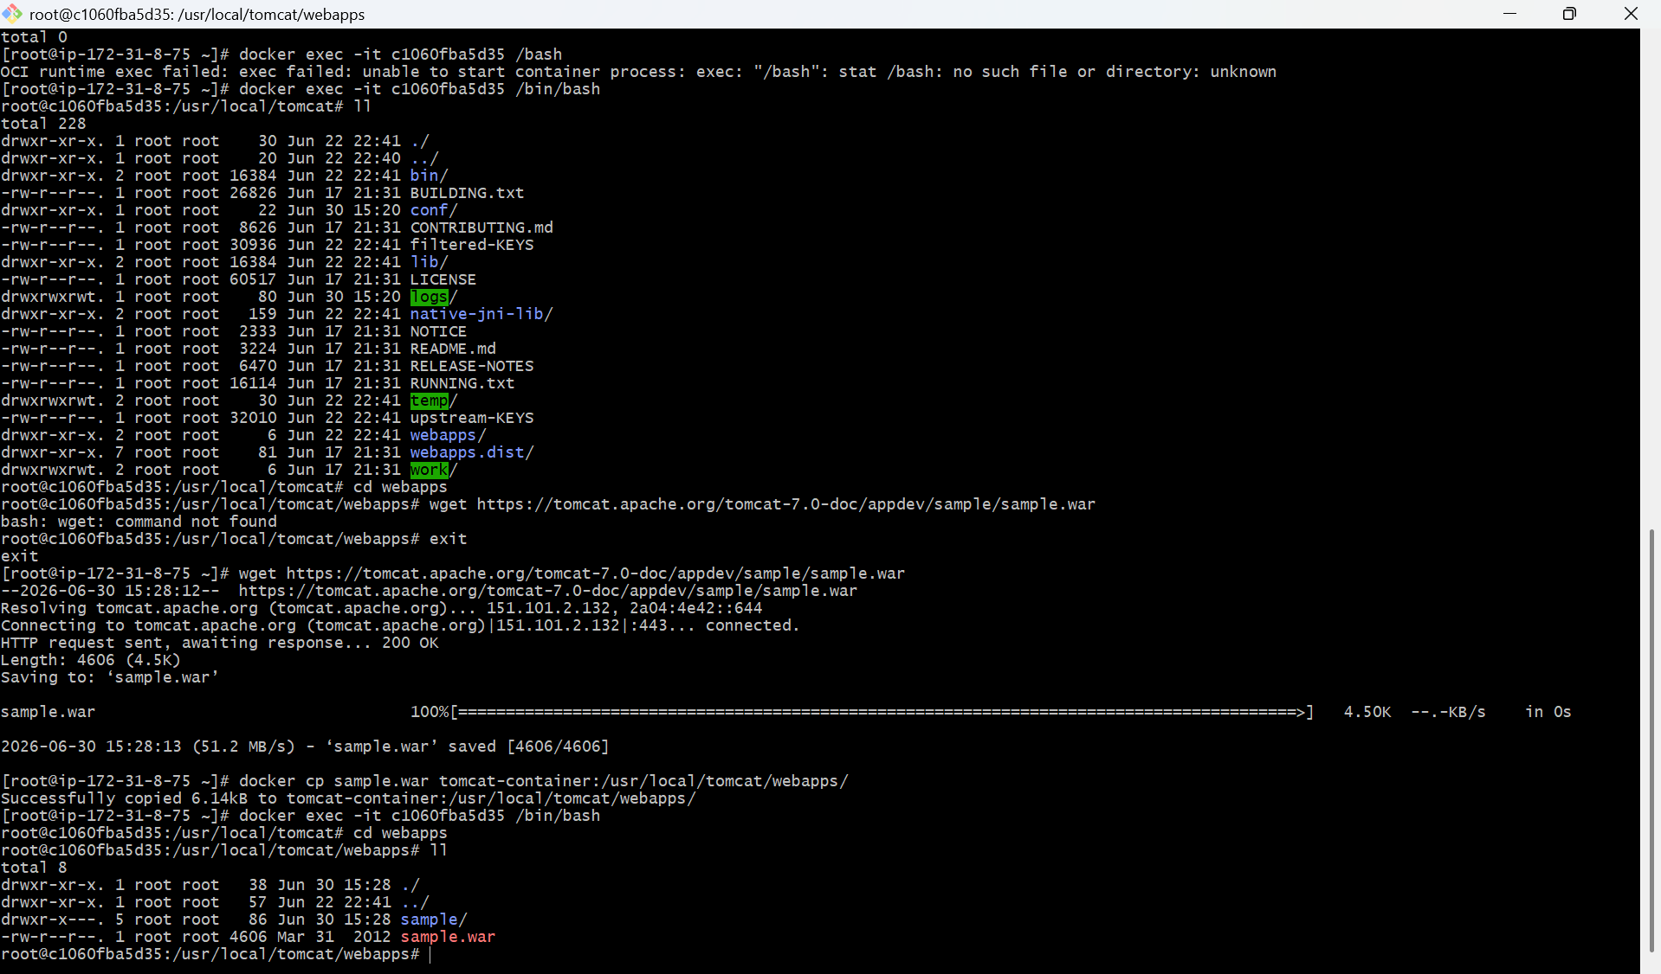

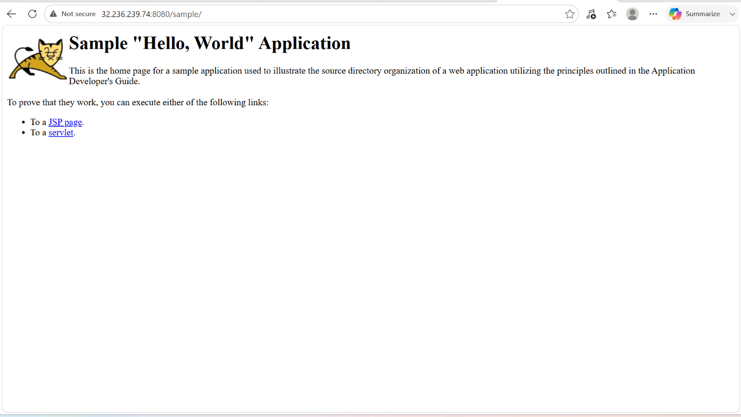

2. Create volume and deploy tomcat container on port 8081.

PURPOSE: The purpose of this task is to learn how to use Docker volumes for persistent data storage with a Tomcat container. A Docker volume ensures that deployed applications and configuration files are retained even if the container is stopped, removed or recreated.
OBJECTIVE:
- Create a Docker volume.
- Verify the created volume.
- Run a Tomcat container using the volume.
- Map the container’s port 8080 to the host’s 8081.
- Store Tomcat web applications in the Docker volume.
- Verify the Tomcat server is accessible through a web browser.

PREREQUISITES:
- Docker installed and rinning.
- Internet connectivity to pull the Tomcat image.
- Port 8081 available on the host.
- Basic knowledge of Docker commands.

STEP BY STEP IMPLEMENTATION:

- First of we have to create docker volume in the docker server by using the command -> docker volume create <volume-name>
- We can also get the list of volumes -> docker volume list
- Default location of the volumes -> /var/lib/docker/volumes/<volumeName>/_data
- After that we have to run our tomcat container ->

Docker container run -itd -p 8082:8080 -v /var/lib/docker/volumes/<volume-name/_data:/usr/local/tomcat/webapps tomcat

- Now we can access the tomcat server sample file in the browser.

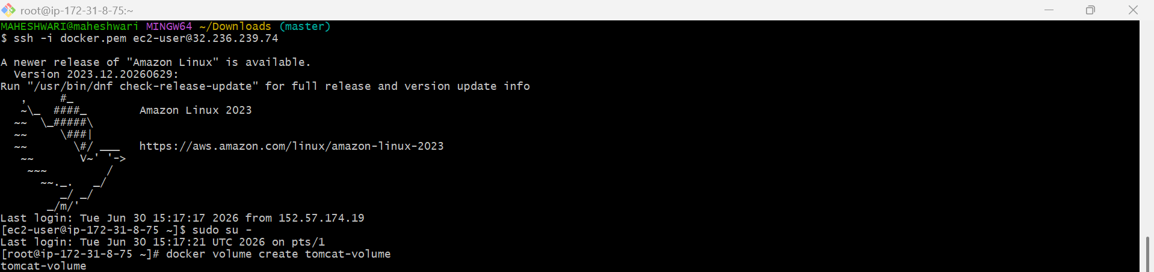

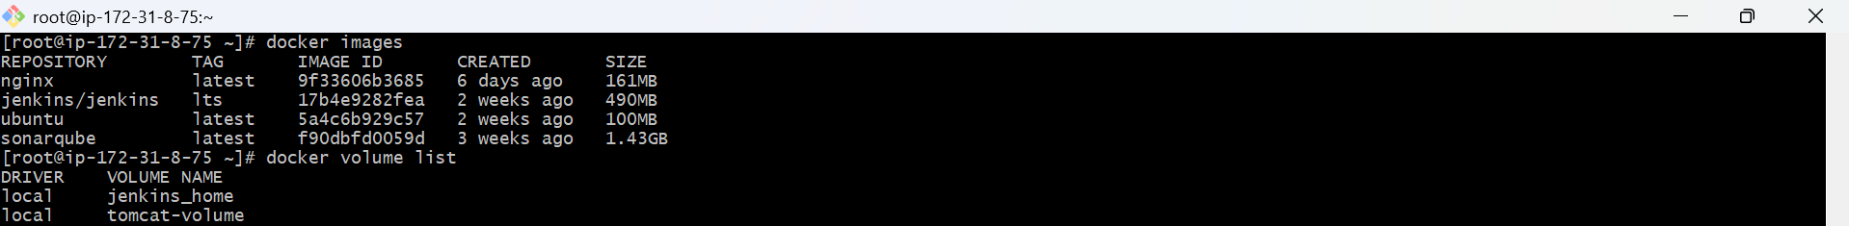

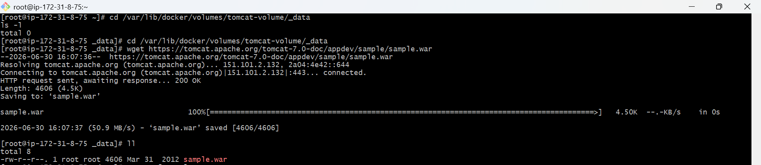

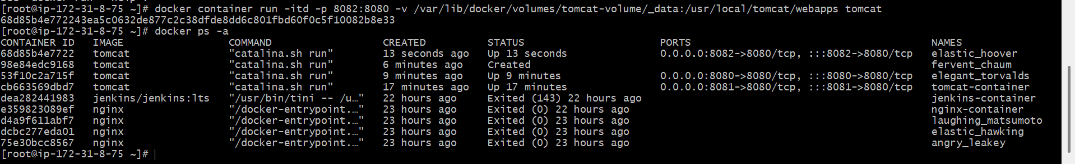

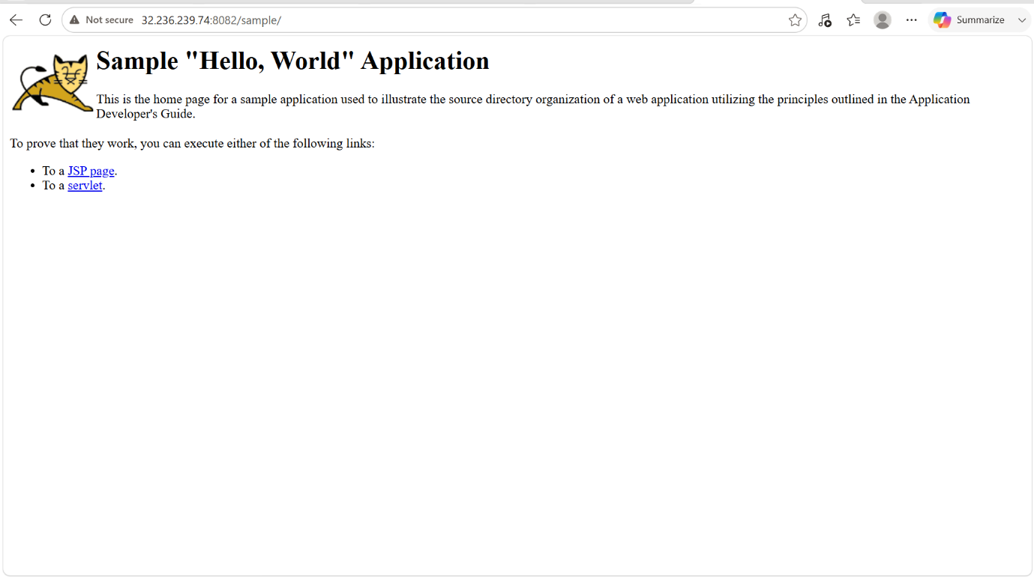

3. Limit the nginx container to 500 MB.

PURPOSE: Limit the maximum memory usage of an Nginx container to 500MB to prevent it from consuming excessive system memory.

OBJECTIVE:
- Run an Nginx container with a memory limit of 500 MB.
- Verify that the memory limit has been applied.

STEP BY STEP IMPLEMENTATION:

- Verify that the nginx-container is running or not.
- After that we have to allocate the 500MB to the nginx-container.
- After that using docker stats nginx-container will give the result that how much memory is allocated.

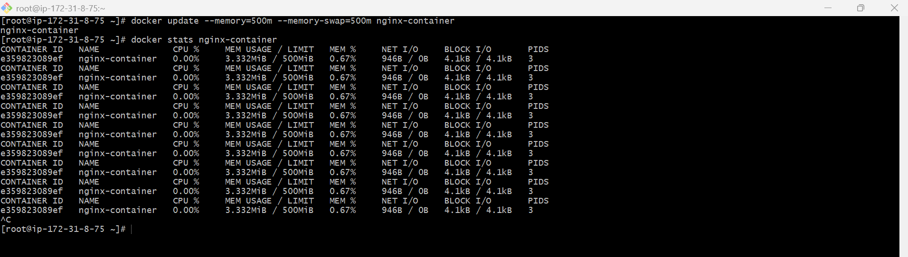

4. Create a sample docker file using below instructions.
- Base module as amazonlinux:latest
- Maintainer you name
- Install nginx
- COPY one index.html file to image
- Expose on port 80
- Command to start the nginx container

PURPOSE: To create a custom Docker image based on Amazon Linux, install Nginx, copy a custom index.html file into the web root, expose port 80, and Nginx when the container launches.

OBJECTIVE:
- Use amazonlinux:latest as the base image.
- Add the maintainer information.
- Install Nginx.
- Copy a custom index.html file.
- Expose port 80.
- Start Nginx when the container starts.

STEP BY STEP IMPLEMENTATION:

- Create a Dockerfile and also a index.html file.
- After that build the image -> docker build -t custom-nginx.
- After the run the nginx ->
docker run -d \
--name nginx-container \
-p 80:80 \
custom-nginx
- Verify the container is running or not -> docker ps
- Access on the browser with public ip of server.

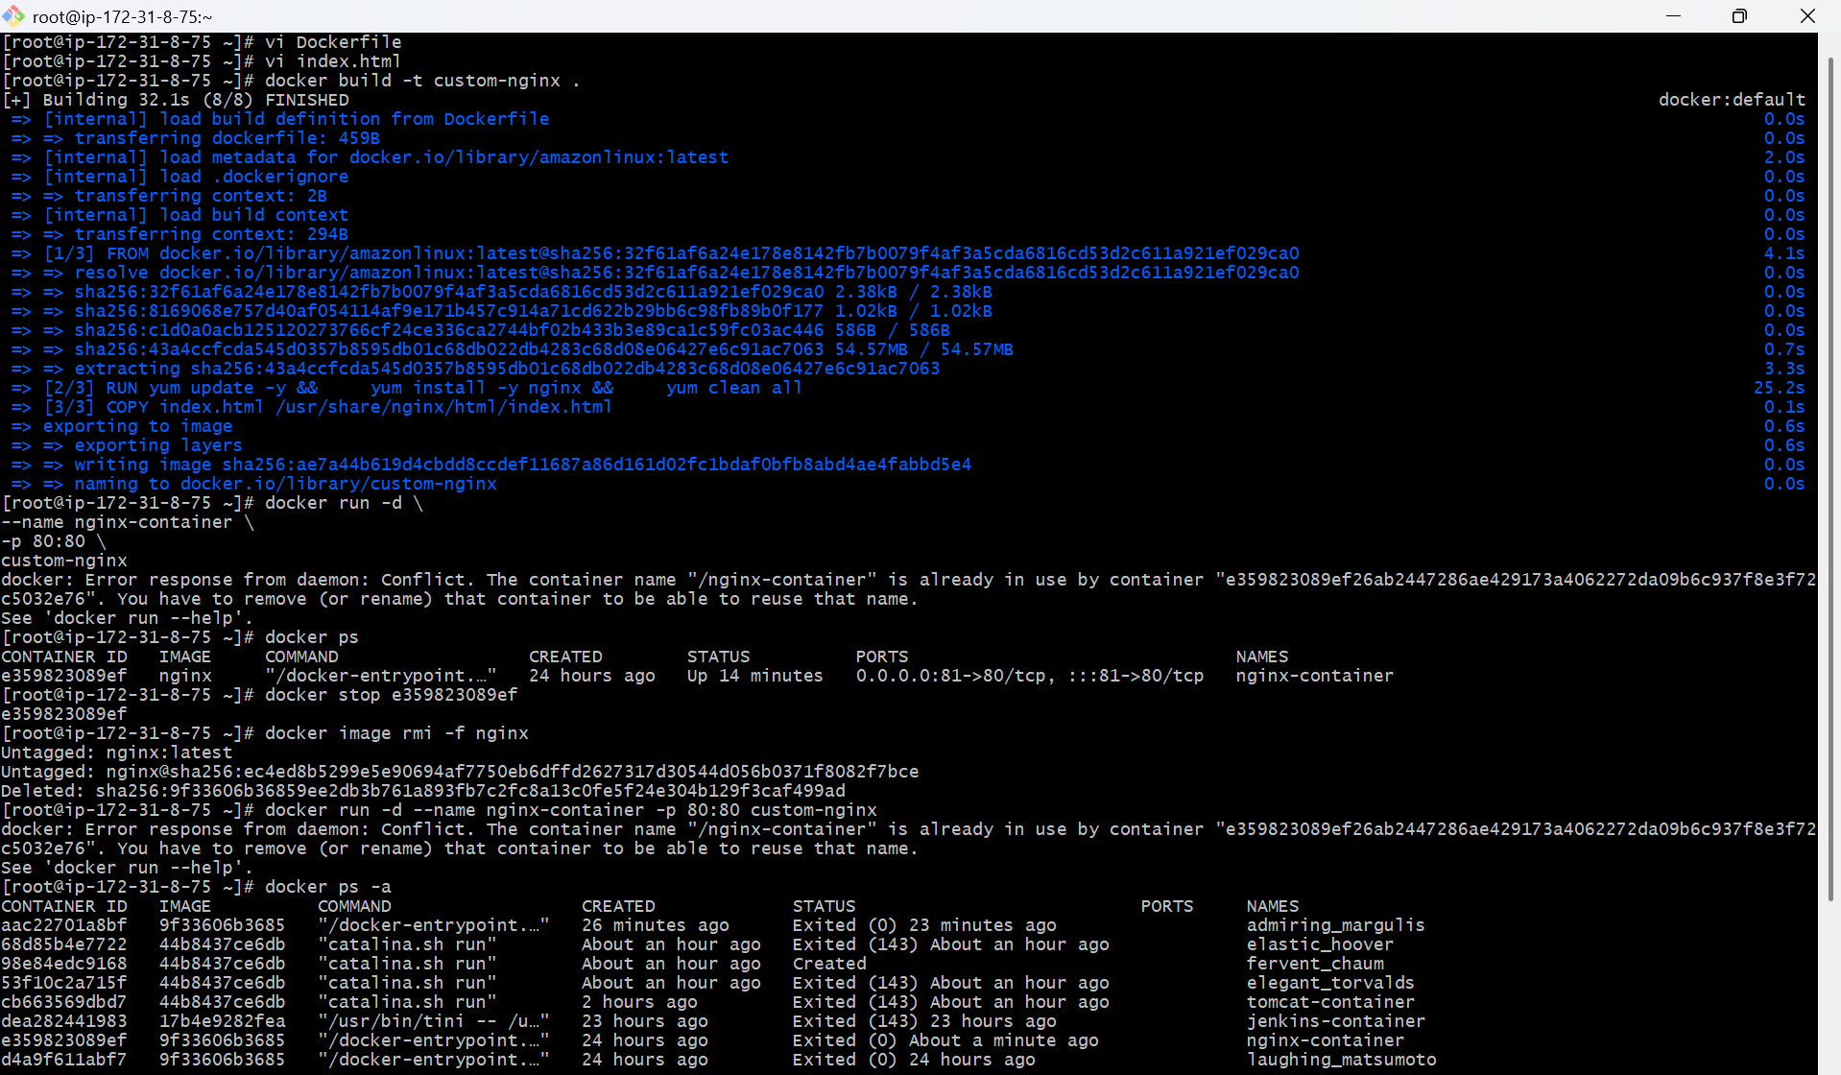

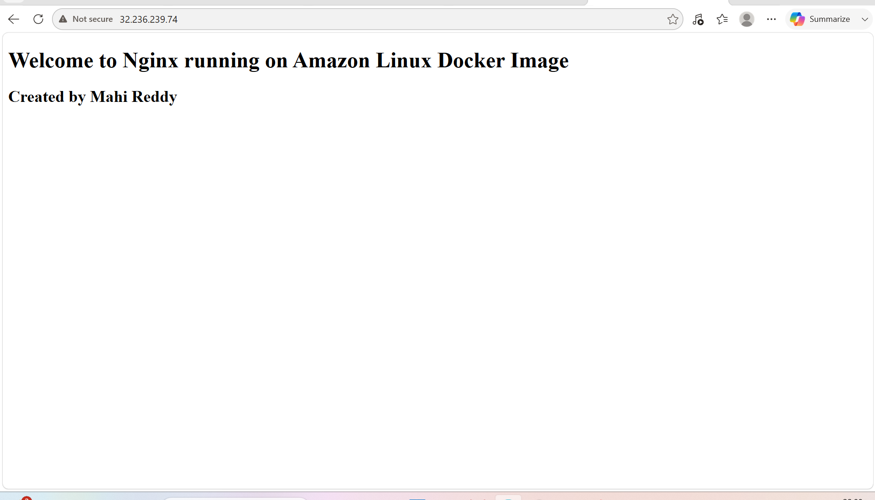

5. Push image to Docker hub.

PURPOSE: The purpose of this task is to upload a custom Docker image to Docker Hub so that it can be stored in a remote repository and shared or deployed from any system.

OBJECTIVE:
- Log in to Docker Hub.
- Tag the local Docker image.
- Push the image to a Docker Hub repository.
- Verify that the image is available in your Docker Hub account.

PREREQUISITES:
- Docker installed and running.
- A Docker Hub account.
- A custom Docker image.
- Internet connectivity.

STEP BY STEP IMPLEMENTATION:

- Verify the image is pulled or not.
- After that login into our docker hub account in the GUI and also in the docker server CLI.
- After that we have to create repo in the docker hub.
- In the CLI, we have to replace the image name with the docker hub repo name because docker hub will accept the image name as repo name that we have created in the docker hub.
- docker tag custom-nginx maheshwari21/amazonlinux2026:latest

- After that we have to push image to the docker hub repo.
- docker push maheshwari21/amazonlinux2026:latest

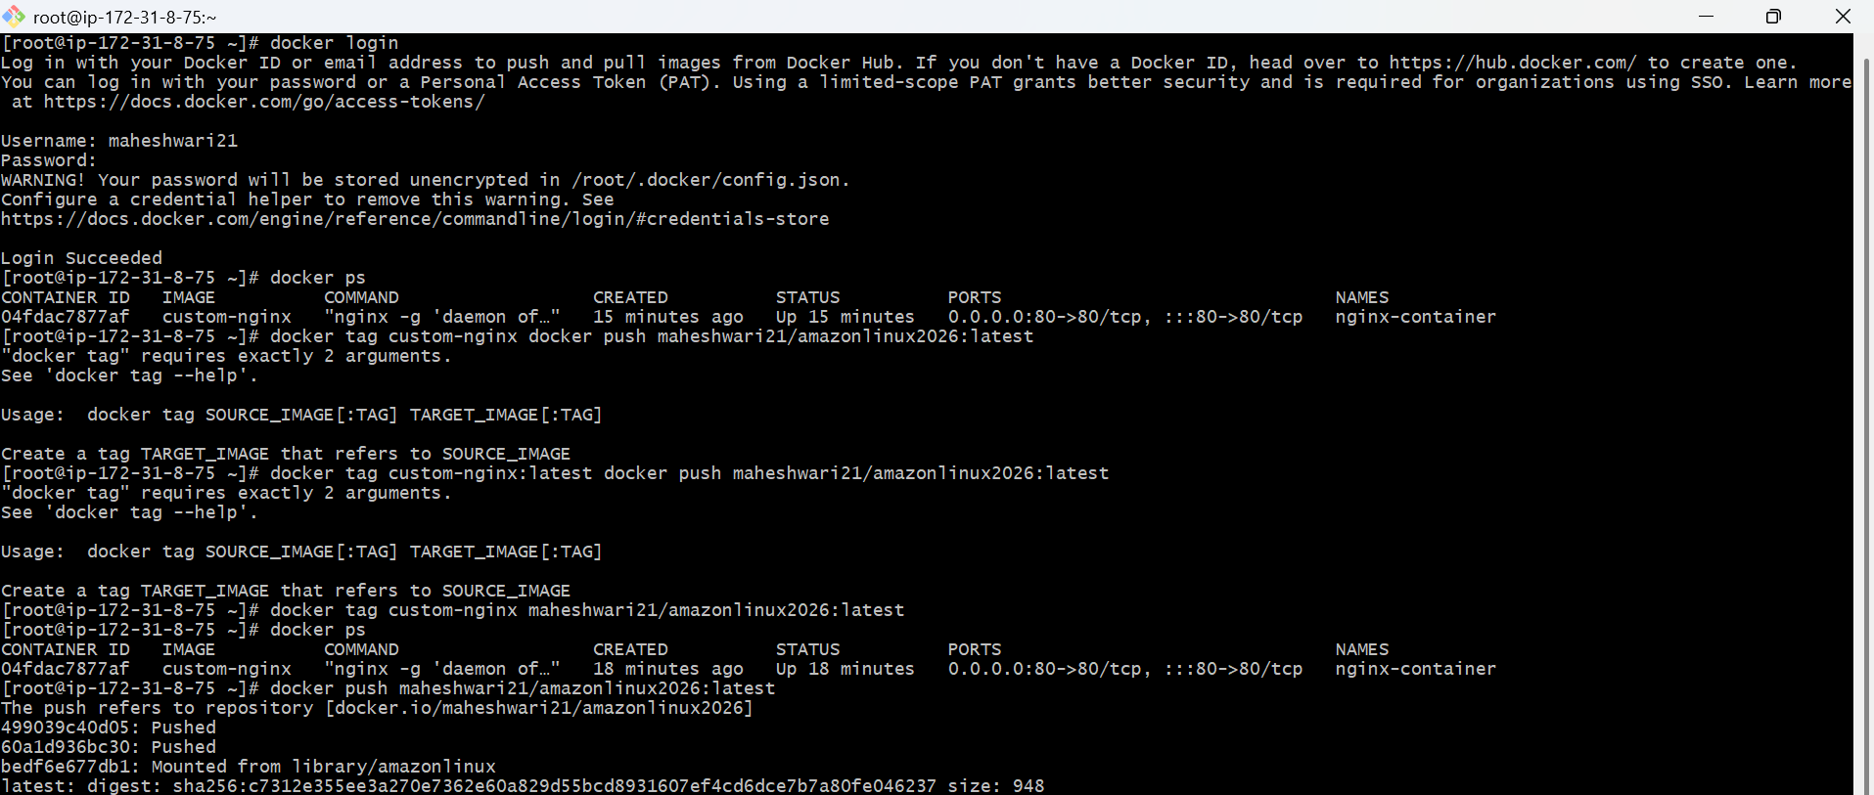

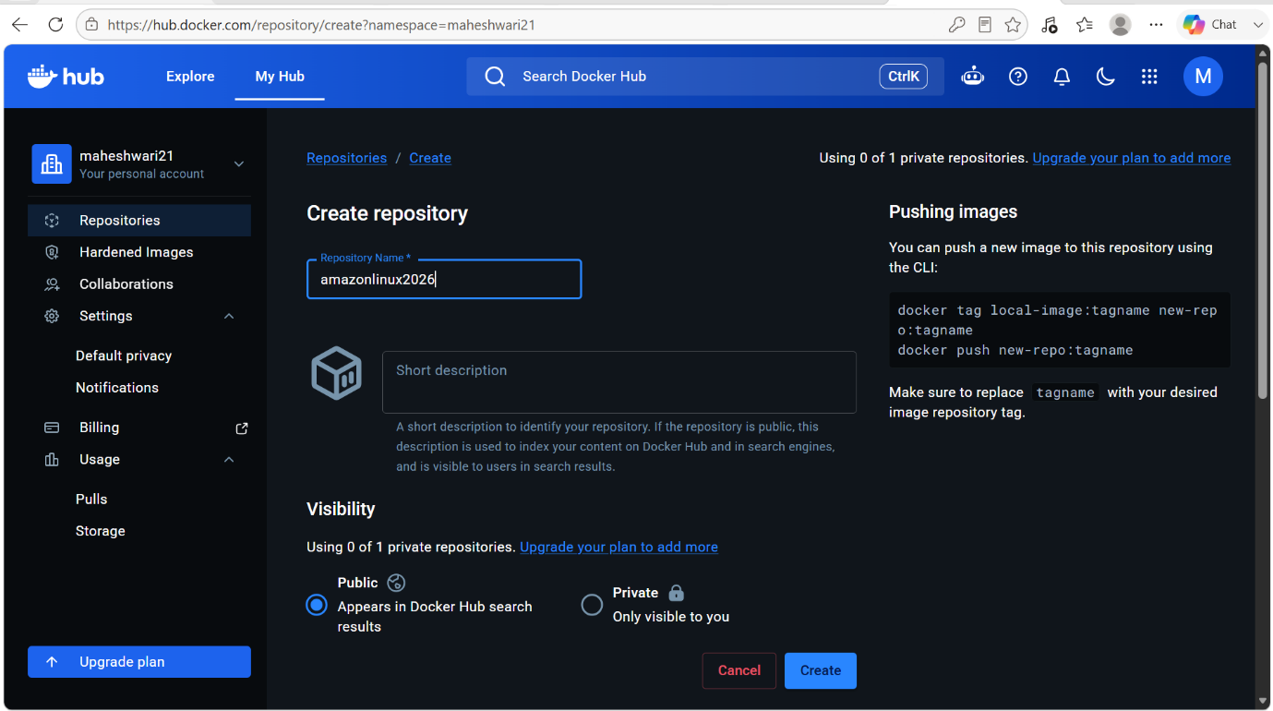

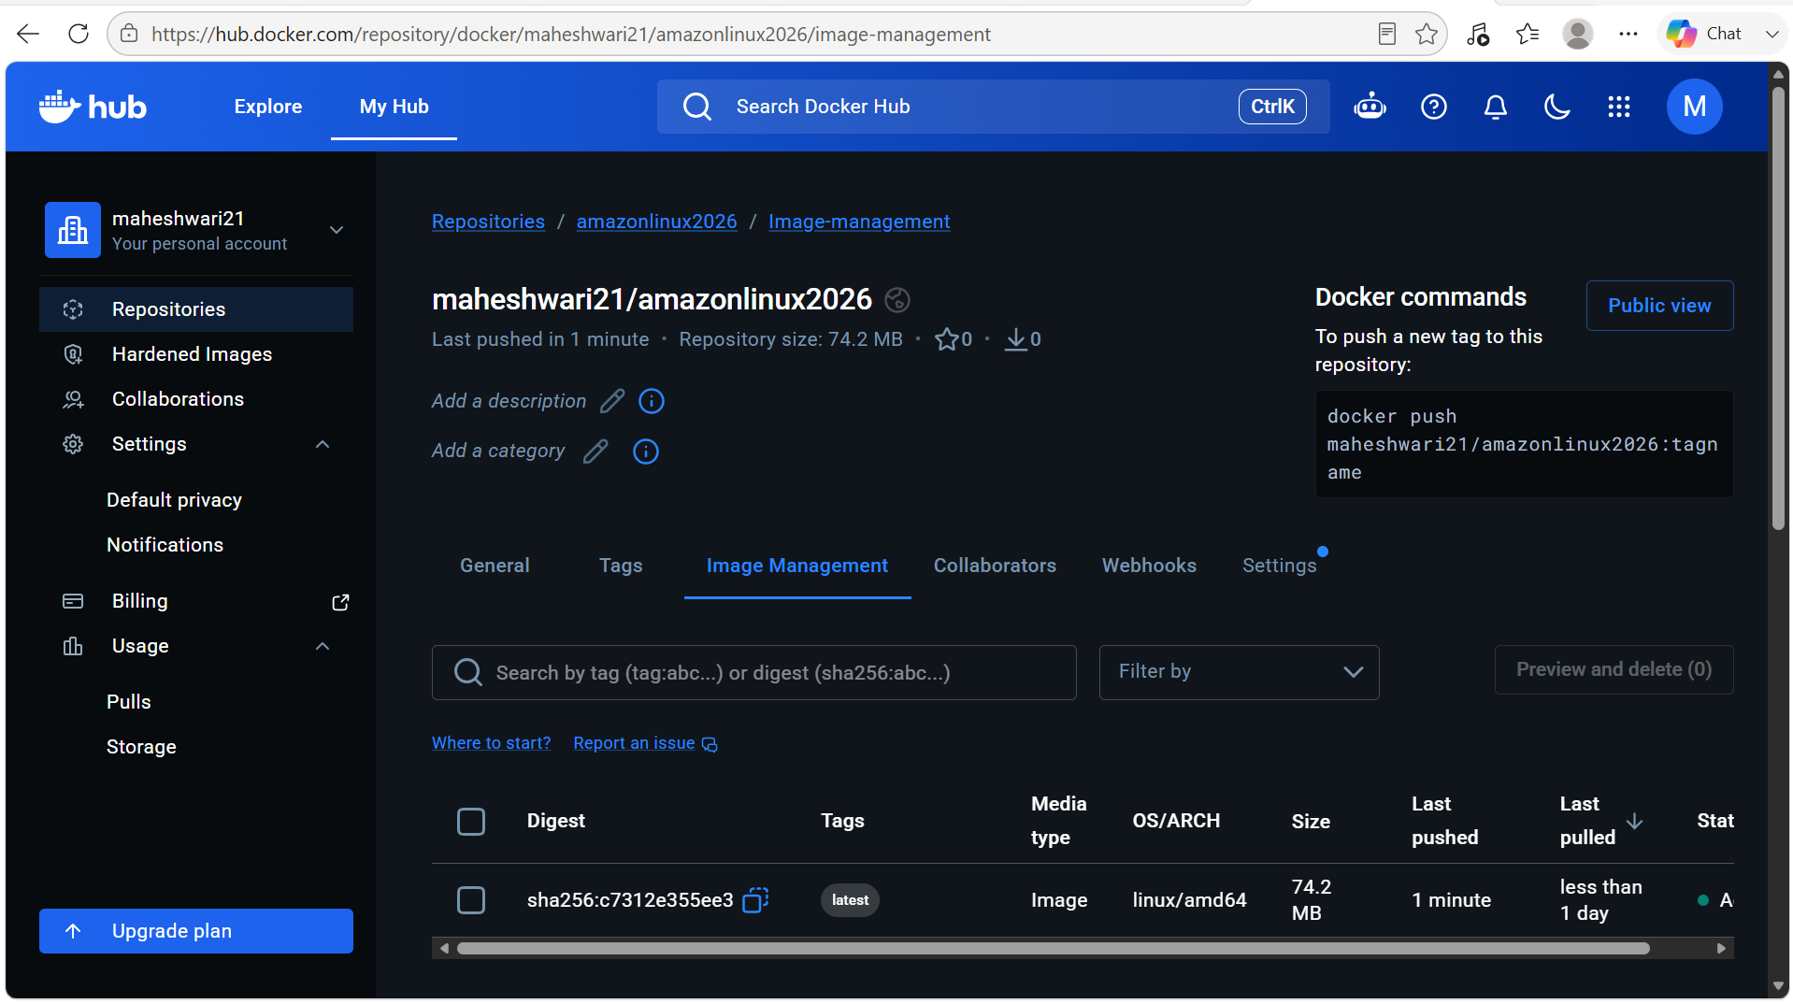

6. push image to AWS ECR.

PURPOSE:
- Store Docker images in a secure, private container registry.
- Enable centralized image management and version control.
- Integrate with CI/CD tools like Jenkins, GitHub Actions, and AWS CodePipeline.
- Allow deployment of containerized applications across AWS services.
- Improve application portability and scalability.

OBJECTIVE: To upload a Docker image from the local machine to Amazon Elastic Container Registry (ECR) so it can be securely stored, versioned and later used for deployment and later used for deployment on AWS services such as Amazon ECS, Amazon EKS, AWS Lambda or EC2.

PREREQUISITES:
- AWS account
- AWS CLI installed and configured
- Docker installed and running
- An existing Docker image (e.g., custom-nginx)
- An ECR repository (e.g., custom-nginx)

STEP BY STEP IMPLEMENTATION:
- In the AWS, create a new repo in the ECR service.
- Verify whether the AWS CLI is installed or not.
- After that we have to configure the AWS -> aws configure
- Then it will prompt to enter details.
- Now we have to login into the docker ECR.
- Change the image name with ECR repo name.
- Push the image to the ECR.

