TASKS ON TERRAFORM

Install Terraform on your PC

OBJECTIVE: To install Terraform on your PC so you can create, manage and automate cloud infrastructure using Infrastructure as Code (IaC).

PURPOSE:
- Automate infrastructure provisioning instead of creating resources manually.
- Manage cloud resources (AWS, Azure, GCP, etc.) using code.
- Maintain consistent infrastructure across development, testing and production environments.
- Version-control infrastructure using Git.
- Reduce configuration errors and enable repeatable deployments.

STEP BY STEP IMPLEMENTATION:
- First of all, we have to download the terraform amb 64 binary from the terraform official page for windows.
- After download completed, then we have to extract the file to the terraform directory created in the C disk.
- Then we have to copy the path and that path should be added in the environment variables.
- Then verify in the git bash with the command -> terraform -version.

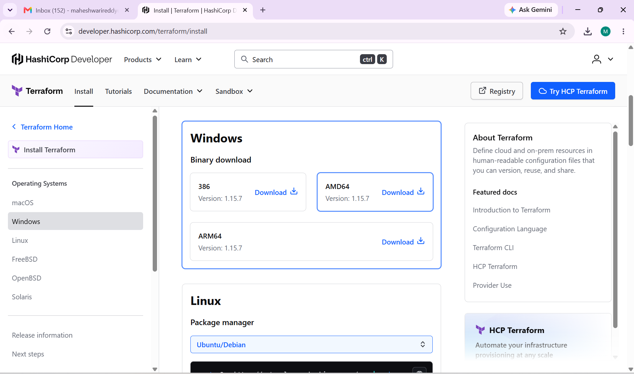

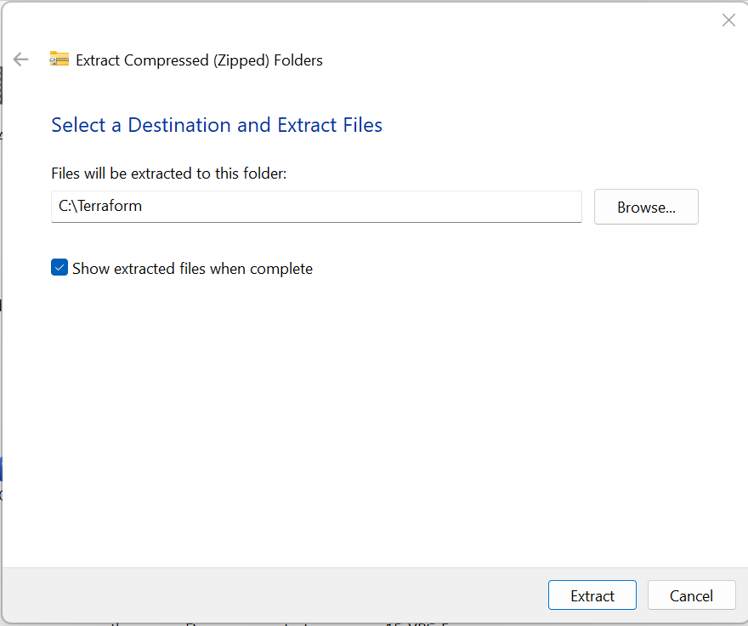

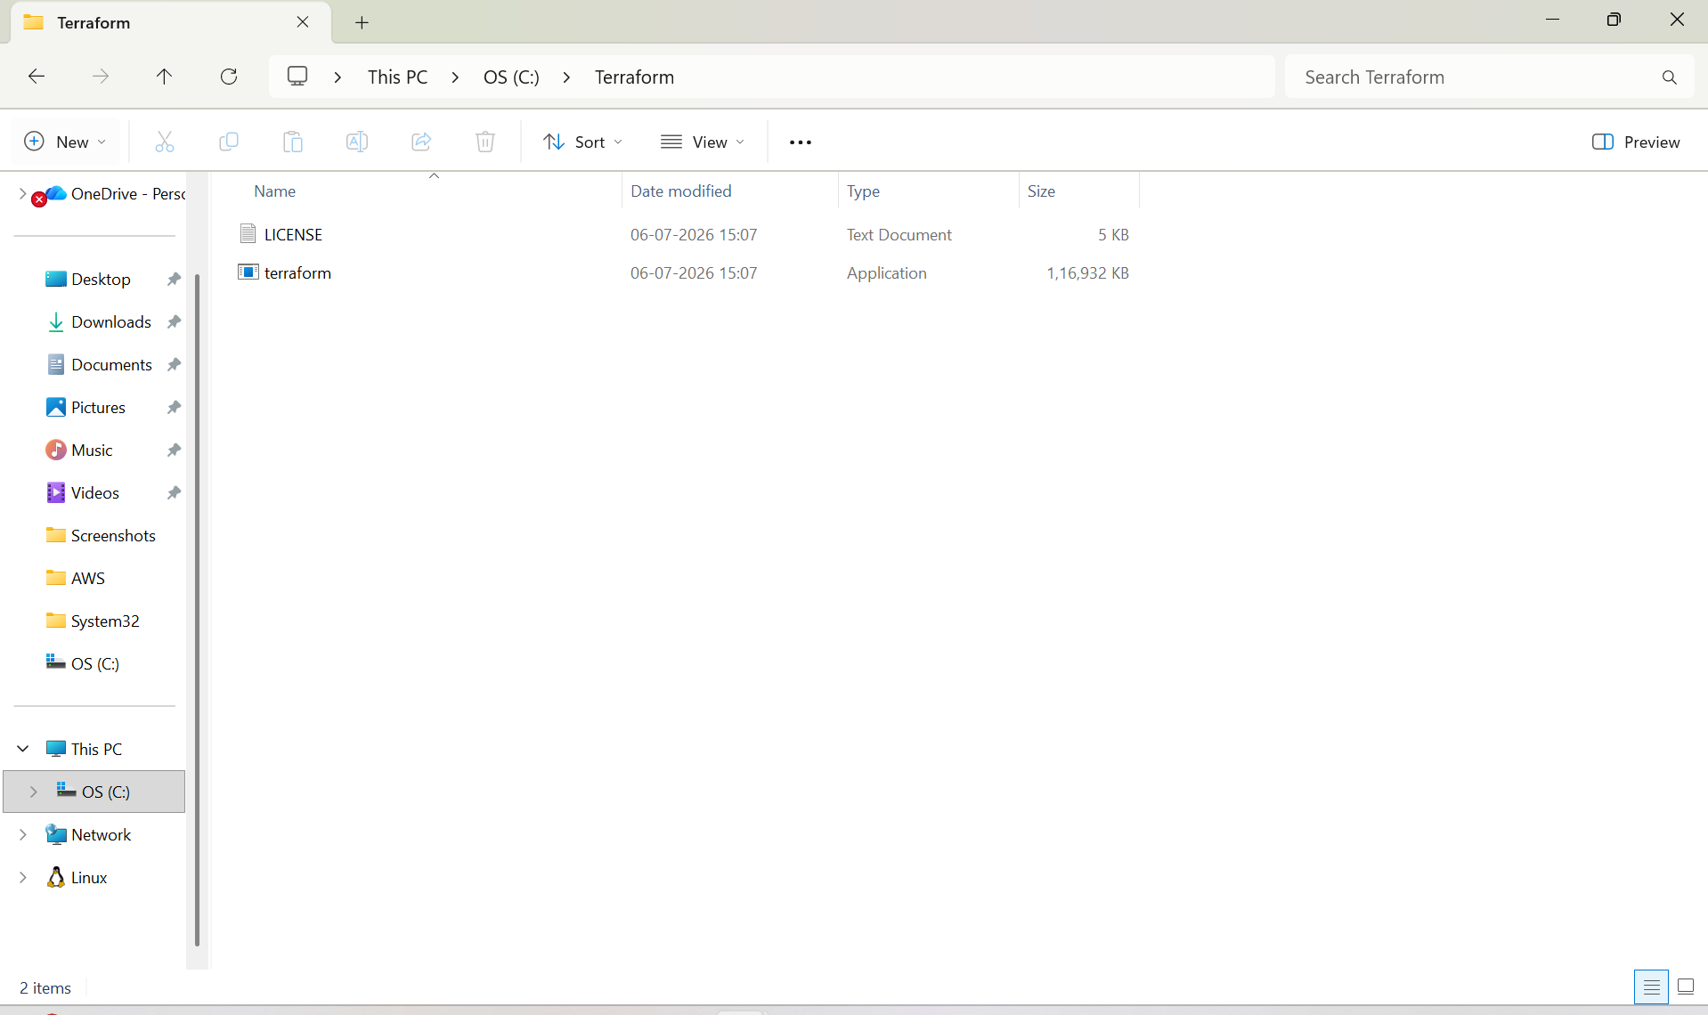

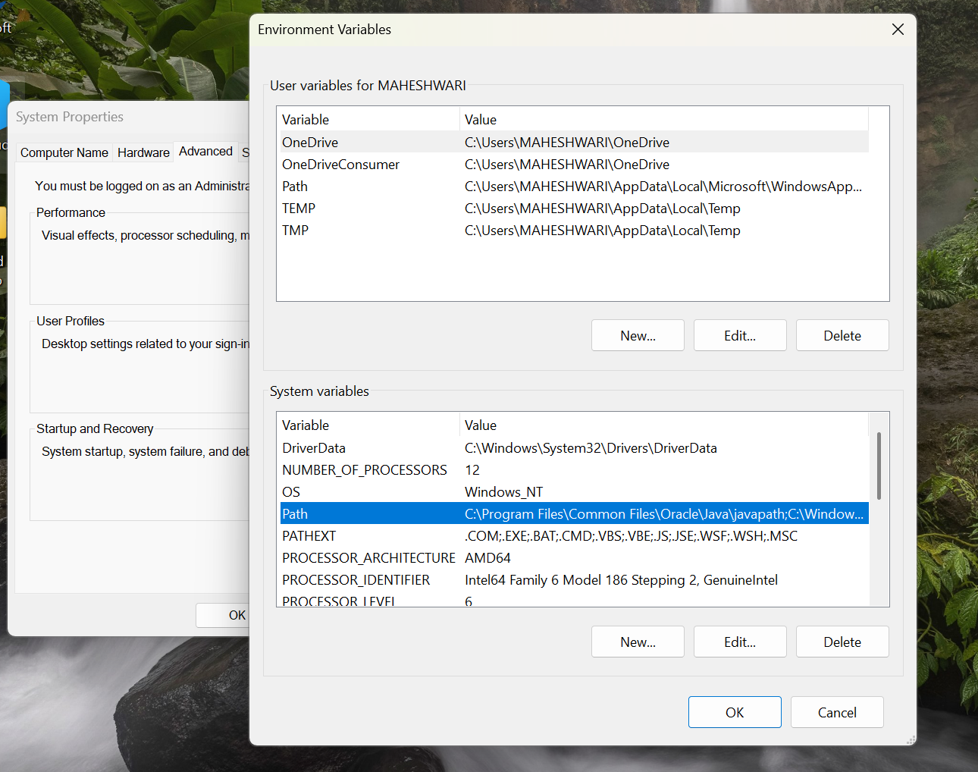

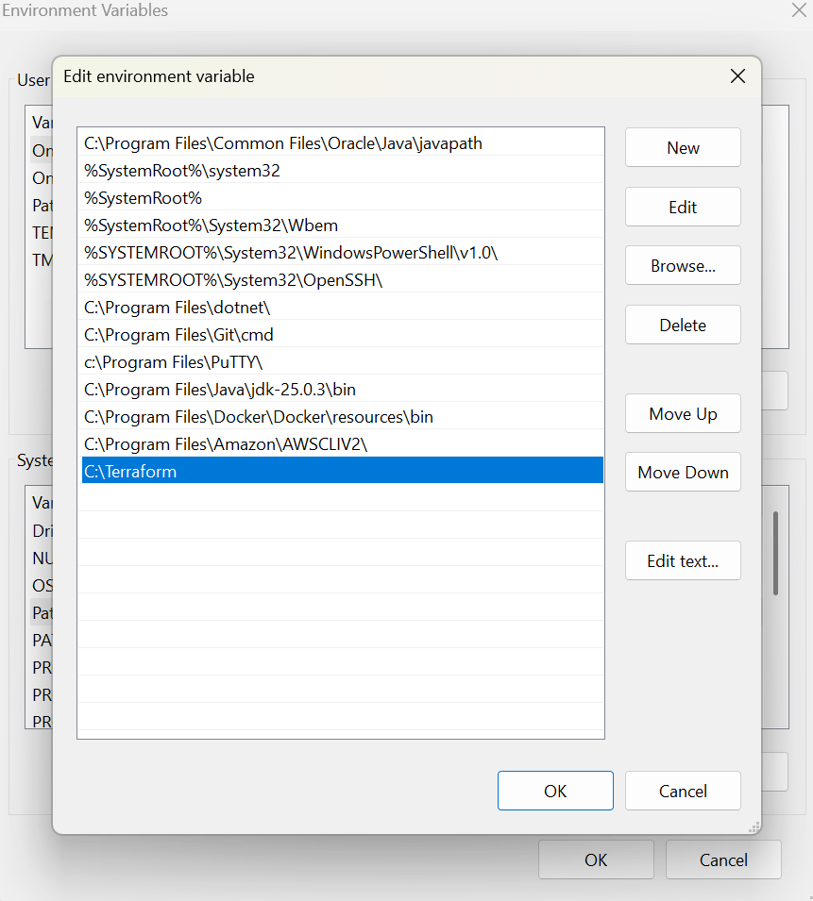

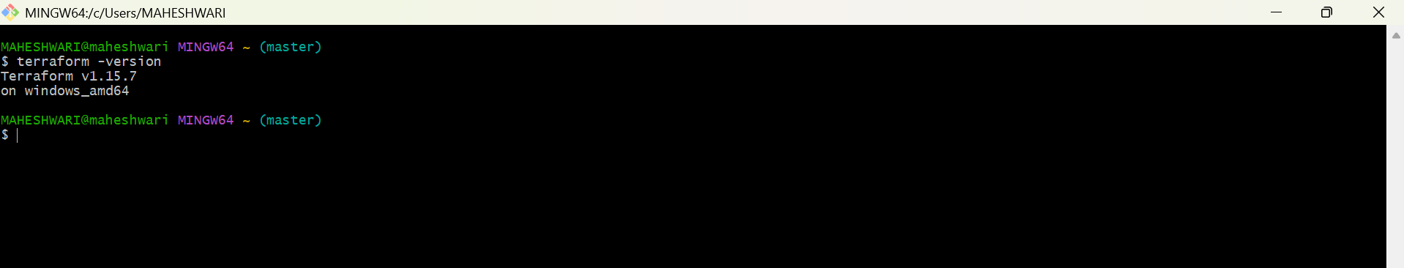

2. Execute all the templates shown in video.

EXAMPLE – 01:

Resource “local_file” “my_pet” {
Filename = “my_pet.txt”
Content = “my pet is a dog”
}

- This example will create a local file in our local machine file name will be my_pet.txt and content will be my pet is a dog.

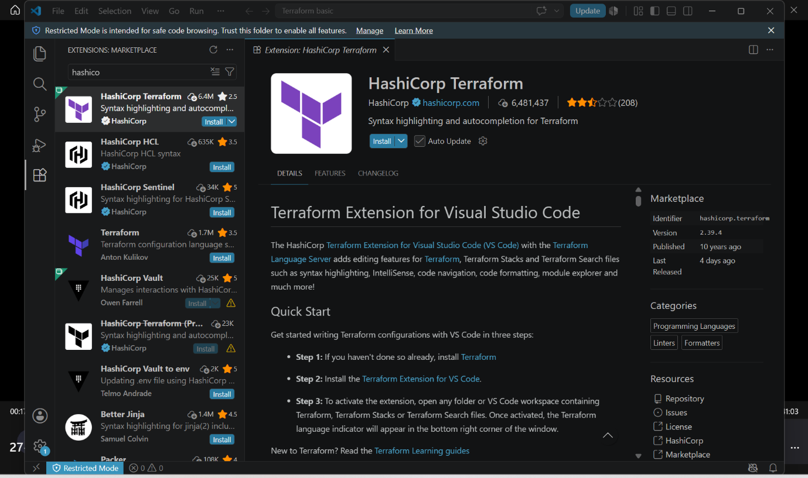

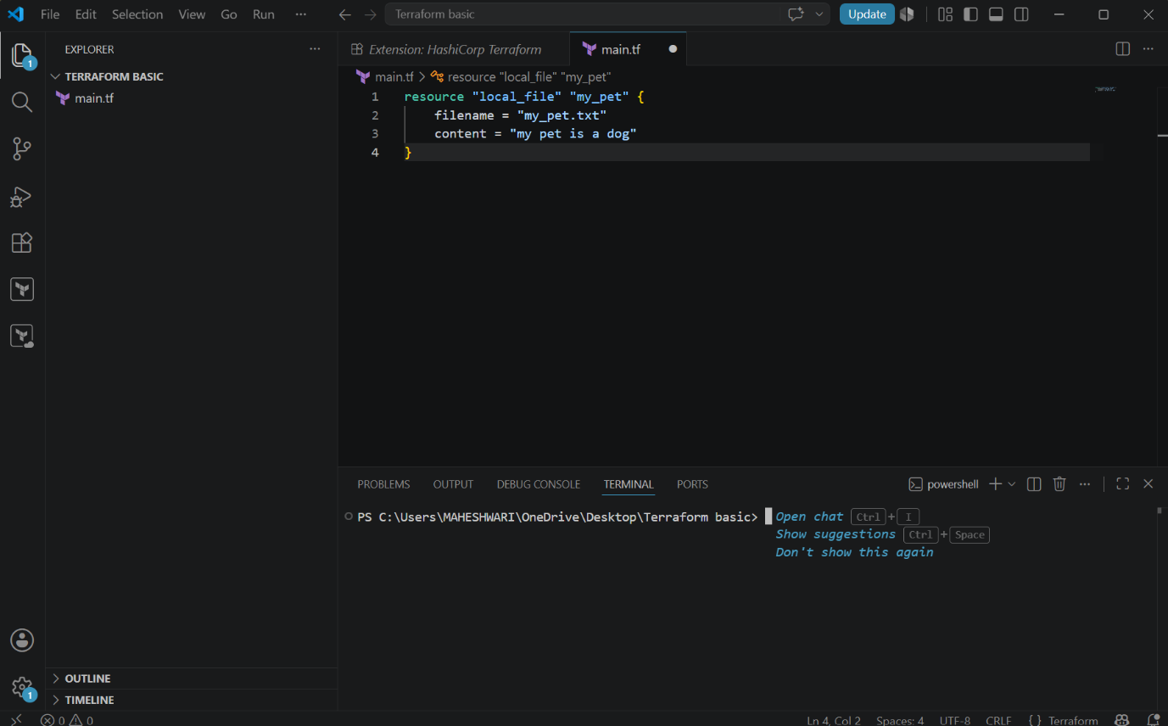

- After writing the template in main.tf, we have to initialize the terraform -> terraform init

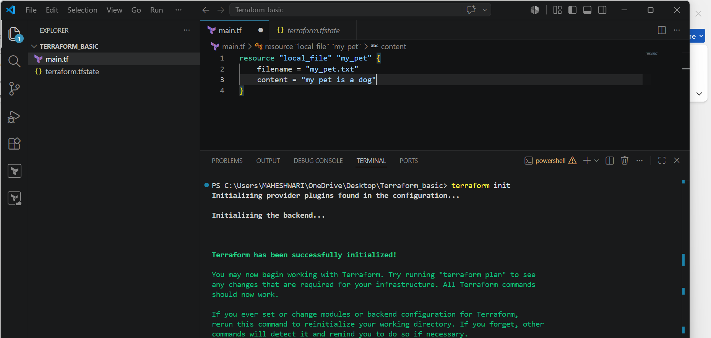

- Then we have to execute the command -> terraform plan
- This command will be shows that what will be created or what will happened by using this template.

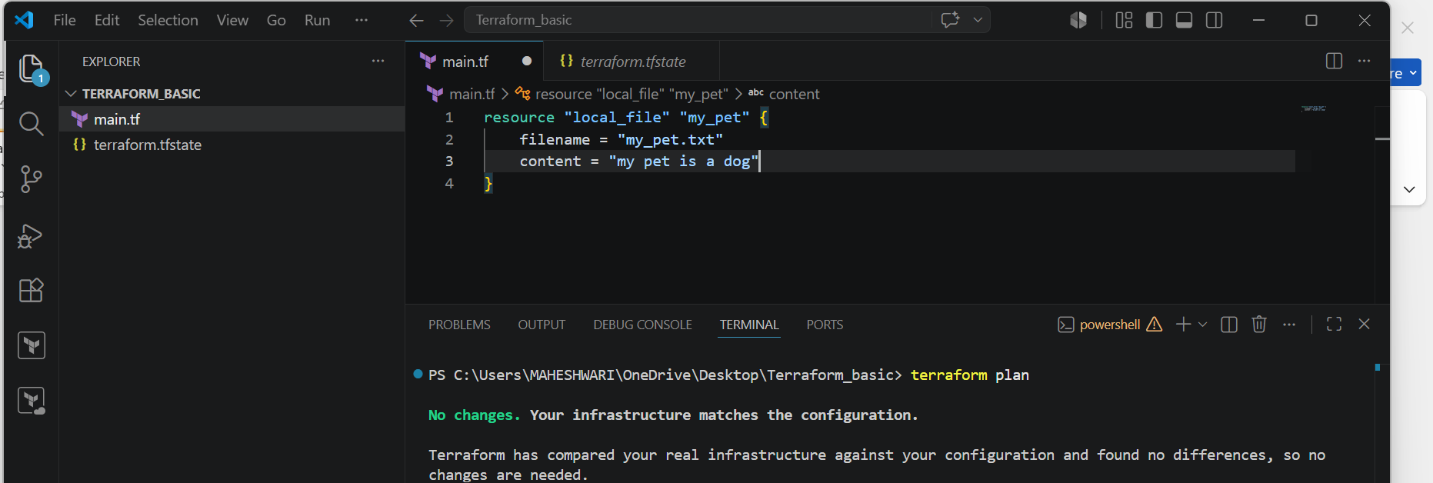

- Then we have to execute the command -> terraform apply.
- This will be the actual command to run our template.

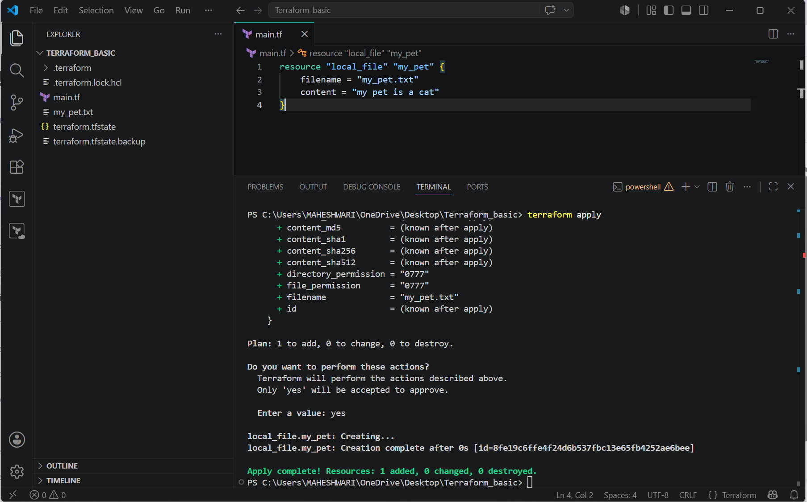

Example – 02:

- Change the content and change the file name.
- After that save the template -> ctrl + s
- Then execute terraform plan and after that execute terraform apply.

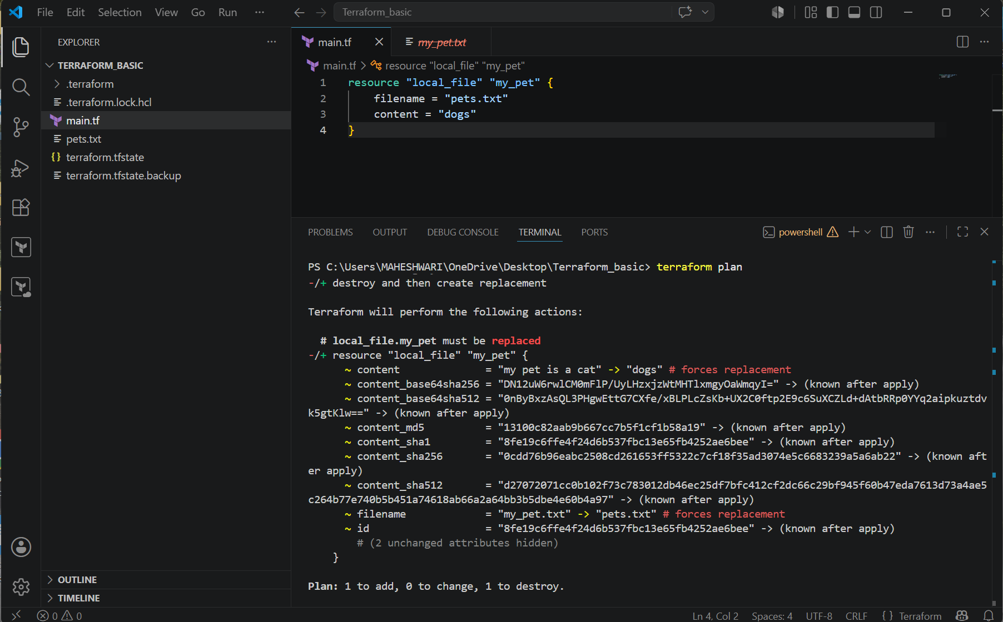

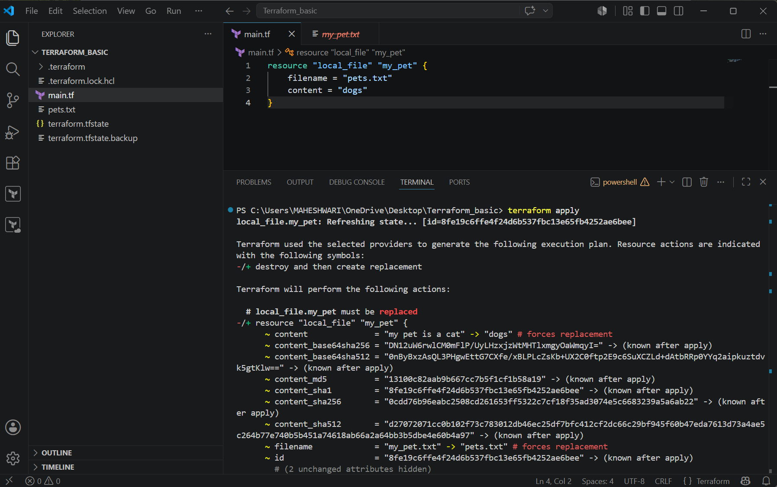

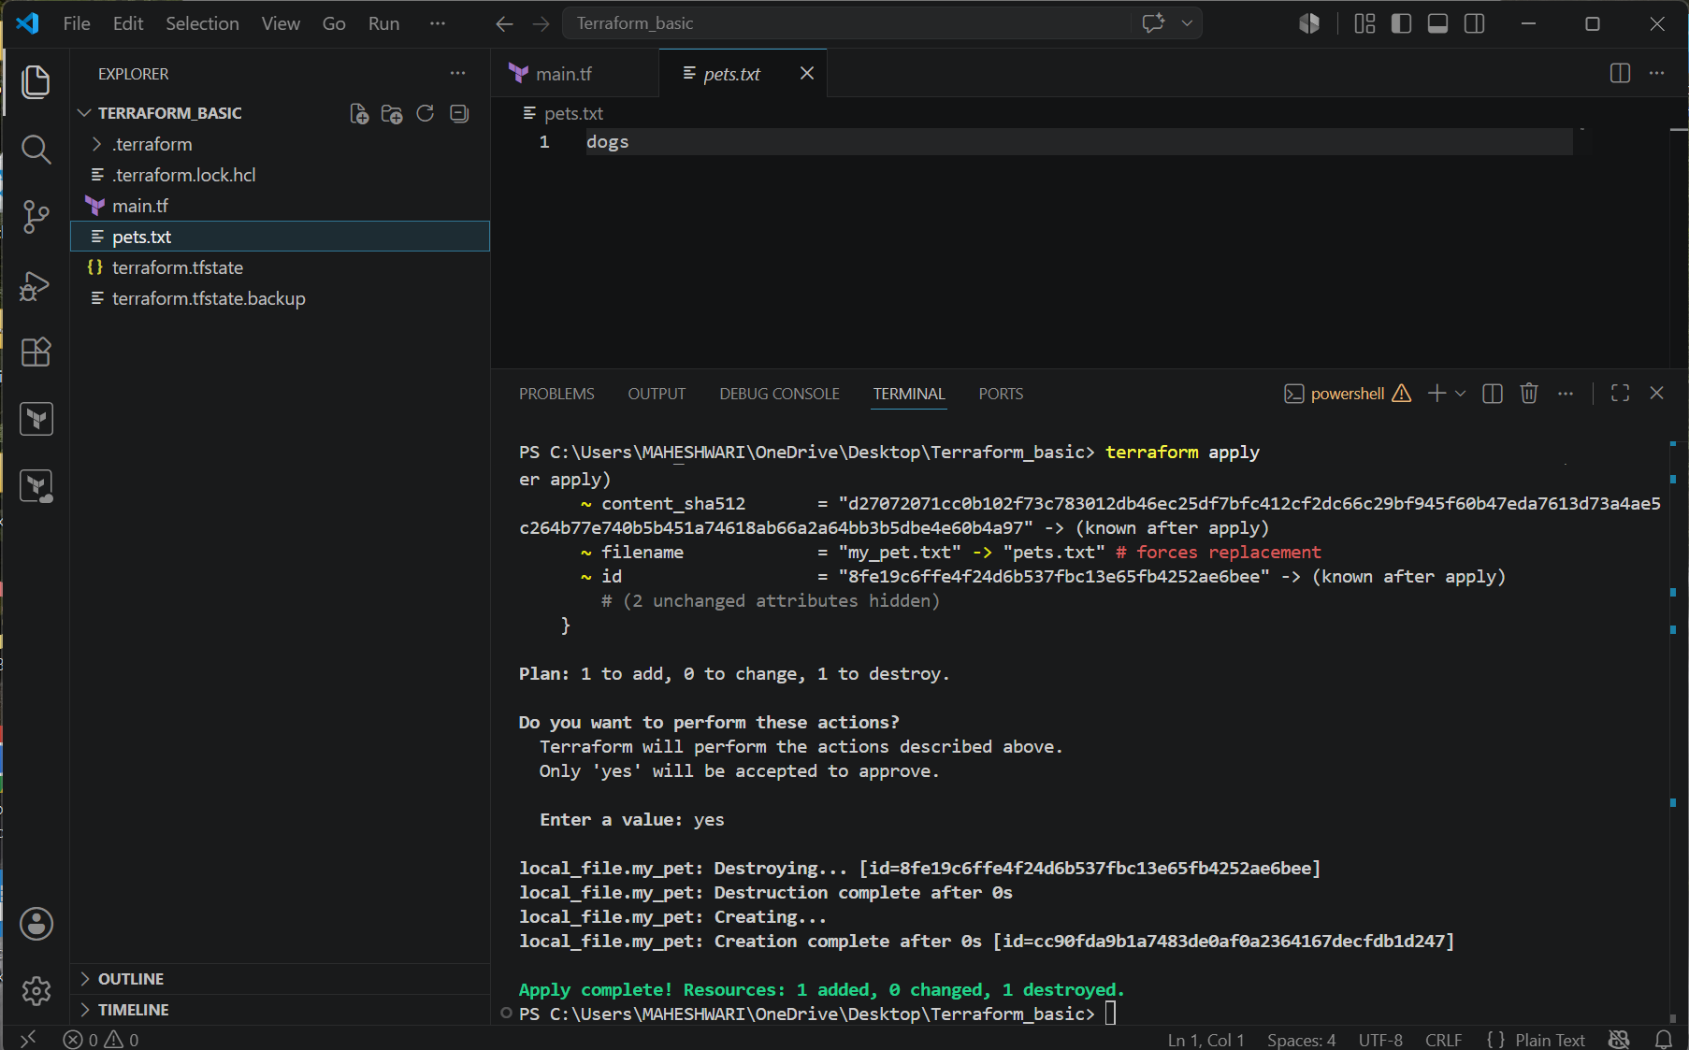

Example – 03:
- Now add one more resource and prefix and separator.

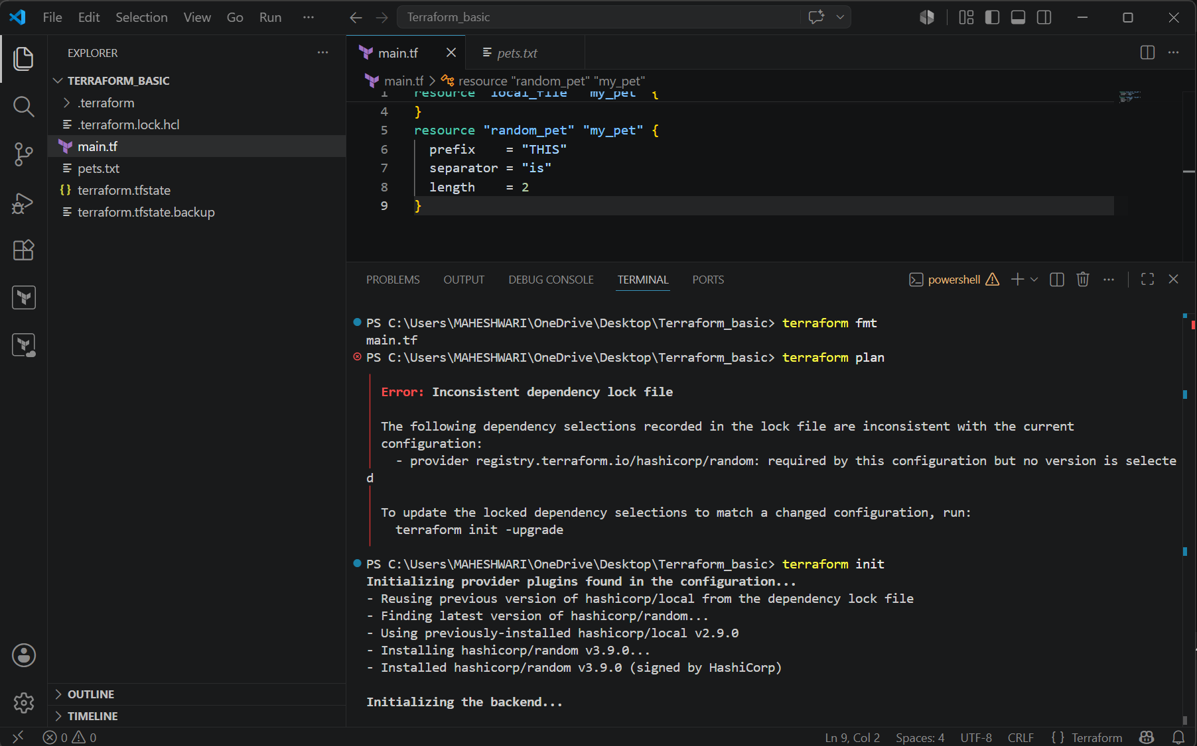

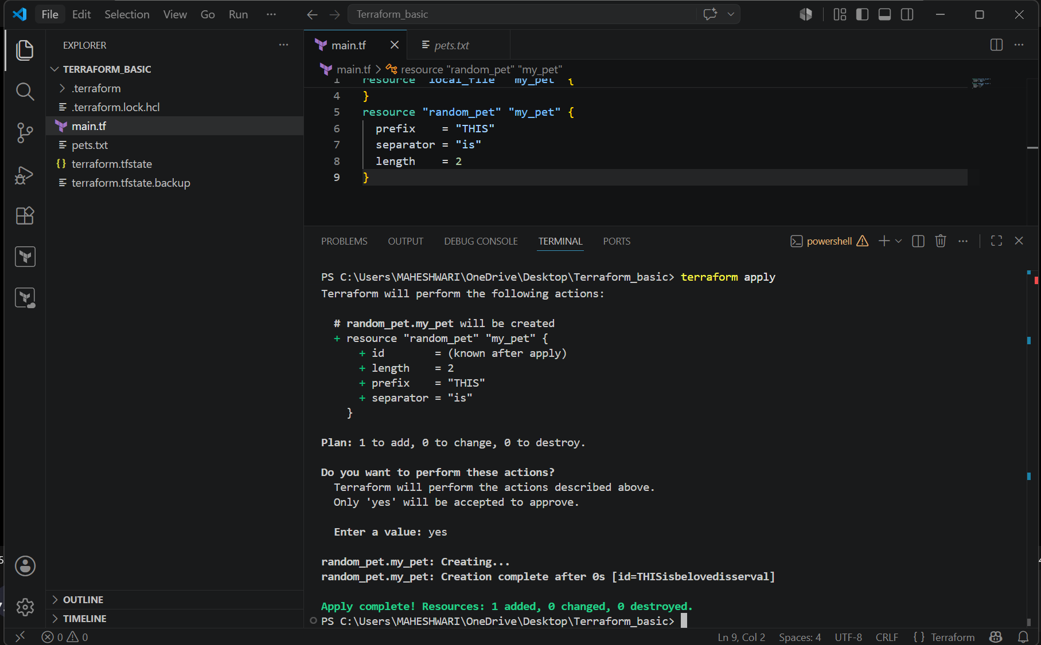

4. Integrate a sample Terraform template in Jenkins.

PURPOSE: The purpose of provisioning an Amazon EC2 instance using Terraform and installing Jenkins is to automate the creation of cloud infrastructure and set up a Continuous Integration/Continuous Delivery (CI/CD) server. This approach ensures infrastructure consistency, reduces manual effort, and enables faster, repeatable deployments.

OBJECTIVE:
- Learn Infrastructure as Code (IaC) concepts using Terraform.
- Provision an Amazon EC2 instance on AWS using Terraform configuration files.
- Configure AWS provider credentials and required Terraform resources.
- Automate the creation of networking, security groups, and compute resources.
- Install and configure Jenkins on the EC2 instance.
- Access the Jenkins web interface and complete the initial setup.
- Understand how Terraform automates infrastructure provisioning and management.
- Gain hands-on experience with integrating Terraform and Jenkins for DevOps workflows.
- Ensure infrastructure deployments are repeatable, scalable, and version-controlled.
- Build a foundation for implementing CI/CD pipelines on AWS using Jenkins.

STEP BY STEP IMPLEMENTATION:
- Create a directory terraform-jenkins.
- In that directory, we have to create file called main.tf for our terraform code.

CODE:

provider "aws" {
region = "ap-south-1"
}

resource "aws_security_group" "jenkins_sg" {
name = "jenkins-sg"

ingress {
from_port = 22
to_port = 22
protocol = "tcp"
cidr_blocks = ["0.0.0.0/0"]
}

ingress {
from_port = 8080
to_port = 8080
protocol = "tcp"
cidr_blocks = ["0.0.0.0/0"]
}

egress {
from_port = 0
to_port = 0
protocol = "-1"
cidr_blocks = ["0.0.0.0/0"]
}
}

resource "aws_instance" "jenkins" {
ami = "ami-0f58b397bc5c1f2e8" # Amazon Linux 2 (update for your region)
instance_type = "t2.micro"
key_name = "your-keypair-name"
vpc_security_group_ids = [aws_security_group.jenkins_sg.id]

user_data = <<-EOF
#!/bin/bash
yum update -y

# Install Java
amazon-linux-extras install java-openjdk11 -y

# Add Jenkins Repository
wget -O /etc/yum.repos.d/jenkins.repo https://pkg.jenkins.io/redhat-stable/jenkins.repo
rpm --import https://pkg.jenkins.io/redhat-stable/jenkins.io-2023.key

# Install Jenkins
yum install -y jenkins

# Start Jenkins
systemctl enable jenkins
systemctl start jenkins
EOF

tags = {
Name = "Terraform-Jenkins"
}
}

- After that verify terraform is installed or not.
- By the commands ->

  - Install terraform - sudo dnf install -y yum-utils
  - Add the hashicorp repo - sudo yum-config-manager --add-repo https://rpm.releases.hashicorp.com/AmazonLinux/hashicorp.repo
  - Install terraform - sudo dnf -y install terraform
  - Check terraform version – terraform --version

- Initialize the terraform -> terraform init
- After that validate the configuration -> terraform validate
- Preview the structure -> terraform plan
- Provision the instance -> terraform apply.
- Now we can see the new instance will be launched in AWS.

