TERRAFORM-02

1. Execute all the templates shown in the video.

USING OF VARIABLES:

Example-1: Declaring variables in the variables.tf file.

After declaring the variables and we have to made changes in the main.tf file also.

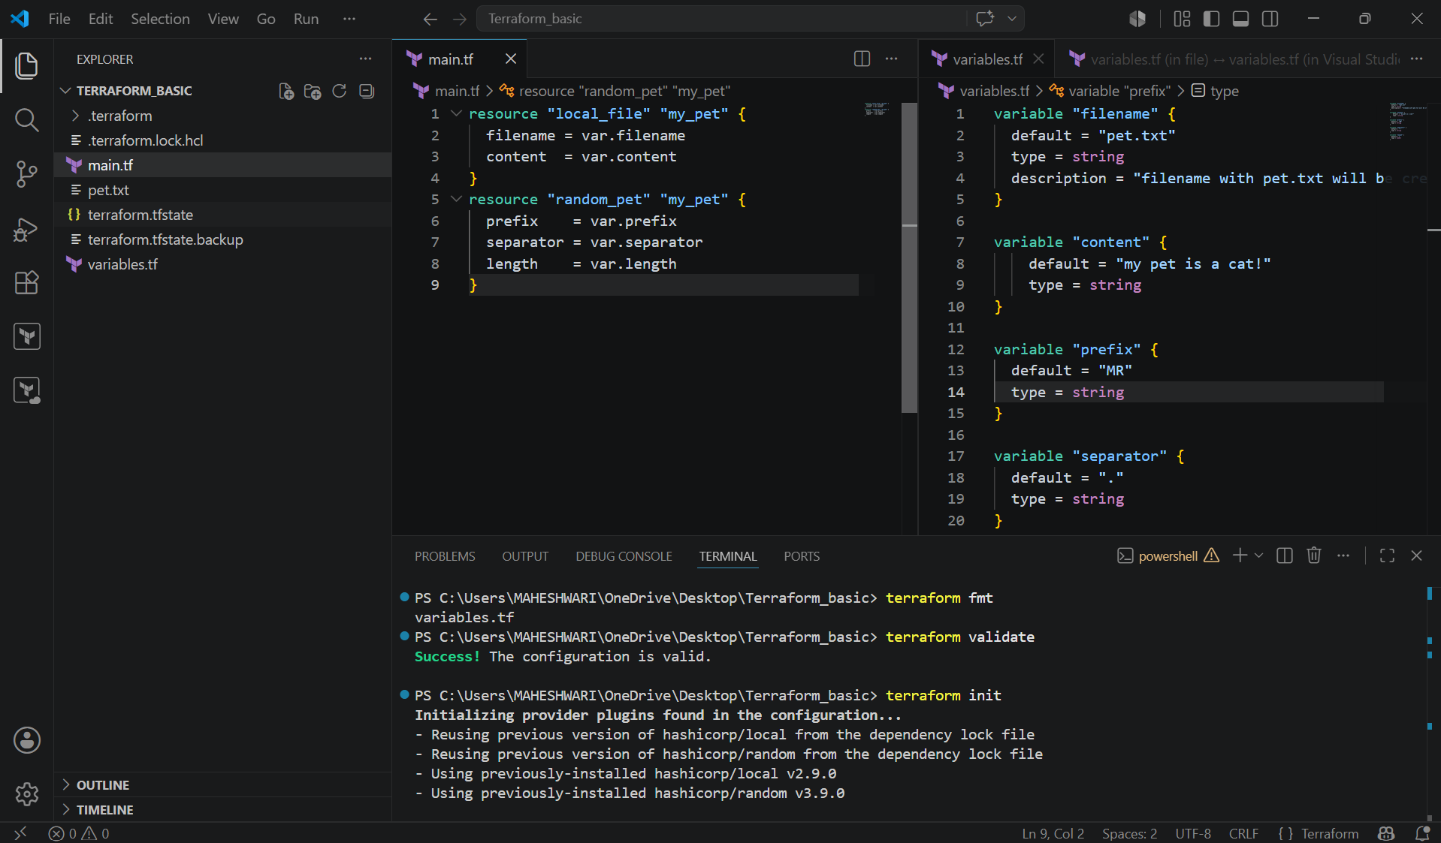

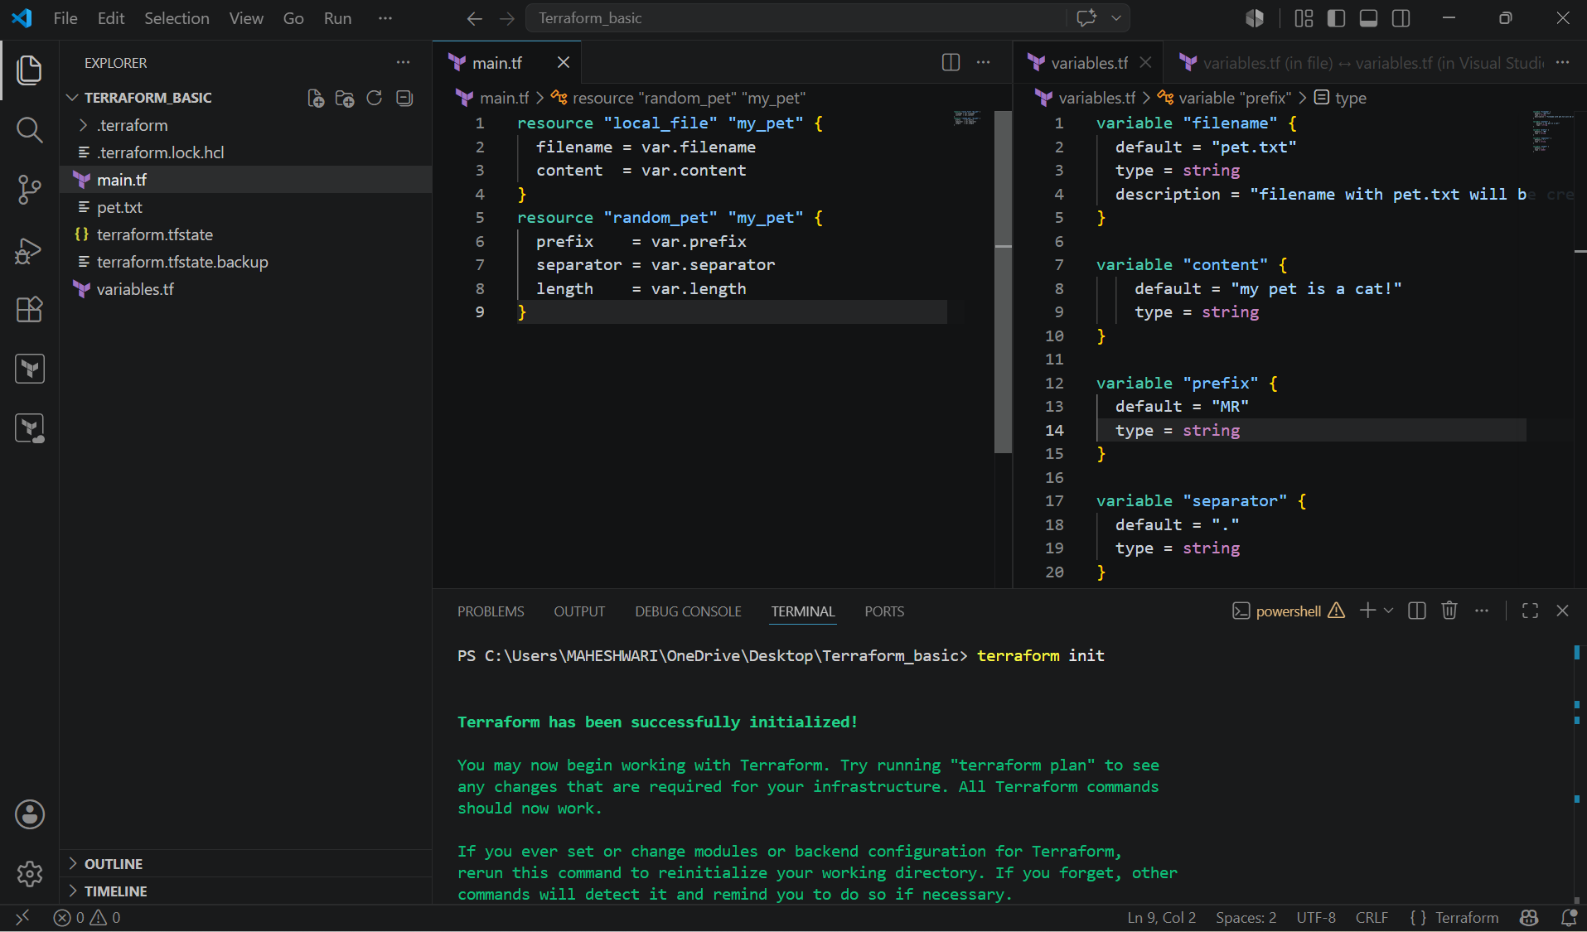

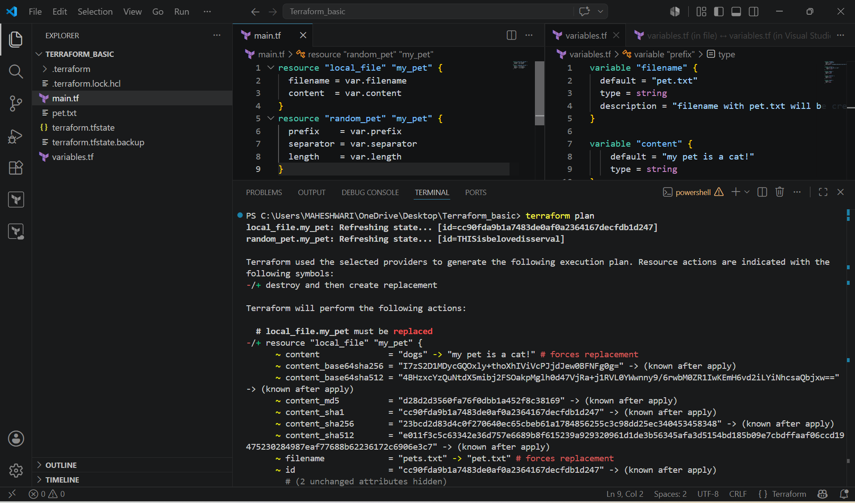

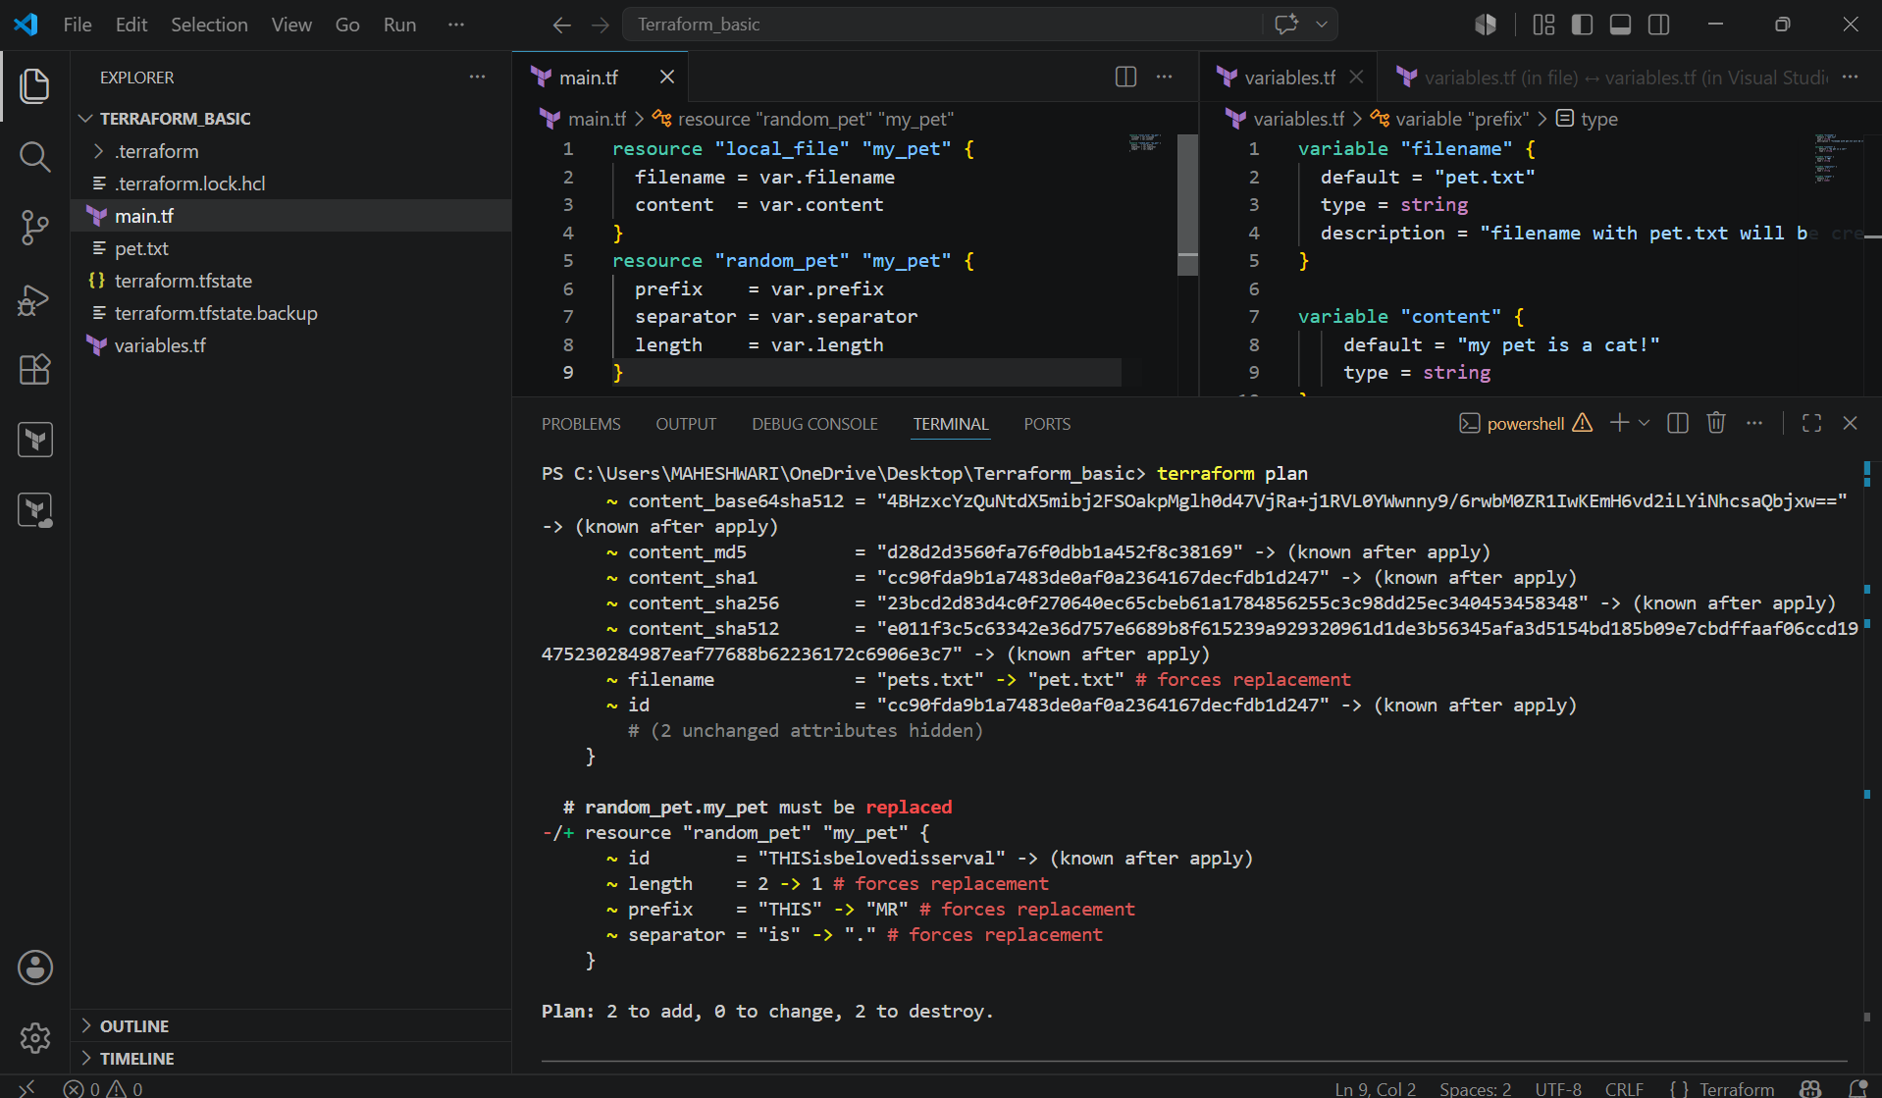

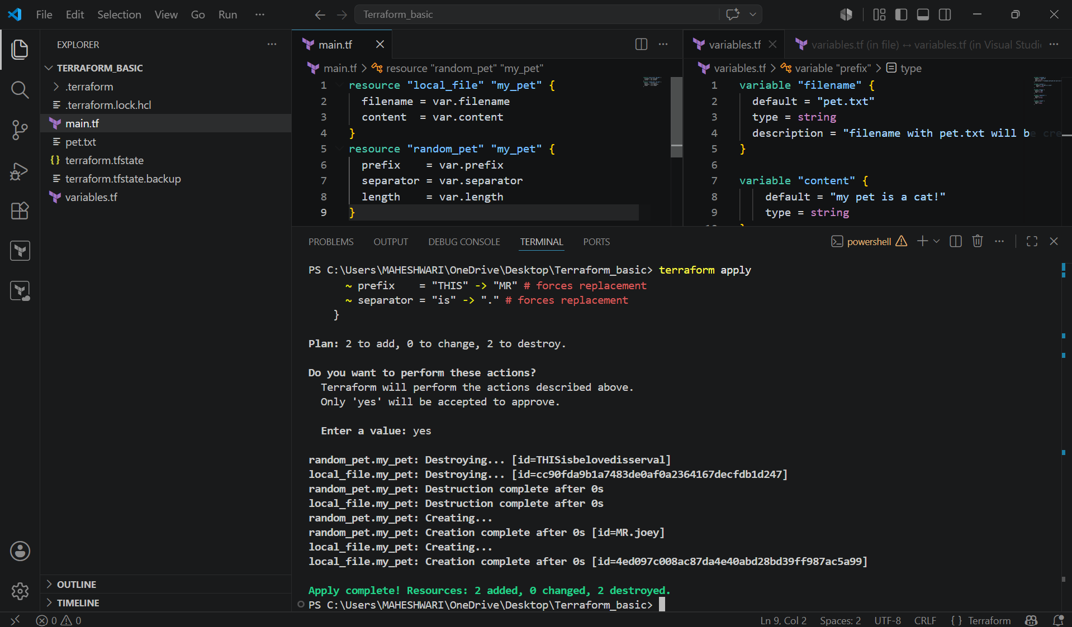

Example-2: command line flags

- We have to first declare the variables filename and content
- Then we have to give the value for the variables that are declared earlier in the command line.
- Ex: terraform apply -var “filename=wild.txt” -var “content=I love Lion!!”
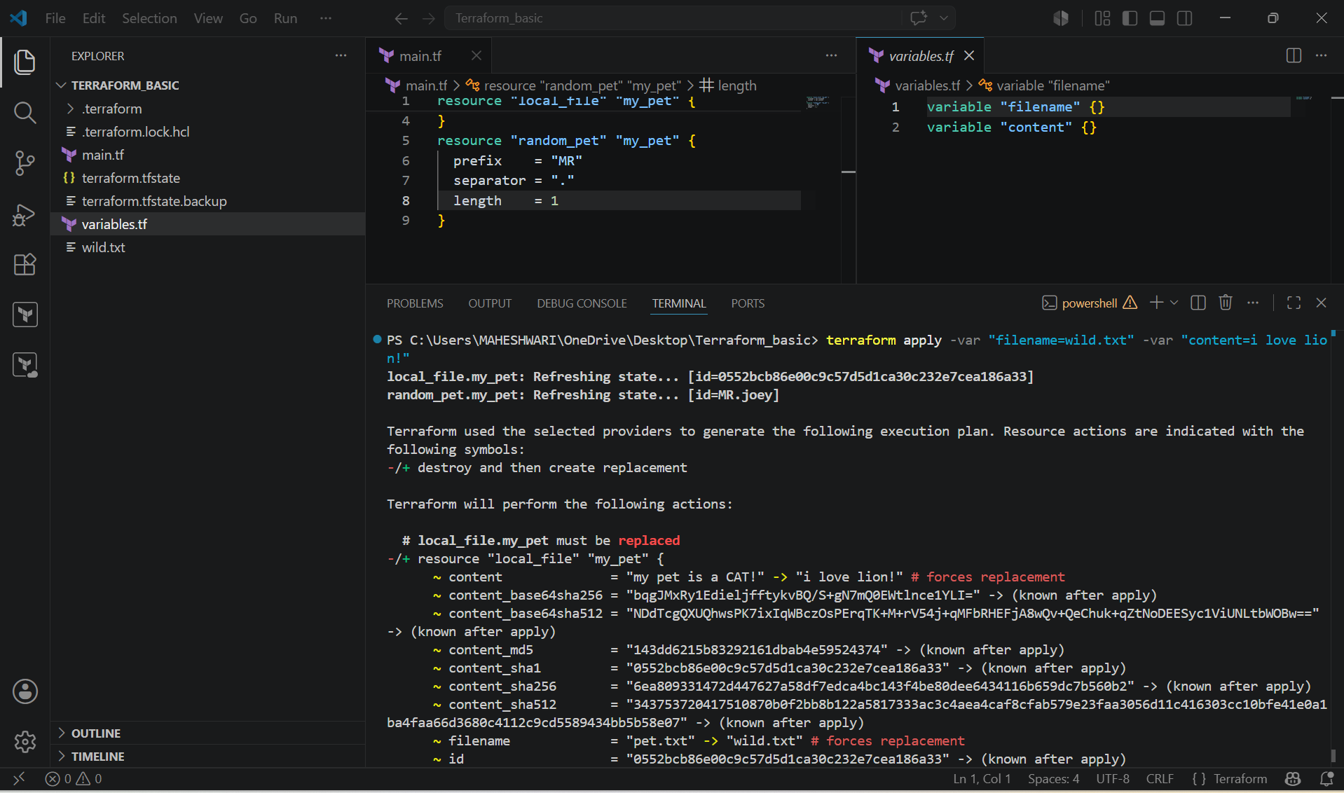

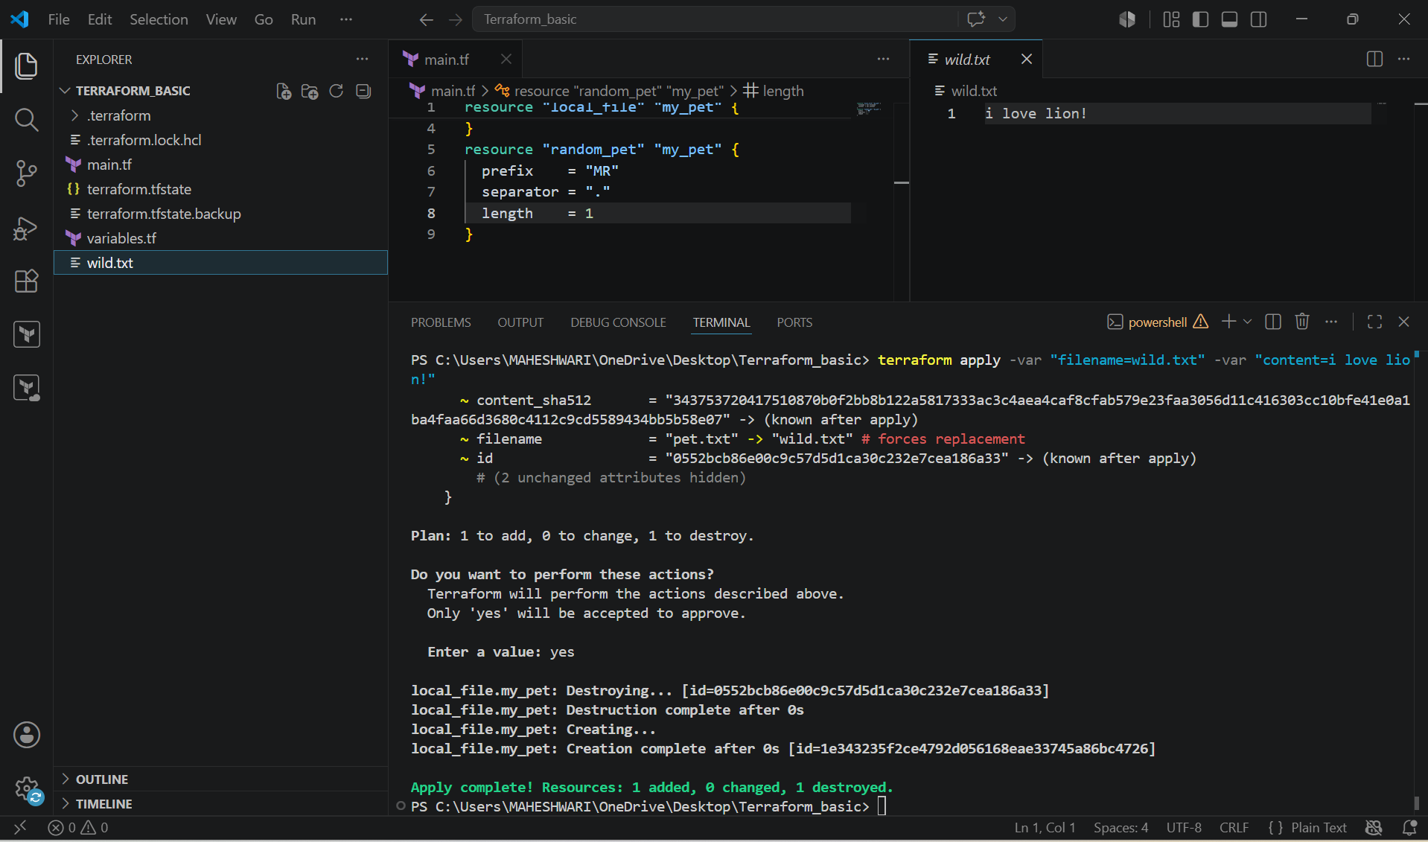

Example-3: By using interactive mode

- By using the variables in the mode, it will prompt us to enter the value for the variables that are declared earlier.
- We have to declare the variables initially only.

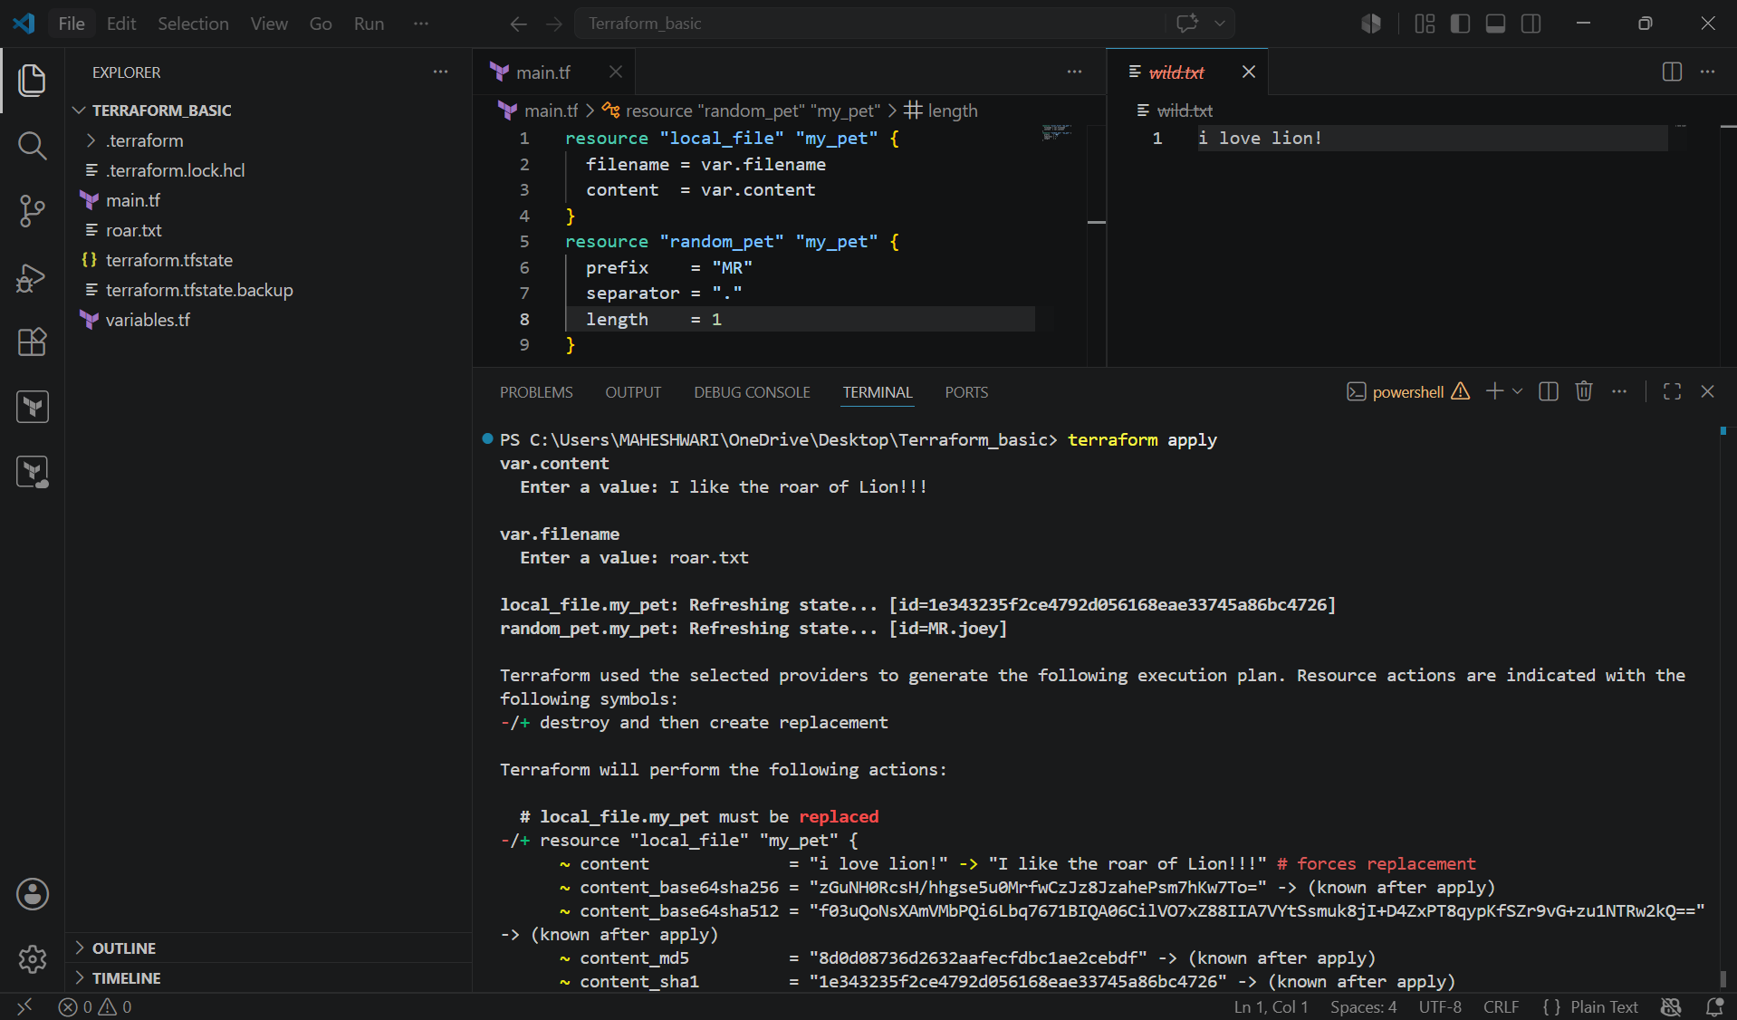

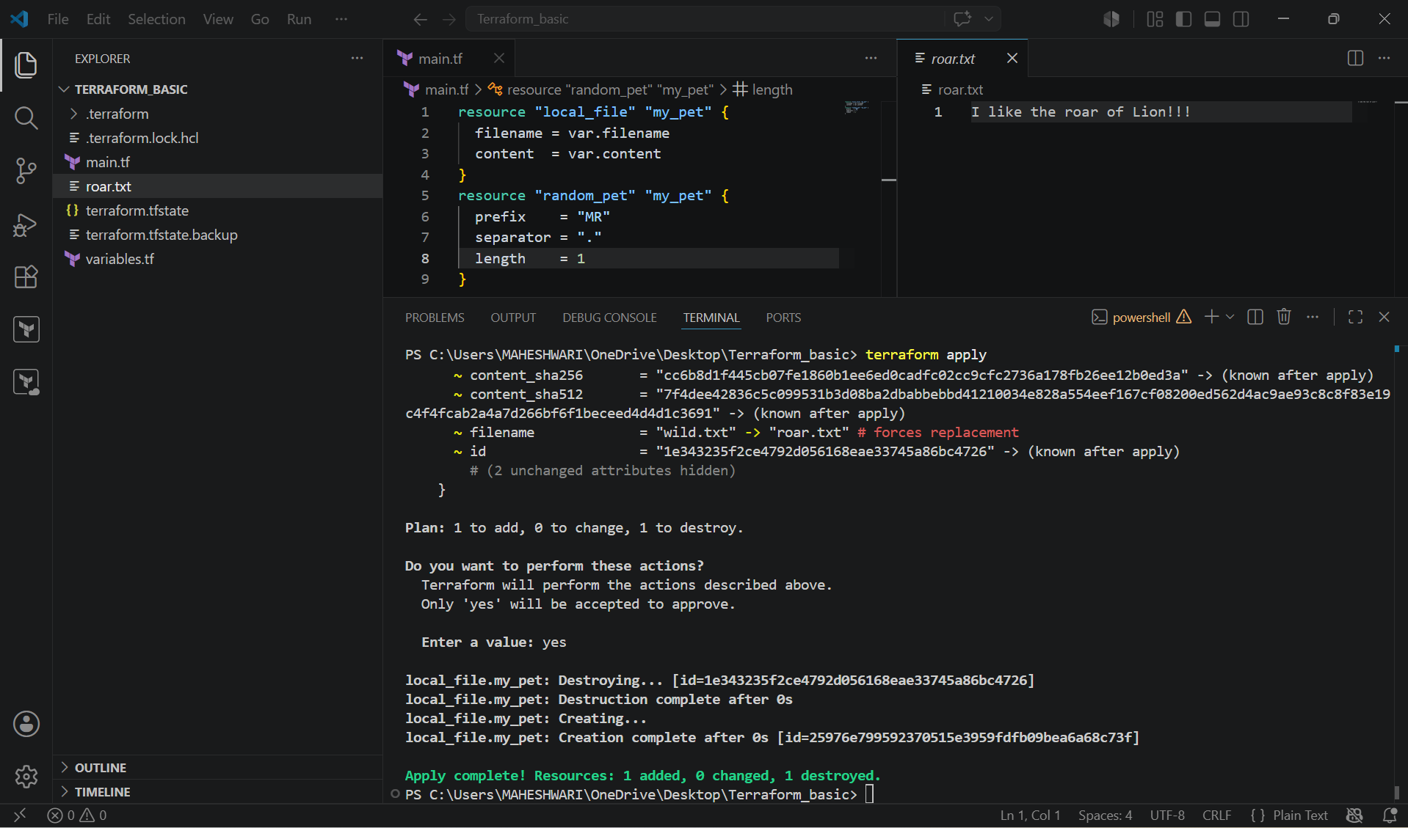

LIFECYCLE RULES:

1. create_before_destroy:

- Terraform will destroy the file before creating a new file by default.
- So we can create a file before destroy by using the lifecycle rules.

Resource “local_file” “pet” {
filename = var.filename
content = var.content

lifecycle {
create_before_destroy = true
}
}

- I have changed the filename from pet.txt to pets.txt.
- By executing terraform apply, it will first create a backup and then it will destroy.

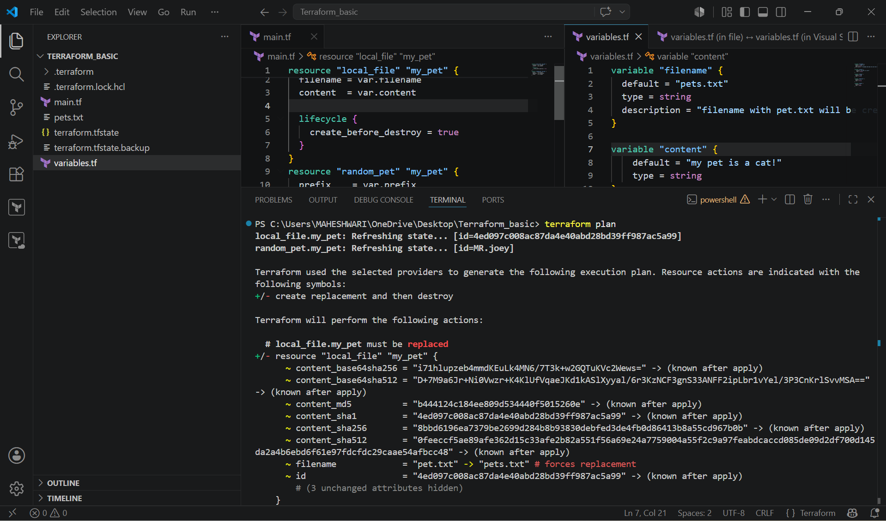

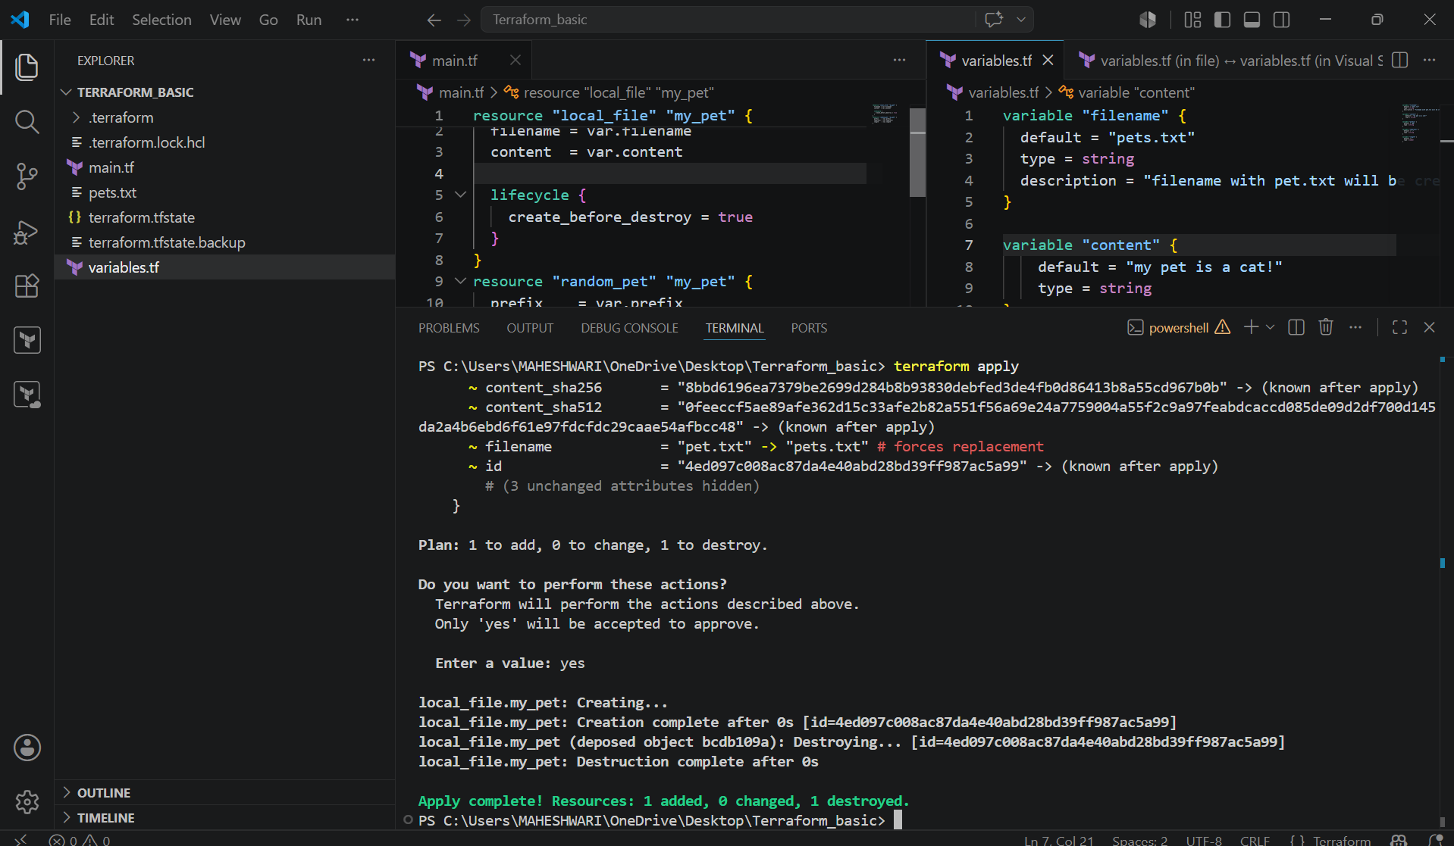

2. prevent_destroy :

- If we don’t want to destroy the existing template configurations, then we can use prevent_destroy.

Resource “local_file” “pet” {
filename = var.filename
content = var.content

lifecycle {
prevent_destroy = true
}
}

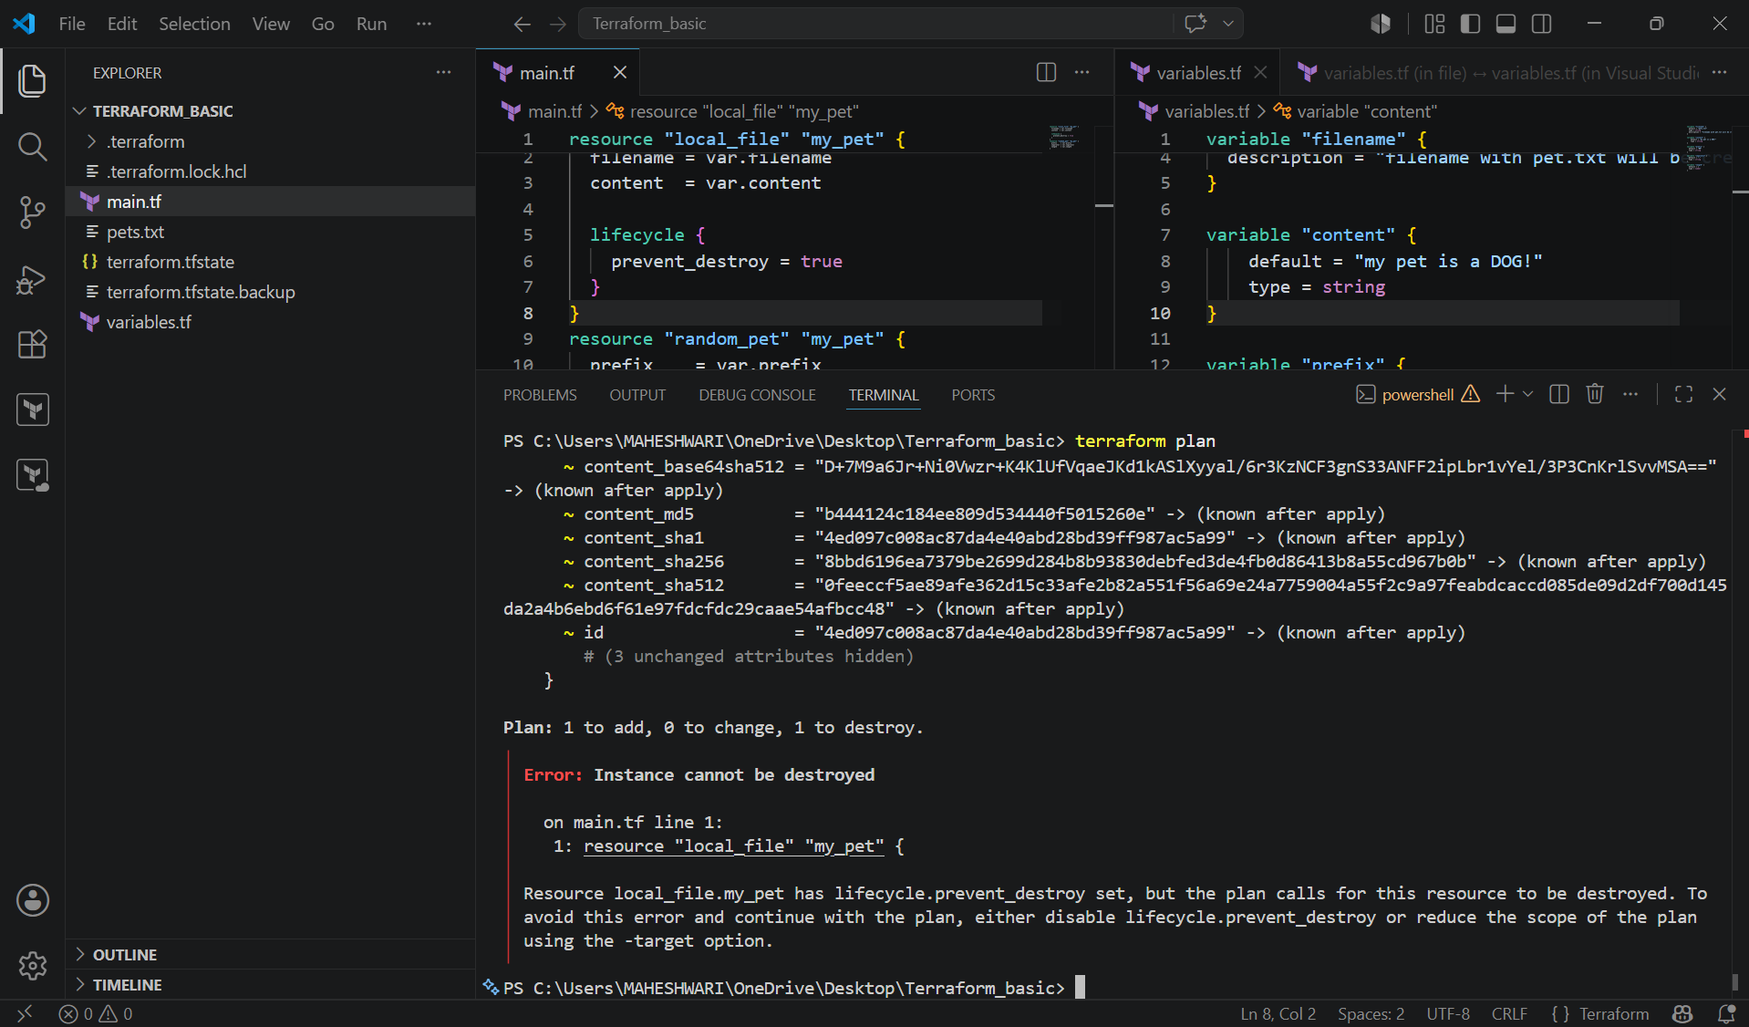

3. ignore_changes:

- This will be only helpful if we are using terraform apply command, if we use terraform destroy then it will destroy the resource.
- If we want to ignore the changes which has been by third-party tool or manually then we can use the ignore_changes.

Resource “local_file” “pet” {
filename = var.filename
content = var.content

lifecycle {
ignore_changes = [
content
]
}
}

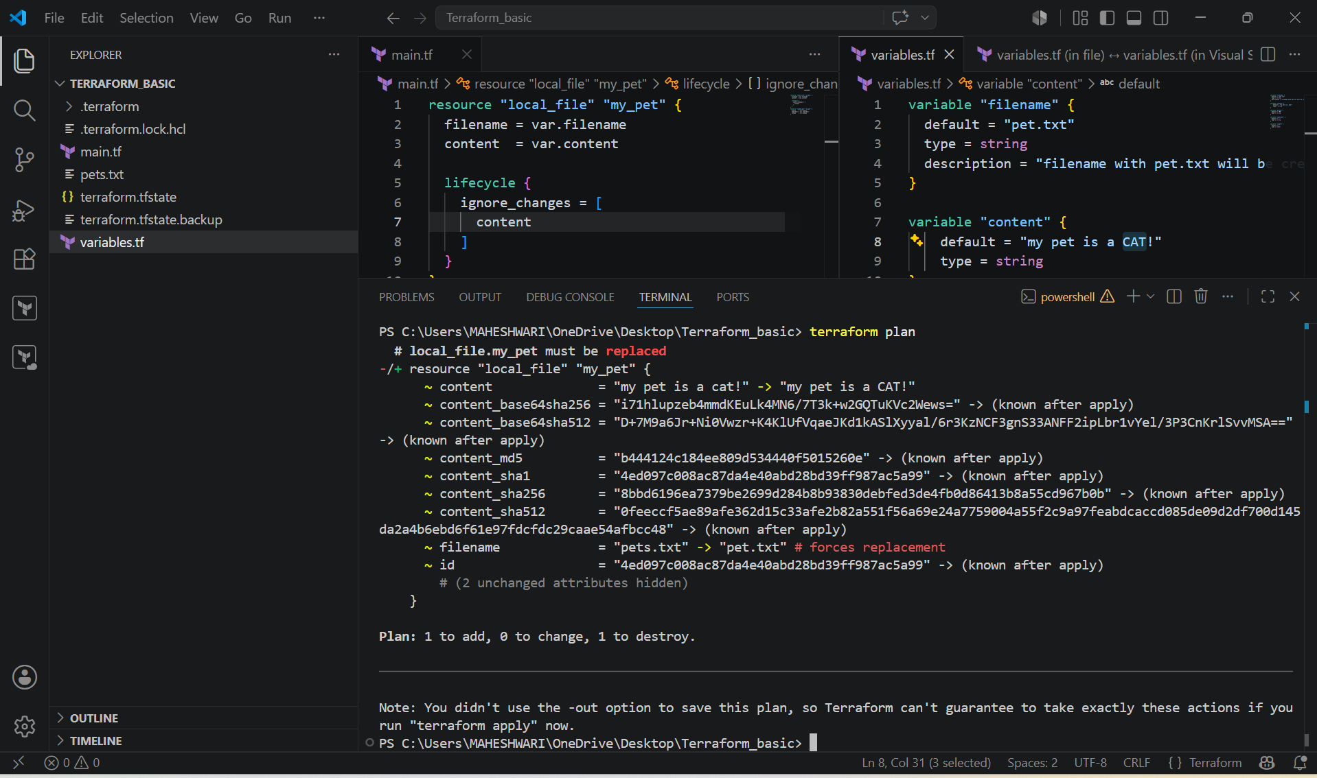

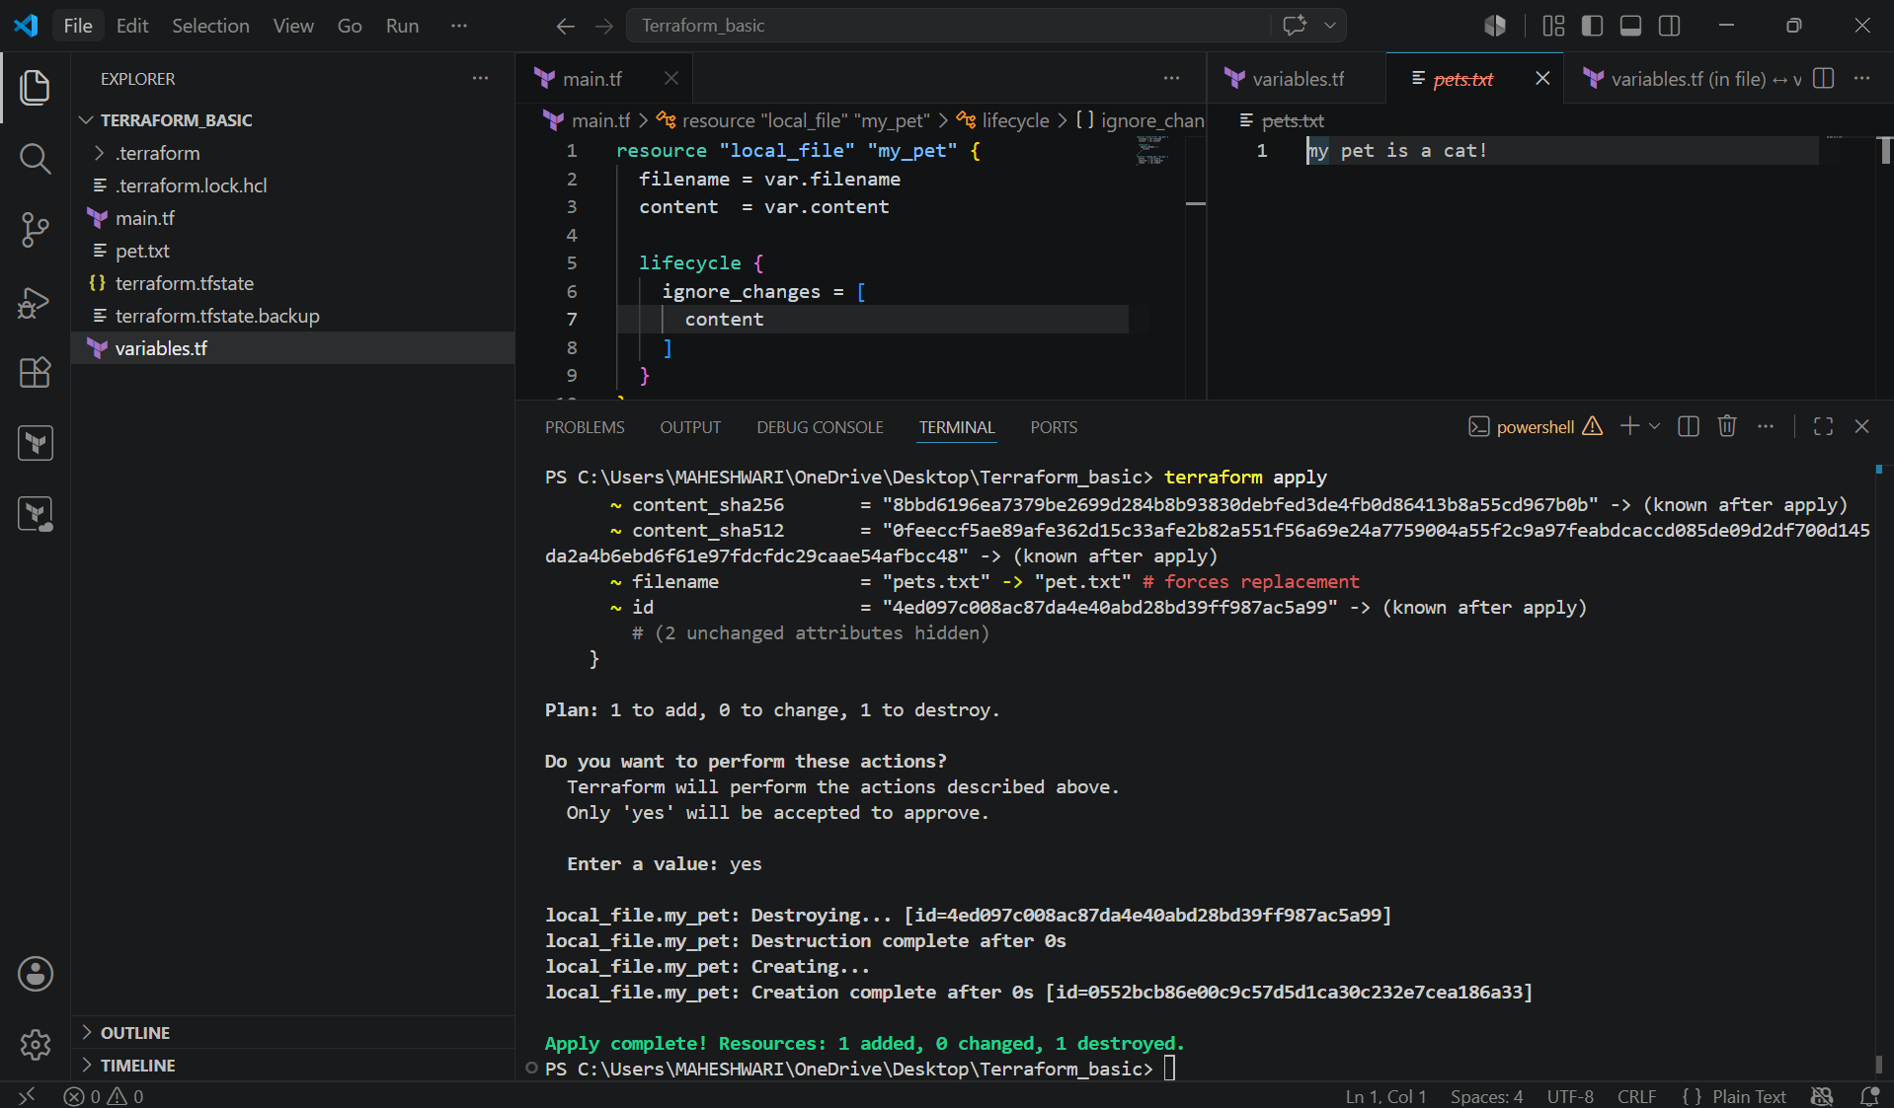

3. Integrate Terraform in Jenkins using the Terraform plugin

PURPOSE: The purpose of integrating Terraform with Jenkins using the Terraform plugin is to automate infrastructure as Code (IaC) deployments through a CI/CD pipeline. Instead of manually running Terraform commands on a machine Jenkins executes them.

OBJECTIVE:
- After integrating Terraform with Jenkins, you should be able to:
- Install and configure Terraform as a Jenkins tool using the Terraform plugin.
- Store Terraform code in a Git repository.
- Automatically check out the latest Terraform code from GitHub.
- Execute Terraform commands from a Jenkins pipeline:
- terraform init
- terraform validate
- terraform plan
- terraform apply
- provision and manage cloud infrastructure (such as AWS, Azure or GCP) in a consistent and repeatable way.
- Reduce manual deployment effort and configuration errors.
- Integrate infrastructure provisioning into the organization’s CI/CD process.

OUTCOME:

By the end of the integration:
- Jenkins is configured with the Terraform plugin.
- Terraform is available as a managed tool in Jenkins.
- A pipeline automatically executes Terraform commands.
- Infrastructure changes are version-controlled through Git.
- Infrastructure deployments become automated, consistent, and repeatable.
- Manual intervention is minimized, improving deployment speed and reliability.

WORKFLOW:

Developer
|
▼
Push Terraform Code to GitHub
|
▼
Jenkins Pipeline Triggered
|
▼
Terraform Plugin Provides Terraform CLI
|
▼
terraform init
terraform validate
terraform plan
terraform apply
|
▼
Infrastructure Created/Updated
(AWS, Azure, GCP, etc.)

STEP BY STEP IMPLEMENTATION:

- First of all, login into the Jenkins server with the publicIp:8080 in the browser.
- Then after logged in, we have search for terraform plugin in the available plugins.
- Install the terraform plugin and add that installation in the tools.
- Then we have create a new job with the pipeline job style.
- In the job configurations, we have to select the pipeline from SCM.
- After selecting that, it will prompt us to select us to select SCM there we have to select git.
- After selecting git, again it will prompt us to enter the github repo url and credentials.
- If the repository is private then we have to give the credentials otherwise no need to pass the credentials if the repo is public.
- The given repo should have the files like JenkinsFile, main.tf, variables.tf, provider.tf and output.tf.
- Then only jenkins will execute the terraform commands by checking whether the repo have all the terraform files.
- Jenkinsfile consists of
pipeline {
agent any

tools {
terraform 'Terraform-1.13'
}

stages {

stage('Checkout') {
steps {
git 'https://github.com/username/terraform-basic.git'
}
}

stage('Terraform Version') {
steps {
sh 'terraform version'
}
}

stage('Terraform Init') {
steps {
sh 'terraform init'
}
}

stage('Terraform Validate') {
steps {
sh 'terraform validate'
}
}

stage('Terraform Plan') {
steps {
sh 'terraform plan'
}
}

stage('Terraform Apply') {
steps {
input "Apply Terraform?"

sh 'terraform apply -auto-approve'
}
}
}
}

- Then when you run the job by clicking on build now, it will go and check for the files in the repo and then it will executes the terraform commands written in Jenkinsfile and our job will be successful.

