TERRAFORM – 03

1. Execute the script shown in the video.

USING VARIABLES:

Example-1:

- Environment variables:
- export TF_VAR_<variableName> = “path/filename”
- export is used for the linux server.
- Set-Item -Path env:TF_VAR_<variableName> -value <filename>
- Set-Item is used for the windows machine.

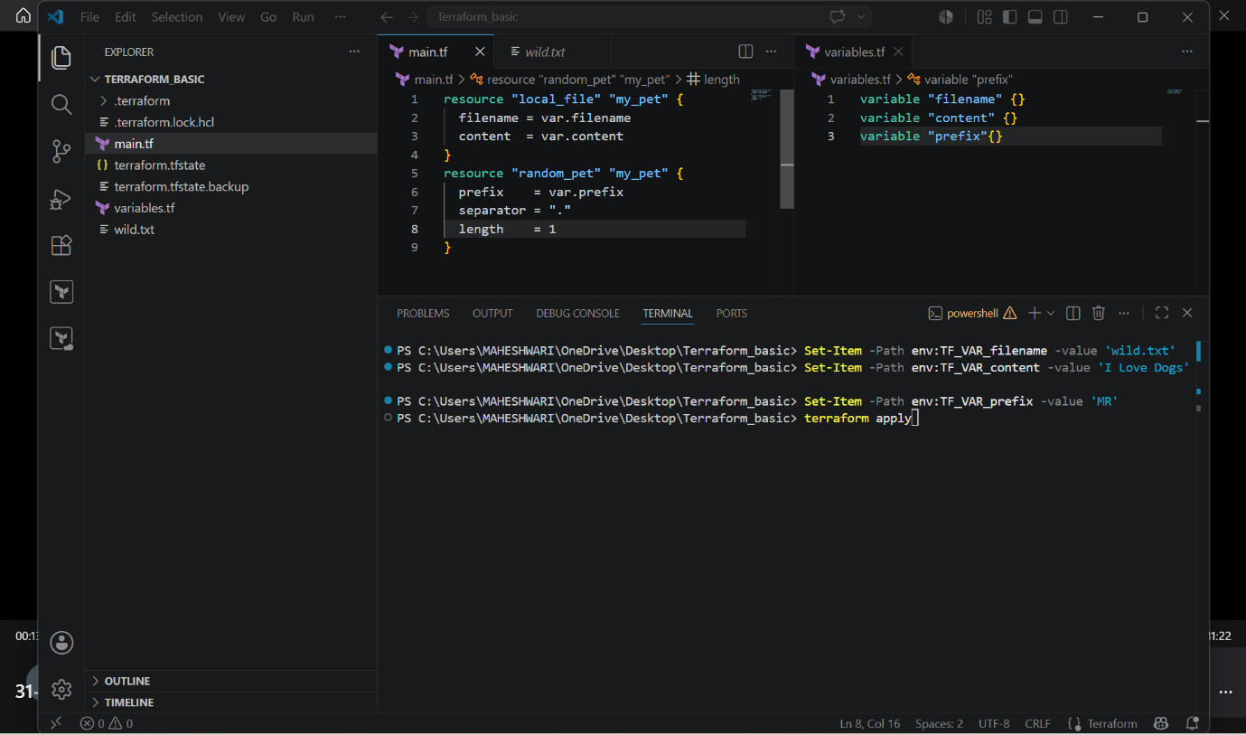

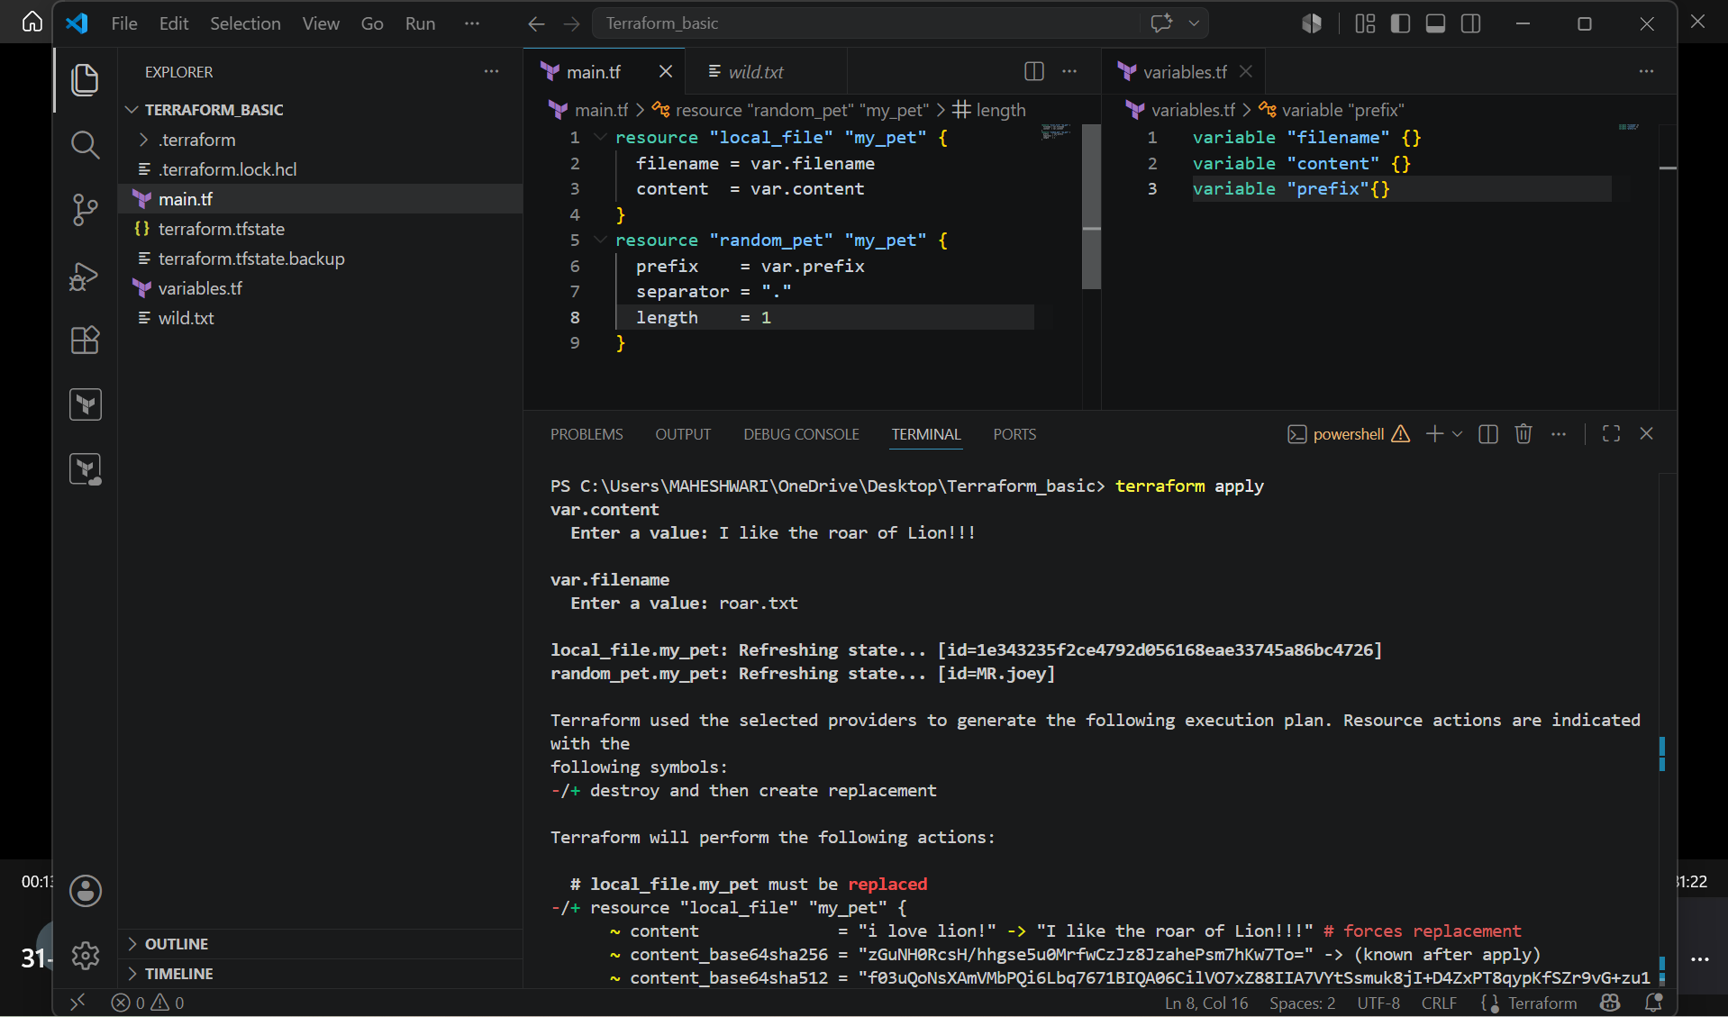

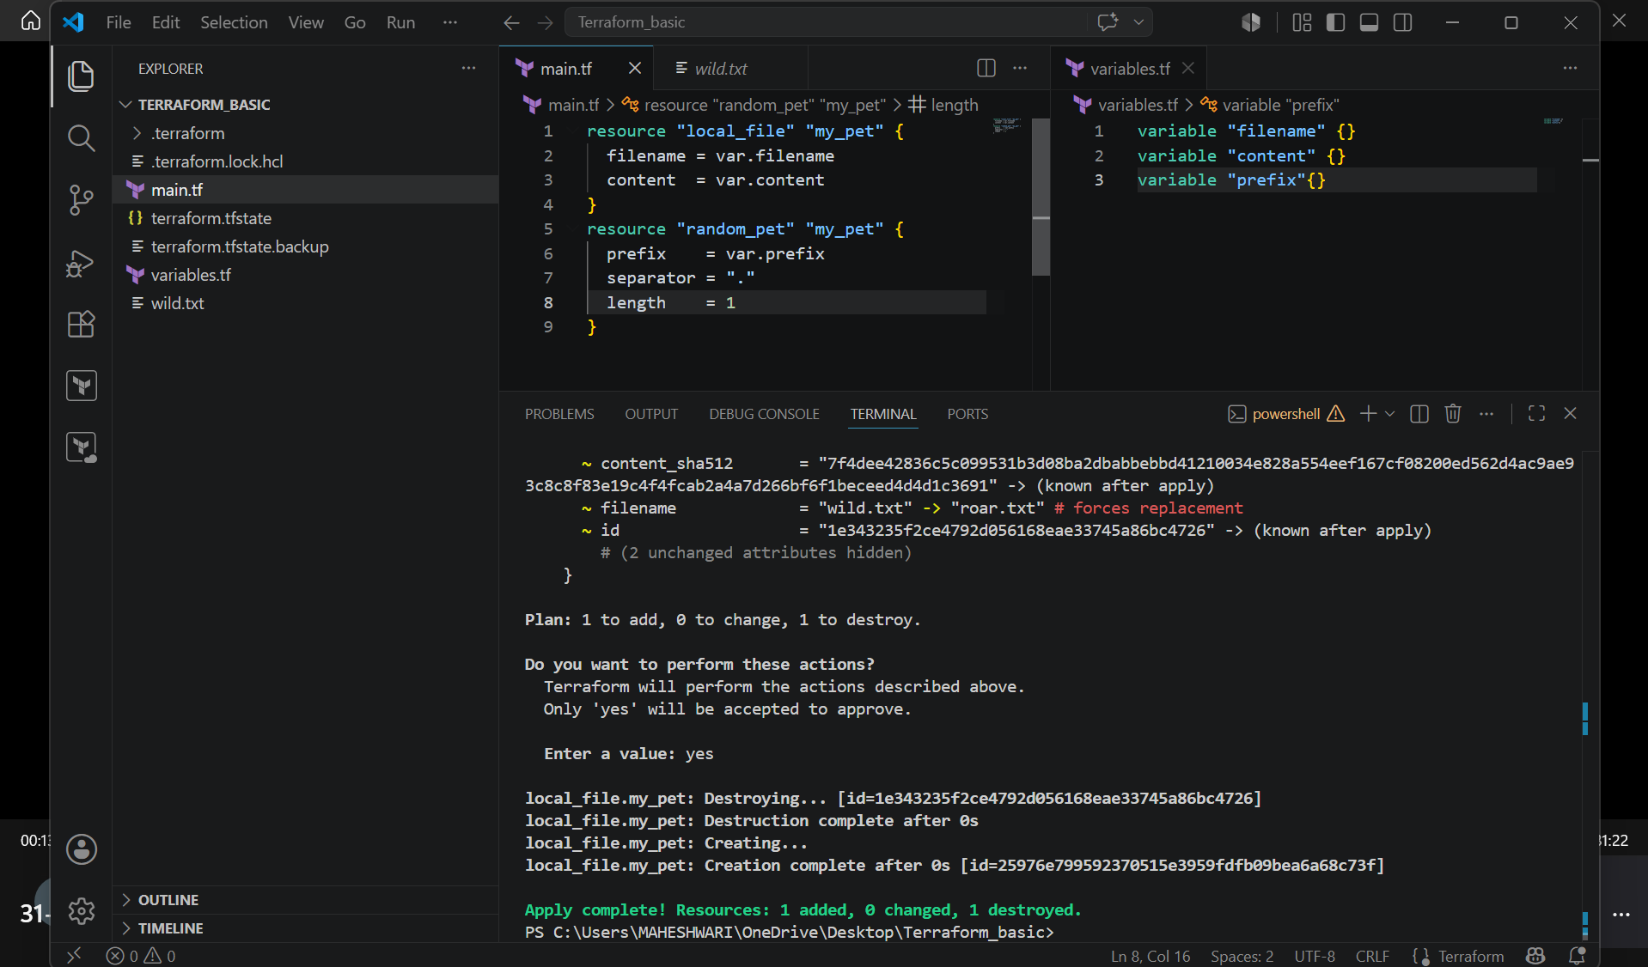

Terraform definition file:

- A Variable Definition File in Terraform is a file used to assign values to input variables declared in variables.tf. It helps separate configuration values from the Terraform code, making the code reusable across different environments.
Purpose of a Variable Definition File
- Stores values for input variables.
- Avoids hardcoding values in Terraform configuration.
- Makes it easy to manage different environments (Development, Testing, Production).
- Improves readability and maintainability.

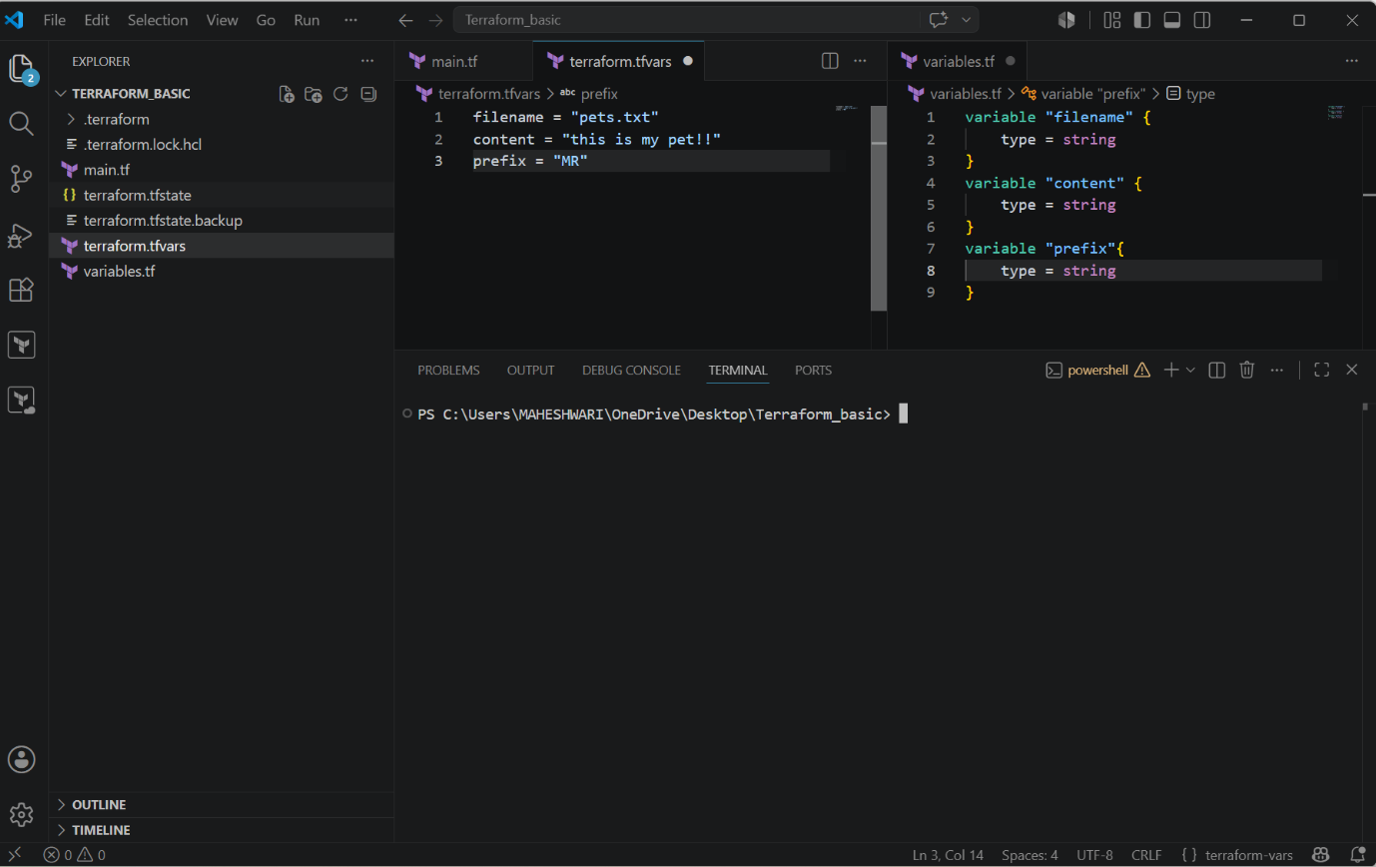

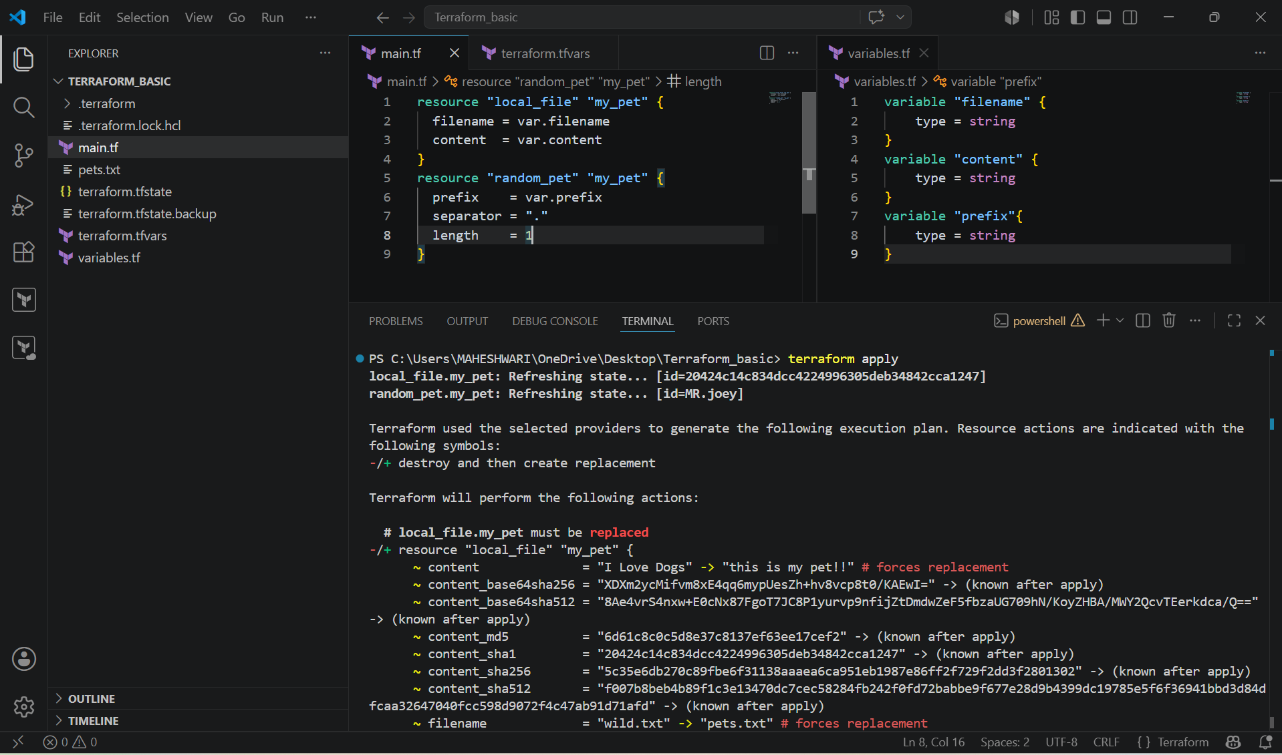

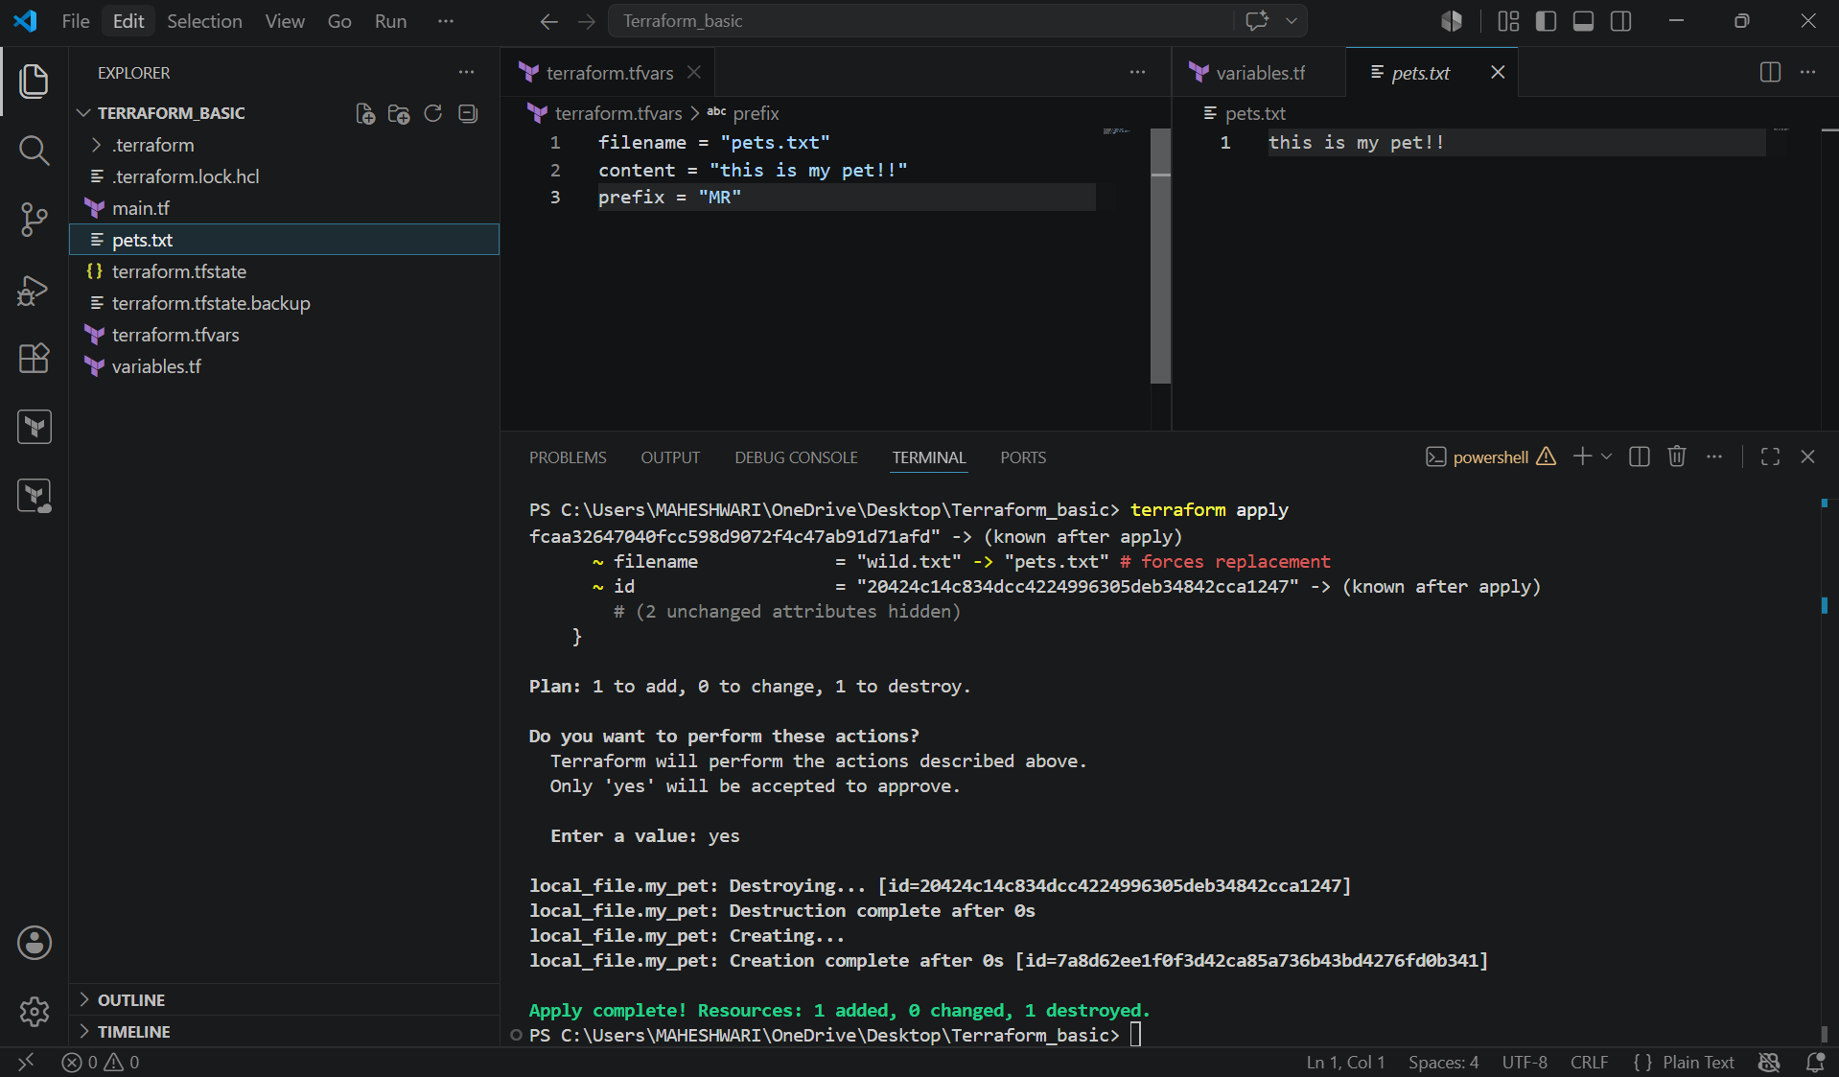

Precedence Order:
- When we execute all the variables using at the same time.

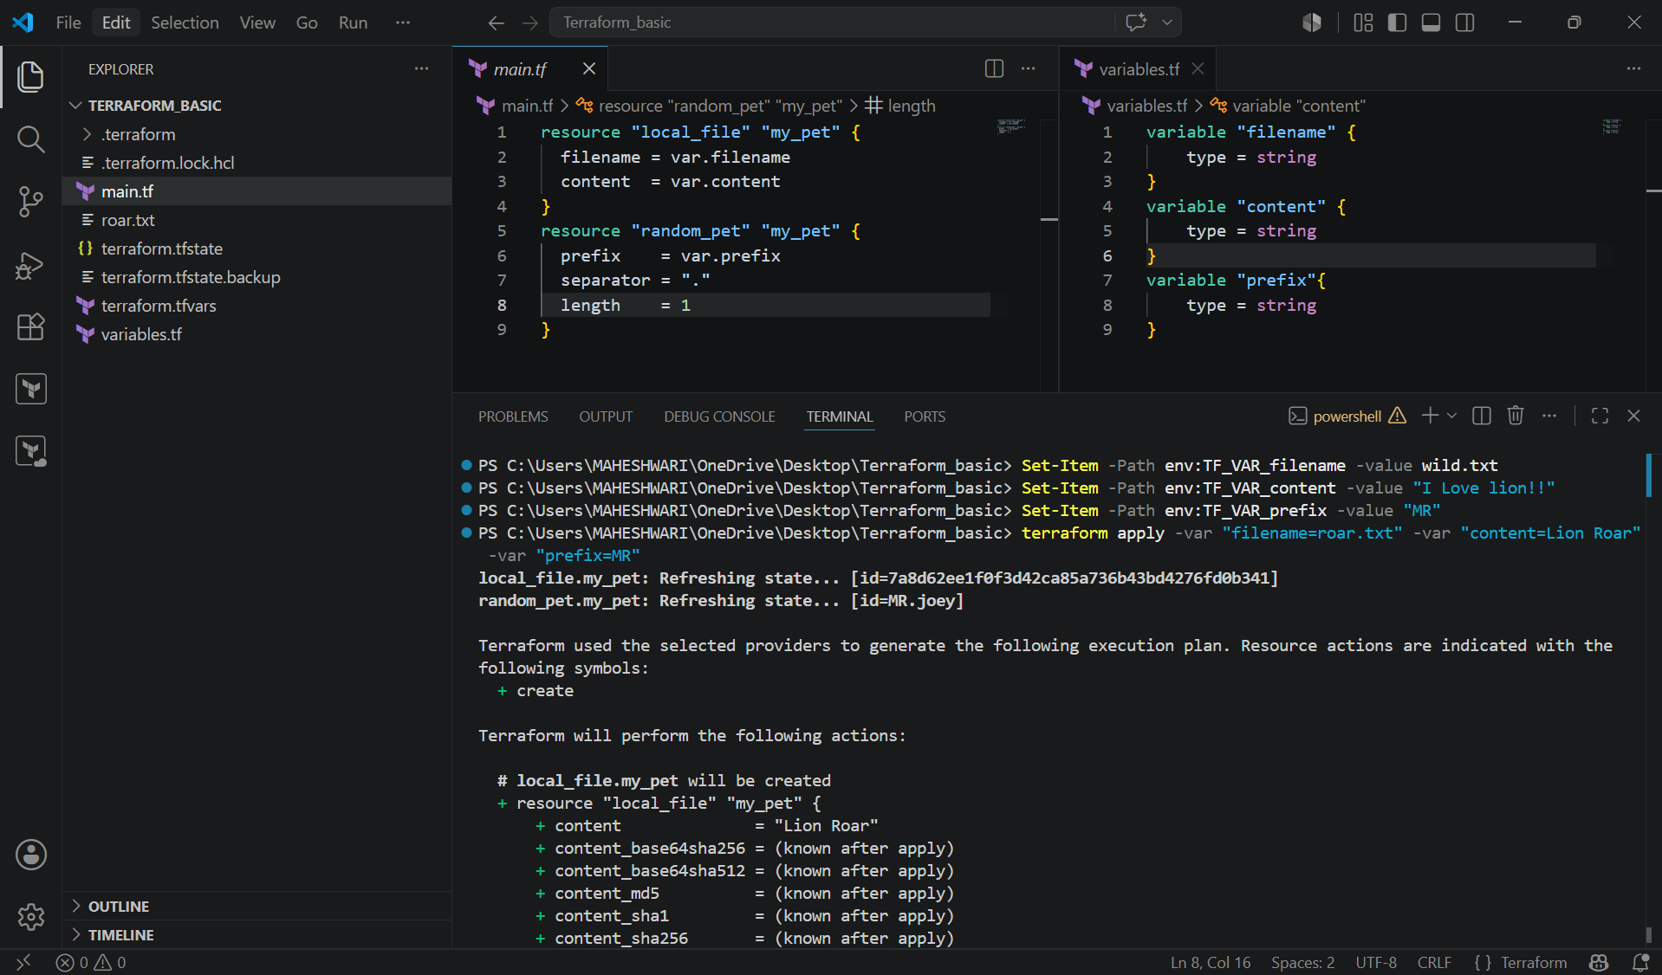

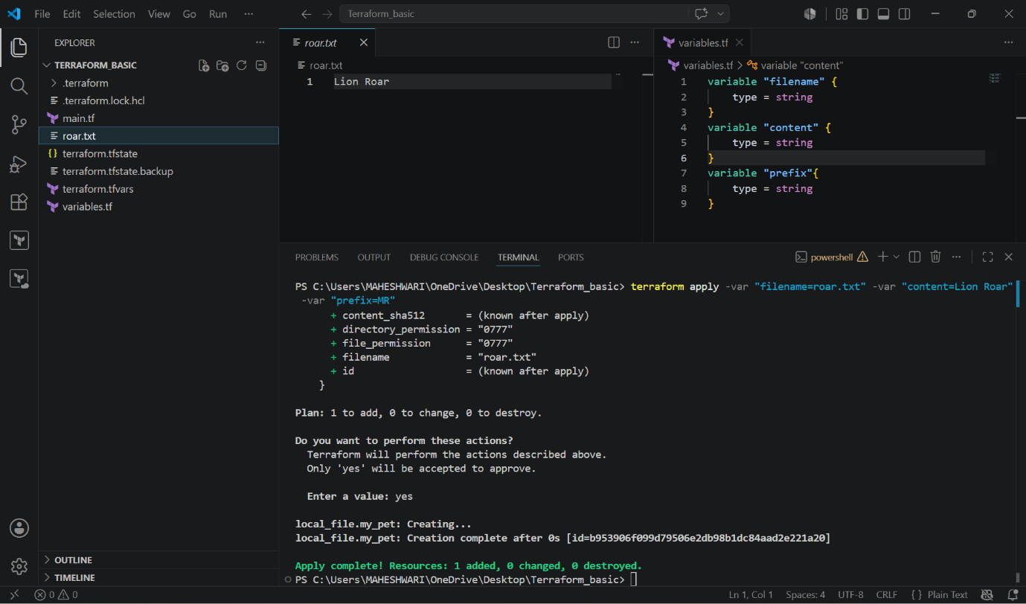

- Environment variables will be overridden with the terraform.tfvars and then terraform.tfvars will be overridden with the Command line flags.

Resource attribute reference:

- If I want to link two resources together by using resource attributes.

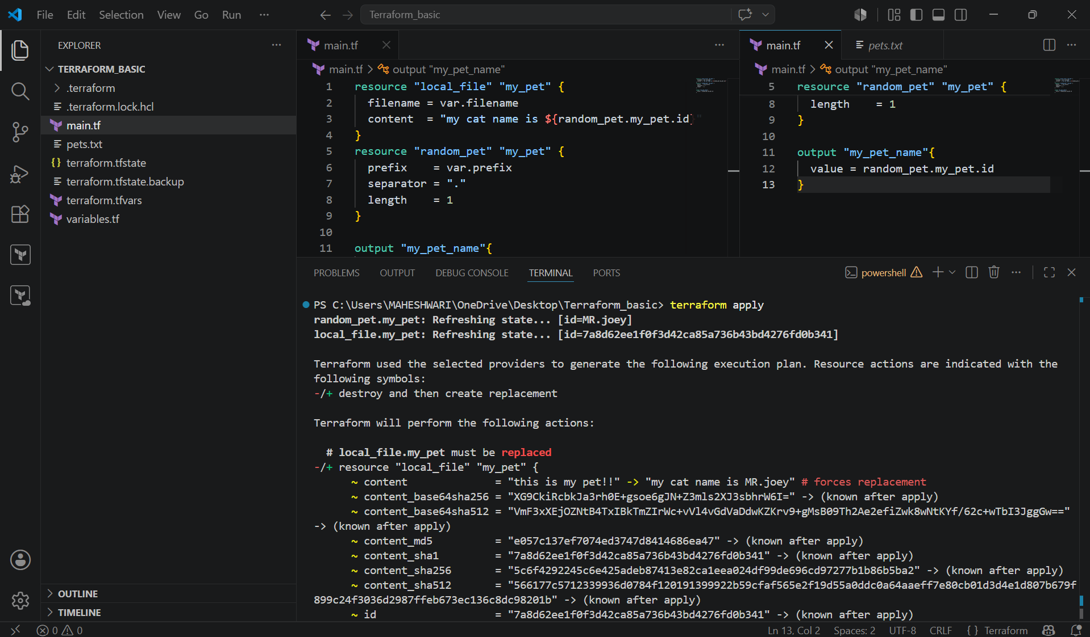

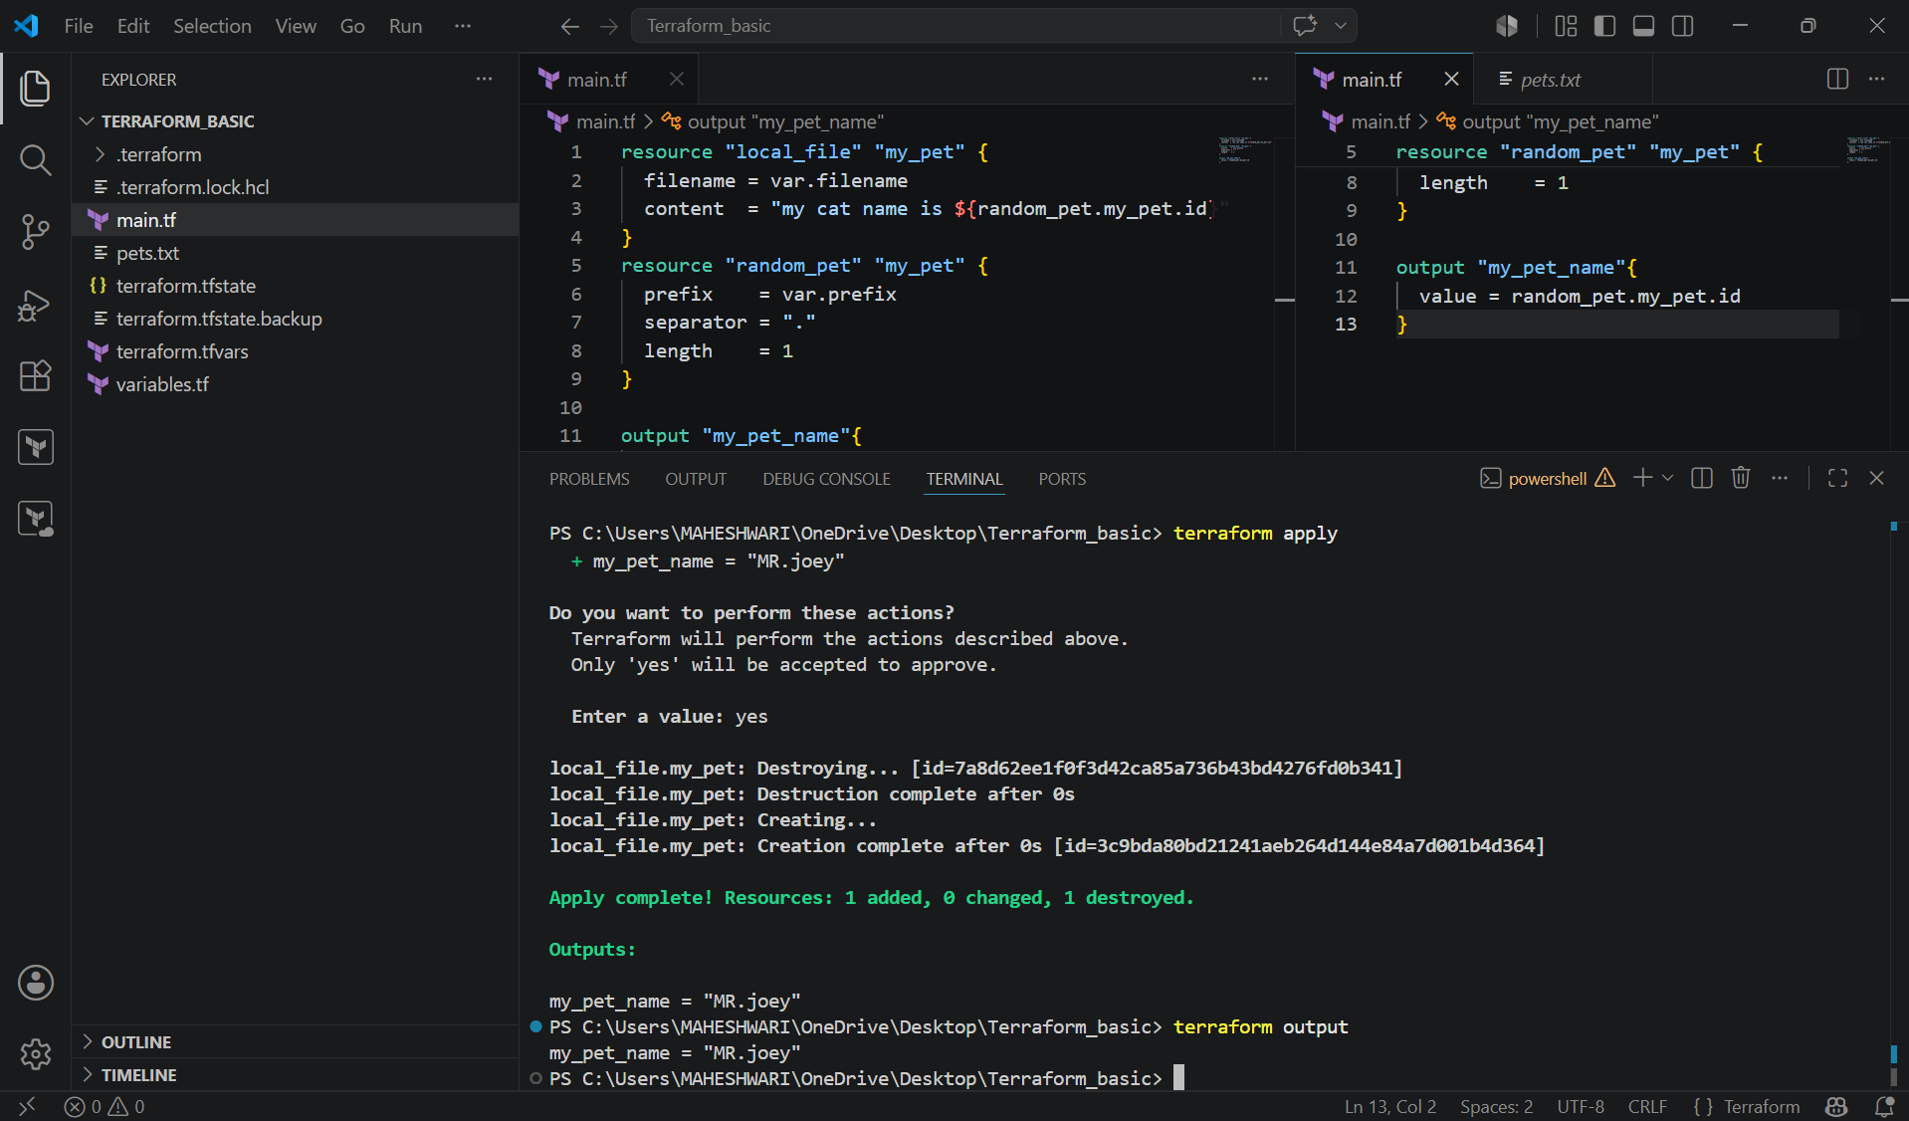

2. Integrate Terraform in Jenkins using the Terraform plugin.

PURPOSE: The purpose of integrating Terraform with Jenkins using the Terraform plugin is to automate infrastructure as Code (IaC) deployments through a CI/CD pipeline. Instead of manually running Terraform commands on a machine Jenkins executes them.

OBJECTIVE:
- After integrating Terraform with Jenkins, you should be able to:
- Install and configure Terraform as a Jenkins tool using the Terraform plugin.
- Store Terraform code in a Git repository.
- Automatically check out the latest Terraform code from GitHub.
- Execute Terraform commands from a Jenkins pipeline:
- terraform init
- terraform validate
- terraform plan
- terraform apply
- provision and manage cloud infrastructure (such as AWS, Azure or GCP) in a consistent and repeatable way.
- Reduce manual deployment effort and configuration errors.
- Integrate infrastructure provisioning into the organization’s CI/CD process.

OUTCOME:

By the end of the integration:
- Jenkins is configured with the Terraform plugin.
- Terraform is available as a managed tool in Jenkins.
- A pipeline automatically executes Terraform commands.
- Infrastructure changes are version-controlled through Git.
- Infrastructure deployments become automated, consistent, and repeatable.
- Manual intervention is minimized, improving deployment speed and reliability.

WORKFLOW:

Developer
|
▼
Push Terraform Code to GitHub
|
▼
Jenkins Pipeline Triggered
|
▼
Terraform Plugin Provides Terraform CLI
|
▼
terraform init
terraform validate
terraform plan
terraform apply
|
▼
Infrastructure Created/Updated
(AWS, Azure, GCP, etc.)

STEP BY STEP IMPLEMENTATION:

- First of all, login into the Jenkins server with the publicIp:8080 in the browser.
- Then after logged in, we have search for terraform plugin in the available plugins.
- Install the terraform plugin and add that installation in the tools.
- Then we have create a new job with the pipeline job style.
- In the job configurations, we have to select the pipeline from SCM.
- After selecting that, it will prompt us to select us to select SCM there we have to select git.
- After selecting git, again it will prompt us to enter the github repo url and credentials.
- If the repository is private then we have to give the credentials otherwise no need to pass the credentials if the repo is public.
- The given repo should have the files like JenkinsFile, main.tf, variables.tf, provider.tf and output.tf.
- Then only jenkins will execute the terraform commands by checking whether the repo have all the terraform files.
- Jenkinsfile consists of
pipeline {
agent any

tools {
terraform 'Terraform-1.13'
}

stages {

stage('Checkout') {
steps {
git 'https://github.com/username/terraform-basic.git'
}
}

stage('Terraform Version') {
steps {
sh 'terraform version'
}
}

stage('Terraform Init') {
steps {
sh 'terraform init'
}
}

stage('Terraform Validate') {
steps {
sh 'terraform validate'
}
}

stage('Terraform Plan') {
steps {
sh 'terraform plan'
}
}

stage('Terraform Apply') {
steps {
input "Apply Terraform?"

sh 'terraform apply -auto-approve'
}
}
}
}

- Then when you run the job by clicking on build now, it will go and check for the files in the repo and then it will executes the terraform commands written in Jenkinsfile and our job will be successful.

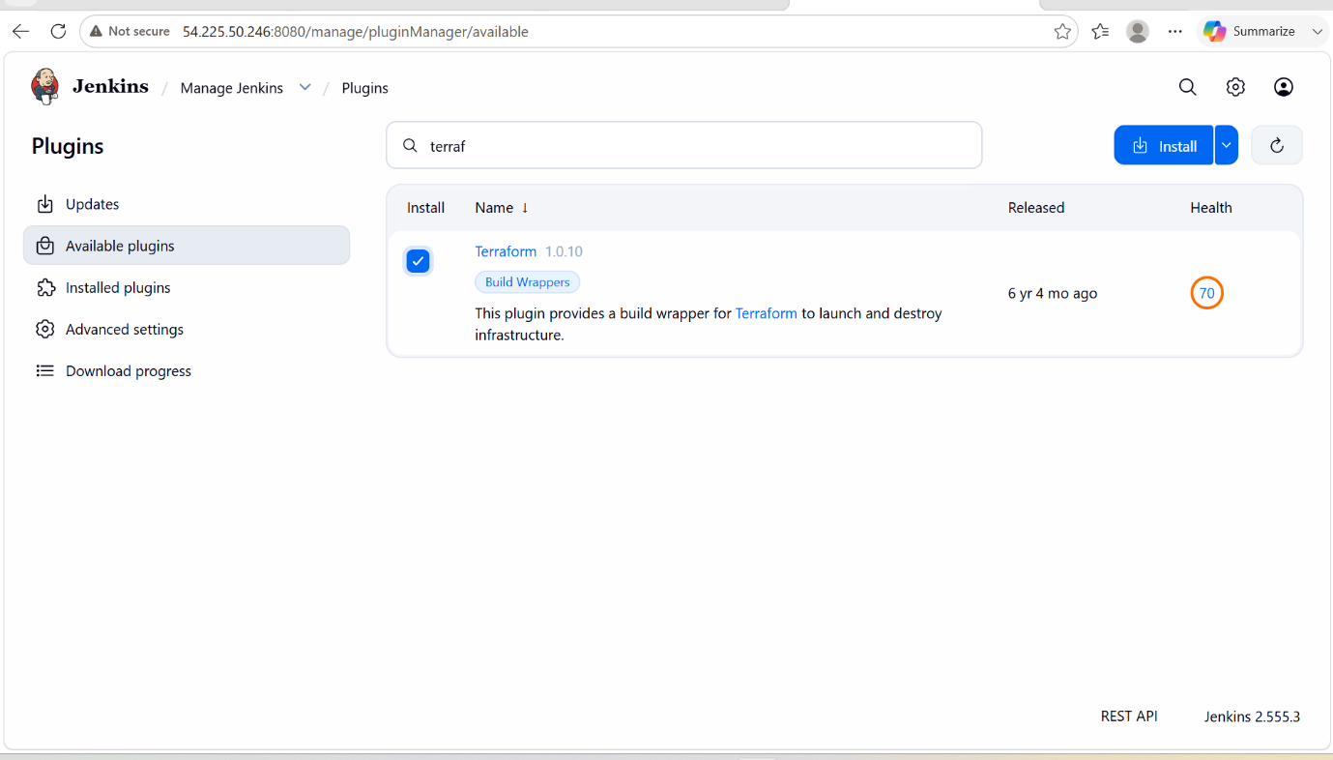

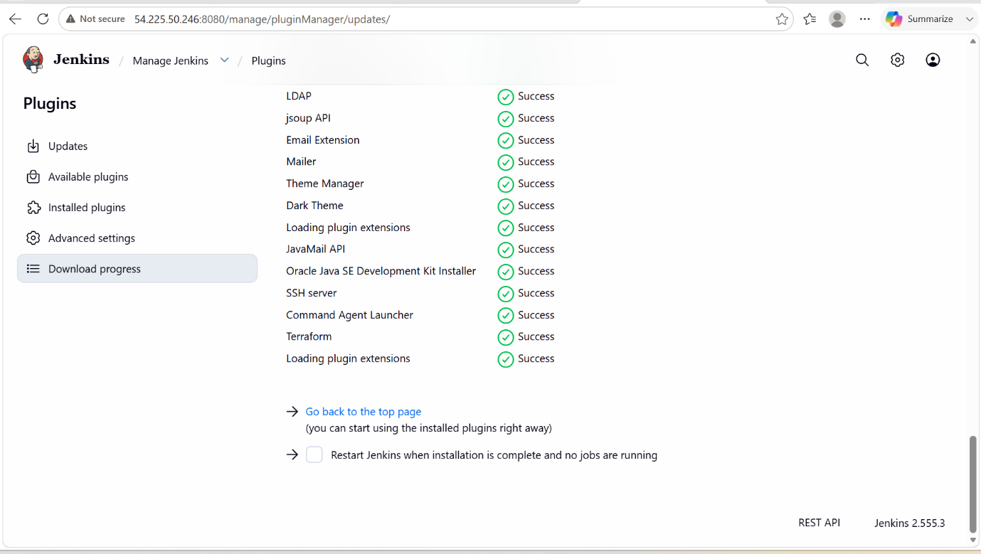

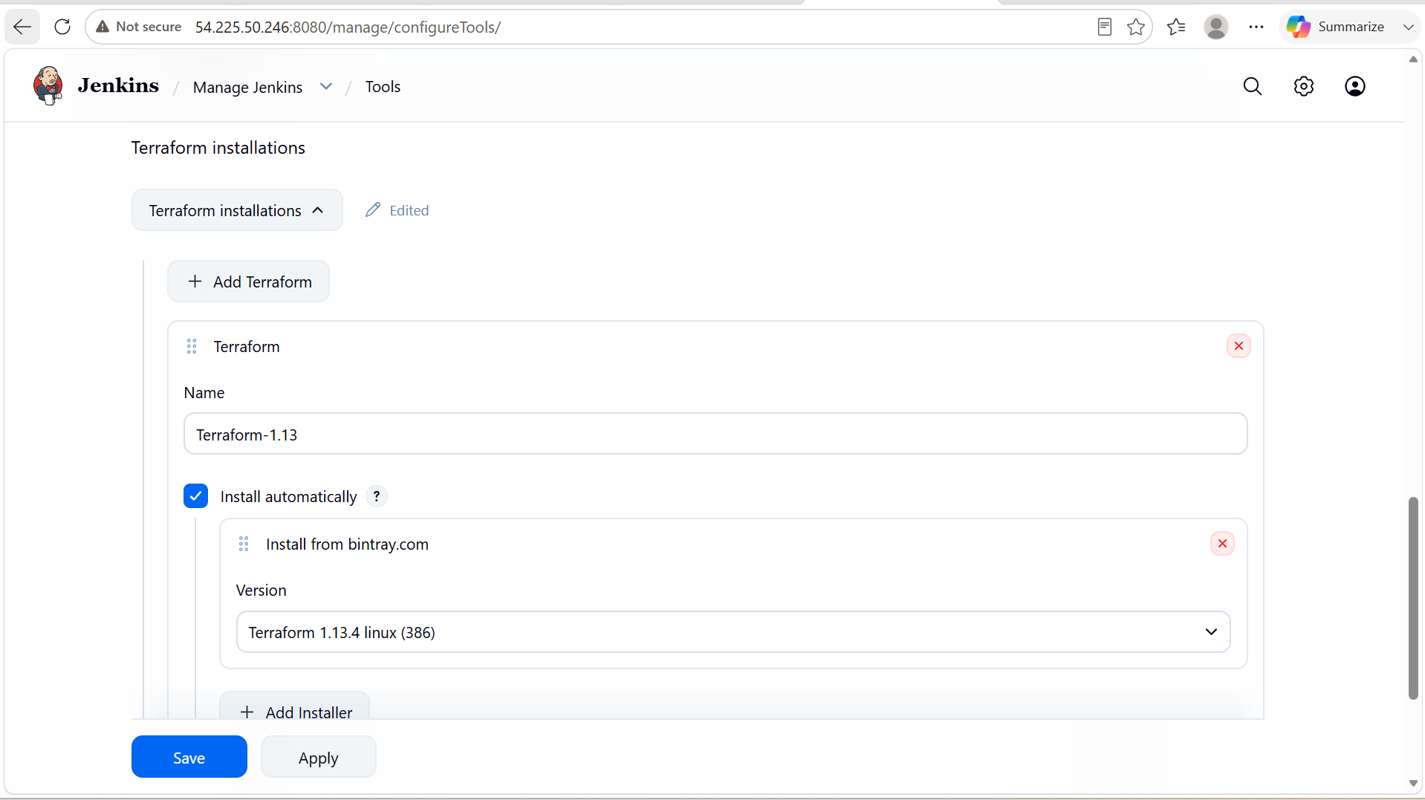

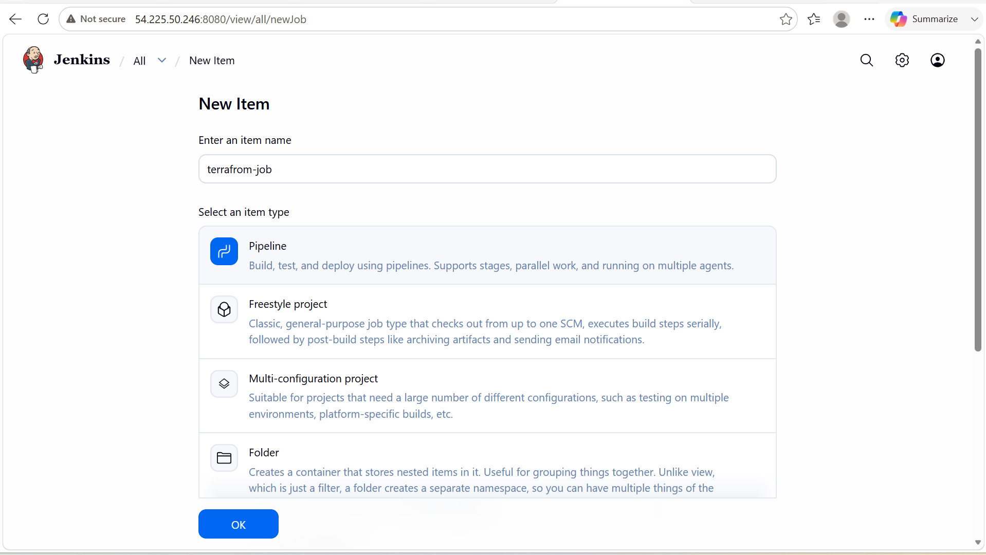

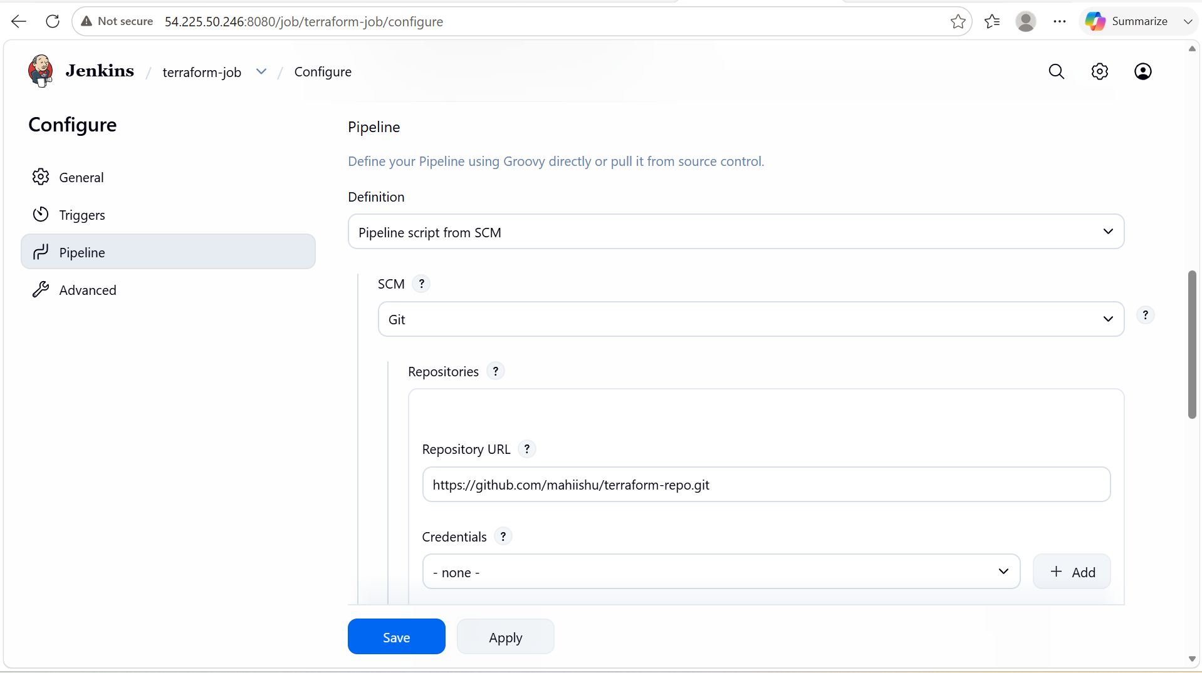

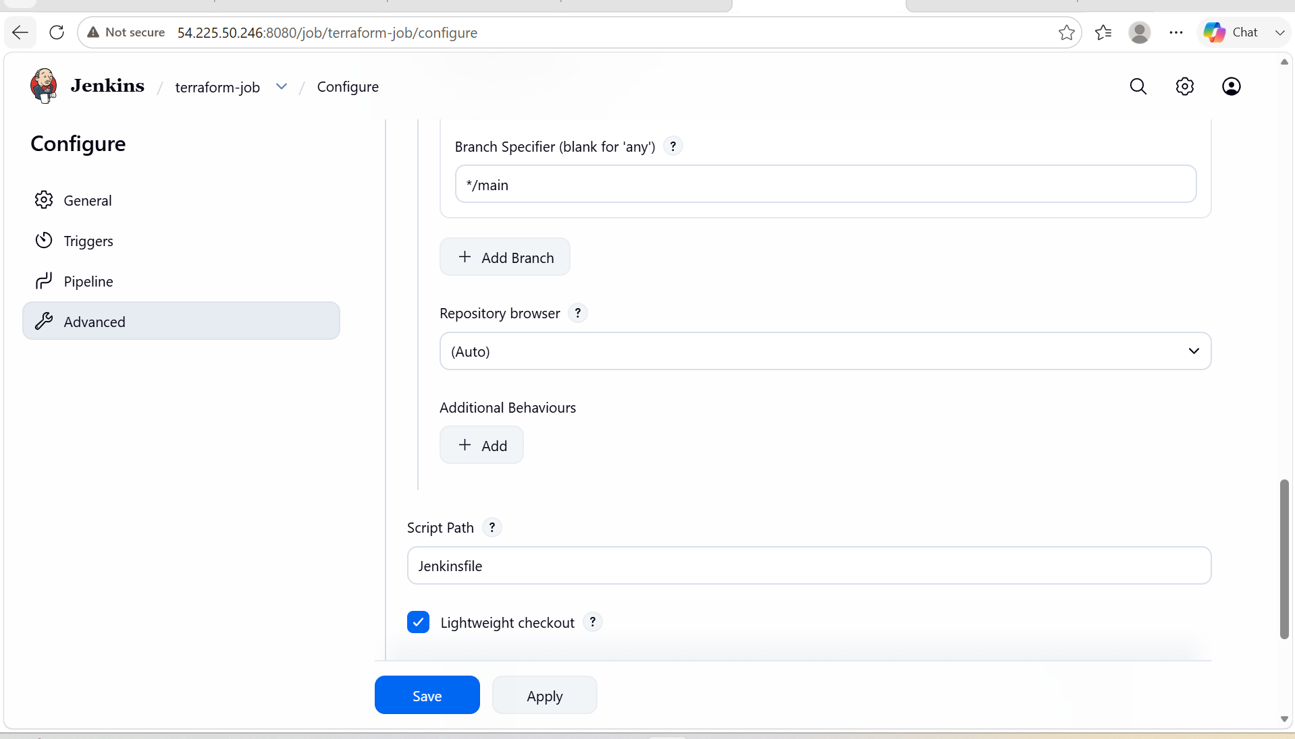

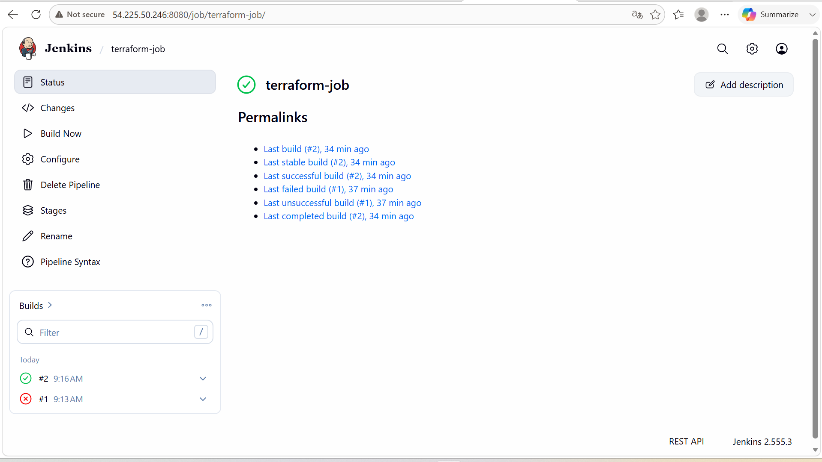

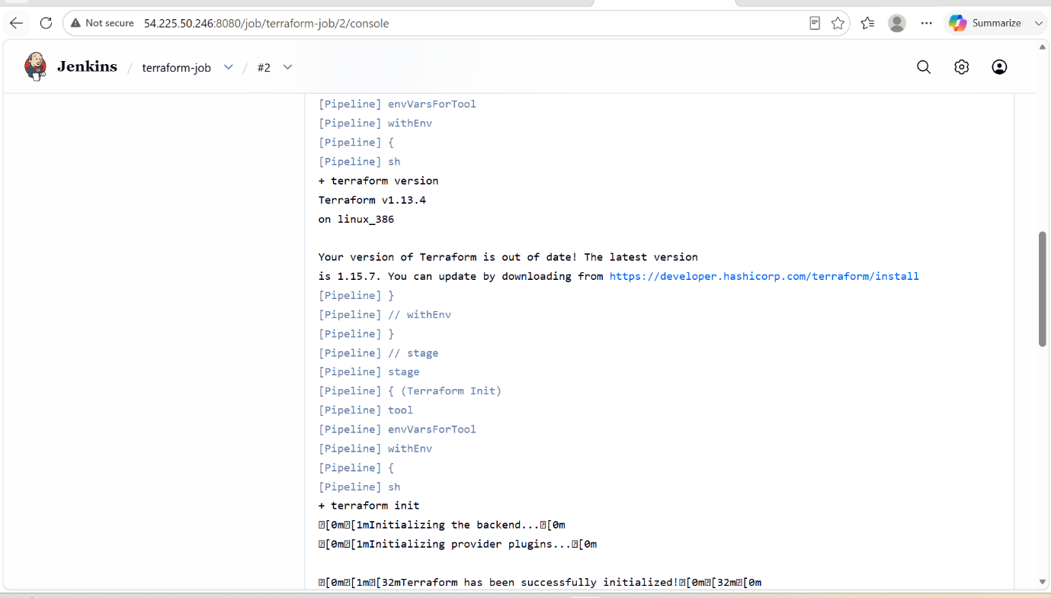

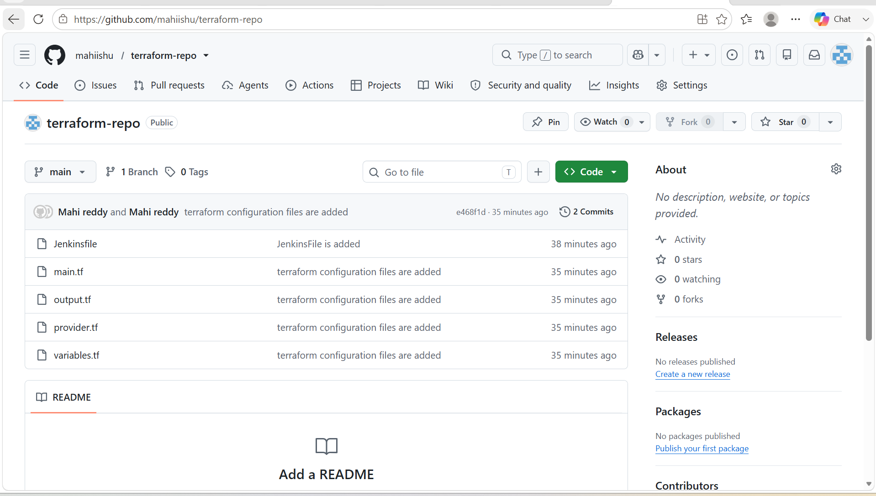

3. Create one Jenkins job using Maven Project for the code below with two stages:

Stage 1:Git clone

Stage 2:Maven CompilationCode:https://github.com/betawins/java-Working-app.git
Prerequisites
- Jenkins installed and running.
- JDK installed and configured in Jenkins.
- Maven installed and configured in Jenkins.
- Git installed on the Jenkins server.

- Create a new job in the jenkins using pipeline job style.
- Then in the configurations, we have to write a code in the pipeline for got clone and maven build for the given repo url.
- After that we have to build the job and it gets successful.

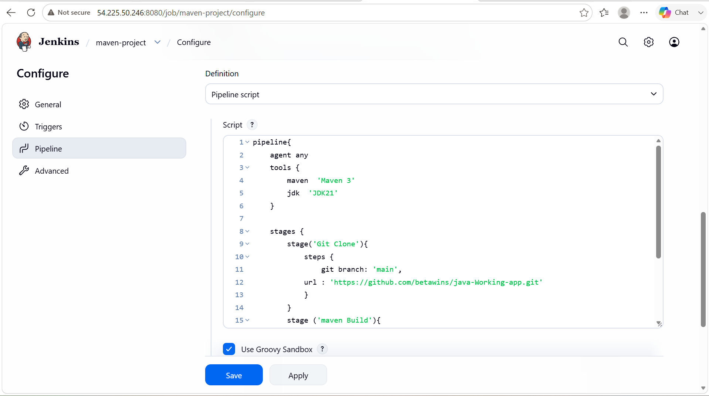

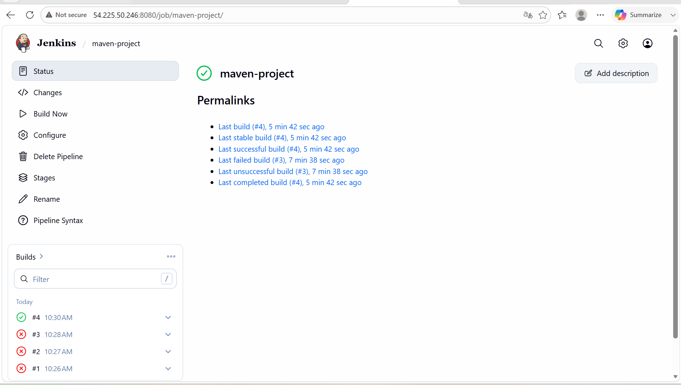

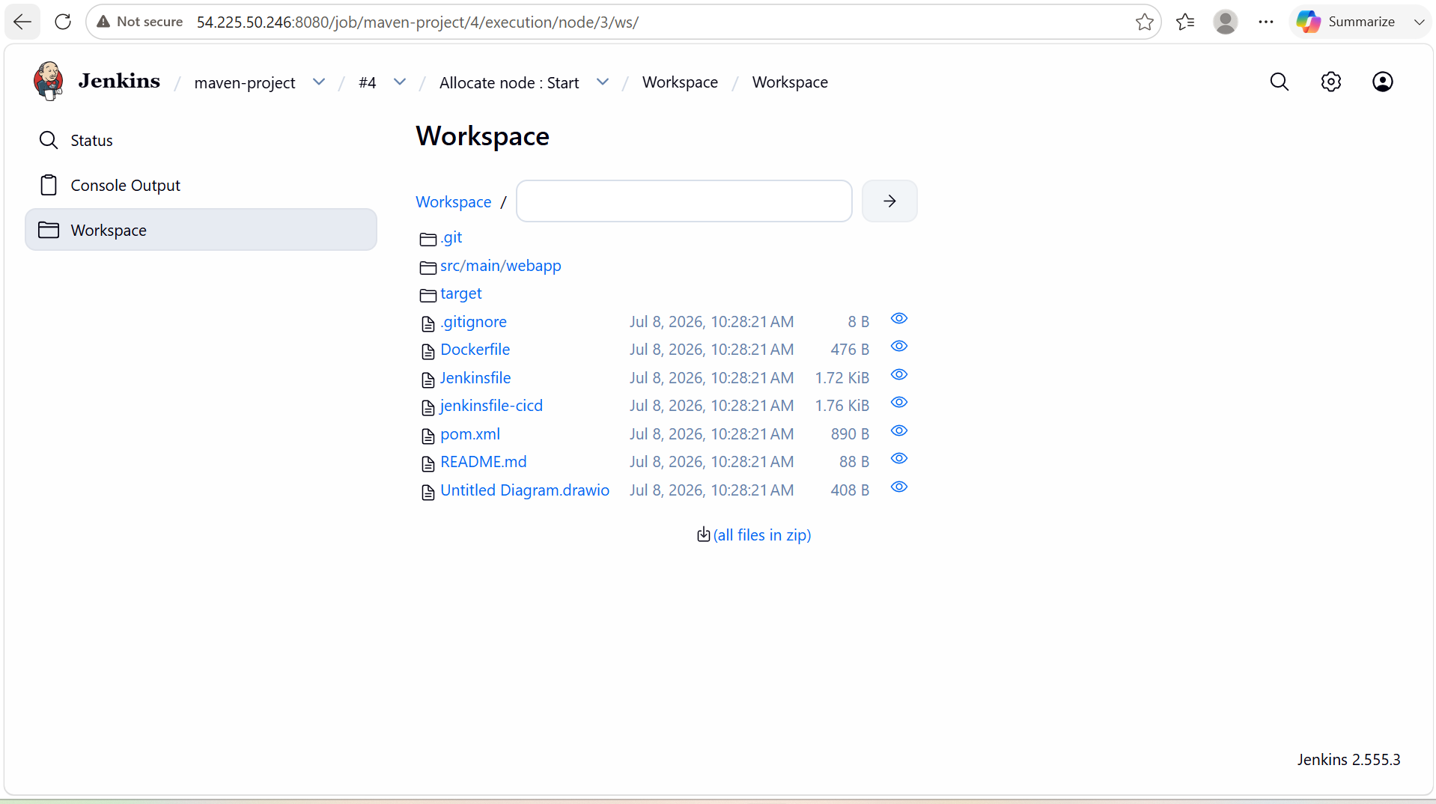

4. Use the same code and create a parameterized job in Jenkins with:

Stage 1:Git clone

Stage 2:Maven CompilationCode:https://github.com/betawins/java-Working-app.git

- Create a new job using pipeline job style.
- Then in the configurations, we have to select this job is parameterized and it will prompt us to enter some details like branch name.
- After that in the pipeline we have to write code using parameters.
- Then click on build now and the job will get successful.
- We can verify in the workspace that it will clone all files in the repo.

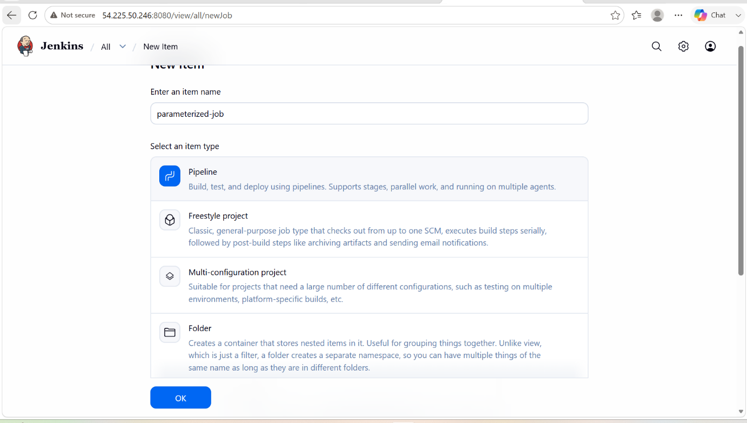

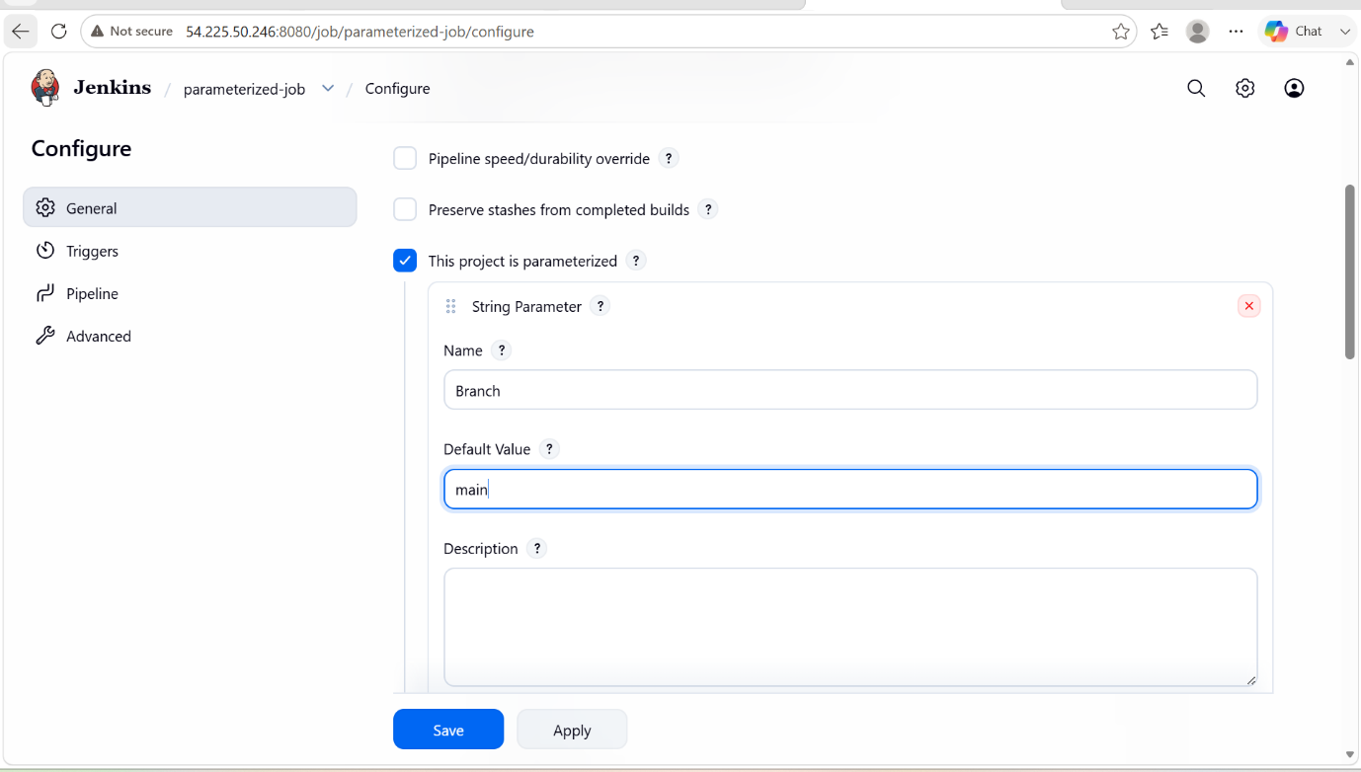

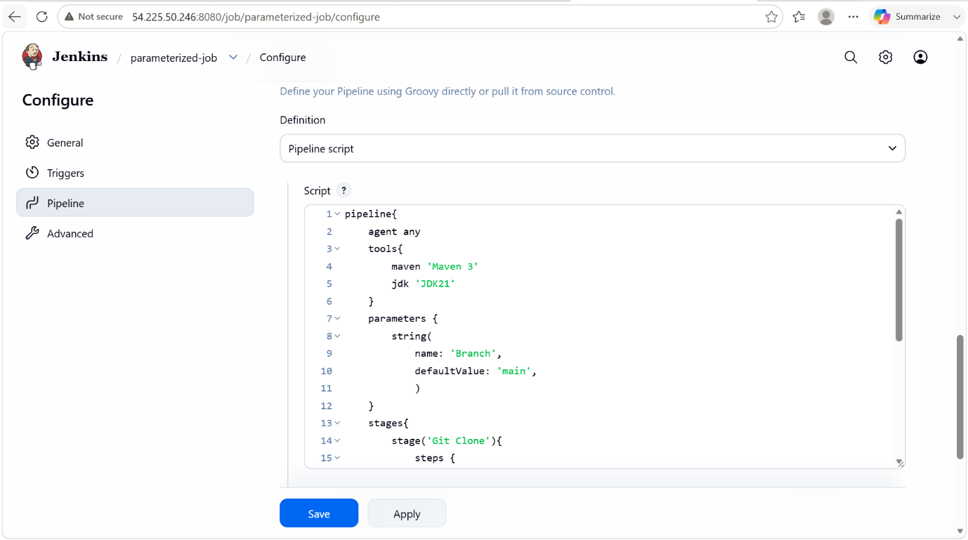

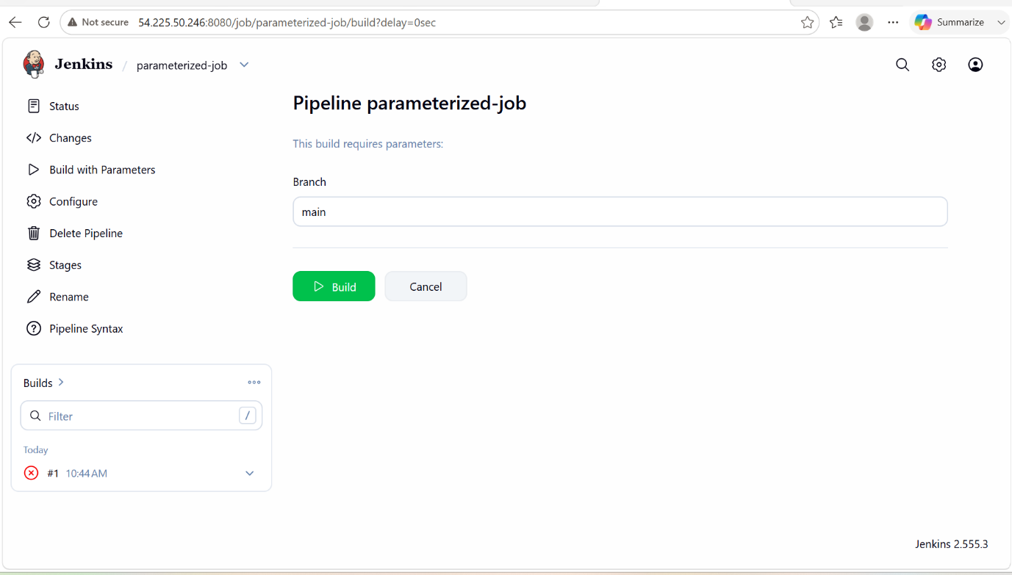

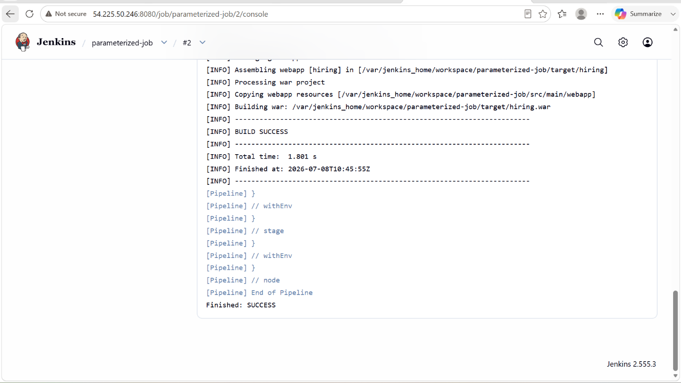

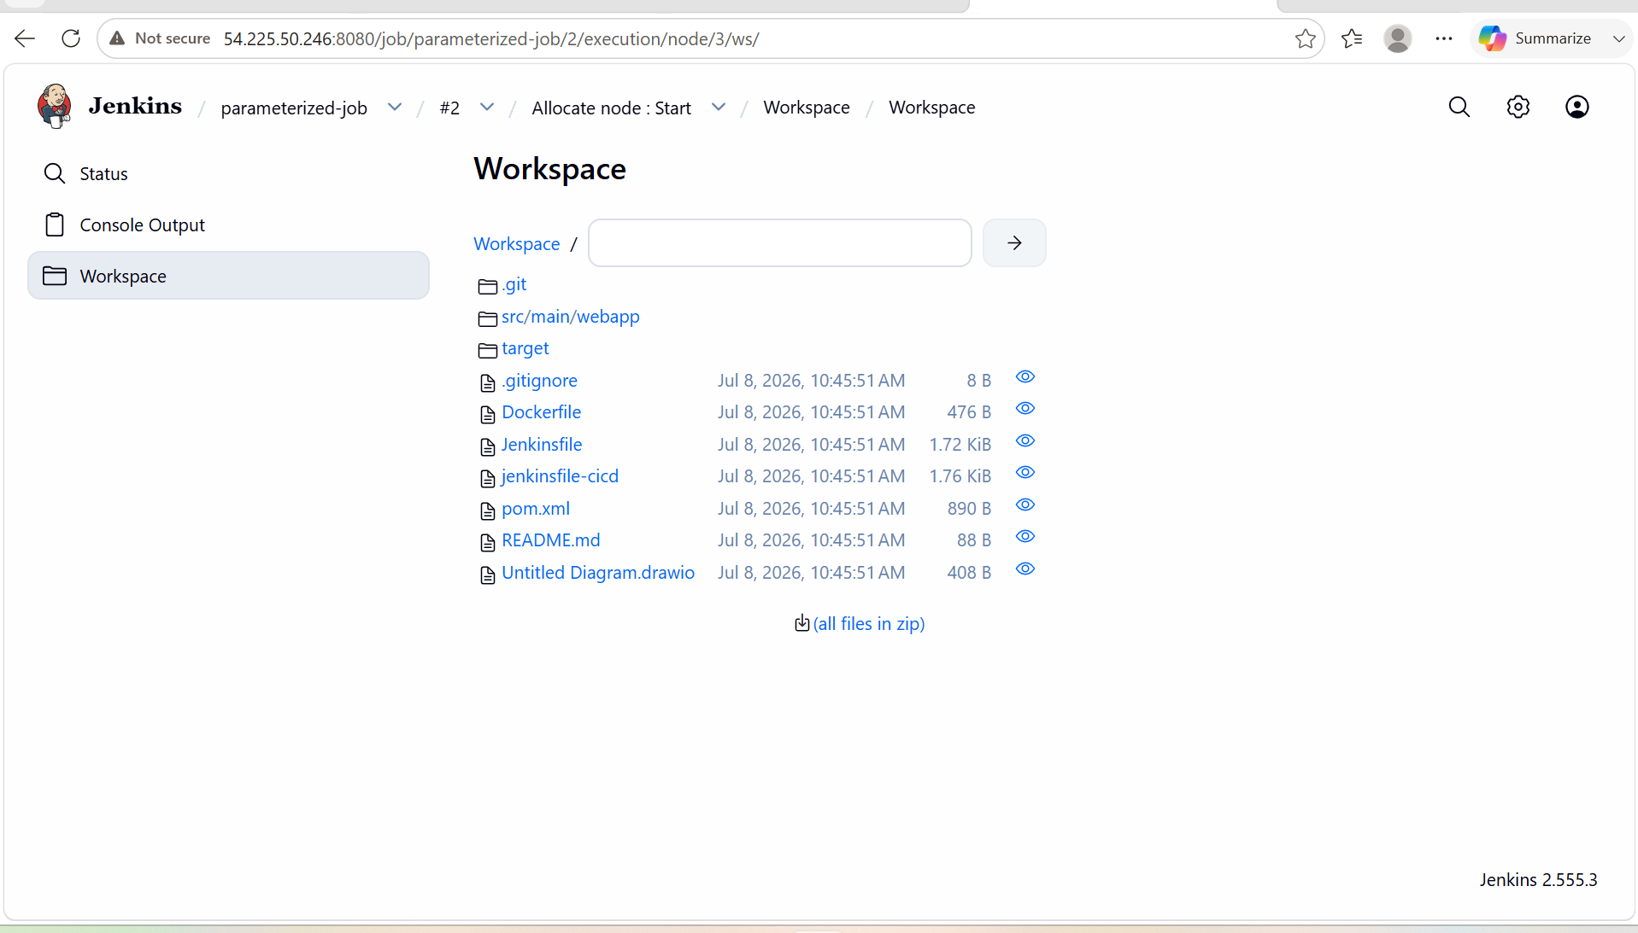

5. What are the global variables in Jenkins?

- In Jenkins, global variables are predefined environment variables that are available throughout a build or pipeline. They provide information about the job, build, workspace, Jenkins server, Git repository, and more.

Common Global Variables in Jenkins

Variable | Description
BUILD_NUMBER | Current build number.
BUILD_ID | Unique identifier for the build.
BUILD_TAG | Unique tag for the build.
BUILD_URL | URL of the current build.
JOB_NAME | Name of the Jenkins job.
JOB_BASE_NAME | Job name without folder path.
BUILD_DISPLAY_NAME | Display name of the current build.
WORKSPACE | Path to the Jenkins workspace.
JENKINS_HOME | Jenkins home directory.
JENKINS_URL | URL of the Jenkins server.
NODE_NAME | Name of the node (agent) running the build.
NODE_LABELS | Labels assigned to the node.
EXECUTOR_NUMBER | Executor number running the build.
JAVA_HOME | Path to the Java installation.
PATH | System executable search path.
HOME | Home directory of the Jenkins user.
GIT_COMMIT | Commit ID checked out from Git.
GIT_BRANCH | Current Git branch.
GIT_URL | Git repository URL.
GIT_PREVIOUS_COMMIT | Previous Git commit hash.

