CHALLENGE – 8

Use the below code and implement our CICD stages.
- Source Code:https://github.com/betawins/hiring-app.git

1. Create one Declarative pipeline job

- Create a new job with the pipeline job style.
- After that we have to write pipeline code in the configure of the job.

pipeline{
agent any
tools {
maven 'maven 3.9.11'
}

environment {
SONAR_SERVER = 'SonarQube'
NEXUS_URL = '3.25.163.255:8081'
NEXUS_REPO = 'maven-releases-1'
SLACK_CHANNEL = '#jenkins-alerts'
JOB_NAME = 'HiringApp'
}

stages {

stage ('Git Clone') {
steps {
git branch: 'main',
url: 'https://github.com/betawins/hiring-app.git'
}
}

stage ('SonarQube Integration') {
steps {
withSonarQubeEnv('SonarQube') {
sh '''
mvn sonar:sonar\
-Dsonar.projectKey=hiring-app\
-Dsonar.projectName=hiring-app
'''
}
}
}

stage ('Maven Compilation') {
steps{
sh 'mvn clean install'
}
}

stage('Find WAR') {
steps {
script {
env.WAR_FILE = sh(
script: "find target -name '*.war' | head -1",
returnStdout: true
).trim()

echo "WAR File = ${env.WAR_FILE}"
}
}
}

stage ('Nexus Artifactory') {
steps {
sh '''
curl -v -u admin:PASSWORD \
--upload-file target/hiring.war \
http://3.25.163.255:8081//repository/maven-releases-1/in/javahome/hiring/${BUILD_NUMBER}/hiring-${BUILD_NUMBER}.war
'''
}
}

stage('Deploy On Tomcat') {
steps {
deploy adapters:
[
tomcat9(
credentialsId: 'tomcat',
path: '',
url: 'http://13.211.209.233:8080/' )
],
contextPath: '/',
war: 'target/*.war'
} }

}
}

- When we deploy to tomcat, we have to first login into that server status page with the username deployer and password deployer

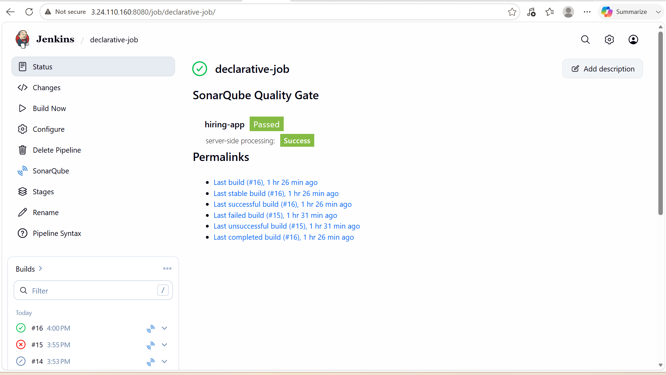

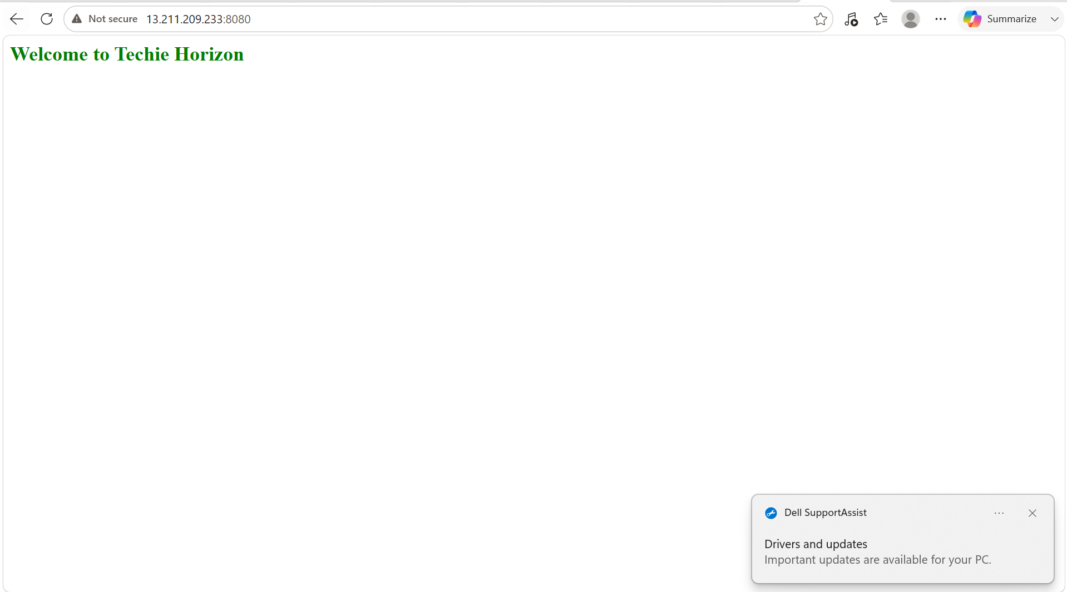

2. Create one Scripted pipeline job

- Create a new job with the pipeline type of job.
- After that we have to write scripted pipeline code in the configure.

node {
def mvnHome = tool 'maven 3.9.11'

env.JAVA_HOME = tool name: 'JDK 21', type: 'jdk'

stage('Check Java') {
sh 'java -version'
sh 'javac -version'
}
env.PATH = "${env.JAVA_HOME}/bin:${mvnHome}/bin:${env.PATH}"

stage ('Git Clone') {
git branch: 'main',
url: 'https://github.com/betawins/hiring-app.git'

sh 'pwd'
sh 'ls -ltr'
}

stage ('SonarQube Integration') {
withSonarQubeEnv('SonarQube'){
sh """
${mvnHome}/bin/mvn sonar:sonar\
-Dsonar.projectKey=hiringApp\
-Dsonar.projectName=hiringApp
"""
}
}

stage ('Maven Compilation') {
sh """
${mvnHome}/bin/mvn clean package
"""
}

stage ('Find WAR') {
WAR_FILE = sh(
script: "ls target/*.war | head -1",
returnStdout: true
).trim()
echo "War File = ${WAR_FILE}"
}

stage ('Nexus Artifactory') {
nexusArtifactUploader(
nexusVersion: 'nexus3',
protocol: 'http',
nexusUrl: '3.25.163.255:8081',
groupId: 'in.javahome',
version: "${env.BUILD_NUMBER}",
repository: 'maven-releases-2',
credentialsId: 'nexus-creds',

artifacts: [
[
artifactId: 'hiring',
classifier: '',
file: WAR_FILE,
type: 'war'
]
]
)
}

stage('Deploy On Tomcat') {
deploy adapters:
[
tomcat9(
credentialsId: 'tomcat',
path: '',
url: 'http://52.62.143.191:8080/'
)
],
contextPath: '/',
war: 'target/*.war'

}

}

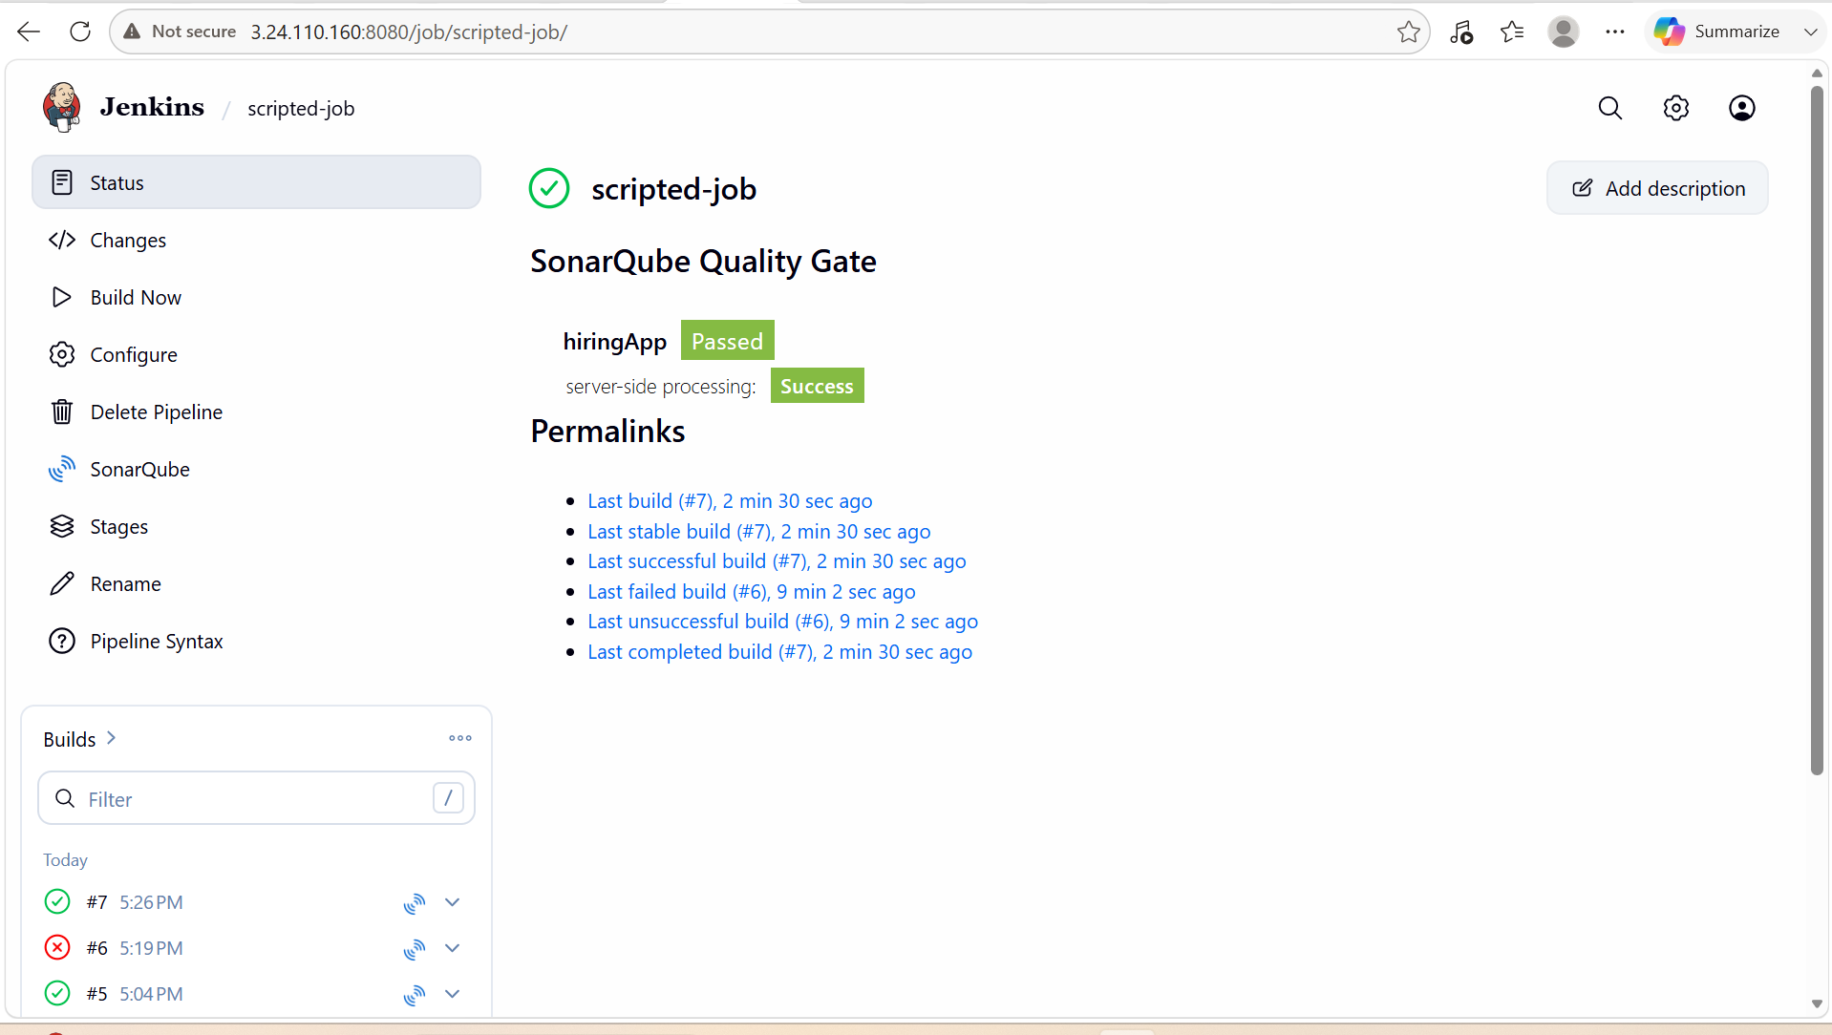

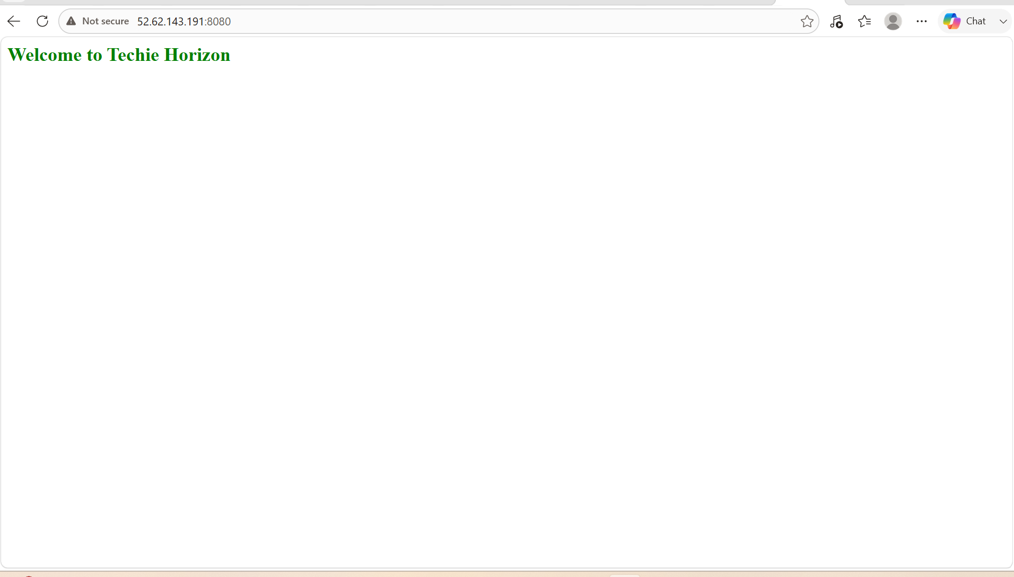

3.create one parallel stage pipeline job

- create a new job with the pipeline job style.
- Write a pipeline code in the configure.

pipeline {
agent any

tools {
jdk 'JDK 21'
maven 'maven 3.9.11'
}

stages {

stage('Checkout') {
steps {
git branch: 'main',
url: 'https://github.com/betawins/hiring-app.git'
}
}

stage('Parallel Stages') {
parallel {

stage('Compile') {
steps {
sh 'mvn clean compile'
}
}

stage('Unit Test') {
steps {
sh 'mvn test'
}
}

stage('Code Verification') {
steps {
sh 'mvn validate'
}
}

}
}

stage('Package') {
steps {
sh 'mvn package'
}
}

stage('Archive WAR') {
steps {
archiveArtifacts artifacts: 'target/*.war', fingerprint: true
}
}
}

post {
success {
echo 'Pipeline executed successfully.'
}

failure {
echo 'Pipeline execution failed.'
}

always {
cleanWs()
}
}
}

- Now when you click on build now the job and it will successful.

