TERRAFORM – 04

1. Execute the script shown in the video.

Terraform versions constraints:

- Terraform version constraints specify which version of Terraform or a provider is allowed to run your configuration. They help ensure compatibility, prevent unexpected behavior, and make your infrastructure code reproducible.
- There are two common places where version constraints are used:
- Terraform CLI version (required_version)
- Provider version (required_providers)

Why Use Version Constraints?

Without version constraints:
- New provider releases may introduce breaking changes.
- Different team members might use different versions.
- CI/CD pipelines may behave differently from local machines.
Version constraints provide:
- Stability
- Consistency
- Predictable deployments
- Easier collaboration

Example:
- Downloading a particular version of terraform.

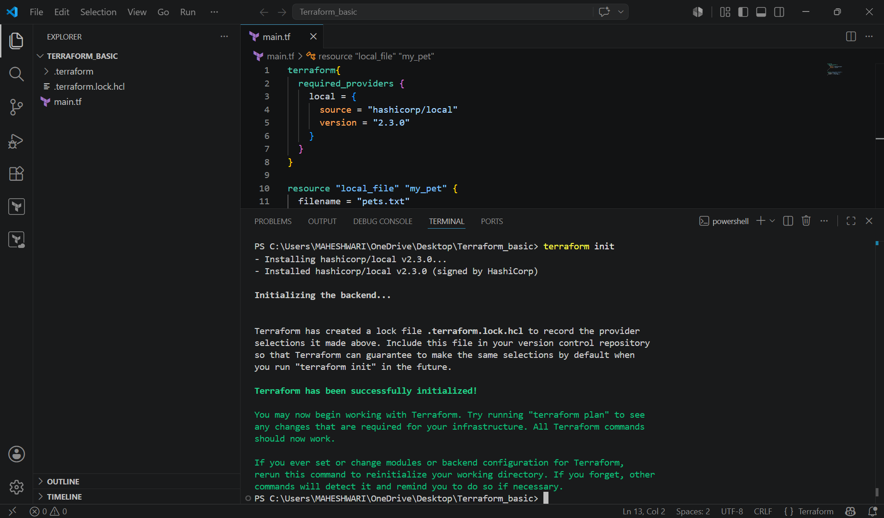

- Different uses cases of version constraints.
- version = “2.3.3” -> download the exact version.
- version = “!= 2.3.3” -> will not use the mentioned version.
- version = “<2.3.3” -> lesser than the mentioned version.
- version = “>2.3.3” -> greater than the given version.
- version = “~>2.3.3” -> specific version or higher version.

DATA SOURCES:

- apart from terraform, we have multiple other tools where the infrastructure can be created.
- EX: ansible, salt, puppet, bash script, manual process.
- Data sources are used to read the content of the infrastructure.
- For example, if we want to terraform to read the content of the file which has been created by any other tool.

Example: create a file called in dogs.txt in the same terraform working directory

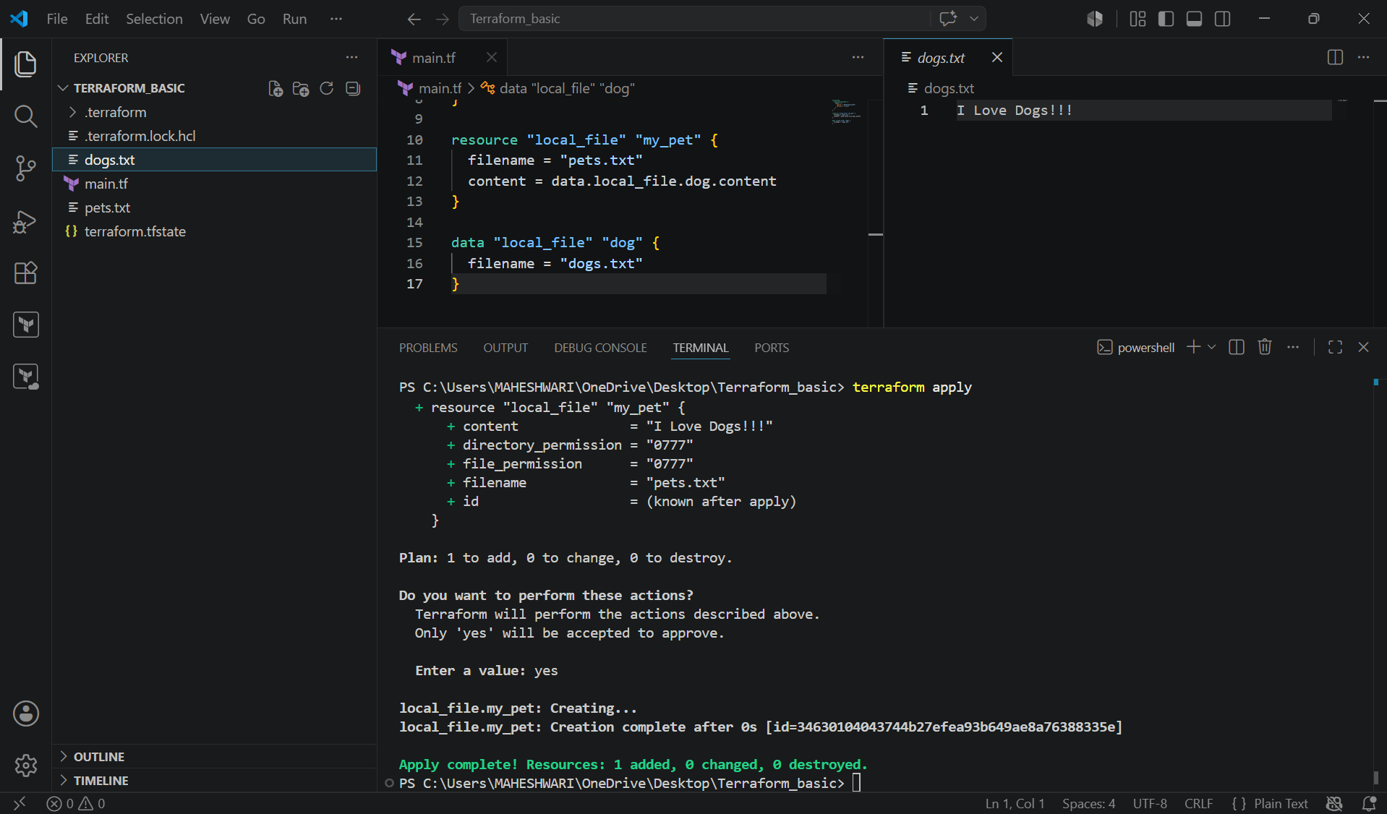

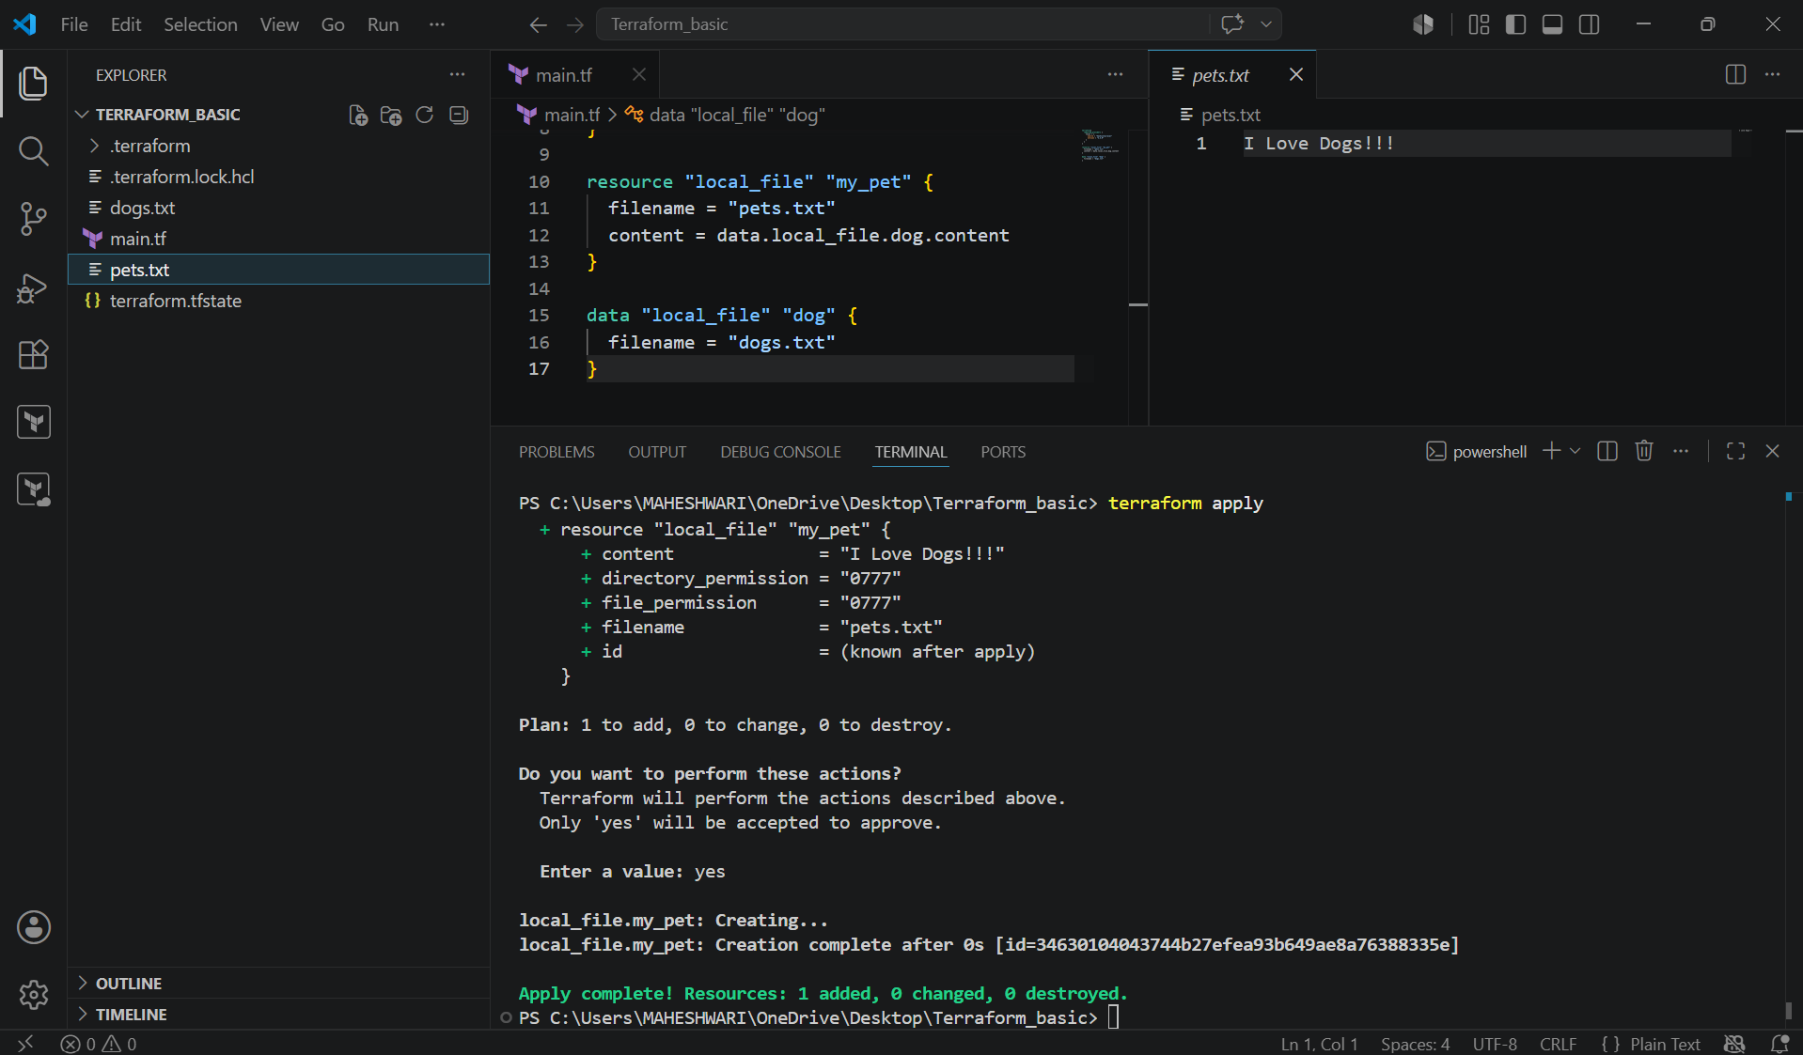

Difference between resources and data?

- Resources starts with keyword resource.
- Resource are used to create, modify, delete the infrastructure.
- Data sources starts with keyword data.
- Data sources are used to read the infrastructure.

METADATA ARGUMENTS

- Metadata arguments (also called meta-arguments) are special arguments in Terraform that control how resources are created, managed, or depend on each other. They are supported by many resource types and are not specific to any one provider.
- Unlike normal arguments (such as ami or instance_type), meta-arguments affect Terraform's behavior, not the configuration of the resource itself.

Why Use Meta-Arguments?
Meta-arguments help you:
- Create multiple resources
- Create resources conditionally
- Control resource dependencies
- Customize resource lifecycle
- Select different providers
- Manage modules efficiently

Types of Meta-Arguments
The main Terraform meta-arguments are:
- count
- for_each
- depends_on
- lifecycle
- provider
- providers (used with modules)

1.Count: The count meta-argument creates multiple identical instances of a resource.
main.tf:

resource "local_file" "my_pet" {
filename = var.filename[count.index]
content = "I Love Dogs!!!"
count = length(var.filename)
}

Variables.tf:
variable "filename" {
default = [
"pets.txt",
"dogs.txt",
"cats.txt"
]
}

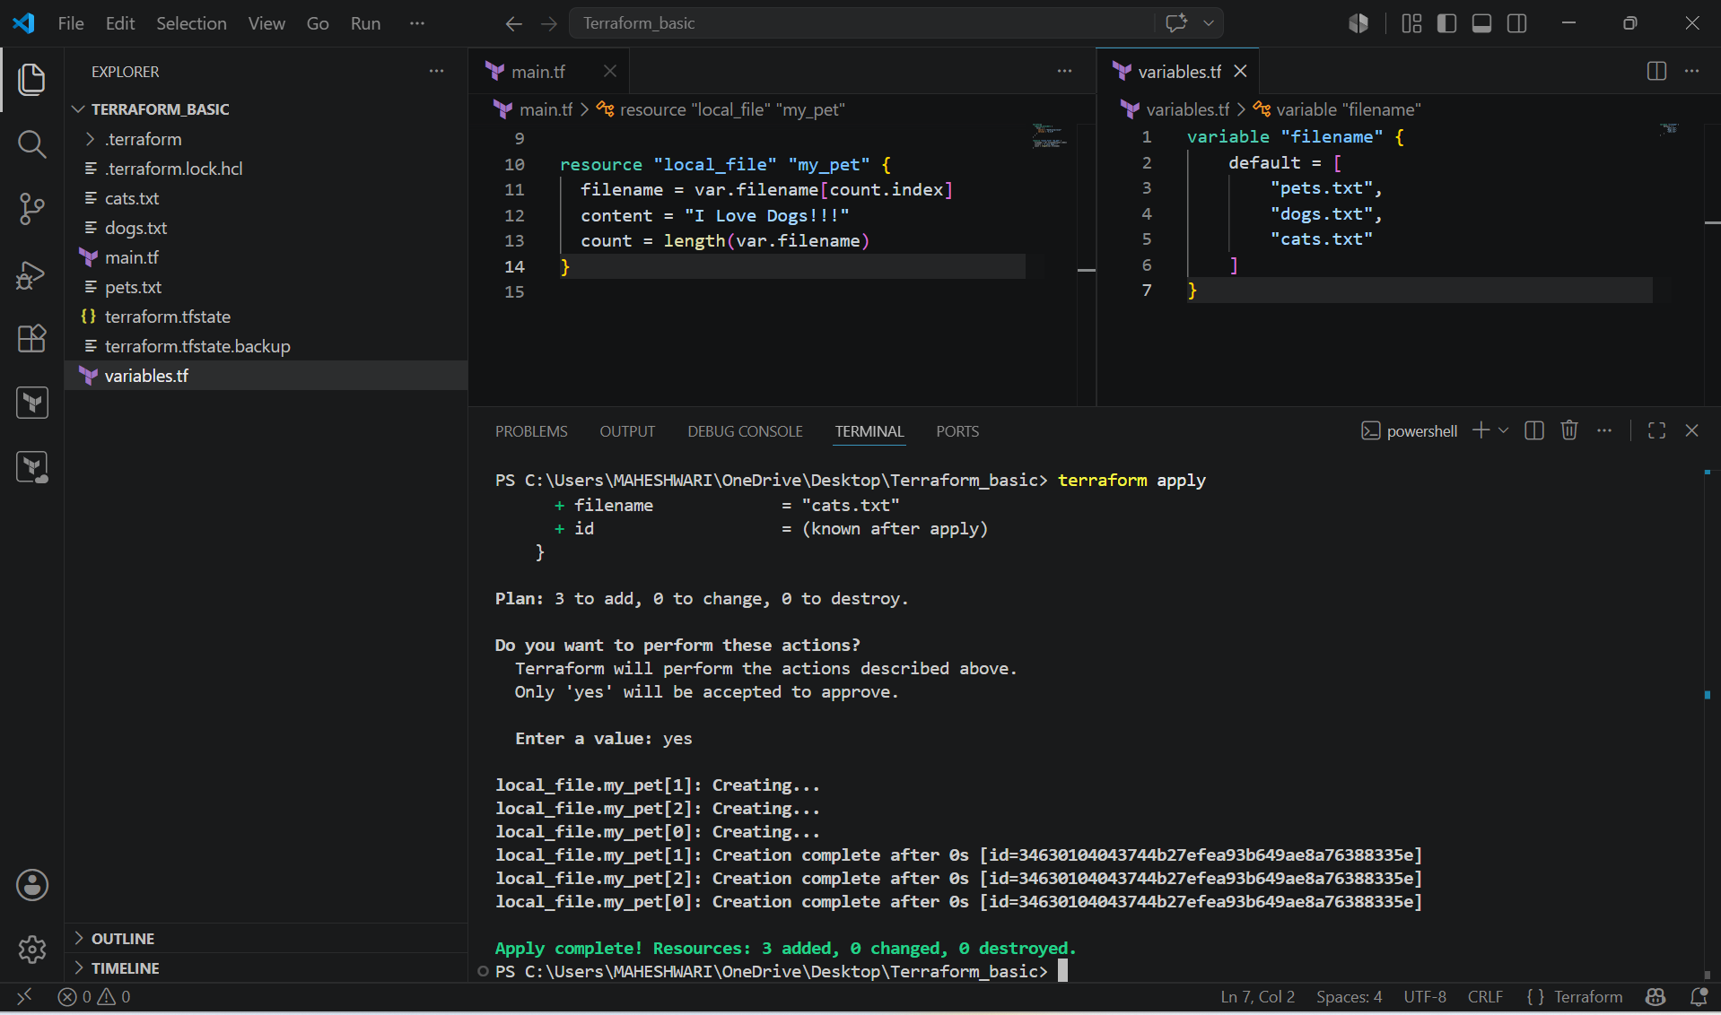

2. for_each: creates one resource for each item in a map or set.
main.tf:
resource "local_file" "my_pet" {
filename = each.value
content = "I Love Dogs!!!"
for_each = toset(var.filename)
}

Variables.tf:
variable "filename" {
default = [
"pets.txt",
"dogs.txt",
"cats.txt"
]
}

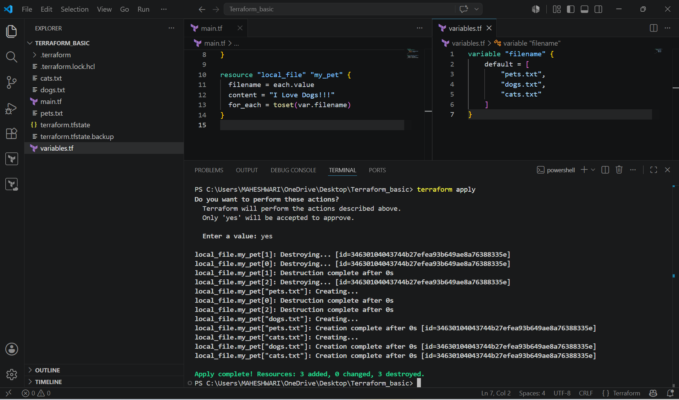

TERRAFORM WITH AWS:
- Terraform with AWS allows you to create, update, and manage AWS infrastructure using Infrastructure as Code (IaC). Instead of manually creating resources in the AWS Management Console, you write Terraform configuration files, and Terraform provisions the infrastructure automatically.
Why Use Terraform with AWS?
Benefits include:
- Infrastructure as Code
- Automation
- Reusability
- Version Control
- Multi-cloud support
- Faster deployments
- Consistency
- Reduced manual errors

Terraform Architecture with AWS
Developer
│
▼
Terraform Configuration (.tf files)
│
terraform init
│
Downloads AWS Provider
│
terraform plan
│
Shows Execution Plan
│
terraform apply
│
AWS API
│
AWS Resources
EC2
S3
VPC
IAM
RDS
ALB
CloudWatch

Example :- Create a new iam user in aws using terraform.

- Write a template in terraform and execute terraform init.
- After that we have to execute terraform apply and it will create a new iam user in the aws.
- main.tf

resource "aws_iam_user" "Admin-user" {
name = "mahe"
tags = {
description = "Technical Admin user"
}
}

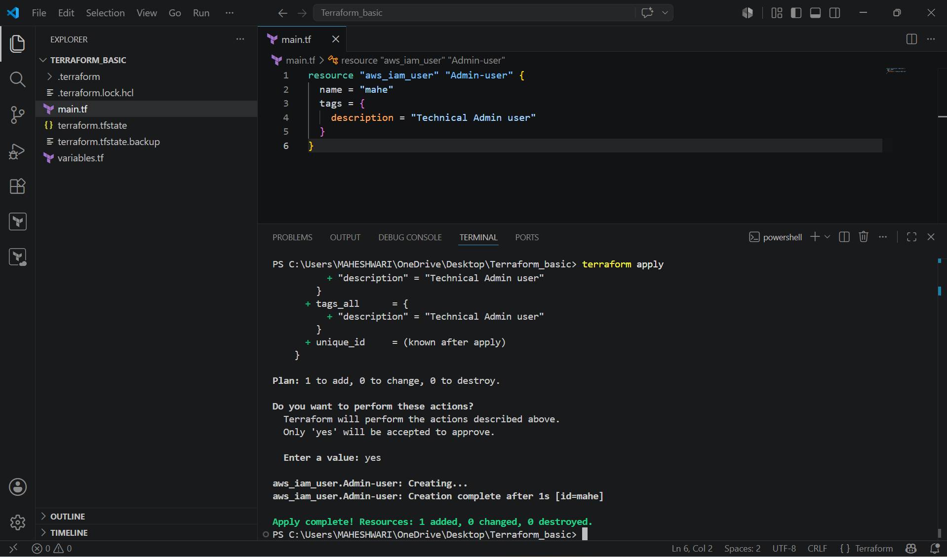

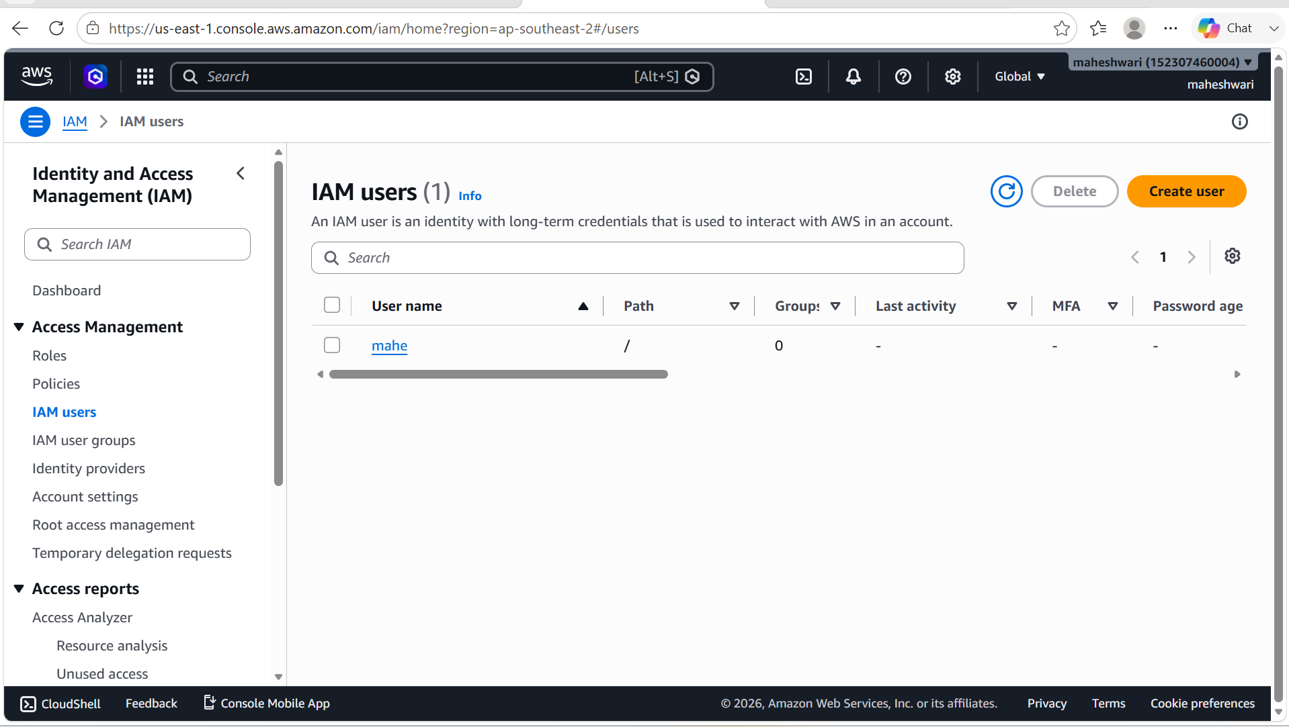

Example:- Attach a policy to the created user.

- Get the iam policy resource name from terraform registry.
- Then we have to write a template to attach a policy to the user.
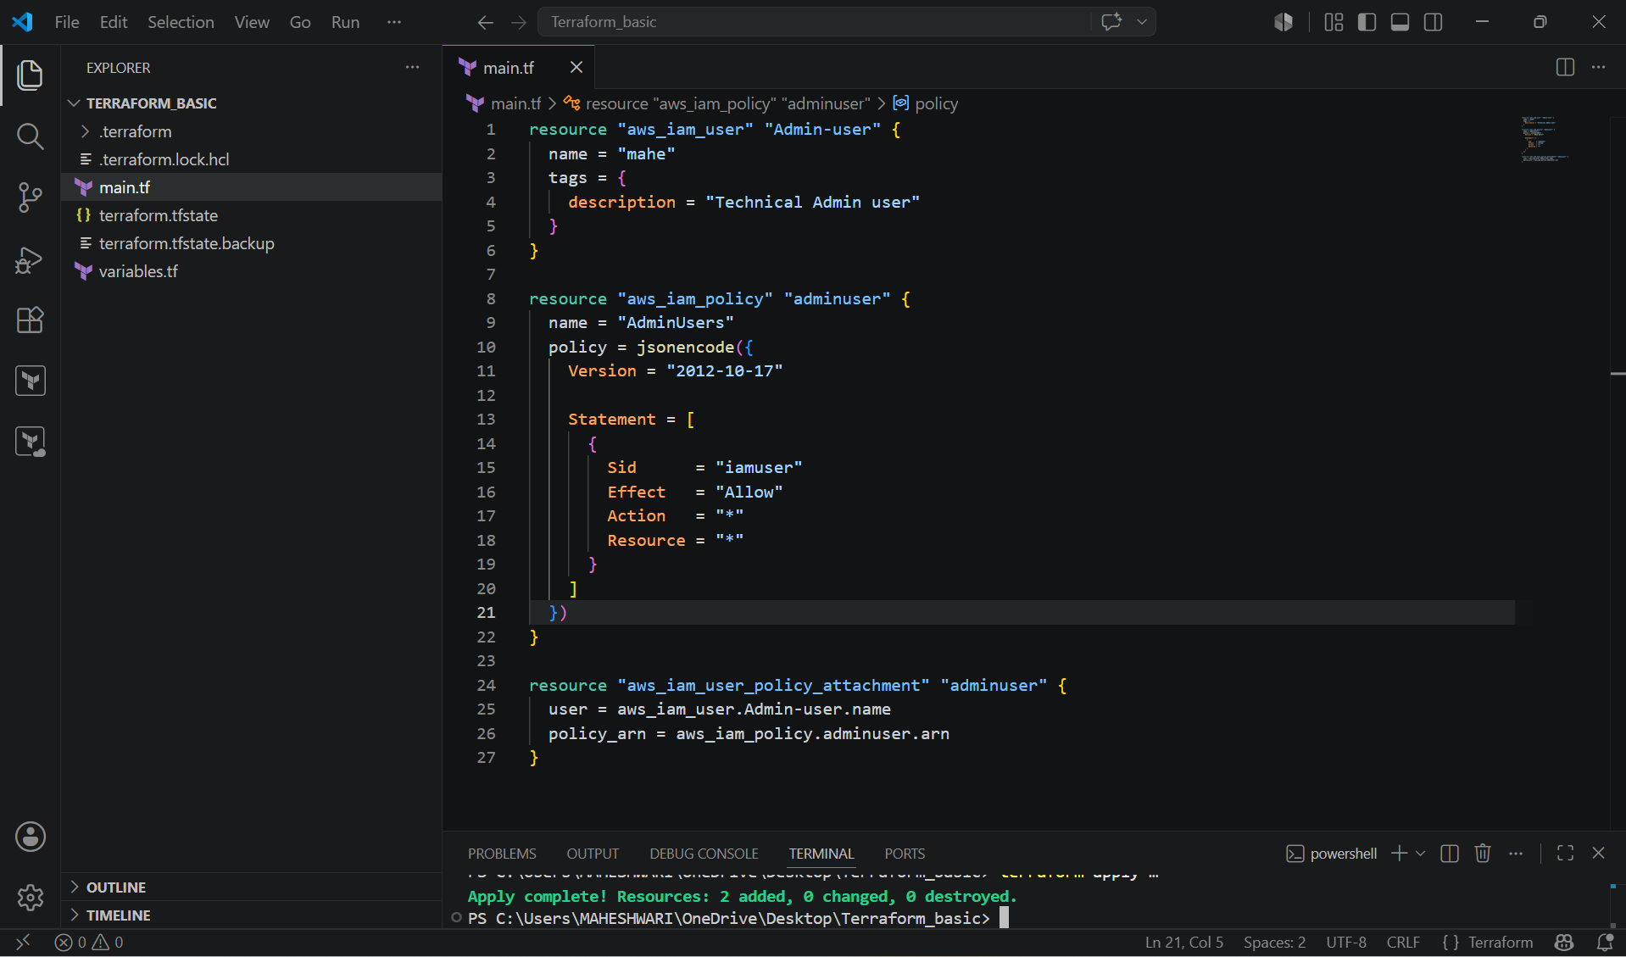

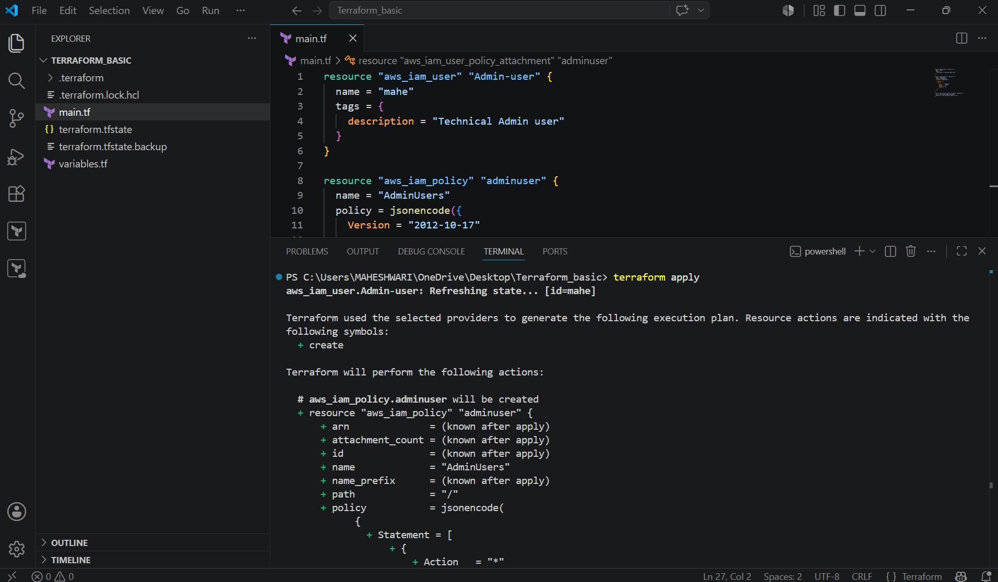

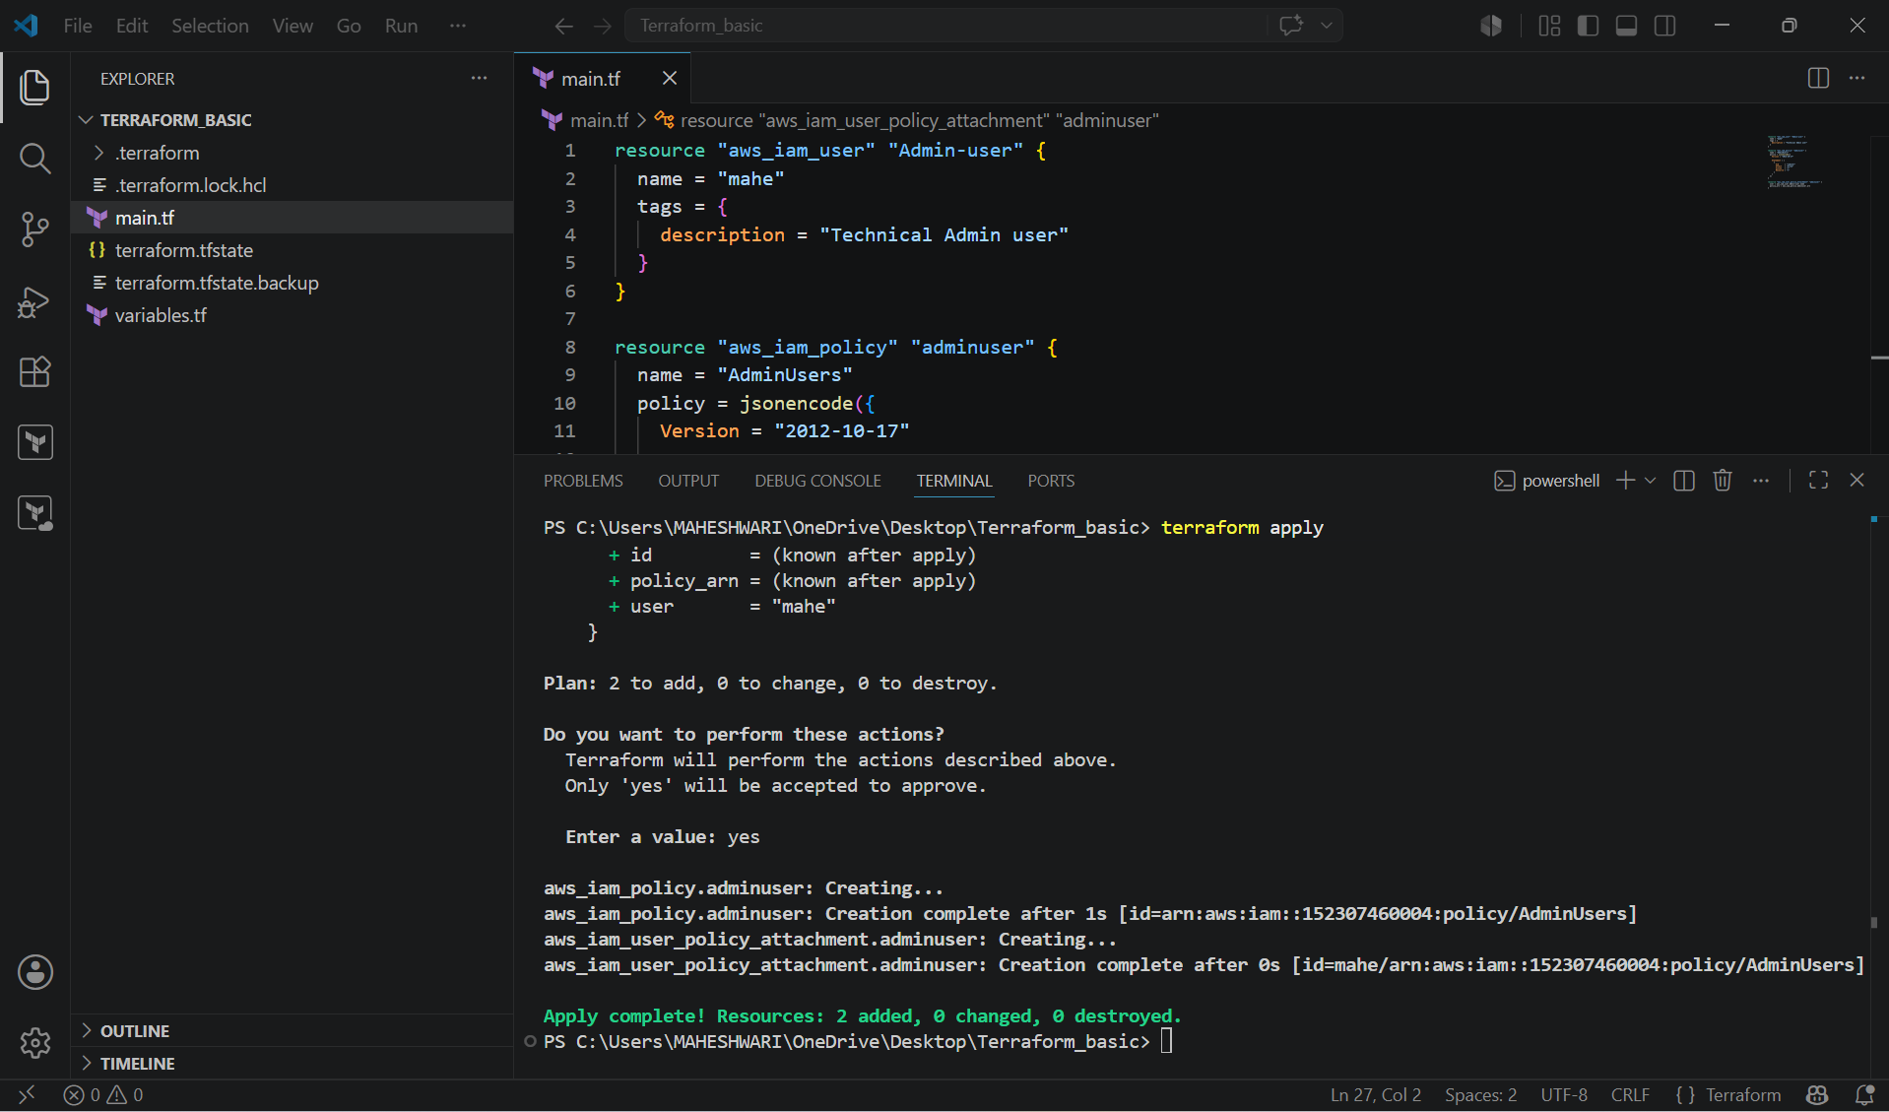

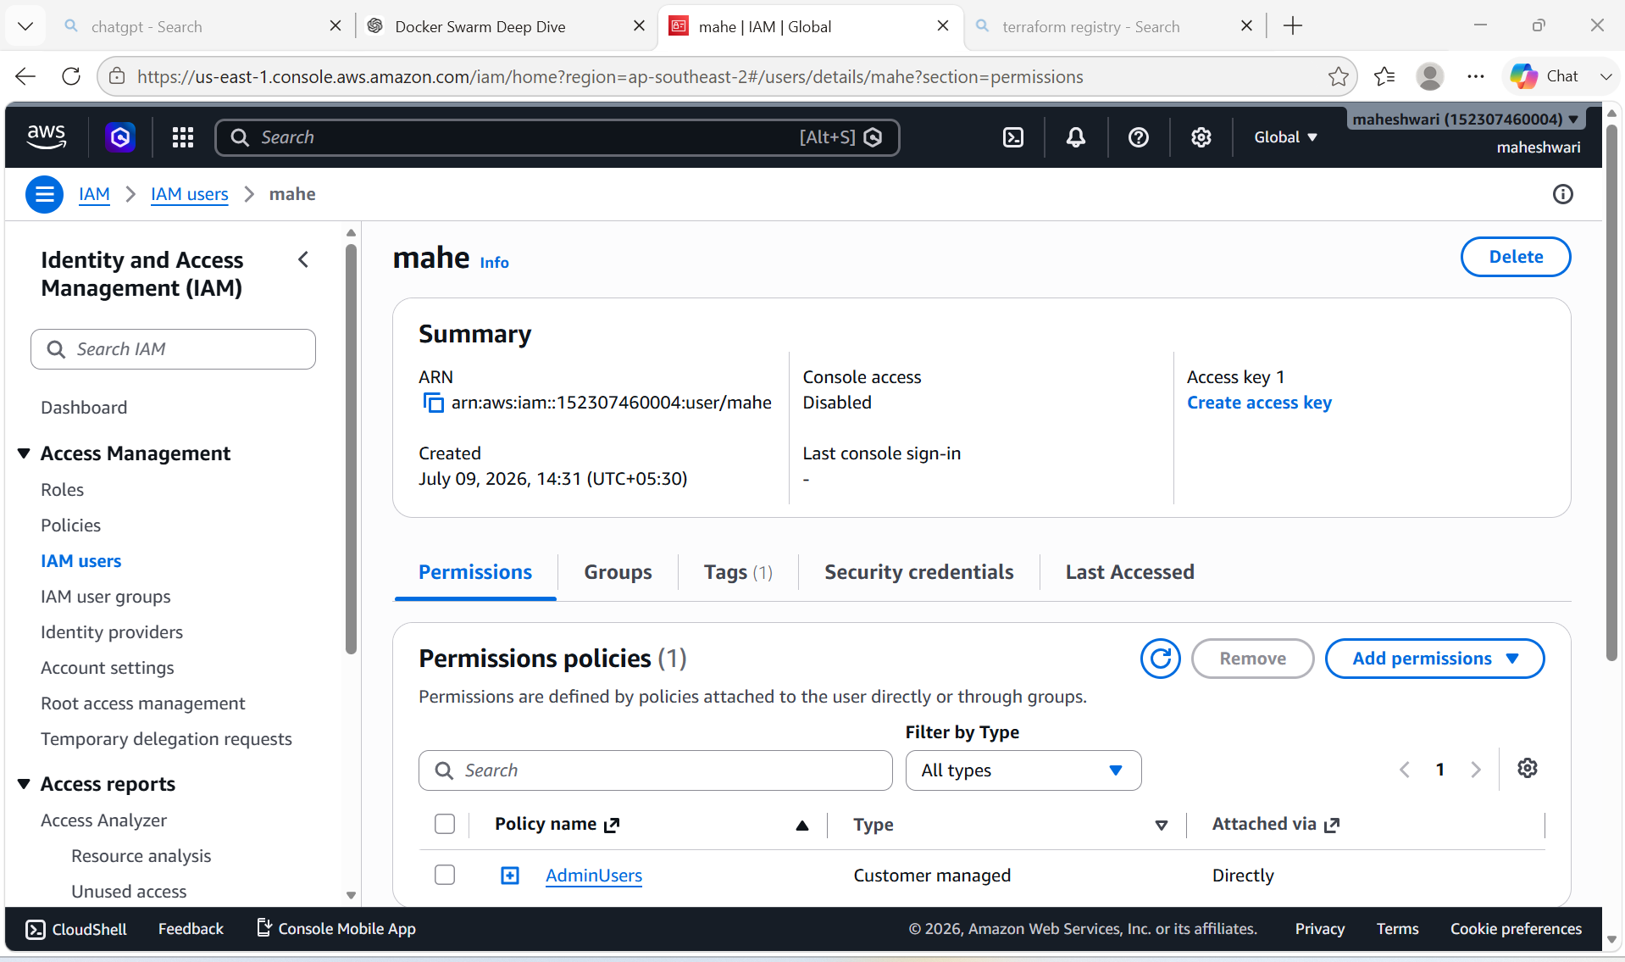

2. Integrate Terraform in Jenkins using the Terraform plugin.

PURPOSE: The purpose of integrating Terraform with Jenkins using the Terraform plugin is to automate infrastructure as Code (IaC) deployments through a CI/CD pipeline. Instead of manually running Terraform commands on a machine Jenkins executes them.

OBJECTIVE:
- After integrating Terraform with Jenkins, you should be able to:
- Install and configure Terraform as a Jenkins tool using the Terraform plugin.
- Store Terraform code in a Git repository.
- Automatically check out the latest Terraform code from GitHub.
- Execute Terraform commands from a Jenkins pipeline:
- terraform init
- terraform validate
- terraform plan
- terraform apply
- provision and manage cloud infrastructure (such as AWS, Azure or GCP) in a consistent and repeatable way.
- Reduce manual deployment effort and configuration errors.
- Integrate infrastructure provisioning into the organization’s CI/CD process.

OUTCOME:

By the end of the integration:
- Jenkins is configured with the Terraform plugin.
- Terraform is available as a managed tool in Jenkins.
- A pipeline automatically executes Terraform commands.
- Infrastructure changes are version-controlled through Git.
- Infrastructure deployments become automated, consistent, and repeatable.
- Manual intervention is minimized, improving deployment speed and reliability.

WORKFLOW:

Developer
|
▼
Push Terraform Code to GitHub
|
▼
Jenkins Pipeline Triggered
|
▼
Terraform Plugin Provides Terraform CLI
|
▼
terraform init
terraform validate
terraform plan
terraform apply
|
▼
Infrastructure Created/Updated
(AWS, Azure, GCP, etc.)

STEP BY STEP IMPLEMENTATION:

- First of all, login into the Jenkins server with the publicIp:8080 in the browser.
- Then after logged in, we have search for terraform plugin in the available plugins.
- Install the terraform plugin and add that installation in the tools.
- Then we have create a new job with the pipeline job style.
- In the job configurations, we have to select the pipeline from SCM.
- After selecting that, it will prompt us to select us to select SCM there we have to select git.
- After selecting git, again it will prompt us to enter the github repo url and credentials.
- If the repository is private then we have to give the credentials otherwise no need to pass the credentials if the repo is public.
- The given repo should have the files like JenkinsFile, main.tf, variables.tf, provider.tf and output.tf.
- Then only jenkins will execute the terraform commands by checking whether the repo have all the terraform files.
- Jenkinsfile consists of
pipeline {
agent any

tools {
terraform 'Terraform-1.13'
}

stages {

stage('Checkout') {
steps {
git 'https://github.com/username/terraform-basic.git'
}
}

stage('Terraform Version') {
steps {
sh 'terraform version'
}
}

stage('Terraform Init') {
steps {
sh 'terraform init'
}
}

stage('Terraform Validate') {
steps {
sh 'terraform validate'
}
}

stage('Terraform Plan') {
steps {
sh 'terraform plan'
}
}

stage('Terraform Apply') {
steps {
input "Apply Terraform?"

sh 'terraform apply -auto-approve'
}
}
}
}

- Then when you run the job by clicking on build now, it will go and check for the files in the repo and then it will executes the terraform commands written in Jenkinsfile and our job will be successful.

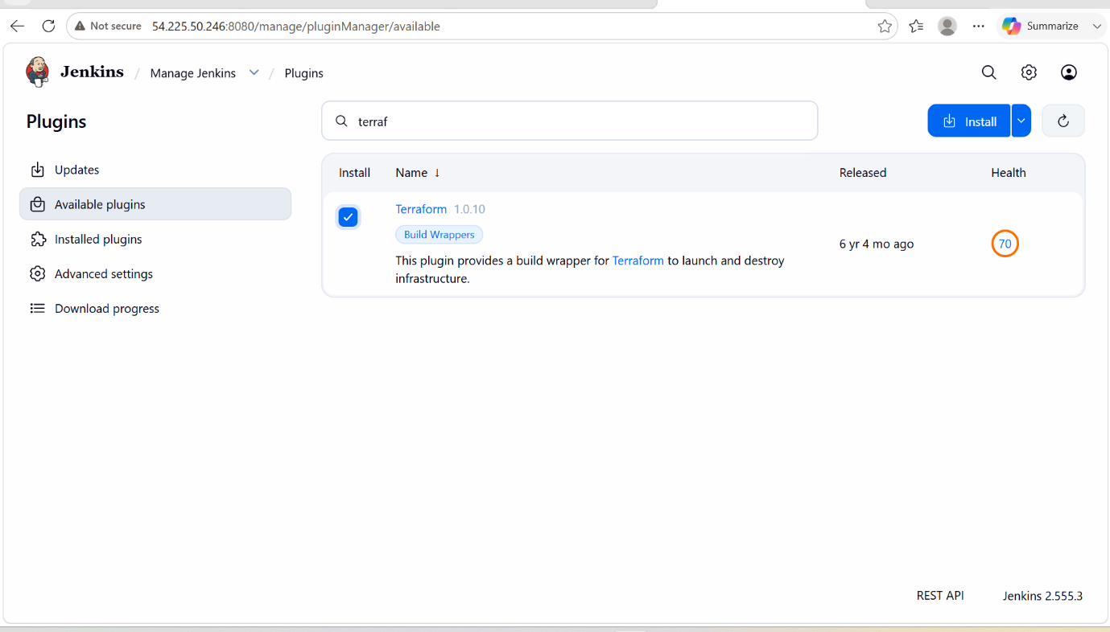

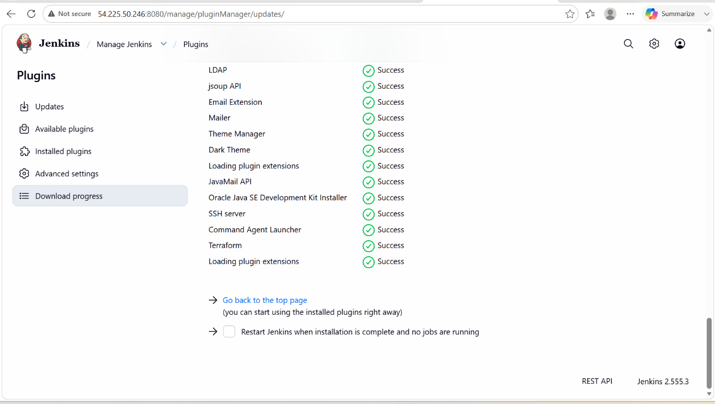

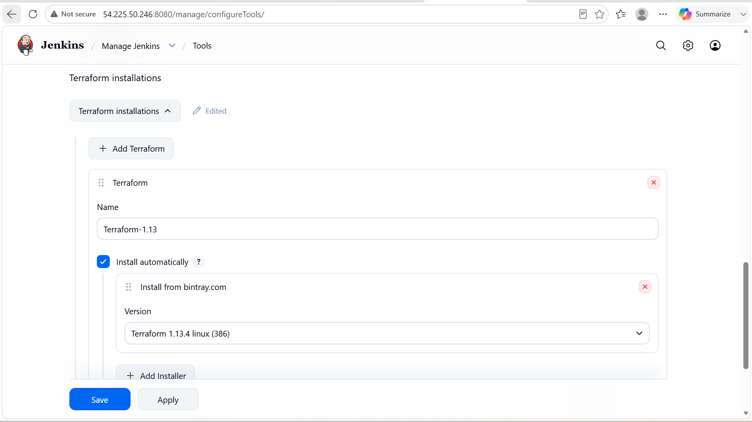

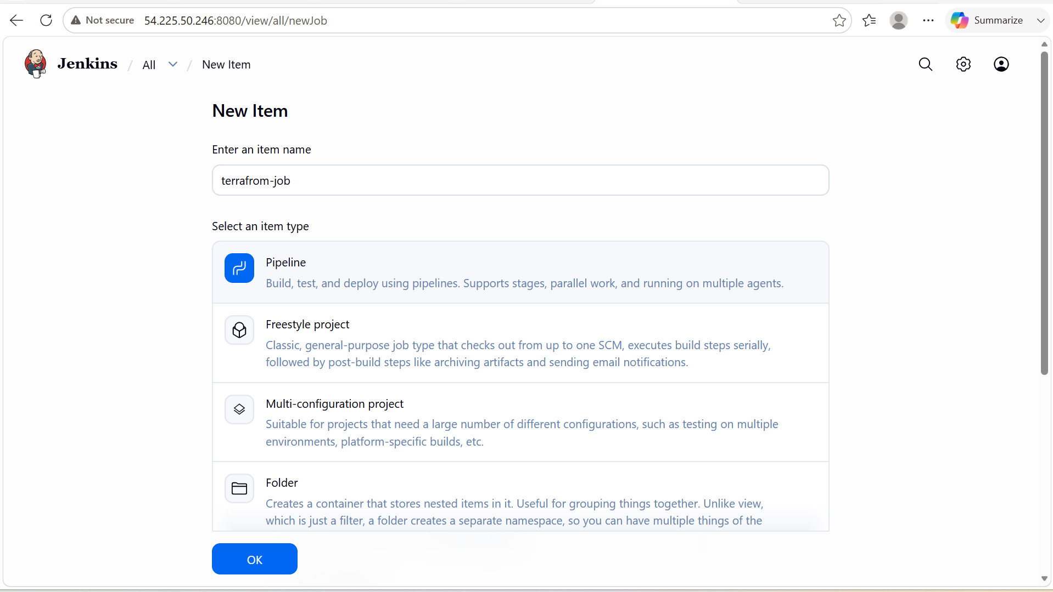

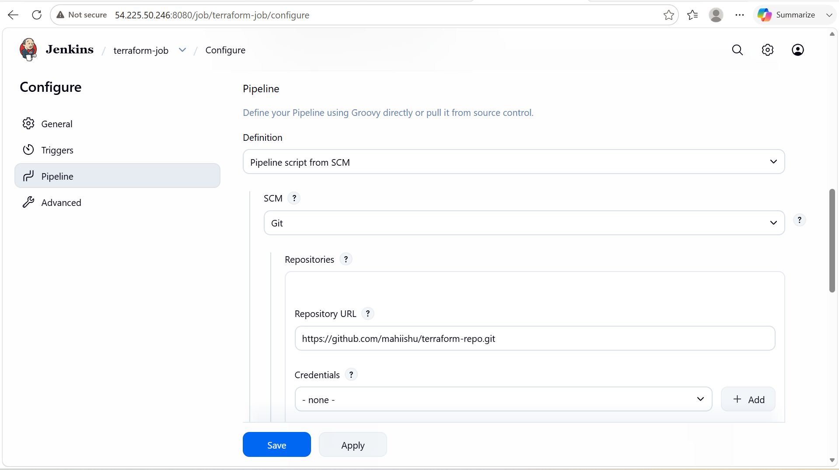

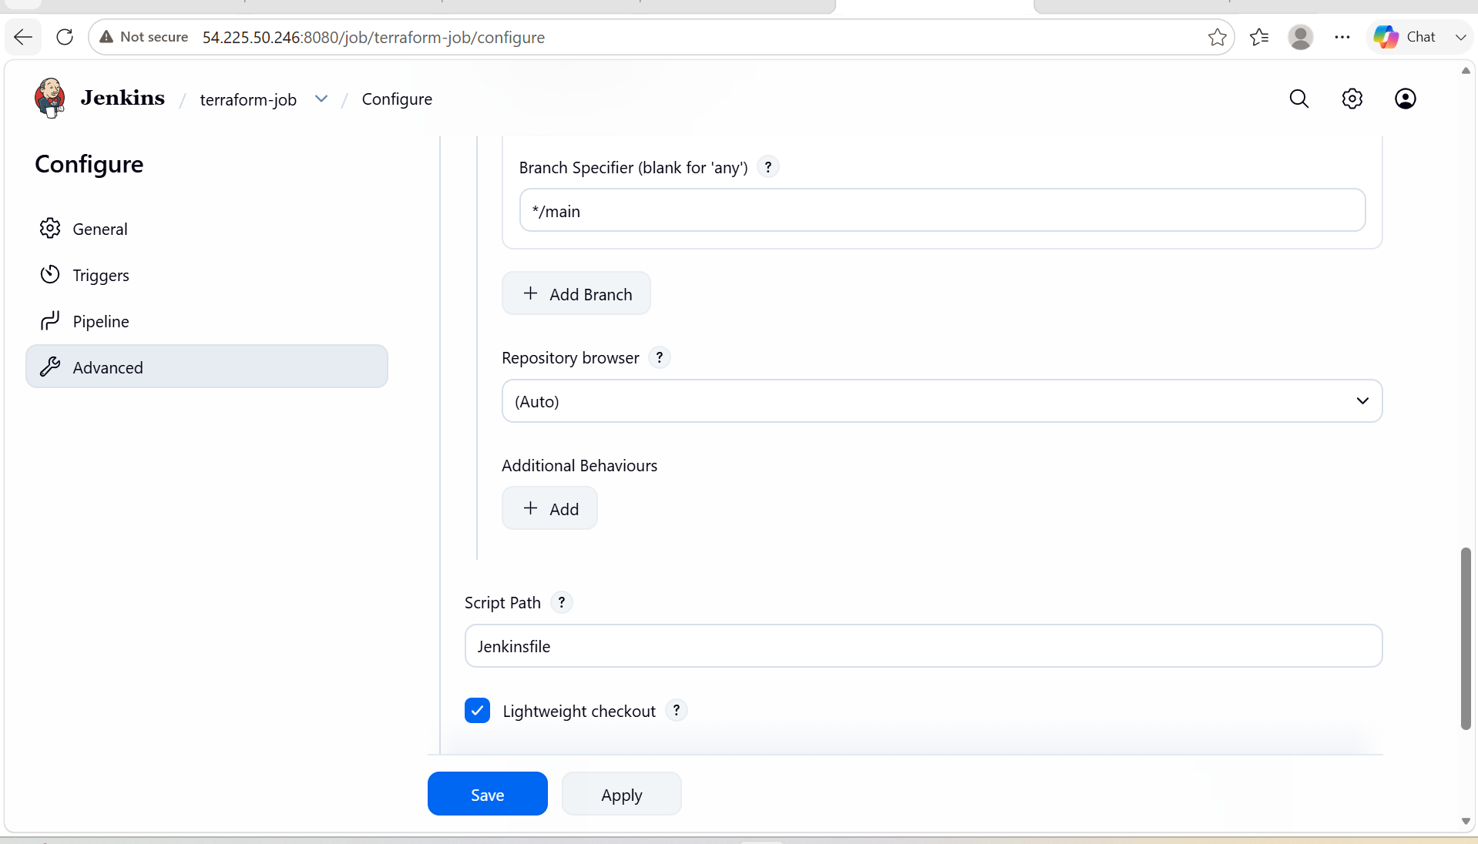

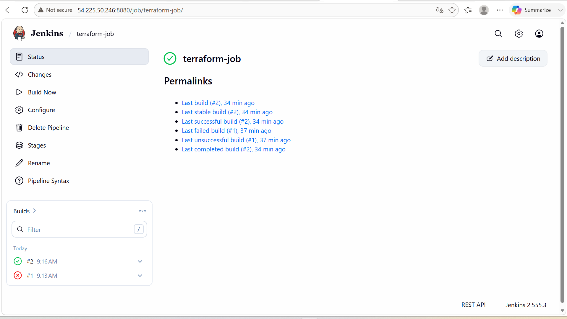

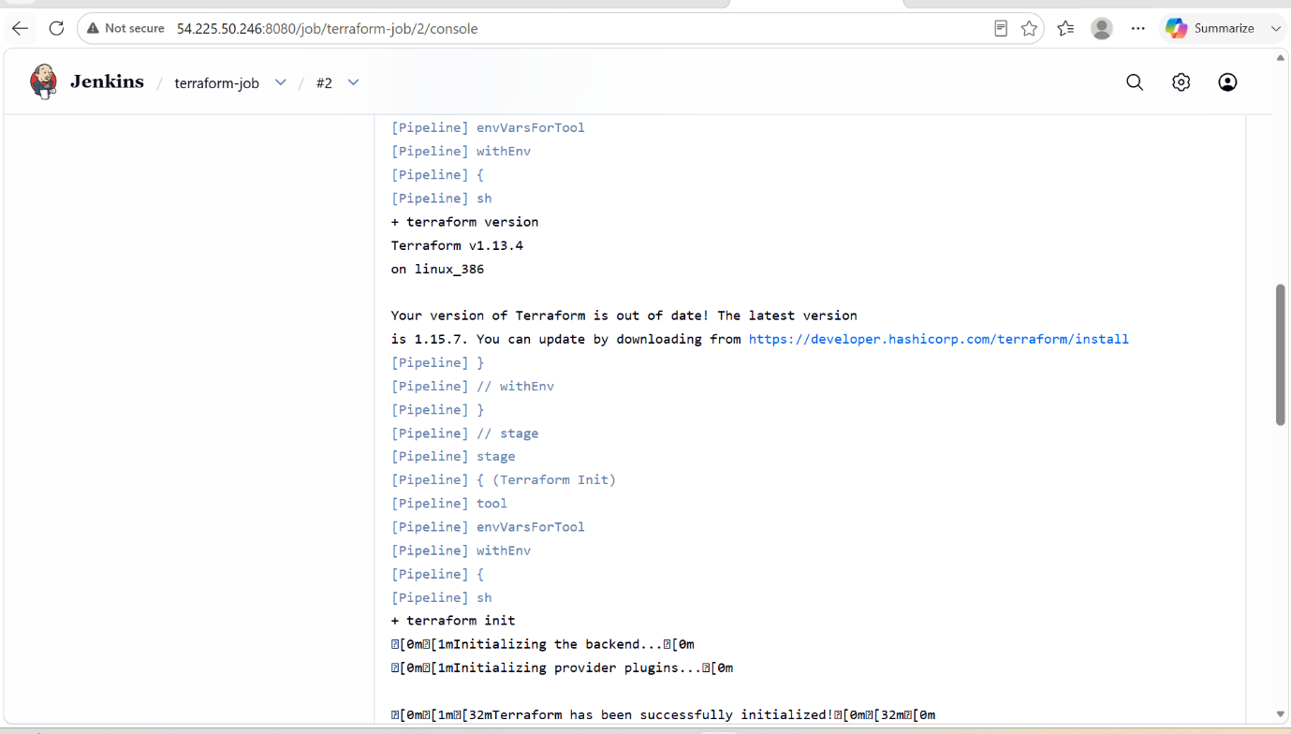

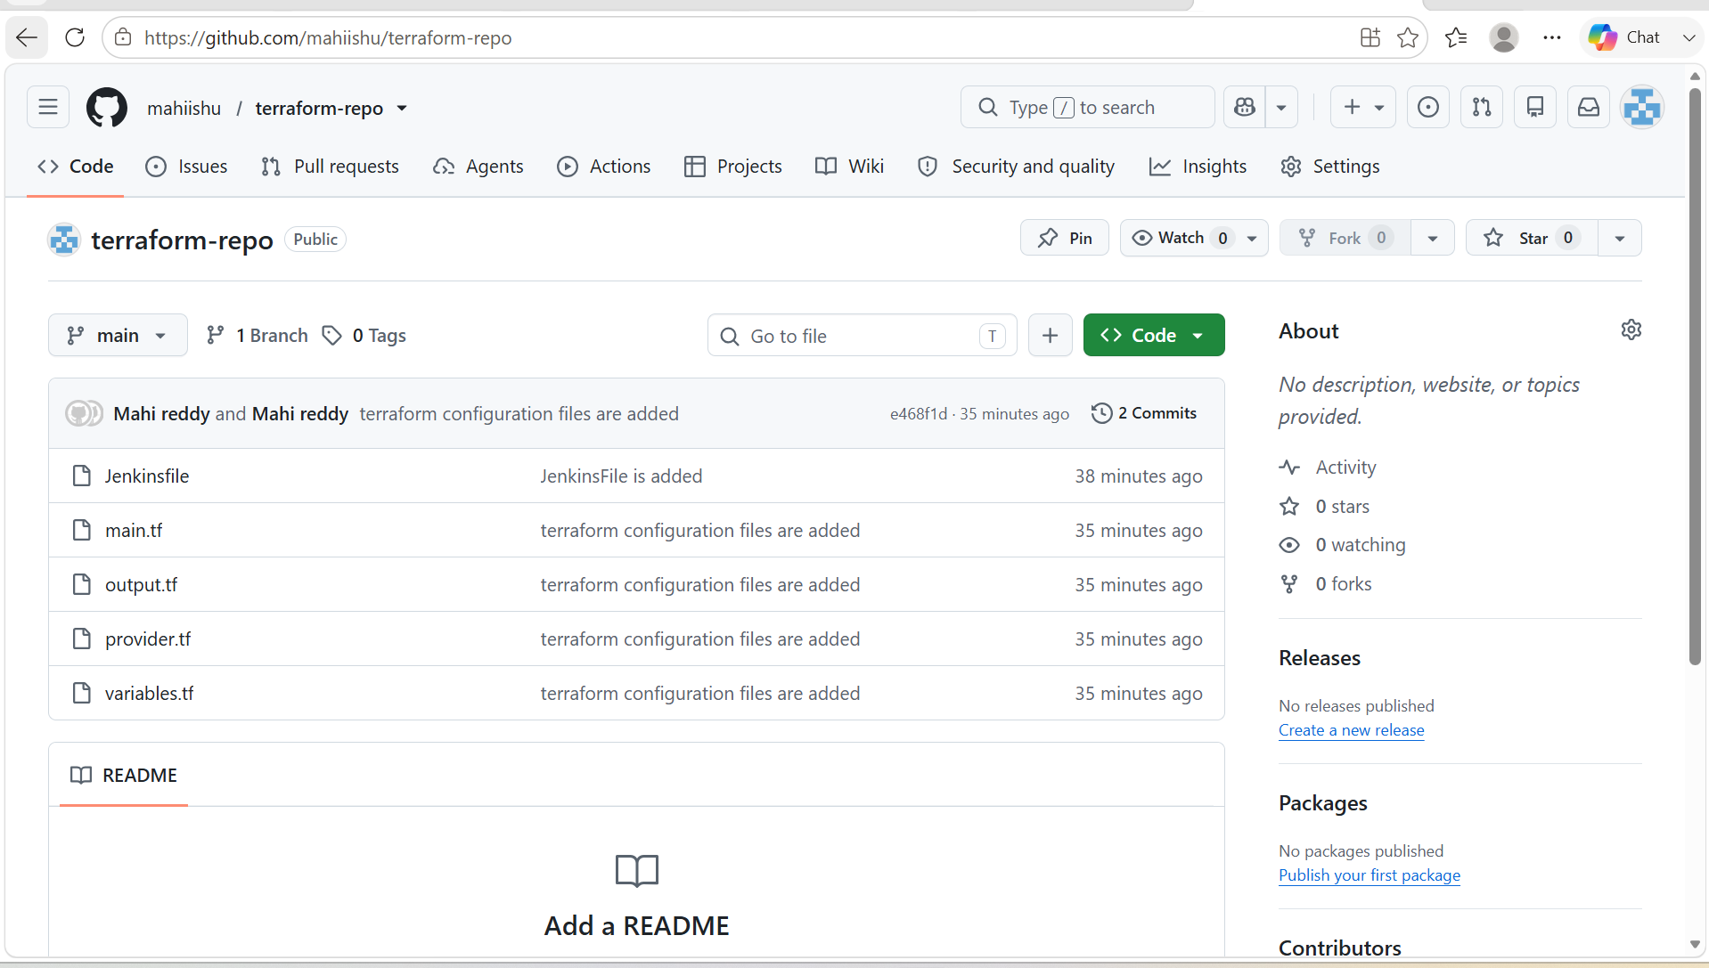

3. Create a CI/CD pipeline for a Nodejs Application: https://github.com/betawins/Trading-UI.git

PIPELINE ARCHITECTURE:

GitHub Repository
│
▼
Jenkins
│
├── Checkout Source Code
│
├── Install Node Modules
│
├── Run Tests
│
├── Build Application
│
├── Build Docker Image
│
├── Push Docker Image
│
└── Deploy Container

Prerequisites
On the Jenkins server install:
- Git
- Node.js (18 or above)
- npm
- Docker
- Docker Pipeline Plugin
- NodeJS Plugin
- Git Plugin
Configure in Jenkins:
- Git installation
- NodeJS installation
- Docker installed and running
- DockerHub credentials

STEP BY STEP IMPLEMENTATION:

- We have to login into our jenkins server.
- After that we have to create a new job of a pipeline job style.
- Then in configurations, we have to write a pipeline code for our NodeJs application.

pipeline {

agent any

tools {
nodejs "NodeJS"
}

environment {
IMAGE_NAME = "yourdockerhubusername/trading-ui"
TAG = "v1"
}

stages {

stage('Git Checkout') {
steps {
git branch: 'main',
url: 'https://github.com/betawins/Trading-UI.git'
}
}

stage('Install Dependencies') {
steps {
sh 'npm install'
}
}

stage('Run Tests') {
steps {
sh 'npm test -- --watchAll=false'
}
}

stage('Build Application') {
steps {
sh 'npm run build'
}
}

stage('Build Docker Image') {
steps {
sh 'docker build -t $IMAGE_NAME:$TAG .'
}
}

stage('Push Docker Image') {
steps {
withDockerRegistry([credentialsId: 'dockerhub', url: '']) {
sh 'docker push $IMAGE_NAME:$TAG'
}
}
}

stage('Deploy') {
steps {
sh '''
docker stop trading-ui || true
docker rm trading-ui || true

docker run -d \
--name trading-ui \
-p 3000:3000 \
$IMAGE_NAME:$TAG
'''
}
}
}

post {

success {
echo "Application deployed successfully."
}

failure {
echo "Pipeline failed."
}
}
}

- We have to install docker pipeline plugin in the jenkins server and then we have to build the job.
- After the job gets successful, we can verify it in the docker hub registry because it will push the created image to the Docker hub registry.

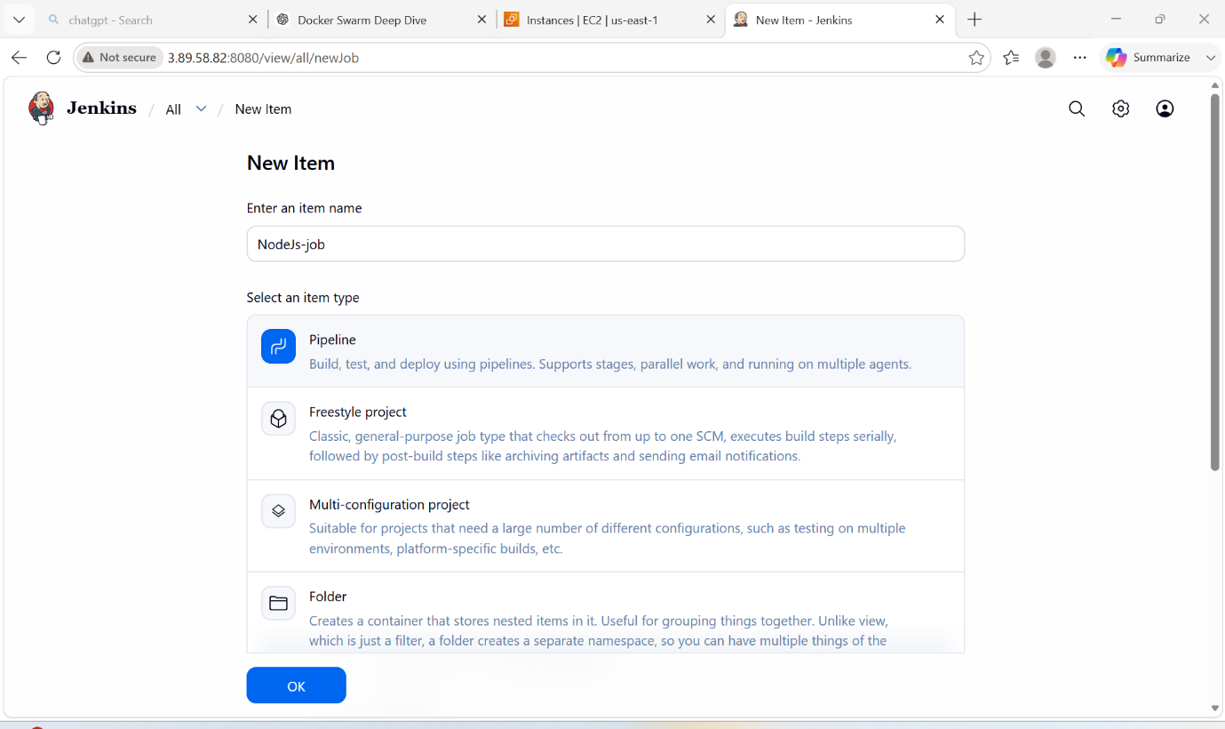

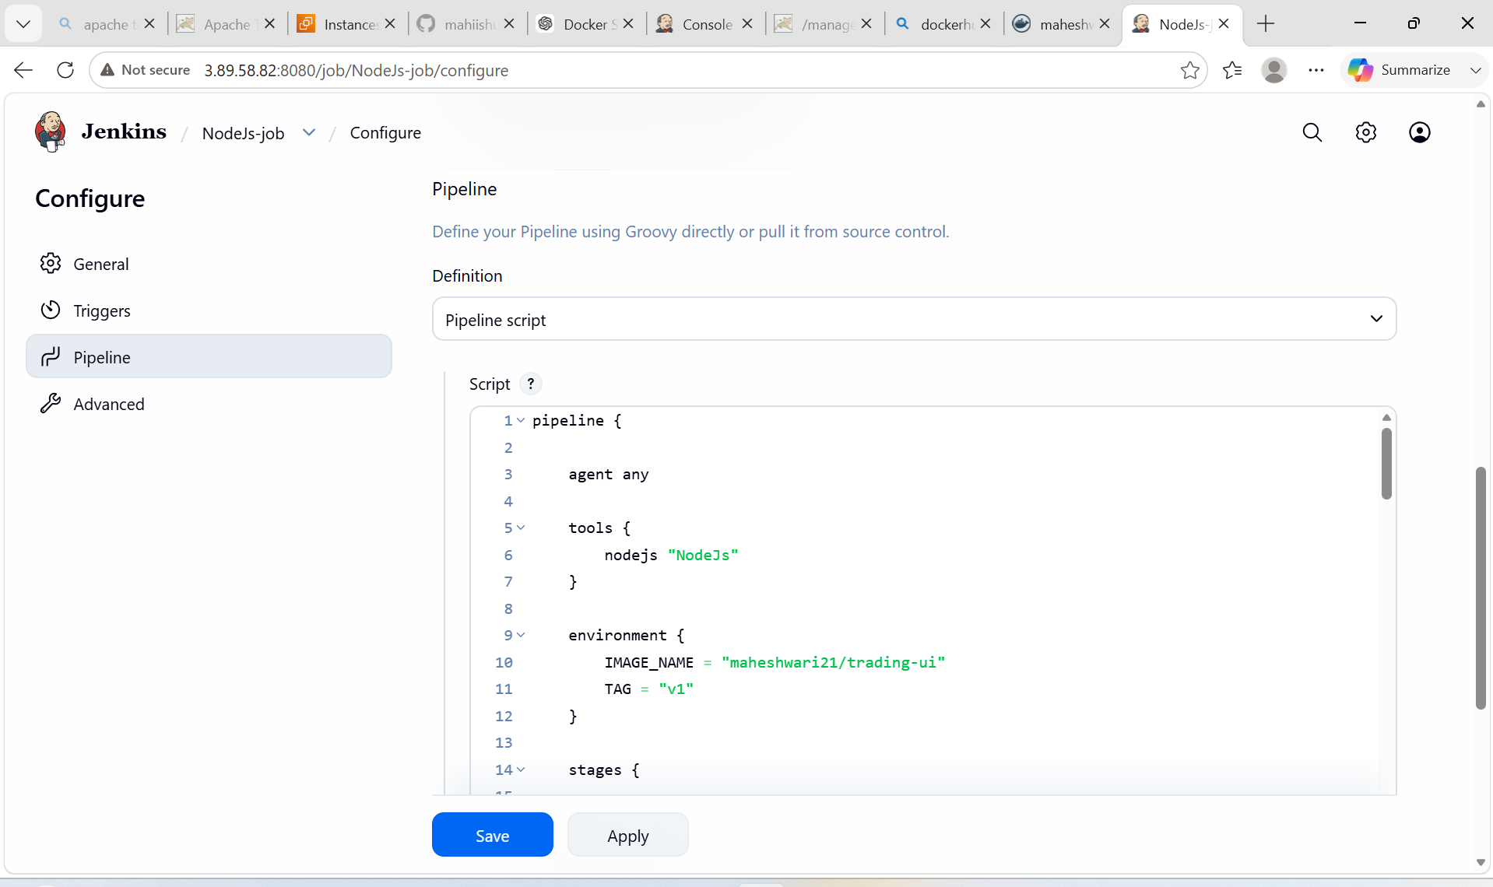

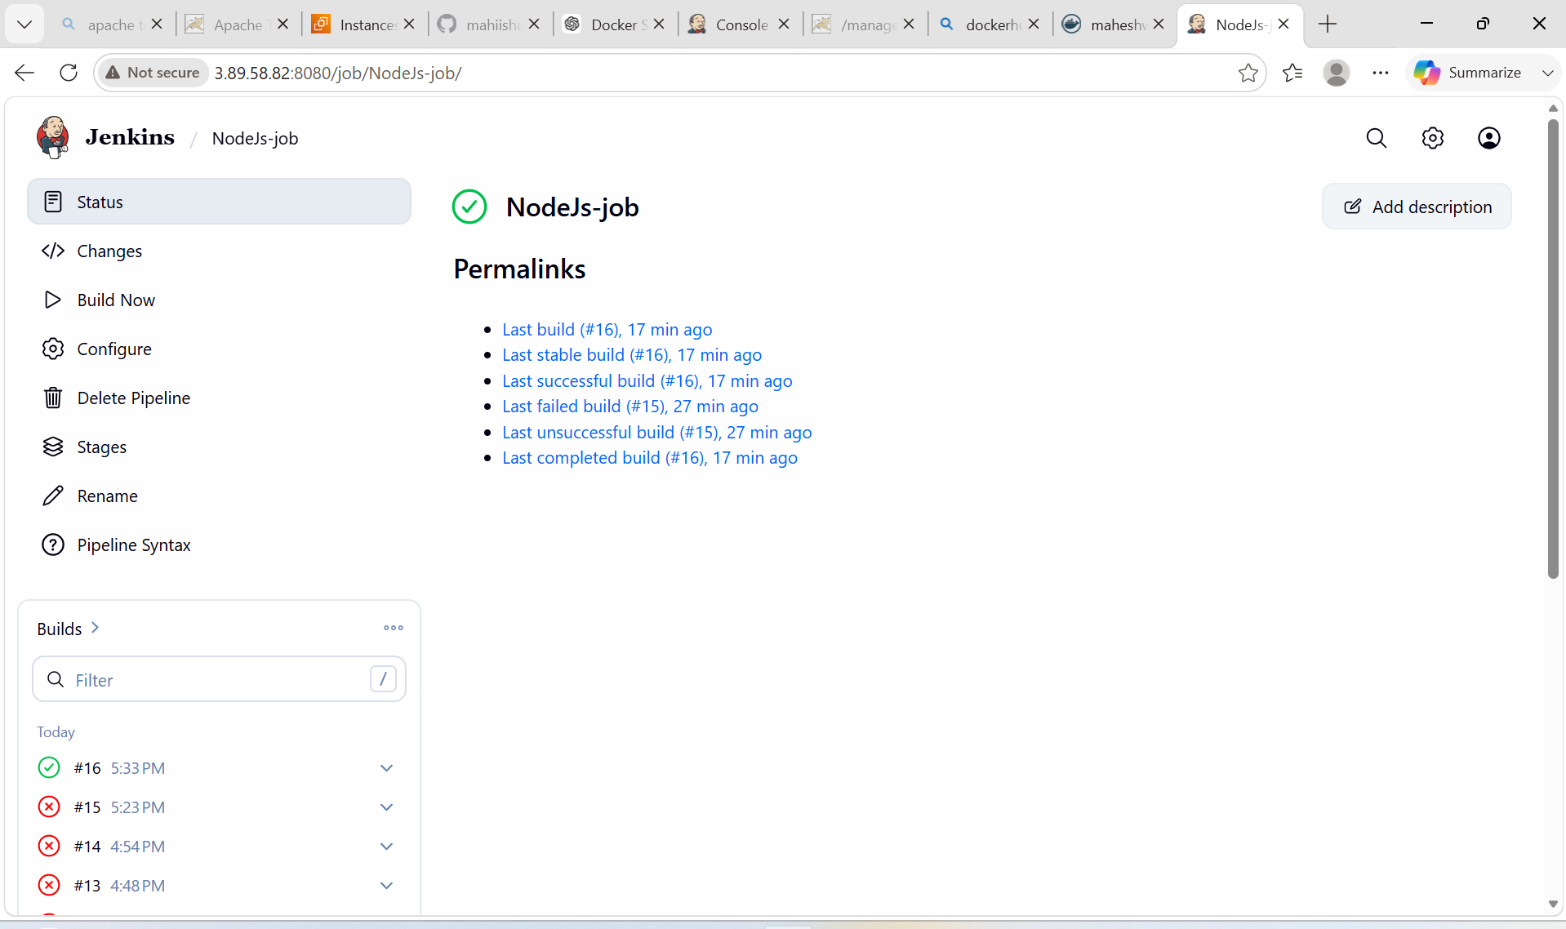

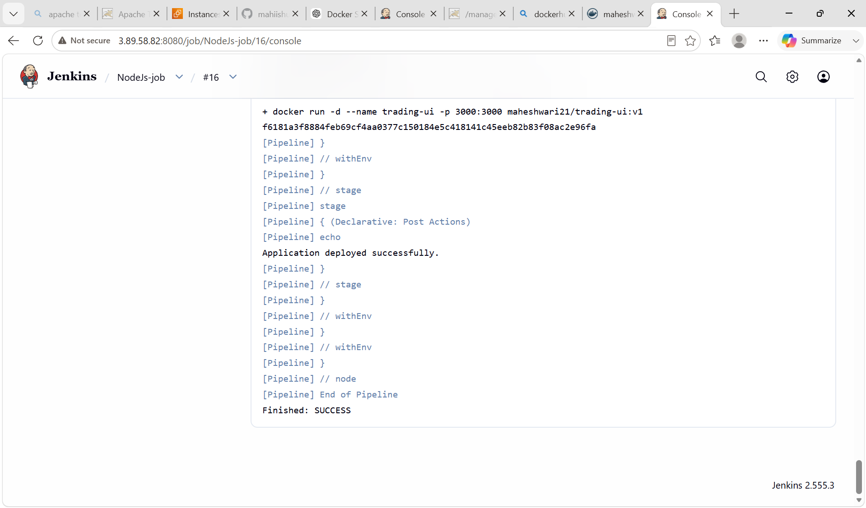

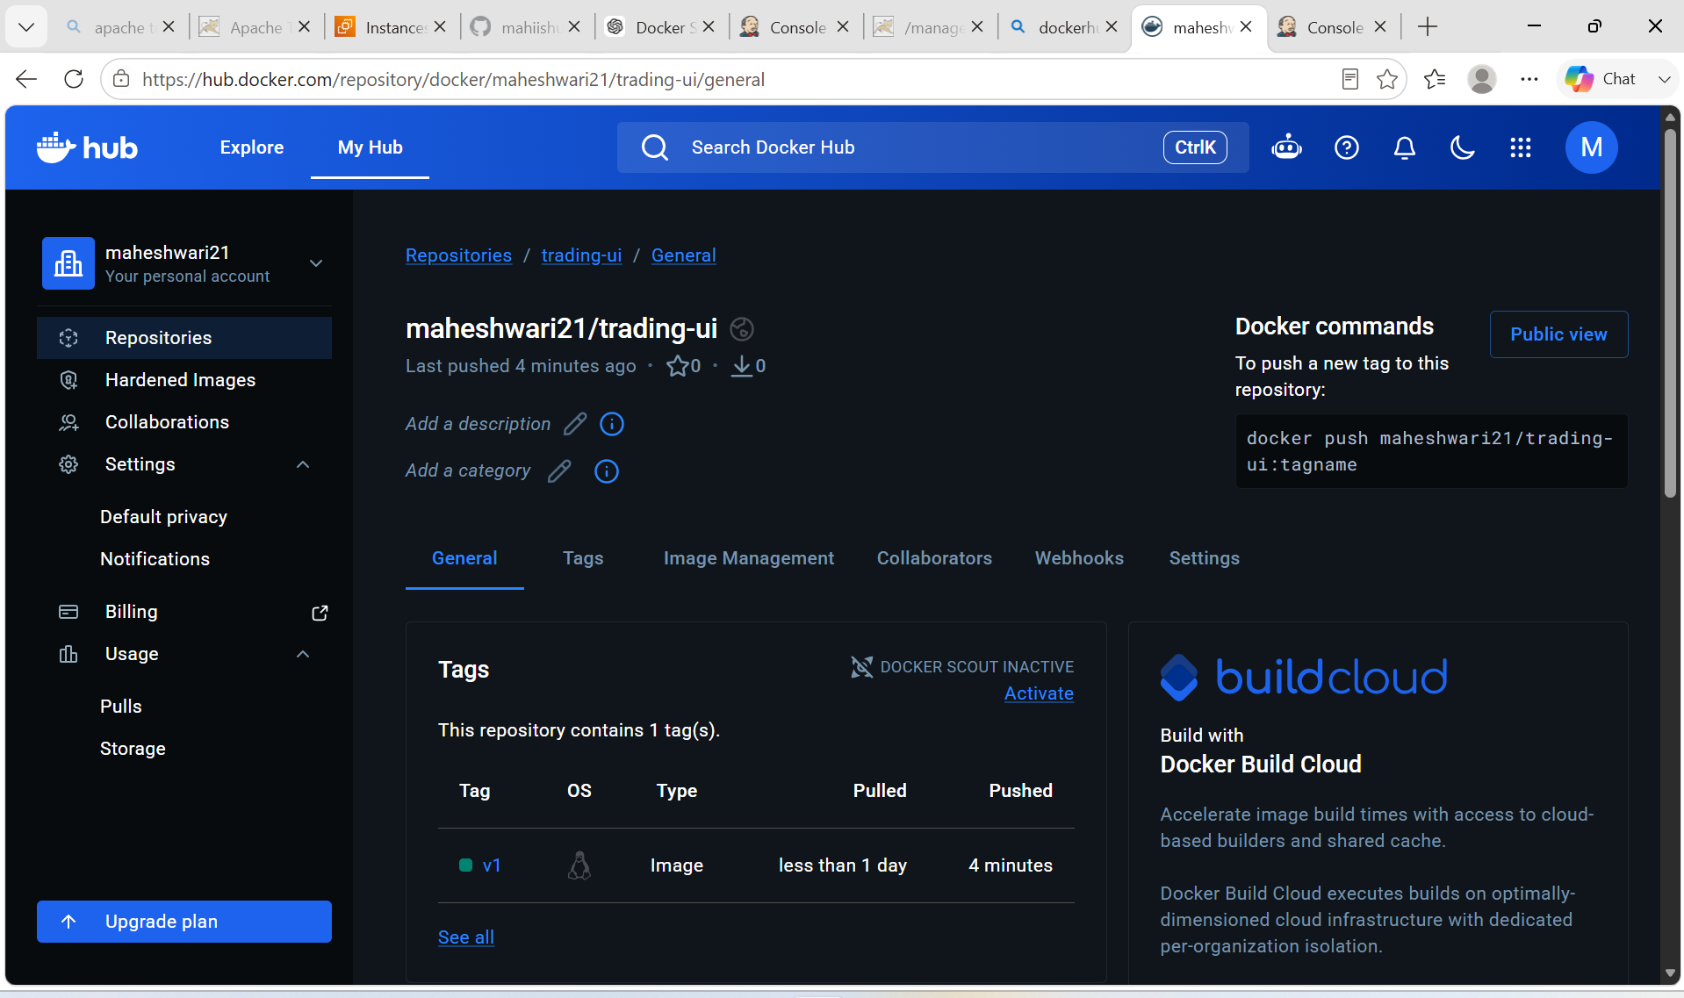

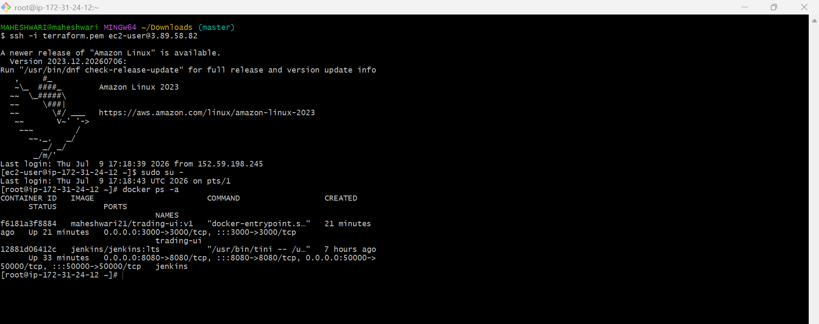

4. Explain 10 Maven commands.

Here are 10 commonly used Maven commands along with their purpose and examples.

Command | Purpose | Example
1. mvn compile | Compiles the project's source code located in the src/main/java directory. | mvn compile
2. mvn test | Runs unit tests using testing frameworks like JUnit or TestNG. | mvn test
3. mvn package | Compiles the code, runs tests, and packages the application into a JAR or WAR file. | mvn package
4. mvn install | Installs the packaged artifact into the local Maven repository (~/.m2/repository) so other local projects can use it. | mvn install
5. mvn clean | Deletes the target directory, removing all previously compiled files and build artifacts. | mvn clean
6. mvn clean install | Cleans previous builds, compiles the project, runs tests, packages it, and installs it into the local repository. | mvn clean install
7. mvn validate | Validates that the project structure and pom.xml are correct before building. | mvn validate
8. mvn verify | Performs additional checks after integration tests to ensure the package meets quality criteria. | mvn verify
9. mvn dependency:tree | Displays the project's dependency hierarchy, helping identify dependency conflicts. | mvn dependency:tree
10. mvn dependency:resolve | Downloads and resolves all project dependencies into the local repository. | mvn dependency:resolve

