TERRAFORM-06

1. Execute the script shown in the video.

TERRAFORM MODULES:

- Modules is a collection of configuration files in a directory.
- For example if we want to create two EC2 for different environments then I can create a directory for aws_instance configuration.
- resource “aws_instance” “webserver” {
ami = var.ami
instance_type = “t2.micro”
}
- we have to create the variables.tf file.

Variable “ami” {
Default = “ami_id”
}

- now let me create a directory for dev under root directory.
- module “dev-webserver” {
source = “../aws_instance”
ami = “ami_id”
}
- then we have to execute the commands terraform init and apply in the aws_instance

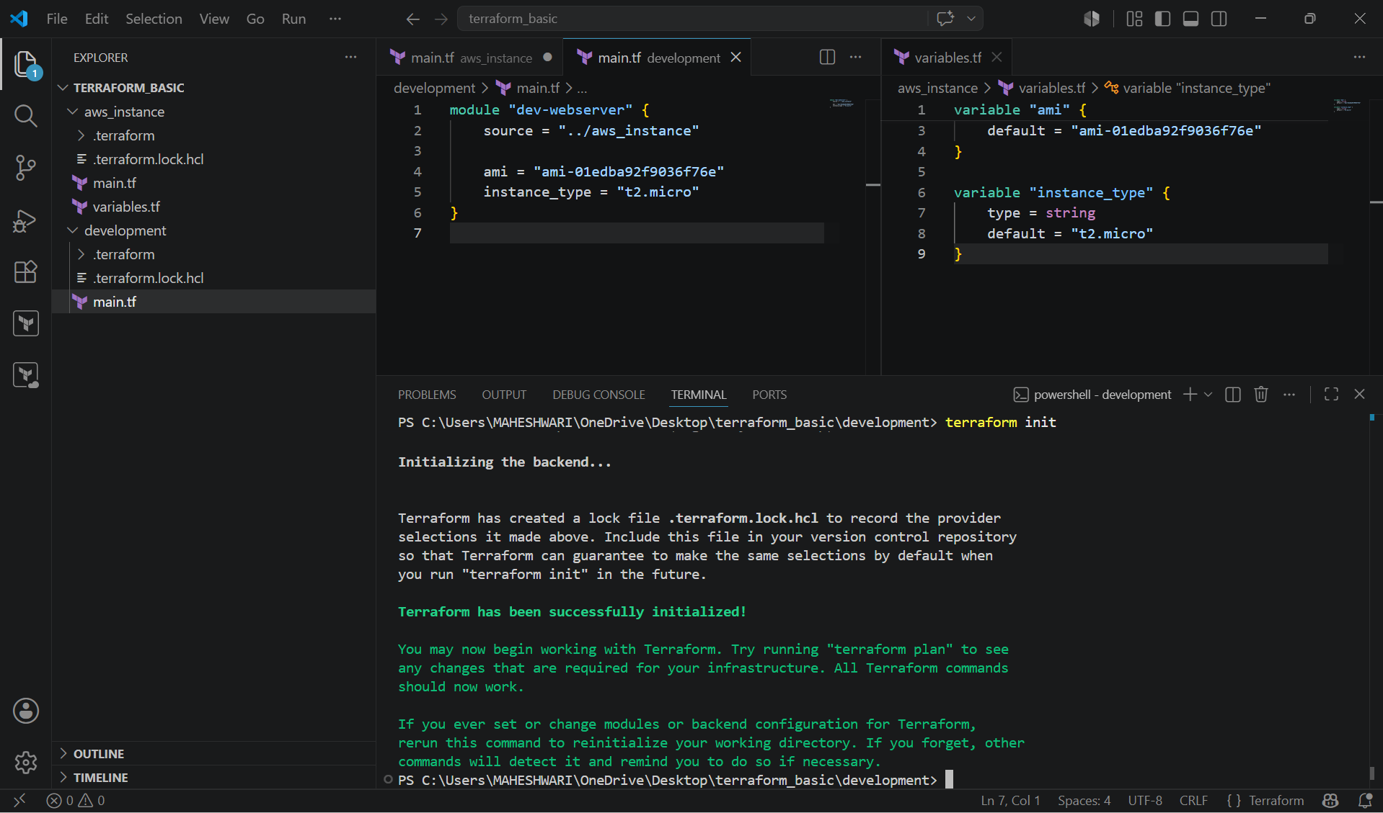

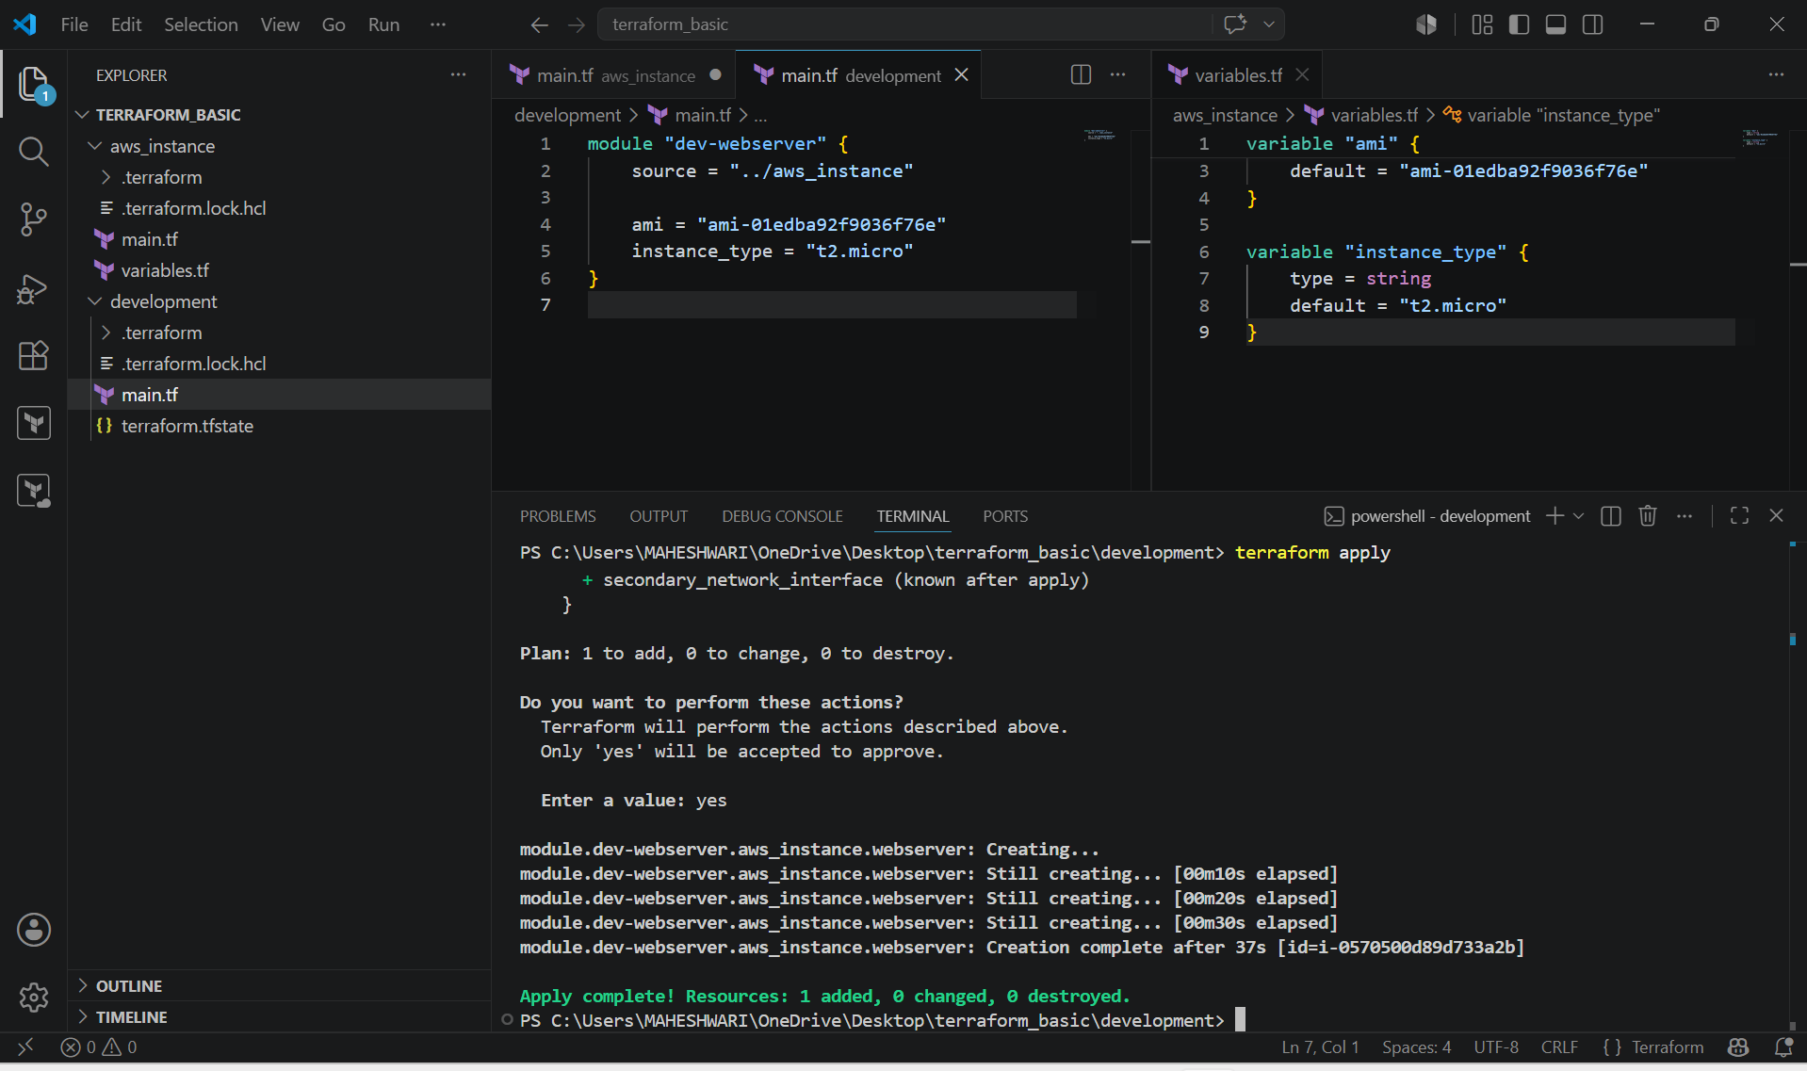

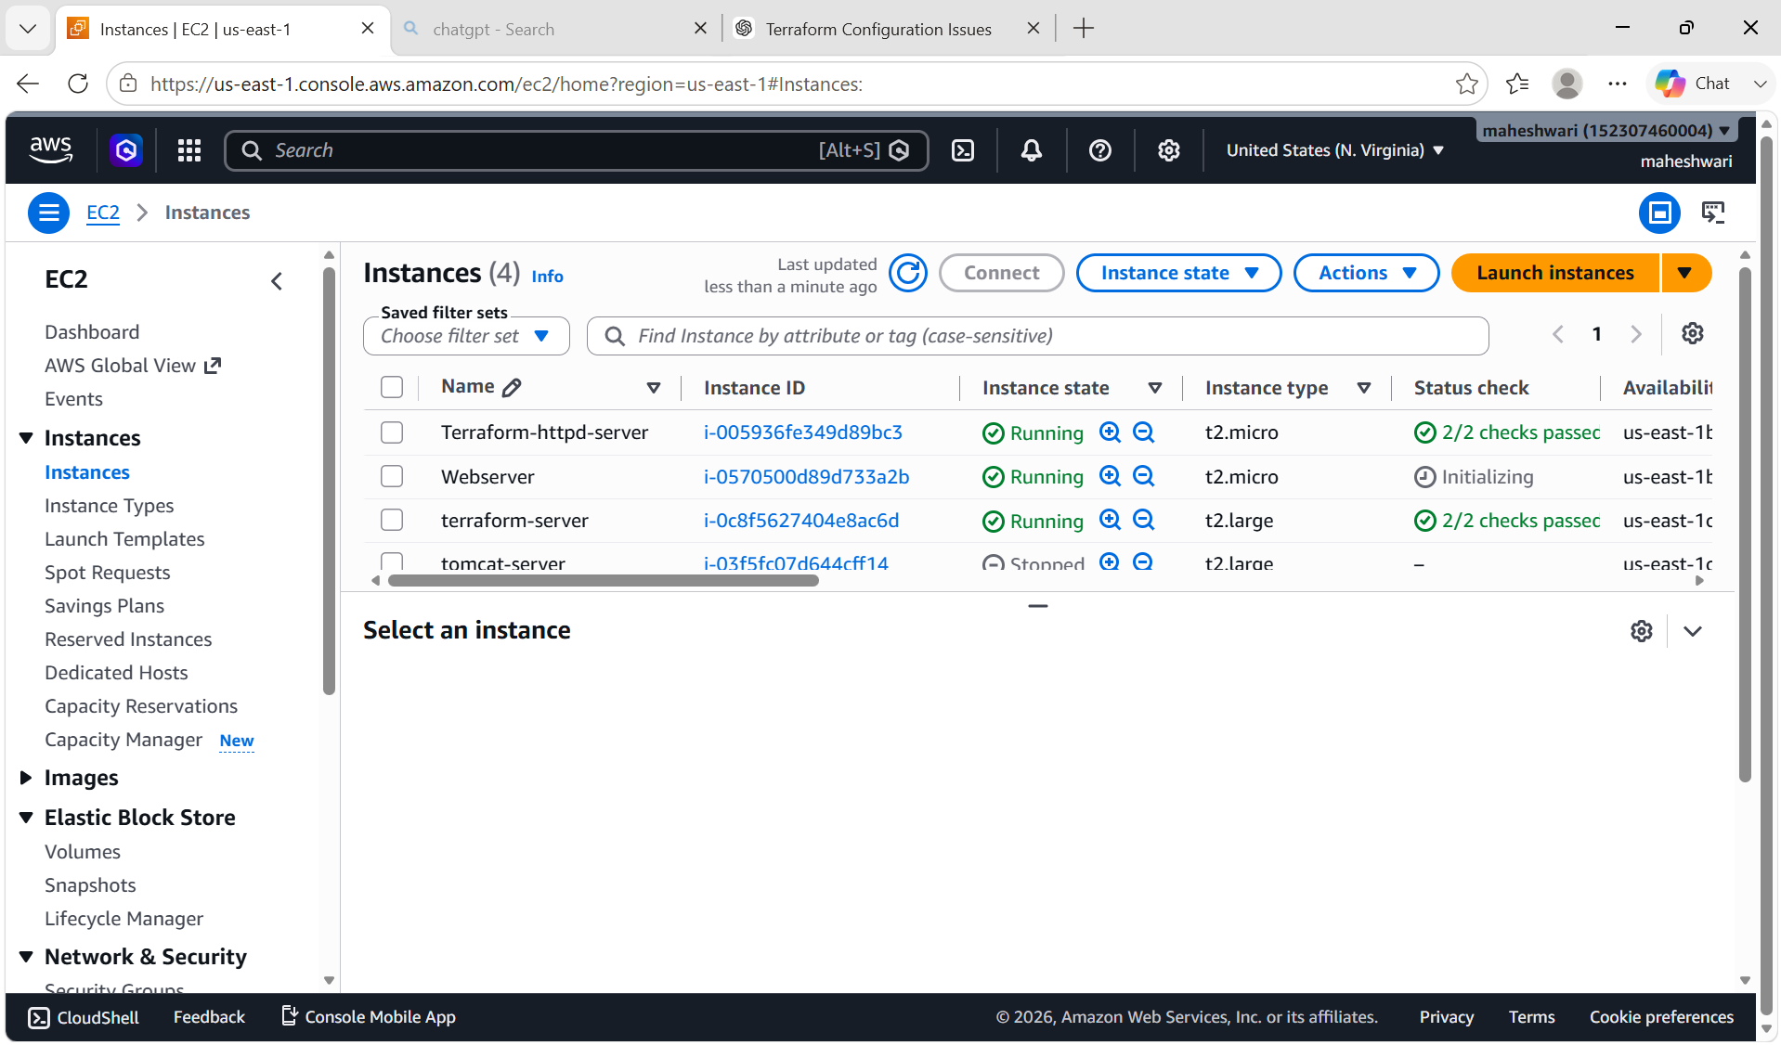

TERRAFORM WORKSPACES:

- workspaces can be used if we have multiple project environments using the same configuration.
- Workspace commands :
- terraform workspace new projectA -> to create a workspace named projectA
- terraform workspace list -> to list the workspaces available
- terraform workspace select projectA -> to switch to secific workspace
- workspaces are like same GitHub branches.

Example :

Main.tf:

Resource “aws_instance” “webserver” {
ami = var.ami
instance_type = “t2.micro”
}

Variables.tf

Variable “ami” {
type = amp
default = {
“projectA” = “ami_id”
“projectB” = “ami_id”
}
}

- when using workspaces, state files will be created in the main directory under a folder “terraform.tfstate.d”

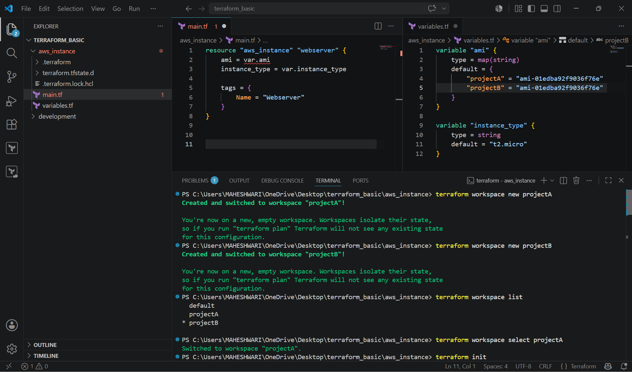

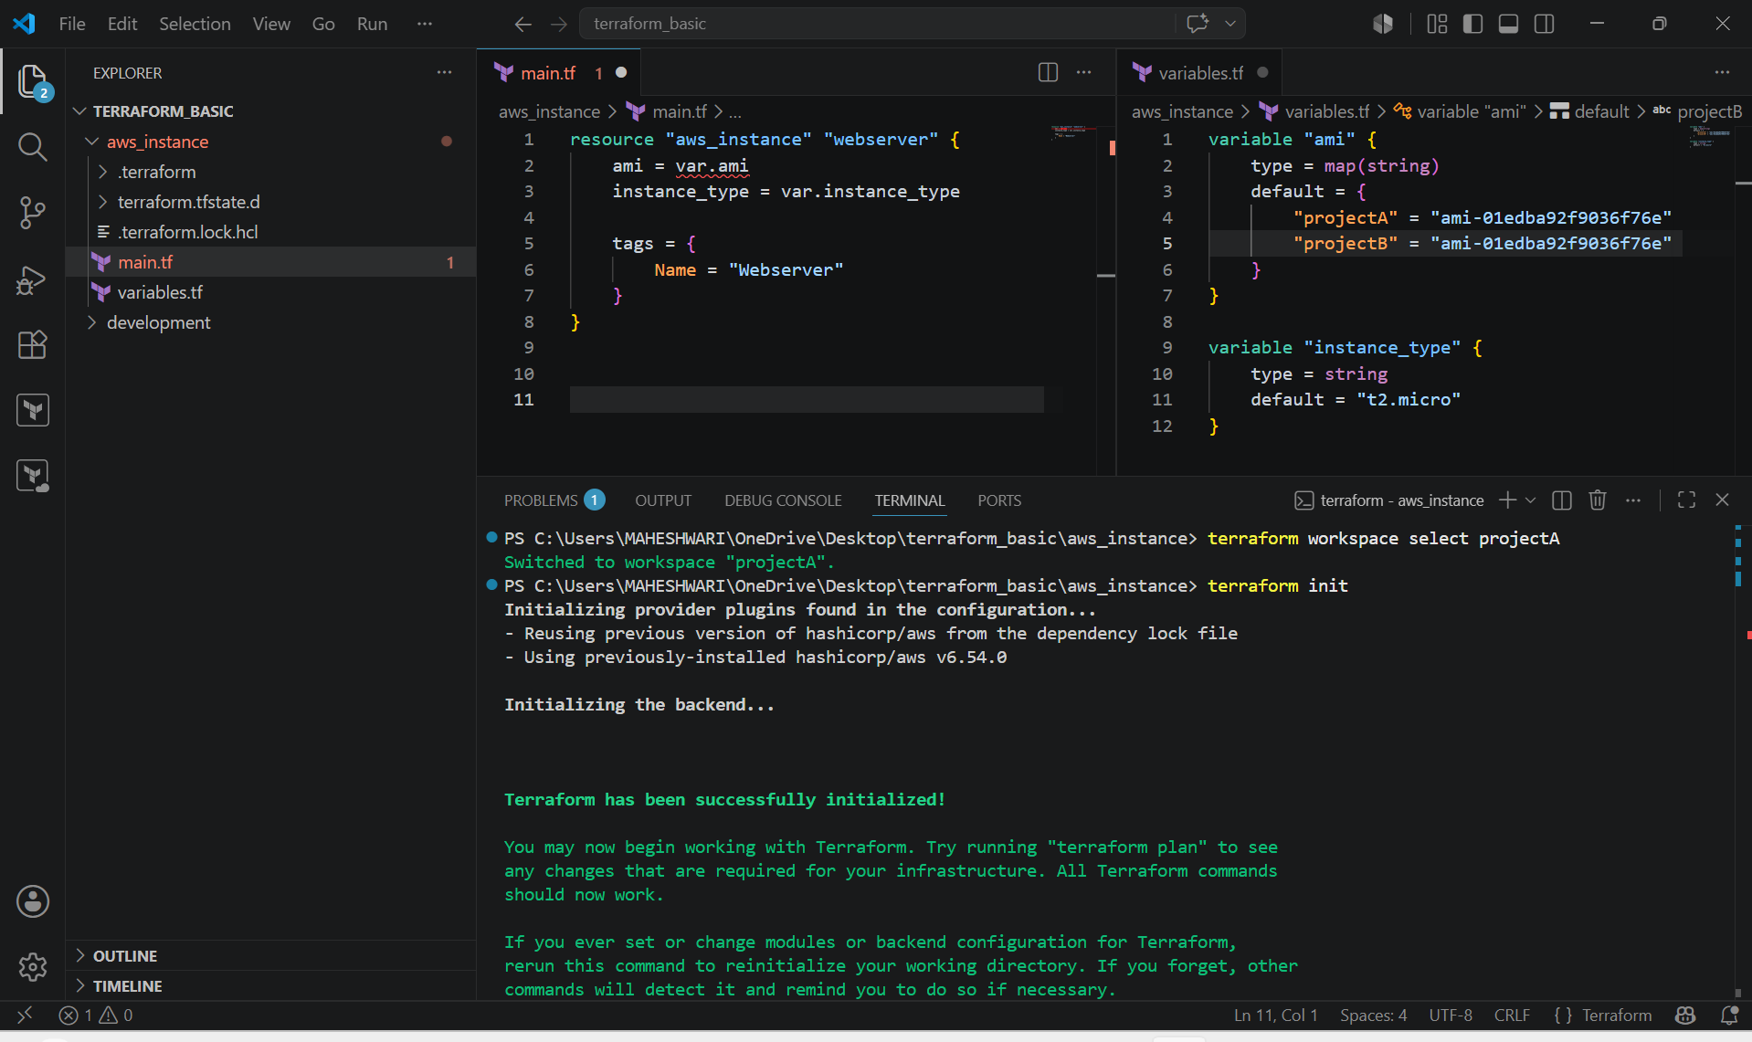

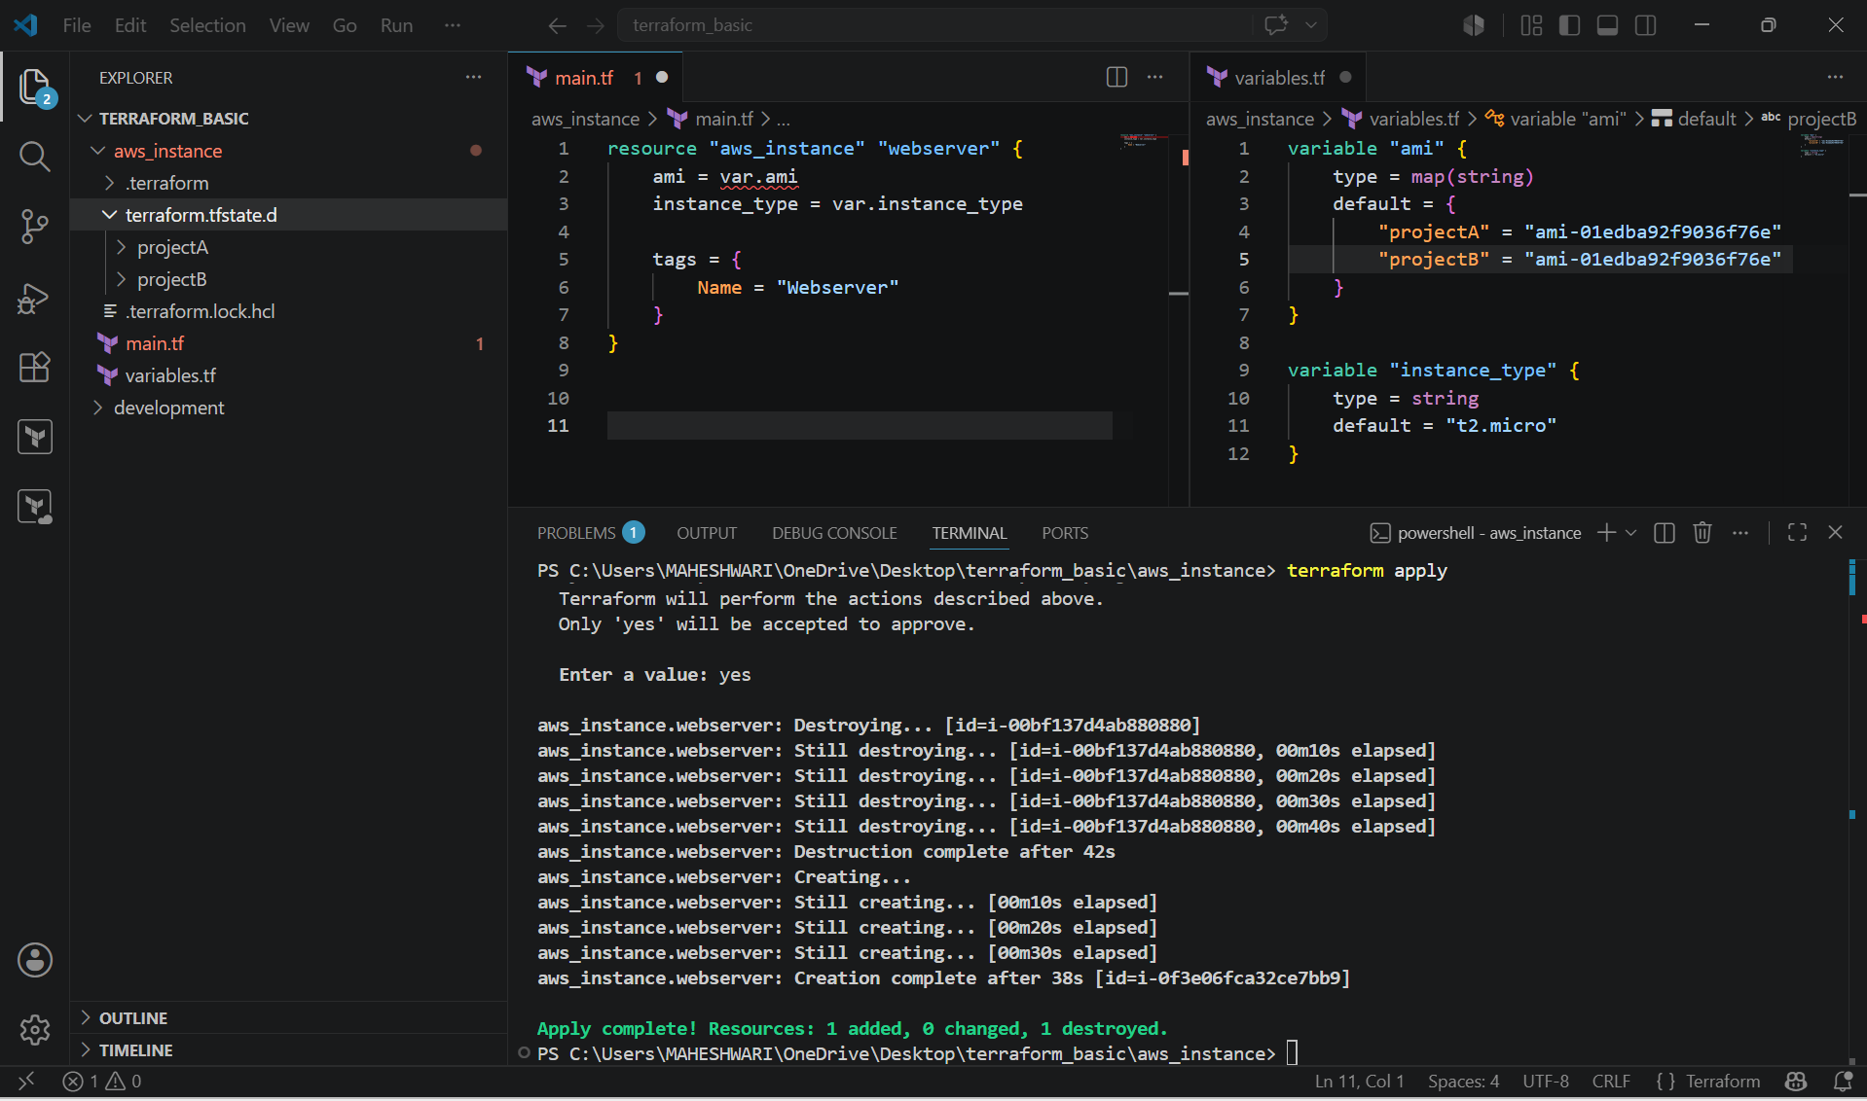

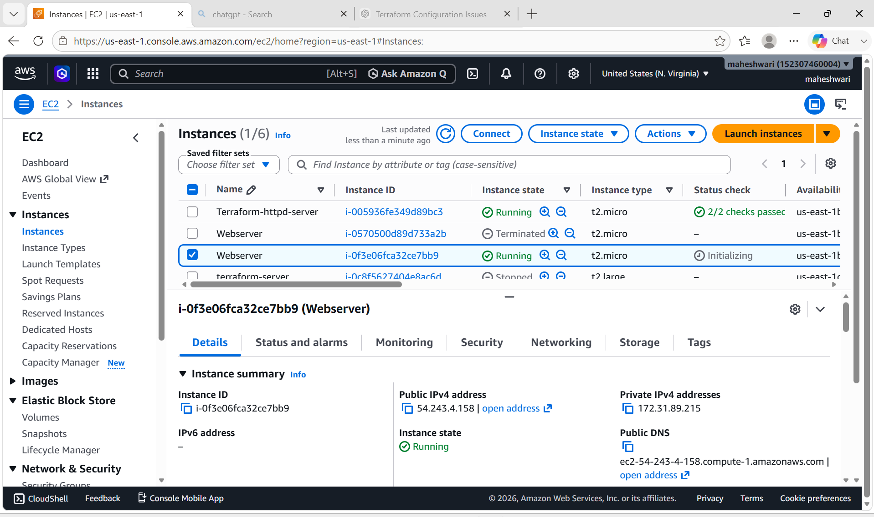

2. Provision EC2, S3, and VPC using Terraform modules.

PURPOSE: Overall, the purpose is to implement a modular Infrastructure as Code approach that provides automated, standardized, and efficient deployment of AWS infrastructure.

OBJECTIVE:
Provision AWS infrastructure using reusable Terraform modules:
- Create a VPC
- Create an EC2 instance
- Create an S3 bucket

Project Structure

terraform-modules/
│
├── development/
│ ├── main.tf
│ ├── variables.tf
│ └── provider.tf
│
├── modules/
│ ├── ec2/
│ │ ├── main.tf
│ │ └── variables.tf
│ │
│ ├── s3/
│ │ ├── main.tf
│ │ └── variables.tf
│ │
│ └── vpc/
│ ├── main.tf
│ └── variables.tf

STEP BY STEP IMPLEMENTATION:
- We have to create a provider.tf file in the aws_instance

terraform {
required_providers {
aws = {
source = "hashicorp/aws"
version = "~> 6.0"
}
}
}

provider "aws" {
region = "us-east-1"
}

- Then we have to create development / main.tf file.

module "vpc" {
source = "../modules/vpc"

cidr_block = "10.0.0.0/16"
}

module "ec2" {
source = "../modules/ec2"

ami = "ami-0c02fb55956c7d316"
instance_type = "t2.micro"
}

module "s3" {
source = "../modules/s3"

bucket_name = "maheshwari-demo-bucket-123456"
}

- Note: S3 bucket names must be globally unique. Change the bucket name before applying.

EC2 Module

modules/ec2/main.tf
resource "aws_instance" "webserver" {
ami = var.ami
instance_type = var.instance_type

tags = {
Name = "Terraform-EC2"
}
}

modules/ec2/variables.tf

variable "ami" {
type = string
}

variable "instance_type" {
type = string
}

S3 Module
modules/s3/main.tf

resource "aws_s3_bucket" "bucket" {
bucket = var.bucket_name

tags = {
Name = "Terraform-S3"
}
}

modules/s3/variables.tf

variable "bucket_name" {
type = string
}

VPC Module
modules/vpc/main.tf

resource "aws_vpc" "main" {
cidr_block = var.cidr_block

tags = {
Name = "Terraform-VPC"
}
}

modules/vpc/variables.tf

variable "cidr_block" {
type = string
}

- Then we have to execute the commands terraform init and terraform apply.

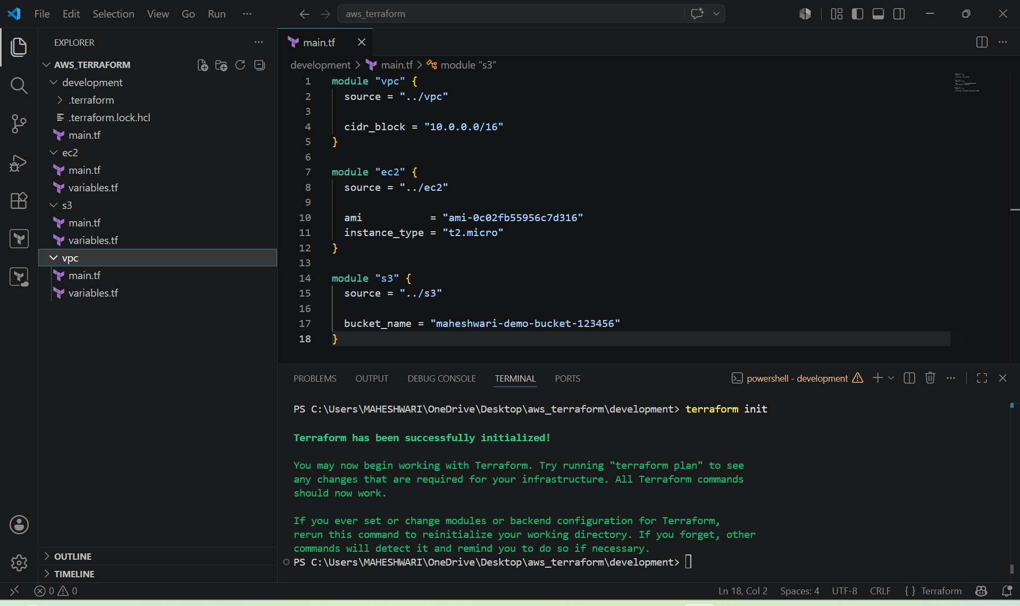

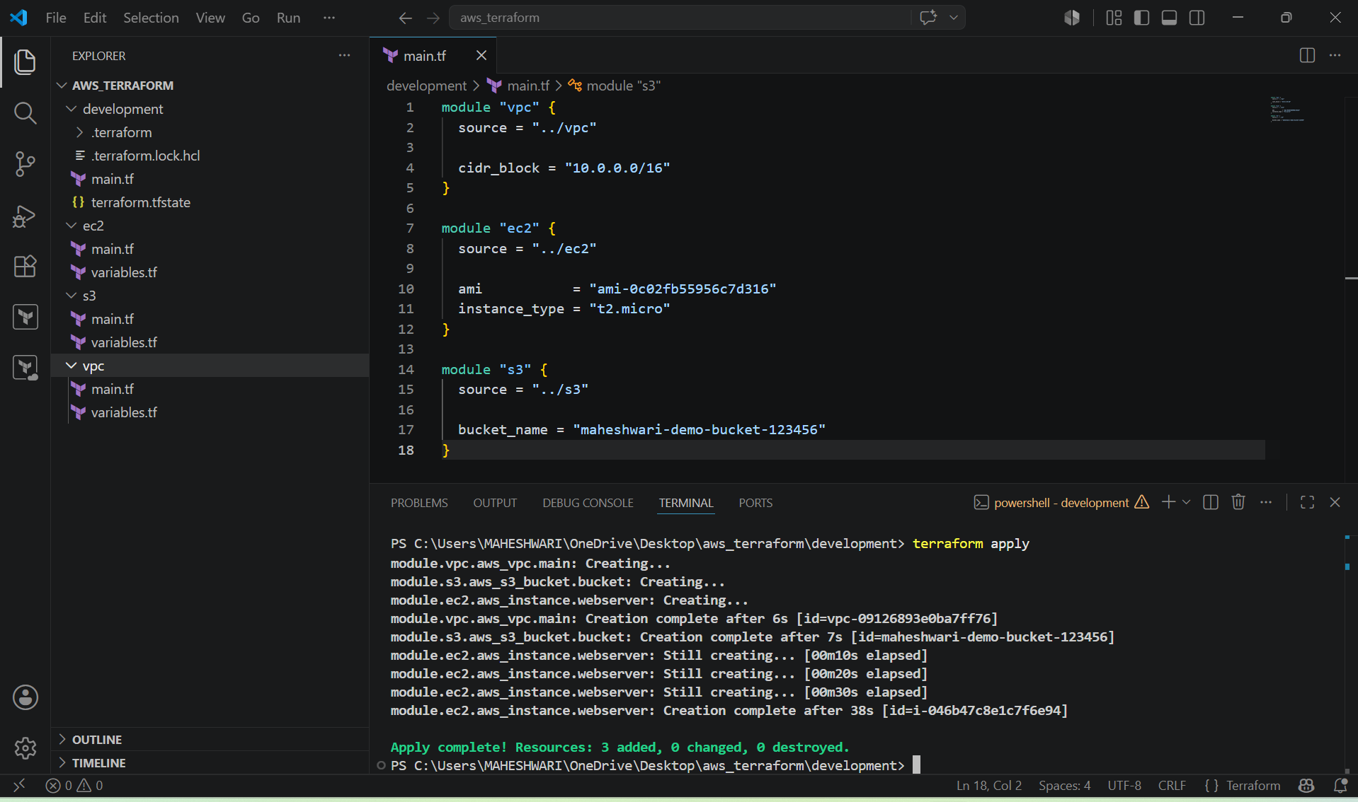

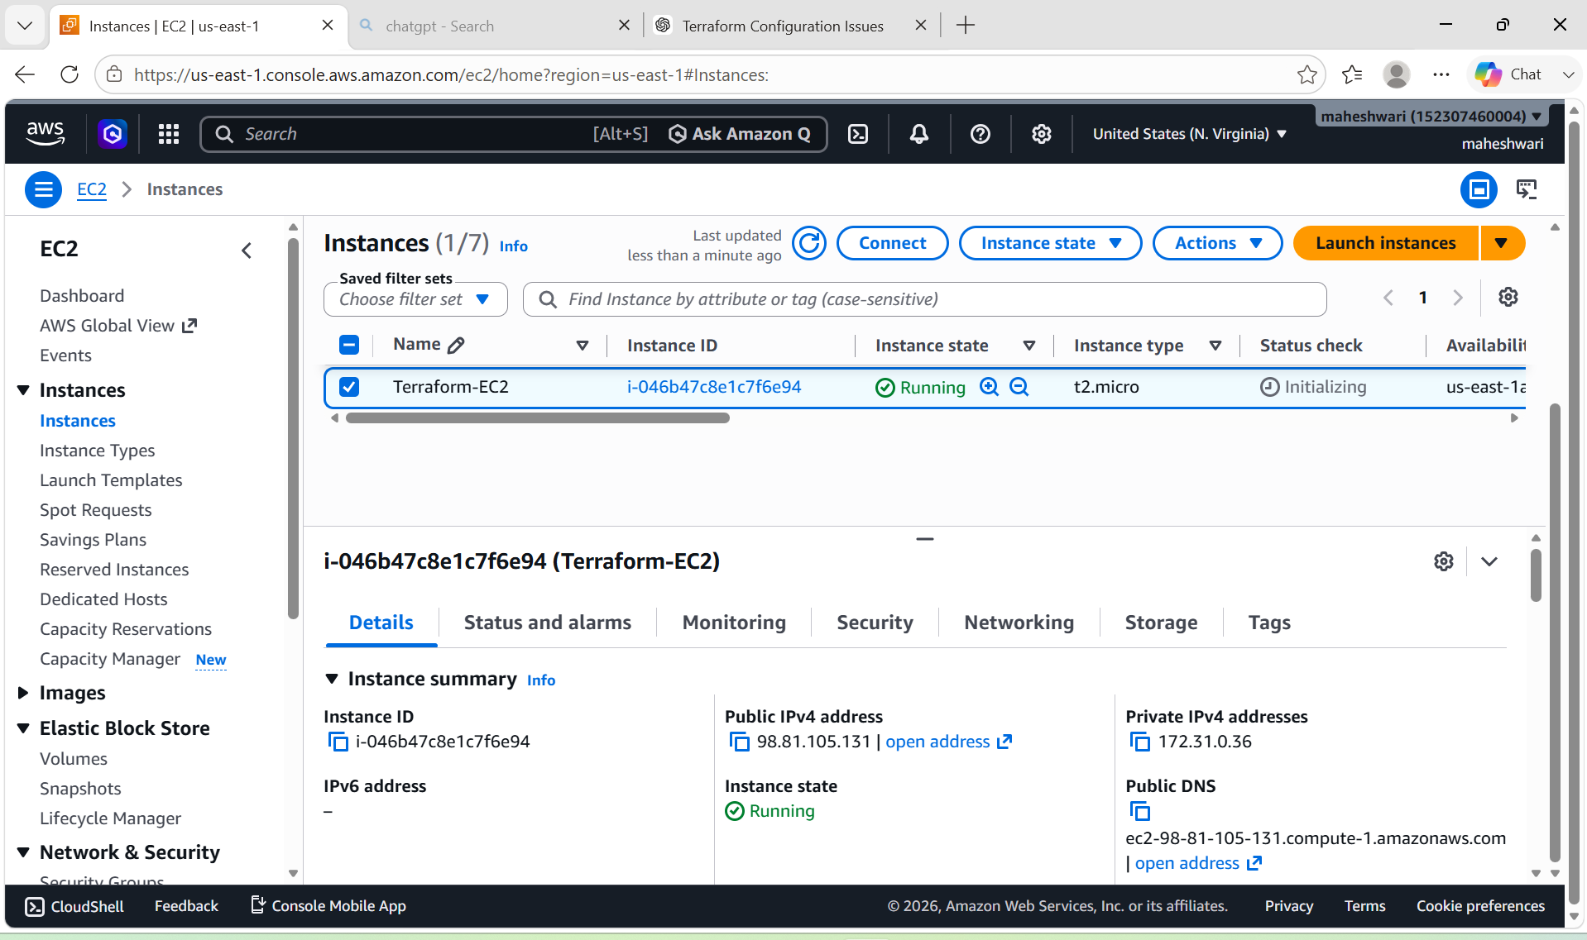

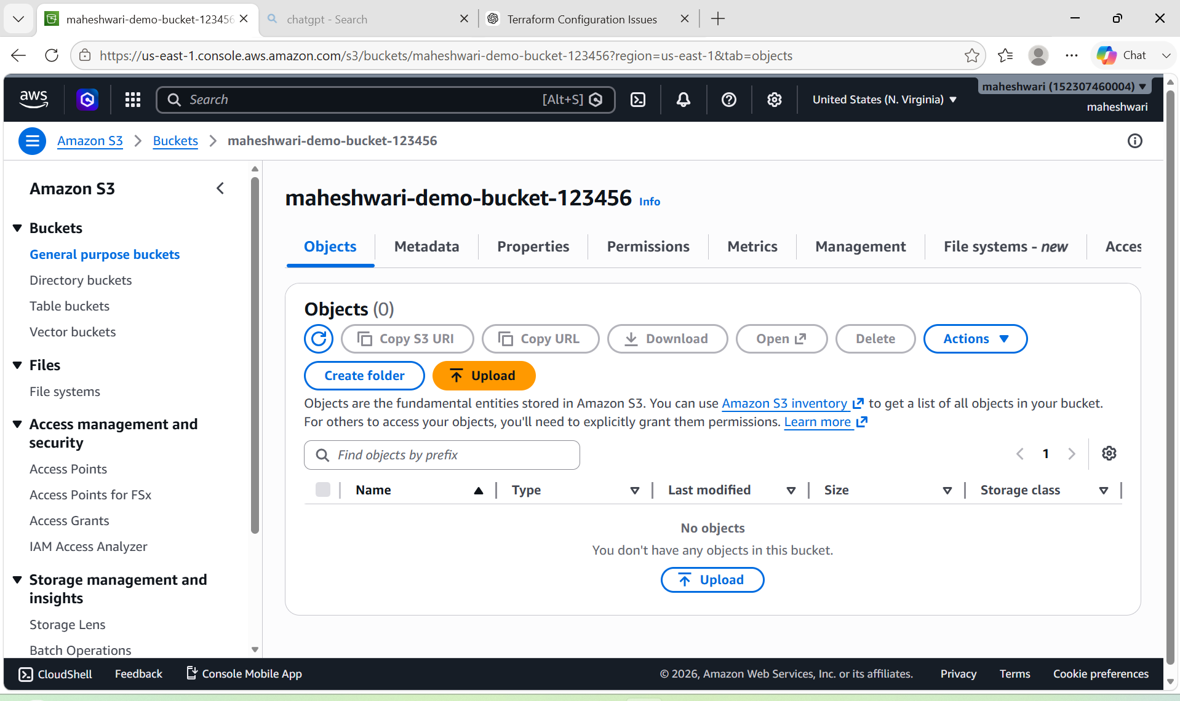

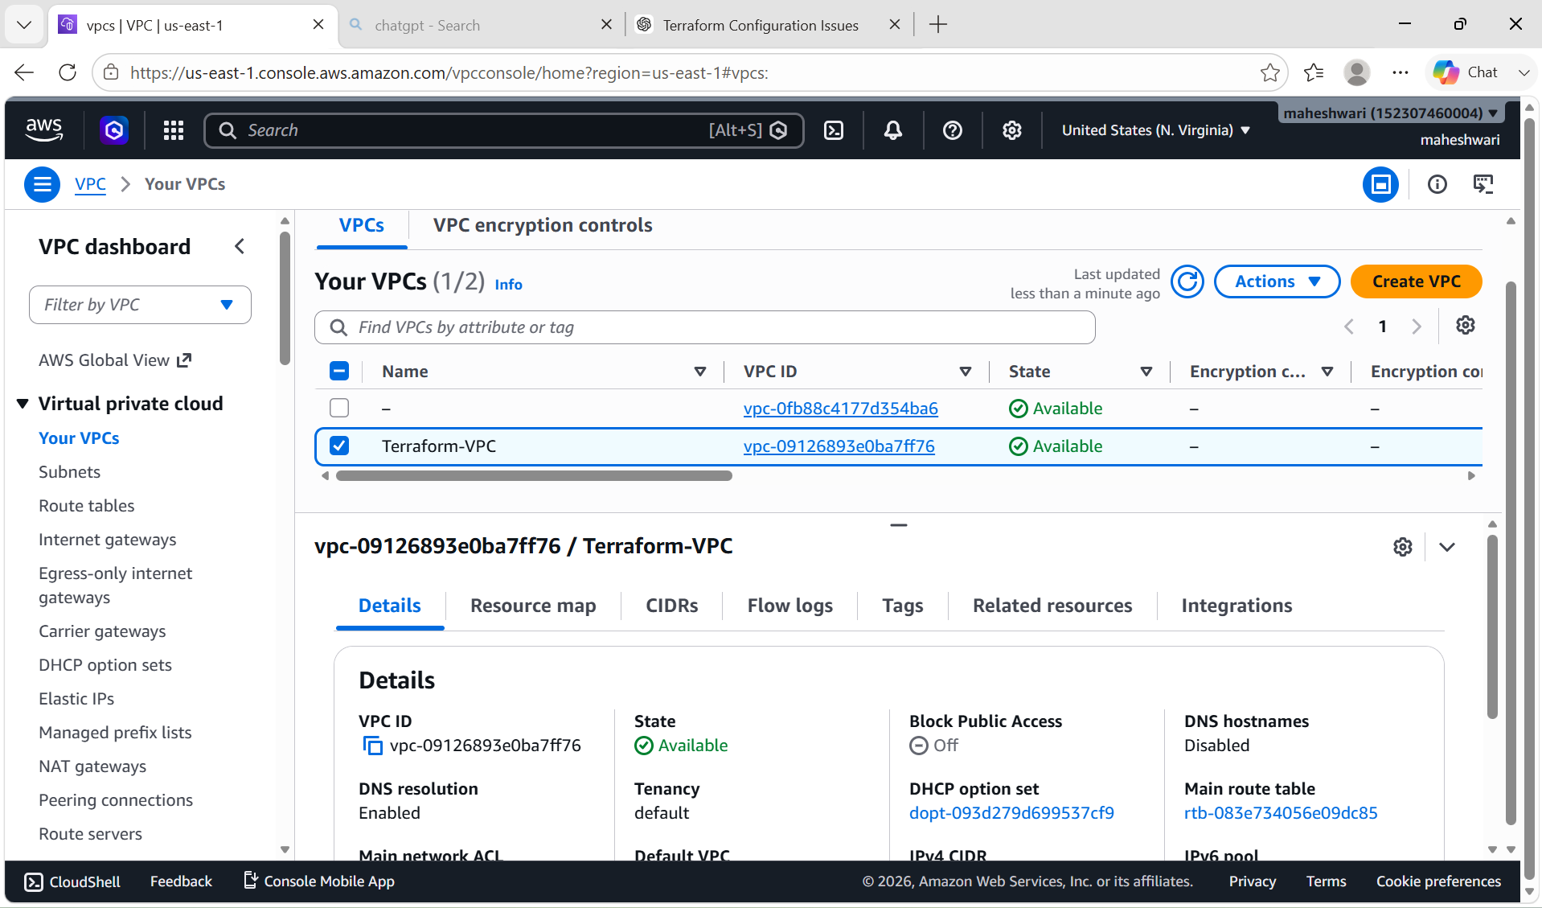

3. Provision EC2 for 3 different environments (Dev, Staging, and Prod) using Terraform workspaces.

PURPOSE: The purpose of this task is to use Terraform Workspaces to provision and manage separate EC2 instances for Development (Dev), Staging, and Production (Prod) environments using a single Terraform configuration. Workspaces enable environment isolation while reducing code duplication and simplifying infrastructure management.

OBJECTIVE:
- Provision separate EC2 instances for Dev, Staging, and Production using Terraform Workspaces.
- Manage multiple environments with a single Terraform codebase.
- Isolate the Terraform state file for each environment to prevent resource conflicts.
- Reduce code duplication by reusing the same Terraform configuration across environments.
- Configure environment-specific settings such as instance names or instance types using workspace-based logic.
- Simplify deployment, updates, and maintenance of infrastructure.
- Improve consistency and reliability across all environments.
- Demonstrate Infrastructure as Code (IaC) best practices using Terraform Workspaces.
- Enable easy switching between environments using Terraform workspace commands.

STEP BY STEP IMPLEMENTATION:
- Create files like provider.tf, main.tf, variables.tf and terraform.tfvars.
- We have to write the configurations in all these files.

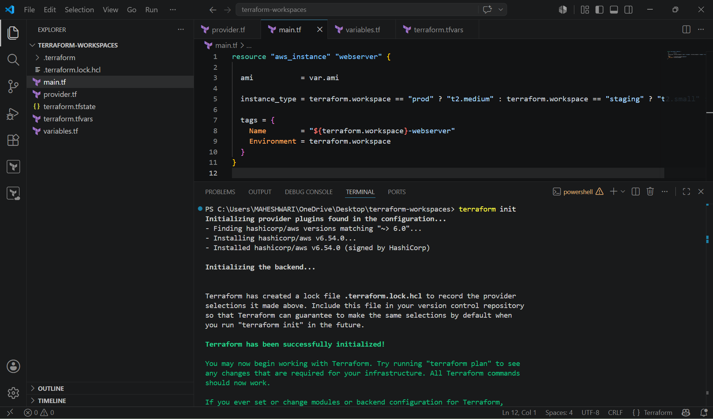

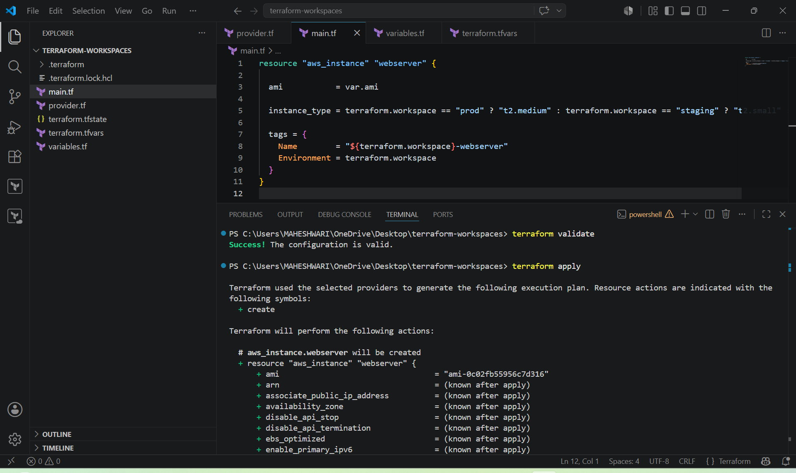

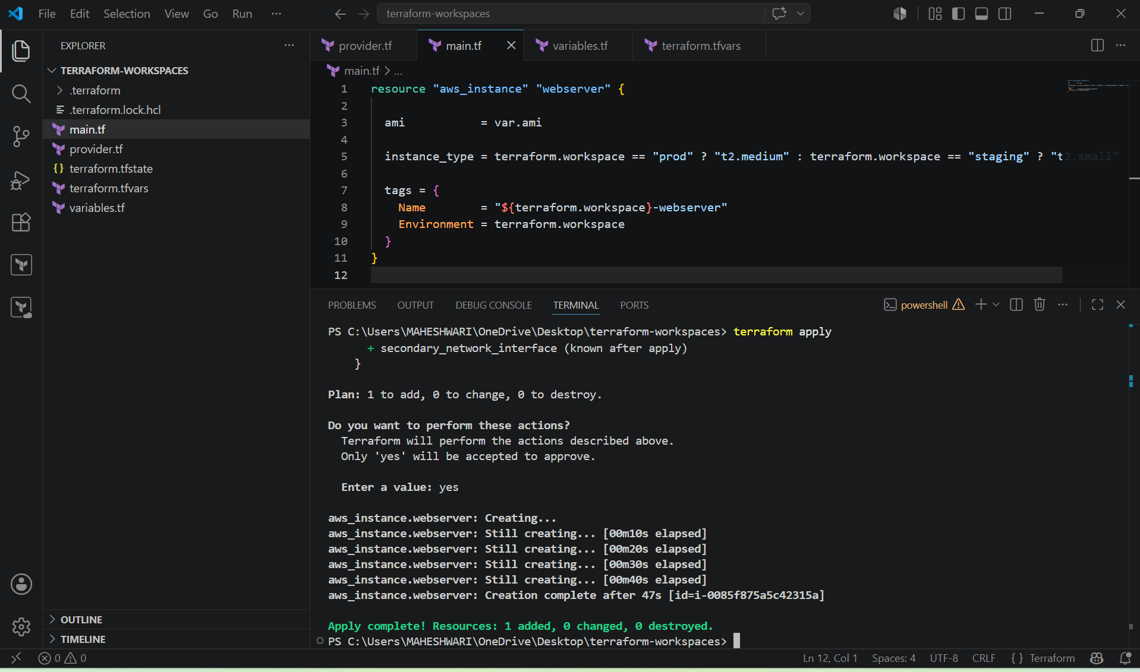

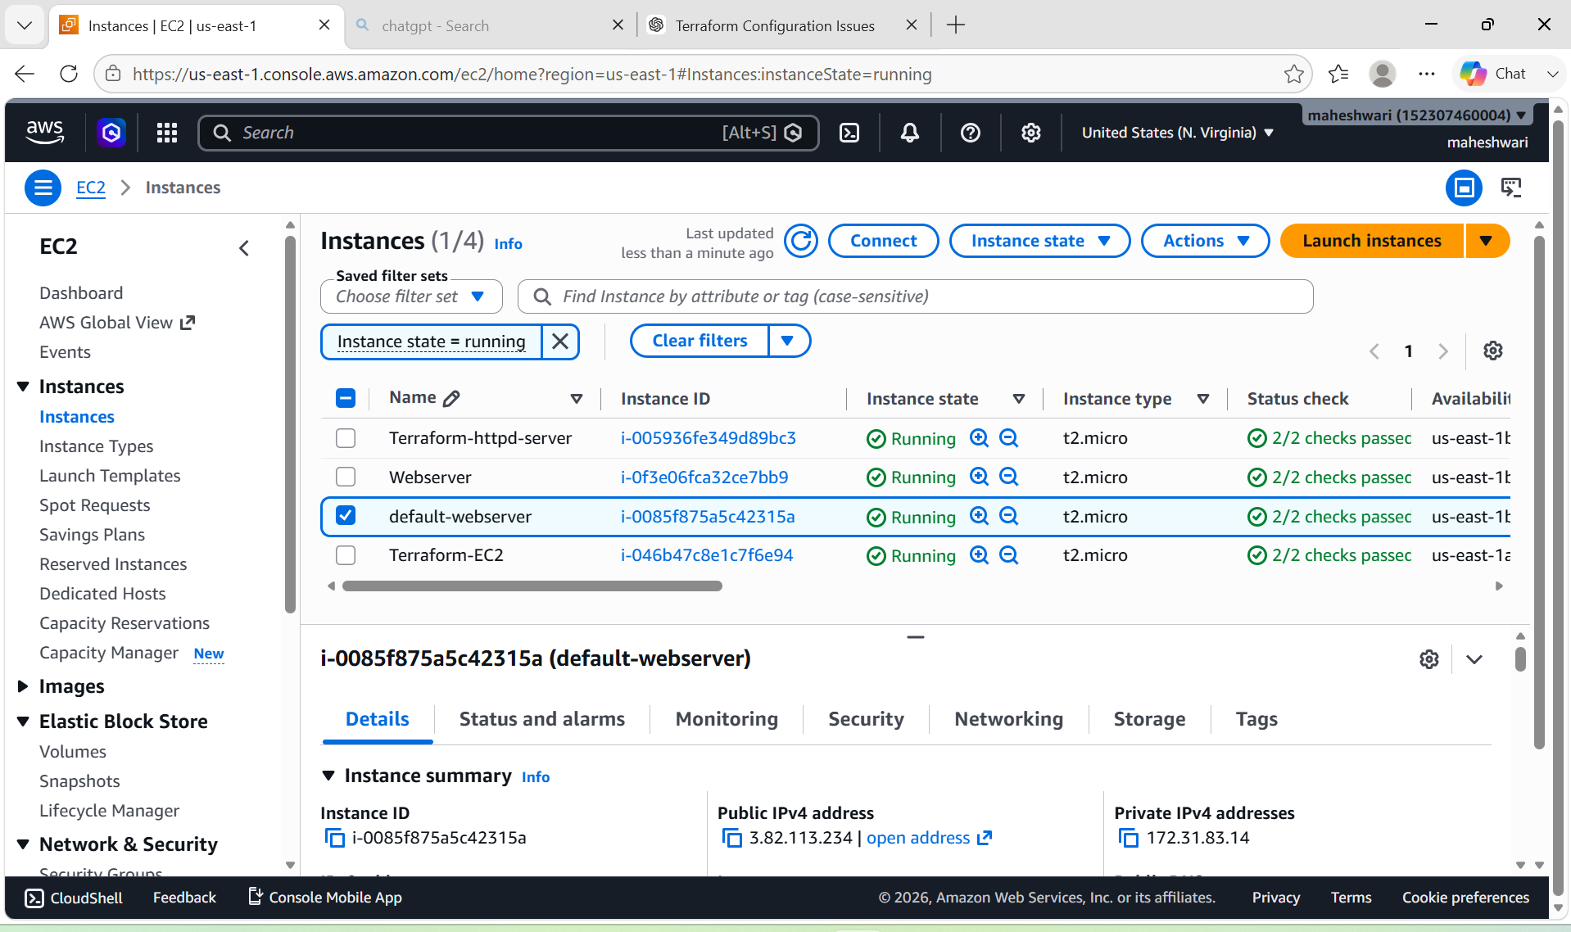

- Create new workspaces like dev, development and prod.
- Switch to each workspaces and execute the commands then we have to verify it in the aws console.

