TERRAFORM-05

1. Execute the script shown in the video.

Terraform Remote State and State Lock:

- We can store terraform configuration files and state file in GitHub or any other repository.
- We can use S3, terraform storage, hashicorp console to store the state file.
- State Locking is used to lock the file so that no two users can execute the main.tf file at the same point of time.

EXAMPLE: Remote backend and state locking
- We can use S3 as Remote backend and Dynamodb for state locking.
- Create S3 using terraform:
resource “aws_s3_bucket” “s3_bucket” {
bucket = “s3backend”
acl = “private”
}

- Create dynamodb using terraform
resource “aws_dynamodb_table” “dynamodb_terraform_state_lock” {
name = “terraform-state-lock-dynamo”
hash-key = “LockID”
read-capacity = 20
write-capacity = 20

attribute {
name = “LockID”
type = “S”
}
}

- S3 as backend for terraform.tfstate file:
terraform {
backend “S3” {
bucket = “s3backend”
dynamodb_table = “terraform-state-lock-dynamo”
key = “terraform.tfstate”
region = “us-east-1”
}
}

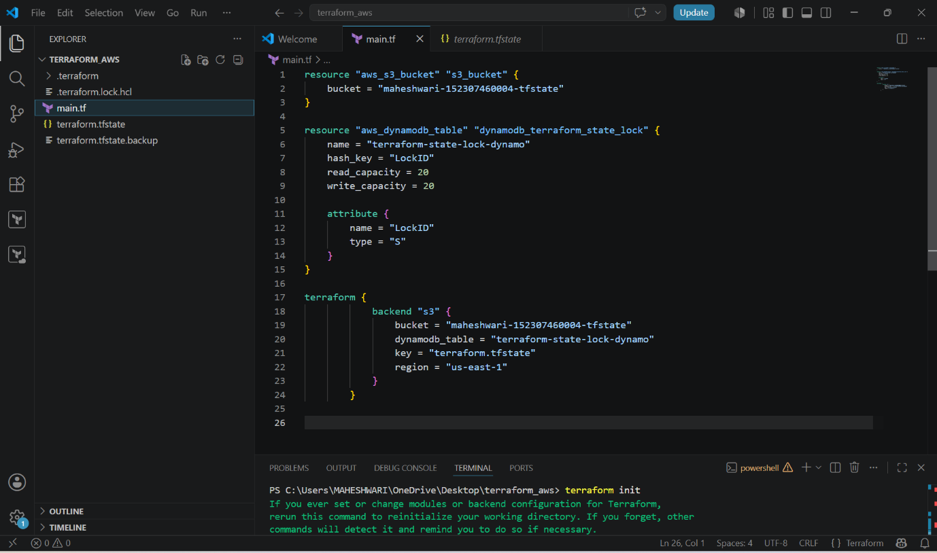

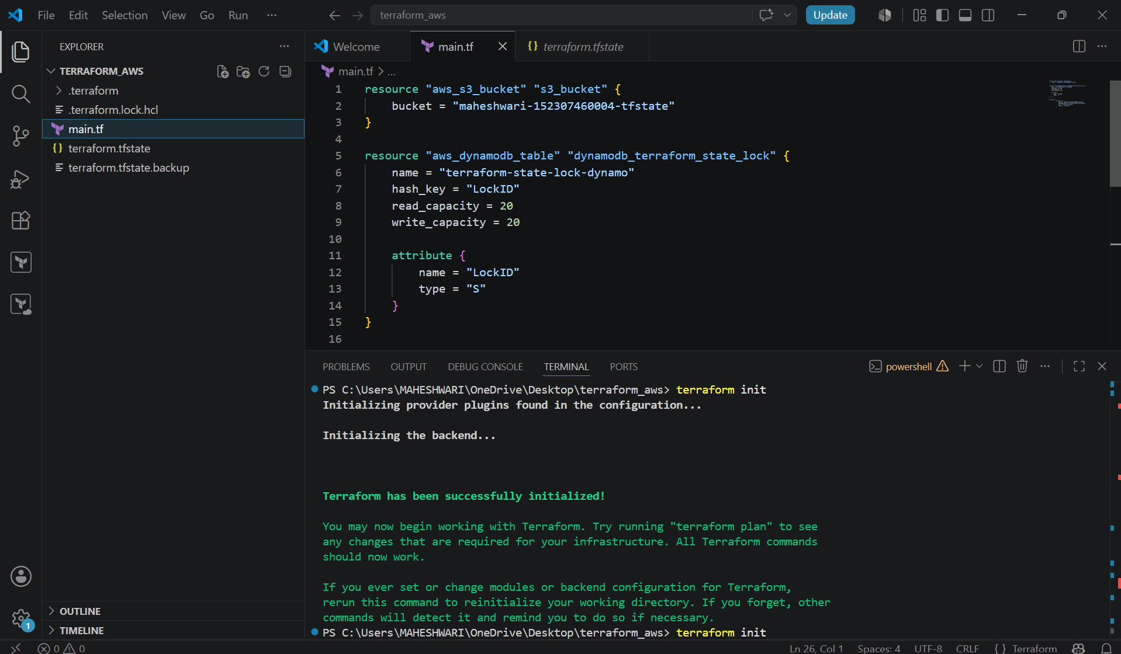

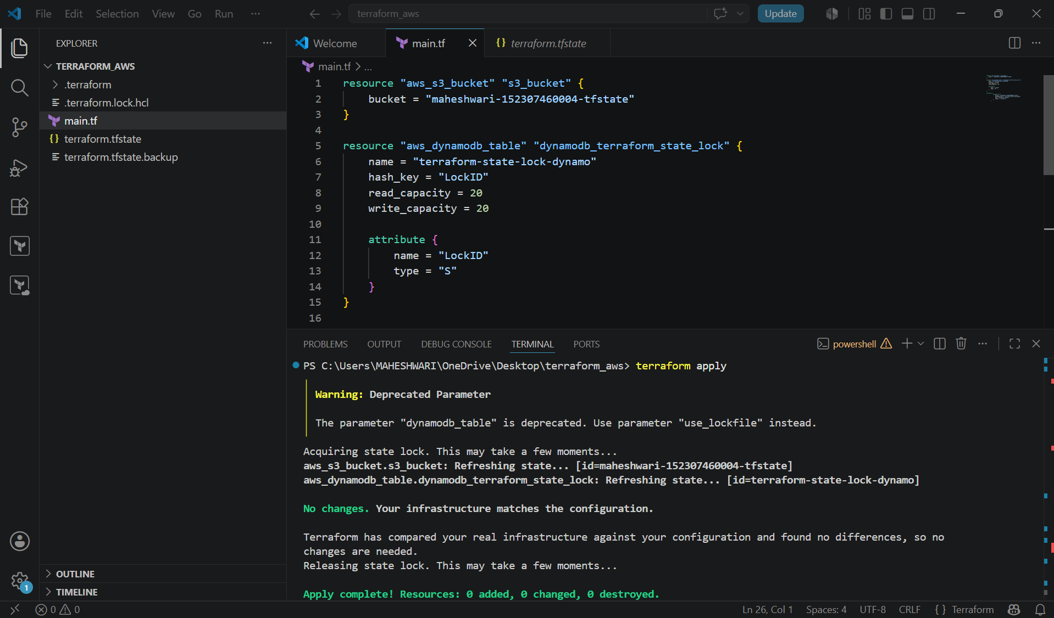

- Our terraform state file will be empty and that terraform.tfstate file will be pushed to the AWS S3 and Dynamodb table.
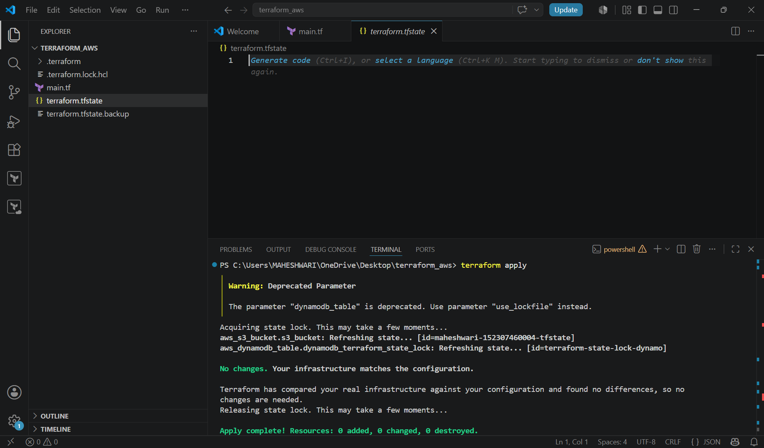

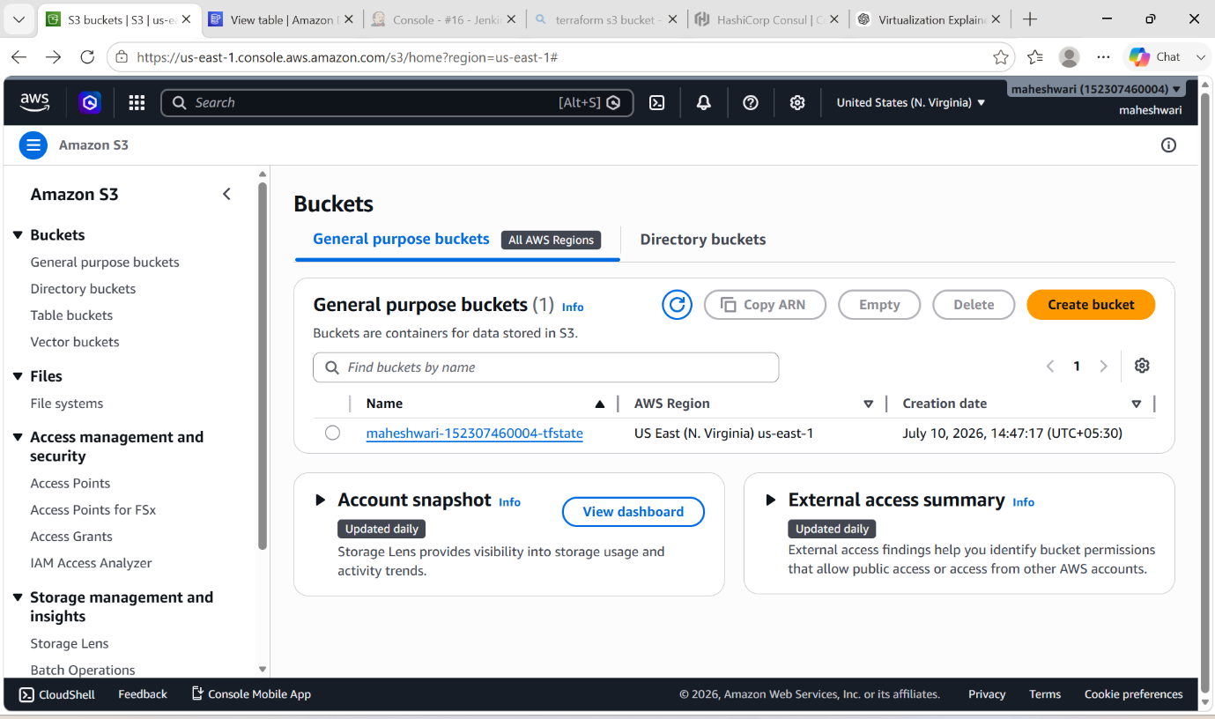

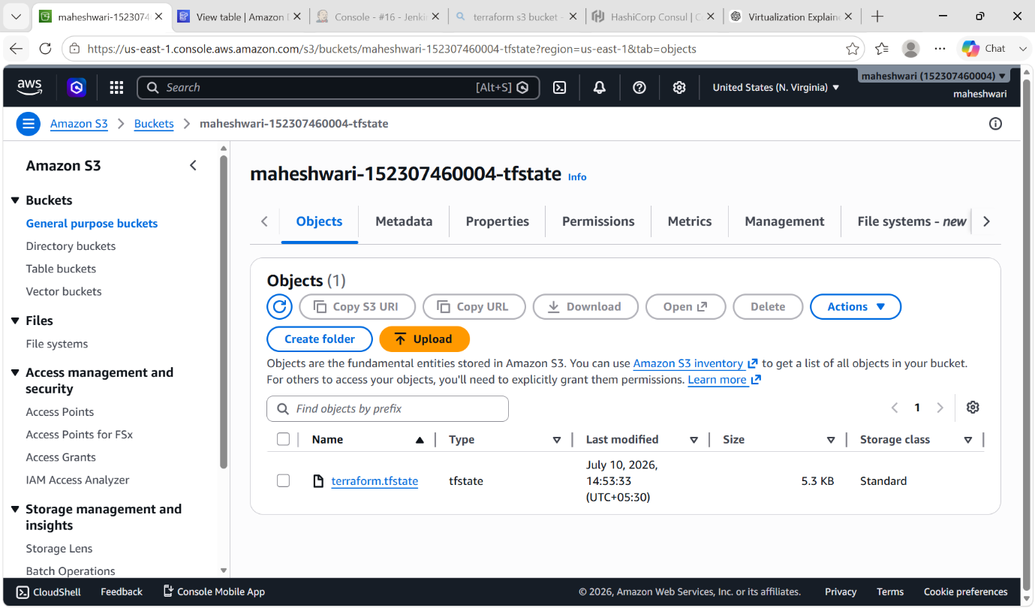

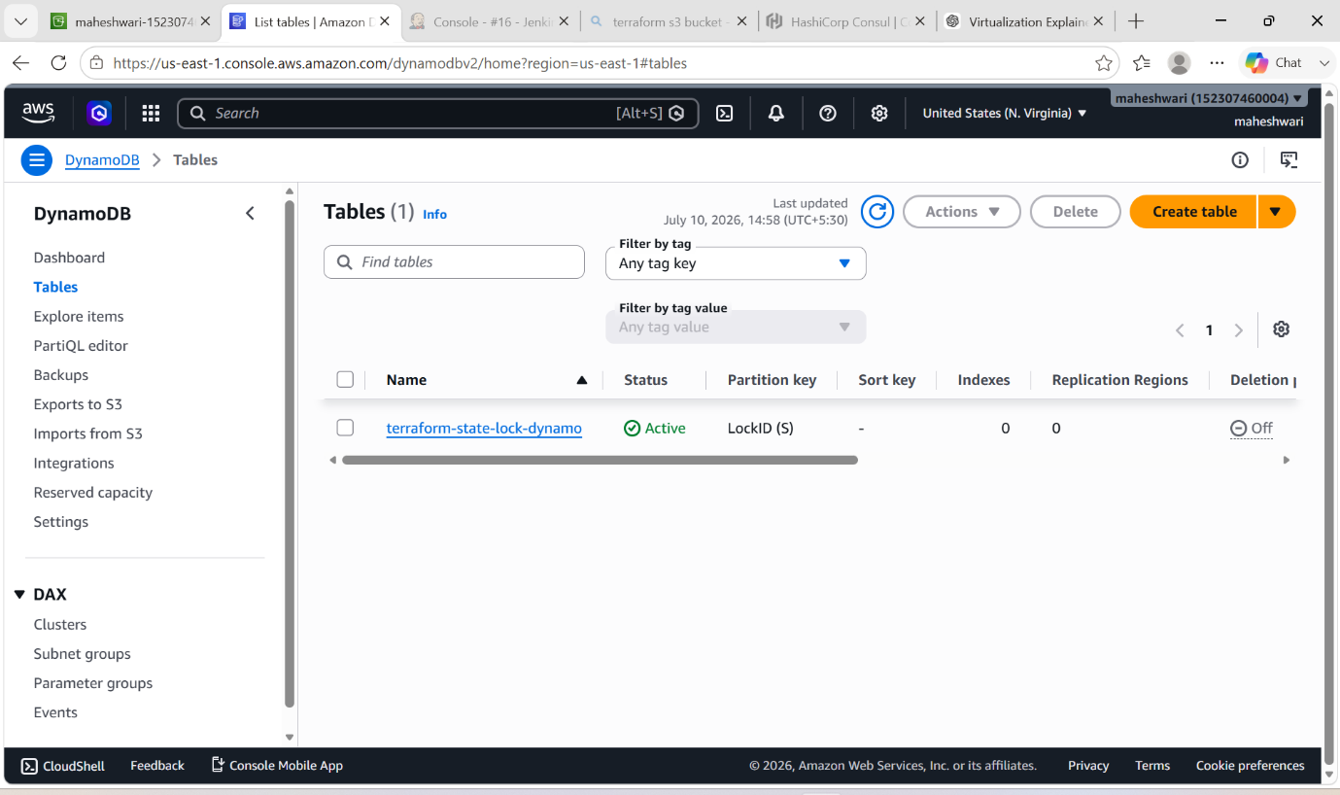

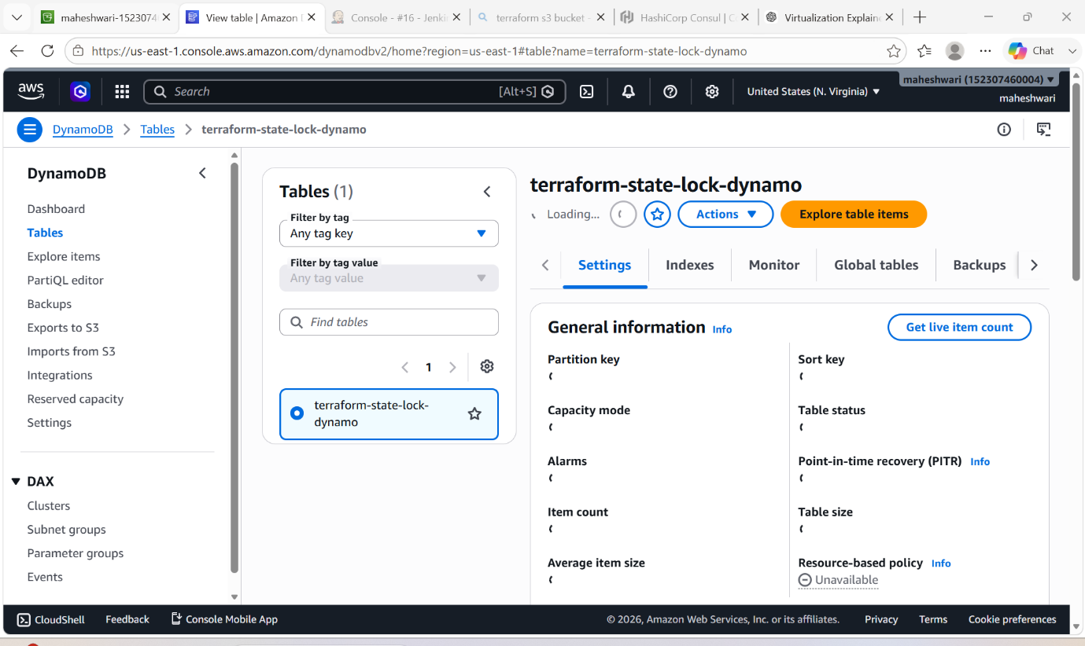

TERRAFORM PROVISIONERS:

- Terraform provisioners allow us to execute command, script on remote machines or local place were terraform is installed.
- Provisioners will be written inside the resource blocks
- We have 2 types of provisioners

- REMOTE PROVISIONER: this is used to execute commands at the run time on remote machines.
- LOCAL PROVISIONER: this is used to execute commands at the run time on local machine (means where terraform is installed).

TERRAFORM PROVISIONER BEHAVIOURS:

- Create at the time of creating resources (default):

- Runs after the resource is created.

EXAMPLE FOR LOCAL PROVISIONER:

Resource “aws_instance” “webserver” {
ami = “ami id”
instance_type = “t2.micro”
key_name = “pem.key”
tags = {
Name = “first_server”
}
Provisioner “local-exec” {
Command = “echo Instance ${aws_instance.test-server.public_IP} created!” > instance_state.txt
}
}

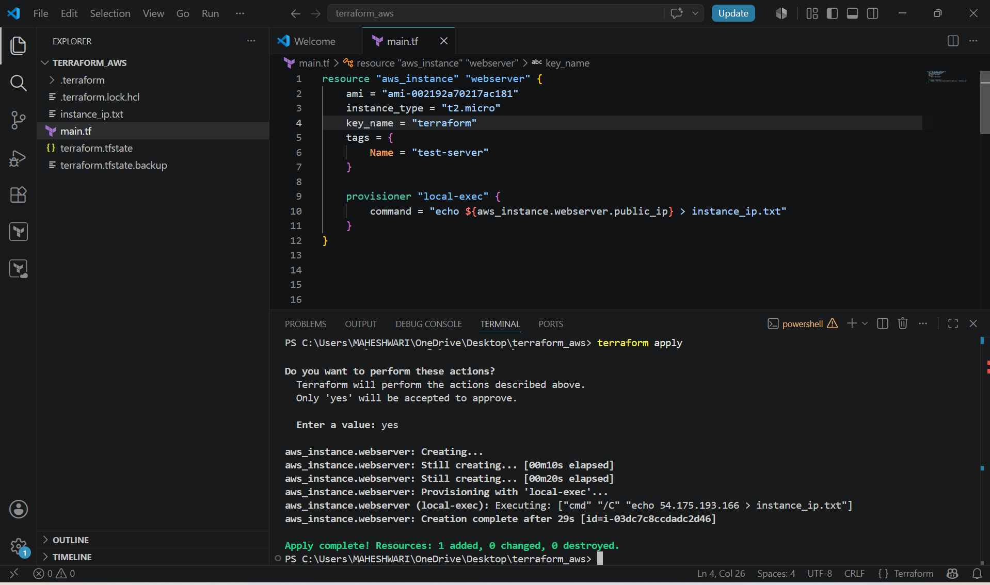

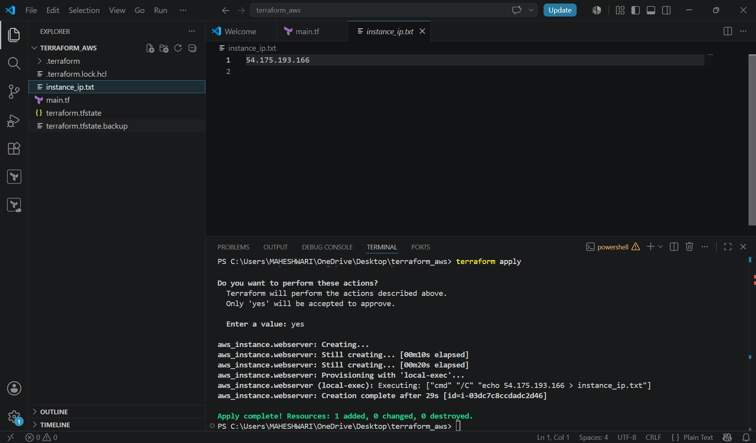

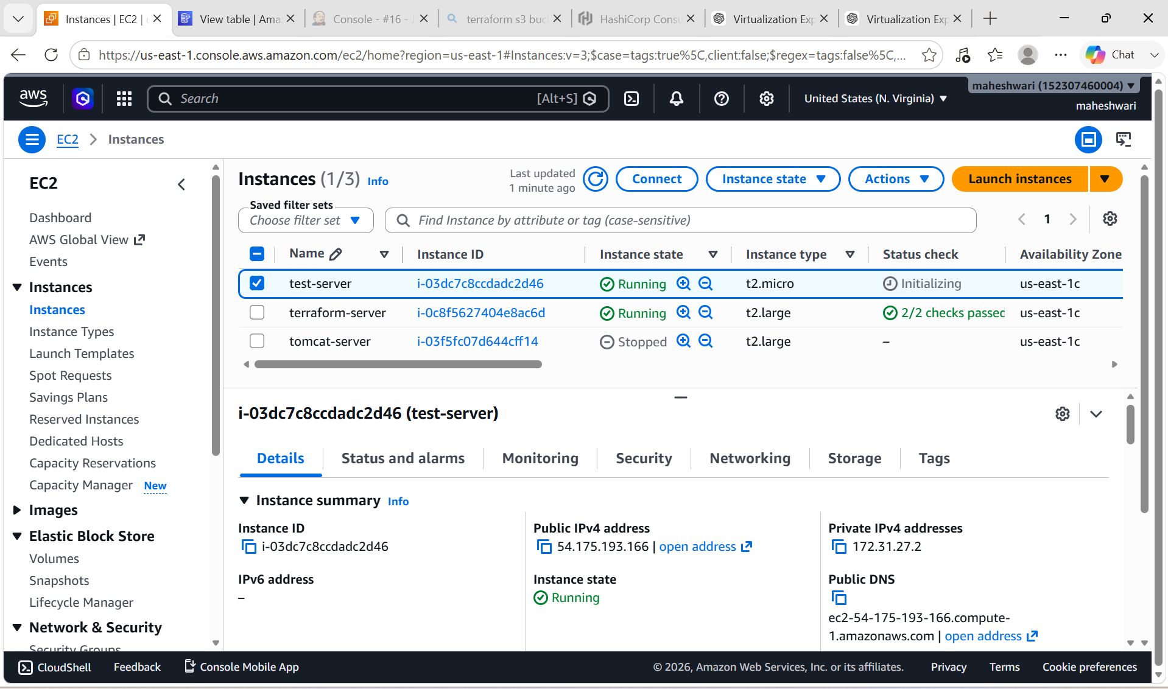

2. create at the time of destroying the resource (when = destroy)

- Runs before the resource is destroyed.
- Use self inside destroy-time provisioners
- command = "echo ${self.public_ip}"
- Do not use
- aws_instance.webserver.public_ip

resource "aws_instance" "webserver" {
ami = "ami-002192a70217ac181"
instance_type = "t2.micro"
key_name = "terraform"
tags = {
Name = "test-server"
}

provisioner "local-exec" {
when = destroy
command = "echo Instance ${self.public_ip} destroyed!!! > instance_ip.txt"
}
}

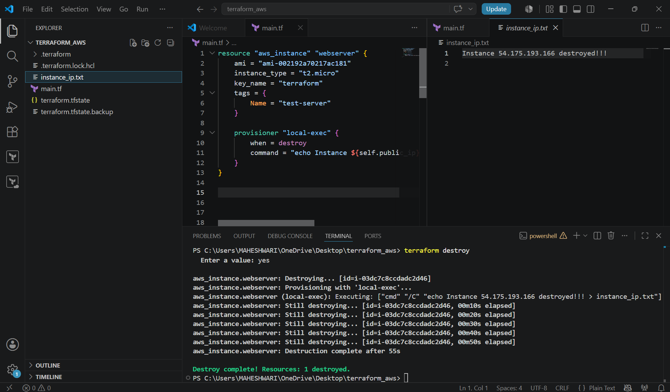

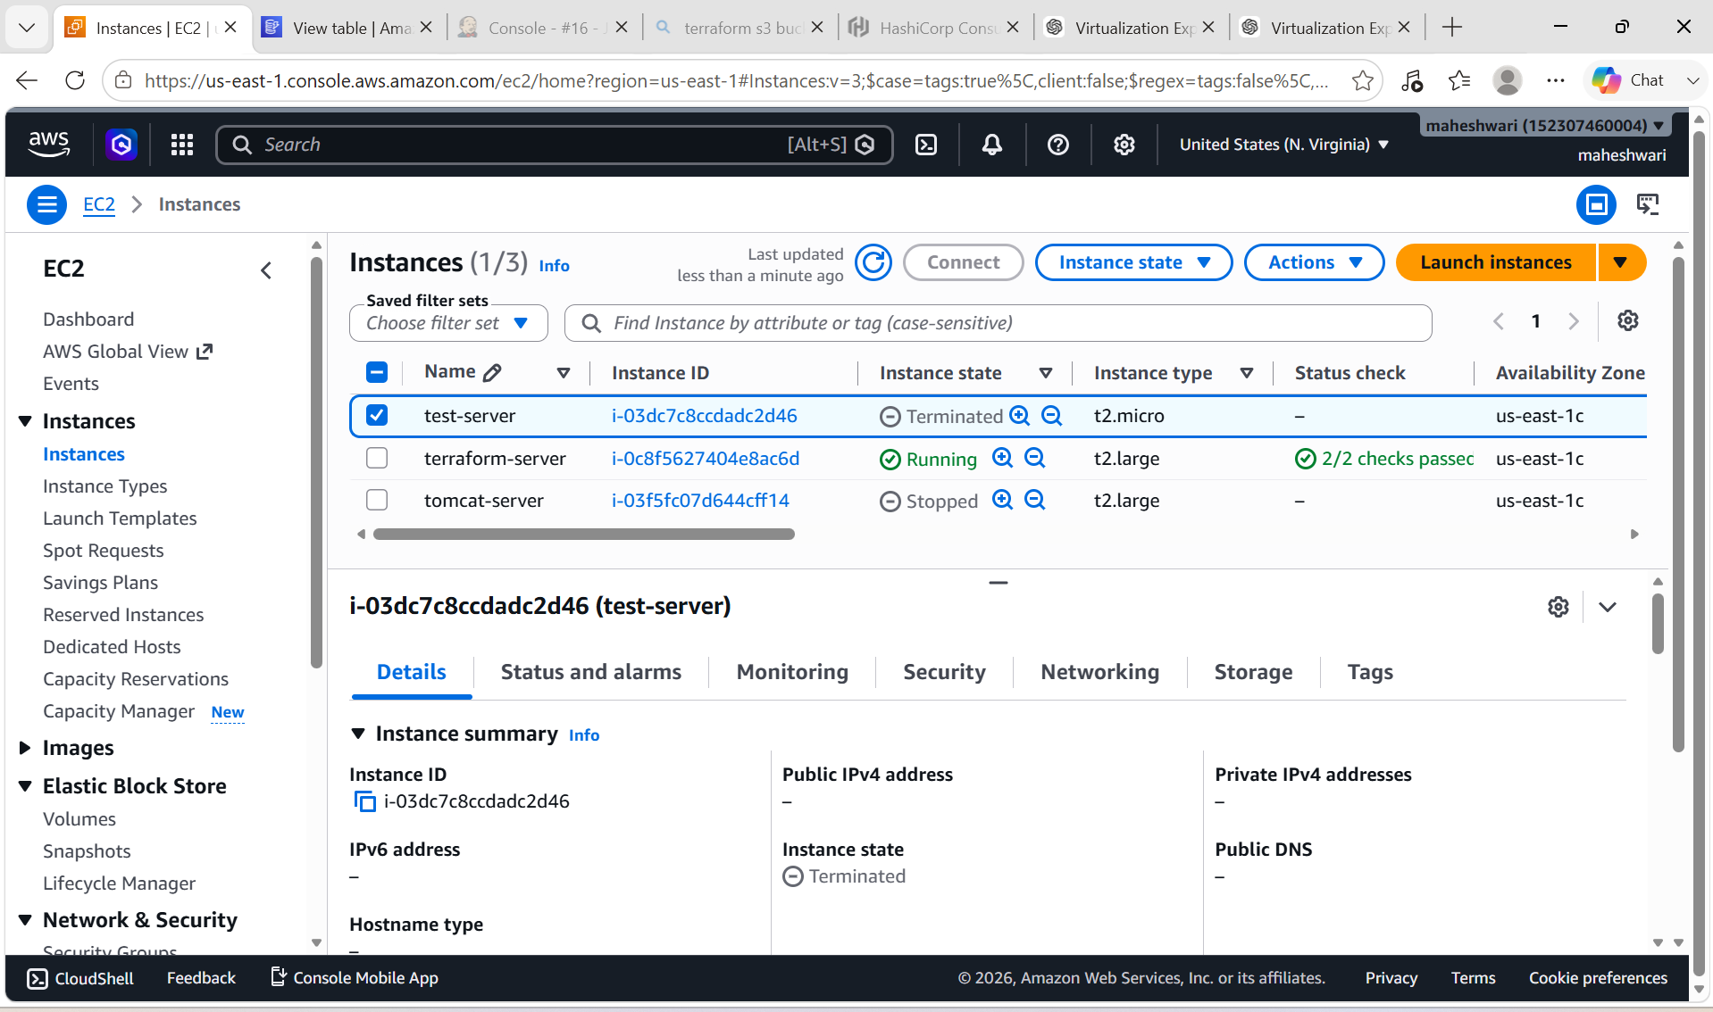

3. on_failure = fail Behavior :
- Terraform stops execution if the command fails.
- Fail (Default)

provisioner "local-exec" {
command = "invalid-command"
}

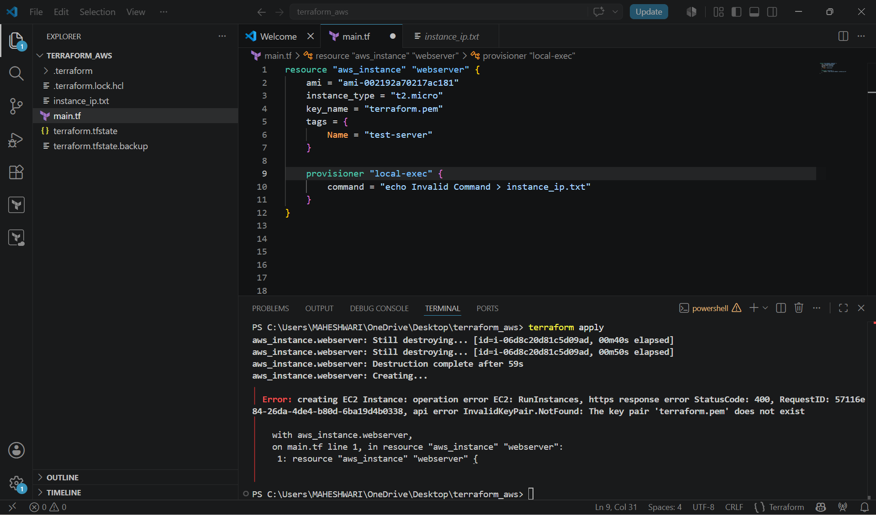

4. on_failure = continue Behavior :

- Terraform continues even if the provisioner command fails.

provisioner "local-exec" {
command = "invalid-command"
on_failure = continue
}

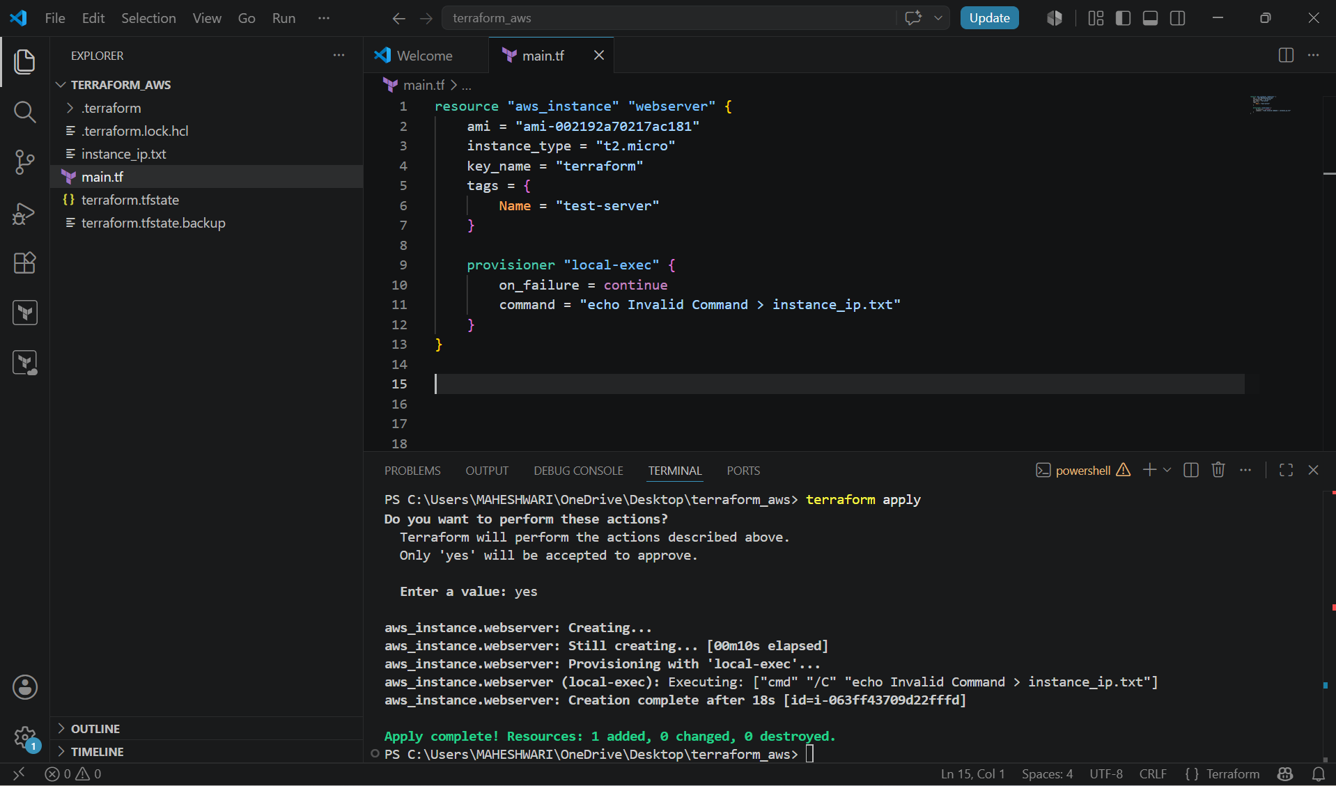

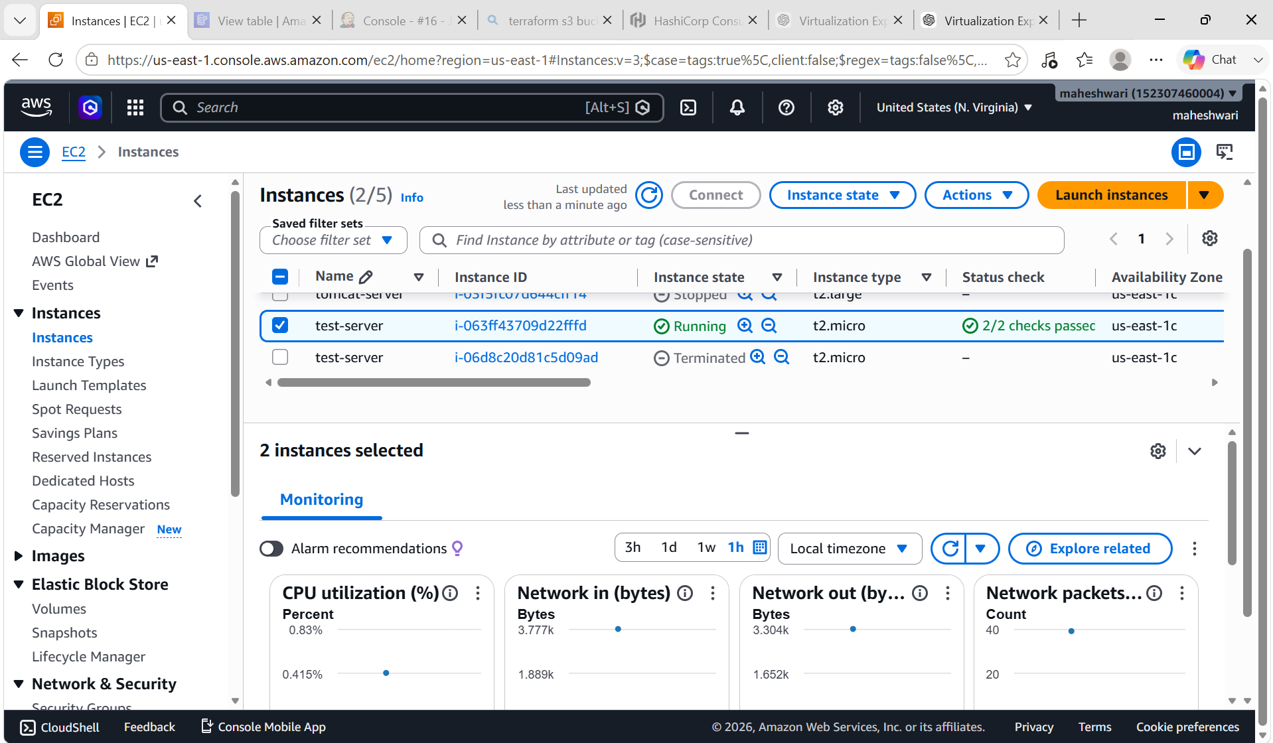

Advantages
- Automates post-deployment configuration.
- Executes custom scripts.
- Integrates with external tools.
- Copies files to remote servers.
- Configures resources immediately after creation.

Disadvantages
- Slows down Terraform execution.
- Makes infrastructure less declarative.
- Can be difficult to troubleshoot.
- Requires network connectivity for remote-exec.
- Not idempotent in many cases.

TERRAFORM TAINT AND UNTAINT:
- There would be a cases when resources creation aill get failed, if this happens then terraform will be marked as “tainted”
- We can see this when we execute terraform plan command and this will be replaced when we use terraform apply command.
- If for any reason you have installed manually in EC2 and you want that to be replaced then we can manually mark that reaosurces as taint in terraform so that it will be replaced next time when use apply.
- terraform taint aws_instance.webserver -> it will be replaced in next apply.
- terraform untaint aws_instance.webserver -> to undo the changes we can use untaint command.

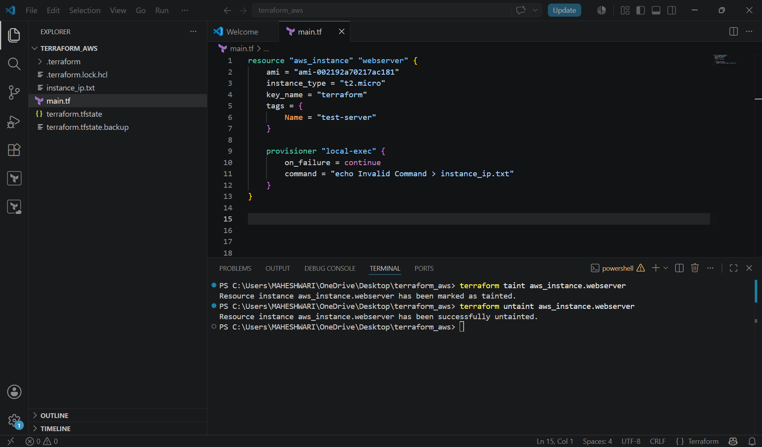

DEBUGGING:
- terraform apply will provide us the logs/cause of the issue, but still if we want to dig deeper than we need to export a variable.
- Terraform provides 5 levels of logs:-
- INFO
- WARNING
- ERROR
- DEBUG
- TRACE
- Example: Set-Item -Path env:TF_LOG_PATH -value “TRACE”
- This will give the logs in the terminal

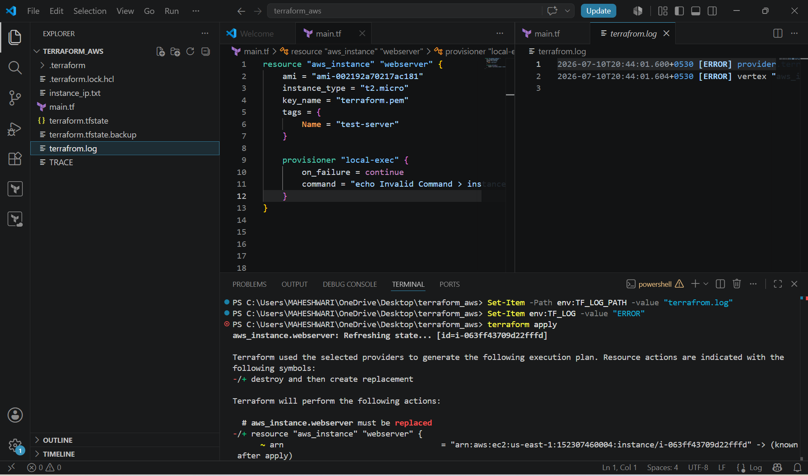

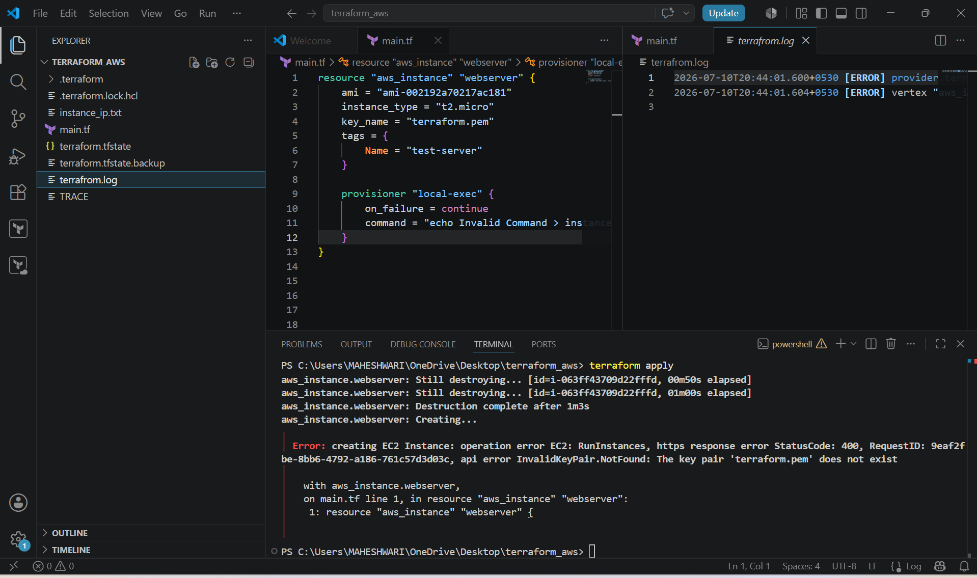

TERRAFORM IMPORT :

- Terraform import is used to import the existing infrastructure in terraform state file.
- Once import is done then we can be able to create / delete and manage the infrastructure.
- In order to import any resource we need to write the resource details in configuration file.
- terraform import aws_instance.<name> instance_id
- we can import any resource from the cloud (AWS) to terraform by the above command but before importing, we have to write the resource block for the specific resource block for the specific resource that we want to import from the AWS.

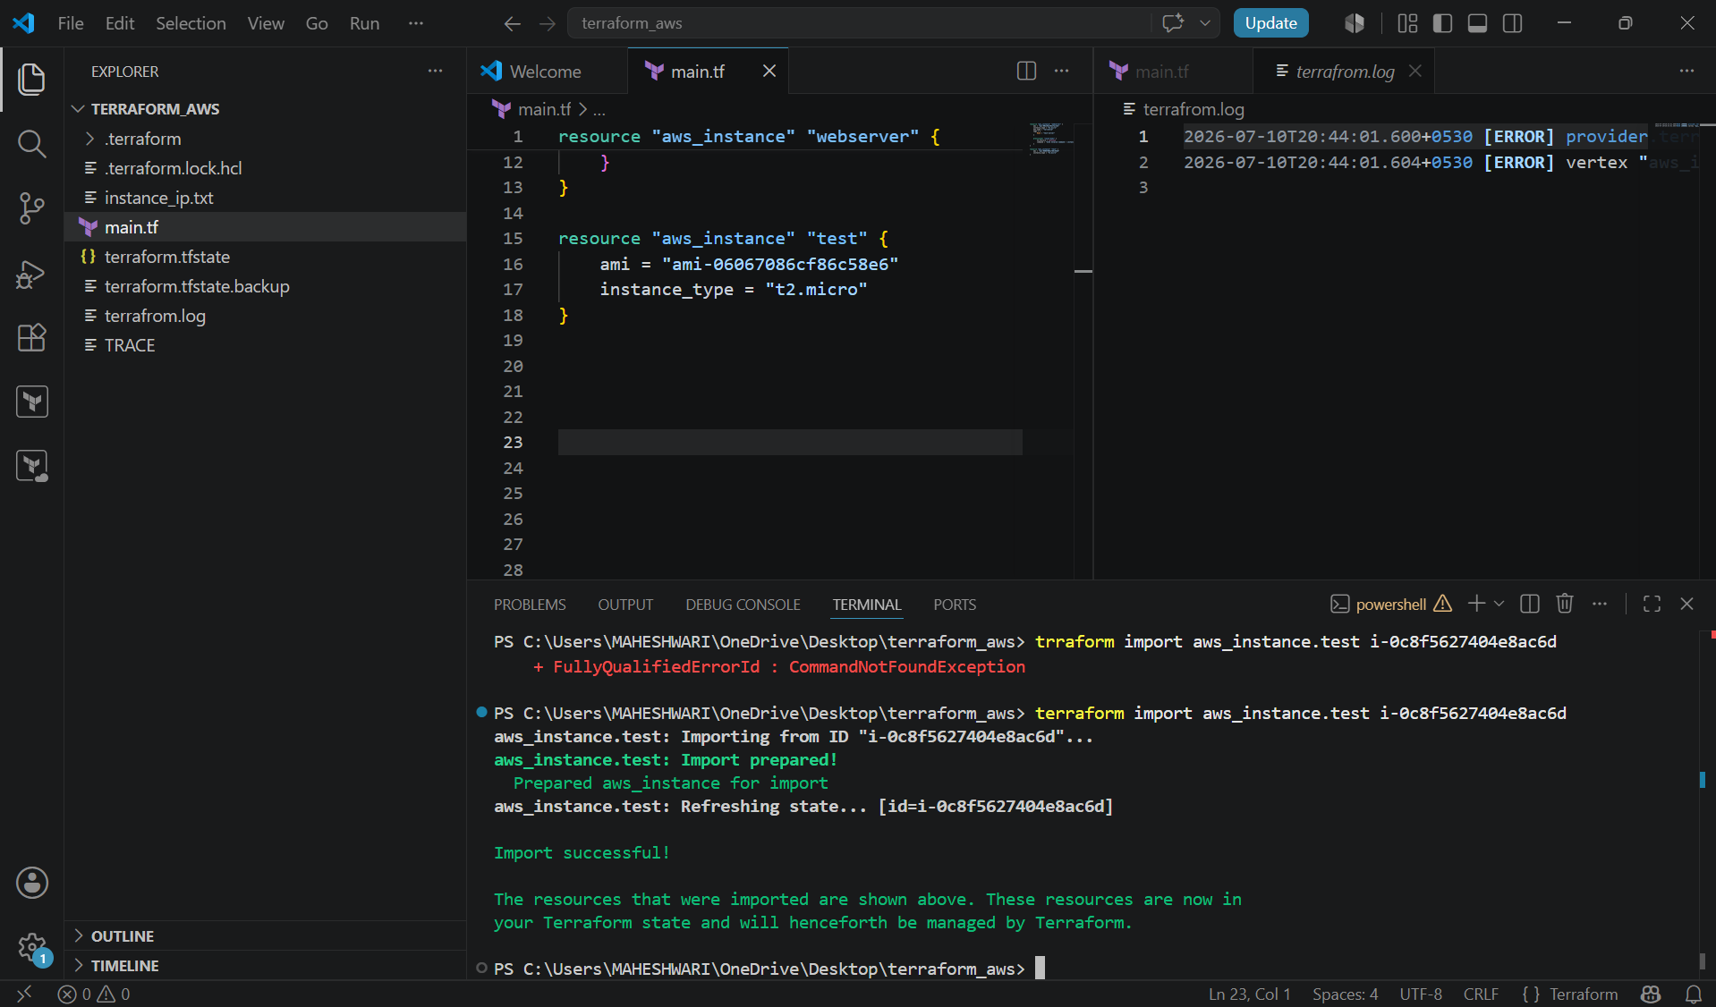

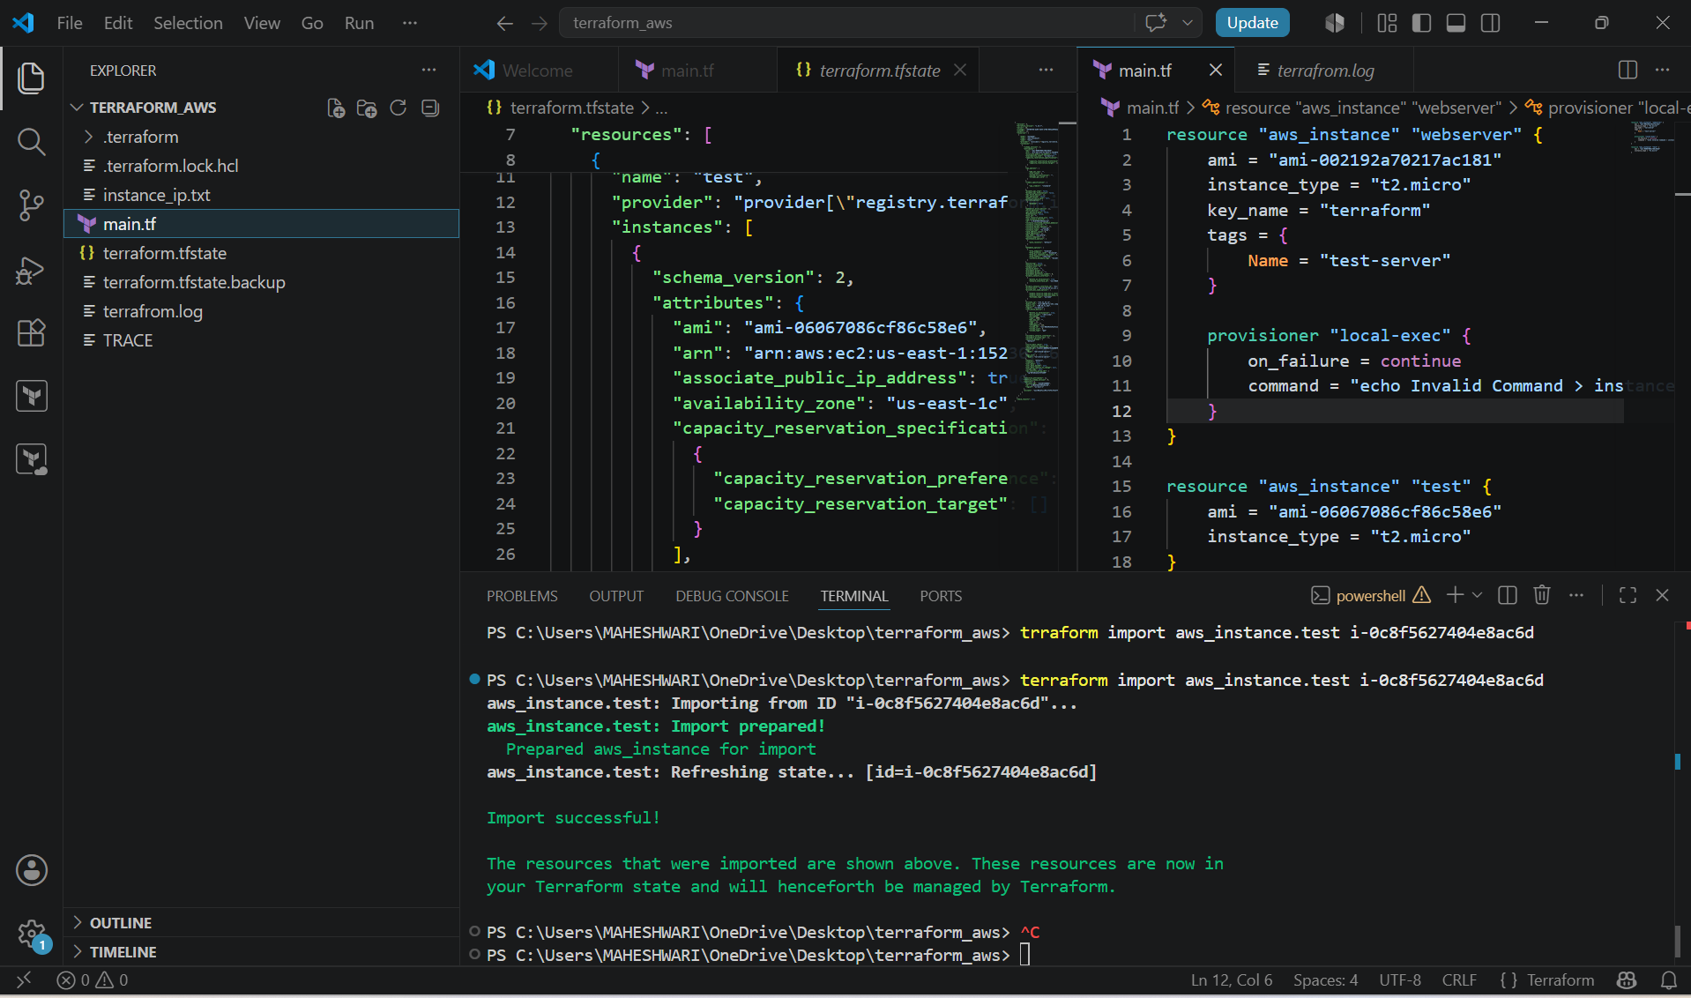

3. Create one EC2 instance with httpd installed using a Terraform script.

PURPOSE: The purpose of this project is to use Terraform infrastructure as Code (IaC) to automatically provision an AWS EC2 instance and install the Apache HTTP Server (httpd) during instance creation. This eliminates manual server configuration and ensures consistency across deployments.

OBJECTIVE:
- provision an EC2 instance in AWS using Terraform.
- Automatically install and configure Apache HTTP Server (httpd) using a user data script.
- Enable HTTP (port 80) and SSH (port 22) access through a security group.
- Host a simple web page to verify that the web server is running.
- Demonstrate infrastructure as Code (IaC) automation.

Terraform template in main.tf:

terraform {
required_providers {
aws = {
source = "hashicorp/aws"
version = "~> 6.0"
}
}
}

provider "aws" {
region = "us-east-1"
}

resource "aws_security_group" "httpd_sg" {
name = "httpd-security-group"

ingress {
from_port = 22
to_port = 22
protocol = "tcp"
cidr_blocks = ["0.0.0.0/0"]
}

ingress {
from_port = 80
to_port = 80
protocol = "tcp"
cidr_blocks = ["0.0.0.0/0"]
}

egress {
from_port = 0
to_port = 0
protocol = "-1"
cidr_blocks = ["0.0.0.0/0"]
}
}

resource "aws_instance" "httpd_server" {
ami = "ami-0c02fb55956c7d316" # Amazon Linux 2 AMI (Update if required)
instance_type = "t2.micro"
key_name = "your-key-pair"
vpc_security_group_ids = [aws_security_group.httpd_sg.id]

user_data = <<-EOF
#!/bin/bash
yum update -y
yum install -y httpd
systemctl start httpd
systemctl enable httpd
echo "<h1>Welcome to Apache HTTP Server installed using Terraform</h1>" > /var/www/html/index.html
EOF

tags = {
Name = "Terraform-HTTPD-Server"
}
}

output "public_ip" {
value = aws_instance.httpd_server.public_ip
}

- Then we have to execute the commands -> terraform init
terraform validate
terraform plan
terraform apply

- Then we can verify the instance in the AWS console.

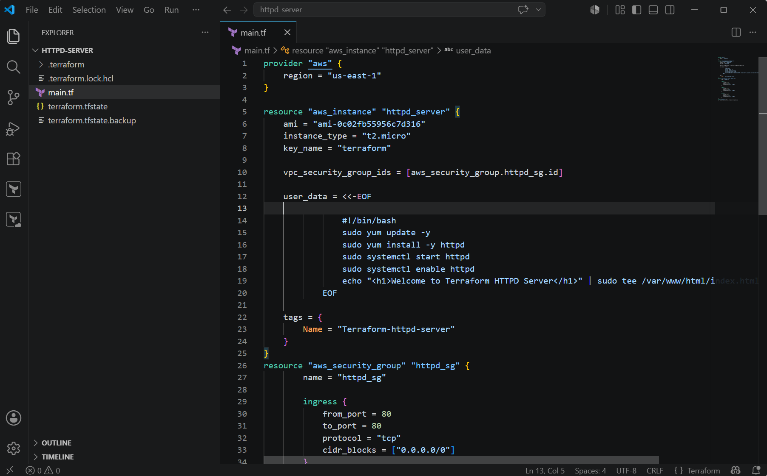

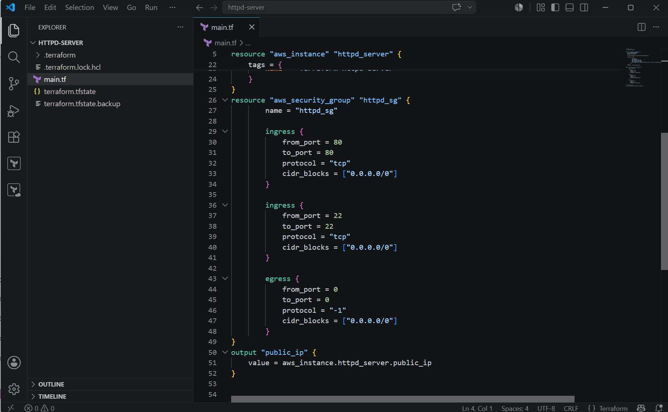

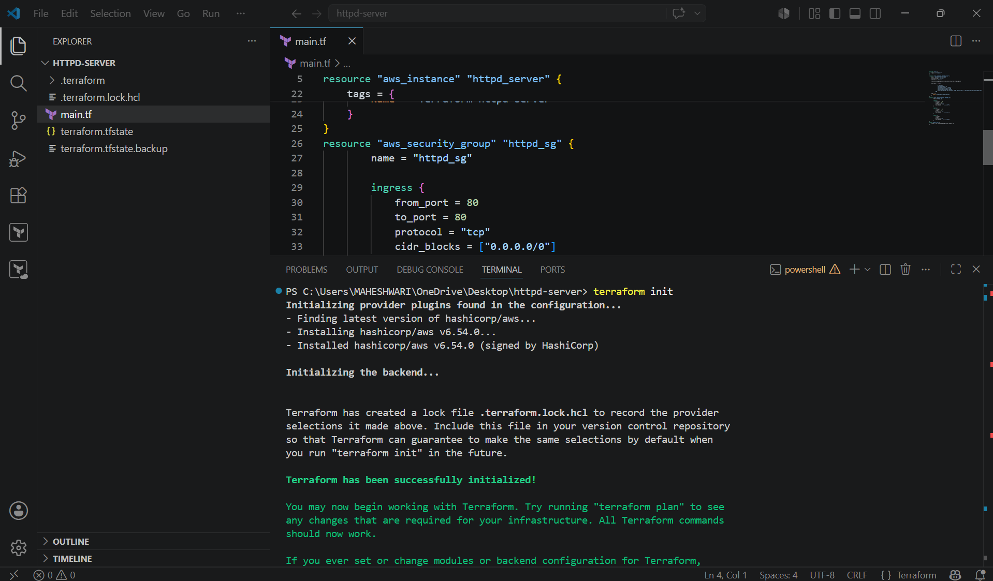

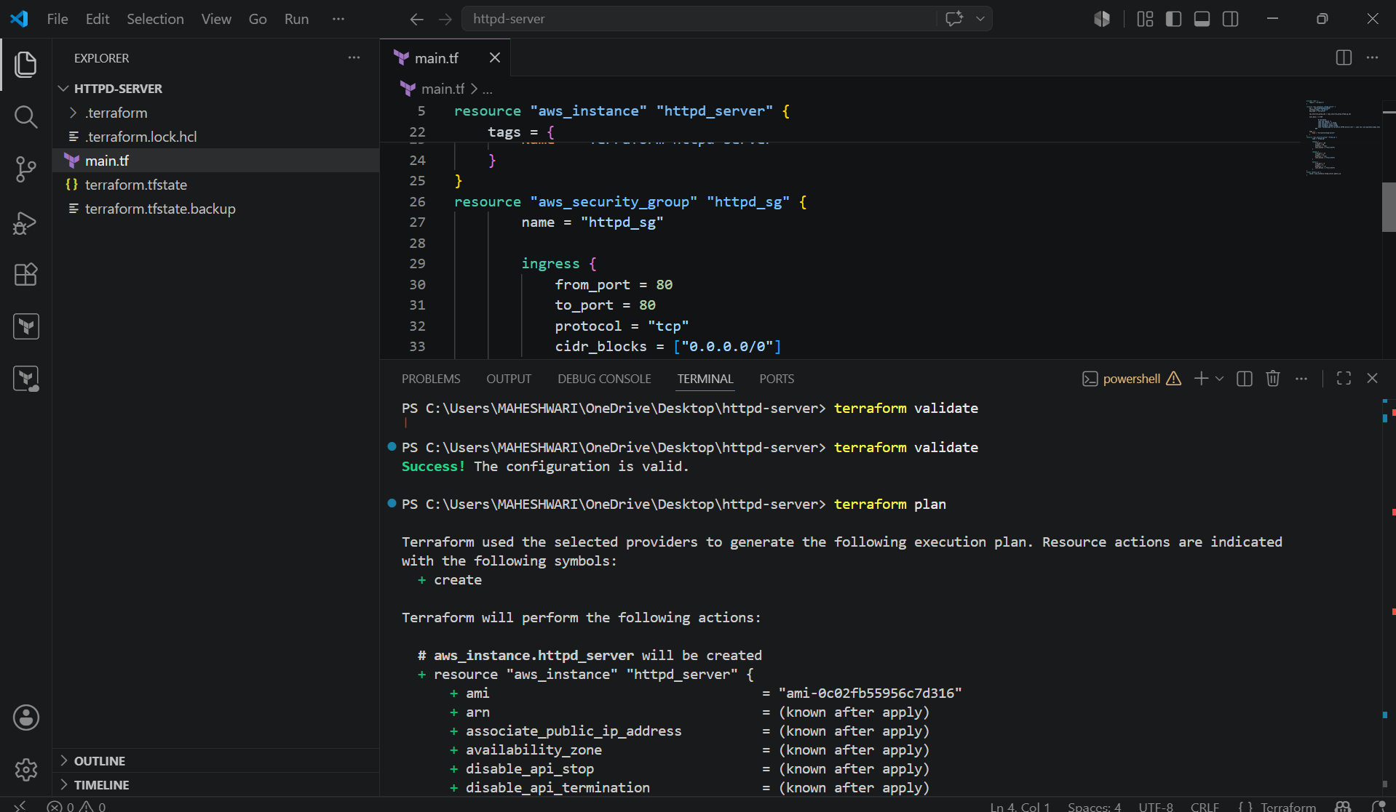

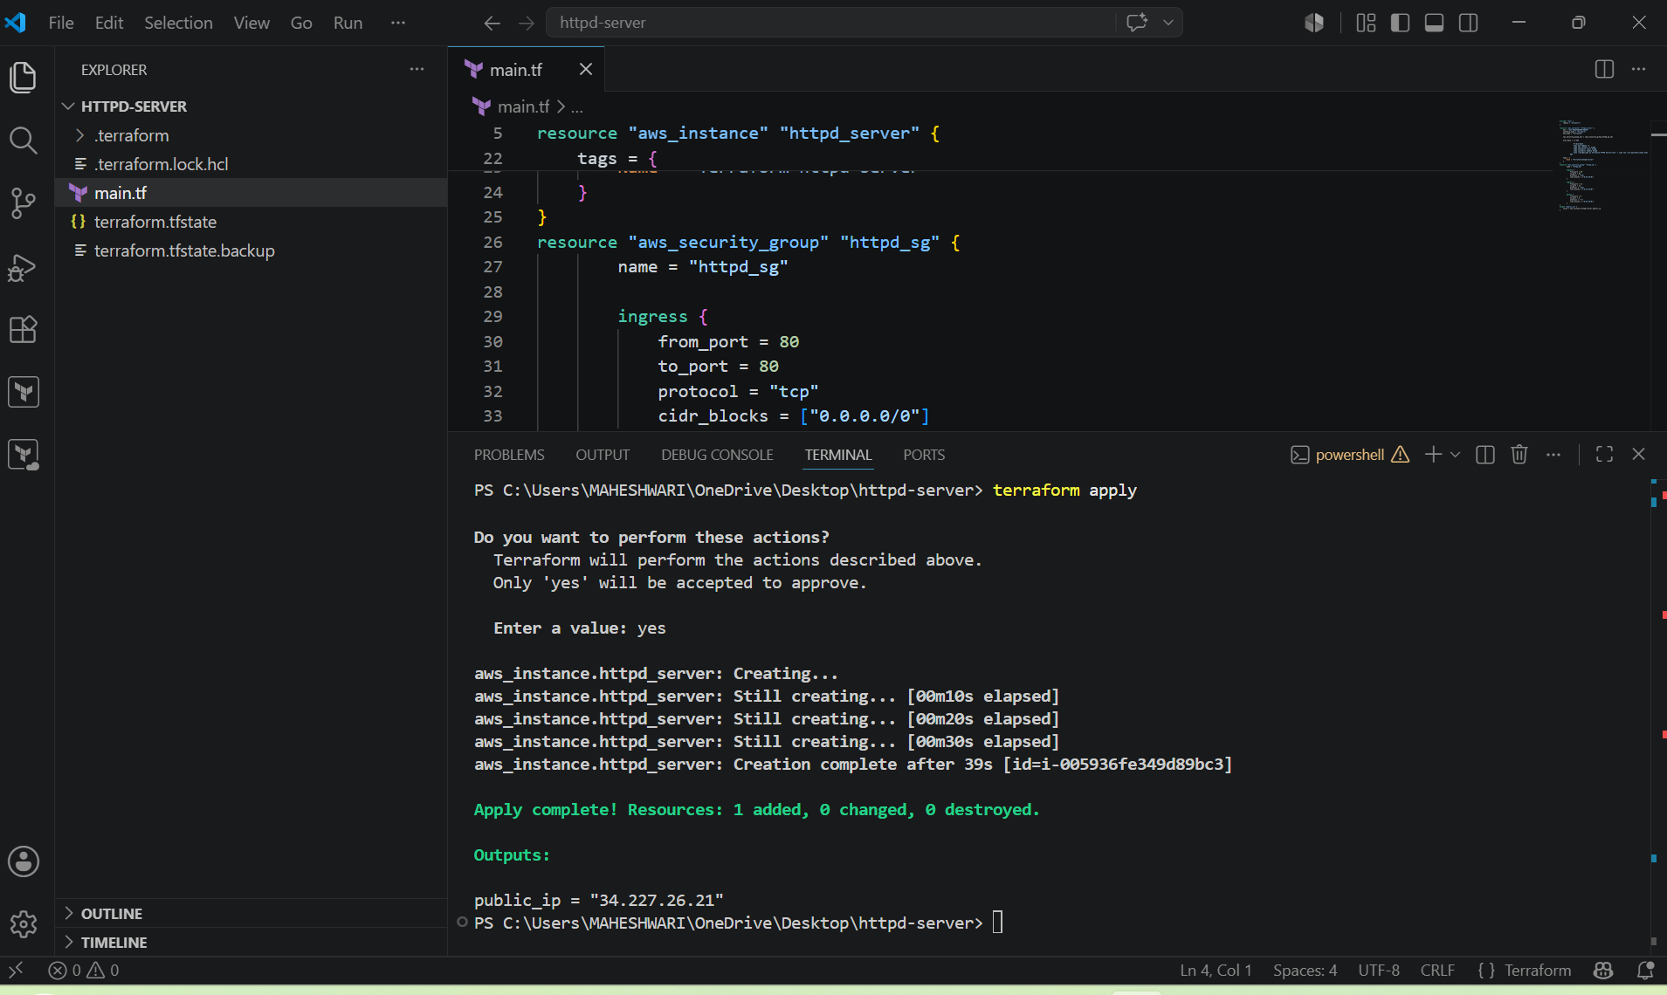

4. Set up S3 as backend for task 3.

PURPOSE: The purpose of configuring Amazon S3 as a Terraform backend is to store the terraform state file (terraform.tfstate) remotely of on the local machine. This allows multiple users to work on the same infrastructure, keeps the state secure, and prevents accidental loss of the state file.

OBJECTIVE:
- Store the Terraform state file in an S3 bucket.
- Enable remote state management.
- Improve collaboration among team members.
- Maintain a secure and centralized Terraform state.

STEP BY STEP IMPLEMENTATION:
- Create an S3 bucket in the terraform template.
- Then we have to execute terraform apply and that will create the bucket in S3 AWS.
- The bucket name should be unique globally.

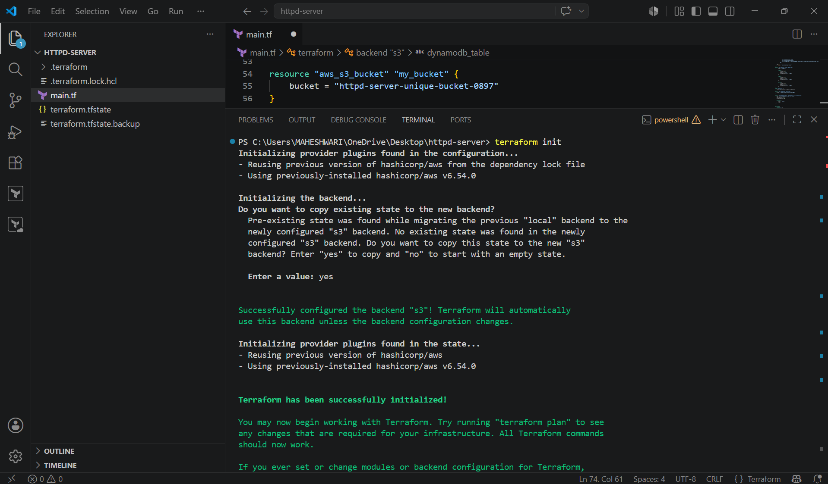

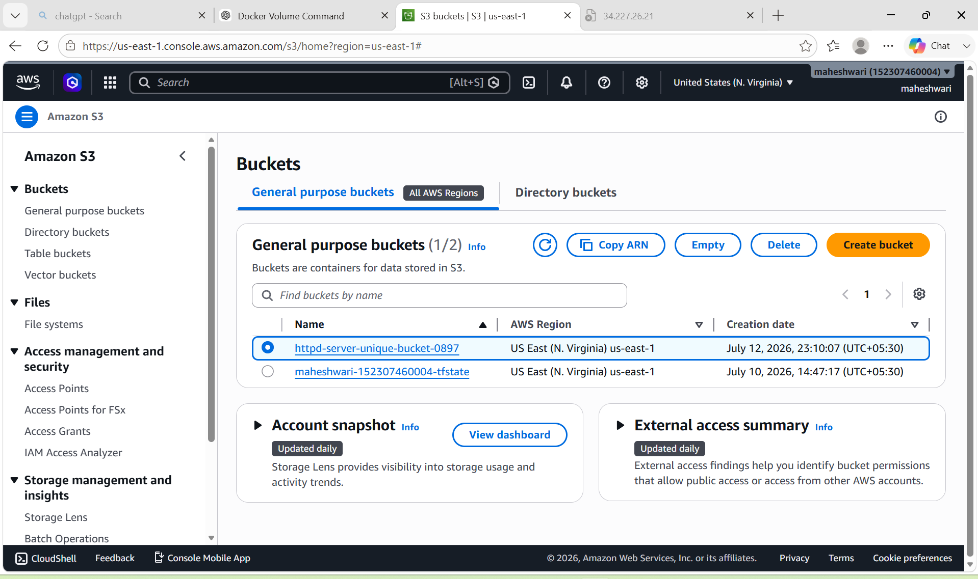

5. Set up DynamoDB locking for task 3.

PURPOSE: The purpose of using Amazon DynamoDB for Terraform state locking is to prevent multiple users from modifying the same terraform state file simultaneously. This ensures that only one terraform operation (such as apply or destroy) can run at a time, avoiding state corruption.

OBJECTIVE:
- Create a DynamoDB table for state locking.
- Configure Terraform to use the DynamoDB table with the S3 backend.
- Prevent concurrent terraform operations.
- Ensure safe and reliable infrastructure as Code (IaC) deployments.

STEP BY STEP IMPLEMENTATION:
- Create a DynamoDB table using terraform template.

resource "aws_dynamodb_table" "terraform_lock" {
name = "terraform-lock"
billing_mode = "PAY_PER_REQUEST"
hash_key = "LockID"

attribute {
name = "LockID"
type = "S"
}

tags = {
Name = "Terraform Lock Table"
}
}

- Since the backend is initialized before resources are created, it is common to create the DynamoDB table separately (or manually) before enabling state locking.
- Configure the S3 backend and execute the terraform init and the terraform apply.

terraform {
backend "s3" {
bucket = "httpd-server-unique-bucket-0897"
key = "httpd-server/terraform.tfstate"
region = "us-east-1"
dynamodb_table = "terraform-lock"
}
}

