CHALLENGE ON INSTALLATIONS ON AMAZON LINUX SERVER

Create a instance in aws account and connect with the git bash with the pem key file by using the command -> ssh -i file.pem ec2-user@publicid-of-instance

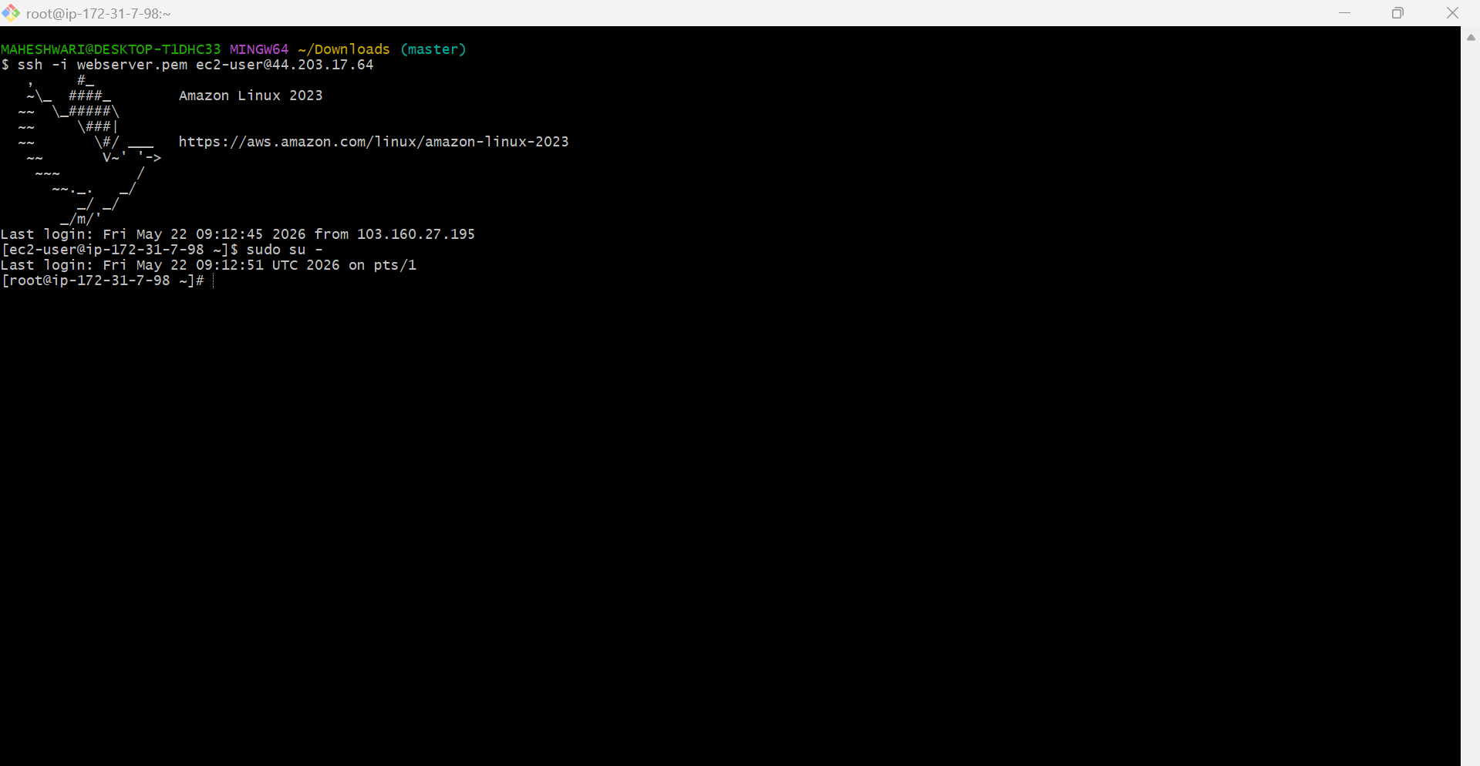

1.INSTALL DOCKER
PURPOSE: Docker in amazon linux server is to automate the deployment of applications inside lightweight, portable containers.
OBJECTIVE: Docker’s lightweight and portable nature allows for efficient resource utilization and scalability.
Step by step implementation:
- Firstly we have to update the server -> yum update -y
- Then we have install docker in our server -> yum install docker -y
- Then start the downloaded docker package -> systemctl start docker
- Check the status of docker activation -> systemctl status docker
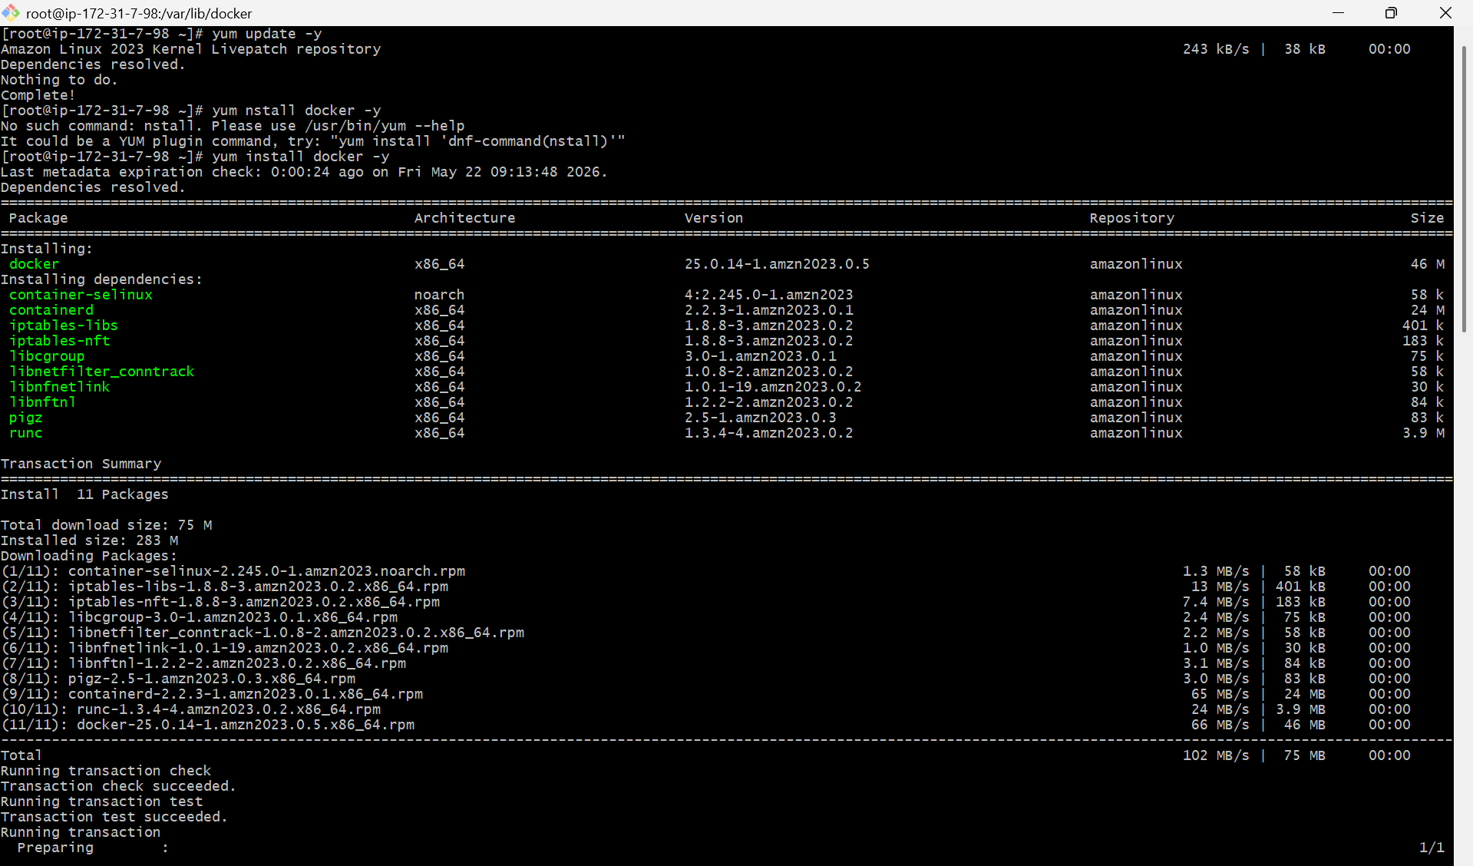
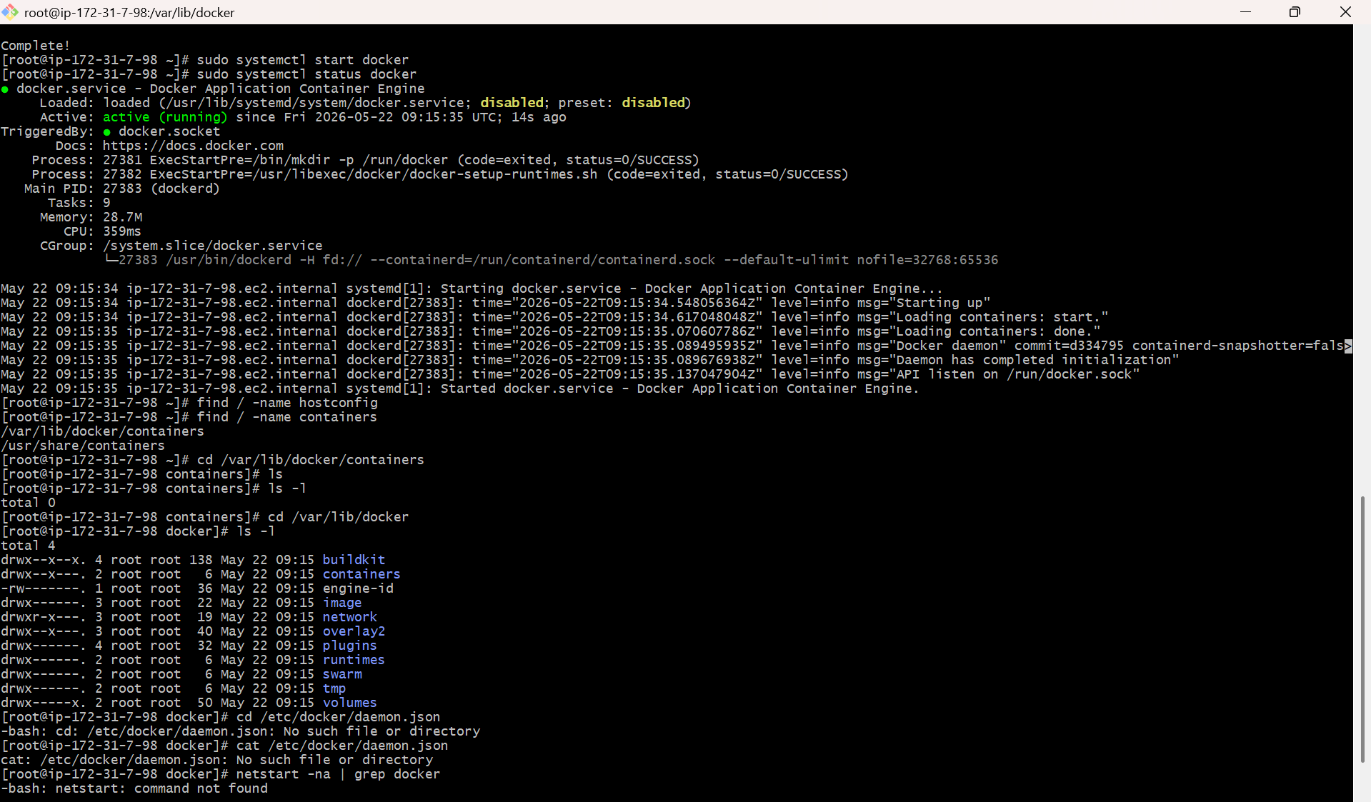

2.INSTALL JENKINS
PURPOSE: helps the user easily set up your Jenkins tools on the EC2 instance for continuos integration and continuous development.
Step by step implementation:
- Java is the prerequisite for the Jenkins
- So download java 21 -> yum install java-21
- Then install Jenkins -> yum install Jenkins -y
- Then start the Jenkins -> systemctl start Jenkins
- Then check the status -> systemctl status Jenkins
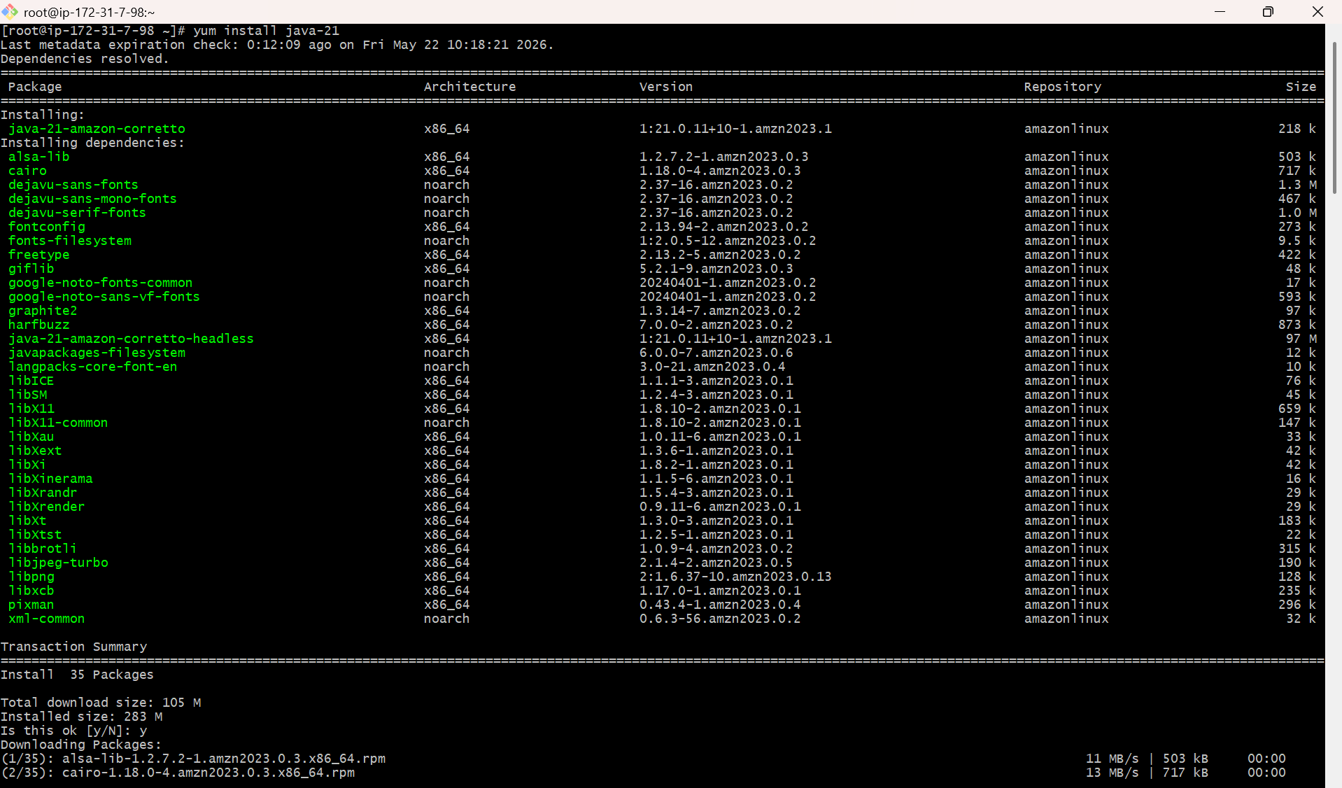

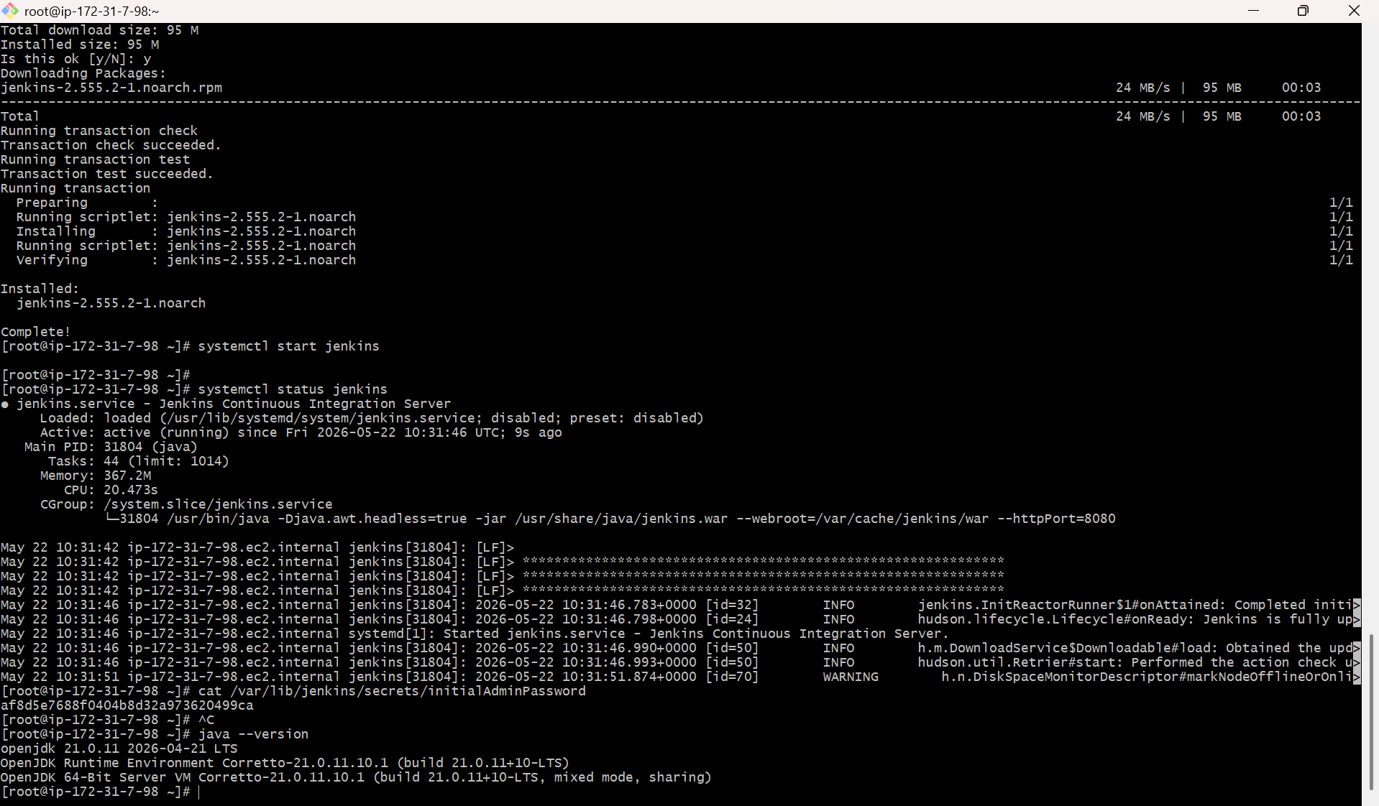

- It will run the default port number -> 8080
- And there you can set your Jenkins account.
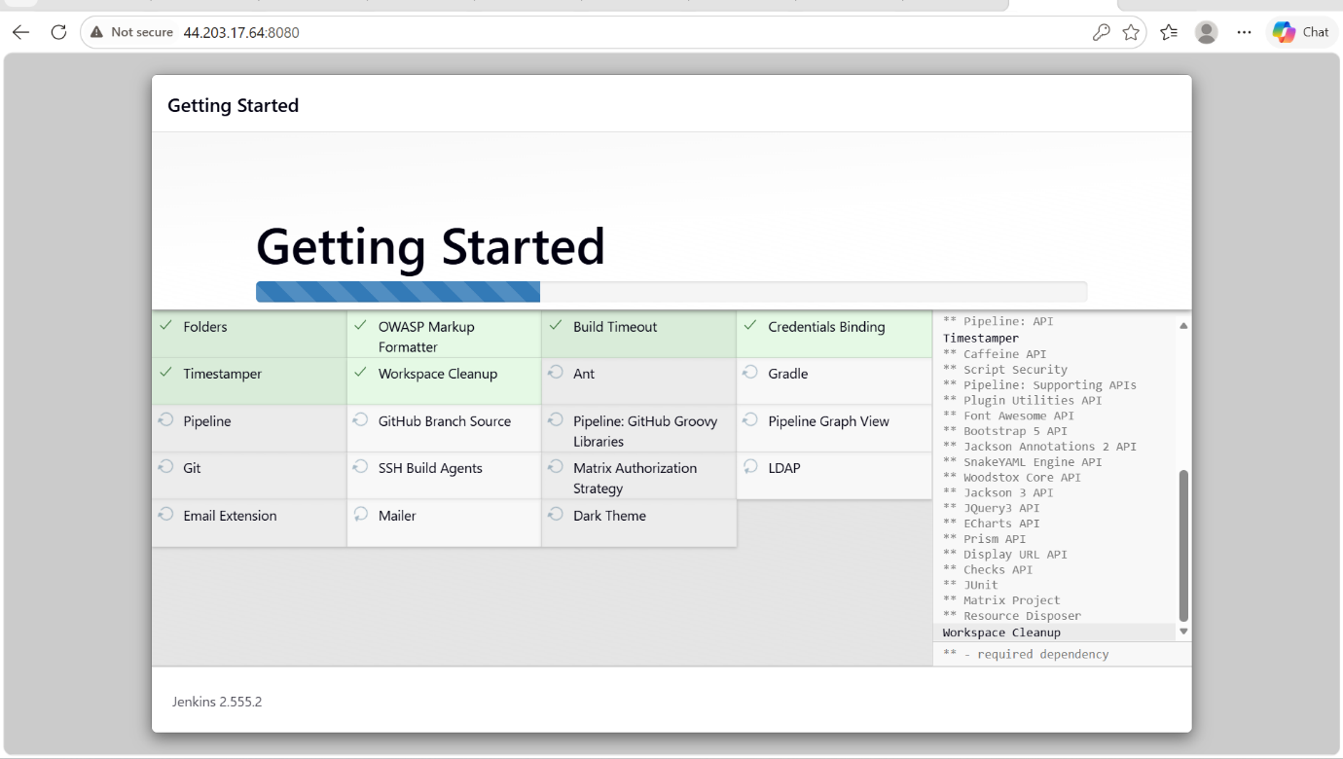
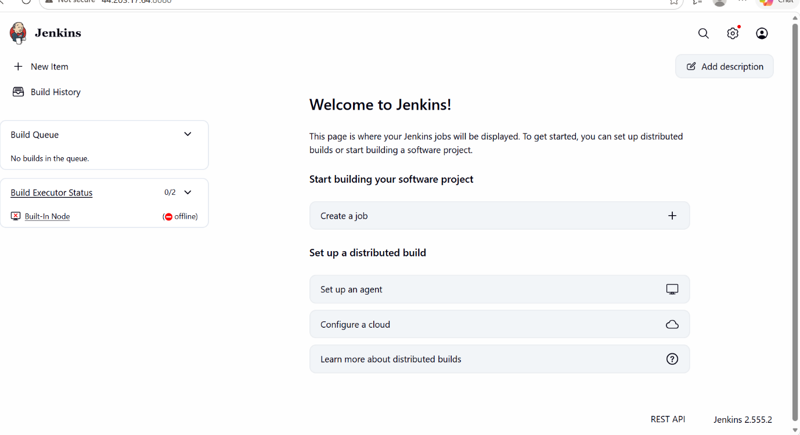

3.INSTALL NGINX
- Nginx server is used to deploy static applications.
- Nginx serves as a high performance web server.
Step by step implementation:
- Firstly u have to update the server -> yum update -y
- Then install the nginx package -> yum install nginx
- Then start the downloaded nginx package -> systemctl start nginx
- Then check the status of nginx -> systemctl status nginx
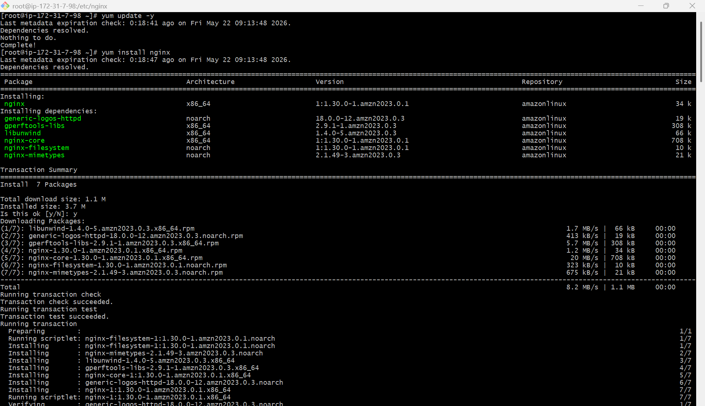

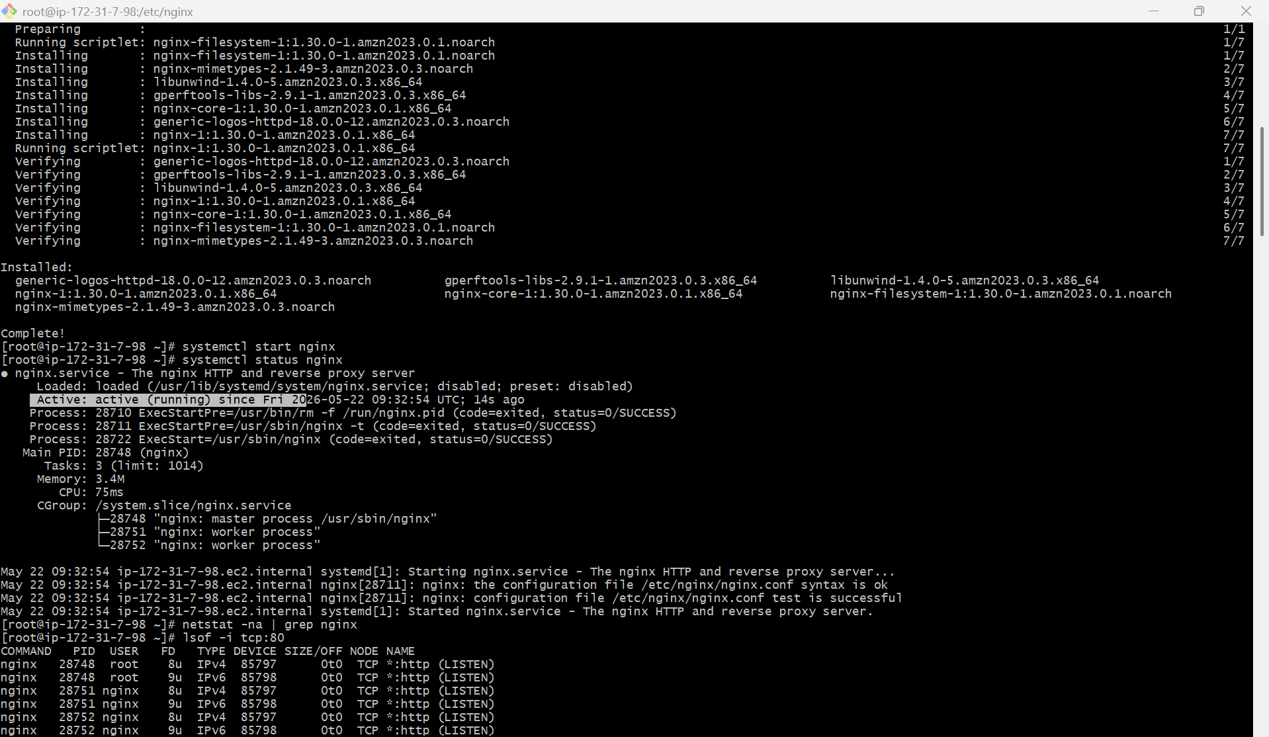
- Default port number of nginx is 80
- To change that port number from 80 to 81, we have to change the configurations in /etc/nginx/nginx.conf
- Then we have to edit the configurations in nginx.conf file
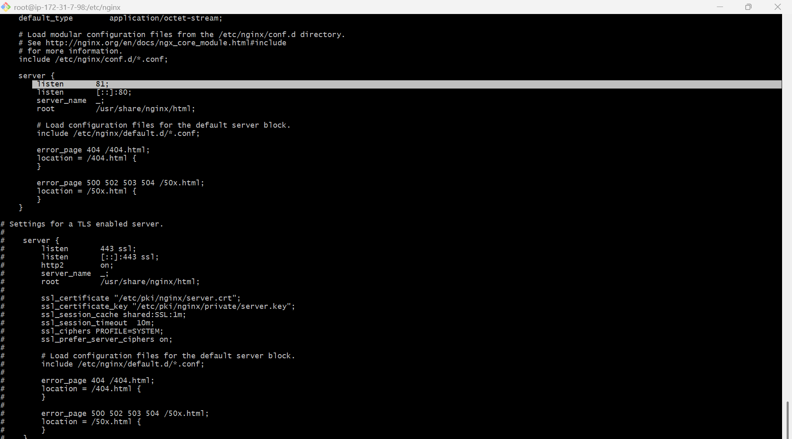
- After changing port number, we have to restart server -> systemctl restart nginx
- Then check the status of server -> systemctl status nginx
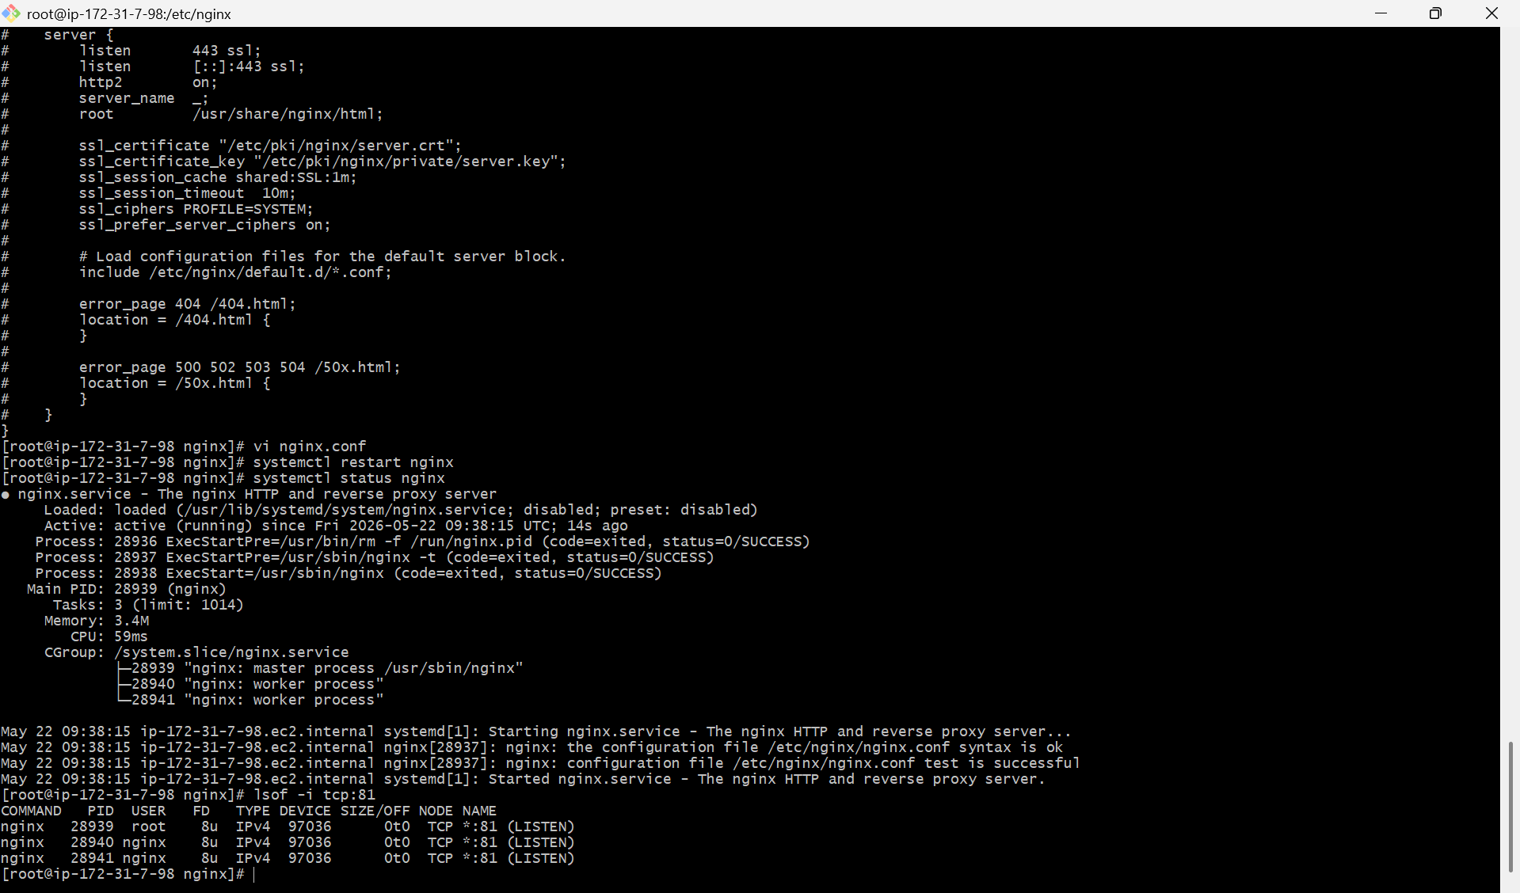
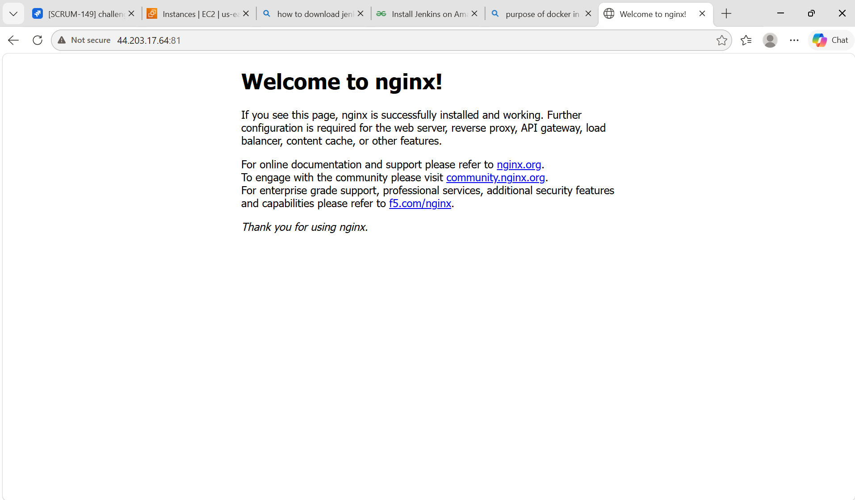

4.INSTALL APACHE (httpd)
PURPOSE: httpd package is used to install the apache HTTP server, which is a web server that processes HTTP requests and serves web content securely.
STEP BY STEP IMPLEMENTATION:
- Update the server -> yum update -y
- Install apache -> yum install httpd
- Start apache -> systemctl start httpd
- Check the status -> systemctl status httpd
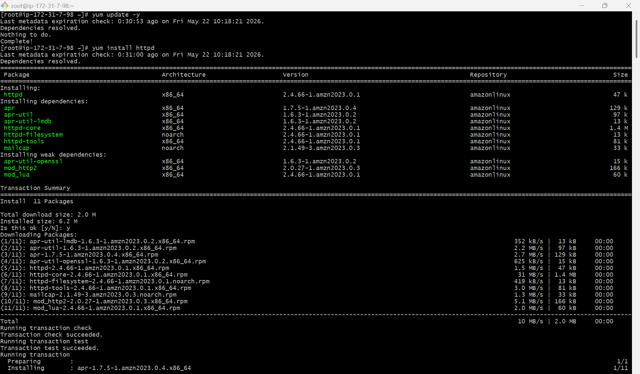
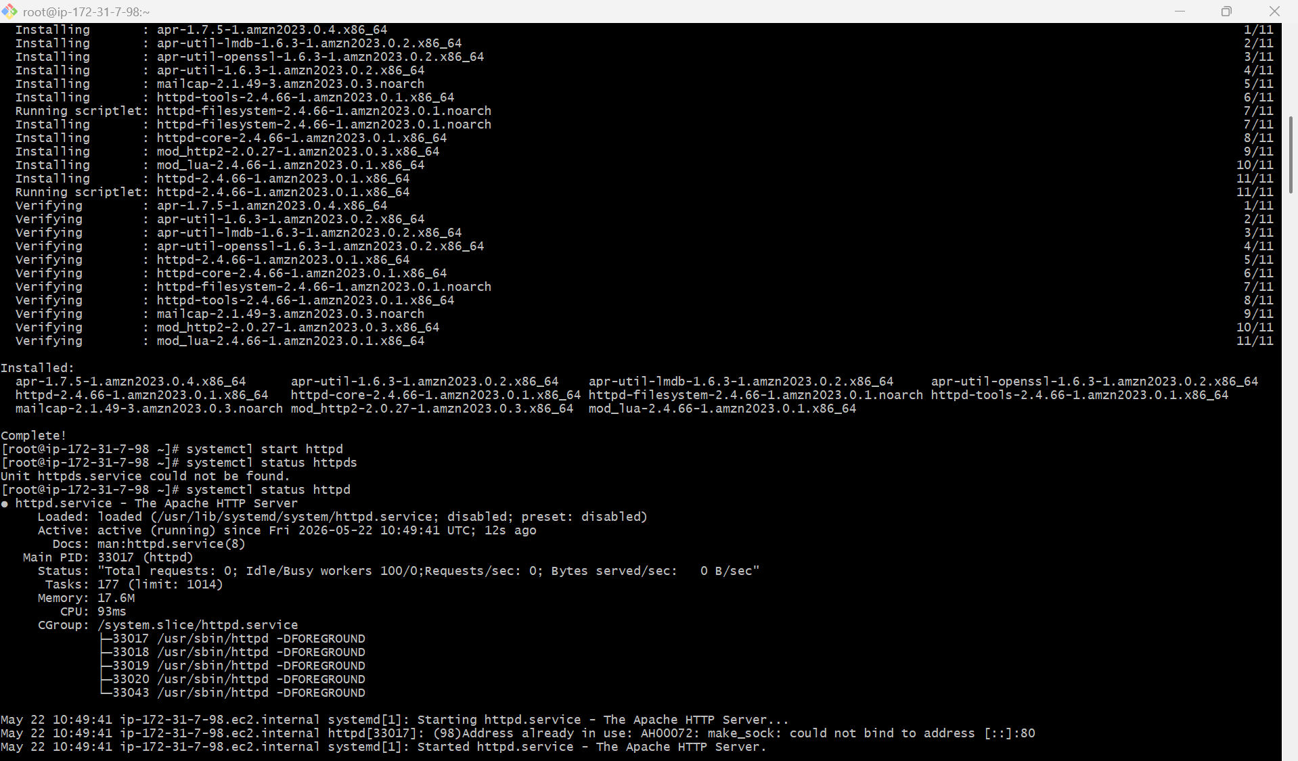

- It will work on default port number -> 80
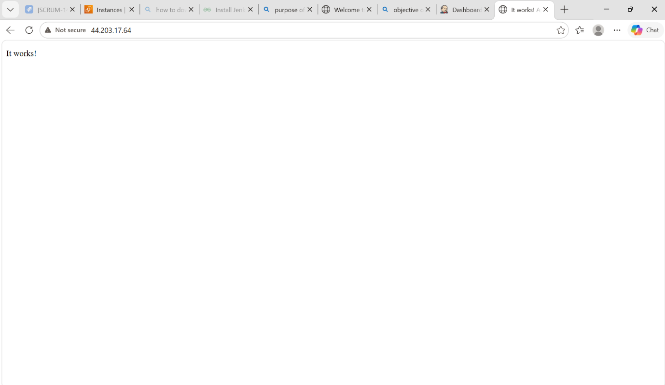

5.INSTALL APACHE TOMCAT
- Install apache tomcat on port number 8080
- Firstofall download the java version 17 -> yum install java-17
- And then download tomcat by using wget command -> wget <url-of-the-link>
- By using wget command a tar fill will download and extract the downloaded
- file by using tar command -> tar xvf downloadedfilename
- And then go to bin directory use the startup.sh to run the tomcat
- To change the port number from default port 8080 to 8082, we have to edit the
- server.xml file and the path of this file -> /opt/tomcat/conf
- After editing the server.xml file we have to shutdown the tomcat and again
- start the tomcat -> shutdown.sh & startup.sh in bin directory
- Deploy a sample app on webapps
- First go the webapps path -> /opt/tomcat/webapps
- This is the default deployment location of tomcat
- Download any sample app from google and download it in our service by using
- wget
- We can access this by publicip:8082/sample
- Create a tomcat.service file for apache
- We can create tomcat.service file in /etc/system/system
- Add a user tomcat by using adduser command and change the ownership of
- the downloaded tomcat file by using chown command -> chown tomcat:tomcat
- tomcat
- then give the java path of our service to the java home in tomcat.service file
- then do the commands
- systemctl daemon-reload
- systemctl enable tomcat
- systemctl start tomcat
- systemctl status tomcat

