CHALLENGE-10

1. Create an EC2 Instance on AWS Cloud using the below-mentioned ubuntu AMI and instance_type. Or, (You can use of your choice as well) ami = "ami-0461b1436c9b3c1a3" instance_type = "t2.micro"

- We have to create a directory and open that folder in the VS studio.
- Create a new file in that folder and write a new template in the terraform.
- Then we have to execute the terraform init to initiate the terraform template and downloads the terraform template dependencies.

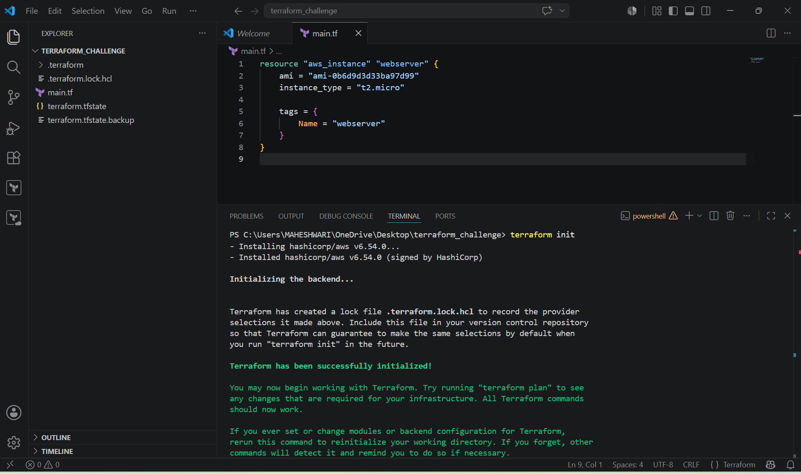

- Then we have to execute the terraform apply to execute the terraform template and it will create a new instance in the EC2 of AWS.
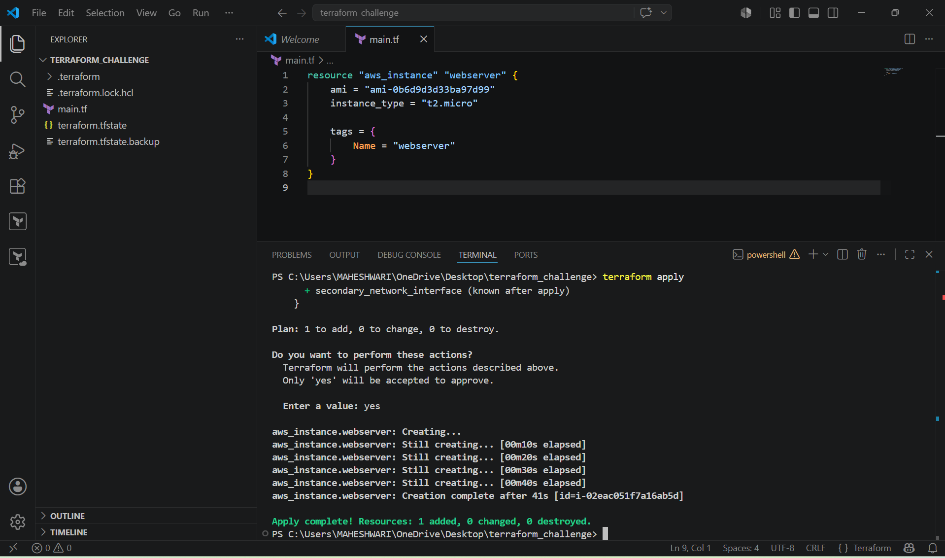
- We can verify it in the AWS EC2 console.
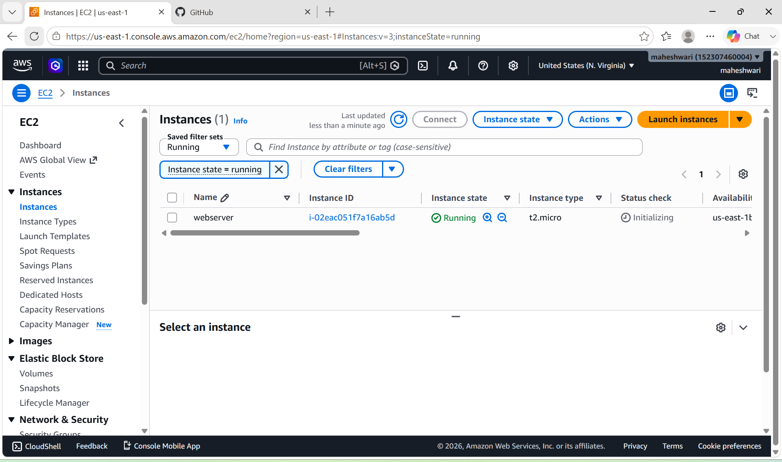

2. Install a web server on the same EC2 Instance. The web server should listen on port 8080.

PURPOSE: Provision an EC2 instance with Apache installed and configured to listen on port 8080 automatically using Terraform.

OBJECTIVE:
- Create an EC2 instance.
- Install the Apache web server.
- Configure Apache to listen on port 8080
- Start and enable the Apache service.
- Display a sample web page.

STEP BY STEP IMPLEMENTATION:

- We have to write a template of aws services like create an EC2 and add a security groups of the EC2 instance.

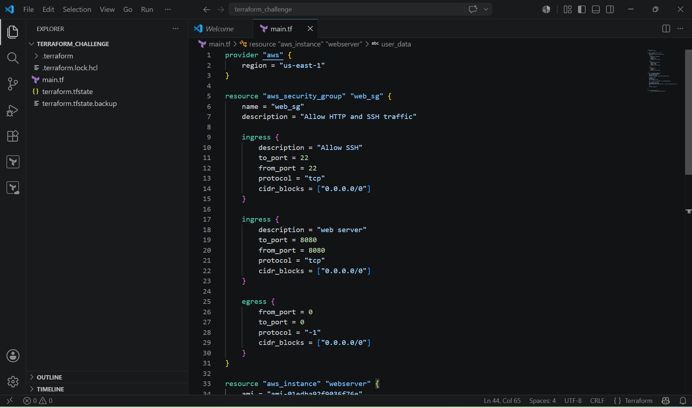

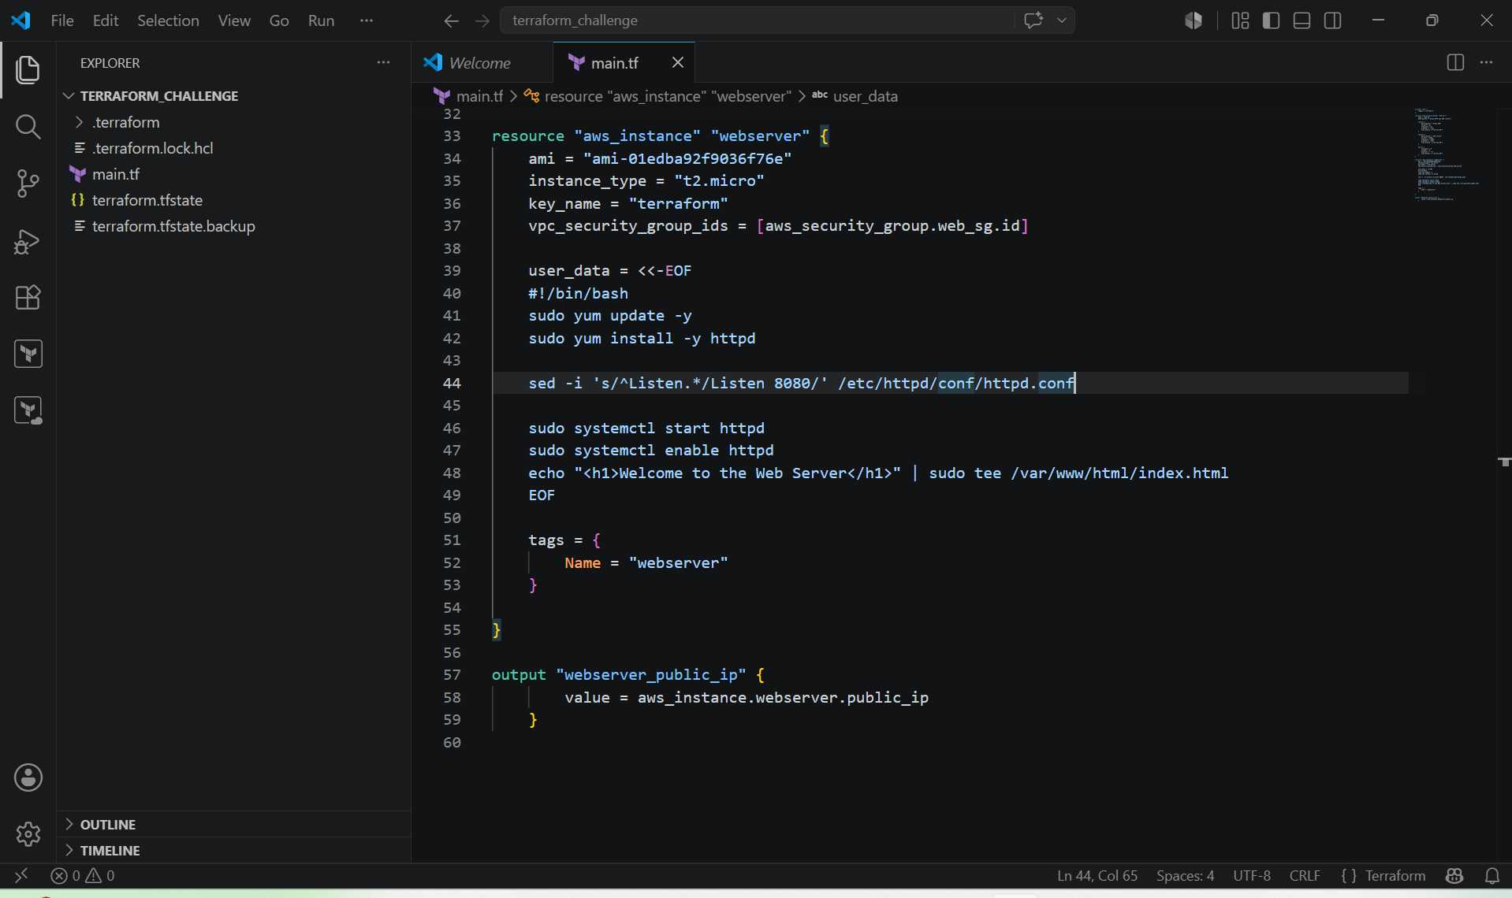

- Then we have to execute the commands terraform init and terraform apply.
- These commands will create a new instance with the specific inbound and outbound rules.

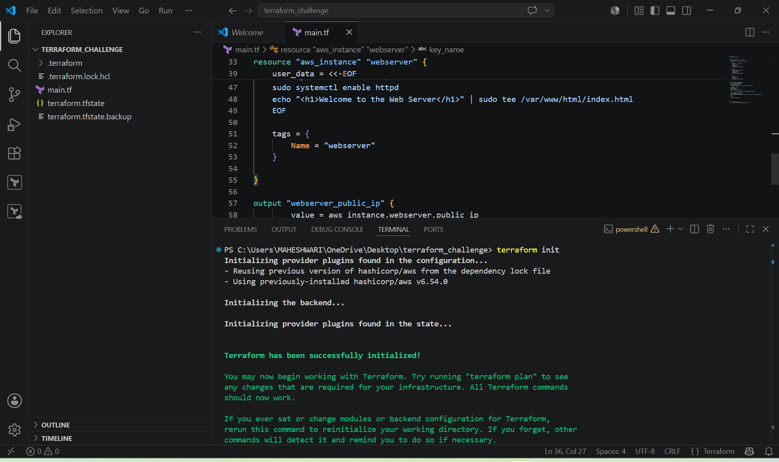

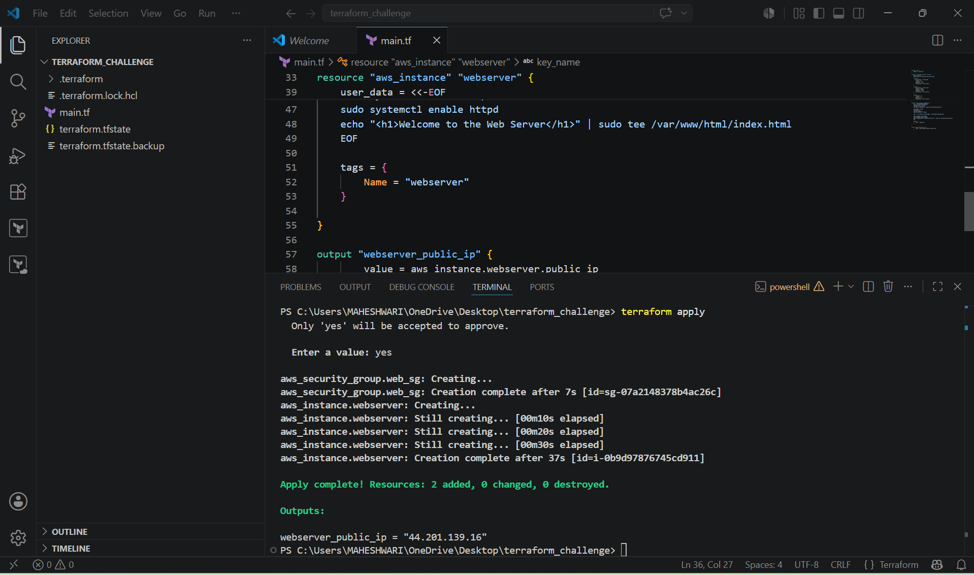

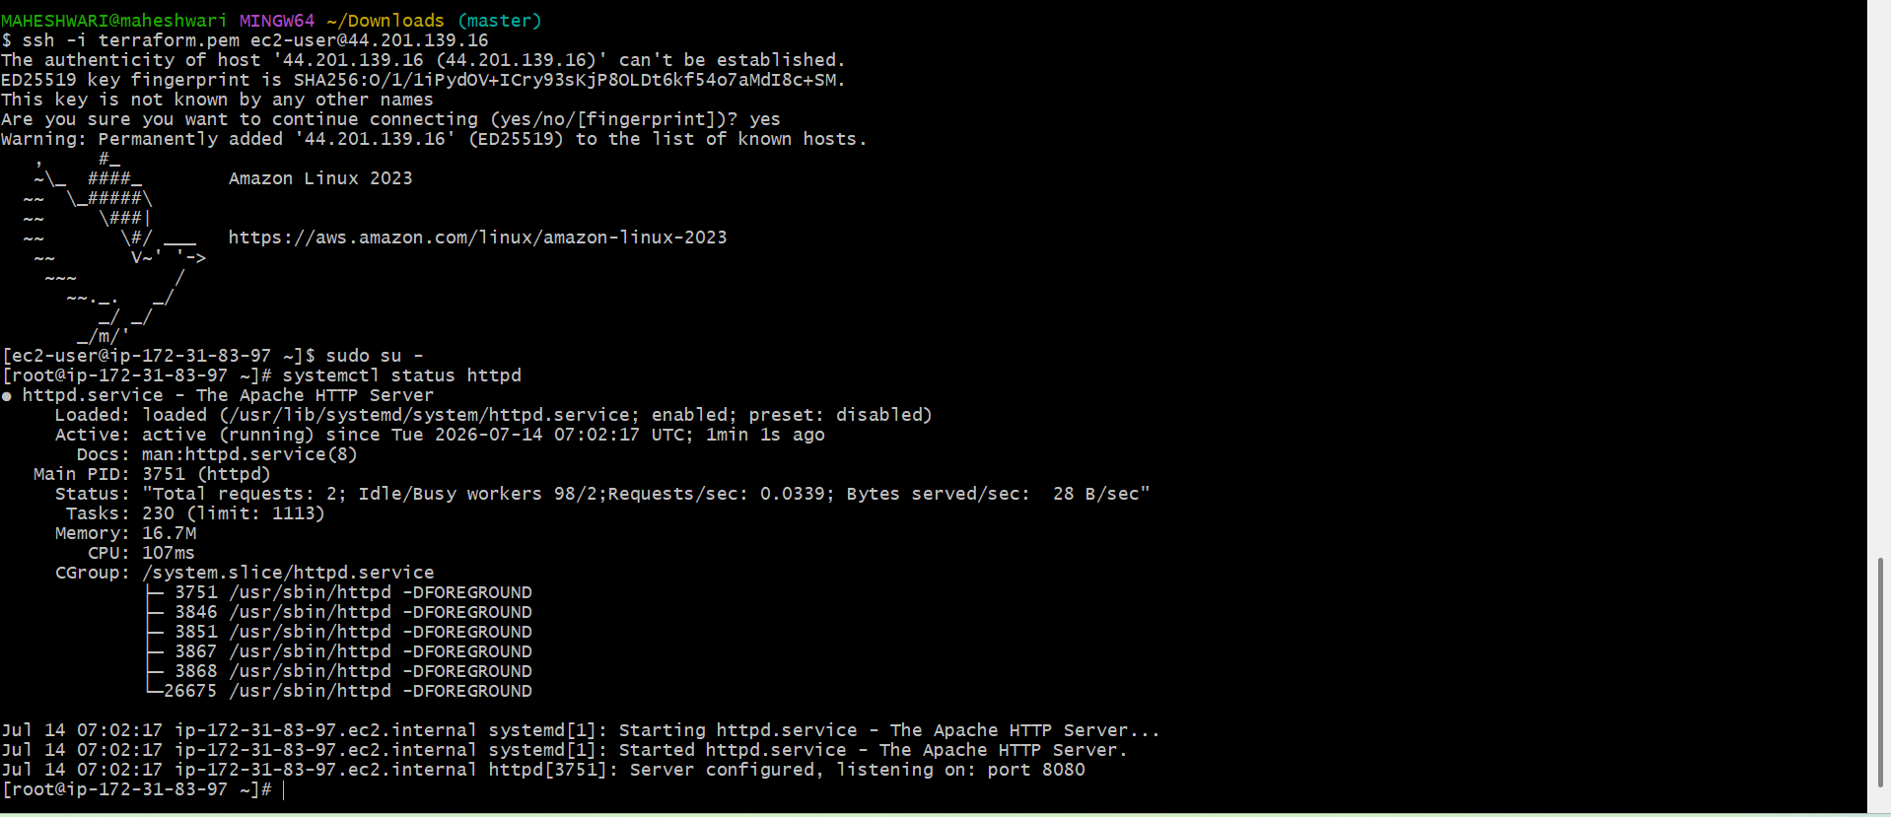

- We can verify it in the browser with the public IP with port number.
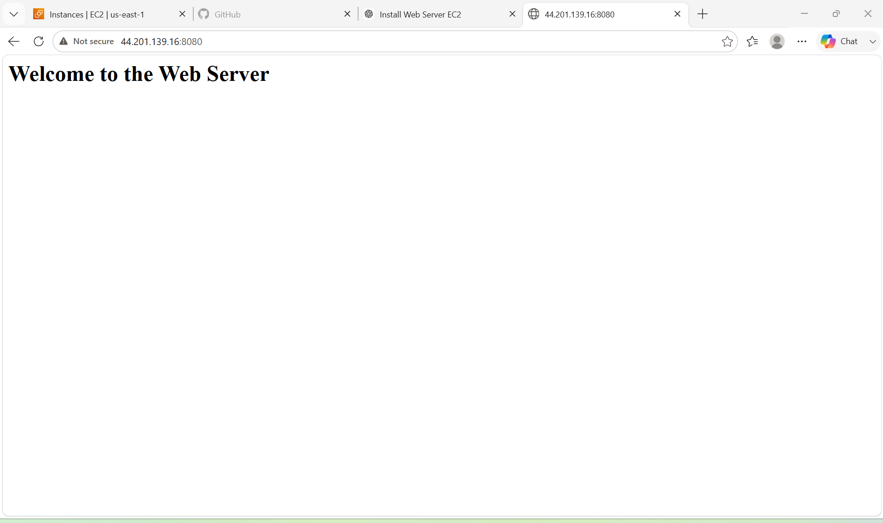

3. Create a Docker-compose file for the project:https://github.com/betawins/cricbuzz-docker-hello-world.gitand point it to port 8000.

PURPOSE: To provision an AWS EC2 instance using terraform, automatically install Docker and Docker Compose, clone with Cricbuzz Docker Hello World project from GitHub, create a Docker Compose file, and deploy the application on port 8000 using Ec2 user_data.

OBJECTIVE:
- Provision an EC2 instance using Terraform.
- Install Docker and Docker Compose automatically.
- Clone the Cricbuzz Docker Hello World project from GitHub.
- Create a Docker Compose configuration.
- Deploy the application on port 8000.
- Automate the complete deployment without manual intervention.

STEP BY STEP IMPLEMENTATION:
- Create main.tf template in terraform with this content.

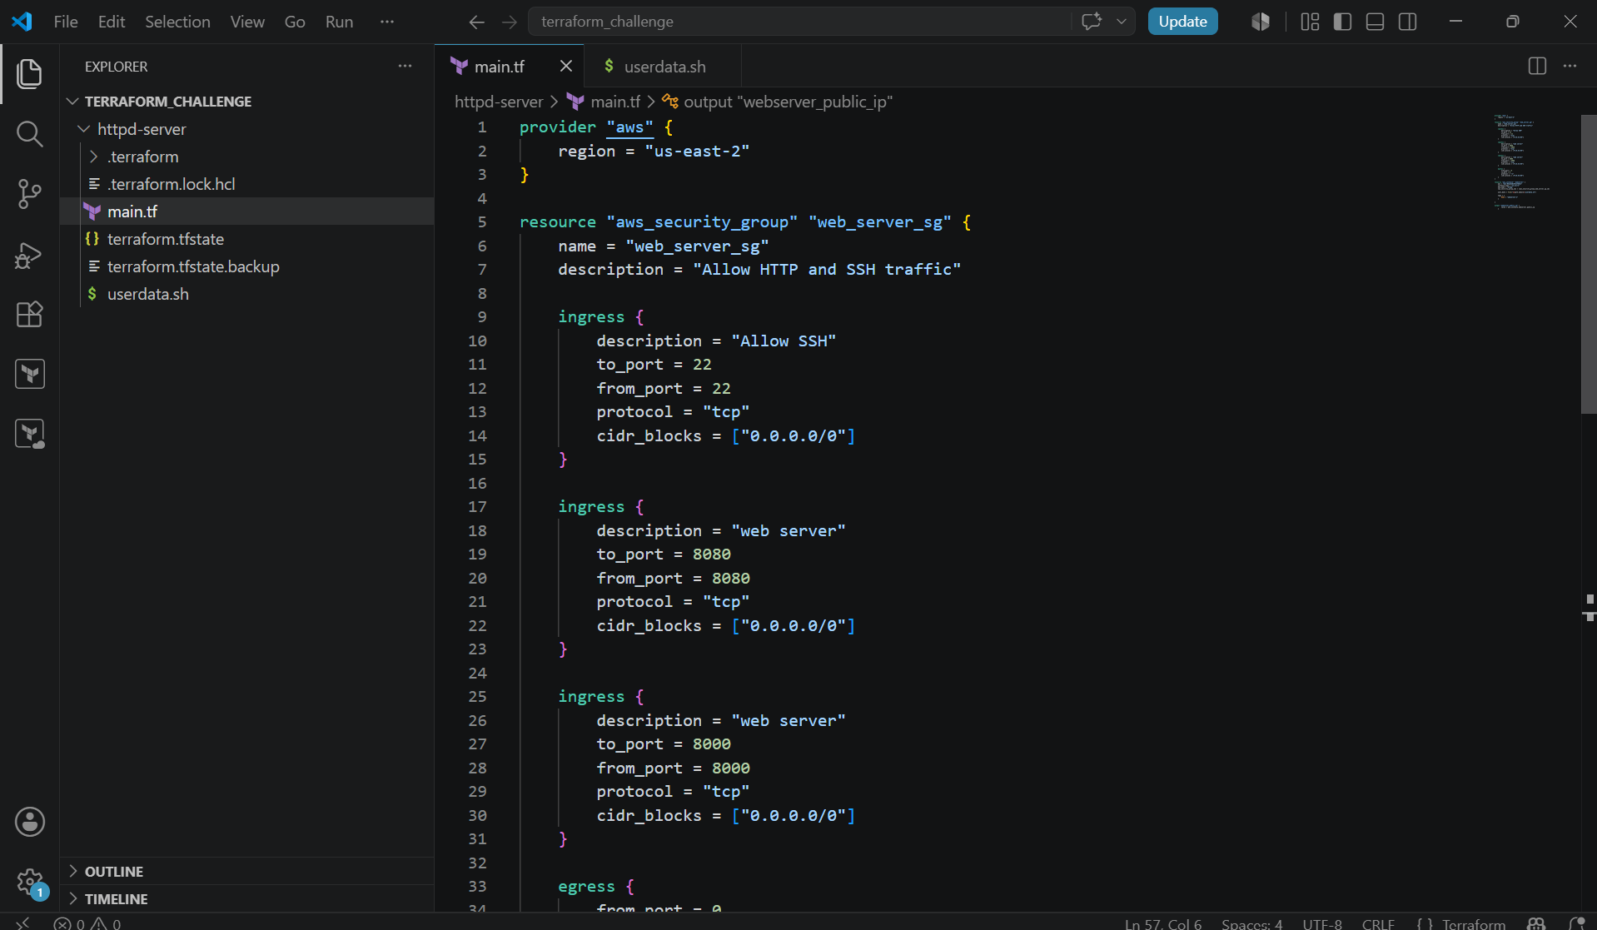

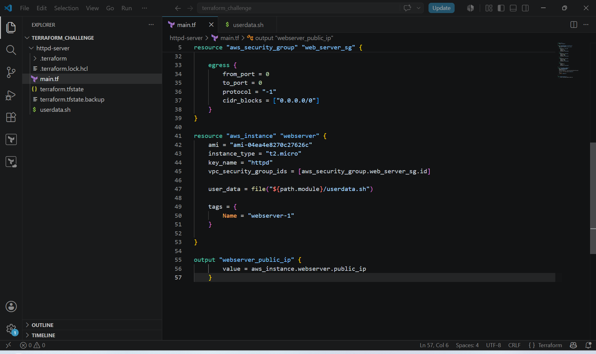

- This template will create AWS EC2 instance and security group with the inbound rules and outbound rules for the instance.
- Then we have to create userdata.sh template.

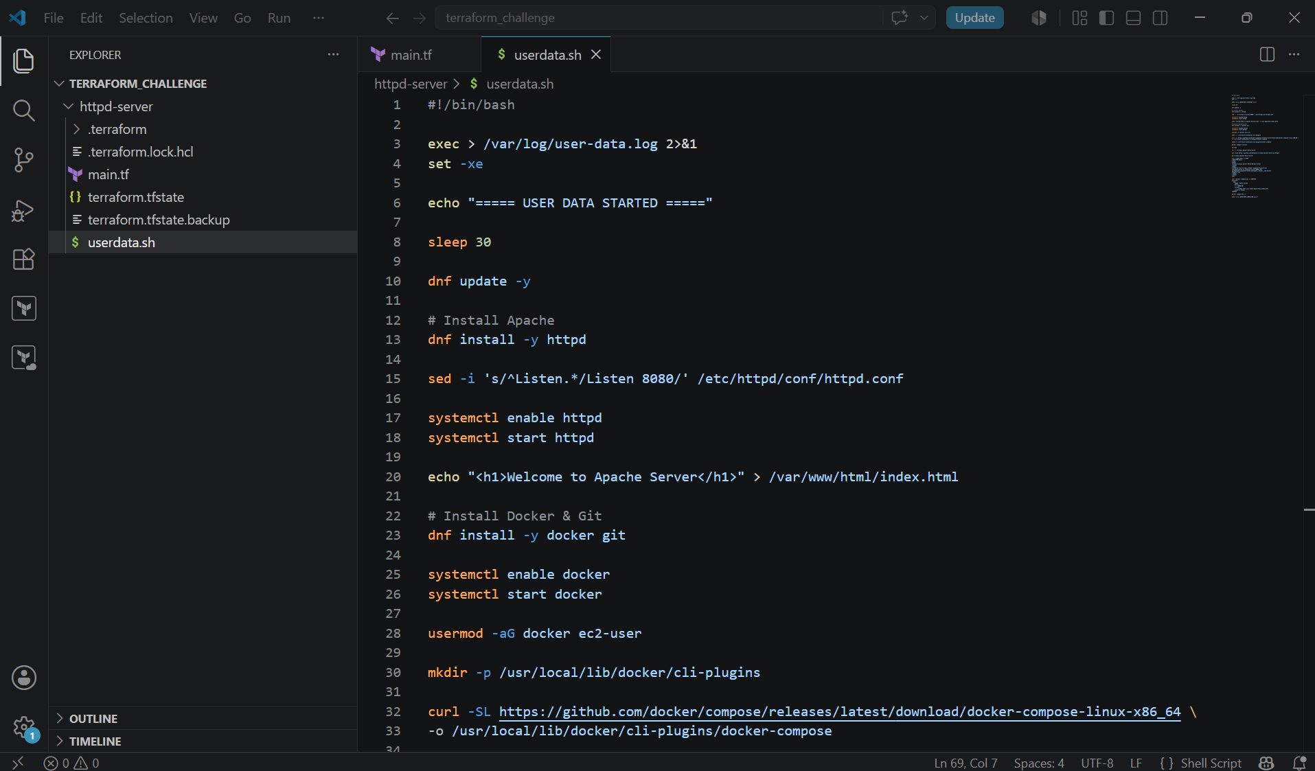

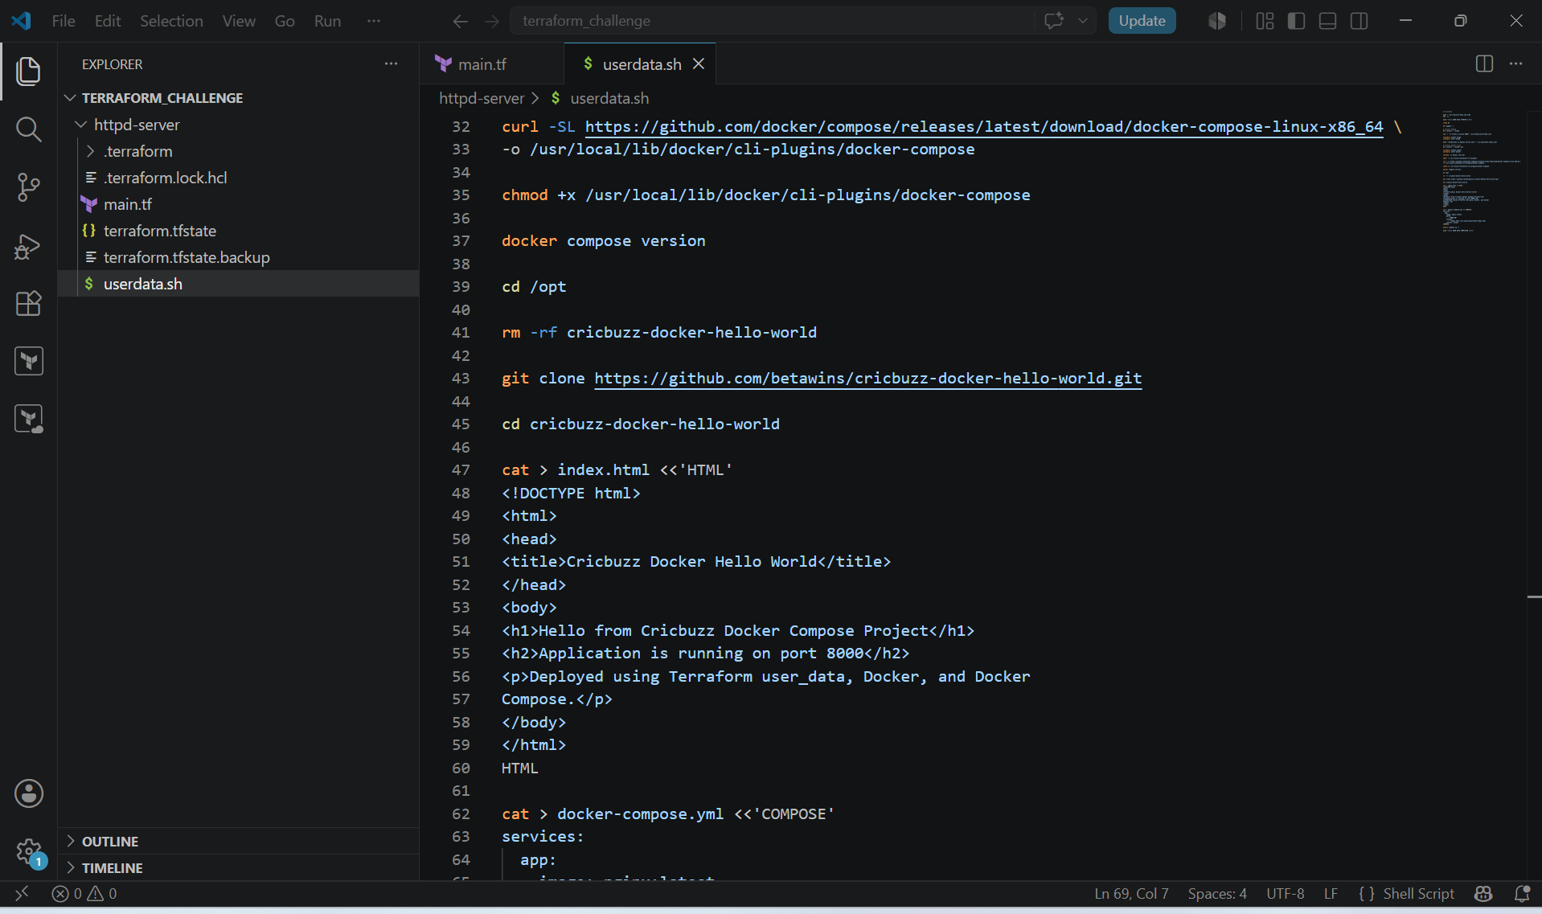

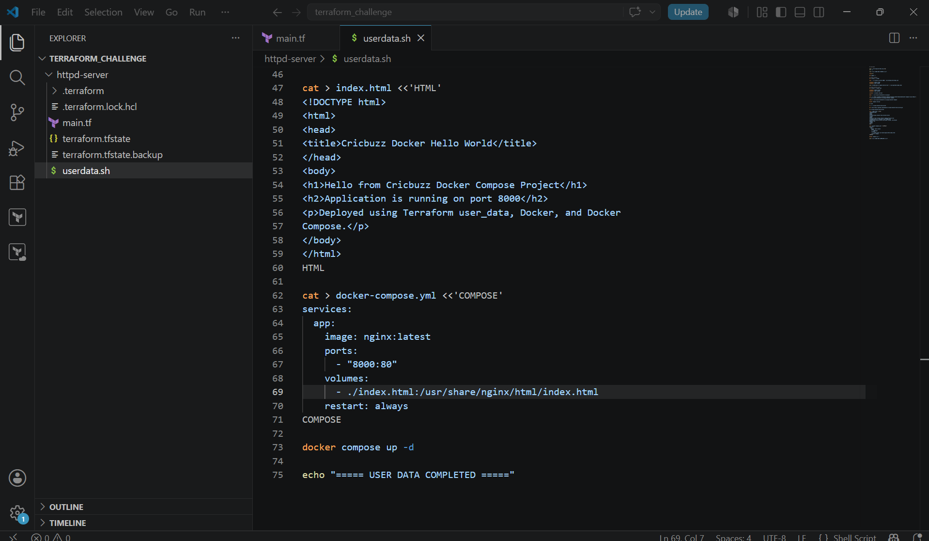

- We have to call this userdata.sh template in the main.tf template with this command -> user_data = file("${path.module}/userdata.sh")
- Then we have to check for the region in which region you want to create the instance. We have to pass the region in the provider of the main.tf template.
- We have to crosscheck the ami id of the region which we have selected in the provider.
- Then we have to initialize the terraform with the command -> terraform init
- Then we have to apply the terraform template with the command -> terraform apply.
- User data will execute only once when the instance is created.
- If we have modified the user data, then we have to firstly destroy all the resources and then after destroying we have reapply the terraform -> terraform apply.

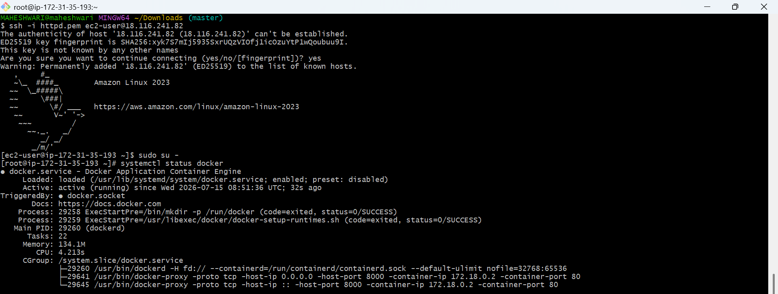

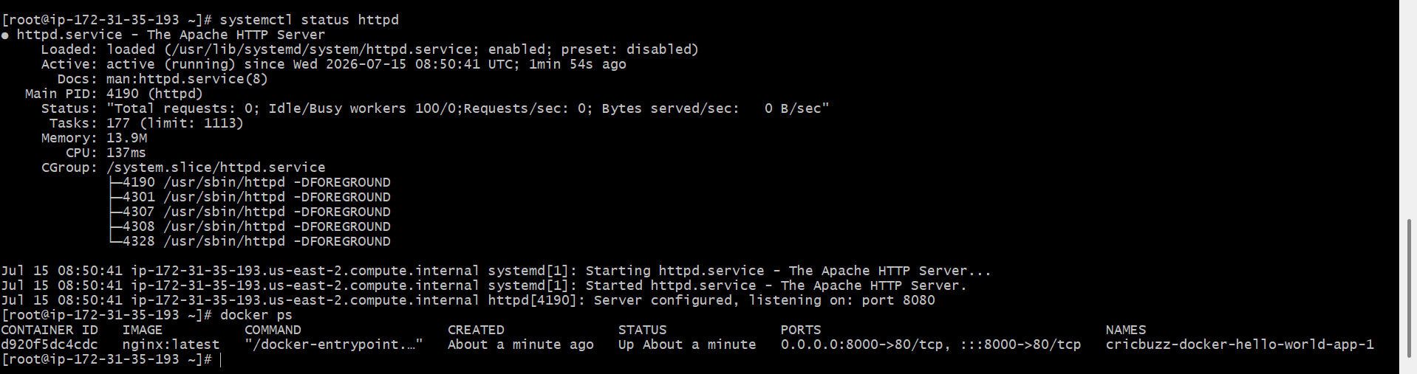

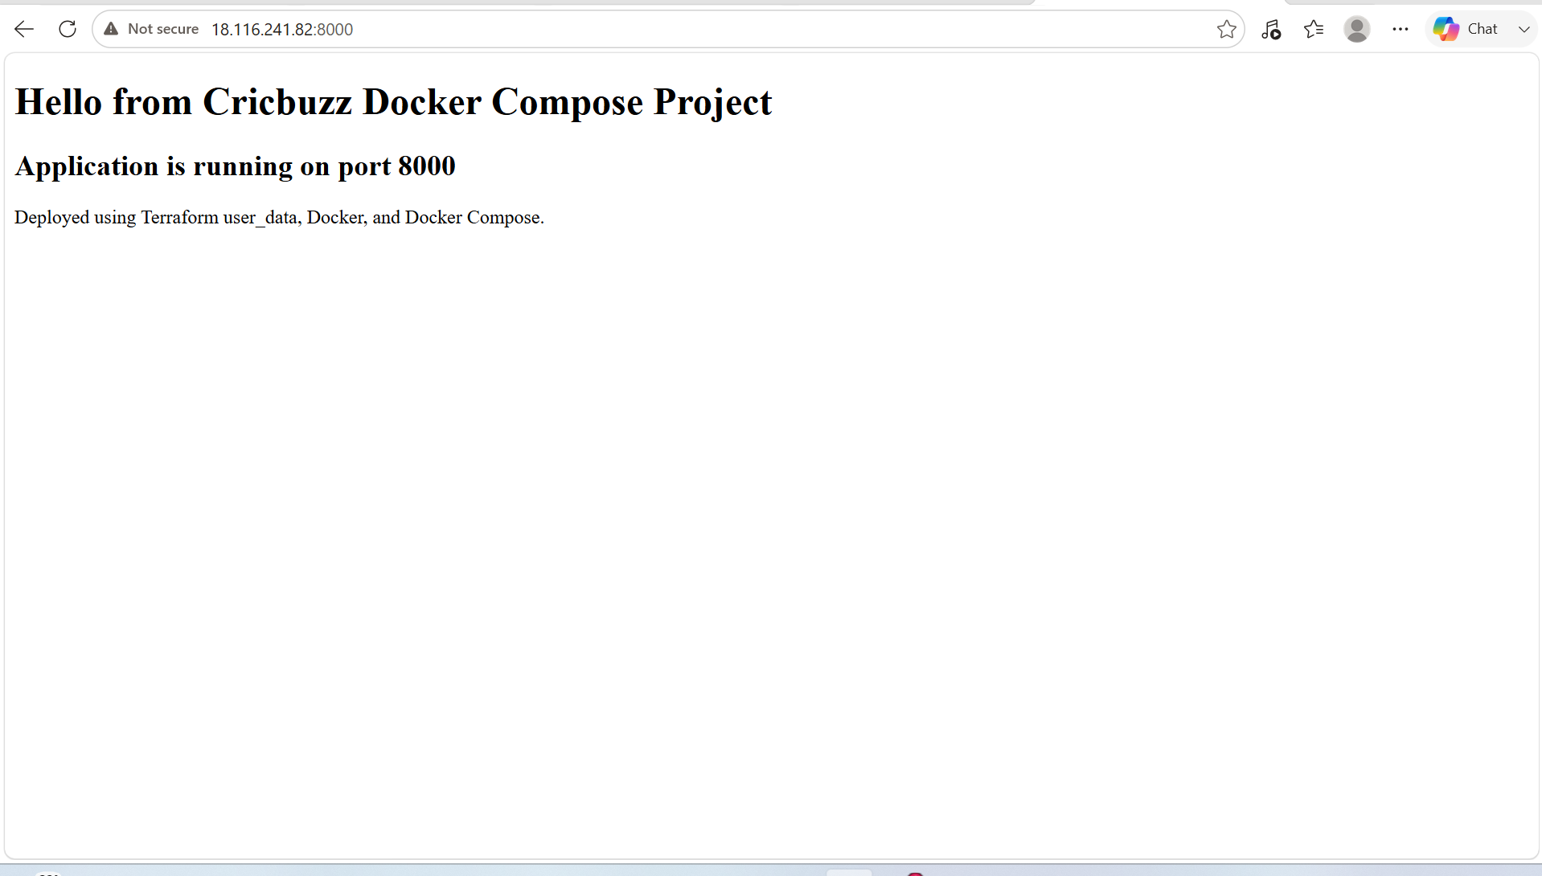

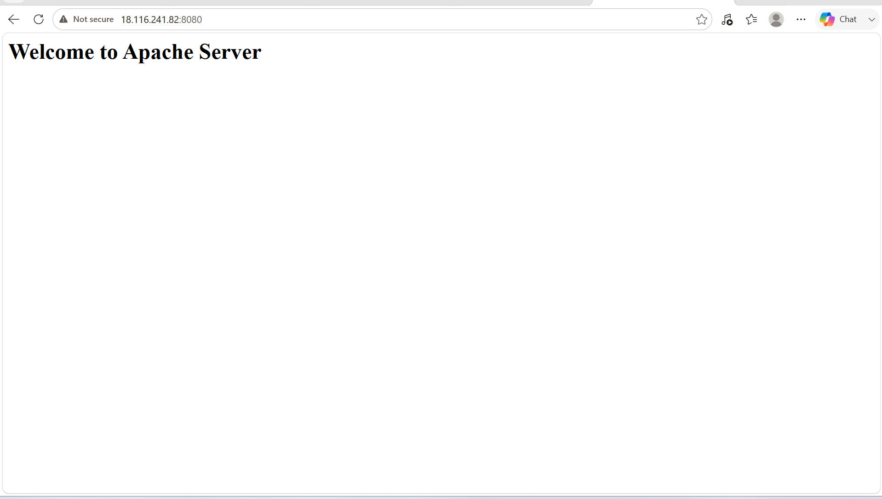

Problems faced and fixes:

Problem 1: Docker not installed
Reason:
user_data did not run correctly or cloud-init failed.

Fix:
Moved script into userdata.sh and used user_data_base64
in main.tf.

Problem 3: Browser showed 403 Forbidden

Reason:
Nginx was serving a folder without index.html.

Fix:
Created index.html from userdata.sh and mounted it into
Nginx container

4. Make the web server point to the above service so that 8080 returns the response from the Docker service.

PURPOSE: Provision an EC2 instance using Terraform that installs Docker, deploys the Cricbuzz application with the Docker Compose on Port 8000 and configures Apache to act as a reverse proxy so that users can access the application on port 8080.

OBJECTIVE:
- Deploy the Cricbuzz Docker application.
- Configure Apache as a reverse proxy.
- Access the application through http://EC2-public -IP:8080.

STEP BY STEP IMPLEMENTATION:
- In the userdata.sh template, we have to edit the content with that Apache act as a reverse proxy.

cat > /etc/httpd/conf.d/docker-proxy.conf <<EOF
Listen 8080

<VirtualHost *:8080>

ProxyRequests Off

ProxyPreserveHost On

ProxyPass / http://localhost:8000/

ProxyPassReverse / http://localhost:8000/

</VirtualHost>
EOF

echo "LoadModule proxy_module modules/mod_proxy.so" >> /etc/httpd/conf.modules.d/00-proxy.conf

echo "LoadModule proxy_http_module modules/mod_proxy_http.so" >> /etc/httpd/conf.modules.d/00-proxy.conf

systemctl enable httpd

systemctl restart httpd

- Then we have to destroy the existing resources and then again we have to apply the terraform template.

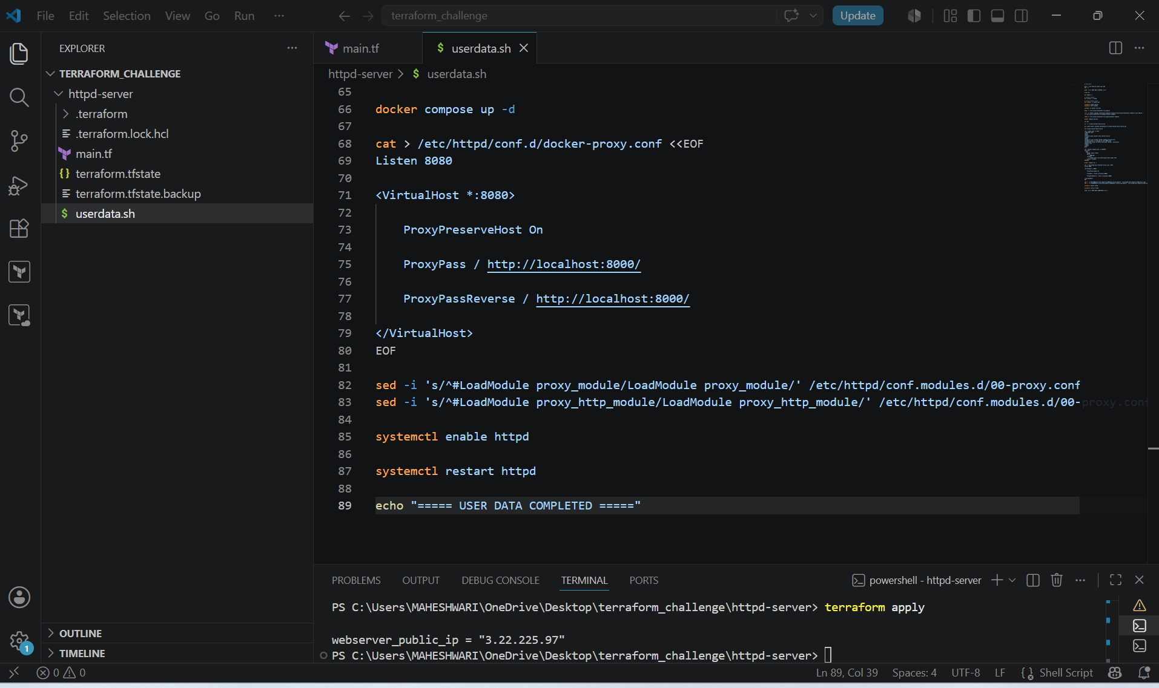
- Then we have to destroy the existing resources and execute terraform apply again.
- This reverse proxy will redirects the docker application from 8000 to 8080 port.

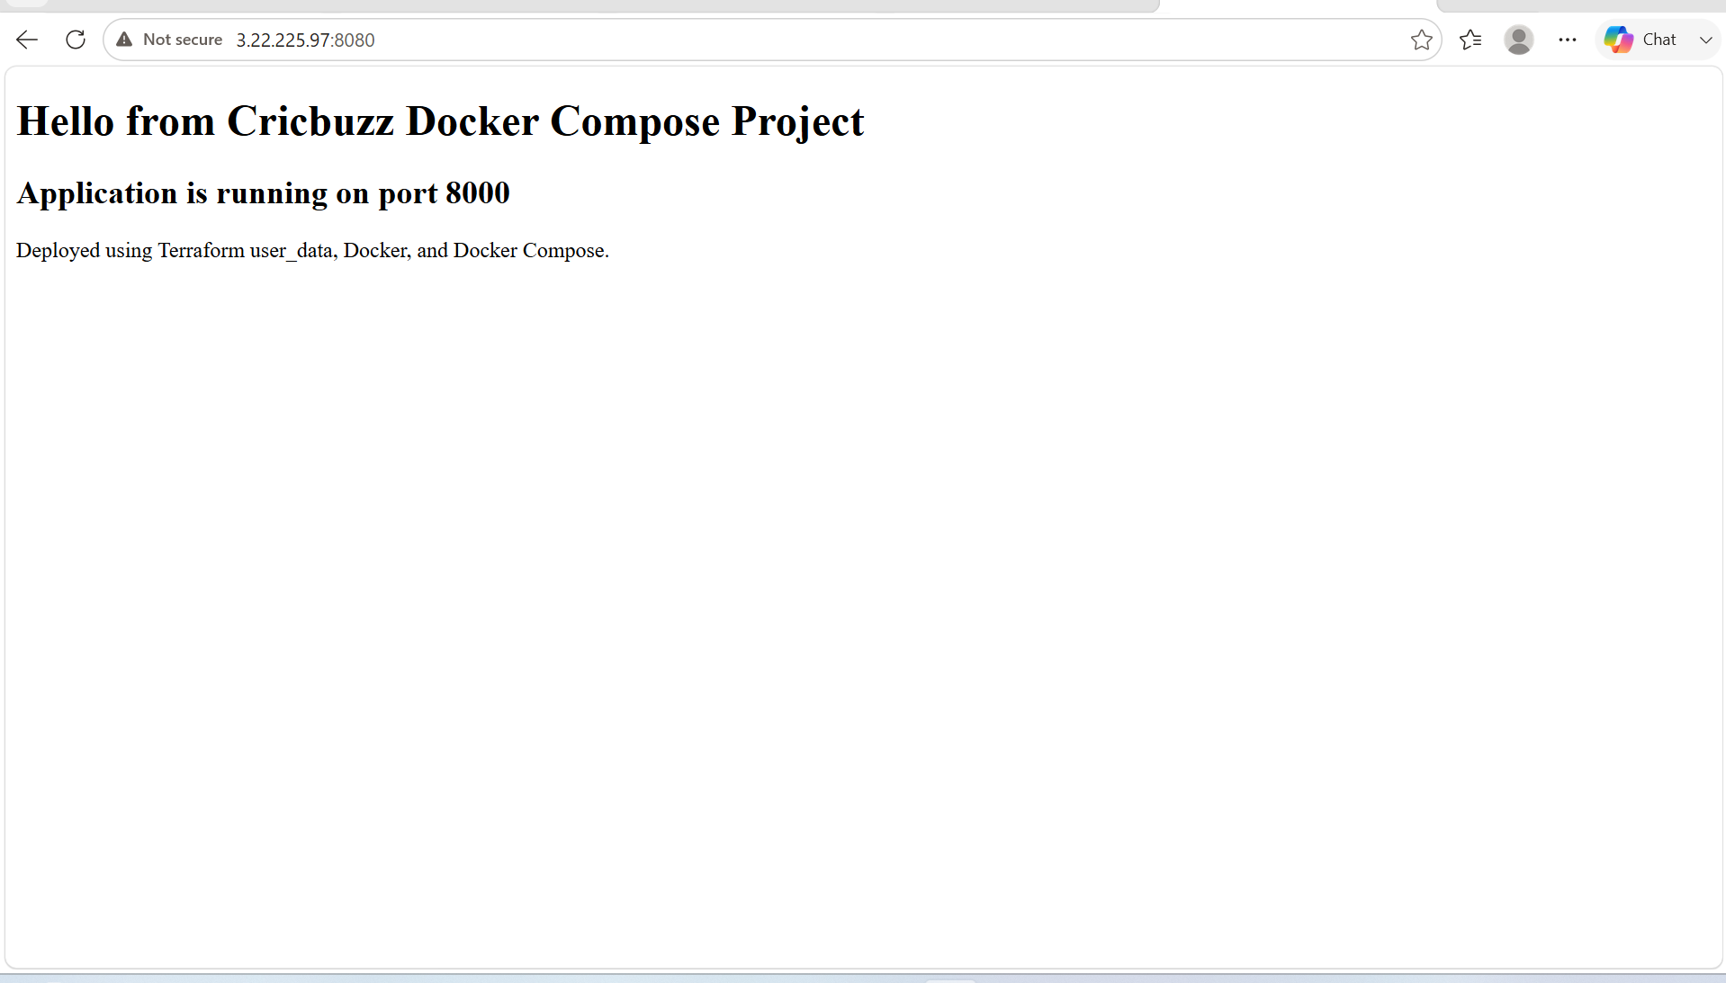

5. Configure to Save the Logs in the location /var/log/cb.log

PURPOSE: To centralize the web server logs in a custom log file (/var/log/cb.log) for easier monitoring, troubleshooting, auditing and maintenance of the application. Storing logs in a dedicated location simplifies log analysis and helps administrators quickly identify errors and access requests.

OBJECTIVE:
- Configure the Apache web server to store access and error logs in /var/log/cb.log
- Centralize application request and error logging.
- Improve monitoring and debugging of the web application.
- Verify that log entries are generated when users access the application.

STEP BY STEP IMPLEMENTATION:
- In the userdata.sh template, we have to edit the docker proxy conf to store the logs.

cat > /etc/httpd/conf.d/docker-proxy.conf <<EOF
Listen 8080

<VirtualHost *:8080>

ProxyPreserveHost On

ProxyPass / http://localhost:8000/

ProxyPassReverse / http://localhost:8000/

ErrorLog /var/log/cb.log
CustomLog /var/log/cb.log combined

</VirtualHost>
EOF

- After editing with this lines, we have to destroy existing resources and then reapply the template.

- We can see this logs in the cb.log file with command -> cat /var/log/cb.log

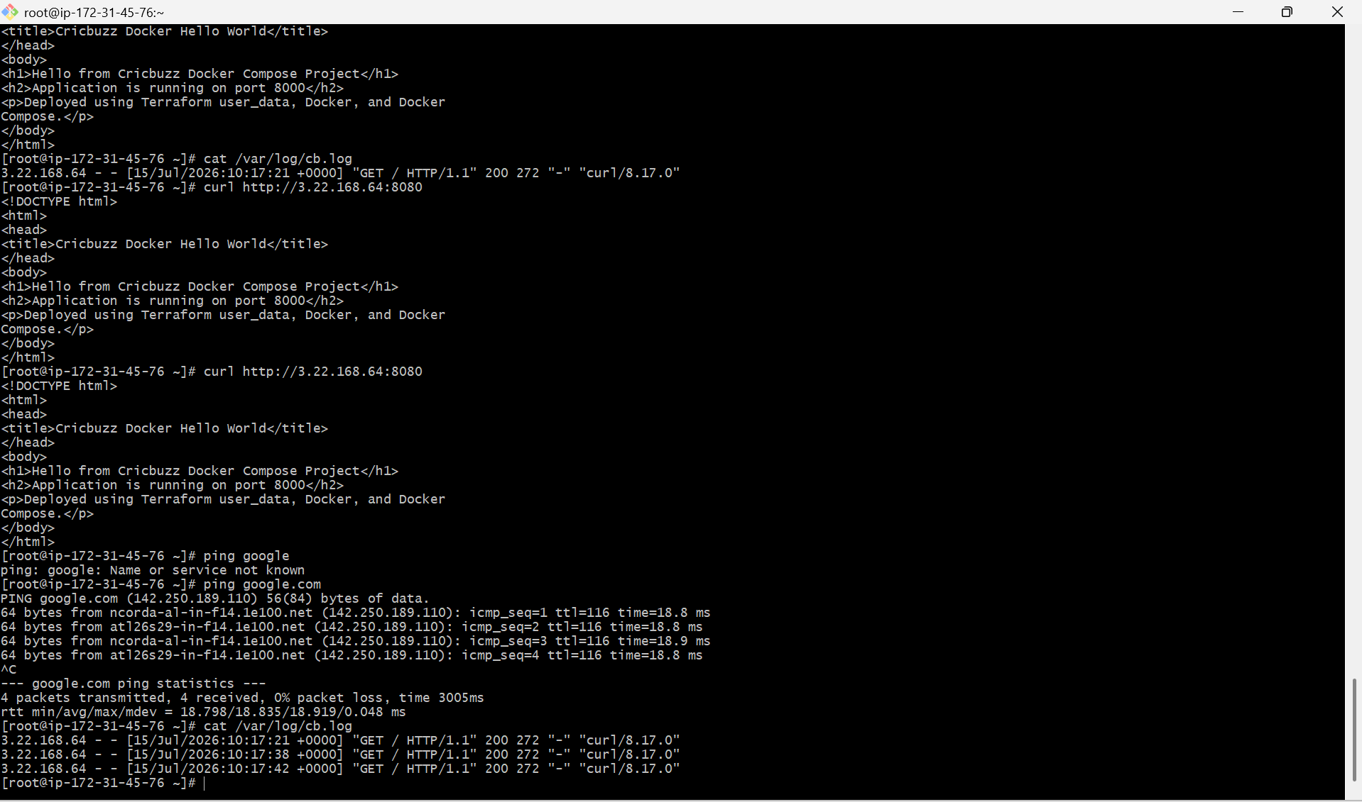

6. Write the Log rotate configuration for the above file

PURPOSE: To automatically manage the growth of the custom log file (/var/log/cb.log) by rotating, compressing and removing old log files. This prevents the log file from consuming excessive disk space while retaing logs for troubleshooting and auditing.

OBJECTIVE:
- Rotate the cb.log file automatically.
- Rotate logs daily.
- Keep the last 7 rotated log files.
- Compress old log files to save disk space.
- Create a new log file automatically after rotation.
- Restart Apache after log rotation so it writes to the new log file.

STEP BY STEP IMPLEMENTATION:

- In the userdata.sh file, we have to write the code that rotates the log file of the application.

cat > /etc/logrotate.d/cb <<EOF
/var/log/cb.log {
daily
rotate 7
compress
delaycompress
missingok
notifempty
create 0644 apache apache
sharedscripts

postrotate
/bin/systemctl reload httpd > /dev/null 2>/dev/null || true
endscript
}
EOF

- Then we have to destroy the existing resources and the reapply the template -> terraform apply.

