CHALLENGE-11

1. Create VPC

PURPOSE: To automate the creation of an AWS Virtual Private Cloud(VPC) using Terraform, enabling infrastructure as Code (IaC) for consistent, repeatable and version controlled deployments.

OBJECTIVE: To provision a custom VPC with a CIDR block in AWS using Terraform, which can later be extended with subnets, route tables, internet Gateway, Nat Gateway and other networking components.

Terraform Configuration

Main.tf:

provider "aws" {
region = "us-east-2"
}

resource "aws_vpc" "my_vpc" {
cidr_block = "10.0.0.0/16"
enable_dns_support = true
enable_dns_hostnames = true
tags = {
Name = "My-VPC"
}
}

output "vpc_id" {
value = aws_vpc.my_vpc.id
}

output "vpc_cidr" {
value = aws_vpc.my_vpc.cidr_block
}

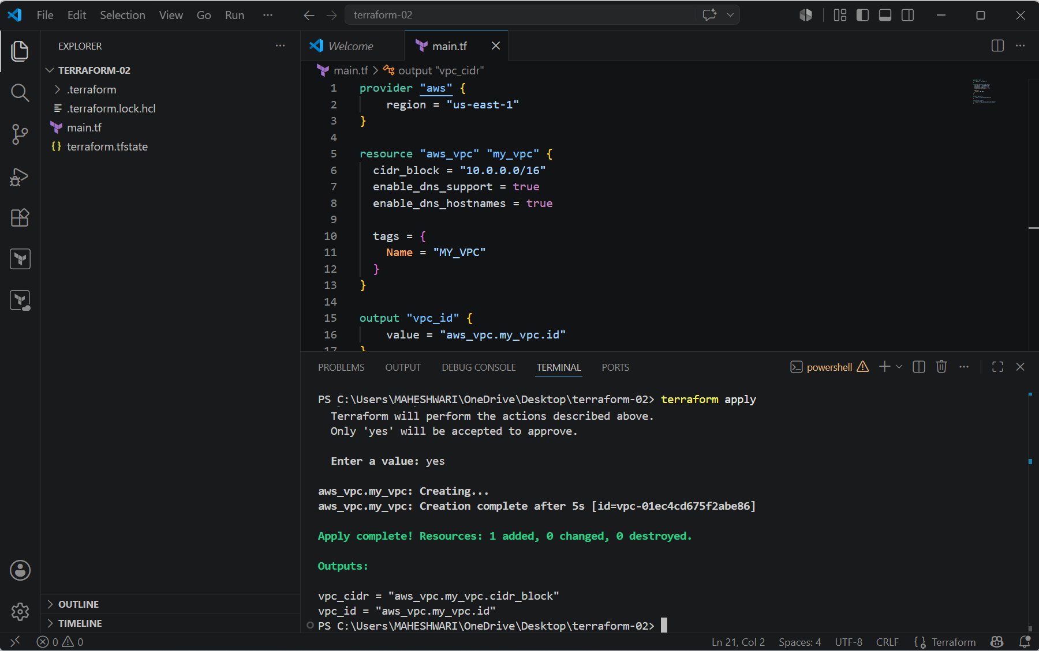

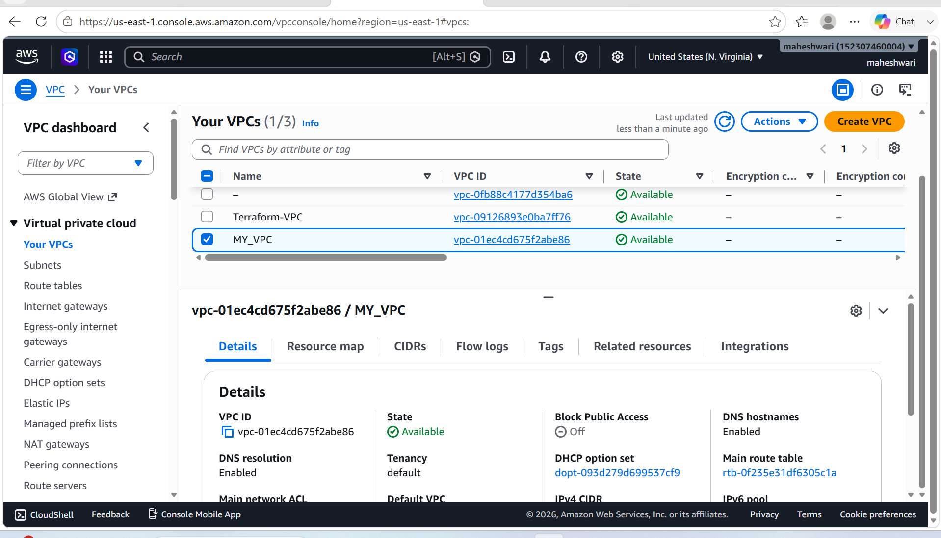

2. Create Internet Gateway

PURPOSE: To create and attach an Internet Gateway (IGW) to an AWS VPC, allowing resources in public subnets to communicate with the internet.

OBJECTIVE: To provision an Internet Gateway and attach it to an existing VPC using Terraform.

Terraform configuration in main.tf file of terraform to provide an internet gateway to the Vpc.

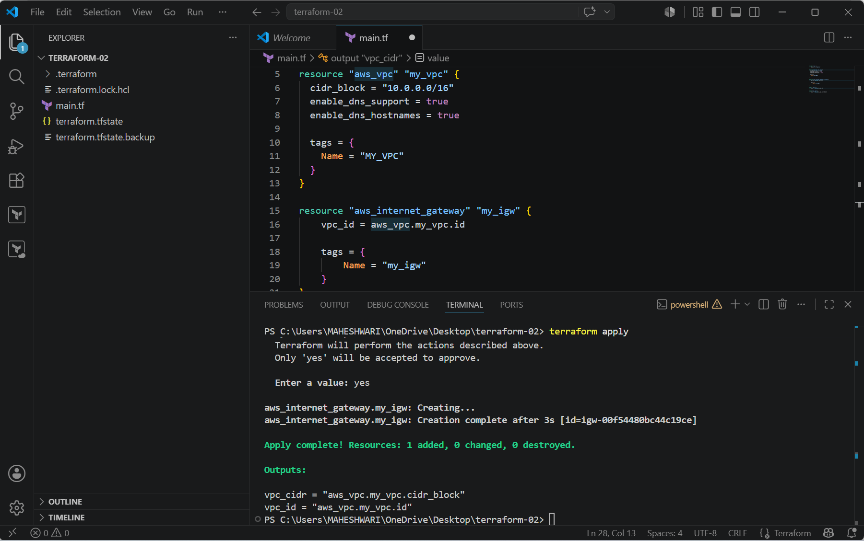

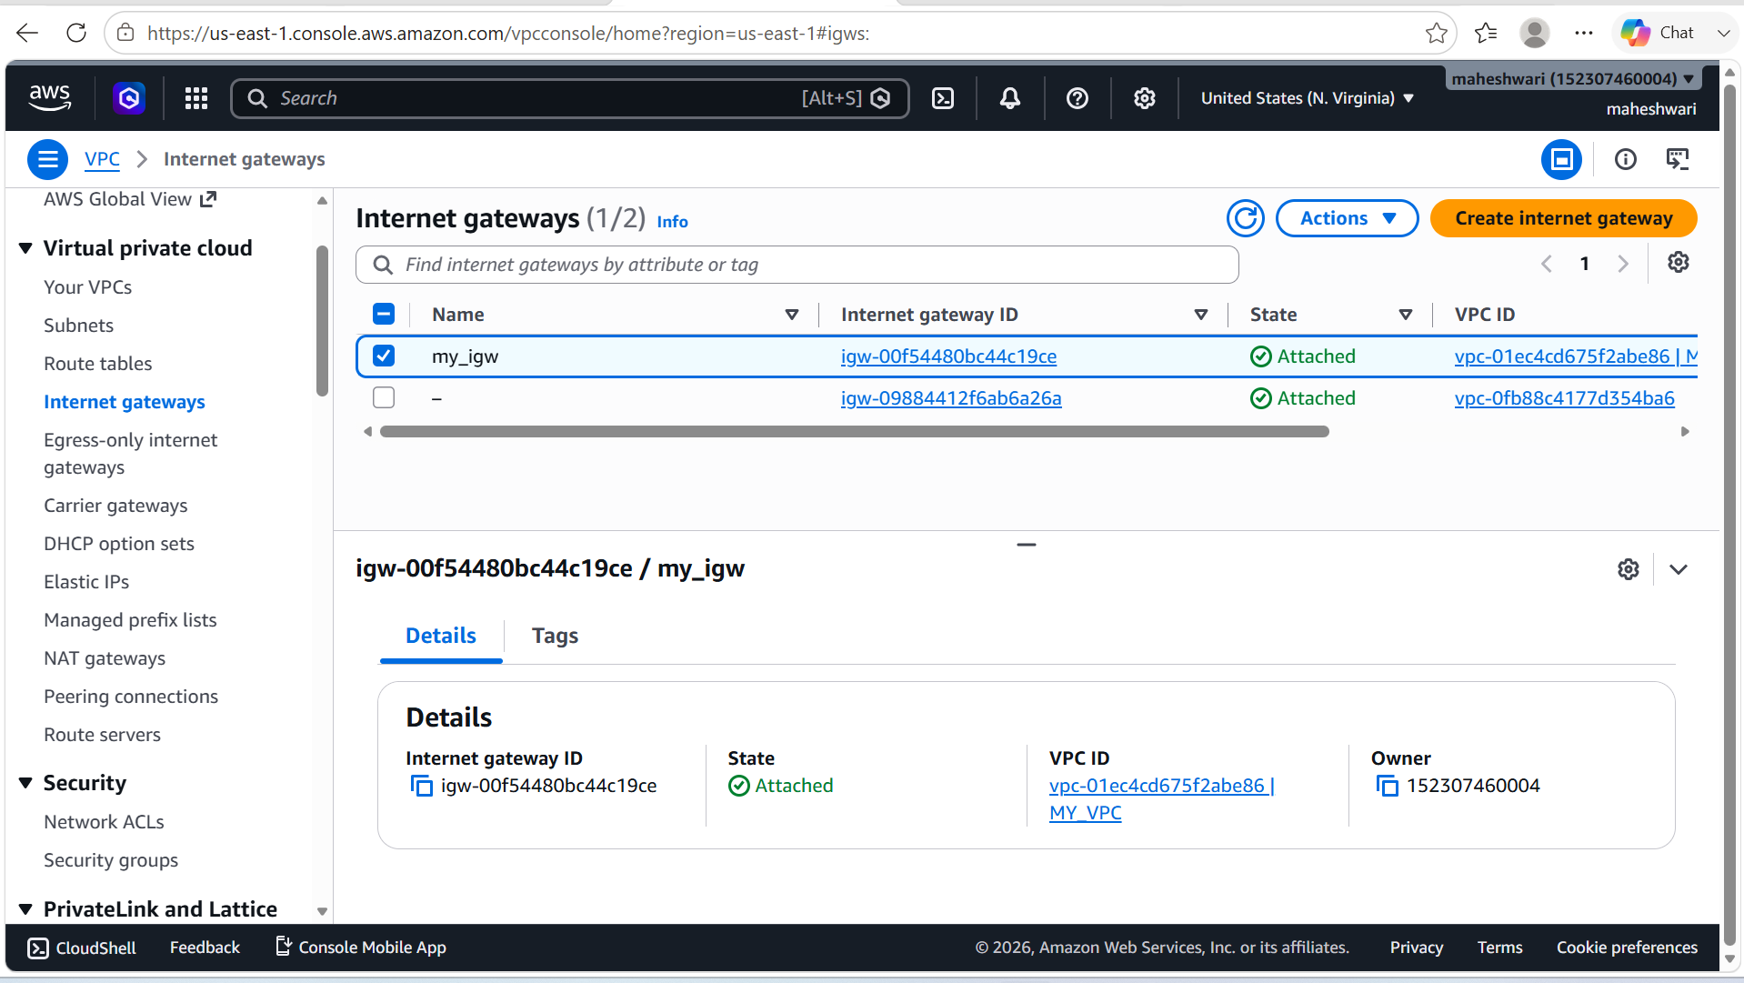

3. Create Custom Route Table

PURPOSE: To create a custom route table and configure a default route to the Internet Gateway, enabling internet access for resources in a public subnet.

OBJECTIVE: To provision a custom route table, add a route to the Internet Gateway, and associate it with the VPC using Terraform.

Terraform configuration in main.tf file of terraform to provide an Route Table to the Vpc.

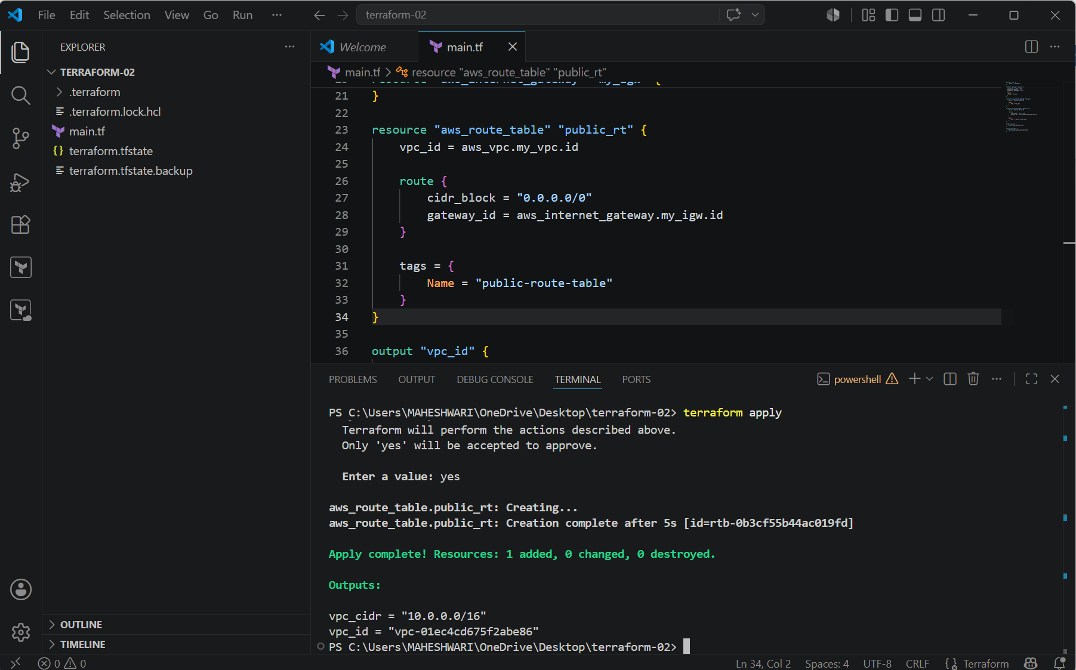

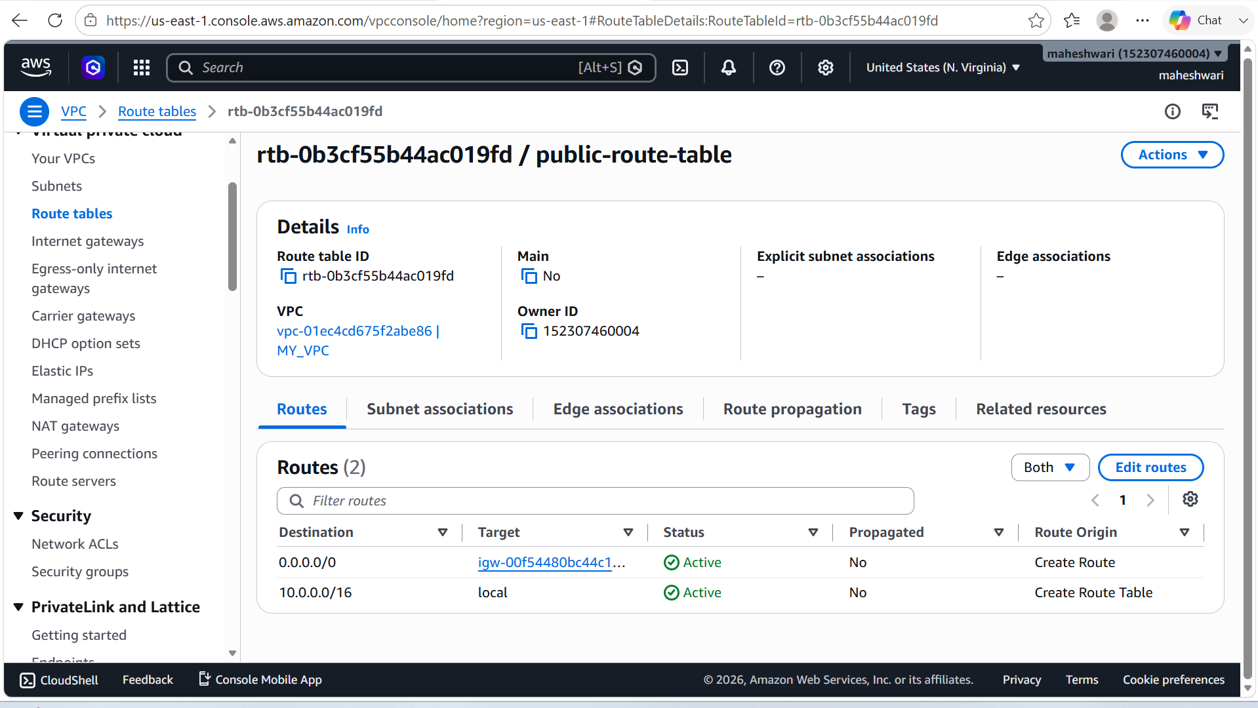

4. Create Subnet

PURPOSE: To create a public subnet within an AWS VPC where internet-facing resources such as EC2 instances, Load Balancers, and Bastion Hosts can be deployed.

OBJECTIVE: To provision a public subnet inside an existing VPC and enable automatic assignment of public IP addresses to instances launched in the subnet.

Terraform configuration in main.tf file of terraform to provide an Subnet to the Vpc.

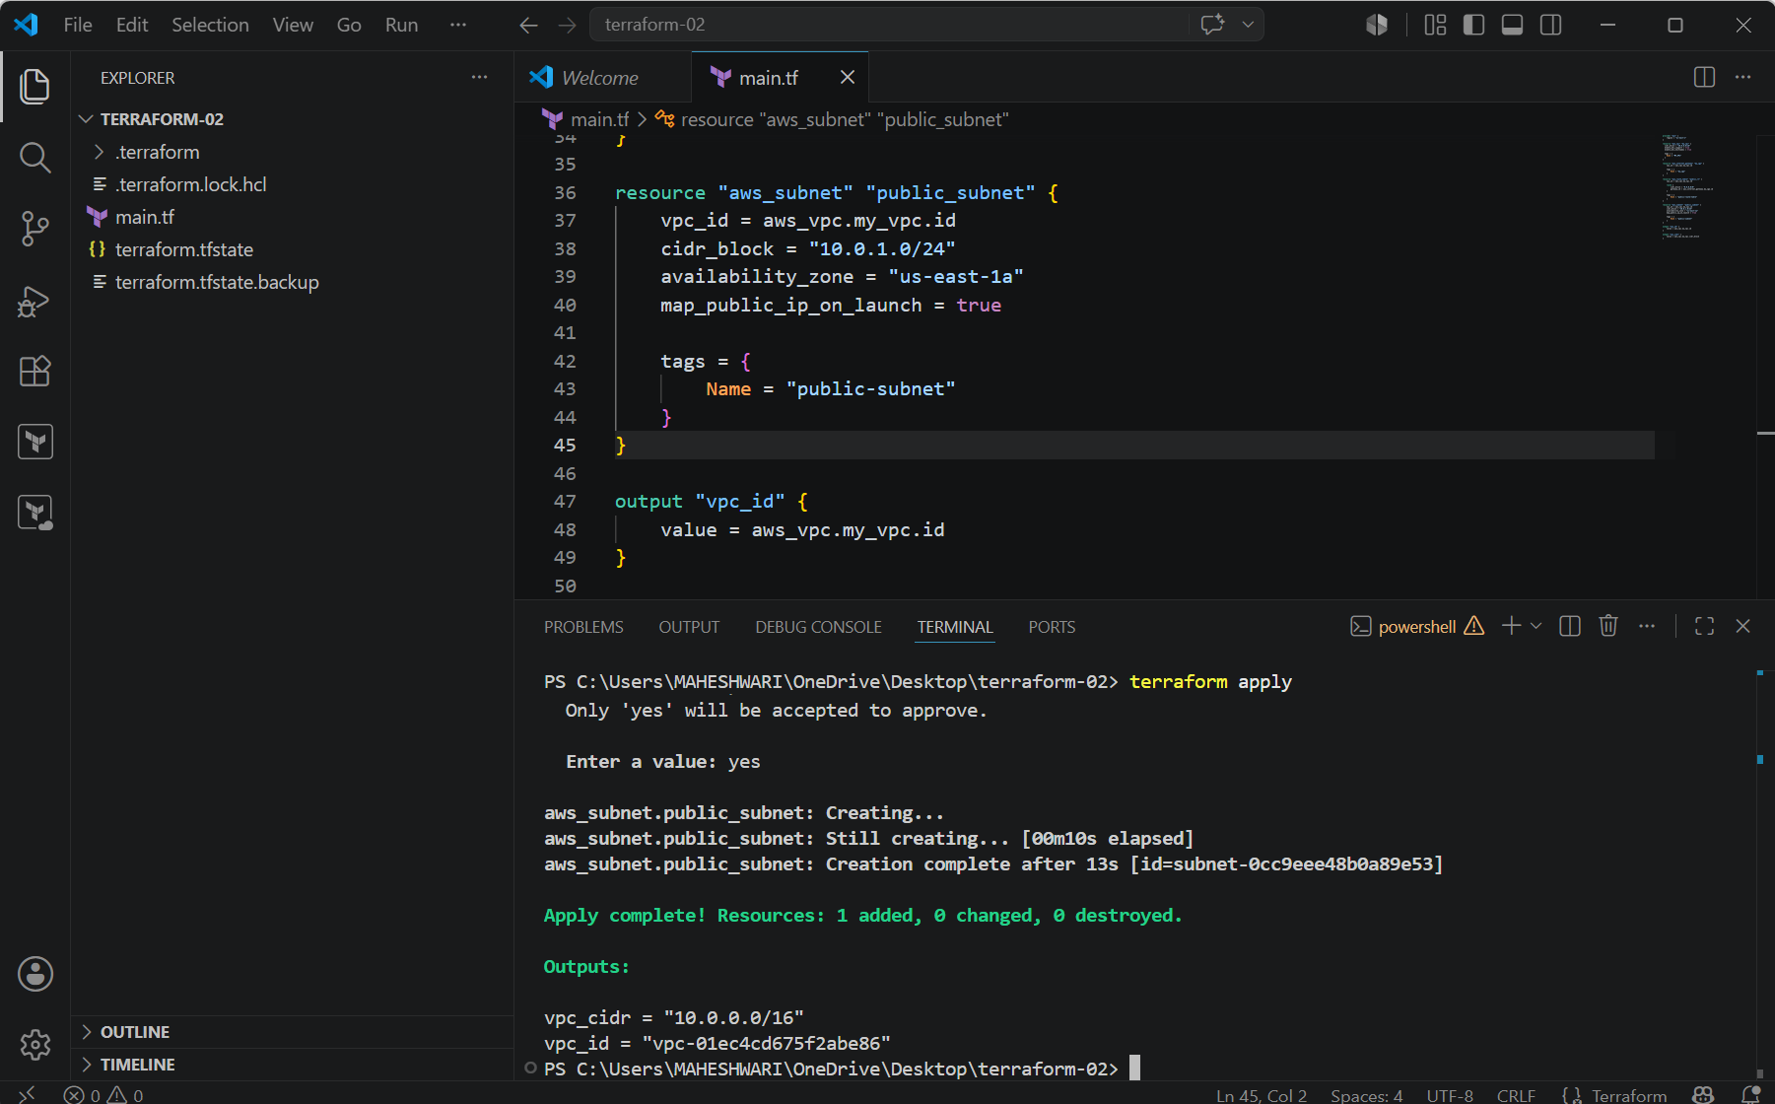

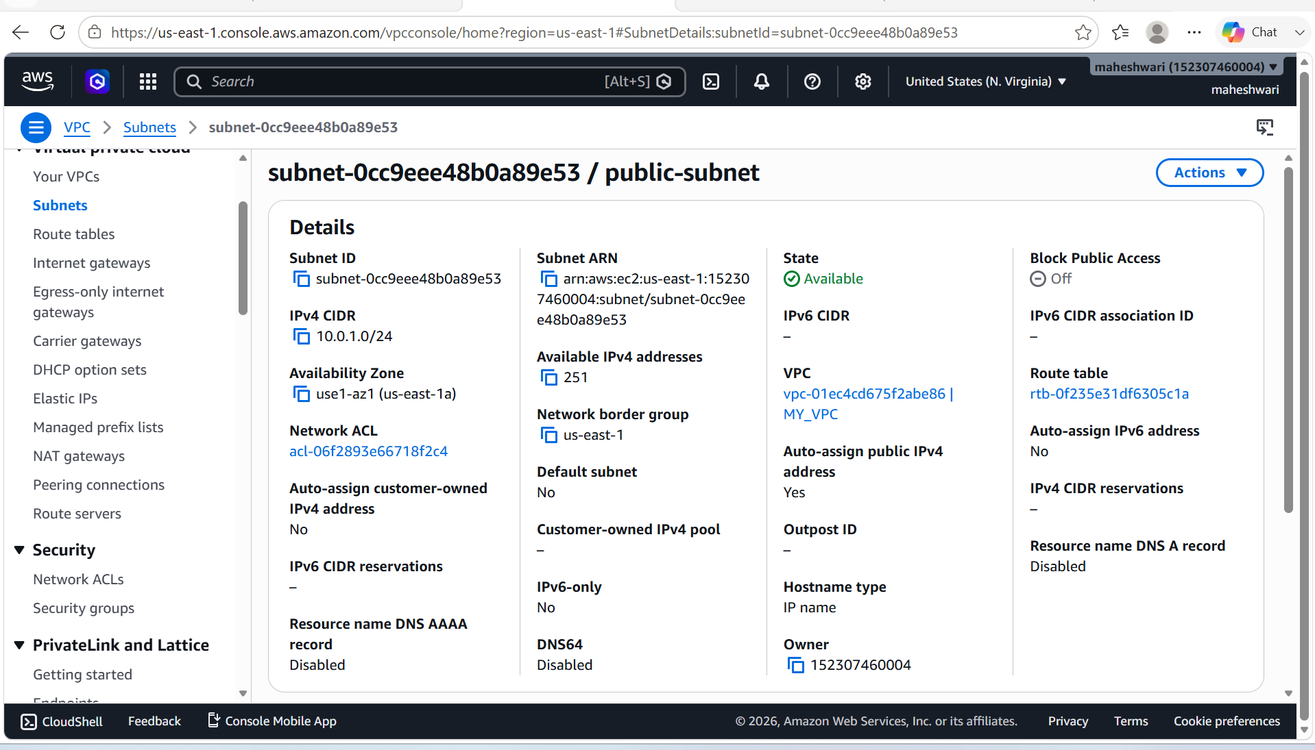

5. Associate subnet with Route Table

PURPOSE: To associate a public subnet with a custom route table so that the subnet uses the routes defined in the route table, including internet access through the Internet Gateway.

OBJECTIVE: To create a route table association between the public subnet and the custom route table using Terraform.

Terraform configuration in main.tf file of terraform to associate an Subnet to the Route Table.

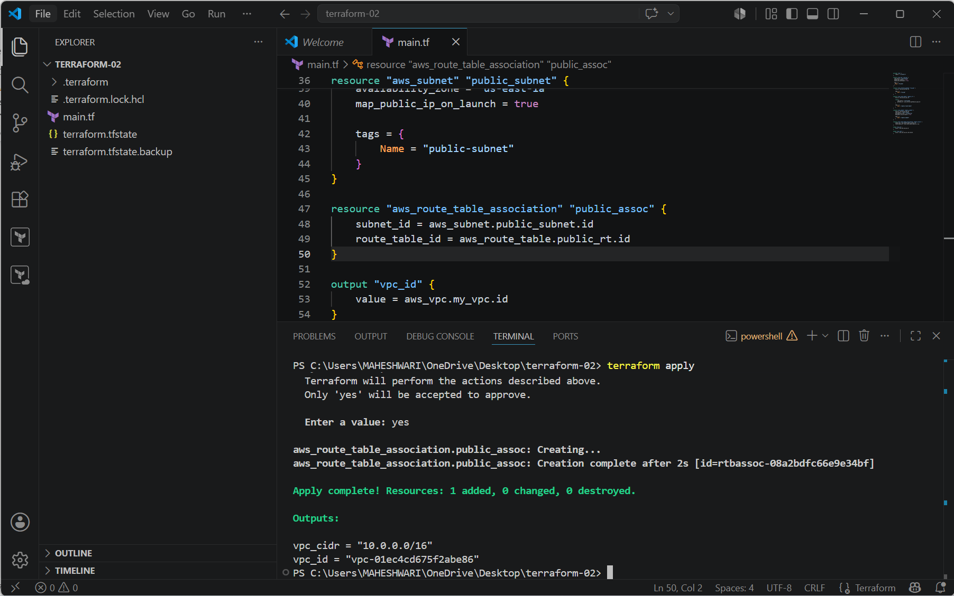



6. Create Security Group to allow port 22.80,443

PURPOSE: To create an AWS Security Group that allows inbound SSH (22), HTTP (80), and HTTPS (443) traffic while permitting all outbound traffic.

OBJECTIVE: To provision a Security Group within the VPC that enables secure remote access and allows web traffic to EC2 instances.

Terraform configuration in main.tf file of terraform to create a security group to allow ports 22, 80 and 443.

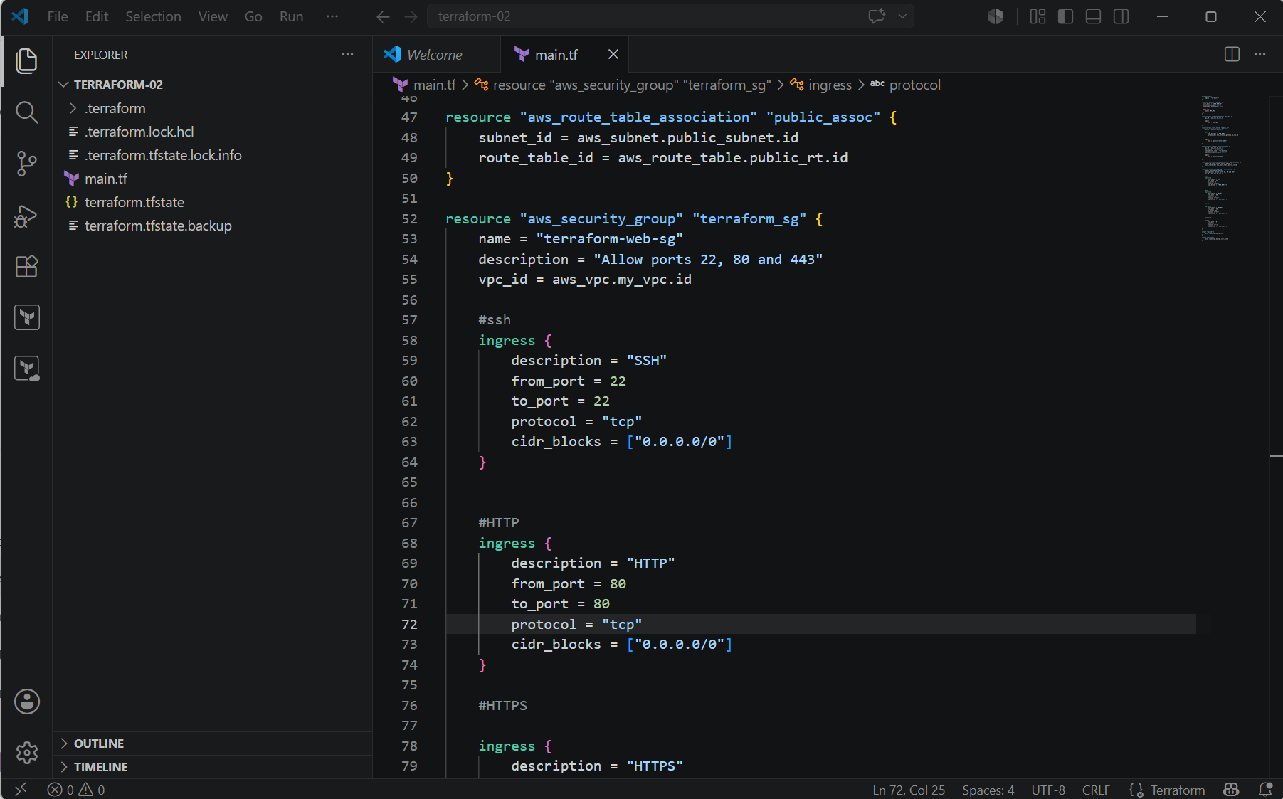

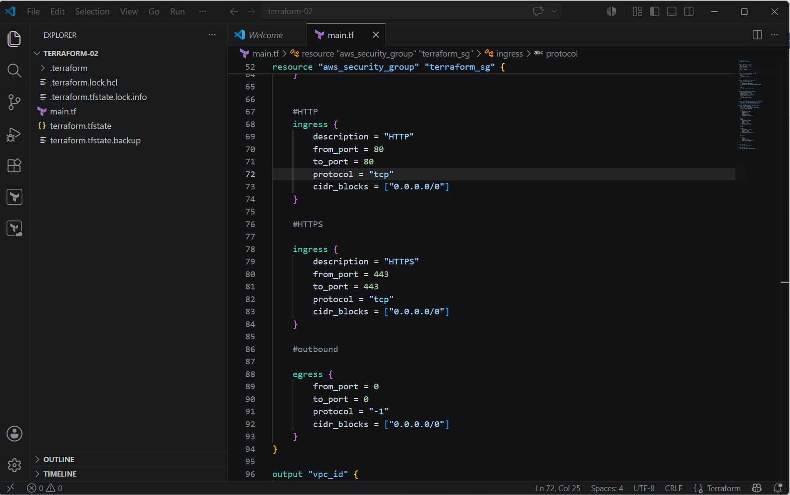

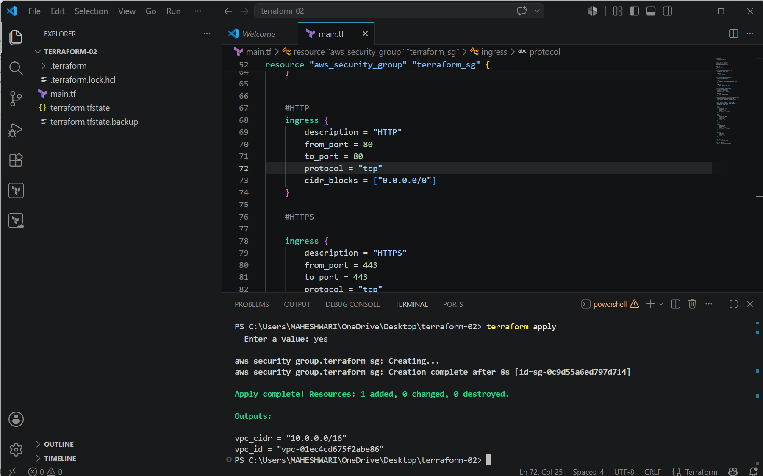

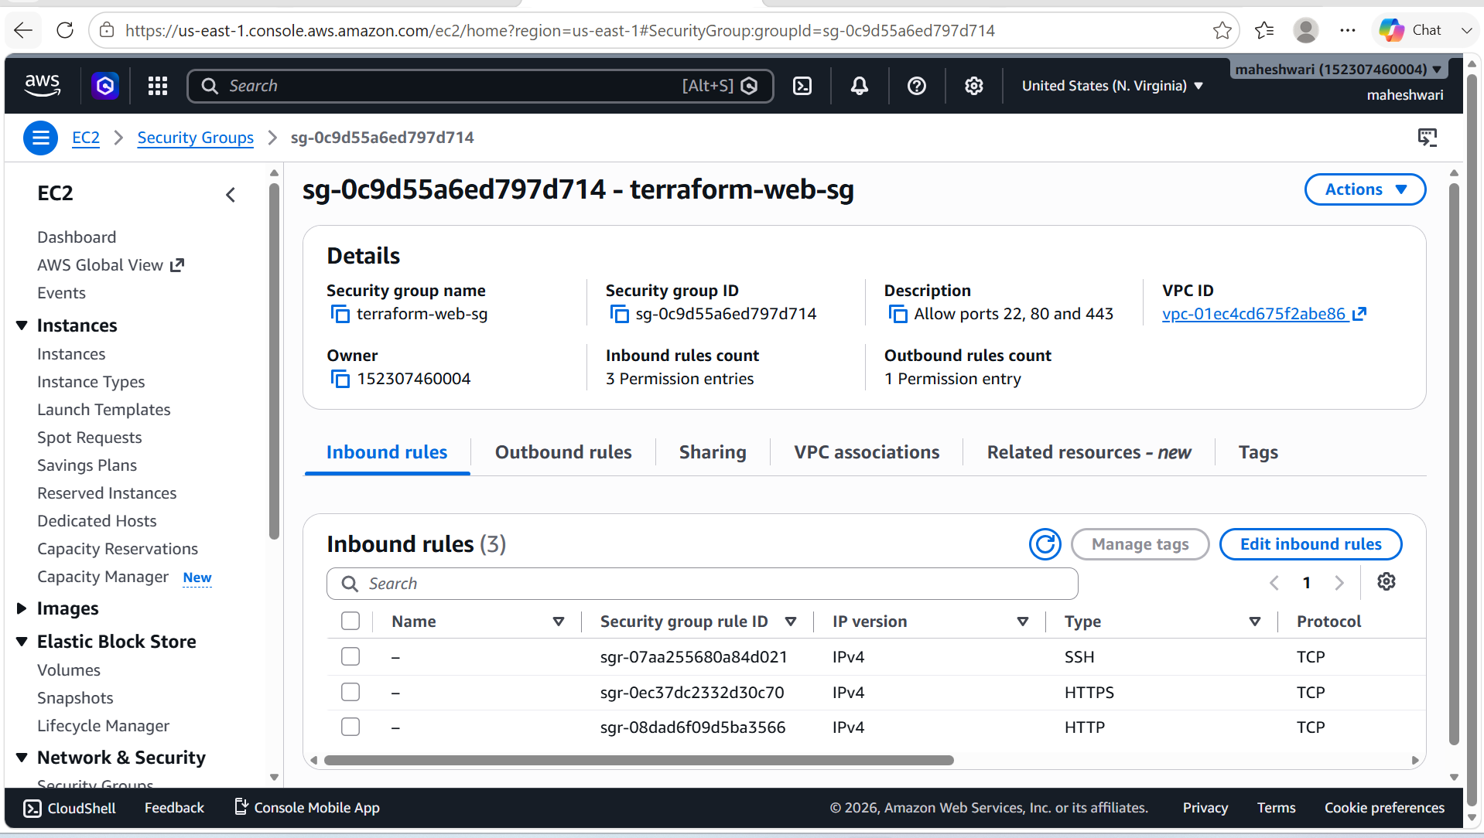

7. Create a network interface with an ip in the subnet that was created in step 4

PURPOSE: To create an Elastic Network Interface (ENI) in the public subnet with a static private IP address and associate it with the security group, enabling secure network communication for an EC2 instance.

OBJECTIVE: To provision a network interface in the public subnet created in Step 4 and assign it a private IP address within the subnet's CIDR block.

Terraform configuration in main.tf file of terraform to create a network interface with an ip of the subnet.

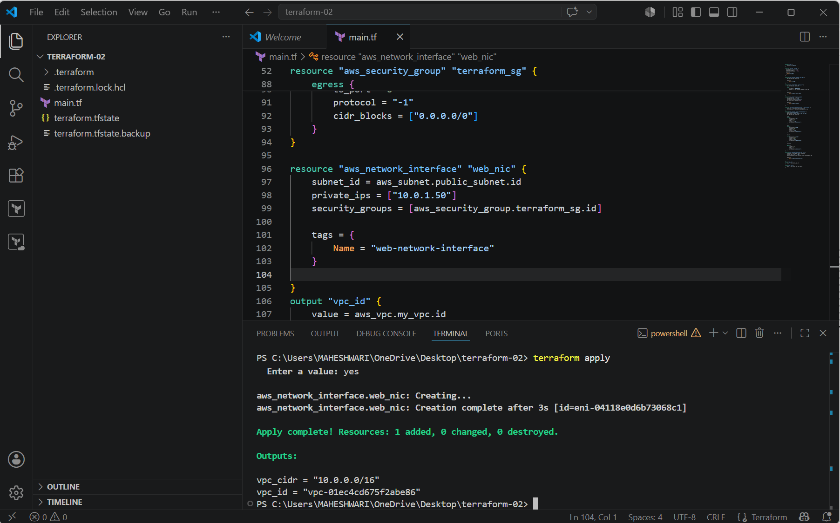

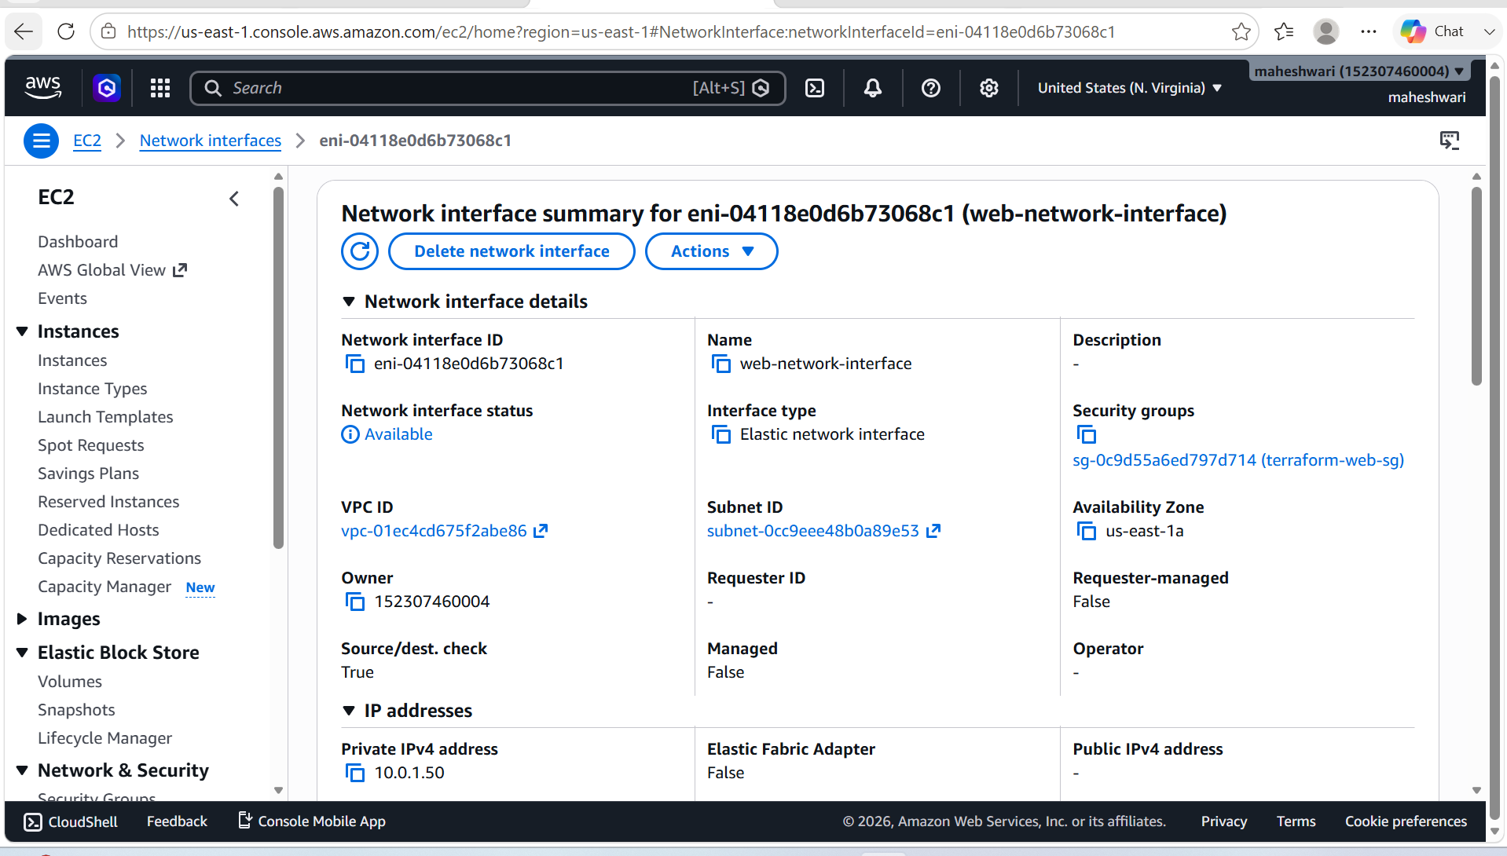

8. Assign an elastic IP to the network interface created in step 7

PURPOSE: To allocate a static public IP address (Elastic IP) and associate it with the network interface created in Step 7, enabling internet access and a permanent public IP for the EC2 instance.

OBJECTIVE: To provision an Elastic IP (EIP) and associate it with the existing network interface using Terraform.

Terraform configuration in main.tf file of terraform to assign an elastic IP to the network interface.

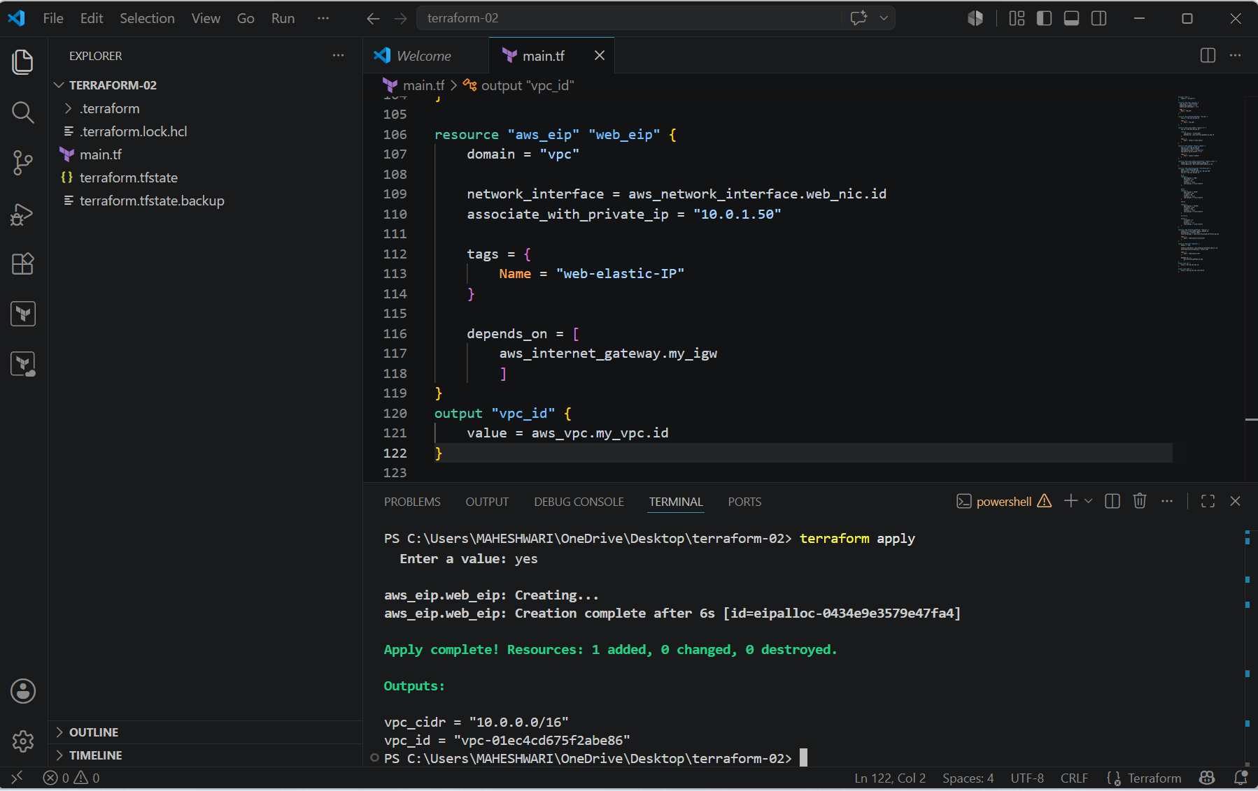

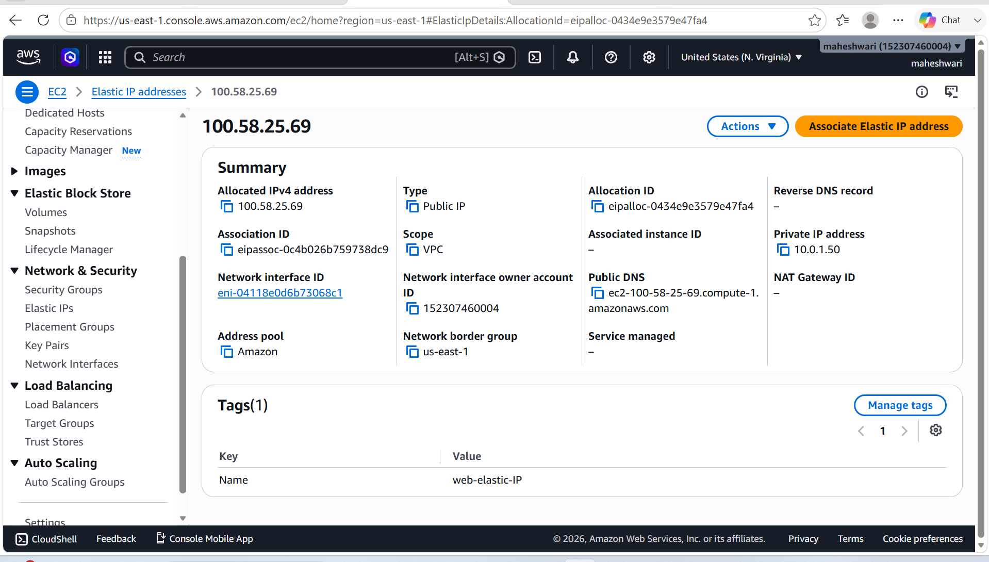

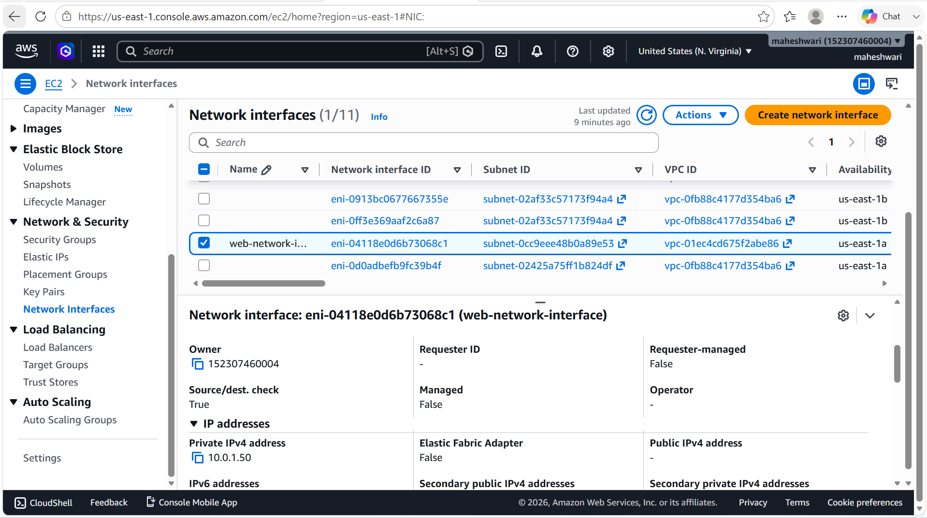

9. Create Ubuntu server and install/enable apache2

PURPOSE: To provision an Ubuntu EC2 instance in AWS and automatically install and start the Apache2 web server using a user data script.

OBJECTIVE: To launch an Ubuntu EC2 instance in the public subnet, attach the existing network interface, and configure Apache2 to start automatically at boot.

Terraform configuration in main.tf file of terraform to create a ubuntu server and install/enable apache2.

