Linux Commands End to End Cheat Sheet
Command: whoami
PURPOSE OF COMMAND:
- Whoami command is used to display the current username of the user running the command
- It is particularly useful for verifying the user identity in mutli user environments or when switching accounts
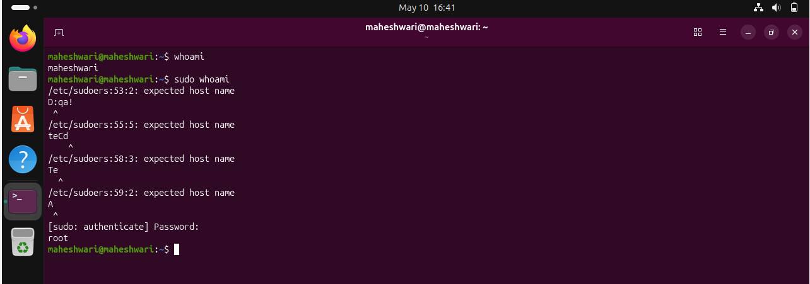
Command: ls
Purpose of command
- ls command is used to get list of directories/files within the file system
- ls command has many use cases:
- ls -l -> gives the detailed list
- ls -x -> list entries in rows instead of columns
- ls -m -> list entries separated by commas
- ls -I -> shows the inode number of each file
- ls -S -> sort files by size by default larger first
- ls -lh -> displays file sizes in human readable format
- ls -t -> sorts files by modification time by default newest comes first
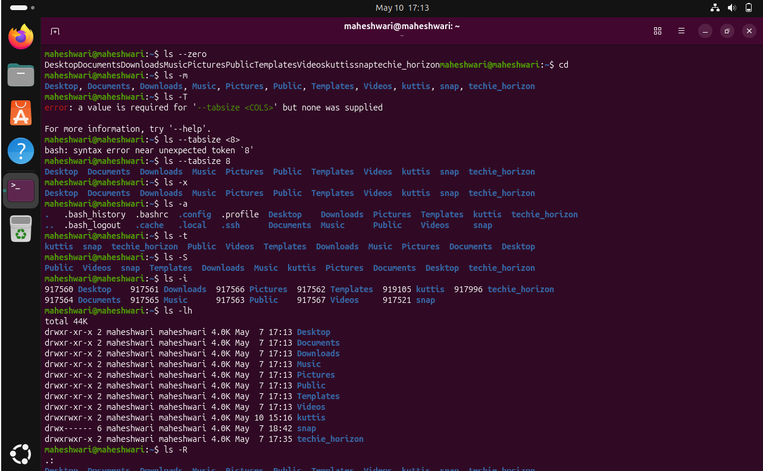
Command: ip a
PURPOSE OF COMMAND:
- ip a command is used to configure the ip address of a system
- we can also use the command called ifconfig -a to know the ip address
- The ip a command is more powerfull and versatile
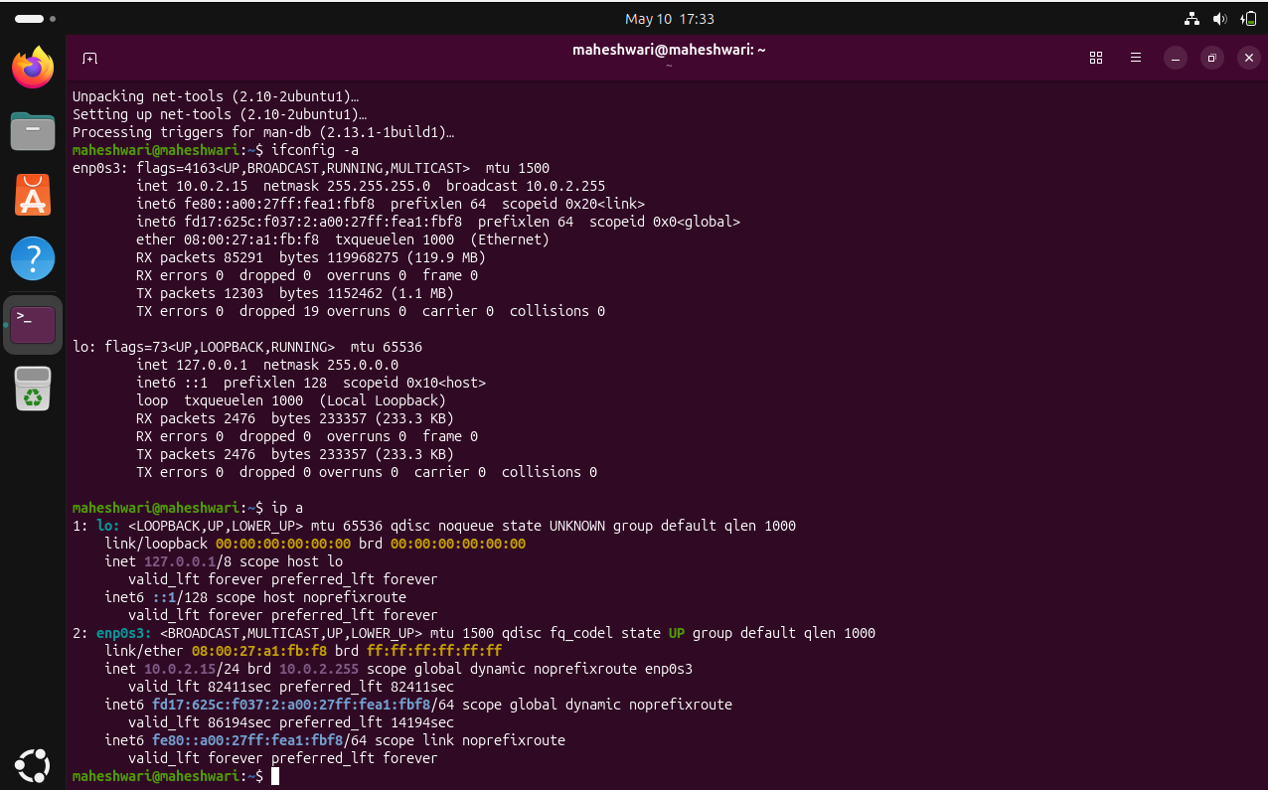
Command: cat
PURPOSE OF COMMAND:
- cat command is generally used to display the content present in the file -> cat f1
- use cases
- cat file1 file2 -> to view the content of multiple files sequentially
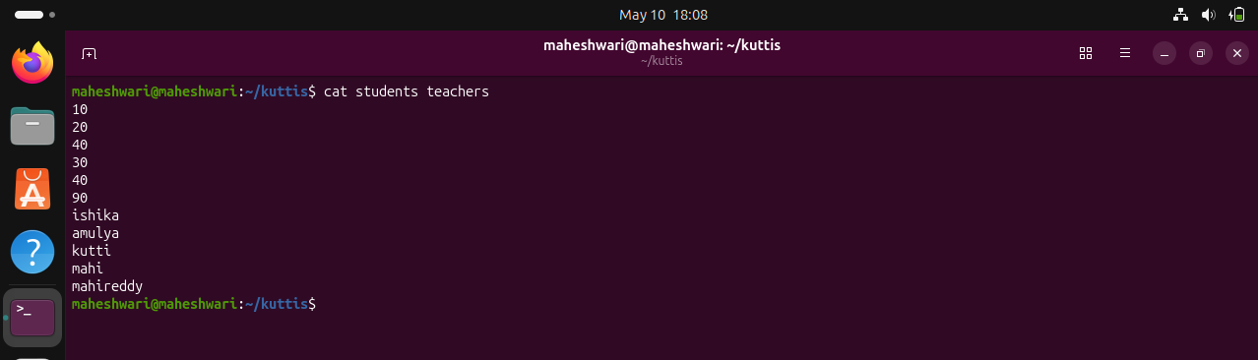

- cat file1 file2 > merged_file -> to merge 2 files into one file
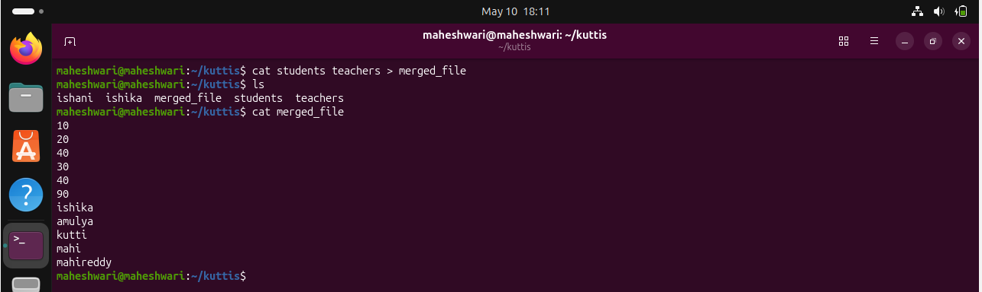

- cat -n file1 -> Number all lines


Command: passwd
PURPOSE OF PASSWD:
- passwd is used to set a password and also to change a password for a user
- command -> sudo passwd username
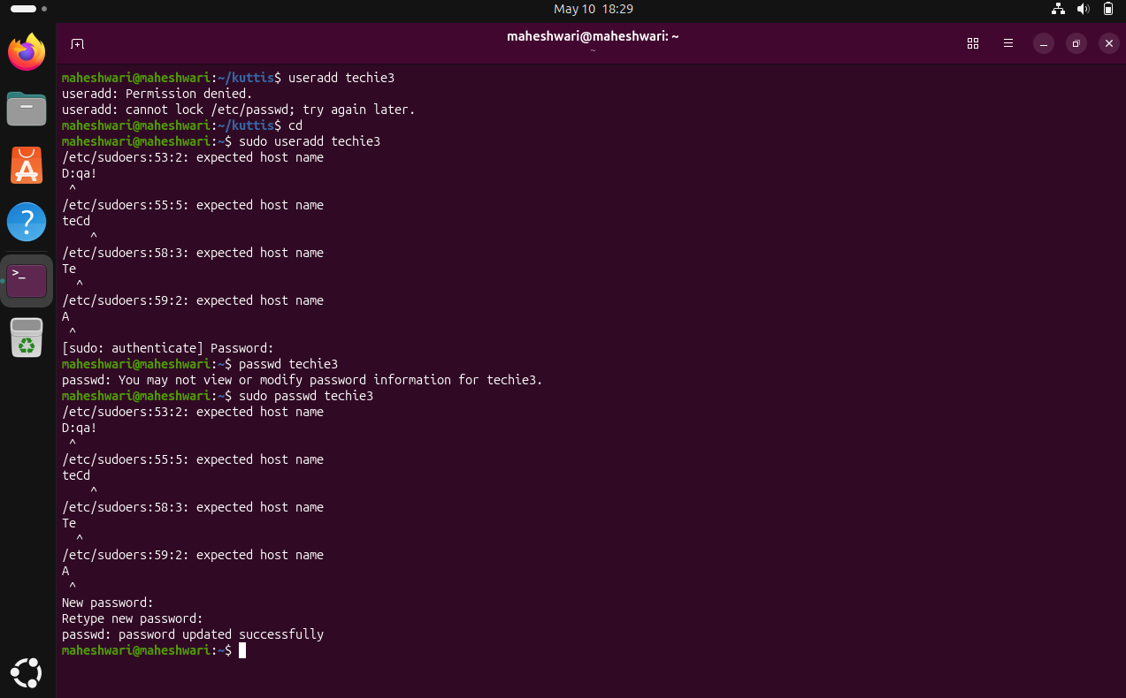
Command: touch
PURPOSE OF COMMAND:
- touch command will create an empty file and also update the timestamp of existing file -> touch f1
- can create multiple empty files at once -> touch f1 f2 f3
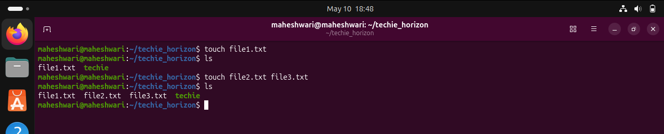

Command: pwd
PURPOSE OF COMMAND:
- pwd is used to know the print working directory
- It displays the absolute path of the current directory where the user is operating
- Absolute path : A absolute path specifies the full location start from the root directory and it always starts with /
- Relative path : A relative path specifies the location of a file relative to the current page’s directory
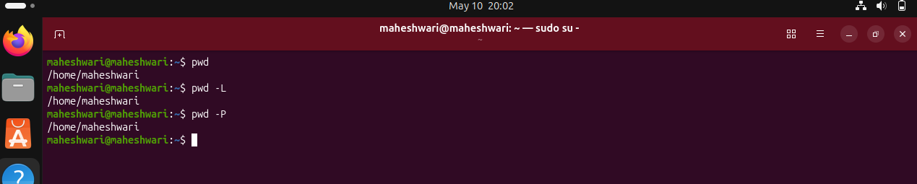
Command: man
PURPOSE OF COMMAND:
- man command serves a manual for using linux commands and utilities
- 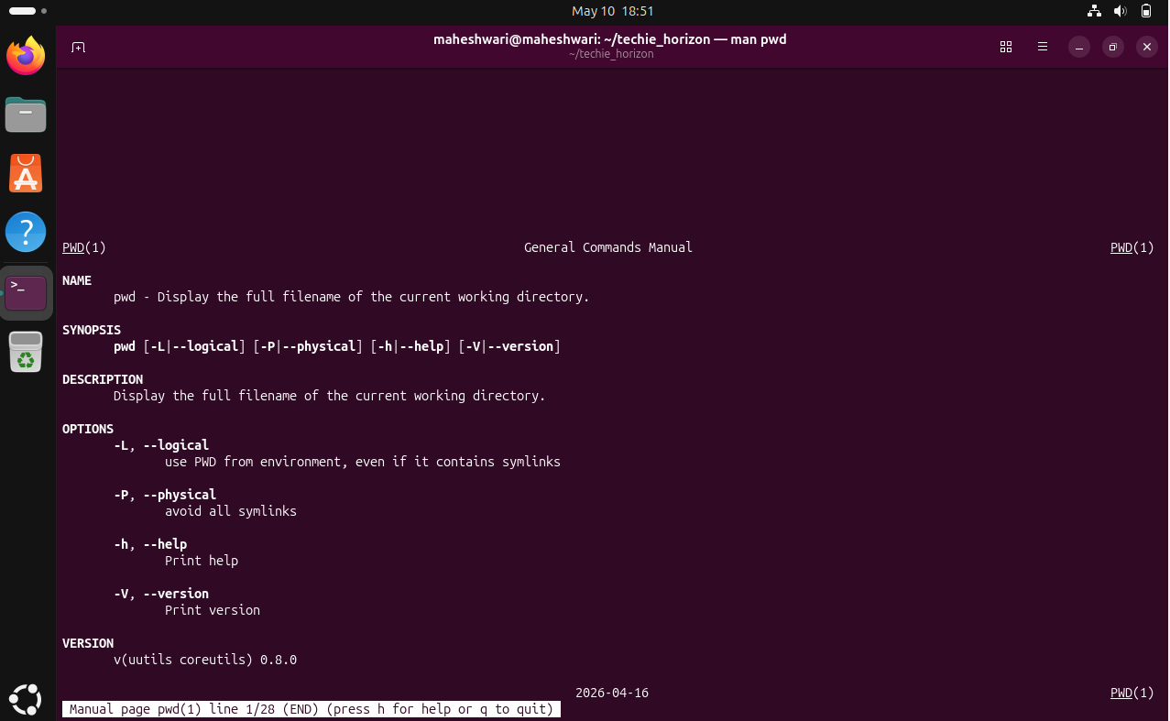

Command: apropos
PURPOSE OF COMMAND:
- This command is used to search the manual pages for commands related to a specific keyword
- Its especially useful when u don’t remember the exact command but know part of its description or functionality
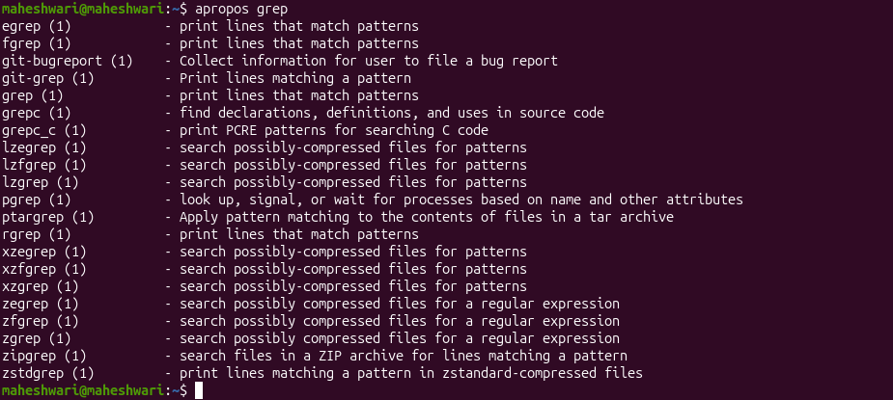
Command: pinfo
PURPOSE OF pinfo
- The pinfo command is designed to make it easier to read and navigate through documentation and man pages in a terminal environment.
- The pinfo command may not be installed by default on all linux distributions
- To install pinfo -> sudo apt install pinfo
- Then to verify -> pinfo bash
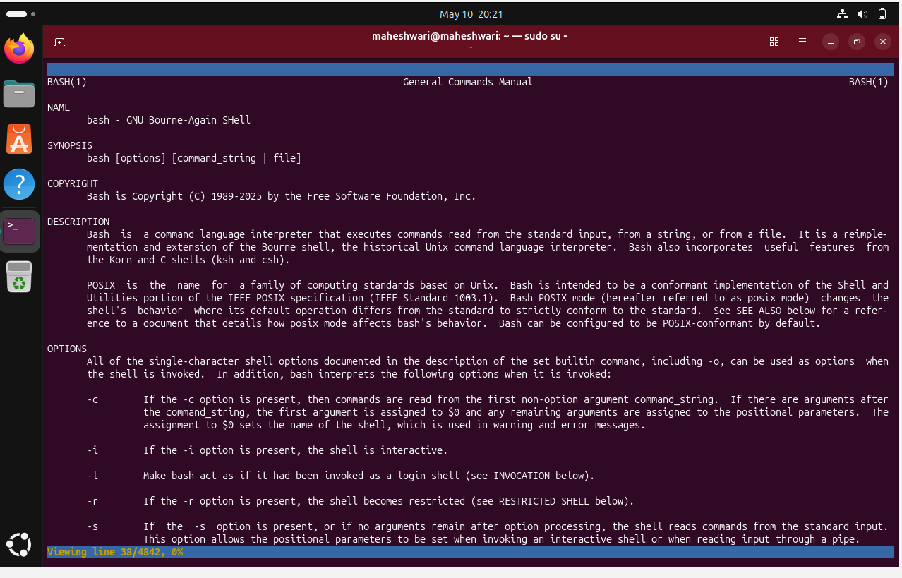
Command: tldr
PURPOSE OF COMMAND:
- tldr is a community maintained collection of simplified command line cheat sheet for linux, macOs, and windows.
- Unlike traditional man pages, tldr focuses on practical and ready to use examples rather than lengthy description.

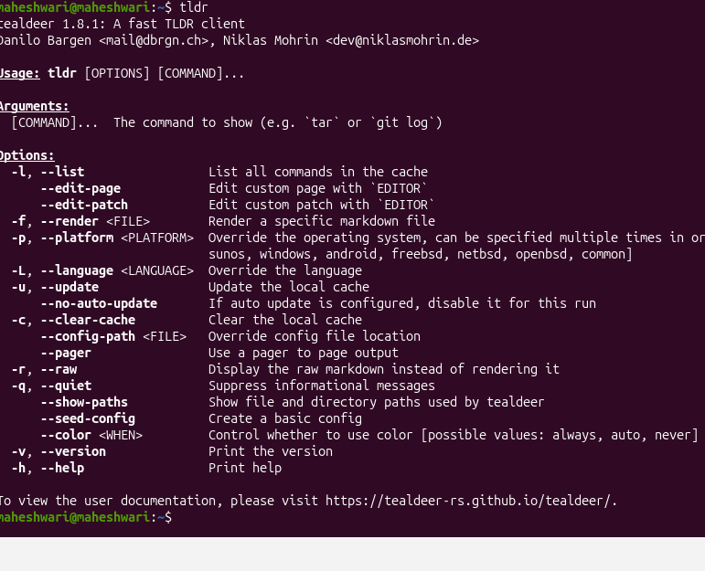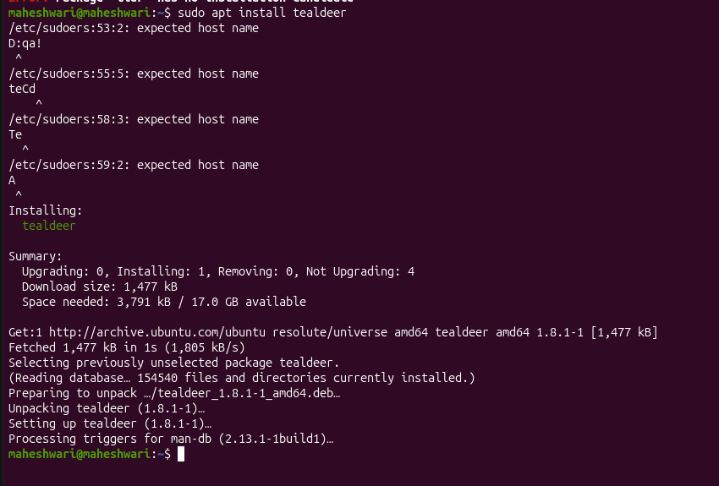

Essential File Management Tools Commands

Command: ls
PURPOSE OF COMMAND
- ls command is used to list files
- 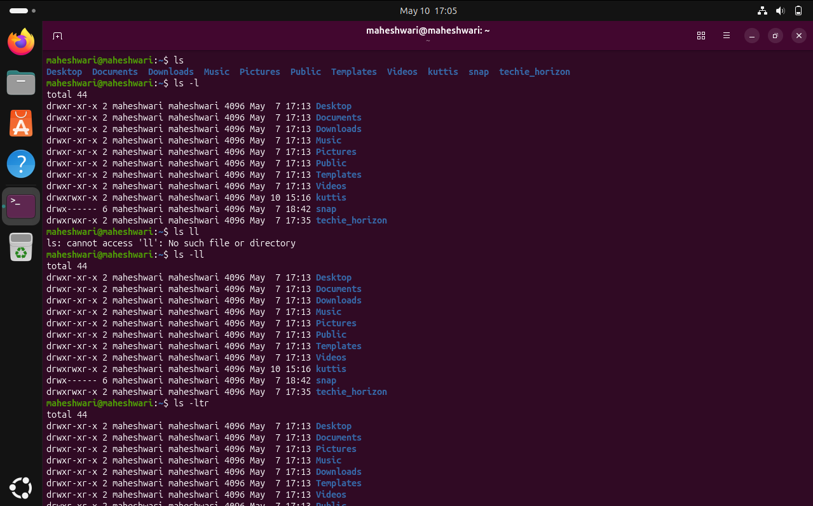

Command: cp
PURPOSE OF COMMAND
- cp command is used to copy a files or directories from one location to another location in linux
- cp -pr -> copy a directory and its sub-directories files from one location to another with same permissions and timestamps.
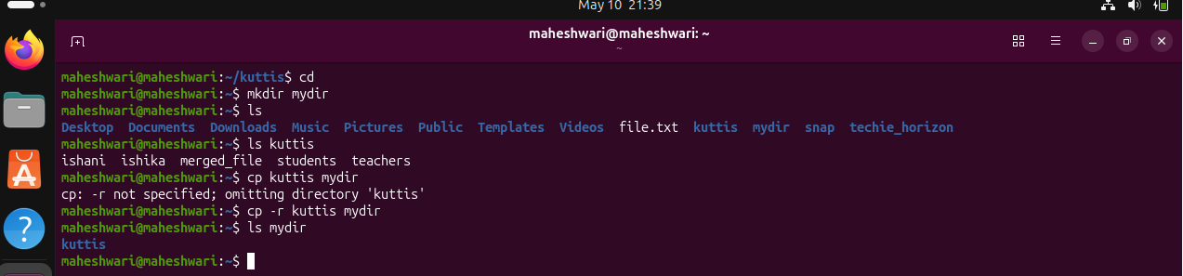
Command: mkdir
PURPOSE OF COMMAND
- mkdir command is used to create a directory
- 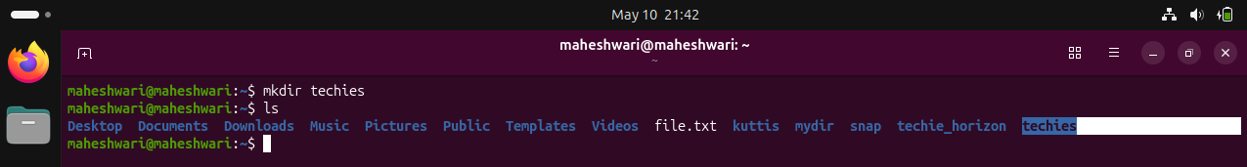
Command: rmdir
PURPOSE OF COMMAND
- rmdir command is used to remove the empty directories only
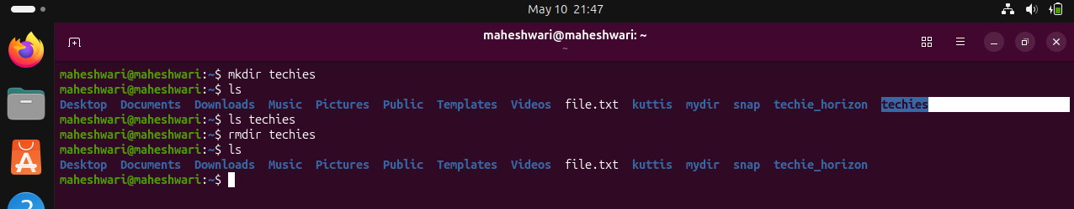
Command: mv
PURPOSE OF COMMAND
- mv command is used to move the directory/file from one location to another location
- with this command we can also rename the directory/filename
- And also we can also hide or unhide the directory/file
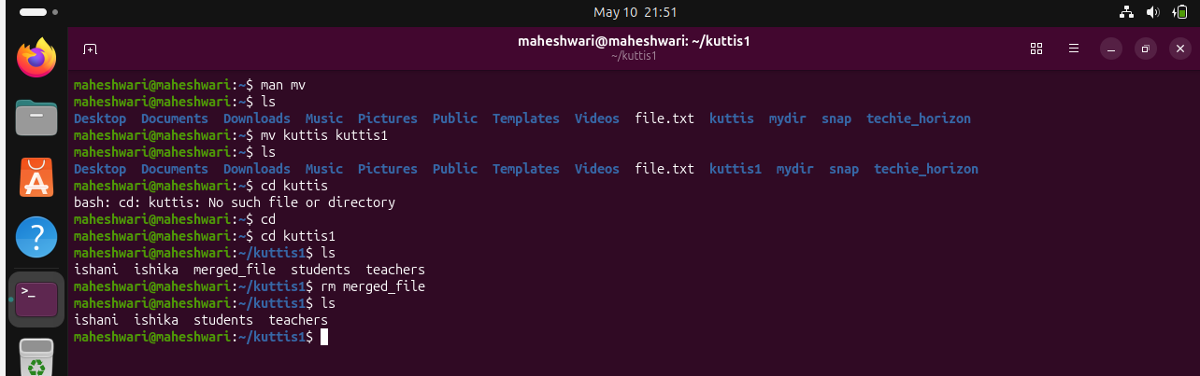
Command: rm

PURPOSE OF COMMAND

- Rm is used to remove the file / directory from a file system
- rm -rf dirname -> this will delete the directory even if the owner does have the write permission
- r means recursivefully & f means forcefully
- rm will remove the files permanently from the filesystem
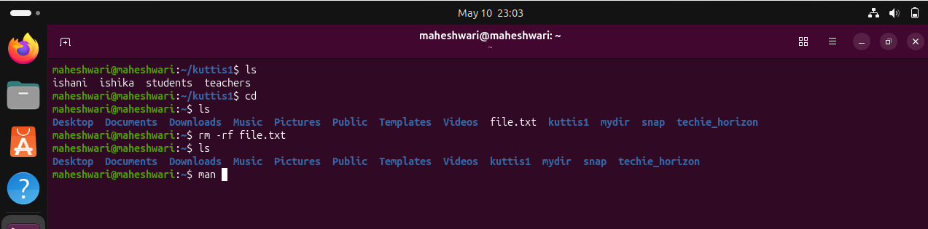

Advanced File Management Tools Commands

ln: used to create links between files and directories
ln -s -> used to create symbolic link
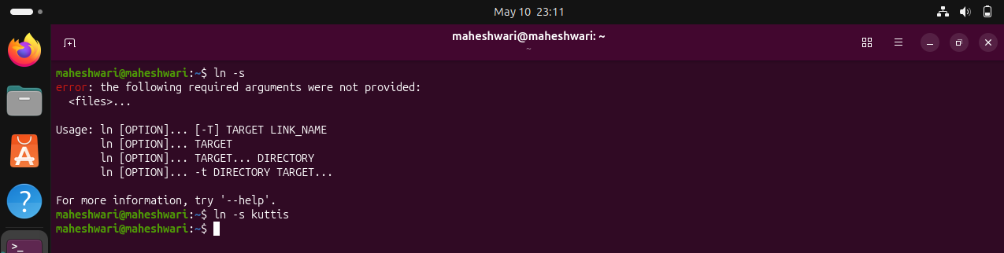
Find : purpose -> find command is used to search files and directories in a directory hirerarchy based on various criteria such as name (-name), type, size(s), permissions or modification time(-mtime)
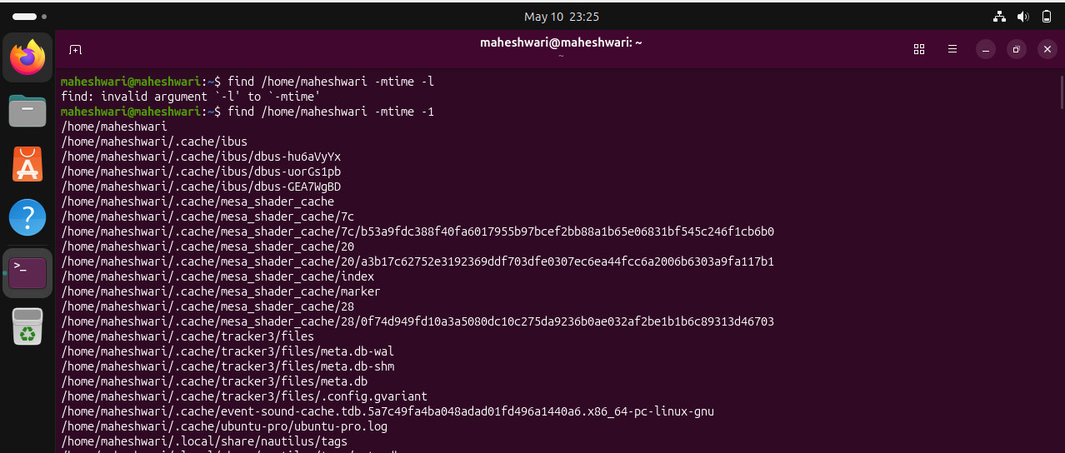
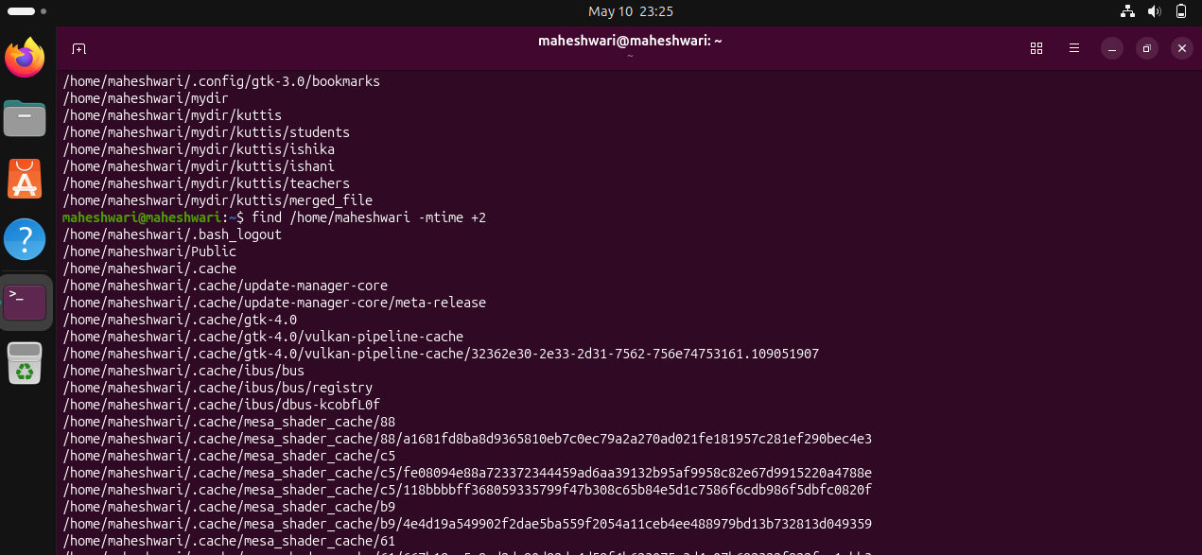

locate: used to quickly search for files by their names -> locate filename
much faster than find command and uses database instead of scanning disk
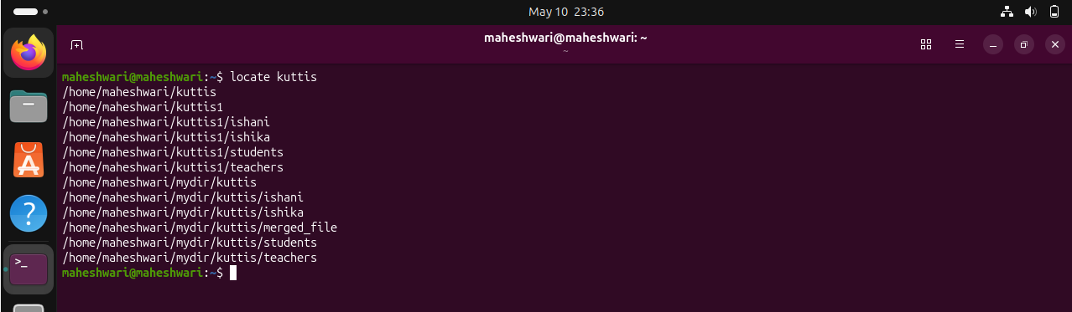
which: purpose -> will show full path of command/ executable
command -> which $PATH
path shows where command is installed
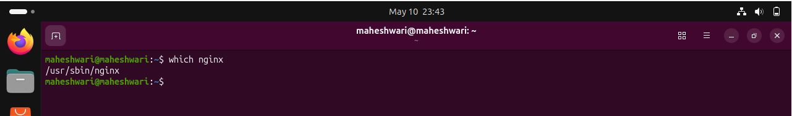
tar: purpose -> archiving tool
  - it combines files into one file
  - to tar a file -> tar -cvf archive.tar dir
  - to extract a file -> tar -xvf archive.tar
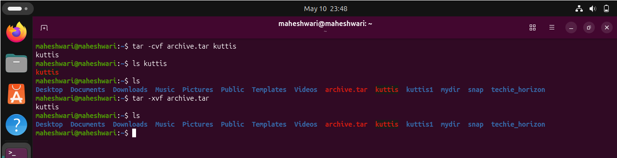
gzip: Compresses files.
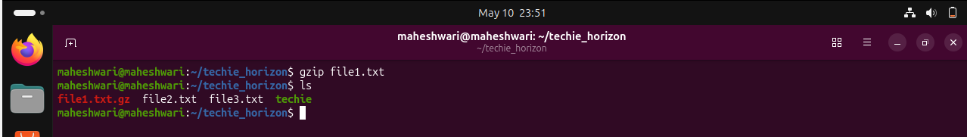
bzip2: A file compression utility.
  - bzip2 file.txt compresses file.txt.
  - Offers better compression ratios than gzip at the cost of speed.

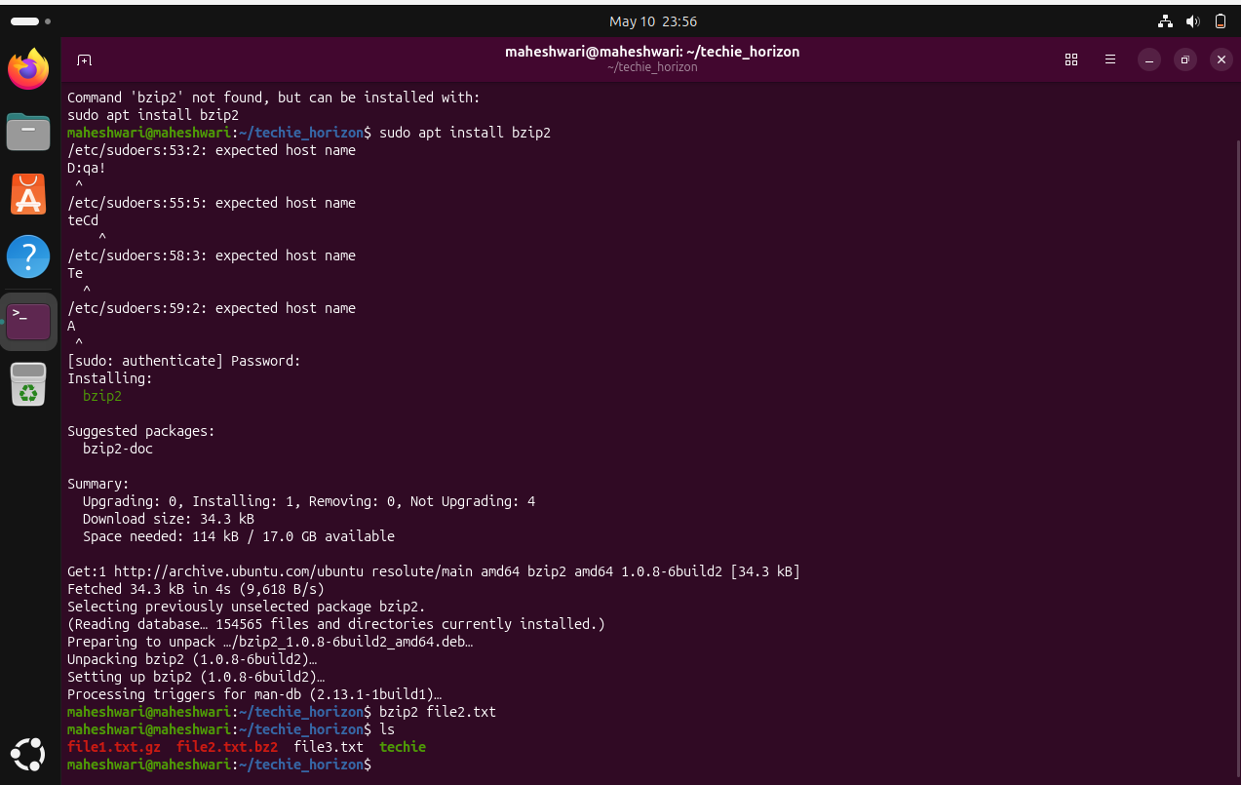
xz: High compression utility.
  - Syntax : xz file.txt
  - Provides the best compression ratio.
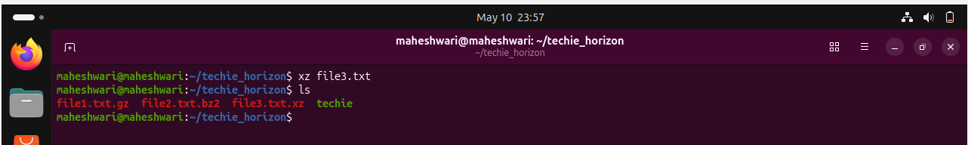
zip: Used for packaging and compressing (archiving) files.
creates an archive with file1 and file2.
  - Syntax : zip archive.zip file1 file2
  - Description: Commonly used for creating .zip files.
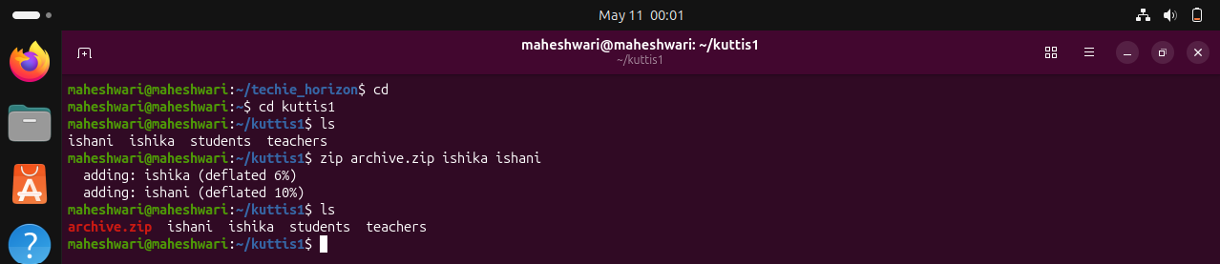
file: Determines the type of a file.
  - Example: file file1.txt displays the type of file1.txt
  - Description: Useful for identifying file formats.
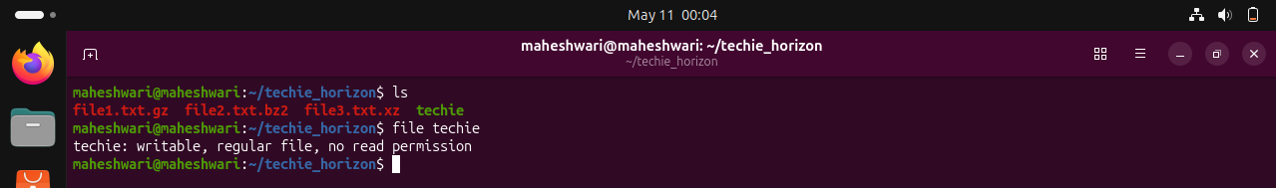
mount: mount command is used to attach a storage device or a filesystem to a directory
    - findmnt -t ext4 -> list all mounted filesystems with ext4
    - lsblk -> list all block devices
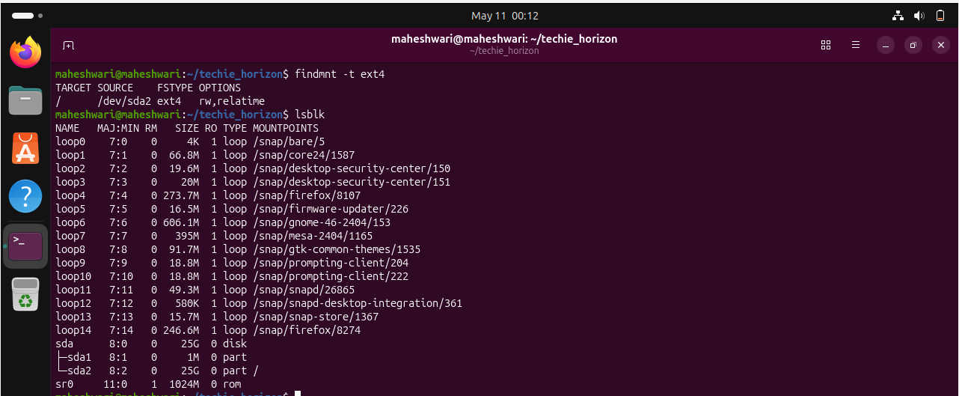

df: Displays disk space usage of all mounted filesystems.
  - df -h shows disk space in human-readable format.
  - df -> shows disk free space
  - Description:
Useful for monitoring disk space usage.
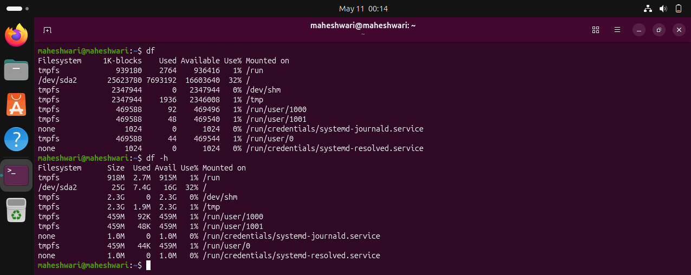
findmnt: Lists all mounted filesystems.
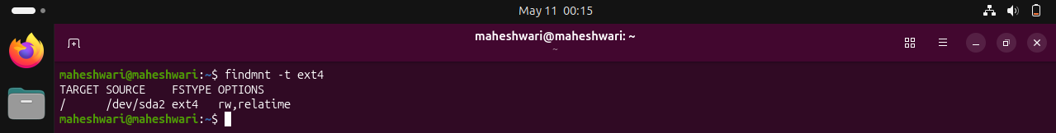
lsblk: Lists information about block devices
  - Description: Useful for identifying storage devices and their partitions.
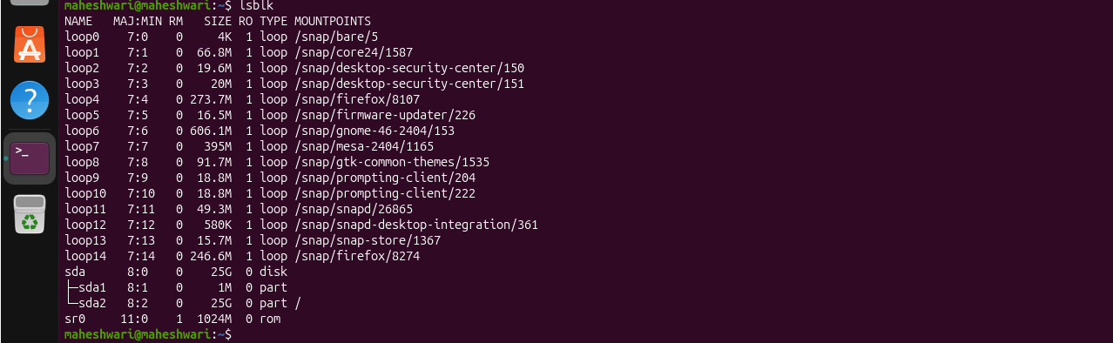

Working with Text Files Commands

Nano (A user-friendly text editor)
  - Syntax : nano filename.txt - Opens filename.txt in nano editor.
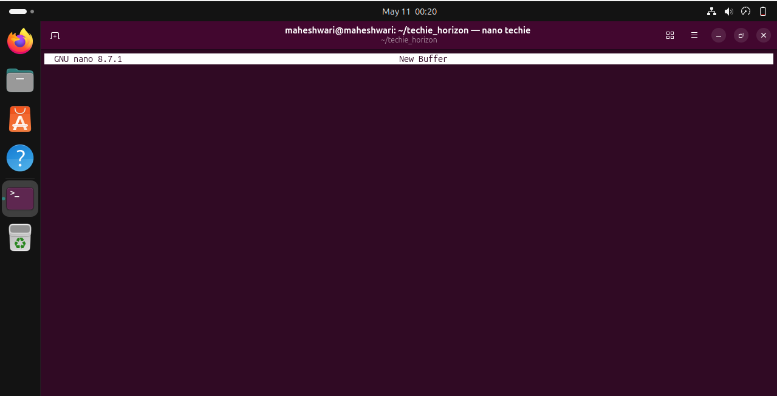
vimtutor
  - Description: A tutorial program for learning VIM, an advanced text editor.
  - Example: vimtutor - Starts the VIM tutorial.
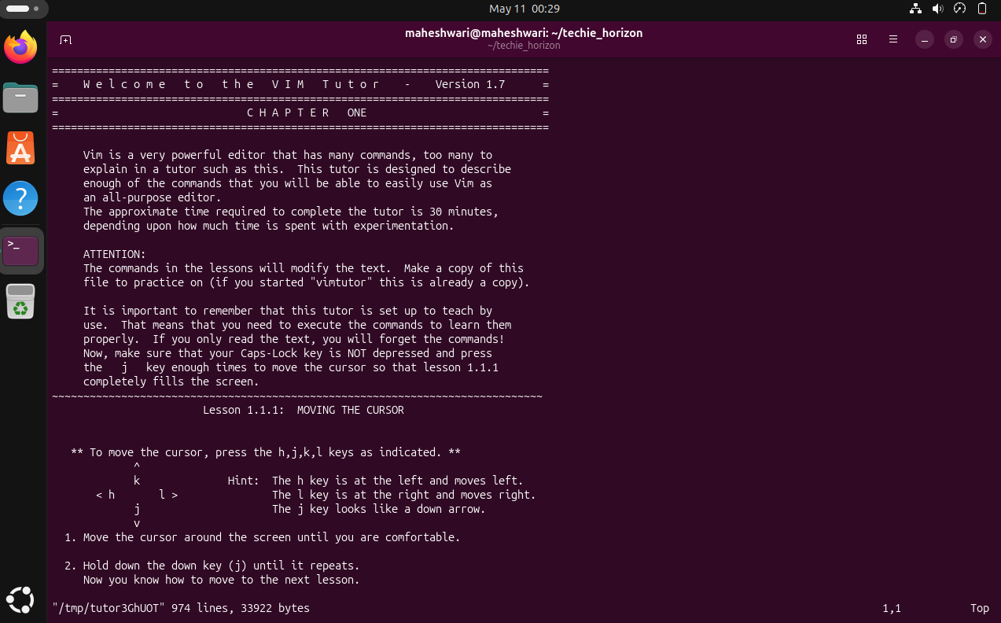

vi
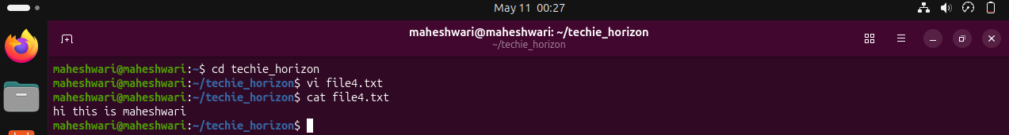
vim
  - An improved version of VI with more features.
  - syntax: vim filename.txt - Opens filename.txt in VIM editor.
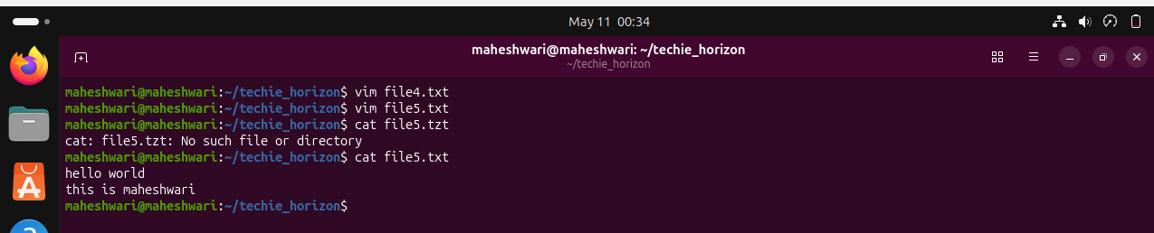
more (to view the contents of text files)
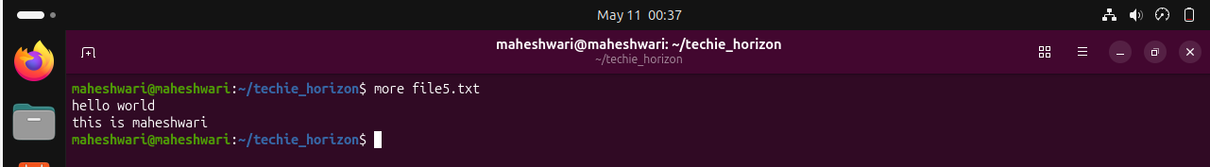
less (similar to more)

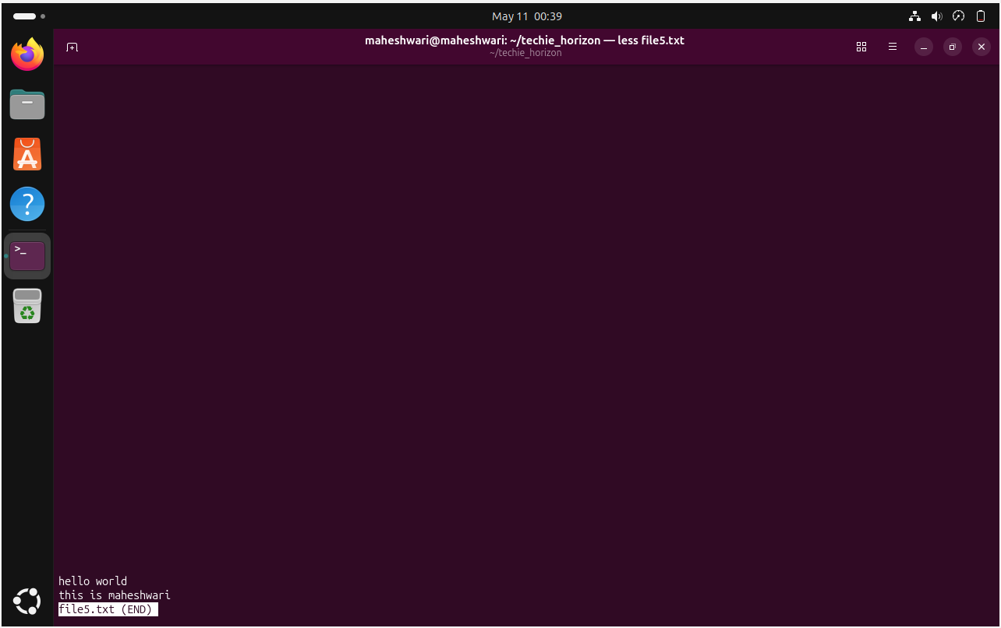
Head
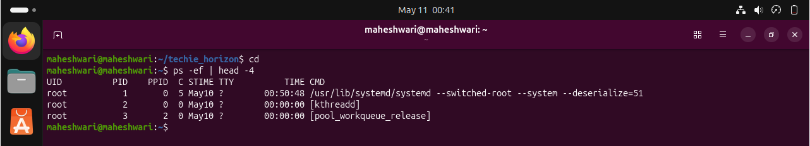
Tail
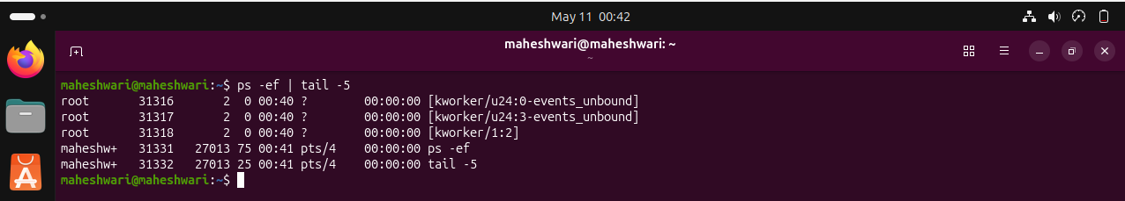
Cat
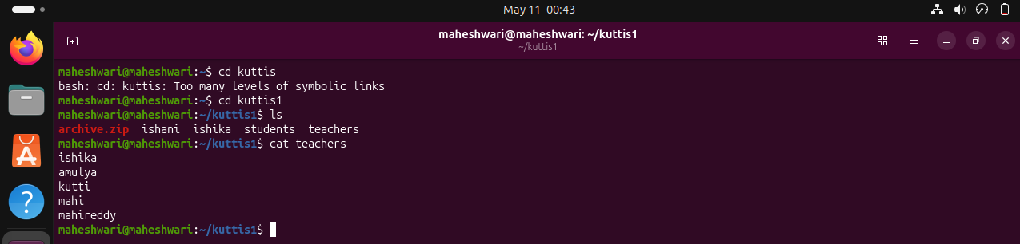
cat -A
  - Description: Similar to cat, but also displays special characters.

tac
  - Description: Prints the contents of a text file in reverse order.
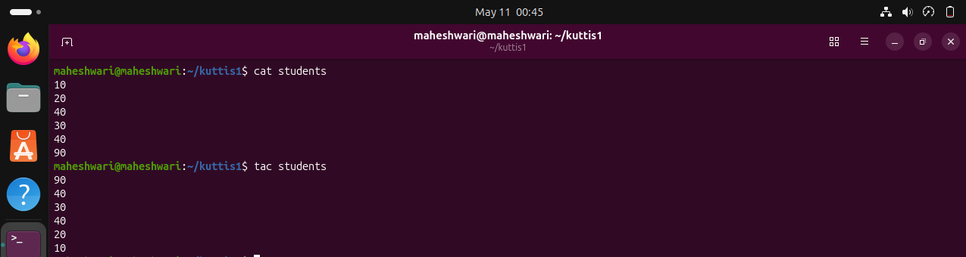
grep
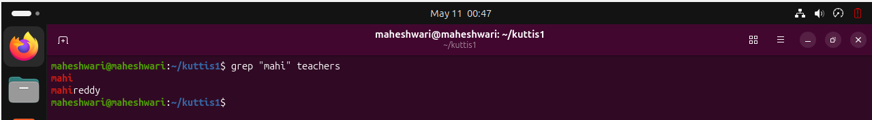
Advanced Text File Processing Commands

grep:

awk:
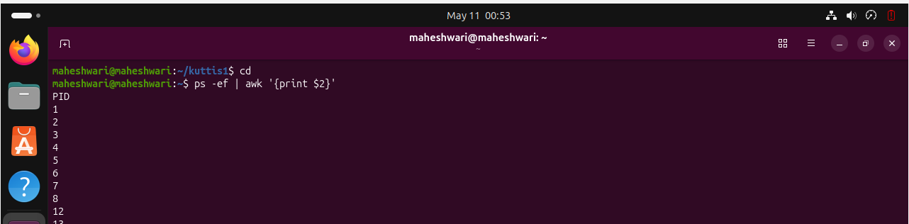
sed:
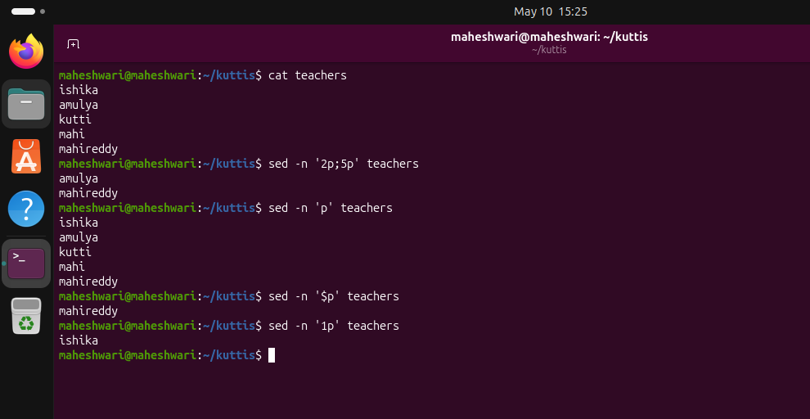

tr:
  - Command: "tr"
  - Example: "tr '[:lower:]' '[:upper:]' < file.txt"
  - Description: Translates or deletes characters from input text.
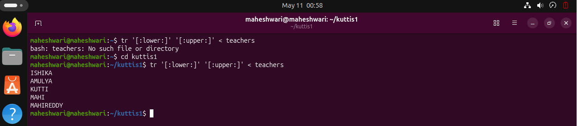
cut:
  - Command: "cut"
  - Example: "cut -d':' -f1 file.txt"
  - Description: Extracts sections from each line of files, such as columns from a table.
sort:

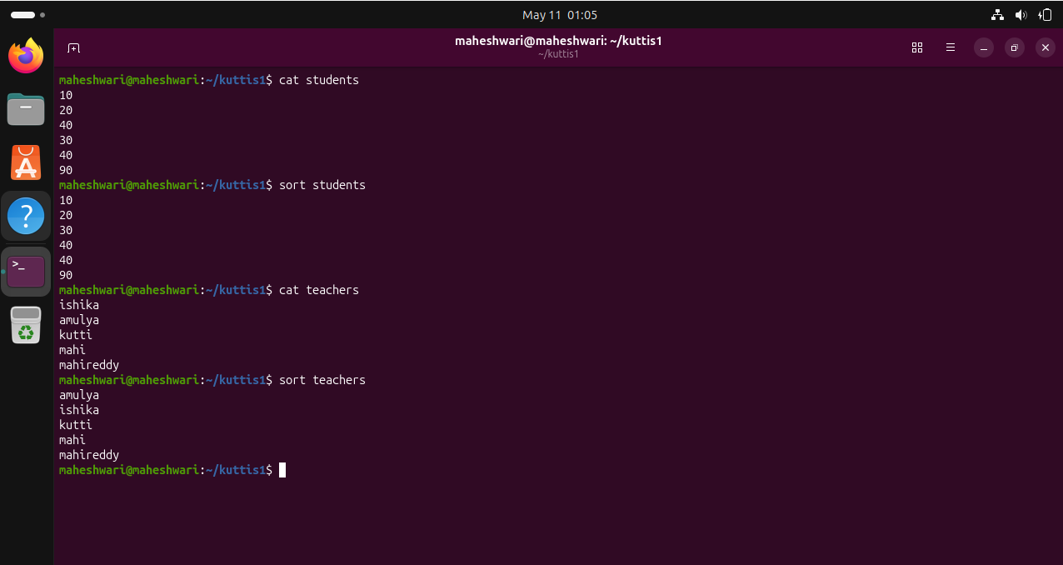
Connecting to a Server Commands
su Command
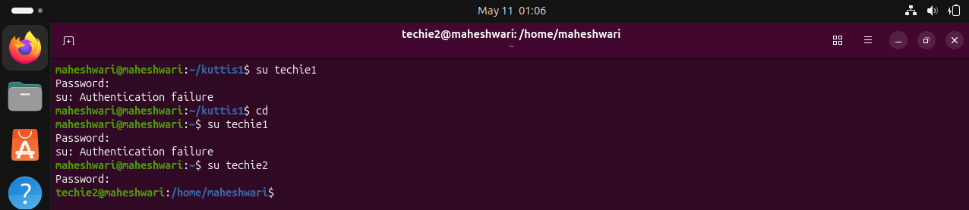
sudo Command
