Medicinal Plants and Emergency Uses

Amla (Indian Gooseberry)
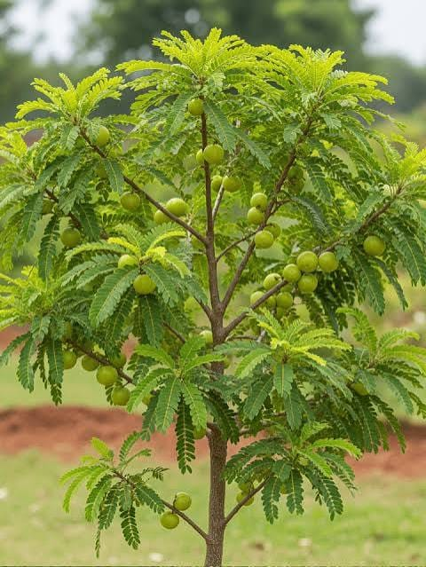
Category: Tree
Medicinal Use: Rich in Vitamin C; supports immunity and digestion.
Emergency Use: Eat fresh fruit or drink fresh juice to help with dehydration recovery and general weakness. Not a substitute for emergency care.
Note: These are traditional uses. Serious illness, poisoning, severe bleeding, breathing difficulty, fractures, or major burns require professional medical care.

Ashoka
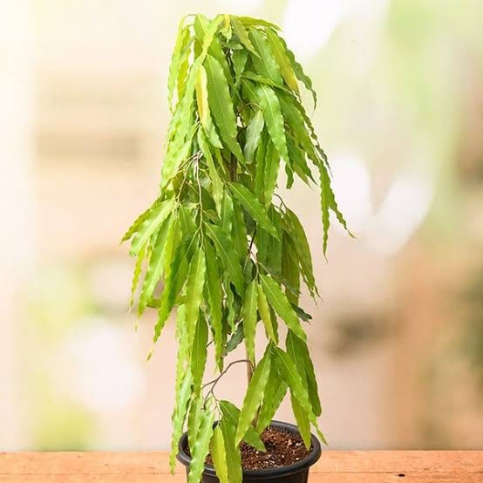
Category: Tree
Medicinal Use: Traditionally used in Ayurveda for women's health.
Emergency Use: Not typically used as first aid. Seek medical care for emergencies.
Note: These are traditional uses. Serious illness, poisoning, severe bleeding, breathing difficulty, fractures, or major burns require professional medical care.

Aspilia africana
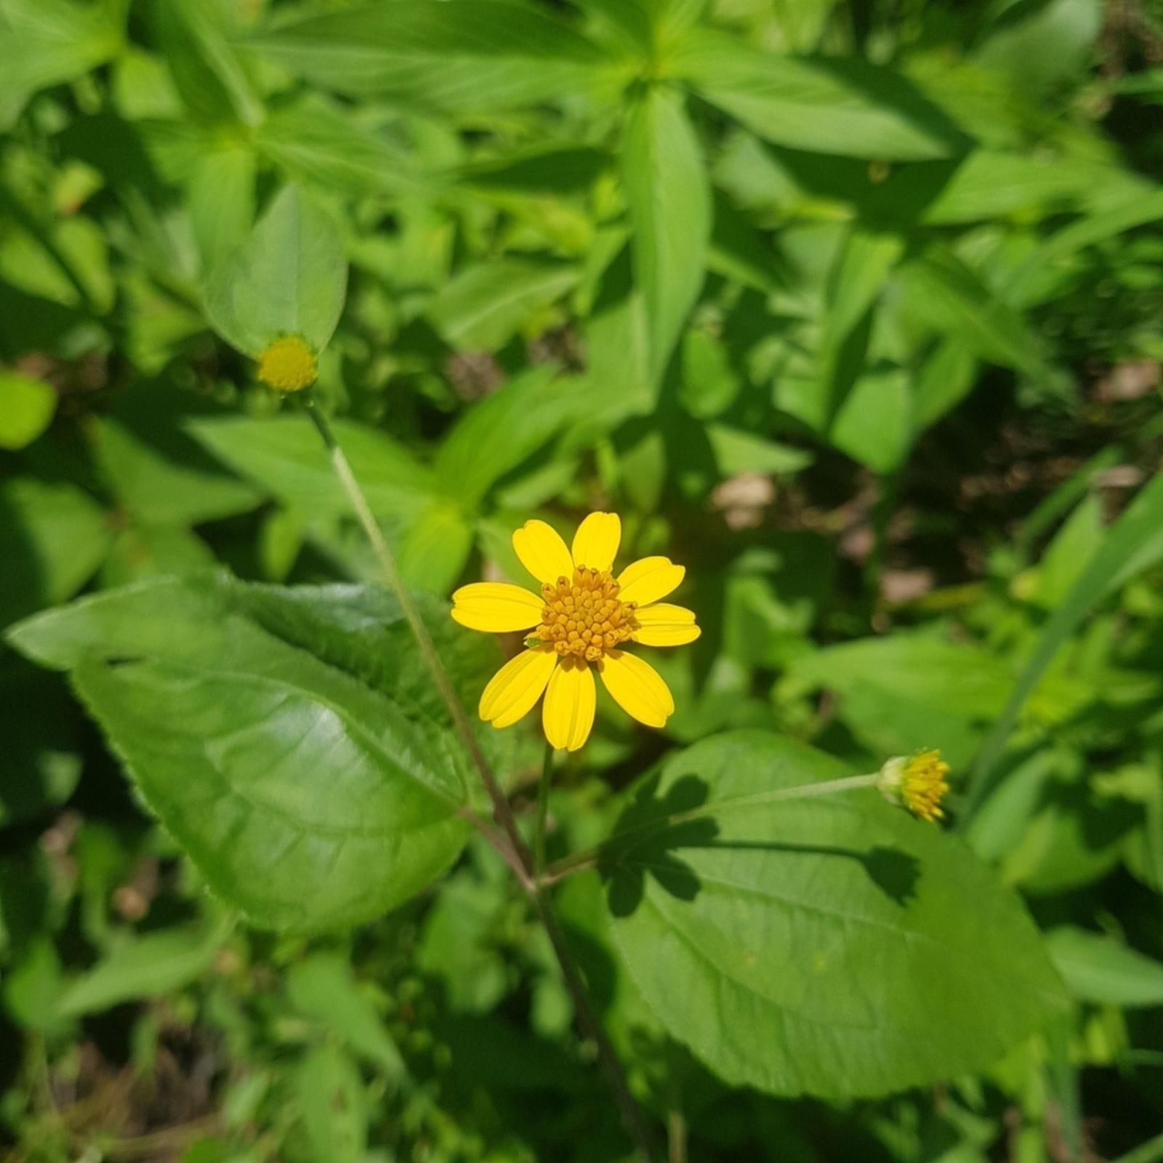
Category: Herb
Medicinal Use: Traditionally used for wound care.
Emergency Use: Clean the wound with safe water, then fresh crushed leaves have been traditionally applied to minor cuts. Medical evaluation is recommended.
Note: These are traditional uses. Serious illness, poisoning, severe bleeding, breathing difficulty, fractures, or major burns require professional medical care.

Banyan

Category: Tree
Medicinal Use: Latex and bark used traditionally.
Emergency Use: Latex has been traditionally applied to minor cuts; use only after cleaning the wound.
Note: These are traditional uses. Serious illness, poisoning, severe bleeding, breathing difficulty, fractures, or major burns require professional medical care.

Gulmohar
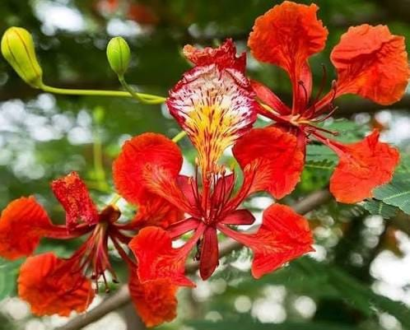
Category: Tree
Medicinal Use: Mostly ornamental; limited traditional medicinal use.
Emergency Use: Not recommended for emergency self-treatment.
Note: These are traditional uses. Serious illness, poisoning, severe bleeding, breathing difficulty, fractures, or major burns require professional medical care.

Shepherd's Purse
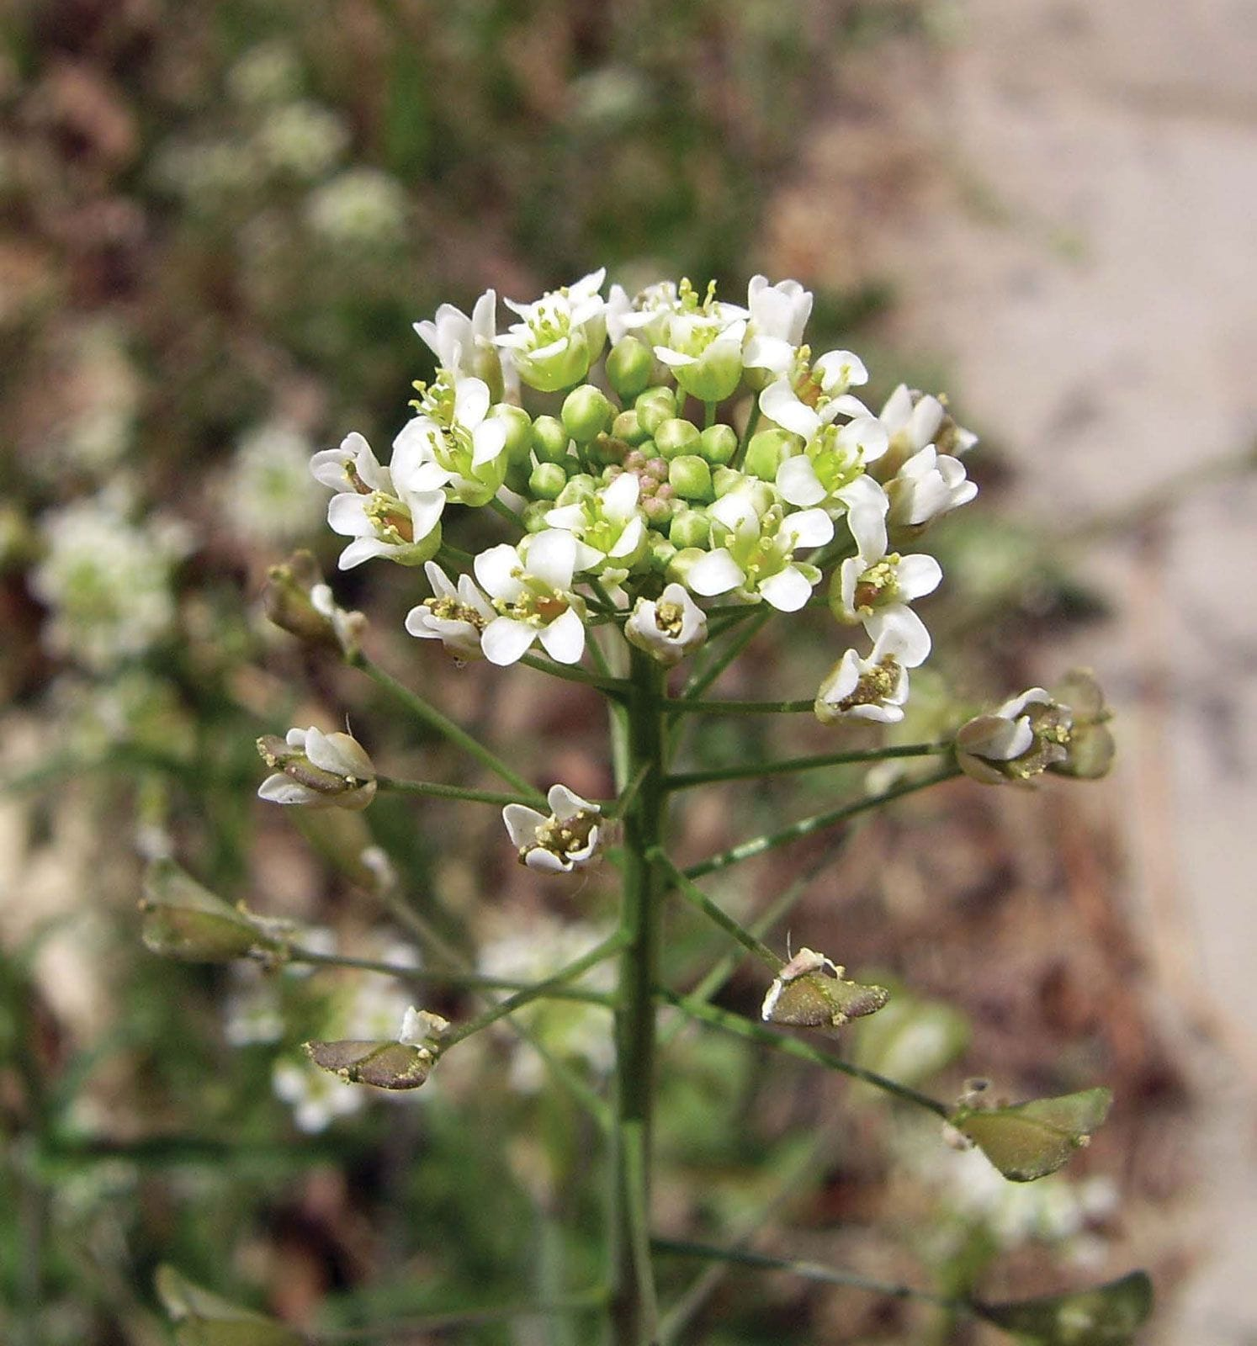
Category: Herb
Medicinal Use: Traditionally associated with reducing minor bleeding.
Emergency Use: Fresh aerial parts have traditionally been used on small cuts. Persistent bleeding requires urgent care.
Note: These are traditional uses. Serious illness, poisoning, severe bleeding, breathing difficulty, fractures, or major burns require professional medical care.

Tulsi (Holy Basil)
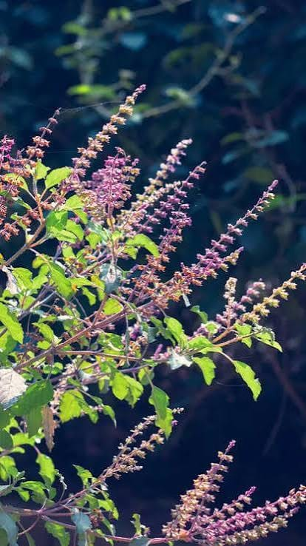
Category: Herb
Medicinal Use: Helps with cough, cold and sore throat.
Emergency Use: Chew washed leaves or prepare a warm infusion for mild cough/cold symptoms.
Note: These are traditional uses. Serious illness, poisoning, severe bleeding, breathing difficulty, fractures, or major burns require professional medical care.

White Yarrow (Achillea millefolium)
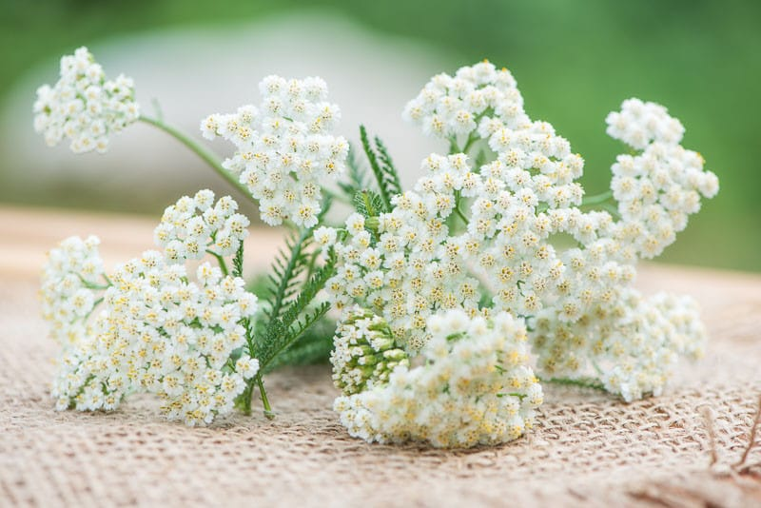
Category: Herb
Medicinal Use: Traditionally used for minor wounds.
Emergency Use: Clean wound then apply crushed clean leaves to minor cuts only.
Note: These are traditional uses. Serious illness, poisoning, severe bleeding, breathing difficulty, fractures, or major burns require professional medical care.

Witch Hazel
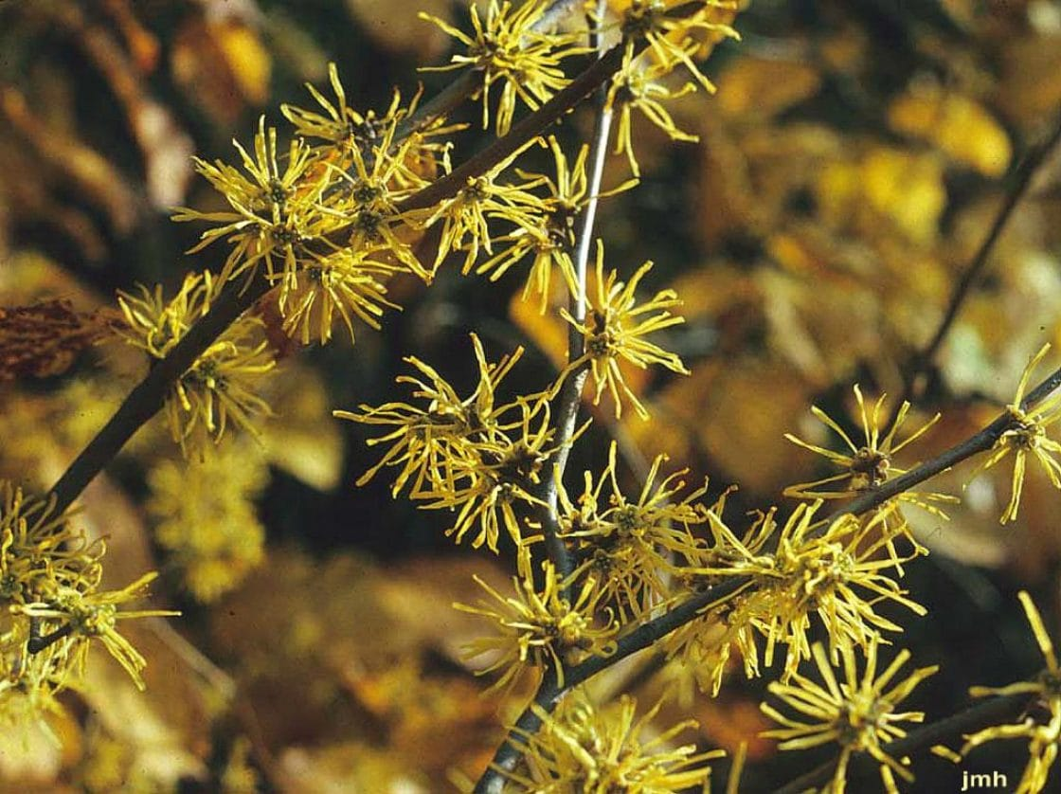
Category: Shrub
Medicinal Use: Astringent; relieves skin irritation.
Emergency Use: Commercial witch hazel extract can soothe minor insect bites or skin irritation.
Note: These are traditional uses. Serious illness, poisoning, severe bleeding, breathing difficulty, fractures, or major burns require professional medical care.

Yellow Yarrow
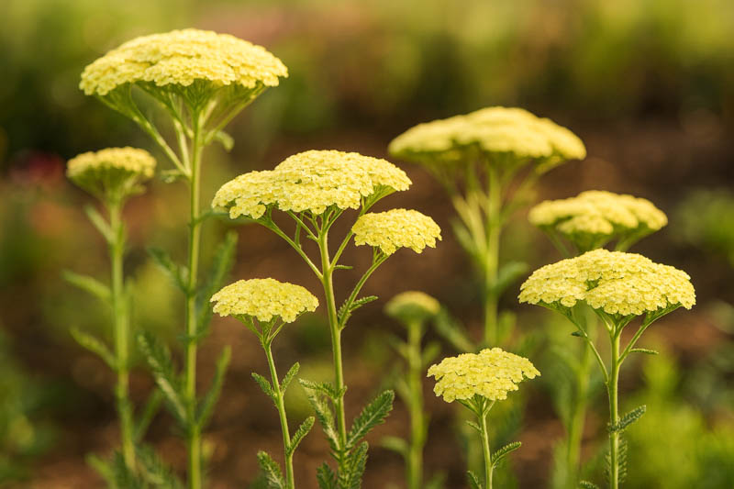
Category: Herb
Medicinal Use: Similar uses to white yarrow.
Emergency Use: Traditionally used on minor cuts after cleaning.
Note: These are traditional uses. Serious illness, poisoning, severe bleeding, breathing difficulty, fractures, or major burns require professional medical care.

