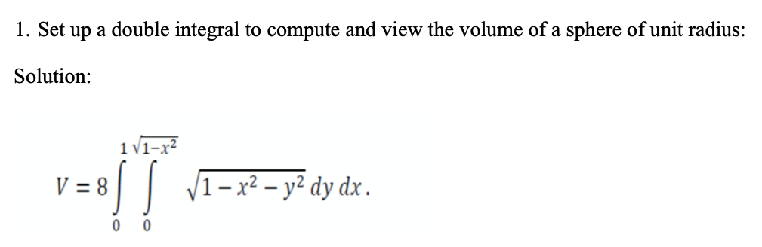

Input:

clear all

clc

syms x y z

V=8\*int(int(sqrt(1-x^2-y^2),y,0,sqrt(1-x^2)),x,0,1)

viewSolid(z,0+0\*x\*y,sqrt(1-x^2-y^2),y,0\*x,sqrt(1-x^2),x,0,1);

grid on;

Output:

V =  
   
(4\*pi)/3

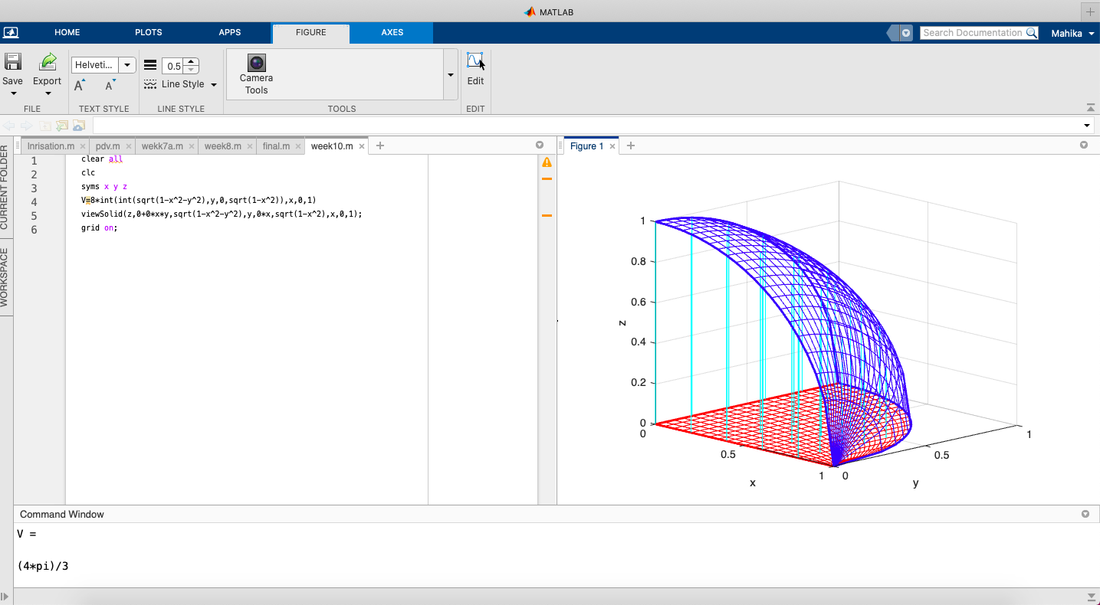

Example 2:

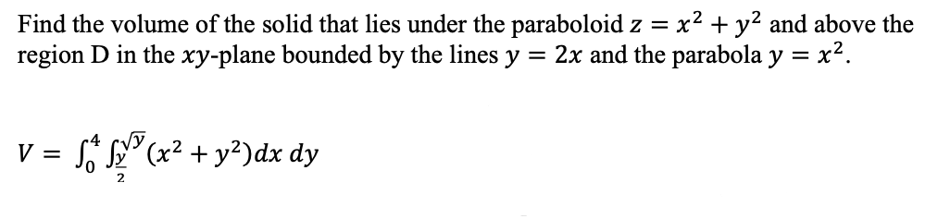

Input:

clear all

clc

syms x y z

V=int(int(x^2 + y^2,x,y/2,sqrt(y)),y,0,4)

viewSolidone(z,0+0\*x\*y,x^2 + y^2,x,y/2,sqrt(y),y,0,4);

grid on;

Output:

V =  
   
216/35

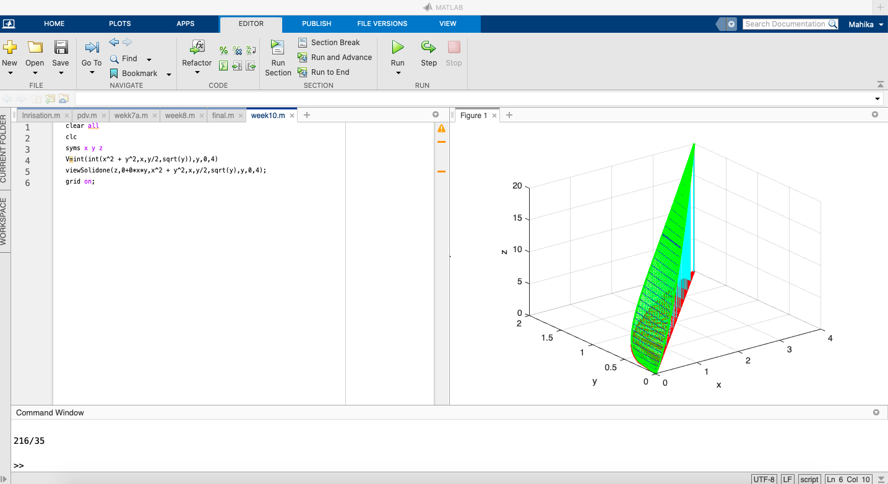

Example 3:

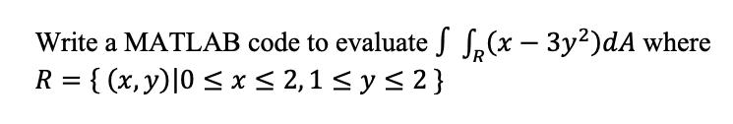

Input:

clear all

clc

syms x y z

V=int(int(x - 3\*y^2,x,0,2),y,1,2)

viewSolidone(z,0+0\*x\*y,x - 3\*y^2,x,0\*y,0\*y + 2,y,1,2);

grid on;

Output:

V =  
   
-12

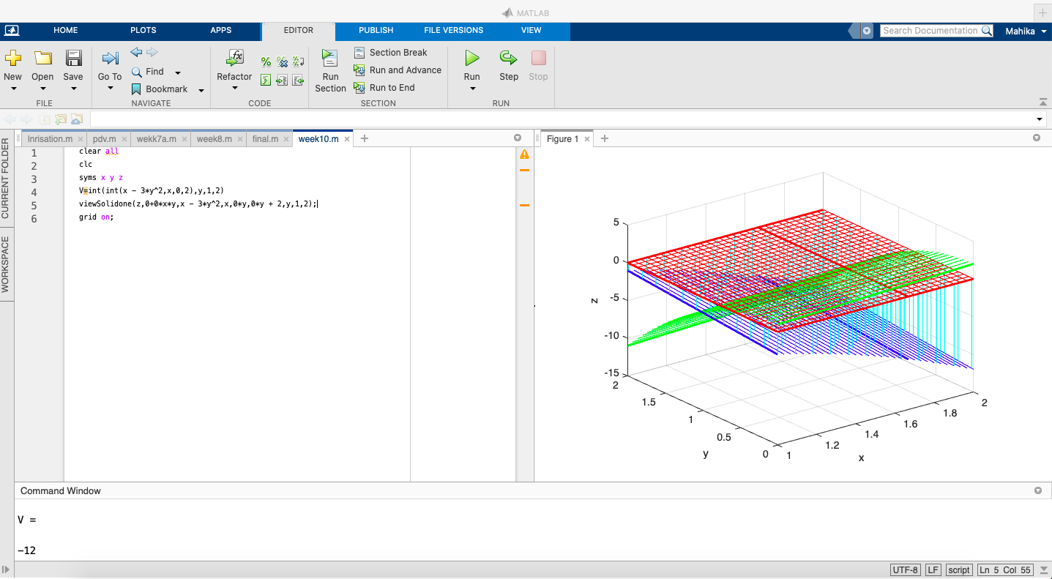

Practice problems

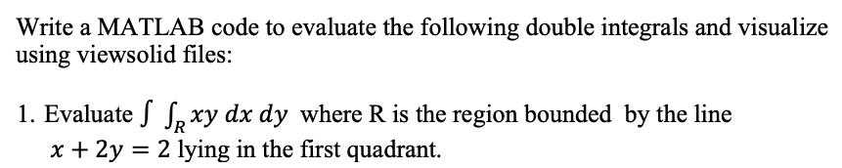

Input:

clear all

clc

syms x y z

V=int(int(x\*y,x,0,2 - 2\*y),y,0,1)

viewSolidone(z,0+0\*x\*y,x\*y,x,0+0\*y,2 - 2\*y,y,0,1);

grid on;

Output:

V =  
   
1/6

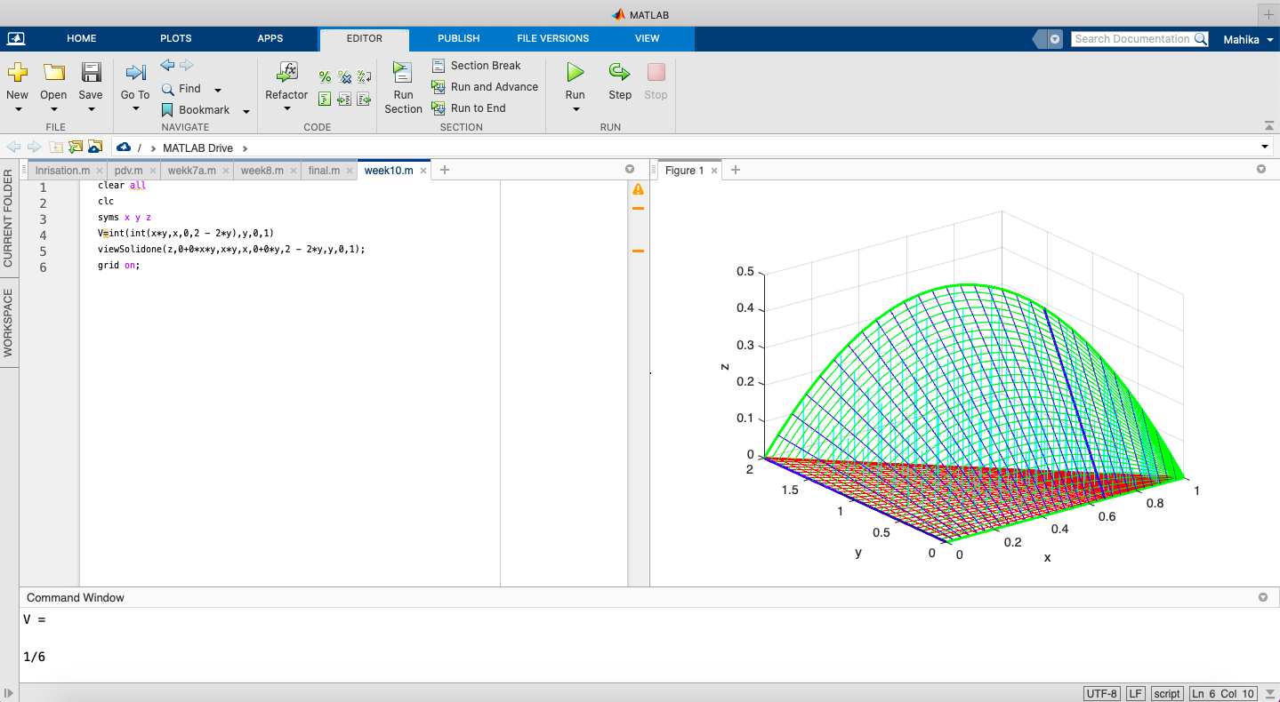

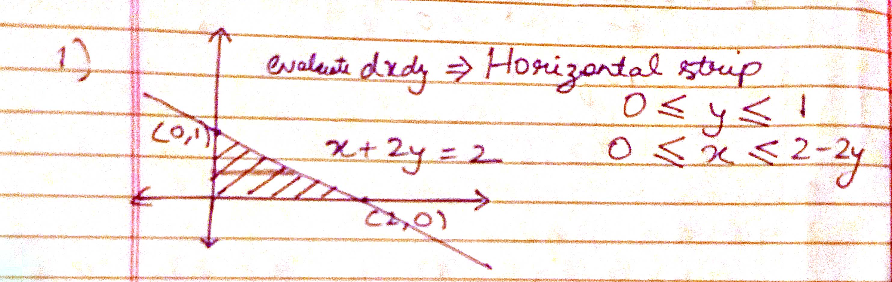

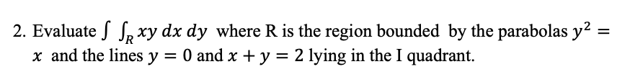

Input:

clear all

clc

syms x y z

V=int(int(x\*y,x,y^2,2 - y),y,0,1)

viewSolidone(z,0+0\*x\*y,x\*y,x,y^2,2 - y,y,0,1);

grid on;

Output:

V =  
   
3/8

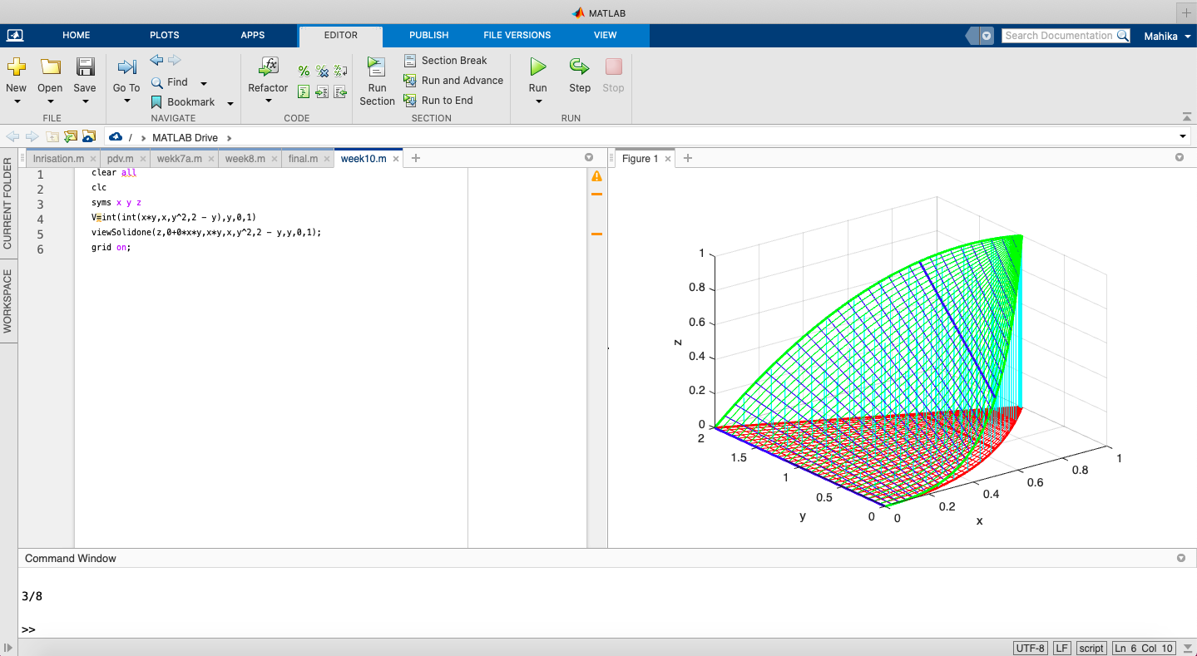

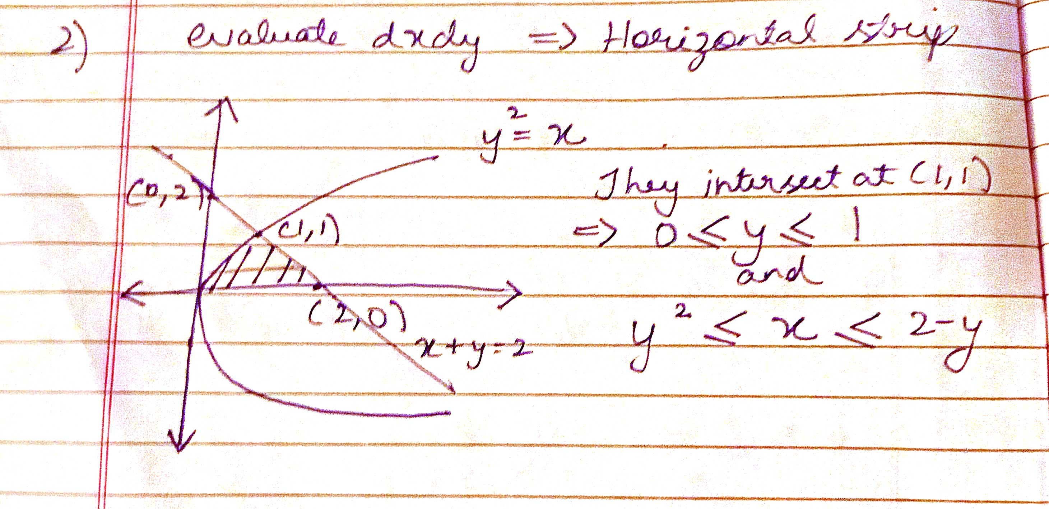

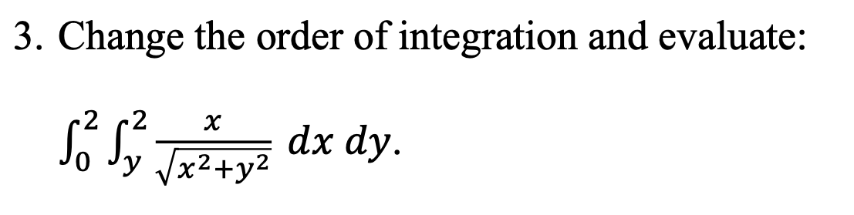

Input:

clear all

clc

syms x y z

V=int(int(x/sqrt(x^2 + y^2),y,0,x),x,0,2)

viewSolid(z,0+0\*x\*y,x/sqrt(x^2 + y^2),y,0+0\*x,x,x,0+0\*x,2);

grid on;

Output:

V =  
   
log(2\*2^(1/2) + 3)

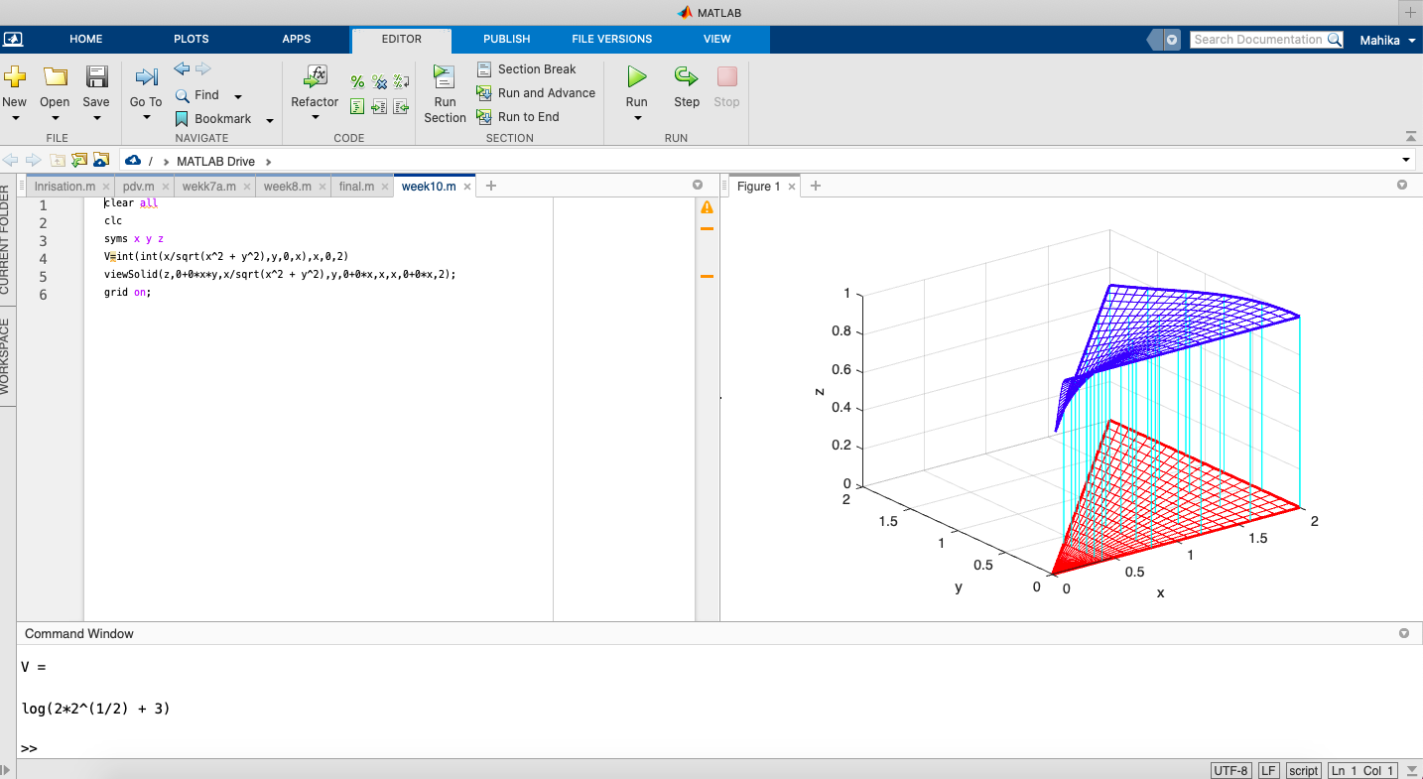

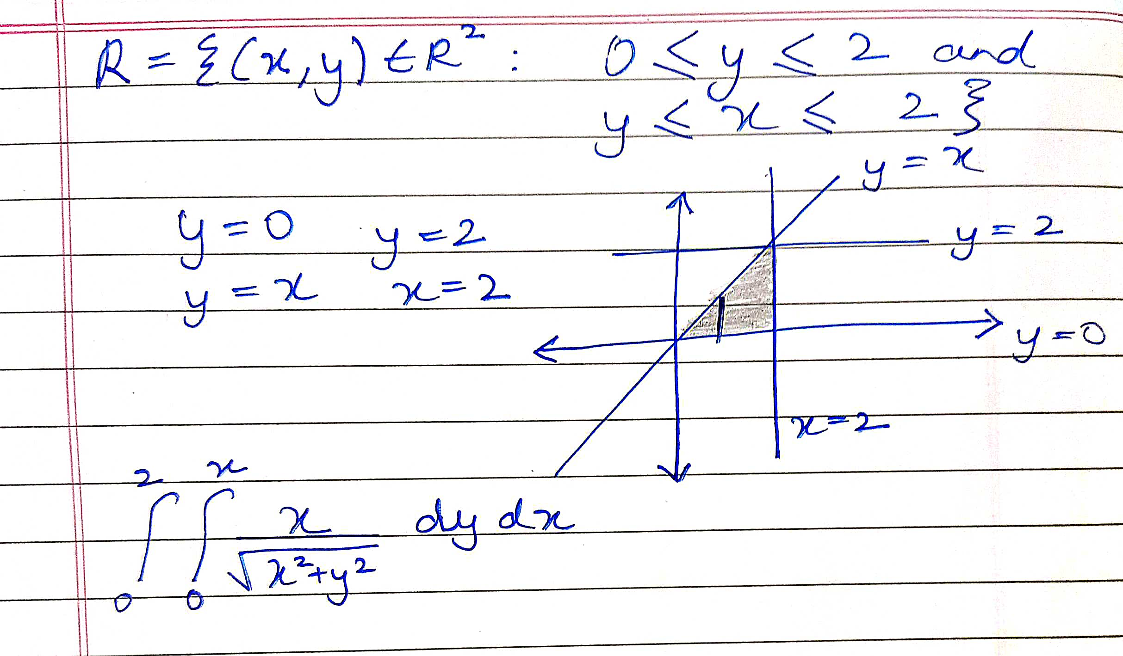

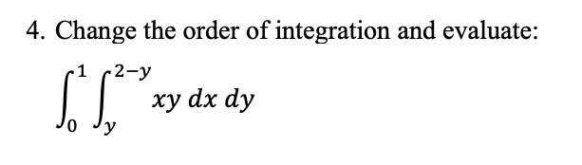

Input:

clear all

clc

syms x y z

V=int(int(x\*y,y,0,x),x,0,1)+int(int(x\*y,y,0,2-x),x,1,2)

figure

viewSolid(z,0+0\*x\*y,x\*y,y,0+0\*x,x,x,0+0\*x,1);

figure

viewSolid(z,0+0\*x\*y,x\*y,y,0+0\*x,2-x,x,1,2);

grid on;

Output:

V =  
   
1/3

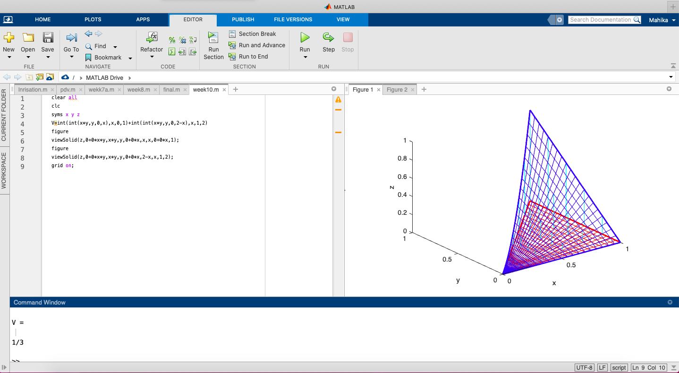

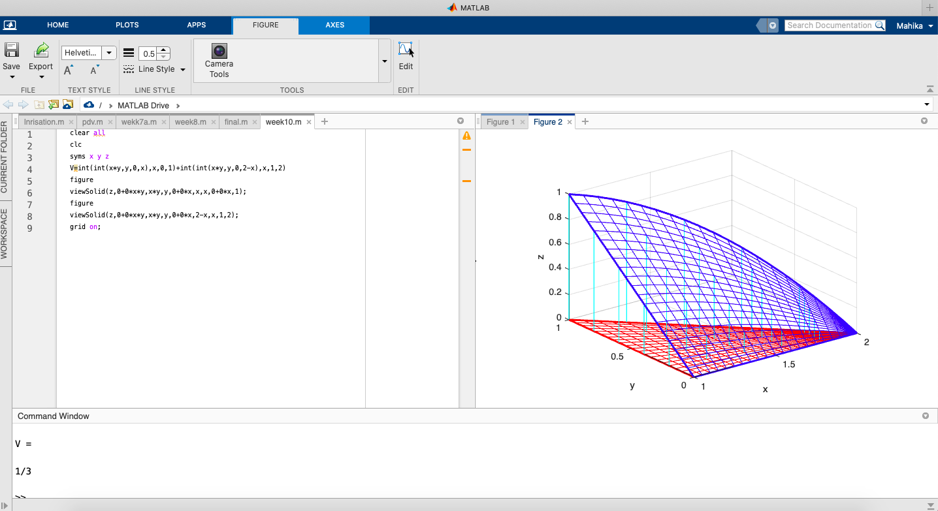

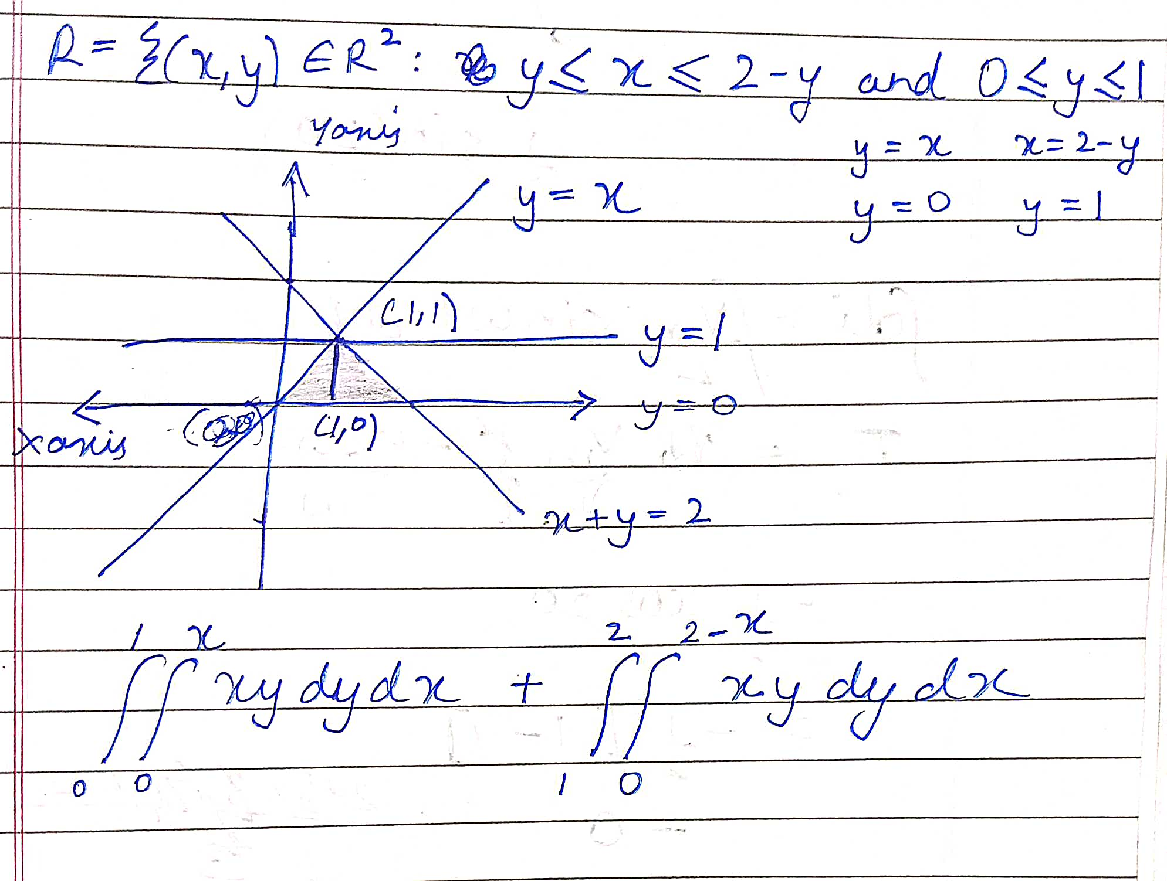

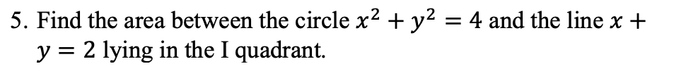

Input:

clear all

clc

syms x y z

V=int(int(1,x,2 - y,sqrt(4 - y^2)),y,0,2)

viewSolidone(z,0+0\*x\*y,1+0\*y,x,2 - y,sqrt(4 - y^2),y,0,2);

grid on;

Output:

V =  
   
pi – 2

