**Name: S. Mahika Rao**

**RegNo: 17BCE0944**

**Subject: NLP (A2)**

**Teacher: Prof. Sharmila Banu**

**Date: 21.12.19**

**TASK 2:**

1. **Explore what COCA is and perform following :**

**1.Concordance:** Search with reference to the context.

Eg: do the **right**  things. (Refer first meaning)

Eg: Turn to your right (Refer second meaning)

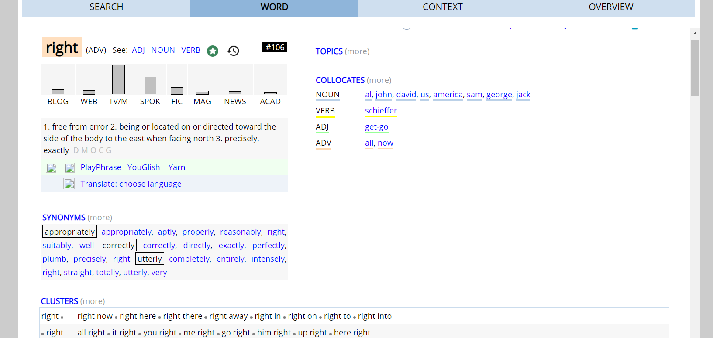

**2.Chart**

Failure of the tagger to identify phrase: **Let’s not give up**

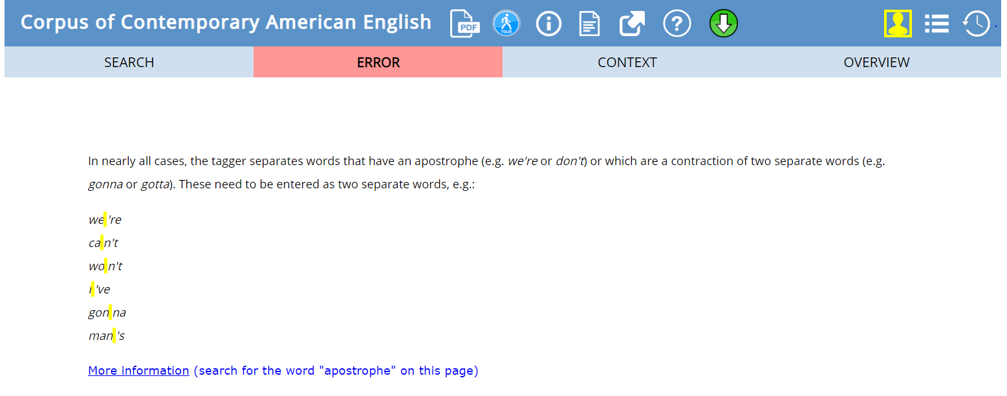

Other words explained in class include The Flesch Reading Ease formula, The Flesch-Kincaid Grade Level , Gunning Fog , Smog Index, The Coleman-Liau Index, Automated Readability , Index, Linsear

1. **Use readable.com and write a note on your experience in 2 lines**

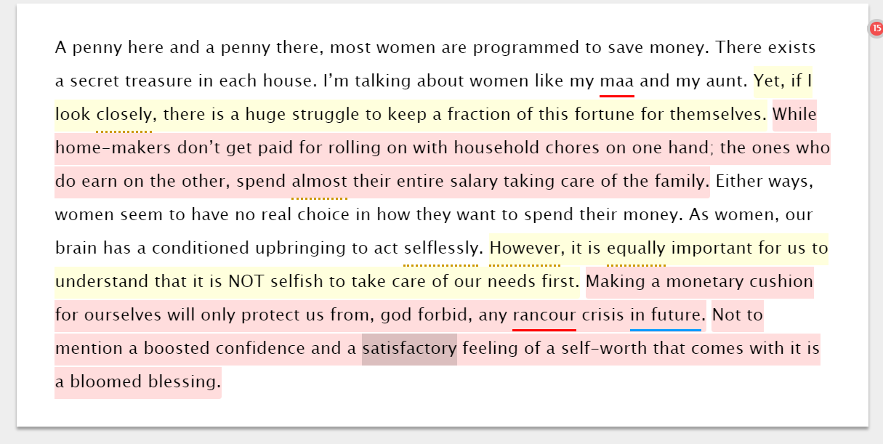

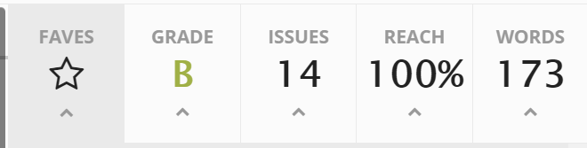

My Experience:

It was a beautiful website that not only indicated spelling and grammatical errors but also pointed out adverb count and use of CLICHÉ. Though it may not seem much to a novice linguist, it can be used by the head of a fictitious magazine before RECRUITING a new employee to check the originality in ideas and not traditional un-plagiarized content by apps like spin bot etc.