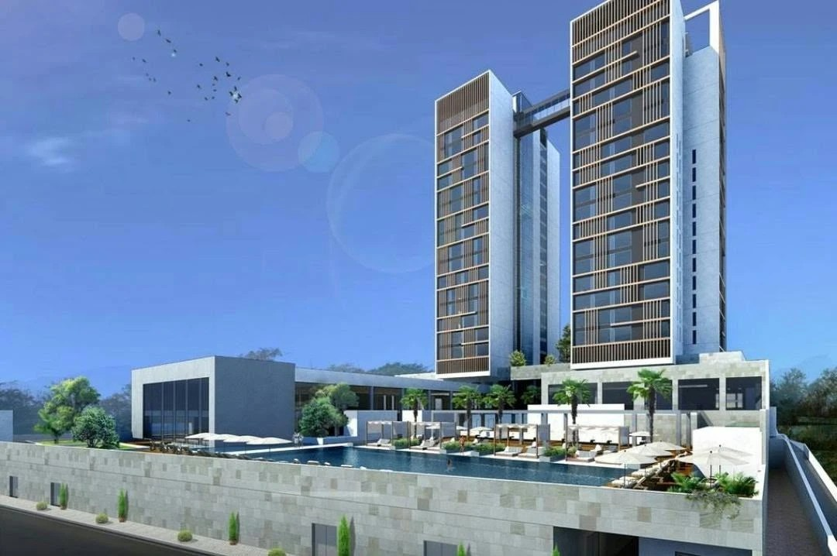

TECHNICAL REPORT · RENEWABLE ENERGY
Rooftop Solar PV System
Design Basis & Cost Estimate
Marriott Hotel – Mezzanine Roof (Drawing D18102-DD-A-104)
Document No. | PV-RPT-D18102-001
Revision | B – Issued for review
Date | 4 November 2026
Client | Tororo PV Power Company Limited
System capacity | 185.4 kWp DC / 160 kW AC, grid-tied, no battery

Document Control
Rev | Date | Description | Prepared | Checked | Approved
A | 3 November 2026 | Issued for review
B | 4 November 2026 | Inverters 2 × 80 kW; solar zone limited to architect's drawing

Reference documents
Reference | Title
D18102-DD-A-104 | Mezzanine floor plan incl. roof PV zones (architect)
PV-LAY-D18102-002 | PV layout with Enerack ballast structure, 10° tilt
EPJ-26110401 V1.0 | Enerack mounting structure drawings (2P and 1P tables)

Contents

Right-click the table of contents and choose Update Field if page numbers are not shown.

1. Executive Summary
This report sets out the design basis, layout, energy yield and budget cost for a grid-tied rooftop solar photovoltaic (PV) system on the mezzanine-level roof of the Marriott Hotel, as shown on architectural drawing D18102-DD-A-104. The system has no battery storage and supplies the hotel's own load behind the utility meter.
185.4 kWp | 274 MWh | USD 109k | 3.4 yrs
DC capacity (299 × 620 Wp) | Year-1 generation | Budget EPC cost (0.59 USD/Wp) | Simple payback

Key findings
- Capacity. The solar zones on the architect's drawing (≈1,150 m² gross) accommodate 299 modules of 620 Wp in 13 rows of 23, giving 185.4 kWp at 10° tilt with 800 mm maintenance aisles and 1.0 m edge setbacks.
- Self-consumption. The hotel uses about 1,000,000 kWh per month (average demand ≈1.37 MW). The PV peak output (≈160 kW AC) is about one-tenth of the daytime load, so 100 % of the solar energy is used on site. No energy is exported and no battery is needed.
- Energy and savings. Year-1 generation is about 274 MWh (2.3 % of annual consumption). At an avoided tariff of USD 0.12/kWh this saves about USD 32,923 in year 1.
- Cost and return. The budget turnkey (EPC) cost is USD 109,278 excluding taxes, including 7 % contingency. Simple payback is 3.4 years, project IRR 30 % and 25-year NPV (10 %) USD 207,408. The levelised cost of solar energy is about USD 0.053/kWh.
- Path to 500 kWp. The architect's solar zone limits this roof to 185.4 kWp. The balance of ≈315 kWp would need other roof areas or car-park canopies (Section 9).

Recommendation
Proceed with the 185.4 kWp mezzanine roof system as Phase 1, subject to (i) a structural check of the slab for the ballasted structure (dead load, ballast and wind uplift), and (ii) confirmation of the avoided tariff from recent utility bills. In parallel, survey other roof areas and the car park for Phase 2.

2. Site and Design Basis

2.1 Site and load
Facility | Marriott Hotel – twin towers with podium; PV on the mezzanine-level roof
Location | Kampala, Uganda – 0°18'11.34"N, 32°35'13.76"E
Roof | Flat reinforced-concrete slab, single level, with parapet; architect's two PV zones (29.39 m wide)
Annual electricity consumption | ≈12,000,000 kWh (≈1,000,000 kWh/month)
Average / daytime demand | ≈1,370 kW / ≈1,700 kW (hotel load profile assumed)
Grid connection | Behind-the-meter, LV main switchboard; zero-export control
Energy storage | None

2.2 Design criteria
Parameter | Value | Basis
Module | 620 Wp bifacial TOPCon, 2382 × 1134 × 30 mm, ≈33 kg | Current Tier-1 mainstream size
Orientation / mounting | Portrait, 2 modules high (2P) per table | Matches roof depth
Tilt | 10° | Low wind load, self-cleaning by rain
Table depth on plan | 4,711 mm (2P); 2,346 mm (1P) | 2 × 2382 + 20 mm, × cos 10°
Module clamp gap | 20 mm | Mid-clamp
Aisle between tables | 800 mm | No inter-row shading 09:00–15:00 all year; walkway for cleaning
Edge setback | 1,000 mm (east side 1,742 mm) | Wind edge zone, safe access; clear of roof opening
Inverter DC voltage | 1,100 V max | Standard C&I string inverter
Design standards | IEC 62548, IEC 60364-7-712, IEC 61215/61730, IEC 62109, IEC 62305 | PV array, wiring, modules, inverters, lightning

3. PV Array Layout
The array occupies only the solar zones shown on drawing D18102-DD-A-104. Each row holds 23 modules on Enerack R80 rails 26,630 mm long, supported by 11 frames per table at 2,600 mm centres. The upper block carries two 2P tables and one 1P table; the lower block carries four 2P tables.
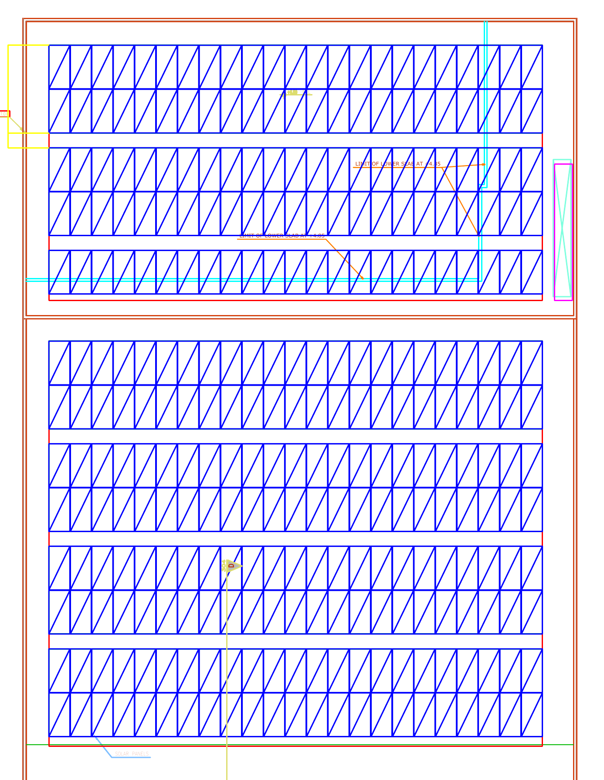
Figure 1 – PV module layout on the mezzanine roof
Zone | Tables | Rows | Modules | kWp
Upper block | 2 × 2P + 1 × 1P | 5 | 115 | 71.3
Lower block | 4 × 2P | 8 | 184 | 114.1
Total | 7 tables | 13 | 299 | 185.4
Mounting structure: Enerack ballast system, drawing EPJ-26110401 V1.0 – 66 frames for 2P tables and 11 frames for 1P tables, 26 rail lines. Module area 807 m².

4. Electrical Design

4.1 Configuration
Item | Inverter INV-01 | Inverter INV-02 | Total
Rated AC power | 80 kW | 80 kW | 160 kW
Strings | 8 × 19 modules | 3 × 19 + 5 × 18 modules | 16 strings
Modules | 152 | 147 | 299
DC capacity | 94.2 kWp | 91.1 kWp | 185.4 kWp
DC/AC ratio | 1.18 | 1.14 | 1.16

4.2 String voltage check
Check | Value | Limit | Result
Max. open-circuit voltage, 19 modules at 12 °C (Voc ≈ 50.2 V) | 954 V | ≤ 1,100 V | OK
Min. MPP voltage, 18 modules at 65 °C (Vmp ≈ 36.2 V) | 652 V | ≥ MPPT minimum (≈200 V) | OK
String current (Isc ≈ 16.1 A, × 1.25 bifacial) | ≈20 A | MPPT input rating | OK, max. 2 strings per MPPT
Module electrical values are typical for 620 Wp TOPCon modules. Re-check against the selected module and inverter datasheets.

4.3 Single-line arrangement
- PV strings → 6 mm² double-insulated PV cable in UV-resistant trunking → inverters on the roof in a shaded, ventilated location.
- Inverters (400 V, 3-phase) → AC combiner panel with outgoing 250 A MCCB, Type II SPD and roof isolator.
- AC combiner panel → 4C × 120 mm² Cu XLPE/SWA (≈80 m, confirm route) → dedicated 250 A way on the main LV switchboard.
- Zero-export controller with CTs on the incomer limits PV output so the site never exports.
- Earthing: array frames bonded to the building earth and integrated with the lightning protection system (IEC 62305).

5. Estimated PV Solar Generation
Site | Kampala, 0°18'11.34"N, 32°35'13.76"E · 185.4 kWp · 10° fixed tilt
Specific yield (year 1, incl. losses) | 1,480 kWh/kWp/yr · performance ratio ≈ 0.80
Year-1 generation | 274,362 kWh · average 22,864 kWh/month · 752 kWh/day
25-year generation | 6,477 MWh (1.0 % degradation in year 1, then 0.4 %/yr)
Self-consumption / share of hotel use | 100 % · 2.3 % of annual consumption

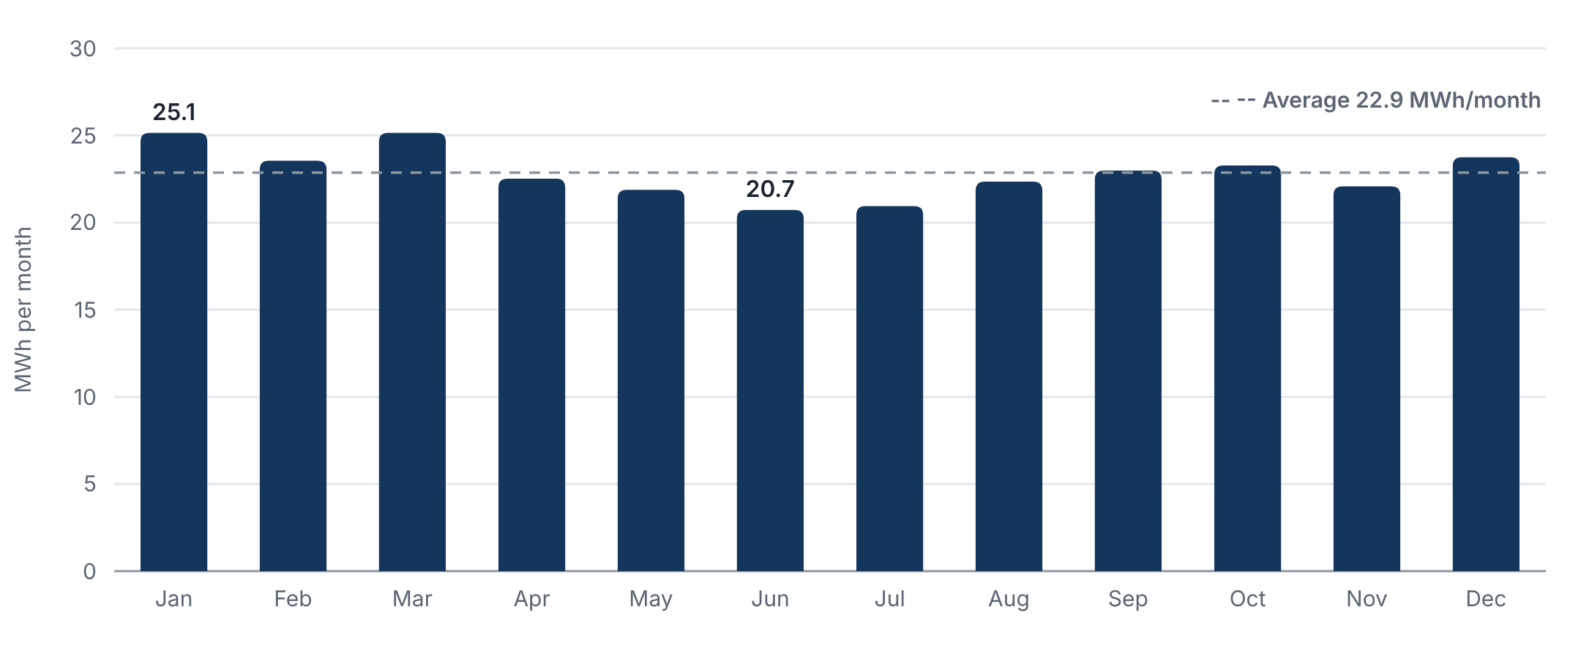
Figure 2 – Estimated monthly PV generation, year 1 (MWh)
Month | Jan | Feb | Mar | Apr | May | Jun | Jul | Aug | Sep | Oct | Nov | Dec | Year
MWh | 25.1 | 23.6 | 25.1 | 22.5 | 21.9 | 20.7 | 21.0 | 22.3 | 23.0 | 23.3 | 22.1 | 23.7 | 274.4
kWh/day | 811 | 841 | 811 | 751 | 706 | 691 | 676 | 721 | 766 | 751 | 736 | 766 | 752

Output is highest from January to March and lowest in June–July, when cloud cover in Kampala is heaviest. Because the site is on the equator, the difference between the best and worst month is only about 20 %. The hotel load is higher than the PV output in every hour, so all of this energy is used on site.
The monthly split uses typical Kampala solar irradiation; the annual total is the design yield above. Confirm with a PVsyst simulation using the site coordinates at detailed design.

6. Solar Impact on Time-of-Use Tariff
The hotel is billed on a time-of-use (TOU) tariff, so each kWh is worth a different amount depending on when it is used. This section shows when the solar energy is produced and which part of the bill it reduces.
Tariff period | Hours | Indicative rate (USD/kWh)
Off-peak | 00:00–06:00 | 0.07
Shoulder | 06:00–18:00 | 0.12
Peak | 18:00–24:00 | 0.15
Period hours follow the Uganda ERA time-of-use structure; rates are indicative – replace both with the values on the hotel's electricity bill.
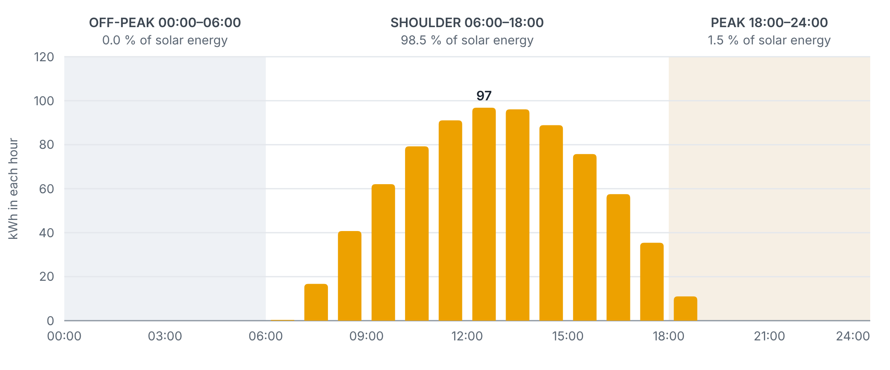
Figure 3 – Average-day solar generation by hour and tariff period (sunrise ≈ 06:50, sunset ≈ 18:56)
Period | Hotel use (MWh/yr) | Solar (MWh/yr) | Share of solar | Grid after solar (MWh/yr) | Reduction | Saving (USD/yr)
Off-peak | 2,090 | 0.0 | 0.0 % | 2,090 | 0.00 % | 0
Shoulder | 6,954 | 270.3 | 98.5 % | 6,684 | 3.89 % | 32,440
Peak | 2,956 | 4.0 | 1.5 % | 2,952 | 0.14 % | 604
Total | 12,000 | 274.4 | 100 % | 11,726 | 2.29 % | 33,044

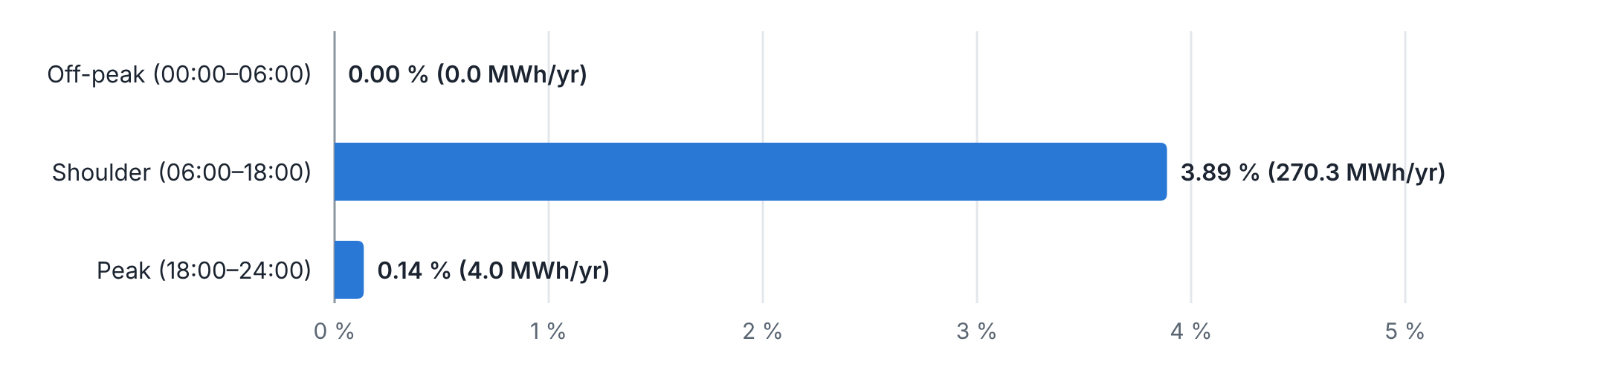
Figure 4 – Reduction of grid energy in each tariff period

What this means
- Shoulder period: 98.5 % of the solar energy is produced between 06:00 and 18:00, cutting shoulder-period grid energy by 3.9 %.
- Peak period: only 1.5 % falls in the peak period, in the last hour of daylight (18:00–19:00). Solar does not reduce the evening peak, and it does not lower a maximum-demand (kVA) charge set in the evening.
- Off-peak period: no solar generation, so no change.
- Bill impact: at these rates the energy bill falls by 2.3 %, about USD 33,044 per year. Each solar kWh is worth ≈ USD 0.120, close to the shoulder rate used in the financial analysis.
- Reducing peak-period energy would need battery storage or moving flexible loads (laundry, water heating, pool pumps) into daylight hours.
Average-day model: year-1 solar generation spread over the day at the site's sun times; hotel load assumed at 1,000,000 kWh/month with a typical hotel hourly profile. Confirm with interval-meter data.

7. Cost Estimate (Bill of Quantities)
Budget turnkey (EPC) estimate in US dollars, based on 2026 East African market prices for commercial rooftop systems. Accuracy ±15 %.
No. | Description | Qty | Rate | Amount (USD)
1 | PV modules, 620 Wp bifacial TOPCon, Tier-1 (landed, cleared) | 299 nos | USD 0.150/Wp | 27,807
2 | String inverters, 80 kW, 1,100 V, multi-MPPT (incl. comms) | 2 nos | USD 4,800 each | 9,600
3 | Mounting structure, aluminium, 10° tilt, ballasted/anchored, incl. roof pads | 185.4 kWp | USD 0.090/Wp | 16,684
4 | DC system: 6 mm² PV cable, MC4 connectors, DC isolators, SPD Type II | Lot | USD 0.040/Wp | 7,415
5 | AC system: AC combiner panel, 250 A MCCB, 4C×120 mm² Cu XLPE to main LV board (≈80 m), cable tray | Lot | Lump sum | 9,500
6 | Zero-export controller, CT/power meter, data logger & remote monitoring | 1 set | Lump sum | 3,500
7 | Earthing, equipotential bonding & lightning protection integration | Lot | Lump sum | 3,000
8 | Roof walkways, safety lifeline & water point for cleaning | Lot | Lump sum | 3,500
9 | Installation, testing & commissioning (labour, supervision, lifting) | 185.4 kWp | USD 0.060/Wp | 11,123
10 | Engineering: detailed design, structural check of slab, PVsyst, as-builts | Lot | Lump sum | 4,000
11 | Approvals & utility interface (ERA / UEDCL), O&M manuals, training | Lot | Lump sum | 2,000
12 | Transport, logistics & customs clearing | Lot | Lump sum | 4,000
 | Sub-total |  |  | 102,129
 | Contingency (7 %) |  |  | 7,149
 | Total budget EPC cost (excluding taxes) |  |  | 109,278
 | Specific cost |  |  | 0.589 USD/Wp
Excludes VAT, withholding tax and import duties (solar equipment is generally zero-rated or exempt in Uganda; confirm with URA), roof waterproofing upgrades, structural strengthening if required, and utility charges. Annual O&M is estimated at USD 1,311/yr (≈1.2 % of capex), escalating at 3 %/yr. The Enerack structure quote ERKI20261104TP (USD 11,303.92 CIF Mombasa, as quoted) falls within item 3, which also covers ballast blocks, pads, clearing and inland transport.

8. Financial Analysis
Investment (EPC, excluding taxes) | USD 109,278
Avoided grid tariff (year 1) / escalation | USD 0.12/kWh / 2 % per year
Year-1 savings | USD 32,923
Inverter replacement (year 12) | USD 9,600
Simple payback | 3.4 years
Project IRR (25 years, unlevered) | 30.1 %
NPV at 10 % discount rate | USD 207,408
Levelised cost of energy (LCOE) | USD 0.053/kWh
25-year cumulative savings, net of O&M | USD 934,239

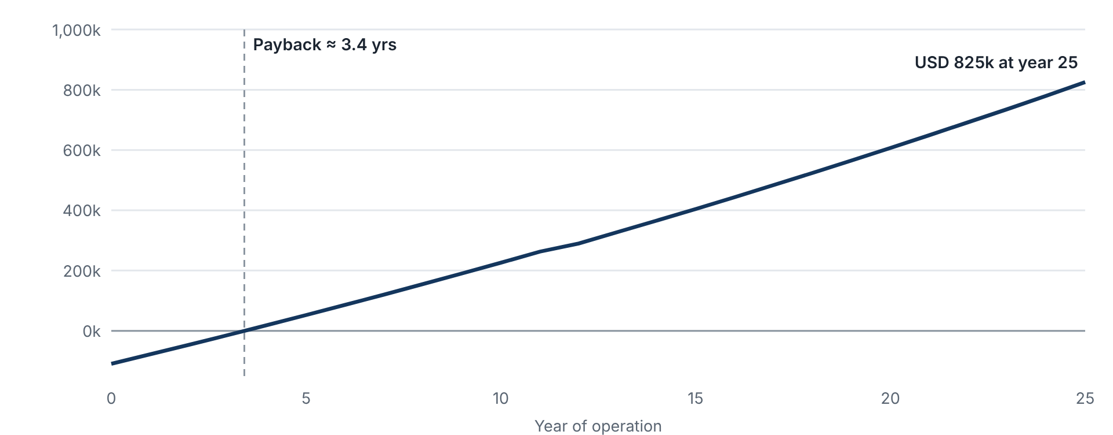
Figure 5 – Cumulative net cash flow (USD)

Tariff sensitivity
Avoided tariff (USD/kWh) | Payback (yrs) | IRR | NPV @ 10 % (USD)
0.09 | 4.6 | 22 % | 123,694
0.10 | 4.1 | 25 % | 151,599
0.12 | 3.4 | 30 % | 207,408
0.14 | 2.9 | 35 % | 263,217
0.16 | 2.5 | 40 % | 319,026

Annual cash flow (selected years, USD)
Year | Generation (MWh) | Tariff (USD/kWh) | Savings | O&M | Replacement | Net cash flow | Cumulative
0 |  |  |  |  |  | -109,278 | -109,278
1 | 274.4 | 0.120 | 32,923 | 1,311 | – | 31,612 | -77,666
2 | 270.5 | 0.122 | 33,113 | 1,350 | – | 31,763 | -45,903
3 | 269.4 | 0.125 | 33,640 | 1,391 | – | 32,249 | -13,653
4 | 268.4 | 0.127 | 34,176 | 1,433 | – | 32,743 | 19,090
5 | 267.3 | 0.130 | 34,720 | 1,476 | – | 33,244 | 52,334
6 | 266.2 | 0.133 | 35,273 | 1,520 | – | 33,753 | 86,087
8 | 264.1 | 0.138 | 36,405 | 1,612 | – | 34,792 | 155,149
10 | 262.0 | 0.143 | 37,573 | 1,711 | – | 35,863 | 226,335
12 | 259.9 | 0.149 | 38,779 | 1,815 | 9,600 | 27,364 | 290,108
15 | 256.8 | 0.158 | 40,661 | 1,983 | – | 38,678 | 404,411
20 | 251.7 | 0.175 | 44,002 | 2,299 | – | 41,703 | 606,789
25 | 246.7 | 0.193 | 47,618 | 2,665 | – | 44,953 | 824,961

9. Expansion Options
The target of about 500 kWp exceeds what the architect's solar zone on the mezzanine roof can hold. Because the hotel load is around ten times the PV output, every additional kWp would also be fully self-consumed, so expansion can be added in stages without a battery.
Option | Capacity | Year-1 energy | Budget cost (USD) | Remarks
Phase 1 – mezzanine roof (this report) | 185.4 kWp | 274 MWh | 109,278 | Ready for detailed design
Other roofs (left podium roof ≈370 m², lobby roof) | ≈ 65–120 kWp | ≈ 95–180 MWh | ≈ 38,000–68,000 | Survey and structural check required
Car-park solar canopies | ≈ 150–250 kWp | ≈ 220–370 MWh | ≈ 0.75–0.85 USD/Wp | Adds shaded parking; steel canopy cost
Indicative total | ≈ 400–555 kWp | ≈ 590–825 MWh |  | ≈ 5–7 % of hotel consumption

10. Assumptions, Exclusions and Next Steps

10.1 Key assumptions
- Roof geometry is taken from drawing D18102-DD-A-104; PV is limited to the architect's solar zones.
- The roof slab can carry the ballasted structure and wind loads without strengthening, subject to verification by the structural engineer.
- The hotel load is about 1,000,000 kWh per month with a continuous daytime demand well above 160 kW.
- The avoided tariff is USD 0.12/kWh escalating at 2 %/yr, to be confirmed from the latest utility bills.
- Prices are 2026 East African market levels in USD, excluding taxes.

10.2 Exclusions
- Battery storage, diesel-generator synchronisation and export metering.
- Roof waterproofing renewal, structural strengthening, and civil works to the LV room.
- Utility network upgrades, permit fees and financing costs.

10.3 Recommended next steps
- Obtain 12 months of utility bills or interval-meter data and confirm the tariff structure.
- Obtain the Enerack structural calculation (loads per foot, ballast weights) and have the building structural engineer approve the roof load.
- Confirm the inverter location, AC cable route and spare way on the main LV switchboard.
- Run a PVsyst simulation with site coordinates and the selected module and inverter datasheets.
- Issue the tender package (layout, single-line diagram, specification, BOQ) to qualified EPC contractors.
- Start the Phase 2 survey of other roofs and the car park.

