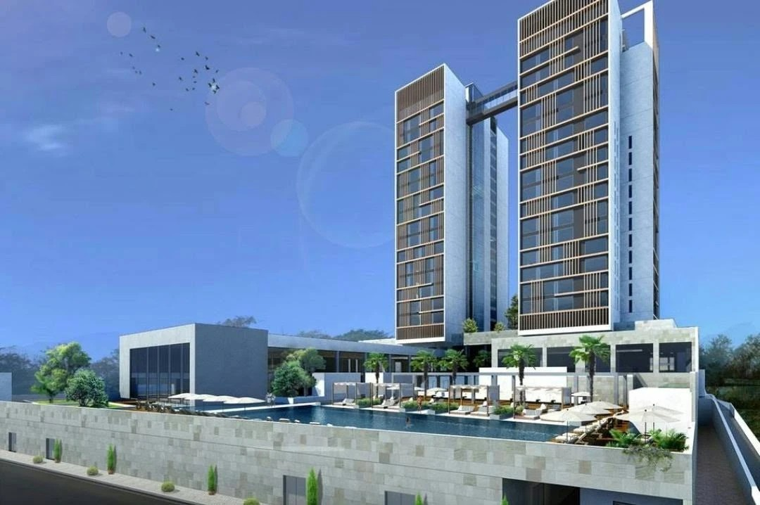

TECHNICAL REPORT · ROAD TO GREEN

Rooftop Solar PV System
Design Basis & Cost Estimate
Marriott Hotel – Mezzanine Roof – Phase 1
Document No. | NILESUN POWER RF002
Revision | B – Updated costing and financials
Date | 9 November 2026
Client | Kampala Marriott Hotel
System capacity | 185.4 kWp DC / 160 kW AC, grid-tied

Prepared by NileSun Power Limited
2026.11.04
Document Control

Rev | Date | Description | Prepared | Checked | Approved
A | 3/11/2026 | Version A | Mahil Fernando | Prasanna Dissanayake | Manjula Perera

Reference documents
Reference | Title
D18102-DD-A-104 | Mezzanine floor plan incl. roof PV zones (architect)
PV-LAY-D18102-002 | PV layout with ballast structure, 10° tilt
EPJ-26110401 V1.0 | Mounting structure drawings (2P and 1P tables)

Contents
Contents
Reference documents 2
Contents 2
1. Executive Summary 3
Key findings 3
Recommendation 3
2. Site and Design Basis 4
2.1 Site and load 4
3.Estimation PV Solar Generation 5
4. Solar Impact on Time-of-Use Tariff 5
3.PV Array Layout 6
4. Electrical Design 7
4.1 Configuration 7
4.3 Single-line arrangement 7
5 Cost Estimate (Bill of Quantities) 8
7. Financial Analysis 8
Tariff sensitivity 9
Annual cash flow (selected years, USD) 9
8. Expansion Options 10
9. Assumptions, Exclusions and Next Steps 10
9.1 Key assumptions 10
9.2 Exclusions 10

1. Executive Summary
This report sets out the design basis, layout, energy yield and budget cost for a grid-tied rooftop solar photovoltaic (PV) system on the mezzanine-level roof of the Marriott Hotel,
The system has no battery storage and supplies the hotel's own load behind the utility meter.

185.4 kWp | 291 MWh | USD 103k | 4.0 yrs
DC capacity  (299 × 620 Wp) | Year-1 generation | Total project cost  (0.55 USD/Wp) | Simple payback

Key findings
From Energy audit and feasibility study key findings.

Item | Value
Roof area (mezzanine roof) | 1,150 m² (Available area for solar installation)
Plant capacity | 185.4 kWp
Modules | 299 × 620 Wp (13 rows of 23 solar modules)
Structure | Fixed-tilt ballast structure, 10°
Inverters | 2 × 80 kW (160 kW AC)
Hotel consumption | 981,901 kWh/month (UEDCL bill, Oct 2026)
Self-consumption | 100% (no export, no battery)
Year-1 generation | 291 MWh (2.5% of annual consumption) – PVsyst P50
Avoided tariff | USD 0.0871/kWh (UGX 357/kWh shoulder tariff, as billed)
Year-1 savings | USD 25,343
Total project cost | USD 102,789
Simple payback | 4.0 years
Project IRR | 25.9%
NPV (25 years at 10%) | USD 154,964
Cost of solar energy (LCOE) | 0.040 USD/kWh
Road to 500 kWp | 315 kWp, needs other roofs or car-park canopies

Table 1: Summary of Energy Audit Finding & Recommended PV Solar Installation

Recommendation
Phase 1: Proceed with the 185.4 kWp mezzanine roof system.

Phase 2: Proceed with 250.4 kWp the car park

2. Site and Design Basis

2.1 Site and load

Facility | Marriott Hotel –PV on the mezzanine-level roof
Location | 0°18'11.34"N, 32°35'13.76"E
Roof | Flat reinforced-concrete slab, single level, with parapet.
Annual electricity consumption | 11,782,812 kWh (October 2026 bill × 12)
Average monthly energy consumption | 981,901 kWh (UEDCL bill, 01/10–01/11/2026)
Average / daytime demand | ≈ 1,348 kW average in the shoulder band; maximum demand 1,836 kW
Grid connection | Behind-the-meter, LV main switchboard
Energy storage | None

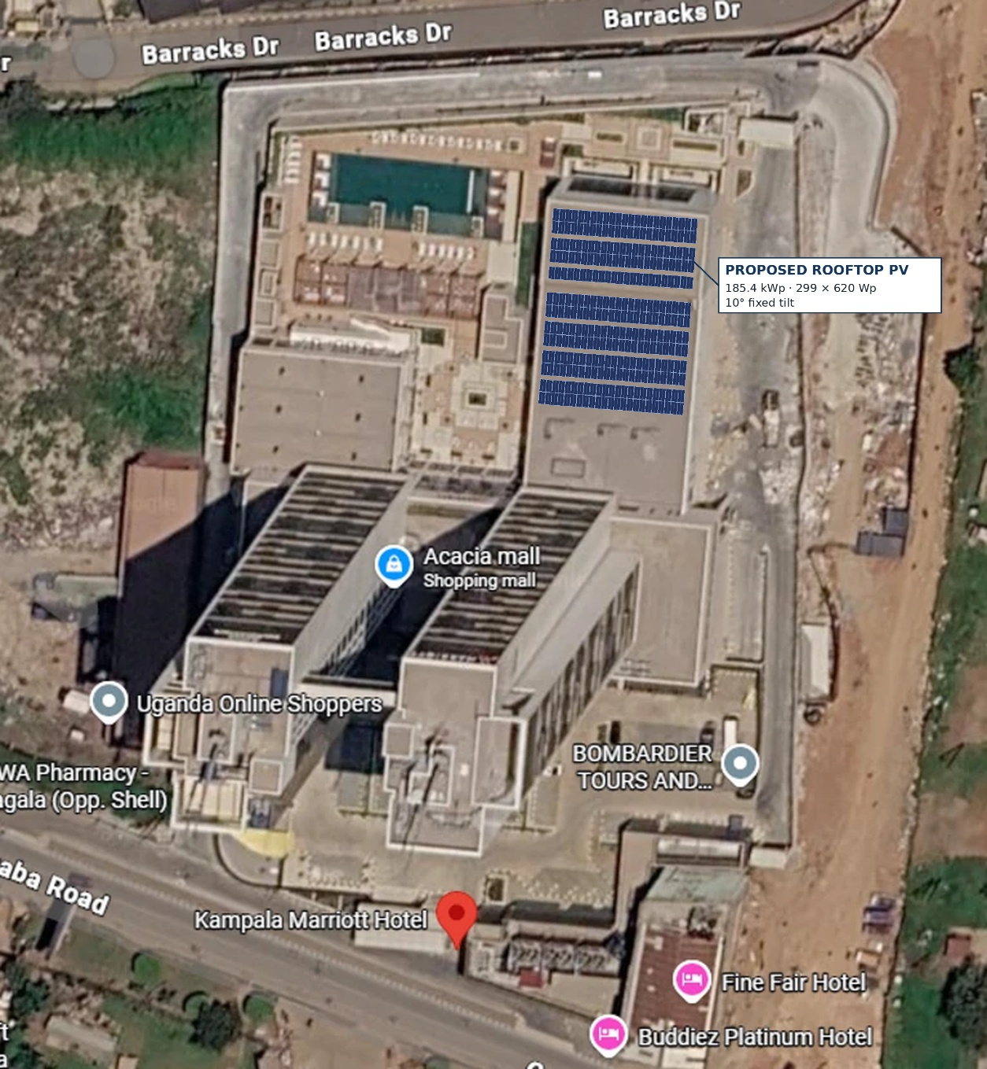

Figure 1: PV module installation on the mezzanine roof ( AI Generated )

3. Estimation of PV Solar Generation
- Year-1 generation 291,051 kWh, on average 24,254 kWh/month and 797 kWh/day
- 25-year generation 6,871 MWh*
- share of hotel uses 100 %, 2.5 % of annual consumption

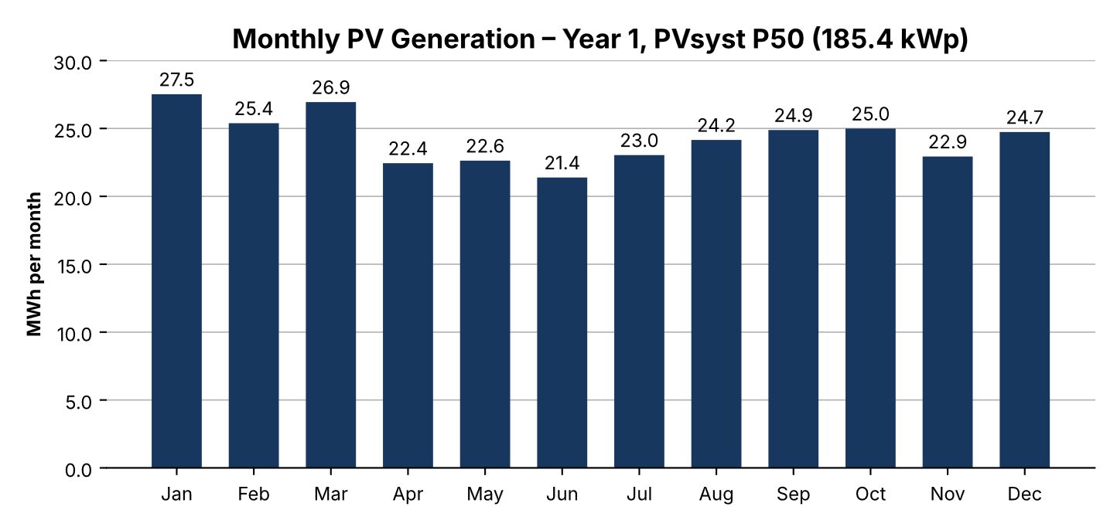

*1.0 % degradation in year 1, then 0.4 %/yr

Source: PVsyst V8.1.8 simulation (P50, Meteonorm 9.0 weather, performance ratio 85.4 %, specific yield 1,570 kWh/kWp) – Annex 7. Output is highest from January to March and lowest in June.
The best month is about 29 % above the lowest. The hotel load is higher than the PV output in every hour, so all this energy is used on site. Figures are P50 as simulated, before shading and soiling losses (P90 ≈ 8 % lower).

4. Solar Impact on Time-of-Use Tariff
The hotel is billed on a time-of-use (TOU) tariff, so each kWh is worth a different amount depending on when it is used.

Tariff period | Hours | Tariff UGX/kWh → USD/kWh (UGX 4,100/USD)
Off-peak | 00:00–06:00 | 286.5 → 0.0699
Shoulder | 06:00–18:00 | 357.0 → 0.0871
Peak | 18:00–24:00 | 428.8 → 0.1046

Table 2: UEDCL tariff 30.2 Large Consumers (bill Oct 2026), tariffs as billed excl. VAT, at UGX 4,100/USD
Period | Hotel use (kWh/yr) | Solar (MWh/yr) | Share of solar | Grid after solar (kWh/yr) | Reduction | Cost before (USD/yr) | Cost after (USD/yr) | Saving (USD/yr)
Off-peak | 2,765 | 0.0 | 0.0% | 2,765 | 0.00% | 193,201 | 193,201 | 0
Shoulder | 6,016 | 291.1 | 100.0% | 5,725 | 4.84% | 523,795 | 498,452 | 25,343
Peak | 3,002 | 0.0 | 0.0% | 3,002 | 0.00% | 314,008 | 314,008 | 0
Total | 11,783 | 291.1 | 100.0% | 11,492 | 2.47% | 1,031,004 | 1,005,661 | 25,343

Table 3 : Energy reduction percentage & cost saving per year
*Annual energy demand = UEDCL bill for October 2026 (981,901 kWh) × 12, split by tariff band as billed. All solar output (including the small output just after 18:00) is counted in the shoulder period. The demand charge (UGX 11,096/kW) is not reduced by solar.

5. PV Array Layout
Each row holds 23 modules on Enerack R80 rails 26,630 mm long, supported by 11 frames per table at 2,600 mm centers. The upper block carries two 2P tables and one 1P table; the lower block carries four 2P tables.
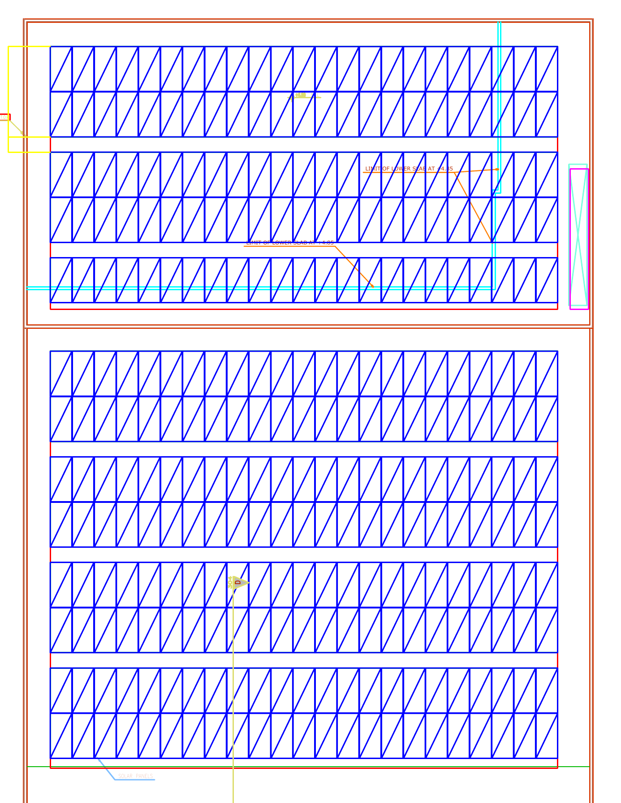

Upper Block A

Lower Block B

Zone | Tables | Rows | Modules | kWp
Upper block A | 2 × 2P + 1 × 1P | 5 | 115 | 71.3
Lower block B | 4 × 2P | 8 | 184 | 114.1
Total | 7 tables | 13 | 299 | 185.4

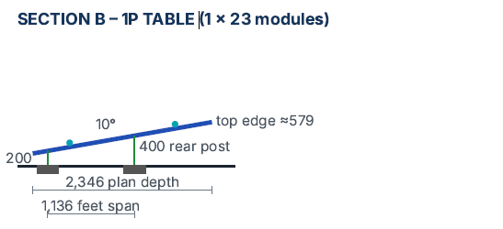
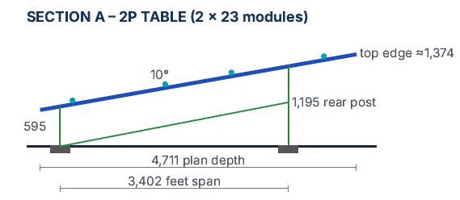

Figure 4 : PV Layout and Table Structure details,

6. Electrical Design

6.1 Configuration
Item | Inverter INV-01 | Inverter INV-02 | Total
Rated AC power | 80 kW | 80 kW | 160 kW
Strings | 8 × 19 modules | 3 × 19 + 5 × 18 modules | 16 strings
Modules | 152 | 147 | 299
DC capacity | 94.2 kWp | 91.1 kWp | 185.4 kWp
DC/AC ratio | 1.18 | 1.14 | 1.16

Table 5: System Configuration & Inverter Capacity of each block

6.2 Single-line arrangement
- PV strings: 4 mm² double-insulated PV cable through the cable trays, via a DC isolator and a Type II DC SPD for every string, to the inverters on the roof in a shaded, ventilated location.
- Inverters (400 V, 3-phase) → AC combiner panel with 2 × 160 A MCCB incomers, Type II AC SPD and 400 A roof isolator.
- AC combiner panel → 4C × 240 mm² Cu XLPE/SWA → existing Masterpact NW10 H1 (1000 A) solar incomer on the main LV switchboard.
- Earthing: panel-to-panel bonding of the module frames, connected to the building earth and integrated with the lightning protection system.
Component | Description | Size / Quantity
Solar panels | Generate DC electricity | 299 × 620 W = 185.4 kWp
Inverters | Convert DC power to AC power | 2 × 80 kW
AC combiner panel | Joins both inverter outputs on the roof | 1 panel, 400 A
Main switchboard | Where solar and grid power meet (hotel LV room) | Existing, 1000 A
Utility grid (UEDCL) | Supplies the rest of the hotel's electricity | Existing supply
Expected generation | Solar energy used by the hotel each year | 291,000 kWh/yr  (24,250 kWh/month)
Table 6 each item and in the block and Size/Quantity
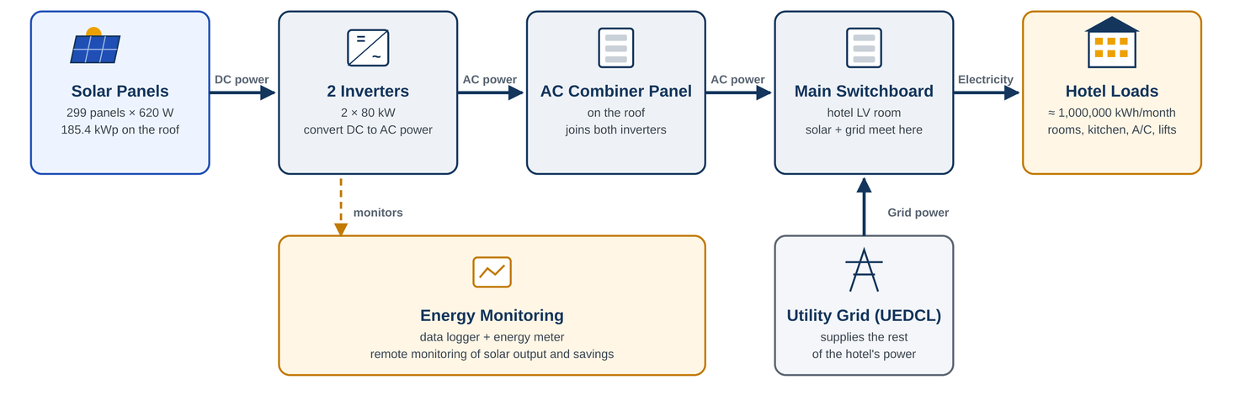
Figure 5 : Roof Top PV System Block Diagram

7. Cost Estimate (Bill of Quantities)

No. | Description | Qty | Rate (USD) | Amount (USD)
1 | Supply of PV modules, 620 Wp (299 Nos Modules) | 185.4 kWp | 0.185 | 34,378
2 | Supply of String inverters, 80 kW | 2 nos | 4,000 | 8,000
3 | Supply of Mounting structure per Wp | 185.4 kWp | 0.095 | 17,634
4 | Supply of DC system | Lot | USD 0.029/Wp | 5,376
5 | Supply of AC system | Lot | Lump sum | 6,245
6 | Earthing, equipotential bonding & lightning protection integration | Lot | Lump sum | 1,847
7 | Installation, testing & commissioning | Lot | Lump sum | 15,279
8 | Transport, logistics & customs clearing | Lot | Lump sum | 8,650
 | Sub-total |  |  | 97,409
 | Contingency |  | 7 % | 5,380
 | Total Project Value (excluding taxes) |  |  | 102,789
 | Specific cost |  |  | 0.554 USD/Wp

Table 7: Project Cost Estimation

8. Financial Analysis
The solar system needs a total investment of USD 102,789 (total project value, excluding taxes). At the avoided shoulder tariff of USD 0.0871/kWh (UGX 357/kWh as billed, excl. VAT, at UGX 4,100/USD), rising 2% a year, it saves about USD 25.3k in its first year (PVsyst P50 generation).
The investment pays back in about 4.0 years. Over 25 years the project gives an IRR of 25.9% and an NPV of USD 154,964 at a 10% discount rate, with total savings of about USD 763,000.

Solar energy costs about USD 0.040/kWh, below the grid tariff, so every unit generated reduces the hotel’s electricity cost. No O&M or inverter-replacement cost is included in the cash flow.

Total investment (excluding taxes) | USD 102,789
Avoided grid tariff (year 1) / escalation | USD 0.0871/kWh (shoulder) / 2 % per year
Year-1 savings | USD 25,343
Simple payback | 4.0 years
Project IRR (25 years, unlevered) | 25.9 %
NPV at 10 % discount rate | USD 154,964
Levelized cost of energy (LCOE) | USD 0.040/kWh
25-year cumulative savings | USD 763,309

Table 8 : Financial Analysis

Tariff sensitivity
The base case uses the shoulder tariff from the October 2026 bill, UGX 357/kWh (USD 0.0871/kWh at UGX 4,100/USD). If the 40 % energy rebate shown on the bill is applied to the saved energy, the avoided cost falls to USD 0.0522/kWh; if VAT on electricity cannot be recovered it rises to USD 0.1027/kWh. Each USD 0.01/kWh change in the avoided tariff moves the NPV by about USD 29.6k. The break-even tariff (NPV = 0 at 10 %) is about USD 0.035/kWh, roughly 60 % below the current shoulder tariff.

Avoided tariff (USD/kWh) | Payback (yrs) | IRR | NPV 10 % (USD)
0.0522 (with 40 % rebate) | 6.5 | 15.7% | 51,863
0.0700 | 4.9 | 21.0% | 104,424
0.0871 (base – bill tariff) | 4.0 | 25.9% | 154,964
0.1000 | 3.5 | 29.6% | 193,230
0.1027 (VAT not recoverable) | 3.4 | 30.4% | 201,359
Table 9: Tariff Sensitivity

Annual cash flow (selected years, USD)
For an investment of USD 102,789, the system saves about USD 25.3k in its first year, rising with the tariff*. The investment is recovered in about 4.0 years, and over 25 years the hotel's cumulative net cash flow reaches USD 660,520.

Year | Generation (kWh) | Tariff (USD/kWh) | Savings | Net cash flow | Cumulative
0 |  |  |  | (102,789) | (102,789)
1 | 291,051 | 0.087 | 25,343 | 25,343 | (77,446)
2 | 286,988 | 0.089 | 25,489 | 25,489 | (51,957)
3 | 285,840 | 0.091 | 25,895 | 25,895 | (26,063)
4 | 284,697 | 0.092 | 26,307 | 26,307 | 244
5 | 283,558 | 0.094 | 26,726 | 26,726 | 26,970
6 | 282,424 | 0.096 | 27,151 | 27,151 | 54,121
7 | 281,294 | 0.098 | 27,583 | 27,583 | 81,704
8 | 280,169 | 0.100 | 28,022 | 28,022 | 109,726
9 | 279,048 | 0.102 | 28,469 | 28,469 | 138,195
10 | 277,932 | 0.104 | 28,922 | 28,922 | 167,116
12 | 275,713 | 0.108 | 29,850 | 29,850 | 226,349
15 | 272,418 | 0.115 | 31,298 | 31,298 | 318,780
18 | 269,162 | 0.122 | 32,817 | 32,817 | 415,697
20 | 267,013 | 0.127 | 33,870 | 33,870 | 482,906
25 | 261,715 | 0.140 | 36,654 | 36,654 | 660,520

Table 10: Annual Cash Flow
*Grid price saved for each kWh of solar. Starts at USD 0.087 (UGX 357/kWh shoulder tariff) and rises 2% a year to about USD 0.140 by year 25.

9. Expansion Options

The target of about 500 kWp exceeds what the architect's solar zone on the mezzanine roof can hold. Because the hotel load is around ten times the PV output, every additional kWp would also be fully self-consumed, so expansion can be added in stages without a battery.
Option | Capacity | Year-1 energy | Budget cost (USD) | Remarks
Phase 1 – mezzanine roof (this report) | 185.4 kWp | 291 MWh | 102,789 | Ready for detailed design
Phase 2 – car-park solar canopies | 250 kWp | 370 MWh | 187,500 | Adds shaded parking; steel canopy cost
Indicative total | 435 kWp | 661 MWh | 290,289 | 5.6 % of hotel consumption

10. Assumptions, Exclusions and Next Steps

Key assumptions
- The hotel used 981,901 kWh in October 2026 (UEDCL bill) with an average daytime demand of about 1,348 kW – far above the 160 kW PV output.
- The avoided tariff is the UEDCL shoulder tariff as billed, UGX 357/kWh ≈ USD 0.0871/kWh at UGX 4,100/USD (excl. VAT), escalating 2 %/yr. The bill also shows a 40 % energy rebate; if it is applied to the solar savings the value is USD 0.0522/kWh.
- Prices are 2026 East African market levels in USD, excluding taxes.
- Energy yield from the PVsyst V8.1.8 simulation, P50 as simulated (291,051 kWh/yr); shading and soiling are not yet modelled and a P90 year is about 8 % lower.

Exclusions
- Battery storage, diesel-generator synchronisation and export metering.
- Roof waterproofing renewal, structural strengthening, and civil works to the LV room.
- Utility network upgrades, permit fees and financing costs.

Annexes

1.Single Line Diagram
2.Layout Drawing
3.Data Sheets of Inverter
4.Data Sheet of Solar Module
5.Stuctrural Drawing
6.Quotation
7.PVsyst Simulation Report

