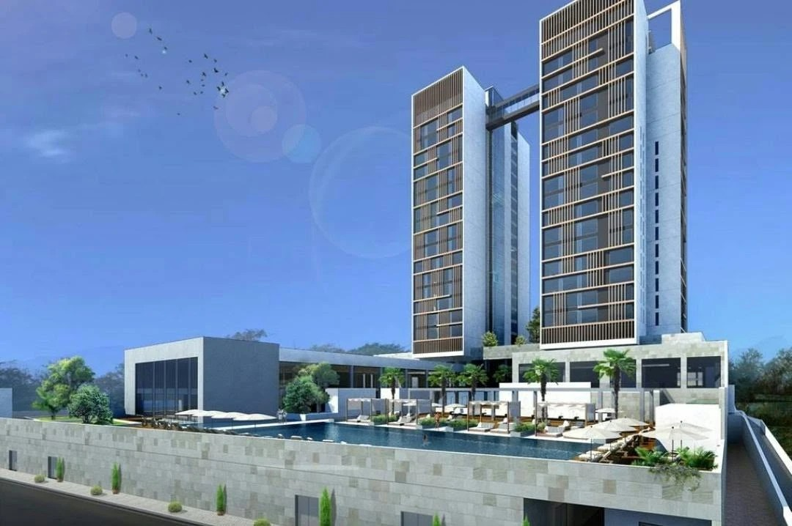

TECHNICAL & COMMERCIAL PROPOSAL
185.4 kWp Rooftop Solar PV System
Kampala Marriott Hotel – Mezzanine Roof
Prepared for | Kampala Marriott Hotel, Kampala, Uganda
Prepared by | Tororo PV Power Company Ltd.
Proposal ref. | P-KMH-PV-2026-001
Date | 5 November 2026
Validity | 30 days

1. Executive Summary
Tororo PV Power Company Ltd. is pleased to propose a turnkey 185.4 kWp grid-tied solar PV system on the mezzanine roof of the Kampala Marriott Hotel. The system generates clean electricity during the day that is used entirely by the hotel, reducing purchases from the grid. It operates with zero export and needs no battery storage.
185.4 kWp  Solar capacity | 274,362 kWh  Year-1 generation | USD 19,212  Year-1 savings | 6.1 years  Simple payback
USD 121,115  Turnkey investment | 16.6 %  Project IRR (25 yrs) | USD 71,221  NPV @ 10 % | USD 569,043  25-year net savings

Why this project makes sense
- Fast payback: the investment is recovered in about 6.1 years, and the system then keeps saving for more than 18 more years.
- Low-cost energy: solar electricity costs about USD 0.052/kWh over the system life, below the grid tariff of about USD 0.070/kWh – and grid tariffs are expected to rise.
- Every unit is used: the hotel's daytime demand is far above the solar output, so 100 % of the energy offsets grid purchases. No export, no battery.
- Sustainability: about 6.5 GWh of clean energy over 25 years, supporting the hotel's environmental commitments.
- Turnkey delivery: design, supply, installation, commissioning and handover by a single contractor, in about 12–14 weeks.

2. Site & Energy Profile
Location | Kampala Marriott Hotel, Kampala, Uganda (0°18'11.34"N, 32°35'13.76"E)
Installation area | Mezzanine-level flat concrete roof – architect's solar zone (drawing D18102-DD-A-104)
Hotel consumption | ≈ 1,000,000 kWh per month (≈ 12 GWh per year)
Grid supply | UEDCL, time-of-use tariff; main LV switchboard with 1000 A incomer
Solar resource | Equatorial site – stable output all year, ≈ 1,480 kWh per kWp per year

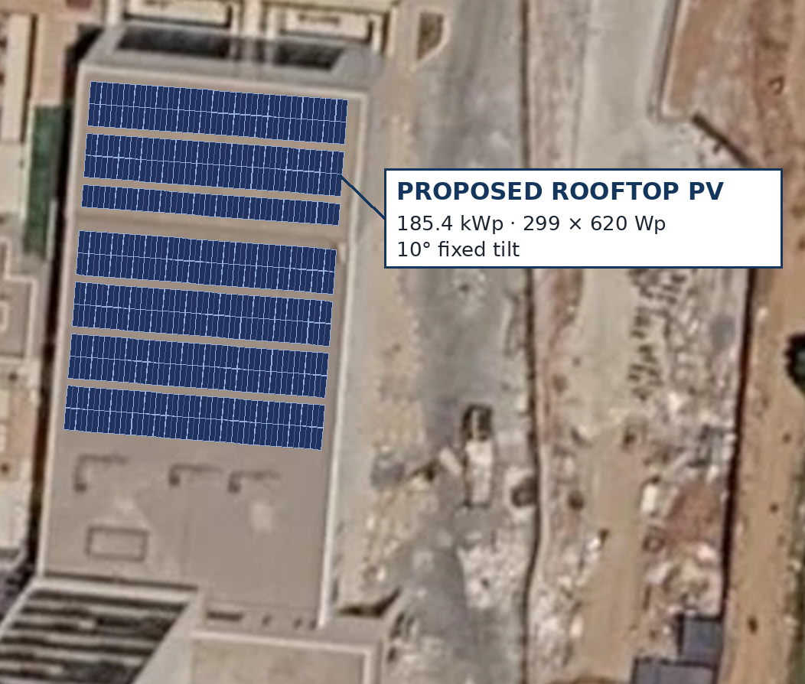
Figure 1 – Proposed PV array on the mezzanine roof (indicative visual)

3. Proposed Solution
The system is a grid-tied rooftop PV plant feeding the hotel's main LV switchboard. Solar power is always used first; the grid supplies the balance. A zero-export controller measures the hotel's grid import and limits solar output so that no power flows back to the utility.
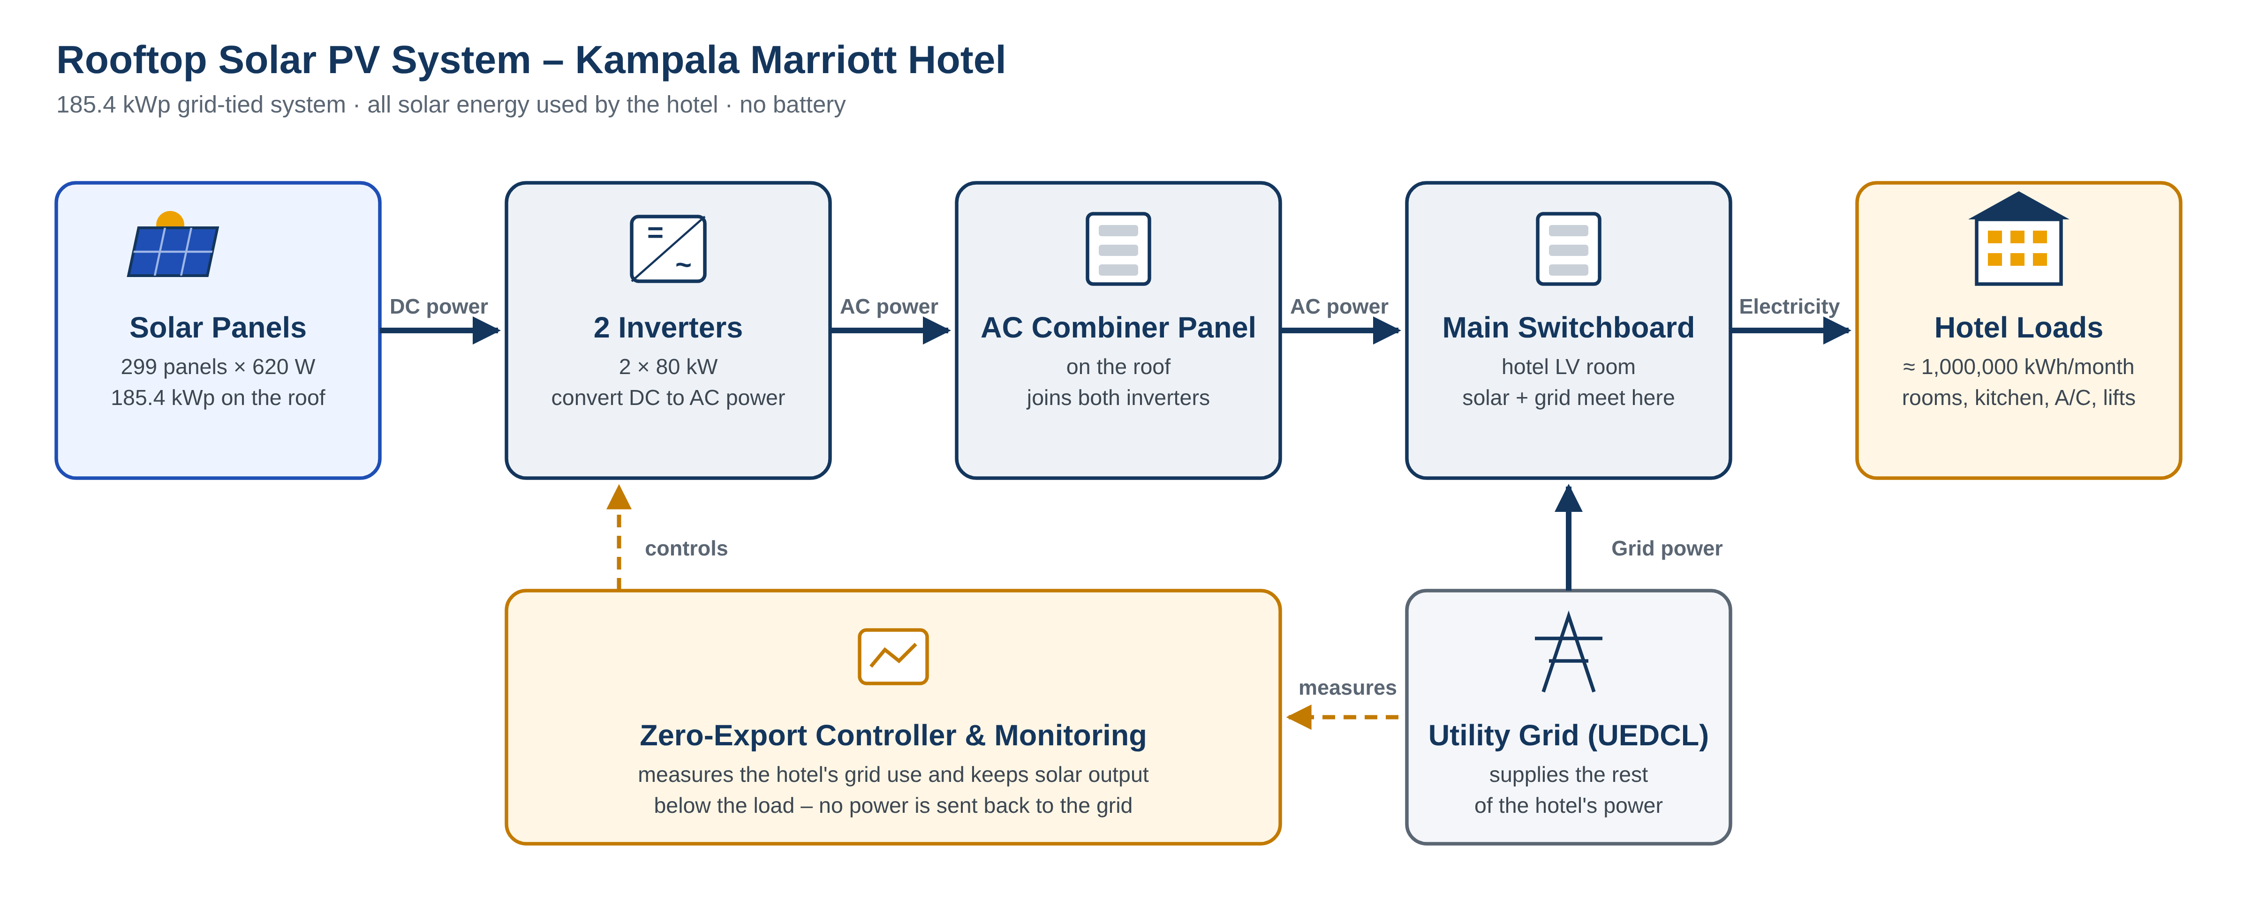
Figure 2 – System block diagram
Component | Description | Size / Quantity
Solar panels | 620 Wp bifacial N-type TOPCon, Tier-1, portrait, 10° tilt | 299 nos = 185.4 kWp
Inverters | Three-phase string inverters, 1100 V, multi-MPPT | 2 × 80 kW = 160 kW AC
Mounting structure | Ballasted aluminium system, no roof penetration | 7 tables (6 × 2P, 1 × 1P)
AC combiner panel | Joins both inverters; MCCBs, surge protection, roof isolator | 1 panel, 250 A
Grid connection | New 250 A way on the existing main LV switchboard | 1 feeder
Monitoring & control | Smart data logger, remote monitoring, zero-export control | 1 set
Earthing & protection | Array bonding, connection to building earth and lightning protection | 1 lot

4. Energy Generation
The system is expected to generate about 274,362 kWh in its first year – about 22,900 kWh per month or 750 kWh per day. Because Kampala lies on the equator, output is stable through the year: the best months (January–March) are only about 20 % above the lowest (June–July).
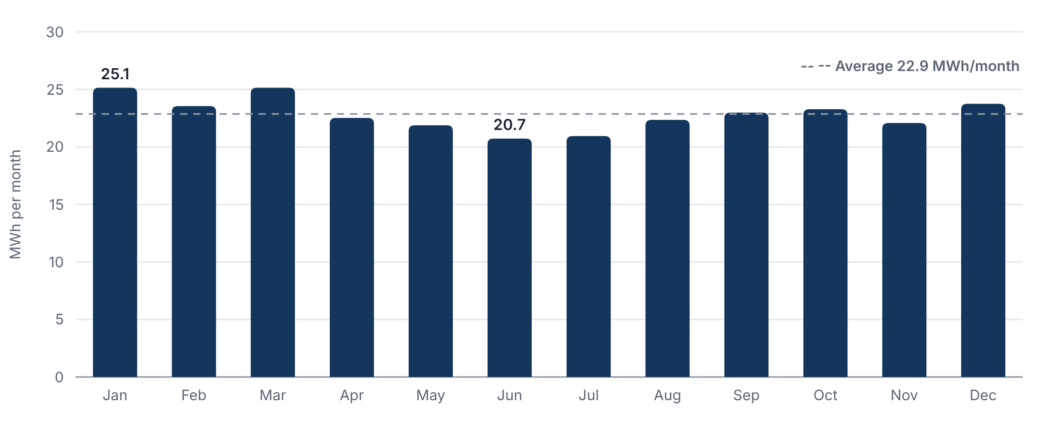
Figure 3 – Estimated monthly generation, year 1 (MWh)
Almost all generation (≈ 98.6 %) falls in the shoulder tariff period (06:00–18:00), when the hotel's demand is high, so every kWh directly reduces grid purchases. Panel output degrades slowly (about 0.4 % per year); total generation over 25 years is about 6,477 MWh.

5. Financial Analysis

5.1 Key assumptions
Turnkey investment (excl. VAT) | USD 121,115
Avoided grid tariff (year 1) | USD 0.070/kWh, escalating 2 % per year
Generation, year 1 / degradation | 274,362 kWh / 1 % in year 1, then 0.4 % per year
Inverter replacement | USD 9,600 in year 12
Discount rate / analysis period | 10 % / 25 years

5.2 Results
Year-1 savings | USD 19,212
Simple payback | 6.1 years
Project IRR (25 years) | 16.6 %
Net present value @ 10 % | USD 71,221
Levelised cost of solar energy | USD 0.052/kWh
25-year net savings (after inverter replacement) | USD 569,043

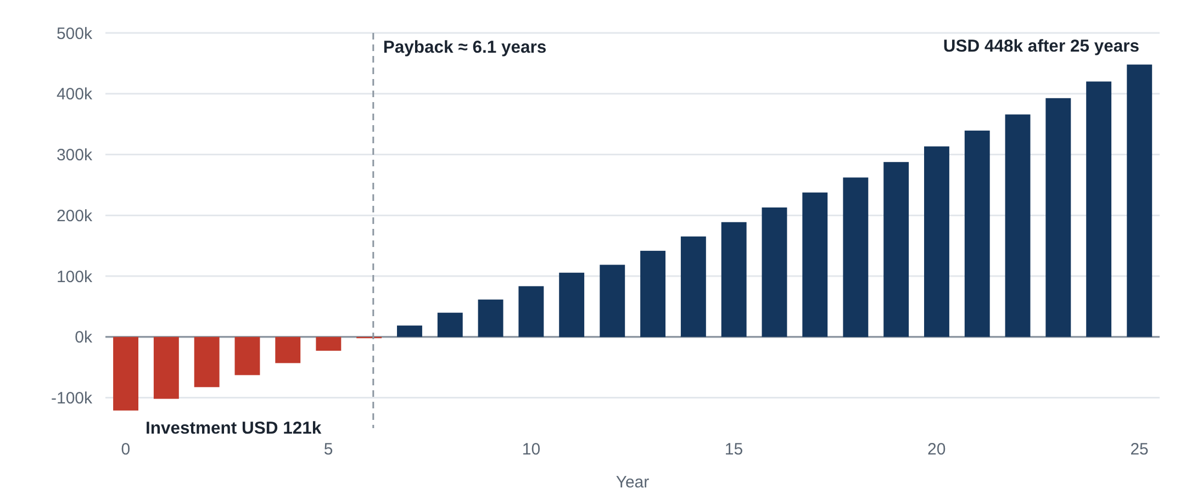
Figure 4 – Cumulative cash flow (USD)

5.3 Cash flow (selected years, USD)
Year | Generation (kWh) | Tariff (USD/kWh) | Savings | Net cash flow | Cumulative
0 |  |  |  | (121,115) | (121,115)
1 | 274,362 | 0.070 | 19,212 | 19,212 | (101,903)
2 | 270,532 | 0.071 | 19,322 | 19,322 | (82,581)
3 | 269,450 | 0.073 | 19,630 | 19,630 | (62,951)
4 | 268,372 | 0.074 | 19,942 | 19,942 | (43,009)
5 | 267,299 | 0.076 | 20,260 | 20,260 | (22,749)
6 | 266,230 | 0.077 | 20,582 | 20,582 | (2,167)
7 | 265,165 | 0.079 | 20,910 | 20,910 | 18,744
8 | 264,104 | 0.080 | 21,243 | 21,243 | 39,987
10 | 261,996 | 0.084 | 21,925 | 21,925 | 83,492
12 | 259,904 | 0.087 | 22,628 | 13,028 | 118,795
15 | 256,797 | 0.092 | 23,726 | 23,726 | 188,864
20 | 251,702 | 0.102 | 25,676 | 25,676 | 313,284
25 | 246,708 | 0.113 | 27,786 | 27,786 | 447,928
Year 12 includes the USD 9,600 inverter replacement. Values in brackets are negative (investment not yet recovered).

5.4 Tariff sensitivity
Avoided tariff (USD/kWh) | Year-1 savings (USD) | Payback (years) | IRR | NPV @ 10 % (USD)
0.05 | 13,718 | 8.4 | 11.5 % | 15,349
0.06 | 16,462 | 7.1 | 14.1 % | 43,253
0.07 | 19,205 | 6.1 | 16.6 % | 71,158
0.08 | 21,949 | 5.4 | 19.0 % | 99,062
0.09 | 24,693 | 4.8 | 21.4 % | 126,967
0.10 | 27,436 | 4.3 | 23.8 % | 154,871
The project remains attractive across a wide tariff range. The break-even tariff (NPV = 0 at 10 %) is about USD 0.044/kWh – roughly 36 % below today's tariff – which gives a strong safety margin.
Financial figures are indicative and exclude O&M costs, which can be offered separately (see Section 7).

6. Scope of Works & Project Schedule

6.1 Included
- Detailed engineering: layout, single-line diagram, string design, cable sizing and protection.
- Supply of all equipment: PV modules, inverters, mounting structure, DC and AC systems, monitoring and zero-export control.
- Transport, customs clearing and delivery to site in Kampala.
- Installation, cabling, earthing and connection to the main LV switchboard.
- Testing, commissioning, as-built documentation, operator training and handover.

6.2 Client responsibilities & exclusions
- Roof access, secure storage area, and power and water during installation.
- A spare 250 A way on the main LV switchboard and access to the LV room.
- Excluded: roof structural strengthening or waterproofing, battery storage, utility or permit fees, VAT and statutory levies.

6.3 Indicative schedule
Phase | Timing | Key output
Detailed design & approvals | Weeks 1–3 | Approved drawings, structural sign-off
Procurement & shipping | Weeks 2–10 | Equipment delivered to site
Installation | Weeks 10–13 | Structure, modules, cabling, panels
Testing & commissioning | Weeks 13–14 | System energised, handover

7. Warranties & After-Sales Support
Item | Warranty
PV modules | 12-year product warranty; 30-year linear power warranty
Inverters | 5 years (extendable)
Mounting structure | 10 years
Workmanship | 2 years from commissioning

Optional operation & maintenance (O&M) services – panel cleaning, periodic inspections, remote performance monitoring and reporting – can be provided under a separate annual agreement.

8. Commercial Offer – Quotation
Quotation No. | Q-KMH-PV-2026-001 | Date | 05-11-2026
Revision | A | Valid until | 05-12-2026 (30 days)
Client | Kampala Marriott Hotel | Supplier | Tororo PV Power Company Ltd.

No. | Scope of supply & works | Qty | Unit | Total Price (USD)
1 | PV modules – 620 Wp bifacial N-type TOPCon (Tier-1) | 299 | nos | USD 121,115
2 | String inverters – 80 kW, 1100 V, multi-MPPT | 2 | nos | USD 121,115
3 | Ballasted aluminium mounting structure, 10° tilt | 1 | lot | USD 121,115
4 | DC system – PV cable, connectors, string isolators, cable tray | 1 | lot | USD 121,115
5 | AC system – combiner panel, MCCBs, cabling to main LV switchboard | 1 | lot | USD 121,115
6 | Smart data logger, remote monitoring & zero-export control | 1 | set | USD 121,115
7 | Earthing & lightning protection integration | 1 | lot | USD 121,115
8 | Installation, testing & commissioning | 1 | lot | USD 121,115
9 | Transport, logistics & customs clearing to site | 1 | lot | USD 121,115
TOTAL TURNKEY EPC PRICE (excluding VAT and other applicable taxes) |  |  |  | USD 121,115
Equivalent to USD 0.65 per Wp. Amount in words: One hundred twenty-one thousand one hundred fifteen US Dollars only.
Price basis | Turnkey EPC – delivered, installed and commissioned at site, Kampala. Currency: USD.
Payment terms | 30 % advance with purchase order · 60 % on delivery of main equipment to site · 10 % on commissioning
Taxes | Prices exclude VAT, withholding tax and other statutory levies, charged as applicable.
Delivery | Equipment 8–10 weeks from PO and advance; installation and commissioning ≈ 4 weeks after delivery.
Warranties | Modules 12-yr product / 30-yr power · inverters 5 yrs · structure 10 yrs · workmanship 2 yrs
Notes | Final quantities subject to detailed engineering and site survey. Exclusions as listed in Section 6.2.

For Tororo PV Power Company Ltd.  Signature / Name / Date | Accepted by Kampala Marriott Hotel  Signature / Name / Date

9. Next Steps
- Review of this proposal and clarification meeting with the hotel's engineering team.
- Site survey: roof condition, LV switchboard, cable route and inverter location.
- Confirmation of the tariff from recent utility bills and structural review of the roof.
- Purchase order and advance payment – project start.

We thank the Kampala Marriott Hotel for the opportunity and look forward to delivering this project together.
Contact: Mr. Mahil · +94 773 55 96 82 · mahil@windforce.lk

