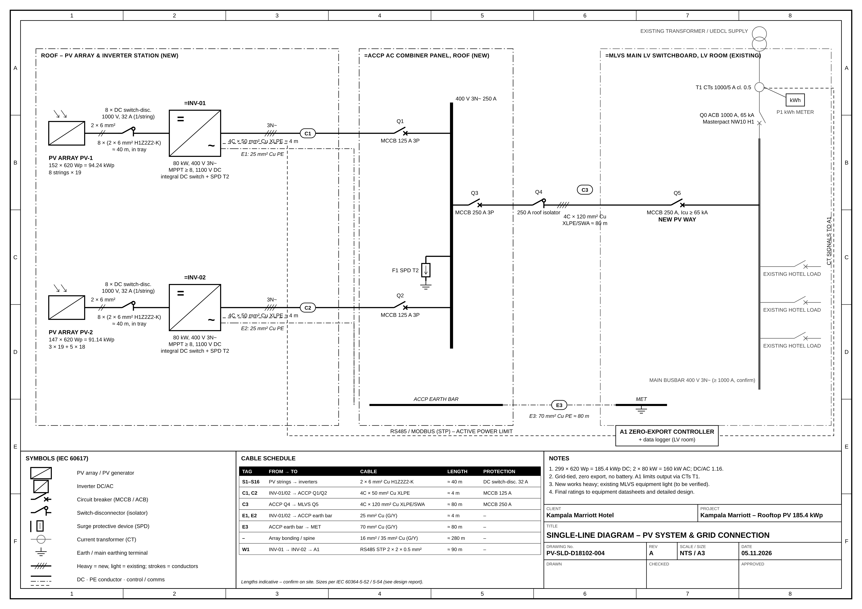
Figure – Single-line diagram, 185.4 kWp rooftop PV (drawing PV-SLD-D18102-004 Rev A)

