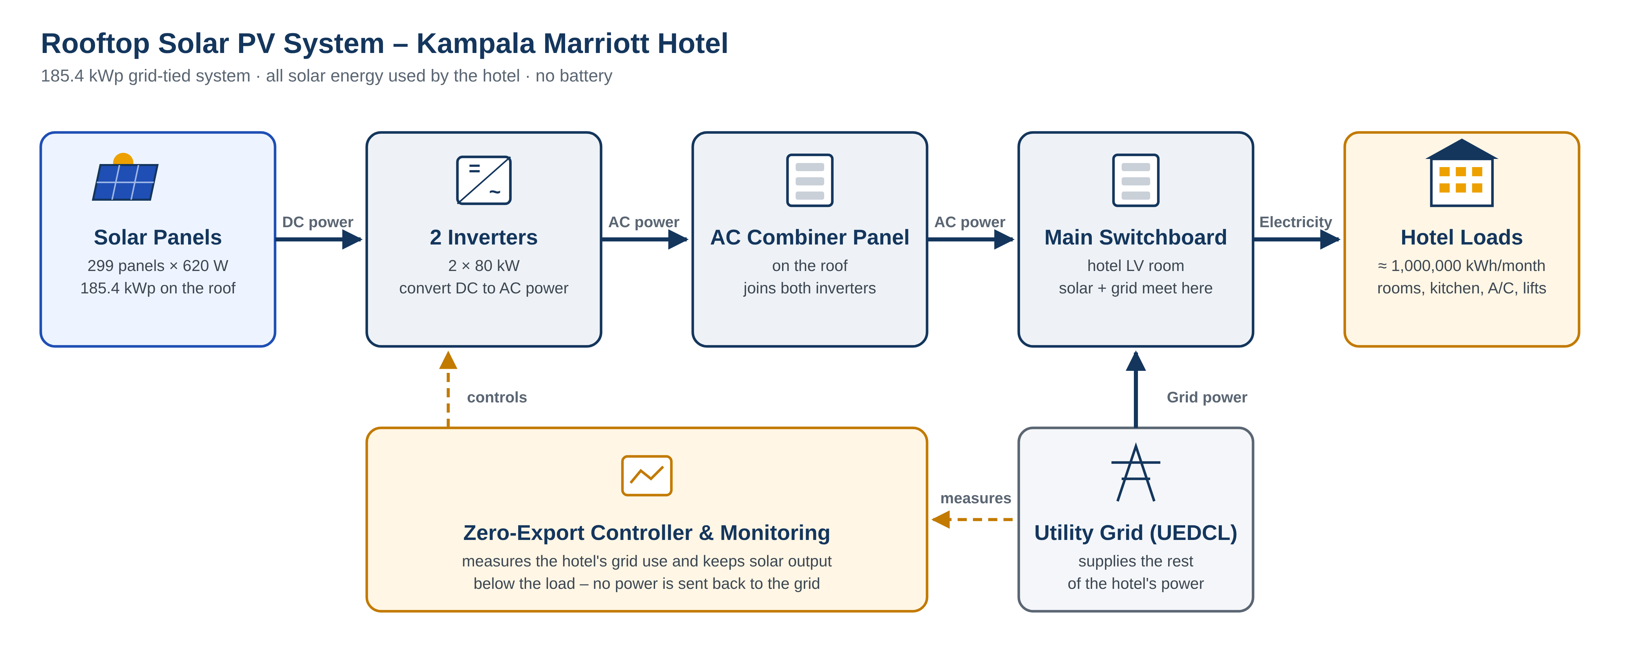
Figure – Rooftop solar PV system block diagram
Component | Description | Size / Quantity
Solar panels | Generate DC electricity from sunlight on the roof | 299 × 620 W = 185.4 kWp
Inverters | Convert DC power to AC power for the hotel | 2 × 80 kW
AC combiner panel | Joins both inverter outputs on the roof | 1 panel, 250 A
Main switchboard | Where solar and grid power meet (hotel LV room) | Existing, 1000 A
Zero-export controller | Keeps solar below hotel use – no export to the grid | 1 unit with monitoring
Utility grid (UEDCL) | Supplies the rest of the hotel's electricity | Existing supply
Expected generation | Solar energy used by the hotel each year | ≈ 274,000 kWh/yr (≈ 22,900 kWh/month)

