Assignment 1
Attrition Prediction

1. Exploratory Data Analysis

The given datset has 2466 No instances and 474 Yes instances of Attrition i.e the response variable. This is an unbalanced class problem. So imblearn.over_sampling.SMOTE can be used to resolve this class imbalance. But later on it is seen that even applying SMOTE doesn’t affect the predictions much as the Cohen’s Kappa is found to be good for this dataset when Random Forest is applied to it.

A graph is plotted for Attrition v/s Gender and it is found that not much depends on it. Attrition is not much dependent on Gender.
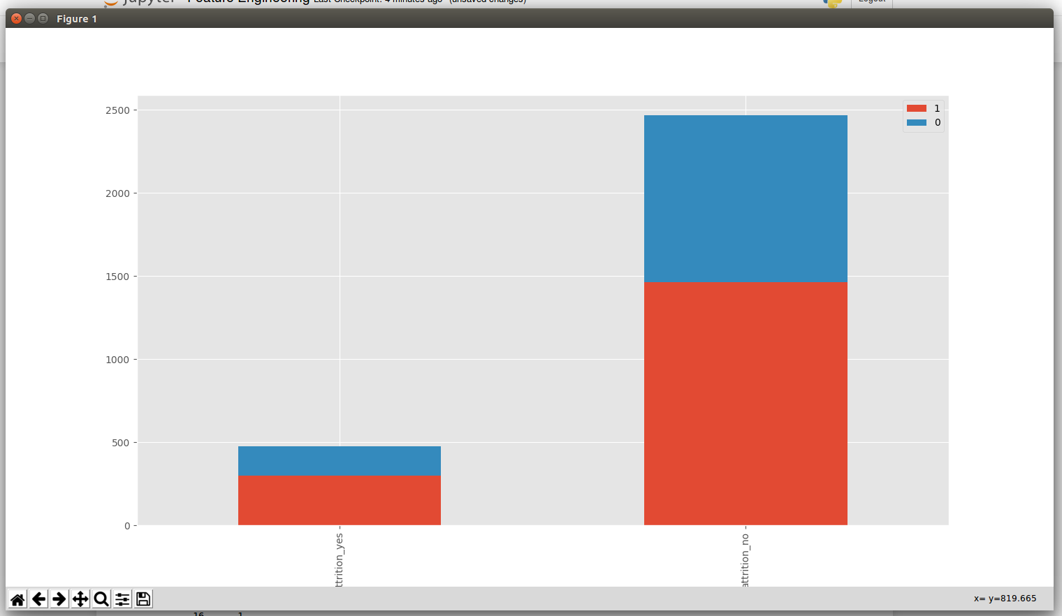
Below graph was obtained. Blue is for females and red for males.

A graph is plotted for Attrition v/s DistanceFromHome and it is found that ones having more distant houses are more likely to have Attrition_yes. Attrition therefore seems to be dependent on DistanceFromHome to some extent.

Below graph was obtained. Blue is for females and red for males. 0 to 4 in the graph is very far from office to very near from office.
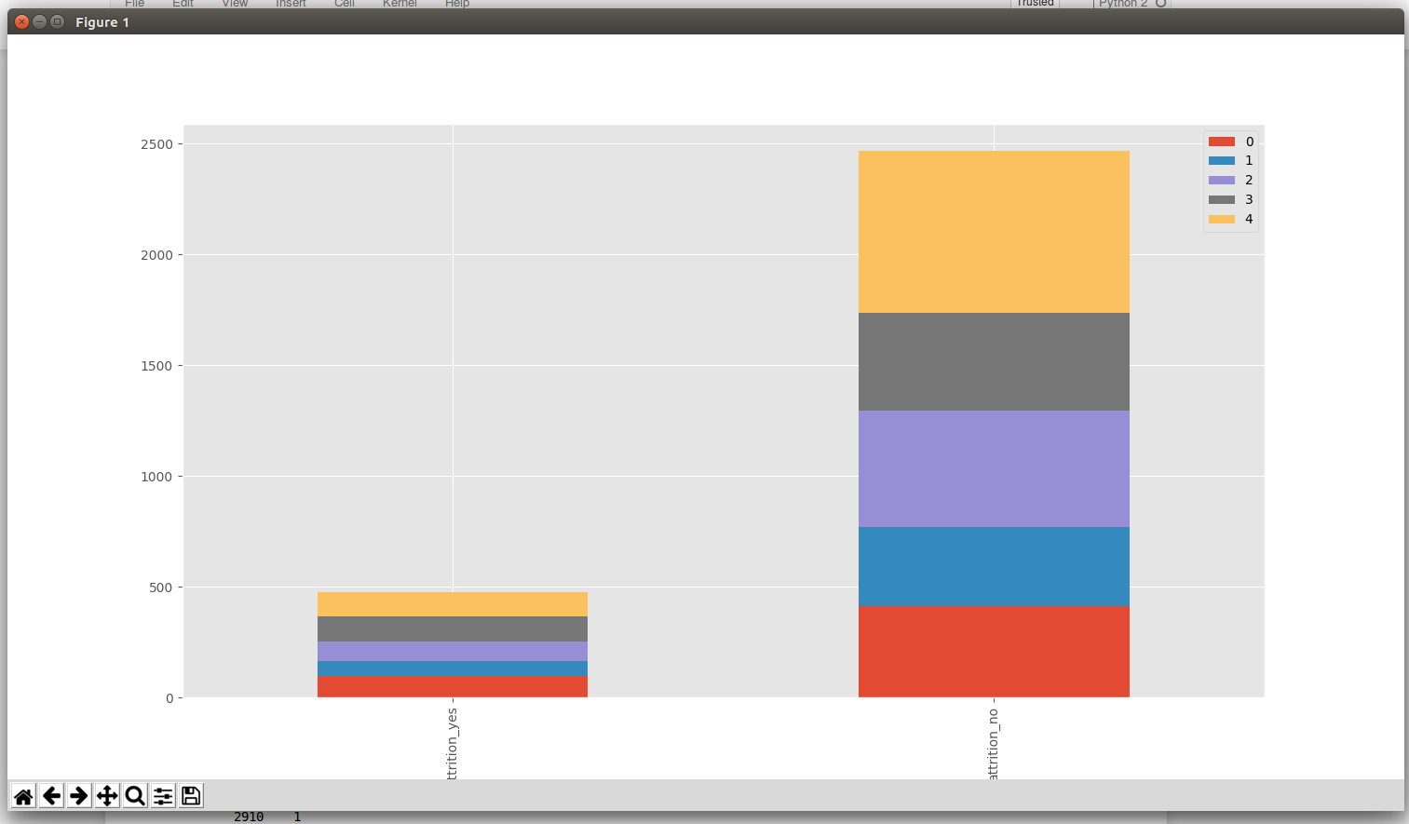
Similarly to find out which predictor affects the reponse more and to better visualize the data a feature importance graph is plotted by the Random Forest Classifier. It arranges the predictors in an ascending order of importance. According to it JobLevel, Overtime, JobRole, MaritalStatus are the leading predictor variables along with others.

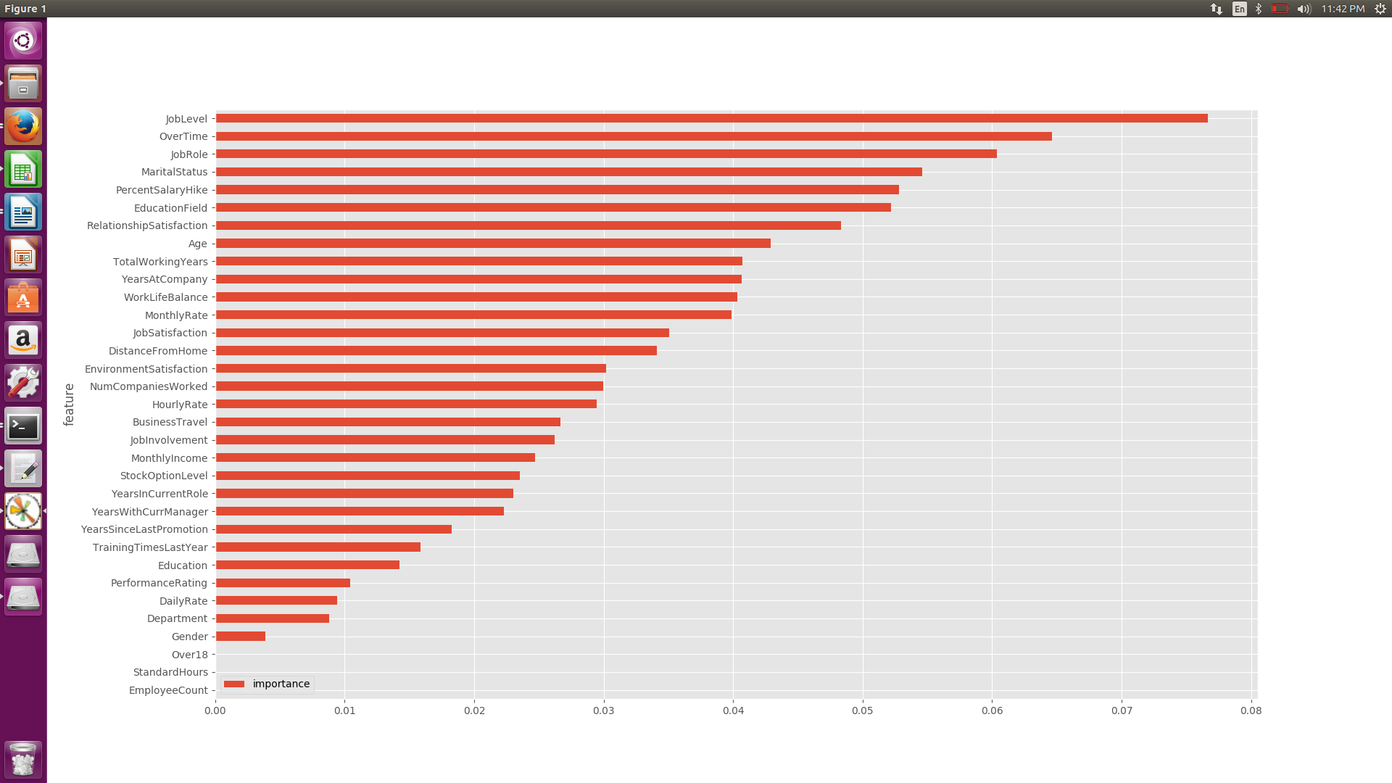
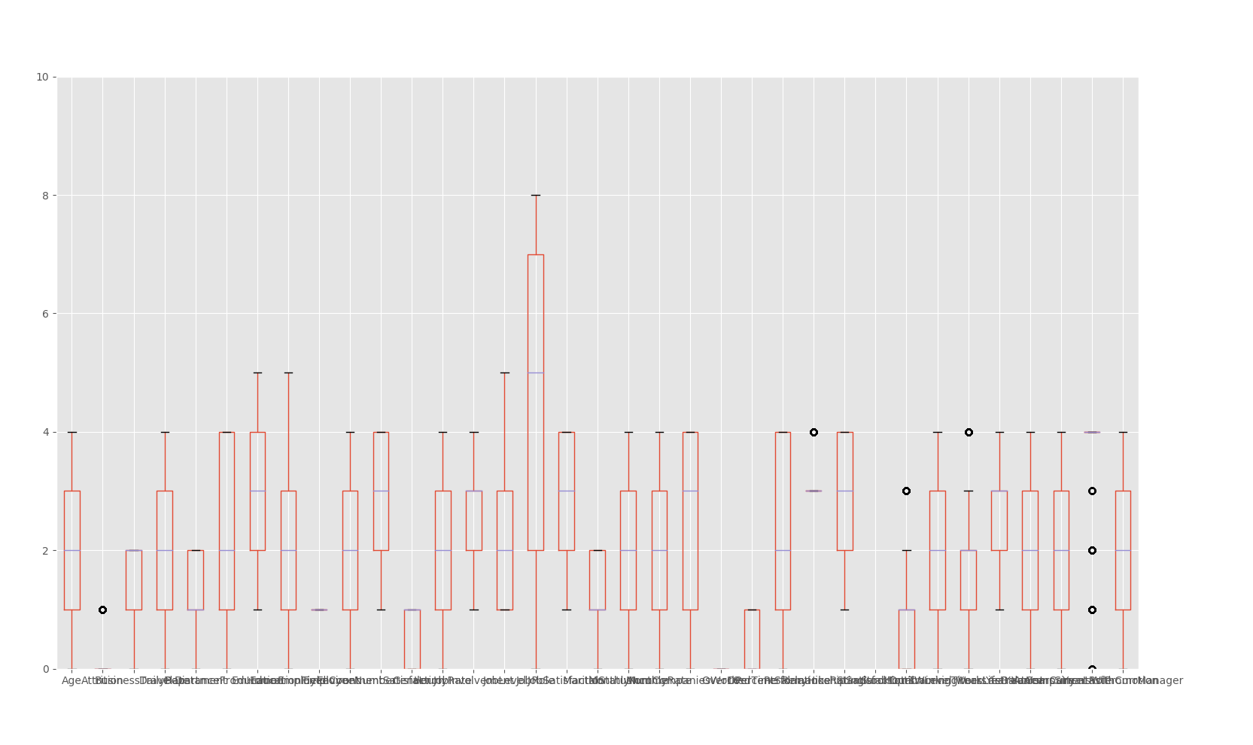
It is common to consider boxplot as an informal test for the existence of outliers. Any data not included between the whiskers is plotted as an outlier with a dot, small circle, or star. So the Boxplot is plotted to check for outliers in the dataset and we find some outliers lying in the data. So the rows with values lying only within twice the standard deviation of the column are kept, rest are removed.The below boxplot was plotted after removing outliers and as can be seen many of them have been removed.
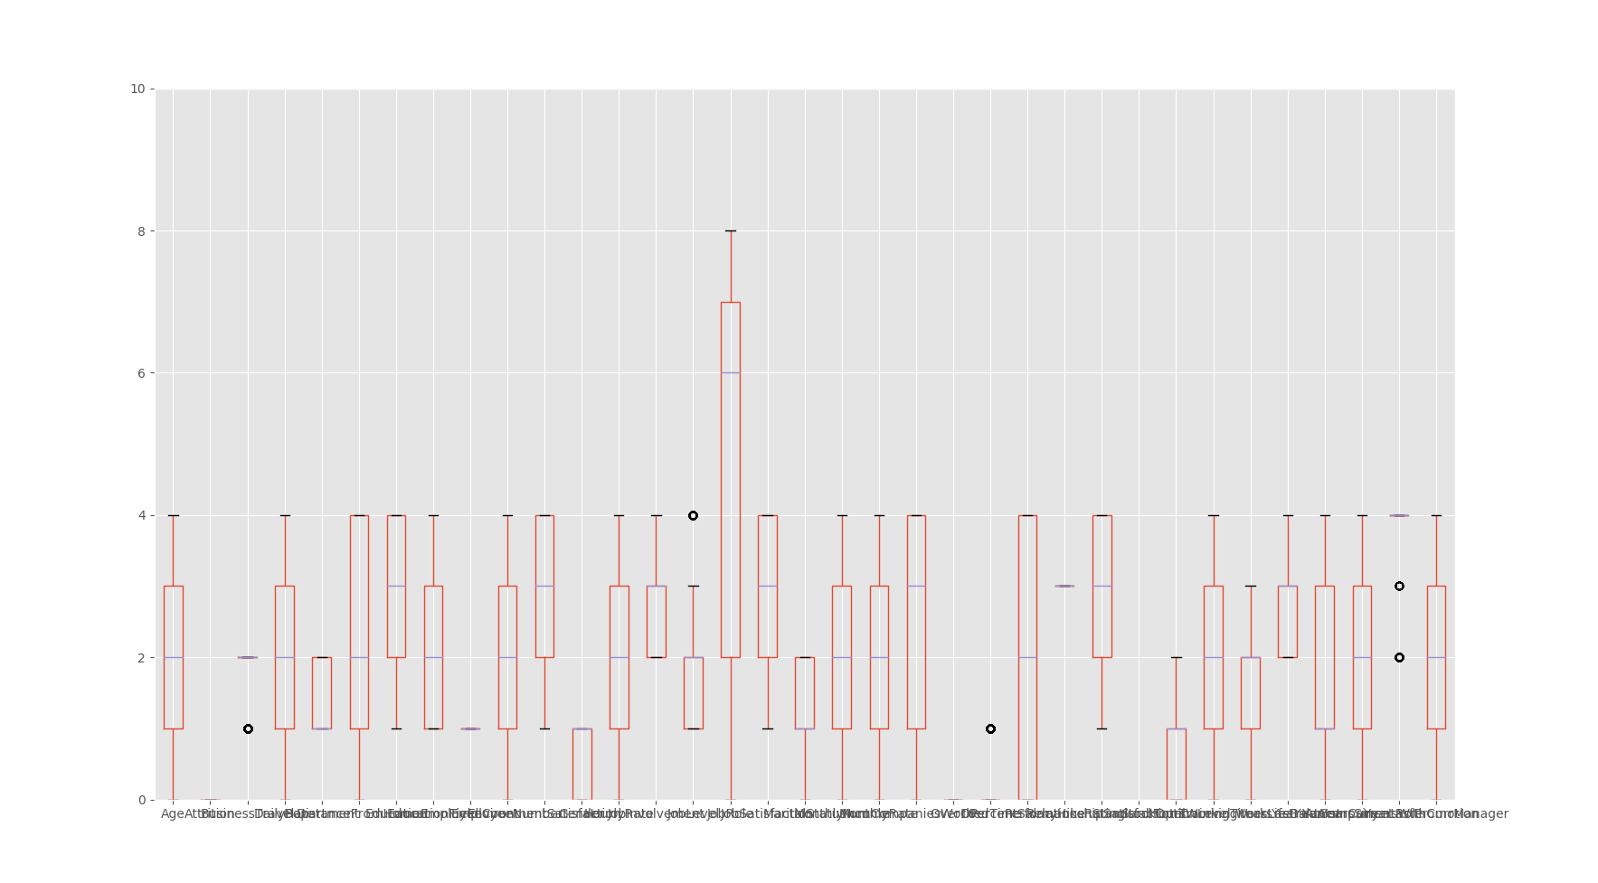
2. Converting Continuous variables to categorical variables

In the given columns of dataset there are certain columns which are already categorical and there are some others which are continuous. Quantile cut is used to divide the data into 5 buckets with labels "very low", "low", "medium","high" and "very high". It discretizes variable into equal-sized buckets based on rank or based on sample quantiles. There were certain columns on which qcut threw an errror because qcut() makes sure that the bins bounderies are unique before passing them to _bins_to_cuts. So in that case simply pandas.cut was used to divide them into buckets. And the columns which could not be divided into 5 buckets were left the way they were as number of buckets formed in them were less.

3. Prediction algorithms

The given dataset was divided into train and test to avoid overfitting and check the accuracy of the model.
Random Forest is applied to the data for prediction along with other models and it is found that Random Forest givs the best accuracy. The point of Random Forest is to prevent overfitting. It does this by creating random subsets of the features and building smaller (shallow) trees using the subsets and then it combines the subtrees. It also provided the feature importance graph implying that all the features are not equally affecting the Respone variable.

Decision tree, SVM, Naive Bayes, Logistic Regression and K neighbour classifier do not give a significant accuracy and the cohen’s kappa and the roc_auc_score are too low which shows the are not a good model for this case.
A decision tree is built using the whole dataset considering all features,but in random forests a fraction of the number of rows is selected at random and a particular number of features are selected at random to train on and a decision tree is built on this subset. Because of this reason the accuracy is coming out to be less in decision tree than Random Forest. Decision tree overfits the training data which is giving poor results for unseen data. So, to overcome this limitation ensemble model is used. In ensemble model results from different models are combined.
Naive bayes classifier assumes that the presence (or absence) of a particular feature of a class is unrelated to the presence (or absence) of any other feature and treats them all equally thus affecting the accuracy of the model in this case.

SVM is generally good in text classification problems. SVMs do not perform well on highly skewed/imbalanced data sets i.e. data sets in which the number of samples that fall in one of the classes far outnumber those that are a member of the other class which is the case with us.

The ROC curve is the sensitivity (True Positive Rate) as a function of fall-out (False Positive Rate). As can be seen from their confusion matrix we get in the result, roc score is justified.

4. Result Visualization

Confusion matrix obtained as a result indicates the number of False Negatives, True Negatives, True Positives and False Positives.
This was the confusion matrix obtained from the best model for the dataset i.e. random forest with leaf size=1.
[[484 2]
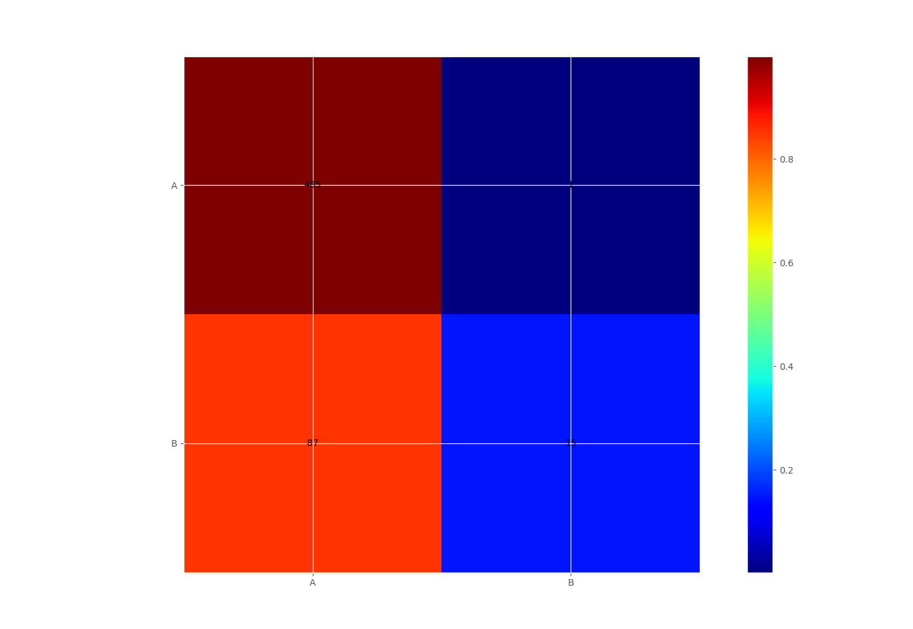
[ 24 78]]

___________________________________________________________________________________________________END_________________________________

