**OSOC**

**1: grep pattern filename**

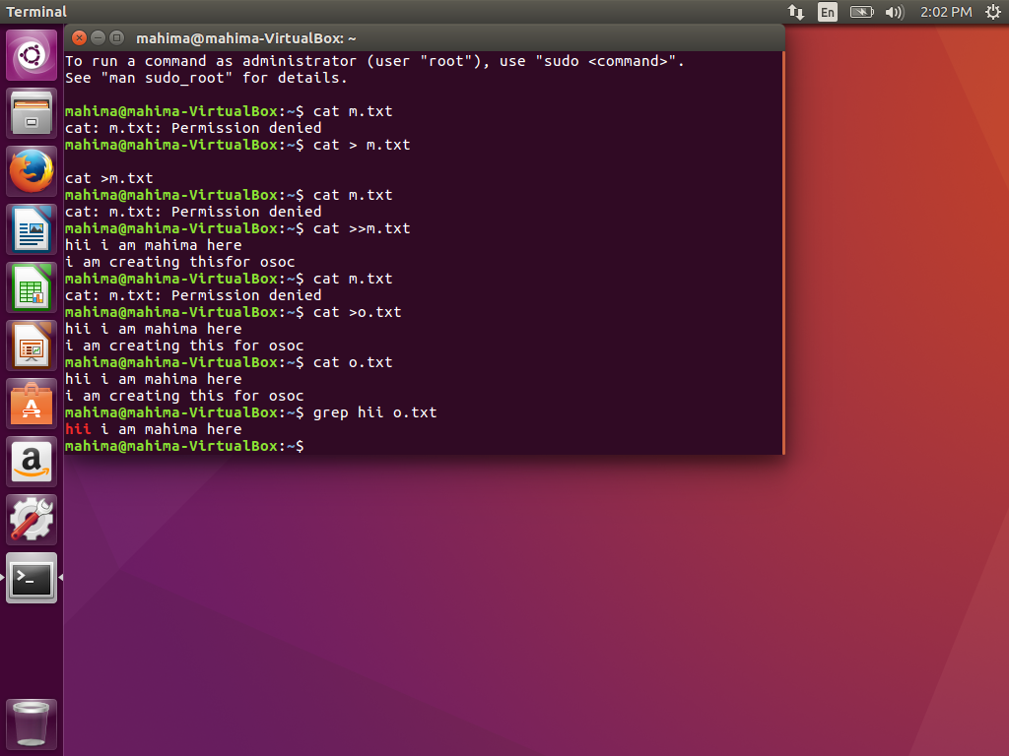

**2:**

**There three types of permissions in linux are-**

1. **r-read**
2. **w-write**
3. **x-execute**

**Permissions group are-**

1. **u-owner**
2. **g-group**
3. **o-others**
4. **a-all users**

Ways of changing permissions-

a- chmod u+r,u+w,u+x,u-w,u-r,u-x

chmod a+r,a+w,a+x, a-r,a-w,a-x

b- we can assign number to give permissions-

1 for permission and 0 for no permission

Since numbers are treated in binary so 7 means all the permissions and 0 means no permission.

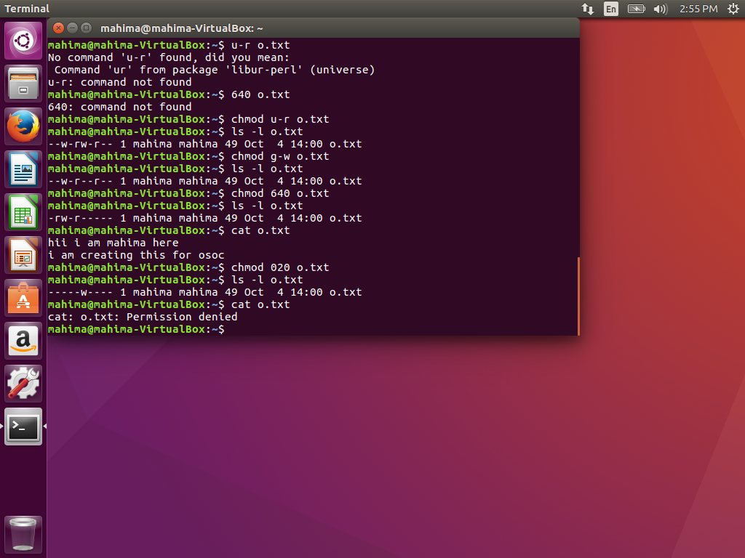

3: 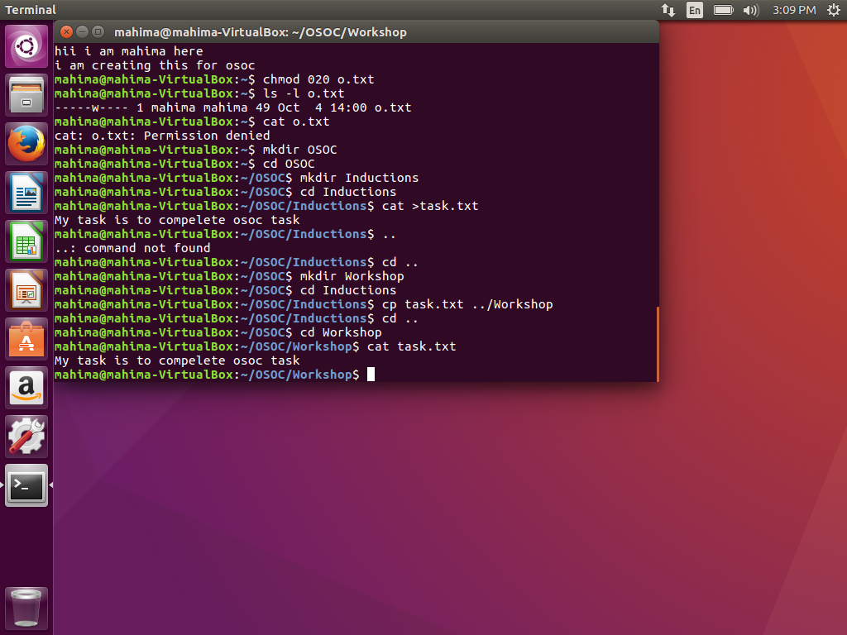

4: ping command is used to check whether the specific network can be reached or not.

5: sudo passwd username is used to change password of other user.

6: Sorting an array

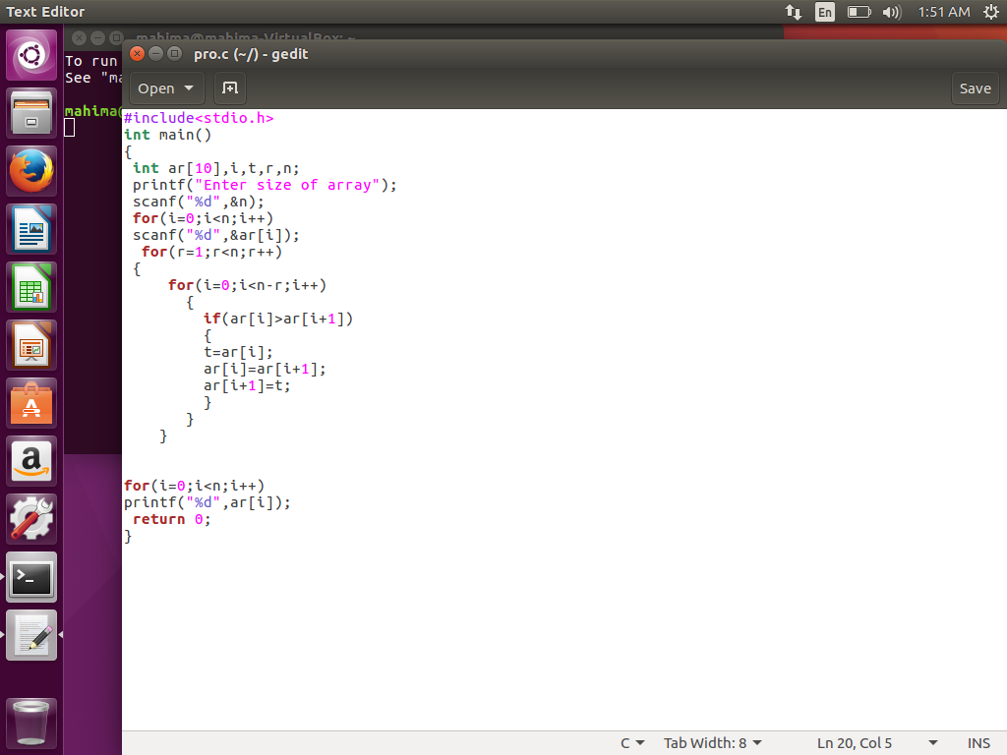

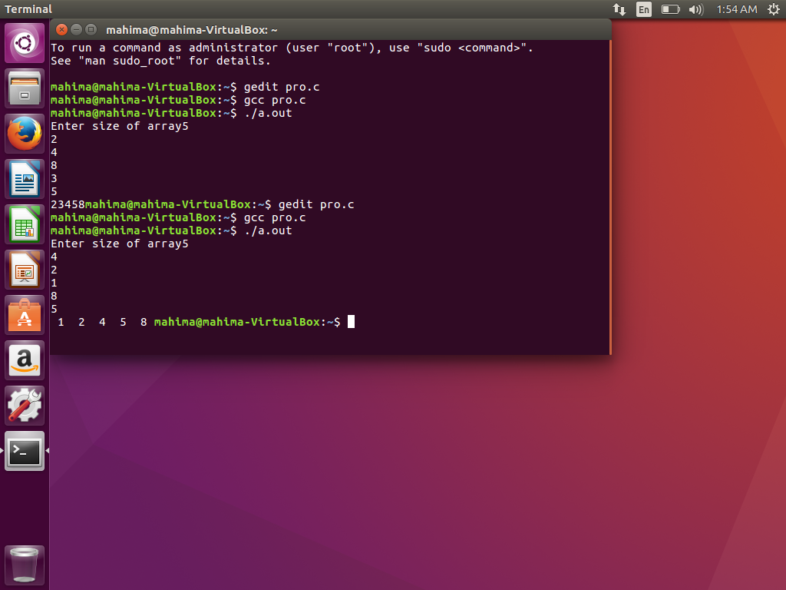

7: String Reverse

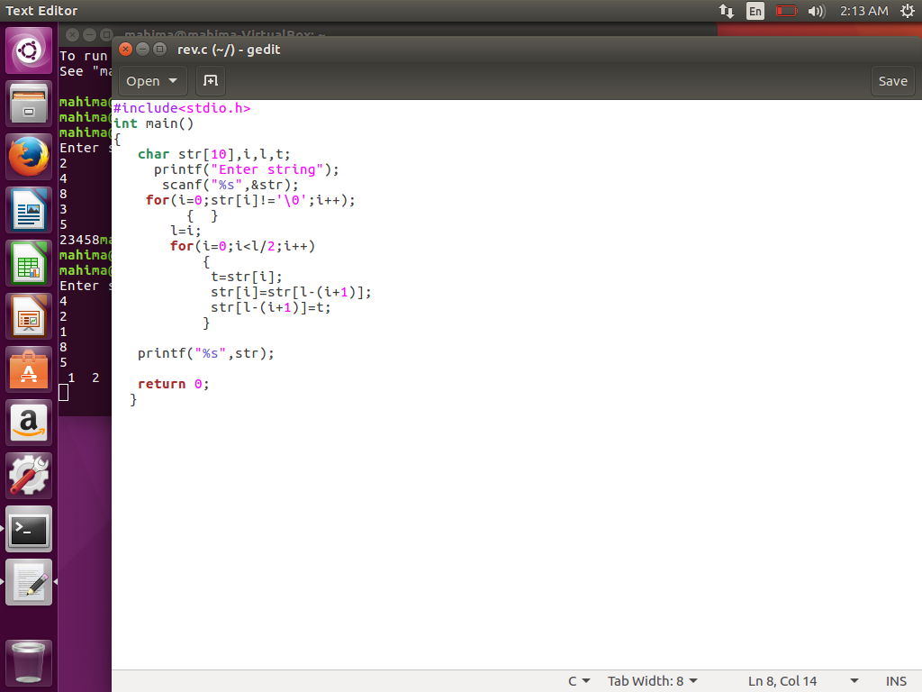

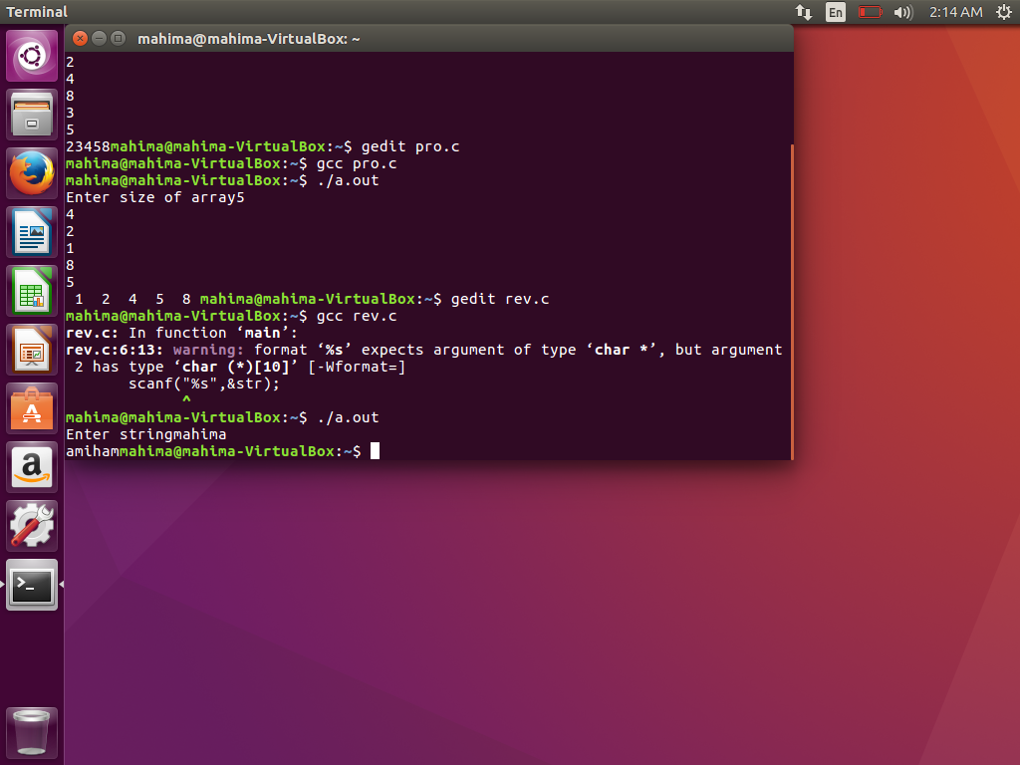

9:

Push- put the changes in to remote repo.

Pull-copy the content from remote repo to local repo.

Commit- it puts the changes into local repo.